

**UNIVERSIDAD DE CASTILLA-LA MANCHA**

**ESCUELA SUPERIOR DE INFORMÁTICA**

**Documentation**

**Lydia Prado Ibañez**

**Rubén Pérez Rubio**

**Juan Garrido Arcos**

**Pablo Ruiz Ciudad**



**Index**

1. Roles of the project . . . . . . . . . . . . . . . . . . . . . . . . . . . . . . . . . . . . 2
2. Functional requirements . . . . . . . . . . . . . . . . . . . . . . . . . . . . . . . . 2
3. Non functional requirements . . . . . . . . . . . . . . . . . . . . . . . . . . . . . 2
4. Iterations. . . . . . . . . . . . . . . . . . . . . . . . . . . . . . . . . . . . . . . . . . . . . 2
5. Planification . . . . . . . . . . . . . . . . . . . . . . . . . . . . . . . . . . . . . . . . . . 3
6. Use case diagrams. . . . . . . . . . . . . . . . . . . . . . . . . . . . . . . . . . . . 4
7. Analysis diagram. . . . . . . . . . . . . . . . . . . . . . . . . . . . . . . . . . . . . . .5
8. Class diagrams. . . . . . . . . . . . . . . . . . . . . . . . . . . . . . . . . . . . . . . . 7
9. **Roles of the project**

We have stated that the roles of the team members are going to be as follows:

* Analyst: Lydia Prado Ibáñez.
* Designer: Rubén Pérez Rubio.
* Programmer: Juan Garrido Marcos.
* Tester: Pablo Ruiz Ciudad.

The tasks that we have to carry out are going to be developed independently of the role that we have in the project. This means that everyone, besides their assigned tasks, will have to participate in other chores.

We have ended up with this solution because the project that we have to develop is too big for so few people, so if each one of us had to carry out by ourselves one task without help from others, the project would take too much time to complete. Time that, on the other hand, we don’t have, since the project has to be ready for December 9th.

**2. Functional requirements**

**FR1:** Case file opening

**FR2:** Sanction driver

**FR3:** Pay for a penalty

**FR4:** Change car’s owner

**3. Non functional requirements**

NFR1: The programming language will be Java and MySQL.

NFR2: The language of the application will be in English.

NFR3: The user is going to have a direct connection with the database.

**4. Iterations**

**Iteration 1 (FR1)**: In case that the radar detects any kind of infringement, a case file will be opened to the driver who has exceeded the speed limit, regarding the license plate of the vehicle. The system will look for the owner.

**Iteration 2 (FR2):** The system identifies the driver of the sanctioned vehicle and creates a new penalty. The fine is calculated and applied.

**Iteration 3 (FR3):** The user proceeds to pay the corresponding sanction that the radar has detected.

**Iteration 4 (FR4):** The user can change the car’s owner in case he sells it.

**Priority table**

|  |  |
| --- | --- |
| **Iteration** | **Priority** |
| **1** | **1** |
| **2** | **3** |
| **3** | **4** |
| **4** | **5** |
| **5** | **2** |

**5. Planification**

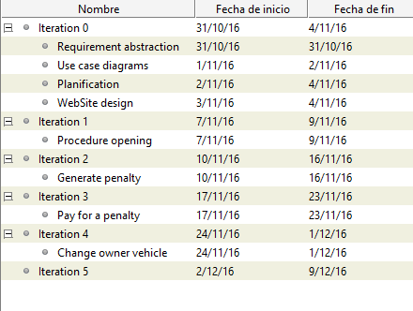

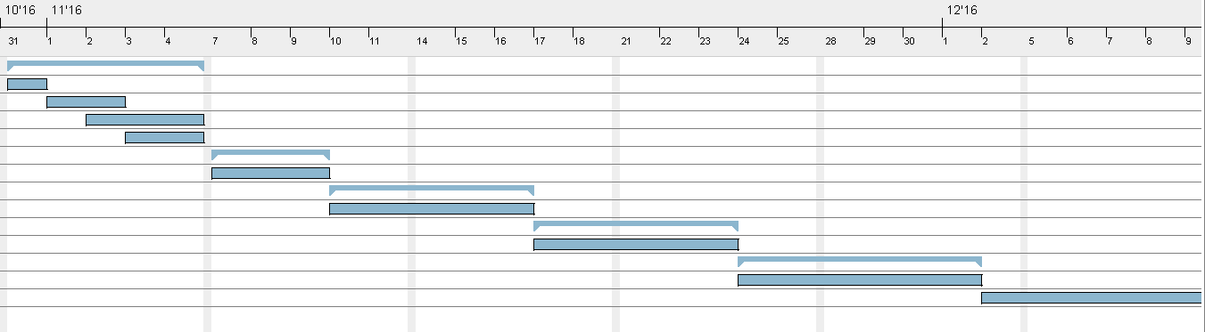

**6. Use case diagrams**

**General diagram:**

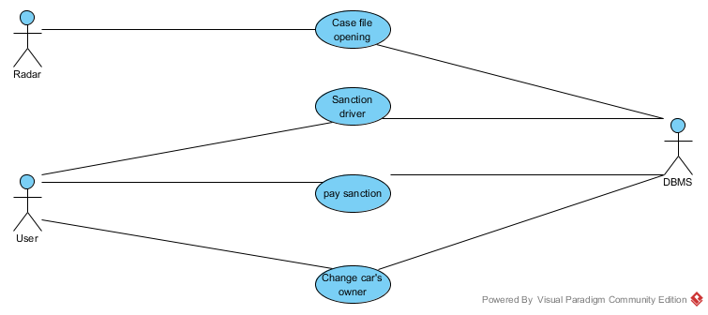

**Iteration 1:** Procedure opening

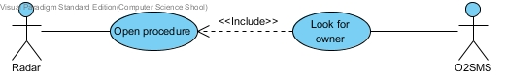

**Iteration 2:** Generate penalty

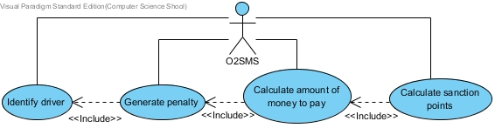

**Iteration 3:** Pay for a penalty

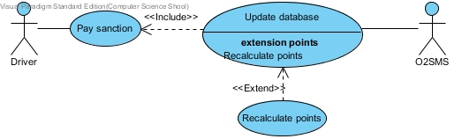

**Iteration 4:** Change owner of vehicle

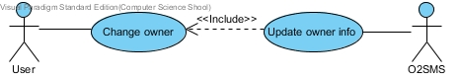

**7. Analysis diagrams**

**Iteration 1:**

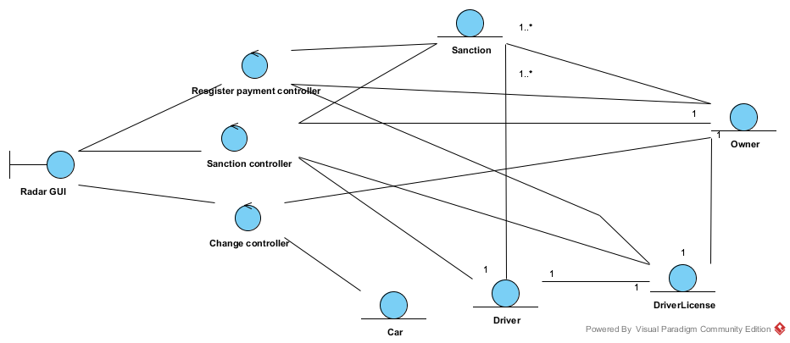

**Iteration 2:**

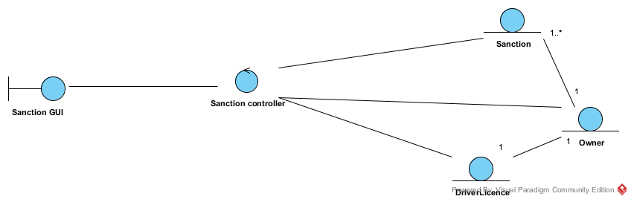

**Iteration 3:**

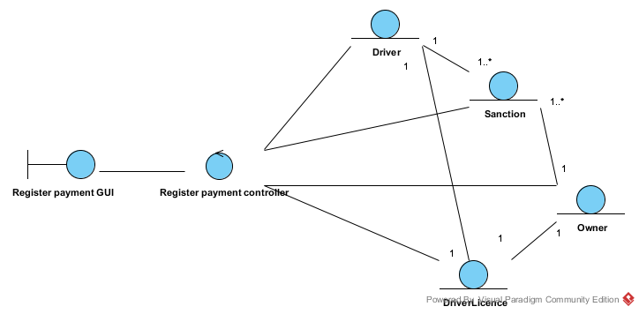

**Iteration 4:**

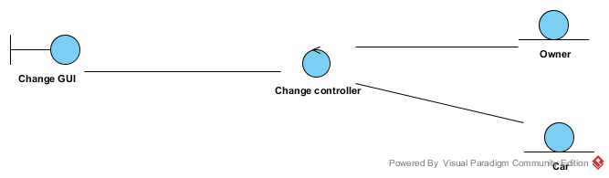

**8. Class diagrams**

**Iteration 1:**

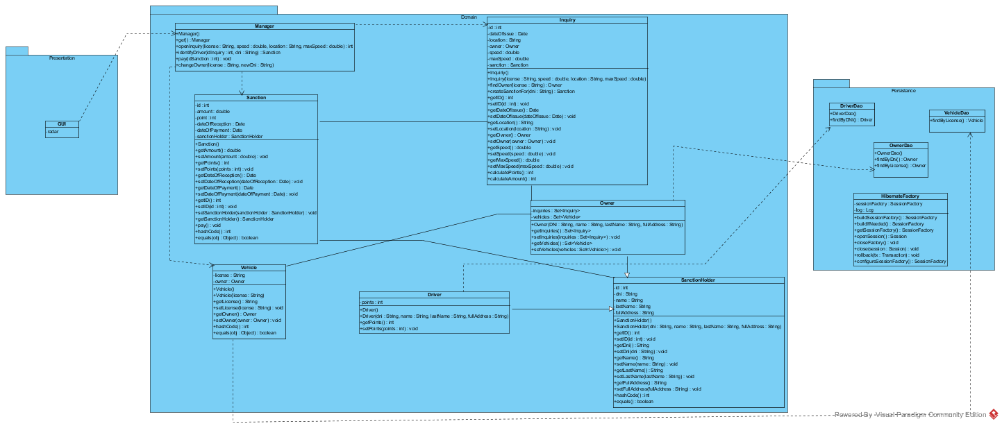

**Iteration 2:**

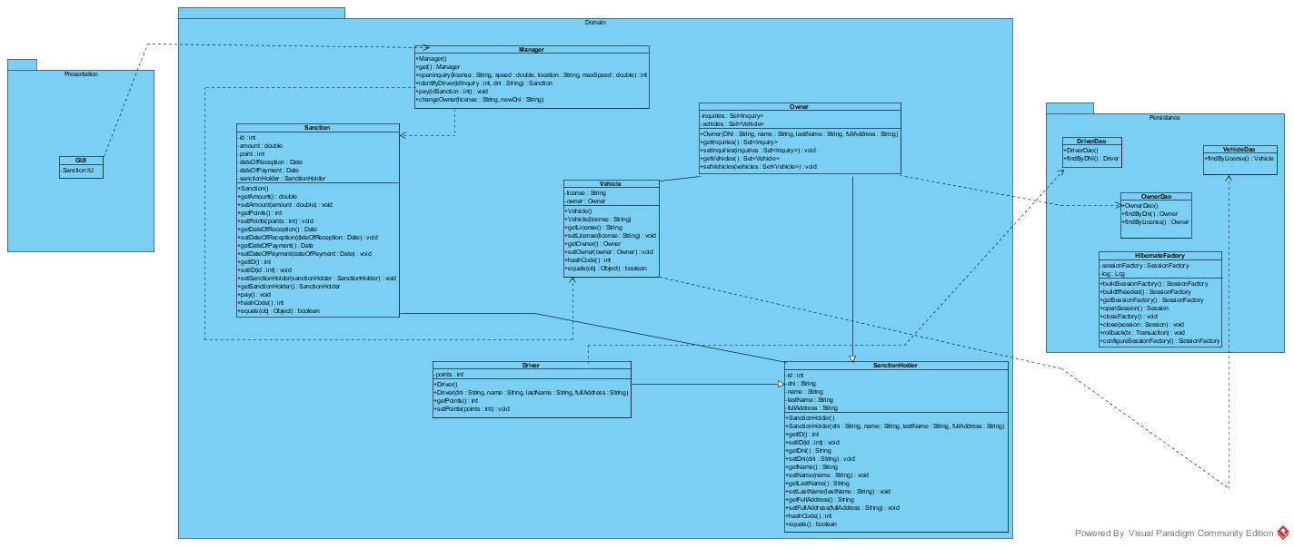

**Iteration 3:**

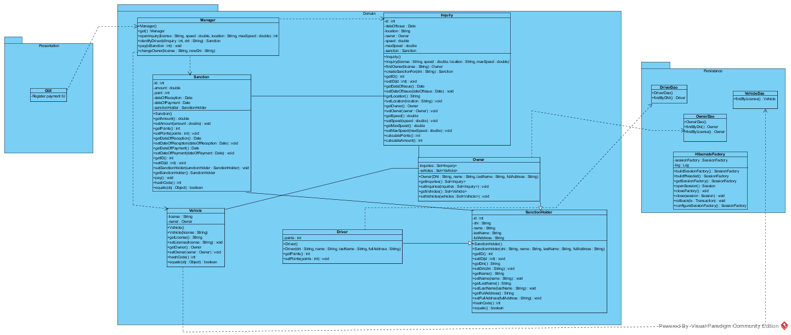

**Iteration 4:**

