CyFj11: FlowJo v11 Workspace Import and Legacy Format Export for R-Based Flow Cytometry Analysis

Title Page
Title: CyFj11: FlowJo v11 Workspace Import and Legacy Format Export for R-Based Flow Cytometry Analysis
Short running title: CyFj11: FlowJo v11 / R Interoperability
Manuscript version: v0.2-draft (2026-05-22)
Authors: Bernd Jagla, bernd.jagla@pasteur.fr (1)
Slobodan Culina, Slobodan.culina@pasteur.fr (2)
Francois Le Guerroue, francois.le-guerroue@pasteur.fr (2)
Esma Karkeni, esma.karkeni@pasteur.fr (2)
Milena Hasan, milena.hasan@pasteur.fr (2)
Affiliations: 1: Institut Pasteur, scBiomarkers UTechS & Bioinformatics & Biostatistics Hub, 25-28 rue du Docteur Roux, 75015 Paris
2 : Institut Pasteur, scBiomarkers UTechS, 25-28 rue du Docteur Roux, 75015 Paris
Corresponding author: Bernd Jagla, ORCID: https://orcid.org/0000-0002-7696-0484
Acknowledgments: [TODO: funding sources, acknowledgments]
Funding: [TODO: grant numbers and funding bodies]
Conflict of interest: The authors declare no conflicts of interest.
Data and code availability: The CyFj11 package is available at https://github.com/C3BI-pasteur-fr/CyFj11.
AI use disclosure: AI-assisted tools were used for drafting and editing portions of this manuscript. All scientific content and interpretation are the responsibility of the authors.
Author contributions (CRediT): BJ: Conceptualization, Methodology, Software, Validation,
Investigation, Writing – original draft. SC, EK,FG: .MH: Supervision, Writing – review & editing

Abstract
High-dimensional flow cytometry enables systematic characterization of immune cell populations at population scale. But harnessing this potential requires seamless interoperability between the interactive gating tools used by biologists and the statistical environments used for downstream analysis. FlowJo, one of the most widely used commercial cytometry analysis software, now stores workspaces in a format that existing R tools cannot read, leaving researchers unable to import their gating strategies into R, or to return R-based results to FlowJo for visual review or collaborative sharing, without manual reconstruction. We present CyFj11, an R package that closes this gap, enabling import of FlowJo v11 gating hierarchies into R and export of R-defined gates back to FlowJo. Using a combination of synthetic test scenarios and a real-world immunophenotyping dataset, we show that population counts in FlowJo matched R-derived values within 0.03% fluctuation? on average. CyFj11 is platform-independent, requires no additional software infrastructure, and is freely available at [https://github.com/C3BI-pasteur-fr/CyFj11].
Keywords: flow cytometry, FlowJo, GatingSet, Gating-ML, workspace interoperability, R/Bioconductor

Introduction
Flow cytometry is a cornerstone technology for characterizing immune cell populations at single-cell resolution. As datasets grow in dimensionality (over 40 parameters) and cohort sizes scale to hundreds of donors, the ability to apply systematic, reproducible gating strategies across samples, and to integrate gating results with statistical and genomic analyses, becomes essential. Population-scale studies linking immune cell phenotypes to genetic variation (1) exemplify both the scientific opportunity and the computational demands that such workflows impose.
FlowJo (2) is one of the most widely used interactive commercial software for flow cytometry data analysis. Its version 11, released 2025, adopts a JSON-based workspace format that no current R/Bioconductor tool can read. CytoML (3), the primary Bioconductor gateway for FlowJo data, supports only the v10 XML format and is additionally constrained by Docker-dependent compiled components that are unsupported on macOS Apple Silicon. Researchers who gate in FlowJo v11 therefore lack a maintained pathway to import gating hierarchies into R or to return R-derived results to FlowJo without manual reconstruction.
CyFj11 addresses this with two functions: fj11_to_gatingset(), which imports a v11 workspace as GatingSet objects (4), and export_flowjo10_workspace(), which writes a GatingSet to FlowJo v10-compatible XML (Figure 1). The new JSON format relies on a complex web of cross-referenced identifiers across multiple components, making faithful generation from R prohibitively difficult. Rather than attempting to write native FlowJo v11 files, CyFj11 exports to the well-documented v10 XML format and relies on FlowJo v11's built-in ability to open v10 workspaces, a capability that FlowJo v11 supports natively. The package requires no external dependencies beyond standard Bioconductor infrastructure, is fully compatible with openCyto (5) and flowWorkspace.
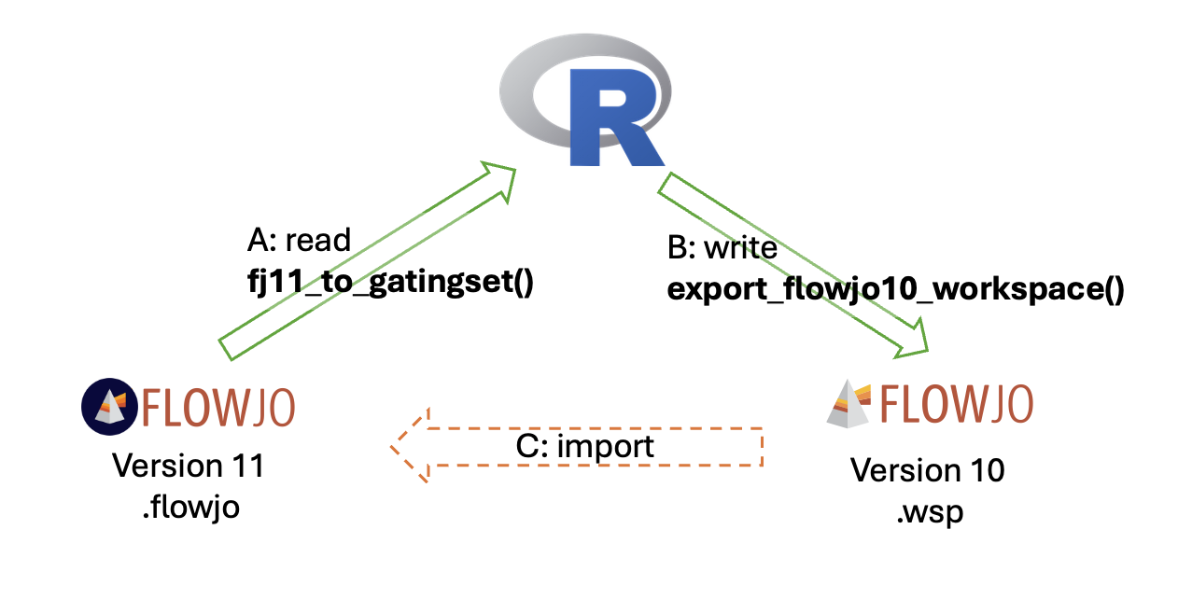
Figure 1: Figure 1. CyFj11 workflow overview. Arrow A: fj11_to_gatingset() reads a FlowJo v11 .flowjo workspace into R as a GatingSet object. Arrow B: export_flowjo10_workspace() writes a GatingSet to a FlowJo v10-compatible .wsp XML file. Arrow C (dashed): the exported .wsp can be opened in FlowJo v11; this step is performed outside R and is subject to FlowJo v11's partial backward compatibility with the v10 format (see Limitations).

Software Description
read_flowjo11_workspace() extracts and parses the .flowjo file, which is a ZIP archive containing a JSON workspace. It reconstructs the workspace components — sample groups, FCS file references, gate definitions, per-sample gate variations, and transformation parameters — and returns them as a structured list for downstream processing.

fj11_to_gatingset() takes the parsed workspace and constructs flowWorkspace GatingSet objects. It locates FCS files by recursive directory search, applies compensation (from the workspace or user-supplied), converts transformation parameters to flowCore objects, and imports the full gate hierarchy. Gate coordinates are converted from FlowJo's display space to the raw data space expected by flowCore. Because FlowJo v11 supports per-sample tailored gates, the function returns a named list of per-sample GatingSet objects; users who require a single merged object can call flowWorkspace::merge_list_to_gs(). Samples can be filtered by index, filename, or a pData expression, and FCS keyword metadata can be extracted as sample-level covariates.

export_flowjo10_workspace() serializes a GatingSet to FlowJo v10 XML, replicating FlowJo v10's native element structure, namespace conventions, and transformation encodings. Supported gate types include rectangle, polygon, ellipsoid, range, and boolean. Compensation matrices and all transformation parameters are preserved. Quadrant gates and per-sample gate variations cannot be represented in v10 XML and are respectively omitted or collapsed to group-level on export (see Limitations). For v10 workspace import, CyFj11 delegates to CytoML::flowjo_to_gatingset().

Results
Validation design. Thirteen synthetic test scenarios were constructed to systematically exercise all supported gate types (rectangle, polygon, ellipsoid, range, boolean) and transformation types (linear, biexponential, log, arcsinh) in isolation and combination, including hierarchical and boolean configurations (full descriptions in Appendix A). For each scenario, synthetic FCS files were generated in R, a GatingSet was constructed, and the result was exported to a FlowJo v10 XML workspace using export_flowjo10_workspace(). Each exported workspace was then opened in FlowJo v10 to manually record population counts for comparison against the R ground truth. The workspace was subsequently re-saved from within FlowJo v10; this re-saved file was used for all subsequent FlowJo v11 import steps, ensuring that any import failures observed in FlowJo v11 could be attributed to FlowJo v11's handling of v10-format workspaces in general, rather than to any idiosyncrasy of the CyFj11-generated XML specifically. To assess FlowJo v11 compatibility, this re-saved workspace was imported into FlowJo v11, manually verified, and corrected where necessary (see Appendix B for details). The corrected workspace was saved in v11 format, and population counts recorded within FlowJo v11 at this stage served as the ground truth for the import-to-R comparison. This v11 workspace was then imported into R using read_flowjo11_workspace() and fj11_to_gatingset(), and the resulting GatingSet counts were compared against those FlowJo v11 reference counts. Additional test, Test 14, used the FlowSOM (6) example dataset (15 populations across scatter and compensated fluorescence channels) to assess performance on a real-world dataset and to validate compensation matrix preservation through the round trip. All source code, FCS files, and workspaces are deposited at https://doi.org/10.5281/zenodo.20933199.

FlowJo v10 export. All gate types (rectangle, polygon, boolean, and ellipse) FlowJo v10 reproduced R-derived counts with high fidelity across all tests. Rectangle and range gates showed exact agreement in every case. The small count differences that did appear (at most 14 cells, confined to polygon and ellipse gates) arise because cells that fall very close to a gate boundary line may be counted as inside or outside depending on how each program handles that exact boundary value; the gate itself is in the right place. This was confirmed by extracting gate coordinates directly from the exported file: boundary coordinates matched the R definitions exactly across all axis transformation types tested. To put the 14-cell maximum in perspective: a biologist redrawing the same gate by hand on two separate occasions would typically shift far more cells than this.

In Test 14 all 12 populations on compensated fluorescence channels, including NK cells, B cells, T cell subsets, and CD4/CD8 populations, were reproduced with identical counts. The three scatter-channel populations differed by at most 10 cells (0.05%). The exact reproduction of fluorescence-channel counts is itself evidence that the compensation matrix was correctly transferred: obtaining the same cell counts after compensation in two different programs requires that both apply exactly the same spillover values. This was confirmed directly by comparing the exported compensation matrix entry by entry against the original.

FlowJo v11 import. Two systematic FlowJo v11 import failures restricted the populations available for count comparison. Some boolean gates and gates on arcsinh-transformed axes were silently dropped or incorrectly rendered when FlowJo v11 read the v10 workspace files; the same file opened without error in FlowJo v10, confirming the export is structurally correct. For rectangle and range gates on linear, log, and biexponential R-derived counts reproduced FlowJo v11 reliably. Where discrepancies appeared, they were confined to polygon and ellipse gates, reflecting differences in how FlowJo v11 renders these shapes when reading v10-format coordinates rather than errors in the gate definitions themselves. Full per-population data are in Appendix B, Table B1.

Table 1. Export validation summary by gate type.

Gate type | FJ10 export | FJ11 import
Rectangle / Range | Exact agreement in all cases | Reliable
Polygon | ≤14-cell boundary effect | Some shape differences; verify after import
Ellipse | Minor coordinate drift (expected) | Additional shape differences
Boolean (AND / OR / NOT) | Exact agreement | Exact, if supported
Arcsinh-transformed | Exact agreement | Not supported
Compensation matrix | Confirmed: entry-by-entry match (Test 14) | Only compensation matrix from FCS supported

Standards compliance. All 50 applicable Gating-ML 2.0 structural checks passed across the 13 test workspaces (Appendix C).

Limitations/Discussion
Four limitations apply. (1) FlowJo v11’s v10 importer sometimes drops Boolean gates (observed in hierarchical tests 11–13, not in the root-level test 10) and mis-renders arcsinh ellipsoid gate boundaries (test13 FITC_PE_gate). In every case the exported v10 XML itself was reproduced correctly by FlowJo v10, localizing the visible failures to FJ11’s v10 importer. These incompatibilities likely affect any v10-format workspace opened in FJ11, not only CyFj11 exports. (2) Compensation matrix export has been validated indirectly and by element-wise comparison for Test 14. Manually in FJ11 modified compensations are not supported at the moment. In general because of the complexity of the json format it cannot be assured that all features are currently supported. Here we tried to cover the most common use cases. (3) Per-sample tailored gates are collapsed to group-level on v10 export. (4) Quadrant gates are not currently supported in the export functionality.
The residual differences observed across the validation pipeline underscore an inherent fragility in flow cytometry analysis more generally. Whether populations are gated manually in a GUI or defined automatically in code, the final counts are shaped by numerical precision, transform conventions, and file-format idiosyncrasies. Thus, even fully reproducible, automated workflows should be expected to yield small, non-zero discrepancies when compared across software platforms.

Availability
CyFj11 is available as open-source software at [https://github.com/C3BI-pasteur-fr/CyFj11]. Validation datasets and scripts are deposited at https://doi.org/10.5281/zenodo.20933199. The package is compatible with R ≥ 4.0 and Bioconductor ≥ 3.14.

References
1. The Milieu Intérieur Consortium, Patin E, Hasan M, Bergstedt J, Rouilly V, Libri V, et al. Natural variation in the parameters of innate immune cells is preferentially driven by genetic factors. Nat Immunol. 2018 Mar;19(3):302–14. doi:10.1038/s41590-018-0049-7
2. FlowJo TM, version 10 & 11. Becton, Dickinson and Company.
3. Finak G, Jiang W, Gottardo R. CytoML for cross-platform cytometry data sharing. Cytometry Part A. 2018;93(12):1189–96. doi:10.1002/cyto.a.23663
4. Greg Finak MJ. flowWorkspace [Internet]. Bioconductor; 2017 [cited 2026 Jul 6]. Available from: https://bioconductor.org/packages/flowWorkspace doi:10.18129/B9.BIOC.FLOWWORKSPACE
5. Finak G, Frelinger J, Jiang W, Newell EW, Ramey J, Davis MM, et al. OpenCyto: An Open Source Infrastructure for Scalable, Robust, Reproducible, and Automated, End-to-End Flow Cytometry Data Analysis. Prlic A, editor. PLoS Comput Biol. 2014 Aug 28;10(8):e1003806. doi:10.1371/journal.pcbi.1003806
6. Van Gassen S, Callebaut B, Van Helden MJ, Lambrecht BN, Demeester P, Dhaene T, et al. FlowSOM: Using self‐organizing maps for visualization and interpretation of cytometry data. Cytometry Pt A. 2015 Jul;87(7):636–45. doi:10.1002/cyto.a.22625
7. Finak G, Jiang W, Gottardo R. CytoML for cross‐platform cytometry data sharing. Cytometry Pt A. 2018 Dec;93(12):1189–96. doi:10.1002/cyto.a.23663
8. Finak G, Frelinger J, Jiang W, Newell EW, Ramey J, Davis MM, et al. OpenCyto: An Open Source Infrastructure for Scalable, Robust, Reproducible, and Automated, End-to-End Flow Cytometry Data Analysis. Prlic A, editor. PLoS Comput Biol. 2014 Aug 28;10(8):e1003806. doi:10.1371/journal.pcbi.1003806

