A Donor-Aware Framework for Mechanistic Interpretability of Aging Signals in Single-Cell Foundation Models
[Author names and affiliations to be inserted before submission]
March 31, 2026
Abstract
Single-cell foundation models may encode aging biology, but apparent signals can easily be distorted by donor identity and cell-composition differences. We built a donor-aware interpretability framework to test aging-related structure in frozen scGPT and Geneformer embeddings from age-labeled human single-cell datasets. The workflow combines donor-held-out age decoding, sparse autoencoder feature discovery, cross-model pathway matching, latent-space intervention tests, donor-bootstrap confidence intervals, and progressively stricter confound controls.
Across five datasets, frozen representations contained detectable age information, with best donor-aware balanced accuracy 0.384. Sparse autoencoders recovered 132 donor-aware robust features across the two core AIDA cohorts, and cross-model pathway matching yielded 193 paired features, most strongly concentrated in inflammation / NF-kappaB programs in AIDA phase 1 v2. The clearest positive intervention result appeared in a global Geneformer inflammation branch: old-versus-random and old-versus-young expected-age contrasts remained significant after split expansion and donor-threshold tightening up to 400 donors. In a monocyte-restricted analysis on AIDA phase 1 v1, both scGPT and Geneformer also showed positive old-versus-random responses at intervention scale 2.0.
Under the strictest control, however, the strongest global branch weakened. Fully composition-matched forward-pass reruns eliminated full strict replication, with 0 of 4 matched-seed reruns passing the full claim gate. These results show that frozen single-cell foundation models do contain biologically coherent aging-related structure, especially around inflammatory programs, but they also show that donor-aware and composition-aware stress tests are essential before treating those patterns as robust mechanisms.
Keywords: aging; biogerontology; single-cell transcriptomics; foundation models; mechanistic interpretability; inflammation

Introduction
Aging does not appear as a single transcriptomic program. Instead, it emerges through shifts in immune activation, stress response, proteostasis, and cell composition that vary across cell types and cohorts. Single-cell foundation models compress these patterns into latent representations, which raises an attractive question for biogerontology: do those latent spaces contain interpretable aging biology, or only weak predictive signal? Two recent foundation models for single-cell transcriptomics, Geneformer (Theodoris et al. 2023) and scGPT (Cui et al. 2024), provide suitable frozen backbones for testing that question.
This distinction matters because age can be decodable without supporting a defensible biological mechanism. Donor identity, cell-type imbalance, and cohort-specific composition shifts can all create apparent aging signals that disappear under stronger controls. We therefore focused on a harder target: not just whether age can be decoded from frozen embeddings, but whether candidate aging programs remain directional, biologically coherent, and donor-aware under increasingly strict stress tests.

Methods

Data
Core analyses centered on age-labeled human immune single-cell data already available in-project, with primary focus on AIDA phase 1 v1 and AIDA phase 1 v2. External and reference datasets included Tabula Sapiens-derived assets (Jones et al. 2022), the Yazar immune single-cell eQTL cohort (Yazar et al. 2022), and Allen immune aging-derived subsets.
The strongest-branch analyses were performed on AIDA phase 1 v2, which had the largest donor support in the deep-dive stage ($n≈424$ in the baseline expanded-split run and $n≈333$–340 in the composition-matched reruns).

Models
We used frozen representations from:
- scGPT (contextual layer scgpt_layer_09) (Cui et al. 2024)
- Geneformer (contextual representation) (Theodoris et al. 2023)
Neither model was fine-tuned for age prediction in the core pipeline.

Interpretability workflow
The analysis proceeded in four blocks. First, we asked whether age-related signal was present at all, using donor-held-out linear probes and simple manifold diagnostics (Stages 1–2). Second, we searched for interpretable latent structure using sparse autoencoders and cross-model pathway matching (Stages 3–4), motivated by sparse dictionary learning frameworks (Bricken et al. 2023; Templeton et al. 2024). Third, we tested candidate pathways with targeted interventions, donor-bootstrap confidence intervals, and conservative promotion gates (Stages 5–8). Finally, we stress-tested the strongest surviving branch with donor-threshold sweeps, donor-composition reweighting, fully composition-matched reruns, and multi-seed matched reruns (Stages 9–11).
Bootstrap confidence intervals used nonparametric donor resampling (Efron 1979).

Strict gate policy
Claims were promoted only when multiple directional checks agreed: expected-age contrasts had to point in the correct direction, marginal effects had to remain supportive, and old-probability shifts had to be consistent. This policy was intentionally stricter than contrast-only screening because the project goal was mechanism-grade evidence rather than loose signal detection.

Results

Global trajectory across stages
Table 1 summarizes stage-level outcomes.
Stage-level outcomes across the full pipeline.
Stage | Objective | Key outcome
1 | Frozen age probe | Best balanced accuracy range: 0.299–0.384 across 5 datasets
2 | Manifold geometry | Geometry gate passes: 0/5 datasets
3 | SAE features | 132 robust donor-aware sparse features retained
4 | Cross-model convergence | 193 pathway-matched cross-model feature pairs
6 (strict) | Model-specific claim promotion | 0/4 strict claim passes
8 (strict audit) | Contrast + marginal strict gate | 1/19 runs with at least one full strict row
9 | Deep-dive robustness | Surviving row stable up to min-donors=400; fails at 500
10 | Composition controls | Reweighting preserved strict pass; full compmatched forward rerun removed full strict pass
11 | Compmatched seed panel | 0/4 full strict replications under composition-matched seeds

Age can be decoded, but global age geometry is not robust (Stages 1–2)
Frozen probes reached moderate performance (best $BA=0.3838$ in AIDA phase 1 v2), indicating that age-associated signal is present in the frozen representations. However, the manifold-alignment criteria did not pass robustness gates in any dataset (0/5), even after donor-aware within-cell-type checks. Figure 1 shows this separation clearly: age is detectable, but it does not organize the global latent geometry in a stable way.
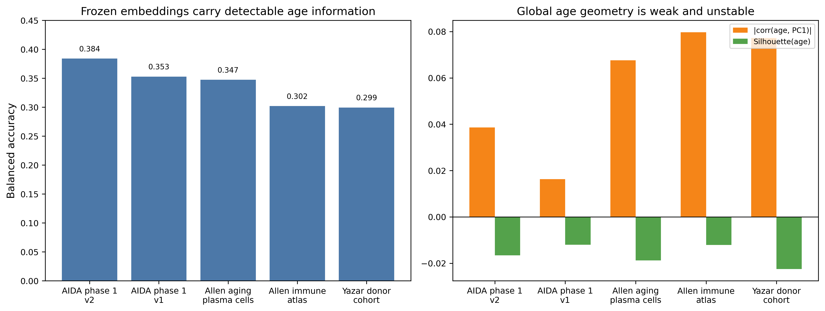
Detection versus geometry. Left: donor-aware age-decoding performance by dataset. Right: age-alignment geometry statistics remain weak and inconsistent, with no dataset passing the geometry gate.

Sparse features and cross-model overlap point to inflammatory programs (Stages 3–4)
Sparse autoencoder analysis identified many donor-aware robust features (91 in scGPT core runs and 41 in Geneformer core runs). Figure 2 summarizes these counts.
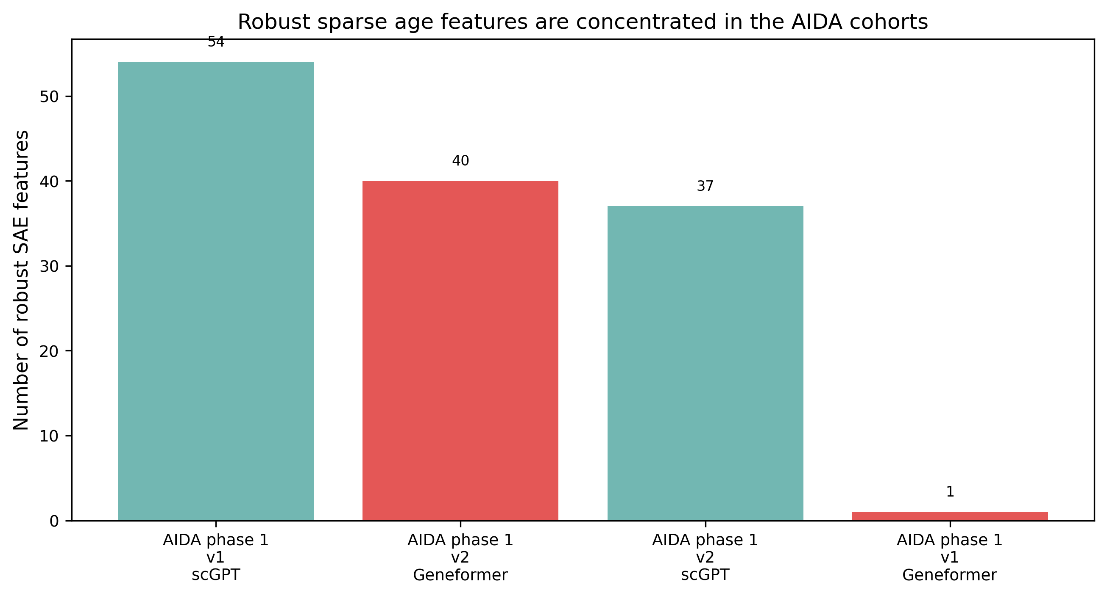
Donor-aware robust sparse features retained after filtering. Most of the signal comes from the two AIDA cohorts.
Cross-model pathway matching produced 193 pairs in aggregate. This overlap was dominated by inflammation / NF-kappaB in AIDA phase 1 v2 (175 pairs; best convergence score 0.0957), suggesting that both models capture a shared inflammatory latent program rather than completely unrelated features (Figure 3).
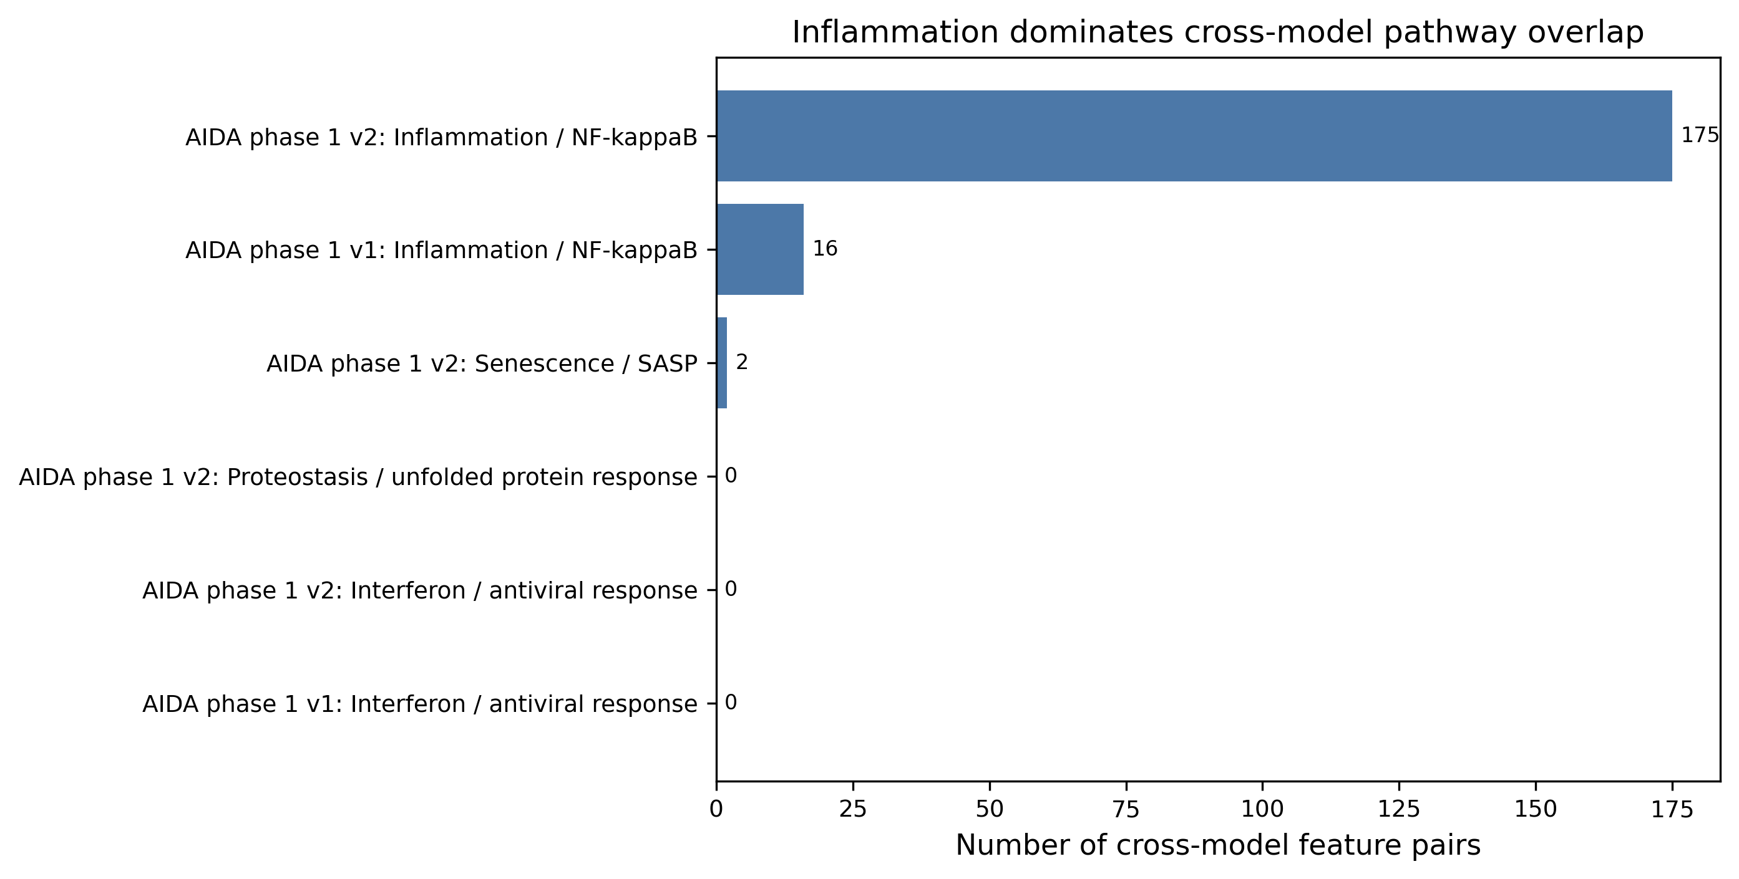
Cross-model pathway convergence. Inflammation / NF-kappaB dominates the shared signal between scGPT and Geneformer.

The clearest cell-type-specific signal appears in AIDA v1 monocytes (Stage 8)
A clear positive result appeared in AIDA phase 1 v1 CD14 monocytes for inflammation / NF-kappaB at intervention scale 2.0:
- Geneformer old-minus-random expected-age contrast: 0.0357 [0.0314, 0.0398], positive.
- scGPT old-minus-random expected-age contrast: 0.0419 [0.0368, 0.0474], positive.
In contrast, AIDA phase 1 v2 monocytes were weak or discordant (Geneformer uncertain; scGPT negative), emphasizing that the signal is real but cohort-dependent (Figure 4).
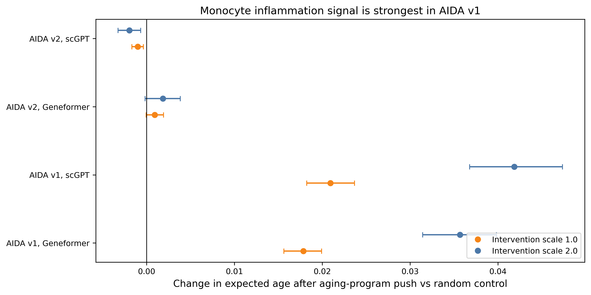
Monocyte-restricted inflammation intervention results. Positive old-versus-random effects are strongest in AIDA phase 1 v1, especially at intervention scale 2.0.

A single global Geneformer branch survives the deep-dive stress test (Stage 9)
Under strict gating, one global branch survived: the AIDA phase 1 v2 Geneformer inflammation / NF-kappaB branch evaluated at global scope and intervention scale 2.0. After expanding split seeds (60 splits per model), this branch remained full-strict positive up to a minimum donor threshold of 400, failing only at 500 because donor coverage became too sparse (Figure 5).
The key Geneformer expected-age contrasts in this deep-dive run were:
- old-minus-random: 0.1494 [0.1423, 0.1564], positive
- young-minus-random: -0.1324 [-0.1379, -0.1267], negative
- old-minus-young: 0.2817 [0.2698, 0.2940], positive
This was the strongest positive mechanistic candidate in the full project trajectory.
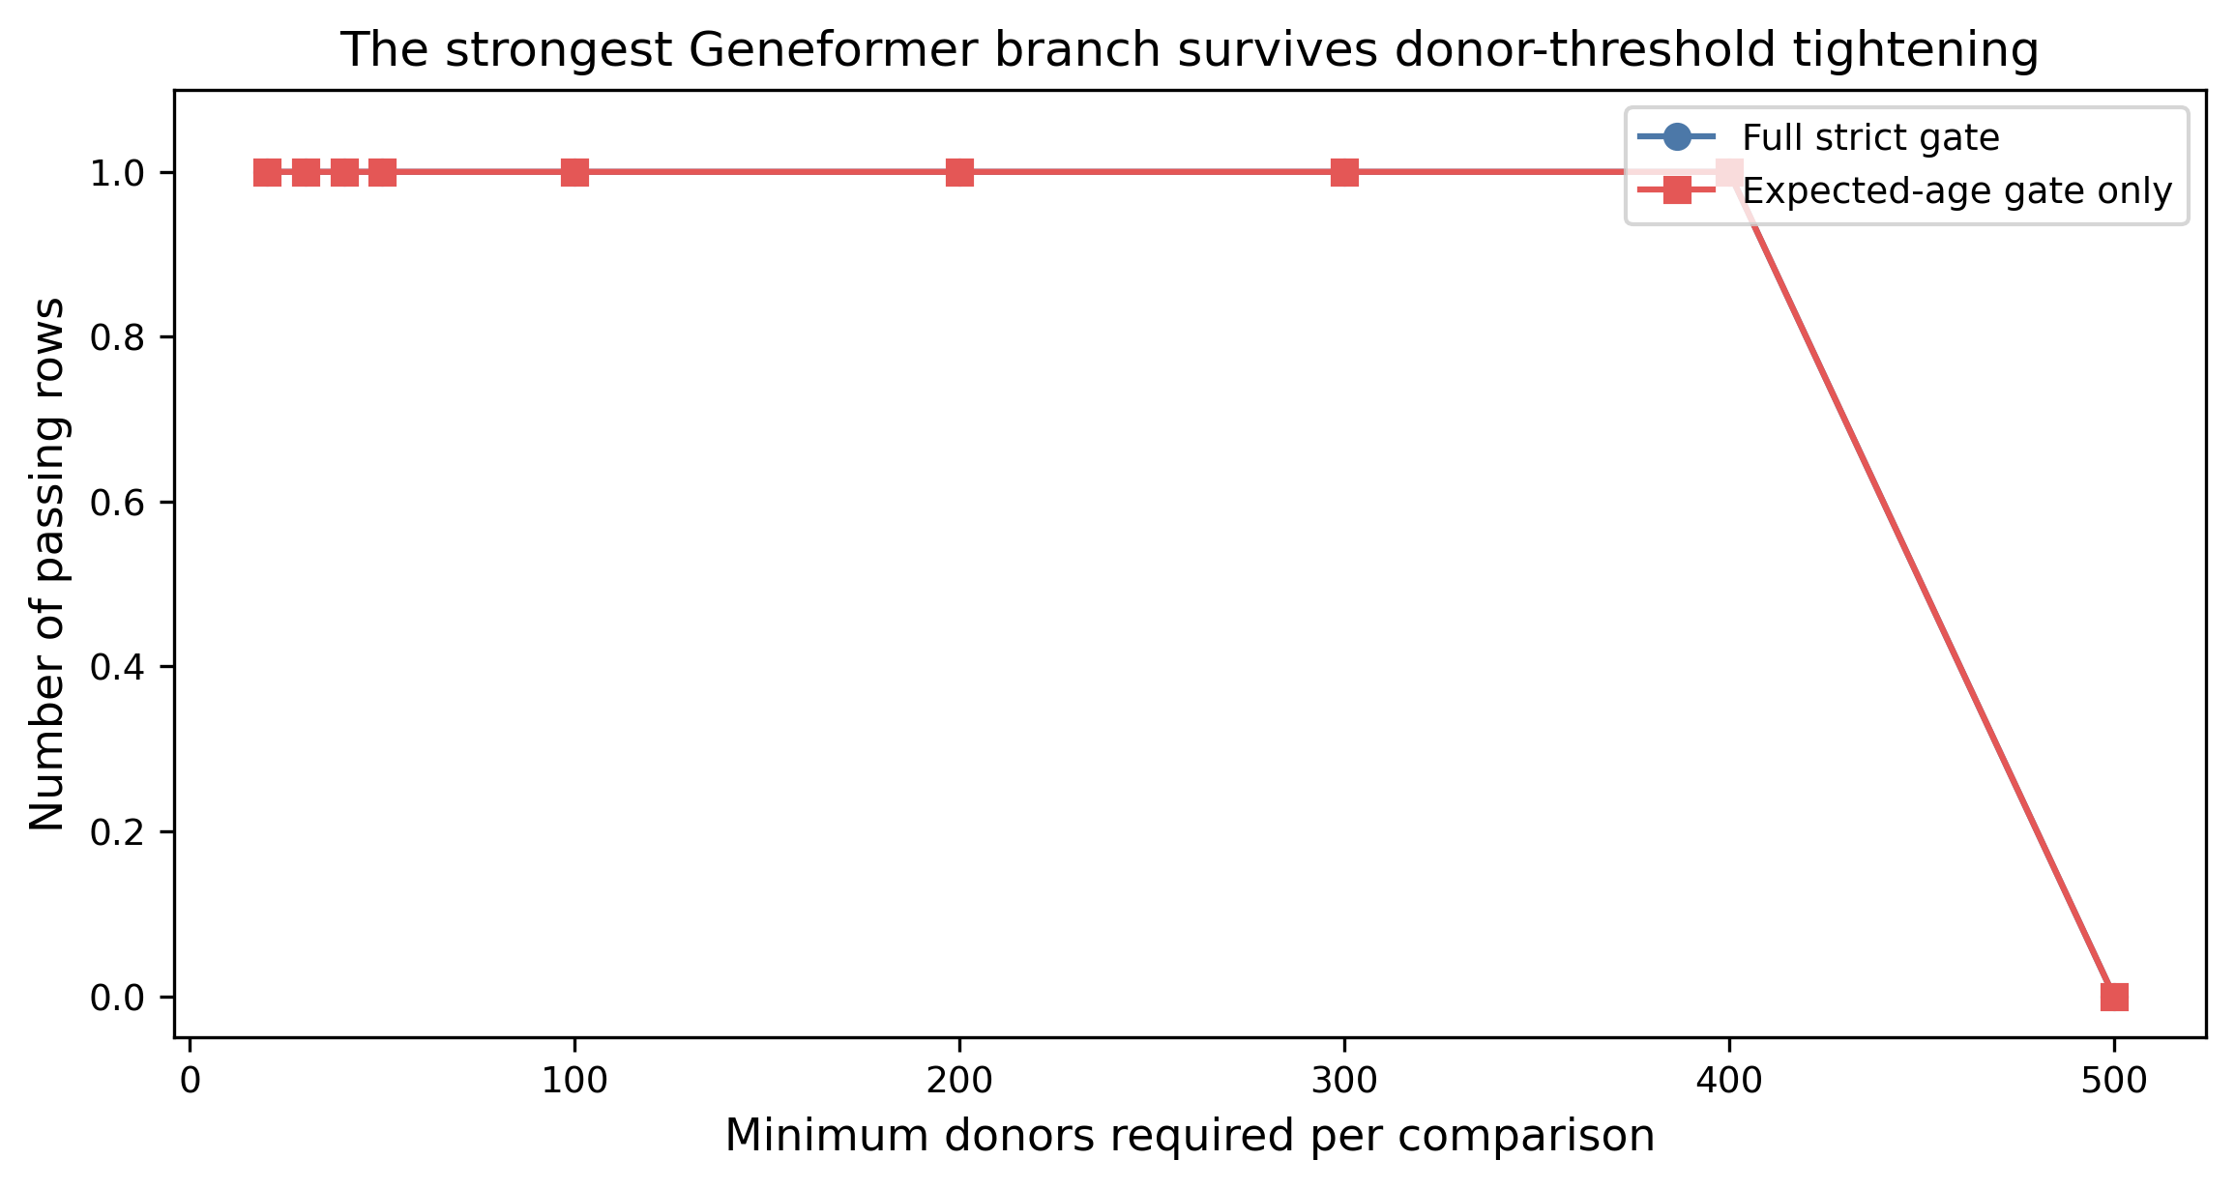
Donor-threshold stress test for the strongest surviving global branch. The full strict gate remains satisfied until the minimum donor threshold reaches 500.

Composition matching weakens the strongest global signal (Stages 10–11)
Positive control result (reweighting): donor-composition reweighting preserved strict pass status across ridge penalties of 0.1, 1, 10, and 100, with near-zero effect shifts.
Stronger control result (full composition-matched forward rerun): the full strict pass disappeared ($n_{full strict}=0$) despite one expected-age contrast-strict row. Figure 6 shows both points: simple reweighting barely changes the estimated effect sizes, but fully matched reruns do not preserve the baseline claim. Figure 7 compares the donor-bootstrap intervention intervals before and after full composition matching.
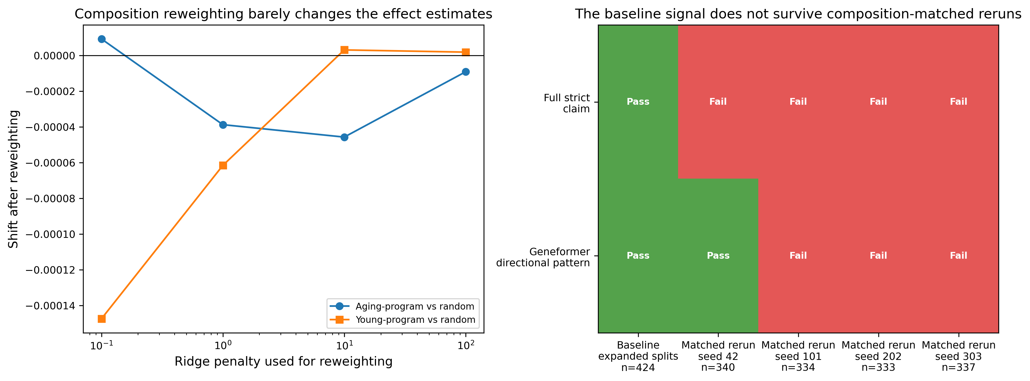
Composition controls. Left: donor-composition reweighting produces only negligible changes in the effect estimates. Right: the baseline strict claim does not replicate under composition-matched reruns, although one matched rerun retains the weaker Geneformer directional pattern.
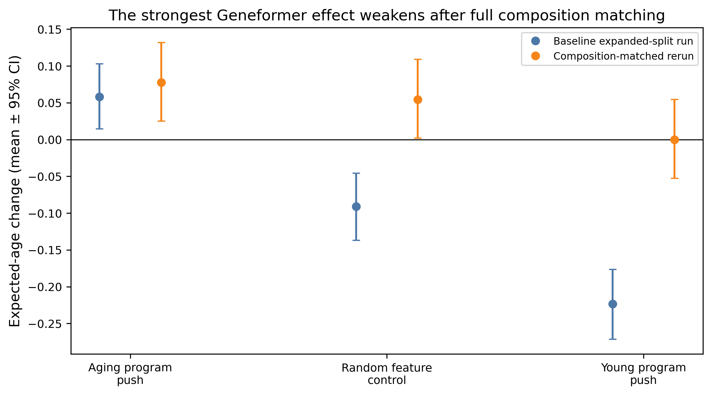
Geneformer donor-bootstrap intervention effects before and after full composition matching. The aging-program push remains positive, but the overall directional structure becomes less clean once full matching is enforced.

Matched reruns do not reproduce the baseline claim (Stage 11)
A four-run composition-matched seed panel (seed42, 101, 202, 303) yielded:
- 0/4 full strict replications,
- Geneformer directional-pattern criterion retained in 1/4 runs,
- unstable random/young intervention directional structure across seeds.
Table 2 summarizes the panel-level strict outcomes.
Stage 11 composition-matched seed panel summary (strict outcomes).
Run | $n_{\text{full strict}}$ | Aging push | Random control | Young-program push
Baseline expanded-split run | 1 | positive | negative | negative
Composition-matched rerun, seed 42 | 0 | positive | positive | uncertain
Composition-matched rerun, seed 101 | 0 | uncertain | positive | positive
Composition-matched rerun, seed 202 | 0 | positive | positive | positive
Composition-matched rerun, seed 303 | 0 | positive | uncertain | uncertain

Discussion
A clear pattern emerged across the project. Frozen single-cell foundation models do contain aging-related structure, and some of that structure is biologically interpretable. We repeatedly recovered donor-aware sparse features, saw substantial cross-model overlap in inflammatory programs, and observed a strong cell-type-local monocyte signal in AIDA phase 1 v1. These are not trivial findings, because they appeared without age-specific fine-tuning.
At the same time, the strongest global signal did not survive the most demanding control. The AIDA phase 1 v2 Geneformer inflammation branch looked convincing after split expansion, donor-threshold tightening, and donor-composition reweighting. But once we enforced full composition matching and repeated the analysis across multiple matched seeds, the full strict claim did not replicate. That is not a side note. It is the central methodological result of the study.

Interpretation for longevity-focused mechanistic research
For longevity-focused mechanistic work, these results suggest a practical strategy:
- Use frozen models first to test signal existence and feature interpretability.
- Promote candidate mechanisms only after donor-aware, cell-type-aware, and composition-aware replication.
- Distinguish model-specific interpretable signal from cross-model robust mechanism; these are not equivalent.

Limitations
Key limitations include: (i) limited donor support in some strata and external subsets; (ii) reduced power under strict within-cell-type constraints; (iii) sensitivity of final strict status to composition-matched sample realization; and (iv) incomplete high-power composition-matched reruns due runtime constraints.

Conclusion
This project establishes that frozen scGPT and Geneformer representations contain meaningful, interpretable aging-associated latent programs, with particularly strong intermediate evidence around inflammatory biology. However, under repeated fully composition-matched forward-pass controls, the strongest global strict-claim branch did not replicate. The most accurate summary is therefore: promising mechanistic signal, not yet a promotion-grade robust mechanism.
The highest-value next step is a higher-power composition-matched consensus protocol (larger matched cell budgets and pooled multi-resample decision rules) to determine whether the Stage-9 signal reflects a true stable mechanism or a sampling-sensitive artifact.

Statements and Declarations
Funding: The author received no specific funding for this work.
Competing interests: The author declares no competing interests.
Author contributions: The sole author conceived the study, designed the analyses, executed the computational work, interpreted the results, and wrote the manuscript.
Ethics approval: This study analyzed previously generated datasets and did not involve new recruitment or intervention on human participants within the present work.
Consent to participate: Not applicable.
Consent for publication: Not applicable.
Data availability: The public project repository includes the processed summary artifacts needed to reproduce the manuscript figures and tables. Access to the raw underlying single-cell datasets is governed by the original data providers; the repository documents dataset provenance and contains derived summary outputs only.
Code availability: The analysis code, manuscript source, figure-generation script, and reproducibility notes are available at https://github.com/Biodyn-AI/longevity-mechinterp.
Bricken, Trenton, Adly Templeton, Joshua Batson, et al. 2023. “Towards Monosemanticity: Decomposing Language Models with Dictionary Learning.” https://arxiv.org/abs/2305.01610.
Cui, Haotian, Chloe Wang, Himanshu Maan, et al. 2024. “scGPT: Toward Building a Foundation Model for Single-Cell Multi-Omics Using Generative AI.” Nature Methods 21 (8): 1470–80. https://doi.org/10.1038/s41592-024-02201-0.
Efron, Bradley. 1979. “Bootstrap Methods: Another Look at the Jackknife.” The Annals of Statistics 7 (1): 1–26. https://doi.org/10.1214/aos/1176344552.
Jones, R. C., J. Karkanias, M. A. Krasnow, A. O. Pisco, et al. 2022. “The Tabula Sapiens: A Multiple-Organ, Single-Cell Transcriptomic Atlas of Humans.” Science 376 (6594): eabl4896. https://doi.org/10.1126/science.abl4896.
Templeton, Adly, Trenton Bricken, Joshua Batson, et al. 2024. “Scaling Monosemanticity: Extracting Interpretable Features from Claude 3 Sonnet.” https://arxiv.org/abs/2406.04093.
Theodoris, Christina V., Ling Xiao, Aashi Chopra, et al. 2023. “Transfer Learning Enables Predictions in Network Biology.” Nature 618 (7964): 355–64. https://doi.org/10.1038/s41586-023-06139-9.
Yazar, S., J. Alquicira-Hernandez, K. Wing, et al. 2022. “Single-Cell eQTL Mapping Identifies Cell Type-Specific Genetic Control of Autoimmune Disease.” Science 376 (6589): eabf3041. https://doi.org/10.1126/science.abf3041.

