**NGS Bioinformatics**

**Module topic: NGS Data Processing and QC**

**Contact session title: Read Data QC**

**Trainer: Shaun Aron**

**Participant:** <*write your name here>*

**Date:** <*write today’s date here*>

**FASTQ Data QC**

**Introduction**

In the assignment, you will have an opportunity to view and run a set of FASTQ files through the FASTQC program and assess the html output reports.

* *View raw high throughput sequencing files (FASTQ).*
* *Check the quality of the dataset = run a standard QC pipeline.*
  + *This step is crucial to ensure that your dataset is of good quality before you continue further with the analysis.*
* *Remove adapters and low quality reads from the dataset.*
* *Compare a « good » and a « bad » quality dataset.*

**Tools used in this session**

*FASTQC -* [*https://www.bioinformatics.babraham.ac.uk/projects/fastqc/*](https://www.bioinformatics.babraham.ac.uk/projects/fastqc/)

*Trimmomatic -* [*https://github.com/usadellab/Trimmomatic*](https://github.com/usadellab/Trimmomatic)

**Task 1: Quality Control of a FASTQ dataset**

*The datasets for this assignment can be found on the course website. The dataset you will be working with first is paired end reads from an Escherichia coli K1 sample. The data has been produced on the Illumina MiSeq platform and is stored in the SRR957824.zip archive.*

Log into the HPC

In your home directory create a folder called ngs_qc

mkdir ngs_qc

cd ngs_qc

Download the datasets into the ngs_qc folder

wget https://hpc.ilri.cgiar.org/~mkofia/NGS_QC/SRR6319976.zip

wget https://hpc.ilri.cgiar.org/~mkofia/NGS_QC/SRR957824.zip

Unzip the SRR957824 archive and cd into the unzipped directory

unzip SRR957824.zip

cd SRR957824

View the files in the directory.

ls

View the FASTQ files

zcat SRR957824_1.fastq.gz | less

Tip: You can use the *space bar* to scroll through the file and *Q* to quit. The suffix of _1 indicates that the file contains data for Read1.

Using a similar approach you can view the contents of the Read2 file.

zcat SRR957824_2.fastq.gz | less

**Question 1: Why are there two files for the single sample dataset?**

**Task 2: Run FASTQC on your dataset**

The next step is to access the quality of our raw reads. We will do this by running FASTQC on our dataset.

Load the fastqc module

module load fastqc/0.11.7

Run FASTQC on the forward reads file

fastqc SRR957824_1.fastq.gz

You may also run the analysis in parallel if you have multiple FASTQ files in a single directory.

fastqc SRR957824_1.fastq.gz SRR957824_2.fastq.gz

or using a wildcard

fastqc *.fastq.gz

Tip: A tool called MultiQC (<https://multiqc.info/>) can be used to combine the results from several QC outputs into a single report. This may be useful when working with a large number of samples. FASTQC can also be run via a graphical user interface, via the terminal or in R Studio (fastqcr package).

Once the analysis is complete, you will notice that new files with a .html extension will be generated. These files contain the information report and images produced by the FASTQC program. You will need to copy the FASTQC html files back to your local machine in order to view the reports in a web browser.

Open up a new terminal on your local computer (not on the HPC).

Use the following command to copy the html FASTQC files to your local computer. Replace **X** with your usernumber and **/path/to/your/html_files/** with the actual path to your FASTQC html files on the HPC. You can get the path to your FASTQC html files by typing pwd on the terminal while in the directory with the FASTQC html files.

scp user**X**@hpc.ilri.cgiar.org**:/path/to/your/html_files/**\*.html .

Once the files have been copied to your local computer, you can open them using the following approaches based on your operating system:

MacOS

open SRR957824_1_fastqc.html

Linux

firefox SRR957824_1_fastqc.html

Windows

Navigate to the location where you copied the file to and double-click on the file to open it. If you are using a terminal emulator it should be in the installation directory for the emulator.

This command should open the html report for read1 in your browser. You can use the same approach to open all the FASTQC reports.

In a similar way open the quality control report for Read2.

firefox SRR957824_2_fastqc.html

**Task 3: Interpretation of QC report**

Compare the quality control reports for the two FASTQ files.

**Question 2: Comment on the quality of the sequenced reads in file 1 and file 2.**

Read through the other reports in the FASTQC output html file and ensure that you understand the information in each report.

**Question 3: What can be done to improve the quality of the reads?**

**Trimming**

Trimming can be done using a tool called Trimmomatic (<https://github.com/usadellab/Trimmomatic>)

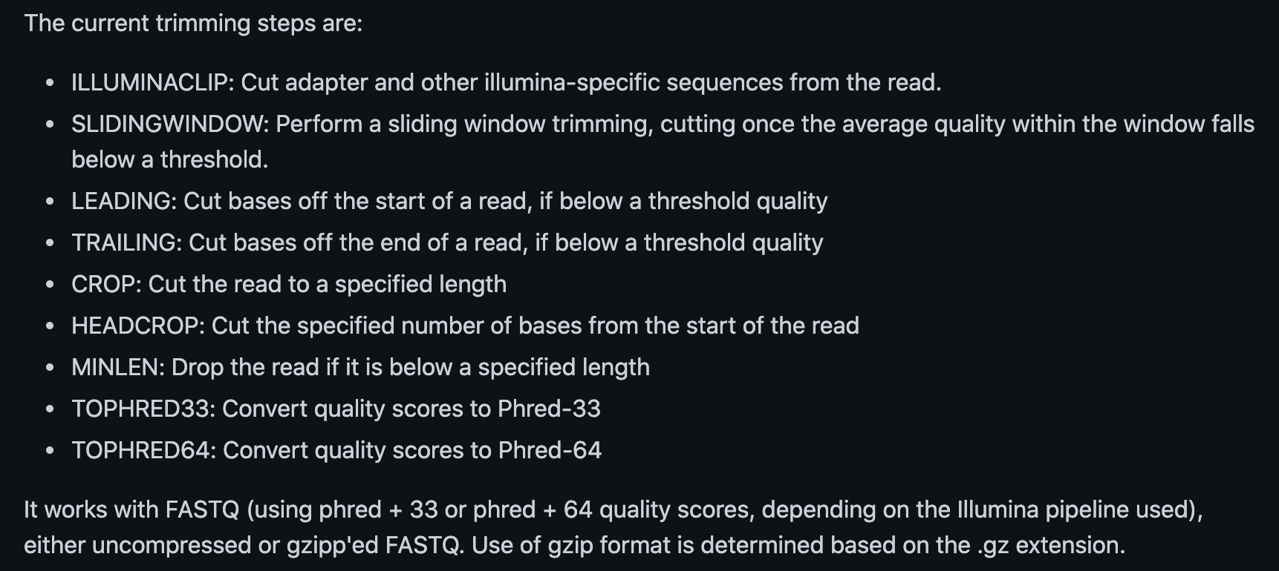

Below is an example for using Trimmomatic. Trimmomatic will produce both paired and unpaired datasets from a paired-end set of FASTQ files. The file ILLUMINACLIP:TrueSeq3-PE.fa contains the adapter sequences associated with that sequencing platform.

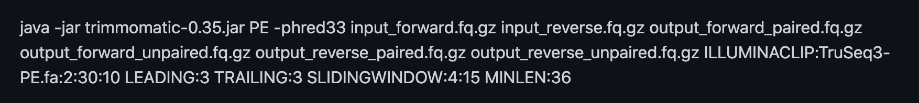

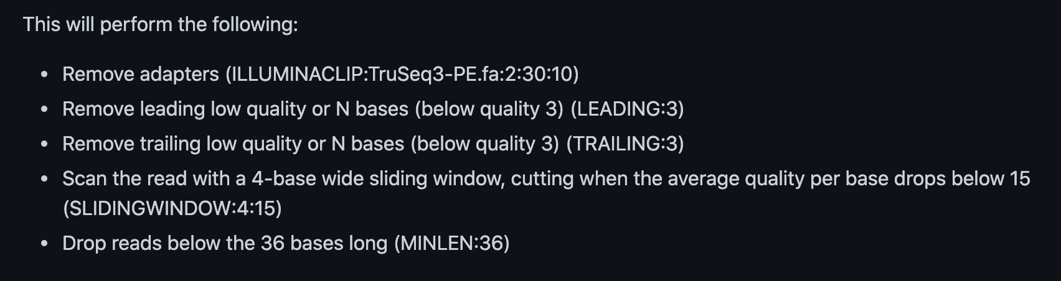

Run the command below in order to trim your fastq files. Ensure that you understand what each of the options in the command means. You may need to load the Trimmomatic module first.

trimmomatic PE SRR957824_1.fastq SRR957824_2.fastq SRR957824_1_paired.fq.gz SRR957824_1_unpaired.fq.gz SRR957824_2_paired.fq.gz SRR957824_2_unpaired.fq.gz LEADING:15 TRAILING:15 SLIDINGWINDOW:4:20 MINLEN:100

**Question 4: Explain what each of the options in the trimmomatic command above specifying. i.e. LEADING, TRAILING, SLIDINGWINDOW, MINLEN.**

If you list your files again you will notice that you now have some new unpaired and paired .fq.gz files. These are your qc’d files that have been trimmed using Trimmomatic in the last step. To see the effect of your trimming on your new files, run FASTQC on the paired output files as you have done previously. Compare the output of the first FASTQC run and the second FASTQC run.

**Question 5: Comment on the quality of your two trimmed read files. Have you improved the quality of your data? How many reads have you lost for each file by trimming the data? Please note any other improvements in the dataset.**