Introduction to R programming

Caleb

October 31, 2017

# Introduction to R-programming

R is a powerful language and environment for statistical computing and graphics.

Why R? * Widely used statistical package * Free to install and use * Lots of readily available help online * Have lots of packages tailored for domain specific statistical problems

But, may have some steep learning curve and installing packages can be a headache.

# Getting started

To use R, we will need to have the following installed:

1. R: the statistical package
2. RStudio: The interactive development environment that will make your life easy
3. Install the packages and libraries needed

* * install.packages('packagename')

# Before you start

* Create project within a folder in your computer
* Create folder for your code
* Create folder for Data
  + Raw: Downloaded or gathered from the field
  + Derived: processed through your analysis
* Create for figures generated from your analysis
* Ensure separation of information

# Quick Demo

A demo on:

* Creating a project
* setting working directory
* Creating folders

# Types of Data Objects in R

**scalars:** a single number – 0 - dimensional

**vectors:** a row of numbers, also called arrays - 1 - dimensional

newVector<-c(2,5,5,3,3,6,2,3,5,6,3)  
newVector

## [1] 2 5 5 3 3 6 2 3 5 6 3

scannedVector <- scan() #Reads in data from the console

# Matrices

**matrices:** Data in two-dimensions organized into rows and columns, just like a table

mat<-matrix(c(2,3,1,5),nrow=2,ncol=2)  
mat

## [,1] [,2]  
## [1,] 2 1  
## [2,] 3 5

# We can also use = sign  
mb = matrix(1:9, nrow=3, ncol=3)

#demos

# DataFrames

This is a versatile data object in R used to store high dimensional data, more like a spreadsheet. Each row and column is a vector is the same data type.

organism <- c("Human","Mouse","Fruit Fly", "Roundworm","Yeast")  
genomeSizeBP <- c(3000000000,3000000000,135600000,97000000,12100000)  
estGeneCount <- c(30000,30000,13061,19099,6034)  
  
comparativeGenomeSize <- data.frame(organism=organism,genomeSizeBP=genomeSizeBP,  
 estGeneCount=estGeneCount)

=====

comparativeGenomeSize

## organism genomeSizeBP estGeneCount  
## 1 Human 3.000e+09 30000  
## 2 Mouse 3.000e+09 30000  
## 3 Fruit Fly 1.356e+08 13061  
## 4 Roundworm 9.700e+07 19099  
## 5 Yeast 1.210e+07 6034

# Continue learning the basics on your own

Due to time limtation, we will not be able to cover all the basics. The purpose of this introduction is to pique your interest and teach you how to learn.

Swirl: “swirl teaches you R programming and data science interactively, at your own pace, and right in the R console!”

# {r} # library(swirl) # swirl() #

# Getting Help

#help("seq")  
#?seq

# Are High fat fed mice heavier?

We’ll learn the rest of the concepts by reproducing the analysis from this [paper](http://diabetes.diabetesjournals.org/content/53/suppl_3/S215.full)

dat <- read.csv("D:/Teaching_R/Data/femaleMiceWeights.csv")  
control <- dat[ dat$Diet == 'chow', colnames(dat)=='Bodyweight']  
treatment <- dat[ dat$Diet == 'hf', colnames(dat)=='Bodyweight']  
print( mean(treatment) )

## [1] 26.83417

print( mean(control) )

## [1] 23.81333

===================================================== What is the observed difference?

obsdiff <- mean(treatment) - mean(control)  
print(obsdiff)

## [1] 3.020833

This is a random variable; repeating the experiment gives different mean.

# Random Variables

Lets use the control population data to explore random variables further.

population <- read.csv("D:/Teaching_R/Data/femaleControlsPopulation.csv")  
population <- unlist(population) # turn it into a numeric

Let’s sample 12 mice and see how the mean varies.

control <- sample(population,12)  
mean(control)

## [1] 23.76417

======================================================== Sampling a few more times gives us the following means:

control <- sample(population,12)  
mean(control)

## [1] 23.00667

control <- sample(population,12)  
mean(control)

## [1] 23.09833

NB:You may get different results, since this is random sampling.

# The Null Hypothesis

n <- 10000  
null <- vector("numeric",n)  
for (i in 1:n) {  
 control <- sample(population,12)  
 treatment <- sample(population,12)  
 null[i] <- mean(treatment) - mean(control)  
}  
  
mean(null >= obsdiff)

## [1] 0.0124

This shows the observed difference is seen at random 1.3% of the time. This is the p-value

# Distribution

We’ll use the following data to demonstrate this concept

library(UsingR)

## Loading required package: MASS

## Loading required package: HistData

## Loading required package: Hmisc

## Loading required package: lattice

## Loading required package: survival

## Loading required package: Formula

## Loading required package: ggplot2

##   
## Attaching package: 'Hmisc'

## The following objects are masked from 'package:base':  
##   
## format.pval, round.POSIXt, trunc.POSIXt, units

##   
## Attaching package: 'UsingR'

## The following object is masked from 'package:survival':  
##   
## cancer

x <- father.son$fheight

We can visualize distribution of raw data

round(sample(x,10),1)

## [1] 64.8 67.6 66.7 70.6 71.7 64.5 68.8 66.5 65.7 63.6

But, this is hard to see

# Cumulative distribution function

smallest <- floor( min(x) )  
largest <- ceiling( max(x) )  
values <- seq(smallest, largest,len=300)  
heightecdf <- ecdf(x)

====================================================== We get the following plot:

plot(values, heightecdf(values), type="l",  
 xlab="a (Height in inches)",ylab="Pr(x <= a)")

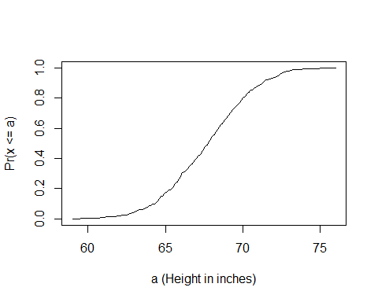

# Histogram

bins <- seq(smallest, largest)  
hist(x,breaks=bins,xlab="Height (in inches)",main="Adult men heights")

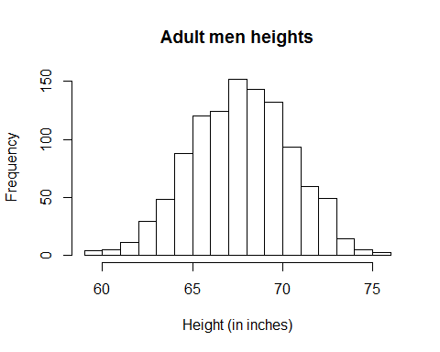 May be better.

# Probability Distribution

n <- 100  
library(rafalib)  
nullplot(-5,5,1,30, xlab="Observed differences (grams)", ylab="Frequency")  
totals <- vector("numeric",11)  
for (i in 1:n) {  
 control <- sample(population,12)  
 treatment <- sample(population,12)  
 nulldiff <- mean(treatment) - mean(control)  
 j <- pmax(pmin(round(nulldiff)+6,11),1)  
 totals[j] <- totals[j]+1  
 text(j-6,totals[j],pch=15,round(nulldiff,1))  
##if(i < 15) Sys.sleep(1) ##You can add this line to see values appear slowly  
}

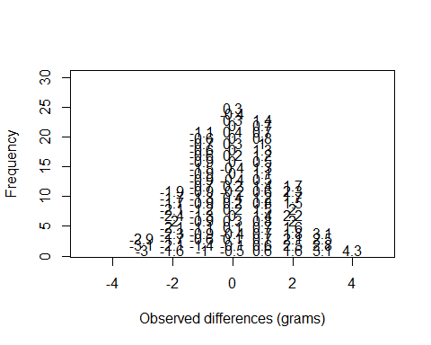

======================================================

hist(null, freq=TRUE)  
abline(v=obsdiff, col="red", lwd=2)

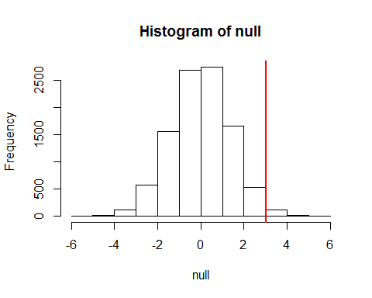

# Normal Distribution

1 - pnorm(obsdiff,mean(null),sd(null))

## [1] 0.01296352

# Explolatory Data Analysis and Visualization

# Plots: Quantile Quantile Plots

It is a plot of the quantiles of the first data set against the quantiles of the second data set. Used to check if data comes from a theoritical distribution.

library(UsingR) ##available from CRAN  
library(rafalib)  
x <- father.son$fheight  
ps <- ( seq(0,99) + 0.5 )/100  
qs <- quantile(x, ps)  
normalqs <- qnorm(ps, mean(x), popsd(x))

======

plot(normalqs,qs,xlab="Normal percentiles",ylab="Height percentiles")  
abline(0,1) ##identity

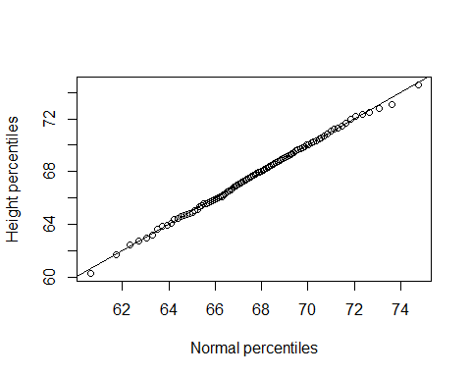

# But we can get the same plot by:

qqnorm(x)  
qqline(x)

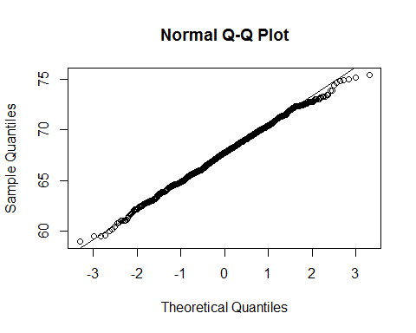

This plots against the standard normal.

# Boxplots

When the data is not normally distributed, the standard deviation and mean are not always informative.

====

mypar(1,2)  
hist(exec.pay) ##in UsingR package  
qqnorm(exec.pay)  
qqline(exec.pay)

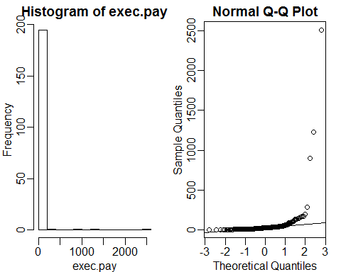

# Explaining Box plot

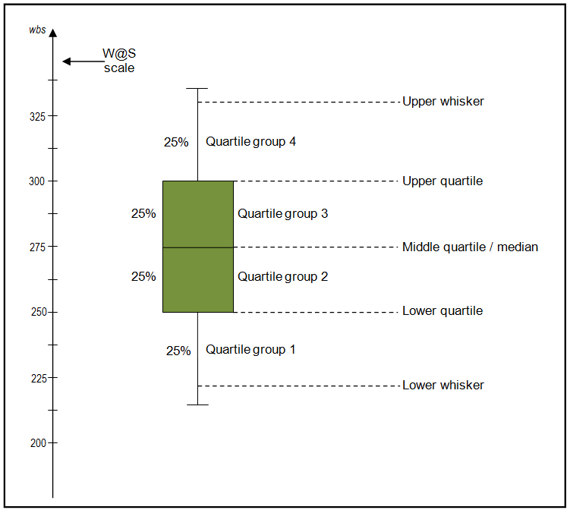

Caption for the picture.

=========

boxplot(exec.pay, ylab="10,000s of dollars", ylim=c(0,400))

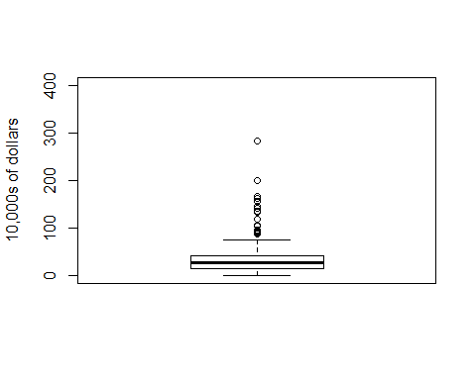

ggplot(data = father.son, aes(x = fheight, y = sheight)) +  
 geom_boxplot()

## Warning: Continuous x aesthetic -- did you forget aes(group=...)?

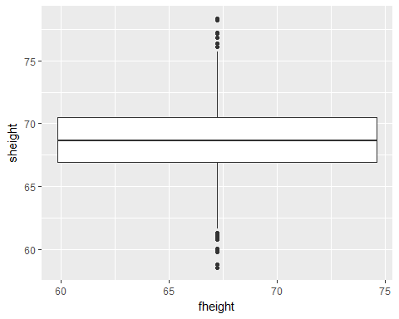

## Scatterplots And Correlation

Used to visualize the relationship between two numerical variables.

library(UsingR)  
data("father.son")  
x=father.son$fheight  
y=father.son$sheight

## Plot

plot(x,y,xlab="Father's height in inches",ylab="Son's height in inches",main=paste("correlation =",signif(cor(x,y),2)))

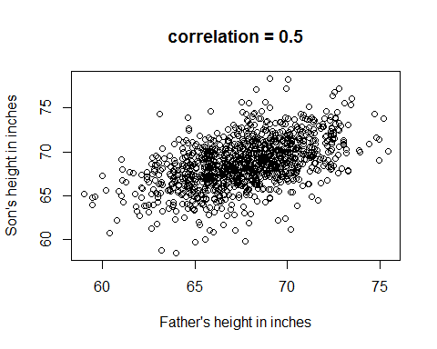

# ## A good graphic

A good graphic should inform and provide information about the data accurately and clearly. It should follow these principles: - Be accurate and clear. - Let the data speak. - Show as much information as possible, taking care not to obscure the message. - Science not sales: avoid unnecessary frills (esp. gratuitous 3D). - In tables, every digit should be meaningful. Don’t drop ending 0’s.

## However, it should not:

* Display as little information as possible.
* Obscure what you do show (with chart junk).
* Use pseudo-3D and color gratuitously.
* Make a pie chart (preferably in color and 3D).
* Use a poorly chosen scale.
* Ignore significant figures

### R Markdown

This is an R Markdown document. Markdown is a simple formatting syntax for authoring HTML, PDF, and MS Word documents. For more details on using R Markdown see <http://rmarkdown.rstudio.com>.

When you click the **Knit** button a document will be generated that includes both content as well as the output of any embedded R code chunks within the document. You can embed an R code chunk like this:

summary(cars)

## speed dist   
## Min. : 4.0 Min. : 2.00   
## 1st Qu.:12.0 1st Qu.: 26.00   
## Median :15.0 Median : 36.00   
## Mean :15.4 Mean : 42.98   
## 3rd Qu.:19.0 3rd Qu.: 56.00   
## Max. :25.0 Max. :120.00

## Including Plots

You can also embed plots, for example:



Note that the echo = FALSE parameter was added to the code chunk to prevent printing of the R code that generated the plot.