Geneious  
Getting started:   
installation of Geneious is real easy and comes with a simple guide, furthermore the program has a very easy to use menu and all the options speak for themselves so getting used to the program and actually using the more advanced options goes really fast.  
 If the user does require some additional training/help Geneious provides an detailed tutorial available from both their website and the program itself (tutorial includes topics like: Blast, Align, etc.) and includes different sections with exercises varying in difficulty from beginner to advanced.

Actually using the program (tests were done using Ion Torrent MID 6) :  
Trying to BLAST the sequence you are given the option to change the initial parameters for your search (see Figure 1) e.g. max e-value and what database you would like to use(for testing purposes all parameters were left to default).  
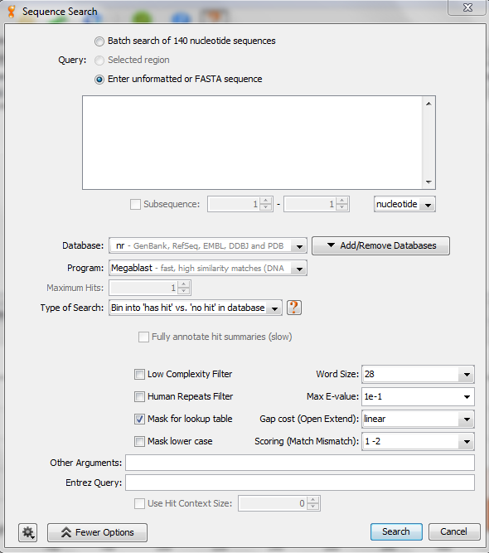  
Figure 1, “search sequence” option and its default parameters.

If you then ask the program to search the sequence that was submitted, a message appears advising the user on parameters that are better or faster for the inputted sequence (hints include: changing the type of search, setting the maximum number of hits, etc.)  
  
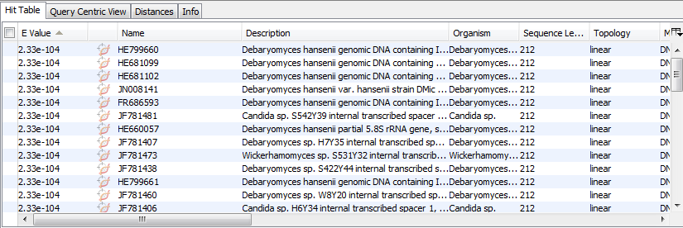Figure 2, BLAST results from MID 6 (mega blast, max hits 50, standard search)

Note: Geneious uses a default word size of 28 and a match-mismatch of 1/2 while the BLAST web-tool uses a word size of 11 and a match-mismatch of 2/-3.

Conclusion

Geneious is a overall good program with no visible flaws or drawbacks, its speed while searching for sequences is excellent and with the full version you get a lot of extra’s that will be useful for further research.