Intermediary Report, 15-11-2012

**Roeben Vink  
Thomas Bolderink  
Alex Hoogkamer**

**About ION Torrent**

The Torrent suite does not have any options or functions that can trim or blast sequences. There are plug-ins available yet none of them will add the ability to trim. Torrent suite has a different focus than the other programs and requires a different level of user skill. It's main purpose is to process the data an ION Torrent cycle delivers. It’s main features include searching for gen variations and assembly.

The software itself is at face value simple to use but can be a bit tricky at times. It comes as a virtual machine which needs to be set-up before it can be used. While someone with experience in Linux and virtual machines in general will find it easy to do, it can be daunting for someone with no experience.

**About Geneious**

Installing Geneious is a comforting experience that does not require much experience on the part of the user. It is easy to work with and the menu’s are usually clean and simple. Tutorials are readily available and are one of the first things one sees when they boot up the program. These tutorials are partitioned in segments with exercises with varying difficulty, ranging from a Beginner tutorial to ones useful to any Advanced user. It can be concluded is not hard to get used to working with Geneious as long as one follows these tutorials. They are available online as well.

**About CLC Genomics Workbench**

CLC Genomics Workbench is extremely easy to use and definitely seems to be designed by a team of professionals. It breezes through its tasks, and equally positive statements can be made about its stability.

Unlike Geneious however, CLC does not grant you a tutorial when one first starts it. However, the argument can be made that CLC Genomics Workbench is essentially the non-freeware version of Geneious, as the two programs are strikingly similar down to the interface and options menus. If one is familiar with the one, they can nearly be guaranteed to be somewhat familiar with the other.

Out of the box, When one uses BLASTn on CLC Workbench, the default settings will be equal to the ones you find on the NCBI website, with one important difference. The score for a mismatch is -3 instead of -2. This might be a trigger for differentiating results.

**Time spent on this project.**

The following is a condensed overview of the time spent on this project. The figures were taken from the personal logs of the project members.



**Why do different software packages give different results?**

Since the Torrent suite has no trim and BLAST functions, we have included default NCBI BLAST in the comparison. NCBI BLAST uses the same default values as Geneious, however, CLC Genomics Workbench uses a different mismatch value. Furthermore CLC Genomics Workbench uses the BLASTn algorithm as default. The different value is the match/mismatch score, which is 1/-3 compared to the 2/-3 used for BLASTn of NCBI BLAST and Geneious. Both NCBI BLAST and Geneious use the MEGABLAST algorithm on default. CLC Genomics Workbench seems to prefer using BLASTn unless a different algorithm is specified.

In all cases, The BLAST search of the MID6 FASTA file resulted in clear match with *Debaryomyces hansenii* for all three programs.

The following is a screenshot of **CLC Genomics Workbench**. The results gathered from MID 6, Displaying some fungal organisms. It should be noted that these results are not very different from the output gathered from Geneious.

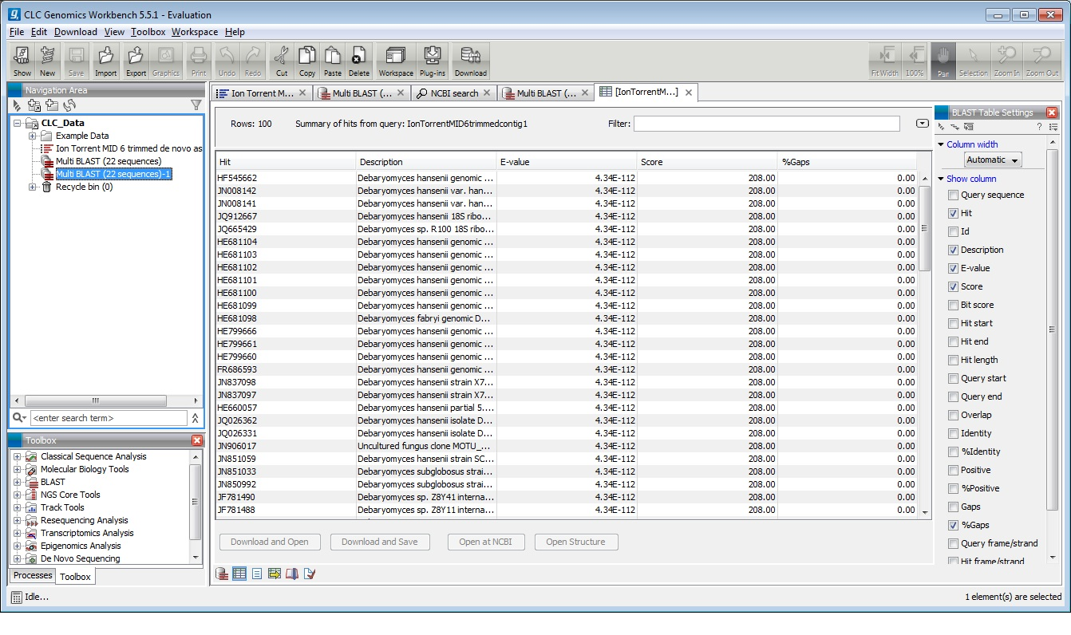

This picture is a screenshot from **Geneious**. Though the results are very much comparable, the E-values are different. Why this happens is currently unknown and requires deeper investigation.

