LIFE 4141
Practical – from sequence to phylogeny

Aim: To apply the skills required to generate a gene tree from an initial single query sequence.

Learning outcomes:
- Perform command-line operations that form the basis of many comparative genomics and phylogenomics studies.
- Perform a standalone BLASTp
- Generate multiple sequence alignments from variety of methods and compare the results using specific custom made statistics.
- Identify the most significant MSA fit for a gene family.
- Generate a phylogenetic tree.
- Visualise your phylogenetic tree.

Clone the github repository

Make sure you are logged in to Ada by going to your terminal and typing:

ssh ada

Clone the github repository for this practical and navigate inside it:

git clone https://github.com/BioinformaticsMSc/LIFE4141_gene_tree_practical.git

cd LIFE4141_gene_tree_practical

Data: In the github repository for this practical you have been provided with two data files:

(1) SubjectFile.fasta.gz a file of protein sequences from a range of species. We will use this file to compare our protein of interest to.
(2) Practical_QuerySeq.fasta a query protein sequence that we want to build a gene tree for.

Please take a moment to examine the content of these files now. (note one of them is compressed so you will need to use zless or zcat to view the contents)

Create the conda environment

Create and activate the conda environment containing all the software we will use:

conda env create --file=gene_tree.yaml

conda activate phylogeny

Our goal is to generate and interpret a phylogenetic tree for this gene family.

Steps 1-7 make up your pipeline, i.e. the set of associated command line operations required to achieve your goal.

Step 1: Identify all homologs of the query protein using a blast search.

gzip -dk SubjectFile.fasta.gz

[decompresses the fasta file of proteins from different species]

makeblastdb -dbtype prot -in SubjectFile.fasta -parse_seqids -out blast_db

[formats the database for blast, have a look at the output files generated]

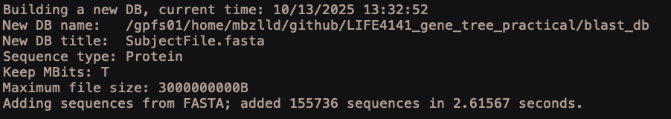

ls

[have a look at the new files that have been generated]

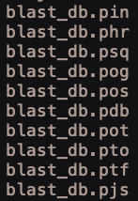

Perform blast search to find proteins in the database that are homologous to our query protein:

blastp -query Practical_QuerySeq.fasta -db blast_db -outfmt '6 sseqid' -evalue 1e-5 -out blast_output.txt
[This command makes a file with subject IDs, the portion of the command that states <-outfmt '6 sseqid'> means that only subject IDs from blast results are shown]

Examine the output file.

Step 2: Extract from the subject database a single file that contains fasta formatted sequences of all homologs identified.

sort blast_output.txt | uniq > file_with_IDs.txt
[removes duplicates from the file with subject IDs… sometimes blast can have several hits for one query and one subject - when there is a big non-conserved region between two conserved ones]

blastdbcmd -db blast_db -entry_batch file_with_IDs.txt -outfmt "%f" -out extracted_proteins.fasta

[extracts sequences (in fasta format) from blast database using filtered blast results].

Have a look at the contents of the extracted_proteins.fasta file

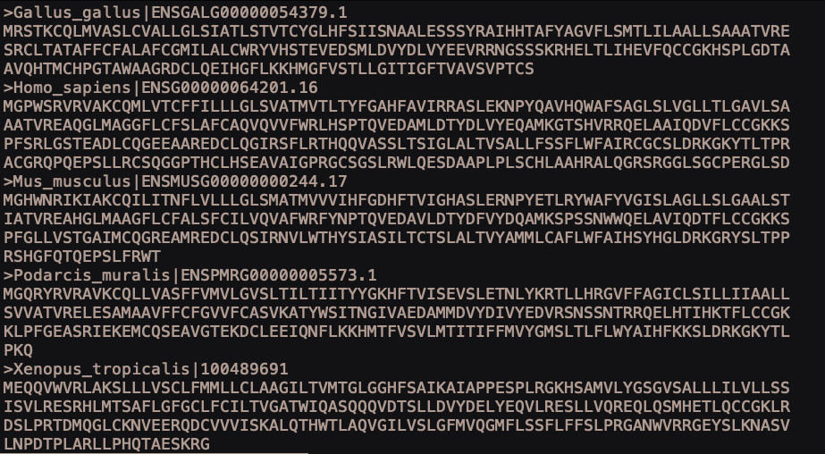

Step 3: Align the sequences using 2 of the most highly used multiple sequence alignment methods MUSCLE (Edgar, 2004), and MAFFT (Katoh et al, 2002).

muscle -align extracted_proteins.fasta -output muscle_alignment.fasta
and

mafft --auto extracted_proteins.fasta > mafft_alignment.fasta
[generates multiple sequence alignments for your homologous proteins using default parameters, in your practice sessions feel free to play with these settings for both MUSCLE and MAFFT, their manuals are readily available online].

Step 4: Compare the statistical fit of the alignments to the data and select the best fit.

Run metal on your two alignments to quantify the level of difference between. (metal can’t be installed with conda so we have given you the executable file in the github repository instead. If, when you try to run the command below, you see a permission denied error message, then you need to make sure you have executable permissions on the metal file using chmod.)

./metal muscle_alignment.fasta mafft_alignment.fasta

[metal (https://github.com/benb/MetAl) is used calculate a metric distance between alternative alignments of the same sequences. A comparison of these two aligners output is presented as XXX/YYY = 0.ZZZZ, where XXX is the score for first aligner, YYY is the score for second, and 0.ZZZZ is the difference.
e.g. If 0.ZZZZ = 0.149 for example then these two alignments would be 15% (i.e. significantly) different and you would choose the better fitting aligner for this dataset.
e.g. If 0.ZZZZ = 0.00003 then there is no significant difference between alignment methods, and you can randomly choose one].

Step 5: Generate a phylogenetic tree in IQTree (Nguyan L.-T., Schmidt HA, von Haeseler A, Minh BQ (2015) Mol. Biol. Evol., 32:268-274). NOTE: this is computationally a little more intensive and so you will have to run it on a compute node.

srun --partition defq --cpus-per-task 1 --mem 2g --time 00:20:00 --pty bash

[Request a job on a compute node. Continue once your job has been allocated resources]

conda activate phylogeny

[because you have switched nodes you will need to activate your conda environment again]

iqtree -s mafft_alignment.fasta -b 100 -nt AUTO

iqtree -s muscle_alignment.fasta -b 100 -nt AUTO

[run iqtree with each of your alignment files and 100 bootstraps, and in the background it is also running a modelFinder search to provide the best fitting substitution model for your data]

More options for running IQtree are found here http://www.iqtree.org/doc/

Step 6: Tree Visualisation

To visualise your tree quickly just look at the end of the output file with the suffix “.contree”
How might you do this?

Then if all looks well, you can download and install software on your own machine to visualise this in nicer format. To do this grab this file off the server and place on your local machine to visualise.

You can download the muscle_alignment.fasta.contree and mafft_alignment.fasta.contree files onto your laptop using Ada Open on Demand or using the scp command below (where you replace the /path/to/file with the actual path to your file on Ada).

scp ada:/path/to/file/ muscle_alignment.fasta.contree ./
scp ada:/path/to/file/ mafft_alignment.fasta.contree ./

For Tree visualisation, I recommend the following, just open your tree files in these pieces of software to view your tree:
FigTree: https://github.com/rambaut/figtree/releases
ETE: http://etetoolkit.org/treeview/
Dendroscope3: https://www.wsi.uni-tuebingen.de/lehrstuehle/algorithms-in-bioinformatics/software/dendroscope/

Or for a quick online solution : https://itol.embl.de/

