Here are some responses to Questions asked during the Introductory Session of this and previous runs of the course you now attend. Some answers are quite long and “in depth”. Where this is so, we have provided both a “Short” and simple answer AND a “Longer” extended answer. If you find the “Short “ answer sufficient, that is fine. Read the “Longer” version only if it amuses you.

We have tried to answer all the Questions that were asked of us as fully as we can. Do remember though, that many of the Questions you asked will be considered again in more specialised sessions of the course still ahead of you. If you find our answers insufficient, why not ask the presenter(s) of the more targeted session when it arrives.

In hope you find these Answers useful,

Dave and Pedro

PDF generated 2020-06-25 00:17:21

QUESTION INDEX

Broadly Informatics Questions
Biological Queries
Broadly Informatics Questions

- Are the Linux and Windows Operating Systems compatible? Answer
- Can I install both Linux AND Windows on the same machine? Answer
- What is Cygwin? Answer

Return to Main Index
Biological Queries
Homology, Parology, Othology:
- Explain the difference between Similarity and Homology in MSA? Answer
- … and how can we deduce, with a precision, that two or more sequences are Homologous? Answer
- Explain briefly the term Homologues, Orthologues and Paralogues? Answer
- What is the difference between a Protein Domain and a Motif? Answer
Sequence Alignment:
- Explain the differences between Pairwise Alignment, Global Alignment and Local Alignment? Answer
- When would a Local approach be preferable to Global approach for a Pairwise Alignment? Answer
- Which is the best software tool to compute Pairwise Sequence Alignments? Answer
- Which is the best software tool to compute Multiple Sequence Alignments (MSAs)? Answer
General:
- Is it possible for one to create a Personal Profile at NCBI, and/or any other site providing similar services, enabling search results (and similar analytical computations) for future references? Answer
- What is the difference between Bioinformatics and Computational Biology? Answer

Return to Main Index
Query: Are the Linux and Windows Operating Systems compatible?
Reply: These two Operating Systems are not really compatible, as they manage and explore the hardware differently and use incompatible mechanisms to host applications. In other words you cannot expect to move around seamlessly. Specifically, software developed and installed in one system will not necessarily just run it in the other. A variety of workarounds do exist to reduce the impact of this incompatibility, however, generally at the expense of resources such as memory and disk space, resulting in significantly reduced program execution speeds.
Return To Index
Query: Can I install both Linux AND Windows on the same machine?
Reply: Yes, just not one on top of the other. And in general terms it only requires free software and some labour.
- If you have a comfortable amount of memory and disk space, from either Linux or Windows, you can use a technique called Virtualisation, which involves installing a Virtual Machine (VM) that runs the alternative Operating system. Virtual machines (VMs) are managed by specialised software such as Oracle VM Virtualbox. It is a good idea to have a shared disk area, such as the Downloads folder. This solution may slow down things, and you may be encouraged to add memory to your computer. The two operating systems will be sharing hardware resources all the time.
- A technique called Containerisation also virtualises a machine with a different Operating System. A container carries the Operating System, installed applications and data, and can be moved around seamlessly in heterogeneous systems. The most commonly used software to do this is Docker. The containers do not run autonomously as VMs, they share software resources with the native Operating System that hosts them.
- Alternatively, you can create a separate Disk Partition and install the second Operating System there. In this case they will not be running simultaneously, and as you will be starting one OS or the other (so, to change Operating Systems for always involve a reboot of the entire machine), this technique is called “Dual Boot”. Sharing files between the systems is a bit harder to set-up.
Return To Index
Query: What is Cygwin?
Reply: Cygwin is just a collection of open source tools that operate in a Linux-like Terminal under MS Windows. You should not expect native Linux applications to run under Cygwin. Its usage is limited to trivial Command Line file manipulations. Cygwin is not suitable for most serious Bioinformatics work.

Return To Index
Query: Explain the difference between Similarity and Homology in MSA? ….

Briefly: In all contexts of sequence alignment, Similarity is a measure of how well the aligned sequences match. Homology is an assertion that the Proteins/DNA represented by the aligned sequences are related by evolution.

In full: In this context, Similarity is a quantitative evaluation of the degree to which a set of Sequences are similar. This measure typically becomes interesting when it is significantly greater than that which might be expected by chance.
Homology is the assertion that a given set of Proteins/DNA/RNAs are Biologically related by evolution. That is, all the elements of the set evolved directly from a single origin. Homology is a binary judgement (i.e. not quantitative!). A set of Proteins/DNA/RNAs are either Biologically related by evolution (i.e. Homologous) or they are not.
Where Proteins/DNA/RNAs are judged to be Homologous, ALL differences between their aligned Sequences should be exclusively due to evolutionary processes (e.g. Substitutions, Insertions, Deletions …).
In all contexts (not just Multiple Sequence Alignment, MSA), Similarity, typically represented as alignments between Sequences (simple, incomplete representations of Proteins, DNA, RNA) is an association computed, most commonly, by computer programs.
An Alignment of Sequences (Pairwise or Multiple) is but an attractively intuitive way to display Sequence data in a fashion that highlights regions that are Similar beyond random expectation, maybe for some reason of Biological significance (e.g. evolutionary Conservation, the sequences represent different instances of a repeated region ) … or just by chance.
Whether Homology exists, or not, between a given set of Proteins/DNA/RNA is a judgement that can only be made by an informed human(s) after careful reference to all the evidence. Such evidence will usually include the degree of Similarity indicated by carefully computed alignments of the relevant Sequences.
A computer program has no way to directly infer Homology between Proteins/DNA/RNA from Similarity, however complete/perfect that Similarity might be.
Only informed people, assisted by real Biological research, can meaningfully speculate upon Homology. Similarity between Sequences can but be a part of the evidence for claiming Homology between Proteins/DNA/RNA.
Aligning the Sequences of biological entities that are not Homologous is not usually sensible. In particular, Alignment Programs are written to assume the sequences they process represent Homologous entities. What can the Alignment mean if this is not true?
Return To Index
Query: … and how can we deduce, with a precision, that two or more sequences are Homologous?

Briefly: Just from the alignment, you cannot, although a highly similar alignment can be taken as a pretty strong indication of homology. To be confident that a promising alignment truly indicates homology, you must know something about the Proteins/DNA represented by the aligned sequences. Bioinformatics rarely completely replaces Biology.

In full: Well … there is certainly no universal formula for inferring Homology from Similarity, especially if you desire “precision”. Specifically, there is no objective level of Similarity between Sequences that assures Homology between the Proteins/DNA/RNAs that those sequences represent.
Convincingly high Similarity evident in Sequence Alignments is commonly indicative of Protein/DNA/RNA Homology. However, Sequence Alignments for Proteins/DNA/RNAs that are not Homologous can appear temptingly Similar. Also, Sequence Alignments for Proteins/DNA/RNAs that are Homologous can appear surprisingly dissimilar. Reasons include:
- DNA/RNA only uses a four letter alphabet. Relatively small shared compositional bias between a set of Sequences is going to start looking “interesting” unreasonable early.
- Compositional Bias even in Protein Sequences can look a bit more like Homology than perhaps it deserves.
- DNA/RNA sequences can be quite different and yet code for very Similar, genuinely Homologous, proteins due to Redundancy in the Genetics code. It is quite possible to MISS more distant protein Homology when trying to make a judgement based on DNA/RNA Sequence alignments. This is why it is always so much better to align PROTEIN Sequences rather than DNA/RNA Sequences wherever it is possible. Protein Sequences encapsulate much more information than do DNA/RNA Sequences.
- Convergent Evolution can occur to produce apparent similarity between proteins that are evolutionarily unrelated but perform similar functions and have similar structures.

Return To Index
Query: Explain briefly the term Homologues, Orthologues and Paralogues?

Reply: “briefly”? … afraid this half of Pedro and Dave is not known for his close acquaintance with “briefly”, but one will do one's very best.
To say two Genes/Proteins are Homologues is to say that they are related by Evolution. That is, multiple copies emerged from a single common ancestor Gene/Protein and then evolved apart (generally) from each other whilst (normally) retaining essential original elements of function and/or structure.
Homologues are also Paralogues if they exist separately exclusively because of duplication event(s). Specifically, no Speciation event(s) were involved in the creation of multiple instances of the original single Gene/Protein. This being so, Paralogues are Homologues that occur always in the same species.
Homologues are also Orthologues if they exist separately because of duplication event(s) plus at least one Speciation event. This being so, Orthologues are Homologues that occur always in different species.
Return To Index
Query: What is the difference between a Protein Domain and a Motif?
Briefly: From a purely Biological perspective:
A Motif is an Sequence pattern or a Structural Feature that is to be found repeated, with significant accuracy, in many Proteins, RNAs or regions of a Genome (typically within Genes). The conservation of a Motif should have, or at least should be conjectured to have, some biological significance.
A Protein Domain is a conserved part of a Protein that can evolve, function and exist independently of the Proteins of which it forms part. A Protein Domain may occur in any number of different Proteins that are, outside of the extent of the Domain, not Homologous.
From the limited perspective of their representation in Domain/Motif Databases, it is tempting (if inaccurate) to consider somewhat simpler definitions. This is elaborated below.
In full:
Motifs
Accepting the Biologically complete definitions above.
Motifs can be either Sequence Motifs or Structural Motifs.
As the names suggest, a Sequence Motif is identified by a region of significantly conserved Sequence (DNA/RNA/Protein). A Structural Motif is define by a region in which Structure is conserved (DNA/RNA/Protein).
A Sequence Motif, might well also be a Structural Motif, but the definition does not insist on such.
A Structural Motif will often also involve high levels of Sequence conservation, but not necessarily. Many Motifs idenfied by Structural conservation are NOT well conserved at the Sequence Level.
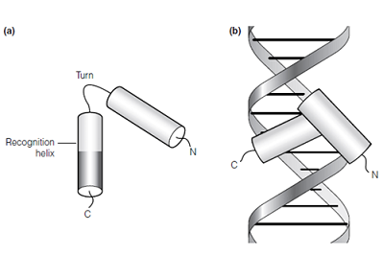
Specifically, some Structural Motifs can be found in non-Homologous Proteins. In such cases, the Structure and biological significance of the Motif will be conserved, but there should be no great expectation of high Sequence Conservation. And example of such a Motif is the Helix-Turn-Helix (HTH) Motif, an arrangement of 2 Helices separated by a Turn, that binds DNA.
Programs exist to try and identify the presence of HTH motifs in DNA Sequence. These programs look for Sequence Patterns in the DNA that are typical of HTH motifs. Due to relatively poor general Sequence Conservation, these programs are not very effective. To work at all, they use search models very specific to particular, narrowly defined families of HTHs.
All Protein Domains whose function includes DNA Binding will include one, or more, HTH Motif (or something very similar).
In Sequence Motif Databases (e.g. Prosite) hightly conserved Motifs are sometimes represented (crudely!) by consensus Sequence Patterns computed from Multiple Sequence Alignments (MSAs) of known examples of the Motif.
All Motifs represented in commonly used Databases are Sequence Motifs. It is not easy to see how conserved structure could be represented in a Computer usefully.

Protein Domains
Again, accepting the Biologically complete definitions above.
Protein Domains are generally Homologous, even if the entire Proteins in which they exist are not. Sequence Consevation should therefore, geneally, be expected at some level through the span of a Protein Domain.
Protein Domains often include various Motifs that, commonly define the function of the Domain (see example of HTH Motifs above).
The sequence conservation of a Protein Domain is, generally, not consistent over its length. There will be regions of Low Conservation (typically at each end). Accordingly, representing a Protein Domain in a database using a simple Sequence Pattern will almost never be sufficient. More sophisticated techniques are required.
Currently, the most popular way to represent Domains is to construct a probablistic model (a Profile Hidden Markov Model) from an alignment of known examples of the Protein Domain. As their name suggests, these Domain "Profiles" are constructed using the principles behind "Hidden Markov Models". These profiles can represent successfully regions of high or low (but not no) conservation effectively.
Profile Hidden Markov Models are also used (in addition to Sequence Patterns) to represent Motifs (for example, in Prosite). They are far more flexible, complete and effective than Sequence Patterns.

Motif and Domain Databases
The main role of both Motifs and Domains, from a purely Computational perspective, is to represent conserved features that can be searched for in Proteins. This being so, Motifs and Domains need to take some form that can be matched against a Protein(s) to determine anywhere they might match sufficiently well to imply their presence.
The computer programs that implement these searches need no concept of “Biological Significance”. They just seek Similarity between a Database entry and a Protein that is significantly beyond that expected to occur randomly.
Motif searches, generally at least, rely solely on Sequence matching. It is not easy to see how Structure might be usefully/simply represented in a computer in a way that would enable comparison with a Protein Sequence. It is thus tempting (if wrong) for those whose interest is focus only on the computational aspects of Bioinformatics to think soley of Sequence Motifs and conveniently forget Structural Motifs!
Representing Sequence conservation is relatively simple. A simple Consensus Pattern would work for very very highly conserved Motifs, slightly more sophistication (e.g. Profile Hidden Markov Models, HMMs) are available when conservation is less obvious.
Usefully representing Domains in a computer is, generally, done more honestly. The entire Domain (as defined properly above) is typically, represented. Almost always, there will be parts of a Domain that are not particularly well conserved, so any Consensus Pattern approach is unlikely to succeed. HMMs are commonly used to represent the elements of Domain Databases.
An exception is the Domain Database PRINTS. Here, regions of Proteins that correspond to Protein Domains by specified by arrangement of “motifs” referred to as “fingerprints”.
But, the “motifs” employed by PRINTS are not required to be true Biological Motifs (as defined earlier). PRINTS has no need for them to have any Biological significance, after all. PRINTS only requires that its “motifs” be well conserved, that is, likely to match in the right place. Perhaps using the term Motif is not strictly appropriate? Maybe “signature” or “conserved region” might be more exact?
Also, the “Domains” represented in PRINTS do not always correspond exactly to the Biological “best specification” of the position of a Domain. It does not really have to, after all. It is generally sufficient for a user to be informed that some specified Domain is predicted in a position including the region (the “fingerprint”) identified by PRINTS.
Return To Index
Query: Explain the differences between Pairwise Alignment, Global Alignment and Local Alignment?

Briefly: Pairwise Alignment is the Alignment of exactly two (a pair) of DNA\RNA or Protein sequences.
Global Alignment is the Alignment of two or more DNA\RNA or Protein sequences in which the entire length of all sequences must be included.
Local Alignment is the Alignment of two or more of DNA\RNA or Protein sequences in which only convincingly similar regions of some or all sequences need be involved.
In full:
Pairwise Alignment is the Alignment of exactly two (a pair) of DNA/RNA or Protein sequences between which Homology is assumed for all or part of the length of the biological entities represented by those sequences.
The programs that are used to compute Pairwise (or Multiple, come to that) Sequence Alignments analyse only the Sequences, not the DNA/RNA/Proteins themselves. They can only consider the strings of characters that represent the biological entities. All the software has to use as a guide are some rather basic and (typically) very general assumptions concerning how the various sequence elements (Bases/Amino Acids) relate to each other in an evolutionary context.
For DNA/RNA, this amounts to almost nothing! Essentially, to the Alignment software, corresponding Bases in Pairwise Alignments (usually) are either seen as simply identical or different. In addition, with only a four letter alphabet (A, C, G , T/U), the chances of random Alignments looking better than they are must be high. This is especially so as DNA/RNA sequences are not randomly (evenly) composed (e.g. Base Bias) which most Alignment software does not take into consideration when evaluating the quality of an Alignment possibility. Thus there is a significant risk of False Positives (Alignments that look good, but are not).
Conversely, for coding DNA/RNA, due to the redundancy of the Genetic Code, quite diverse sequences can code for very similar proteins. True similarity (at the Protein level) can be masked at the DNA/RNA level. So there is also a significant chance of False Negatives (Alignments that look random at the DNA/RNA level, but not at the Protein level). This last observation should loudly encourage protein coding DNA/RNA always to be translated into Protein sequences before any alignment is attempted. There is much more information in a Protein sequence than in a DNA/RNA sequence.
Finally, ALL alignment programs assume that the sequences they seek to align represent Homologous biological entities. If this is not true, then trivially, the Alignments generated are worthless! The software will always produce an alignment that is arithmetically “the best” according to some set of simple rules. However, there is no meaningful Alignment to find if there is no Homology! It is up to the user to start with sensible data.

Global Alignment is the Alignment of two or more DNA/RNA or Protein sequences all assumed to represent biological entities that are Homology over their full length (Globally). Obviously, if a Global Alignment Program is asked to align things that are NOT Globally Homologous, an Alignment will be generated but it will be nonsense. It is up to the user to pose a sensible question before a sensible answer can be expected.
A Global Alignment must include the entire length of all the sequences it is given to align. Clearly, if all the sequences represents entities that are Homologous end to end, then it makes no sense to “shave off” any part of any sequence, however poorly it matches the rest of the Alignment.
Multiple Sequence Alignments (MSAs) computed for the determination of Phylogenetic Trees are typically Global. They are usually Alignments between the same Gene (or similar) from each of the organisms under study. Logically, they should match over their entire length. However, they are not always consistently impressively similar over their entire length!
All Global Sequence Alignments that involve only two sequences are Pairwise Sequence Alignments.

Local Alignment is the Alignment of two or more of DNA or Protein sequences in which Homology is assumed to exist between DNA/RNA or Protein regions (e.g. Domains, Sequence Motifs) represented by the Aligned Sequences, but possible not over their entire length.
Local Alignment is appropriate when the purpose of the Alignment is to determine the position of Domains (or other regions conserved due to Homology) between two DNA/RNA regions or Proteins. The software is written to seek out highly Similar portions of the sequences it is considering and then to extend and align those regions only until the degree of similarity falls below some specified level. Surrounding sequence that does not match significantly can be ignored (as is not allowed for Global Alignment).
All Local Sequence Alignments that involve only two sequences are Pairwise Sequence Alignments.

Return To Index
Query: When would a Local approach be preferable to Global approach for a Pairwise Alignment?
Briefly: A Local approach is the correct choice if the sequences to be aligned are assumed to to represent DNA/RNA/Proteins that share Homologous regions but are not necessarily Homologous over their entire lengths.
A Global approach is the correct choice only if the sequences to be aligned are assumed to represent DNA/RNA/Proteins that are Homologous over their entire lengths.
In full: I think the best way to expand upon the explanation above is with an example or two.

Example 1:
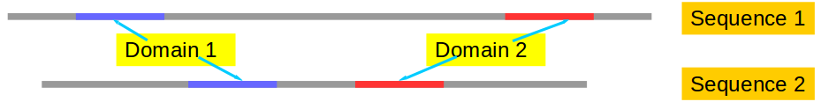
Imagine that you wish to align two Proteins, each of which include two domains (a Blue one, and a Red one).

Clearly, the correct choice would be to use a Local strategy. Assuming each Domain is sufficiently similar (well conserved) in both proteins, this should result in two separate Alignments, one for each Domain.
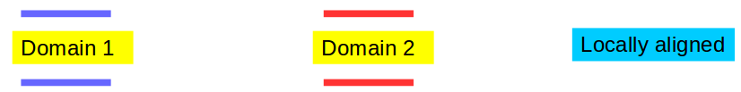
Assuming there are no serendipitously Similar regions in the Non-Homologous parts of the Proteins, only the Domain regions should be considered. The worst that could happen is that the Domain Boundaries are not determined with 100% accuracy, as it is likely that Sequence Similarity will decline towards the extremities.
Now consider the likely result of using a Global approach. The software must assume the Proteins to be Homologous throughout their length (not true!). Assuming the Similarity between the Domains is sufficiently strong, a broadly correct alignment of the Domains might be achieved (as illustrated). However, the software will insist on padding out the two sequences it has been given to align, until they are the same length. The Linker Regions between the two Domains must also be padded (typically with ‘-’ characters) so that they are also the same length.
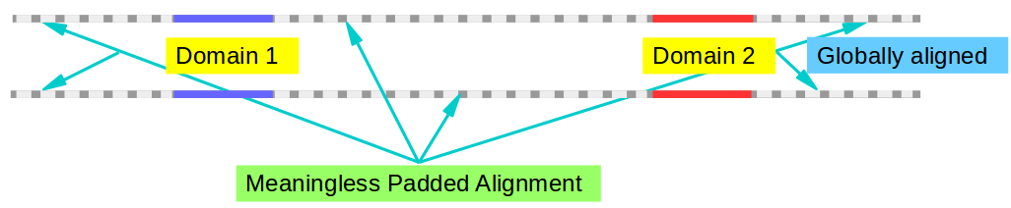

The insertion of Padding Characters (‘-’s) into one or both Sequences is the way the way the software mimics Evolution causing Insertions and/or Deletions (commonly referred to as Indels) in Proteins.
/Indel – Either an Insertion of a T in the Lower Sequence, or a Deletion in the Upper Sequence
...ALSG-YFQPR...
|||| ||| |
...ALSGTYFQ-R...
\Indel – Either an Insertion of a P in the Upper Sequence, or a Deletion in the Lower Sequence
So, if you are lucky, the Global Alignment might tell you much that you wanted to know. However, the alignment at each end is between Non-Homologous stretches of protein and is thus, very probably, complete nonsense. Similarly, the Alignment of the Linker Region is without meaning.
Remember also, if the Non-Homologous regions are of greatly dissimilar length and/or if the Domain Similarity is weak, then the software might be reluctant to predict the required number of Indels for a tidy answer (as illustrated). Instead, it is very possible the entire Global answer could be nonsense!

Example 2:
Imagine again that you wish to align two Proteins, each of which include two domains (a Blue one, and a Red one). The difference now is that the two Domains no longer occur in the same order!
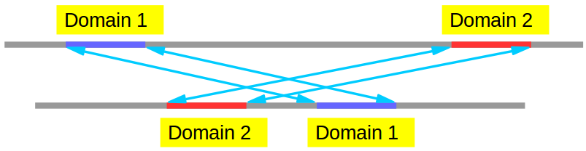

Again, and equally clearly, the correct choice would be to use a Local strategy. Assuming each Domain is sufficiently Similar (well conserved) in both Proteins, this should result in two separate Alignments, one for each Domain. The Local Alignment software has no requirements for regions to be in any particular order. The Local Alignment software will seek out Similar regions from any part of the Sequences it is examining and … Align them!
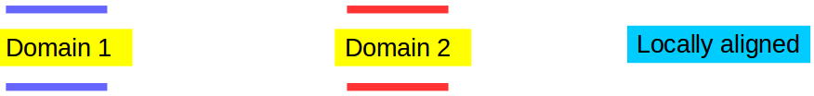

The Global approach is doomed to failure! It is (typically) written to find just one solution (the arithmetically “best” on according to rules either built into the programs or supplied by the user). It can either align the Blue Domain, or the Red Domain (or neither if things are not sufficiently obvious!). It cannot align both in a Global Alignment! It will choose the most Similar Domain (the Blue one in my illustration) and ignore the weaker (Red) one altogether. The entire Alignment either side of the “correctly” aligned Domain, is meaningless!
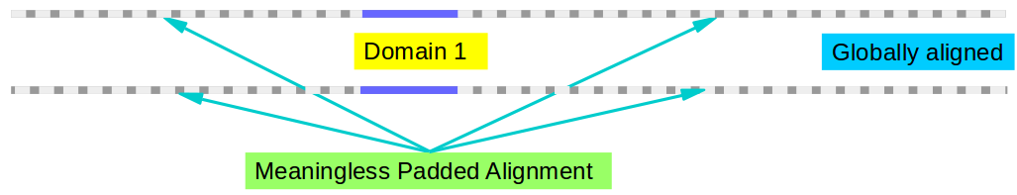

Example 3:
Imagine this time that you have two Proteins. The confident assumption is that they are Homologous over their entire lengths. However, Sequence Similarity is not likely to be consistent. In some regions, the Protein Sequences will look very Similar (to both the user and the software). In other regions, the Similarity will be far less obvious. In my illustration, the darker a region is coloured in one Sequence, the greater Similarity it has with its corresponding region in the other Sequence. I have arbitrarily decided to have three well matched regions between my two Sequences.
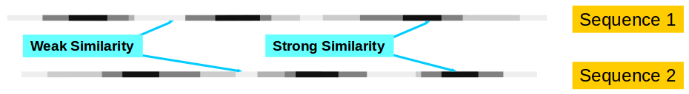

If a Local Alignment is computed between these two Sequences, it is most likely that the three most Similar regions will be detected, isolated and aligned reasonably satisfactorily. Three answers would generally be expected. However, although these regions would probably be aligned accurately enough, it cannot be satisfactory that so much Sequence has been eliminated because Similarity is insufficiently obvious. The assumption here is that ALL of both proteins are Homologous. It is therefore it is logical that ALL of both sequences be represented in a single Alignment.
Even the partial solutions of the Local Alignments must be between Sequence regions of equal length. This requires the software to insert padding characters, that is, to predict a number of Indel evolutionary events. Indels may be predicted anywhere in the Local Alignments, however, it should to be expected that the poorer the Similarity, the more willing the software would be to predict Indels.
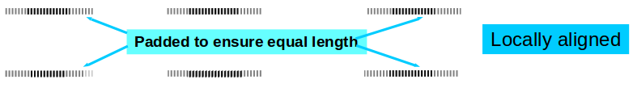
Now consider the application of a Global approach to the Aligning of the two Sequences.
A single Alignment including the full length of both sequences will be generated. It is reasonable to expect that the strongly Similarly Sequence regions will be matched correctly. Padding (i.e. the assumption of Indels) will normally be required (particularly in the poorly matching regions) in order to stretch out the Sequences to allow Alignment of ALL corresponding regions.
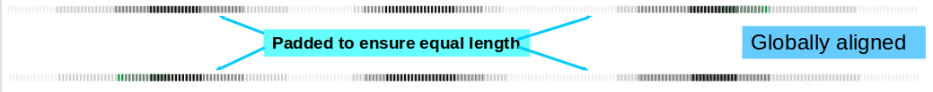

The Global Alignment is clearly the one that best fits the assumptions of the problem.
The message of these thee examples is that it is very important to think carefully before choosing between Global and Local Alignment for you data.
Return To Index
Query: Which is the best software tool to compute Pairwise Sequence Alignments?
Briefly: For Pairwise Alignment, the major choice to be made is whether to compute a Local Alignment or a Global Alignment. This is discussed quite fully in the answer to another FAQ.
Most of the more popular Local Alignment programs use the same basic approach (Algorithm). Specifically, something very close to the Smith-Waterman Algorithm. The Alignments you compute will vary slightly with the implementation of the Algorithm you choose, but not (usually) significantly. There is room for poetry, even in the creation of computer programs. Most of the major alternatives produce fine Alignments.
Most of the more popular Global Alignment programs are based upon the same Algorithm. Specifically, something very close to the Needleman–Wunsch Algorithm. The Alignments you compute will vary slightly with the implementation of the Algorithm you choose, but not (usually) significantly. Most of the major alternatives produce fine Alignments.
In full: Wikipedia (a wonderful resource!) provide an extensive list of software for Pairwise Alignment. Here, I will just mention a couple of options. Unsurprisingly, the ones I tend to rely on most.
The easiest way to compute a Pairwise Alignment, is to do so using one of the major Bioinformatics Services via a Web Browser.
For example, at the NCBI, amongst the Specialisations of Blast (very loosely!), Global Pairwise Alignment (based upon the Needleman-Wunsch Algorithm) is offered. This option gives very good results.
Local Pairwise Alignment is also offered as apart of the Blast service at the NCBI. This does not employ the Smith-Waterman Algorithm. Instead a version of the standard Blast Algorithm is used, with Parameters set to compare two Sequences with each other rather than one Sequence with a Sequence Database. In theory, this should not really be as sensitive as using a Smith-Waterman Algorithm method. Nevertheless, the results are generally satisfactory in my experience. If you want to try this method, go first to the normal Blast page, then chose either the Proteins or DNA option. Next click on the “Align two or more sequences” button, and finally, follow your nose.
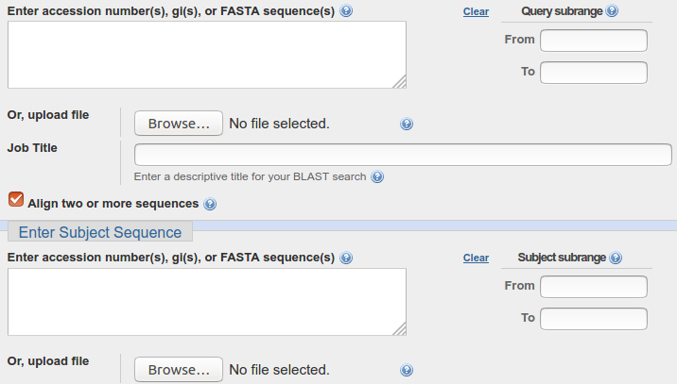

At the EBI (and many many other sites) a selection of programs from the EMBOSS Package of Bioinformatics Software are offered. The Local Pairwise Alignment option (an implementation of Smith-Waterman) is called matcher. The Global Pairwise Alignment option (an implementation of Needleman-Wunsch) is called needle. Both are quite easy to use and give good results.
A downside of running programs implemented on the INTERNET, is that all to often you will be denied full access to all the program’s parameters. This is particularly the case for the Pairwise Alignments options at the EBI. The EBI declare:
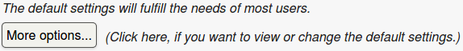
Even if you insist, and click on “More options”, you are not given access to all the options that the program allows! Well, OK, it is true that the default setting are usually the right settings, but I still resent being denied access to the programs full range of capabilities.
For some programs demanding a lot of compute time, you may also be restricted as to the volume of data you can process. Specifically, some Multiple Sequence Alignment (MSA) Programs limit the number of Sequences you may align!
The solution is to download the programs to your own machine. Read the Manual! And run the software locally. This is not as hard as it sounds. Blast is easy to download and install on a LINUX laptop, as are the programs of the EMBOSS Package. Why not try it sometime? Once the programs are running on your hardware, you have access to all the parameters and the data volume limits are determined by the capacities of your computer.
I conclude with a cynical note. Only my opinion, feel free to disagree.
Aligning pairs of sequences is a crude process. It relies on incomplete information (just the sequences, NOT the DNA/RNA or Proteins themselves). Hugely general assumptions are made concerning the way substitutions occur during Evolution, but surely the way substitutions happen varies widely according to circumstances (e.g. substitutions in a Linker Region must be far more likely than in the middle of a highly conserved Protein Domain), also very simple rules governing where Indels might occur are applied evenly over the length of the sequences being aligned. This cannot be right? The likelihood of an Indel in the middle of a Helix (for example) just has to be far less than in a region where there is no important secondary structure.
So, I wonder, how much effort should one take fine tuning the parameters of such a sloppy analysis? Of course, if a program is to be written to align ANY two sequences, there is little option but to implement such improbably general assumptions. The programs (I suggest), even when run as carefully as is possible, will only align Sequences that you could align manually (with a bit of knowledge about the relationships between amino acids). The programs will just produce the “best” Alignments a lot faster than any human can.
Return To Index
Query: Which is the best software tool to compute Multiple Sequence Alignments (MSAs)?
Briefly: The first MSA program commonly used is Clustal. It was born around 1988 and was just about the only real option for many years. It is still around in several forms, most still in common use and generating believable MSAs.
Over the years, a wide variety of alternatives to Clustal have emerged (starting with T-Coffee in 2000) ... most claiming to be improvements on Clustal. The list is intimidatingly long! I will mention some of the more popular examples here, but will resist giving too much detail until I have read and understood more about the various “new” approaches.
In full:
The most popular Pairwise Alignments Algorithms rely on a technique called Dynamic Programming. The Dynamic Programming Pairwise Alignment Algorithms (see previous Answer) can, in theory at least, also be used for Multiple Sequence Alignments. Sadly, however, to do so is not practical. The requirement for computer memory (in particular) increases exponentially as the number of Sequences to be aligned increases. Even in a world of cheap and copious computer resources, direct application of Dynamic Programming strategies to Multiple Sequence Alignment leads to impossible memory requirement to align even relatively modest numbers of Sequences.
Clustal, and many other programs following the lead of Clustal, use a compromise approach. In overview, they build Multiple Sequence Alignments by combining Sequences in a series of Pairwise Alignment steps. This is, theoretically, not as good as using the Dynamic Programming Algorithms directly, BUT it allows the Multiple Alignment of very large numbers of Sequences using only the resources expected to be available on a modern laptop.
So the original question was asking which was the best program to use. As usual, it all depends what you want to do, how many Sequences you wish to align and the length of those Sequences.

The EBI offer a range of MSA programs and advice on which one to use for what purpose. I cannot really improve on this advice (mostly concerning only the size of the Alignment?). Note however, when it is suggested that a particular program is suitable for “small alignments”, that often means only that the program (e.g. T-Coffee) is slow and resource hungry, so if you use it for a large MSA, you will use an unacceptable amount of EBI computing power. T-Coffee, at the EBI, imposes a limit on the number of Sequences it will accept, for example. However, that limit is 500 Sequences, which really seems quite generous … at first glance. Do not miss the further restriction implying a maximum total Sequence file size of 1MB!? So … 500 Sequences of mean length … 2 Residues? I hope I have something wrong here, I will investigate further soon. I hope the 1MB limit only applies when Sequence Data is supplied in an up loaded file rather than pasted into the box provided on the Web Page.
Some of the EBI choices claim to be particularly appropriate for specific purposes. For example, webPRANK is intended for people interested in Phylogeny. T_Coffee will combine alignments produced by other MSA methods.
Muscle (offered at the EBI) is an option that works in a similar, but more sophisticated way to Clustal. It should produce better Alignments more swiftly (generally) than Clustal and is quite “light” on computer resources.

The NCBI offer an MSA program called COBALT. This aligns Protein Sequences only. Interesting features of COBALT include the use of Domain/Motif Databases to detect regions of the Sequences being processed that really should align well. Also, COBALT uses models for the way evolution works computed from the Sequences under investigation, rather than models assumed to apply to the whole of Nature. Clearly, this has to be a good idea.
So, COBALT works on a more informative set of data than most of its competitors. I suggest that generating better Alignments by simply designing better computer Algorithms is limited by the usual paucity of the raw data. Only by providing MORE information, in particular MORE specific information, can real improvements be achieved. That, it would appear, is what COBALT attempts to do.
At this time, my experimentations with COBALT are at an early stage, I hope to have more to say after I look more closely. I suggest it is worth a try however, given you have a suitable set of Protein Sequences to align.

As with all software, if you wish to get the best out of the programs, download them and run them on your on computer (after reading the manual, of course). This is possible for most (if not all) of the MSA programs mentioned above.
Return To Index
Query: Is it possible for one to create a Personal Profile at NCBI, and/or any other site providing similar services, enabling search results (and similar analytical computations) for future references?
If all you wish to do is to save your results to your laptop for further consideration, this is generally possible at most relevant sites without having a Personal Profile. You might lose some of the pretty ways to view your results offered by the web, but you will have the essential ingredients of your analysis stored locally.
It is certainly the case that Personal Profiles are available at the NCBI. The EBI also offer something of the sort (that I have never used). There is no reason to believe such Profiles are not also available at other large Bioinformatics Service Sites but I have no personal experience. I investigate and will expand upon this answer if I learn anything interesting.
Ensembl (a Genome Database site, not a general service site like the NCBI or EBI), also offers a Personal Profile option for more serious users of their facilities.
NCBI: To create a Personal Profile at the NCBI, go to the NCBI Home Page, click on the link “Sign in to NCBI” (top right hand corner of the page), click then on the link “Register for an NCBI account” (bottom of the page. And follow your nose.
Or … take the following Shortcut and then follow your nose.
EBI: I feel sure it is possible to create a useful Personal Profile at the EBI. However, I have never serious made and used such a Profile. It does not look particularly straight forward. Instructions are few (it is claimed “More details to come soon here...” in the place that claims to offer to explain “How to use the AAP?”.
If you wish to explore, I suggest you start Here. I will expand these notes if/when I learn more.
Ensembl: To create a Personal Profile at Ensembl, go to the Ensembl Home Page, click on the link “Login/Register” (top right hand corner of the page), elect to Register and follow your nose.
Return To Index
Query: What is the difference between Bioinformatics and Computational Biology?

Briefly: Bioinformatics is the application of Mathematics, Statistics and Computing Science to achieve a better understanding of the information encoded in biological molecules (Protein/DNA/RNA).

Computational Biology includes all aspects of Bioinformatics, emphasising the development of algorithms and software tools.

In full: A number of different terms to define the meeting of Computing Science/Informatics and Biology have emerged in recent years. Terms including Bioinformatics, Computational Biology, Biological Computation …
The distinctions between these terms typically require a bit of thought. The first step of finding clear definitions is not always trivial. Here your query concerns specifically the distinction between Bioinformatics and Computational Biology.
For Bioinformatics, there exist many definitions exhibiting variation of emphasis. Generally though, Bioinformatics is the application of Mathematics, Statistics and Computing Science to the achievement of a better understanding of the information encoded in biological molecules (Protein/DNA/RNA). A broad definition that allows Bioinformatics to encompass a very wide range of activities in very many forms of Biological research.
Computational Biology can be thought of as including all aspects of Bioinformatics, emphasising the development of algorithms and software tools.
Computational Biology also encompasses the construction of mathematical models and the use of simulations to study biological, behavioural and social systems. These, not being concerned with the information derived from biological molecules, are generally considered outside the definition of Bioinformatics. This implies that all of Bioinformatics forms a substantial subset of Computational Biology.
When attempting to determine whether a particular activity is Bioinformatics, Computational Biology or both, it is often more useful to consider that which is being analysed rather than the analysis itself. Studying Biology using Bioinformatics always involves the analysis of biological information encoded in the molecules of life (DNA, RNA, Proteins) and is also always Computational Biology. Using Computational methods to study any other form of Biological data/information is not Bioinformatics but could be Computational Biology.
Examples abound. For instance:
- When studying Ecology, information encoded in specific organisms is not considered directly. However, computation and modelling using observed quantities such as areas/weight of biomass, temperatures, pH, etc. will be central. Computational Biology but not Bioinformatics!
- Studying Biological (e.g. Membrane) Transport using numerical models that work with concentrations, fluxes, electrical charge, etc. and not the amino acids of the proteins that form pores in membranes. Computational Biology but not Bioinformatics!

Return To Index

We both agree that: Sequences can be Similar (or even Identical) but they CANNOT be Homologous!!!! Proteins, for example, can be Homologous. That is, two proteins CAN evolve from a common ancestor, but Protein Sequences are merely representations of Proteins and so cannot evolve In any sense whatsoever! Many of the links we have provided refer to “Sequence Homology”. We think this is inaccurate, but this we overlook as otherwise, the links are useful. Pedantic? Possibly, but we are convinced we are right to be pedantic!

