

ELB17S
Entry Level Bioinformatics
06-10 November 2017

(Second 2017 run of this Course)

Basic Bioinformatics Sessions

Practical 4: Primer Design

Sunday 29 October 2017
Primer Design
The prime intention of this exercise is to design a way to amplify a DNA fragment of reasonable size that includes a specific portion of the PAX6 gene. The target region is that which includes the mutation you glanced at earlier, that is a major cause of Aniridia. That is, the substitution that mutates the 33rd amino acid position of the PAX6 human protein. I remind that the details you discovered earlier are as follows:
Affected Patient: 33rd amino acid position mRNA Base position
Proline (P) 459 (CCT)
Wild Type: 33rd amino acid position Genomic DNA Base position
Alanine (A) 15915 (GCT)
The isolation, amplification and analysis of the target region of the genome could be affected by using restriction enzymes. In this case, there is more than one restriction enzyme whose cut site is dependant upon the mutation and so would produce a differing set of restriction fragments when used with the DNA of Aniridia affected patients to that normally expected. As long as those differences were course enough to be detected by a Restriction Fragment Length Polymorphism (RFLP) experiment. Software exists to select enzymes to isolate a chosen region of genomic DNA and to fragment that isolate in such a way it is possible to determine whether it includes the unfortunate mutation or not from the pattern of fragments generated.
For a variety of reasons, including the ready availability and ever decreasing cost of sequencing, this is typically not the preferred way to proceed. It is normally preferable to use Polymerase Chain Reaction (PCR) to isolate the region around the mutation and then to sequence samples from all individuals under examination. To do this, the first step would be to design suitable PCR primers. One program, in many different forms, is almost exclusively used for this purpose. The program is primer3. It is free and can be downloaded and run under linux and windows (at least). It is available as part of the EMBOSS package (eprimer3) and from a number of websites, including at the Massachusetts Institute of Technology (MIT):
http://bioinfo.ut.ee/primer3/
This site is popular with many users wanting the very latest version of the software, complete control over the various options offered by primer3 and are not too concerned with using a database search to check the uniqueness of the products they will produce.
Another excellent primer3 web interface developed in the Netherlands is available at:
http://www.bioinformatics.nl/cgi-bin/primer3plus/primer3plus.cgi
The site incorporates access to a blast search to check the uniqueness of the selected primers (important if unwanted PCR products are to be avoided).
Mostly because of its completely seamless inclusion of a blast search to compare potential primers with appropriate sequence collections, I suggest we here use primer3 as implemented at the NCBI, even though it offers less than complete control over the execution of primer3 itself. Go to:
http://www.ncbi.nlm.nih.gov
Click on the BLAST option. Select 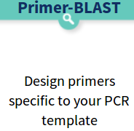from the Specialized BLAST section.
Upload your genomic PAX6 sequence using the Browse (or Choose File) button for the PCR Template.
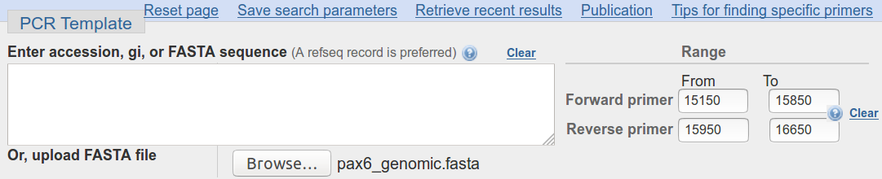
You have established that the mutation of greatest interest is the G/C substitution at position 15915 of the genomic sequence copied from Ensembl. It is logical therefore to specify that this feature be included in the PCR product not too near either end. Accordingly, request the Forward primer to be chosen From the region starting at base pair 15150 and continuing To base pair 15850. Set the range for the Reverse primer to be From 15950 and To 16650.

The default PCR product size is specified in the Primer Parameters section as between 70 and 1000 base pairs. This seems fine.
I would not presume to advise you on the melting temperatures that were most suitable. For this exercise, the defaults work splendidly.
By default, primer-BLAST will report the best 10 primer pairs it can find (# of primers to return). This is plenty for the exercise.
Do you think 10 primer pair suggestions is sufficient? If not, what number would you choose?
In addition to running primer3 to suggest primers, Primer-BLAST checks against the possibility of unwanted PCR products by comparing potential primers against an appropriate sequence database with blast.

In the Primer Pair Specificity Checking Parameters section, set the Database selection to RefSeq representative genomes. Leave the Organism set as Homo sapiens.
You thus request each potential pair of PCR primers to be compared to the entire human genome. Thus unintended products of similar size to the intended product, can be identified.
The ideal conclusion is “just one product will be produced, on chromosome 11, in the region of the PAX6 gene”.
Use the appropriate button to discover the purpose of the Max target size parameter.
This is a relatively new parameter replacing a very different parameter, the purpose of which was somewhat less obvious. The reason for the Max target size parameter is surely pretty transparent, so maybe there is now less requirement to wake up itsbutton? For the present, the maximum size of any proposed PCR product, in this instance, is 1,000 base pairs (the form default). So the greatest size of an unwanted product that might be a problem (the Max target size) must be small enough to potentially be mistaken for a real product of 1,000 base pairs. 4,000 base pairs seems a bit cautious to me? However, unless you feel strongly about the matter, accept the default value of 4000.
What value would you choose here if you were looking for uncluttered results?
Before setting primer-BLAST going, click on the Advanced parameters button. Not really so Advanced? More Avoidable by those in a hurry. At the top are the Primer Pair Specificity Checking Parameters that control the way that blast is run. Note thebuttons offering explanation.

Note the very high default Blast expect (E) value, suggesting you will be interested in matches with your primers that might occur up too 30000 times by chance! This does make sense as the primers will be very short and so many good, even exact, “chance” matches might be expected against a large database. You are essentially requesting that exclusion of results with high Expect Scores be disabled.
Comment upon the small default value for the blast word size?


Note that you could get primer-BLAST to suggest an Internal hybridisation oligo, but decline the invitation this time.

Accept all the Advanced parameters as they are. Ask primer-BLAST to Show results in a new window.
Click on the Get Primers button.
After a few moments of deep thought, primer-BLAST will notice that the template sequence you are using is highly similar (identical in fact) to part of an entry in the database being searched. Hardly surprising if one was to think about it. The RefSeq entry identified is the PAX6 RefSeqGene sequence you examined in a previous exercise.
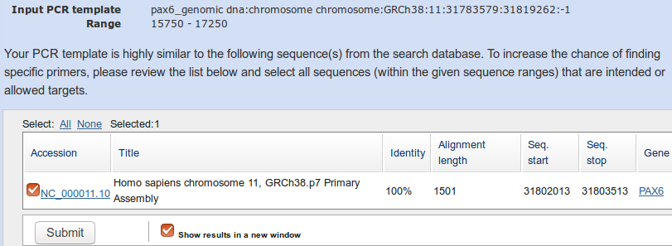
You are invited to select all listed regions (just one this time) where matches with primers are likely to be the intended product. In this case, that is the whole list of one, so click on the All button. Every pair of primers that primer3 selects must match this region of Chromosome 11 as it is precisely the region investigated by primer3 in the first place. This process avoids blast reporting intended products as unintended products.
Finally, all is ready, so ask to Show results in a new window once more and then click on the Submit button.

Once you have revelled in the opportunity to twiddle the fingers and scratch the ear(s) whilst primers3 and blast go merrily about their appointed tasks, you will receive your results. These should look disarmingly like mine if all has gone well.
The summary Graphic view suggest just 2 solutions met the default criteria for success used by primer3. Up to 10 were permitted.
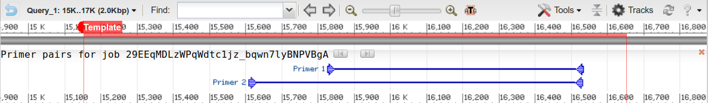
Hover your mouse over one or more and further details will pop up in separate windows.
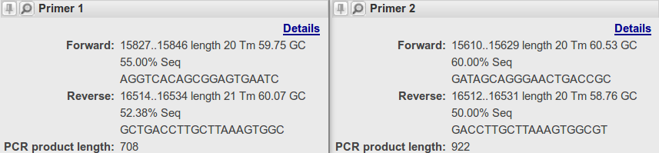
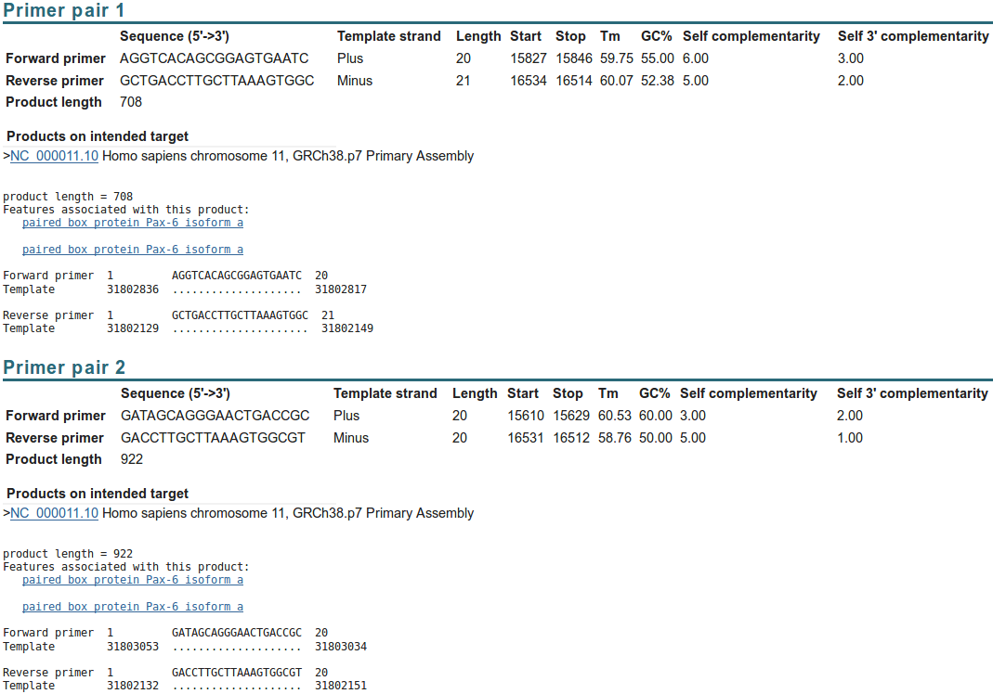

Neither of your suggested primer pairs are reported with any unintended products, even given the very generous suggestion that products 4000 bases long should be considered a potential problem.
As well as suggesting primers for PCR (or other purposes) and (optionally) suggesting hybridisation oligos, primer-BLAST can be used to evaluate user-selected primers. Earlier, you saved a pair of primer sequences associated with PAX6 when searching the nucleotide databases at the NCBI. It would be interesting to discover the product these might produce. To do this you need an unsullied Primer-BLAST page. Go again to:
http://www.ncbi.nlm.nih.gov
Click on the BLAST option. Select from the Specialized BLAST section.
Upload your genomic PAX6 sequence using the Browse (or Choose File) button for the PCR Template.

Open up the file you made containing the primers from GenBank (pax6_primers.fasta) in a text editor.
Copy and Paste the two primer sequences into the Use my own forward primer and Use my own reverse primer boxes as appropriate.
In the Primer Pair Specificity Checking Parameters section, set the Database selection to RefSeq representative genomes.
Leave the Organism as Homo sapiens.
Raise the Max target size parameter from 4000 to 20000. You should check for enormous unintended products with this run of Primer-BLAST. The reasons for this will soon become apparent.
Ask primer-BLAST to Show results in a new window. Click on the Get Primers button.
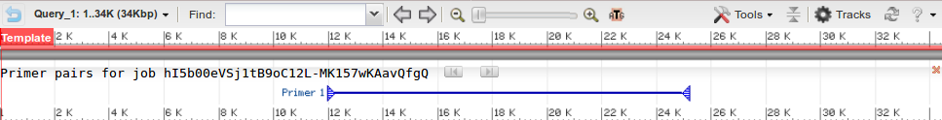
After a short thrill filled pause, you will receive a result that should again looks more that a trifle like mine.
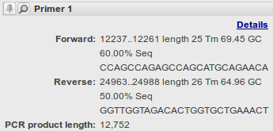
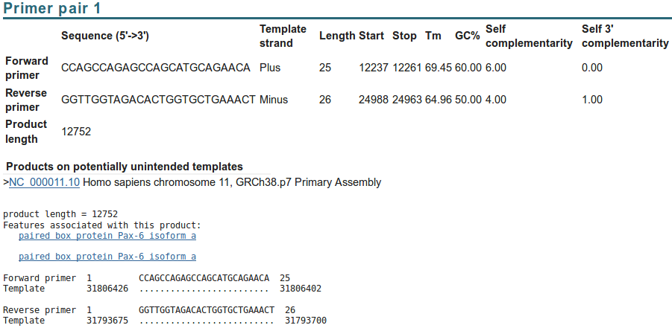

Seemingly a fine match. Even the single potentially unintended product reported is actually the intended product. For some reason, Primer-BLAST does not eliminate predictable intended products when investigating user specified primers?
Success! However, applying a small measure of sober reflection, one has to wonder at a PCR product of 12,752 base pairs? I suspect that to be just a tad on the boastful side of probable? Clearly, primer-BLAST is convinced, but maybe a look at the references that came with these primer sequences would be advised before accepting this result.
Reading the only paper referenced seems a little like hard work! Better by far to investigate the only sensible reason for the prediction of such an outrageously large PCR product, by experiment. A sensible conjecture is that the primers you saved were designed for use with mRNA/cDNA data. Therefore it might be interesting to run primer-BLAST one last time with pax6_mrna.fasta as the PCR Template.

Move back to your last primer-BLAST launch page. This time, load pax6_mrna.fasta as the PCR Template.
In the Primer Pair Specificity Checking Parameters section, set the Database selection set to Refseq mRNA and leave the organism set to Homo sapiens.
Set the Max target size back to its default value of 4000, you should expect much smaller mRNA products this time, so no need for extending this maximum beyond 4000.
These selections suppose that the design of PCR product was for selection from a library of all human cDNAs.
Ask primer-BLAST to Show results in a new window.
Click on the Get Primers button.
The result is a much more reasonable Product length of just 908 base pairs, reinforcing the theory that these primers were indeed designed for use with a cDNA library.
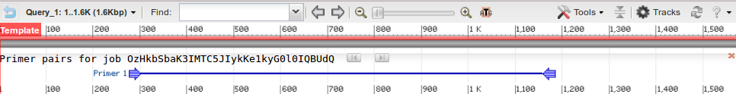
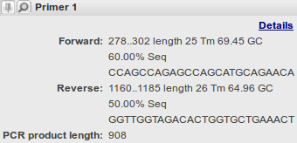

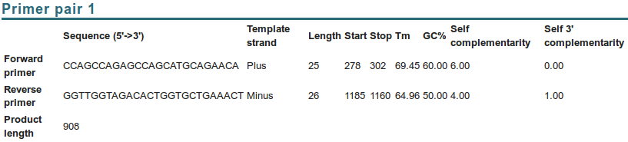
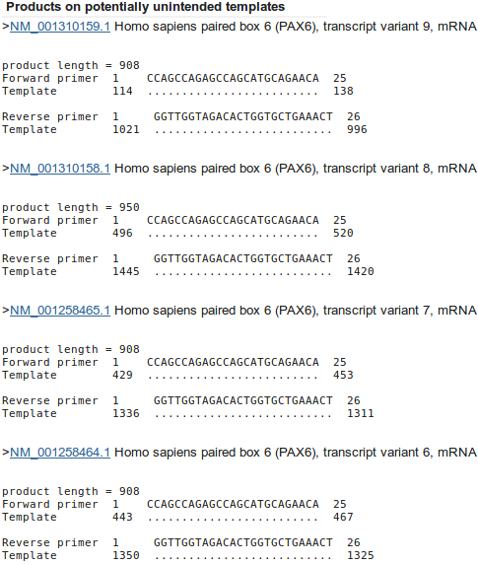
Before moving on, afford a quick glance at the report offered concerning possible unintended products. Here primer-BLAST warns against human mRNAs that might be cloned along with the intended target.
The first thing to note is that the template (the mRNA sequence in the file pax6_mrna.fasta) is not a RefSeq mRNA. It comes from the GenBank database and so was included in the “non-redundant” union of databases you searched earlier.
Genbank sequences are generally generated directly from a specific sequencing project. RefSeq mRNAs are generally consensus sequences computed from the evidence represented by Genbank sequences. Consequently, there is no unintended product that we can ignore because it relates to the original template sequence.
All the unintended products could/would potentially be generated by the primers under investigation and have the potential to cause confusion. If you look down the list, you should conclude that the 9 unintended products come from 9 of the 11 RefSeq PAX6 transcripts found in the databases by test search and later detected by blast.
Why do you suppose blast did not pick up all the transcripts?
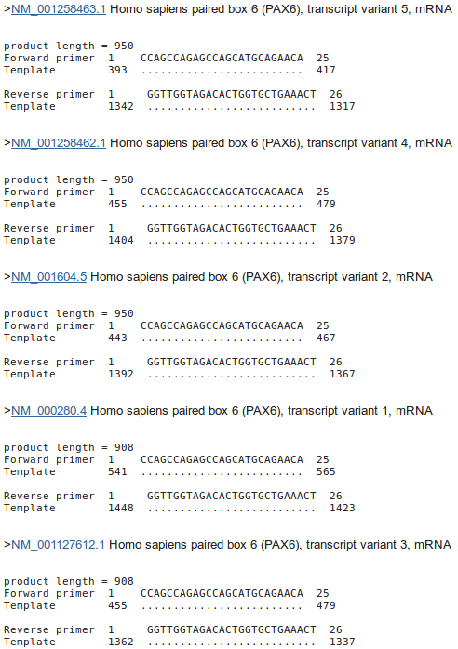
Note that the intended product is 908 base pairs long. Note that all the unintended products are either 908 long or 950 long. A difference of 42.
How would you tell quickly which isoform was represented by each mRNA listed here?

Some fairly redundant questions to finish this section. I think I have already answered them all. But maybe you might wish to differ?

For all the “potentially unintended products”, the selected primers match exactly. Can you explain this?
DPJ – 2017.10.29
Model Answers to Questions in the Instructions Text.
Notes:
For the most part, these “Model Answers” just provide the reactions/solutions I hoped you would work out for yourselves. However, sometime I have tried to offer a bit more background and material for thought? Occasionally, I have rambled off into some rather self indulgent investigations that even I would not want to try and justify as pertinent to the objective of these exercises. I like to keep these meanders, as they help and entertain me, but I wish to warn you to only take regard of them if you are feeling particularly strong and have time to burn. Certainly not a good idea to indulge here during a time constrained course event!
Where things have got extreme, I am going to make two versions of the answer. One starting:
Summary:
Which has the answer with only a reasonably digestible volume of deep thought. Read this one.
The other will start:
Full Answer:
Beware of entering here! I do not hold back. Nothing complicated, but it will be long and full of pedantry.
This makes the Model answers section very big. BUT, it is not intended for printing or for reading serially, so I submit, being long and wordy does not matter. Feel free to disagree.
From your investigations of Primer Design
Do you think 10 primer pair suggestions is sufficient? If not, what number would you choose?
Until a few years ago, the default here was 5. That seemed rather low to me. I included this question to solicit opinion rather than to impart knowledge. A default of 10 seems more in line with my instincts, but people who use this program seriously mostly tell me that they can select suitable primers from the first 2 or 3 suggestions of the program. So, 5 would seem a good choice and 10 would be moving towards cautiously overdoing things.
On the whole, informed opinion suggests that 10 suggestions will be more than enough in most circumstances.
What value would you choose here if you were looking for uncluttered results?
Summary:
Clearly, the smaller the number chosen, the shorter will be the list of spurious products. However, pick something too small and you risk including unintended product(s) that could cause confusion. The size selected must be sufficient that larger unwanted PCR product(s) could easily be spotted by other means (simply by size?).
Full Answer:
Well, mostly for me, and just in case you were curious, when I first wrote the question, the parameter was very different and not so easy to understand. Pure self indulgence, I know, but here is the history. The parameter explained itself, via thebutton, thus:
I interpreted this to mean that only blast predicted products of up to X+4,000 base pairs, where X base pairs is the length of the intended target, will be given any regard. It is thus assumed that a difference of 4,000 base pairs between an intended PCR product (predicted by primer3) and a spurious product (detected by blast) can easily be detected simply by size difference.
Of course this parameter also will reject unwanted blast predicted products that are less than X–4,000 base pairs will be given any regard. Given the largest possible primer3 suggestion will be 1,000 base pairs (the form setting for the exercise specifies products of between 100 and 1,000 base pairs), this is hardly an issue here.
Comment upon the small default value for the blast word size?
By default, blast will be looking for aligned exactly matching blocks of 7 nucleotides when identifying where a primer might match a database entry. The entire primer match with the template sequence does not have to be exact for the primer to be acceptable. The entire primer is typically only around 20 bases long. And word size much more that 7 would clearly miss too much to be effective.
Why do you suppose blast did not pick up all the transcripts?
Well, the simple answer is that the transcripts that were not detected as unwanted products cannot include either the forward primer, or the reverse primer, or both. This is, almost, the only possible explanation.
I have a huge Full Answer: for this one that needs either throwing away or bringing up to date. I think I was the only one who ever read it, so you miss little while I decide its fate.
How would you tell quickly which isoform was represented by each mRNA listed here?
All the mRNAs reported were of length 908 or 950.
A reasonable guess might be based on the length of the products? All those that are 908 bases might be assume to produce the 422 amino acid canonical isoform. All those that are 950 (i.e. 42 base pairs longer) might be assumed to 436 produce amino acid isoform 5a proteins (i.e. 14 amino acids longer).
Just a guess of course, but one I would be happy to have faith in. To be certain, one would need to read the annotations of each listed RefSeq entry!
Is the number of “potentially unintended products” as you would you expect, given the evidence from Entrez and blast?
Yes, I think so, given you accept my investigation (see above) as to why there were only 16 “potentially unintended products” when you might have expected 24, given your blast results. GeneCards now encourages an initial expectation of 24 “potentially unintended products”. Ensembl only uses the higher quality RefSeq mRNAs. Currently, Ensembl uses 10 of the 11 good quality RefSeq mRNAs to make its transcripts predictions. Close enough?
For all the “potentially unintended products”, the selected primers match exactly. Can you explain this?
Well, of course they do??? All the transcripts found are generated from the same region of genomic DNA and therefore will be identical in all shared regions, including the primer regions. I suppose, in other instances, it would be possible to have transcripts with variation in the regions matching the primers insufficient to stop the primers working? But not in this case.
One might conclude there are no genuinely “unintended” products? All are real PAX6 transcripts. A genuine unintended product would come from an entirely different part of the genome and would not necessarily match exactly with respect to the primers. They would just need to be “good enough to work”.

DPJ – 2017.10.29

The MIT link here is to the latest version of primer3 (version 4.0.0, soon primer4 maybe?).
My policy has been to not discuss parameters that pertain to the experimental conditions. In future versions of these notes, I will include discussion of some of these parameters. In the mean time, thebuttons are very helpful. I would also suggest the MIT site (or the Wageningen site) for very readable explanations linked from every parameter. The full primer3 manual can be found here.
Which rather makes mock of all the deep thought employed deciding upon the most sensible maximum number of predictions to be reported.
This was not true until recently. Primer-BLAST reported many more primer pair suggestions and quite a few unintended products for each. The previous parameter restriction the length of unintended products was substantially more generous.
I have asked the guys at NCBI to explain. No full answer as yet, further prodding required. Prodded last 2016.04.02. Maybe I give up?
Apparently, such a PCR product is possible! However, above 5,000 base pairs would be slow, require very close attention and be prone to errors.
The form explicitly declares a minimum of 70, but the ranges from which the forward & reverse primers must come (15000-15700 & 15800-16500) make the smallest possible primer3 prediction 100 base pairs long.

