

TGAC/EMBL-EBI Summer School in Bioinformatics for Biological Researchers

25-29 July 2016

Basic Bioinformatics Sessions

Practical 3: Databases Searching

Saturday 2 July 2016

Searching for sequence similarities in databases.
The most popular way to investigate a sequence has always been to compare it with one of the sequence databases now accessible from sites all over the world. When sequences databases were more sparsely populated than now, the objective was to search hopefully, not always with success, for any convincingly similar sequence(s). When such a match was discovered, it could be supposed that known properties of the “similar” database sequence might provide insight to the properties of the query sequence. Now, the databases are full of sequences representative of most interesting conditions. Similarity searches are conducted in the expectation of finding many close “hits” for almost any sequence. Fewer database searches are conducted in complete ignorance of what the query sequence might be.
Here, take the PAX6 genomic DNA sequence retrieved from Ensembl and conduct two searches analogous to those run in the Ensembl pipeline. Results should confirm that which has already been discovered using other sources.
blast is not the only sequence database searching program available, but it is the most popular by a very long way. blast searches are offered in many forms by many servers all over the world, but the most comprehensive and reliable service has to be that offered by the NCBI.
Go to the NCBI homepage at:
http://ncbi.nlm.nih.gov

Select the BLAST option (from the Popular Resources list). In the Basic BLAST section, select nucleotide blast. Use the Enter Query Sequence Browse (or Choose File) button to upload the file:
pax6_genomic.fasta.
For results like those used by Ensembl to predict PAX6 transcripts, you must compare your genomic sequence to a reliable set of human mRNA/cDNA (or similar) sequences.
In the Choose Search Set section, set the Database to Reference RNA sequences (refeseq_rna).
You are now able to specify an Organism, choose Human.
blast is now set to compare the PAX6 genomic region with all Human mRNA sequences in RefSeq.
Note that the default Program Selection is Highly similar sequences (megablast), which seems appropriate here as all the mRNA that correctly match should surely do so almost perfectly.
Click on the Algorithm Parameters button. The defaults are fine here, but before starting your search, try changing the Program Selection and observing the different Algorithm Parameters.

The default settings of all shared parameters are identical for the two slower more sensitive Program Selections.
There are differences for megablast, where speed is of the essence and sensitivity can be sacrificed.
Smaller Word sizes slow searches but increase sensitivity. For megablast the default Word size is 28 otherwise it is 11.
Gapped alignment is time consuming and, by default, considered more crudely by megablast than the other two algorithms.
Filtering and Masking matches with organism specific repeats and/or low complexity regions takes time, and so only avoiding Low complexity regions is on by default for all Program Selections.

When discontinuous megablast is selected, an extra options section appears. Discussing how this flavour of blast works is a little beyond the scope of these note, but briefly. Unlike the other Program Selections, discontinuous megablast does not just look for exactly matching “words” of given size as a first step towards identifying matching regions between sequences. It looks for a pattern of matching bases within a word. For example, the default choice assumes your query is coding and looks for 11 matching bases within a word of 18. Approximately, every third base is allowed not to match. Biologically, this can be justified as allowing for third codon position wobble. For more detail, use the appropriatebutton. Notice there arebuttons by every parameter selection. Try one or two. In the process, discover:
When would Mask lower case letters be a useful thing to do?

Automatically adjust parameters for short input sequences is independent of Program selection, and so remains unaltered.
Which parameters would blast need to automatically adjust to cater for short input sequences (such as primers being tested for uniqueness), and why?

Finally, ensure all the defaults are back in place and the megablast is the Program Selection, ask blast to Show results in a new window and then click on the button. Impressively swiftly, you will have results. At the top of which will be a graphical overview.
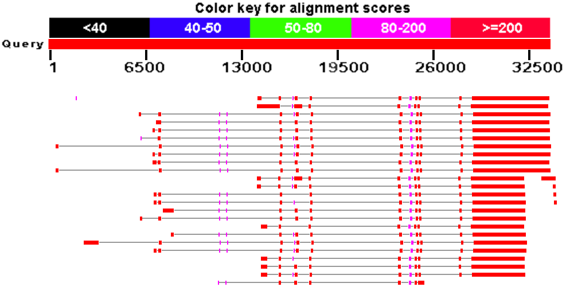
This graphic implies that there are 24 full length matches between your genomic sequence and mRNAs in RefSeq. The RefSeq entries had to be “gapped” in order to compensate for the introns that are represented in the genomic sequence but removed from the mRNA sequences. The red blocks therefore represent very closely matching ( brownie points) exons, the lines joining the red blocks represent introns that have been spliced out. All 24 hits match reasonably uniformly except for the first few exons, implying significant variation in the 5´ UTR.
Why do you suppose that a few of the exons do not achieve the maximum score?

Explain why one exon in the reasonably consistent region, does not appear in all of the transcript matches?

GeneCards reported that there were 24 PAX6 transcripts recorded in RefSeq, 11 high quality NM_ entries plus a further 13 XM_ PREDICTED transcripts. Ensembl claimed to have used 10 or the 11 high quality NM_ RefSeq sequences to aid its transcript predictions, but ignored the 13 XM_ PREDICTED, less certain RefSeq sequences. blast just sees sequences and cannot be influenced by the quality of the support for their existence, so blast reports that all 24 RefSeq PAX6 mRNAs match the PAX6 genomic region convincingly.
Perfect consistency between three sources of information! Wonderful, but this is not always the case. When RefSeq acquires extra sequences, Ensembl will not notice until its next “genebuild” event. When Ensembl finally gets into line with the changes in RefSeq. GeneCards will not respond until its next update. RefSeq has been relatively static of late, with regards to this particular gene. It is rather a nice change to be looking at a neat and consistent picture at this point. Sadly, it will not last.

In summary, if you hover over the graphical hits, their origin will be displayed above the graphic. The facts are:
- The top 10 and the bottom 1 full length hits are of the best quality (i.e. NM_ entries with good supporting evidence). 11 in all.
- From the 11th full length hit, there are 13 entries all labelled “PREDICTED”. We have already concluded that Ensembl is clever enough not to rely on PREDICTED RefSeq entries alone to justify an Ensembl transcript prediction. GeneCards does count them as sufficient to indicate RefSeq transcript predictions however.
- There are 4 small hits to the extreme right of the graphics at the same level as the top 4 PREDICTED hits. These are the ends of mRNAs for the ELP4 gene and are exactly where you should expect them to be given previous discussion. Reject these contemptuously, they do not pertain to our investigation of PAX6.
- The tiny smudge match to the left of the top hit is “uncharacterized” and fails to fit in with my story, so I ignore it!
So, this blast search suggests the existence of 24 PAX6 transcripts supported by RefSeq data, as is reported by GenCards. Also, the results are consistent with the information discovered in Ensembl.
Move down a trifle and you will find a simple list of the 29 matches represented in the graphic.

Why were you not surprised to discover 24 PAX6 transcripts in Refseq matching this sequence?

Which of the Refseq PAX6 transcripts corresponds to isoform 5a?
Moving further down the results you will come to the alignments between pax6-genomic and the matching database entries. All similarity searches use local alignment strategies, so you should not be surprised to see a number of alignments for each “hit” in the list. Here we have a genomic query sequence aligned exclusively with mRNA sequences from RefSeq. The expectation is therefore to find an alignments corresponding to exons. The alignments are ordered by quality, though you are provided with a Sort by: menu to alter the order to taste.
Look at the first alignment for the best matching PAX6 transcript. It is the alignment of the very last exon of a RefSeq transcript with the end of the gene you exported from Ensembl.
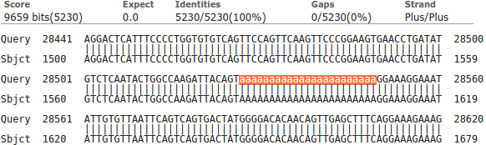
Notice the lower case string of 'a's. The case indicates that they were ignored (filtered) as a Low complexity region whilst megablast was looking for identically matching words that might suggest matching regions. By themselves, the 'a's are not sufficient evidence that a biological match exists. Only because the surrounding sequence is compellingly similar, can it be assumed that such a match does exist. The 'a's are replaced (lower case to indicate they were filtered) when the final alignment is computed. If you look a little further down the same alignment, you will see several other runs of 'a's and 't's for which the same explanation applies.

Now use a version of blast (called blastx) to compare your genomic sequence with a protein database. blastx will translate a DNA query sequence in all six reading frames and compare each translation with a protein sequence database. Thus, in a similar fashion to that employed by the Ensembl pipeline, protein coding regions of the genomic DNA can be identified. For clarity, we will use only the well annotated human proteins of the SwissProt section of Uniprot. First go to the home of blast at:
http://blast.ncbi.nlm.nih.gov/Blast.cgi
In the Basic BLAST section, select blastx. Use the Enter Query Sequence Browse (or Choose File) button to upload file pax6_genomic.fasta.
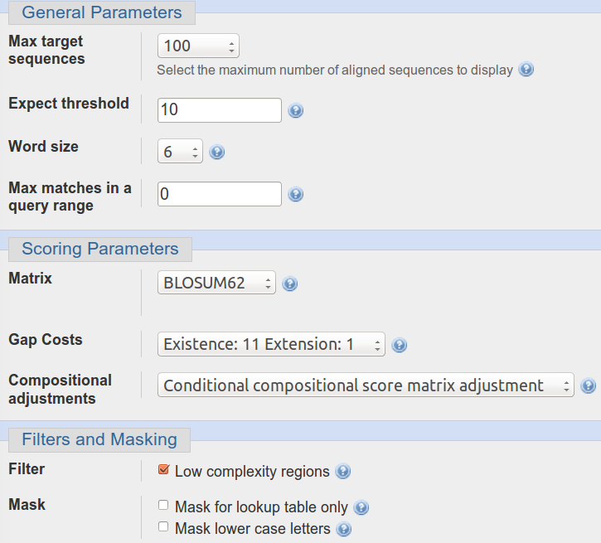
In the Choose Search Set section, set the Database to UniProtKB/Swiss-prot prot(swissprot). Specify the Organism as Human.
Take a look at the Algorithm parameters.
The Word size choice is 2, 3 or 6 . The default is 6. We seek very close matches here, so the largest Word size would seem appropriate.
The default scoring matrix is BLOSUM62, but choices from both the BLOSUM and PAM families are offered.
Low complexity regions will be filtered by default.

Change nothing other than to ask blast to Show results in a new window. and click the button.
After minimal thought, blastx will thrust its conclusions before you. Hover over the graphical hits for identification.
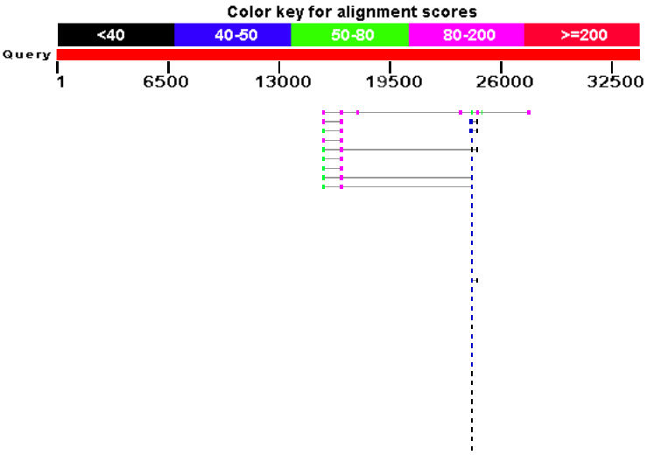
What are the 9 stronger matches around base position 16,000?
Why would you expect exactly 9 matches around this point?
What do you make of the plethora of matches around 24,000?
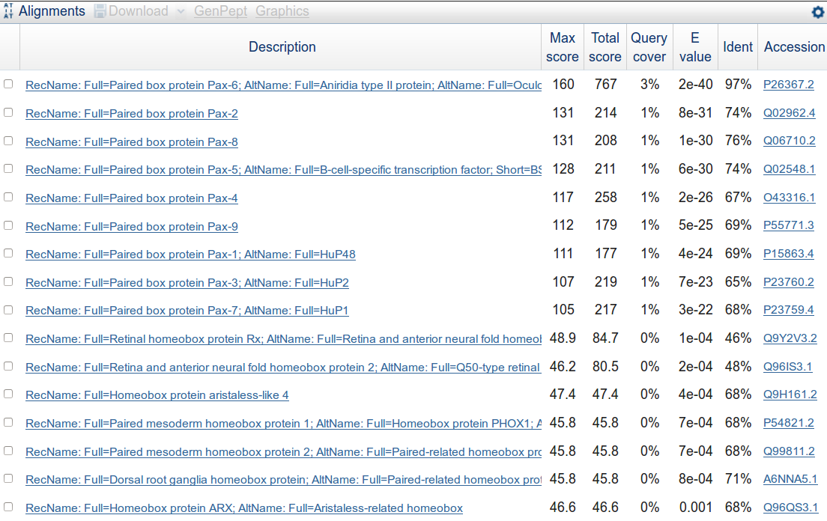
Move down to the textual list of the matches. Hopefully as you fully expected you will find the expected number of Paired box matches at the top of the list followed by many many Homeobox matches.
Why do you suppose the Paired box matches precede the Homeobox matches?
How do you suppose the Max matches in a query range parameter might be of value if this order was reversed?

Take a look at the alignments. You will see many places where regions have been filtered as non-informative. I suggest the one illustrated was filtered because it would match anywhere that was sufficiently Serine rich.
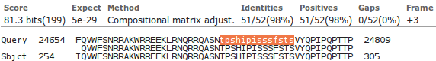
How does this “non-informative” region match expectations suggested by Prosite and the Feature table of Uniprot for PAX6_HUMAN?
PSI-BLAST
This program is used to find a comprehensive set of relatives of a protein. First, BLAST is used to find closely related proteins. From an alignment of these proteins a general "profile" (a Position Specific Scoring Matrix - PSSM) is computed. A PSSM is very similar in concept and purpose to an HMM profile in that it summarises significant features present in the sequences it represents.
A query against the protein database is then run using the PSSM, and a larger more widely associated group of proteins is found. This larger group is used to construct another PSSM, and the process is repeated until no more significantly matching new sequences can be detected, or the user tires of the whole process.
You have used PSI-BLAST integrated into Jpred already and similar ideas were used to create the PFAM alignments. Here we will use PSI-BLAST explicitly at the NCBI on the Paired DOMAIN of the PAX6 protein that you saved in a file earlier. It should be possible to detect a large family of PAX domains and to eventually multiply align them generating something like the Full alignment from the PFAM database viewed earlier.
To investigate PSI-BLAST go first to the NCBI Home page at:
http://www.ncbi.nlm.nih.gov/
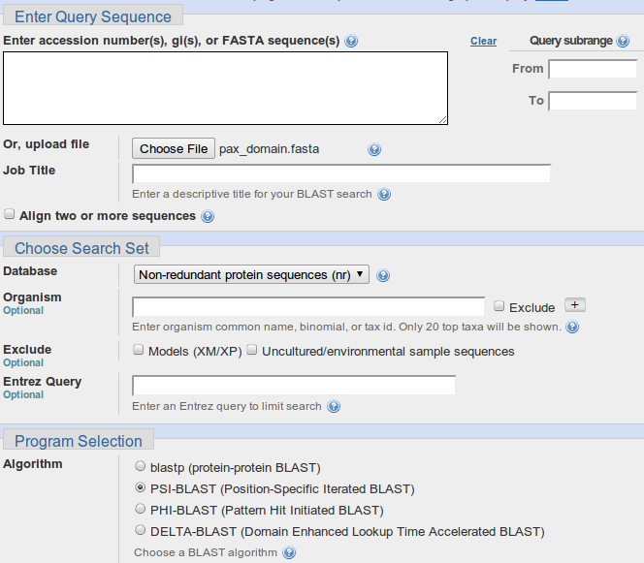

Click on the BLAST option. Select protein BLAST from the Basic BLAST section. Upload the PAX6 paired box domain sequence (stored in the file pax_domain.fasta) using the appropriate Browse button.

Select PSI-BLAST from the Program Selection section. Leave all the others options at their default settings, particularly the option to search all the proteins available.

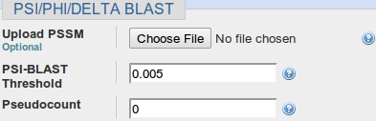
Before you set PSI-BLAST going, click on the Algorithm parameters link and take a look at the PSI/PHI/DELTA BLAST section. Here is offered the option to use a PSSM from a previous run PSI-BLAST, potentially on a different database (but with the same query sequence). Accept the default that database entries scoring better than an Expect Threshold of 0.005 be offered for inclusion into the PSSM of each successive PSI-BLAST iteration. Remember the buttons.
What do you suppose the choice of Pseudocount might influence?
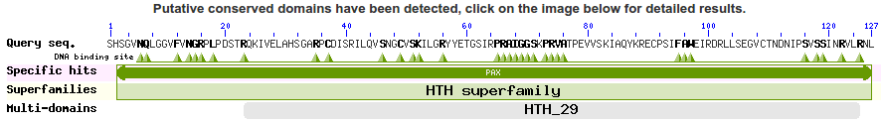
Elect to Show results in a new window and then click on the button. After several moments of deep thought, PSI-BLAST will come back with its first set of results, at the top of which is a report that (unsurprisingly) matches have been detected between the query sequence and several domain databases. For more detail, click on the Conserved Domains graphic.

SMART, Pfam and the NCBI Conserved Domains database hits are reported. None should be a surprise.
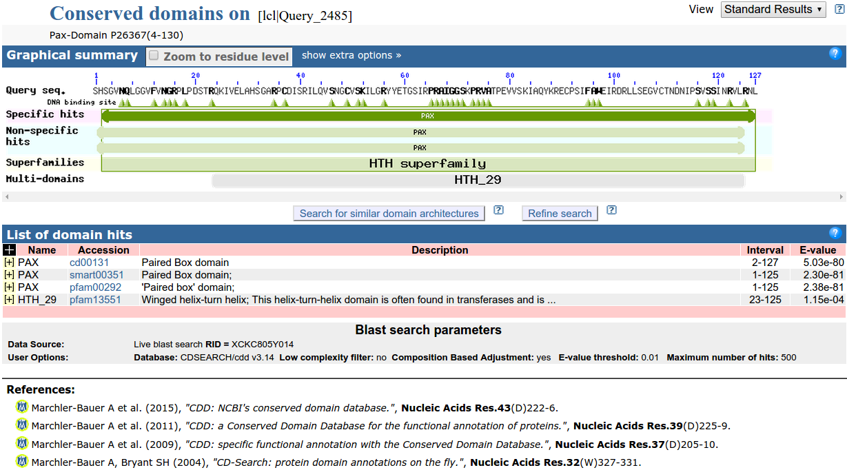
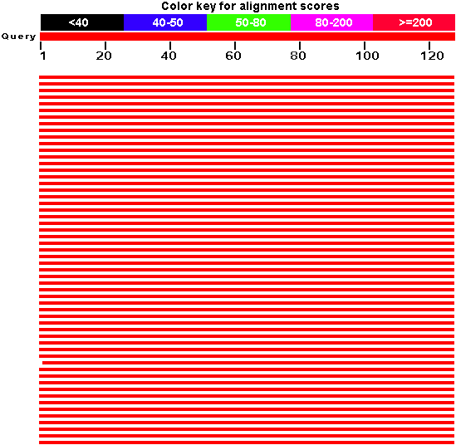

Moving back to the main PSI-BLAST results, you will see that there are many high quality hits covering the whole length of the query sequence.

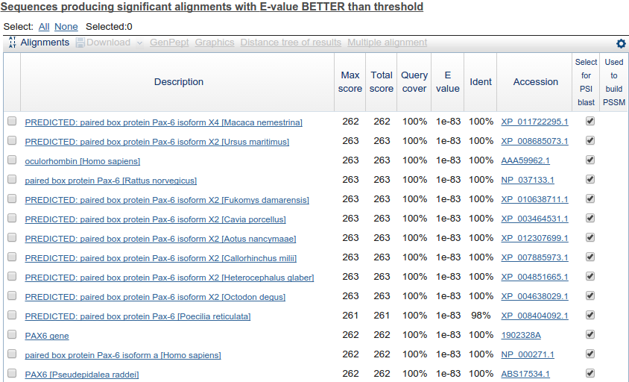

The best 500 of these are listed.

All the listed hits are selected for inclusion into the PSSM for the next iteration. Unless you feel strongly about any particular entry, leave them all selected.
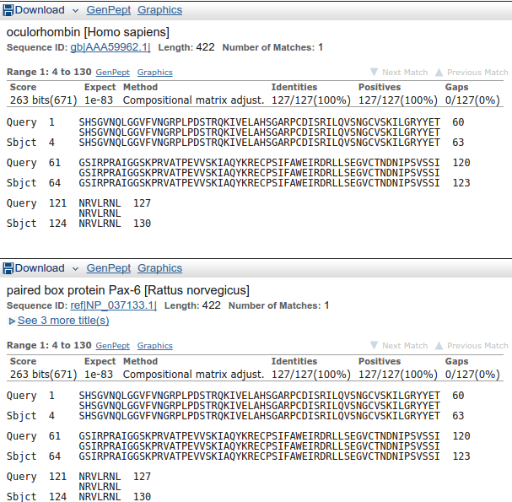
Move down to the Alignments section of the results and you will see that many of the top hits match the query exactly.

Note that many of the top hits come from the GenPept database (roughly equivalent to the TrEMBL section of UniProtKB).

How might the inclusion of relatively poor quality sequences and the presence of so much duplication have been minimised?

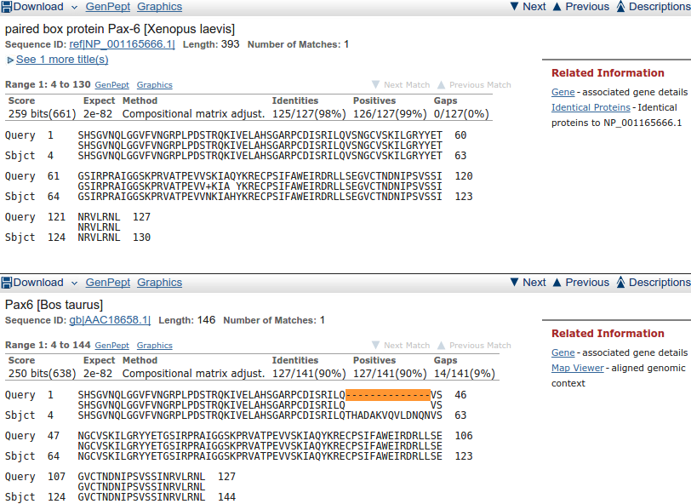

Move down far enough and you will see less perfect matches, some of which involve proteins with the extra 14 amino acids of isoform 5a of PAX6_HUMAN.

Having browsed your results sufficiently, click on the button to Run PSI-Blast iteration 2. It is at the bottom of the hit list.

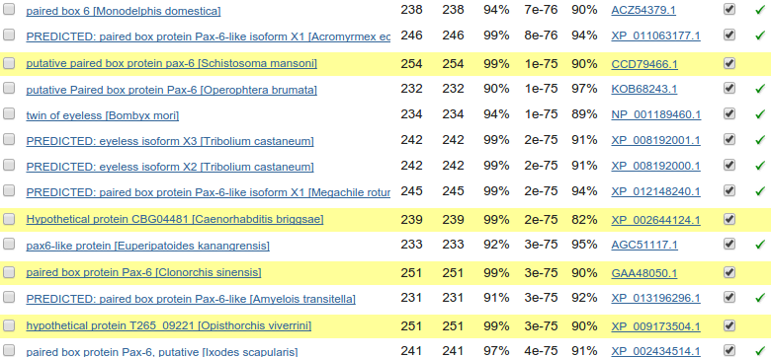
After a few moments, PSI-BLAST will return with the results of searching through the database again using the PSSM derived from the hits of the first iteration(ed). This time the top of the list will be predominantly filled with hits that have already been incorporated into the PSI-BLAST PSSM. However, look far enough down the list and you will find some new ones, highlighted yellow.
Once more, click on the button to Run PSI-Blast iteration 3. That is probably enough! It took 4 iterations before there were no more new sequences suggested for inclusion into the PSMM when I ran this last, so if you really want to take things to their logical conclusion, it should not detain you long.

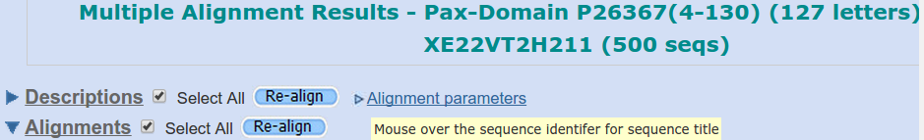
Next, move to the top of the Descriptions list and Select All. Click on the Multiple Alignment button. You have elected to use the NCBI multiple alignment program Cobalt to align all the PAX domain sequences of your final PSI-BLAST iteration that match with an Expect score better than 0.001. In an impressively short time, your alignment will appear.
Move past the long list of proteins that have been aligned (the easiest way is to hide the Descriptions view).

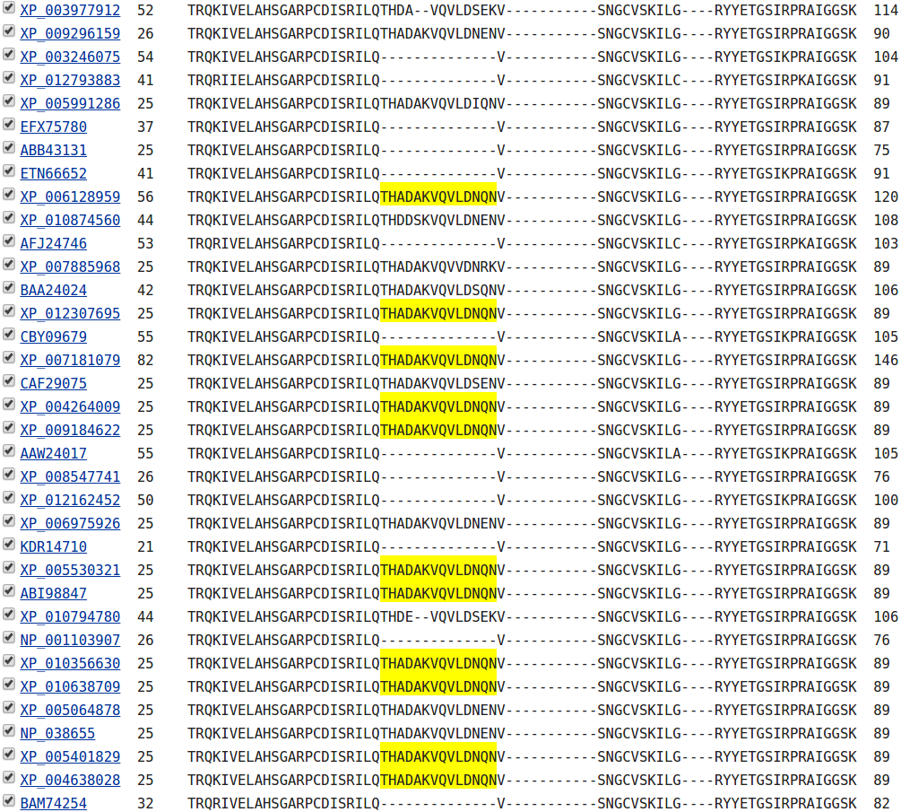
At the top of the actual alignment, set View Format to Plain Text (…. and then hide the Descriptions again??), this being the easiest format to understand in a hurry. The alignment will have very ragged ends, but the important region of 120 or so amino acids representing the PAX domain is really quite impressive. In particular, the isoform 5a insertion is very convincing.

Model Answers to Questions in the Instructions Text.
Notes:
For the most part, these “Model Answers” just provide the reactions/solutions I hoped you would work out for yourselves. However, sometime I have tried to offer a bit moer back ground and material for thought? Occasionally, I have rambled off into some rather self indulgent investigations that even I would not want to try and justify as pertenent to the objective of these exercises. I like to keep these meanders, as they help and entertain me, but I wish to warn you to only take regard of them if you are feeling particularly strong and have time to burn. Certainly not a good idea to indulge here during a time constrained course event!
Where things have got extreme, I am going to make two versions of the answer. One starting:
Summary:
Which has the answer with only a reasonably digestible volume of deep thought. Read this one.
The other will start:
Full Answer:
Beware of entering here! I do not hold back. Nothing complicated, but it will be long and full of pedantry.
This makes the Model answers section very big. BUT, it is not intended for printing or for reading serially, so I submit, being long and wordy does not matter. Feel free to disagree.

From your investigations of Searching for sequence similarities in databases
When would Mask lower case letters be a useful thing to do?
Generally, whenever one might suspect the automatic masking algorithms of blast might miss a non informative region in a specific query sequence, obviously.
A specific example might be when a query sequence contained a significant informative region that was known to be common amongst the sequences being searched. If this region was left unmasked, blast would pick up so many similar matches to this one region that other interesting similarities might be obscured. By manually masking such a region by changing it to lower case, its matches would not be seen by blast and matches with other regions of the query sequence should be more apparent.
Which parameters would blast need to automatically adjust to cater for short input sequences (such as primers being tested for uniqueness), and why?
The word size: Clearly, if you are trying to find matches for a primer (for example) of around 20 base pairs, it would be pretty silly to use a word size of 28 (default for megablast). A word the same size as the primer would find only exact matches. A word of about 7 would allow a couple of mismatches and would probably be most generally appropriate.
The expect score: As good chance matches between between a short query sequence and a large database will be abundant, it would not be sensible to choose a demanding (i.e. small) expect score to represent the limit of significance. In particular, a primer sized query sequence of around 20 base pairs might easily exactly match more than 10 times (generally the default maximum expect score for a significant match) just by chance. After all, there are only 4 bases, a string of 20 is not that long and the databases can be huge! Typically blast chooses very high expect score cut off for short query sequences, effectively removing the expect score filter altogether.
Earlier versions of blast did not automatically adjust these parameters. When a short query sequences were selected, suitable adjustment was left to the user. Without sensible parameter adjustment, results could be greatly confusing. For example, a 21 base pair primer could easily match perfectly more than 10 times against a large DNA sequence database. blast is set to ignore matches that are expected to occur more than 10 times by chance. Thus even exact matches with such a small sequences would be ignored! Now automatic parameter adjustment is undertaken by blast, the user does not really have to think too hard. However, it does seem to be a good idea to know what blast is doing and why.
Why do you suppose that a few of the exons do not achieve the maximum score?
Summary:
Each local region of significant alignment between a database entry and a query sequence is scored independently. The scoring method that governs the alignment score colour in this graphic, reflects both the quality of the match and its length. Unless a particular region is of sufficient length, it cannot achieve the 200 bit threshold even if the alignment is perfect. Note that is is the shorter regions that fail to reach thestatus. All of the illustrated local alignments associated with PAX6 transcripts are essentially perfect.
Full Answer:
In common with most database searching programs, blast compares query sequences with database entries using a local strategy. The overall evaluation of a particular query sequence is taken to be the highest local score.
Individual local matches are coloured according to individual quality. In this query, all true matches should be perfect, or very nearly so. Scores might therefore be expected to be maximal (). However, they are not? Some only manage a score in the range .
The score referenced for this purpose is the bit score. For a full, no holds barred definition of this score, try here. I prefer this somewhat gentler version:
“The bit score gives an indication of how good the alignment is; the higher the score, the better the alignment. In general terms, this score is calculated from a formula that takes into account the alignment of similar or identical residues, as well as any gaps introduced to align the sequences. A key element in this calculation is the “substitution matrix ”, which assigns a score for aligning any possible pair of residues. The BLOSUM62 matrix is the default for most BLAST programs, the exceptions being blastn and MegaBLAST (programs that perform nucleotide–nucleotide comparisons and hence do not use protein-specific matrices). Bit scores are normalized, which means that the bit scores from different alignments can be compared, even if different scoring matrices have been used.”
Still too scary? The important things to note are that:
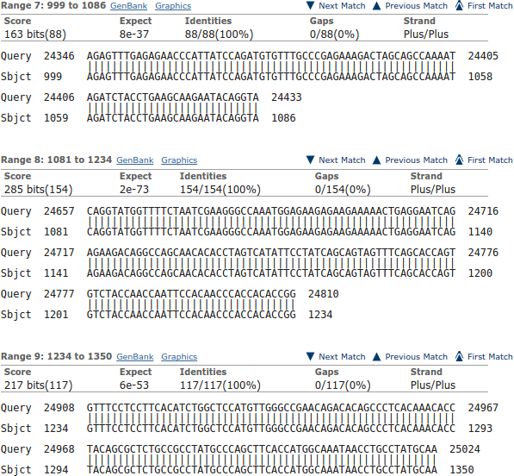
- These scores are based on a simple DNA scoring matrix (1 for a match, -2 for a mismatch by default for megablast), plus penalties for gaps. So scores will be limited by the length of the alignment, ignoring gaps.
- The scores reflect penalties for indels (insertions or deletions).
- The scores are normalised so that they do not depend on the chosen scoring matrix. This allows bits scores from searches using different scoring matrices to be compared.
This being so, bit scores will reflect the length of an alignment as well as its quality. If an alignment is very short, it might be perfect but still not achieve a very high value. bit scores are designed to reflect significance, not just local quality. A short perfect match clearly can be less significant than a longer less perfect match. That is what you see illustrated here.
You can see evidence of what is occurring in the alignments further down your results. Here is illustrated one of the exons that occur in all transcripts at position 24,346. The match is perfect, but the length of the exon is consistently just to short to get to the heady level.
Note how imperfectly blast finds exon/intron boundaries. If the start of an intron happens to match the start of the next exon, blast will included the bases in two alignments. It is not looking for exons and introns as was spline, it just mindlessly seeks matches.
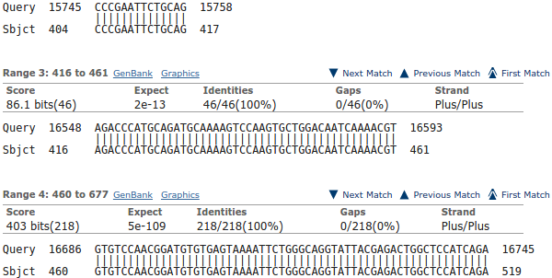
For a further example, look at the exon that is found only in the isoform 5a transcripts. It is tiny (42 base pairs) and scores well below even thought it is a perfect match.
Note that the alignment is 46 base pairs long due to blast adding on two bases either side that are actually the highly conserved intron start and end base pairs. As you can see, these extra base pairs occur in the preceding and succeeding alignment also.
Explain why one exon in the reasonably consistent region, does not appear in all of the transcript matches?
Oh dear oh dear! Not this again.
Well I refer to the isoform 5a exon, of course. The tiny inconsistent one about 9 exons in from the right (when it exists). This will, clearly, only occur in isoform 5a transcripts. One day I will tidy these questions up a trifle!
Why were you not surprised to discover 24 PAX6 transcripts in Refseq matching this sequence?
Repetitive? True. This question is more “interesting” when the resources you have visited do not agree. That is, most of the time. Whilst the situation is in balance, the answer is:
Because GeneCards says there should be 11 quality and a further 13 less supported PAX6 mRNA sequences in RefSeq. A total of 24 PAX6 implied transcripts in total. In passing, you could have discovered the number of PAX6 mRNA sequences in RefSeq but asking RefSeq directly. Probably a more sensible and certainly a more reliable approach.

Which of the Refseq PAX6 transcripts corresponds to isoform 5a?
Summary:
As I am sure you are tired of noting by now, all the transcripts with the extra tiny exon around position 1,600 in the genomic sequence are isoform 5a transcripts.
Full Answer:
The isoform 5a transcripts can be spotted most easily from the graphic. They are the ones with the extra small exon slightly to the left of middle (around base position 1,600). For example, the first, second and third blast matches displayed. If you hover over these matches with your mouse, you will see that they are transcript variants 1, 2, 3, 6, 7, 8, 11, 12, 14, 18, 19, 20, 21 and 23 (in the vertical order of the graphic).
Stated with the unequalled poetry of RefSeq Accession Code and lyrical Title Line, that becomes:
TITLE ACCESSION CODE
Homo sapiens paired box 6 (PAX6), transcript variant 11, mRNA NM_001310161.1
Homo sapiens paired box 6 (PAX6), transcript variant 10, mRNA NM_001310160.1
Homo sapiens paired box 6 (PAX6), transcript variant 8, mRNA NM_001310158.1
Homo sapiens paired box 6 (PAX6), transcript variant 5, mRNA NM_001258463.1
Homo sapiens paired box 6 (PAX6), transcript variant 4, mRNA NM_001258462.1
Homo sapiens paired box 6 (PAX6), transcript variant 2, mRNA NM_001604.5
PREDICTED: Homo sapiens paired box 6 (PAX6), transcript variant X13, mRNA XM_005252958.3
PREDICTED: Homo sapiens paired box 6 (PAX6), transcript variant X12, mRNA XM_011520153.1
PREDICTED: Homo sapiens paired box 6 (PAX6), transcript variant X10, mRNA XM_011520152.1
PREDICTED: Homo sapiens paired box 6 (PAX6), transcript variant X6, mRNA XM_011520150.1
PREDICTED: Homo sapiens paired box 6 (PAX6), transcript variant X5, mRNA XM_011520149.1
PREDICTED: Homo sapiens paired box 6 (PAX6), transcript variant X4, mRNA XM_005252954.3
PREDICTED: Homo sapiens paired box 6 (PAX6), transcript variant X3, mRNA XM_011520148.1
PREDICTED: Homo sapiens paired box 6 (PAX6), transcript variant X1, mRNA XM_011520146.1
Yes well, that was fun? When I first wrote this question, there was only 5 or 6 RefSeq mRNAs! The message of the question was to ensure you could see how to spot the isoform 5a transcripts (again!), not to list them! But, never mind, doing so was in fine tune with the ennui of the moment.
Additional Meanderings:
That really should not detain anyone but me? They belong after the consideration of masking the run of As for the megablast you ran. I just enjoyed this detour, so I keep it somewhere low profile. The whole journey leads nowhere of any note, so, should you decide to read, expect little!
The 500 base pairs of 3' flanking sequence added on to the Ensembl sequence for “good measure”, is not part of the alignment (as would be expected). This can be seen easily if you look at the end of the alignment illustrated above, which is the alignment of the last exon of a transcript.
The entire length of this transcript is 6,732 base pairs.
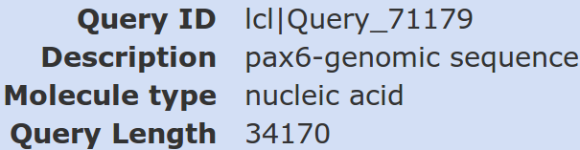
The entire length of the genomic query sequence is 34,170 base pairs.

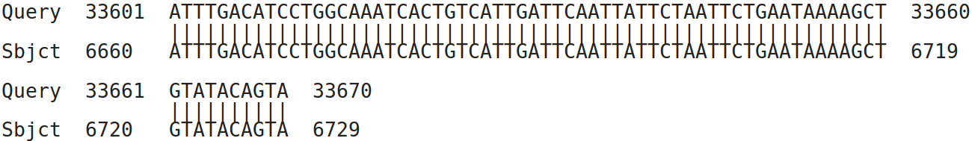
The alignment ends at position position 6,729 of the mRNA (3 from the end) and position 33,670 of the genomic sequence (exactly 500 base pairs from the end).
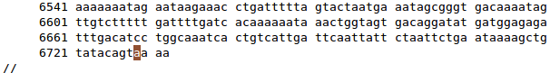
The 3 missing base pairs of the mRNA are all As, due to polyadenylation. Position 6,729 being recorded as a polyA site by RefSeq. A very short polyA tail surely? But there is no telling what stage of the mRNA is recorded on RefSeq. Wikipedia says:
“The tail is shortened over time, and, when it is short enough, the mRNA is enzymatically degraded.”
Of course, the neatness of this observation does reflect less some profund biological truth than it does that this mRNA just happens to be one that extends furthest to the right in the genome, and there is no chance match between the polyA tail and the extra 500 bases of genomic sequence you added on when extracting it from Ensembl.
The journey was fun even though the destination was dubious. Much the way of a considerable portion of life in general one might reflect?
What are the 9 stronger matches around base position 16,000?
Matches between the regions of genomic DNA encoding Paired Box domains.
Why would you expect exactly 9 matches around this point?
Because that is how many Paired box domains are suggested to be in the human genome by counting the number of quality mRNA sequences in RefSeq claiming to include a Paired box coding region. There is PAX6 plus its 8 paralogues, imaginatively all named:
PAX1, PAX2, PAX3, PAX4, PAX5, PAX6, PAX7, PAX8 & PAX9

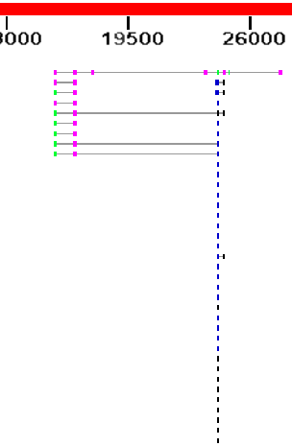
What do you make of the plethora of matches around 24,000?
These are matches between human mRNA sequences with the regions of genomic DNA encoding Homeo Box domains. As you discovered from Interpro, there are many of these.
The thin line joining features implies that those features relate to the same database entry.
Notice that 4 of the 9 proteins matching a Paired box genomic region also match a Homeo box region. the remaining 5 do not. This implies that 4 of the 9 proteins corresponding to the hits detected here have a Paired box domain near the start of the protein and a Homeo box domain further along. This is exactly as was suggested by the PROSITE annotation you examined.
Why do you suppose the Paired box matches precede the Homeobox matches?
Because they score more highly and so, in the opinion of blast, are more worthy. Primarily, they score more highly because they are longer. The list is ranked by E Value. Good matches with long sequence are less likely to occur by chance than equally good matches with shorter sequences.
Possibly a more interesting question might have been: “Why are not all the hits which include both domains at the top of the list?”. Surely they should be, as they match over a longer proportion of the query sequence and so must, in general at least, be of the greatest significance.
They do not always come at the top of the list because blast scores each matching region individually and uses the ranking scores associated with the single region with the highest E Value to evaluate the similarity of the entire database entry with the query. This has to be a dubious practice surely? But, it appears to work, so why complain.
To justify this last assertion, Look at your top hit.
E Val = 2e-40, Max score = 160, Total score 767 associated with the whole of P26367.2
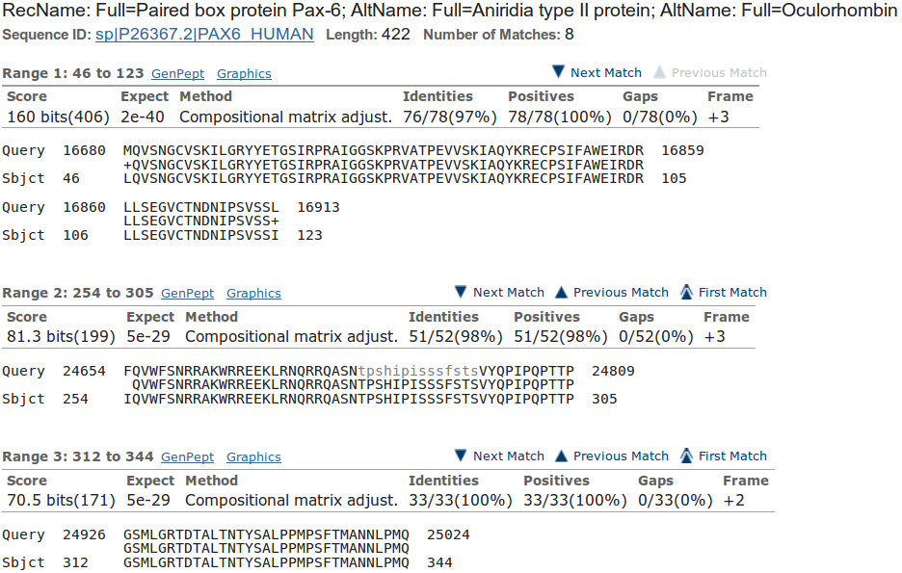
Now look at the first few individual regional alignments for this hit.
As you can see, the E Value and Max score values used to evaluate the whole protein were computed from just the best (ranked by E Value) local alignment! Crude, but never mind.
The Total score for the entire protein is the sum (rounded up to the nearest integer) of all the bit scores for all 8 local alignments computed for this protein (I suggest you just trust me on this assertion).
How do you suppose the Max matches in a query range parameter might be of value if this order was reversed?
If Paired boxes had been more prolific, then the number of Paired box matches might have filled the blast hit list before the highest scoring Homeo box hit was registered.
If Homeo boxes were longer, and so justified a better E value, then the number of Homeo box matches might have filled the blast hit list before the highest scoring Paired box hit was registered.
Either of these situations would be very unfortunate, but easily avoided by setting the Max matches in a query range parameter to something sensible (50 say). This would ensure that only the top 50 items in the blast hit list would be dominated by the strongest hit.
For further discussion of the parameter, see above.
How does this “non-informative” region match expectations suggested by Prosite and the Feature table of Uniprot for PAX6_HUMAN?
blast identifies two non-informative regions. I only discussed the prettiest one above. The region discussed is comprised largely of Serines, Prolines, Threonines & Isoleucines the 15 residues between 294-308.
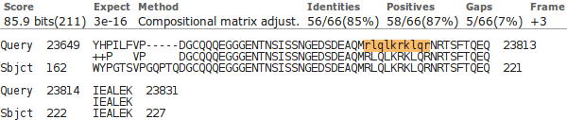
The second (to be found much further down your blast Alignments output) is comprised entirely of Arginines, Luecines and Lysines and Glutamines, the 10 residues between 203 - 212.

Uniprotkb also suggests there are two compositionally biased regions.
Well, hardly an exact match, but there is approximate agreement? One would certainly suppose that blast is only willing to mask fairly severe cases of compositional bias. It is also probable that blast has a rather more mechanistic (i.e. non-biological) interpretation of what computational bias is?
PROSITE also predicts the more obvious region of computational bias, rather more generally:
“An octapeptide and/or a homeodomain can occur C-terminal to the paired domain, as well as a Pro-Ser-Thr-rich C-terminus”
PSI-Blast

What do you suppose the choice of Pseudocount might influence?

I clicked with confidences upon the link to the help. It opined as illustrated.
I suppose the next step is to read PMID 19088134? There is most certainly no elucidation amongst the strangle of words offered here?
The article Abstract says:
“Position specific score matrices (PSSMs) are derived from multiple sequence alignments to aid in the recognition of distant protein sequence relationships. The PSI-BLAST protein database search program derives the column scores of its PSSMs with the aid of pseudocounts, added to the observed amino acid counts in a multiple alignment column. In the absence of theory, the number of pseudocounts used has been a completely empirical parameter. This article argues that the minimum description length principle can motivate the choice of this parameter. Specifically, for realistic alignments, the principle supports the practice of using a number of pseudocounts essentially independent of alignment size. However, it also implies that more highly conserved columns should use fewer pseudocounts, increasing the inter-column contrast of the implied PSSMs. A new method for calculating pseudocounts that significantly improves PSI-BLAST's; retrieval accuracy is now employed by default.”
The article itself, continues in like vein ….. how about we close our eyes and accept the defaults? I would just wonder why the whole thing does not commence with, at least an attempt, to answer the question in the forefront of my inquiry, which is .. “WHAT, in the current context, IS a pseudocount?”. I do not believe it is as tricky as they appear to wish us to believe. I will try again later, when my view of the world is less storm infested.

megablast is a less sensitive but even faster version of blast only suitable when, as now, almost identical matches are sought.
By default, megablast uses Linear Gap Costs. That is, it just multiplies the size of the gap with the Mismatch penalty. The other two algorithms employ the more common Affine strategy, using Existence and Extension penalties. For more about Gap Penalties, go here.
This filter avoids finding “hits” supported only by matches in regions not specific to the query. For example, a polyA tail cannot help to identify a specific mRNA as it is present is all mRNAs. The use of this filter will be evident when we look at the blast output.
If you have any non-default settings, they should be highlighted in yellow.
Or you could just read the textual list that follows the graphic if you wish to insist on the simplistic.
To use a global approach would be to imply that you were only interested in database entries that matched your query sequence from end to end. Generally, this is not true. You would usually be interested in a database sequence that was similar over any significant region.
Why not try them? End up with the alignments for the top hit in E value order.
The mRNA in the file pax6_cdna.fasta ends at this polyA region. I wonder about the long 3' UTR suggested by some of the RefSeq entries?
Here I will assume we have talked about these parameter and you are reasonably well informed of the issues.
But hopefully a mite more credible!
Much more so than the Full alignment offered by PFAM, I would contend. Although, it has to be admitted, the Pfam alignment included more sequences and I suspect they would have gone for a less closely homologous set of sequences. Even so … I think the alignment illustrated here is MUCH more beautiful!!
In order to make this illustration, I needed set Sort by: (top of the alignments) to Query start position.
6 base pairs (Sbjct: 1081-1086, CAGGTA) occur in both the first two matches illustrated. Just 1 base pair is shared between the 2nd and 3rd match (Sbjct: 1234, G).
That I did not ask, because I only just thought of it.

