

IB16S
Introductory Bioinformatics
12-16 December 2016

(Second 2016 run of this Course)

Basic Bioinformatics Sessions

Practical 5: Secondary Structure Prediction

Friday 9 December 2016
Computational Protein Analysis
In this section, the plan is to look exclusively at the protein of PAX6. The object is to use various software items to confirm what has already discovered from the various web resources. Often the software you will use will be exactly that which was used to determine the pre-computed results you browsed previously.
Predicting Protein Secondary Structure.
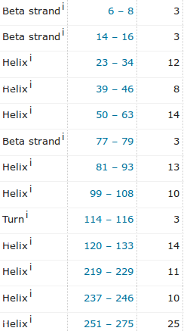
A first step is to look at to look at ways to predict the protein secondary structure of the PAX6 protein. Evidence from various sources suggests that the PAX6 protein has 9 helices arranged in triplets, plus a few beta strands.
To save time, I show here the relevant section from the Uniprot Feature Table. The helical triplets are involved in binding. 2 triplets are to be found in the paired box region, the other in the homeobox a little further along. Here we will try one of the most sophisticated methods available, to predict, essentially from from the primary sequence, what we already know. If you really wish, I also offer a supplementary exercise based around one of the earlier prediction methods, still used, but although faster, significantly less accurate than more modern methods.
Early Secondary Structure Prediction Methods - GOR 
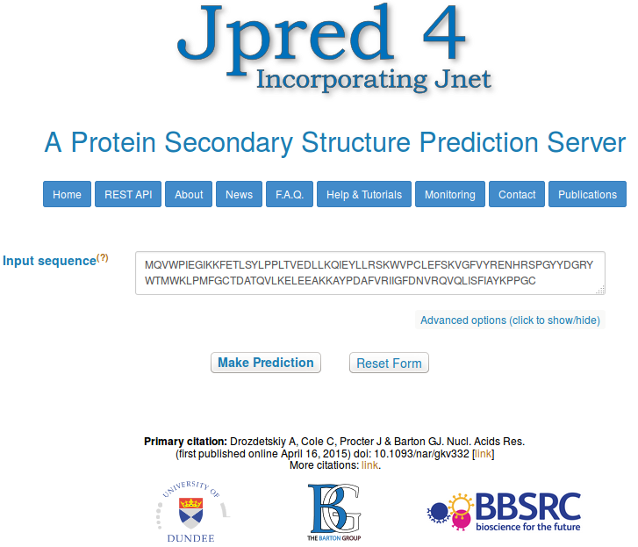
The service considered by many to offer the most effective method of predicting secondary structure is called Jpred. This is developed by the Barton group now located at Dundee University. Over 80% accuracy is claimed for Jpred predictions. Due to the inherent imprecision in defining the end positions of secondary structure elements, 80% is pretty much as good as is practically possible.
Go to the Barton Group web site at:
http://www.compbio.dundee.ac.uk
and follow the link to the server. Copy and paste the PAX6 protein (from the file pax6_human.fasta) into the appropriate text box. Click on Make Prediction.
With alacrity, JPred will report several hits with proteins of known 3D structure (using blast against a database of proteins of known 3D structure). Links are offered to a number of entries in the PDB structure database. At least 2 of the PDB entries listed should be familiar.
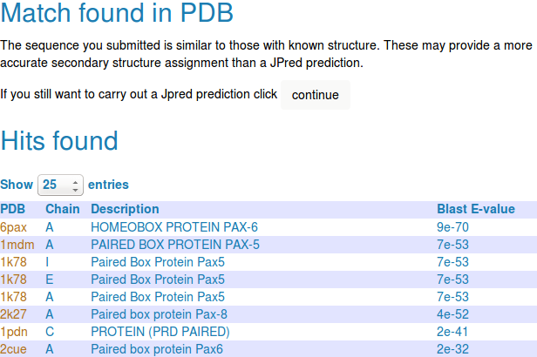
Jpred offers the suggestion that it really does not make sense to continue. After all, if the 3D structure is effectively known, why predict (guess?) the 2D structure? The answer to this challenge being a petulant “Because we want to!”
Click purposefully on the Continue button. JPred, with a small sigh of exasperation, will submit your job and tells you how busy it is. Jpred typically takes a while as it has much to consider.
Jpred will use PSI-Blast to align your sequence with all sequences deemed to be homologous, from a particularly appropriate database. Jpred then makes its structure predictions based on an aligned ”family” of proteins, rather than just one individual sequence. Intuituively at least, this has to be a fine idea. A Multiple Sequence Alignment (MSA) of related proteins will typically represent far more evidence for prediction than any single protein.
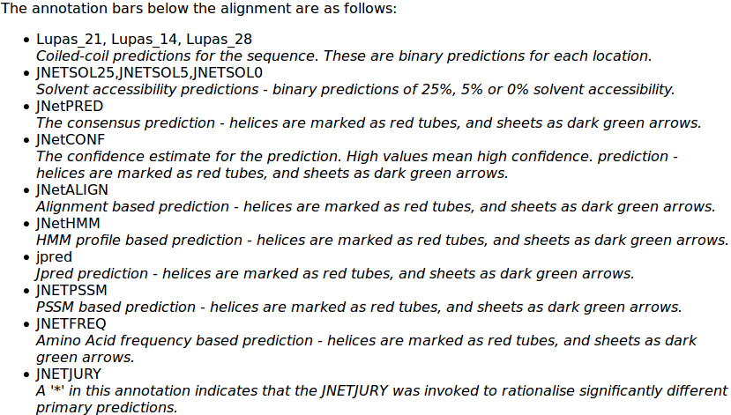
JPred presents the results of running two secondary structure predictions, using the program JNET, based on two different representations of the alignment (HMM and PSSM, similar ideas that will be discussed at some point). Predicted helices are represented as red blocks, predicted beta sheets as green arrows. A consensus prediction is presented (jnetpred) as is an indication of prediction confidence (JNETCONF). Algorithms are also run to predict coiled coils (Lupas, with window sizes 21, 14, 28). The first view of the results offered is a graphical overview aligned with your original single sequence.
The full key to all the abbreviations used (and more information about JNet) can be displayed by clicking on the details on acronyms used link.
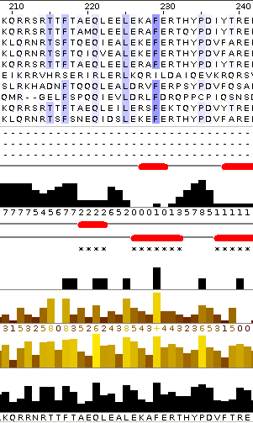
For a fuller view, elect to View results in Jalview. You will arrive at a page inviting you to select from various viewing options. The options are explained clearly, but to save you time reading and pain deciding, I suggest you go for Option 1 for the clearest view. This option does not confuse the picture by gapping your query sequence (and thus making it more difficult to associate structure predictions with regions of the PAX6 protein) and does not force you to look at the entire, huge, MSA generated by PSI-Blast.
Jalview presents something very similar to the original view of the Jpred results. This time though, the most significant part of the PSI-Blast MSA from which the predictions were computed is displayed, if rather blandly.
To highlight the conserved regions of the alignment, some colour is required. Jalview, offers a number of colouring strategies. I refer you to the Help for the full story. Here I will choose what I think is a revealing option with minimal explanation.
From the Jalview Colour pull down menu, select BLOSUM62 Score, to suggest that the inclination to colour any amino acid of the MSA be determined from its BLOSUM 62 score with the corresponding Consensus sequence residue and the quality of that consensus sequence residue. A few of the most highly conserved MSA positions around the homeobox region will now be coloured a watery blue, but otherwise, the display will remain unimpressed.

In order to remove unwanted subtlety, from the Jalview Colour pull down menu, select By Conservation, thus electing for the colour intensity to be reflected by the degree of conservation for each MSA column. A jolly little slider bar will leap forward. Slide the bar to and fro to get a feel for what it is doing. Terminate your oscillations with the minimum value selected, thus demanding that any slight odour of conservation should elicit a maximal colour burst! Clearly appropriate. You can ignore the reference to Groups as you have not specified any, so the entire MSA is regarded as a single Group at this point.
Now, all the regions regarded as even vaguely conserved glow enthusiastically blue. All regions, in this instance, being everywhere a conservation score of “0” or more is recorded. That is, everywhere except where the conservation is represented by a “-” by the conservation histogram.
Slide along the entire width of the MSA and you should clearly see that, roughly, the Paired Box domain, Homeobox domain and the compositionally biased C-terminus are exclusively highlighted.
Here I have included the Jalview version of the MSA and structure predictions around the PAX region
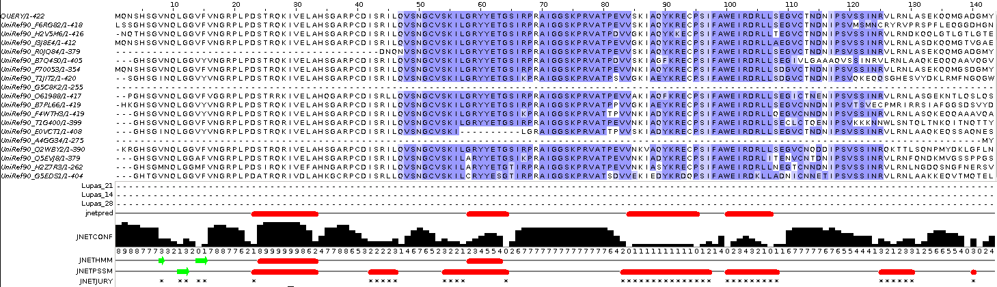
and those around the Homeobox, including some of the C-terminus compositionally biased region.
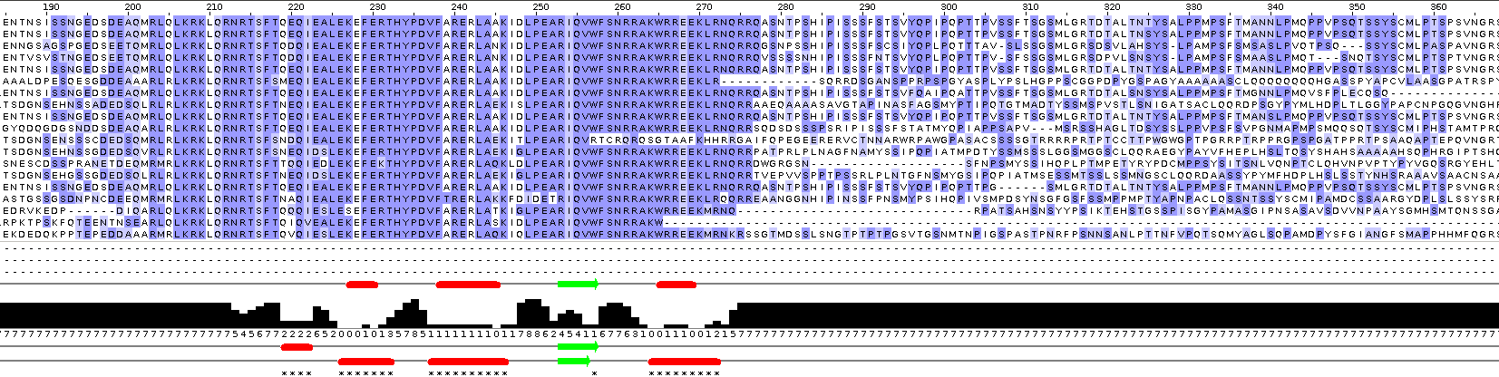
Note that, even though JNET has produced a reasonable secondary structure prediction for the start of the PAX region, Jalview does not consider this region to be sufficiently conserved to colour? Why this might be so will become apparent when you consider the quality of this prediction overall (in a couple of Questions time).
What protein database has Jpred chosen to search for protein sequences for the alignment upon which its predictions will be based?

Why do you suppose this database was used in preference to, say UniprotKB?

Also, I have lined up the entire prediction with the Uniprot Feature Table graphic.
It would appear the helices predicted least confidently by Jpred are the same ones with which GOR IV (investigated in a supplementary exercise) had problems.
How would you rate the Jpred prediction overall?

Protein Tertiary Structure

Protein Data Bank (PDB)
The Protein Data Bank (PDB) archive is the major repository of information about the 3D structures of biological molecules, including proteins and nucleic acids. Structures in the archive range from tiny proteins and bits of DNA to complex molecular machines like the ribosome.
In 1998, the Research Collaboratory for Structural Bioinformatics (RCSB) became responsible for the management of the PDB.

In 2003, the wwwPDB formed to maintain a single PDB archive of macromolecular structural data that is freely and publicly available to the global community. It consists of organizations that act as deposition, data processing and distribution centres for PDB data.

PDBe is the European resource for the collection, organisation and dissemination of data on biological macromolecular structures. In collaboration with the other Worldwide Protein Data Bank (wwPDB) and EMDataBank partners, they work to collate, maintain and provide access to the global repositories of macromolecular structure data (the Protein Data Bank (PDB) and Electron Microscopy Data Bank (EMDB)).
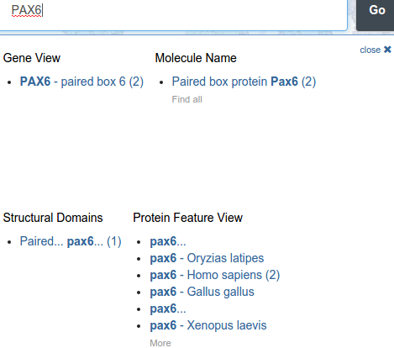
In the course of the exercises undertaken to this point, you will have already had a look at the 3D structures for the 2 major domains of the human PAX6 protein. You might have taken a more direct route to these structures by asking for them directly from the RCSB PDB site as follows.

Go to:
http://www.rcsb.org
Enter PAX6 in the Search box and click on the Go button.
Click on the link under the Molecule Name title..

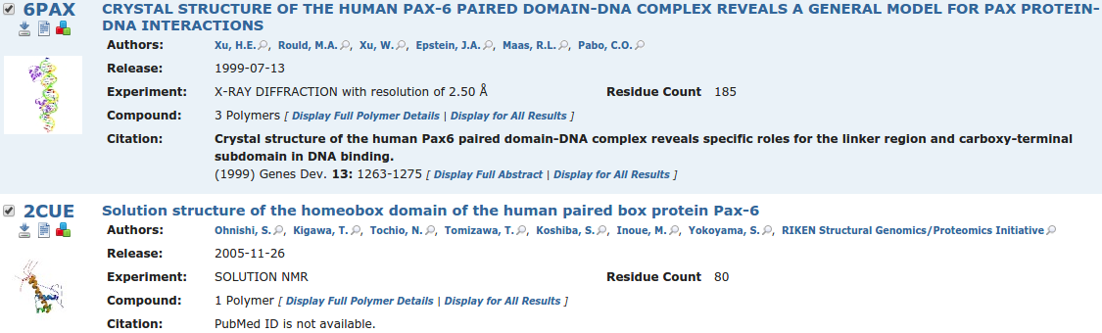
The two PDB structure hits will, hopefully, be familiar. Links are provided with each hit to view the structure with Jmol (a java based structure viewer), view the textual PDB entry and download the PDB entry to a file .
Take a look at the Jmol view of the 6PAX PDB entry. This you have seen this previously, but now I suggest a very quick visualisation of the main mutation that causes aniridia occurs in the PAX protein. The idea is to locate and highlight the Alanine that mutates to a Proline in an aniridia sufferer. As you have discovered, this is the residue 33 in the canonical protein, as recorded by UniProtKB. It is residue 30 in the protein as visualised here, the difference being explained by post translational modification which, in this instance, removes the first three amino acids.
Instructions for using Jmol can be found in many places. For a Quick Guide, you might try:
http://blc.arizona.edu/courses/mcb184/graphics/JmolQuickReferenceSheet.pdf
One place for the full manual is:
http://jmol.sourceforge.net/docs/JmolUserGuide/
Please note Jmol is not the only structure visualisation option available to you, nor is it the most sophisticated. It is just the one used by PDB. Here we look at just the minimum of Jmol skills to see what is required. First notice you can zoom in and out with the wheel of your mouse. You can also rotate the image in all directions using your left hand mouse button. Use these two tricks as needed.
To proceed any further, you really need a console window into which you can type commands. To get a console, choose Console. From the right hand mouse button pull down menu.

In the lower section of the console, select the 30th amino acid with the command:
select 30
Then to make the selected residue more evident, type in the two commands:
spacefill
color cyan
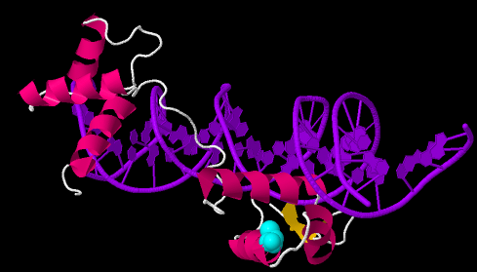
and then manipulate the structure until the selected amino acid can be best observed.


DPJ 2016.12.06
Model Answers to Questions in the Instructions Text.
Notes:
For the most part, these “Model Answers” just provide the reactions/solutions I hoped you would work out for yourselves. However, sometime I have tried to offer a bit more back ground and material for thought? Occasionally, I have rambled off into some rather self indulgent investigations that even I would not want to try and justify as pertinent to the objective of these exercises. I like to keep these meanders, as they help and entertain me, but I wish to warn you to only take regard of them if you are feeling particularly strong and have time to burn. Certainly not a good idea to indulge here during a time constrained course event!
Where things have got extreme, I am going to make two versions of the answer. One starting:
Summary:
Which has the answer with only a reasonably digestible volume of deep thought. Read this one.
The other will start:
Full Answer:
Beware of entering here! I do not hold back. Nothing complicated, but it will be long and full of pedantry.
This makes the Model answers section very big. BUT, it is not intended for printing or for reading serially, so I submit, being long and wordy does not matter. Feel free to disagree.

From your investigations of Protein Secondary Structure Prediction with Jpred
Some Notes on colouring the MSA generated by Jpred: (Click here to return to the Instructions.)
Mostly to remind me why and how I decided to colour the MSA as I did. My objective was purely to make obvious where the family of proteins were meaningfully similar. If you are happy that this objective was achieved, it is probably best to read no further.
I discovered most of what follows by Selecting the Help (easiest way is to press F1 key, otherwise there is a pull down option at the top of the display, choose Documentation option) and searching for “conservation”. From the list of hits, I first selected “Alignment Conservation Annotation”. There it says:
“Conservation is measured as a numerical index reflecting the conservation of physico-chemical properties in the alignment: Identities score highest, and the next most conserved group contain substitutions to amino acids lying in the same physico-chemical class.
Conservation is visualised on the alignment or a sequence group as a histogram giving the score for each column. Conserved columns are indicated by '*' (score of 11 with default amino acid property grouping), and columns with mutations where all properties are conserved are marked with a '+' (score of 10, indicating all properties are conserved).
Mousing over a conservation histogram reveals a tooltip which contains a series of symbols corresponding to the physico-chemical properties that are conserved amongst the amino acids observed at each position. In these tooltips, the presence of ! implies that the lack of a particular physico-chemical property is conserved (e.g. !proline).”
I think to understand the detail of the scoring, one would have to read the paper quoted in the Help. I think I will leave that until another day! For now, I just make a few notes.
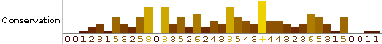
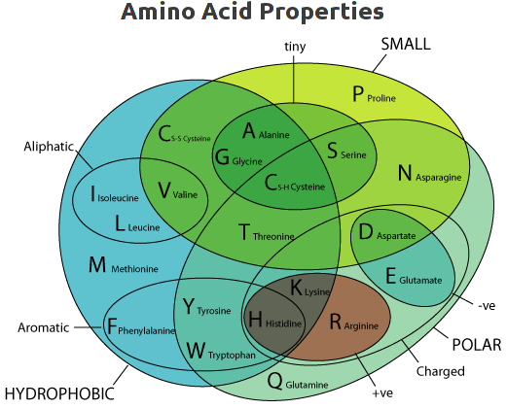
- The numbers under the histogram columns appear to represent simply the number of phsico-chemical properties considered to be conserved. At least, this is consistently true for this example, shown by hovering the mouse over the histogram columns.
- Jalview admits to exactly 10 phsico-chemical properties that must be one of “Not conserved”, “positively conserved” or “negatively conserved”.
ILVCAGMFYWHKREQDNSTPBZX-
XXXXXXXXXXX·······X···XX Hydrophobic
········XXXXXXXXXX·XXXXX Polar
··XXXX·········XXXXX··XX Small
···················X··XX Proline
····XX···········X····XX Tiny
XXX···················XX Aliphatic
·······XXXX···········XX Aromatic
··········XXX·········XX Positive
·············X·X······XX Negative
··········XXXX·X······XX Charged

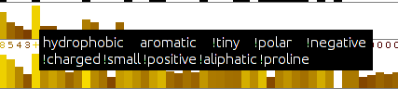
- The column achieving a “+” has all 10 conserved phsico-chemical properties either positively or negatively conserved. It is a highly, but not completely conserved “F”. This would appear to agree with the Help? There is no example of a 100% conserved column in this example. If there was, I would expect it would be represented by a “*” representing a score of 11.
- Conservation of any given property does not have to be 100% and gaps are tolerated. Reasonable as to be too exacting would eliminating. I expect the details are explained in the original paper. I justify this statement, unnecessarily, by claiming there are both gaps and a Proline in the column represented by a “+”.
- I am still uncertain about the difference between a “0” column and a “–” column? I decide to believe they are both columns were there is no measurable conservation, but “0” columns are in regions where they are surrounded by significant conservation? One day, I will read the paper.
- By observation, it can be seen that “conservation” is measured relative to the consensus sequence rather than the query sequence. This seems a reasonable choice to me.
Well that was fun? Now I write some instructions to turn the nasty bland alignment into one that glows blue.
Click here to return to the Instructions.
What protein database has Jpred chosen to search for protein sequences for the alignment upon which its predictions will be based?
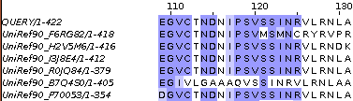
The database Jpred instructed PSI-blast to use to seek proteins homologous to the PAX6 query can be determined by looking at the sequence identifiers displayed down the left hand side of the alignment in Jalview. The identifiers are constructed from the name of the database and the entry identifier separated by an underline character. So the database is the UniRef90 cluster database built from the UniProtKB database.
The UniRef cluster databases comprise entries that are not individual protein sequences, but cluster of similar sequences. In the case of the UniRef90 database, each entry includes all sequences 90% identical to a given seed sequence. A representative sequence is elected as the only one of the cluster to be considered by such as PSI-blast, but clearly, a hit with any representative sequence implies significant similarity with all the sequences of its cluster.
I offer a supplementary exercise to investigate these cluster databases for those to whom they might be of particular interest.
Why do you suppose this database was used in preference to, say UniprotKB?
The reason Jpred runs PSI-blast is to identify sequences representing as wide a family of proteins as possible, to which a Query sequence belongs. For the purpose of structure prediction, there is little value in this collection including many sequences that are essentially identical. A wide variety of sequences, as long as they still are likely to be homologous, is of far greater value than a huge number of sequences. Using a UniRef database allows that only the Representative sequence of each cluster of very similar sequences will be recognised and aligned by PSI-blast. This allows the PSI-blast MSA to include an extensive range of variation without being bloated by sequences too similar to be individually interesting.
How would you rate the Jpred prediction overall?
Well, frankly, not as wonderful as I was expecting. Better than GOR IV (investigated in a supplementary exercise), but still leaves room for improvement? jnetpred (essentially the answer) is reasonable. It misses a couple of helices including one that GOR IV also overlooks. However, it has considerably less false positive prediction tendencies than GOR IV. The JNETHMM predictions are particularly poor, saved by the much more accurate deliberations of JNETPSSM.
JNETHMM is a prediction computed from the Hidden Markov Model (HMM) representation of the final PSI-blast MSA.
JNETPSSM is a prediction computed from the Position Specific Scoring Matrix (PSSM) representation of the final PSI-blast MSA. PSI-blast uses PSSMs of the MSA of each iteration of its search as a Query for the next iteration.
The jnetpred prediction is effectively the consensus of the predictions of JNETHMM and JNETPSSM.
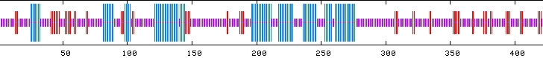
Here I have aligned the GOR IV and Jpred predictions with the secondary structure as recorded by UniProtKB.
So, can the prediction be improved? Jpred is better than this result suggests!
On reflection, maybe just throwing in the entire sequence of PAX6_HUMAN and hoping for the best was a little crude? Our protein has two major domains whose secondary structure one might expect to be conserved. PSI-blast will gather together a mountain of sequences that have one, or the other, or both of the domains and try to align them as if they were homologous over their entire length (a global alignment). BUT, they are not all globally homologous! This means that the alignment of both the domains regions will be polluted by sequence that represent proteins that do not include that domain. This must substantially reduce the quality of the prediction?
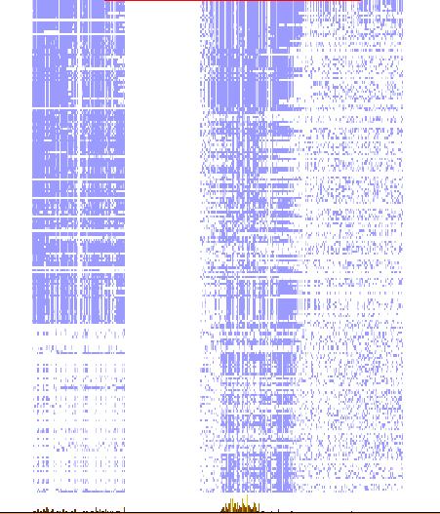
This phenomena can be illustrated by choosing to view the Jalview Overview Window (available from the View pull down menu).
The wider column of blueness at the start of the alignment represents the paired box domains. The picture suggests about one third of the aligned sequences do not have a paired box domain, but those sequences will have unrelated sequence in that region that will reduce the degree to which the alignment represents the properties of a paired box and so also the likelihood of a sensible structure prediction.
The problem for the more common homebox domain looks less severe, however, the alignment clearly includes many sequences that do not look to have a homeobox domain.
So, what to do? I suggest the two domains might be investigated separately? Why not run Jpred twice, once with just the PAX6_HUMAN paired box region and then again with just the homebox region.
I have done this for you and will now show you the results, however, should you wish to try it yourself, you already have the isolated sequence of both domains saved in local files. The sequence of the paired box region should be in a file called pax_domain.fasta. The homeobox sequence should be in a file called homeobox_domain.fasta. Run Jpred again with each sequence and you should get results very similar to mine.
First the new paired box prediction (top) compared to the original (bottom).
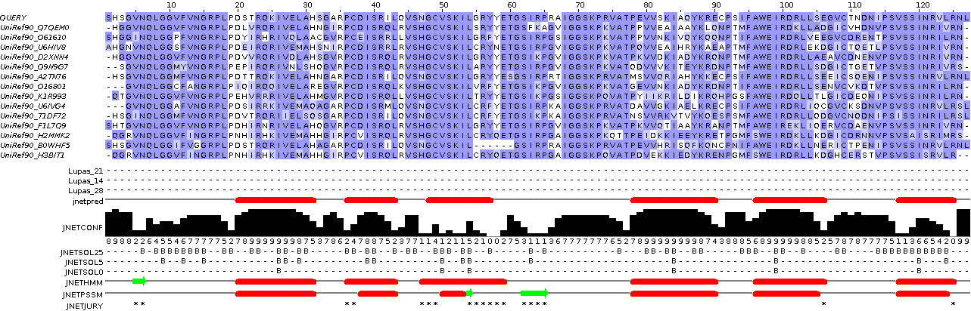
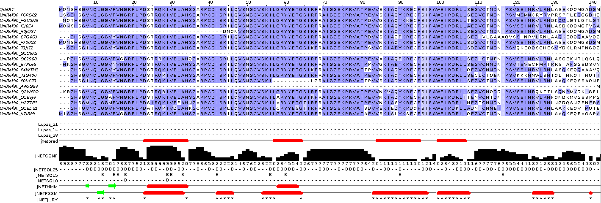
Massively improved I would suggest. All helices present and accurately placed. The JPREDHMM prediction, in particular, is very much improved. The Beta Sheet predictions seem weak? It finds only one (accurately) of the three that UniProtKB suggests to be present. I wonder why, but the helices for the paired box domain specific prediction are excellent.
And so to the homeobox specific results. Once more, the new homeobox prediction (top) compared to the original (bottom).
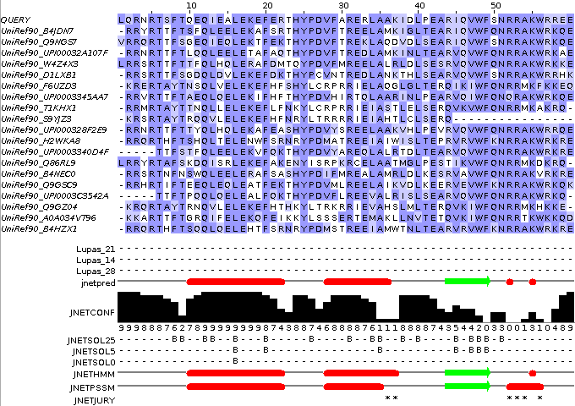
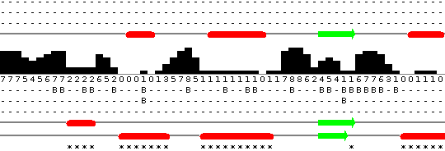
As the homeoboxs are significantly more numerous than the paired boxs, less interference from sequences not including a homeobox might have been expected. I imagined the improvement in prediction would be minimal. However, it is very much better! All three helices are predicted in the correct positions, although Jpred appears to be a little reluctant about the third helix? There is a rather strong beta sheet prediction that is unsupported by UniProtKB. There is no reason to suppose that UniProtKB is 100% correct, of course, but nothing I can find suggests that a beta sheet should appear in the middle of a homeobox. An enigma for another day.
So I conclude that this sort of protein analysis requires a little bit more than just throwing an entire sequence at a dumb program and assuming something marvellous will occur. In this case, considering the regions of the protein that are expected to be homologus separately is a very logical thing to do (and entirely obvious, retrospectively at least). Geoff Barton, whose group is responsible for Jpred agrees. He says:
“ … Always split proteins into domains when searching. … ”
So for both domains the prediction of the helices is far more accurate when each domain is considered separately. However, it is not just the red bars indicating the position of the helical predictions that should be noted. Look also at the confidence histogram. It indicates clearly that with more specific data to work on, better predictions can be made with much improved confidence (i.e. likelihood of being correct!).
DPJ – 2016.12.09

If the wait becomes unbearable, consider opening a new window/tab and moving on to the next section, returning to Jpred later.
Should that not work, try Full HTML.
I have made some notes on my choice, but they should not really detain you at his point. If you insist, they are here.
This could be why, as noted in the instructions, the start of the PAX region was considered insignificantly conserved by Jalview.
As does the Jpred Help.

