

Introduction to Bioinformatics

23-27 March 2020

Practical 1: Databases and Tools
Part ii) – Aniridia from Ensembl

Sunday 26 April 2020
Investigating the gene(s) associated with Aniridia using Ensembl
As previously, the starting point for this exercise is to imagine you have a vital interest in discovering and investigating the main human gene responsible for the terrible disease of the eye, Aniridia. This time, however, we will investigate the topic as recorded by the Genome Database Ensembl.

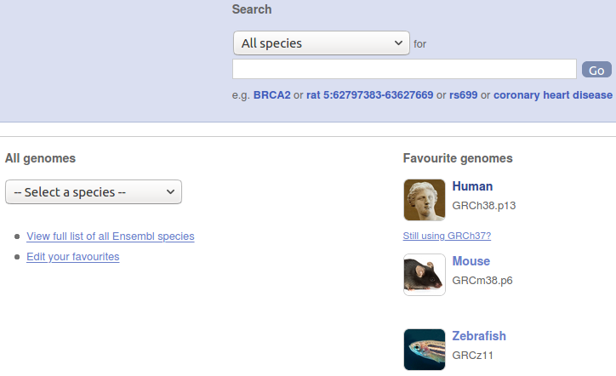
So, begin by going to the Home Page of Ensembl.
A good way to start would be to select a species, Human being the pertinent choice. Accordingly, click on the Human option in the list of Favourite genomes.
Why Ensembl should imagine my Favourite genomes are Human, Mouse and Zebrafish I cannot imagine? I have deep reservations concerning both Mice and Humans, and I have never been formally introduced to a Zebrafish and so am inclined to be of “open mind” for the present.

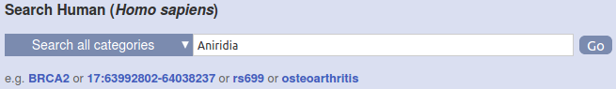
Following the well worn path of the NCBI investigation, enter Aniridia into the Search Human (Homo Sapiens) box and click on the Go button.
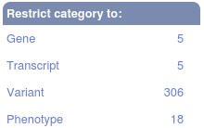
You will arrive at a page offering access to an assortment of data items that relate to Aniridia. These include a link to 5 Genes. As it is the Genes that are of prime interest here, why not click on the aforementioned 5 Gene link in the Restrict category to: section?

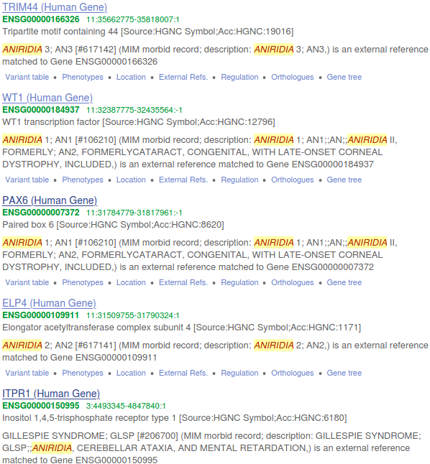

A list of matching Genes bustles forth energetically. Admittedly in a different order, but 4 of the 5 Genes selected were also chosen by the NCBI. Pretty good agreement so far. Once again, it is PAX6 that is of most interest (although relegated from second to third position by Ensembl).
So, click on the PAX6 (Human Gene) link to see the Ensembl version of the details of PAX6.

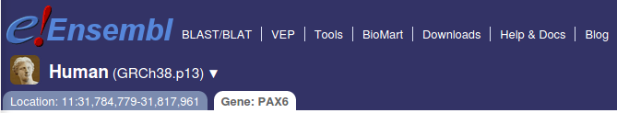
First a quick glance at the top of the page. As you will assuredly recall from our meander through the wonders of the NCBI, the Assembly of the Human Genome analysed at the NCBI is GRCh38.13. As this is the most up to date version, it is not surprising that it is also the Assembly that Ensembl uses.
Both sites use the same, universally accepted Assembly of the Human Genome. This Assembly is updated regularly and the most recent version is the “raw data starting point” for both databases. The analysis of that shared “starting point” at the NCBI and at Ensembl is, however, completely independent. It is the difference in “interpretation” of the same Assembly that we investigate in the early stages of these exercises.
The conflicts begin at once! Both agree upon Chromosome 11, although Ensembl does not mention the band (becoming a legacy concept perhaps?), but the precise region of Chromosome 11 assigned to PAX6 by the NCBI is, as I feel sure you do not need me to remind you:
31,784,792 - 31,817,961
Whereas, Ensembl speculates:
31,784,779 - 31,817,961
Maybe Ensembl sees a PAX6 transcript that reaches a bit farther than its most adventurous NCBI counterpart?
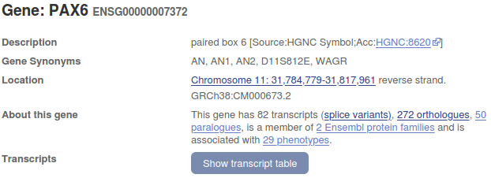
At the top of the Gene: tab, Ensembl declares the internal name for this Gene as a generously zeroed, ENSG00000007372 (equivalent to 5080 at the NCBI, as surely you recall). Why so many leading zeroes? Well … there was a time when it was thought there would be one or two more Genes hiding away in the Human Genome than turned out to be the case. Better safe than sorry, opined the Ensembl designers. ENSG? Stands for ENSembl Gene, but you worked that one out for yourselves, I am certain.
Determining the number of Transcripts is easy. 82, it boldly declares in the About the gene section at the top of the Gene: PAX6 tab.
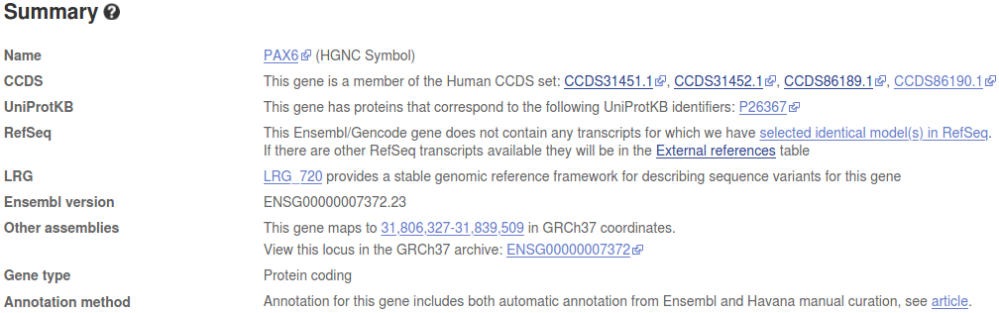
The CCDS (Consensus CoDing Sequence) Database is comprised of CDS (CoDing Sequences, currently just for Human and Mouse) that are agreed by all the major players (including Ensembl and NCBI, of course) concerned with Genome Analysis.
In the Summary section, this gene claims membership of four CCDS families.
A CCDS family being a collection of Gene transcripts sharing the same CCDS approved CoDing Sequence (CDS). Put another way, Transcripts coding for the same isoform? I reason that Ensembl predicts FOUR quality isoforms for PAX6.
Feel free to click around further here if you have the inclination, but … be warned that here the story gets complex beyond the needs of this simple exercise. Simple questions leading to answers that require much disentangling. Such is the way of things.
Were you now to click on the Show transcript table button, you would be offered a cornucopia of further detail.
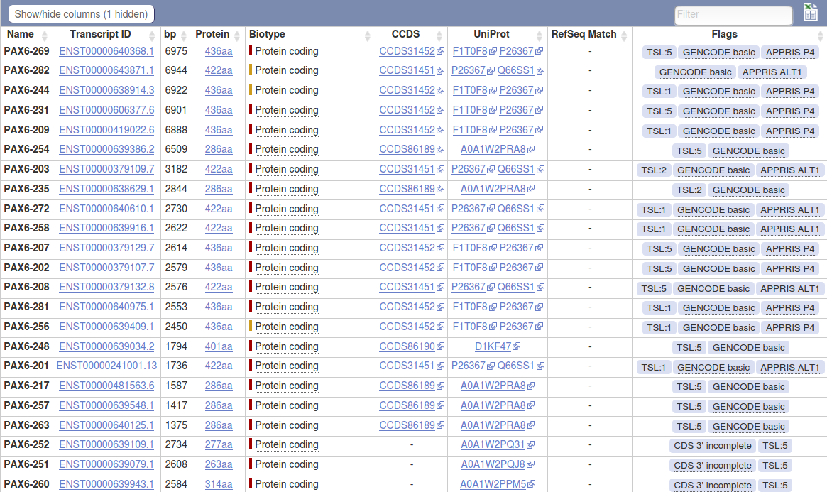
At the top of the table are all the best quality Protein coding Transcripts that belong to CCDS Database Families.
There follows many more “Protein coding” Transcripts, predicted to exist by Ensembl, but not matching any of the agreed CoDing Sequences (CDS) in the CCDS Database.
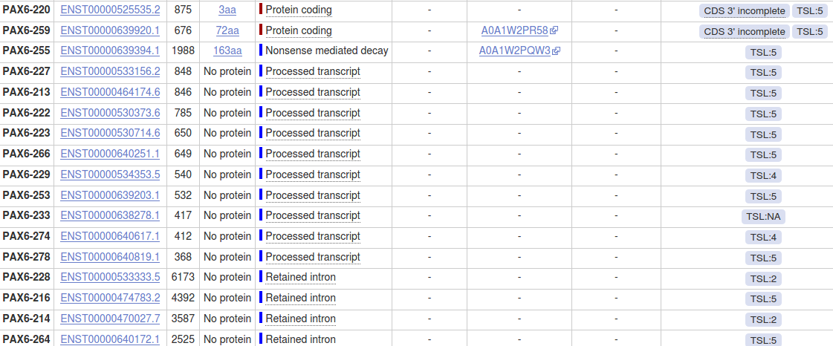
The last Transcript recorded as coding for a protein declares itself as “Nonsense mediated decay”? The official answer to your question is revealed below, but I have to admit that my understanding remains short of full enlightenment.
This Transcript codes for a protein of 163 amino acids that is recorded in the Uniprot Databases with an Accession Code of A0A1W2PQW3. This, I opine, puts it a mite closer to rationality than the Transcript two entries above that codes for a protein of 3 amino acids that has no Uniprot entry?
The remaining Transcripts are of Biotype “Processed transcript” or “Retained intron”.
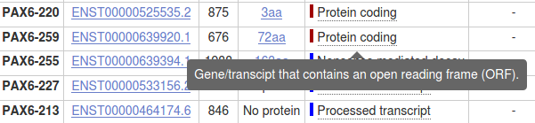
For a clearer explanation as to what the various Biotype possibilities might mean, just hover your mouse over the terms and a pop up will pop up and explain.
“Protein coding” is really self explanatory. A Transcript with an Open Reading Frame that gives rise to a protein.
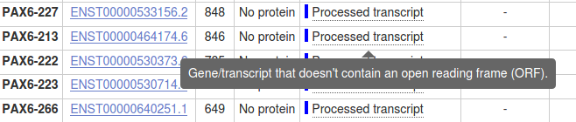
“Processed transcript”. A Transcript that generates an RNA that does not code for a protein.
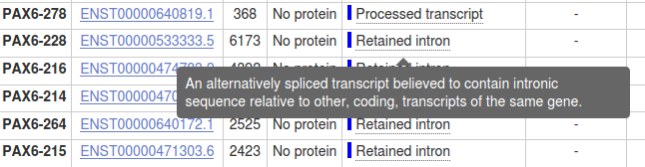
“Retained intron”. A “Protein coding” Transcript whose function has been disrupted because one or more introns have not been successfully spliced out. An RNA is produced, but no protein.

And what of the enigmatic “Nonsense mediated decay”? No pop up, pops up! and we are left to wonder. But, fear not, a suitable pop up is in the planning stage. In the meantime, explanations of all possible Biotype values are available online. Here one can discover that the elaboration of “Nonsense mediated decay” is:
“If the coding sequence (following the appropriate reference) of a transcript finishes >50bp from a downstream splice site then it is tagged as NMD. If the variant does not cover the full reference coding sequence then it is annotated as NMD if NMD is unavoidable i.e. no matter what the exon structure of the missing portion is the transcript will be subject to NMD. ”
Gulp!
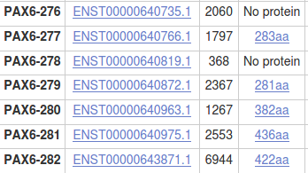
If you wished to check the Transcript count, you might click on the Name header to order the Transcripts by their identifying number. The numbers range from 201 to 282 confirming 82 Transcripts. Jolly good! You might wonder why the numbering starts at 201? “Where are the first 200 Transcripts?” one might ponder. The answer is historical and of no real interest any more. As far as I am aware, there are no current plans to make the naming scheme less whimsical, so why not just accept what is.

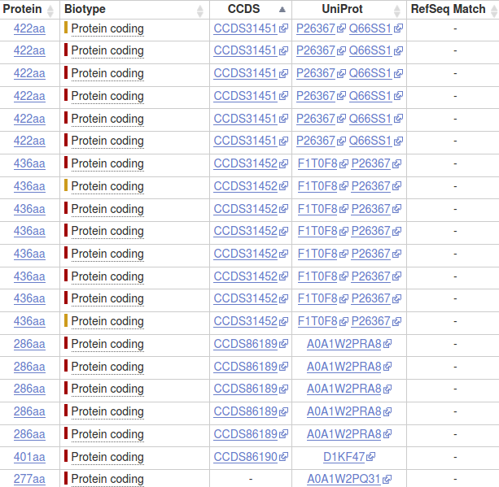
If you wished to checked the CCDS family associations of the quality coding Transcripts, you might click on the CCDS header to order the Transcripts by their CCDS family.
A trifle tedious, but it is now a simple matter to discover how many Transcripts correspond to each CCDS family (and so to each quality isoform).
Logically, each CCDS family should (of course?) correspond to just ONE entry in the protein sequence databases of Uniprot. However, two of the families displayed here relate to two proteins sequences each!! Why this is possible will become clearer when we discuss Uniprot in greater depth. If you cannot wait that long, click HERE for a brief explanation.

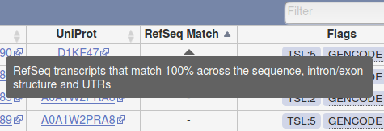
Hover over the RefSeq Match header. It will be revealed that this column exists to record RefSeq Transcript Sequences that match Ensembl Transcript predictions in every locational respect.
ALL exons and introns, including those in UnTranslated Regions (UTRs), must be identical. A substantial objective of this exercise is to highlight the ways in which alternative examinations of the same data (a shared Assembly of the Human Genome in this case) can give rise to conflicting conclusions. Here is an example where the NCBI an Ensembl attempt to achieve a level of agreement.
Exclusively for the Human Genome, these two Institutes have set up The Matched Annotation from the NCBI and EBI (MANE) project, the objective of which is to identify one quality Transcript per Protein Coding Locus that is predicted identically by the differing analytical methods of both services.
Click on the RefSeq Match header. This would bring all the Transcripts with Refesq Matches to the top of the column … if there were any! However, it is clear there are NO RefSeq Transcripts that exactly match ANY Ensembl Transcripts for PAX6! The MANE project is relatively new. Currently they claim to have found Matching Transcripts for around 70% of Human Protein Coding Genes, but not yet PAX6.
To view less stringent associations between the Transcript predictions of the NCBI and Ensembl, click on the External references link to be found in the PAX6 Summary section, RefSeq subsection.
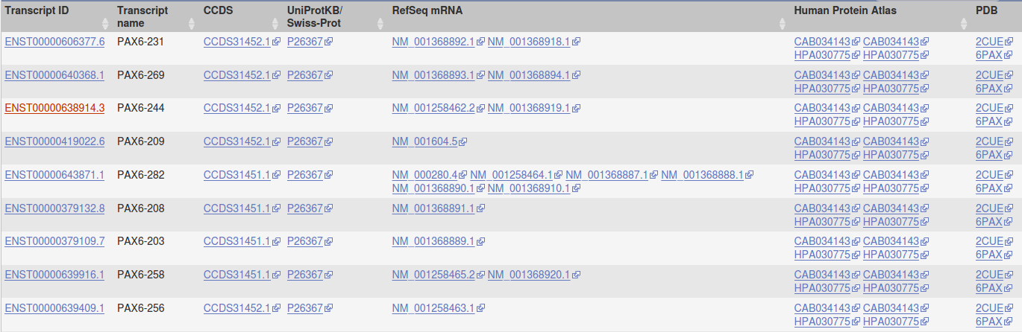
Slide down the page a wee bit and you will come to a table with many superficial similarities to the Transcript Table you have just been examining.
This time, many good quality (NM_) NCBI Transcripts are referenced in the RefSeq mRNA column. In this table, 100% matching is not required. The RefSeq Transcripts only have to agree enough to contribute credibility to the Ensembl assertion that one, or more, exons exist. The RefSeq mRNAs are supportive evidence for part(s) of the Ensembl prediction, not the same entire prediction using different analytical methods.
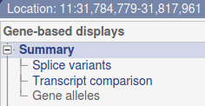
Next, back up a bit. Click on the Summary option from the Gene-based displays offered at the top of the Location tab of your current page.

Slide down a trifle until you come to a graphical representation of the Transcripts of all Genes in the PAX6 region.
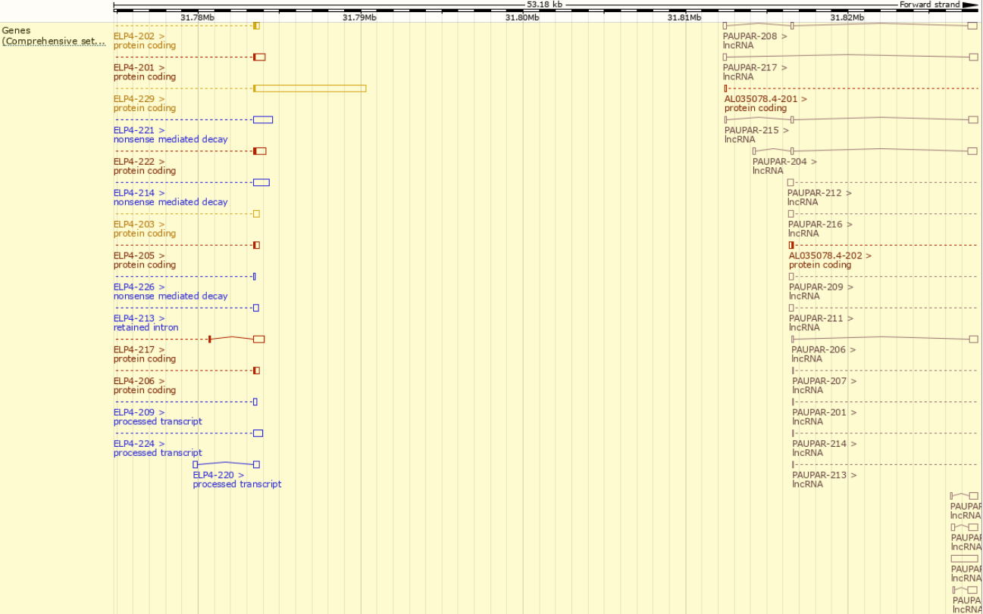
The general arrangement is very similar to that seen at the NCBI site. Transcripts are represented horizontally with “blobs” representing the Exons joined by lines representing the Introns.
“blobs” that are coloured in code for Protein. “blobs” that are empty do not code for Protein.
The top part of the display represents the forward strand of Chromosome 11, that does not include PAX6. Ensembl does not reverse their displays to reflect the strand of the Gene in focus, as does the NCBI.
This top strand paints a different and more complex picture than was seen at the NCBI. Specifically:
- ELP4 has many more than the three Transcripts claimed by the NCBI.
- PAX6-AS1 has disappeared altogether!
- PAUPAR is claimed to overlap the PAX6 region by Ensembl and to be far longer and more complex than claimed by the NCBI.
- AL035078 appears from nowhere!!! This is a “novel protein”. It has appeared since the last Assembly of the Human Genome. I upsets my story!! I will ignore it in the hope it will go away!!
Mostly for fun (???), I investigated the loss of PAX6-AS1 and concluded that Ensembl does still predict its existence, but as a Transcript of PAUPAR and not a separate Gene.
I strongly suggest you just accept this, as it is not so important. However, if you wish to share the several hours of pain I endured coming to this conclusion, feel free, however, I strenuously advise against this diversion, unless you are really desperate for something to do.
Moving down to the PAX6 strand. Notice the region on display is the PAX6 region, plus a bit either side. Note that just 6 of the 82 Transcripts appear to have the very big terminating Exon that the NCBI predicts for all its Transcripts.
Note the line (Track is the official term), labelled Contigs, that lies on top of all the PAX6 Transcript lines. These Contigs are the sequences of random sections of the Human Genome, separately sequenced and then assembled to determined the sequence of entirety of Chromosome 11. The Contigs are coloured alternately light blue and dark blue in the order of their Assembly to form the Chromosome. Later, there will be further discussion of these “Contigs” and their role in the sequencing large Genomes around the era of the Human Genome Sequencing Project (HGMP). For now, just note that the PAX6 region seems to involve the overlap between just two Contigs.
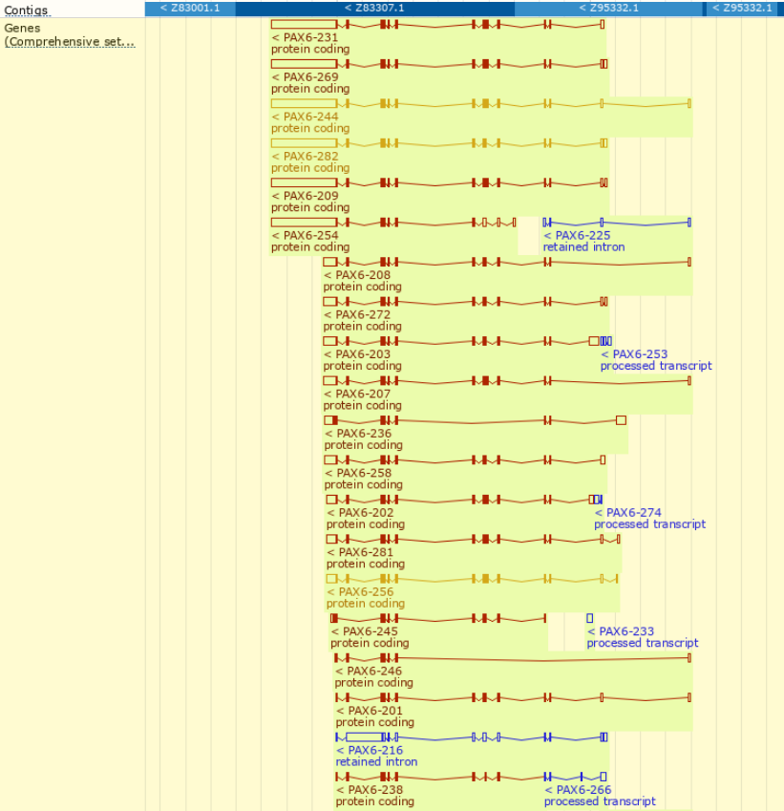
For all organisms, Ensembl employs an entirely automated strategy for predicting Protein Coding Transcripts. The Automatic Gene Annotation Pipeline, involves running a series of computer programs (a pipeline), completely unsupervised, to detect and annotate interesting features.
For a restricted number of major organisms (currently Human, Mouse, Zebrafish and Rat), a second, manual strategy is available. Manual Annotation by the Havana Team, involves running further program pipelines in conjunction with Human Examination of a wealth of other information including data from publications. Only the manual methods can predict non-coding Transcripts.
Where manual annotation is available (as it is here), the predictions of the two strategies are merged, and displayed as above.
Where Protein Coding Transcripts are predicted by one or the other predictive startegy, but not both, the Transcript is coloured Red. When both strategies agree on all the important features of a Protein Coding Transcript, it is coloured Gold.
All the Blue Transcripts are some variety of non-coding Transcript. All Blue Transcripts must be predicted by Manual Annotation methods.
Should it become, for whatever bizarre reason, interesting to discover which annotation strategy predicted a specific Red Transcript, one might click on the Transcript representation. A pop up window of enlightenment will sally forth. Right at the bottom there will be a Source line which will claim Ensembl for a purely Automatic prediction or Havana for a purely Manual prediction. All the Gold Transcripts will declare Ensembl/Havana merge. All the Blue Transcripts will, of course, be Havana.
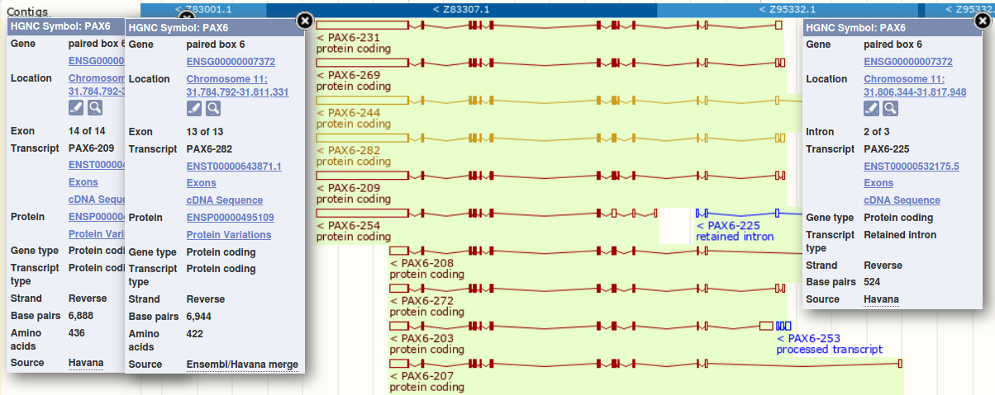
In this case, I could not find any Red Transcripts that declared their source as “Ensembl”. Just 2 Transcripts were Gold and so “Ensembl/Havana merge”. So it looks like the Automated Annotation Pipeline predicted just 2 Protein coding Transcripts, both of which were confirmed by Havana Manual Annotation strategies.
The database searches used as the fundamental strategy to identify Transcripts take a very long time to execute, even given the immense computing resources available to the NCBI and the Ensembl teams. Some clever strategies are employed to minimise the time spent on these searches. Only for those who find such things “interesting?”, I include an Appendix to discuss the some of the ways Ensembl design their pipelines for the Human Genome for maximal efficiency (and a few related issues). Feel free to skip this Appendix if you have better things to do.

Finally, for later analysis we need to save the

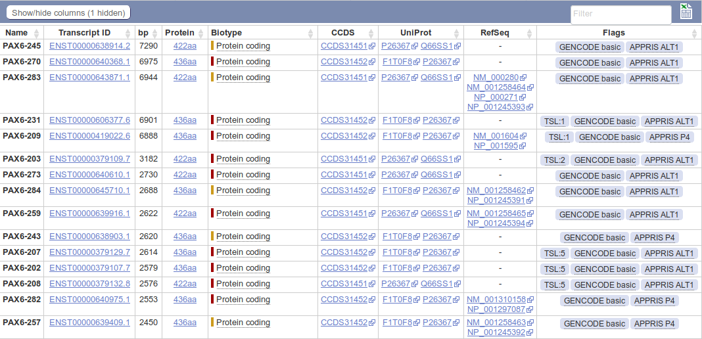
For a more detailed view of the predicted transcripts, click on the link. The transcript predictions are now presented in the form of a table. The protein coding transcripts are all at the top of the table. I counted 56, but I would not claim to be completely accurate, I wavered half way down the list! Lots more than the NCBI anyway.
Ensembl uses both the sequences of RefSeq mRNAs and those of their protein products (the RefSeq entries whose Accession Codes commence NP_) to predict transcripts, however, Ensembl appears to have less blind faith in the accuracy of these data than the NCBI.
Note: There is no “one to one” correspondence between RefSeq mRNAs and transcript predictions. All 11 RefSeq mRNAs are referenced, but two are used to support the single third transcript in the list. If Ensembl regarded RefSeq mRNAs as “perfect” (as the NCBI appears to do) this would clearly be nonsense! We should discuss why it is reasonable not to not to accept the infallibility of a RefSeq mRNA matches with the Genome.
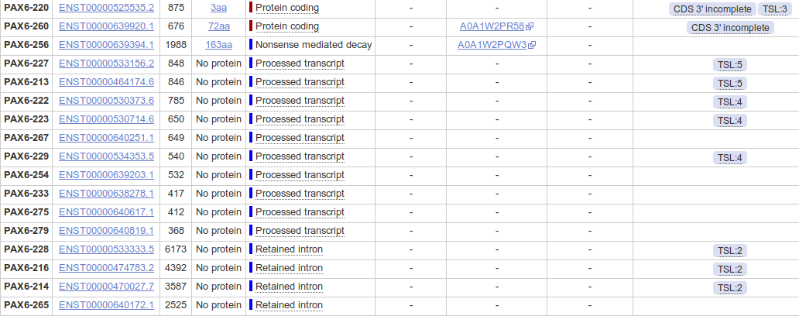
Looking further down the list you will see that many Ensembl protein coding transcripts are predicted without reference to any RefSeq entry.
Hover over the evidence Flags associated with the transcript predictions towards the end of the list. How reliable would you judge these predictions to be?
We could go on. Other sources (not necessarily Genome Databases) would count the transcripts differently again. Perhaps the best answer to the question “How many transcripts are there for the PAX6 gene” is “Several”.

The next investigation might be to discover “How many protein isoforms might there be for PAX6?”.
Well, whilst the Ensembl transcript list is still in view, glance down the Protein column which displays the size of the protein products for each transcript. Clearly insufficient evidence for a serious isoform count, but enough to set a lower limit, as the same isoform cannot be more than one length! If there were not so very many! One might count how many different lengths of proteins were listed. I tried to do this, but I gave up around twenty-something. Let us be content to declare that there are lots. The most likely looking ones are either 422 or 436 amino acids long. Some of the others might cause a raised eyebrow or two, especially the one that is 3 amino acids long (third from last Protein coding entry in the list)? But, who are we to question! Lots is the informal Ensembl minimum total.
Click your way back to the NCBI PAX6 gene entry. So, now to discover the number of protein products (isoforms) that the NCBI predicts. This view makes this simple question clumsy to answer as the protein products of each transcript are reported separately (as they are by Ensembl), even when they are identical???
However, it can be done. Click on the NCBI Reference Sequences (RefSeq) link in the Table of contents on the right hand side of the page. Focus on the mRNA and Protein(s) sub-section. Skim down the entries for every transcript. Check the different isoform names. I see:
01 - NM_000280.4 → NP_000271.1 paired box protein Pax-6 isoform a
02 - NM_001127612.1 → NP_001121084.1 paired box protein Pax-6 isoform a
03 - NM_001258462.1 → NP_001245391.1 paired box protein Pax-6 isoform b
04 - NM_001258463.1 → NP_001245392.1 paired box protein Pax-6 isoform b
05 - NM_001258464.1 → NP_001245393.1 paired box protein Pax-6 isoform a
06 - NM_001258465.1 → NP_001245394.1 paired box protein Pax-6 isoform a
07 - NM_001310158.1 → NP_001297087.1 paired box protein Pax-6 isoform b
08 - NM_001310159.1 → NP_001297088.1 paired box protein Pax-6 isoform c
09 - NM_001310160.1 → NP_001297089.1 paired box protein Pax-6 isoform d
10 - NM_001310161.1 → NP_001297090.1 paired box protein Pax-6 isoform d
11 - NM_001604.5 → NP_001595.2 paired box protein Pax-6 isoform b
I count 4 different isoforms, imaginatively named Isoform a, Isoform b, Isoform c and Isoform d. One associated with each transcript description. Look carefully at the annotations and there is more information. In particular:
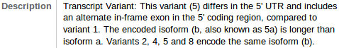
Description: Isoform b is also known as Isoform 5a. Why this is interesting will become apparent in a page or so.
Isoform b is also reported to be longer than Isoform a.
Conserved Domains:

Both Isoform a and Isoform b are recorded as having two domains. A Paired Box Domain at the beginning, and a Homoebox Domain further along.

Both Paired Box Domains are primarily indicated by a hit with the relevant entry in the SMART database. Both Homeobox Domains are supported by matches with Pfam database entries. Other domain databases will almost certainly provide supporting evidence, but reference to just one match is sufficient here.
From the location information, the Paired Box of Isoform b appears to include an extra 14 amino acids.
+++++++++++++++++++++++++++++ END HERE +++++++++++++++++++++++++++++++
Discussion Points and Casual Questions arising from the Instructions Text.
Notes:
Work in progress I fear.
The intention is to provide a full consideration of some issues skimmed over in the exercise proper.
If you are attending a “supervised” presentation of the exercise, I would hope to have conducted a live discussion of all these issues to an extent that reflects:
- the depth that seems appropriate
- the time available
- the degree to which the issues seem to match the interests of the class
- how many of you are awake
Here, I hope to write out very full answers were such a response exists. Accordingly, I suggest you will not need to read much of many of these discussions. There will be much detail of interest to rather few of you. Possibly a bit self indulgent, but I wish to make a note of all the background I have discovered while writing these exercises.
In a nutshell, the exercises are trying to make very general points avoiding too much detail. Nevertheless, I record the detail outside the main exercise text, just in case it might be if interest. Some of the answers to the “Casual Questions” are exceedingly trivial. Some of the “Discussion Points” are exceedingly long and rambling. You have been warned.

******************************* NEW STUFF *******************************

Can a single CCDS Family correspond to more than one Protein from UniProtKB?
All Transcripts belonging to a given CCDS Family, by definition, share exactly the same CoDing Sequence (CDS).
Therefore, all Transcripts belonging to a given CCDS Family must code for the same Protein isoform.
As touched upon in one of the introductory videos for this exercise, UniProtKB strives to be non-redundant, that is, no protein should be represented more than once.
Therefore, all Transcripts belonging to a given CCDS Family should correspond to one and only one Uniprot entry (all CCDS Protein isoforms will certainly be included in UniProtKB).
As touched upon in one of the introductory videos for this exercise, this is true, but only if one considers solely the fully annotated section of the Uniprot Protein Sequence Database (Swissprot).
However, as the video explained, UniprotKB has two sections:
Swiss-Prot Comprised of Proteins that have been fully “Manually annotated” with “information extracted from literature and curator-evaluated computational analysis”.
TrEMBL Comprised of Proteins determined only by “Computational analysis”. These “await full manual annotation”. After such “full manual annotation” a TrEMBL entry will be discovered to be nonsense (and deleted), a duplicate of something already in the Swiss-Prot section (and deleted), or a truly worthy newly discovered Protein deserving of instant promotion to the Swiss-Prot section.
So, it might be the case that a protein could exist, for a short time, both in TrEMBL and in Swiss-Prot. As soon as the TrEMBL version is properly examined and determined to be a duplicate of an extant Swiss-Prot entry, it will be eliminated. However, should the CCDS Families be annotated during the time of duplication, some CCDS Families might well appear, erroneously, to match two proteins.
That is what has happened here in the case of two of the four PAX6 CCDS Families.
Of course, none of this will be new to you as you watched my lovely video carefully? Only very very BAD people who skipped the video will read the above as novel information.
Click Here to Return to the Exercise →
Special Warning! This is long and only of peripheral value. Before you start reading all that follows, please realise it is not really part of the exercise. It is just notes to justify my theory explaining the non-existence of PAX6-AS1 in the Ensembl view of the PAX6 region of the Human Genome.
A record for me? Of interest only to the more pedantic of you. Continue at your own peril, or hurry back to the main exercise instructions (recommended!). Click Here to Return to the Exercise →
PAUPAR and PAX6-AS1 – seen differently from the NCBI and Ensembl.

The NCBI Story:

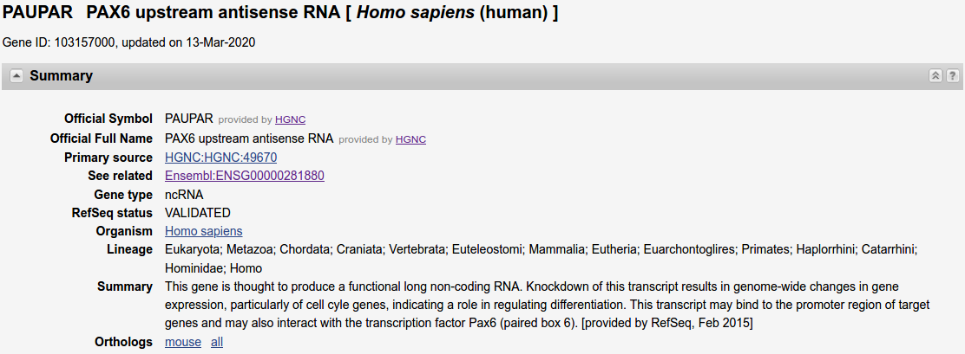
PAUPAR is a PAX6 upstream antisense RNA gene, one Exon, one Transcript, generates a non-coding RNA.

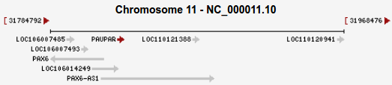
PAUPAR is small relative to PAX6-AS1 and completely contained within PAX6-AS1.

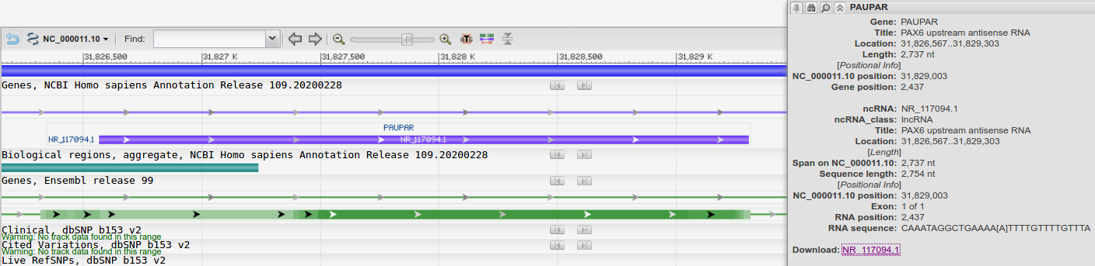
The single exon Gene spans 2,737 nt of the Genome. The RNA itself is 2,754 nt, the difference is the PolyA tail.

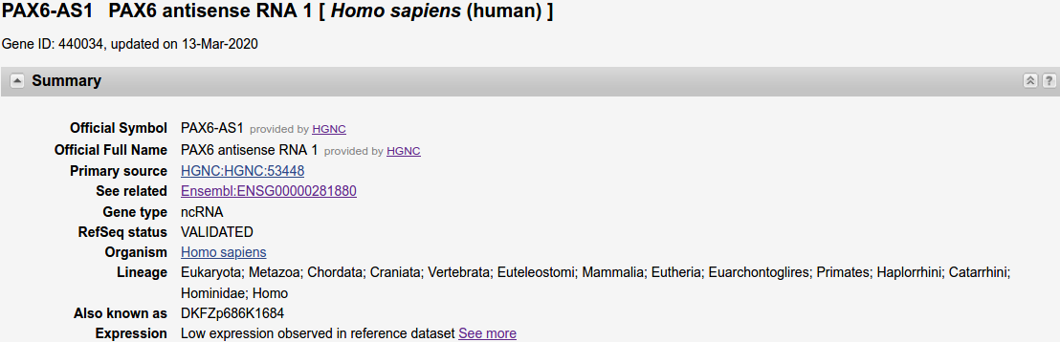

PAX6-AS1 is also a PAX6 antisense RNA gene, three Exons, one Transcript, generates a non-coding RNA.

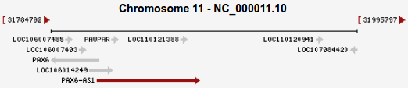
PAX6-AS1 is large relative to PAUPAR and completely contains PAUPAR.

The one Transcript for this Gene involves all three Exons. One Exon is at the start of the Gene, the other two at the extreme end. The Exons span 1,656 nt of the Genome. The RNA is also 1,656 nt long (no PolyA tail this time).
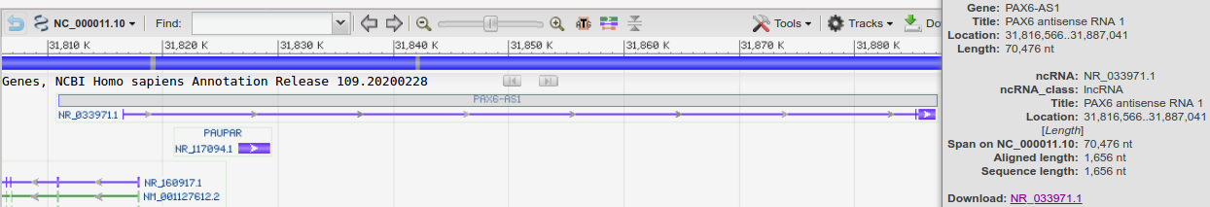

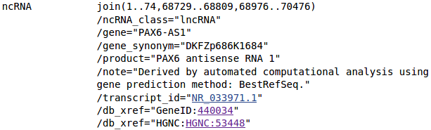
Viewing the GenBank Format version of the sequence for the PAX6-AS1 single Transcript, one can see it is a splicing of three Exons whose positions relative to the start of the Gene are:
1 to 74, 68,729 to 68,809 and 68,976 to 70,476.

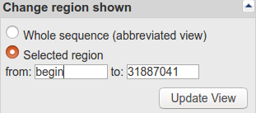
But … I need the Exon positions relative to the start of the Chromosome! Too lazy to do the readily available arithmetic, I change the Selected region (top right) to start at 1 (the system changes this to begin).
Then, in the new sequence view, I search (^F) for PAX6-AS1.

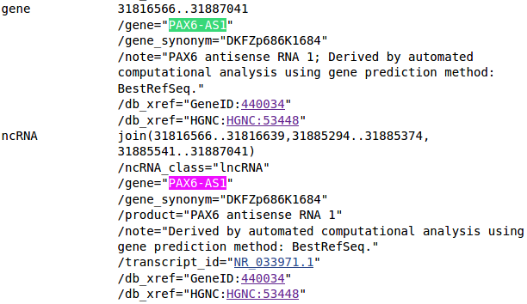
Now it is clear that the three Exons for PAX6-AS1 span the regions of Chromosome 11:

31,816,566 to 31,816,639
31,885,294 to 31,885,374
31,885,541 to 31,887,041
The Ensembl Story:

PAX6-AS1 does not exist according to Ensembl! Search for PAX6-AS1 and you will get PAX6 references, but no mention I could find of a Gene called exactly “PAX6-AS1”.
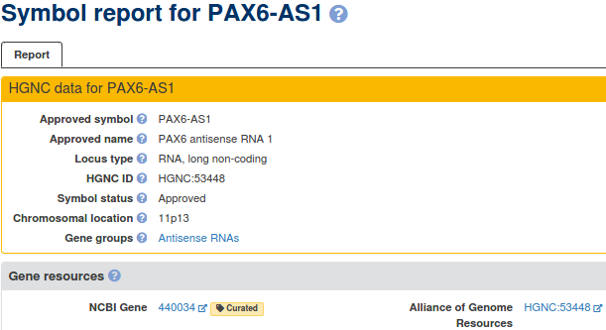

To be extra sure, I look at the HGNC entries for both PAX6-AS1 ...

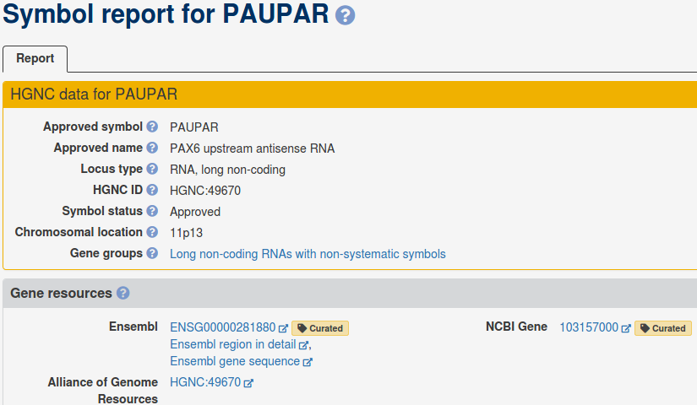

… and PAUPAR.

The former quotes only the NCBI as a Gene resource, the latter quotes both the NCBI and Ensembl.

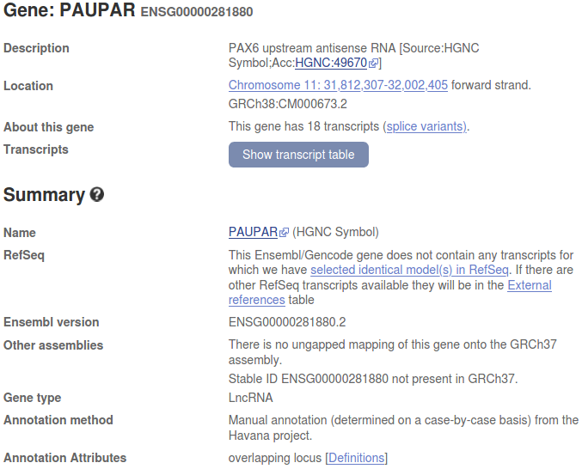
PAUPAR is still a PAX6 upstream antisense RNA Gene. But … it now spans Chromosome 11 from 31,812,307 to 32,002,405 (as opposed to the much smaller region, 31,826,567 to 31,829,303 predicted by the NCBI).
It is also considered to be a much more complex entity than reported by the NCBI. eighteen Transcripts as opposed to one!
The genomic region assigned by Ensembl to PAUPAR comfortably includes the entire region assigned to PAX6-AS1 by NCBI (31,816,566 to31,887,041 - 70,476 bp).
Note that there are no exact matches between the NCBI Transcripts and the Ensembl PAUPAR Transcripts for this Gene.
Not also that the Ensembl view of this Gene was radically different in in the analaysis of the previous Assembly of the Human Genome. THIS, I do not need to be told!!! The story I concocted last year to rationalise all this nonsense was radically different to the current fairy tale!!!
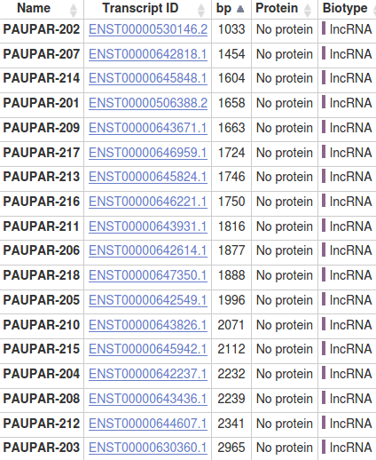

From the Transcript table, ranked in ascending order by Transcript length, I see that the Transcript PAUPAR_201 (1,658 bp) is almost the same length as the PAX6-AS1 Transcript at the NCBI (1,656 bp).

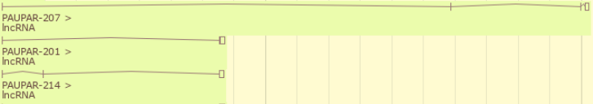
I look at the corresponding graphic view and see that PAUPAR_201 has a very similar three Exon structure to the NCBI PAX6-AS1 Transcript and spans a very similar Genomic Region.

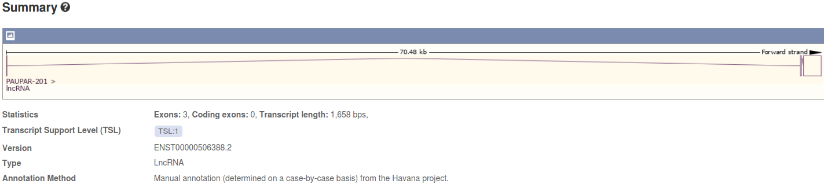
This structural similarlty is even clearer from observed from the graphic specific to the PAUPAR-201 Transcript.

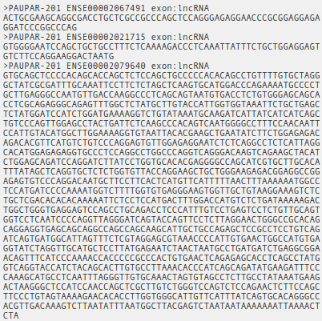

From the Transcript tag, click on the Exons link (top left hand corner), then click on Download sequence and ask to Preview the sequence.

This is one way, probably the most stupid, to ascertain the exact locations of the three Exons that form PAUPAR-201.

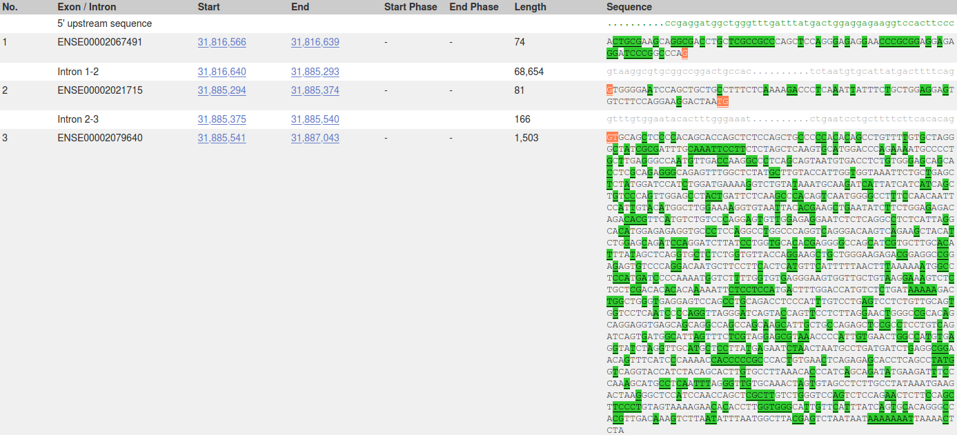
Far better to notice that, once the Exon link is activated, the Exons locations (and much more) are laid out for you to admire.
Information provided includes the Exon locations. They are:
31,816,566 to 31,816,639
31,885,294 to 31,885,374
31,885,541 to 31,887,043
Exactly matching the Exon locations for PAX6-AS1 at the NCBI, except for a couple of extra base pairs at the end of the third Exon.

I conclude that Ensembl predicts the non-coding RNA PAX6-AS1, but as a part of the Gene PAUPAR (specifically the Transcript PAUPAR-201) rather than as a separate Gene.

PAUPAR-201 1 ACTGCGAAGCAGGCGACCTGCTCGCCGCCCAGCTCCAGGGAGAGGAACCC 50
||||||||||||||||||||||||||||||||||||||||||||||||||
PAX6-AS1 1 ACTGCGAAGCAGGCGACCTGCTCGCCGCCCAGCTCCAGGGAGAGGAACCC 50

PAUPAR-201 51 GCGGAGGAGAGGATCCCGGCCCAGGTGGGGAATCCAGCTGCTGCCTTTCT 100
||||||||||||||||||||||||||||||||||||||||||||||||||
PAX6-AS1 51 GCGGAGGAGAGGATCCCGGCCCAGGTGGGGAATCCAGCTGCTGCCTTTCT 100

PAUPAR-201 101 CAAAAGACCCTCAAATTATTTCTGCTGGAGGAGTGTCTTCCAGGAAGGAC 150
||||||||||||||||||||||||||||||||||||||||||||||||||
PAX6-AS1 101 CAAAAGACCCTCAAATTATTTCTGCTGGAGGAGTGTCTTCCAGGAAGGAC 150

PAUPAR-201 151 TAATGGTGCAGCTCCCCACAGCACCAGCTCTCCAGCTGCCCCCACACAGC 200
||||||||||||||||||||||||||||||||||||||||||||||||||
PAX6-AS1 151 TAATGGTGCAGCTCCCCACAGCACCAGCTCTCCAGCTGCCCCCACACAGC 200

PAUPAR-201 201 CTGTTTTGTGCTAGGGCTATCGCGATTTGCAAATTCCTTCTCTAGCTCAA 250
||||||||||||||||||||||||||||||||||||||||||||||||||
PAX6-AS1 201 CTGTTTTGTGCTAGGGCTATCGCGATTTGCAAATTCCTTCTCTAGCTCAA 250

…

PAUPAR-201 1501 GCTTGTCTGGGTCCAGTCTCCAGAACTCTTCCAGCTTCCCTGTAGTAAAA 1550
||||||||||||||||||||||||||||||||||||||||||||||||||
PAX6-AS1 1501 GCTTGTCTGGGTCCAGTCTCCAGAACTCTTCCAGCTTCCCTGTAGTAAAA 1550

PAUPAR-201 1551 GAACACACCTTGGTGGGCATTGTTCATTTATCAGTGCACAGGGCCACGTT 1600
||||||||||||||||||||||||||||||||||||||||||||||||||
PAX6-AS1 1551 GAACACACCTTGGTGGGCATTGTTCATTTATCAGTGCACAGGGCCACGTT 1600

PAUPAR-201 1601 GACAAAGTCTTAATATTTAATGGCTTACGAGTCTAATAATAAAAAAATTA 1650
||||||||||||||||||||||||||||||||||||||||||||||||||
PAX6-AS1 1601 GACAAAGTCTTAATATTTAATGGCTTACGAGTCTAATAATAAAAAAATTA 1650

PAUPAR-201 1651 AAACTCTA 1658
||||||
PAX6-AS1 1651 AAACTC-- 1656

Totally unnecessarily, I celebrate this revelation by aligning the sequence of PAX6-AS1 from the NCBI with the sequence of PAUPAR-201 from Ensembl.

Complete agreement except for the 2 Base Pair overhang at the very end.

Click Here to Return to the Exercise →
Efficient design for Ensembl Protein CodingTranscript prediction for the Human Genome.

I tidy this up when I am sure of my facts …

As described already, assuming a suitable comprehensive set of appropriate sequences, the location and structure of all transcripts could be determined by a simple two stage operation:
mapping all quality mRNA sequence onto the genome to discover the exons of the mRNA
mapping all quality proteins onto the geneome to discover the CDSs
or maybe the other way round? Both would work?

To do this efficiently:
first genscan … find most genes
then CCDS (CDS agreed by pipeline, Vega and NCBI … Human/Mouse specific at present) search on genscan hits only …. reveals coding regions accurately
then mRNA (RefSeq and other high quality data/predictions) only on CCDS hits … reveals UTRs accurately
Why it is reasonable to not regard a match of a RefSeq mRNA with the Genome as, by itself, sufficient evidence to uniquely predict a transcript.
RefSeq mRNA sequences are not determined by careful sequencing of individual mRNA/cDNA. If they were, it would be difficult to argue with the NCBI approach of regarding a quality match between a RefSeq mRNA and the genome as sufficient evidence to predict the location of a transcript.
However, RefSeq mRNA sequences are actually computed from assemblies of many single pass, poor quality, cDNA sequences (ESTs).
Ensembl regards these sequences as good evidence …. but not conclusive by themselves.
NCBI appears to rely more on the reliability of RefSeq mRNA sequences.

Ensembl uses both the sequences of RefSeq mRNAs and those of their protein products (the RefSeq entries whose Accession Codes commence NP_) to predict transcripts, however, Ensembl appears to have less blind faith in the accuracy of these data than the NCBI.
Note: There is no “one to one” correspondence between RefSeq mRNAs and transcript predictions. All RefSeq mRNAs are referenced, but two are used to support the single third transcript in the list. If Ensembl regarded RefSeq mRNAs as “perfect” (as the NCBI appears to do) this would clearly be nonsense!

Above just jumble notes from previous versions … need some Ben input

Click Here to Return to the Exercise →
Downloading the PAX6 Genomic region for later analysis.
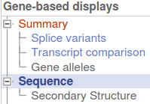
First, click on the Sequence link in the top left hand corner of the page.

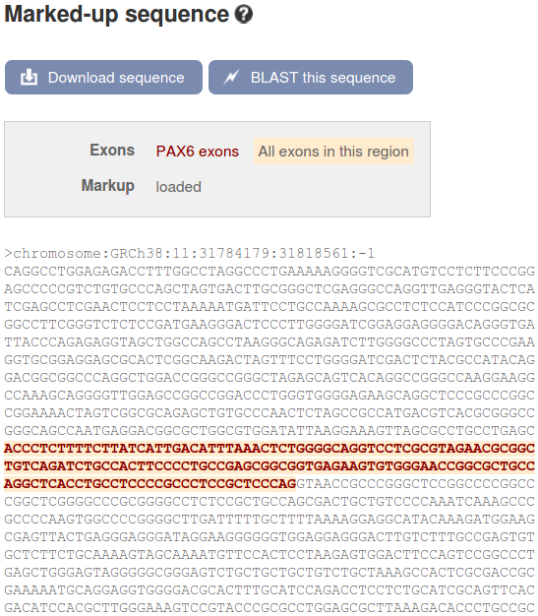

The Transcript Graphic will be replaced by a display of the sequence of the PAX6 region of the genome.
Exons will be tastefully highlighted for you delectation. The display includes 600 base pairs of Flanking Sequence (3' and 5') which are included (by default) when the sequence is downloaded
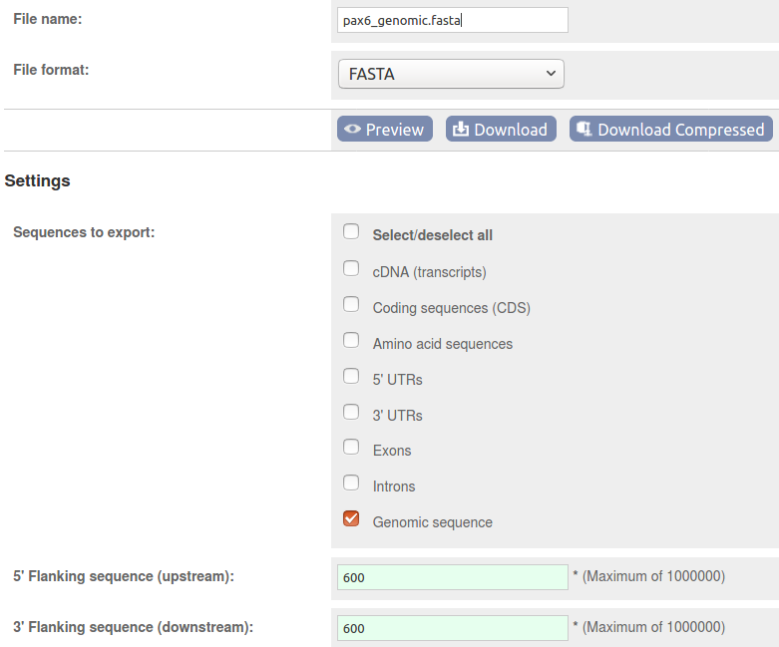
Now chose to. The Download sequence form will burst into view.
Set the File name: to pax6_genomic.fasta
Set the File format: to FASTA
Accept the default 600 base pairs for both the 5’Flanking sequence (upstream): and the 3´ Flanking sequence (downstream):.

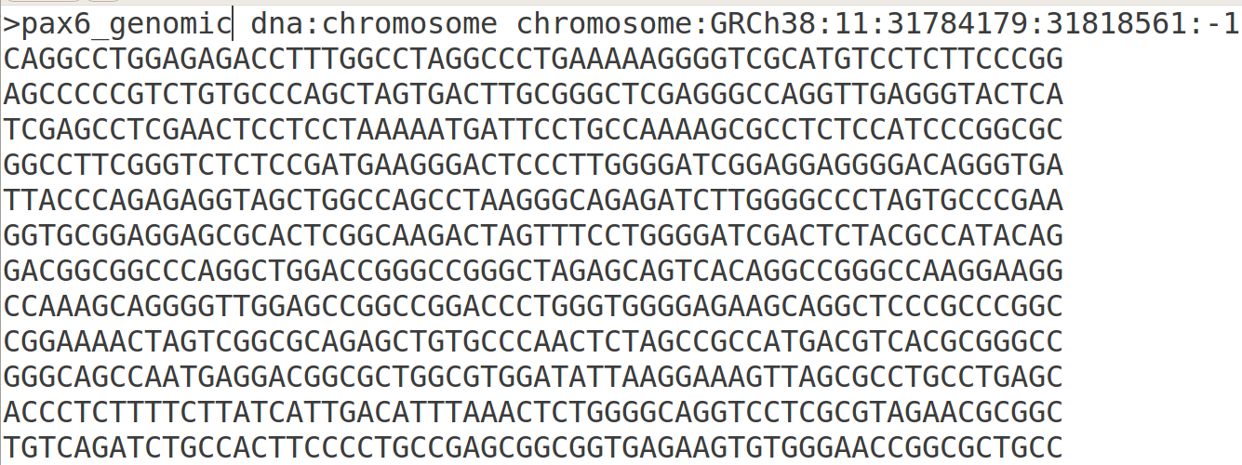
Finally, click on the button and do whatever it takes to move the file you create to somewhere sensible on your Desktop.
Using whatever text editor is most convenient, edit your file to change the first word of the first line of the file to contain information, from 11 to pax6_genomic. This first word is defined as the sequence identifier in FASTA format. pax6_genomic is a far more informative identification than 11 (simply the Chromosome number).

Click Here to Return to the Exercise →
DPJ – 2020.04.20

