

ELB17S
Entry Level Bioinformatics
06-10 November 2017

(Second 2017 run of this Course)

Basic Bioinformatics Sessions

Practical 6: Multiple Sequence Alignment

Tuesday 31 October 2017
Multiple Sequence Alignment
Here we will look at some software tools to align some protein sequences. Before we can do that, we need some sequences to align. I propose we try all the human homeobox domains from the well annotated section of UniprotKB. Getting the sequences is a trifle clumsy, so concentrate now! There used to be a much easier way, but that was made redundant by foolish people intent on making the future ever more tricky!!
So, begin by going to the home of Uniprot:
http://www.uniprot.org/
Choose theoption of the button.
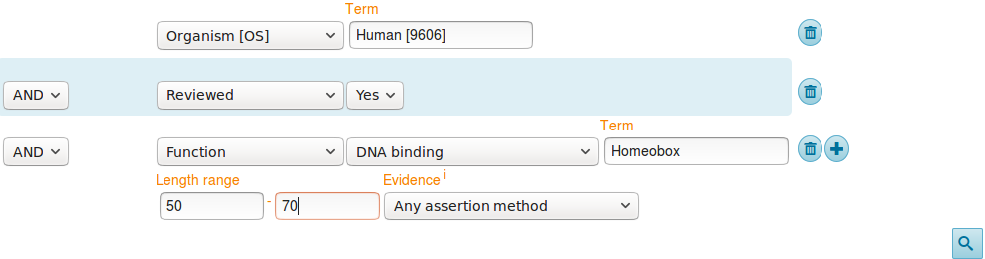
First specify that you are only interested in Human proteins. To do this, set the first field to Organism [OS] and Term to Human [9606].
Set the second field selector to Reviewed and the corresponding Term to Yes (that is, choose to find only SwissProt entries).
Click on the button to request a further field selection option. Set the new field to Function. Set the type of Function to DNA binding. Set the Term selection to Homeobox.
From previous investigations, you should be aware that a Homeobox domain is generally 60 amino acids in length. To avoid partial and/or really weird Homeobox proteins, set the Length range settings to recognise only homeoboxs between 50 and 70 amino acids long.
Leave the Evidence box as Any assertion method, one does not wish to be too fussy! Address the button with authority to get the search going.
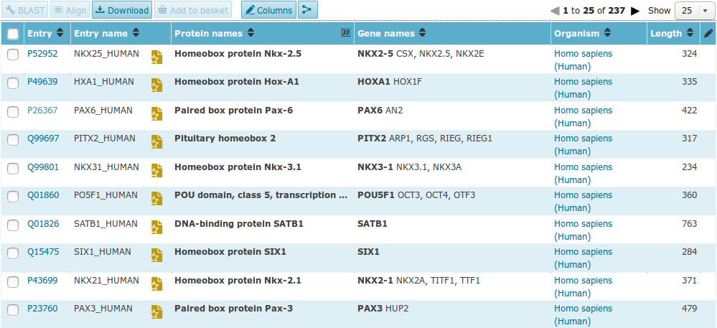
A fine miscellany of sequences will assemble upon you screen. Most seem to declare themselves in possession of a Homeobox or two (including PAX6_HUMAN), so I suggest a declaration of success.
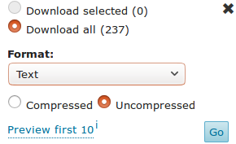
Now save the entire list into a file using thebutton. Set the download to uncompressed. Make sure you have all sequences selected and that Text (i.e. EMBL or SwissProt) format selected. Press the Go button and do whatever it takes to ensure your results end up in a file residing on your Desktop called:
human_homeobox_proteins.emb
ID NKX25_HUMAN Reviewed; 324 AA.
AC P52952; A8K3K0; B4DNB6; E9PBU6;
DT 01-OCT-1996, integrated into UniProtKB/Swiss-Prot.
DT 01-OCT-1996, sequence version 1.
DT 30-NOV-2016, entry version 177.
DE RecName: Full=Homeobox protein Nkx-2.5;
DE AltName: Full=Cardiac-specific homeobox;
DE AltName: Full=Homeobox protein CSX;
DE AltName: Full=Homeobox protein NK-2 homolog E;
GN Name=NKX2-5; Synonyms=CSX, NKX2.5, NKX2E;
OS Homo sapiens (Human).
OC Eukaryota; Metazoa; Chordata; Craniata; Vertebrata; Euteleostomi;
OC Mammalia; Eutheria; Euarchontoglires; Primates; Haplorrhini;
OC Catarrhini; Hominidae; Homo.
OX NCBI_TaxID=9606;
RN [1]
RP NUCLEOTIDE SEQUENCE [MRNA] (ISOFORM 1).
RC TISSUE=Heart;
RX PubMed=8900537;
RA Turbay D., Wechsler S.B., Blanchard K.M., Izumo S.;
RT "Molecular cloning, chromosomal mapping, and characterization of the
RT human cardiac-specific homeobox gene hCsx.";
RL Mol. Med. 2:86-96(1996).

Take a swift look at the file you have just created. Your neat list of Human Homeobox sequences will have transformed into a flood of many SwissProt format UniProtKB entries. Ugly, but what is required.

FT CHAIN 1 374 Pre-B-cell leukemia transcription factor
FT 4.
FT /FTId=PRO_0000049241.
FT DNA_BIND 210 272 Homeobox; TALE-type.
FT {ECO:0000255|PROSITE-ProRule:PRU00108}.
FT VARIANT 169 169 V -> I (in dbSNP:rs8108180).
FT /FTId=VAR_059355.
FT VARIANT 177 177 M -> V (in dbSNP:rs8108981).
FT /FTId=VAR_059356.
FT VARIANT 283 283 T -> M (in a colorectal cancer sample;
FT somatic mutation; dbSNP:rs376647012).
FT {ECO:0000269|PubMed:16959974}.
FT /FTId=VAR_036439.
FT CONFLICT 368 368 I -> T (in Ref. 1; BAG53471).
FT {ECO:0000305}.
SQ SEQUENCE 374 AA; 40854 MW; B9CE8BE93D0B7ABC CRC64;
MAAPPRPAPS PPAPRRLDTS DVLQQIMAIT DQSLDEAQAR KHALNCHRMK PALFSVLCEI
KEKTVVSIRG IQDEDPPDAQ LLRLDNMLLA EGVCRPEKRG RGGAVARAGT ATPGGCPNDN
SIEHSDYRAK LSQIRQIYHS ELEKYEQACR EFTTHVTNLL QEQSRMRPVS PKEIERMVGA
IHGKFSAIQM QLKQSTCEAV MTLRSRLLDA RRKRRNFSKQ ATEVLNEYFY SHLNNPYPSE
EAKEELARKG GLTISQVSNW FGNKRIRYKK NMGKFQEEAT IYTGKTAVDT TEVGVPGNHA
SCLSTPSSGS SGPFPLPSAG DAFLTLRTLA SLQPPPGGGC LQSQAQGSWQ GATPQPATAS
PAGDPGSINS STSN
//
Search (Control F) for the term DNA_BIND.
It should occur many times (at least once per sequence) in the Feature Tables and most often refer to a Homeobox region.
In the DNA_BIND Feature Table entries, the position of the Homeoboxs are recorded and will be used by the next program to isolate the sequence of the Homeoboxs.

Now to extract from the whole protein sequences you have saved in a file, the sequences of just the Homeobox domains. One way of doing this (possibly not the best), is to use an EMBOSS package program called extractfeat. This can be found in many places, including the Bioinformatics server at Wageningen in the Netherlands. Go to:
http://emboss.bioinformatics.nl/


Find the program extractfeat (in the EDIT section), and set it going.

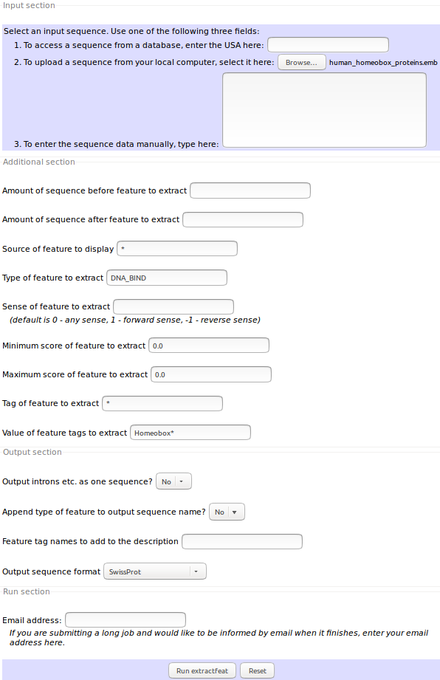
Use the Choose File button to upload the SwissProt format sequences from UniProtKB that you saved in the file:
human_homeobox_proteins.emb.
Set Type of feature to extract field to DNA_BIND (Make sure you remove the “*”).

Set Value of feature tags to extract to Homeobox* (Make sure you append the “*” to ensure hits with, for example “homeoboxes”).

Set the Output sequence format to SwissProt (Fasta would do, but SwissProt retains more annotation).

Click on thebutton to start extractfeat going. Many sequences of 60 amino acids (or so) in length will leap into view.
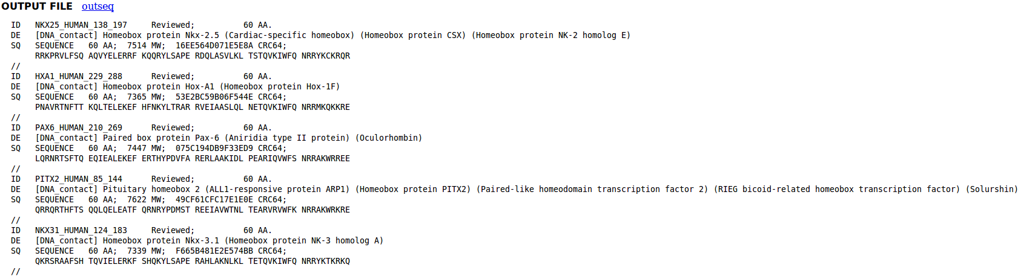
Right click thebutton and select Save Link as... . Do whatever it takes to save all your Homeobox domains into a file residing on your Desktop called:
homeobox_human.emb
Finally, we have some sequences with which to investigate the multiple sequence alignment programs.
Take a look at the file you have created. You should have many human homeobox domains in SwissProt format, looking rather as they did in your browser window. Happily ClustalX, the first multiple alignment program to be investigated, accepts multiple sequence SwissProt format files as input.
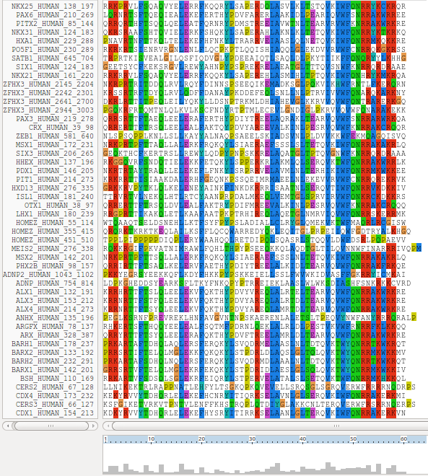
ClustalX is a part of the mostly widely known family of Multiple Sequence Alignments (MSA) programs, originating in the 1980s. Until relatively recently, it was the only real option. ClustalX still has merit, although it lacks some of the sophistication of more recent programs. ClustalX runs on effectively all workstations and has a nice Graphical User Interface (GUI). A good place for us to start. It is installed on your workstations.

Start up the program ClustalX. The ClustalX Graphical User Interface (GUI) will regally mount your screen.

Select Load Sequences from the File pull down menu and load your file of homeobox domains (homeobox_human.emb).

The sequences will arrange themselves colourfully. Many of the homeoboxes are similar enough to look convincing even before alignment. Note the “Manhattan skyline” under the sequences indicating the varying degrees of conservation.

You might like to increase the Font size from the minute default setting designed for Hawks and Eagles, to something more comfortable. 24 works tolerably well for me.


From the Alignment pull down menu, go to the Alignment parameters menu and select Pairwise Alignment Parameters. Just for a moment, change the setting from Slow-Accurate to Fast-Approximate. Bring the corresponding parameters into view by clicking on Fast/Approx Pairwise Parameters tab.
Hopefully, we will have discussed the way ClustalX (and similar multiple alignment tools) work. Intuitively, it should not make a lot of difference how the initial pairwise comparison stage is conducted. However, it very often does.
Specifically for this set of proteins, as well as generally, ClustalX will give a noticeably better alignment if the initial pairwise alignment stage is done carefully. Accordingly, reverse your whimsical setting change by moving back from Fast-Approximate to Slow-Accurate.

Click on the Slow/Accurate Pairwise Parameters tab for a final look at the default parameters to be used. The Slow-Accurate option is essentially a version of Global Alignment algorithm we will have discussed previously. Hopefully, all the parameter options will therefore be familiar to you.

I will assume both sets of parameters at least seem familiar? If not please ask. The default Slow/Accurate Pairwise Parameters you now have in view are fine. Click the OK button to dismiss the Pairwise Parameters window.


Before proceeding, save the homeobox sequences in FASTA format, which will better suit the other MSA programs we will try. Do this by selecting Save sequences as... from the File pull down menu. Deselect CLUSTAL format, select FASTA format.
Change the default file output file name to homeobox_human_full
Click OK. A file called homeobox_human_full.fasta will be created. Take a look to check it is as you would expect.

Strangely, saving your sequences in FASTA format convinces clustalx that it should now output its alignments in FASTA format. To prevent this, select Output Format Options from the Alignments pull down menu. Deselect FASTA format and select CLUSTAL format. Click OK.

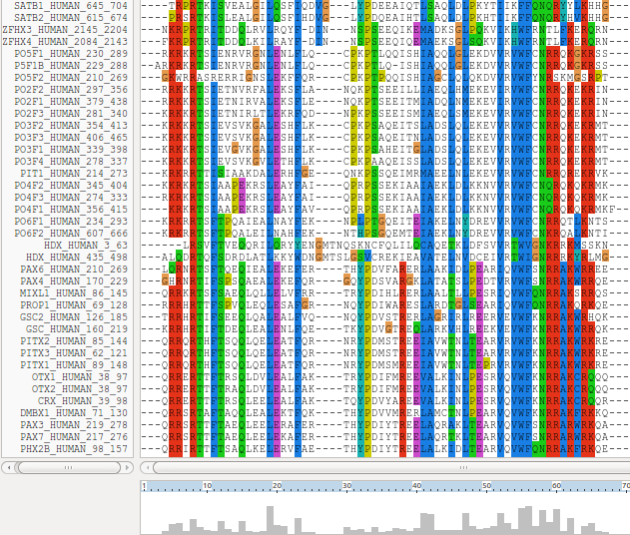
From the Alignment pull down menu, select Do Complete Alignment. Accept the default names for output files and click on the OK button. ClustalX will start to think deeply and eventually come up with it view of how the homeobox domains should be aligned.
Note the display at the bottom of the ClustalX window in which the preliminary pairwise comparisons of all sequences is monitored. The scores from these comparisons are used to compute the Guide Tree.
Not a bad first try. From an entirely non scientific, cosmetic, viewpoint, the ragged ends offend a trifle, as does the gap just before position 30!
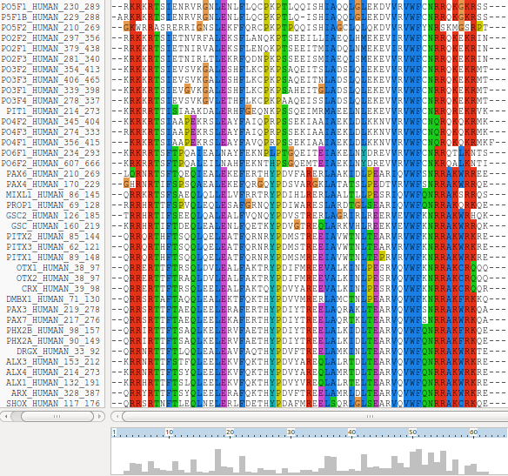
In reality, these features might be interesting, but here I go for pretty!
Just to investigate the possible, select all the homeobox sequences that are causing the gap around position 30 by clicking on their names (quite a lot of them I fear). Hold the Ctrl key down to allow multiple selection.
All selected, go to the Edit pull down menu and select Cut Sequences. Then select Remove Gap-Only columns from the Edit pull down menu. Nasty gap gone … along with all scientific credibility, but … never mind.
You could recompute the same alignment from scratch for the reduced sequence set. To justify this assertion, select Select All Sequences from the Edit menu. Then select Remove All gaps from the Edit menu and confirm your intentions. You are now back where you started, but without the sequences that mess up the alignment.
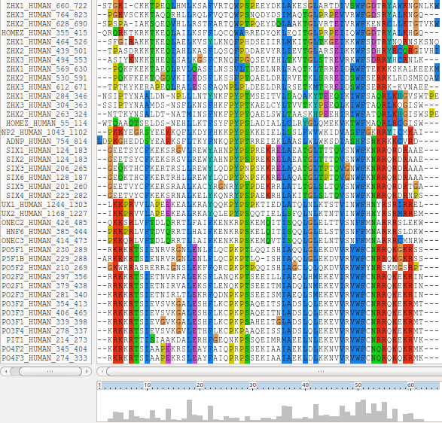
Save your filtered set of sequences. From the File menu select Save Sequences as... . Choose FASTA format only. This time, create a file with the default name:
homeobox_human.fasta
The full original set of sequences was saved in a differently named file, as a precaution. I am convinced the sequences eliminated would not align convincingly with any of the tools we have at hand. Let us lose them! Press the OK button.
From the Alignment menu, select Output Format Options and then select CLUSTAL format only.
From the Alignment menu, select Do Complete Alignment. Accept the default names for the output files. This will overwrite your previous efforts, but no matter. Well, I got back to where I was, no gaps around position 30 but still the ragged ends!
It is difficult to prove you have exactly the same alignment as previously as the order of the MSA will be different. This order being determined by the pairwise comparison stage of the ClustalX MSA computation.
The Prosite motif database uses Patterns to represents protein features (in addition to HMMs). The pattern for a homeobox is the ever memorable:
[LIVMFYG]-[ASLVR]-x(2)-[LIVMSTACN]-x-[LIVM]-{Y}-x(2)-{L}-[LIV]-[RKNQESTAIY]-[LIVFSTNKH]-W-[FYVC]-x-[NDQTAH]-x(5)-[RKNAIMW]
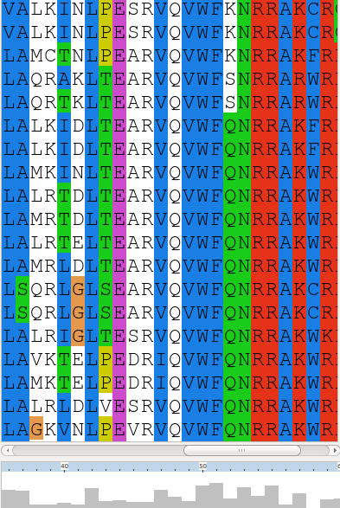
Any speculations as to how this might be interpreted? Quick Hint?

This pattern corresponds to positions 36 to 59 in my alignment. See that the “Manhattan Skyline” is encouraging in the parts of this region that matter.
Note that the profile Tryptophan, in position 50, is very consistent, but not quite 100% as suggested by the Prosite pattern. The W was even conserved in the sequences that were cosmetically removed.
Position 52 is not conserved (“-x-”) according to the Prosite pattern. In the alignment segment offered here, it looks like a pretty consistent Q. However, the “Manhattan skyline” at this position is quite low, suggesting that the sequences in view might not be typical of the whole alignment set. Which, upon checking …. they are not!
Looking through this alignment, I get the feeling I could design a better, stricter pattern for the region between 36 and 59. Possibly true, but remember the pattern in Prosite aims to represent the conservation of Homeobox domains in ALL organisms. Here we have only sequences from Human.
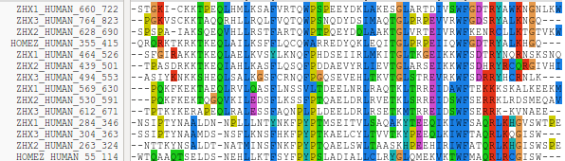
Of course, things are not quite so convincing throughout. If you look at the top and bottom few sequences, you will see that ClustalX had its moments of uncertainty.
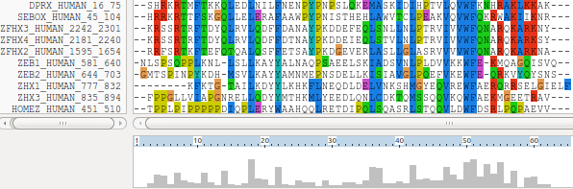

Note, however, the consistent W in position 50 despite the surrounding crumble.
Now to show existence of some msa program options available on the web. There are many. They are available from a number of server sites. An obvious place to start has to be the EBI page dedicated to MSA. Go to:
http://www.ebi.ac.uk/Tools/msa/
Offered here is a selection of popular, current generation MSA tools. Each is accompanied by advice to guide the choice of tool to best fit the circumstances. Each tool is provided with a link to its Launch interface. All the Launch interfaces are very consistent. Once you have run one of the MSA options, you should have no trouble running any of the others.
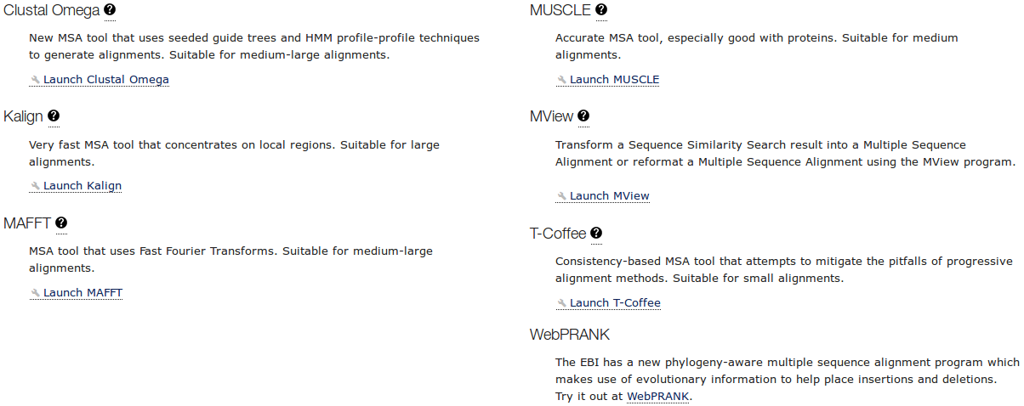
Here I intend to align again the human homeboxes with just one of the tools on offer. Then take a quick look at how the machine generated multiple alignment can be manually edited using Jalview, a program that is probably installed on your workstation and definitely available as a web service. You might have already used Jalview as an alignment viewer when investigating Pfam and/or Jpred.
Then I will invite you to try a few of the other options for yourself and see that they do not all produce the same alignment! Differences reflect not only the parameters selected, which we will have discussed, but also the particular objectives of the program selected. For example, a multiple protein sequence alignment optimal for investigating conservation of protein structure might well not be identical to one best representing protein evolution.
Used to align the Homeobox sequences used in this exercise, I do not expect you will see much difference between the outputs of any of these options. They will all work sufficiently on such a simple data set.
The program whose use I choose to describe carefully, leading on to a short Jalview exercise is MUSCLE. I choose thus as MUSCLE is now the first choice of most of the people with whom I work. Also popular are Clustal Omega, MAFFT and, for phylogeny, WebPRANK.

So the plan now is to use MUSCLE to align again the homeobox sequences previously aligned with ClustalX. MUSCLE works in a way similar to clustalX but it takes rather more care in the generation of the Guide Tree used to control the order of pairwise construction of the final multiple alignment. Particularly for more difficult alignments, MUSCLE should do a better job than ClustalX. The alignment you will generate here will certainly be different. I leave you to judge for yourselves whether it is better.

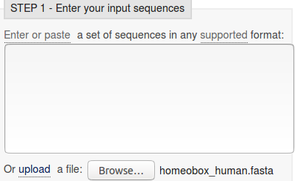
Start by requesting to.
Use thebutton to upload the file containing the FASTA format homeobox sequences, homeobox_human.fasta. This file should not included the sequences with a mess around position 30.

Take a look at the Set your Parameters section of the page. I find the claim that “The default settings will fulfill the needs of most users and, for that reason, are not visible” a little strange? What about the users who are not in the category “most”? I want control over all the programs that their creators deemed sensible to make available?


The default settings behind thebutton are not those that affect the computation of the MSA. I confess myself confused at the lack of any meaningful options to consider? I was expecting at least the gap open and gap extension penalty options (available elsewhere, including Wageningen), plus a way to change the scoring matrix. I have inquired why things are as they are (most recently 2016.04.17). No practical issue here, as I intended to suggest the defaults whatever they were. Look at the range of settings for the OUTPUT TREE parameter. none is indeed the thinking persons choice, but … one or the other (but not both?) of the Guide Trees that MUSCLE will compute can be saved if you wish. You may also set the OUTPUT ORDER to aligned or … aligned?


There are a number of OUTPUT FORMATS offered. For a quick glance at your results, both ClustalW or HTML are fine. Here I suggest it would be nice to generate an output that can be downloaded and viewed in Jalview. The default ClustalW or Pearson/FASTA serve for this purpose. As ClustalW looks more like an alignment in the web page, I choose ClustalW.

How do the options for the OUTPUT TREE relate to the output files of ClustalX and the difference between the way that ClustalX and muscle work?

Comment on how one might choose between the range of options offered for the aligned parameter?

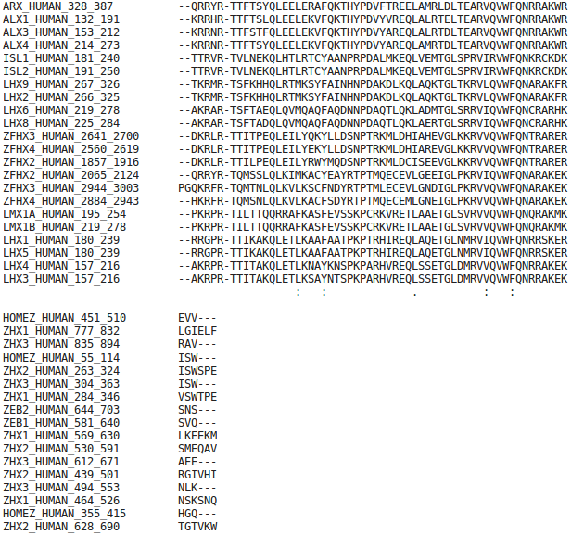

After considering these enigmas, or before if you prefer, Click on thebutton and sit back to admire muscle in action.

The alignment that is computed is, superficially at least, similar to that offered by ClustalX.

The alignment is irritatingly split into two sections. A nice extra parameter might have been “How wide would you like your alignment to be”? A problem with the format rather than the program, to be fair.

At the very bottom of the page, muscle whines:
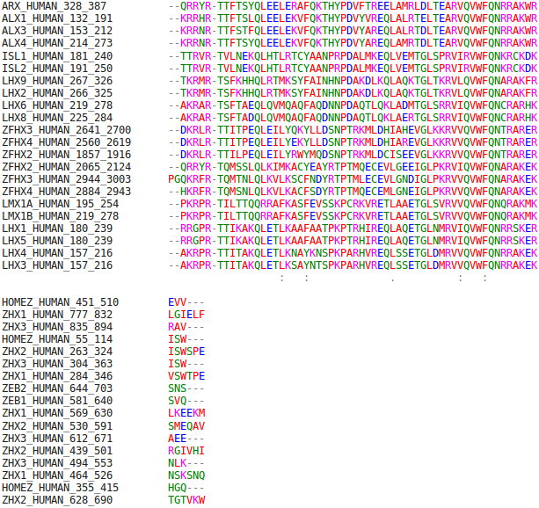

So click the Show Colors button at the top of the page and try to live with the pain of such gross Trans-Atlantic inept spelling in a European site!!! Good Grief! They get everywhere!!

Well, an improvement I suppose? Colours are very useful (even slow ones) in the interpretation of alignments. Various colour schemes are used to clarify the message of alignments. Colouring can indicate shared amino acid properties not immediately evident when the letter representations differ.

But any decoration available here is far short of what can be achieved with Jalview, so click on the Download Alignment File button to save you alignment in a file on your Desktop called:
homeobox_human_muscle.aln
Jalview can be easily installed under all commonly used operating systems and run locally. For these exercises, I attempt to use services available freely from the INTERNET wherever possible, so let us run Jalview from the web here by first going to:
http://www.jalview.org/
and selecting thelink at the top of the page. And agree with all the many questions you will be asked.
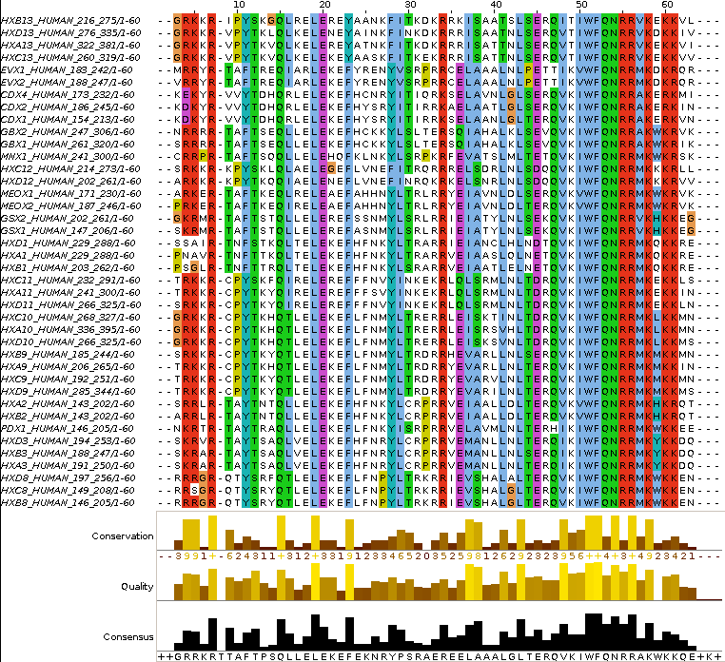
Close down all the example outputs Jalview sees fit to show you on start up. From the File pull down menu choose from File from the Input Alignment option. Locate and load the file:
homeobox_human_muscle.aln
You might need to adjust the file name filter to included .aln files.
The default view is a trifle bland. Try a few of the options from the Colour pull down menu.
You could try the default colour scheme used by ClustalX, for example.
The MUSCLE and massaged ClustalX alignments now look very similar! In the nicely aligned regions at least.
There are many Jalview features that merit investigation. Have a look around if you have time. In particular, Jalview will compute simple phylogenetic trees for you employing a number of methods (Calculate Tree from the Calculate pull down menu). Try it, but be aware this is only sensible if you were very sure of your alignment (and have more meaningfully selected sequences maybe?).
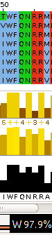
Jalview is made by the same group as produce Jpred (an extremely effective Secondary Structure Prediction system). You could send your alignment for Secondary Structure Prediction via the Web Service pull down menu, if you wished.
A central purpose of Jalview is to allow users to edit alignments as well as just to view them. For example, hold down the Shift key, click and hold on any amino acid at the edge of a gap, slide left and right and see that you can introduce and/or alter the position of gaps. It is very important to be able to edit alignments generated by even the best of programs. As I hope has been made clear, the alignment algorithms are crude. If you know something about the sequences you are aligning it is very reasonable to suppose you can improve upon the computer's alignments. Jalview tries to make this possibility easy. Look through some of the other Edit pull down menu options, maybe to increase the font size in particular!, it does not matter how much you mangle your alignment, you can always make another one.
Finally, take a look at the Jalview “Manhattan Skyline” for the highly conserved W at position 51. This seems better quality than clustalX managed? I am not sure how one can make further comment without knowing what parameters were used. Is there really an improvement? If so, is it due to the improved algorithm or more appropriate choice of parameters? Impossible to discuss further as the parameters used for MUSCLE are not revealed.
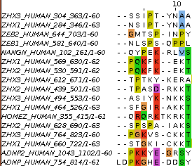

In my alignment, the W at position 51 was at position 50, according to clustalx. This slippage to the right is due to MUSCLE introducing an extra gap, inspired by just one sequence at position 8. Is this sensible? No idea … exactly when it might be good idea to investigate the effect of lighter/heavier gap penalties?

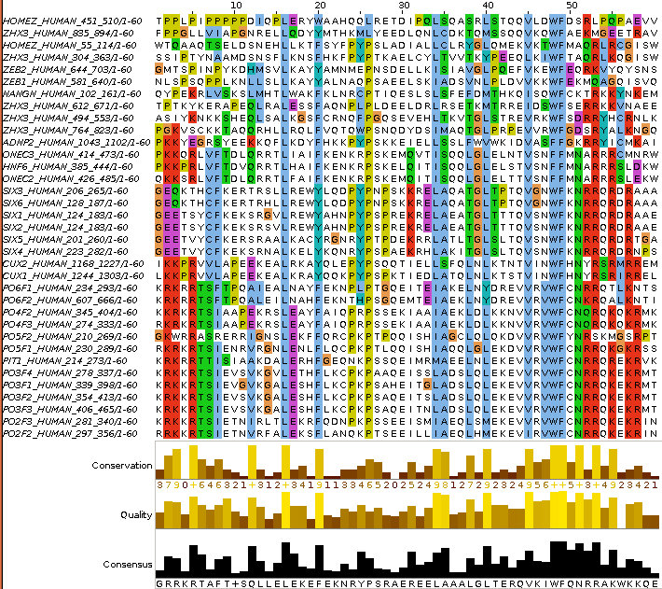
You can also Select and Cut sequences in a way similar to that you employed with clustalx. I could not resist it! I removed all the ugly sequences that caused the gaps at the start and finish of the alignment, and the sequence that messed up column 8 (just select their names and then select Cut or Delete from the Edit menu). I achieved the gap-free beautiful alignment illustrated.
Of course, Jalview does not compute alignments, so once I had removed all the unfortunate proteins, I had to use an Edit option to tidy up my meddling. I used Remove Empty Columns to get rid of the gap columns at the start of the alignment. The gaps at the end just melted away once the sequences that supported their presence were removed.
Science is easy! Once you remove the need for honesty that is.
If it could be done slightly more meaningfully, I would suggest you might try some of the other MSA tools offered by the EBI, to investigate the differences in the alignments computed. Any differences might be due to different parameter selection or differences in the algorithms of the tool you select.
For full control, you really need to download the various tools and run them locally. The EBI is not the only site that hides significant parameters from their users.
DPJ – 2017.10.31
Model Answers to Questions in the Instructions Text.
Notes:
For the most part, these “Model Answers” just provide the reactions/solutions I hoped you would work out for yourselves. However, sometime I have tried to offer a bit moer back ground and material for thought? Occasionally, I have rambled off into some rather self indulgent investigations that even I would not want to try and justify as pertenent to the objective of these exercises. I like to keep these meanders, as they help and entertain me, but I wish to warn you to only take regard of them if you are feeling particularly strong and have time to burn. Certainly not a good idea to indulge here during a time constrained course event!
Where things have got extreme, I am going to make two versions of the answer. One starting:
Summary:
Which has the answer with only a reasonably digestible volume of deep thought. Read this one.
The other will start:
Full Answer:
Beware of entering here! I do not hold back. Nothing complicated, but it will be long and full of pedantry.
This makes the Model answers section very big. BUT, it is not intended for printing or for reading serially, so I submit, being long and wordy does not matter. Feel free to disagree.
From your investigations of Multiple Sequence Alignment
How do the options for the OUTPUT TREE relate to the output files of ClustalX and the difference between the way that ClustalX and muscle work?
I leave this question here in the hope that one day I will be able to offer a full and sensible answer. First draft answer below.
Essentially, both ClustalX and MUSCLE work in two stages. First they create Guide Tree(s). Then they create a multiple alignment by pairwise steps ordered by most refined the Guide Tree.
ClustalX just computes one based exclusively on the pairwise comparison of its input sequence set.
MUSCLE will create a Guide Tree that is the rough equivalent of that computed by ClustalX. Then it will offer to refine this Guide Tree from computed draft MSAs until a user selected maximum number of iterations is met or no further improvement is possible.
ClustalX saves the Guide Tree it computes by default. MUSCLE offers to save its Guide Tree from its first or second refinement iteration.
The purpose of saving the Guide Tree(s) to a file is to enable a rerun of the second phase with new parameter settings without having to first recalculate the Guide Tree. Of course, as mentioned previously, utterly pointless if there is no way to change the parameters to allow a guide tree to be used as input? but that is the theory.
More investigation by me and expansion of this answer required. Discussion with EBI current (2016.04.20).
Comment on how one might choose between the range of options offered for the aligned parameter?
I cannot … beyond suggesting it simply does not make sense? Going by what is offered at Wageningen, the choice should be between aligned and input order. i.e. the order of the original set of sequences to be aligned or the order after they have all been compared with each other and arranged into a Guide Tree … or two.
Currently, the only way of which I am aware to run muscle with full flexibility, is to download it. It is available for Windows, Linux or Mac operating systems but has no pretty GUI front end. You have to read the manual carefully and run from the command line.
To attempt (with pain) to be fair, one might suggest that web services are for creating draft results primarily. If one wanted to get serious and have full control over the software and record properly all the settings one has chosen, it would make sense to download the software and run in locally.
That still does not excuse offering selections that only have one option and/or save files that cannot serve any function. I think I give up trying to persuade the EBI guys of this and just live with “what is”. So much more restful (2017.05.01).

DPJ – 2017.10.31
Discussion Points and Casual Questions arising from the Instructions Text.
Notes:
Work in progress I fear.
The intention is to provide a full consideration of some issues skimmed over in the exercise proper.
If you are attending a “supervised” presentation of the exercise, I would hope to have conducted a live discussion of all these issues to an extent that reflects:
- the depth that seems appropriate
- the time available
- the degree to which the issues seem to match the interests of the class
- how many of you are awake
Here, I hope to write out very full answers were such a response exists. Accordingly, I suggest you will not need to read much of many of these discussions. There will be much detail of interest to rather few of you. Possibly a bit self indulgent, but I wish to make a note of all the background I have discovered while writing these exercises.
In a nutshell, the exercises are trying to make very general points avoiding too much detail. Nevertheless, I record the detail outside the main exercise text, just in case it might be if interest. Some of the answers to the “Casual Questions” are exceedingly trivial. Some of the “Discussion Points” are exceedingly long and rambling. You have been warned.
Discussion of the way ClustalX (and similar multiple alignment tools) work.
…
Explanation of clustalX FAST/APPROXIMATE parameters.

…

Explanation of clustalX Global Alignment parameters.
…

The interpretatie Homeobox Prosite Pattern?
[LIVMFYG]-[ASLVR]-x(2)-[LIVMSTACN]-x-[LIVM]-{Y}-x(2)-{L}-[LIV]-[RKNQESTAIY]-[LIVFSTNKH]-W-[FYVC]-x-[NDQTAH]-x(5)-[RKNAIMW]
After reference to the Quick Hint mentioned it the text, the boring answer (taking each element in turn, after removing the optional “-” signs) is:
Pattern  Position | Pattern  Element | Interpretation
1 | [LIVMFYG] | Any of the bracketed amino acid codes are acceptable
2 | [ASLVR] | Any of the bracketed amino acid codes are acceptable
3 | x(2) | Any amino acid is acceptable in the next 2 position
4 | [LIVMSTACN] | Any of the bracketed amino acid codes are acceptable
5 | x | Any amino acid is acceptable in this position
6 | [LIVM] | Any of the bracketed amino acid codes are acceptable
7 | {Y} | Any amino acid EXCEPT Y (Tyrosine) is acceptable in this position
8 | x(2) | Any amino acid is acceptable in the next 2 position
9 | {L} | Any amino acid EXCEPT L (Leucine) is acceptable in this position
10 | [LIV] | Any of the bracketed amino acid codes are acceptable
11 | [RKNQESTAIY] | Any of the bracketed amino acid codes are acceptable
12 | [LIVFSTNKH] | Any of the bracketed amino acid codes are acceptable
13 | W | The ONLY acceptable amino acid code in this position is a W (Tryptophan)
14 | [FYVC] | Any of the bracketed amino acid codes are acceptable
15 | x | Any amino acid is acceptable in this position
16 | [NDQTAH] | Any of the bracketed amino acid codes are acceptable
17 | x(5) | Any amino acid is acceptable in the next 5 position
18 | [RKNAIMW] | Any of the bracketed amino acid codes are acceptable
Note the lack of flexibility of these patterns. An amino acid code is either allowed or not. No reflection of relative frequency of residues in the region of MSA from which they are designed (typically by hand).
Note that this particular pattern, though long, is too weak for Interpro take take very seriously. As discussed earlier, Interpro records a “Conserved site” when a match is discovered with this pattern. It is not considered strong enough, by itself, to indicate a Homeobox domain.

In this supplementary exercise, we will search for protein sequence motifs and protein domains using individual database searches and specific simple specialised software. Just in case you still have doubts, I have linked the references above to the wikipedia pages that clearly define both motifs and domains in this context. You may have gathered, I am a big fan of Wikipedia.
Searching 
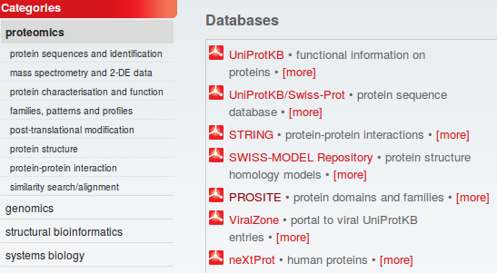
A major database for both motifs and domains is PROSITE. Many sequence motifs in this database are described using a simple pattern description language. They include some very common, simple motifs, many only a few residues long, that indicate possible sites for post-translational modifications (e.g. glycosylation or phosphorylation).
Go to the ExPASy site at:
http://www.expasy.org
Select proteomics from the list of Categories. Select PROSITE from the Databases section. Click on the ScanProsite link at the top of your page.
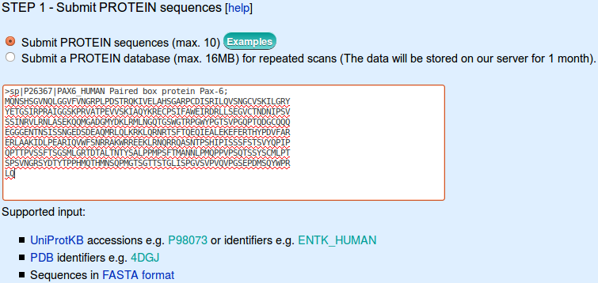

Enter pax6_human in the STEP 1 - Submit PROTEIN sequences section.

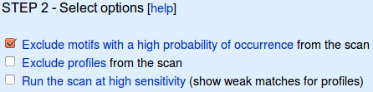
In the STEP 2 - Select options section, ensure that the Exclude motifs with a high probability of occurrence box is ticked.
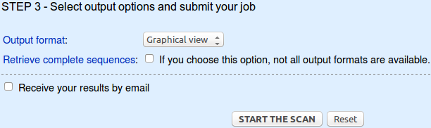
The defaults offered in the STEP 3 - Select output options and submit your job section are fine so just click on the START THE SCAN button. In but a few moments, your results will burst forth.

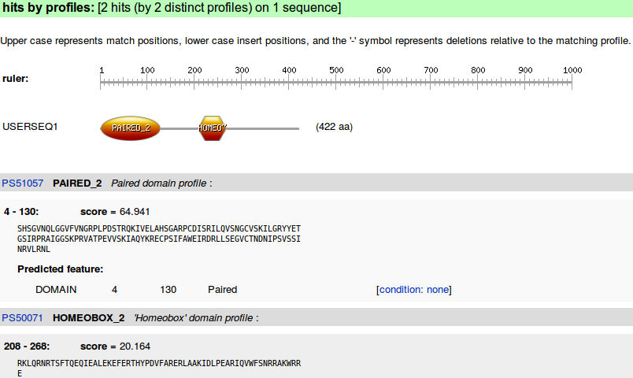

Two hits with PROSITE profiles suggesting the familiar domains in their familiar places.

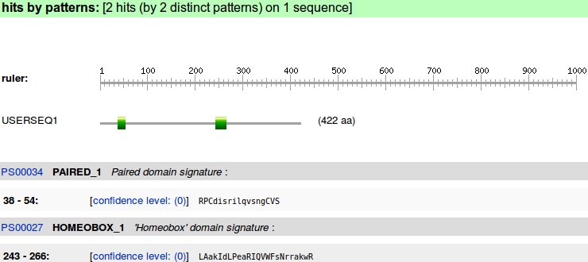
Two hits with PROSITE patterns confirming the same domains by matching their highly conserved subregions. Confirmation of what has already been discovered more than once, but this time, discovered by running a database search program manually. Exactly this program was used to generate the annotation read earlier.
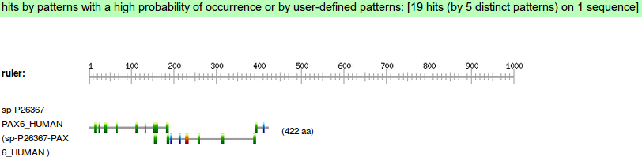
Move back to the search submission page. In Step 2, deselect Exclude patterns with a high probability of occurrence. START THE SCAN again.
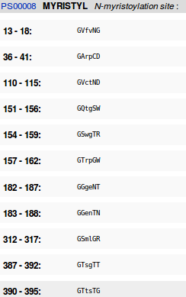

This time you will see many more hits with patterns.

Follow the link to the documentation for an N-myristoylation site (PS00008).

What is the signature pattern for N-myristoylation site?
How would you interpret this pattern?
How many N-myristoylation sites did ScanProsite suggest there might be in PAX6_HUMAN?
How many real N-myristoylation sites would you guess there might be in PAX6_HUMAN?

Searching PROSITE
What is the signature pattern for N-myristoylation site?
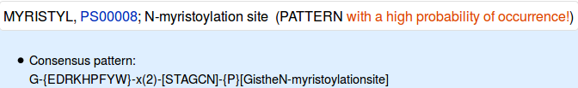
From the database entry, it can be seen that the pattern is 6 positions wide. 2 of those positions can be any amino acid. Only one position is fully specified. Not too demanding on the whole. I would expect this to match most proteins of any size and not always because there was an N-myristoylation site.
How would you interpret this pattern?
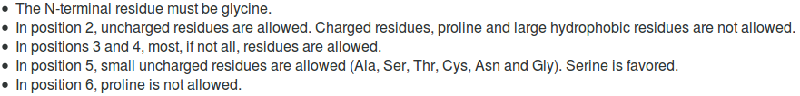
The pattern is explained in the database thus.
The description is not entirely an honest reflection of the information to which the scanning software will respond. The software is given to understand that ANY amino acid can occur in positions 3 and 4. The software has no way to know that “Serine is favoured” in position 5! Maybe you think that my pointing out these transparent truths makes me an intolerable pedant? Well … so is the computer!
How many N-myristoylation sites did ScanProsite suggest there might be in PAX6_HUMAN?
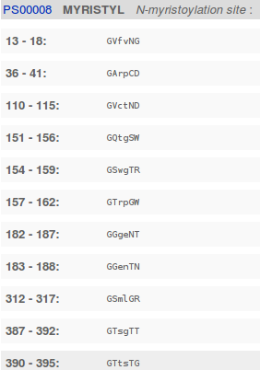

11, is the short answer. A site every 40 amino acids or so.

How many real N-myristoylation sites would you guess there might be in PAX6_HUMAN?
It is not really possible to answer this question from the evidence of this exercise. Intuitively, I would expect a large number of false positives from as weakly specified motif as this one. It has been suggested of this PROSITE pattern, by researchers looking at more sophisticated detection methods, that:
“PS00008 of PROSITE constructed from a small dataset … produces a great number of not only false positive but false negative predictions.”
Good enough for me not to believe the majority of these predictions to be reliable. Not good enough for me to hazard a meaningful guess as to how many real sites I would expect in this particular protein.
Where is the start and end of the Prosite Paired Box pattern (R-P-C-x(11)-C-V-S)?
Where, in relation to the pattern, are the extra isoform 5a amino acids?
Why might the positions of these two features be significant?
MQNSHSGVNQLGGVFVNGRPLPDSTRQKIVELAHSGARPCDISRILQTHADAKVQVLDNQ
NVSNGCVSKILGRYYETGSIRPRAIGGSKPRVATPEVVSKIAQYKRECPSIFAWEIRDRL
LSEGVCTNDNIPSVSSINRVLRNLASEKQQMGADGMYDKLRMLNGQTGSWGTRPGWYPGT
SVPGQPTQDGCQQQEGGGENTNSISSNGEDSDEAQMRLQLKRKLQRNRTSFTQEQIEALE
KEFERTHYPDVFARERLAAKIDLPEARIQVWFSNRRAKWRREEKLRNQRRQASNTPSHIP
ISSSFSTSVYQPIPQPTTPVSSFTSGSMLGRTDTALTNTYSALPPMPSFTMANNLPMQPP
VPSQTSSYSCMLPTSPSVNGRSYDTYTPPHMQTHMNSQPMGTSGTTSTGLISPGVSVPVQ
VPGSEPDMSQYWPRLQ
The pattern RPCxxxxxxxxxxxCVS is pretty easy to spot, but the 14 amino acid insertion of isoform 5a (THADAKVQVLDNQN, corresponding to the entire 3rd coding exon) has landed right in the middle of the pattern!
This is very significant as far as the efficacy of the PROSITE pattern is concerned. Despite the claim of the PROSITE documentation that the pattern picks up all known Paired domains, it is not going to work on any isoform 5a protein. This claim relies on the fact that all the PAX proteins in SwissProt are represented by their canonical sequence. The very common isofrom 5a is consistently recorded as a FEATURE, not search by the pattern matching software.
In order to detect just the PAX isoform 5a, the pattern would have to be:
R-P-C-x(25)-C-V-S
To detect both isoforms, using just one pattern:
R-P-C-x(11,25)-C-V-S
would work, but would be insufficiently specific and would generate far too many false positives. These sort of patterns are useful, but only with caution. They are valuable because of their simplicity, but very fragile.

DPJ – 2017.10.31
References for further extension:
https://en.wikipedia.org/wiki/Multiple_sequence_alignment

Of course, you could run Clustal from websites all over the world if you wished. Specifically, it is available at the Bioinformatics server at Wageningen. Try it if you have time. You get the same results but will, sadly, lose the pretty interface. http://www.bioinformatics.nl/tools/clustalw.html The EBI no longer offer basic Clustal.
The Fast-Approximate algorithm is essential that which the database searching program fasta employs. Assuming we have discussed how fasta (or blast) works, it should require little further explanation here.
From the “Manhattan Skyline”, you can see the conservation is less than 100%. Less conserved than the F that immediately follows in fact? Look at your alignment, the “Manhattan Skyline” does not seem to reflect reality? The W is very well conserved, although the scoring matrices would regard any deviation from W as serious? I need to find out more about how the Skyline is computed.
More available from a variety of websites in addition to the EBI, including the Bioinformatics server at Wageningen: http://www.bioinformatics.nl/tools/muscle.html
As discussed, superficially at least, previously. I hope.
I have asked the EBI about their policy (the same for all the locally provided MSA options). Discussion is ongoing (2016.04.20).
A useful option if you thought it possible you might want to rerun MUSCLE with different parameter setting for the stages after the Guide Tree(s) are generated. The same possibilities exist for ClustalX. Of course, utterly pointless if it is impossible to control the relevant parameters …. so I really cannot see the point of any of the More options section? I am open to elucidation from all/any sources.
A widely used java alignment editor and viewer.
But feel free to try the others. HTML is the default at Wageningen. The Phylip formats are the best if you are going to analyse your output further with the phylogeny programs of the PHYLIP package.
Expasy is a major site for protein based research in Switzerland. As the all knowing Wikipedia puts it: “ExPASy is a bioinformatics resource portal operated by the Swiss Institute of Bioinformatics (SIB) and in particular the SIB Web Team. It is an extensible and integrative portal accessing many scientific resources, databases and software tools in different areas of life sciences. Scientists can access a wide range of resources in many different domains, such as proteomics, genomics, phylogeny/evolution, systems biology, population genetics, and transcriptomics.”

