

ELB199F
Entry Level Bioinformatics
04-08 February 2019

(First 2019 run of this Course)

Basic Bioinformatics Sessions

Practical 2: Pairwise Sequence Alignment

Wednesday 30 January 2019
Sensitive Pairwise Alignment
The purpose of this exercise is to look at some aspects of Pairwise Sequence Alignment using the most accurate methods available.
As hopefully has been discussed, sequences can be aligned using a global strategy, in which the two sequences being aligned are assumed to be homologous from end to end, or using a local approach, in which the sequences are assumed to just have homologous region(s).
Global Pairwise Sequence Comparison
First the global approach. In a previous exercise, you already have used the blast facility at the NCBI to perform crude pairwise alignment. blast also offers a sensitive option, so maybe that would be a good place to start.
So, once more to the NCBI home page (http://www.ncbi.nlm.nih.gov/). From there chose BLAST from the Popular Resources list. Scroll down to the Specialized searches section and chose the 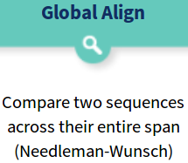option.
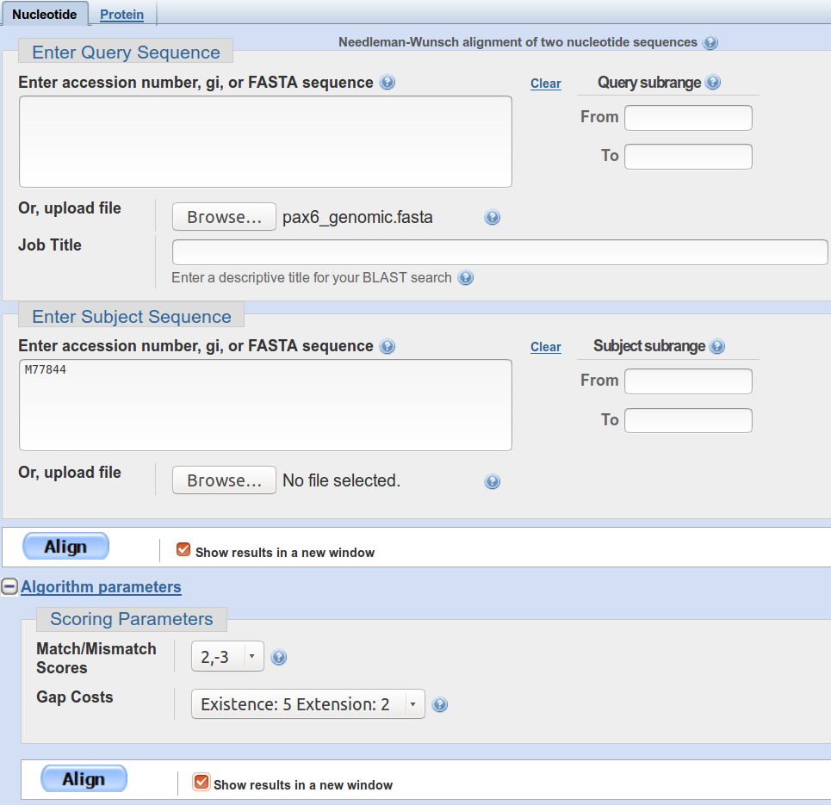
A choice of settings for Nucleotide or Protein alignment is offered. As we are going to investigate the alignment of DNA sequences, the default choice is fine. For the first sequence, browse for the file pax6_genomic.fasta, which you created when looking at Ensembl. It contains the region of Chromosome 11 containing the entire PAX6 gene (with a few extra base pairs either end).
To specify the second sequence, you could load the file pax6_mrna.fasta, but just typing the corresponding Accession code in the appropriate box seems far more sophisticated, so that is what I chose to do.
Open the Algorithmic Parameters section, and see that they are as one might expect. The defaults are fine here as the alignment to be computed is trivial (given the way blast will go about the task), so anything not outrageous should work.
Ask to Show results in a new window and then click on the Align button.
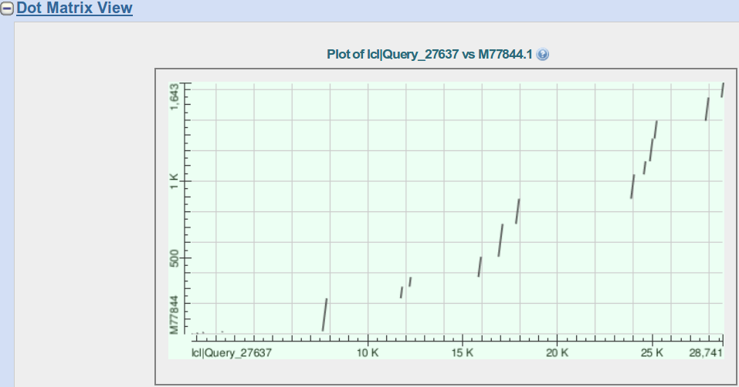
After some significant Rollin' and Tumblin' blast will proclaim its lyrical conclusions. First examine the Dot Matrix View. This sort of representation has rather gone out of fashion in recent years. A shame, I say, this picture represents such a succinct summary of what should be expected of the textual alignment(s) that are the “real” detailed output of this sort of program.
How would you interpret this picture?
What do the diagonal(ish) lines represent?
What are the gaps in between the lines?
Which axis represents the genomic sequence and which the mrna?
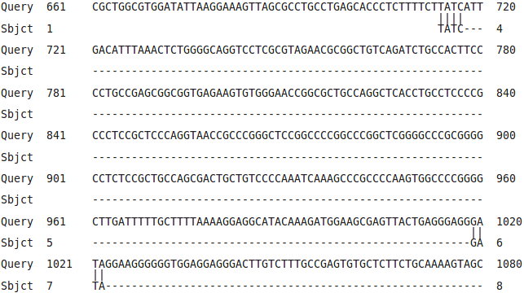
Move down to the textual alignment. There are some weird little bits and pieces at the front of the alignment which defy logic. I decide not to dwell on these to much, beyond noting that the mRNA has some odd bases at the front.
Also, I have faith that the alignment you look at yields the highest alignment score, but equally. I doubt most people would have chosen to throw these odd bases about with quite such abandon! People are best!
You can just see evidence of the little patches of whimsy in the Dot Matrix View.

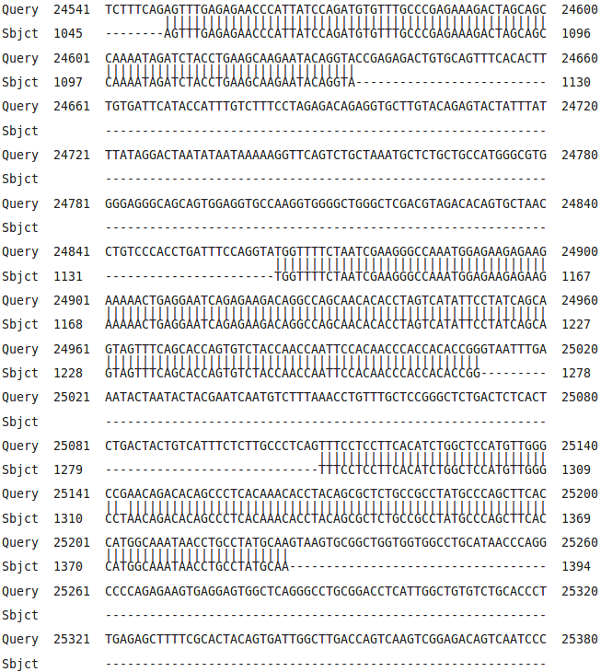
Moving down there are a series of far more convincing near perfect alignments.
You must know what these aligned regions represent by now?
But, just in case:
What do you suppose these regions represent?
How many are there and do they correspond nicely to the lines of the Dot Matrix View?
How many exons would you say this mrna has?
If one was to forgive the strange “bits” at the start, would you say blast seems to have done a reasonable job here?
I think I would.
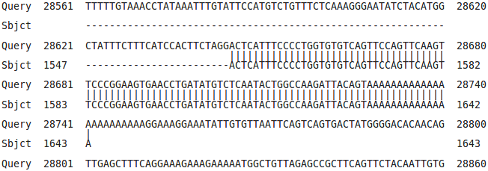

The final alignment section even has a PolyA Tail!
Or does it? How you you interpret the run of As at the end of the final exon?

Wonderful, but it is not safe to assume that just selecting any service that claims to do a sensitive global pairwise alignment will just work for any pair of sequences. I fact, pretty though it appears, the alignment blast has generated is not as entirely logical as it might first seem. For example, consider:

How might the gap around 24,750 in the genomic sequence been positioned more intelligently?
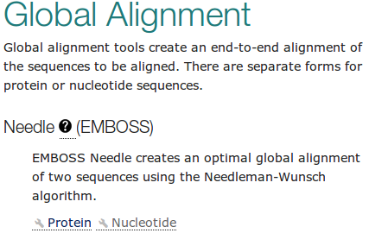
Next, try aligning the same two sequences with another program (implementing the same algorithm) at the EBI.
Go to the Pairwise Sequence Alignment EBI page:
(http://www.ebi.ac.uk/Tools/psa/).
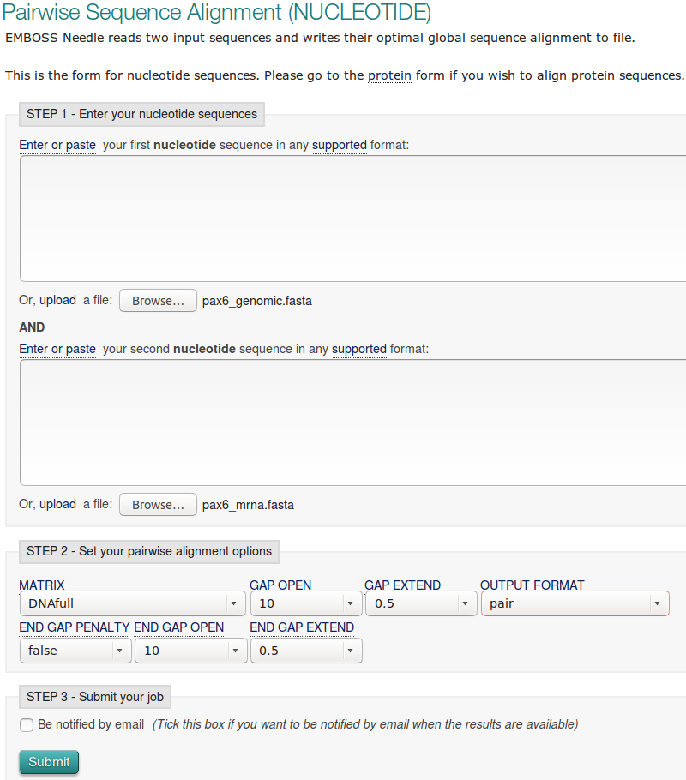
Select the Nucleotide option for the Global Alignment program Needle.
Needle implements the best global pairwise algorithm exactly.
Load up the first sequence from pax6_genomic.fasta.
Load up the second sequence from pax6_mrna.fasta.
Click on the More options button to see what parameters you can set. They should be as you might expect. The defaults are fine for the first run.
Click on the Submit button to get Needle into action.
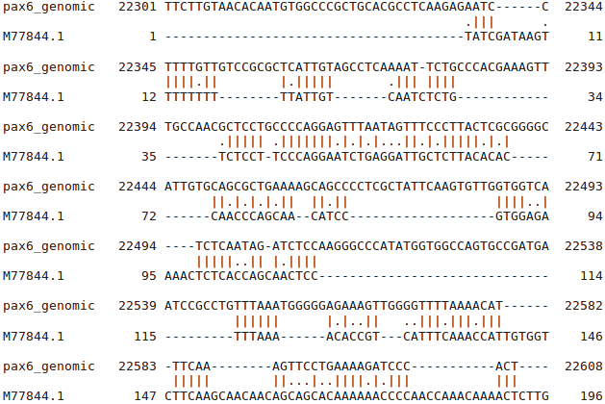

Well! Nothing like as convincing as the alignment blast produced!
Alignment does not even begin until over 22,300 base pairs along the genomic sequence. Even then it is not convincing, as in wrong, if we accept the results already obtained from blast as a fair approximation of the truth.
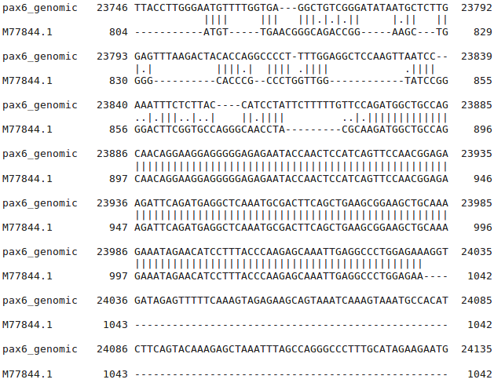
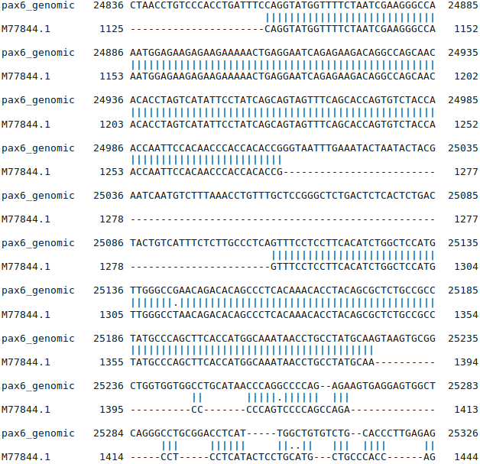
There are some well aligned regions after genomic position 24,500.

Then a resumption of chaos after 25,230 or so.
How many convincingly aligned regions did you see?
How many did you expect?
Clearly, this alignment is not correct. Can you explain why?
I assume you have all read the lucid answers to the question above? If so, I am confident you will agree that there are 3 ways to get an answer, similar to that generated by blast, from the tools offered at the EBI. They are:
- Make gap penalties so cheap that Needle will have no excuse to avoid gaps where they are needed. This works if you use a gap opening penalty of 1.0 (the lowest allowed by the web interface) and a gap extension penalty of 0.0, allowed by the program but not by the EBI web interface!! The lowest value the web interface allows is 0.0005, which really should be sufficiently small, but provably is not. The most important question being “Why would a web interface restrict a program's capabilities other than to prevent excessive resource use?”. I have no answer for that one, I will just petulantly include some extra low gap alignments (made without a web interface) in your Backup_Results directory and retire with self righteous hauteur! Note that making gaps completely free (i.e. both gap opening and extension equal to 0.0) will not work at all! needle would simply match each base of the mRNA with the next identical base of the genomic sequence until it runs out of letters. You could do this from the command line, but it would clearly not make sense.
Actually, using gap penalties to suit huge gaps that are really introns, will only work when the exons are so similar (as here) that any gap penalties will work for their alignment. Generally, you need to pick gap penalties to optimise exon alignment. So this is a very horrible way to “fix” the situation anyway.
- Tell Needle to penalise the gaps it puts at either end of the alignment in the same way it penalises gaps it puts in the middle. By default, end gaps are free!! Which is not very logical here. This is possible using the website.
- Use Stretcher, which uses essentially the same algorithm as Needle, except, it also applies a bit of common sense (heuristics, if you like). Stretcher takes a look at the sequences before it starts to do any serious computation. It identifies any “good regions” (all 12 exon matches in this case) and then says “OK, I am definitely having those, how best can I deal with the rest?”. In essence, Stretcher does a quick Dot Matrix View before it starts and so only goes to work when it has a pretty good idea what the answer should look like It works in this case, but not always. Stretcher is faster than Needle but does not necessarily generate the highest scoring alignment. Stretcher works in a fashion far closer to the way a human would work, which has to be good! Well, usually anyway.
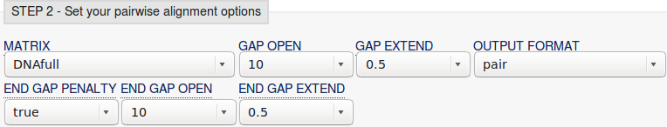
So, try the Needle with penalised End Gaps approach by returning to the Needle launch page from your results. You should find the two sequences are still selected, so you should only have to click on More Options again and change the END GAP PENALTY field from false to true.
Click on the Submit button and Needle will be on the road again.
How many matching regions are there this time? Is the count now roughly as you would expect?
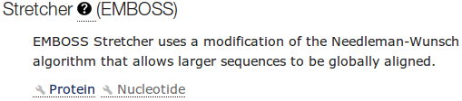
Finally, check that Stretcher works as expected.
Go again to the Pairwise Sequence Alignment EBI page (http://www.ebi.ac.uk/Tools/psa/).
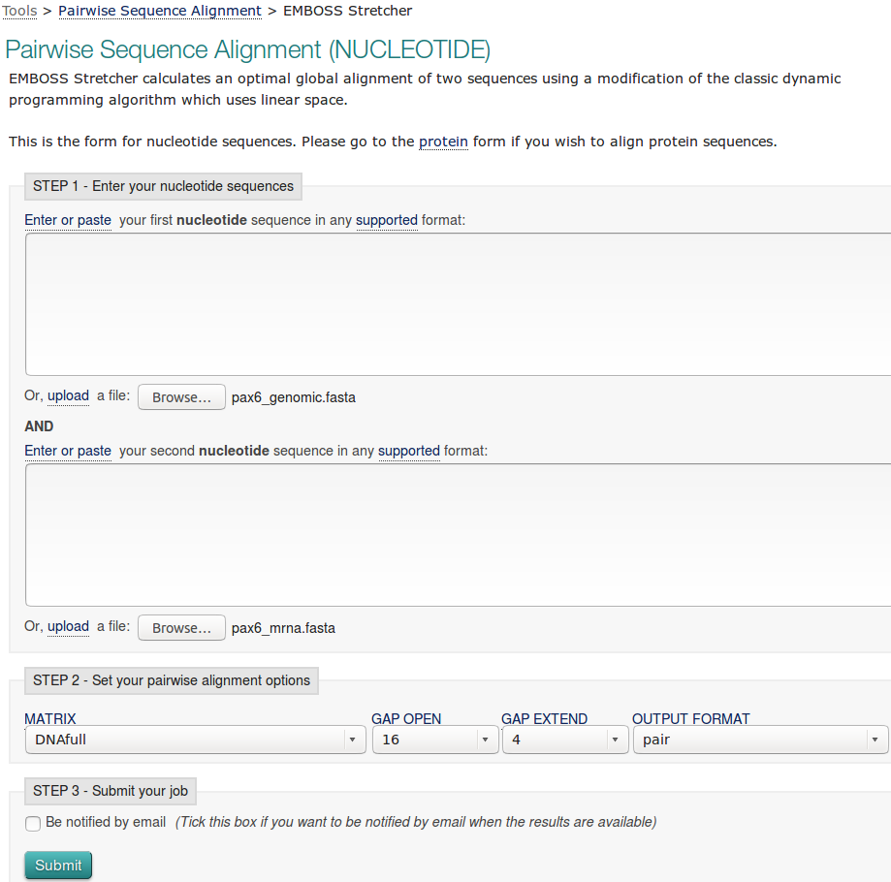
From there, select the Nucleotide option for the Global Alignment program Stretcher.
Load up the sequences exactly as for Needle.
Take a look at the parameters and see there is nothing unexpected hiding there.
Set Stretcher sequence rope stretching.
How do you feel about the results this time?
How do you think blast achieve the correct results without any fuss?
Pairwise Sequence Comparison using Specialised Software
None of the alignments generated thus far have been entirely correct.
By persuading the general global alignment software to treat huge gaps (i.e. the introns) in some sort of special manner, a reasonable answer was obtained. However, the general software could not know that something more than just Substitutions and Indels were at issue here. Consequently, it stood no chance of dealing with the intron/exon boundaries sensibly.
The solution is not to fiddle around with the parameters of the general tools. Aligning mRNAs with Genomic sequence is simply not “General Alignment”. It is an example of a problem that is sufficiently particular to require specialised software for an optimal solution.
There is a program in the EMBOSS package (the same collection of programs as Needle and Stretcher), called est2genome, which is specifically designed for the alignment of cDNA/mRNA and genomic sequences. est2genome (and similar programs) may assume much more about the sequences to be aligned than can a general purpose alignment program. Gaps representing introns can be placed far more accurately if they are known to represent introns. Programs such as est2genome seek the highly conserved bases that occur at intron/exon boundaries, C/T rich intronic regions, polyA regions and Stop/Start codons to assist its detection of exons and gene structures.
est2genome is a fine program, but the option offered at the NCBI in America does the same job, I think, somewhat more nicely. The NCBI program is called splign. To investigate, go to the home of splign at:
http://www.ncbi.nlm.nih.gov/sutils/splign
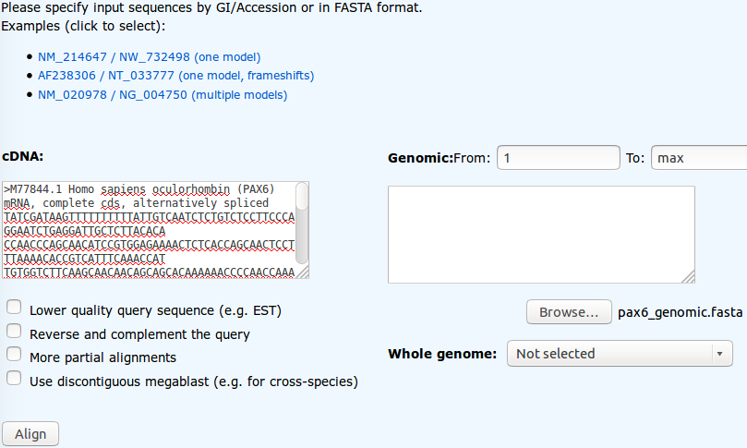
Click on the Online button. In the Genomic section, Browse to upload pax6_genomic.fasta.
In the cDNA section, paste the sequence pax6_mrna.fasta. Where cDNA and Genomic sequences share exons that are nearly identical, splign uses the comparison algorithm megablast (default). Where exons are less similar (e.g. when the cDNA and Genomic sequences are from different organisms) the more sensitive option discontinuous megablast, is a better choice. Note the option to compare your cDNA with a Whole genome (including Human). Today, the default options are fine. Click the Align button.
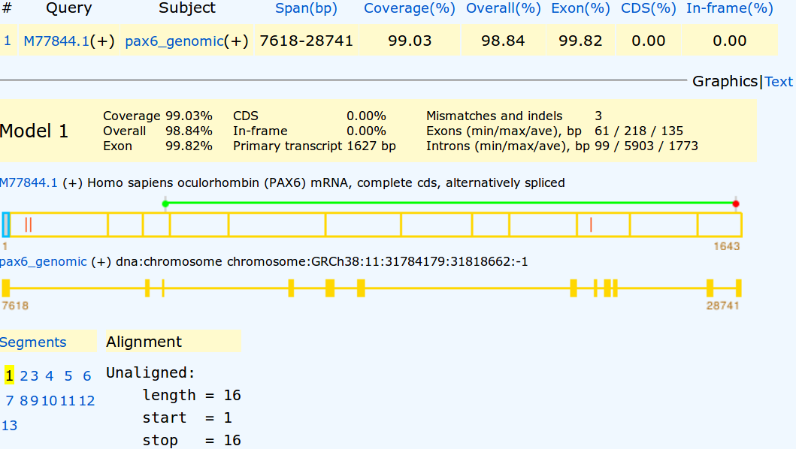
Your results will appear showing the cDNA split into 12 sections (the predicted exons) corresponding to 12 regions of the genomic sequence indicated by yellow rectangles. A 13th region of 16 base pairs is displayed and declared to be unaligned. These are the 16 mystery base pairs at the start of this particular mRNA that Needle and Stretcher had trouble treating sensibly also. I wonder what they are?
Any theories?
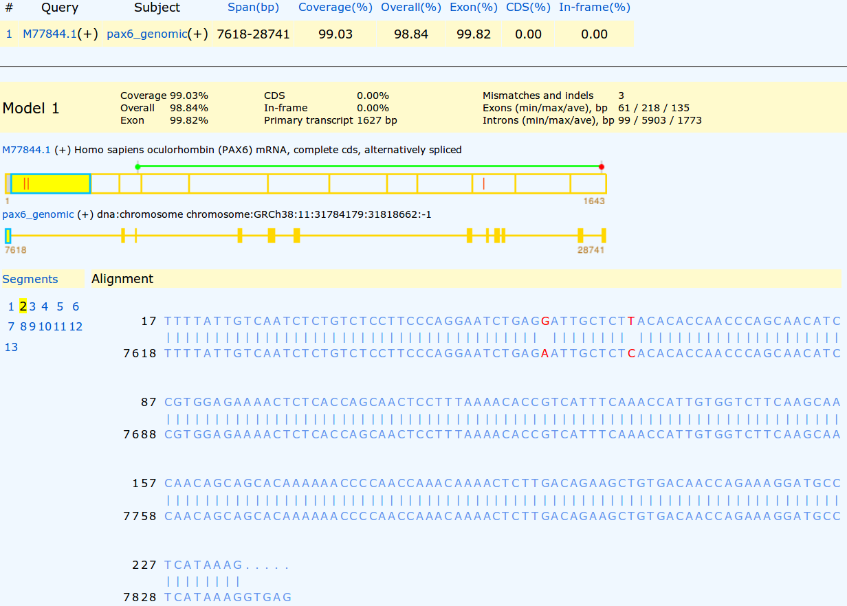
Click on the first exon section of the cDNA display.
Here there shows two substitutions. These were also apparent in the successful blast, Needle and Stretcher alignments. You might have spotted them?
Though these are in a non-coding region, they could easily still be very significant. However, for the purposes of this exercise, let us assume they are not.
The Start (green) and Stop (red) codons delimiting the CoDing Sequence (CDS) are illustrated by the bar above the cDNA display.
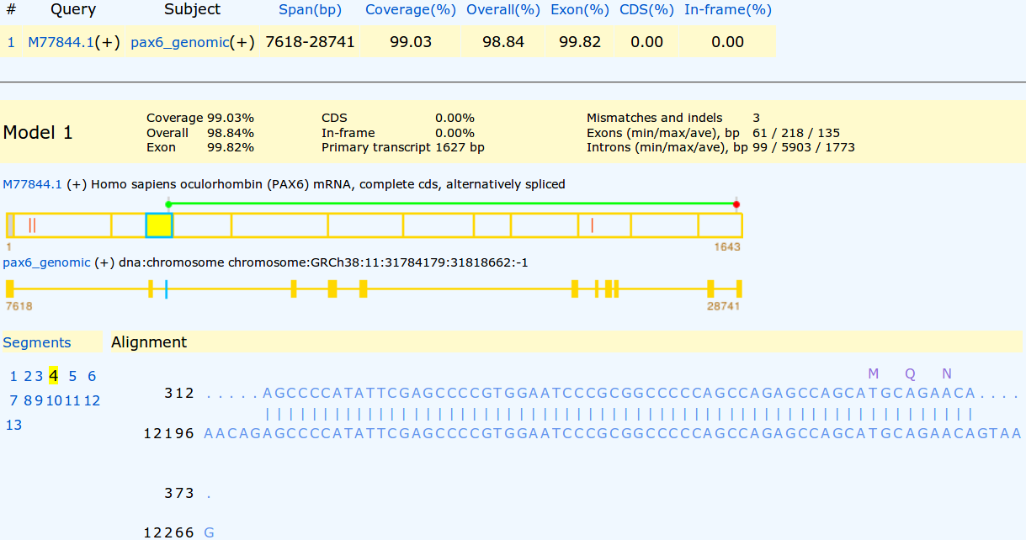
Click on the exon including the green Start codon (the 3rd).
The first coding exon is now displayed with translation of the mRNA where appropriate.
The statistics at the top of the display include the claim that there are 3 discrepancies (Mismatches and Indels) between the cDNA and Genomic sequences.
Two of these are the substitutions we have already seen in the first exon of the cDNA. The third is indicated by the red bar in the 10th exon of the cDNA display.
Click on the 10th exon section of the cDNA display.
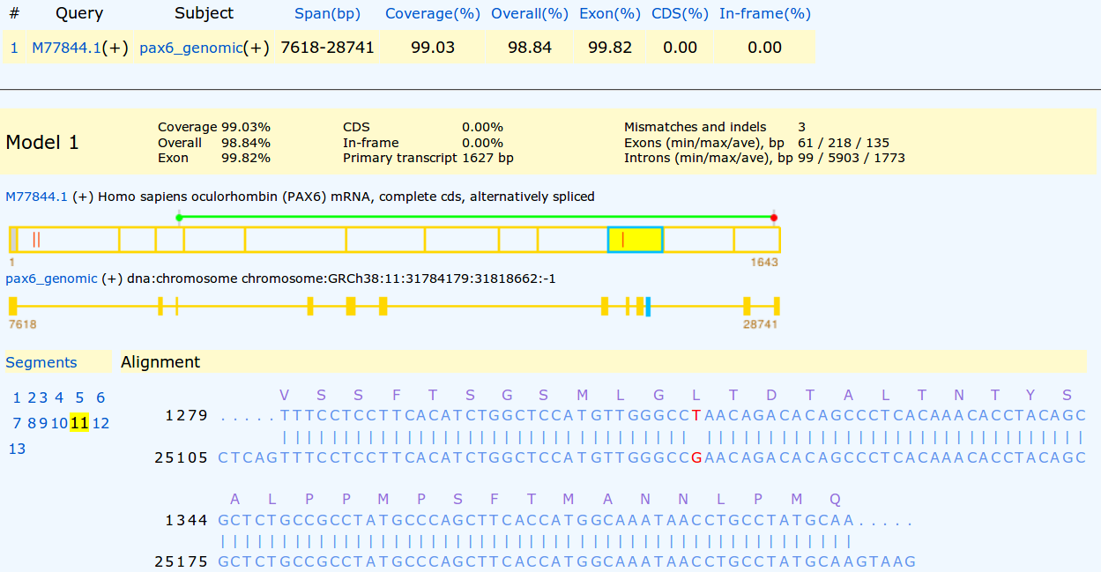
The third difference, a substitution, should be clear to see. Given it changes the coded protein, this substitution is likely to be the most significant.
Irritatingly, in the extreme! splign only translates the mRNA. So one has to work to discover the alternative suggested by the Genomic sequence.
Vital if we were really doing this seriously, but for an exercise, it is fine to relax. I do not intrude on real life much and it, largely, leaves me untouched in grateful response.
What is the amino acid corresponding to the mutated position in the Genomic sequence?
What are the Genomic and mRNA base positions corresponding to the mutation at amino acid position 33?
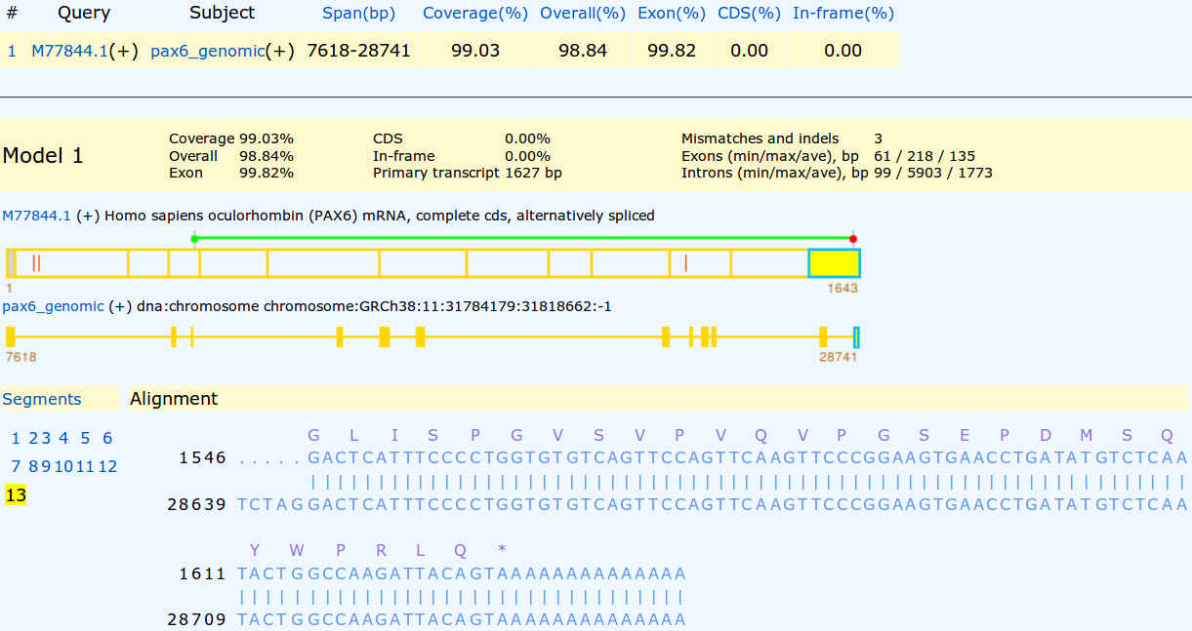

Click on the last exon section in the cDNA display. You should now see the final exon of the cDNA with the Stop codon and polyA region.

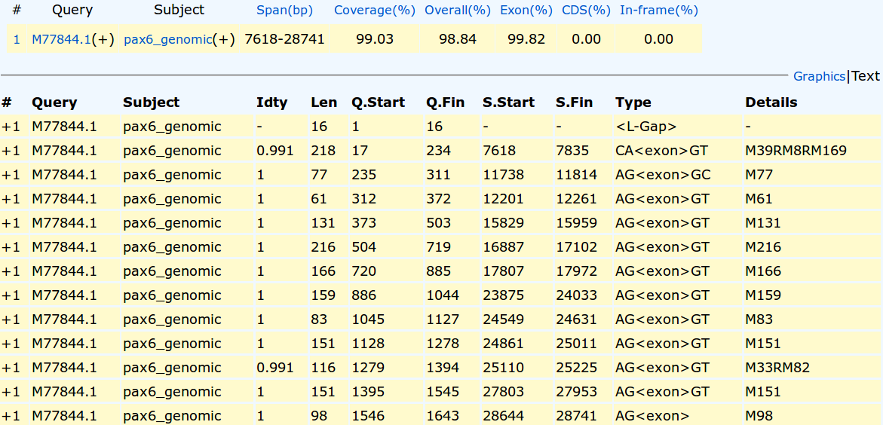

Finally, click on the Text link to view the textual summary of the splign results.

How do you interpret the Details column for exons 1 and 10?

Where is the 3rd substitution in the mRNA?

Where is the 3rd substitution in the Genomic Sequence?


Compare the predicted splign intron/exon boundaries with the conservation suggested by the logo?

What deviation(s) from the model suggested by the logo can you see?
Sensitive Local Pairwise Sequence Comparison
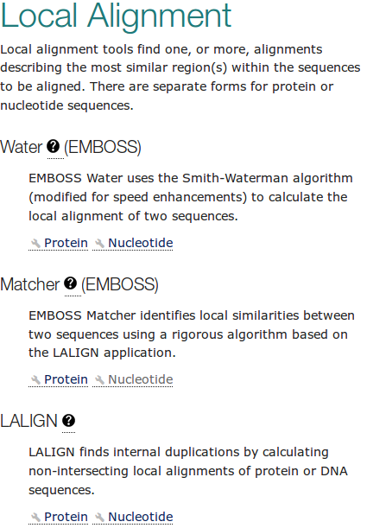
Finally, a swift look at sensitive local pairwise sequence alignment. You have already used blast to do a local pairwise alignment in the last Practical, when you aligned the two human genomic sequencing contigs that covered the PAX6 location in Chromosome 11. blast did not use a sensitive approach however, nothing subtle was required for that particular alignment.
For a more accurate alignment, return to the Pairwise Sequence Alignment EBI page (http://www.ebi.ac.uk/Tools/psa/).
From there, select the Nucleotide option for the Local Alignment program Matcher.
Water or LALIGN would also be fine options, but I declare the nucleotide option of Matcher to be choice of the day.
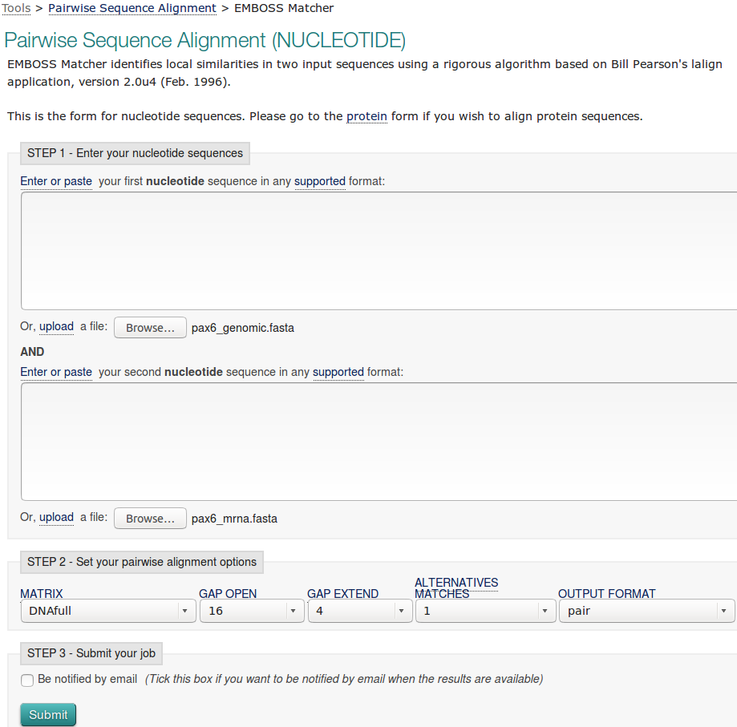

Load up the Genomic and mRNA sequences as you did for Needle.

Click on the More options button to see what parameters you can set. They should be as you might expect. The defaults are fine for the first run.

Click on the Submit button to get Matcher into Matchbox mode.
After due consideration of all the possibilities, Matcher will enrich your screen with its conclusions.
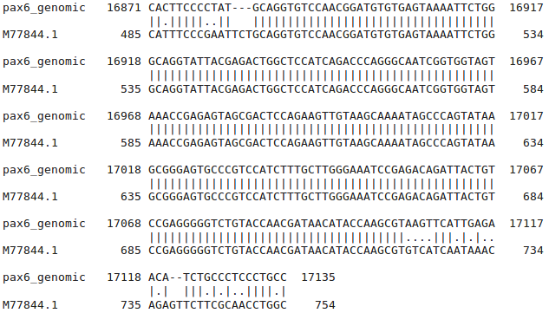
But, only one alignment? A good one, covering the highest scoring region of all those considered, but it cannot be the whole story, which must tell the tale of 12 exons! Here is but one.
In common with most local alignment programs, by default Matcher will only show you the single best local alignment between two sequences.
A good reason to have a Dot Matrix View to inform one of roughly what to expect, which is not one miserable alignment in this case.
Of course, it is also miserable biologically! Matcher fails to align the exons accurately for all the same reasons that the Needle failed to represent the biological reality.
So, what can one do but try again! By returning to the Matcher launch page from your results. You should find the two sequences are still selected, so you should only have to click on More Options again and set the ALTERNATIVE MATCHES field 20.
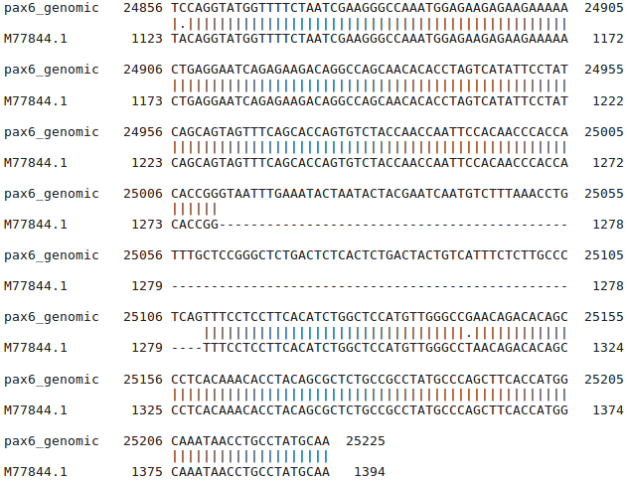
Actually, as you know there are only 12 exons. And that some might well be close enough to be included in the same alignment, you do not need to go as high as 20. However, the web interface restricts choice (WHY!?) such that this is the most sensible cautious choice.
Click on the Submit button and Matcher will trust and obey.
At the top of your output will be some nice believable local alignments, some involving more than one exon.
Matcher tries to make each alignment as long as it can, stopping only when, to stretch the alignment any further would involve the alignment score deceasing due to the necessity for gap penalties.
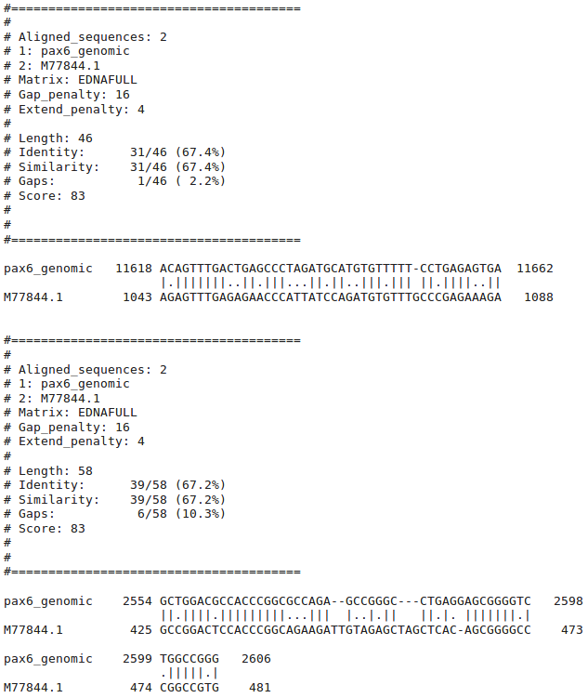
Go to far down the list of alignments and you will realise what a literal interpretation Matcher has of its duties.
You asked for 20 alignments?
So here are the best 20 alignments and it is entirely up to you to decide where “silly” begins.
Not too difficult in this case I suggest.
Why do you suppose your aligned exons are not presented in the correct positional order?
THE END
DPJ – 2019.01.30
Model Answers to Questions in the Instructions Text.
Notes:
For the most part, these “Model Answers” just provide the reactions/solutions I hoped you would work out for yourselves. However, sometime I have tried to offer a bit more background and material for thought? Occasionally, I have rambled off into some rather self indulgent investigations that even I would not want to try and justify as pertinent to the objective of these exercises. I like to keep these meanders, as they help and entertain me, but I wish to warn you to only take regard of them if you are feeling particularly strong and have time to burn. Certainly not a good idea to indulge here during a time constrained course event!
Where things have got extreme, I am going to make two versions of the answer. One starting:
Summary:
Which has the answer with only a reasonably digestible volume of deep thought. Read this one.
The other will start:
Full Answer:
Beware of entering here! I do not hold back. Nothing complicated, but it will be long and full of pedantry.
This makes the Model answers section very big. BUT, it is not intended for printing or for reading serially, so I submit, being long and wordy does not matter. Feel free to disagree.
From your investigations of Global Alignment:
What do you suppose these regions represent?
Exons
Or does it? How you you interpret the run of As at the end of the final exon?
Summary:
Well, whatever they are they cannot be a PolyA Tail as they exist both as part is the mRNA AND the Genomic sequence!
As you assuredly know already, Polyadenylation (the addition of a poly(A) tail to a messenger RNA) is part of the process that produces mature messenger RNA (mRNA). So the As of a poly (A) tail occur only at the end of the messenger RNA, NOT in the genomic sequence!
So, I would suppose the As in question are the 3’ UnTranslated Region (UTR), or at least part of it.
Full Answer:
REFERENCE 1 (bases 1 to 1643)
AUTHORS Ton,C.C.T., Hirvonen,H., Miwa,H., Well,M.M., Monaghan,P.,
Jordan,T., van Heyningen,V., Hastle,N.D., Meijers-Heijboer,H.,
Drechsler,M., Royer-Pokora,B., Collins,F.S., Swaroop,A.,
Strong,L.C. and Saunders,G.F.
TITLE Positional cloning and characterization of a paired box- and
homeobox-containing gene from the aniridia region
JOURNAL Cell 67 (6), 1059-1074 (1991)
PUBMED 1684738
This mRNA was born in 1991, as can be confirmed by a quick glance at its Genbank annotation.

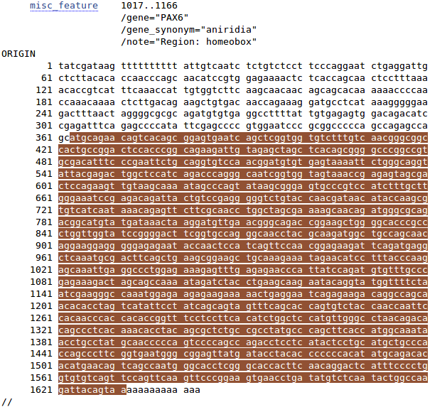

mRNA sequences of this era quite often were submitted with incomplete UTRs.
The absence of a polyA_site Feature further suggests the As at the end of M77844 are not a complete 3’ UTR.

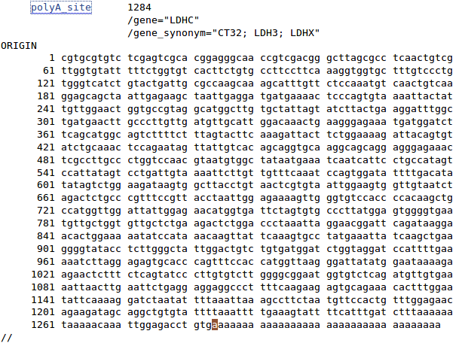

In the following example of a more recent (2018.02) mRNA GenBank entry, there is a polyA _site at the end of the final exon (highlighted, and implying a complete 3’ UTR) with the polyA itself included as a part of the sequence.

Only the highlighted A at position 1284, which is the polyA_site, will occur in the Genomic sequence.
How might the gap around 24,750 in the genomic sequence been positioned more intelligently?
blast has positioned a gap in this region merely to maximize the overall alignment score. There is more than one way of achieving this simple goal. However, if it were to be recognized that the gap to be positioned was to represent an intron, then one of the arithmetically equivalent options becomes far more attractive than the others. This “best” option is not the one chosen by blast, which is forgivable as blast had no reason to expect an intron and was not written to understand the properties of introns anyway.
The alignment chosen for this region by blast was:
Genomic 24601 CAAAATAGATCTACCTGAAGCAAGAATACAGGTACCGAGAGACTGTGCAGTTTCACACTT 24660
||||||||||||||||||||||||||||||||||
mRNA 1097 CAAAATAGATCTACCTGAAGCAAGAATACAGGTA-------------------------- 1130
...
Genomic 24781 GGGAGGGCAGCAGTGGAGGTGCCAAGGTGGGGCTGGGCTCGACGTAGACACAGTGCTAAC 24840

mRNA ------------------------------------------------------------

Genomic 24841 CTGTCCCACCTGATTTCCAGGTATGGTTTTCTAATCGAAGGGCCAAATGGAGAAGAGAAG 24900
|||||||||||||||||||||||||||||||||||||
mRNA 1131 -----------------------TGGTTTTCTAATCGAAGGGCCAAATGGAGAAGAGAAG 1167
Shifting the gap 3 places to the left neither changes the size of the gap nor the perfection of the alignment either side of the gap and so does not affect the alignment score.
However, it does mean the gap begins with an GT and ends with a AG which is what one might expect if it were known that the gap represented an intron. I include the beautiful Intron/Exon logo. As you might gather, I rather like this one.
So, if blast was a little better informed, the improved alignment would have been:
Genomic 24601 CAAAATAGATCTACCTGAAGCAAGAATACAGGTACCGAGAGACTGTGCAGTTTCACACTT 24660
|||||||||||||||||||||||||||||||
mRNA 1097 CAAAATAGATCTACCTGAAGCAAGAATACAG----------------------------- 1130
...
Genomic 24781 GGGAGGGCAGCAGTGGAGGTGCCAAGGTGGGGCTGGGCTCGACGTAGACACAGTGCTAAC 24840

mRNA ------------------------------------------------------------

Genomic 24841 CTGTCCCACCTGATTTCCAGGTATGGTTTTCTAATCGAAGGGCCAAATGGAGAAGAGAAG 24900
||||||||||||||||||||||||||||||||||||||||
mRNA 1131 --------------------GTATGGTTTTCTAATCGAAGGGCCAAATGGAGAAGAGAAG 1167
This is the alignment that one might expect from any program customized to align mRNA with Genomic sequence, as you will see in the fullness of time.
How many convincingly aligned regions did you see?
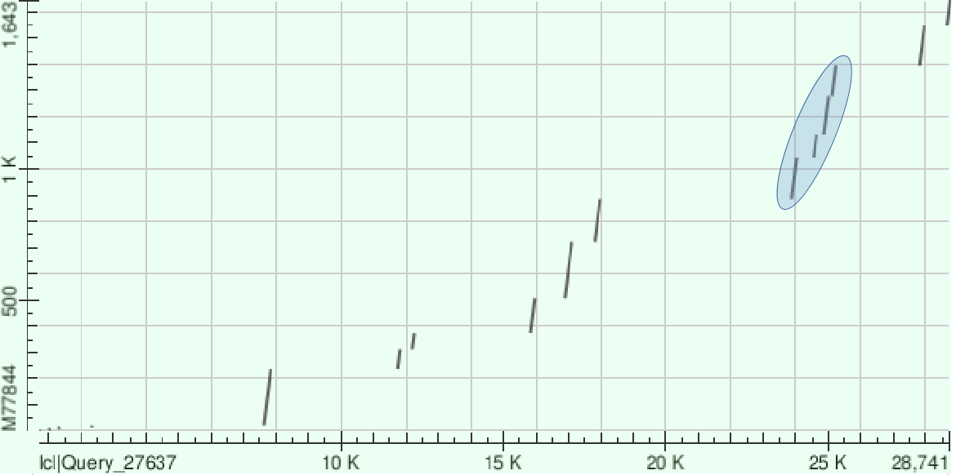
4
How many did you expect?
12, as that was how many blast found, not including the silly ones at the beginning.
The 4 that were found correspond the illustrated 4 diagonal lines grouped together in the Dot Matrix View made by blast.
Clearly, this alignment is not correct. Can you explain why?
This alignment algorithm only wishes to maximise an alignment score. It sees ALL the high scoring exon regions, however, as the gaps between many of the exons (introns that is) are so long that the penalties for representing them correctly are greater than the gain achieved by the inclusion the extra exons in the alignment. Arithmetically, it is better to align all the exons either side of the 4 exons that were aligned sensibly, in the biologically improbably fashion shown. Arithmetically the best alignment, biologically ridiculous!
This behaviour is exaggerated because this program regards the enormous gaps in has suggested at the start and end of the alignments as “free”. Some global alignment programs (including this one if you ask politely, as you will see) offer the option of penalising the ends gaps in the same way as for internal gaps. Normally, not penalising end gaps is sensible as it allows for the sequences to have slightly different lengths. In this case, penalising end gaps will result in a far better alignment.
Had you used stretcher (also offered by the EBI) you would have got a much improved answer in this case (but not necessarily in generally). This is because stretcher works in a way far closer to the way an informed human might think. stretcher does not mindlessly insist of the highest alignment score. Instead, it looks for all the high scoring regions (i.e. all the exons) and then computes the best way to link them together. The result is a far more convincing alignment, but not the arithmetically best scoring answer.
How many matching regions are there this time?
Were you to trawl though your textual output carefully (or simply take my immaculate word for it), you would find 12 perfectly (or nearly so) aligned regions, implying 12 exons.
To be pedantic, the nicely aligned regions do not match the exons exactly (as has been discussed), but well enough to claim definite evidence for the number of exons. 12 is good enough for me.
Is the count now roughly as you would expect?
Yes, exactly the same as blast predicted in the first place. More exons that 17 might have been a surprise as that is how many the gene record for PAX6 at the NCBI suggested. Any given transcript may have less than 17 exons or exactly 17 exons, but not more than 17 exons if the heroes of the NCBI are not mistaken.
How do you think blast achieve the correct results without any fuss?
The only way blast could have got the right answer, as it did, would be to use one of the strategies listed previously. blast did not use the horrible idea of making gaps super cheap! Not only is that a disgustingly dirty trick, but blast actually declares that it is using quite sensible gap penalties.
Leaving penalising end gaps and/or using the same sort of heuristics employed by stretcher. I would strongly suspect blast uses a stretcher approach. After all, blast has clearly already identified all the “promising regions” in order to construct its Dot Matrix View. Also the stretcher strategy is similar to that of all blast searches (discussed in the next Practical). Finally, blast is often used to align very long DNA sequences to detect very strongly similar large regions. This is exactly what the faster (if less pure) stretcher approach is all about.
From your investigations comparing mRNA/cDNA with genomic DNA:
What is the amino acid corresponding to the mutated position in the Genomic sequence?
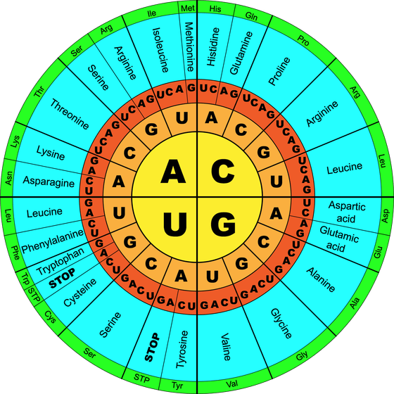
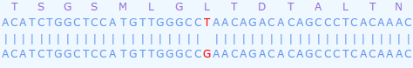
The top sequence is the mRNA. splign is kind enough to explicitly inform us that the “mutated” codon, CTA, will be expressed a Leucine.
So, why not translate the Genomic sequence also splign?! Easy enough to look up. But I resent having to do so!

From this rather beautiful representation of the Genetic Code, I conclude:
mRNA CTA → Leucine (L)
Genomic CGA → Arginine (R)
I checked, and this does not appear to be a substitution that is associated with any “interesting” phenotype.
There is no real reason why it should. We did not pause to find out anything about the mRNA downloaded from the NCBI, The annotation is particularly unrevealing by itself (it is in Backup_Files if you really want to check).
Let us simply assume it is a benign Accepted Point Mutation (PAM). Yes indeed, that feels comfortable. Not so very tricky this Science stuff after all what!
What are the Genomic and mRNA base positions corresponding to the mutation at amino acid position 33?

Remember the Natural variation at amino acid position 33? You looked at it in passing during the course of the first exercise. It is a major cause of Aniridia. An Alanine mutated to a Proline at the end of a Helix vital to the DNA Binding function of the PAX6 protein.
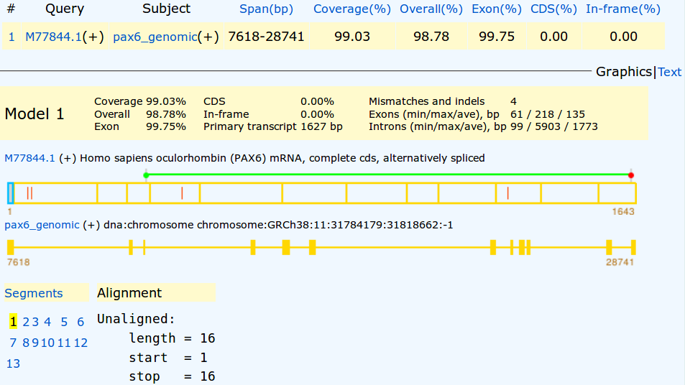
splign shows alignments for all exons and from those alignments the answer to this question is thus clearly available. To make finding the right spot in the alignment to study easier, I ran splign again with an edited version of the mRNA (saved as pax6_mrna_edited.fasta amongst your cheat files) against the same Genomic sequence. Had there been a suitable mRNA sequence in the databases, I would have used it for the exercise, but there is not.
You should be able to clearly see the extra mutation is in the 5th segment.
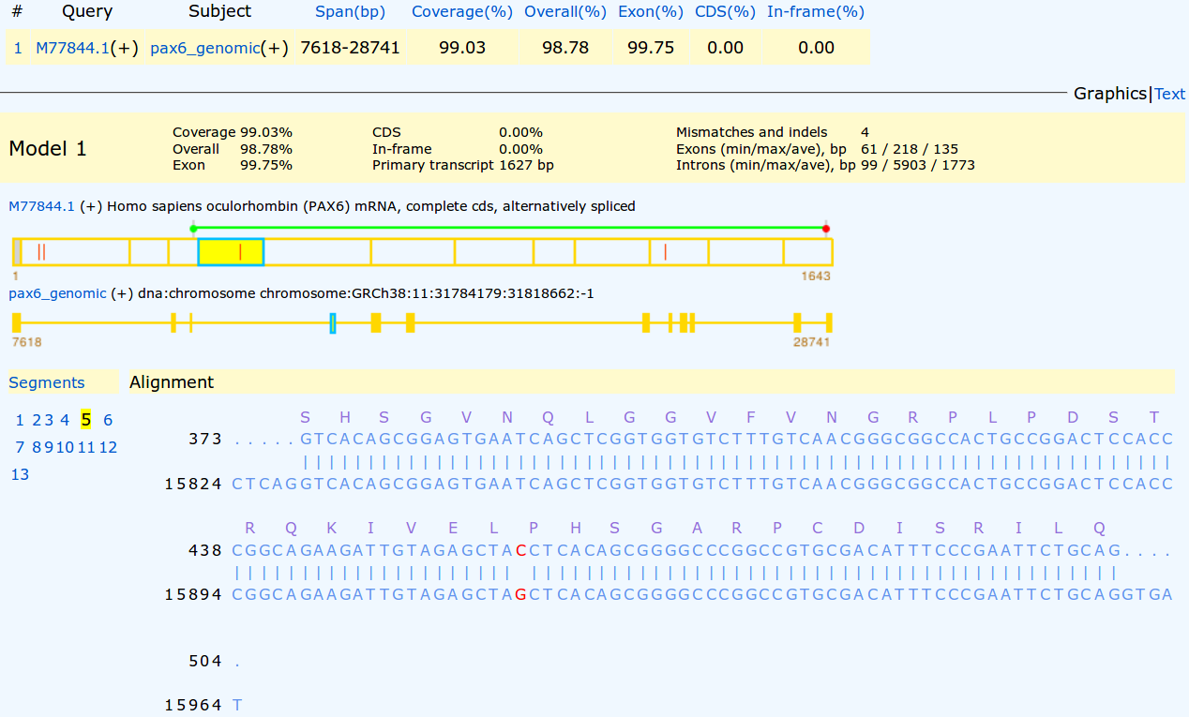
Focussing on the 5th segment, the substitution is clear. Using the same methods as were used for the previous question, it is easy to confirm that the variation at amino acid position 33 amounts to:
Affected Patient protein:
CCT → Proline (P)
Canonical protein:
GCT → Alanine (A)
Squinting madly, you can also discover that the variation base positions are:
Affected Patient mRNA: Base position 459 → C
Wild Type Genomic DNA: Base position 15915 → G
In case you were wondering, chasing these values around is a little more than tragic pedantry. You will need this information later when you investigate Primer Design. No need to take notes, I will remind you of what you need when the time comes. Here I just want to show how the values could be determined, if you had to. Not difficult, just tedious!
How do you interpret the Details column for exons 1 and 10?
Summary:
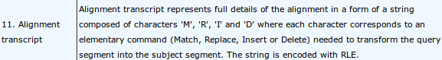
The Details column shows the alignments of each exon in a compressed format described in the splign documentation as illustrated.
The majority of the exon alignments are trivial.
For example:
For Exon 2, splign informs us M77, meaning “There are 77 bases aligned and they all Match perfectly”.
For Exon 4, splign informs us M131, meaning “There are 131 bases aligned and they all Match perfectly”.
The only 2 interesting entries are those were there are some disagreements. That is, the entries for Exons 1 and 5, which, following the documentation, I translate thus:
Exon 1 – M39RM8RM169
An alignment of 218 bases, the first 39 of which Match perfectly (M39), there then follows an Replacement (R), a further 8 Matched bases(M8), a second Replacement (R) all finished off with 169 Matched bases (M169).
Exon 10 – M33RM82
An alignment of 116 bases, the first 33 of which Match perfectly (M33), there them follows a Replacement (R) and a further 82 Matched bases(M82).
Its a pity there are no Insertions (I) and Deletions (D), but this was the best mRNA I could find.

Full Answer:
A point of pedantry to commence. From a different example, which included InDels, I got the display illustrated.
The exon was reported as: M53IM5IM43
This implies that the choice of Insertion (I) or Deletion (D) is made to describe the type of variation required to transform the cDNA (Query) sequence into the genomic (Subject). Hence the two InDels displayed here are considered to be Insertions.
Not that it is a vital issue, but I would have thought the other way around was more logical? That is, to consider the genomic sequence as the reference against which a particular mRNA might vary. In other words, what we see here would surely be more relevantly recorded as “This mRNA/cDNA has two Deletions relative to the genomic sequence which, presumably, attempts to represent the norm in the general population”? Just the reflection of an irretrievable pedant, but I am right, nevertheless!!!
In the documentation (see illustration in the Summary answer) it enigmatically states “The string is encoded with RLE.”. Just in case, RLE stands for Run-length encoding which is succinctly defined by Wikipedia. In a nutshell, it is a very simple form of data compression that recognizes that:
XXXXXXXXXXXXXXXXXXXXXXXXXXXXXXXXXXXXXXXXXXXXXXXXXXXXXXXXXXXX
can be compressed to:
60X
which has to be very effective for any data that has runs of identical characters of significant length. This is certainly the case here where one would expect long stretches of Ms in most alignments. Of course, life would get tricky if the data included numeric characters, but that is not an issue here.
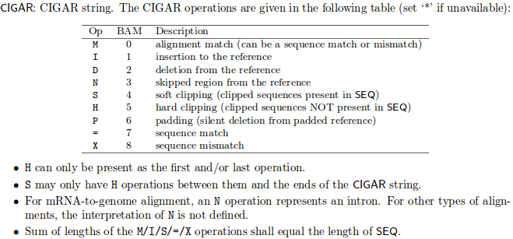
I think it worth mentioning, that this way of representing an alignment is a simplification of CIGAR format. This format is used for SAM (Sequence Alignment Map) and BAM (Binary Alignment Map, exactly the same as SAM, except compressed) files. You will be engulfed in SAM/BAM files if you ever do any Next Generation Sequencing (NGS).

So, straight from the SAM/BAM Format Specification I copy the table of CIGAR enlightenment.

Note, in particular, the extended range of Operators and the different meaning associated with the operator 'M'. The operators '=' and 'X' are such that any 'M' is either an '=' or and 'X' but never both. Which leaves one pondering when one might use 'M' in preference to either an '=' or an 'X'?

Where is the 3rd substitution in the mRNA?
Where is the 3rd substitution in the Genomic Sequence?
splign makes one work quite hard to answer this one! Unless I am missing something.
From the alignment of Exon 10, the exon including the 3rd Replacement, with a bit of squinting, it can be confirmed that the 3rd Replacement is at:
Base pair position 1,312 of the mRNA
Base pair position 25,143 of the genomic sequence
It might also have been relevant to ask which amino acid position corresponded to the Replacement. To discover this one would need to look at the alignment of Exon 3, where the coding begins.
More squinting, and I conclude the A of the ATG representing the initial Methionine of the protein coding region is at position 363. That is, the 5' UTR ends at position 362. So the Replacement is at:
Base position 1312 – 362 = 950 of the protein coding region of the mRNA.
As 950 / 3 is 316 remainder 2, the Replacement is at codon position 2 of the 317th amino acid of the protein.
Cannot help thinking that splign might have helped a bit more here?
I also reflect that I cannot fully recall why I wanted to know where the mutation was, especially given we have decided to reject any chance that it might be a mutation of consequence. Oh well, some things a man must do, just because they are there to be done!!
Time to move on … without checking my arithmetic. Bound to be right, I used to be a mathematics teacher you know! Several lifetimes ago.
Postscript:
After the passage of many months, I now recall why I obsessed as to the position of this amino acid substitution. I wondered if it was in the region of one of the major domains of this protein. If it was, it might increase its chances of being significant?
Well, it is not. In the last exercise, we discovered that:
The Paired-box domain is between positions 4 and 128 (Consensus isoform) or 4 and 142 (isoform 5a).
The Homeo-box domain is between 214 and 266 (Consensus isoform) or 228 and 280 (isoform 5a).
So the Substitution, at position 317, is in a relatively neutral region and so, maybe, less likely to be of great consequence?
Compare the predicted splign intron/exon boundaries with the conservation suggested by the logo?
What deviation(s) from the model suggested by the logo can you see?
You may have gathered, I rather like this logo, although I rather think it is leading me to make the same point a trifle to often?
The logo is in almost 100% agreement with the predictions of splign.
As you will have noted previously, when looking at the Ensembl predictions of exons locations of a similar transcript of the PAX6 human gene (previous Practical), there is a single exception.
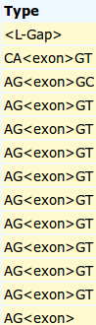
The easiest way to show this in the splign output is to look at the splign text output again.
The Type column records the type of all the <exon> alignments it predicts. It also records 2 flanking intron base pairs.

It is clear that the only time the splign prediction deviates from the model suggested by the logo is at the end of the 2nd exon. Here there is GC rather then GT. Well, nothing is perfect!
From your investigations of Local Alignment:
Why do you suppose your aligned exons are not presented in the correct positional order?
To Matcher, the logical order in which to present the alignments is that governed by quality rather than position. So, the highest scoring alignment, rather than the first exon alignment, will be at the top of the list. I think this is generally logical. Once again, the program splign, knowing it was looking for an ordered set of exons, was more specifically logical.

DPJ – 2019.01.30
Discussion Points and Casual Questions arising from the Instructions Text.
Notes:
Work in progress I fear.
The intention is to provide a full consideration of some issues skimmed over in the exercise proper.
If you are attending a “supervised” presentation of the exercise, I would hope to have conducted a live discussion of all these issues to an extent that reflects:
- the depth that seems appropriate
- the time available
- the degree to which the issues seem to match the interests of the class
- how many of you are awake
Here, I hope to write out very full answers were such a response exists. Accordingly, I suggest you will not need to read much of many of these discussions. There will be much detail of interest to rather few of you. Possibly a bit self indulgent, but I wish to make a note of all the background I have discovered while writing these exercises.
In a nutshell, the exercises are trying to make very general points avoiding too much detail. Nevertheless, I record the detail outside the main exercise text, just in case it might be if interest. Some of the answers to the “Casual Questions” are exceedingly trivial. Some of the “Discussion Points” are exceedingly long and rambling. You have been warned.
How would you interpret this picture?
What do the diagonal(ish) lines represent?
What are the gaps in between the lines?
Which axis represents the genomic sequence and which the mrna?
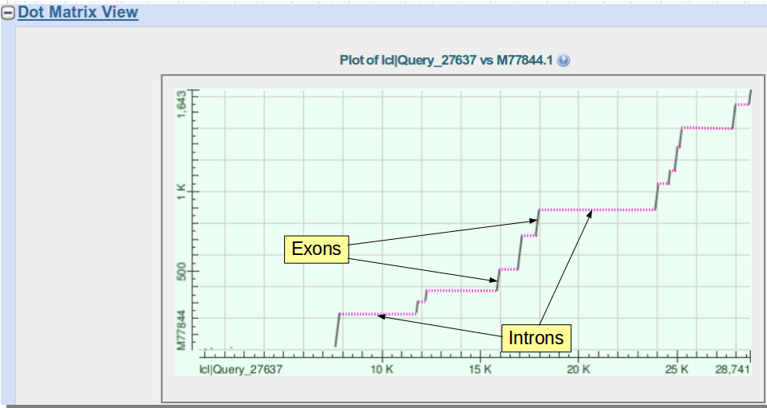
The Genomic sequence is represented by the longer X-Axis. The mRNA is represented by the shorter Y-Axis. The two sequences are not represented in strict proportion, but the Genomic axis is sufficiently longer than the mRNA axis to feel and look intuitively correct.
The sloping lines represent the Exons that comprise this mRNA. The sloping lines are not at 45 degrees because the Genomic sequence is longer than the mRNA.
Considered together they cover the whole length of the mRNA (except for a few mystery bases at the start).
They represent regions of the Genomic sequence (still Exons) that are separated by gaps of varying length which are, of course, the Introns.
All terribly simple, and I am sure you worked all this out for yourself. However, a fine excuse for yet another beautiful picture.
How many aligned regions are there and do they correspond nicely to the lines of the Dot Matrix View?
How many exons would you say this mrna has?
Well, looking only at the Dotplot, I would estimate 12 Exons. Of course, that would be a dangerous prediction as the resolution of the picture might disguise some very small Introns. However, after counting the aligned regions and coming again to a count of 12 (ignoring the silly bit at the start), exactly corresponding to the evidence of the Dotplot, I would predict 12 Exons with confidence.
If one was to forgive the strange “bits” at the start, would you say blast seems to have done a reasonable job here?
Yes indeed!
How do you feel about the results this time?
The results generated by stretcher, that is.
Well, they are effectively the same as were generated by blast. Both blast and stretcher produce credible alignments whereas needle (with default settings|) generates a nonsense. On the face of it, rather strange as needle is the most exacting of the three options.
Any theories?
Concerning the few wayward bases at the start of the mRNA.
I CANNOT HELP YOU HERE? Maybe some sequencing artefact? It is a sequence of some antiquity after all.

DPJ – 2019.01.30

Why this is so will be considered later when we look at the database searching program blast.
The original label for this very nice graphic is: This figure shows two ‘‘sequence logos’’ which represent sequence conservation at the 5’ (donor) and 3’ (acceptor) ends of human introns. The region between the black vertical bars is removed during mRNA splicing. The logos graphically demonstrate that most of the pattern for locating the intron ends resides on the intron. This allows more codon choices in the protein-coding exons. The logos also show a common pattern ‘‘CAG|GT’’, which suggests that the mechanisms that recognize the two ends of the intron had a common ancestor. See R. M. Stephens and T. D. Schneider, "Features of spliceosome evolution and function inferred from an analysis of the information at human splice sites", J. Mol. Biol., 228, 1124-1136, (1992).
Proving beyond reasonable doubt that that substitution is exactly at amino acid position 33 requires a little more counting, dividing by 3 and subtracting the number you first thought of. For now, just trust me? I really am more honest than I look.
The Wikipedia article shows how this complication might be overcome.
There may or may not be some justification for calling the format CIGAR, but if there is, I have no idea what it might be.
NGS is also referred to as High Troughput Sequencing (HTS), which, on the whole, I think is a more meaningful name.

