

ELB199F
Entry Level Bioinformatics
04-08 February 2019

(First 2019 run of this Course)

Basic Bioinformatics Sessions

Practical 3: Database Searching

Wednesday 30 January 2019
Searching for sequence similarities in databases.
The most popular way to investigate a sequence has always been to compare it with one of the sequence databases now accessible from sites all over the world. When sequences databases were more sparsely populated than now, the objective was to search hopefully, not always with success, for any convincingly similar sequence(s). When such a match was discovered, it could be supposed that known properties of the “similar” database sequence might provide insight to the properties of the query sequence. Now, the databases are full of sequences representative of most interesting conditions. Similarity searches are conducted in the expectation of finding many close “hits” for almost any sequence. Fewer database searches are conducted in complete ignorance of what the query sequence might be.
Database Searching to determine gene structure.
Here, take the PAX6 genomic DNA sequence retrieved from Ensembl and conduct two searches analogous to those run in the Ensembl pipeline (or the equivalent NCBI pipeline for the NCBI Genome Database). Results should confirm that which has already been discovered using other sources.
blast is not the only sequence database searching program available, but it is the most popular by a very long way. blast searches are offered in many forms by many servers all over the world, but the most comprehensive and reliable service has to be that offered by the NCBI.
Comparing Genomic sequence against mRNA sequences to predict exon splicing alternatives.
Go to the NCBI homepage at:
http://ncbi.nlm.nih.gov

Select the BLAST option (from the Popular Resources list). In the Basic BLAST section, select nucleotide blast. Use the Enter Query Sequence Browse (or Choose File) button to upload the file:
pax6_genomic.fasta
For results like those used by Ensembl to predict PAX6 transcripts, you must compare your genomic sequence to a reliable set of human mRNA/cDNA (or similar) sequences.
In the Choose Search Set section, set the Database to Reference RNA sequences (refeseq_rna).
You are now able to specify an Organism, choose human (taxid:9606).
blast is now set to compare the PAX6 genomic region with all Human mRNA sequences in RefSeq.
Note that the default Program Selection is Highly similar sequences (megablast), which seems appropriate here as all the mRNA that correctly match should surely do so almost perfectly.
Click on the Algorithm Parameters button. The defaults are fine here, but before starting your search, try changing the Program Selection and observing the different Algorithm Parameters.

The default settings of all shared parameters are identical for the two slower more sensitive Program Selections.
There are differences for megablast, where speed is of the essence and sensitivity can be sacrificed.
Smaller Word sizes slow searches but increase sensitivity. For megablast the default Word size is 28 otherwise it is 11.
Gapped alignment is time consuming and, by default, considered more crudely by megablast than the other two algorithms.
Filtering and Masking matches with organism specific repeats and/or low complexity regions takes time, and so only avoiding Low complexity regions is on by default for all Program Selections.

When discontinuous megablast is selected, an extra options section appears. Discussing how this flavour of blast works is a little beyond the scope of these note, but briefly. Unlike the other Program Selections, discontinuous megablast does not just look for exactly matching “words” of given size as a first step towards identifying matching regions between sequences. It looks for a pattern of matching bases within a word. For example, the default choice assumes your query is coding and looks for 11 matching bases within a word of 18. Approximately, every third base is allowed not to match. Biologically, this can be justified as allowing for third codon position wobble. For more detail, use the appropriatebutton. Notice there arebuttons by every parameter selection. Try one or two. In the process, discover:
When would Mask lower case letters be a useful thing to do?
Automatically adjust parameters for short input sequences is independent of Program selection, and so remains unaltered.
Which parameters would blast need to automatically adjust to cater for short input sequences (such as primers being tested for uniqueness), and why?
Finally, ensure all the parameter defaults are back in place and that megablast is the Program Selection, ask blast to Show results in a new window and then click on the button. Impressively swiftly, you will have results. At the top of which will be a graphical overview.
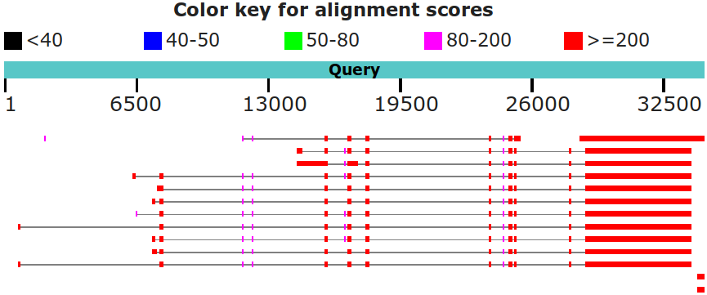
This graphic implies that there are 11 convincing matches between the genomic sequence and PAX6 mRNAs in RefSeq. The RefSeq entries had to be “gapped” in order to compensate for introns present in the genomic sequence but not in the mRNA sequences. The red blocks therefore represent very closely matching (brownie points) exons, the lines joining the red blocks represent introns that have been spliced out. All 11 PAX6 mRNA hits match reasonably uniformly except for the first few exons, implying significant variation in the 5´ UTR.
Why do you suppose that a few of the exons of some matches do not achieve the maximum score?
Explain why one exon in the reasonably consistent region, does not appear in all of the PAX6 transcript matches?
In a previous Practical, you discovered directly that there were 11 high quality “NM_” PAX6 transcripts in RefSeq.
Until recently, there was a further 9 “XM_” PREDICTED transcripts. However, in the last release of RefSeq, the 9 less reliable XM_ transcripts were removed and so were not detected by blast. Ensembl claimed to have used most, if not all, the high quality NM_ RefSeq sequences to aid its transcript predictions. Ensembl would have ignored the XM_ PREDICTED RefSeq sequences even if they still existed.
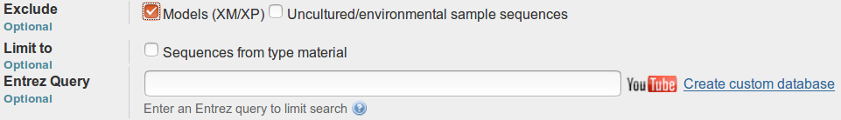
blast just sees sequences and, by default, will not be influenced by the quality of the support for their existence. Run as in this exercise, blast would always report all RefSeq PAX6 mRNAs matching the PAX6 genomic region convincingly, independently of how questionably they are evidenced. However, you could have filtered the target database(s) in various ways, including choosing to Exclude all Modules(XM/XP) (that is all the more questionable mrna sequences and their amino acid translations). This would not be appropriate here as we wish to mimic the approach of the NCBI Genome Database which DOES consider XM/XP sequences should they exist.
There is a point to pursuing all this detail. You reference a collection of interdependent databases, all of which are updated regularly. More often than not you will notice inconsistencies due to asynchronous updates and differences in database management/interpretation policy. A small price to pay for such a rich source of information, but one of which I suggest it is wise to be aware.
The message of the particular blast search here is that it is so easy to predict the same PAX6 transcripts as you discovered with the Genome Data Viewer, just with a simple blast search. That is, you can look things up, or work most of it out for yourself.
If you hover over the graphical hits, their origin will be displayed above the graphic.
Below the Graphic Summary are the Descriptions, a simple list of the 15 matches represented in the graphic.
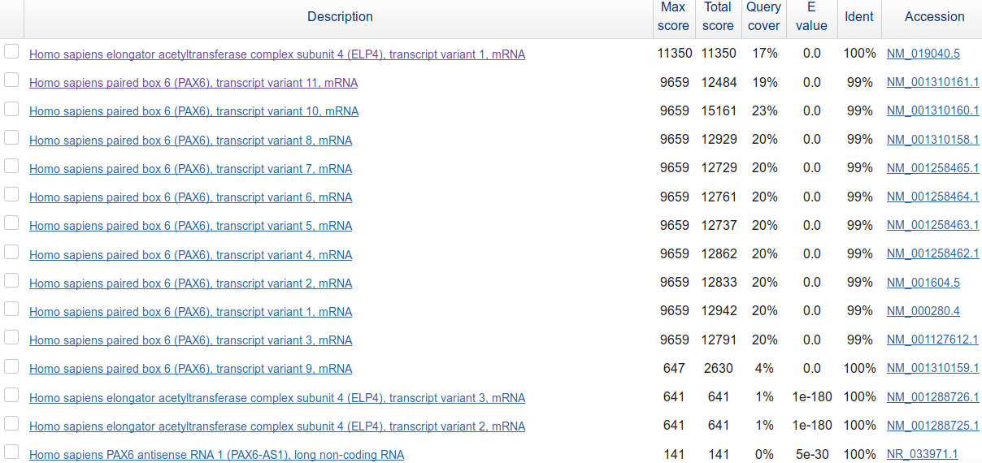
These are such that:
- The top hit is unexpected!!! It is one of the 3 ELP4 transcripts observed when we were looking at the PAX6 RefSeqGene entry earlier. Then, this transcript was small (matching the other two lower down this list). Now it is enormous to the extent that blast scores it higher than all the 11 PAX6 transcripts? One can only suppose that blast is searching a more up to date version of RefSeq than includes the RefSeqGene entry and was used to create the views of the Human Genome we looked at also.
I am going to assume that to be true anyway, as the Genome View from the NCBI is dated 2018.03.27, whereas this huge ELP4 transcript is dated 2018.11.22. Having said that, there is no sign of this newly expanded transcript in Ensembl, the latest version of which post-dates the RefSeq entry (but possibly not the database release?).
Oh well, yet more reinforcement of the message that one cannot just accept what is found in these databases. Confusion and contradiction abounds.
- The next 11 hits, corresponding to the 11 PAX6 mRNAs of the Graphic Summary. These are all quality (i.e. NM_ entries with good supporting evidence) RefSeq transcripts.
- There follows, corresponding to the 2 small red blobs in the extreme bottom right of the Graphic Summary, 2 hits that are the ends of the 2 mRNAs for the ELP4 gene that failed to grow into giants. They are exactly where you should expect them to be, assuming you paid full attention to the ELP4 transcript predictions shown in both the Ensembl and Genome Data Viewer displays of the Genomic region around PAX6. Reject these contemptuously, they do not pertain to our investigation of PAX6.
- The 15th match, corresponding to the barely visible tiny smudge match to the left of the top Graphic Summary hit, is recorded as “uncharacterized” and fails to fit in with my story, so I ignore it!
In summary, the meaningful parts of this this blast search suggests the existence of 11 PAX6 transcripts supported by RefSeq data, as is reported by the Genome Data Viewer. Also, the results are broadly consistent with the information discovered in Ensembl.
Which of the Refseq PAX6 transcripts corresponds to isoform 5a?
Moving further down the results you will come to the alignments between the PAX6 genomic sequence and the matching database entries. All similarity searches use local alignment strategies, so you should not be surprised to see a number of alignments for each “hit” in the list. Here we have a genomic query sequence aligned exclusively with mRNA sequences from RefSeq. The expectation is therefore to find an alignments corresponding to exons. The alignments are ordered by quality, though you are provided with a Sort by: menu to alter the order to taste.
Look at the first alignment for the best matching PAX6 transcript. It is the alignment of the very last exon of a RefSeq transcript with the end of the gene you exported from Ensembl.
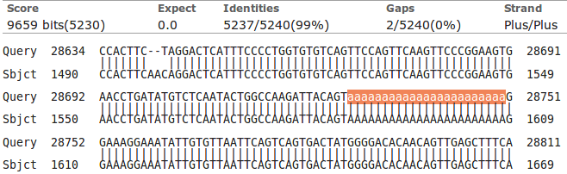
Notice the lower case string of 'a's. The case indicates that they were ignored (filtered) as a Low complexity region whilst megablast was looking for identically matching words that might suggest matching regions. By themselves, the 'a's are not sufficient evidence that a biological match exists. Only because the surrounding sequence is compellingly similar, can it be assumed that such a match does exist. The 'a's are replaced (lower case to indicate they were filtered) when the final alignment is computed. If you look a little further down the same alignment, you will see several other runs of 'a's and 't's for which the same explanation applies.
Comparing Genomic sequence against Protein sequences to predict Coding exons.
Now use a version of blast (called blastx) to compare your genomic sequence with a protein database. blastx will translate a DNA query sequence in all six reading frames and compare each translation with a protein sequence database. Thus, in a similar fashion to that employed by the Ensembl pipeline, protein coding regions of the genomic DNA can be identified. For clarity, we will use only the well annotated human proteins of the SwissProt section of Uniprot. First go to the home of blast at:
http://blast.ncbi.nlm.nih.gov/Blast.cgi
Select. Use the Enter Query Sequence Browse (or Choose File) button to upload file pax6_genomic.fasta.
In the Choose Search Set section, set the Database to UniProtKB/Swiss-prot(swissprot). Specify the Organism as human (taxid:9606).
Take a look at the Algorithm parameters.
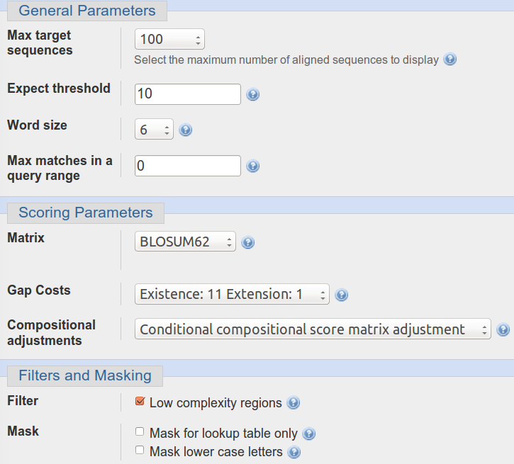
The Word size choice is 2, 3 or 6 . The default is 6. We seek very close matches here, so the largest Word size would seem appropriate.
The default scoring matrix is BLOSUM62, but choices from both the BLOSUM and PAM families are offered.
The Compositional adjustments parameter offers the opportunity to refine the chosen scoring matrix to reflect the residue composition of the sequences being compared in one of a number of ways. Click on the relevantbutton for further enlightenment. I must admit, I was left with questions after reading the Help, but some attempt to customise the evaluation of an alignment to reflect sequence composition does seem like an excellent idea.
Low complexity regions will be filtered by default.

Change nothing other than to ask blast to Show results in a new window and click the button.
After minimal thought, blastx will thrust its conclusions before you. Hover over the graphical hits for identification.
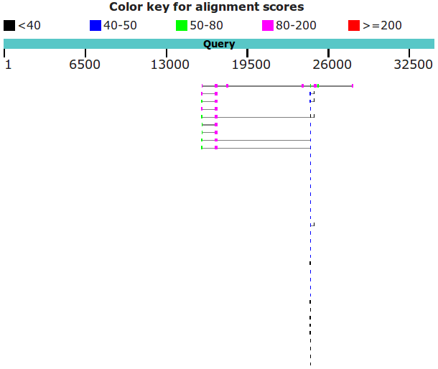
What are the 9 strongest matches around base position 16,750?
Why would you expect exactly 9 matches around this point?
What do you make of the plethora of matches around 24,000?
Move down to the textual list of the matches. Hopefully as you fully expected you will find the expected number of Paired box matches at the top of the list followed by many many Homeobox matches.
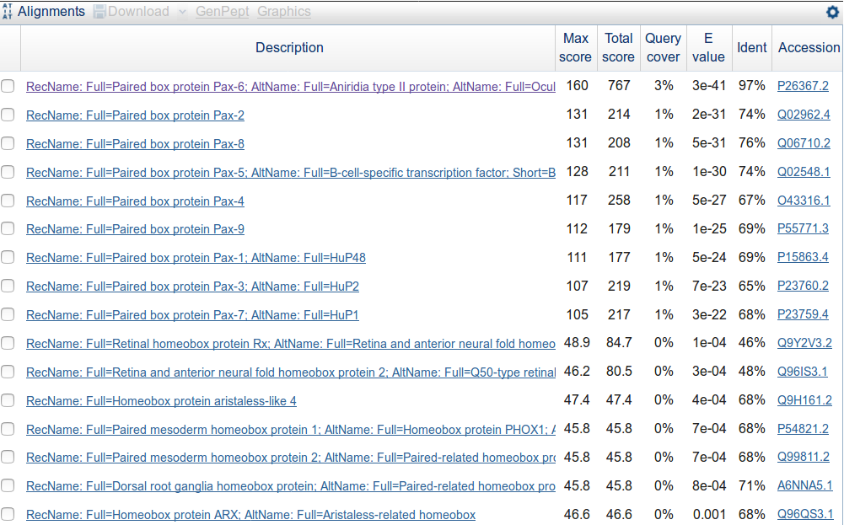
Why do you suppose the Paired box matches precede the Homeobox matches?
How do you suppose the Max matches in a query range parameter might be of value if this order was reversed?
Take a look at the alignments. You will see many places where regions have been filtered as non-informative. I suggest the one illustrated was filtered because it would match anywhere that was sufficiently Serine rich.
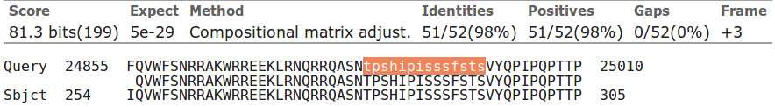
How does this “non-informative” region match expectations suggested by SMART and the Feature table of UniprotKB for PAX6_HUMAN?
Iterative Database Searching to discover and align sequence families (psi-blast & cobalt).
PSI-BLAST is used to find a comprehensive set of relatives of a protein. First, BLAST is used to find closely related proteins. From an alignment of these proteins a general "profile" (a Position Specific Scoring Matrix - PSSM) is computed. A PSSM is very similar in concept and purpose to an HMM profile in that it summarises significant features present in the sequences it represents.
A further search of the protein database is then run using the PSSM as a query, and a larger more widely associated group of proteins is found. This larger group is aligned and used to construct another PSSM, and the process is repeated until no more significantly matching new sequences can be detected, or the user tires of the whole process.
PSI-BLAST is integrated into the Secondary Structure Prediction system Jpred. Whenever Jpred is asked to compute structure form a single protein sequence, it will use PSI-BLAST to construct an aligned family of protein sequences to enable an improved prediction. An aligned family of proteins is a much better starting point than any single protein sequence.
Similar ideas are used by the domain database PFAM to create large alignments of domain regions. Hopefully there will be time to glance at PFAM alignments and HMMs.
Here we will use PSI-BLAST directly from the NCBI on the Paired DOMAIN of the PAX6 protein that you saved in a file earlier. It should be possible to detect a large family of PAX domains and to eventually multiply align them generating something like the alignment from the PFAM database.
To investigate PSI-BLAST go first to the NCBI Home page at:
http://www.ncbi.nlm.nih.gov/
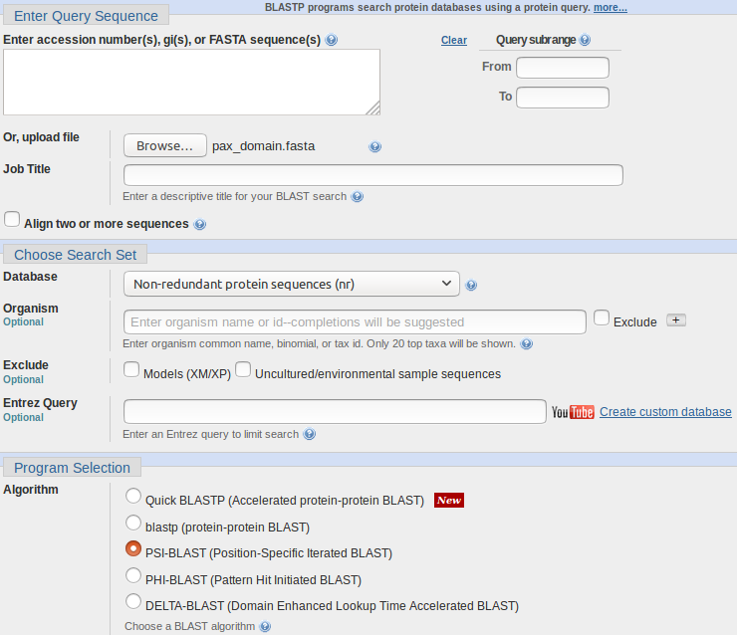
Click on the BLAST option from the Popular Resources menu.
Select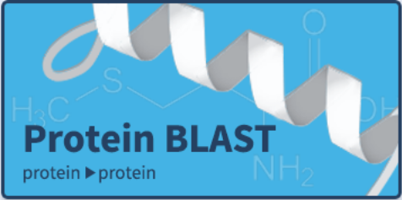from the Web BLAST section.
Upload the PAX6 paired box domain sequence (stored in the file pax_domain.fasta) using the appropriate Browse button.
Select PSI-BLAST from the Program Selection section. Leave all other options at their default settings, particularly the option to search all the proteins available.
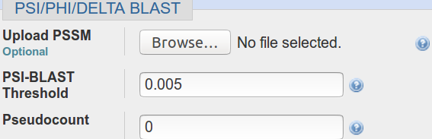
Before you set PSI-BLAST going, click on the Algorithm parameters link and take a look at the PSI/PHI/DELTA BLAST section. Note the option to use a PSSM from a previous run of PSI-BLAST, potentially on a different database (but with the same query sequence). Accept the default that database entries scoring better than an Expect Threshold of 0.005 be offered for inclusion into the PSSM of each successive PSI-BLAST iteration. Remember thebuttons.
What do you suppose the choice of Pseudocount might influence?
Elect to Show results in a new window and then click on the button.
After several moments of deep thought, PSI-BLAST will come back with its first set of results, at the top of which is a report that (unsurprisingly) matches have been detected between the query sequence and several domain databases.
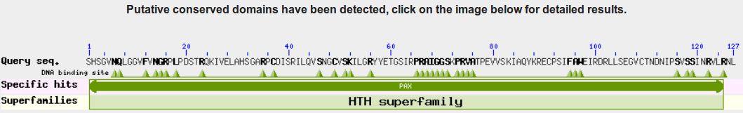
For more detail, click on the Conserved Domains graphic.
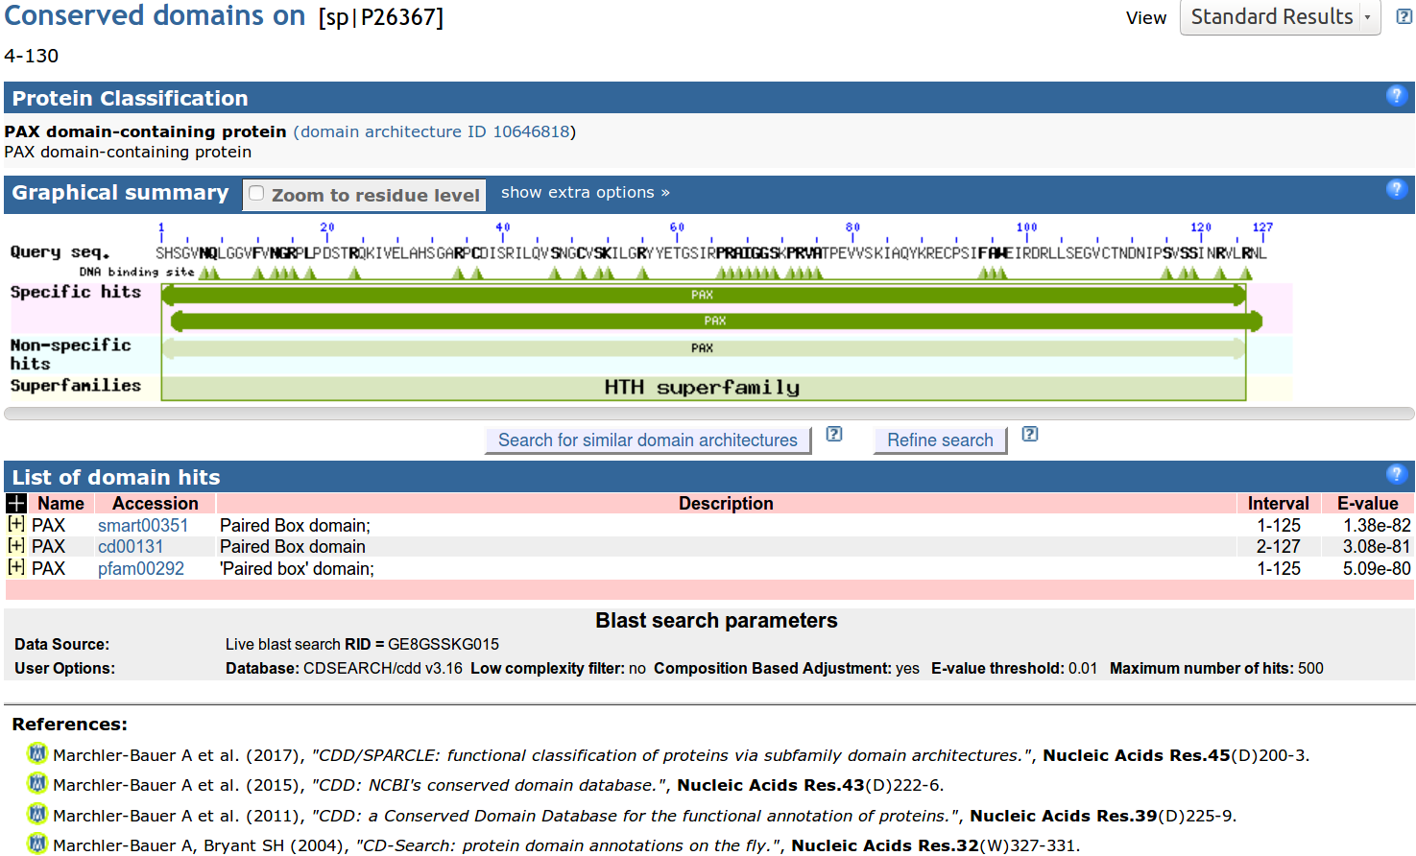
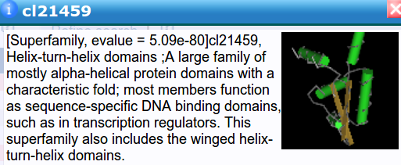
Hover over the Specific / Non-specific hits and you will see that SMART, Pfam and the NCBI Conserved Domains database matches for a PAX domain are all reported. No surprise here.
There is also a Superfamilies (derived from SCOP as briefly mentioned previously) hit recognising that a PAX domain, in common with many other domains, includes Helix-Turn-Helices.
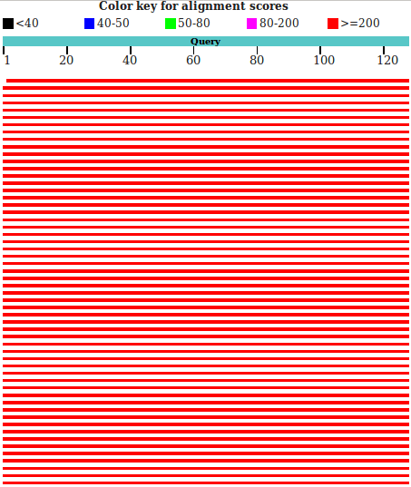

Moving back to the main PSI-BLAST results, you will see that there are many high quality hits covering the whole length of the query sequence.

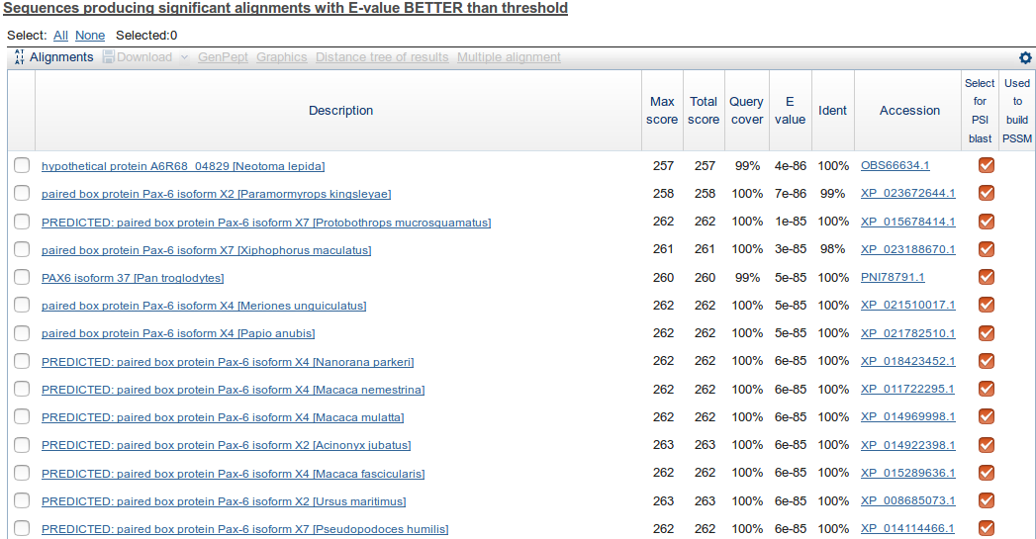
The best 500 of these are listed.
All the listed hits are selected for inclusion into the PSSM for the next iteration. Unless you feel strongly about any particular entry, leave them all selected.
Note the Accession Codes that begin XP_. As mention previously, these are less well evidenced protein sequences from the NCBI databases.
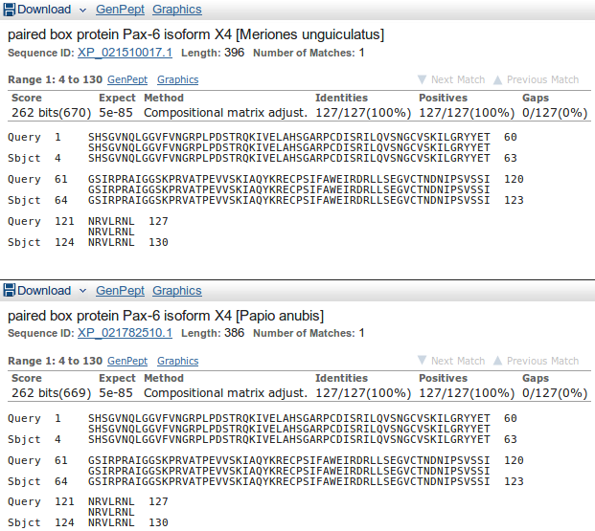
Move down to the Alignments section of the results and you will see that many of the top hits match the query exactly over the aligned region.

Note that many of the top hits come from the GenPept database (roughly equivalent to the TrEMBL section of UniProtKB).
How might the inclusion of poor quality and duplicated sequences have been minimised?
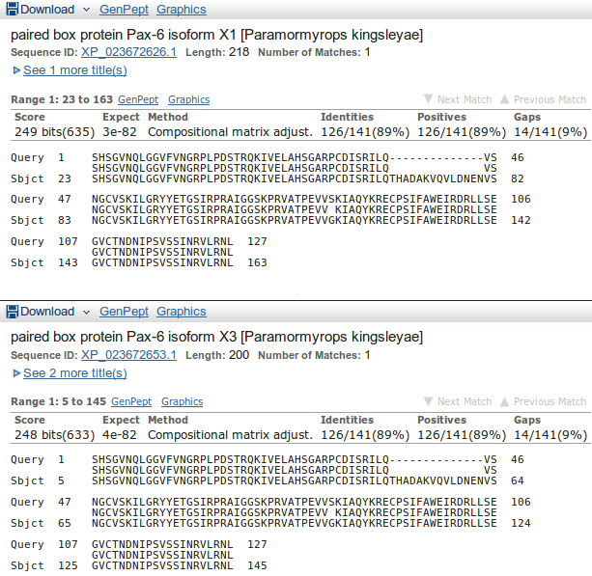

Move down far enough and you will see less perfect matches, some of which involve proteins with the extra 14 amino acids of isoform 5a of PAX6_HUMAN.

Having browsed your results sufficiently, click on the button to Run PSI-Blast iteration 2. It is at the bottom of the hit list.
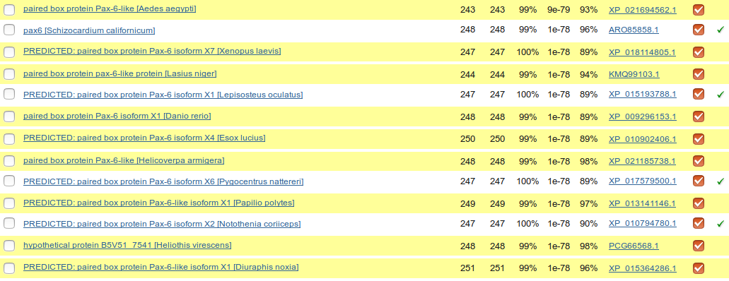
After a few moments, PSI-BLAST will return with the results of searching through the database again using the PSSM derived from the hits of the first iteration (ed). This time the top of the list will be predominantly filled with hits that have already been incorporated into the PSI-BLAST PSSM. However, look far enough down the list and you will find some new ones, highlighted yellow.
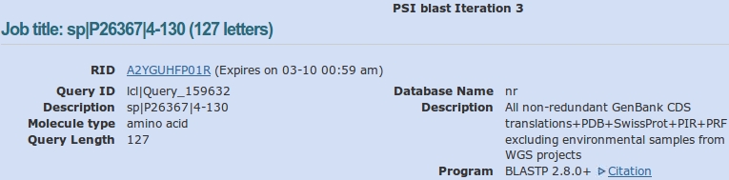
Once more, click on the button to Run PSI-Blast iteration 3. That is probably enough! As dear Eddie oft advised, there are typically but three steps to ultimate fulfilment. Previously, I took 8 iterations before there were no more new sequences suggested for inclusion into the PSMM. However, I do wonder whether it was worth the effort? Certainly not in the context of this exercise. Trying to continue until no more new sequences can be dangerous, as I discovered the hard way. I once got to iteration 21 before I realised that PSI-Blast was playing tricks one me! It was oscillating between two minutely different, perfectly acceptable solutions! Having vented my spleen in shame filled fashion I accepted iteration 21. I advise that you stop here on “good enough” iteration 3, as I will do this time!
Next, move to the just above the Graphic Summary and click on the Multiple alignment link. You have elected to use the NCBI multiple alignment program Cobalt to align the best of the PAX domain sequences of your final PSI-BLAST iteration (up to 250 sequences that match your query reasonably well, Expect Score <= 0.001, plus the query sequence) .
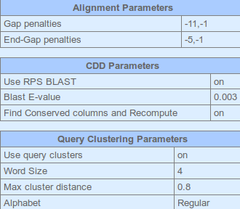
When it is done, click on the Alignment parameters link at the top of the results.
Cobalt reports the parameters it used to make the alignment. It is possible to recompute the alignment with different parameters by using the Edit and Resubmit link at the top of the page and then choosing to set Advanced parameters. But, maybe not today?
Recording the parameters chosen for any computation is surely extremely important. How else can published computer generated results be reproducible?
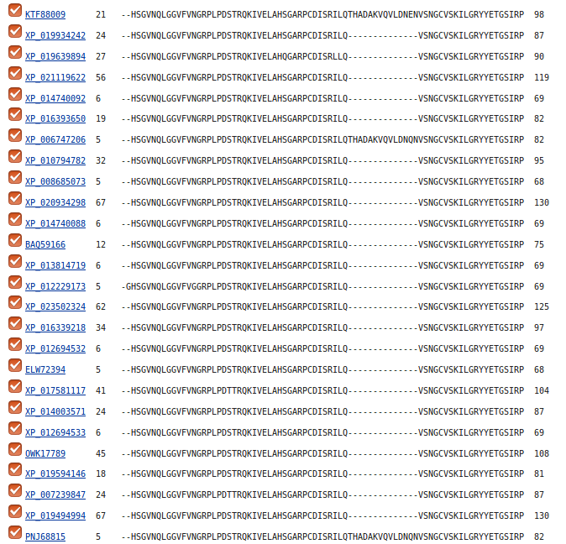
Move past the list of aligned proteins (why not just hide the Descriptions view).
At the top of the actual alignment, set View Format to Plain Text (…. and then hide the Descriptions again??), this being the easiest format to understand in a hurry. The alignment will have very ragged ends, but the important region of 120 or so amino acids representing the PAX domain is really quite impressive. In particular, the isoform 5a insertion is very convincing.
Cobalt achieves such high quality alignment, partially, by considering the position of matches with domain and motif databases in addition to sequence composition. Another example of the use of more information leading to improved analysis results.
More on MSA later.

THE END
DPJ – 2019.01.30
Model Answers to Questions in the Instructions Text.
Notes:
For the most part, these “Model Answers” just provide the reactions/solutions I hoped you would work out for yourselves. However, sometime I have tried to offer a bit more background and material for thought? Occasionally, I have rambled off into some rather self indulgent investigations that even I would not want to try and justify as pertinent to the objective of these exercises. I like to keep these meanders, as they help and entertain me, but I wish to warn you to only take regard of them if you are feeling particularly strong and have time to burn. Certainly not a good idea to indulge here during a time constrained course event!
Where things have got extreme, I am going to make two versions of the answer. One starting:
Summary:
Which has the answer with only a reasonably digestible volume of deep thought. Read this one.
The other will start:
Full Answer:
Beware of entering here! I do not hold back. Nothing complicated, but it will be long and full of pedantry.
This makes the Model answers section very big. BUT, it is not intended for printing or for reading serially, so I submit, being long and wordy does not matter. Feel free to disagree.
From your investigations of Searching for sequence similarities in databases
When would Mask lower case letters be a useful thing to do?
Generally, whenever one might suspect the automatic masking algorithms of blast might miss a non informative region in a specific query sequence, obviously.
A specific example might be when a query sequence contained a significant informative region that was known to be common amongst the sequences being searched. If this region was left unmasked, blast would pick up so many similar matches to this one region that other interesting similarities might be obscured. By manually masking such a region by changing it to lower case, its matches would not be seen by blast and matches with other regions of the query sequence should be more apparent.
Which parameters would blast need to automatically adjust to cater for short input sequences (such as primers being tested for uniqueness), and why?
The word size: Clearly, if you are trying to find matches for a primer (for example) of around 20 base pairs, it would be pretty silly to use a word size of 28 (default for megablast). A word the same size as the primer would find only exact matches. A word of about 7 would allow a couple of mismatches and would probably be most generally appropriate.
The expect score: As good chance matches between between a short query sequence and a large database will be abundant, it would not be sensible to choose a demanding (i.e. small) expect score to represent the limit of significance. In particular, a primer sized query sequence of around 20 base pairs might easily exactly match more than 10 times (generally the default maximum expect score for a significant match) just by chance. After all, there are only 4 bases, a string of 20 is not that long and the databases can be huge! Typically blast chooses very high expect score cut off for short query sequences, effectively removing the expect score filter altogether.
Earlier versions of blast did not automatically adjust these parameters. When a short query sequences were selected, suitable adjustment was left to the user. Without sensible parameter adjustment, results could be greatly confusing. For example, a 21 base pair primer could easily match perfectly more than 10 times against a large DNA sequence database. blast is set to ignore matches that are expected to occur more than 10 times by chance. Thus even exact matches with such a small sequences would be ignored! Now automatic parameter adjustment is undertaken by blast, the user does not really have to think too hard. However, it does seem to be a good idea to know what blast is doing and why.
Why do you suppose that a few of the exons of the first 11 matches do not achieve the maximum score?
Summary:
Each local region of significant alignment between a database entry and a query sequence is scored independently. The scoring method that governs the alignment score colour in this graphic, reflects both the quality of the match and its length. Unless a particular region is of sufficient length, it cannot achieve the 200 bit threshold even if the alignment is perfect. Note that it is the shorter regions that fail to reach thestatus. All of the illustrated local alignments associated with PAX6 transcripts are essentially perfect.
Full Answer:
Using a slightly simpler but out of date illustration that makes the points discussed here clearly enough.
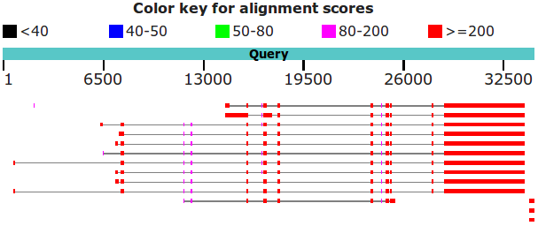
In common with most database searching programs, blast compares query sequences with database entries using a local strategy. The overall evaluation of a particular query sequence is taken to be the highest local score.
Individual local matches are coloured according to individual quality. In this query, all true matches should be perfect, or very nearly so. Scores might therefore be expected to be maximal (). However, they are not? Some only score in the range .
The score referenced for this purpose is the bit score. For a full, no holds barred definition of this score, try here. I prefer this somewhat gentler version:
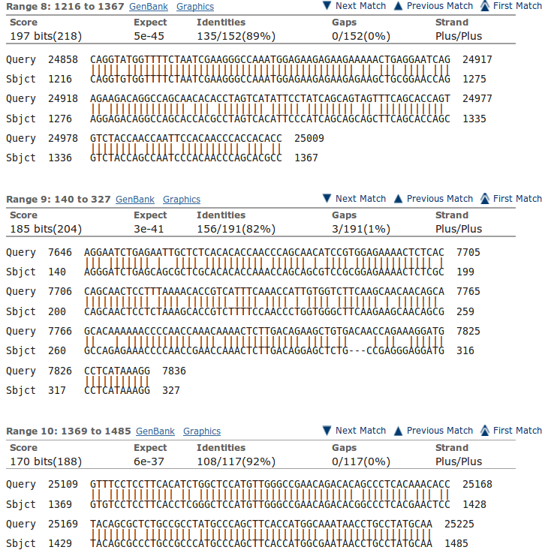
“The bit score gives an indication of how good the alignment is; the higher the score, the better the alignment. In general terms, this score is calculated from a formula that takes into account the alignment of similar or identical residues, as well as any gaps introduced to align the sequences. A key element in this calculation is the “substitution matrix ”, which assigns a score for aligning any possible pair of residues. The BLOSUM62 matrix is the default for most BLAST programs, the exceptions being blastn and MegaBLAST (programs that perform nucleotide–nucleotide comparisons and hence do not use protein-specific matrices). Bit scores are normalized, which means that the bit scores from different alignments can be compared, even if different scoring matrices have been used.”
Still too scary? The important things to note are that:
- These scores are based on a simple DNA scoring matrix (1 for a match, -2 for a mismatch by default for megablast), plus penalties for gaps. So scores will be limited by the length of the alignment, ignoring gaps.
- The scores reflect penalties for indels (insertions or deletions).
- The scores are normalised to be independent of the scoring matrix in use. Thus bits scores from searches using different scoring matrices can be compared.
Both the scoring matrix dependant raw scores and the bit scores reflect both the length of an alignment and its quality. blast presents the local high scoring regions it discovers ranked by bit score. In general, this corresponds to length order. However, a shorter high quality alignment can occasionally outscore a longer less perfect alignment (as illustrated).
To obtain this illustration I had to use the more sensitive blastn algorithm to find more distant alignments (megablast is only going to notice really obvious matches) and remove the organism filter to insure that there were less obvious matches to find (all significant matches between any part of the human genome and any human mrna will be too uniformly near exact).
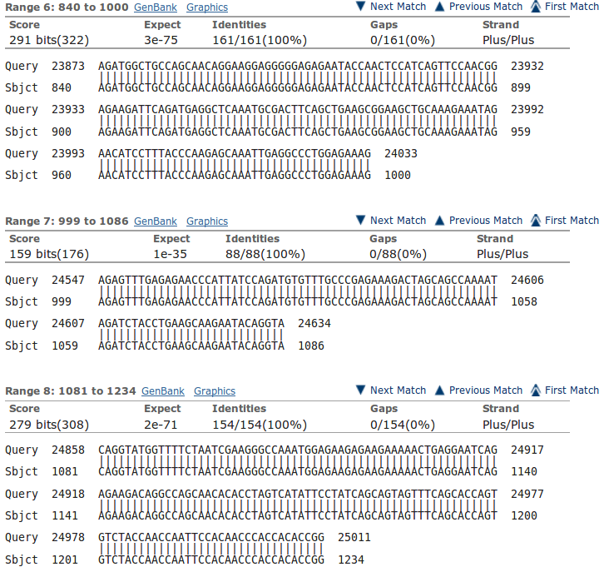
You can see evidence of what is occurring in the alignments further down your results. Here is illustrated one of the exons that occur in all transcripts at position 24,547. The match is perfect, but the length of the exon is consistently just to short to get to the heady level. To make this illustration represent alignments from a particular region, I set Sort by: (top of the alignments) to Query start position. If you look back at the blast graphic, you should be able to easily spot the region of these aligned regions including the one that is.
Note how imperfectly blast finds exon/intron boundaries. If the start of an intron happens to match the start of the next exon, blast will included the bases in two alignments. It is not looking for exons and introns as was spline, it just mindlessly seeks matches.

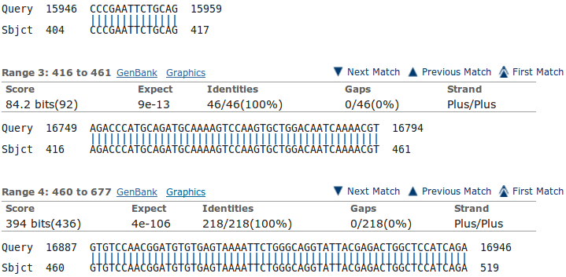
For a further example, look at the exon that is found only in the isoform 5a transcripts. It is tiny (42 base pairs) and scores well below even thought it is a perfect match.
Note that the alignment is 46 base pairs long due to blast adding on two bases either side that are actually the highly conserved intron start and end base pairs. As you can see, these extra base pairs occur in the preceding and succeeding alignment also.
Explain why one exon in the reasonably consistent region, does not appear in all of the PAX6 transcript matches?
Well I refer to the isoform 5a exon, of course. The tiny inconsistent one about 9 exons in from the right (when it exists). This will, clearly, only occur in isoform 5a transcripts.
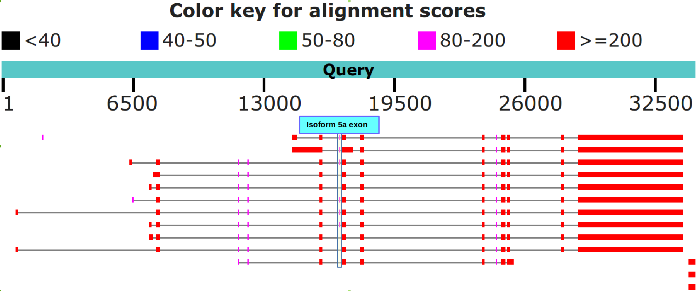
The illustration is the graphic from a previous version of this search. Run before the expansion of one of the ELP4 transcripts. I continue to use it because it is clearer … and I am too lazy to remake my picture.

Which of the Refseq PAX6 transcripts corresponds to isoform 5a?
Summary:
As I am sure you are tired of noting by now, all the transcripts with the extra tiny exon around position 16,750 in the genomic sequence are isoform 5a transcripts. See the illustration for the previous answer.
Full Answer:
The isoform 5a transcripts can be spotted most easily from the graphic. They are the ones with the extra small exon slightly to the left of middle (around base position 16,750). For example, the first, second and third blast matches displayed. If you hover over all the full length matches with your mouse, you will see that they are transcript variants 11, 10, 8, 7, 6, 5, 4, 2, 1, 3 and 9 (in the vertical order of the graphic).
Stated with the unequalled poetry of RefSeq Accession Code and lyrical Title Line, the list of those with the extra exon becomes:
TITLE ACCESSION CODE
Homo sapiens paired box 6 (PAX6), transcript variant 11, mRNA NM_001310161.1
Homo sapiens paired box 6 (PAX6), transcript variant 10, mRNA NM_001310160.1
Homo sapiens paired box 6 (PAX6), transcript variant 8, mRNA NM_001310158.1
Homo sapiens paired box 6 (PAX6), transcript variant 5, mRNA NM_001258463.1
Homo sapiens paired box 6 (PAX6), transcript variant 4, mRNA NM_001258462.1
Homo sapiens paired box 6 (PAX6), transcript variant 2, mRNA NM_001604.5
Yes well, that was fun? The message of the question was to ensure you could see how to spot the isoform 5a transcripts (again!), not to list them! But, never mind, doing so was in fine tune with the ennui of the moment.
What are the 9 strongest matches around base position 16,750?
Summary:
Matches between the regions of the PAX6 genomic region encoding the PAX6 Paired Box domain and SwissProt protein sequences representing human proteins including a Paired Box domain.
Why would you expect exactly 9 matches around this point?
Summary:
Because that is how many human proteins including a Paired Box domain are suggested to exist according to Interpro (as shown in a previous Practical). There is PAX6 plus its 8 paralogues, imaginatively all named:
PAX1, PAX2, PAX3, PAX4, PAX5, PAX6, PAX7, PAX8 & PAX9

What do you make of the plethora of matches around 24,000?
Summary:
These are matches between the regions of the PAX6 genomic region encoding the PAX6 Homeobox domain and SwissProt protein sequences representing human proteins including a Homeobox domain. As you discovered earlier from Interpro, there are lots of such proteins.
The thin line joining features implies that those features relate to the same database entry. Notice that 4 of the 9 proteins including a Paired box domain near the beginning, also include a Homeobox domain further along. This is exactly as was suggested by the SMART annotation you examined earlier.
Full Answer:
Well, a couple of graphics to reinforce what has already been claimed and make life more precise and colourful.
First, recall from UniProtKB the positions of the two domains in PAX6.
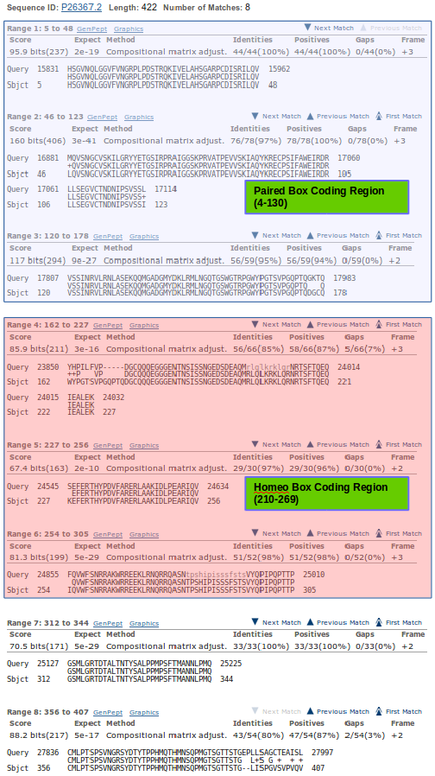
Next, order the blastx alignments by Subject start position.
Then see, from the first of the blastx alignments, it is the first 2 and a bit aligned regions that correspond to the Paired Box coding region.

The next 3 matching sections cover the whole of the HomeoBox coding region (with a fair overlap each side).

The final 2 matching sections are not involved in either domain.

With this understanding, one can decorate the blastx graphic in a fashion that makes the entirely obvious even MORE apparent than it was in the first place?
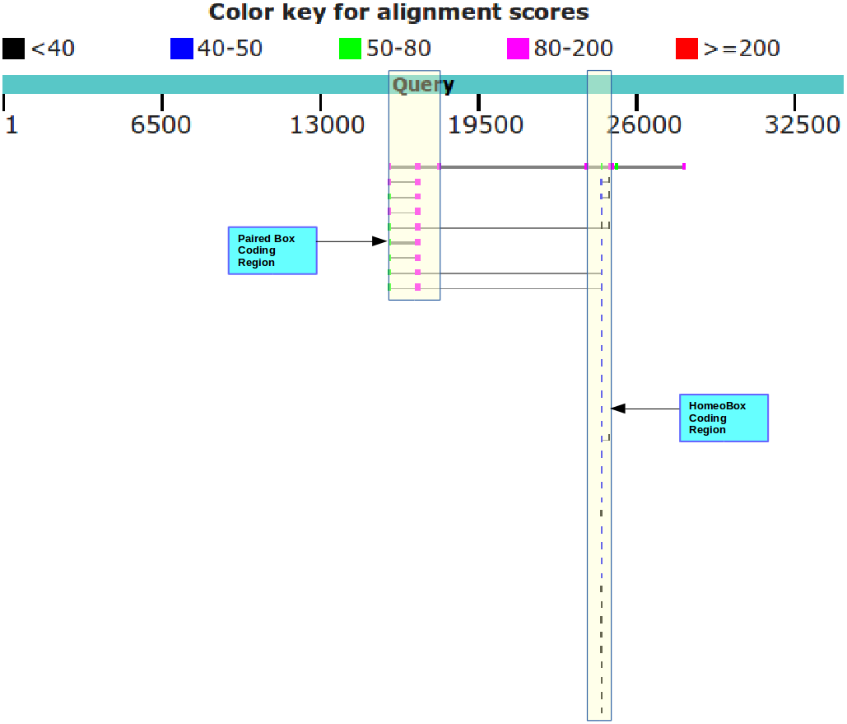
Well, I think it is a nice picture anyway.

Why do you suppose the Paired box matches precede the Homeobox matches?
Because they score more highly and so, in the opinion of blast, are more worthy. Primarily, they score more highly because they are longer. The list is ranked by E Value. Good matches with long sequence are less likely to occur by chance than equally good matches with shorter sequences.
Possibly a more interesting question might have been: “Why are not all the hits which include both domains at the top of the list?”. Surely they should be, as they match over a longer proportion of the query sequence and so must, in general at least, be of the greatest significance.
They do not always come at the top of the list because blast scores each matching region individually and uses the ranking scores associated with the single region with the highest E Value to evaluate the similarity of the entire database entry with the query. This has to be a dubious practice surely? But, it appears to work, so why complain.
To justify this last assertion, Look at your top hit.
E Val = 3e-41, Max score = 160, Total score 767 associated with the whole of P26367.2
Now look at the first few individual regional alignments for this hit.
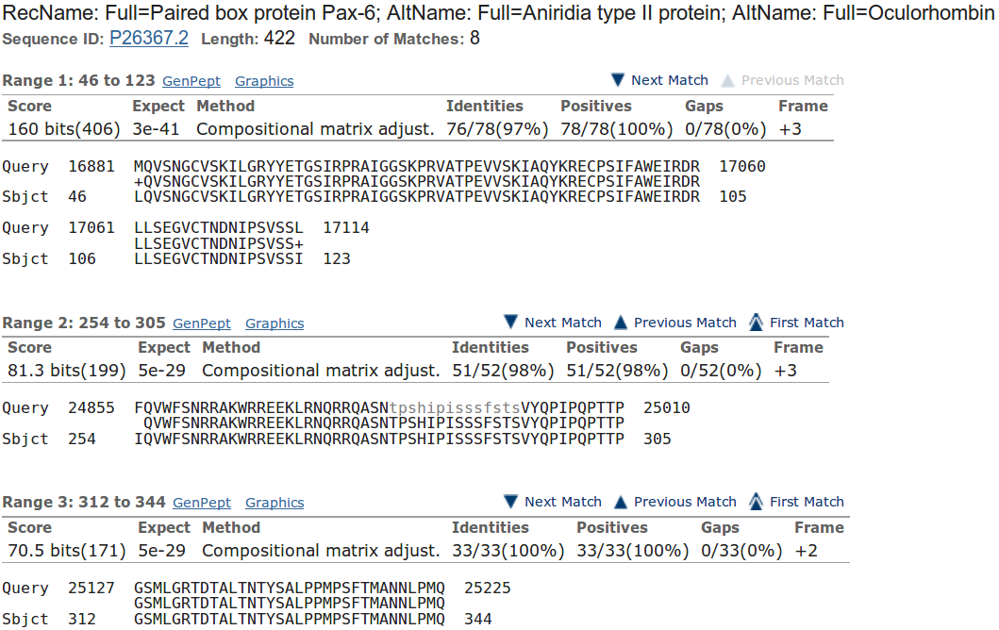
As you can see, the E Value and Max score values used to evaluate the whole protein were computed from just the best (ranked by E Value) local alignment! Crude, but never mind.

The Total score for the entire protein is the sum (rounded up to the nearest integer) of all the bit scores for all 8 local alignments computed for this protein (I suggest you just trust me on this assertion).
How do you suppose the Max matches in a query range parameter might be of value if this order was reversed?
If Paired boxes had been more prolific, then the number of Paired box matches might have filled the blast hit list before the highest scoring Homeo box hit was registered.
If Homeo boxes were longer, and so justified a better E value, then the number of Homeo box matches might have filled the blast hit list before the highest scoring Paired box hit was registered.
Either of these situations would be very unfortunate, but easily avoided by setting the Max matches in a query range parameter to something sensible (50 say). This would ensure that only the top 50 items in the blast hit list would be dominated by the strongest hit.
UNFORTUNATELY … although that is the intention of this parameter, it currently simply will not work, except in very particular circumstances, because of the way it is implemented. This is a great pity, because it is a very good idea, in principle.
I will spare you the details as, despite energetic debate, the NCBI people appear to have no intention of changing things, although they do appear to accept my arguments? Or maybe they just humour me?
How does this “non-informative” region match expectations suggested by SMART and the Feature table of UniprotKB for PAX6_HUMAN?
blast identifies two non-informative regions. I only discussed the prettiest one above. The region discussed is comprised largely of Serines, Prolines, Threonines & Isoleucines the 15 residues between 294-308.
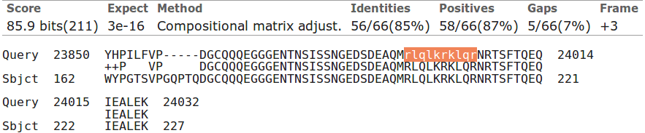
The second (to be found much further down your blast Alignments output) is comprised entirely of Arginines, Luecines and Lysines and Glutamines, the 10 residues between 203 - 212.

UniprotKB also suggests there are two compositionally biased regions.
Well, hardly an exact match, but there is approximate agreement? One would certainly suppose that blast is only willing to mask fairly severe cases of compositional bias. It is also probable that blast has a rather more mechanistic (i.e. non-biological) interpretation of what computational bias is?
SMART also predicts the more obvious region of computational bias, rather more generally:
“An octapeptide and/or a homeodomain can occur C-terminal to the paired domain, as well as a Pro-Ser-Thr-rich C-terminus”
Not important points in themselves of course, the real message of the exercise is that you can discover so much by either:
Looking things up in databases
or:
Using the simple analytical software tools yourself.

From your investigations of PSI-Blast
What do you suppose the choice of Pseudocount might influence?

I clicked with confidence upon the link to the help. It opined as illustrated.
I learn that the default choice of 0 does not mean 0, but instead suggests leaving the value choice to PSI-Blast. To discover what a psuedocount might be, I suppose the next step is to read PMID 19088134? There is most certainly no elucidation amongst the strangle of words offered here?
The article Abstract says:
“Position specific score matrices (PSSMs) are derived from multiple sequence alignments to aid in the recognition of distant protein sequence relationships. The PSI-BLAST protein database search program derives the column scores of its PSSMs with the aid of pseudocounts, added to the observed amino acid counts in a multiple alignment column. In the absence of theory, the number of pseudocounts used has been a completely empirical parameter. This article argues that the minimum description length principle can motivate the choice of this parameter. Specifically, for realistic alignments, the principle supports the practice of using a number of pseudocounts essentially independent of alignment size. However, it also implies that more highly conserved columns should use fewer pseudocounts, increasing the inter-column contrast of the implied PSSMs. A new method for calculating pseudocounts that significantly improves PSI-BLAST's; retrieval accuracy is now employed by default.”
The article itself, continues in like vein … should we avert the eyes and accept the defaults? I cannot but wonder why the whole thing does not commence with, at least an attempt, to answer the question in the forefront of my inquiry, which is .. “WHAT, in the current context, IS a pseudocount?”. I do not believe it is as tricky as they appear to wish us to believe. I will try again later, when my view of the world is less storm infested. In the meantime I will take comfort in the claim that:
“A new method for calculating pseudocounts that significantly improves PSI-BLAST's; retrieval accuracy is now employed by default.”
Jolly good!
2016.12.04: Aha! Wikipedia to the rescues once more. Maybe I will donate again? Wonderful service. One must forgive the NCBI people for not explaining what a pseudocount is, as they did not, as I first thought, invent the term. It is an idea/strategy of far wider and general application as wikipedia explains.
My interpretation of this article (feel free to disagree/correct) in the current context is:
A PSSM is a representation of a Multiple protein Sequence Alignment (MSA) based on the amino acid frequencies observed, independently, in each column of that MSA. Their purpose is to identify other protein regions of the same size that might be homologous. If a given amino acid is not represented at all in a given column of an MSA, the probability of a match for any compared sequence that includes that missing amino acid in that position is implied to be 0 (i.e. impossible!) even if the rest of the region matches extremely well.
Generally speaking, that would be a nonsense! Solution? Add a tiny bit (a pseudocount even) to all amino acid counts that come to 0. Then “impossible” becomes “extremely unlikely”, which makes a bit more sense. A trifle more poetry than science here, but I think I follow the logic.
A popular way of implementing pseudocounts is due to Pierre-Simon Laplace. A French chap who was pretty famous for having good ideas. His strategy, nattily known as Laplace's Rule of Succession, was to add a psuedocount of 1 to ALL the real counts and so pervert the message of the data uniformly. Nice one Pierre.
I am not entirely sure why, but this all reminds me of one of the many dubious culinary practices of my dear mother (when not in the kitchen, an unsurpassed example of the human female condition!). To-whit, when confronted with a spice or condiment with which she was unfamiliar, she would avoid the unacceptable zero condition by adding a swift pseudocount (sometimes two!) into whatever she was brewing at the time. The principle being that of “just in case” and the avoidance of the horror filled possibilities of “missing an exciting new flavour”.
She would protect the family from any ill effects by assiduously, testing the psuedocount side effects upon its most dispensable member … the youngest son, say? If he still frisked after a given period, she would let loose the potion upon the rest of the family. Happily, I survive! But repeated pseudocount experimentations may well explain much of the condition of what remains.
How might the inclusion of poor quality and duplicated sequences have been minimised?
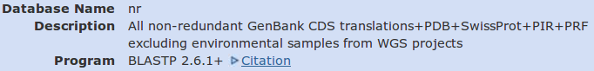
At the top of your output is recorded some details of the conditions under which you database search was undertaken. This is a very important step towards making your results reproducible. Not sufficient I would opine. Surely the database versions and a complete record of the parameters used by blast are required in order to be able to exactly reproduce a search?
But at least the version of blast and the databases that were searched are recorded. The collection of databases searched is rather optimistically called “nr”, for non-redundant. A bit of an exaggeration I would think. Surely PDB and SwissProt overlap a trifle? But let us not be too picky, in fact, a noble attempt to remove duplication between these databases has been made, understandably, imperfectly.
The collection of databases that is nr includes “All non-redundant GenBank CDS translations” (aka GenPept) which, like it European broad equivalent TrEMBL, includes some pretty dubious sequences.
I would think that if one wanted to maximise quality and minimise duplication, it would be best to pick just one good quality database. SwissProt is the obvious choice. blast, in general, and PSI-BLAST in particular, allows such a selection.
However, today the objective is not refinement!!! Bloat is good! More the merrier! Never mind the quality, just admire the volume.

DPJ – 2019.01.30
Discussion Points and Casual Questions arising from the Instructions Text.
Notes:
Work in progress I fear.
The intention is to provide a full consideration of some issues skimmed over in the exercise proper.
If you are attending a “supervised” presentation of the exercise, I would hope to have conducted a live discussion of all these issues to an extent that reflects:
- the depth that seems appropriate
- the time available
- the degree to which the issues seem to match the interests of the class
- how many of you are awake
Here, I hope to write out very full answers were such a response exists. Accordingly, I suggest you will not need to read much of many of these discussions. There will be much detail of interest to rather few of you. Possibly a bit self indulgent, but I wish to make a note of all the background I have discovered while writing these exercises.
In a nutshell, the exercises are trying to make very general points avoiding too much detail. Nevertheless, I record the detail outside the main exercise text, just in case it might be if interest. Some of the answers to the “Casual Questions” are exceedingly trivial. Some of the “Discussion Points” are exceedingly long and rambling. You have been warned.
A glance at PFAM alignments and HMMs.
Actually a very long “glance”. Intended to back up a group discussion and/or for people going through these notes by themselves. If you are doing this exercise in a class environment, please just speed read or leave this stuff for later.
I will provide detailed exercise notes, so you can easily produce similar results yourself, but, a quick browse of the results will be sufficient to back up a class discussion I suggest.
Searching PFAM
Go to the home of Pfam at:
http://pfam.xfam.org/
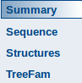
Select the VIEW A SEQUENCE option. Enter pax6_human (or the corresponding accession code) into the proffered space and press the Go button. You will be taken to a Summary of the PFAM version of what is known about this sequence. Links are provided to several other views of this information, most of which you have already considered. The possibilities include the opportunity to generate easily a phylogenetic tree based upon PAX6 from the TreeFam database, which is fun if nothing else. We will not be seriously covering phylogeny in the course of these exercises, but why not try it anyway by clicking on the TreeFam link.
Fine, but you are just looking at what has already been decided. Here we set out to discover, by analysis. How could you use Pfam for a sequence that has yet to be annotated.
Go back to the home of Pfam at:
http://pfam.xfam.org/
This time select the SEQUENCE SEARCH option. Copy and paste the sequence of PAX6_HUMAN into the appropriate box. Click on the Go button.
You should discover nothing you did not expect. This same conclusions, but via direct investigation of the sequence rather than database lookup (or as a component of your Interpro analysis).
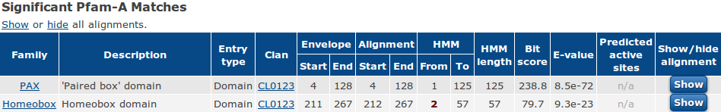
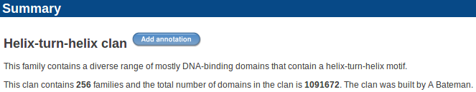
Have a look around generally, but in the course of your investigations, Click on one of the CL0123 links. You will see that both the PAX and Homeobox Pfam families belong to a collection of families (a Clan, a similar idea to the Superfamily and Gene3D domain clusters you met earlier) all of which contain helix-turn-helix motifs and are mostly involved in DNA binding. Unsurprisingly, the clan in question is the Helix-turn-helix clan.
Notice that PFAM reports the matches it finds as being with entries of the Pfam-A database (rather than just with Pfam). This reflects that, as with a number of the other databases you have considered (including UniProtKB, RefSeq, Prosite … ), PFAM entries vary considerably in credibility. At one time PFAM was offered in two distinct sections, Pfam-A and Pfam-B. Pfam-A was comprised of the more reliable, manually annotated, domain models. Pfam-B was entirely computer generated. A few years ago, access to Pfam-B was removed from public use as its domain models rarely represented “meaningful potential new domains”. The PFAM team now advise that users regard Pfam-A and PFAM as effectively synonymous.

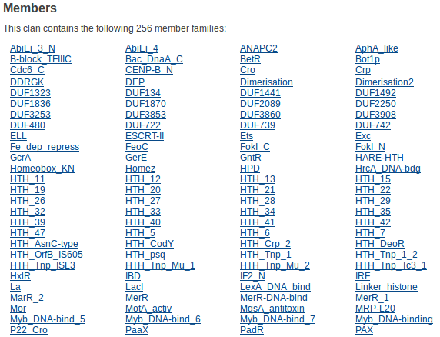
From the Helix-turn-helix clan page, select the link to the PFAM PAX family.
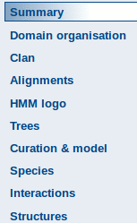
From here, choose Alignments from the menu on the left of the page.
The plan now is to look at two alignments. First an alignment of all the PAX domains to which PFAM admits the existence (currently 2001). Then the alignment of the carefully selected representative “Seed” sequences (currently just 5) from which the PFAM HMM model for the PAX domain is computed.
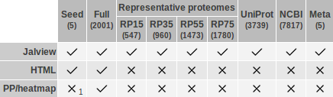
In the View options section, click on the tick in the Full column of the Jalview Row. A new window will thrust its way onto your screen offering the requested alignment displayed by Jalview.
More Jalview functionality is claimed when running Jalview via Java Web Start, so click on the button. In a new window, you should now see the alignment garishly coloured for your delight. The alignment is automatically generated by the program HMMER3 and, at first glance, is not very impressive! The region illustrated is that around the isoform 5a 14 amino acid insertion. You should be able to see the gap in that alignment, but … what are all the other gaps?
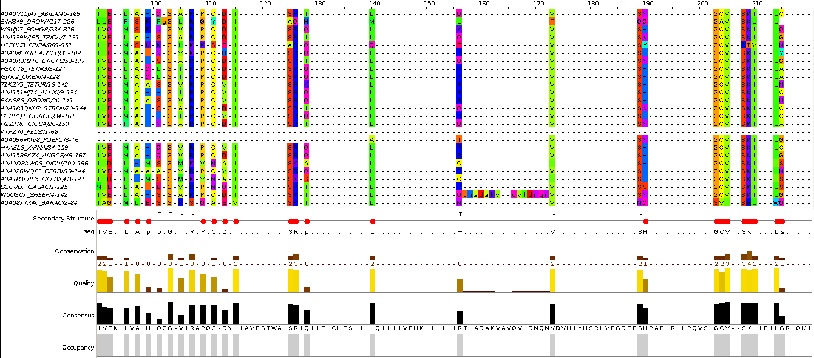
To be fair to PFAM (and HMMER3), this alignment is generated only for cosmetic purposes. It is the Seed alignment that is used to represent a PAX domain. Also, a while ago when the were slightly less than 2001 aligned sequences, I discovered that one could massively improve the look of this alignment by removing relatively few (about 10) outlying sequences (not very good science but very satisfying nonetheless).
Rather than repeat by tedious alignment editing again, I this time elected to look at one of the Representative proteome alignments. The illustration here is the same region as above from RP15. Much better!
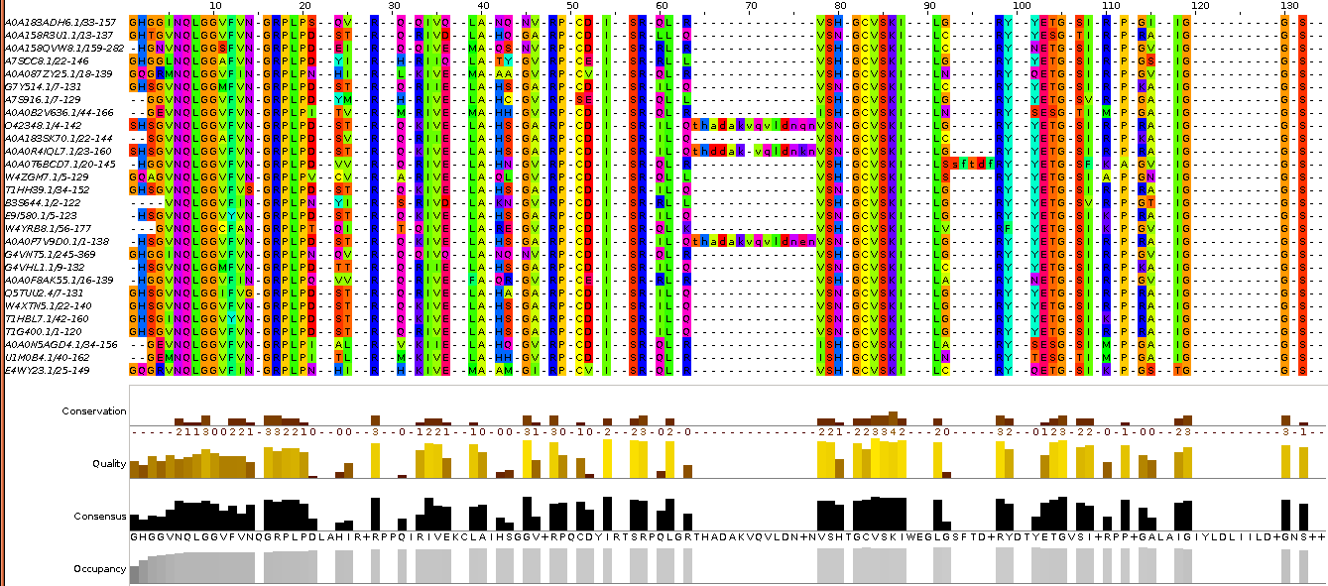
Now to take a look at the Seed alignment. Move back to the Alignments section of the Pfam PAX entry page. In the View options section, click on the tick in the Seed column of the Jalview Row. Click on the button to start the Java Web Start version of Jalview.
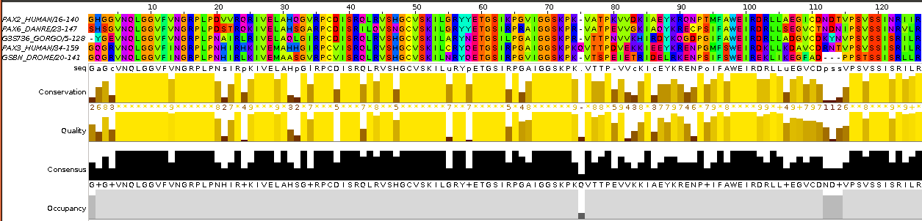
Here is the alignment of the Seed sequences from which the profile HMM for PAX is calculated. None of the 5 seed sequences include the 14 extra amino acids noted previously. Human PAX6 is not a seed sequence.
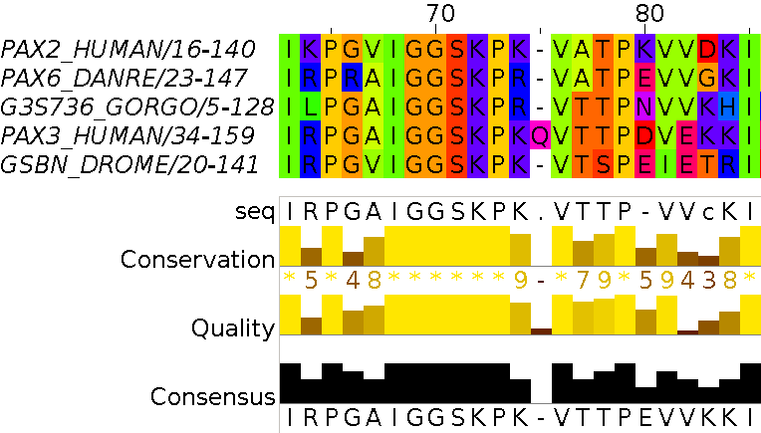
Notice particularly position 75 where 4 of the 5 Seed sequences are gapped. Only one sequence, PAX3_HUMAN, has an amino acid recorded, a Q (Glutamine). The Consensus character at this point is “-”. Jalview has it own way to calculate the Consensus. Read the documentation for the official explanation. Informally: for positions where there is no dominant amino acid code, + means “more than one possibility”, - means “predominantly a gap”.
Back again to the PFAM PAX family page. Click on the HMM Logo link on the left of the page. This is a way of visualising the HMM profile computed from the seed sequence alignment you have just been viewing. The logos are indubitably very beautiful. There is a link their documentation just above the picture.
Notice first columns 49 (C), 65(P), 73(P), 92(P) and 97(W). These positions (and several others) represent positions in the Seed alignment that are 100% conserved. Nevertheless, the Logo appears to admit the possibility of alternative amino acids in these positions of a real PAX domain? This observation illustrates that this Logo is not a simplistic representation of an alignment (as would be a simple pattern as found in Prosite, for example). It is instead, a representation of the profile HMM (pHMM) derived from the Seed alignment. The pHMM admits the possibility of a viable PAX domain deviating from strict adherence to the pattern suggested by the Seed alignment, even where the alignment appears to suggest no variation. These possibilities are computed using such evidences as the scoring matrices discussed earlier.
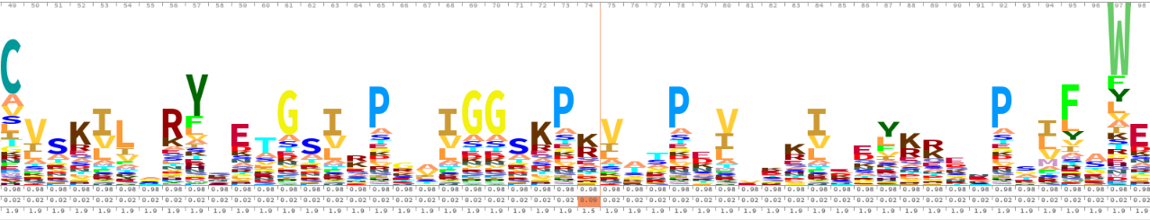
Further evidence of the flexibility of the pHMM is the way that isoform 5a PAX domains are detected (see Full alignment) even though no isoform 5a sequences are included in the Seed set.
Stated simply, a pHHM, of the type used by PFAM, is comprised of a number of likelihood scores for each position of the alignment from which it is computed. They are:
- 20 scores representing the likelihood of each amino acid occurring in that position of a “true” domain match
- 1 score representing the likelihood of that position being omitted from a “true” domain match (i.e. a deletion)
- 1 score representing the likelihood of the inclusion of an extra amino acid before that position in a “true” domain match (i.e. an insertion)
- 20 scores representing the likelihoods of each amino acid being that which is inserted, given an insertion event
In the light of that lucid description of a pHMM, consider the heavily gapped position of the Seed alignment at position 75. In this position, 4 of the 5 aligned sequences have been gapped, the remaining sequence has a Q.
This position does not appear in the Logo (although there is a position 75 … which relates to position 76 of the alignment … which seems a bit silly to me!). This implies that the HMM represents the data at position 75 thus:
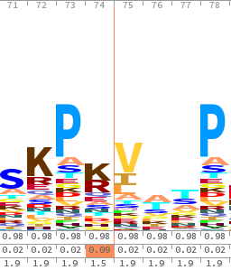
“Generally not present, but a relatively high chance of an insertion which is most likely to be a Q”
The alternative, equivalent, representation would be:
“Generally a Q, but a relatively high chance of a deletion”
Had the second alternative been selected, the Logo would have shown a healthy Q at position 75. The Logo is not sufficiently sophisticated to indicate the high deletion likelihood that would be recorded in the pHMM.
A thin brownish line is placed in the Logo to indicate where position 75 was omitted. The Logo is not a precise enough representation to clearly show that the insertion is likely to be a Q …. but this will be recorded in the pHMM.

DPJ – 2019.01.30

megablast is a less sensitive but even faster version of blast only suitable when, as now, almost identical matches are sought.
By default, megablast uses Linear Gap Costs. That is, it just multiplies the size of the gap with the Mismatch penalty. The other two algorithms employ the more common Affine strategy, using Existence and Extension penalties. For more about Gap Penalties, go here.
This filter avoids finding “hits” supported only by matches in regions not specific to the query. For example, a polyA tail cannot help to identify a specific mRNA as it is present is all mRNAs. The use of this filter will be evident when we look at the blast output.
If you have any non-default settings, they should be highlighted in yellow.
Or you could just read the textual list that follows the graphic if you wish to insist on the simplistic.
Actually, I see now it is a single exon of the PAX6-AS1 entity pursued so vigorously in the last exercise. Those of you foolish enough to read all the ramble of my answers to questions will recall PAX6-AS1 with glee! Yep … ignore it.
To use a global approach would be to imply that you were only interested in database entries that matched your query sequence from end to end. Generally, this is not true. You would usually be interested in a database sequence that was similar over any significant region.
Why not try them? End up with the alignments for the top hit in E value order.
Here I will assume we have talked about these parameter and you are reasonably well informed of the issues.
2 base pairs (Sbjct: 999-1000, AG) occur in both the first two matches illustrated. 6 base pairs are shared between the 2nd and 3rd matches (Sbjct: 1081-1086, CAGGTA).
That I did not ask, because I only just thought of it.
A very nice Java tool for viewing and editing alignments that we will use again.
Exactly what you have to do next should be intuitive (mostly a matter of replying affirmatively to a series of foolish questions), but can vary according to operating system and browser. Whatever is required to display the alignment – do it.
On some systems, there can be problems getting Java Web Start to behave properly. Ask if you have any difficulty.
Full alignment columns that are not represented in the seed alignment (and so do not contribute to the calculation of the HMM), are shown in lower case. As you can see from the Full alignment illustration, including the 14 extra isoform 5a positions.

