

Introduction to Bioinformatics

23-27 March 2020

Practical 1: Databases and Tools
Part i) – Aniridia viewed from The NCBI

Tuesday 28 April 2020
Investigating the gene(s) associated with Aniridia at the NCBI
As a starting point for this exercise, imagine you have a vital interest in discovering and investigating the main human gene responsible for the terrible disease of the eye, Aniridia. There are many ways (including google!) you could discover what this gene might be. I choose to delve into the vast seas of knowledge so generously proffered by the The National Center for Biotechnology Information (NCBI).

So, begin by going to the Home Page of the The National Center for Biotechnology Information (NCBI) (“http://www.ncbi.nlm.nih.gov/”).

You will arrive at a page offering access to the many NCBI resources available to you. Currently, you only require to search for genes, specifically those that relate to Aniridia, so first set the database selection field of the Search facility at the top of your page to Gene, set the Search field to Aniridia and click on the Search button.

A fine list of genes will emerge, including those sought. However, our interest is specific to Human, so the search should really be organism specific. To do this, one needs to execute an Advanced search. So, click on the Advanced button of the Search tool.

Now you can specify the precise field(s) of the annotation you wish to interrogate. In this case, set the Disease/Phenotype field to Aniridia and the Organism field to Human. As the two conditions are linked by AND, both must be true for any gene to be listed.
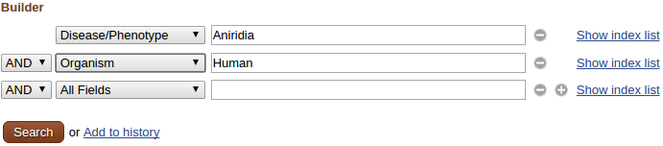

Click on the prettybutton.
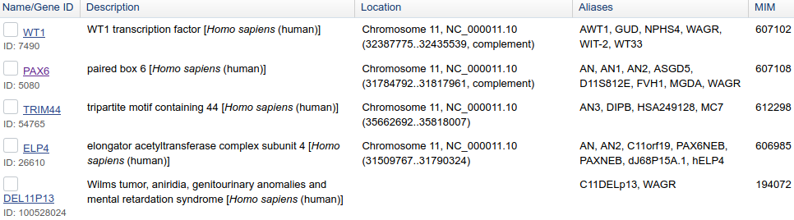
Just a few genes survive. All should really be examined, but this is just an exercise, so trust me … it is PAX6 that is the most interesting gene, in this context. This is the one to follow up by clicking on the link to its details.
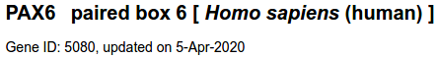
From the very top of the page, one learns that the NCBI specific identifier for this Gene is a simple number (5080, to be precise). Effective, if rather bland and indicative of a tragic lack of flare and imagination!
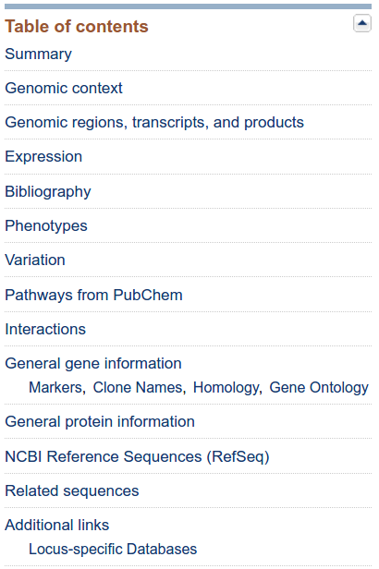

There is much information about the gene PAX6 on this page. One can slide up and down to drink in all the wonders on offer, or there is a Table of contents in the top right corner that will transport you directly to the section of your desires.

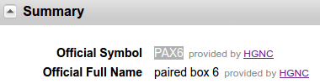
In the Summary section, one discovers that the fine fellows of the pretentiously labelled, Hugo Gene Nomenclature Committee (HGNC) suggest the name “paired box 6”, to be truncated to the less cumbersome Symbol “PAX6” when less formal address is deemed appropriate.
Also, from the Summary section one can conclude (concentrating on the features that pertain to this exercise) that:
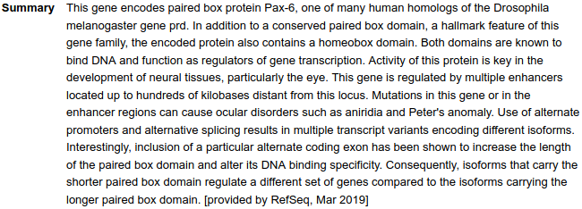
- There are two major domains, a paired domain and a homeobox, both of which bind DNA.
- The gene is a homologue of a Drosophila Melangaster gene called prd.
- This gene is “key in the development of neural tissues, particularly the eye”, as eyes are almost universal, it is not surprising that PAX6 has homologues in a wide range of organisms and that prd is not the only PAX6 homologue in the fly.
- The gene regulates Transcription (i.e. is a Transcription Factor).
- “ … alternative promoters and alternative splicing results in multiple transcript variants encoding different isoforms.”.
- “ … inclusion of a particular alternative coding exon has been shown to increase the length of the paired box domain and alter its DNA binding specificity”.
All of these observations will be investigated in the exercises that follow.
From the Genomic context section it can be seen that:

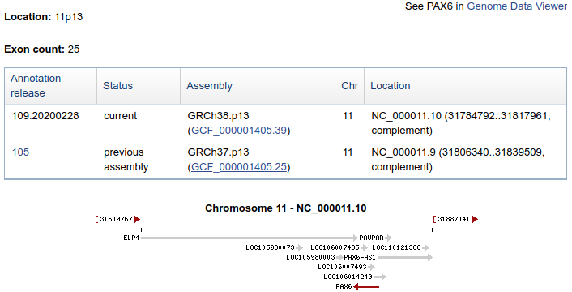
- PAX6 is situated on Chromosome 11, band p13.
- PAX6 is on the complementary strand relative to that chosen to represent Chromosome 11.
- ELP4 (another human gene listed as associated with Aniridia) is very close, on the opposite strand to PAX6.
- There are 25 exons for PAX6.
- A number of other features are recorded here. Most are not genes and so we will ignore them for now. However, do note the feature PAX6-AS1. This is a non-coding RNA that will play a small part in the dance to follow.
- Note also the feature PAUPAR. This is it only appearance that we come across at the NCBI, but it does seem to have a marginally higher profile elsewhere. Both PAX6-AS1 and PAUPAR are reported as PAX6 antisense RNAs, which informs one only slightly.
- Note how the location of the PAX6 gene has moved slightly between the current assembly of the Human Genome and the previous assembly.
This demonstrates clearly that, of course the Human Genome is not DONE! FINISHED! FIXED forever! It is a consensus of the Genomes of a number of individuals and is recalculated regularly. Genes therefore appear to “move”, even change shape! It is even the case that some areas of the Genome, particularly around Centromeres, have proven exceptionally difficult to sequence and are, even now, represented in the sequence databases as long runs of Ns (N indicating the presence of a base of unknown type).
25 Exons? Jolly good, but I really wanted to know how many Transcripts there were according to the NCBI. That is, how many different ways it is thought that nature spliced the 25 exons together. I would also like to discover how many distinct isoforms the NCBI imagines to result from however many Transcripts. I proceed with impatience!
All of these observations will play a role in the exercises that follow.
Move down to the Genome regions, transcripts and products section. The PAX6 genomic region, as interpreted by the NCBI Genome Database, is displayed for your delectation.
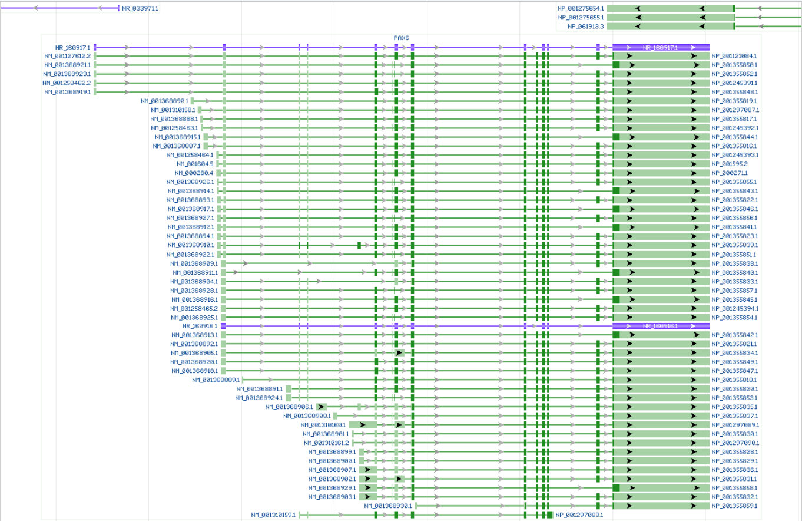
The whole width of the display represents the entire PAX6 region of Chromosome 11. Each line represents a PAX6 Transcript.
The top PAX6 line represents one of the two the non-coding Transcripts that this database associates with PAX6. A non-coding Transcript has a name (Accession Code) that begins NR_ (Non-coding RNA). The Accession Code is displayed to the left of the transcript line (in this case, NR_160917, the .1 at the end is the version number). The Accession Code for the Protein Product of the Transcript is displayed at the right hand end of the Transcript line (in this case it is blank, of course). The pretty blue blobs represent the Exons, the equally attractive blue lines joining the blobs, represent the Introns.
The choice of the first two letters of the Accession codes you see here reflect the status of the Genes, Transcripts, or Proteins they represent. Here we see, NR_, NM_ and NP_ representing non-coding Transcripts, curated coding Transcripts and protein products of NM_ Transcripts respectively. There are, for example, also Accessions codes prefixed by XR_, XM_ and XP_ representing predicted non-coding Transcripts, predicted coding Transcripts and protein products of XM_ Transcripts respectively. A full list of RefSeq Accesson code prefixes can be found Here.
All the PAX6 Transcripts shown here, excepting the two blue NR_ Transcripts, are curated coding Transcripts. Each coding Transcript is represented by a Transcript line showing CoDing Sequence (CDS) Exons as dark green blobs, Untranslated Regions (UTRs) in Exons as lighter green blobs, joined together by green lines representing the Introns.
Note that each coding Transcript is associated with a unique Protein Product, the Accession Code of which is displayed at the right hand end of each coding Transcript line. This does not mean that every coding Transcript generates a different Protein Product. It just means that this database finds it convenient to represent Protein Products as if they were all distinct. There are, in fact, far fewer Protein Isoforms than there are coding Transcripts, as we will discover.
Note the three curated coding Transcripts in the top right hand corner of the graphic.
Hover over the any one of them and an large grey box full of fascinating facts will bounce forth from nowhere!
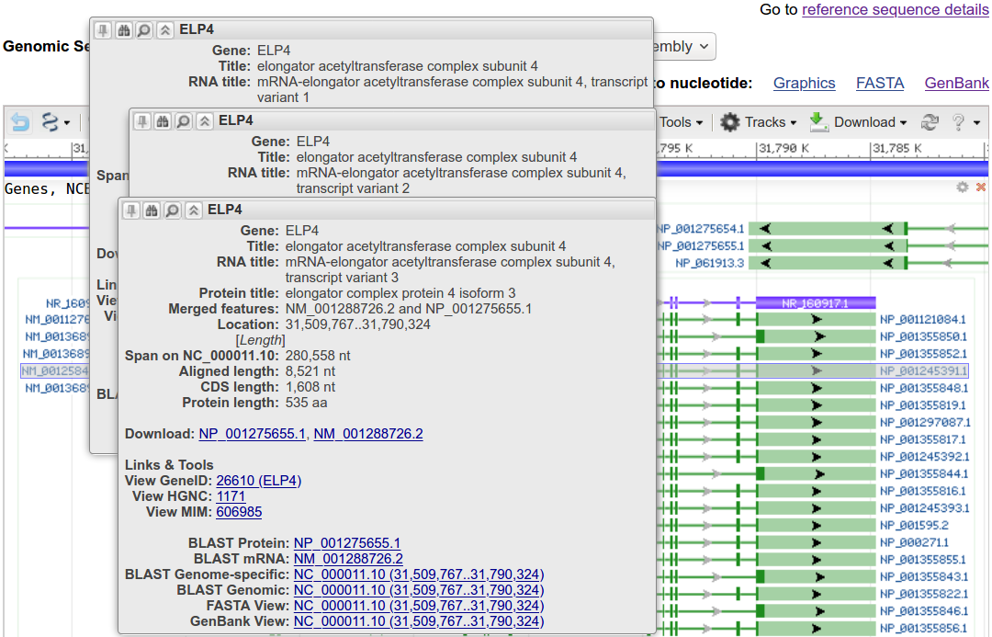

It should be clear that these are three Transcripts of the ELP4 gene that was noted when looking at the Genomic context section.

Note also an enigmatic non-coding Gene with just one Transcript called, endearingly, NR_0339711. Hover over the NR_0339711 transcript line and a new box of tasteful grey will sally forth telling all there is to know about the mysterious NR_0339711!
A swift glance will be sufficient for you to see that NR_0339711 is simply the PAX6-AS1 gene we first met in the Genomic context section, in rather thin disguise. NR_0339711 being the Accession code for the non-coding RNA product of the gene called PAX6-AS1.
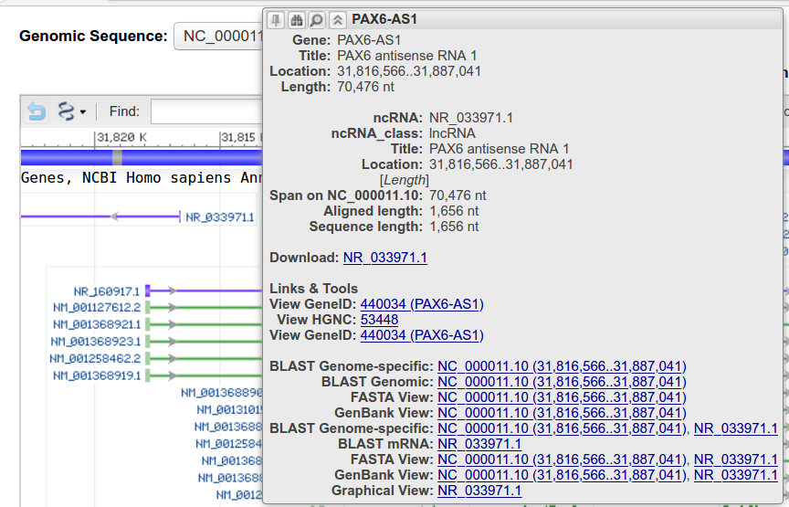

There does not appear to be a wealth of information about the noble gene PAX6-AS1? Its Title “PAX6 antisense RNA 1” would seem to be the all there is to say? Well, I suppose that leaves plenty of good things for future investigators to research? But … remember … when the vital role for PAX6-AS1 is revealed, you saw it first HERE!

In passing, there is no sign of the other PAX6 antisense RNA, PAUPAR, mentioned above? This can only be because region of the PAUPAR gene (as computed by the NCBI) does not overlap that of PAX6. This is not entirely clear from the more approximate graphic representation of the Genomic context section.
Our first objective, to determine the number of Transcipts the NCBI suggests PAX6 might have, remains unrequited!
We seek a number that varies wildly according to the definition of “Transcript” used by the NCBI, the quality of evidence required by the NCBI before they accept a Transcript exists and the volume of experimental evidence which increases as more research is completed (amongst other things!). Only a year ago, the evidence suggested just 11 PAX6 Transcripts, now it is clear, at a glance, that there are many many more!
OK, so you could count the number of Transcript lines from the graphic? But I am far too nice a person to suggest you do that! Happily, the answer is readily available elsewhere.

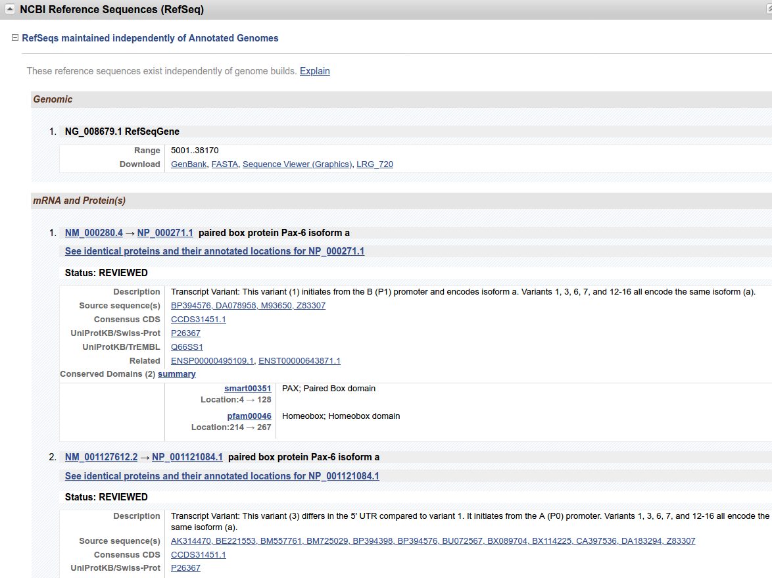

Move to the NCBI Reference Sequences (RefSeq) section. Here you will find a numbered list of all the mRNA and Protein(s).

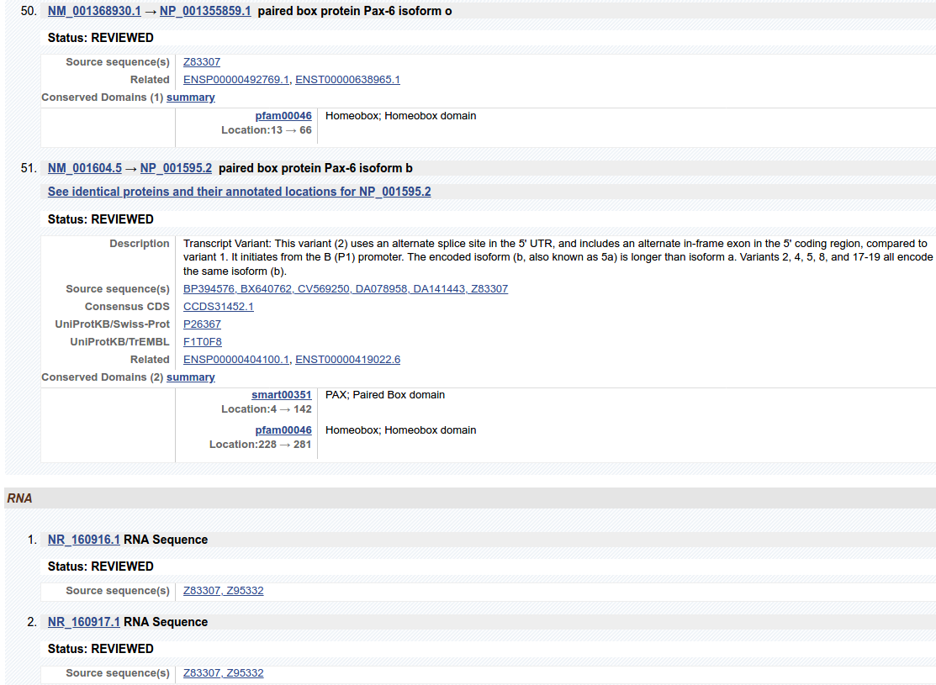

Slide gracefully to the bottom of this list and you will see that the NCBI admit to 51 Messenger RNAs and 2 non-coding RNAs.
Well … that was easy!
There are a few other observations to make before leaving the NCBI Reference Sequences (RefSeq) section. Primarily, details that will be expanded upon later, as these exercises progress.
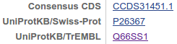
Note first, that many of the coding Transcripts are associated with 2 UniProtKB Proteins. One from the SwissProt section of UniProtKB and one from the TrEMBL section. At first glance, this duplication might seem illogical. Of course, how this can happen sensibly will be clear to you, as you have all listened attentively to my pre-exercise videos!!? If not, explanation will be found in brief here, and reinforced in the exercises that follow.
Look next at the Title lines, (first numbered lines) of a few of the coding Transcripts. It is clear that Isoform names are of the form isoform x, where x is a letter (starting with ‘a’ and progressing on towards ‘z’ as far as is required). Clearly, you could count how many isoforms there are … but please do not! There are far better ways to do this.
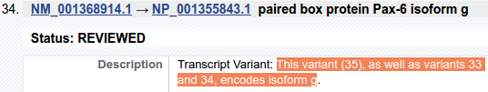
Look now at the Description field of any coding Transcript. See that a list of all the Transcript Variants coding for the same isoform are listed. Clearly, this would enable you to determine the number of Transcripts that code for each isoform (e.g. from the illustrated example it can be seen that 3 Transcripts code for isoform g)… but please do not! There are far better ways to do this.

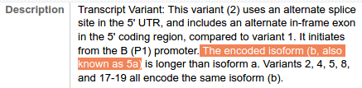
Look now at the Description field of any isoform b Transcript (e.g. Number 51). Note that “isoform 5a” is an alternative name for isoform b (the relevance of this will become apparent later). Note also, that isoform b (aka isoform 5a) is reported to be longer than isoform a.
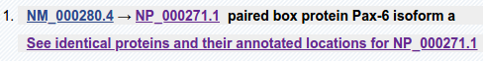
Click on the link to the Protein for any isoform a Transcript (e.g. NP_000271.1).
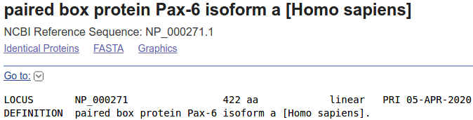
Note the the length of the protein is 422 Amino Acids.
Click back to the NCBI Reference Sequences (RefSeq) display.
Click on the link to the Protein for any isoform b Transcript (e.g. NP_001245391.1).
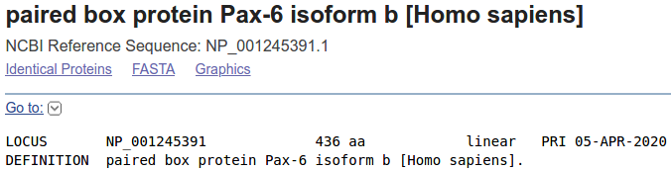
Note the the length of the protein is 436 Amino Acids.
Click back to the NCBI Reference Sequences (RefSeq) display.

Finally, compare the Conserved Regions of any isoform a Transcript with those of any isoform b Transcript.

Both Isoform a and Isoform b are recorded as having two domains. A Paired Box Domain at the beginning, and a Homoebox Domain further along (as noted earlier).

Both Paired Box Domains are detected by a matches in the SMART database. Both Homeobox Domains are detected by matches in the Pfam database. Other Domain Databases will certainly provide supporting evidence, but reference to just one match is sufficient here.
From the location information, the Paired Box of Isoform b appears to include an extra 14 amino acids.
All the information to discover, rather clumsily, the number of distinct isoforms, and the number of Transcripts generating each of those isoforms, has been located. Job done? Well yes, but before retiring in triumph, let us look at a couple of alternative sources for this information involving simple textual sources.
These straight text information sources can more easily be interrogated programmatically from the command line to discover the counts we seek. Some indication of how this might be achieved will be offered in a session at the end of the full week version of this training course.
Arguably the most obvious information sources is the Textual Gene Table for PAX6.
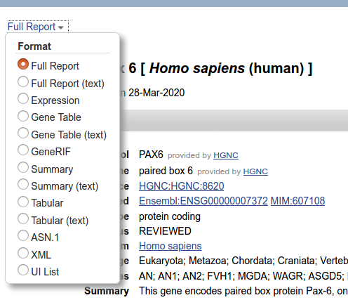

Move to the top of the PAX6 Gene page and click on menu link currently set to Full Report.

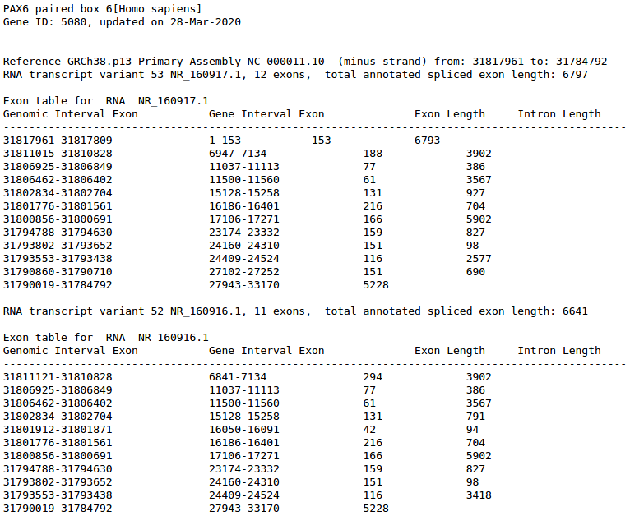

Select the option Gene Table (Text).

Details of all the PAX6 Transcripts are displayed in tabular form. First the two non-coding RNAs.
Followed by information for each of the 51 coding Transcripts.
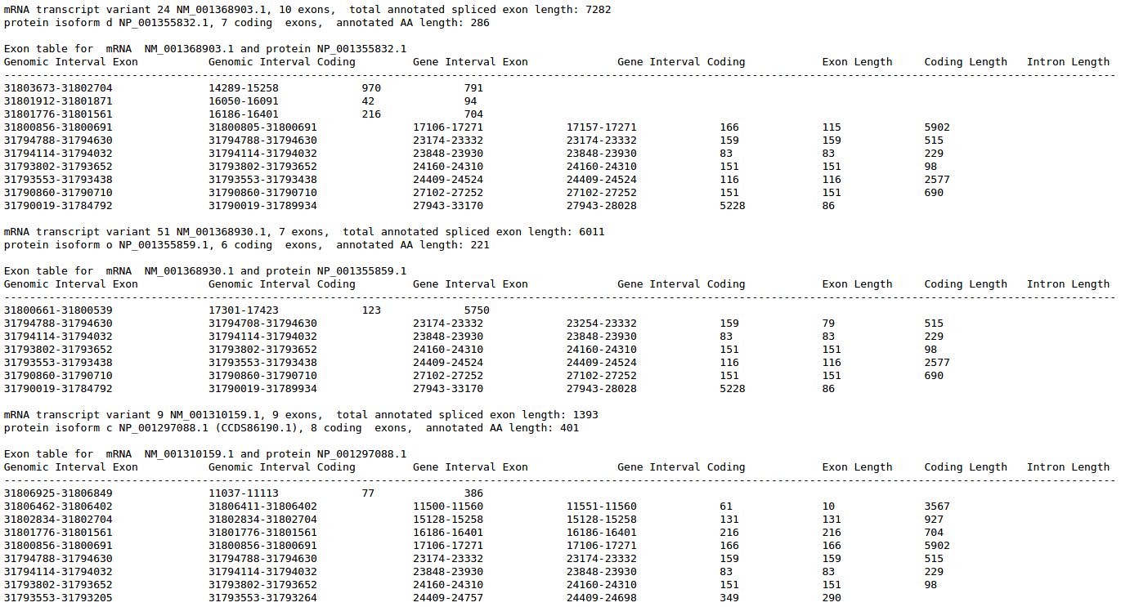

Notice that for every coding Transcript there is a line specifying the isoform that corresponds to the Transcript. The isoforms only have different names if they represent different protein products.

Name#
isoform a:9
isoform b:7
isoform c:1
isoform d:13
isoform e:1
isoform f:1
isoform g:3
isoform h:3
isoform i:2
isoform j:1
isoform k:1
isoform l:6
isoform m:1
isoform n:1
isoform o:1

Isoform names can be swiftly be confirmed to be of the form isoform x, where x is a letter (starting with ‘a’ and progressing on towards ‘z’ as far as is required) determining the particular isoform.
So … all you have to do is to trawl through the tables and see how much of the alphabet had to be used! Easy! But … PLEASE DO NOT DO THIS!!! I will tell you, there are 15 isoforms. They are called isoform a, isoform b … isoform o.
Finally, there remains query number three, which is to determine how many Transcripts generate each of the 15 isoforms? Again, easy! The answer lurks in the tables, you need only to read through for an hour or two and then you have the answer (and a headache). Once more … PLEASE DO NOT DO THIS!!! I give you the answer.
Counting the number of Transcripts for each isoform requires one to count how many times an isoform name occurs. Significantly more ugly than just reading the Description fields of the NCBI Reference Sequences (RefSeq) display, BUT much easier to code, as you will see.
Alternatively, you might move back to the Genomic regions, transcripts, and products section and click on the GenBank link just above the graphic.
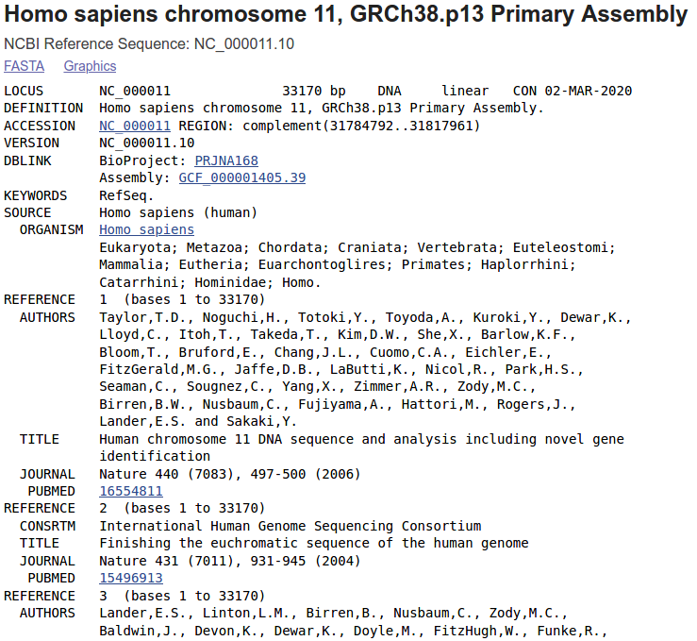
Here you see the portion of the RefSeq entry for the entirety of Chromosome 11 that covers the PAX6 gene region. As you can see the Chromose 11 RefSeq entry is NC_000011. ‘C’ for Chromosome, of course. As always, the number after the ‘.’ is a version number.
Notice there is no permanent RefSeq entry for the genomic region for any specific Gene. Such are dynamically generated as required from the single entry for the Chromosome.
One purpose for looking at this entry is to ensure everyone has delighted in viewing at least one example of a GenBank Format sequence. This format was originally designed for the entries of the GenBank DNA sequence database. I suggest the format really explains itself, but if you need to, try the Sample GenBank Record, which provides links to clear explanation of all the possible features.
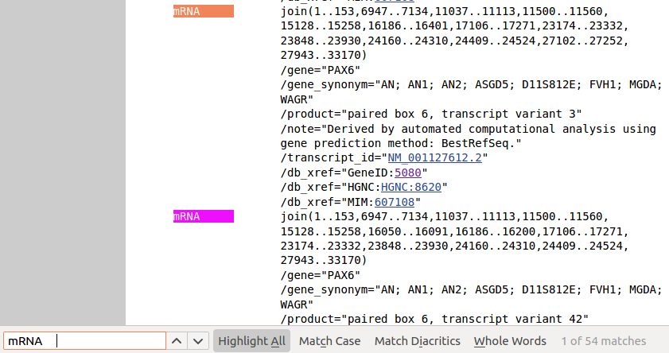
Also, the idea was to demonstrate that you could compute the answers to the questions posed by the exercise from the contents of this RefSeq entry as well as from the Gene Table (Text).
Try searching for all lines that contain “mRNA” followed by 4 spaces (type CtrlF and a search box will appear at the bottom of the page).
You should find 54 hits. This suggesting the presence of 54 transcripts that generate mRNAs perhaps?
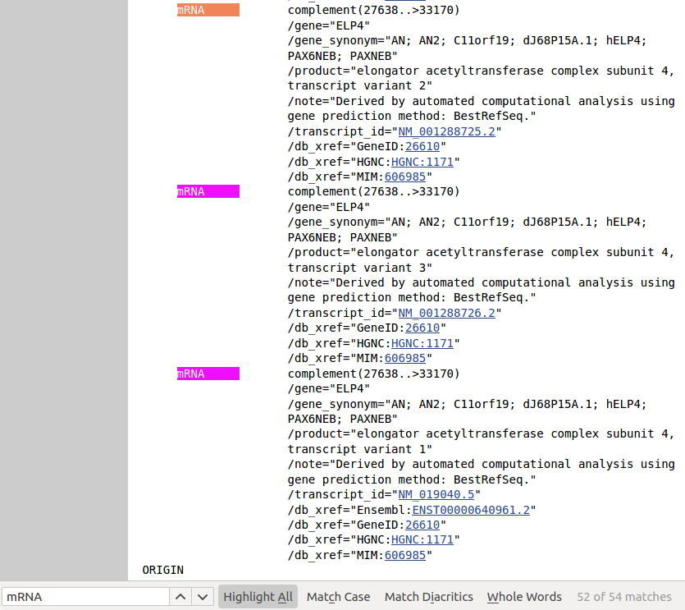

You might have expected 51, given previous investigations BUT … remember that this “PAX6” region also includes 3 ELP4 coding Transcripts. So, with a bit of thought, answer confirmed as far as counting the Transcripts is concerned? 51 PAX6 transcripts plus 3 ELP4 transcripts equals 54 transcripts of unspecified origin, after all.

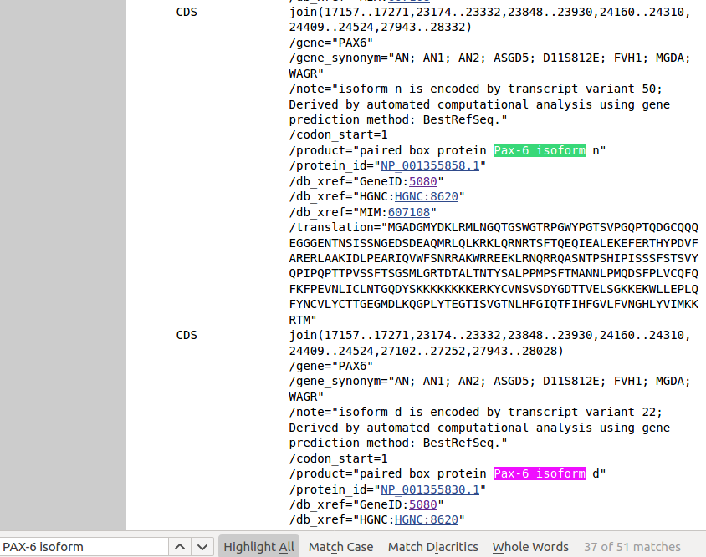
Now try searching for “PAX-6 isoform”. Lo and behold! 51 hits and the naming scheme for the isoforms as expected? Also, the number of Transcripts for each isoform can easily be confirmed. I suggest we are there!
Of course, we discuss extremely sloppy strategies to answer questions of rather dubious worth here, but it is the principles, the possibilities that are of interest in this context.
Once again, please do not try to work out anything from you displays. The answers offered a page back still apply.
Just one question remains. How did I determine the answers I strenuously requested you not to wast time working out? Well … I most certainly did not spend ages reading through web displays, text tables or the GenBank format sequence!! I spent just long enough to see HOW the queries could be answered, and then I downloaded both the plain text data representations to my computer and wrote simple programs to extract the information I wanted.
Pretty clever eh? … Well, not really. I do not generally do clever things. With some small instruction, copying data from sites such as the NCBI and composing small programs (scripts) to analyse that data is trivial. We hope to convince you that this is true in the final stage of this course of instruction.
Hopefully , you will see the importance of acquiring minimal programming skills. The general truth being that, if you wish merely to superficially browse the data/information offered by sites such as the NCBI, then use a browser. However, if you wish to meaningfully interrogate that data/information, you will almost inevitably need to use more powerful, if less beautiful, tools.
You may, with some justice say, “But when would we ever want to ask the questions suggested in these exercises?”. Maybe never, but the fact remains. Whatever questions you do want to ask, a browsing approach alone will rarely suffice, particularly if you wish to examine large sets of data.
Time for a break folks? Next we will look at, basically the same story, as told by the Ensembl database.

DPJ – 2020.04.28
Supplementary notes and discussion arising from the Instruction Text.
The intention is to provide extra instruction and discussion not essential to the purpose of the exercise. The “Appendices” are for “interest only”. They can all be skipped if you are short of time.

a full consideration of some issues skimmed over in the exercise proper.
If you are attending a “supervised” presentation of the exercise, I would hope to have conducted a live discussion of all these issues to an extent that reflects:
Some of the “Discussion Points” are rather long and rambling. You have been warned.
Can a single coding Transcript correspond to more than one UniProtKB Protein?
Any given Transcript will have just one CoDing Sequence (CDS) and so should only code for a single Protein.
As touched upon in one of the introductory videos for this exercise, UniProtKB strives to be non-redundant, that is, no Protein should be represented more than once.
Therefore, all coding Transcripts should correspond to one and only one UniProtKB entry.
However, as the video explained, UniprotKB has two sections:
Swiss-Prot Comprised of Proteins that have been fully “Manually annotated” with “information extracted from literature and curator-evaluated computational analysis”.
TrEMBL Comprised of Proteins determined only by “Computational analysis”. These “await full manual annotation”. After such “full manual annotation” a TrEMBL entry will be discovered to be nonsense (and deleted), a duplicate of something already in the Swiss-Prot section (and deleted), or a truly worthy newly discovered Protein deserving of instant promotion to the Swiss-Prot section.
So, it might be the case that a protein could exist, for a short time, both in TrEMBL and in Swiss-Prot. As soon as the TrEMBL version is properly examined and determined to be a duplicate of an extant Swiss-Prot entry, it will be eliminated. However, should a coding Transcript be annotated during the time of duplication, some coding Transcripts might well appear, erroneously, to match two proteins.
That is what has happened here in the case of several coding Transcripts.
Of course, none of this will be new to you as you watched my lovely video carefully? Only very very BAD people who skipped the video will read the above as novel information.
Click Here to Return to the Exercise →

DPJ – 2020.04.28

This despite WT1 being at the top of the list? This is a relatively new promotion for WT1. For years it has been but a close second to PAX6. Whilst congratulations are clearly in order, this elevation is jolly inconvenient for the story I wish to reveal. So … I intend to ignore it!

