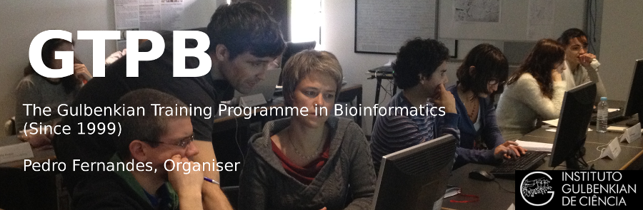

ELB17S
Entry Level Bioinformatics
06-10 November 2017

(Second 2017 run of this Course)

Basic Bioinformatics Sessions

Practical 4: Primer Design

