

ELB17F
Introductory Bioinformatics
08-12 May 2017

(First 2017 run of this Course)

Basic Bioinformatics Sessions

Practical 1: Databases and Tools

Wednesday 26 April 2017
Investigating the gene(s) associated with Aniridia
As a starting point for this exercise, imagine you have a vital interest in discovering and investigating the main human gene responsible for the terrible disease of the eye, Aniridia. There are many ways (including google!) you could discover what this gene might be. I choose to delve into the vast seas of knowledge so generously proffered by the The National Center for Biotechnology Information (NCBI).
So, begin by going to the Home Page of the The National Center for Biotechnology Information (NCBI) (“http://www.ncbi.nlm.nih.gov/”).
You will arrive at a page offering access to the many NCBI resources available to you. Currently, you only require to search for genes, specifically those that relate to Aniridia, so first set the database selection field of the Search facility at the top of your page to Gene, set the Search field to Aniridia and click on the Search button.
A fine list of genes will emerge, including those sought. However, our interest is specific to Human, so the search should really be organism specific. To do this, one needs to execute an Advanced search. So, click on the Advanced button of the Search tool.
Now you can specify the precise field(s) of the annotation you wish to interrogate. In this case, set the Disease/Phenotype field to Aniridia and the Organism field to Human. As the two conditions are linked by AND, both must be true for any gene to be listed.
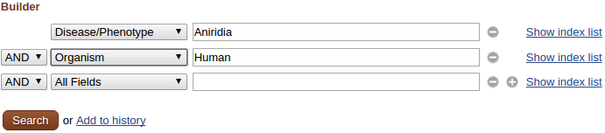

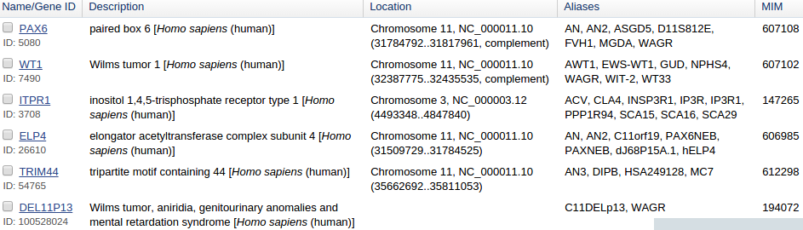
Click on the pretty redbutton.
Just a few genes survive. All should really be examined, but this is just an exercise, so trust me … it is PAX6 that is the most interesting gene, in this context. This is the one to follow up by clicking on the link to its details.
From the Summary section one can conclude (sticking to the features that pertain to this exercise) that:
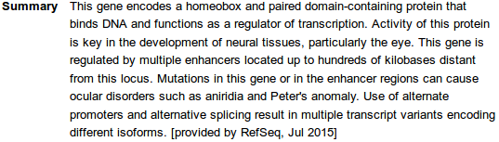
- there are two major domains, a paired domain and a homeobox, both of which bind DNA
- the gene regulates transcription (is a transcription factor)
- there is more than one protein isoform, and thus more than one transcript variant.
From the Genomic context section it can be seen that:
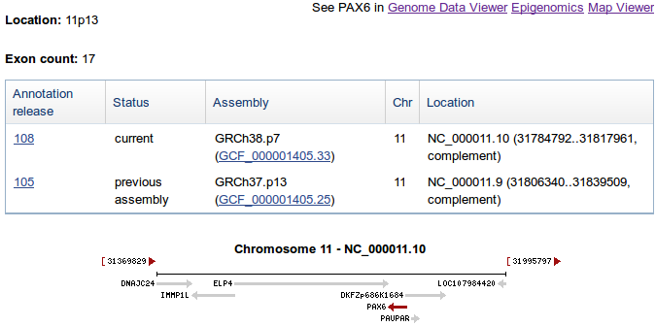
- PAX6 is situated on Chromosome 11, band p13
- PAX6 is on the complementary strand relative to that chosen by Map Viewer to represent Chromosome 11
- ELP4 (another gene in the list of human genes associated with Aniridia) is exceedingly close, on the opposite strand to PAX6. This might be worthy of a glance, at a later time?
- There are 17 exons for PAX6. Jolly good, but I really wanted to know how many transcripts there were according to the NCBI? That is, how many different ways it is thought that nature spliced the 17 exons together. I would also like to discover how many distinct isoforms the NCBI imagines to result from however many transcripts. I proceed with impatience!
Click either the Genome Data Viewer or the MapViewer link. Both offer you essentially the same story, the choice really is cosmetic. Do you like your genomes vertical or horizontal. I am a horizontal man myself, so I prefer the Genome Data Viewer. The data is from the Map Viewer Genome Database, whichever choice you make.
I reproduce both views here. The Genome Data Viewer picture is included in the PAX6 gene page for free, so maybe the MapViewer link is the best one for you to choose? Or both, of course! First consider the marginally clearer and simpler Genome Data Viewer picture.
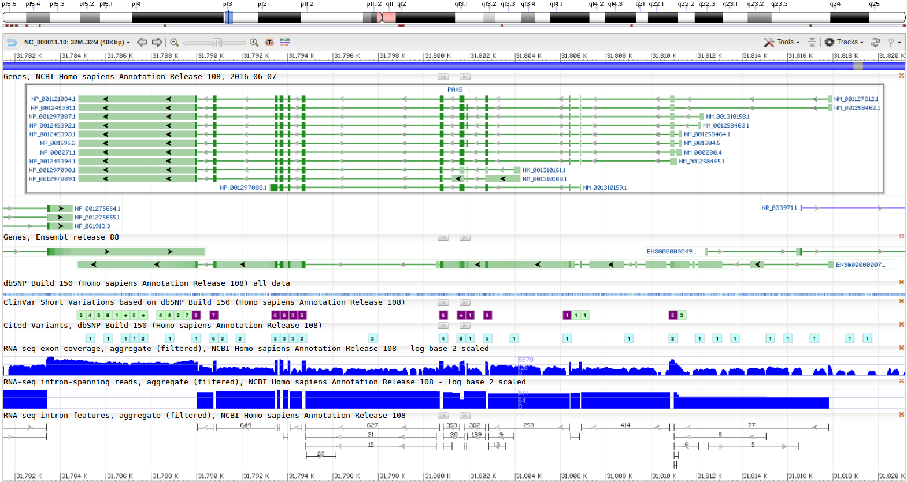
So, if I tell you the region displayed is the entire PAX6 region of Chromosome 11 and the green lines labelled on the right as something beginning with NM_ represent the different transcripts, can you now say how many transcripts there are according to this view? In passing, the blobs along each line represent the exons. Dark blobs are coding exons. Light blobs represent the exons that form the 3'/5' UTR regions of each transcript. The Introns are the pale green lines joining the blobs together.
The prediction of the transcripts shown here are based on database searches of all Human mRNA sequences stored in RefSeq against this region of the genome. The theory is that every human mRNA sequence must match (nearly) perfectly somewhere in the human genome. Where it matches, there must be the genomic DNA from which the mRNA was transcribed. How charmingly simple!
To differentiate between coding and non-coding exons of a transcript, why not compare all human proteins with the genome (after suitable translation to amino acid codes in all six reading frames). They too must match near perfectly somewhere, identifying the CoDing Sequence (CDS) of each transcript. Transcript fully located. Job done! Of course, it does not always work so very neatly, but we need not admit that for the moment at least.
Comparing proteins with the genome is clumsy, compute intensive, slow. For major organisms (currently just Human and Mouse), specially comprehensive databases of extremely reliable DNA Coding Sequences have been constructed. Searching with these databases enables much more efficient searching for coding exons and so is very much preferred.
And so to the Map Viewer version of exactly the same region of Chromosome 11.
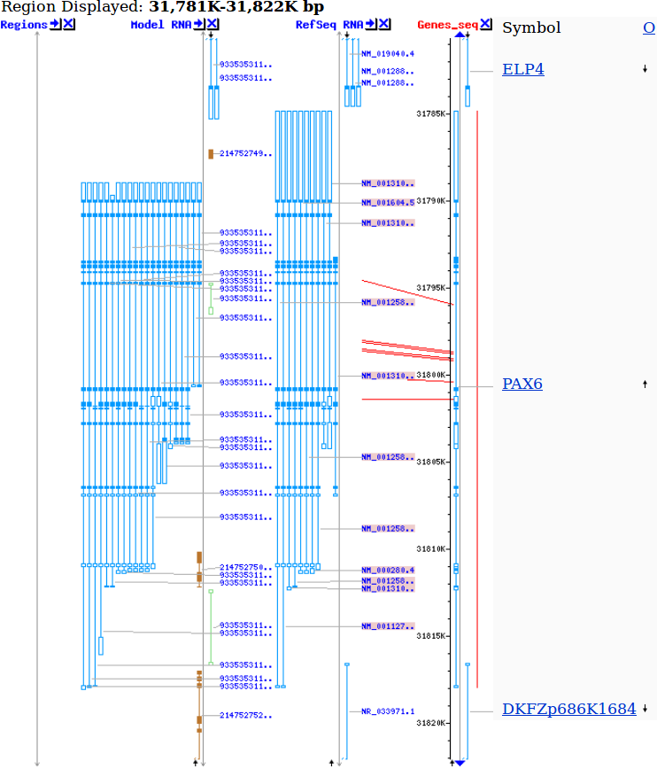
OK, times up, how many transcripts are predicted for PAX6 by MapViewer?
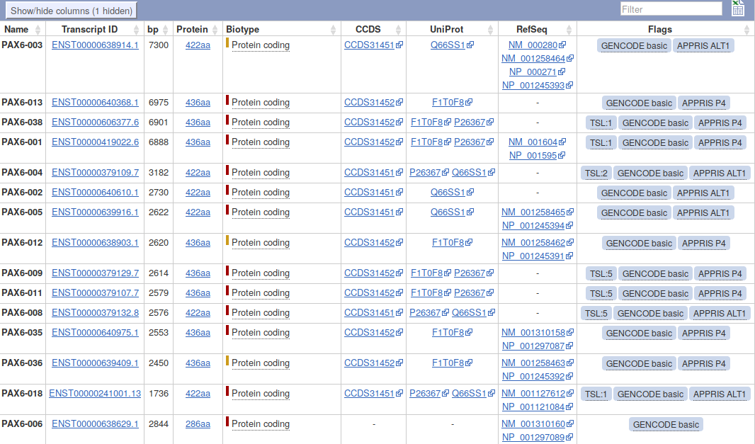
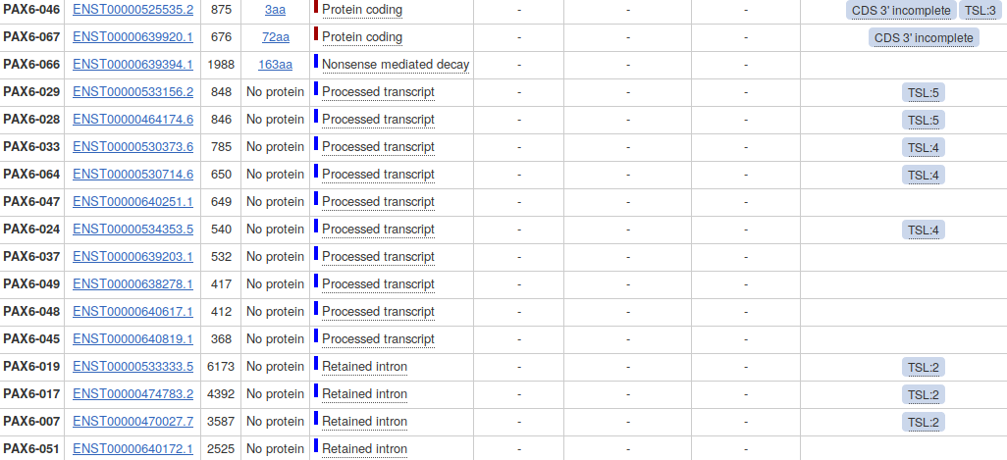
11 being the correct answer. Obviously? Exactly as suggested by the Genome Data Viewer! True, but this is not always the case. The transcript count (and much else) depends on the version of the data used to build the views.. Very recently, these two viewers displayed the interpretation of different data versions. Mapviewer being slightly behind the times. When this was the case, the transcript count depended upon which viewer was chosen. This vitally illustrates that many of the “facts” presented by these services are but predictions that will vary as more/better data become available. Pretty good predictions, but nevertheless, predictions!
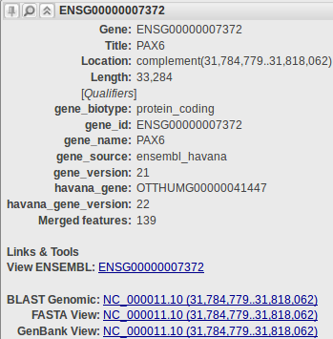
In passing, the reason that there used to be a difference in transcript counts between the two viewers was that MapViewer used an older version of RefSeq than the Genome Data Viewer. The older RefSeq included some extra mRNA sequences of less certainty than the ones you see represented above. Clearly, the evidence for these extra mRNA sequences was proved insufficient and they were removed in the newer RefSeq. Where they exist, such less certain RefSeq mRNA sequences can be recognised easily as their labels (Accession Codes) which begin with XM_ rather than NM_. I make a point of mentioning this as the inclusion of data of varying credibility, in databases such as RefSeq, is very common. Usually, the difference in confidence is that between database entries that are only detected by computer programs (questionable) and those that have been properly investigated by human experimenters/investigators (less questionable).
Even without database version variation, seemingly trivial inquiries such as “how many transcripts are there?” can still yield conflicting answers depending upon where the question is asked. Move back to the page describing the PAX6 gene. In the familiar graphic at the top of the Genome regions, transcripts and products section you will find routes to corresponding information from the Ensembl Genome Database. Hover over the PAX6 (also known as ESNG00000007372, by Ensembl and close friends) green line in the bottom half of the picture. You will be rewarded by cheery gray box full of links to Ensembl and other exciting places.

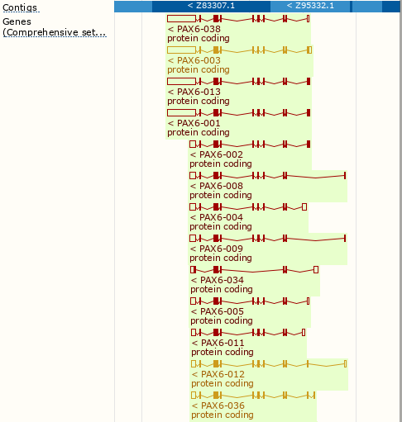
Use the link labelled View ENSEMBL:. A view of the region of Chromosome 11 similar to those you have already considered will leap forth. As before, the exons for each transcript are represented by blobs (filled for coding, empty for UTR regions). Introns are represented by wiggly lines joining the blobs. Notice first that there are considerably more than 11 transcripts represented here! At the top of the page, in tiny letters it claims 82! (a massive increase from the 31 transcripts predicted by the previous version of Ensembl!).
You could check this assertion by counting all the transcripts represented in the graphic, but I would not recommend doing so. Sometimes it is best just to believe. There are indeed 82.
The colour scheme used for the transcripts we might discuss in overview later. For now, just know that the gold transcripts are supported by better evidence than the red ones. Once more a database that offers data items of varying credibility.
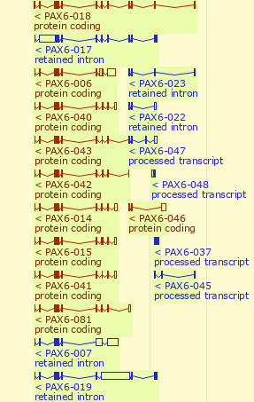
Looking a little further down the transcipts displays, you will see that some of the transcripts are not protein coding. Both of the displays you examined at the NCBI only represented protein coding transcripts. This partially explains why Ensembl finds so many more transcripts that the other options.
So a further reason for not finding a consistent answer to the simple question “How many transcripts are there for the PAX6 gene” is variation in the definition of a transcript.
Also, and more importantly, Ensembl and MapViewer use different strategies to predict transcripts (and just about everything else!). Both use database searches in roughly the manner described previously and (for the human genome at least) the same basic assemblies of the genome and sequence databases. It is the interpretation of the data and analytical results that varies.
The database searches used as the fundamental to identify transcripts take a very long time to execute, even given the immense computing resources available to the NCBI and the Ensembl teams. Some clever strategies are employed to minimise the time spent on these searches. It would be good to consider these, specifically with respect to their implementation by Ensembl, at least superficially.
For a more detailed view of the predicted transcripts, click on the link. The transcript predictions are now presented in the form of a table. The protein coding transcripts are all at the top of the table. I counted 56, but I would not claim to be completely accurate, I got a bit confused half way down the list! Lots more than the NCBI anyway.
Ensembl uses both the sequences of the RefSeq mRNA sequences and their protein products (the RefSeq entries whose Accession Codes commence NP_) to predict transcripts, however, Ensembl has less blind faith in the accuracy of these data than the NCBI. We should discuss briefly why it is reasonable to not regard a match of a RefSeq mRNA with the Genome as, by itself, sufficient evidence to predict a transcript. Specifically, you should not expect every RefSeq mRNA to appear in this table any more than you should expect a “one to one” correspondence between RefSeq mRNA and a transcript prediction. In this instance you can see an instance where two RefSeq mRNAs are associated with the prediction of a single Ensembl transcript (the first transcript in the list).
Looking further down the list you will see that many Ensembl protein coding transcripts are predicted without reference to any RefSeq entry.
Hover over the evidence Flags associated with the transcript predictions towards the end of the list. How reliable would you judge these predictions to be?
We could go on. Other sources (not necessarily Genome Databases) would count the transcripts differently again. Perhaps the best answer to the question “How many transcripts are there for the PAX6 gene” is “Several”.
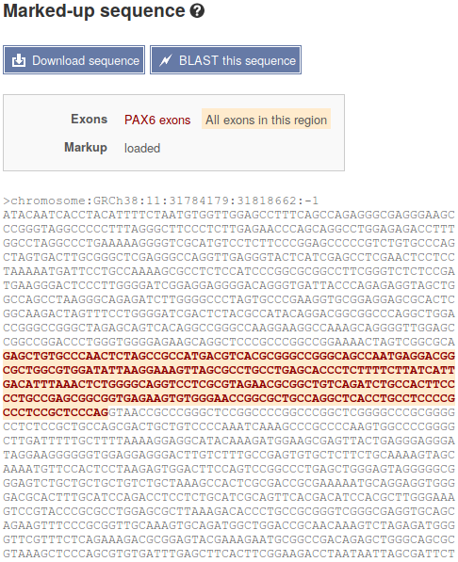

Before leaving Ensembl, it would be good to save the genomic sequence of this region for analysis later on.

To do this, first click on the Sequence link on the left hand side of the page. Under the transcript table the sequence of the PAX6 region of the genome will be displayed. The exons will be tastefully highlighted for you delectation.

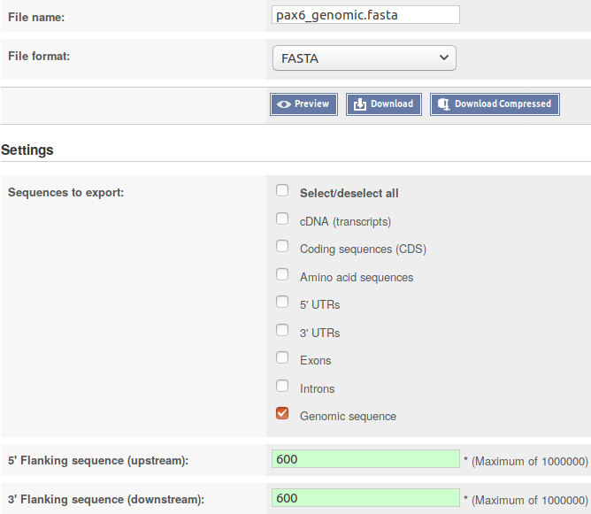
Now chose to. The Download sequence form will burst into view.
Set the File name: to pax6_genomic.fasta
Set the File format: to FASTA
Accept the default 600 base pairs for both the 5’Flanking sequence (upstream): and the 3´ Flanking sequence (downstream):.
Finally, click on the button and do whatever it takes to move the file you create to somewhere sensible on your Desktop.
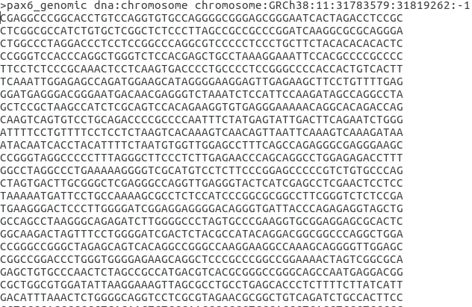
Using whatever text editor is most convenient, edit your file to:
- Remove the many blank lines at the top of the file. These serve no purpose, but are not really a problem either. They are, however ugly!
- Change the first word of the first line of the file to contain information from 11 to pax6_genomic. This first word is defined as the sequence identifier in FASTA format (as, I hope, will be explained at some point). pax6_genomic is a far more informative identification than 11 (the Chromosome number).

The next question might be “How many protein isoforms might there be for PAX6?”.
Well, whilst the Ensembl transcript list is still in view, glance down the Protein column which displays the size of the protein products for each transcript. Clearly insufficient evidence for a serious isoform count, but enough to set a lower limit, as the same isoform cannot be more than one length! If there were not so very many! One might count how many different lengths of proteins were listed. I tried to do this, but I gave up around twenty-something. Let us be content to declare that there are lots. The most likely looking ones are either 422 or 436 amino acids long. Some of the others might cause a raised eyebrow or two, especially the one that is 3 amino acids long? But, who are we to question! Lots is the informal Ensembl total.
Click your way back to the NCBI PAX6 gene entry. So, now I would like to discover the number of protein products (isoforms) that the NCBI predicts. This view makes this simple question clumsy to answer as the protein products of each transcript are reported separately (as they are by Ensembl), even when they are identical???
However, it can be done. Click on the NCBI Reference Sequences (RefSeq) link in the Table of contents on the right hand side of the page. Focus on the mRNA and Protein(s) sub-section. Skim down the entries for every transcript. Check the different isoform names. I see:
01 - NM_000280.4 → NP_000271.1 paired box protein Pax-6 isoform a
02 - NM_001127612.1 → NP_001121084.1 paired box protein Pax-6 isoform a
03 - NM_001258462.1 → NP_001245391.1 paired box protein Pax-6 isoform b
04 - NM_001258463.1 → NP_001245392.1 paired box protein Pax-6 isoform b
05 - NM_001258464.1 → NP_001245393.1 paired box protein Pax-6 isoform a
06 - NM_001258465.1 → NP_001245394.1 paired box protein Pax-6 isoform a
07 - NM_001310158.1 → NP_001297087.1 paired box protein Pax-6 isoform b
08 - NM_001310159.1 → NP_001297088.1 paired box protein Pax-6 isoform c
09 - NM_001310160.1 → NP_001297089.1 paired box protein Pax-6 isoform d
10 - NM_001310161.1 → NP_001297090.1 paired box protein Pax-6 isoform d
11 - NM_001604.5 → NP_001595.2 paired box protein Pax-6 isoform b
I count 4 different isoforms, imaginatively named Isoform a, Isoform b, Isoform c and Isoform d. One associated with each transcript description. Look carefully at the annotations and there is more information. In particular:
Description field: Isoform b is also known as Isoform 5a. Why this is interesting will become apparent in a page or so.
Isoform b is also reported to be longer than Isoform a.
Conserved Domains.

Both Isoform a and Isoform b are recorded as having two domains. A Paired Box Domain at the beginning, and a Homoebox Domain further along.

Both Paired Box Domains are primarily indicated by a hit with the relevant entry in the SMART database. Both Homeobox Domains are supported by matches with Pfam database entries. Other domain databases will almost certainly provide supporting evidence, but reference to just one match is sufficient here.
From the location information, the Paired Box of Isoform a appears to include an extra 14 amino acids.
UniprotKB offers yet another version of this story. Just for a for a few clicks, let us intrude into the UniProt session of your course.
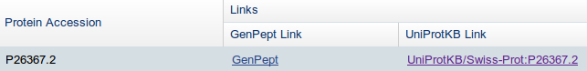
At the very bottom of the current page, you will find a link to UniprotKB. Use it.
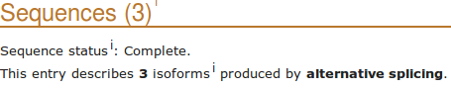
Lo! the PAX6 human protein as seen and understood by UniProtKB. Click on thebutton on the left hand side of the page. UniProtKB declares 3 isoforms! At least, 3 that it is willing to admit to publicly.
There is isoform 1, also known as isoform a in America. Note that this is the “canonical sequence” for this protein. That is, this is the isoform used to represent this protein in UniProtKB. The sequence(s) of all other isoform(s) are recorded as elements of the annotation.
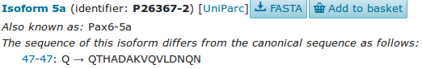
Also we have Isoform 5a (or PAX6-5a), also known as isoform b in America (where it also answers to Isoform 5a when pressed). Note that the entry declares the sequence difference to be:
47-47: Q → QTHADAKVQVLDNQN
Literally:
“The amino acid at position 47 is a Q in the canonical sequence. In isoform 5a this is replaced by the 15 amino acids QTHADAKVQVLDNQN”.
More coherently this amounts to:
“isoform 5a differs from the canonical isoform 1 in that it has an insertion of 14 amino acids after the 47th amino acid of the canonical protein”.
It is significant to note that position 47 is right in the middle of the Paired Box Domain that occurs in both isoforms. This confirms that which was discovered at the NCBI.
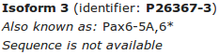
Finally UniProtKB proudly presents the somewhat ephemeral isoform 3 (or PAX6-5A,6* for those who enjoy formality). But, this one has no known sequence? Not much that Bioinformatics can offer here methinks.
So I hope you will agree that the UniProtKB count stands at a very modest 2, plus a ghost.
To visualise the differences between the 2 isoforms with sequence, click on thebutton at the top of the Sequences section. After deep thought and much fumbling, UniProtKB will multiply align all the isoform sequences for you. As there are only 2 in this case, this will appear very similar to a Pairwise alignment. Highlight the DNA binding regions and the Domains.
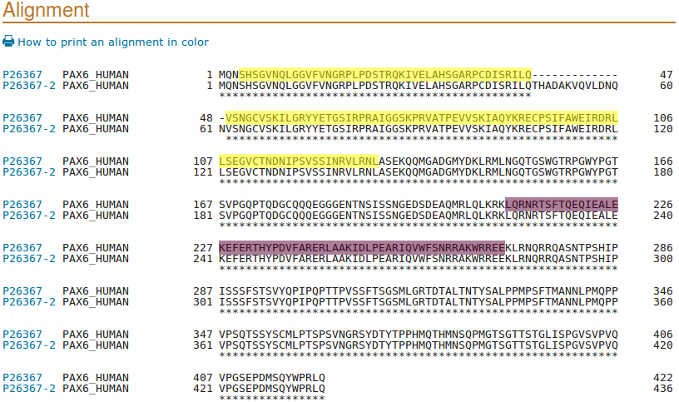
I leave the interpretation of this splendid display to you.
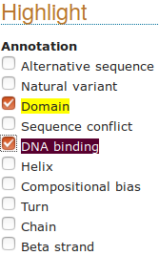
The extra 14 amino acids of isoform 5a are due to the inclusion of a tiny extra (42 base pair) exon in some transcripts.
Can you see the evidence for this assertion in the regional genomic maps of a few pages back?
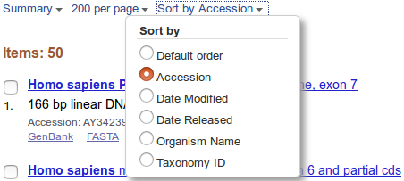
We need to save a some protein sequences for future analysis. This is easiest from UniProtKB so now is good. To declare your intention to save the entire canonical version of the PAX6 protein to a file, move back from your alignment. Move to the top of the page where you will find the bizarre invitation to? Just do it.
You also need to download the sequences of both domains is separate files, via your basket. First the Paired Box. Click thebutton on the left of the page. Then use thebutton adjacent to the Paired entry. Its now in your basket you will be ecstatic to know.

As they are so conveniently in view, take note of the Compositional bias features. They will be of interest when we look at database searching.

Then take an excursion to glance at thesection. Note the many Natural variants recorded as responsible for AN (ANiridia, that is). Particularly those around amino acid positions 29 to 44 and specifically that at position 33.
Looking at PCR Primer Design later, you will be attempting to create a PCR products from patients that, when sequenced, will determine the presence or absence of this variant.
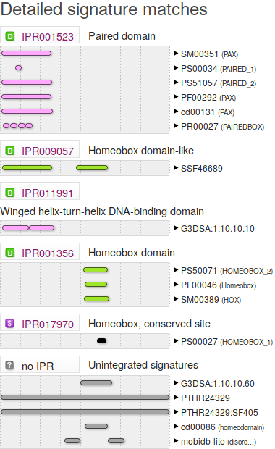
Next, skip nimbly to the section. Concentrate on the Family and domain database sub-section. Here are stored the results of comparing the PAX6 protein with many of available Domain/Motif Databases, including those of the Interpro Consortium collectively.
Are the results broadly as you might expect?
For an effective summary, link tofor the Interpro graphical results. If the detail is not entirely transparent, hopefully there will be time to discuss this graphic at some point.

The results you are looking at are computed, largely automatically, by the UniProtKB/Interpro annotation system. However, running many of the same analysis manually is trivial. Maybe you will do some of this as part of these exercises?
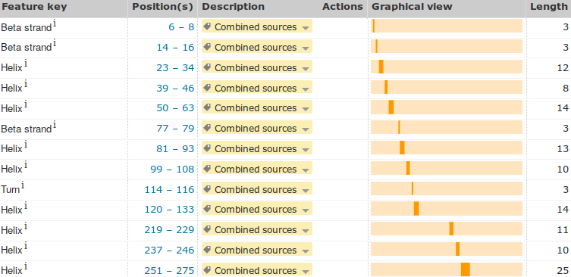
Finally, return to the UniProtKB PAX6 page and move to the section.
Click on the Show more details button.
Describe the arrangement of Helices within PAX6.

Back to saving sequences for later! To get to the Homeobox domain, you need to click on thebutton on the left hand side of the page.
A valid question at this point might be “Why is the Homeobox domain a Function (specifically a DNA binding feature), but the Paired domain is a Domain feature?” To which the answer is “History, dear boy, history” to paraphrase a disputed quote of dear Harold (Macmillan that is).
The fact both are Domains, and both are DNA binding. The illogicality of them being recorded in different places is accepted, however, to fix this early mistake now would not be trivial. So, we live with it. So doing, click on the appropriatebutton and head for the checkout desk (Good Grief! I am beginning to get used to this!).
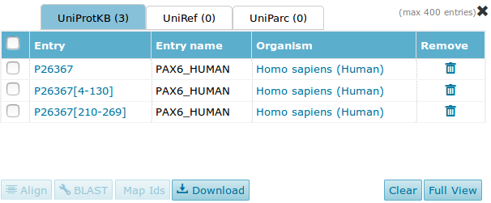
Shimmy back to the top of the page. You should havethings in your basket.
Click on the basket to view your booty.
For each of the 3 items in turn (not all at once or you get all sequences in one file), select and.
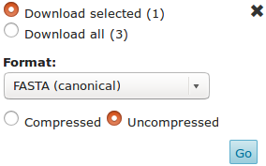

Each time ensure the download parameters are set to Uncompressed and FASTA (canonical). Then click thebutton.
The next few steps, as before, are very browser/OS dependant. Just do whatever it takes to save the three sequences in files called, as appropriate:
pax6_human.fasta
pax_domain.fasta
homeobox_domain.fasta
Now move back to America to the NCBI view of the PAX6 gene. If you have problems getting there … click here.
At the bottom of the page, there is a section called Related sequences. Click on the last entry, the mRNA called AB209177.1. You will be rewarded by a GenBank entry in GenBank format. Formats are tedious, but we will discuss them briefly at some point. You have already witnessed FASTA format. I expect we will bump into EMBL format at some point. The other 137 or so formats I suggest be ignored!
Can you see the official gene name PAX6, mentioned in this entry? The Gene Name field (where PAX6 should most certainly be mentioned) is entirely missing! If you searched GenBank (or EMBL come to that) for this sequence using the most obvious search Keyword, that is PAX6, do you think you would find this PAX6 mRNA? You clearly should! A case for more consistent annotation? Perhaps something to consider further when we superficially mention the Gene Ontology project later.
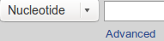
Next, search the nucleotide databases, by textual Keyword, for PAX6 related sequences and down load one or two for investigation. To achieve this worthy goal, move to the top of the current page and note that the database selection has changed from Gene to Nucleotide. Click on the search option button.
Then in the , change to in the pull down menu associated with the first search field and type in the keywords:
chromosome 11
In the second search field, again change to and type in the keyword:
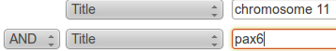
pax6
You are asking Entrez to search for all Nucleotide database entries that contain the terms chromosome 11 and pax6 in the section of their annotation intended to be a succinct brief description (I.e. Title) of the entry. Click on the  button to start the search going.
There is just one matching entry which is arrayed before you in Genbank format, very neat!! It was the DEFINITION line that you searched by selecting the Field value Title. I needed a few tries to get the right search to find just what was needed, and was a bit surprised at the simplicity and accuracy of the final search. You are looking at a RefSeqGene (a subset of the RefSeq database) entry. As such, it represents a genomic sequence for a “well-characterised gene”, in this case PAX6.
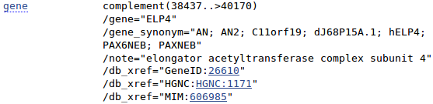
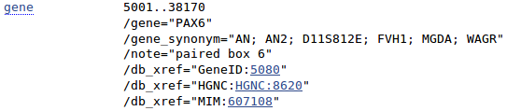
Take a look at the FEATURES for this entry. You will see that there are two genes mentioned. PAX6, of course, and ELP4 on the strand that is the complement of that represented here.
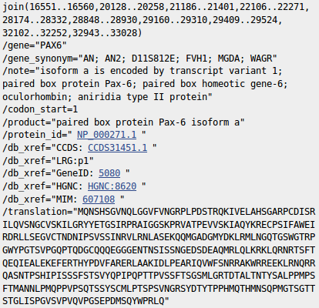
At the top of your page, Analyze this sequence by clicking on the Highlight Sequence Features option. The CoDing Sequence (CDS) feature for PAX6 is displayed for you by highlighting the relevant parts (the coding exons) of the sequence and displaying the CDS details including the DNA regions that need to be joined to form the CDS and the translation of the CDS.
Use the controls at the bottom of your page to look at the other features of this entry (select feature number and then click on the Feature button).
What were the features that you found?
Why might you have expected more features than there were?


Take a look at the COMMENT and PRIMARY sections just above the FEATURES. This entry is suggested to be constructed from two sequences from GenBank. That is, the products of two sequencing projects.

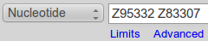
Take a quick look at the GenBank entries by entering their ACCESSION numbers into the Search box at the top of your page. Click on the button.


Lo and behold, the two GenBank entries are summoned forth. Take a look at one or both. Not particularly illuminating I think. These are clones sequenced as part of the Human Genome Project (HGP). They served to cover regions of Chromosome 11 and have little biological significance in themselves.


Move back to the list, as illustrated. Elect to Analyze these sequences, selecting from the extensive range of possibilities Run BLAST. We will look at blast properly later, the idea here is to simple prove that these two sequencing clones really do overlap in the fashion suggested by the evidence so far. So, elect to Align two or more sequences. Cut and paste one of the sequencing clone accession numbers from the Enter Query Sequence box to the Enter Subject Sequence section of the form. Elect to Show results in a new window. Firmly address thebutton.

Just one region of overlap should be identified.

How does the alignment you generated match up with the annotation of the original RefSeq entry you discovered?

Now for an entirely new search. The easiest way to get a fresh start is to move back to your browser tab displaying the GenBank Search results, and then click on the Advanced option of the Search facility at the top of the page. You should arrive back at the Nucleotide Advanced Search Builder offering a fresh start.

Set up a new search as illustrated and set it going. Ultimately simple this time. You have requested all Human sequences that are centrally associated with the gene PAX6.
A list of 50 or so sequences, all clearly claiming PAX6 association and announcing their humanity loudly in Latin, will tumble forth.
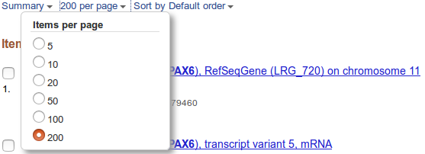
You will have more hits than are displayed in one go, by default. Also, the hits are arranged in a “Default” order which has thus far defied all my attempts to associate with any reasonable definition of logic!
To deal with both of these issues, use the display control pull down menus at the top of your page to set the items per page to something big and the Sort by option to something sane.
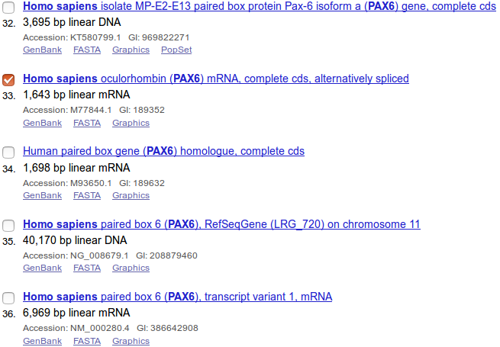
The list shows matches between the terms entered and the annotation of DNA sequences. Not all relevant sequences will be present. For example, the mRNA with accession number AB209177 was justifiably referenced in the PAX6 Gene entry but will not be in this list. PAX6 appears nowhere in the annotation of AB209177 including its DESCRIPTION (or Title) field.
Move far down the list, you will come to the RefSeq PAX6 mRNAs of a few pages back. Just before these entries is M77844.1. Save this one for later analysis. I choose M77844.1 as it includes a few variations that will add interest. Select the target sequence.
You could now use the diminutive button which is near the bottom of your page to download all the selected sequences into a single file.
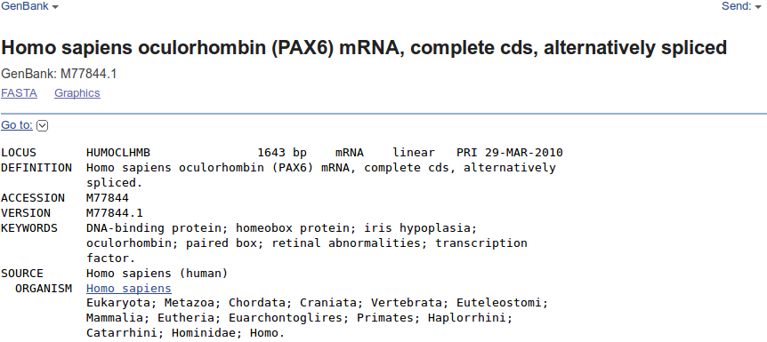
However, as there is only one sequence, and it would be so nice to be introduced properly before such intimacies as “downloading”. Click on the link to the database entry to see it in all its GenBank Format glory.
The sequence is for analysis rather than decoration, so use the format menu at the top of the page (currently set GenBank), and ask for FASTA format.
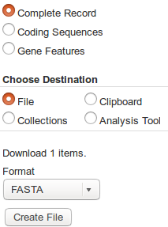
Now click the tiny Send: button and Choose Destination to be File.
Strike the Create File button with a firm resolve. With irritating presumption, the choice of file name is made for you. Your sequence will be stored in a file named:
sequence.fasta
The NCBI is justifiably not famed for its understanding of poetry! Do whatever it takes to rename this file to be called:
pax6_mrna.fasta
One last file to save. Move back to your list of hits and deselect the mRNA that you have already saved.
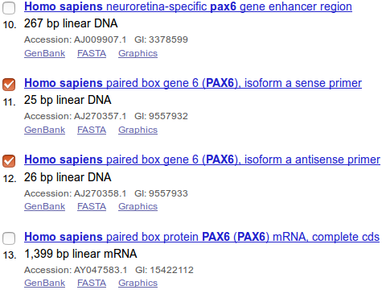
Near the top of the list you should find two primer sequences. Their Descriptions suggest they are a pair of PCR primers used for picking out the PAX6 gene. Select both by clicking in their selection boxes.



Click on the sense primer. Properly, you would read all the References carefully. Instead, note the length looks about right and return to your list with the Back button.

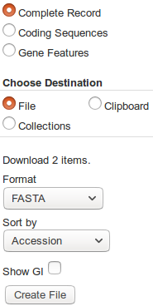

It will be good to investigate these primers later, so find the diminutive button which is at the top of your page and use it. Choose your Destination to be File and set the Format of that file to be FASTA. Strike the Create File button with a confident click of your every ready mouse. Once more, the choice of file name is made for you. Your sequences are stored in a file named:
sequence.fasta
Do whatever it takes to rename this file to be called:
pax6_primers.fasta

Back to Ensembl. More with the objective of looking at more sources of information via Ensembl than becoming expert Ensembl users.
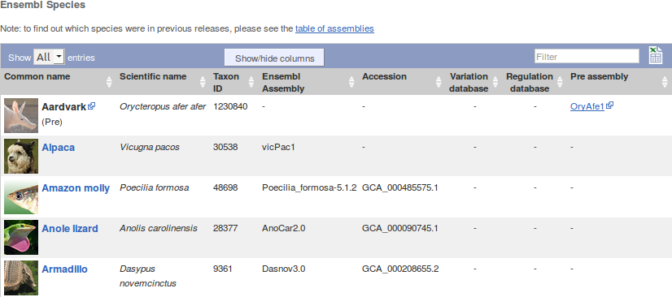
Go to the Ensembl home page (www.ensembl.org). Choose to View full list of all Ensembl species using the link just under the Select a species menu.
Note that Ensembl (and MapViewer, of course) offers far more than just the Human Genome.
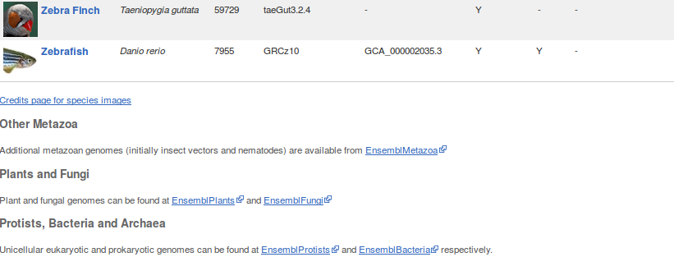
In particular, note the links to EnsemblPlants, EnsemblFungi, EnsemblBacteria etc. Ensembl databases at the bottom of the list.
During this exercise, you will only look at the Human genome, by far the most completely recorded. However, all the other Ensembl genomes are behind the same interface. The techniques required to examine the Human genome are broadly those required to examine any Ensembl genome.
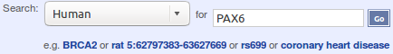
Move back to the home page and go to the Human PAX6 gene information by setting up the Search fields as shown and clicking the Go button boldly.
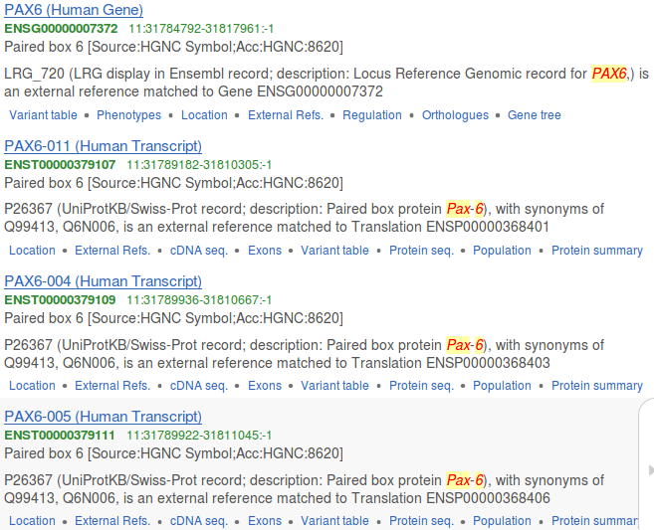
The target gene is at the top of the hit list.
Click on the link to the PAX6 (Human Gene).
You should recognise the view you now see. The list of transcripts and a view of the genomic region roughly similar to those offered by the NCBI.
There is much to investigate here, but maybe that should wait for a specialised Ensembl course. They are run regularly in Cambridge and elsewhere.
To make a bit more space, elect to.
First a look at how Ensembl sees the Homologues of PAX6. First the Orthologues and then the Paralogues. Click on the Othologues link in the left hand side of your browser page.
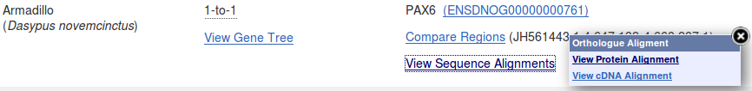
Take a look at some of the alignments providing support for the homologous relations. The protein alignments are the more informative (from the View Sequence Alignments menu, select View Protein Alignment).
Using the evidence of the protein alignments, which PAX6 isoforms do the fruitfly orthologues most resemble?

Once your curiosity is completely sated, click on the Paralogues link. View some of the protein alignments between the PAX6 isoform and its paralogues.
What region(s) of the paralogues seem to be best conserved? Does this surprise you? If not, why not?
How many PAX protein paralogues are there for human? Suggest a prettier naming scheme than PAX1, PAX2, ...
Next look at some transcript specific features as they are recorded in Ensembl. To do this, one must first select a transcript, soonce more and select ENST00000419022. Again, to make a bit more space, why Paralogues notaway.
Now click the Exons link (from Transcript-based displays → Sequence). Exons, Introns and Variations within Exons are clearly displayed.
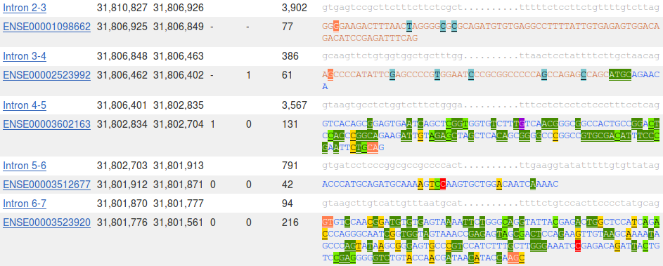
What are the first two bases and what are the last two bases of nearly every intron?
How long is the sixth exon and why would this concur with your expectations?
Explain the Start Phase and End Phase columns?

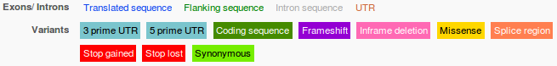
Click on some of the colourful variation locations. The colours are explained in the legend at the top of the display.
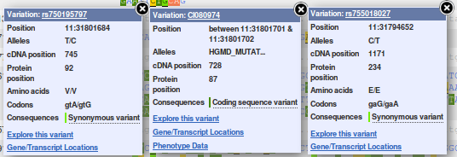
The variations come from a number of variation databases, including dbSNP. The dbSNP entries are those whose names begin with “rs”. dbSNP can be investigated directly at the NCBI, of course, but it very handy to have all the variation information built into Genome Databases such as Ensembl.
Click on the Domains & features link (from Transcript-based displays → Protein Information).
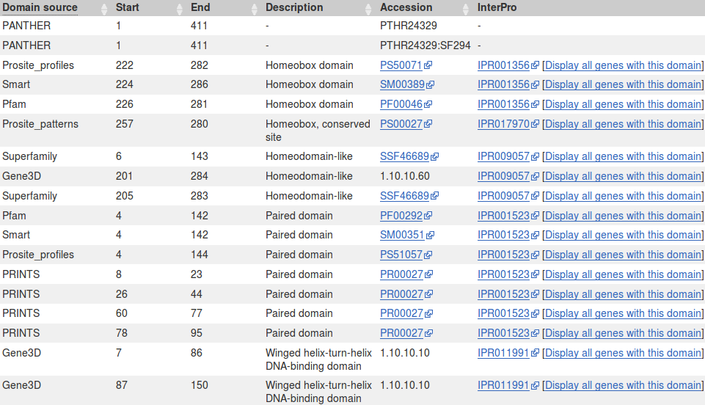
Are you shocked and dismayed that the precise location of the PAX6 Homeobox domain is not identically predicted by the SMART and Pfam Domain Databases? If not, why not?
How is that all the predictions, of different domain databases, for a Paired domain have the same Interpro identifier?
Why does PRINTS appear to predict four Paired_domains?
Click on the link to the SMART entry for the Paired domain (SM00351).
Here you will find (quoted from Interpro) a Description of a Paired domain.
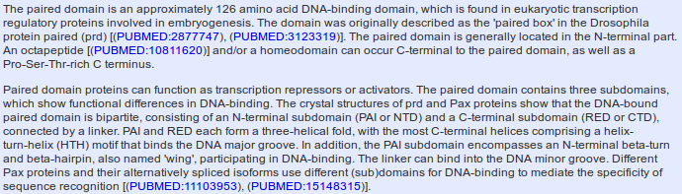
Where would you expect a Paired domain to occur in a protein?
What expectations do you have concerning what typically follows a Paired domain?
The reason for these two questions will become apparent later.

The second paragraph of the Description claims, in gross summary:
- A paired domain is a DNA binding domain that has 2 binding regions each of which involves a helical triplet
- The second and third helices of each helical triplet form Helix-Turn-Helix (HTH) motifs

- The HTH regions bind the DNA major groove


- The first helical triplet is preceded by a β-turn and β-hairpin (“wing”) that participate in the DNA binding
- The linker region between the two helical triplets can bind the DNA minor groove

Bear this in mind when looking at the 3D structures a couple of pages on.

Click on Display all genes with this domain for the Paired domain and Homeobox domain InterPro families. The locations of all genes including each domain will be displayed graphically and textually. PAX6 is shown in red.
Paired domain - IPR001523 Homeobox domain - IPR001356



Which domain, Paired domain or Homeobox domain is more common in humans?
How many human PAX genes are there?
Are all the PAX genes on Chromosome 11?
Move back to the Domains & features display. Link to the InterPro database entry for Paired domain, also know as IPR001523. Here you will find the origins of the SMART documentation. Click on the Proteins matched link. You will see listed a number of representations of proteins that, according to InterPro, include a Paired domain. Amongst these will be the human PAX6 protein, also known as P26367. There are links provided to entries in a number of relevant databases for each listed protein.
What type of Helix-Turn-Helix (HTH) is predicted by InterPro for all the Paired domains in the list?

Click on the Structures link in the top left hand corner of the page. InterPro will offer links to relevant entries in the PDBe, SCOP and CATH databases. Click on the link to the 6pax entry in the PDBe database. You will arrive at the entry for 6pax in PDBe, the European version of PDB maintained at the EBI. Views of this structure are offered on the right hand side of the page. Click on the largest image which shows the paired box protein domain binding DNA rather beautifully. Once you have admired this image sufficiently, move back to the 6pax PDBe entry. From the on the right of the page, select the 3D Visualisation option.
The SMART documentation you read earlier suggested two paired box subdomains, each of which “ ... form a three-helical fold, with the most C-terminal helices comprising a helix-turn-helix (HTH) motif that binds the DNA major groove”. Move your image around to confirm this assertion.
The same SMART documentation claims the subdomain nearer the N terminal “ ... encompasses an N-terminal beta-turn and beta-hairpin, also named 'wing', participating in DNA-binding. The linker can bind into the DNA minor groove”. Manipulate you image to investigate the veracity of these assertions.

Once you have seen all there is to see of 6PAX, move back to the Ensembl Domains & features display. Try the same tricks with the InterPro Homeobox domain. This time, it is difficult to find P26367 in the huge list Proteins matched, but you do not need to in order to link to the Structures. There are many more structures to choose from this time. I suggest you go for 2cue. You have to imagine the DNA this time.
It looks rather as if the Homeobox domain also includes a helical triplet including a Helix-Turn-Helix. You could have confirmed this by reference to the relevant SMART documentation (as you did for the Paired box domain). It is the HTH that the Homeobox uses to bind to DNA.
InterPro did not detect the Homeobox HTH as it did the Paired box HTH. Have you any thoughts as to why this might be?
Can you explain the strangely frayed ends displayed in some of the representations of the 2cue 3D structure?

To end, a gesture towards demonstrating that you could quite easily have computed most of the information you have been accessing, ready packed, from various databases. There are many way this objective could be achieved, I choose to search for the features of the PAX6 protein.
As has been discovered from several information sources, the PAX6 human protein has two DNA binding domains. A paired box at the N terminal and a homeobox a little further along. Both of the domains include Helix-Turn-Helix (HTH) motifs. In this exercise, you will investigate how you might discover these domains and motifs using the various freely available domain databases (discussed previously) and other feature prediction programs. Clearly, this is superfluous for this particularly, well documented protein, but a valuable option in other circumstances.
One approach would be to consider each relevant domain database in turn. Each major domain database has its own Home web site and customised software to take Query protein sequences, compare those sequences with domain representations (typically based on Hidden Markov Models) and to report convincing matches. This would work, but would be tedious as there are many viable databases to consider. It would be dangerous to rely on too few of the databases available as none is perfect. You need a consensus prediction to be sure you miss nothing.
Also, you would need to know which databases are particularly appropriate for each domain you considered might be present. All databases cannot be optimised for all types of domain (for example, the SMART database specialises in domains that occur in signalling proteins).
So, let us not search individual domain databases in the main part of these exercises. Instead, I offer a supplementary exercise investigating a representative selection of the available searches. I selected the Prosite, Pfam and PRINTS domain databases, If you do this exercise, consider particularly the PRINTS section. It illustrates how and why PRINTS just fails to see one of the two PAX6 domains (as you already discovered when looking at UniProt).
Here, use just Interpro to do the whole job. Interpro will search for all domains using the appropriate domain databases, thus removing the tedium of interrogating a miscellany of domain searching resources individually.
defines protein families according to the way that proteins match elements of a wide range of protein family databases, including all those we have discussed thus far. Interpro provides a search tool that will search all or any of the major protein family databases and assign Interpro family associations to the query protein(s) accordingly. To have a look at some of the possibilities offered by Interpro, Go to:
http://www.ebi.ac.uk/interpro/
If you were to enter the PAX6 human protein into the obvious place on the InterPro home page, you would produce exactly the results you saw many pages back, when you were investigating UniProtKB. Do this if you have the time and inclination.
By implication, InterPro offers a fuller experience via the InterProScan search tool. Other than the opportunity not to search ALL the domain databases, and having the results arranged slightly differently, I am unsure what the extra effort brings? Never mind, there are many things of which I am unsure, so, from the InterPro Home page ...


Select the InterProScan link. Here you will be offered the opportunity to download the InterProScan program.
I am not sure this is too useful an offer for most? But it is there.
For now, chose the online Sequence search.

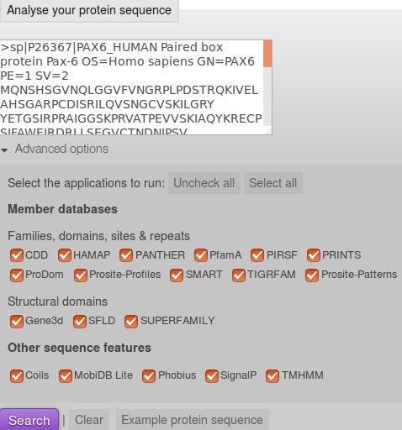
You will arrive at a page that looks very similar to that from which you started, as far as the offer to run a domain search is concerned? Except! We now have Advanced options. Click on the Advanced options.
The Advanced options only allow you to choose which databases you wish to search and which feature prediction programs you wish to run. The default is to use all the databases and to run all the predictor programs. I struggle to imagine an occasion I would want to save the EBI servers a few cycles by considering which options to deselect, but it so nice to know I could if I wished to.
In passing, the offer to run the feature predictor programs in the Other sequence features section is relatively new. Of course, all these programs could be run individually from their home websites (follow the links behind the program names), in the same way as the domain databases can be searched individually. Interpro just aims to make thing easy for the user. The programs currently offered are:
- Coils is a program for predicting coiled coils.
- Phobius & TMHMM are programs to predict Transmembrane regions (essentially hydrophobic, uncharged regions). There is no reason to expect any Transmembrane regions in this protein.
- SignalP predicts the presence and location of signal peptide cleavage sites in amino acid sequences from different organisms. I am pretty certain that there is no reason to expect signal peptides in this protein.
Do you think it a good idea for Interpro to offer feature prediction programs as well as domain database searches?
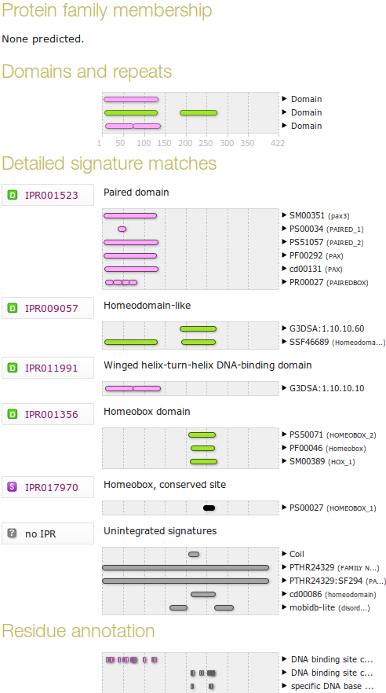
Paste the human PAX6 sequence into the patiently waiting box (from the file you made earlier called pax6_human.fasta). Accept the “do everything” default. Click on the Search button.
After several moments of deep thought, filtering and validating, you will be presented with a table of results looking very much like the one your saw earlier when looking around UniProtKB.
There is, however, one significant difference. In the Unintegrated signatures section, you will see that a coiled coil has been detected by the program Coils. This was not included in the UniProtKB information, maybe as Interpro has only recently included analysis using Coils? UniProtKB might catch up next time it is updated.
Do you think the Coil prediction might be correct?
Notice that Interpro assigns both the PAX domain and the Homeobox domain of human PAX6 to the Interpro family Homeodomain-like. Both of these associations are based on the hit behind the link SSF46689.
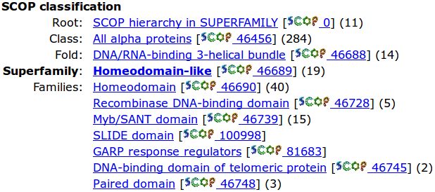
Follow this link and you will see it leads to the Homeodomain-like superfamily of thedatabase that specialises in very general (SCOP superfamily level) protein classifications. One Superfamily entry will typically correspond to a number of more specific domain definitions in other domain databases. Here you can see that the Superfamily domain Homeodomain-like includes both the Homeodomain & Paired domain Families.
Return to your Interpro results page. The Gene3D database is similar to superfamily but based on the CATH database. It suggests the two HTH motifs of the paired box are both Winged helix-turn-helix. The HTH in the Homeobox domain is not detected?
Why might you suppose Interpro predicts only 2 of the 3 helix-turn-helix domains that might be expected?

Follow the link to the Interpro family Homeodomain-like (IPR009057). Click on the button in the Domain relationships section to show the full list of Homeodomain-like Interpro domains.
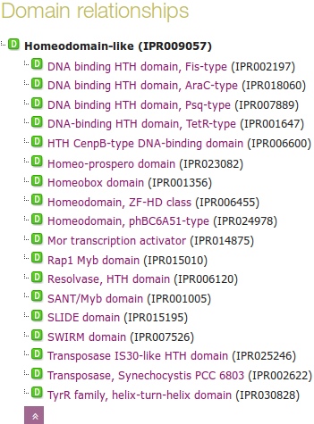
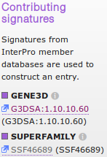
Note also the Contributing signatures in the top right hand corner of the page. Here is listed the domain databases that are searched to determine the presence of an Interpro Homeodomain-like domain.
Essentially, if Gene3D finds a match with its Homeodomain-like superfamily and/or Superfamily finds a match with its Homeodomain-like superfamily, then Interpro records a match with its Homeodomain-like domain (IPR009057).
None of the other domain databases Interpro searches are used to determine membership of IPR009057.
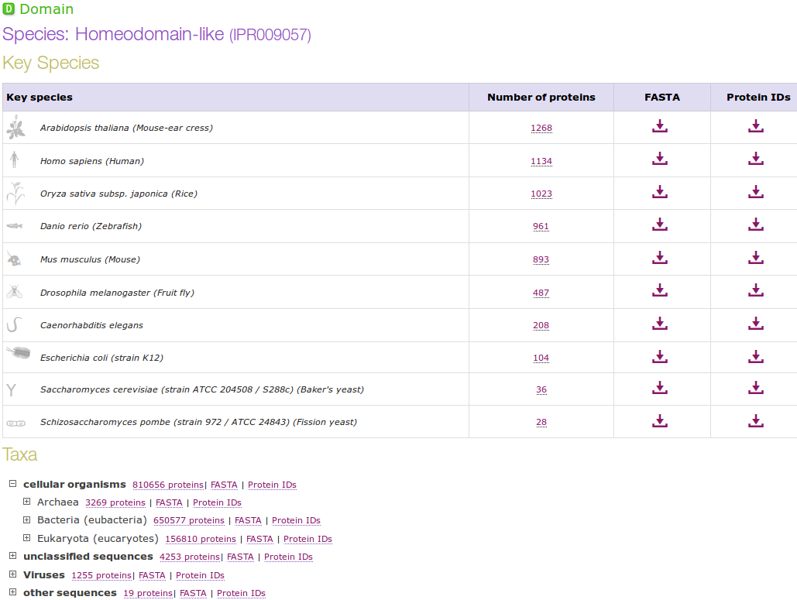
To obtain an impression of how widely spread throughout nature is this domain. Click on the Species button on the left hand side of the page.
As you can see, this is a very popular domain. You can make this list enormous by injudicious employment of the expansion buttons (the Number of protein links). Why not? It amused me for a few moments anyway.
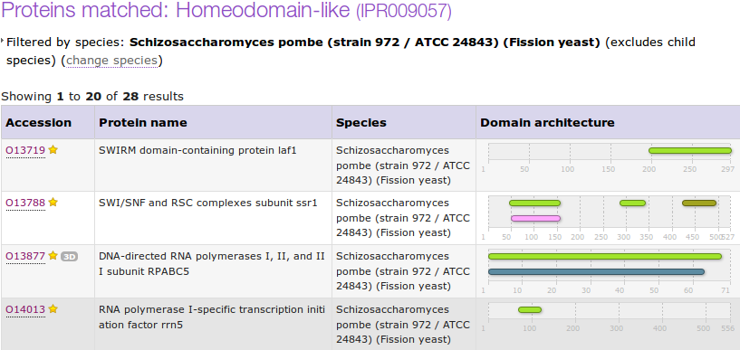
By clicking on the appropriate button, you can get to either the protein sequences in Fasta format or list their accessions codes. Try a few, but be careful! It really does get you ALL the sequences, and that is often quite a lot, which can take time.

THE END
DPJ – 2016.12.12

Model Answers to Questions in the Instructions Text.
Notes:
For the most part, these “Model Answers” just provide the reactions/solutions I hoped you would work out for yourselves. However, sometime I have tried to offer a bit more background and material for thought? Occasionally, I have rambled off into some rather self indulgent investigations that even I would not want to try and justify as pertinent to the objective of these exercises. I like to keep these meanders, as they help and entertain me, but I wish to warn you to only take regard of them if you are feeling particularly strong and have time to burn. Certainly not a good idea to indulge here during a time constrained course event!
Where things have got extreme, I am going to make two versions of the answer. One starting:
Summary:
Which has the answer with only a reasonably digestible volume of deep thought. Read this one.
The other will start:
Full Answer:
Beware of entering here! I do not hold back. Nothing complicated, but it will be long and full of pedantry.
This makes the Model answers section very big. BUT, it is not intended for printing or for reading serially, so I submit, being long and wordy does not matter. Feel free to disagree.

From your investigations using UniProtKB:
Describe the arrangement of Helices within PAX6.
From the evidence of the textual table and the graphic, there are nine helices in all, that occur in groups of three.
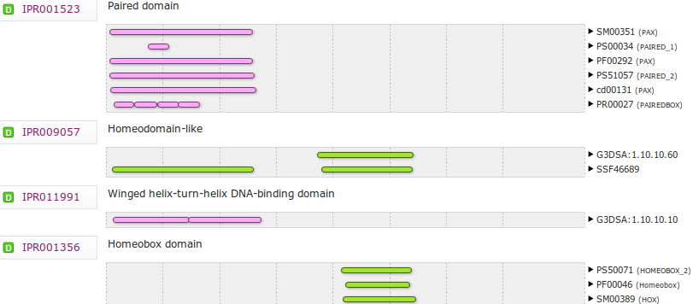
Aligning the graphical representation of the positions of these helices with the Interpro domain prediction graphics (discovered via UniProtKB earlier), it is clear that the first two of the helical triplets lie in the Paired domain and the third is in the Homeobox domain.
From your investigations using Entrez:
What were the features that you found?
Summary:
The first feature was the CoDing Sequence (CDS) for a PAX6 isoform.
The other three features were the coding sequences for three ELP4 isoforms.
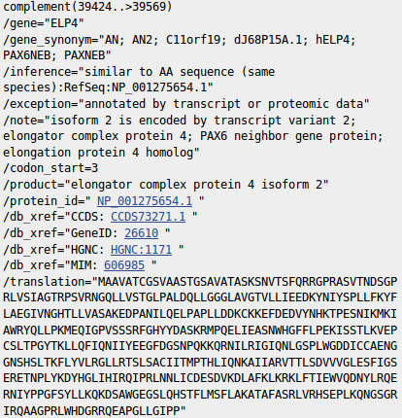
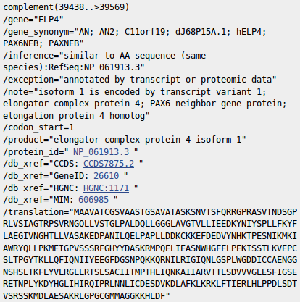
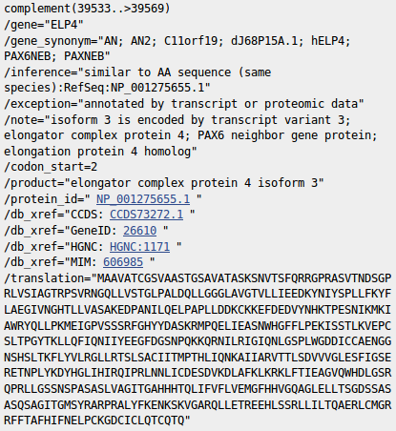

Full Answer:
Note that only the final coding exon of ELP4 is within this RefSeq sequence, which is defined as the genomic region for PAX6. This is clear from the length of the translations offered. The exon referenced is only long enough to code for just over 40 amino acids which is far short of any of the three isoform sequences offered here.
Note also that this final coding exon of ELP4 (stretching from 39424/39438/39533 to 39569 of this RefSeq entry) does not overlap the coding region of the PAX6 gene itself (stretching from 16551 to 33028 of this RefSeq entry).
In fact, the two entire genes do not overlap according to the evidence here. The entire PAX6 gene extends from 5001 to 38170. The portion of the ELP4 gene that is included in this entry extends from 40170 (the end) to 38437 (in the opposite direction). This give a gap between the two genes stretching from 38171 to 38436.
RefSeqGenes, comprise the entire gene plus 5,000 “extra” base pairs in either direction. The overlap here is entirely within the “extra” base pairs.
As you will see later, Ensembl will confirm the lack of overlap between these two genes graphically as well as their relative positions.
The annotation (specifically the gene_synonyms) of ELP4 associate this gene with PAX6. However, I believe only because of its proximity.
Why might you have expected more features than there were?
Summary:
All the evidence has suggested that PAX6 has at least 2 isoforms. This would lead me to expect at least 2 CDS features here related to PAX6?
Full Answer:
The explanation from the NCBI is that this sort of RefSeq entry is intended to be used as a template against which sequences from an individual can be mapped to seek variations. Only a token CDS feature is included to indicate the position of the gene. For such an entry, recording every isoform is not essential.
This sounded convincing to me, Until I began to wonder why there were three CDS features for ELP4 which is not even the gene primarily represented by this entry? Maybe I will ask more questions if and when I ever have the strength. In the meantime, mostly for my information, I record their exact explanation here.
“ ... note that RefSeqGene defines genomic sequences to be used as reference standards for well-characterized genes. These sequences serve as a stable foundation for reporting mutations, for numbering exons and introns, and for defining the coordinates of other variations. We normally select one RefSeq transcript to serve as a reference standard. The goal is not to record all introns and exons of all isoforms, but just to choose one representative to help define the locus. Therefore, most of our RSG records have only a single RefSeq as reference standard. If an LSDB manager or other stakeholder requests that other RefSeqs be added as alternate standards, this can easily be done (with the complication that, if a public LRG exists, the RefSeqGene record is fixed). We receive requests from stakeholders to include RefSeqs that represent all known exons, or RefSeqs that have become community standards. Often, after creating an RSG using our own internal criteria, we receive stakeholder requests to change or add transcripts. Many of these requests come from the LRG project regarding transcripts to be included on the LRG records.
Generally, RefSeq accessions can be added or removed without reversioning, unless a transcript is upgraded or a new one defined that extends beyond the bounds of the RSG, or matches a new build of the genome, in which case the RSG will be extended and reversioned as needed.
Regarding the chromosomal locus, our standard range is 5 kb upstream from the 5' end and 2 kb downstream from the 3' end of the mRNAs with the greatest extent. For this calculation, we do indeed use all available RefSeq (NM_) accessions. If the database manager or stakeholder has information on promoters or other upstream or downstream regulatory regions, we can certainly extend the RefSeqGene locus to accommodate these.
Regarding mismatches, the goal is to exactly match the current build of the genome, unless there is overwhelming transcript and EST evidence that a mismatch should be retained.
Regarding the confusing subject of exon numbering, exon numbers are currently provided only on RSG genomic records based on a subset of available transcript RefSeqs for the gene. These are often those selected by locus-specific databases as reference sequence reporting standards. You can find an explanation of how exons are numbered here:
http://www.ncbi.nlm.nih.gov/refseq/rsg/faq/#exon
You will find links to more information on RefSeqGenes on the home page for the RefSeqGene project:
http://www.ncbi.nlm.nih.gov/refseq/rsg/
Regarding the PAX6 RSG sequence, only difference I see between NG_008679.1 and the current build of the genome (GRCh38) is an extra 'G' beyond the 3'-UTR of the PAX6 transcripts (at NC_000011.10:g.31,819,125). ... “
Yes, well I think I followed most of that? and that my interpretation is broadly correct? In summary, there are no fixed rules.
How does the alignment you generated match up with the annotation of the original RefSeq entry you discovered?
Summary:

The most intuitive way of encapsulating graphically the way these two sequencing clones overlap was donated by Cecilia Pinto (Oeiras, 2013.12.09-12). Much better than my rambling attempts, that I keep for sentimental reasons in the “Full Answer”. Thank you Cecilia.

Full Answer:
Do not spend to much time working this one out, the picture above should be more than sufficient. I just needed to see it all balanced ... then I can sleep soundly?
If you do want to read on, I strongly suggest you look at the picture contributed by Cecilia (now promoted to the “Summary Answer”) first. So simple! I have to admit I cannot follow my own wonderful table at all now ... at least, not without bleeding! Although, it did feel good at the time?

So …

The Query sequence is Z95332 (Length 20,874)
The Subject sequence is Z83307 (Length 22,253)

NG_008679  Range Start | NG_008679  Range End | NG_008679  Range | Z95332  Range Start | Z95332  Range Start | Z95332  Range | Z83307  Range Start | Z83307  Range End | Z83307  Range
- | - | - | 1 | 2022 | 2022 | - | - | -
1 | 18748 | 18748 | 2023 | 20770 | 18748 | - | - | -
18749 | 18852 | 104 | 20771 | 20874 (end) | 104 | 1 | 104 | 104
18853 | 40170 (end) | 21319 | - | - | - | 105 | 21422 | 21318
- | - | - | - | - | - | 21423 | 22253 (end) | 831
 |  | 40171 |  |  | 20874 |  |  | 22253

Legend: Not used in construction of RefSeq entry NG_008679
Non-overlapping GenBank entry used in construction of RefSeq entry NG_008679
Overlapping GenBank entry used in construction of RefSeq entry NG_008679
Total entry lengths
The RefSeq entry was thus constructed by overlapping the two Genbank entries and then manually trimming away the edges to form a biologically meaning region. If I was a bit brighter, I think I might have come to that conclusion without the fuss above? Oh well, one has to use what one has.
I refer you again to the far more intuitive way of encapsulating the same message graphically, donated by Cecilia Pinto that is now the “Summary Answer” above. Much better! Thank you once more Cecilia.

From your investigations using Ensembl:
Using the evidence of the protein alignments, which PAX6 isoforms do the fruitfly orthologues most resemble?
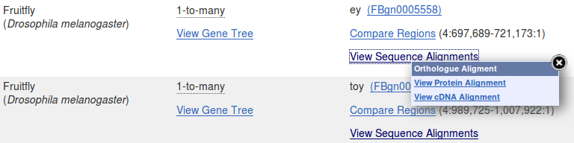
The protein used to represent PAX6 human is consistently ENSP00000404100. This can most easily be confirmed by displaying the Protein Alignments for each of the 2 Fruitfly orthologues in turn. This is the protein sequence of isoform 5a, probably chosen as it is the longer option (436 amino acids as opposed to 422) and so (from the crude informatics viewpoint) represents more information.
There are two Fruitfly orthologues recorded here, with the gene names ey and toy. Looking at the first few lines of the protein alignments for these genes, it is clear that that 14 amino acid insert that defines isoform 5a (THADAKVQVLDNQN) is not present in either. It is therefore reasonable to conclude that the representative fly proteins are both closest to the canonical protein sequence of PAX6 human (isoform 1).
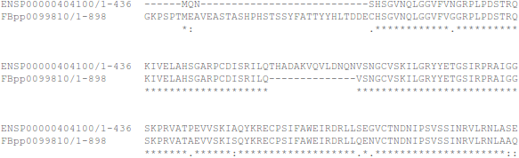
Protein alignment for ey

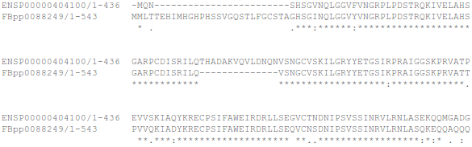
Protein alignment for toy

Well, maybe also it is not that simple? I would not be surprised If there were isoforms for ey and/or toy that were roughly equivalent to human isoform 5a. The alignment displayed could well reflect the relatively arbitrary choice of Ensembl as to which isoform it decides to use for the alignments, rather than any deep and meaningful biological truth. Already you can see that Ensembl prefers the (presumably) less important human isoform, merely because it is longer (more letters to match). Again, useful though these displays are, caution is required before reading too much “biology” into them.
Ensembl does not pick up all fruitfly homologues of PAX6? Again, I wonder why. Mind you, Ensembl does only claim “Selected orthologues”? Still prd, in particular, is a pretty important one to pass over!

What are the first two bases and what are the last two bases of nearly every intron?

As you are probably well aware, introns are highly conserved at each end. They typically begin with GT and end with AG. This rule is obeyed by all but one of the introns of this transcript (intron 3-4 starts GC rather than GT).
As the cartoon suggests, the conservation does not apply just to the first and last two bases, but that is where the conservation is most strict. So strict that when exceptions from this rule were sought in the databases, it was thought most of the deviations were due to annotation error!
The cartoon also suggests that introns have C/T rich regions towards their ends (the Polypyrimidine tract). This too is clearly evident in most of the introns of this transcript, even though only small parts of the introns are displayed.
How long is the sixth exon and why would this concur with your expectations?
It is 42 base pairs long, so it codes for 14 amino acids. Specifically, it codes for the 14 extra amino acids that define isoform 5a.
Explain the Start Phase and End Phase columns?
An exon/intron boundary can occur anywhere in a codon. The Start and End Phases record how an intron has been inserted into a coding region with respect to the coding reading frame.
If an exon ends at the end of a codon, then its End Phase is 0.
Clearly, the next exon must begin at the start of a codon. Its Start Phase is also 0.
If an exon ends after the first base of a codon, then its End Phase is 1.
Clearly, the next exon must begin after the first base of a codon. Its End Phase is also 1.
If an exon ends after the second base of a codon, then its End Phase is 2.
Clearly, the next exon must begin after the second base of a codon. Its End Phase is also 2.
I attempt a picture, though I am sure that is clear? I just like pictures, and lots of colours.
S A I L Q ← intron → T H A D A K V Q V L ← intron → V S N ...
...TCCCGAATTCTGCAG← intron →ACCCATGCAGATGCAAAAGTCCAAGTGCTG← intron →GTGTCCAAC...
End Phase 0← intron →Start Phase 0 End Phase 0← intron →Start Phase 0
S A I L ← intron →Q T H A D A K V Q V L← intron → V S N ...
...TCCCGAATTCTGC← intron →AGACCCATGCAGATGCAAAAGTCCAAGTGCT← intron →GGTGTCCAAC...
End Phase 1← intron →Start Phase 1 End Phase 2← intron →Start Phase 2

Why does Prints appear to predict four Paired_domains?
Prints does not find the Homeobox_domain at all. If you were to investigate by using the Prints search carefully, you will find it nearly does, but the evidence is not quite strong enough. As has been discussed, none of these systems are perfect. They all occasionally fail. That is why it is always best to use Interpro to consult them all and deliver a consensus answer.
Prints appears to find FOUR Paired_domains. This is only because of the way Prints works. Prints finds FOUR signatures (or motifs) that together indicate ONE Paired domain. Prints searches for ordered series of motifs that together indicate domains. Here it reports each of four motifs separately, but it is only claiming one Paired domain.
Which domain, Paired domain or Homeobox domain is more common in humans?
How many human PAX genes are there?
As you will have expected, there are but 9 Paired domains in the Human genome. There are many more Homeobox domains.
Are all the PAX genes on Chromosome 11?
Of course not? What a stupid question!
Well, I suppose they could all be on Chromosome 11? By chance … or maybe design … who knows, the lack of predictable pattern in all this business never ceases to astound me.
But, philosophy aside, the answer is NO.
Can you explain the strangely frayed ends displayed in some of the representations of the 2cue 3D structure?
2cue is a 3D structure determined by Nuclear Magnetic Resonance (NMR).This is a process that does not involve immobilizing the target as a crystal (as is the case with structures determined by X-ray crystallography). Parts of the protein will still be moving around whilst its structure is being determined.
I think of NMR as analogous to taking a long exposure photograph of a group of children. Each child will appear in many different places! The frayed ends represent various positions in which the ends of the homeobox were detected during the NMR process.
In some views, including the one you were offered to move around, all the possible positions are averaged out before the structure is stored. I prefer the fuzzy view ... much more fun.
I broadly believe that which I have just typed, however, I must stress that my understanding of NMR is tragically incomplete. If anyone would like to offer a better explanation, I am very willing to hear it.
From your investigations of Domain & Motif identification using Interpro
Do you think it a good idea for Interpro to offer feature prediction programs as well as domain database searches?
Well … why not? The purpose of InterProScan is to associate regions of query proteins with Interpro domains. This was originally achieved, exclusively, by simply comparing a query sequence with all entries of relevant individual domain databases. These entries being representations of alignments of examples of specific domains constructed by homology searching (i.e. blast and similar).
I would suggest including a few predictor programs would provide extra evidence gathered from more general, more theoretical definitions of domains. I would imagine the inclusion of these programs has improved and widened the picture provided by InterProScan.
Searching domain databases, typically composed of HMM profiles, such as Pfam, Prosite and PRINTS is quite different to running the predictor programs. As I cannot improve on the justification of this claim offered to me by Geoff Barton (Head of the group responsible for Jalview, Jpred, Jnet and much more), I will just reproduce his explanation here:
“ … The main difference is that with an HMM profile you have a "specific" example of a domain or motif whereas with something like COILS, you have something trained across all examples.
For example, for secondary structure prediction, you could (a) do predictions of alpha-helix and beta-strand just by aligning a sequence to a protein of known structure, or an HMM from a family of aligned proteins of known structure. This is a specific case of secondary structure in the context of one protein family. Or (b) you can train a predictor from ALL protein families and then apply this. The advantage of (a) is it is very specific to the individual protein family and so should be more accurate for that family. The disadvantage is that it does not generalise to proteins that are not very like the specific example. The advantage of (b) is that it will work with any protein but will likely be less accurate than (a) for proteins that fit into the (a) category. … “

Do you think the Coil prediction might be correct?
I do not recall anything in what we have discovered thus far that would directly suggest there should be a coiled coil here, in the middle of the HTH. However, wikipedia does suggest coiled coils are associated with transcription factors (which pax6_human is).
" ... Many coiled coil-type proteins are involved in important biological functions such as the regulation of gene expression, e.g. transcription factors. ... "
I think I would not be overly convinced by this prediction, but I would not make that judgement with any great confidence. The all knowing wikipedia says:
“ … Coiled coils usually contain a repeated pattern, hxxhcxc, of hydrophobic (h) and charged (c) amino-acid residues, referred to as a heptad repeat. … “
Geoff Barton comments:
“ … Sometimes the pattern that is particular to coiled-coils also turns up in other helices that pack against each other. You would need to look at some examples of coiled-coil structures to see if the example you are using fits structurally. … “
Which seems very reasonable. The heptad repeat pattern could easily occur just by chance. COILS surely cannot predict the structure of the helices well enough to make an assured judgement? COILS offers a suggestion the user must follow up with other resources.
There is also the evidence that Jpred (a system for secondary structure prediction), possibly using the COILS program disguised as LUPAS, does not detect any coiled coils. This could be for a number of reasons. Possibly LUPAS is not the same program as COILS, or it is a different version, or Jpred runs COILS, but with different parameters.
Not many clear and confident answers in Bioinformatics are there!
Why might you suppose Interpro predicts only 2 of the 3 helix-turn-helix domains that might be expected?
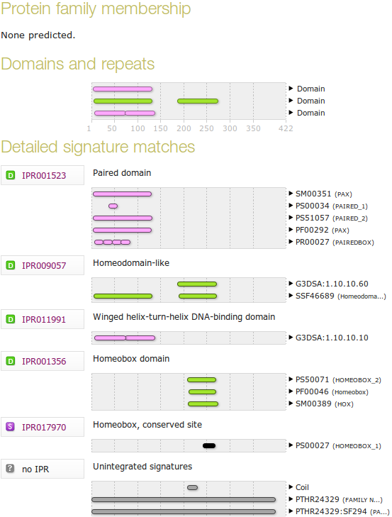
2 Winged helix-turn-helix (wHTH) DNA-binding domains are predicted coincident with the helical triplets of the Paired domain. This should broadly match your expectations.
No helix-turn-helix (HTH) domain is detected coincident with the Homeobox domain, where one might also have been expected?
I am not entirely certain why this might be, so I speculate.
Pfam attempts to classify a variety of types of HTH, and offers a range of HTH domain models (HTH_17, HTH_38, HTH_39 and HTH_40 to name but a few) and a number of wHTH domain models (including HTH_33 and HTH_24).
Interpro also has a considerable number of HTH entries (IPR017895, IPR032877, IPR007394, IPR013197 and more) and wHTH entries (IPR005104, IPR023120 to name but 2).
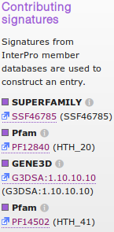
Interpro does use Pfam models to detect its various flavours of HTH/wHTH domain, but it does so selectively. For example, to detect the wHTH domains discovered here, only two Pfam families were used HTH_20 and HTH_41, see illustration). These appear not to have matched in this instant as only a G3DSA entry is quoted.
All the above suggests that no one model exists to pick up all HTH domains? Possibly also, the fact that HTH domains come in such a variety of forms makes them difficult to detect reliably?
There is a simple EMBOSS program to detect HTHs. It easily detected the Homeobox domain HTH but essentially failed to detect the wHTHs recorded here. This must be because the, very simple, model (based on a Weight Matrix built from about 100 examples) used by the program only reliably applies to a specific range of HTH domains/motifs that includes the one in the Homeobox domain of the human PAX6 protein?
I am very open to better explanations. I am not completely convinced by the discussion above.

DPJ – 2016.12.12

The annotation is very sparse which makes these entries very hard to find directly. The EML-Bank versions include some links to Ensembl codes. These would have been helpful but are not part of the official International Nucleotide Sequence Database Collaboration (INSDC) annotation that should be consistent between GenBank, European Nucleotide Archive (ENA), which includes EML-Bank, and DNA Data Bank of Japan (DDBJ).
As opposed to comparing each of the two clones against an entire sequence database.
Just because its neater. In my, significantly less then humble, opinion anyway.
If, like me, you have conceptual problems with major and minor groves. Try this animated picture. Helped me at least. As did the image above.
Third from the bottom of the first page, last time I counted.
PDB is the main database for 3D protein structures. SCOP and CATH are also 3D structure related databases.
If you really wanted to, the best approach is to search for P26367 in the search box at the top of the page and then look for the Homeobox domain entry in the Detailed signature matches list.
Not surprising as UniProtKB simply links to Interpro to show you its graphic.
Structural Classification Of Proteins.
CATH is similar to SCOP in that it is another Structural classification database.
The features here only represent the CDS regions of the genes. I wonder why not the entire transcript length?

