

ELB199F
Entry Level Bioinformatics
04-08 February 2019

(First 2019 run of this Course)

Basic Bioinformatics Sessions

Practical 1: Databases and Tools

Wednesday 30 January 2019
Investigating the gene(s) associated with Aniridia
As a starting point for this exercise, imagine you have a vital interest in discovering and investigating the main human gene responsible for the terrible disease of the eye, Aniridia. There are many ways (including google!) you could discover what this gene might be. I choose to delve into the vast seas of knowledge so generously proffered by the The National Center for Biotechnology Information (NCBI).
So, begin by going to the Home Page of the The National Center for Biotechnology Information (NCBI) (“http://www.ncbi.nlm.nih.gov/”).
You will arrive at a page offering access to the many NCBI resources available to you. Currently, you only require to search for genes, specifically those that relate to Aniridia, so first set the database selection field of the Search facility at the top of your page to Gene, set the Search field to Aniridia and click on the Search button.
A fine list of genes will emerge, including those sought. However, our interest is specific to Human, so the search should really be organism specific. To do this, one needs to execute an Advanced search. So, click on the Advanced button of the Search tool.
Now you can specify the precise field(s) of the annotation you wish to interrogate. In this case, set the Disease/Phenotype field to Aniridia and the Organism field to Human. As the two conditions are linked by AND, both must be true for any gene to be listed.
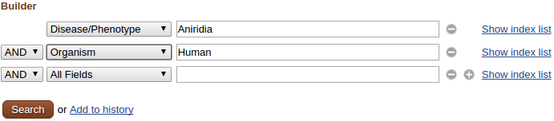

Click on the pretty redbutton.
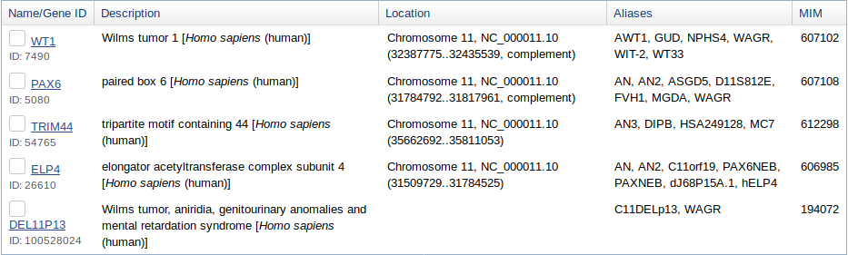
Just a few genes survive. All should really be examined, but this is just an exercise, so trust me … it is PAX6 that is the most interesting gene, in this context. This is the one to follow up by clicking on the link to its details.
From the Summary section one can conclude (sticking to the features that pertain to this exercise) that:
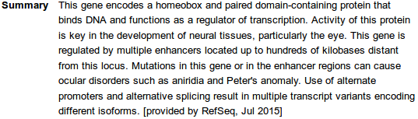
- there are two major domains, a paired domain and a homeobox, both of which bind DNA
- the gene regulates transcription (is a transcription factor)
- there is more than one protein isoform, and thus more than one transcript variant.
From the Genomic context section it can be seen that:
- PAX6 is situated on Chromosome 11, band p13
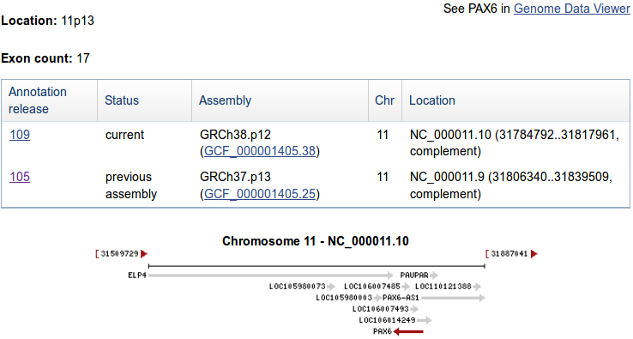
- PAX6 is on the complementary strand relative to that chosen to represent Chromosome 11
- ELP4 (another human gene listed as associated with Aniridia) is very close, on the opposite strand to PAX6. This might be worthy of a mention, at a later time?
- There are 17 exons for PAX6. Jolly good, but I really wanted to know how many transcripts there were according to the NCBI? That is, how many different ways it is thought that nature spliced the 17 exons together. I would also like to discover how many distinct isoforms the NCBI imagines to result from however many transcripts. I proceed with impatience!
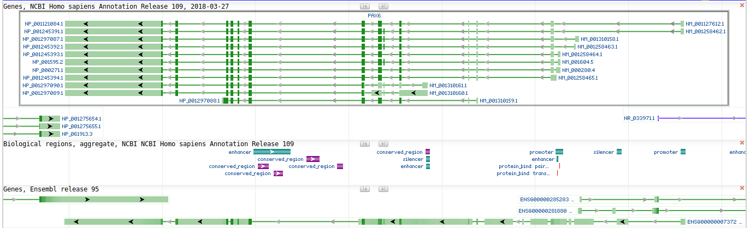
Click the Genome Data Viewer link. The PAX6 genomic region, as interpreted by the NCBI Genome Database, is displayed for your delectation.
So, if I tell you the region displayed is the entire PAX6 region of Chromosome 11 and the green lines labelled on the right as something beginning with NM_ represent the different transcripts, can you now say how many transcripts there are according to this view? In passing, the blobs along each line represent the exons. Dark blobs are coding exons. Light blobs represent the exons that form the 3'/5' UTR regions of each transcript. The Introns are the pale green lines joining the blobs together.
The prediction of the transcripts shown here are based on database searches of all Human mRNA sequences stored in RefSeq against this region of the genome. The theory is that every Human mRNA sequence must match (nearly) perfectly somewhere in the human genome. Where it matches, there must be the genomic DNA from which the mRNA was transcribed. How charmingly true and simple!
To differentiate between coding and non-coding exons of a transcript, why not compare all human proteins with the genome (after suitable translation to amino acid codes in all six reading frames). They too must match near perfectly somewhere, identifying the CoDing Sequence (CDS) of each transcript. Transcript fully located. Job done! Of course, it does not always work so very neatly, but we need not admit that for the moment at least.
Comparing proteins with the genome is clumsy, compute intensive, slow. For major organisms (currently just Human and Mouse), specially compiled comprehensive databases of extremely reliable DNA Coding Sequences have been constructed. Searching with these databases enables much more efficient searching for coding exons and so is very much preferred.
OK, times up, the correct number of PAX6 transcripts, according to the evidence you are offered here is 11, of course! A conclusion you came to by counting the transcript prediction lines in the display. Jolly good! But it should be noted that the transcript count (and much else) depends on many transient circumstances, including particularly the versions of the databases used to build the views.
Quite recently indeed, RefSeq included 9 extra PAX6 mRNA sequences of less certainty than the ones you see represented above. As more evidence was gathered, the credibility of these “extra” mRNA sequences was proved insufficient and they were removed. However, while they existed, they increased the transcript count to 20!
This exposes that many of the “facts” presented by these services are but “predictions“ that will vary as more/better data become available. Pretty good predictions, but nevertheless, predictions!
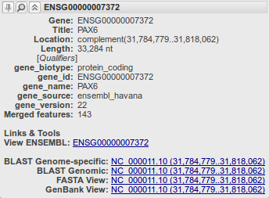
As will be emphasised throughout these exercises, databases in general contain entries (often simply predictions) of varying certainty. That being so, the user must be able to ascertain the relative quality of a given data item. In the case of mRNA sequences in RefSeq, the entry Accession Codes (unique data entry labels) indicate the quality of the evidence for the mRNA predictions. Accession Codes which begin with XM_ indicate mRNA sequence predictions of less certainty than those that begin NM_. Typically, the less certain entries (XM_ entries) have been identified by computer programs alone. The NM_ entries, normally, will have been properly investigated by human experimenters/investigators.
It gets worse! Other factors interfere with any hope of simple answers to seemingly trivial inquiries such as “how many transcripts are there?”. One such factor being where the question is asked.
Move back to the page describing the PAX6 gene. In the familiar graphic at the top of the Genome regions, transcripts and products section you will find routes to corresponding information from the Ensembl Genome Database. Hover over the PAX6 (also known as ESNG00000007372, by Ensembl and close friends) green line in the bottom half of the picture. You will be rewarded by cheery grey box full of links to Ensembl and other exciting places.
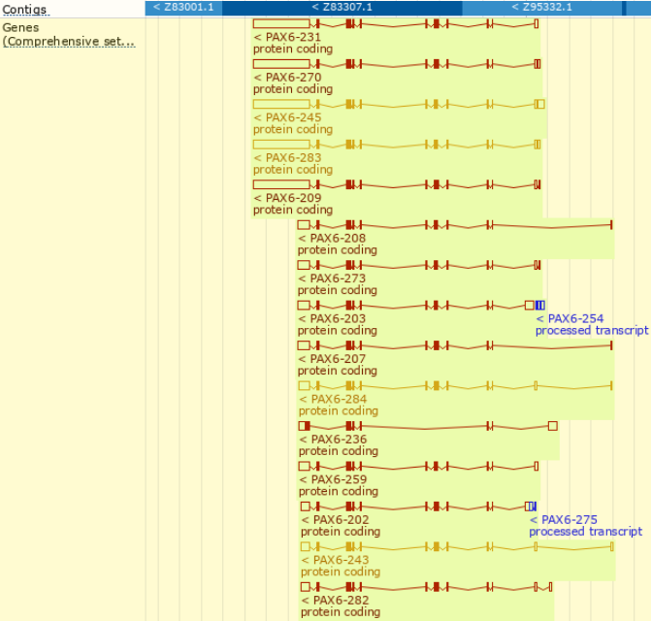
Use the link labelled View ENSEMBL:. A view of the region of Chromosome 11 similar to those you have already considered will leap forth. As before, the exons for each transcript are represented by blobs (filled for coding, empty for UTR regions). Introns are represented by wiggly lines joining the blobs. Notice first that there are considerably more than 11 transcripts represented here! At the top of the page, in tiny letters it claims 84! (a massive increase even from the 31 transcripts predicted by a recent previous version of Ensembl!).
You could check this assertion by counting all the transcripts represented in the graphic, but I would not recommend doing so. Sometimes it is best just to believe. There are indeed 84.
The colour scheme used for the transcripts we might discuss in overview later. For now, just know that the gold transcripts are supported by better evidence than the red ones.
Once more a database that offers data items (“predictions”) of varying credibility.
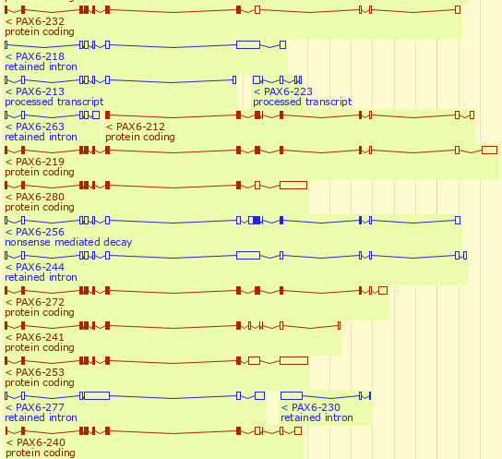
Looking a little further down the transcripts displays, you will see that an increasing proportion of the transcripts are not protein coding (the blue ones). The display you examined at the NCBI only represented protein coding transcripts. This partially explains why Ensembl appears finds so many more transcripts that its broad alternatives.
So a further reason for not finding a consistent answer to the simple question “How many transcripts are there for the PAX6 gene” is variation in the definition of a transcript.
Also, and more importantly, Ensembl and the NCBI Genome Database use different strategies to predict transcripts (and nearly everything else!). Both use database searches broadly in the manner described above and (for the human genome at least) the same basic assemblies of the genome and sequence databases. It is primarily the interpretation of the data and analytical results that varies.
The database searches used as the fundamental strategy to identify transcripts take a very long time to execute, even given the immense computing resources available to the NCBI and the Ensembl teams. Some clever strategies are employed to minimise the time spent on these searches. It would be good to consider these, specifically with respect to their implementation by Ensembl, at least superficially.
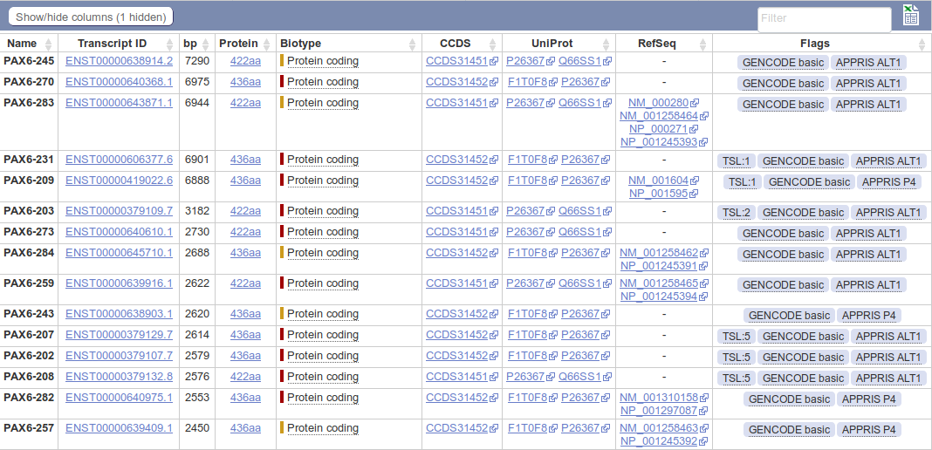
For a more detailed view of the predicted transcripts, click on the link. The transcript predictions are now presented in the form of a table. The protein coding transcripts are all at the top of the table. I counted 56, but I would not claim to be completely accurate, I wavered half way down the list! Lots more than the NCBI anyway.
Ensembl uses both the sequences of RefSeq mRNAs and those of their protein products (the RefSeq entries whose Accession Codes commence NP_) to predict transcripts, however, Ensembl appears to have less blind faith in the accuracy of these data than the NCBI.
Note: There is no “one to one” correspondence between RefSeq mRNAs and transcript predictions. All 11 RefSeq mRNAs are referenced, but two are used to support the single third transcript in the list. If Ensembl regarded RefSeq mRNAs as “perfect” (as the NCBI appears to do) this would clearly be nonsense! We should discuss why it is reasonable not to not to accept the infallibility of a RefSeq mRNA matches with the Genome.
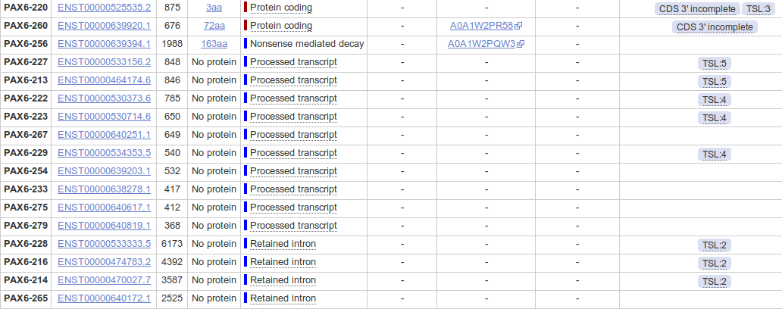
Looking further down the list you will see that many Ensembl protein coding transcripts are predicted without reference to any RefSeq entry.
Hover over the evidence Flags associated with the transcript predictions towards the end of the list. How reliable would you judge these predictions to be?
We could go on. Other sources (not necessarily Genome Databases) would count the transcripts differently again. Perhaps the best answer to the question “How many transcripts are there for the PAX6 gene” is “Several”.
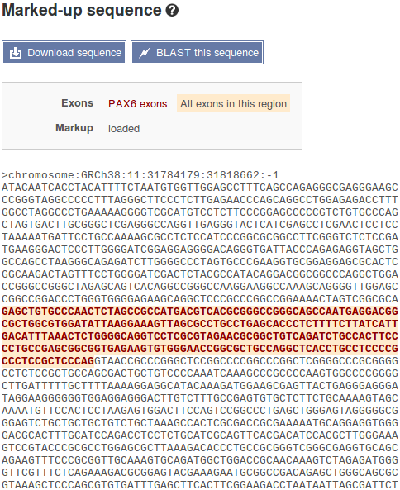

Before leaving Ensembl, it would be good to save the genomic sequence of this region for analysis later on.

To do this, first click on the Sequence link on the left hand side of the page. Under the transcript table the sequence of the PAX6 region of the genome will be displayed. The exons will be tastefully highlighted for you delectation. The display includes 600 base pairs of Flanking Sequence (3' and 5') which are included (by default) when the sequence is downloaded
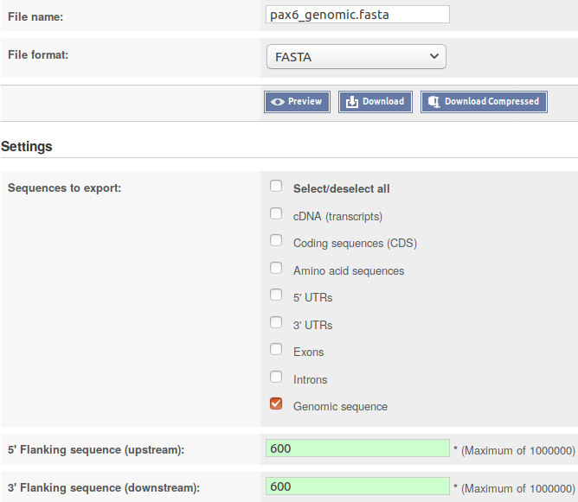
Now chose to. The Download sequence form will burst into view.
Set the File name: to pax6_genomic.fasta
Set the File format: to FASTA
Accept the default 600 base pairs for both the 5’Flanking sequence (upstream): and the 3´ Flanking sequence (downstream):.
Finally, click on the button and do whatever it takes to move the file you create to somewhere sensible on your Desktop.
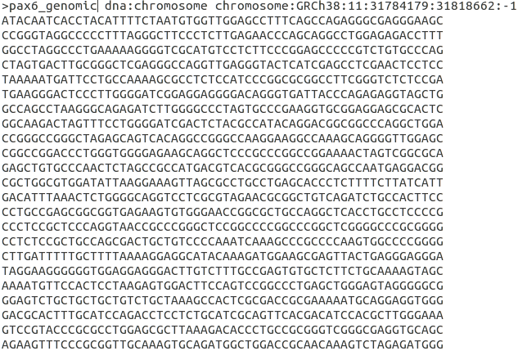

Using whatever text editor is most convenient, edit your file to change the first word of the first line of the file to contain information, from 11 to pax6_genomic. This first word is defined as the sequence identifier in FASTA format (as, I hope, will be explained at some point). pax6_genomic is a far more informative identification than 11 (simply the Chromosome number).

The next investigation might be to discover “How many protein isoforms might there be for PAX6?”.
Well, whilst the Ensembl transcript list is still in view, glance down the Protein column which displays the size of the protein products for each transcript. Clearly insufficient evidence for a serious isoform count, but enough to set a lower limit, as the same isoform cannot be more than one length! If there were not so very many! One might count how many different lengths of proteins were listed. I tried to do this, but I gave up around twenty-something. Let us be content to declare that there are lots. The most likely looking ones are either 422 or 436 amino acids long. Some of the others might cause a raised eyebrow or two, especially the one that is 3 amino acids long (third from last Protein coding entry in the list)? But, who are we to question! Lots is the informal Ensembl minimum total.
Click your way back to the NCBI PAX6 gene entry. So, now to discover the number of protein products (isoforms) that the NCBI predicts. This view makes this simple question clumsy to answer as the protein products of each transcript are reported separately (as they are by Ensembl), even when they are identical???
However, it can be done. Click on the NCBI Reference Sequences (RefSeq) link in the Table of contents on the right hand side of the page. Focus on the mRNA and Protein(s) sub-section. Skim down the entries for every transcript. Check the different isoform names. I see:
01 - NM_000280.4 → NP_000271.1 paired box protein Pax-6 isoform a
02 - NM_001127612.1 → NP_001121084.1 paired box protein Pax-6 isoform a
03 - NM_001258462.1 → NP_001245391.1 paired box protein Pax-6 isoform b
04 - NM_001258463.1 → NP_001245392.1 paired box protein Pax-6 isoform b
05 - NM_001258464.1 → NP_001245393.1 paired box protein Pax-6 isoform a
06 - NM_001258465.1 → NP_001245394.1 paired box protein Pax-6 isoform a
07 - NM_001310158.1 → NP_001297087.1 paired box protein Pax-6 isoform b
08 - NM_001310159.1 → NP_001297088.1 paired box protein Pax-6 isoform c
09 - NM_001310160.1 → NP_001297089.1 paired box protein Pax-6 isoform d
10 - NM_001310161.1 → NP_001297090.1 paired box protein Pax-6 isoform d
11 - NM_001604.5 → NP_001595.2 paired box protein Pax-6 isoform b
I count 4 different isoforms, imaginatively named Isoform a, Isoform b, Isoform c and Isoform d. One associated with each transcript description. Look carefully at the annotations and there is more information. In particular:
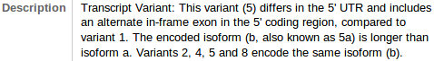
Description: Isoform b is also known as Isoform 5a. Why this is interesting will become apparent in a page or so.
Isoform b is also reported to be longer than Isoform a.
Conserved Domains:

Both Isoform a and Isoform b are recorded as having two domains. A Paired Box Domain at the beginning, and a Homoebox Domain further along.

Both Paired Box Domains are primarily indicated by a hit with the relevant entry in the SMART database. Both Homeobox Domains are supported by matches with Pfam database entries. Other domain databases will almost certainly provide supporting evidence, but reference to just one match is sufficient here.
From the location information, the Paired Box of Isoform b appears to include an extra 14 amino acids.
UniprotKB offers yet another version of this story. Just for a for a few clicks, let us intrude into the UniProtKB section of your course.
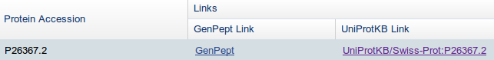
At the very bottom of the current page, you will find a link to UniprotKB. Use it.
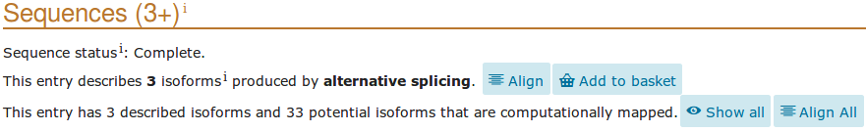
Lo! the PAX6 human protein as seen and understood by UniProtKB. Click on thebutton on the left hand side of the page. UniProtKB declares 3 isoforms! At least, 3 that it is willing to admit to with certainty. Also mentioned are a further 33 that are suggested as possible by computer analysis.
There is isoform 1, also known as isoform a in America. Note that this is the “canonical sequence” for this protein. That is, this is the isoform used to represent this protein in UniProtKB. The sequence(s) of all other isoform(s) are recorded as elements of the annotation.
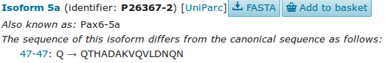
Also we have Isoform 5a (or PAX6-5a), also known as isoform b in America (where it also answers to Isoform 5a when pressed). Note that the entry declares the sequence difference to be:
47-47: Q → QTHADAKVQVLDNQN
Literally:
“The amino acid at position 47 is a Q in the canonical sequence. In isoform 5a this is replaced by the 15 amino acids QTHADAKVQVLDNQN”.
More coherently this amounts to:
“isoform 5a differs from the canonical isoform 1 in that it has an insertion of 14 amino acids after the 47th amino acid (a Q) of the canonical protein”.
It is significant to note that position 47 is right in the middle of the Paired Box Domain that occurs in both isoforms. This confirms that which was noticed at the NCBI.
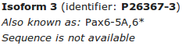
Finally UniProtKB proudly presents the somewhat ephemeral isoform 3 (or PAX6-5A,6* for those who enjoy formality). But, this one has no known sequence? Not much that Bioinformatics can offer here methinks.
So I hope you will agree that the UniProtKB confident isoform count stands at a very modest 2, plus a ghost.
To visualise the differences between the 2 isoforms with sequence, click on thebutton for the 3 described isoforms, at the top of the Sequences section. After deep thought and much fumbling, UniProtKB will multiply align all the selected isoform sequences for you. As there are only 2 in this case, this will appear very similar to a Pairwise alignment. Highlight the DNA binding regions and the Domains.
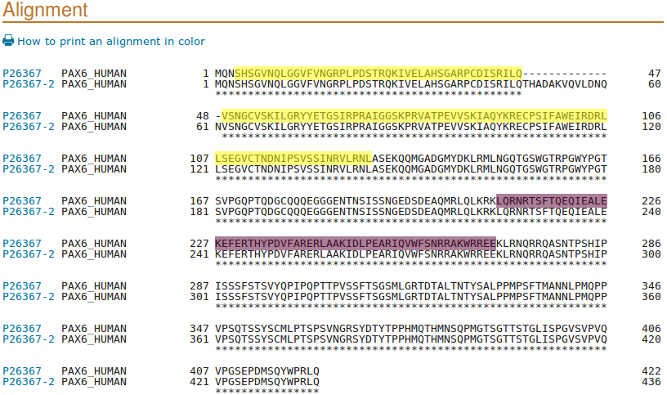
I leave the interpretation of this splendid display to you, and later short discussion if required.
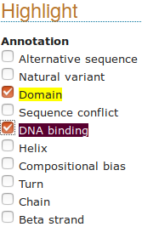
The extra 14 amino acids of isoform 5a are due to the inclusion of a tiny extra (42 base pair) exon in some transcripts.
Can you see the evidence for this assertion in the regional genomic maps of a few pages back?
We need to save a some protein sequences for future analysis. This is easiest from UniProtKB so now is good. To declare your intention to save the entire canonical version of the PAX6 protein to a file, move back from your alignment. Move to the top of the page where you will find the bizarre invitation to? Just do it.
You also need to download the sequences of both domains is separate files, via your basket. First the Paired Box. Click thebutton on the left of the page. Then use thebutton adjacent to the Paired entry. Its now in your basket you will be ecstatic to know.

As they are so conveniently in view, take note of the Compositional bias features. They will be of interest when we look at database searching.

Then take an excursion to glance at thesection. Note the many Natural variants recorded as responsible for AN (ANiridia, that is). Particularly those around amino acid positions 29 to 44 and specifically that at position 33.
Looking at PCR Primer Design later, you will be attempting to create a PCR products from patients that, when sequenced, will determine the presence or absence of this variant.
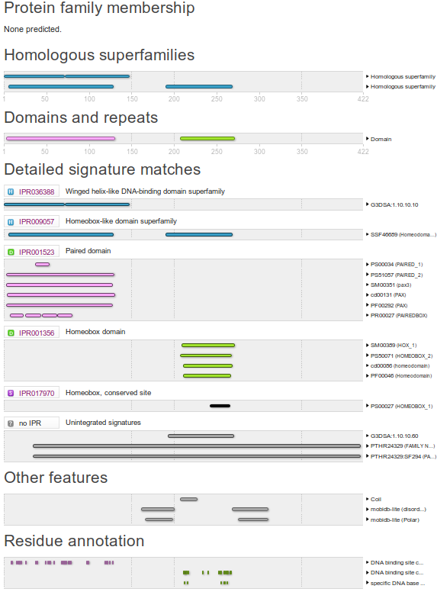
Next, skip nimbly to the section. Concentrate on the Family and domain databases sub-section. Here are displayed the results of comparing the PAX6 protein with many of the available Domain/Motif Databases, including those of the Interpro Consortium, collectively.
Are the results broadly as you might expect?
For an effective graphic summary, link tofor the Interpro graphical results. If the detail is not entirely transparent, this result will be discussed further when you generate it for yourselves using Interpro.

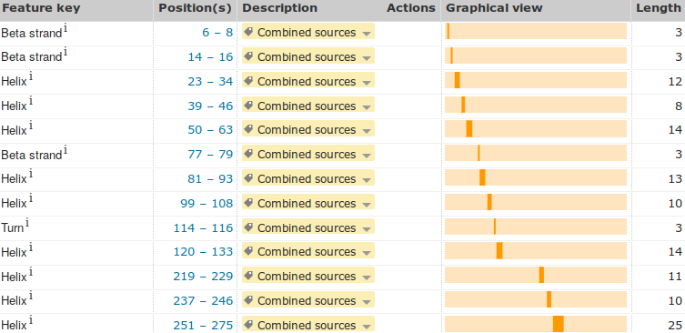
The results you are looking at are computed, largely automatically, by the UniProtKB/Interpro annotation system. However, running many of the same analyses manually is trivial. Maybe you will do some in the course of these exercises?
Finally, return to the UniProtKB PAX6 page and move to the section.
Click on the Show more details button.
Describe the arrangement of Helices within PAX6.
Back to saving sequences for later! To get to the Homeobox domain, you need to click on thebutton on the left hand side of the page.
A valid question at this point might be “Why is the Homeobox domain a Function (specifically a DNA binding feature), but the Paired domain is a Domain feature?” To which the answer is “History, dear boy, history” to paraphrase a disputed quote of dear Harold (Macmillan that is).
In fact, both are Domains, and both are DNA binding. The illogicality of them being recorded in different places is accepted, however, to fix this early mistake now would not, it is claimed, be trivial. So, we live with it. So doing, click on the appropriatebutton and then prepare to head for the checkout desk (Good Grief! I am beginning to get used to this!).
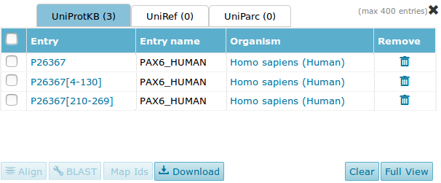
Shimmy back to the top of the page. You should havethings in your basket.
Click on the basket to view your booty.
For each of the 3 items in turn (not all at once or you get all sequences in one file), select and.
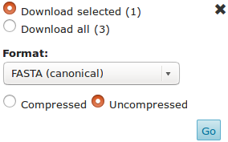

Each time ensure you have Download selected set and the download parameters are set to Uncompressed and FASTA (canonical). Then click thebutton.
The next few steps, as before, are very browser/OS dependant. Just do whatever it takes to save the three sequences in files called, as appropriate:
pax6_human.fasta
pax_domain.fasta
homeobox_domain.fasta
Now move back to America to the NCBI view of the PAX6 gene. If you have problems getting there … click here.
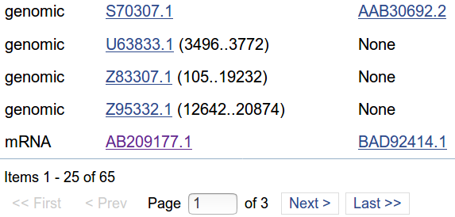
Near the bottom of the page, there is a section called Related sequences. Move to the bottom of the first page (of three) of the list of sequences. Click on the entry for the mRNA called AB209177.1. You will be rewarded by a GenBank entry in GenBank format.
Formats are tedious, but we will discuss them briefly at some point. You have already seen FASTA format. We will bump into EMBL format at some point. The other 137 or so formats are to be ignored!
Can you see the official gene name PAX6, mentioned in this entry? The Gene Name field (where PAX6 should most certainly be mentioned) is entirely missing! If you searched GenBank (or EMBL come to that) for this sequence using the most obvious search Keyword, that is PAX6, do you think you would find this PAX6 mRNA? You clearly should! A case for more consistent annotation? Perhaps something to consider further when we superficially mention the Gene Ontology project later.
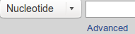
Next, search the Nucleotide databases, by textual Keyword, for PAX6 related sequences and down load one or two for investigation. To achieve this worthy goal, move to the top of the current page and ensure that the database selection is set to to Nucleotide. Click on the search option button.
Then in the , change to in the pull down menu associated with the first search field and type in the keywords:
chromosome 11
In the second search field, again change to and type in the keyword:
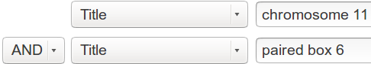
paired box 6
You are asking Entrez to search for all Nucleotide database entries that contain the terms “chromosome 11” and “paired box 6” in the section of their annotation intended to be a succinct brief description (I.e. Title) of the entry. Click on the  button to start the search going.
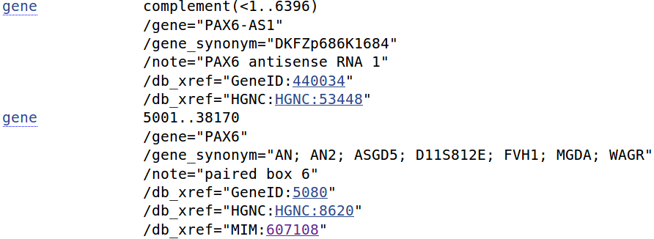
There is just one matching entry which is arrayed before you in Genbank format, very neat!! It was the DEFINITION line that you searched by selecting the Field value Title. I needed a few tries to get the right search to find just what was needed, and was a bit surprised at the simplicity and accuracy of the final search. You are looking at a RefSeqGene (a subset of the RefSeq database) entry. As such, it represents a genomic sequence for a “well-characterised gene”, in this case PAX6.
Take a look at the FEATURES for this entry. You will see that there are three genes mentioned. PAX6, of course. Also, on the strand that is the complement of that represented here, there is PAX6-AS1 and ELP4.
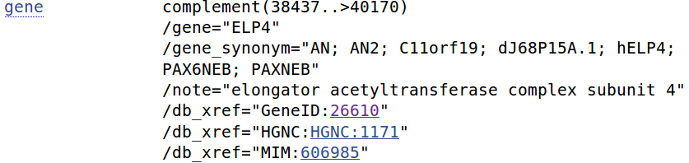
Can you find the additional genes PAX6-AS1 and ELP4 in the genome displays you have looked at so far?

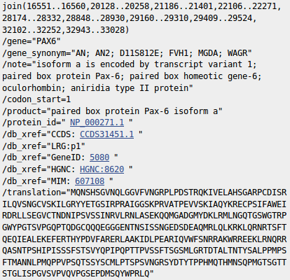
At the top of your page, Analyse this sequence by clicking on the Highlight Sequence Features option. The CoDing Sequence (CDS) feature for PAX6 is displayed for you by highlighting the relevant parts (the coding exons) of the sequence and displaying the CDS details including the DNA regions that need to be joined to form the CDS and the translation of the CDS.
Use the controls at the bottom of your page to look at the other features of this entry (select feature number and then click on the Feature button).
What were the features that you found?
Why might you have expected more features than there were?


Take a look at the COMMENT and PRIMARY sections just above the FEATURES. This entry is suggested to be constructed from the alignment of two sequences from GenBank. The two aligned sequences being “contigs”, that is products of two individual sequencing projects of separate portions of the PAX6 genomic region. We should discuss role of “contigs” in the human genome project, a little.

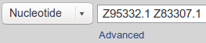
Take a quick look at the GenBank entries by entering their ACCESSION numbers (be sure to include the “.1”, the version number, at the end to avoid unwanted hits) into the Search box at the top of your page. Click on the button.

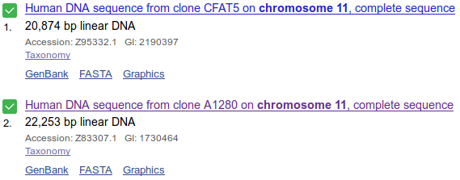
Lo and behold, the two GenBank entries are summoned forth. Take a look at one or both. Not particularly illuminating I think. These are clones sequenced as part of the Human Genome Project (HGP). They served to cover regions of Chromosome 11 and have little biological significance in themselves.

Move back to the list, as illustrated. Select both entries.


Elect to Analyse these sequences, selecting from the extensive range of possibilities Run BLAST.

We will look at blast properly later, the idea here is to simple prove that these two sequencing clones really do overlap in the fashion suggested by the evidence so far. So, elect to Align two or more sequences.

Cut and paste one of the sequencing clone accession numbers from the Enter Query Sequence box to the Enter Subject Sequence section of the form. Elect to Show results in a new window. Firmly address thebutton.
Just one region of overlap should be identified.

How does the alignment you generated match up with the annotation of the original RefSeq entry you discovered?
Now for an entirely new search. The easiest way to get a fresh start is to move back to your browser tab displaying the GenBank Search results, and then click on the Advanced option of the Search facility at the top of the page. You should arrive back at the Nucleotide Advanced Search Builder offering a fresh start.

Set up a new search as illustrated and set it going. Ultimately simple this time. You have requested all Human sequences that are centrally associated with the gene PAX6.
A list of 60 or so sequences, all clearly claiming PAX6 association and announcing their humanity loudly in Latin, will tumble forth.
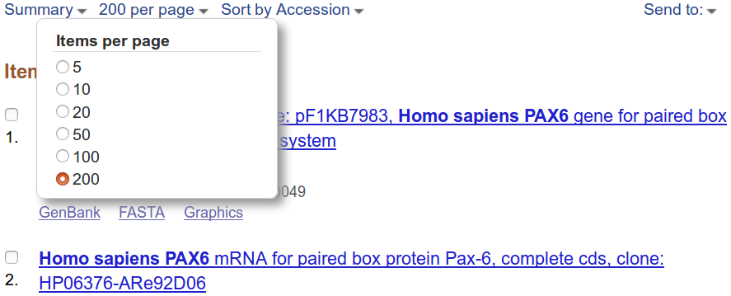
You will have more hits than are displayed in one go, by default. Also, the hits are arranged in a “Default” order which has thus far defied all my attempts to associate with any reasonable definition of logic!

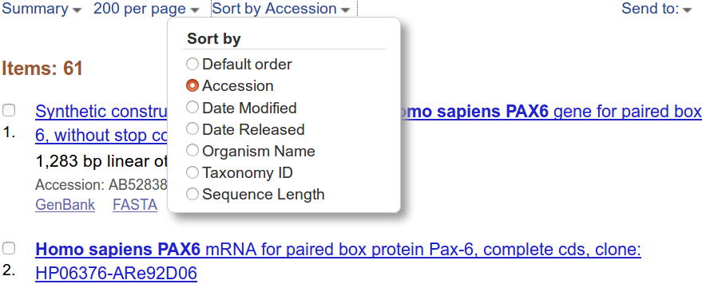
To deal with both of these issues, use the display control pull down menus at the top of your page to set the items per page to something big and the Sort by option to something sane.
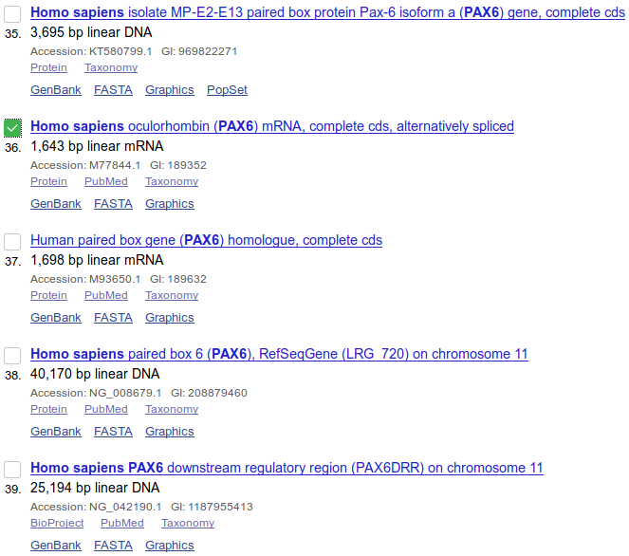
The list shows matches between the terms entered and the annotation of DNA sequences. Not all relevant sequences will be present. For example, the mRNA with accession number AB209177 was justifiably referenced in the PAX6 Gene entry but will not be in this list. PAX6 appears nowhere in the annotation of AB209177 including its DESCRIPTION (or Title) field.
Move far down the list, you will come to the RefSeq PAX6 mRNAs of a few pages back. Just before these entries is M77844.1. Save this one for later analysis. I choose M77844.1 as it includes a few variations that will add interest. Select the target sequence.
You could now use the diminutive button which is near the bottom of your page to download all the selected sequences into a single file.
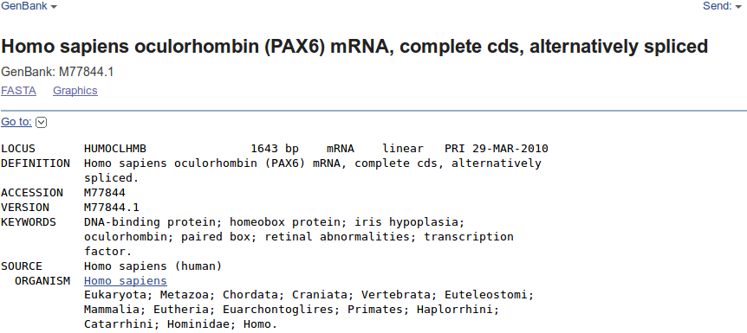
However, as there is only one sequence, and it would be so nice to be introduced properly before such intimacies as “downloading”. Click on the link to the database entry to see it in all its GenBank Format glory.
The sequence is for analysis rather than decoration, so use the format menu at the top of the page (currently set GenBank), and ask for FASTA format.
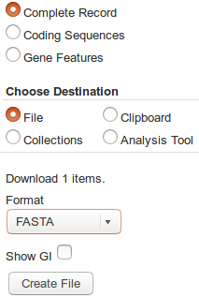
Now click the tiny Send to: button and Choose Destination to be File.
Strike the Create File button with a firm resolve. With irritating presumption, the choice of file name is made for you. Your sequence will be stored in a file named:
sequence.fasta
The NCBI is justifiably not famed for its understanding of poetry! Do whatever it takes to rename this file to be called:
pax6_mrna.fasta
One last file to save. Move back to your list of hits and deselect the mRNA that you have already saved.
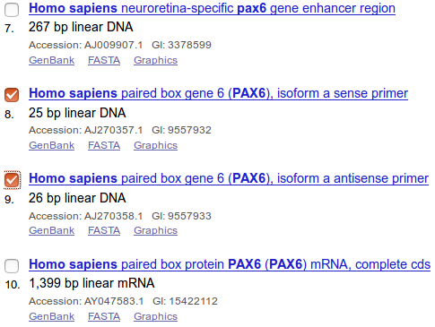
Near the top of the list you should find two primer sequences. Their Descriptions suggest they are a pair of PCR primers used for picking out the PAX6 gene. Select both by clicking in their selection boxes.



Click on the sense primer. Properly, you would read all the References carefully. Instead, note the length looks about right and return to your list with the Back button.

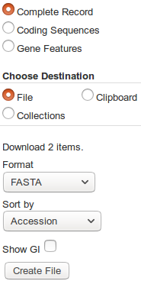

It will be good to investigate these primers later, so find the diminutive button which is at the top of your page and use it. Choose your Destination to be File and set the Format of that file to be FASTA. Strike the Create File button with a confident click of your every ready mouse. Once more, the choice of file name is made for you. Your sequences are stored in a file named:
sequence.fasta
Do whatever it takes to rename this file to be called:
pax6_primers.fasta

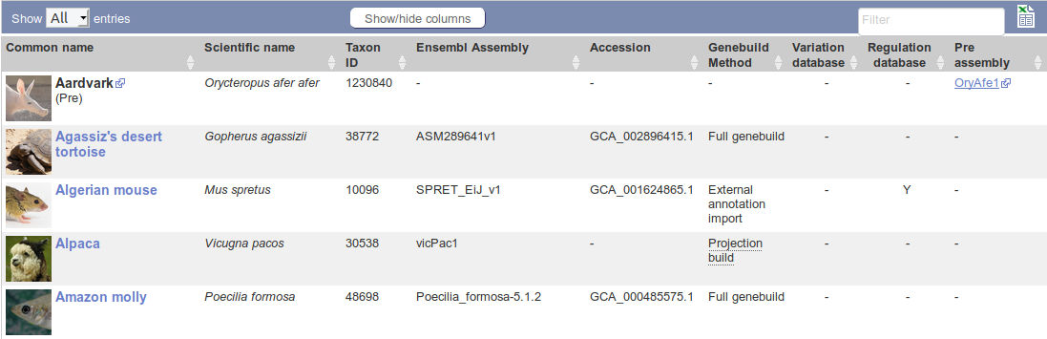
Back to Ensembl. More with the objective of looking at more sources of information via Ensembl than becoming expert Ensembl users.
Go to the Ensembl home page (www.ensembl.org). Choose to View full list of all Ensembl species using the link just under the Select a species menu.
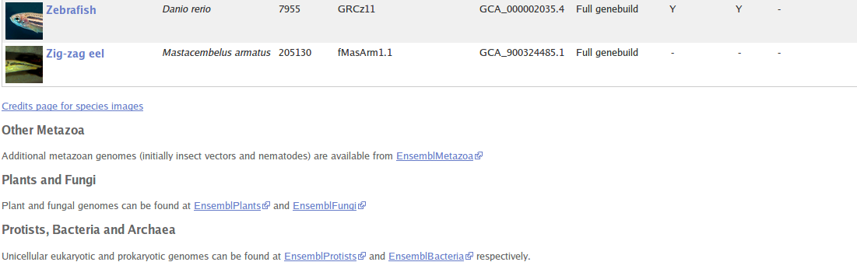
Note that Ensembl (and MapMaker, of course) offers far more than just the Human Genome.
In particular, note the links to EnsemblPlants, EnsemblFungi, EnsemblBacteria etc. Ensembl databases at the bottom of the list.
During this exercise, you will only look at the Human genome, by far the most completely recorded. However, all the other Ensembl genomes are behind the same interface. The techniques required to examine the Human genome are broadly those required to examine any Ensembl genome.
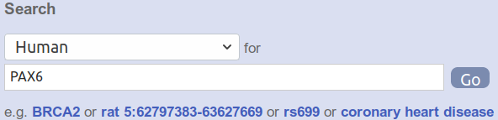
Move back to the Ensembl home page and go to the Human PAX6 gene information by setting the Search fields as shown and clicking the Go button boldly.
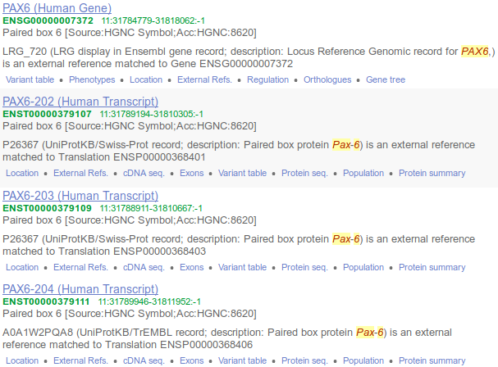
The target gene is at the top of the hit list.
Click on the link to the PAX6 (Human Gene).
You should recognise the view you now see. The list of transcripts and view of the genomic region exactly as you examined via the NCBI.
There is much to investigate here, but maybe that should wait for a specialised Ensembl course. They are run regularly in Cambridge and elsewhere.
To make a bit more space, elect to.
At the top of the page, note the summary giving, particularly, an expectation of the numbers of Transcripts, Orthologues and Paralogues.
Begin by taking a look at how Ensembl sees the Homologues of PAX6. First the Orthologues and then the Paralogues. Click on the Othologues link in the left hand side of your browser page.
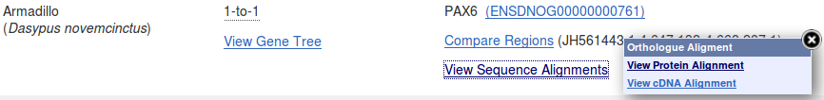
Take a look at some of the alignments providing support for the homologous relations. The protein alignments are the more informative (from the View Sequence Alignments menu, select View Protein Alignment).
Which human PAX6 isoform has been chosen to align with orthologues?
How do you suppose this choice might have been justified?
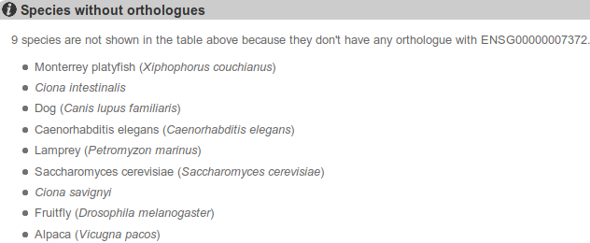
At the bottom of your screen, Ensembl offers a list of organisms with no PAX6 Orthologue.
Can you comment of the inclusion of Drosophila in this list?

Once your curiosity concerning Orthologue alignments is completely sated, click on the Paralogues link.
All 50 that Ensembl expected (see above) are listed in a seemingly randomised series. This is not very helpful.
What regions of PAX6 would you expect might have Paralogues (or Orthologues, come to that)?
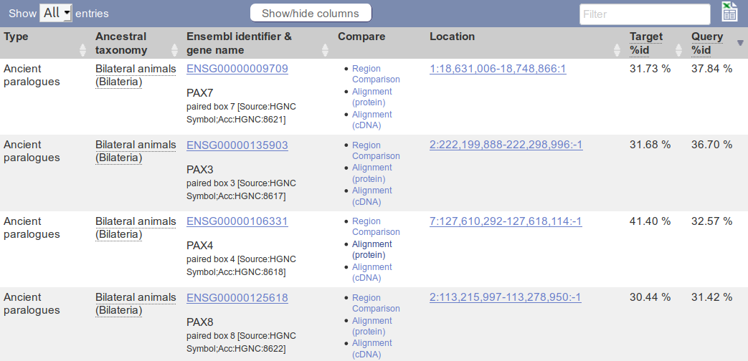
In order to easily make sense of this list, rank it by some measure of Quality, click on the column header as many times as it takes to achieve an ordering of the list of paralogues that is High → Low by Query %id.
You should now be able to discern at least 2 distinct sets of paralogues by looking down the Ensembl identifier and gene name column.
At the top of the list you should find genes paralogous to the Paired Box domain of PAX6.
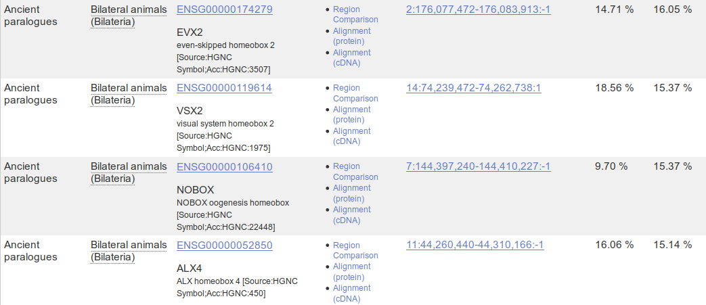
Further down, list entries declare a paralogous association with the Homeobox domain of PAX6.

How many of the PAX6 paralogues are associated with the conservation of the Paired Box domain?
View some of the protein alignments between the gene PAX6 and its paralogues.
Some paralogues seem to have two regions of high similarity (e.g. PAX4 or PAX2), others only one (e.g. PAX1)? Can you explain?
Next look at some transcript specific features as they are recorded in Ensembl. To do this, one must first select a transcript, soonce more and select ENST00000419022 (PAX6-209). Again, to make a bit more space, why notaway.
Now click the Exons link (from Transcript-based displays → Sequence). Exons, Introns and Variations within Exons are clearly displayed.
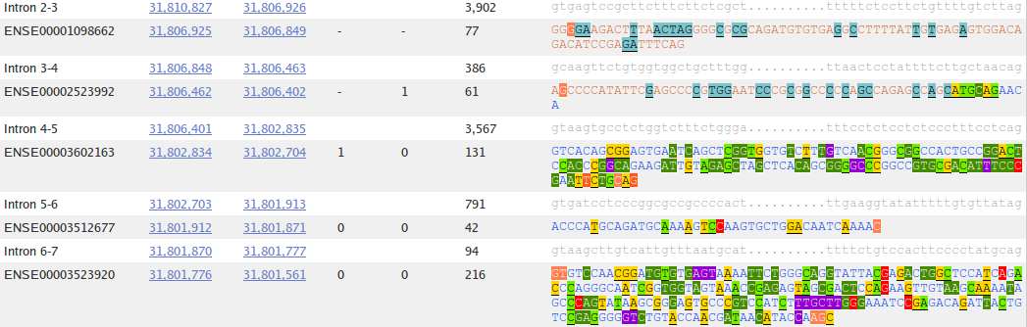
What are the first two bases and what are the last two bases of nearly every intron?
How long is the sixth exon and why would this concur with your expectations?
Explain the Start Phase and End Phase columns?
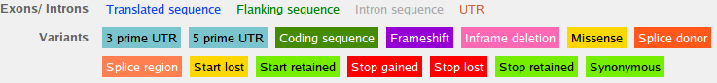
Click on some of the colourful variation locations. The colours are explained in the legend at the top of the display.
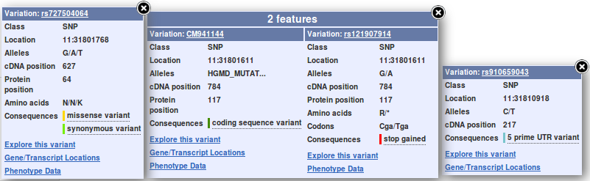
The variations come from a number of databases, including dbSNP. The dbSNP entries are those whose names begin with “rs”. dbSNP can be investigated directly at the NCBI, of course, but it very convenient to have all the variation information built into Genome Databases such as Ensembl.
Click on the Domains & features link (from Transcript-based displays → Protein Information).
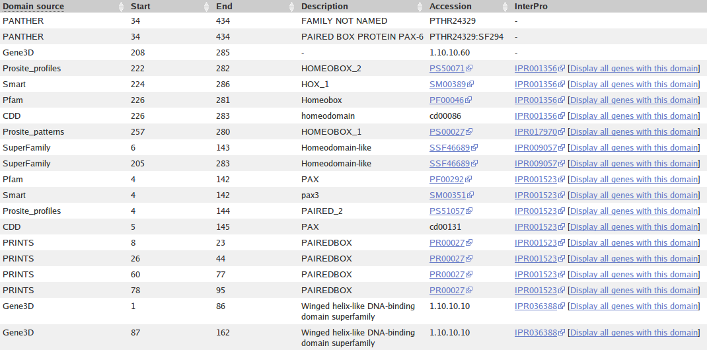
Are you surprised that the precise location of the PAX6 Homeobox domain is not identically predicted by the SMART and Pfam Domain Databases? If not, why not?
How is that all the predictions, of different domain databases, for a Paired domain have the same Interpro identifier?
Why does PRINTS appear to predict four Paired_domains?
Click on the link to the SMART entry for the Paired domain (SM00351).
Here you will find (quoted from Interpro) a Description of a Paired domain.
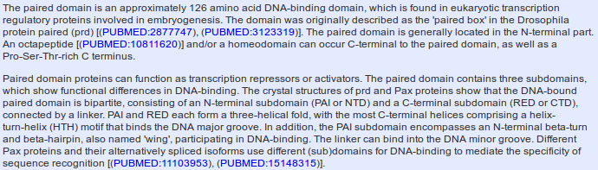
Where would you expect a Paired domain to occur in a protein?
What expectations do you have concerning what typically follows a Paired domain?
The second paragraph of the Description claims, in gross summary:
- A paired domain is a DNA binding domain that has 2 binding regions each of which involves a helical triplet
- The second and third helices of each helical triplet form Helix-Turn-Helix (HTH) motifs

- The HTH regions bind the DNA major groove


- The first helical triplet is preceded by a β-turn and β-hairpin (“wing”) that participate in the DNA binding
- The linker region between the two helical triplets can bind the DNA minor groove

Bear this in mind when looking at the 3D structures a couple of pages on.

Click on Display all genes with this domain for the Paired domain and Homeobox domain InterPro families. The locations of all genes including each domain will be displayed graphically and textually. PAX6 is shown in red.
Paired domain - IPR001523 Homeobox domain - IPR001356



Which domain, Paired domain or Homeobox domain is more common in humans?
How many human PAX genes are there?
Are all the PAX genes on Chromosome 11?
Move back to the Domains & features display. Link to the InterPro database entry for Paired domain, also know as IPR001523. Here you will find the origins of the SMART documentation. Click on the Proteins matched link. You will see listed a number of representations of proteins that, according to InterPro, include a Paired domain. Amongst these will be the human PAX6 protein, also known as P26367.
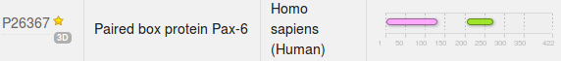

Click on the Structures link in the top left hand corner of the page. InterPro will offer links to relevant entries in the PDBe, SCOP and CATH databases. Click on the link to the 6pax entry in the PDBe database. You will arrive at the entry for 6pax in PDBe, the European version of PDB maintained at the EBI. Views of this structure are offered on the right hand side of the page. Click on the largest image which shows the paired box protein domain binding DNA rather beautifully. Once you have admired this image, in all its various guises, sufficiently, move back to the 6pax PDBe entry. From the on the right of the page, select the 3D Visualisation option.
The SMART documentation you read earlier suggested two paired box sub-domains, each of which “ ... form a three-helical fold, with the most C-terminal helices comprising a helix-turn-helix (HTH) motif that binds the DNA major groove”. Move your image around to confirm this assertion.
The same SMART documentation claims the sub-domain nearer the N terminal “ ... encompasses an N-terminal beta-turn and beta-hairpin, also named 'wing', participating in DNA-binding. The linker can bind into the DNA minor groove”. Manipulate you image to investigate the veracity of these assertions.

Once you have seen all there is to see of 6PAX, move back to the Ensembl Domains & features display. Try the same tricks with the InterPro Homeobox domain. This time, it is difficult to find P26367 in the huge list Proteins matched, but you do not need to in order to link to the Structures. There are many more structures to choose from this time. I suggest you go for 2cue. You have to imagine the DNA this time.
It looks rather as if the Homeobox domain also includes a helical triplet including a Helix-Turn-Helix. You could have confirmed this by reference to the relevant SMART documentation (as you did for the Paired box domain). It is the HTH that the Homeobox uses to bind to DNA.
InterPro did not detect the Homeobox HTH as it did the Paired box HTH. Have you any thoughts as to why this might be?
Can you explain the strangely frayed ends displayed in some of the representations of the 2cue 3D structure?
To end, a gesture towards demonstrating that you could quite easily have computed most of the information you have been accessing, ready packed, from various databases. There are many way this objective could be achieved, I choose to search for the features of the PAX6 protein.
As has been discovered from several information sources, the PAX6 human protein has two DNA binding domains. A paired box at the N terminal and a homeobox a little further along. Both of the domains include Helix-Turn-Helix (HTH) motifs. In this exercise, you will investigate how you might discover these domains and motifs using the various freely available domain databases (discussed previously) and other feature prediction programs. Clearly, this is superfluous for this particularly, well documented protein, but a valuable option in other circumstances.
One approach would be to consider each relevant domain database in turn. Each major domain database has its own Home web site and customised software to take Query protein sequences, compare those sequences with domain representations (typically based on Hidden Markov Models) and to report convincing matches. This would work, but would be tedious as there are many viable databases to consider. It would be dangerous to rely on too few of the databases available as none is perfect. You need a consensus prediction to be sure you miss nothing.
Also, you would need to know which databases are particularly appropriate for each domain you considered might be present. All databases cannot be optimised for all types of domain (for example, the SMART database specialises in domains that occur in signalling proteins).
So, let us not search individual domain databases. I am sure you could find your own way through using most of the major searches, if you wished. Notes on using the Prosite, Pfam and PRINTS domain databases appear in the discussion sections of appropriate exercises, but should not take up significant class practical time I feel. Investigating each individually turn does have some merit however. Prosite illustrates how widely domain matches can vary in significance, Pfam gives and opportunity to superficially discuss HMMs and searching PRINTS illustrates the small margin between a positive and a negative result.
Here, use just Interpro to do the whole job. Interpro will search for all domains using the appropriate domain databases, thus removing the tedium of interrogating a miscellany of domain searching resources individually.
defines protein families according to the way that proteins match elements of a wide range of protein family databases, including all those we have discussed thus far. Interpro provides a search tool that will search all or any of the major protein family databases and assign Interpro family associations to the query protein(s) accordingly. To have a look at some of the possibilities offered by Interpro, Go to:
http://www.ebi.ac.uk/interpro/
If you were to enter the PAX6 human protein into the obvious place on the InterPro home page and click the Submit button, you would produce exactly the results you saw many pages back, when you were investigating UniProtKB. Do this if you have the time and inclination.
By implication, InterPro offers a fuller experience via the InterProScan search tool. Other than the opportunity not to search ALL the domain databases, and having the results arranged slightly differently, I am unsure what the extra effort brings? Never mind, there are many things of which I am unsure, so, from the InterPro Home page ...

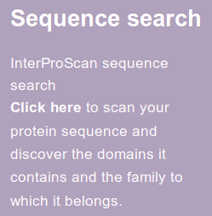
Select the InterProScan link. Here you will be offered the opportunity to download the InterProScan program.
I am not sure this is too useful an offer for most? But it is there.
For now, chose the online Sequence search.

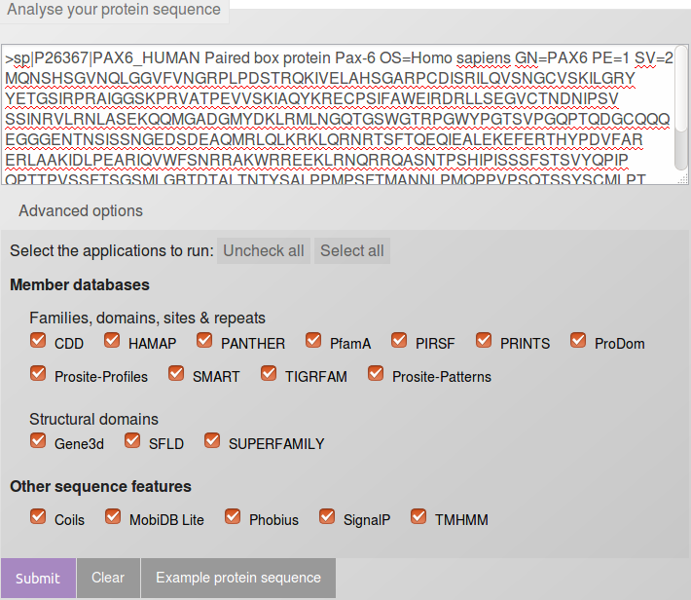
You will arrive at a page very similar to that from which you started, as far as the offer to run a domain search is concerned? Except! We now have Advanced options. Click on the Advanced options.
The Advanced options only allow you to choose which databases you wish to search and which feature prediction programs you wish to run. The default is to use all the databases and to run all the predictor programs. I struggle to imagine an occasion I would want to save the EBI servers a few cycles by considering which options to deselect, but it so nice to know I could if I wished to.
In passing, the offer to run the feature predictor programs in the Other sequence features section is relatively new. Of course, all these programs could be run individually from their home websites (follow the links behind the program names), in the same way as the domain databases can be searched individually. Interpro just aims to make thing easy for the user. The programs currently offered are:
- Coils is a program for predicting coiled coils.
- MobiDB Lite is a method of Fast and highly specific consensus prediction of intrinsic disorder in proteins. A new facility for Interpro. It uses MobiDB, a database of annotations of intrinsic protein disorder. Protein disorder being a structural features characterising large sets of proteins with prominent members that are intrinsically disordered proteins.
- Phobius & TMHMM are programs to predict Transmembrane regions (essentially hydrophobic, uncharged regions). There is no reason to expect any Transmembrane regions in this protein.
- SignalP predicts the presence and location of signal peptide cleavage sites in amino acid sequences from different organisms. I am pretty certain that there is no reason to expect signal peptides in this protein.
Do you think it a good idea for Interpro to offer feature prediction programs as well as domain database searches?
Paste the human PAX6 sequence into the patiently waiting box (from the file you made earlier called pax6_human.fasta). Accept the “do everything” default. Click on the Submit button.
After several moments of deep thought, filtering and validating, you will be presented with a table of results looking very much like the one your saw earlier when looking around UniProtKB.

Do you think the Coil prediction might be correct?

Notice that Interpro assigns both the PAX domain and the Homeobox domain of human PAX6 to the Interpro family Homeobox domain-like. Both of these associations are based on the hit behind the link SSF46689.
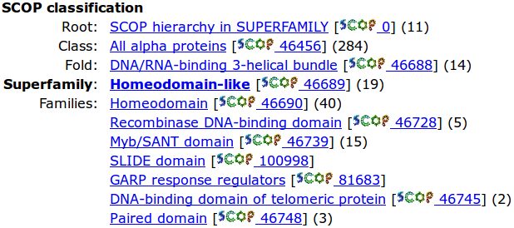
Follow this link and you will see it leads to the Homeodomain-like superfamily of thedatabase that specialises in very general (SCOP superfamily level) protein classifications. One Superfamily entry will typically correspond to a number of more specific SCOP classifications. Here you can see that the Superfamily domain Homeodomain-like includes both the Homeodomain & Paired domain Families.
Return to your Interpro results page. The links beginning “GD3SA” point to Superfamily domains defined by the CATH Protein Structure Classification database. CATH is similar to to SCOP in that it is another Structural classification database. CATH Superfamilies are to be found in the Gene3D database. One such link suggests two regions that belong to a Winged helix-like DNA-binding domain superfamily. These seem to correspond to the two Helix Triplets of the Paired domain. Note that the Helix Triplet in the Homeobox domain is not detected by Gene3D? Possibly because of the lack of Beta Sheet “Wings” in the Homeobox domain?
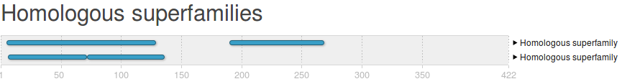
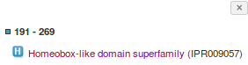
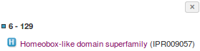
Interpro provides a unified report of all the superfamilies detected either by reference to the SCOP or CATH databases.
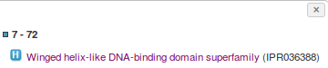
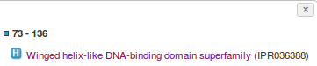
Click on the region bars and you will be offered links to the relevant Interpro entries.
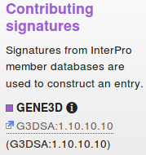
Follow one of the links to the Interpro family Winged helix-like DNA-binding domain superfamily (IPR036388). Note the Contributing signatures in the top right hand corner of the page. Here is listed the domain database entries that are used to determine the presence of an Interpro Winged helix-like DNA-binding domain superfamily
Essentially, if GENE3D finds a match with its Winged helix-like DNA-binding domain superfamily (G3DSA:1.10.10.10), then Interpro records a match with its Winged helix-like DNA-binding domain superfamily (IPR036388).
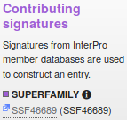
Move back to your Interpro graphic and follow one of the links to the Interpro family Homeodomain-like domain superfamily (IPR009057). Again, note the Contributing signatures.
This time it is stated that, if Superfamily finds a match with its Homeodomain-like superfamily (SSF46689), then Interpro records a match with its Homeodomain-like domain (IPR009057).
I conclude the Homologous superfamilies and Domains and Repeats sections of the graphic simply summarise and confirm information from the Detailed signature matches section.
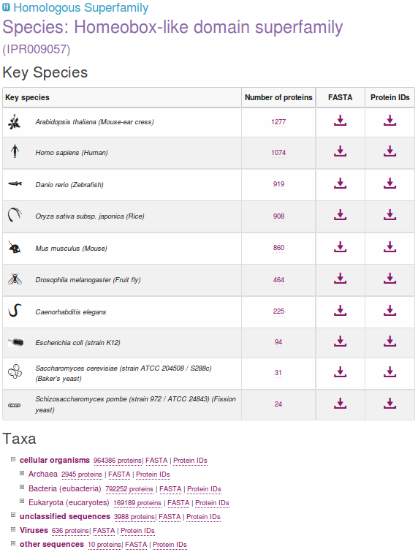
While you have the Interpro Homeobox-like domain superfamily in view, it is easy to obtain an impression of how widely spread throughout nature is this domain family. You have already established that there are a fair few in human proteins.
Click on the Species button on the left hand side of the page.
As you can see, this is a very popular domain. By clicking on the appropriatebutton, you can get to either the protein sequences in Fasta format or list their accessions codes. Try a few, but be careful! It really does get you ALL the sequences, and that is often quite a lot, which can take time.
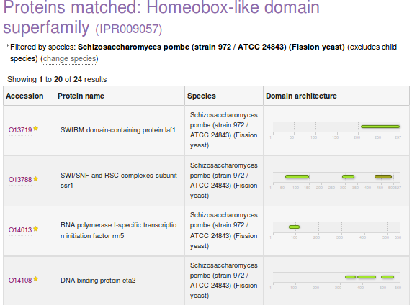
You can make this list enormous by injudicious employment of the expansion buttons (the Number of protein links). Why not? It amused me for a few moments anyway.
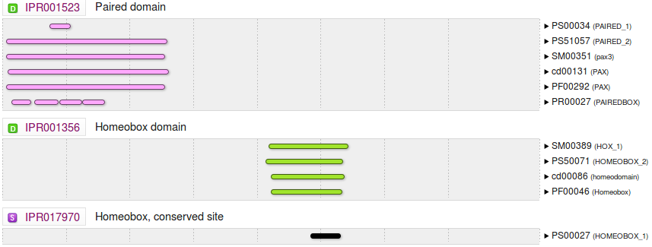
Finally, return again to you Interpro graphic. Notice that the Paired domain prediction is supported by matches with six different domain databases. Only four of these support the Homeobox domain prediction. The missing two database matches are with Prosite patterns (identifier begins PS and typically matches the domain partially where it is best conserved) and with PRINTS (identifier begins PR).
Why do you suppose there is no match from PRINTS or Prosite patterns to support the Homeobox domain prediction for this protein?
What do you suppose the Homeobox conserved site might be?

THE END
DPJ – 2019.01.30
Model Answers to Questions in the Instructions Text.
Notes:
For the most part, these “Model Answers” just provide the reactions/solutions I hoped you would work out for yourselves. However, sometime I have tried to offer a bit more background and material for thought? Occasionally, I have rambled off into some rather self indulgent investigations that even I would not want to try and justify as pertinent to the objective of these exercises. I like to keep these meanders, as they help and entertain me, but I wish to warn you to only take regard of them if you are feeling particularly strong and have time to burn. Certainly not a good idea to indulge here during a time constrained course event!
Where things have got extreme, I am going to make two versions of the answer. One starting:
Summary:
Which has the answer with only a reasonably digestible volume of deep thought. Read this one.
The other will start:
Full Answer:
Beware of entering here! I do not hold back. Nothing complicated, but it will be long and full of pedantry.
This makes the Model answers section very big. BUT, it is not intended for printing or for reading serially, so I submit, being long and wordy does not matter. Feel free to disagree.

From your investigations using UniProtKB:
Describe the arrangement of Helices within PAX6.
From the evidence of the textual table and the graphic, there are nine helices in all, that occur in groups of three.
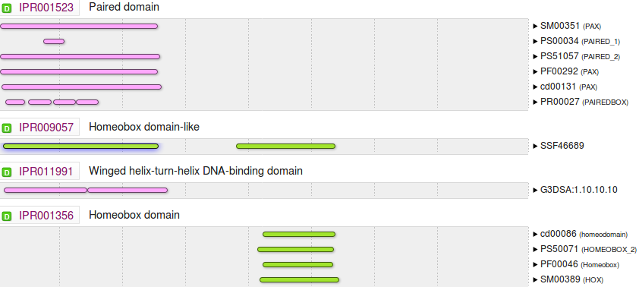
Aligning the graphical representation of the positions of these helices with the Interpro domain prediction graphics (discovered via UniProtKB earlier), it is clear that the first two of the helical triplets lie in the Paired domain and the third is in the Homeobox domain
From your investigations using Entrez:
What were the features that you found?
Summary:
The first feature was the CoDing Sequence (CDS) for a PAX6 isoform, the canonical isoform a. The NCBI say they omit the other isoform(s) as they do not aspire to “completeness” but just an indication of structure with the RefSeq entries.
The other three features were the coding sequences for three ELP4 isoforms. Why more than one for this gene then? Possibly because they are “more different” representing interesting variation in gene structure?
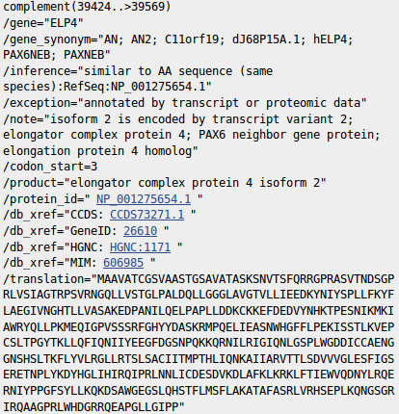
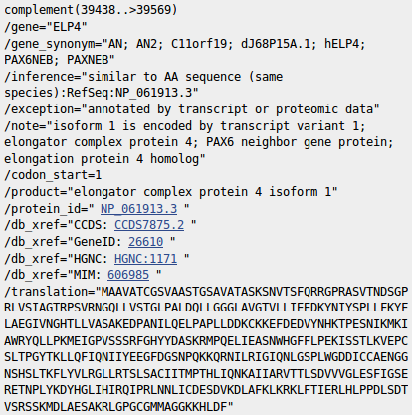
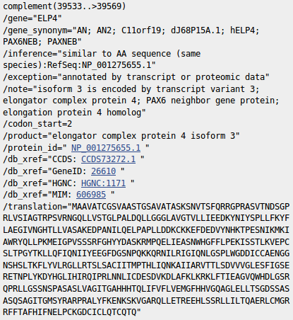

Full Answer:
Note that only the final coding exon of ELP4 is within this RefSeq sequence, which is defined as the genomic region for PAX6. This is clear from the length of the translations offered. The exon referenced is only long enough to code for just over 40 amino acids which is far shorter than any of the three entire isoform sequences offered here.
Note also that this final coding exon of ELP4 (stretching from 39424/39438/39533 to 39569 of this RefSeq entry) does not overlap the coding region of the PAX6 gene itself (stretching from 16551 to 33028 of this RefSeq entry).
In fact, the two genes do not overlap according to the evidence. The PAX6 gene extends from 5001 to 38170. The portion of the ELP4 gene that is included in this entry extends from 40170 (the end) to 38437 (in the opposite direction). This give a gap between the two genes stretching from 38171 to 38436.
RefSeqGenes, comprise the entire gene plus 5,000 “extra” base pairs in either direction. The overlap here is entirely within the “extra” base pairs.
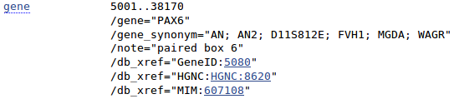
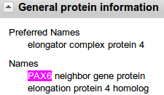
Careful study of either of the two Genome Database displays visited earlier (Genome Data Viewer or Ensembl) will confirm the relative positions of PAX6 and ELP4.

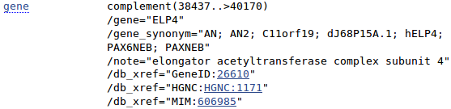
The annotation (specifically the gene_synonyms) of ELP4 associate this gene with PAX6. However, as the ELP4 gene annotation to the right attests, only because of its proximity.
Why might you have expected more features than there were?
Summary:
All the evidence has suggested that PAX6 has at least 2 isoforms. This would lead me to expect at least 2 CDS features here related to PAX6?
Full Answer:
The explanation from the NCBI is that this sort of RefSeq entry is intended to be used as a template against which sequences from an individual can be mapped to seek variations. Only a token CDS feature is included to indicate the position of the gene. For such an entry, recording every isoform is not essential.
This sounded convincing to me, Until I began to wonder why there were three CDS features for ELP4 which is not even the gene primarily represented by this entry? Maybe I will ask more questions if and when I ever have the strength. In the meantime, mostly for my information, I record their exact explanation here.
“ ... note that RefSeqGene defines genomic sequences to be used as reference standards for well-characterized genes. These sequences serve as a stable foundation for reporting mutations, for numbering exons and introns, and for defining the coordinates of other variations. We normally select one RefSeq transcript to serve as a reference standard. The goal is not to record all introns and exons of all isoforms, but just to choose one representative to help define the locus. Therefore, most of our RSG records have only a single RefSeq as reference standard. If an LSDB manager or other stakeholder requests that other RefSeqs be added as alternate standards, this can easily be done (with the complication that, if a public LRG exists, the RefSeqGene record is fixed). We receive requests from stakeholders to include RefSeqs that represent all known exons, or RefSeqs that have become community standards. Often, after creating an RSG using our own internal criteria, we receive stakeholder requests to change or add transcripts. Many of these requests come from the LRG project regarding transcripts to be included on the LRG records.
Generally, RefSeq accessions can be added or removed without reversioning, unless a transcript is upgraded or a new one defined that extends beyond the bounds of the RSG, or matches a new build of the genome, in which case the RSG will be extended and reversioned as needed.
Regarding the chromosomal locus, our standard range is 5 kb upstream from the 5' end and 2 kb downstream from the 3' end of the mRNAs with the greatest extent. For this calculation, we do indeed use all available RefSeq (NM_) accessions. If the database manager or stakeholder has information on promoters or other upstream or downstream regulatory regions, we can certainly extend the RefSeqGene locus to accommodate these.
Regarding mismatches, the goal is to exactly match the current build of the genome, unless there is overwhelming transcript and EST evidence that a mismatch should be retained.
Regarding the confusing subject of exon numbering, exon numbers are currently provided only on RSG genomic records based on a subset of available transcript RefSeqs for the gene. These are often those selected by locus-specific databases as reference sequence reporting standards. You can find an explanation of how exons are numbered here:
http://www.ncbi.nlm.nih.gov/refseq/rsg/faq/#exon
You will find links to more information on RefSeqGenes on the home page for the RefSeqGene project:
http://www.ncbi.nlm.nih.gov/refseq/rsg/
Regarding the PAX6 RSG sequence, only difference I see between NG_008679.1 and the current build of the genome (GRCh38) is an extra 'G' beyond the 3'-UTR of the PAX6 transcripts (at NC_000011.10:g.31,819,125). ... “
Yes, well I think I followed most of that? and that my interpretation is broadly correct? In summary, there are no fixed rules.
How does the alignment you generated match up with the annotation of the original RefSeq entry you discovered?

The most intuitive way of encapsulating graphically the way these two sequencing clones overlap was donated by Cecilia Pinto (Oeiras, 2013.12.09-12). Thank you Cecilia.

From your investigations using Ensembl:
Which human PAX6 isoform has been chosen to align with orthologues?
How do you suppose this choice might have been justified?
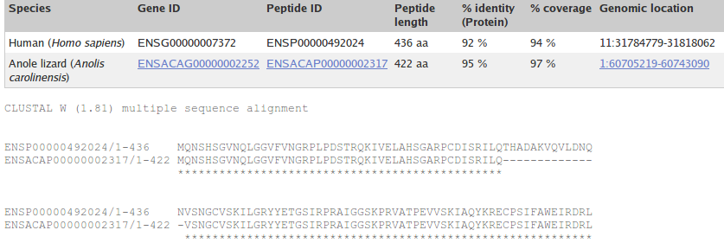
The protein used to represent PAX6 human is consistently ENSP00000492024. At least, this was the choice for the alignments I looked at. This is the protein sequence of isoform 5a (as evidenced by the extra 14 amino acids around the end of the first line), probably chosen as it is the longer option (436 amino acids as opposed to 422) and so (from the crude informatics viewpoint) represents more information.
The canonical isoform is used for the non-human sequence, I imagine because that is what you get if you pull the sequence from UniProt (or similar). If I am right, more computational convenience than Biological justification.
Can you comment of the inclusion of Drosophila in this list?
The claim that there are no Human PAX6 Orthologues for Drosophila does seem a bit strange even entirely wrong?) given the abundance of evidence to the contrary available from the INTERNET and beyond. For example:
Source 1, Source 2, Source 3, Sources 4, Source 5 ...
However, the people I speak to from Ensembl are adamant, so maybe I am missing something. I suspect a more accurate statement might be:
“There is insufficient evidence for the Ensembl automatic Orthology detection procedures to identify any Drosophila Orthologues for Human PAX6.”
What regions of PAX6 would you expect might have Paralogues (or Orthologues, come to that)?
It has been established that PAX6 has 2 domains. A Paired Box domain and a Homeobox domain.
It is surely reasonable to expect that Homologues of PAX6 will correspond to either one of these domains? Or possibly to both?
The list of 50 is not organised in any way that makes it easy to decide the domain(s) to which each Paralogue might be associated, Some manipulation is required for a clear view.
In this exercise, ranking by quality (defined by alignment Sequence Identity) is used. This works because the Paired Box matches are much longer than the Homeobox matches. I would not expect this approach to work in all cases however. Maybe there should be a way to separate the types of Paralogues in a more reliable fashion?
What are the first two bases and what are the last two bases of nearly every intron?

As you are probably well aware, introns are highly conserved at each end. They typically begin with GT and end with AG. This rule is obeyed by all but one of the introns of this transcript (intron 3-4 starts GC rather than GT).
As the cartoon suggests, the conservation does not apply just to the first and last two bases, but that is where the conservation is most strict. So strict that when exceptions from this rule were sought in the databases, it was thought most of the deviations were due to annotation error!
The cartoon also suggests that introns have C/T rich regions towards their ends (the Polypyrimidine tract). This too is clearly evident in most of the introns of this transcript, even though only small parts of the introns are displayed.
How long is the sixth exon and why would this concur with your expectations?
It is 42 base pairs long, so it codes for 14 amino acids. Specifically, it codes for the 14 extra amino acids that define isoform 5a.
Explain the Start Phase and End Phase columns?
An exon/intron boundary can occur anywhere in a codon. The Start and End Phases record how an intron has been inserted into a coding region with respect to the coding reading frame.
If an exon ends at the end of a codon, then its End Phase is 0.
Clearly, the next exon must begin at the start of a codon. Its Start Phase is also 0.
If an exon ends after the first base of a codon, then its End Phase is 1.
Clearly, the next exon must begin after the first base of a codon. Its End Phase is also 1.
If an exon ends after the second base of a codon, then its End Phase is 2.
Clearly, the next exon must begin after the second base of a codon. Its End Phase is also 2.
I attempt a picture, though I am sure that is clear? I just like pictures, and lots of colours.
S A I L Q ← intron → T H A D A K V Q V L ← intron → V S N ...
...TCCCGAATTCTGCAG← intron →ACCCATGCAGATGCAAAAGTCCAAGTGCTG← intron →GTGTCCAAC...
End Phase 0← intron →Start Phase 0 End Phase 0← intron →Start Phase 0
S A I L ← intron →Q T H A D A K V Q V L← intron → V S N ...
...TCCCGAATTCTGC← intron →AGACCCATGCAGATGCAAAAGTCCAAGTGCT← intron →GGTGTCCAAC...
End Phase 1← intron →Start Phase 1 End Phase 2← intron →Start Phase 2

Why does Prints appear to predict four Paired_domains?
Prints does not find the Homeobox_domain at all. If you were to investigate by using the Prints search carefully, you will find it nearly does, but the evidence is not quite strong enough. As has been discussed, none of these systems are perfect. They all occasionally fail. That is why it is always best to use Interpro to consult them all and deliver a consensus answer.
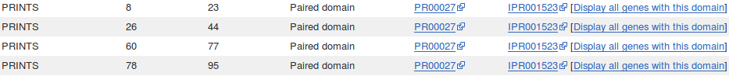
Prints appears to find FOUR Paired_domains. This is only because of the way Prints works. Prints finds FOUR signatures (or motifs) that together indicate ONE Paired domain. Prints searches for ordered series of motifs that together indicate domains. Here it reports each of four motifs separately, but it is only claiming one Paired domain.
Which domain, Paired domain or Homeobox domain is more common in humans?
How many human PAX genes are there?
As you will have expected, there are but 9 Paired domains in the Human genome. There are many more Homeobox domains. Note particularly that Interpro predicts far more Homeobox domains than Ensembl admits to. Ensembl predictions are based purely on computer searches and comparisons, which can never be entirely perfect.
Are all the PAX genes on Chromosome 11?
Of course not? What a stupid question!
Well, I suppose they could all be on Chromosome 11? By chance … or maybe design … who knows, the lack of predictable pattern in all this business never ceases to astound me.
But, philosophy aside, the answer is NO.

Can you explain the strangely frayed ends displayed in some of the representations of the 2cue 3D structure?
2cue is a 3D structure determined by Nuclear Magnetic Resonance (NMR).This is a process that does not involve immobilizing the target as a crystal (as is the case with structures determined by X-ray crystallography). Parts of the protein will still be moving around whilst its structure is being determined.
I think of NMR as analogous to taking a long exposure photograph of a group of children. Each child will appear in many different places! The frayed ends represent various positions in which the ends of the homeobox were detected during the NMR process.
In some views, including the one you were offered to move around, all the possible positions are averaged out before the structure is stored. I prefer the fuzzy view ... much more fun.
I broadly believe that which I have just typed, however, I must stress that my understanding of NMR is tragically incomplete. If anyone would like to offer a better explanation, I am very willing to hear it.
From your investigations of Domain & Motif identification using Interpro
Do you think it a good idea for Interpro to offer feature prediction programs as well as domain database searches?
Well … why not? The purpose of InterProScan is to associate regions of query proteins with Interpro domains. This was originally achieved, exclusively, by simply comparing a query sequence with all entries of relevant individual domain databases. These entries being representations of alignments of examples of specific domains constructed by homology searching (i.e. blast and similar).
I would suggest including a few predictor programs would provide extra evidence gathered from more general, more theoretical definitions of domains. I would imagine the inclusion of these programs has improved and widened the picture provided by InterProScan.
Searching domain databases, typically composed of HMM profiles, such as Pfam, Prosite and PRINTS is quite different to running the predictor programs. As I cannot improve on the justification of this claim offered to me by Geoff Barton (Head of the group responsible for Jalview, Jpred, Jnet and much more), I will just reproduce his explanation here:
“ … The main difference is that with an HMM profile you have a "specific" example of a domain or motif whereas with something like COILS, you have something trained across all examples.
For example, for secondary structure prediction, you could (a) do predictions of alpha-helix and beta-strand just by aligning a sequence to a protein of known structure, or an HMM from a family of aligned proteins of known structure. This is a specific case of secondary structure in the context of one protein family. Or (b) you can train a predictor from ALL protein families and then apply this. The advantage of (a) is it is very specific to the individual protein family and so should be more accurate for that family. The disadvantage is that it does not generalise to proteins that are not very like the specific example. The advantage of (b) is that it will work with any protein but will likely be less accurate than (a) for proteins that fit into the (a) category. … “

Do you think the Coil prediction might be correct?
I do not recall anything in what we have discovered thus far that would directly suggest there should be a coiled coil here, in the middle of the HTH. However, wikipedia does suggest coiled coils are associated with transcription factors (which pax6_human is).
" ... Many coiled coil-type proteins are involved in important biological functions such as the regulation of gene expression, e.g. transcription factors. ... "
I think I would not be overly convinced by this prediction, but I would not make that judgement with any great confidence. The all knowing wikipedia says:
“ … Coiled coils usually contain a repeated pattern, hxxhcxc, of hydrophobic (h) and charged (c) amino-acid residues, referred to as a heptad repeat. … “
Geoff Barton comments:
“ … Sometimes the pattern that is particular to coiled-coils also turns up in other helices that pack against each other. You would need to look at some examples of coiled-coil structures to see if the example you are using fits structurally. … “
Which seems very reasonable. The heptad repeat pattern could easily occur just by chance. COILS surely cannot predict the structure of the helices well enough to make an assured judgement? COILS offers a suggestion the user must follow up with other resources.
There is also the evidence that Jpred (a system for secondary structure prediction that you will meet later), possibly using the COILS program disguised as LUPAS, does not detect any coiled coils. This could be for a number of reasons. Possibly LUPAS is not the same program as COILS, or it is a different version, or Jpred runs COILS, but with different parameters.
Not many clear and confident answers in Bioinformatics are there!

DPJ – 2019.01.30
Discussion Points and Casual Questions arising from the Instructions Text.
Notes:
Work in progress I fear.
The intention is to provide a full consideration of some issues skimmed over in the exercise proper.
If you are attending a “supervised” presentation of the exercise, I would hope to have conducted a live discussion of all these issues to an extent that reflects:
- the depth that seems appropriate
- the time available
- the degree to which the issues seem to match the interests of the class
- how many of you are awake
Here, I hope to write out very full answers were such a response exists. Accordingly, I suggest you will not need to read much of many of these discussions. There will be much detail of interest to rather few of you. Possibly a bit self indulgent, but I wish to make a note of all the background I have discovered while writing these exercises.
In a nutshell, the exercises are trying to make very general points avoiding too much detail. Nevertheless, I record the detail outside the main exercise text, just in case it might be if interest. Some of the answers to the “Casual Questions” are exceedingly trivial. Some of the “Discussion Points” are exceedingly long and rambling. You have been warned.
Can you now say how many transcripts there are according to the Genome Data Viewer?
11, count the transcript prediction lines of blobs and wiggly lines.
Discussion of the Ensembl transcript colour and numbering schemes.
Introduce Ensembl pipeline
Introduce Vega … for a number of vertebrates
Havana = group feeding Vega for human/Mouse and similar … not all genomes of Vega
GENCODE … amalgamation of Vega and ensembl pipeline … source of Ensembl transcript predictions
Conclusion: gold … agreed between pipeline and Vega
red … either Vega or pipeline, used to be able to tell which by the transcript number (>=200 pipeline, <200 Vega) but now all numbers 200+
blue … non-protein coding
The naming/numbering of transcripts is being improved. Current temporary. Future a method representing prediction quality.
Source … Latest gems from Ben of Ensembl (Email 2017.09.25)

Strategies employed to minimise the time spent on searches employed to determine gene structures, specifically with respect to their implementation by Ensembl.
As described already, assuming a suitable comprehensive set of appropriate sequences, the location and structure of all transcripts could be determined by a simple two stage operation:
mapping all quality mRNA sequence onto the genome to discover the
In particular:
first genscan … find most genes
then CCDS (CDS agreed by pipeline, Vega and NCBI … Human/Mouse specific at present) search on genscan hits only …. reveals coding regions accurately
then mRNA (RefSeq and other high quality data/predictions) only on CCDS hits … reveals UTRs accurately
Why it is reasonable to not regard a match of a RefSeq mRNA with the Genome as, by itself, sufficient evidence to uniquely predict a transcript.
RefSeq mRNA sequences are not determined by careful sequencing of individual mRNA/cDNA. If they were, it would be difficult to argue with the NCBI approach of regarding a quality match between a RefSeq mRNA and the genome as sufficient evidence to predict the location of a transcript.
However, RefSeq mRNA sequences are actually computed from assemblies of many single pass, poor quality, cDNA sequences (ESTs).
Ensembl regards these sequences as good evidence …. but not conclusive by themselves.
NCBI appears to rely more on the reliability of RefSeq mRNA sequences.
How reliable would you judge these predictions to be?
Needs thought and investigation here but … main message is that there is huge variance in quality between these predictions! Far from binary announcement of existence or otherwise.
Specifically, there is only APPRIS support where there is CCDS matching. This makes sense as a CCDS hit implies a relationship to a confident protein isoform that is very likely to have orthologues. This will make more sense when we have considered how many PAX6 isoforms there might be.
Sequence formats, specifically FASTA format.
Indeed, sequence formats will be discussed, but a little further down. Until then, try to contain thy urgent thirst for elucidation.
Discussion of the isoform alignments.
Not much to say? … see the inserted 14 amino acids in the middle of the PAX domain?
Refer to silly domain / DNA Binding confusion, although I think I do that elsewhere.
Can you see the evidence for this assertion in the regional genomic maps of a few pages back?
Yep … it is visible in the Genome Data Viewer version. The default Ensembl pictures are too crushed.
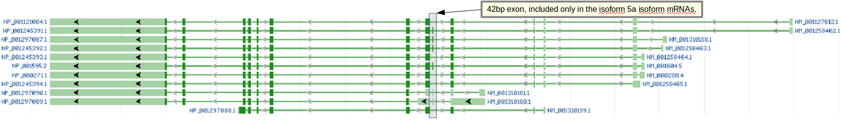

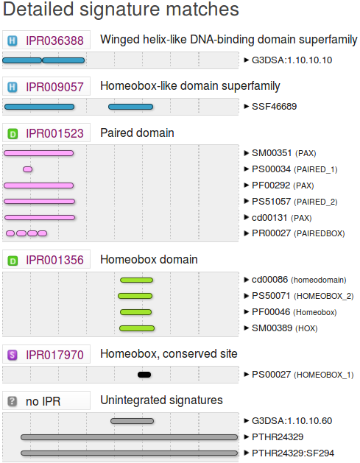
Are the Interpro results broadly as you might expect?
Yep … two domains, homeo & PAX, as suggested by NCBI. Here more domain/motif databases are quoted, but the conclusion is the same both sides of the Atlantic.
Note the inconsistent naming of the domains! Is this really necessary one muses? Life is muddled enough already surely. How long does it take to choose a single name?
This graphic will be considered in more detail later when we look ay Interpro more closely.
Sequence formats.
2 varieties required. For analysis (FASTA) or for storage in a database with annotation (GenBank, EMBL).
FASTA for all the sequences saved so far, minimal annotation, just enough for identification. The sequence is the issue.
>NAME Description
Sequence … … …
>NAME Description
Sequence … … …
Genbank or EMBL (why two!!?) where the annotation is the primary focus (although a bit silly without the sequence!). Formats for the databases. Pity there is two, but to expect too much sanity between EMBL and NCBI is clearly asking too much. Here we look at Genbank, later we will see EMBL. I will not elaborate, both have online manuals (GenBank, EMBL). The basics are intuitive (I hope).
Some reference to the times of many many formats here???
Can you see the official gene name PAX6, mentioned in this entry?
No … PAX6 occurs several times in the page (try searching with Ctrl F) but only in the page annotation, not in the databases entry!
Do you think you would find this PAX6 mRNA using the search term PAX6?
Absolutely not!!
A superficial mention of the Gene Ontology Project.
Very superficially … possibly here?

Can you find the additional genes PAX6-AS1 and ELP4 in the genome displays you have looked at so far?
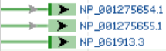
The Genome Data Viewer picture prefers to show the location of the RefSeq mRNAs that support the existence of ELP4.
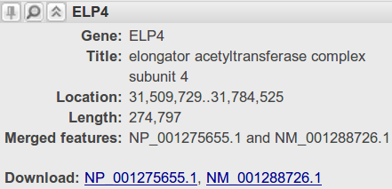
Hover of any of these and the link to ELP4 is revealed.

The Ensembl display you viewed earlier clearly includes all its predictions of transcripts for ELP4.
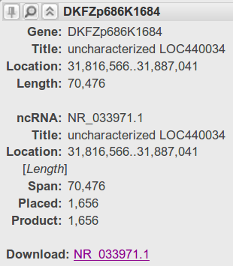
The Genome Data Viewer picture shows the location of the RefSeq RNA that support the existence of PAX6-AS1.
Hover over the RNA reference. An association with a gene called “DKFZp686K1684” is revealed. But “DKFZp686K1684” is the gene-synonym of PAX6-AS1. So the gene is discovered, if indirectly.
This gene synonym implies that this gene was originally identified by the German Cancer Research Centre (DKFZ).
No mention of PAX6-AS1 Though? Unless you Download NR_033971.1 and look at the FASTA description line which reads:
>gi|300068930|ref|NR_033971.1|:1-1656 Homo sapiens PAX6 antisense RNA 1 (PAX6-AS1), long non-coding RNA
Declaring that this RefSeq RNA is a feature of a non-coding gene called PAX6-AS1. The only reason for naming it such being that it slightly overlaps the PAX6 gene on its antisense strand.
PAX6-AS1 is also represented in the Ensembl view of the PAX6 region. However, it is not so easy to find. Certainly there is no obvious evidence is the view as you examined it previously.
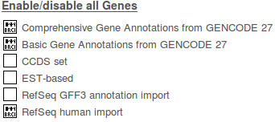
To find PAX6-AS1 (even disguised as DKFZp686K1684), should you really want to, try the following. First add the RefSeq human import track to your display. To achieve this, elect to. In the Genes subsection of the Genes and transcripts section, turn on RefSeq human import, choosing Expanded with labels.
Finally click on the in the top right hand corner to Save and close your selections.
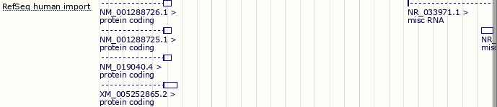
Essentially, you have asked for some RefSeq based predictions from the NCBI to be added to the display. Amongst these (top right) is the misc RNA prediction based on the match between the RefSeq sequence NR_033971.1
Job done? Well … yes I think so, but having travelled so far! Let us proceed to the tortuous end.

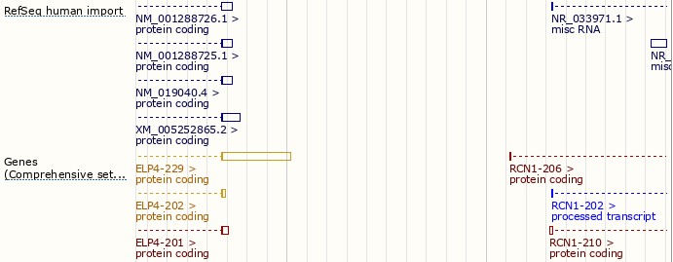
Notice the suspicious matching of some of the RCN1 gene transcripts and the new misc RNA from the NCBI (I removed the Genes (Basic set from GENCODE 27) track from the display to enhance clarity).
For a closer look, adjust the Region in view to expose the whole of that covered by NR_033971.1
To do this and then blunder about with the zooming and sliding and dragging tools until you get a view something like mine ... OR, you could use the trick it has just taken me an hour to discover, of selection the area desired by entering the RCN1 gene name in the appropriate place!!!
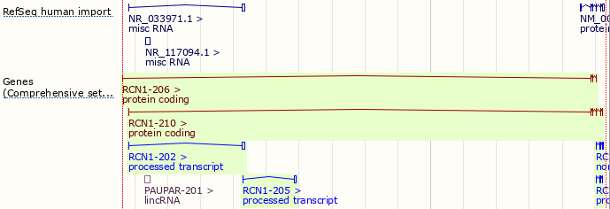
Now I am even more convinced by the similarity of structure of the processed transcript RCN1-202 and the misc RNA NR_033971.1
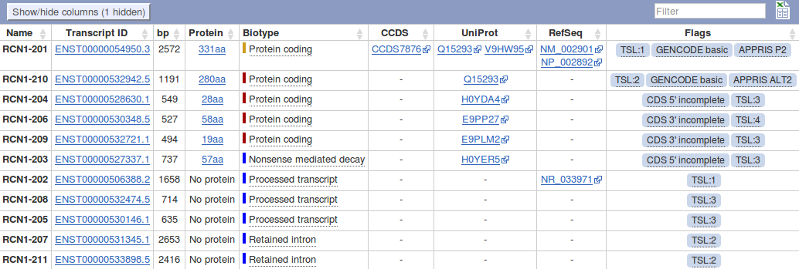
Time to look at the transcript table for RCN1 for the detail.
Go to the RCN1 Ensembl gene page using the main search option at the top of your current page. Make sure the transcript table is in view and take a look at the entry for the processed transcript RCN1-202.
By the Lord Harry! processed transcript RCN1-202 is based exclusively on the evidence of the match between NR_033971.1 and the genome!
I conclude that what the NCBI predict as the non-coding gene PAX6-AS1 with a single transcript based upon the RefSeq RNA NR_033971.1, Ensembl predicts as a non-coding transcript of the protein coding gene RCN1.
All this nonsense achieves rather little, in the context of the exercise, I suppose. I certainly do not want to suggest you follow your way through the pain I have just endured. However, I hope this little diversion into pedantry does illustrate how using multiple sources of imperfect information can be less than straight forward. To obtain a complete picture often requires lot of effort and patience. Never mind, it will ever get better … possibly.
The role of “contigs” in the human genome project.
The objective here is to establish some understanding of what these two sequences that you have found are. To do this it is necessary to understand how the Human Genome was determined using the sequencing technologies available at the turn of the century.
Broadly, the Human Genome was considered to big to sequence in one step. Each Chromosome was therefore processed separately.
However, even the smallest Human Chromosome was too large to be efficiently sequenced as a single entity. Accordingly, Chromosomes were fragmented randomly into manageable sections (20-40Mb at the start of the project, up to 150Mb by the end). Each fragment was cloned and sequenced separately. The sequences determined for the chromosome fragments are, in this context, referred to as Contigs. The Contigs, once reassembled, determined the sequence of each entire Chromosome. Time for President Clinton to, somewhat optimistically, announce the task completed.
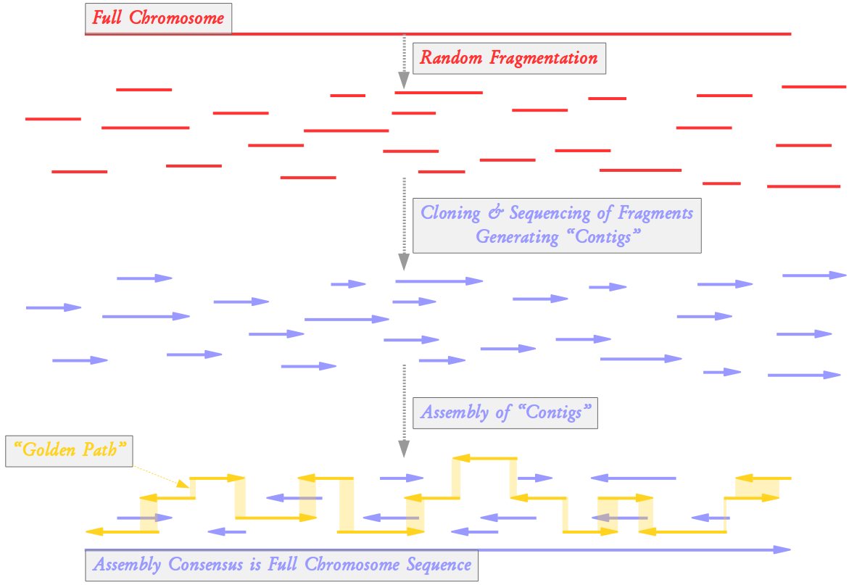
All the individual Contig sequences are retained in specialist databases. A minimal selection of the Contigs are stored in more general databases such as those you are searching in this exercise. The selected Contigs form a “Golden Path” through the assembly of all Contigs. The “Golden Path” is such that the entire Chromosome is represented using the smallest set of contigs practical.
Clearly, just the contigs of the “Golden Path” would be insufficient to reliable determine the Full Chromosome Sequence. “Golden Path” elements might overlap only by a few tens of base pairs. Such an overlap would not be credible except for the knowledge that it is supported by many other contigs stored elsewhere.
So, you are looking at the two “Golden Path” contigs whose overlap fully encompasses the entire PAX6 gene. Your next task is to use blast to compute the overlap between the two contigs.
To conclude, a final note on the term “Contig”.
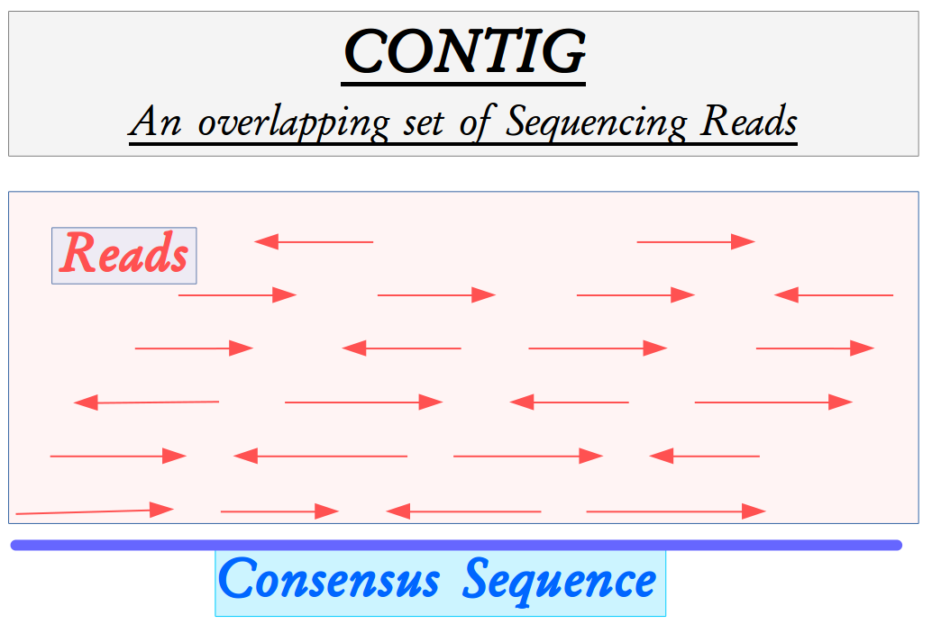
Contig (short for Contiguous) was a term introduced by Rodger Staden to mean an overlapping set of sequencing reads.
Once assembled, any overlapping set of sequencing reads (Contig) will acquire a Consensus Sequence that is its single best representation.
The ultimate objective of any sequencing project is to create a single Contig that represents the entire target region. The Consensus Sequence of this final Contig will be “The Answer”.
Inevitably, due to incomplete data and/or insufficiently clever software, the initial assemblies generated many partial region Contigs. Sequencing and assembling must continue until a whole region Contig, of acceptable quality, is computed.
For reasons of convenience, the term Contig has come to mean the Consensus sequence associated with a Contiguous set of sequencing reads. This is the meaning I have used in the preceding discussion.

How many of the PAX6 paralogues are associated with the conservation of the Paired Box domain?
The first 8 entries in the “Quality Ordered” list of Paralogues are recorded as being associated with the Paired Box domain of PAX6 in the Ensembl identifier and gene name column. So there are 9 PAX paralogues for Human (according to Ensembl, and all the other sources I have come across). They are PAX1 PAX2 PAX3 PAX4 PAX5 PAX6 PAX7 PAX8 and, last but by no means least, PAX9.
The remaining 42 list entries are recorded as paralogous to the Homeobox domain of PAX6.
Some paralogues seem to have two regions of high similarity (e.g. PAX4 or PAX2), others only one (e.g. PAX1)? Can you explain?
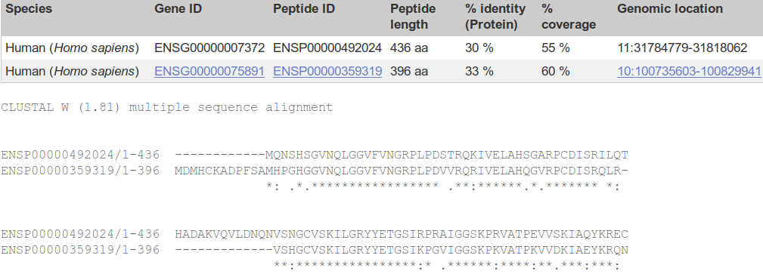
The obvious way to decide which regions of the aligned proteins have been best conserved is to examine the alignments. Some of the PAX paralogues also show conservation in the Homeobox region. Rather than plough through all 8 separate pairwise paralogue alignments to determine the full story, it would be a good strategy to gather together the sequences of all 9 PAX paralogues and construct a multiple alignment (we will consider the issues of Multiple Sequence Alignment, MSA, in a separate exercise, later)? To save time, I will do this for you.
First note that the protein ENSP00000492024, used to find the orthologues to the PAX6 protein, was also used to find the paralogues. You could prove this to yourself by looking at a few of the pairwise paralogue protein alignments. I aligned this version of the PAX6 protein (isoform 5a, the longest isoform) and the 8 paralogues reported by Ensembl.
The results I show you were computed by Clustal Omega at the EBI, but I put the Clustal w/o numbers output through a program called Jalview (which you will meet later) to make them prettier.
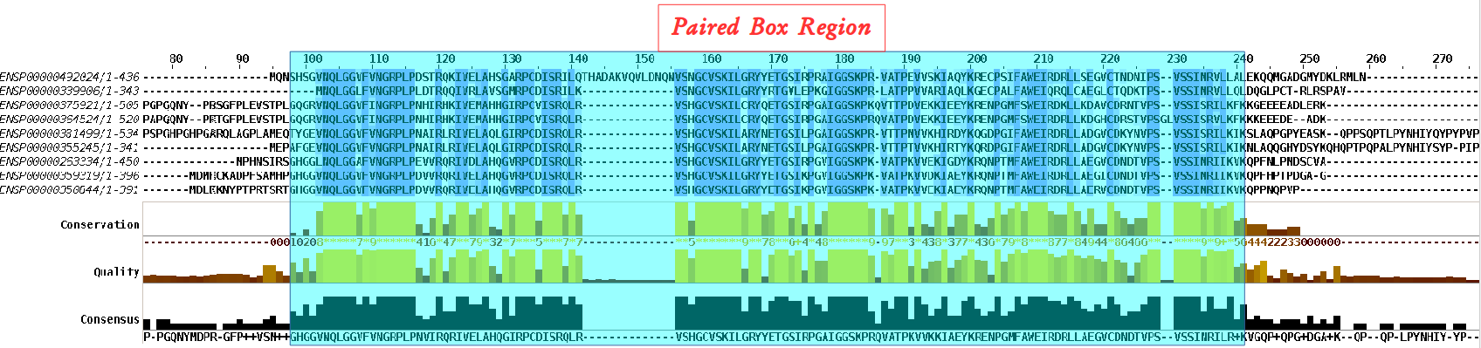
All the aligned proteins are Paired Box proteins. By definition, they must all include a Paired Box Domain. It should not therefore be surprising that the region of this multiple alignment coincident with the Paired Box domain of the PAX6 protein (the top one) is very highly conserved between all the aligned proteins.
Note that only the PAX6 protein is represented by the isoform 5a, all the others are canonical isoform 1 proteins. I am sure that does not mean that only PAX6 has an isoform 5a. I suspect it is simply that the longer protein is best for searching databases that will present only the canonical shorter isoform for matching.
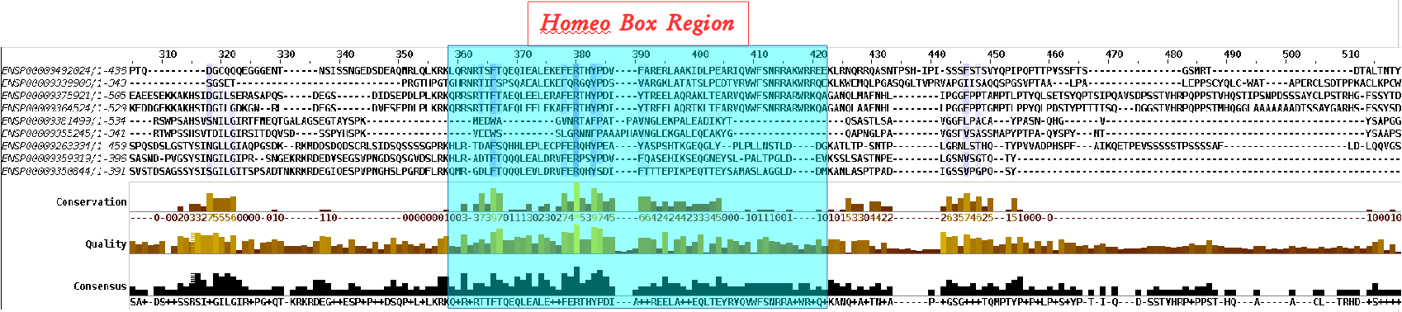
There is something odd around the region of the PAX6 HomeoBox. There is high conservation between some of the Paired Box proteins (the top 4 maybe) but not all of them (specifically. the bottom 5).
Well, these are Paired Box proteins. They are all obliged to have a Paired Box Domain, however, nowhere in the rule book does it insist they also have a Homeo Box Domain! It would appear, some do and some do not. Which is fine This observation will be confirmed by some of the documentation you will read soon and also during the exercise in which we investigate features of blast.
Note that the paralogues that have both a Paired Box domain and a Homeobox domain are only reported once, as a Paired Box paralogue.
Are you surprised that the precise location of the PAX6 Homeobox domain is not identically predicted by the SMART and Pfam Domain Databases? If not, why not?
Both Smart and Pfam predict the locations of protein domains. They both use similar, but not identical, methods. In this case, both predict a Homeobox domain where it is very likely that there is a Homeobox domain. This is surely very good news. Should we really expect the predicted locations to be identical? These are just predictions after all and it is questionable whether domains really have precise amino acid specific locations. It is doubtful that all human experts would agree on the most probable exact domain location. Why would we expect computer programs to do better?
How is that all the predictions, of different domain databases, for a Paired domain have the same Interpro identifier?
Interpro does not have its own domain models. It defines domains by the predictions of other domain databases including Prosite_profiles, Smart and Pfam. So if, as here, a Homeobox domain is detected by Prosite_profiles (PS50071), Smart (SM00389) and Pfam (PF0046), there exists 3 pieces of evidence to encourage Interpro to declare it to believes there to be a Homeobox domain (IPR001356).
Any one of the Prosite_profiles, Smart or Pfam hits would have been sufficient for Interpro to assign membership of this domain to its Homeobox classification IPR001356.
Where would you expect a Paired domain to occur in a protein?
What expectations do you have concerning what typically follows a Paired domain?
The Paired domain is here said to be found “generally in the N-terminal part” of the protein. That is certainly true of all the examples we have met so far.

The claim here that “An octapeptide and/or a homeodomain can occur C-terminal to the paired domain, as well as a Pro-Ser-Thr-rich C terminus” confirms what was seen from the Human PAX paralogue alignments Previously. That is, sometimes there is a homeodomain C-terminal to the Paired domain, but not always.
From the UniProtKB documentation, you saw that Human PAX6 at least has “a Pro-Ser-Thr-rich C terminus”
Note the mention of the important prd Drosophila gene here, overlooked in the Ensembl presentation of orthologues to Human PAX6?

InterPro did not detect the Homeobox HTH as it did the Paired box HTH. Have you any thoughts as to why this might be?
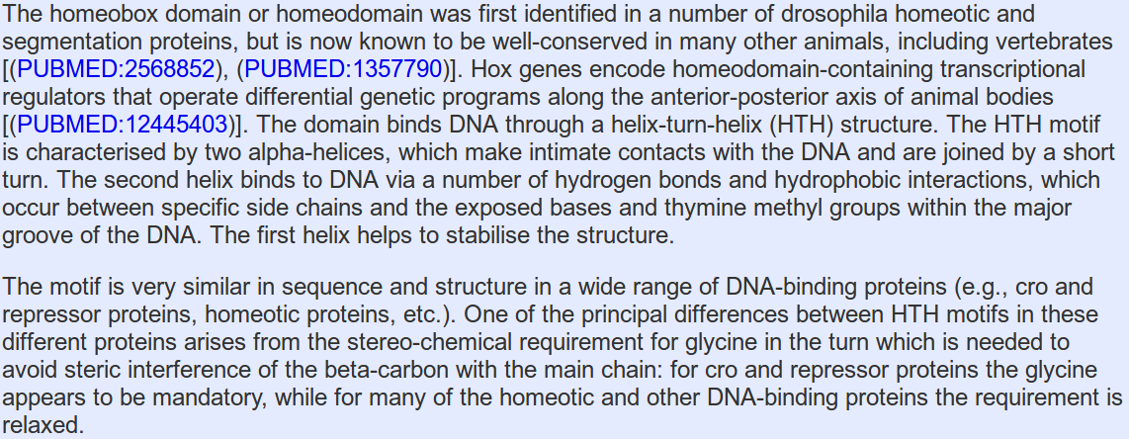
The documentation from SMART, which really originates from Interpro, clearly claims the presence of an HTH as the DNA binding element. However, Interpro does not predict the presence of an HTH, as it did for the Paired Box?
I cannot be certain why, however, HTHs are difficult to detect just with computer programs. I used to include an exercise that tried for this protein. It proved impossible to obtain a complete picture. One of the reasons being that there are a number of different types of HTH. Any given program will typically only search effectively for one type.
Not a very satisfactory answer!

Why do you suppose there is no match from PRINTS or Prosite patterns to support the Homeobox domain prediction for this protein?
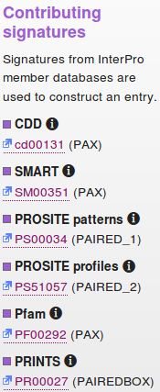
What do you suppose the Homeobox conserved site might be?
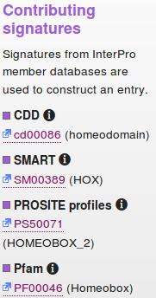
Well, the short and rather boring answer to the first part of this question is that Interpro did not interrogate PRINTS or Prosite patterns when it considered the existence of a Homeobox domain in this protein!
To prove this you only need to follow the links to the relevant Interpro entries and look at the Contributing signatures.
Both PRINTS and Prosite patterns are used to determine the presence of a Paired domain. Neither is used to detect a Homeobox domain.
More interestingly, in the case of Human PAX6 at least, it would not have made any difference had PRINTS and/or Prosite patterns been considered for the Homeobox domain prediction.
Interpro did actually register a match between the PAX6 human protein and the relevant Prosite pattern. However, Interpro judged this match as too weak (i.e. the probability of a false positive is too high) to be regarded as viable evidence for predicting a Homeobox domain. Interpro records the match as a conserved site, as you can see from your Interpro graphic.
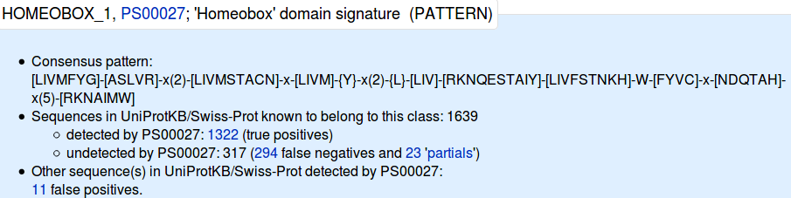
Were you to look at the relevant Prosite entry (the illustration is a link), you would see that the Prosite pattern is quite long, but rather non-specific (the pattern syntax will be fully explained somewhere else). It misses 317 of the 1,639 Homeobox domains in SwissProt! And incorrectly claims a Homeobox where no Homeobox exists on 11 occasions (according to SwissProt, which is assumed immaculate in this context). I think Interpro is correct to take a hit with this pattern rather lightly.
PRINTS has a domain model for HOMEOBOX, however, it does not match the PAX6 Human Homeobox domain sufficiently well to register as a hit! Nearly, but not quite good enough. One might speculate that, in the judgement of Interpro at least, the chance of a false negative is too high to consider the PRINTS model seriously for Homeobox detection.
You could just believe me when I claim the PRINTS HOMEOBOX model does not work in this instance? Instead just speed read the next two pages concentrating only on the last bit which covers the struggles of PRINTS to find a HOMEOBOX (recommended), or you could prove all for yourself by doing the search. Just for the few doubters and those of you who have nothing better to do, I offer full instructions here (although I feel sure you could work it all out for yourselves).
The PRINTS database defines functional protein families. Domains are identified by a number of short, ordered, well-conserved regions. A full match to one of these “fingerprints” will match all the relevant short regions in the correct order. A partial match is recorded if some are missing or if they occur in an incorrect order. PRINTS can be searched using the fingerPRINTscan program.
Go to the fingerPRINTscan home page:
http://130.88.97.239/PRINTS/
Select the FPScan link and paste in the PAX6_HUMAN sequence in raw format. Leave all defaults and hit the Send Query button.

The top hit is with the PAIREDBOX fingerprint. No surprise here. Move down to the list of the best 10 hits.

In the list of Ten top scoring fingerprints, there is a second fingerprint that matches all elements in the correct order. This is the HTHREPRESSR. Click on the HTHREPRESSR link and from the documentation you can confirm that an HTHREPRESSOR is an HTH motif of which you might have reasonably expected three? Move back to your fingerPRINTscan results. Shimmy down to the Ten top scoring fingerprints.

From the Position information included in the Detailed by motif table, you can see that the HTH motif that fingerPRINTscan finds is the one that is part of the HOMEOBOX domain it fails to fully detect. PRINTS does not see the HTHs in the PAIREDBOX domain.


Take a look at the GRAPHScan for the PAIREDBOX prediction and see that is is good! Four out of four very positive motif matches are shown.

Each motif by itself might not be significant. Together, in a fingerprint, they constitute a confident prediction for a Paired Box domain.

Click on the Graphic link for the HTHREPRESSOR hit. The best (highest) of the four motif 1 hits plus the single motif 2 hit is the finger print that justifies the HTHREPRESSOR prediction.

Move back to the Ten top scoring fingerprints table. Notice that, whilst there is a prediction for a homeobox, it is an incomplete prediction. Only two of the required motifs were detected and so no prediction of a homeobox would have been made automatically by fingerPRINTscan. This explains why there is no PRINTS prediction for a homeobox in the Uniprot Feature Table for PAX6_HUMAN.
However, if you click on the Graphics link for the “ 2 out of 3” motif hit for homeobox, you will see that fingerPRINTscan only missed the homeobox by a whisker! Just a minute bit short for the first motif!
From the Top ten scoring fingerprints table, you can see that fingerPRINTscan considers the first motif to be missing (“.II”). But I see a fairly healthy motif 1 in the graphic? I think I would be inclined to give the homeobox the benefit of the doubt, would you not? Programs can be so very picky!!! Its a hit!!

DPJ – 2019.01.30

This despite WT1 being at the top of the list? This is a new promotion for WT1. For years it has been but a close second to PAX6. Whilst congratulations are clearly in order, this elevation is jolly inconvenient for the story I wish to reveal. So … I intend to ignore it!
The annotation is very sparse which makes these entries very hard to find directly. The EML-Bank versions include some links to Ensembl codes. These would have been helpful but are not part of the official International Nucleotide Sequence Database Collaboration (INSDC) annotation that should be consistent between GenBank, European Nucleotide Archive (ENA), which includes EML-Bank, and DNA Data Bank of Japan (DDBJ).
As opposed to comparing each of the two clones against an entire sequence database.
Just because its neater. In my, significantly less than humble, opinion anyway.
If, like me, you have conceptual problems with major and minor groves. Try this animated picture. Helped me at least. As did the image above.
Third from the bottom of the first page, last time I counted.
PDB is the main database for 3D protein structures. SCOP and CATH are also 3D structure related databases.
If you really wanted to, the best approach is to search for P26367 in the search box at the top of the page and then look for the Homeobox domain entry in the Detailed signature matches list.
Not surprising as UniProtKB simply links to Interpro to show you its graphic.
Structural Classification Of Proteins.
Broadly, CATH is to Gene3D as SCOP is to Superfamily.
Until recently, matches with Gene3D entries were also regarded as significant here.
Despite the inexplicitly undecorated URL, this is the currently official PRINTS home page provided by Manchester University.

