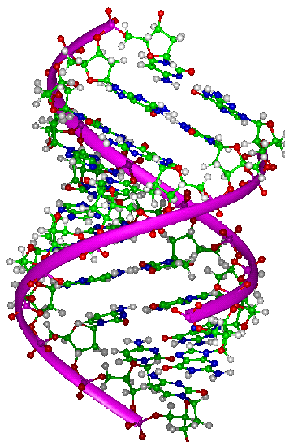

Basic Bioinformatics

A Practical User Introduction

Friday 15 April 2016

This material is intended to be used for self instruction or in a more formal class setting. When offered as a set of class exercises, I describe my intentions as follows:

Overview
This is an entry level course aimed that those with a reasonable biological background but no significant experience with bioinformatics. The course is broadly based around a series of exercises in which a combination of simple analytical tools and publicly available databases is applied to the investigation of a single human gene. The training manual for the course is comprised of detailed instruction for the tasks undertaken. Included are, questions (with answers) and discussion of and the interpretation of the results achieved. The manual is under constant development, a recent version is available online.

Outline
Participants are asked to imagine an interest in the disease aniridia. Course exercises then provide extremely detailed instruction leading participants to discover the gene primarily associated with this disease and all that is interesting about that gene and its protein products.

Objectives
This course is not intended to fully meet the requirements of many modern research projects. The intention is more to examine and practice the basic tools that underpin many current bioinformatic solutions and have changed little over the years. Specifically, we set out to show how many answers can be simply be looked up in an appropriate information source and/or how it is also usually a trivial matter to compute the similar/identical answers using readily available software.
We set out to explain the operation of the various programs used in the exercise, but only to the extent that allows a user to select parameters intelligently and to interpret results fully.

Timetable
The main topics covered, in order, are as follows:
Simple Information and Data (i.e. sequence) retrieval from public resources (primarily the NCBI and EBI).
Genome Databases (primarily Ensembl including access using Biomart)
Pairwise Sequence Alignment (dotplots, global and local alignments)
Database searching (using elements of the blast family)
Primer design (primarily using the NCBI services)
Secondary Structure Prediction (GOR, JPred)
Multiple Sequence Alignment (clustal, muscle, t-coffee … )
PSI-blast (an explicit example, but incorporated into a number of the previous topics)
3D Structure (a very superficial look specific to the exercise protein)

The timing can vary depending on circumstances. A very rushed 3 days to a relatively leisurely 5 days.

DPJ – 2016.03.03

Course Objectives
The aim is to present a hands-on introduction to the ways computer resources can be utilised to assist the molecular biological researcher. Our target audience is the informed biologist who is new to using the computer for such a purpose. We cannot cover “everything” but hope to introduce a range of computing facilities available to answer simple molecular biological enquiries. Where appropriate, how programs work will be discussed, but only as far as is required to understand the parameters that a user is required to set and the results generated. We will assume that a brief introductory talk mentioning the more important databases has been delivered before offering these exercises.
There will be a mixture of talks and frequent practical sessions. During the practical sessions you are encouraged to go through the exercises in the book, as far as is practical, at your own pace. Please ask for assistance at any time you are unsure how to proceed or require clarification on any point.
At various points in the exercises, you will be asked to answer simple questions. The purpose of the questions is to draw your attention to some aspect of what you are doing rather than to test your understanding. Sometimes, the answers you note down will be useful later in the exercise, so try not to skip over the questions. If you cannot answer any question, please just ask.
It is now less usual than previously for individual researchers to meticulously analyse small volumes of data. Sequence data is typically generated and analysed by large, well equipped, Institutes. Whole genomes are processed in a single project. Sequence data, analytical results and associated, often automated, interpretation are centrally organised for easy access. In consequence, many investigations can be completed by simply locating answers stored in information rich databases. Accordingly, our exercises will be roughly split into two sections. In the first we will take a topic and see how it is possible to discover effectively all one would wish to know from various combinations of appropriate information resources over the internet. In the second section we will look at how many of the same conclusions might have been reach by applying analytical software to raw sequence data. The software tools we will use are essentially those used to generate the pre-processed “answers” achieved in the first section so it should not be surprising that the results will be very similar.
Of course, we will cheat! Our topic will be a well researched one to ensure that there is a full set of pre-processed answers to find in the databases we interrogate. But the principles we will use are universal. As completely as we were able, we have built all the exercises around a single starting point. That is, a need to find out all there is to know about the human disease of the eye called aniridia.
If your research does not involve humans, please do not be concerned. Using a human example ensures a well researched topic, but very few of the resources we will visit are specifically human. The basic principles of how to proceed really are not organism specific.

DPJ/PDFJ – 2016.03.03
Searching for ready made answers
To recap, our objective is to discover what we can about the disease aniridia and its causes. There are many ways we could begin, including the ultimately lazy (but often very effective) universal strategy of “google”. In an attempt to be slightly more directed, and as our example query involves a human disease, we will start with GeneCards.
GeneCards
If we assume the disease might be genetically linked, a sensible starting service for our investigations might be GeneCards, a famous service maintained in Israel by the Weizmann Institute. Genecards is:
“ ... a searchable, integrated, database of human genes that provides concise genomic, transcriptomic, genetic, proteomic, functional and disease related information on all known and predicted human genes”
Information from many sources is stored for each human gene in a “card”. These cards can be searched using clues (Keywords) specifying your interests to determine the gene(s) that might be of interest. In addition to summarising what is known about a gene, each GeneCard offers links to pertinent internet resources for further investigation. Effectively, GeneCards has searched tens of databases for each gene and saved the results as links. Thus, one search of GeneCards can substitute for many individual searches of other resource sites.
Hopefully you have a browser window open at this stage, if not, open one up and go to:
http://www.genecards.org
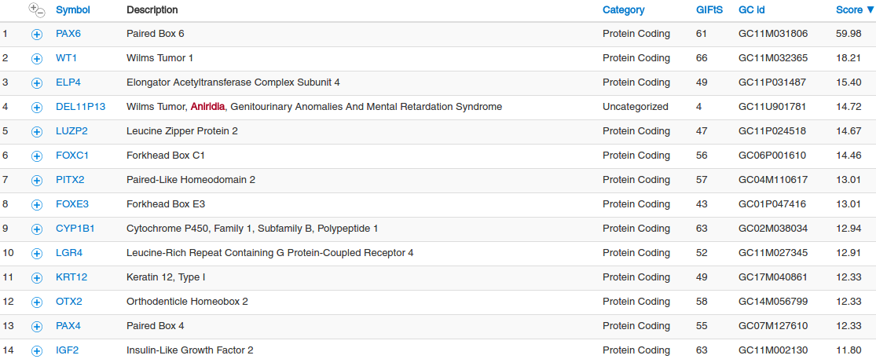
Leave the type of search set to set to , enter the Search Term aniridia and click the button. You will be rewarded with a list of links to GeneCards in order of “relevance”.

The score for each GeneCard suggests how close a match has been found between your search term(s) and the gene. The top hit should be a clear “winner”.
Words matching search terms are marked in red.
What do you conclude to be the gene most relevant to aniridia?
To confirm the top hit as the best match, click a few of thebuttons by the gene names for more information.
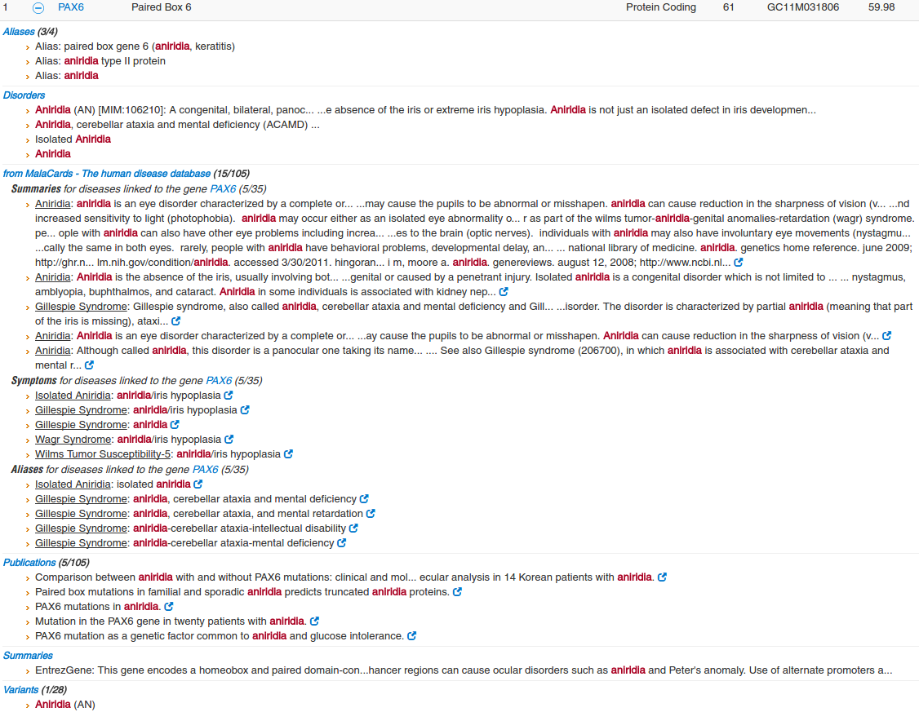
Follow the link to the most relevant GeneCard.
At the top of the GeneCard is a table offering the opportunity to Jump to any of the sections of the GeneCard easily.
Discover some of the properties of PAX6 using the Jump to section menu.
Cytogenetic location (Jump to the Genomics section).
Number of UniProt isoforms (Jump to the Proteins section).
Jump to the Transcripts section. Notice the number of estimated PAX6 transcripts is inconsistent. In particular:
How many transcripts are predicted by matches to mRNAs in REFSEQ?
How many transcripts are predicted by the Alternative Splicing Database (ASD)?
How many transcripts are predicted by Ensembl?
How would you rationalize the discrepancies?
Within the Transcripts section, there is an Additional mRNA sequences: subsection listing mRNA sequences from Genbank that match PAX6. Follow the link to the Genbank entry with accession code BX640762.1. You will be taken to the entry as it is stored in the Genbank database. The sequence and its annotation is displayed in Genbank format and surrounded by useful links that we will ignore for the time being.
How many times does the term PAX6 occur in this entry's annotation?
Move back to the PAX6 GeneCard.
Why might the number of Additional mRNA matches not match the number of PAX6 transcripts?

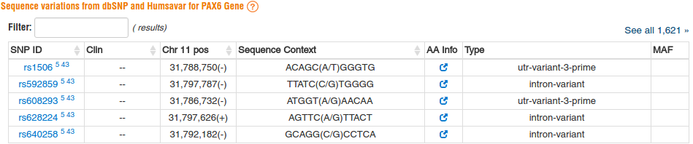
Jump to the Variants section.
Listed are the first 5 variations in the genomic region of PAX6 according to the two variant databases dbSNP and Humsavar.
Click on the See all link to show all relevant variations. Move to the bottom of the list where you will find the, relatively few, Humsavar database entries. Follow one or two of the Humsavar links to arrive at pages from ExPASy in Switzerland.
What sort of variations are recorded in the Humsavar database?
The dbSNP variants are linked to corresponding Ensembl data, where such exists, by the superscript 5. Try a couple of these links.
Note that all SNPs available from dbSNP are also available from Ensembl. Why might that be?

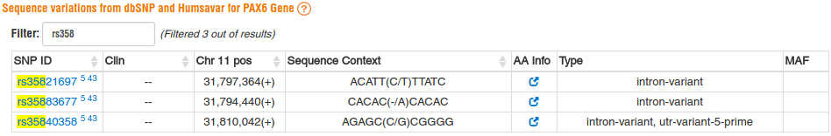
Filter with the term rs358. You should find three dnSNP database entries.

Why might it be considered odd that rs35883677 be included in dbSNP?

GeneCards provides links to entries that relate to PAX6 in many other databases (e.g. Ensembl , OMIM). You can access entries in any of these databases from GeneCards. Mostly for later reference, note:
The Ensembl Accession Number for the aniridia gene (Jump to the Aliases section).
The number of human PAX genes (Jump to the Paralogs section).
What Orthologues exist in Mouse and Drosophila (Jump to the Orthologs section)?

What functions are suggested for PAX6 (Jump to the Summaries section and/or Jump to the Function section)?

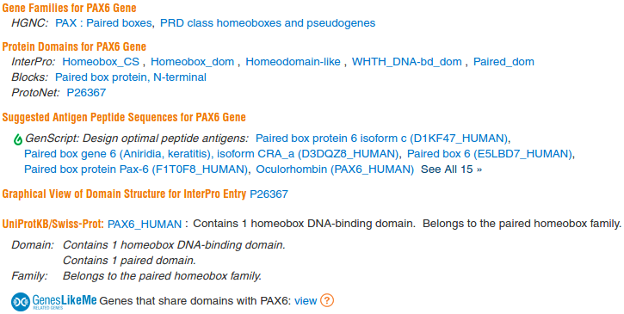

To view the domain structure of the PAX6 protein, Jump to the Domains section. In the Protein Domains for PAX6 Gene section, the InterPro and Blocks families to which PAX6 belongs suggest a Paired Box domain at the N terminal, and a Homeobox domain.

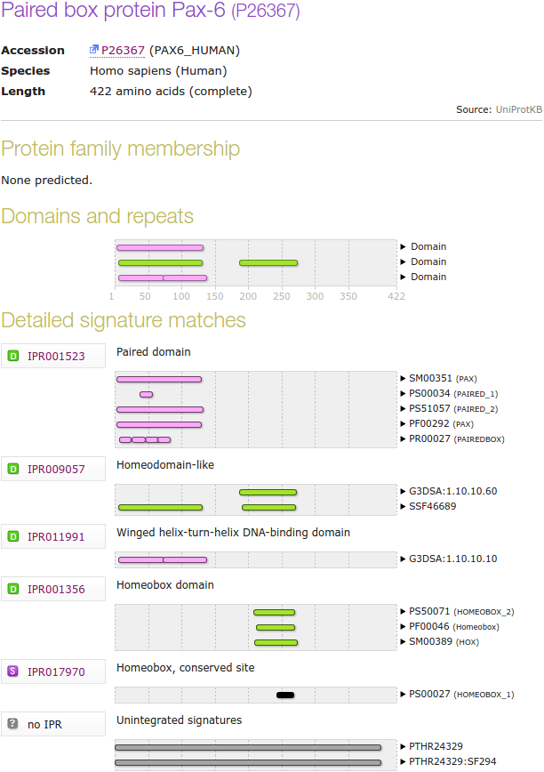

Try the. This is a graphic generated by the Interpro database. See that the presence of the two main domains mentioned in the textual report is confirmed.

See the membership evidence for the two Interpro families that suggest a Paired Box followed by a Homeobox.

We will return here later for a closer look. For now, given that the Signatures whose identifiers begin PS represent Prosite matches and those beginning PR represent Prints matches. Can you explain:
Why there are two Prosite predictions for both the Homeobox and the Paired Box domains?

Why Prints appears to predict four very small Paired box domains instead of the single larger domain indicated by all the other predictions?
A quick look at OMIM 
Retrieving and Examining DNA Sequence Data
A good start would be to retrieve some of the DNA sequences that are associated with PAX6, the gene most associated with the disease aniridia, as was discovered from GeneCards. This could be done in a number of ways at any of several sites. The most popular choice must be to use Entrez at the NCBI.
First, go to the Home Page of the The National Center for Biotechnology Information (NCBI) (if necessary, try your Bookmarks, as a last resort, type in the URL “www.ncbi.nlm.nih.gov”).
You will arrive at a page offering access to the many NCBI resources available to you. Currently, you only require to search for DNA sequences, specifically those that relate to aniridia, so first set the database selection field of the Search facility at the top of your page to Nucleotide. and click on the Search button.
You are now offered the subset of NCBI resources specific to Nucleotides. You need to search the databases with more sophistication than the basic search offered, so click on the search option button.
Then in the , change to in the pull down menu associated with the first search field and type in the keywords:
chromosome 11
In the second search field, again change to and type in the keyword:
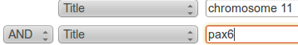
pax6
You are asking Entrez to search for all Nucleotide database entries that contain the terms chromosome 11 and pax6 in the section of their annotation intended to be a succinct brief description (I.e. Title) of the entry. Click on the  button to start the search going.
There is just one matching entry which is arrayed before you in Genbank format, very neat!! It was the DEFINITION line that you searched by selecting the Field value Title. I needed a few tries to get the right search to find just what was needed, and was a bit surprised at the simplicity and accuracy of the final search. You are looking at a RefSeqGene (a subset of the RefSeq database) entry. As such, it represents a genomic sequence for a “well-characterised gene”, in this case PAX6.
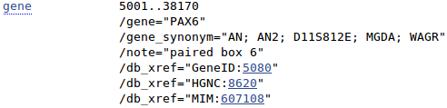
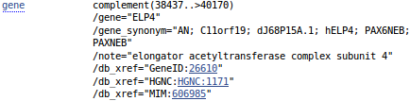
Take a brief tour of the FEATURES for this entry and you will see that there are actually two genes associated with this sequence. PAX6, of course, and ELP4 on the strand that is the complement of that represented here.
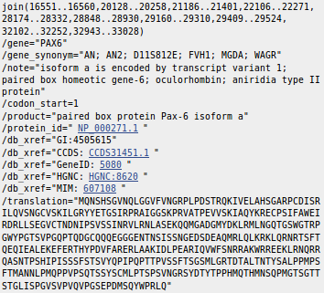
At the top of your page, Analyze this sequence by clicking on the Highlight Sequence Features option. The CoDing Sequence (CDS) feature for PAX6 is displayed for you by highlighting the relevant parts (the coding exons) of the sequence and displaying the CDS details including the DNA regions that need to be joined to form the CDS and the translation of the CDS.
Use the controls at the bottom of your page to look at the other features of this entry (select feature number and then click on the Feature button).
What were the features that you found?
Why might you have expected more features than there were?


Take a look at the COMMENT and PRIMARY sections just above the FEATURES. This entry is suggested to be constructed from two sequences from GenBank. That is, the products of two sequencing projects.

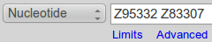
Take a quick look at the GenBank entries by entering their ACCESSION numbers into the Search box at the top of your page. Click on the button.


Lo and behold, the two GenBank entries are summoned forth. Take a look at one or both. Not particularly illuminating I think. These are clones sequenced as part of the Human Genome Project (HGP). They served to cover regions of Chromosome 11 and have little biological significance in themselves.


Move back to the list, as illustrated. Elect to Analyze these sequences, selecting from the extensive range of possibilities Run BLAST. We will look at blast properly later, the idea here is to simple prove that these two sequencing clones really do overlap in the fashion suggested by the evidence so far. So, elect to Align two or more sequences. Cut and paste one of the sequencing clone accession numbers from the Enter Query Sequence box to the Enter Subject Sequence section of the form. Elect to Show results in a new window. Firmly address thebutton.

Just one region of overlap should be identified.

How does the alignment you generated match up with the annotation of the original RefSeq entry you discovered?

Now for an entirely new search. The easiest way to get a fresh start is to move back to your browser tab displaying the GenBank Search results, and then click on the Advanced option of the Search facility at the top of the page. You should arrive back at the Nucleotide Advanced Search Builder offering a fresh start.

Set up a new search as illustrated and set it going. Ultimately simple this time. You have requested all Human sequences that are centrally associated with the gene PAX6.
You should achieve a list of 60 or so sequences, all clearly claiming PAX6 association and most proclaiming their humanity loudly in Latin.
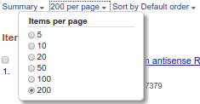
You will have more hits than can be displayed in one go. Also, the hits are arranged in a “Default” order which has thus far defied all my attempts to associate with any definition of logic!
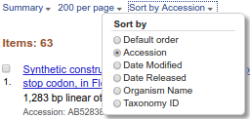
To deal with both of these issues, use the display control pull down menus at the top of your page to set the items per page to something big and the Sort by option to something sane.
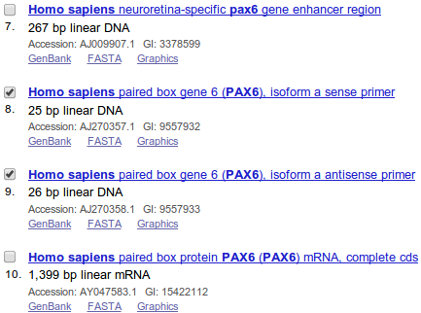
The list shows matches between the terms entered and the annotation of DNA sequences. Not all relevant sequences will be present. For example, the mRNA with accession number BX640762 was justifiably referenced in the PAX6 Genecard will not be in this list. PAX6 appears nowhere in the entire annotation of BX640762 let alone just its DESCRIPTION (or Title) field.

A little way down the list you should see two primer sequences. Their Descriptions suggest they are a pair of PCR primers used for picking out the PAX6 gene. Select both by clicking in their selection boxes.


Click on the sense primer. Properly, you would read all the References carefully. Instead, note the length looks about right and return to your list with the Back button.

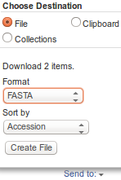
It will be good to investigate these primers later, so find the diminutive button which is near the bottom of your page and use it. Choose your Destination to be File and set the Format of that file to be FASTA. Strike the Create File button with a firm and confident click of your every ready mouse. With irritating presumption, the choice of file name is made for you. Your sequences are stored in a file named:
sequence.fasta
The NCBI is justifiably not famed for its understanding of poetry! Do whatever it takes to rename this file to be called:
pax6_primers.fasta
Retrieving and Examining Protein Sequence Data
For protein sequences, we will move from the NCBI and use UniprotKB. First move to the home of UniProtKB (www.uniprot.org).
Enter the GenBank accession number Z83307 that you discover at the NCBI into the Query box at the top of you page and then click the button.
You should achieve a list of around 10 protein sequences all associated with the genes PAX6 and ELP4. Most of the list will be unreviewed entries from UniProtKB/TrEMBL.
To simplify, click on the button that reduces the list to just the Reviewed entries from UniProtKB/Swiss-Prot.
Increase the information in the Protein names column by clicking the button.
Where have you seen these genes mentioned previously?
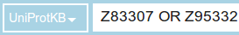
Now edit the contents of the Query box to be both the Genbank accession numbers that you discovered at the NCBI joined by the boolean operator OR and then click the button.
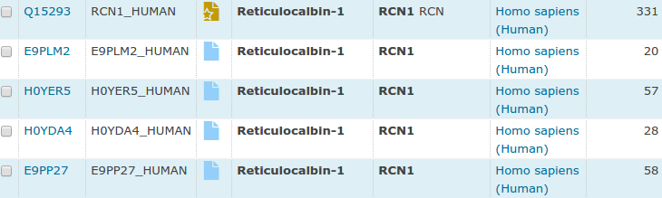
Your list of hits should be a little longer this time. Order the list byby clicking in the appropriate column heading. The extra proteins should be at the bottom of your list associated with a third gene to which introductions are still pending. Meet RCN1. Note that all but one of the proteins associated with this gene are unreviewed.
These entries are in UniProtKB/TrEMBL (indicated with aas opposed to awhich indicates a reviewed UniProtKB/Swiss-Prot protein).
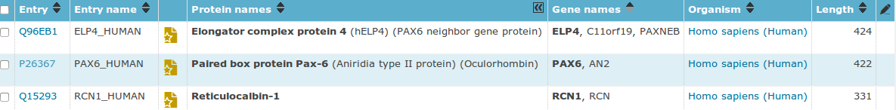
For a nice tidy list, again click on the button that reduces the list to just the Reviewed entries from UniProtKB/Swiss-Prot.
How is that this is the first occasion that the gene RCN1 has been apparent?
How is it that we have found any protein sequences at all by looking at the barren annotation of the two clones Z83307 and Z95332?
Select the entry PAX6_HUMAN by clicking in the selection box on the extreme left.
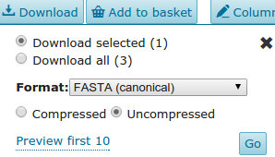
Click on the button near the top of your page. Ensure Uncompressed and FASTA (canonical) are selected, as illustrated, and click on the button. Do whatever it takes to get the canonical isoform of the selected sequence into a file on your Desktop called:
pax6_human.fasta
Deselect the entry PAX6_HUMAN. Click on the Accession number (P26367) to view the database entry for the protein you have just saved to file in all its UniProtKB splendour.
Note the navigation bar down the left hand side of the entry that enables easy access to the various sections of the database record.
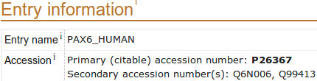
Move to the section.

Make a note of the first UniProtKB Accession number for the PAX6 protein.
Why do you suppose there is more than one Accession number for this protein?
Make a note of the UniProtKB Identifier (or entry name)?
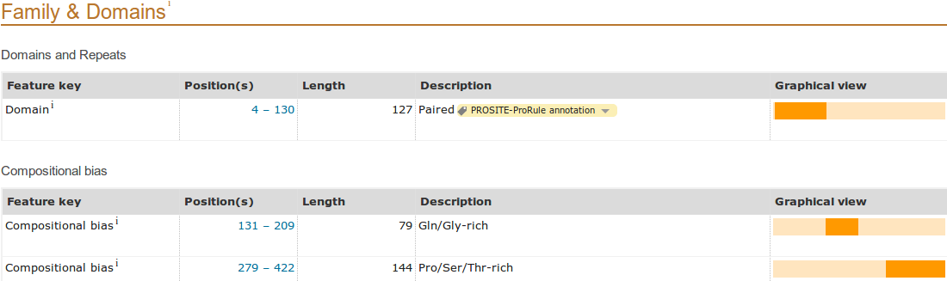
Move to the section.
Look in the Domains and Repeats section for the two major domains suggested by GeneCards. Only the Paired box Domain is present?
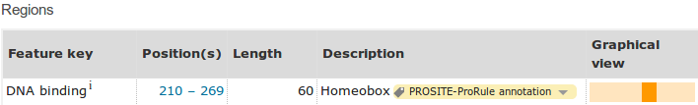
Now move to the section. Look in the Regions section.
You should see the Homeobox recorded as a DNA binding Functional region. Both the Paired box and the Homeobox are, of course, Domains and both are DNA binding Functional regions. It is messy that one is listed as a Domain, the other as DNA binding? Nevertheless ...
What are the start and end positions of the Paired domain?
What are the start and end positions of the Homeobox domain?
Note the range of the Proline, Serine, Threonine rich region at the end of the protein.
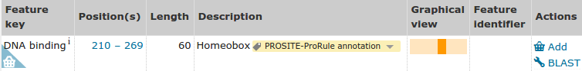
Whilst you have it in view, download the sequence of just the Homeobox region for analysis later on. The way to do this involves baskets? As in shopping baskets? OK, ours not to reason why ... just do whatever works. In this instance, click on the associated with the Homeobox region.
Go to the top of the page and click on . Select the only entry.
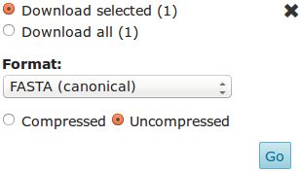
Click on the button. Accept the default settings as illustrated and click on the button.
Do whatever it takes to get the Paired box sequence into a file on your Desktop called:
homeobox_domain.fasta
Finally, open up the file you just created in an appropriate text editor and change the first line from:
>sp|P26367|210-269 to >Homeobox-Domain P26367(210-269)

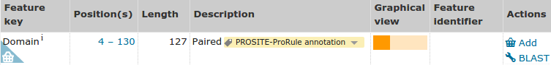
It would also be good to save the Paired box region for later analysis whilst it is nearby. So move once more to the section. Click on the associated with the Paired box Domain.
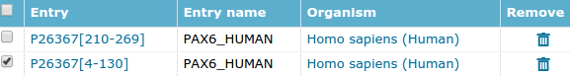
Go up the page and click on . Select the Paired box entry only.
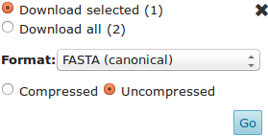
Click on the button. Accept the default settings as illustrated and click on the button.
Do whatever it takes to get the Paired box sequence into a file on your Desktop called:
pax_domain.fasta
As for the Homeobox file, open up the new file in an appropriate text editor and change the first line from:
>sp|P26367|4-130 to >Pax-Domain P26367(4-130)
To complete the job tidily, Click on the button to empty your Basket. Confirm that you really really want to tip all the entries out of the stupid Basket. Enough shopping for today?!?
Consider next the section. In particular, the Natural variants.
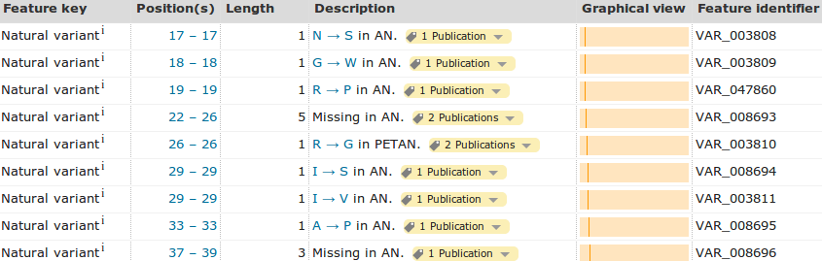
The mention of AN in the description implies that this variant is a cause for the disease Aniridia. All the variants recorded here are described as causal for either AN or PETAN. PETAN refers to another disease (Peters anomaly).
One might suppose that all the variants recorded as substitutions must all be associated with one or more SNP(s) in the genome.
However, only the variation at 375 is associated with a dbSNP entry?
Why do you suppose this is the case?

Click on thelink associated with position 33. This substitution is the disease causing Natural variant that is the focus of many of the exercises that follow. You will be taken to entry VAR_008695 of a variant database (glanced at when considering Humsavar whilst looking around GeneCards) at Expasy in Switzerland (to be revisited). This entry very probably represents a short cut to much we will more ponderously discover by other means. Too easy!! take a quick look and then move back to PAX6_HUMAN.

Move to the section.
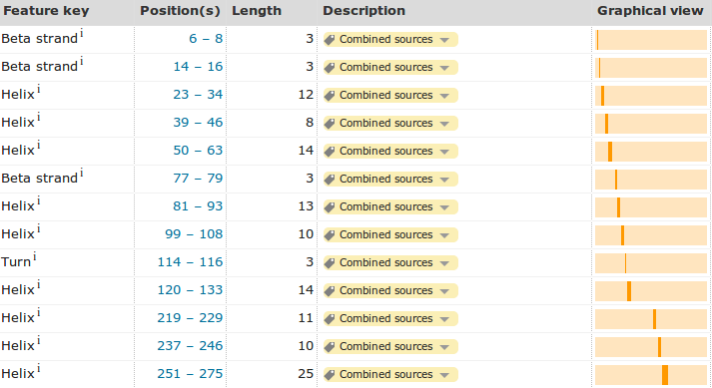

Click on the Show more details button.

Describe the arrangement of Helices within PAX6.

Note the start position of the middle helix of each set of three.

Note the end position of the third helix of each set of three.

Note the position of the Beta strands relative to the helix groups.

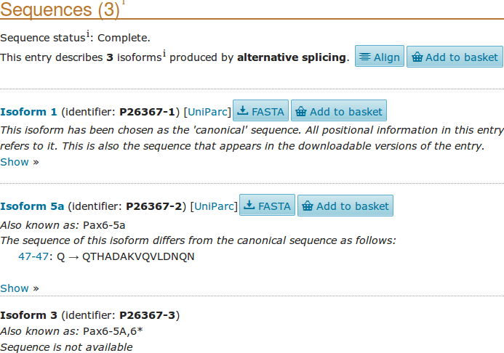
Click on the link to the section. This section confirms the Uniprot isoform count of 3 recorded in GeneCards.
The sequence of isoform 1, the 'canonical' sequence, is the one you will have saved in a file called pax6_human.fasta. Having admired this sequence, displayed by default, send it away by clicking on the nearest button.
The second isoform, Isoform 5a, is shown here to have 14 extra amino acids after position 47 (a Q) of the canonical sequence.
The 3rd isoform, Isoform 3, declares “The sequence of this isoform is not available”, indicating that although the literature records Western blots suggesting a third protein product, the protein sequence has yet to be determined.
Compare the two isoforms with sequence. Click on the link. The best isoform alignment is computed and displayed by ClustalW, a popular tool for aligning sequences, that you will use again later. The isoforms are extremely similar. The alignment highlights the only difference well. The extra amino acids in the second isoform are clear to see. Experiment with the Annotation possibilities. I choose to show the two major domains and the helices, showing clearly the way the helix triplets are arranged in the PAX and Homebox domains.
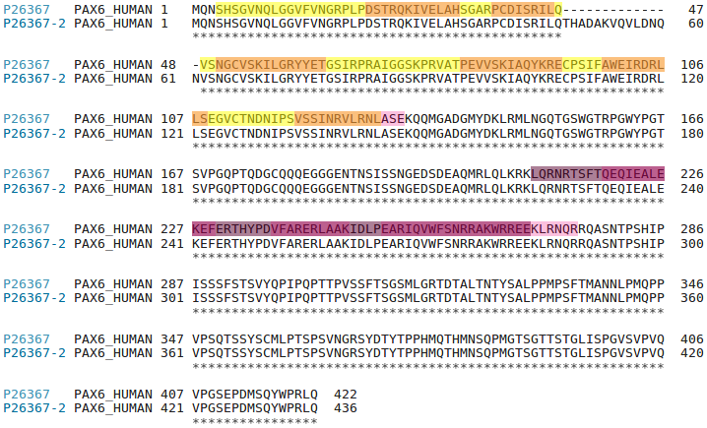
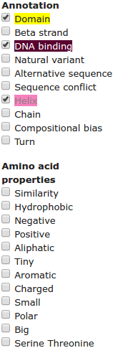
Describe the arrangement of Helices within the two major domains of PAX6.

Move back to the page showing P26367. You should still have the section in view.
Note the extra sequence in P26367-2 and where it starts.
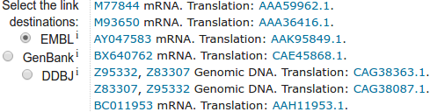
Move to the section and see that the names of several relevant sequences are recorded, including the genomic two genomic sequencing clones.
How would you rationalise the reference to the mRNA entry BX640762 here?

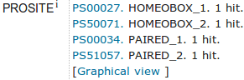
At the bottom of the section are links to Family and domain databases, including PROSITE database. Click on the link to the third PROSITE entry down, the first for PAIRED.
You will be presented with the documentation page for the PROSITE pattern/profile for a Paired domain at the top of which is a general Description of a Paired domain. I found this quite a difficult read. Please do not struggle with it too much. My summary of the parts of the message relevant to these exercises is:
- A Paired domain is about 126 amino acids long
- It is generally found at the beginning of a protein
- It is often followed by a homeodomain (as here) and/or an octopeptide (of unspecified properties?)
- There is often a Pro-Ser-Thr-rich C-terminus (as in this case)
- A paired domain is a DNA binding domain that has 2 binding regions each of which involves a helical triplet
- The second and third helices of each helical triplet form helix-turn-helix (HTH) motifs

- The HTH regions bind the DNA major groove


- The first helical triplet is preceded by a β-turn and β-hairpin (“wing”) that participate in the DNA binding
- The linker region between the two helical triplets can bind the DNA minor groove

All of these properties have already been suggested and/or will be discovered variously as the exercise progresses.

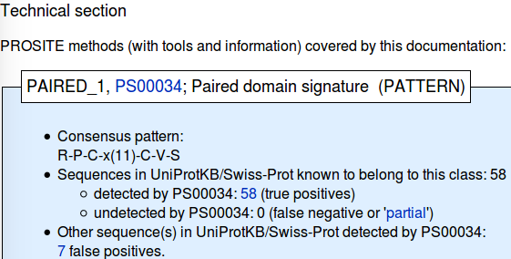
Move down to the Technical section. PROSITE stores representations of conserved protein features (motifs). It uses two methods. One requires a bit of thought, but the other is quite intuitive. That which you are now considering is a simple Consensus pattern defined clearly at the top of this section. The suggestion here is that this pattern is to be found in all known Paired domain sequences.
What is the Consensus pattern for a Paired domain?
Where in a Paired domain should the Consensus pattern occur?
How would you interpret this Consensus pattern?

How effective does the Technical section imply this pattern to be?

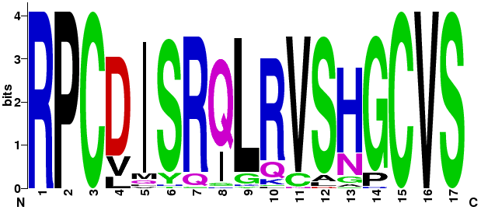
There are a number of links to follow here. I would suggest you . The logo is representing the degree to which each position of the Consensus pattern is conserved and how. The higher the letter, the more prominent is that letter in that position. The particular value of the logo here is to illustrate that the region of the Consensus pattern is not only conserved over the 3 positions at either end. It is well conserved over its entire length. Not well enough, however, to be described effectively using such a simplistic strategy as this sort of Consensus pattern.
Move back and up to the Description of a Paired domain. Follow the link to the Prosite documentation for homeobox embedded here (PDOC00027) .
How well does the secondary structure suggested by Prosite match that recorded by Uniprot?

How many helix-turn-helix motifs would you expect in the homeobox domain?
Where (in amino acid positions) would you expect all the PAX6 HTH motifs to be?
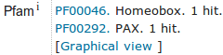
Move back to the page displaying the UniprotKB/SwissProt entry for the human PAX6 protein. Find the Pfam links in the Family and domain databases section (use the button again if necessary). Unsurprisingly, there are two links to Pfam .
The Pfam database is a collection of protein domain families. Each family is represented by multiple sequence alignments and Hidden Markov Models (HMMs).
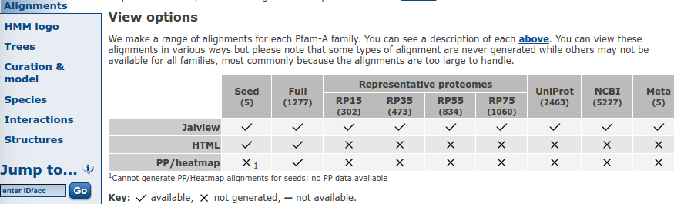
Click on the accession code for the Pfam entry for PAX (PF00292). The requested Pfam entry is displayed offering access to much PAX related information in other databases. Now, click on the Alignments link on the left of the page. In the View options section, click on the tick in the Full column of the Jalview Row. A new window will thrust its way onto your screen displaying (possibly after a little persuasion) the requested alignment displayed by the Jalview applet.
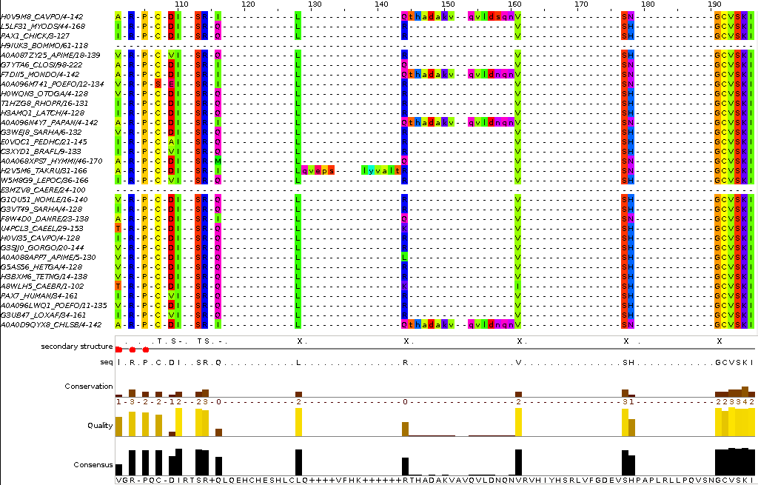
More Jalview functionality is available when running Jalview via Java Web Start, so click on the button. In a new window, you should now see the same alignment even more garishly coloured for your delight. Use the scroll bar on the right to scroll up and down the full set. The Seed alignment for this family is carefully constructed and manually curated, however the Full alignment is transparently not. The alignment is automatically generated by the program HMMER3. The alignment includes a number of PAX domains that align badly at the beginning. The region illustrated is that around the isoform 5a 14 amino acid insertion.
Allowing for the distorted numbering of the alignment, how would you interpret the extra 14 or so amino acids that some sequences appear to have around position 100-190?
How might you interpret the way that HMMER3 suggests that some sequences have a similar insertions in a slightly different places to others?

For a more restrained view, move back to the Pfam PAX entry page, move back to the Pfam PAX entry page. In the View options section, click on the tick in the Seed column of the Jalview Row.
Click on the button to start the Java Web Start version of Jalview. In view are the aligned sequences of the Seed alignment from which the profile HMM for PAX is calculated. None of the 5 seed sequences include the 14 extra amino acids noted previously. Human PAX6 is not a seed sequence.
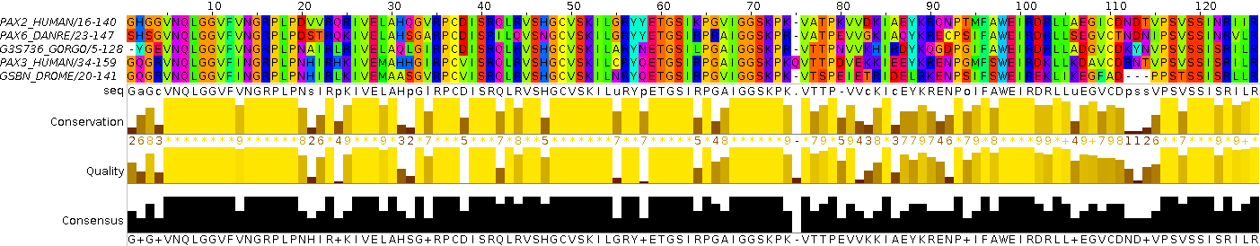
Note down the position in the alignment where all but one seed sequence has a gap.
Note the consensus character at this point and its most logical interpretation.
Back again to the Pfam PAX entry page. Click on the HMM Logo link on the left of the page. This is a way of visualising the HMM profile computed from the seed sequence alignment you have just been viewing. The logos are indubitably very beautiful. There is a link their documentation just above the picture.
How is the heavily gapped position of the seed alignment represented in its HMM Logo?

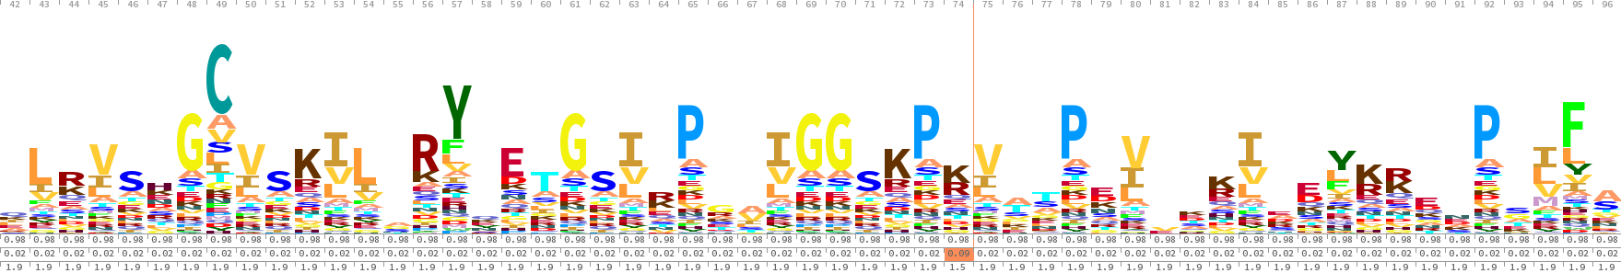
How would you interpret the Logo in this region?

Go back now to the PAX6_HUMAN UniProtKB/Swiss-Prot entry. Find the PRINTS links in the Family and domain databases section (use the button again if necessary). In PRINTS, domains are represented by fingerprints. A fingerprint, in this context being an ordered group of conserved motifs.
How many links to PRINTS would you expect?
What if anything, do you think is missing?
Well, if you thought all was OK, you were jolly well wrong! Should be a link to a Homeobox domain surely? You will see why it is missing later, when we look at the tools used to search PRINTS (now a supplementary exercise).
Other databases from the European Bioinformatics Institute (EBI)
Browsing Genomes with Ensembl
The objective now is to examine PAX6 and related genes in the context of the entire human genome. You will use the genome browser Ensembl, one of several well known facilities allowing easy access to genomic information. Similar databases and browsers can be found at NCBI and the University of California, Santa Cruz (UCSC).
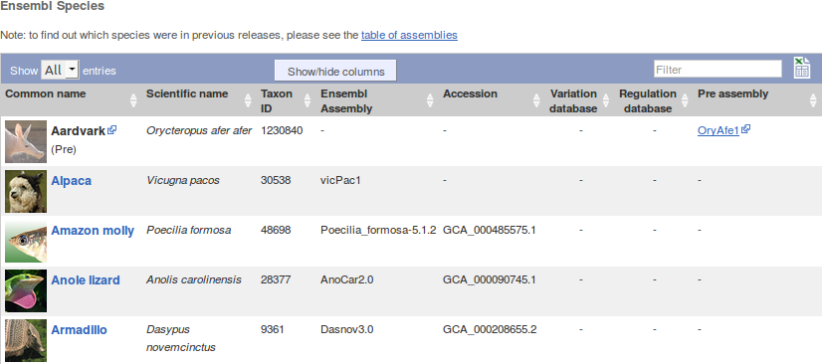
Go to the Ensembl home page (www.ensembl.org). Choose to View full list of all Ensembl species using the link just under the Select a species menu.

Note that Ensembl offers far more than just the Human Genome.
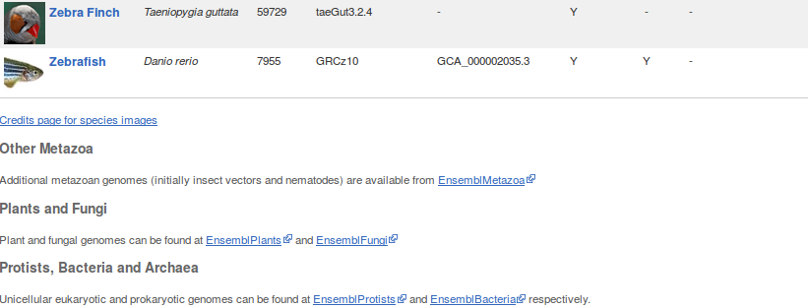
In particular, note the links to EnsemblPlants, EnsemblFungi, EnsemblBacteria etc. Ensembl databases at the bottom of the list.

During this exercise, you will only look at the Human genome, by far the most fully developed. However, all the other Ensembl genomes are behind the same interface. The techniques required to examine the Human genome are broadly those required to examine any Ensembl genome.

Try looking at the Species tree by clicking on the View the full Ensembl species tree link (at the top of the Species list page). This shows the main (i.e. vertebrate) Ensembl species arranged according to their probable evolution.


Move back to the Ensembl Home page. Click on the Human genome icon.

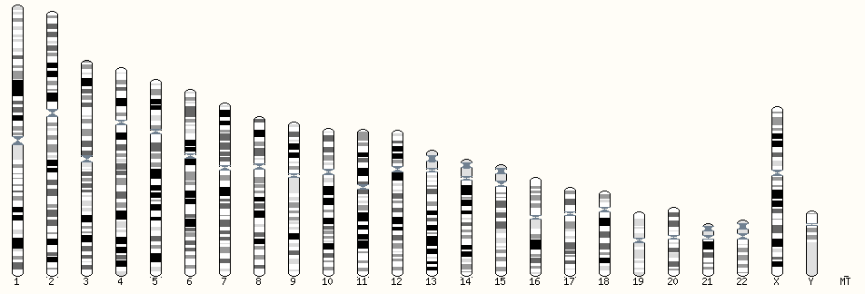
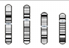
Select the View karyotype link. Your reward will be an image of the banding patterns of all the human chromosomes.

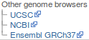
Notice the links to the major alternative genome database browsers, particularly the two very popular options from America. Try one or both of these. You will be linked to a view from the alternative browser as close to the Ensembl page you are viewing as is possible. The NCBI site, in this instance, offers a very similar view of all the chromosomes. An easy route to these alternative services can be very useful. No one provider is “best” at everything.
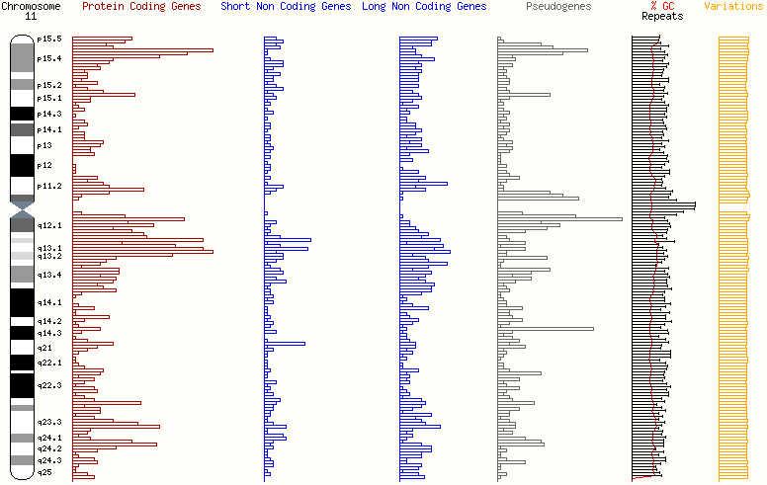
From the Ensembl Karyotype view, select the PAX6 chromosome and then Chromosome Summary from the menu presented. Look at the PAX6 chromosome region.

Is it a gene dense region?

What about Variation density?

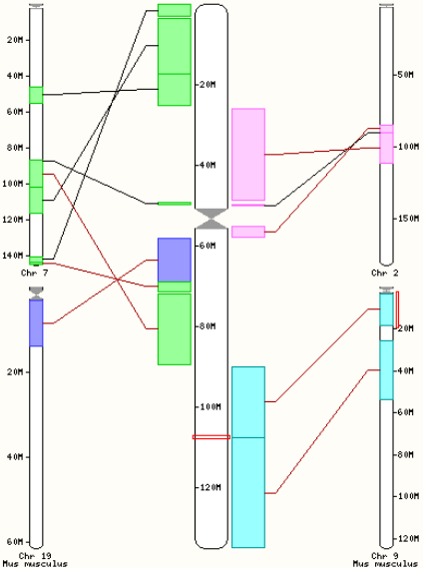
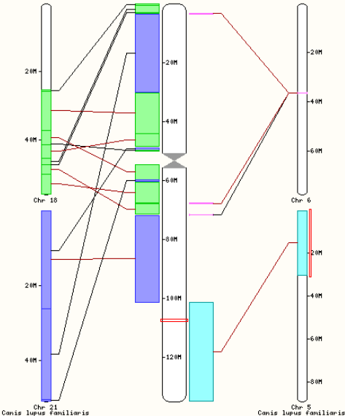

A short diversion. Click on the Synteny link on the left hand side of the page. A graphic will appear showing all regions (over 100,000 bp) of Human Chromosome 11 that are very similar to regions of the mouse genome. You can choose from a number of other Ensembl species. I choose mouse and dog. Diversion over, move back to the Chromosome summary of Human Chromosome 11.

Click on your chosen band and select the proffered link to the region. A Region overview is generated. Look in the section marked Genes (Comprehensive ... you should be able to locate PAX6.
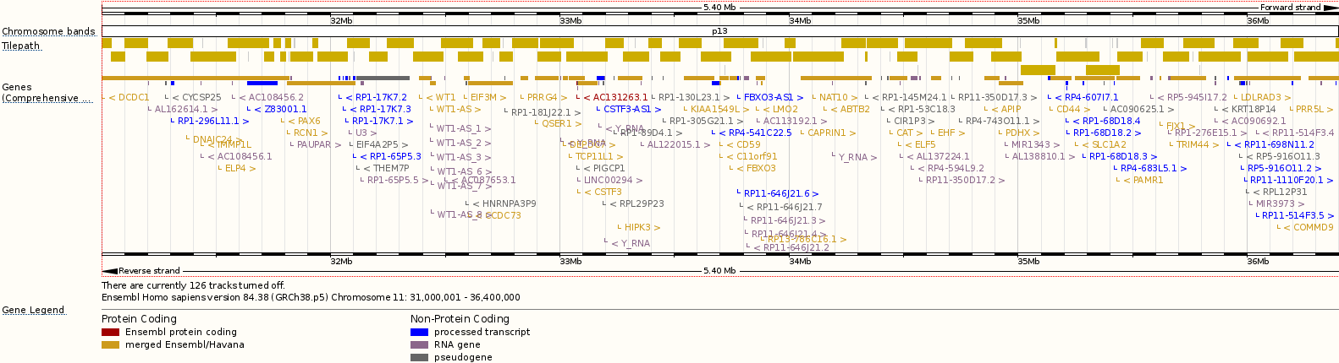
Can you also see the two other genes you might have expected to be in this region?
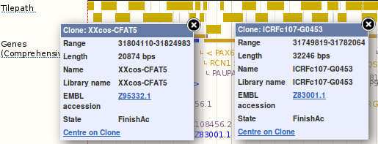
The gold rectangles of the Tilepath track (sometimes referred to as the “Golden Path”) represent the way selected sequencing clones from the Human Genome Project overlap to define the entirety of Chromosome 11. If you click with care, you should be able to identify the two clones you found in Genbank that cover the PAX6 region.
In order to see a detailed view of a particular gene, it is necessary to click on its representation at the top of the Genes (Comprehensive … track. That is, the relevant portion of one of the rectangles in the two rows just below the three rows of the Tilepath. This is practically impossible at the resolution you have currently, so zoom in around the PAX6 region by clicking on thegene name and selecting the Centre here link of the Location menu.
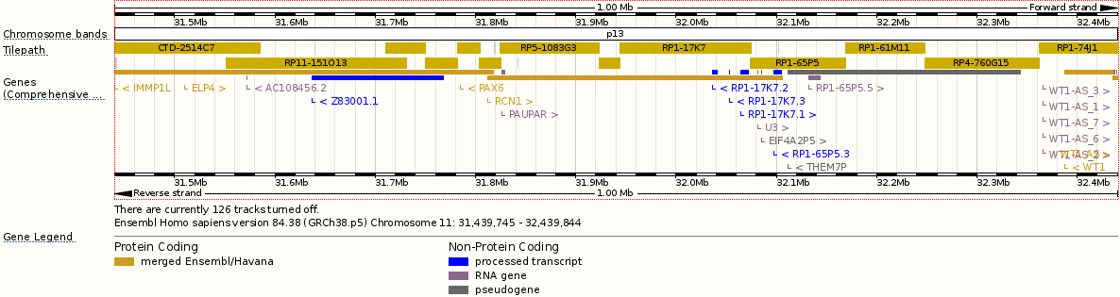
The Region Overview is redrawn for a more specific region, with the PAX6 gene in the centre (well, nearly?). If you note that thesymbol indicates the leftmost extent of the gene with which it is associated, you should now be able to identify the gene block that corresponds to PAX6. Be careful though, as the PAX6 gene block actually runs into the ELP4 gene block! The genes do not overlap, so their blocks are both at the same level. As there is too small a gap between them the two genes cannot be represented as distinct blocks. You need to aim at the right hand extremity of the very long block that represents ELP4, PAX6 and other genes even further to the left. Not the clearest of graphics I suggest!
So, having found it, click on the PAX6 gene block and choose the Location option. Ensembl zooms into a Region in detail view centred (exactly this time!) around PAX6. This view is comprised of two illustrations. The first, more general view, shows the location of PAX6 and immediately neighbouring features, predominantly genes. The colours of the genes represented in this display indicate the gene type (see Gene Legend). The second illustration shows a more detailed view of the region exactly spanned by PAX6.
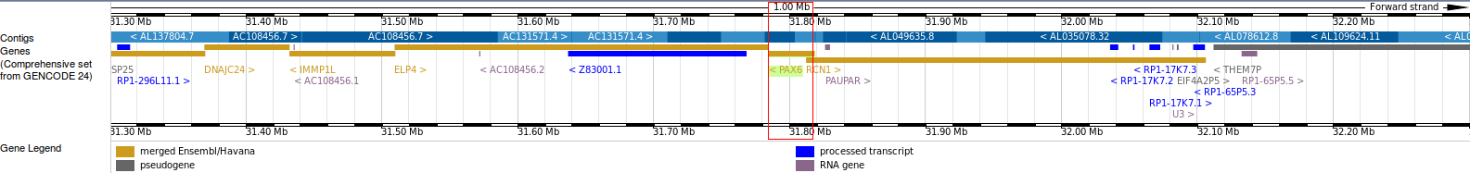
In both views, in the Contigs track, the “Golden Path” is now represented as thick alternately light and dark blue lines. The red rectangular box in the more general view indicates the region of the chromosome represented in the more detailed view.
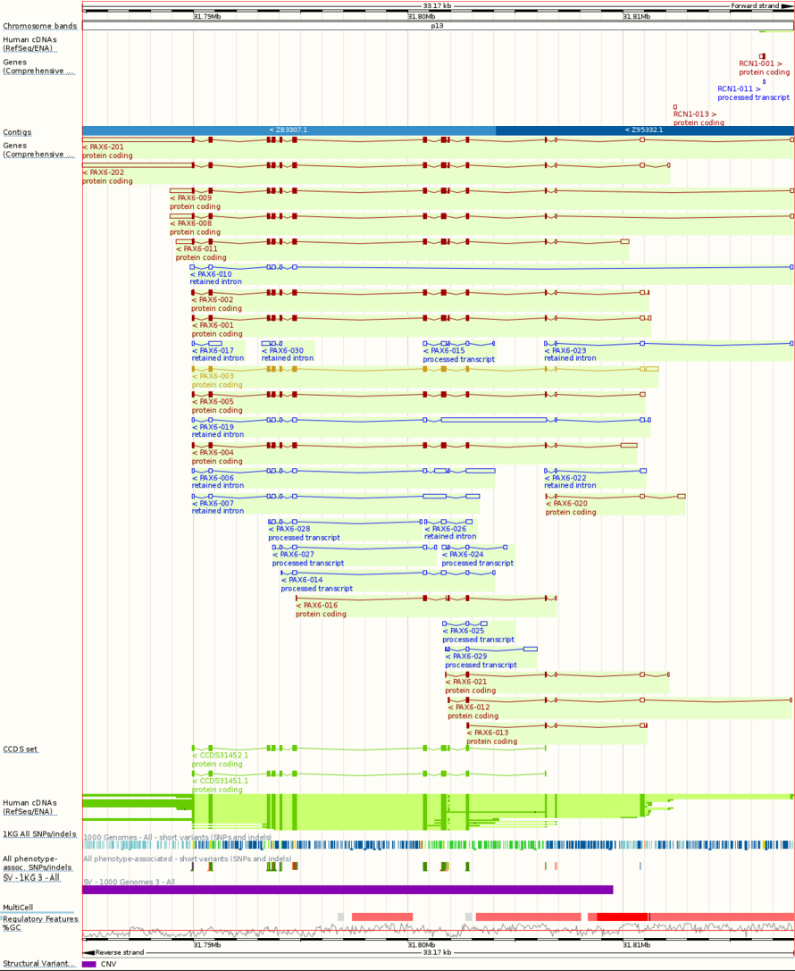
The more detailed view Location bar indicates the region you are viewing and allows adjustment and zoom. In the detailed view, the forward strand is described above the light/dark blue line, the reverse strand below. PAX6 is on the reverse strand and so its predicted transcripts appear below the blue line and should be read from right to left. The filled boxes of the transcripts represent coding exons, the unfilled boxes non-coding exons. The wiggly lines joining the boxes are the introns. As should not surprise you, many of the transcripts of PAX6 span two contigs.
There are a number of ways to customize the region displayed in the Region in detail view. The most dramatic is to the the red box in the more general view left or right. The area of focus (governed by the size of the red box) remains constant, but is adjusted horizontally. When you release you mouse, you are asked whether you wish your detailed view to reflect the new logical position of your red box (Update this image), or whether you wish to bottle out and return from whence you came (Reset scrollable image). Try it.
To scroll in a more reserved fashion, again in the more general view, select the Scroll to a region part of the button. Now you can scroll your view left or right by clicking image and moving your mouse left and/or right. Once you have done this, Ensembl checks that you really like where you ended up in the same way it did for more abandoned scrolling. Try it.
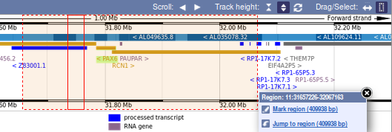
To change the size of the red box defining the area displayed in detail, click on the Select a region part of the button. Then drag your mouse over the region you wish to be displayed. When you release the mouse button, choose to Jump to region. Try it.
If you just click anywhere in the more general view, you will be asked if you wish to Centre here. If you do this, both views will be re-centred as requested without any adjustment to the size of the region in view. Try it.
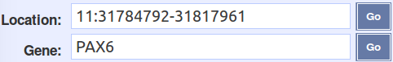
For single base accuracy, you could set the Location values in the more detailed view, but I wonder when one would to do this? These possibilities examined, use the Gene field of the to get PAX6 centrally back into focus.
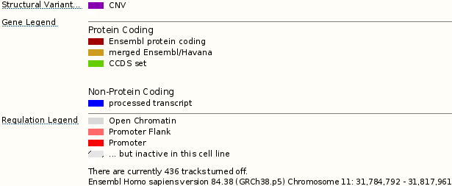
By default, in the more detailed view, transcripts confidently predicted by the Ensembl pipeline and/or the Vega/Havana project are shown. The colour of a transcript indicates its type.
The Human cDNAs (RefSeq/ENA) and CCDS set tracks show the prime evidence for the transcript predictions.
The Human cDNAs (RefSeq/ENA) track represents very close matches between good quality human cDNA/mRNA sequences and the genome. Dark green boxes indicate matched regions and suggest the position of all exons. Light green boxes indicate regions of the genome between matches, suggesting introns.
The CCDS set track represents very close matches between the most assured coding DNA sequences and the genome. Dark green boxes indicate matched regions and suggest the position of coding exons. Wiggly lines join CCDS matches, suggesting the positions of introns between coding exons.
A good match between a high quality cDNA/mRNA sequence and the genome can suggest all the exons of a transcript. A corresponding good match between a CCDS sequence and the genome can suggest which of that transcript's exons code for protein.
What are the (familiar?) contig numbers containing all of PAX6?
Explain the visible differences between the coding exons of transcripts PAX6-008 and PAX6-009?

From the left hand side of the browser page, select Configure this page. Turn on the features:
Genscan predictions (from Genes and transcripts → Prediction transcripts, choose with labels)
Proteins (mammal) from UniProt (from mRNA and protein alignments → Protein alignments, choose Normal)
Then click on SAVE and close (the in the top right hand corner). The Detailed view will reassemble showing where any Mammalian Uniprot proteins match, extremely closely, translated regions of the genomic sequence. As do the CCDS set track, these matches indicate where protein coding exons exist in the genome. Essentially, the CCDS set track and the Proteins (mammal) from Uniprot tracks serve the same purpose. That is they both identify the coding exons of each transcript prediction. The CCDS set track is far more targeted and effective, to the extent that a Protein Comparison track is no longer included in the default display. The CCDS evidence is also far more efficiently generated and is used to reduce the search space of the less efficient searches that follow in the pipeline.
The Genscan prediction track shows where a program called Genscan predicts gene structures directly from the genomic sequence. Genscan bases its judgement on models derived from other known human gene structures. Genscan is very good, but it does get over excited at times. It misses little, but tends to predict some spurious exons. Genscan and similar programs will be discussed briefly later (in a Supplementary Exercise). Genscan predictions are not sufficiently accurate to be taken, in detail, at face value (hence they are not included in the default display), however, they are very fast and accurate enough to be used to reduce the search space for subsequent gene searches. Genscan is run ahead of even the CCDS searches in the pipeline.
What PAX6 exon of note has Genscan omitted to predict?
Select Configure this page once again. Turn on the features:
Vega Havana (from Genes and transcripts → Genes, choose Expanded with labels)
EST-based (from Genes and transcripts → Genes, choose Expanded with labels)
Then click on SAVE and close. You should now have in view three types of transcript prediction including purple EST-based genes that are suggested only by matches with Expressed Sequence Tags (ESTs). Of course, the Vega Havana transcript predictions are a subset of the predictions displayed originally by default. On the other hand, the EST-based transcript predictions are not considered of sufficient reliability to include in the default view.
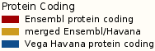
From the Gene Legend at the bottom of your display, you learn that:
Red transcripts are Ensembl protein coding. A rough translation being “Protein coding transcripts predicted either by the Havana/Vega people or by the Ensembl pipeline of programs, but not both”.
Gold transcripts, and there is currently only one, are merged Ensembl/Havana. A rough translation being “Protein coding transcripts predicted, in all important respects, by BOTH by the Havana/Vega people AND by the Ensembl pipeline of programs”.
Dirty blue? transcripts are Vega Havana protein coding. A rough translation being “Protein coding transcripts predicted by the Havana/Vega”. These are the ones you have just caused to be added to your display.
Some questions now, but .. why not just cheat and look the answers up straight away for these? Whilst worthy, they could easily take up more time than they deserve.
Is a merged Ensembl/Havana transcript also a Vega Havana protein coding transcript?
Which Ensembl protein coding transcripts were only predicted by the Ensembl pipeline?
For pedants only. Can you see how to identify the Ensembl protein coding predictions only predicted by the Ensembl pipeline by the way they are numbered?

The features now displayed represent just a few of those offered by Ensembl. Feel free to try more.
Before looking at some of the gene and transcript properties Ensembl offers, it would be good to save the genomic sequence of this region for analysis later on.
To effect this, first click on thelink on the left hand side of the page.
PAX6 is on the negative strand of the genomic region in view, so in the Select location section of the Export data page the will fly forth, you must change the strand selection fromto.
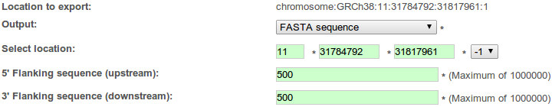
Ask for 500 base pairs of extra sequence at either end of the PAX6 gene. That is, set both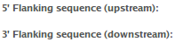to 500.
Click on thebutton.
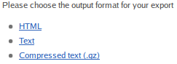
Choose Text as the output format for the sequence to be saved.

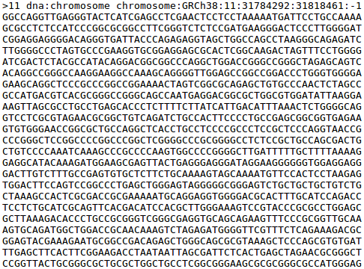
In you browser you should now have the genomic region of the PAX6 gene, with 500 base pairs of flanking sequence on either end, in FASTA format.
Do whatever it takes to download this to a file called:
pax6_genomic.fasta
on your Desktop. Then use a suitable text editor to change the rather clumsy first line to:
>pax6-genomic sequence

Move back to the Ensembl view of the PAX6 genomic region.
Click on the gold Ensembl/Havana gene Ensembl transcript in the more detailed view and then on the link to the Gene. You now see the Gene summary for PAX6.
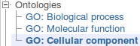
Click on the GO: Cellular component link (from Gene-based displays → Ontologies). You are offered a tabular view of a part of the ontology for this transcript.
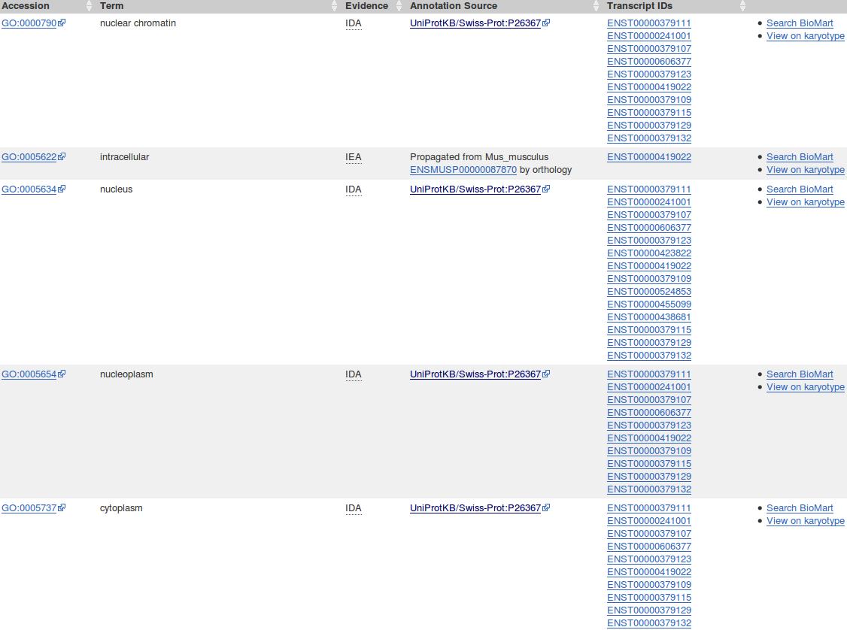
I choose to direct you to the Cellular component section of the Gene Ontology, purely because it is the smallest, and thus easiest to represent here. Feel free to glance at the other two sections. As you can see, each table records those properties of the protein(s) associated with the selected gene (PAX6 in this case).
I only aim to impart an awareness of the Gene Onotogy. To covered GO properly would require more space than can be afforded here. Click here to discover more for yourselves.
How might the Gene Ontology improve sequence database text searching?
Why is the Transcript Ids column necessary?
Follow one or two of the GO accession code links in any of the 3 tables. These will take to GO entries from the Gene Ontology Home site.
Generally, GO terms are more prolific here than in Uniprot but the message is the same concerning the domains and functions of the PAX6 gene transcripts.
Click on thebutton to display the transcript information textually. Transcripts are not necessarily in the same order in the table as in the Regional view.
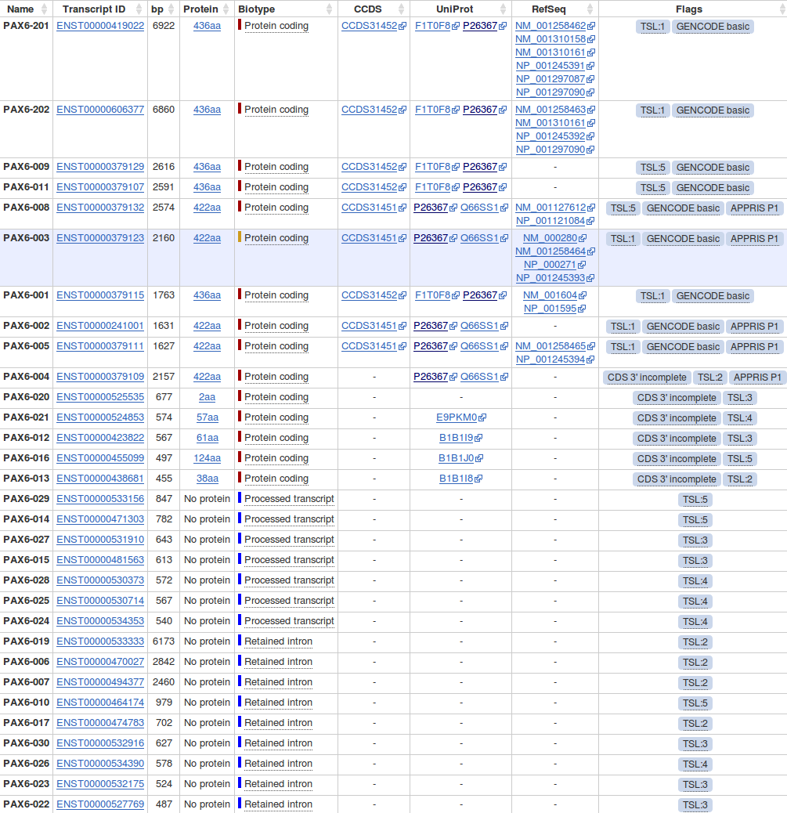
Note the number of RefSeq mRNAs and RefSeq proteins associated with Ensembl transcripts predictions.

Which of the 24 RefSeq mRNAs reported by GeneCards can be seen here?

Why would you suppose these mRNAs were selected and the others ignored?

Click on the Othologues link in the left hand side of your browser page. Take a look at some of the alignments providing support for the homologous relations. The protein alignments are the more informative.
Using the evidence of the protein alignments, which PAX6 isoforms do the fruitfly orthologues most resemble?

Move back to the othologue list and try one or more of the Region Comparison links. I selected the one for Cow. Not too far and not too near I mused? In the more general regional comparison, you can still see familiar neighbouring genes such as ELP4 and RNC1. Not so sure I wish to be quite this similar to a cow?
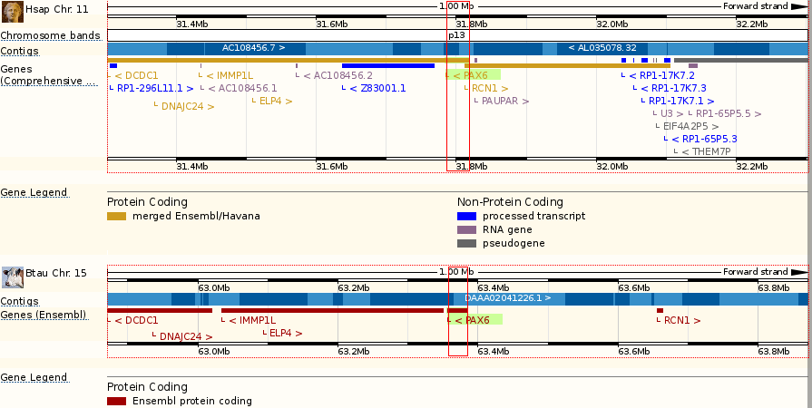
In the more detailed view, the similarities are even more worryingly apparent!
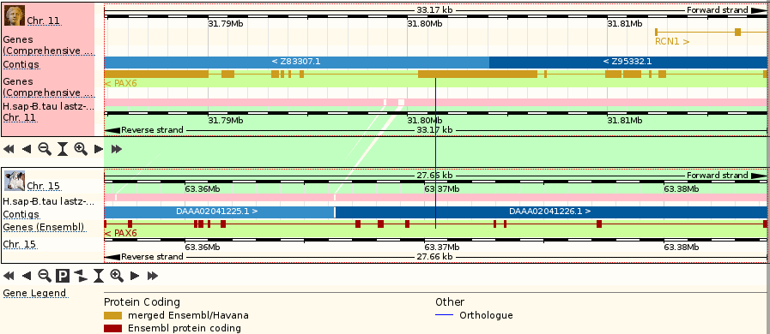
Once your curiosity is completely sated, move back to the othologue list.
Click on the Paralogues link. Paralogues here should match those reported by GeneCards as GeneCards obtains its Paralogues report from Ensembl.
Do the Paralogue reports of GeneCards and Ensembl agree?
Try somelinks to view an alignments between a PAX6 isoform and its paralogues.
Which isoform of PAX6 has been chosen for the alignments, and why would you suppose it was selected?

Which isoform is most common amongst the paralogues?
Move back to the list of paralogues. Try one or more of the Region Comparison links. Not nearly so interesting as for the orthologues as the only expectation of similar regions here would be the two gene paralogues and not the surrounding region.
Move back to the list of paralogues. Go to the Gene tree representing proteins potentially related to PAX6. This picture gets more outrageously huge each time I look at it! I will trust you get to see it for yourselves. If not, click here. Or, if you are off line, here.
To expand any subtree, click on the horizontal triangles of your choice and select expand this sub-tree. To expand the entire tree, click on any of the horizontal triangles , stand well back and select expand all sub-trees.
You can download this tree in various textual forms using the button from the menu at the top of the graphic. Newick format, accepted by most tree drawing programs, is probably the most important of the many offered.
Click on the Supporting evidence link in the left hand side of your browser page.
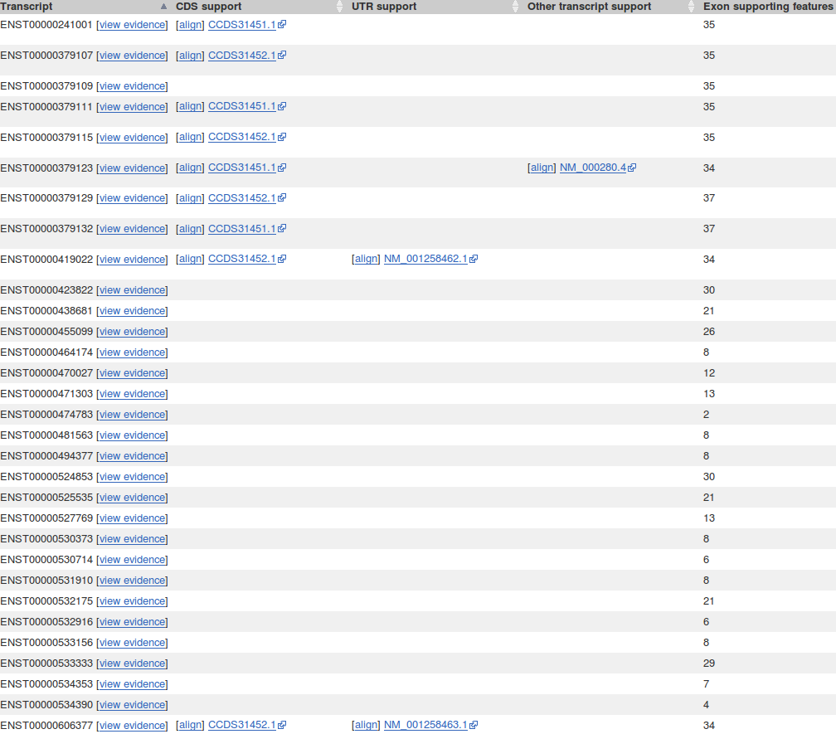

For each transcript Ensembl offers evidence to support the existence of the CDS, UTRs and Exons. Take a look at some of the [align]ments and sequences providing the support for the CDSs and UTRs.
Click on the view evidence link to view the support for ENST00000419022. In the Transcript supporting evidence section, sequence matches supporting the entire transcript are recorded. Here there is match with a RefSeq mRNA suporting all exons of the transcript and CCDS (and sometimes, but rarely these days, protein matches) suggesting which exons are coding. In the Exon supporting evidence sections, extra matches with a variety of sequences from different sources are offered to support individual exons of the transcript are illustrated.
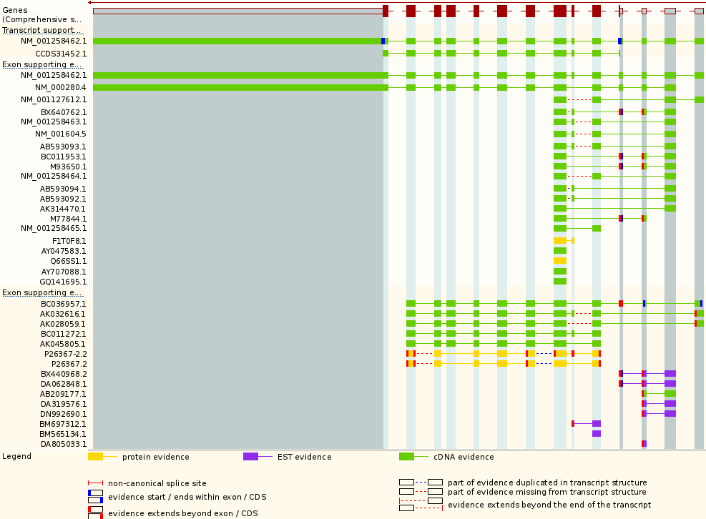
Some matching sequences offer no support for the 6th exon from the right. Why do you suppose this is?

Why is there no protein or CCDS evidence for exons 1, 2 and 3?

Until recently (mid-2014), the RefSeq mRNA match in the Transcript evidence section did not match all exons. Was this logical?

Click the Exons link (from Transcript-based displays → Sequence). Exons, Introns and Variations within Exons are clearly displayed.
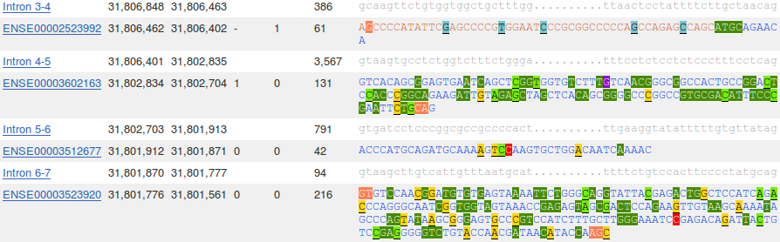
How many exons are there in this transcript?
What are the first two bases and what are the last two bases of nearly every intron?
How long is the sixth exon and why would this concur with your expectations?
Explain the Start Phase and End Phase columns?

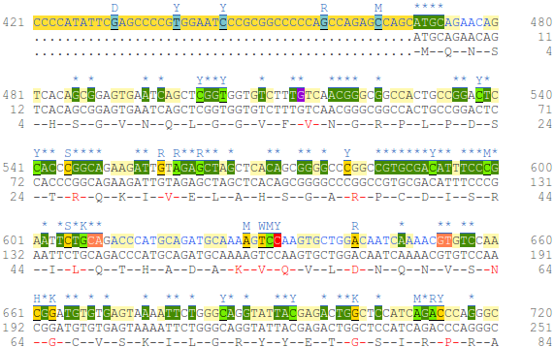
Click on the cDNA link (Transcript-based displays → Sequence). The default view of the transcript cDNA is ornate, exhibiting all the features described in the Key.
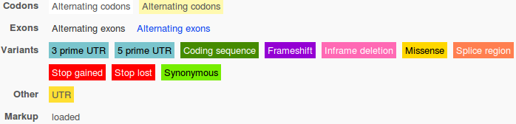
The default view displays most available information. Click on the Configure this page link and choose deselect all. Click on Save and close. Now you see a plain view intended to allow easy export of the sequence by copying/pasting from your browser window.

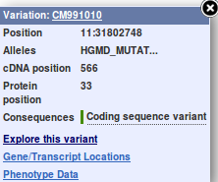
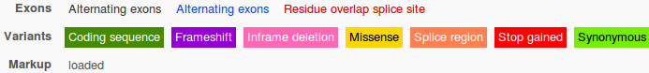
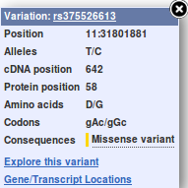
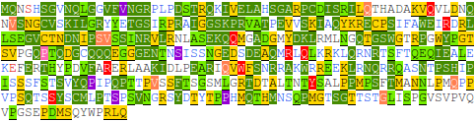
Click on the Protein link (Transcript-based displays → Sequence). Add the variation information to the default view by clicking on the Configure this page link and ticking Show variants. Click on Save and close. A number of features, including sequence variations, are shown (details in the Key). By clicking on variations, further information can be obtained, try a few.
Many of the variations come from the HGMD_MUTATION database. Much of this database is not in the public domain. For the commercial section of the HGMD_MUTATION database, mutation details are not available to all. They are only revealed to people who pay for the database. Here, they just make a mess of what would otherwise be a useful display.
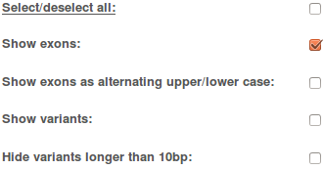
Click again on the Configure this page link and do whatever it takes to select just the Show exons option. Click on Save and close.

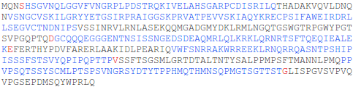
This view should be plain but showing clearly where all exons start and end.
Where is the start and end of the Prosite Paired Box pattern (R-P-C-x(11)-C-V-S)?
Where, in relation to the pattern, are the extra isoform 5a amino acids?
Why might the positions of these two features be significant?
Click on the Domains & features link (from Transcript-based displays → Protein Information). Look at the domains of Domain type Smart. There are two. Predictably, a Paired box and a Homeobox domain.
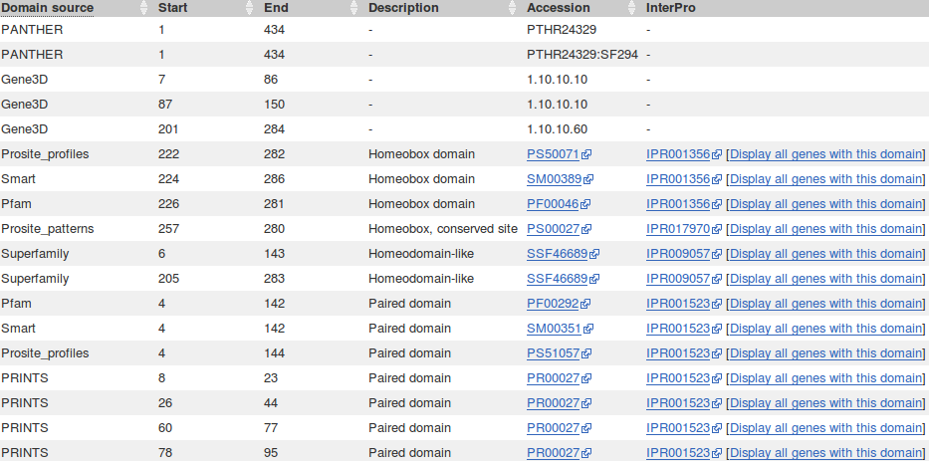
Where do each of the SMART domains start and end?
Do the regions match your earlier recording? If not, why not?
What are the Interpro database accession codes for the two major PAX6 domains?
Why does Prints appear to predict four Paired_domains?
Click on Display all genes with this domain for the Paired domaim and Homeobox domain InterPro families. The locations of all genes including each domain will be displayed graphically and textually. PAX6 is shown in red.
Paired domain - IPR001523 Homeobox domain - IPR001356



Which domain, Paired domain or Homeobox domain is more common in humans?
How many human PAX genes are there?
Are all the PAX genes on Chromosome 11?
How does Interpro match with the PAX6 Paralogues reported by Ensembl/GeneCards earlier?

Move back to the Domains & features display. Link to the InterPro database entry for Paired domain. Here you will find much confirmation of that which we have already discovered. Click on the Proteins matched link. You will see listed a number of representations of proteins that, according to InterPro, include a Paired domain. Amongst these will be P26367. There are links provided to entries in a number of relevant databases for each listed protein.

Click on the Structures link in the top left hand corner of the page. InterPro will offer links to relevant entries in the PDBe, SCOP and CATH databases. Click on the link to the 6pax entry in the PDBe database. You will arrive at the entry for 6pax in PDBe, the European version of PDB maintained at the EBI. Views of this structure are offered on the right hand side of the page. Click on the largest image which shows the paired box protein domain binding DNA rather beautifully. Once you have admired this image sufficiently, move back to the 6PAX PDBe entry. From the on the right of the page, select the 3D Visualisation option.
The Prosite documentation you read earlier suggested two paired box subdomains, each of which “ ... form a three-helical fold, with the most C-terminal helices comprising a helix-turn-helix (HTH) motif that binds the DNA major groove”. Move your image around to confirm this assertion.
The same Prosite documentation claims the subdomain nearer the N terminal “ ... encompasses an N-terminal beta-turn and beta-hairpin, also named 'wing', participating in DNA-binding. The linker can bind into the DNA minor groove”. Manipulate you image to investigate the veracity of these assertions.


Once you have seen all there is to see of 6PAX, move back to the Ensembl Domains & features display. Try the same tricks with the InterPro Homeobox domain. This time, it is difficult to find P26367 in the huge list Proteins matched, but you do not need to in order to link to the Stuctures. There are many more structures to choose from this time. I suggest you go for 2cue. You have to imagine the DNA this time.

Can you explain the strangely frayed ends displayed in some of the representations of the 2cue 3D structure?

Further Features of Ensembl
Mining Ensembl with Biomart
Used from the Ensembl pages, Biomart allows the intuitive construction of queries of the entire Ensembl database. Biomart can be used for various purposes, some of which will be investigated here. The first objective is to use BioMart to identify human genes that share specific properties with PAX6.

Return to the Ensembl homepage (http://www.ensembl.org). Click on the BioMart link in the banner at the top of the page.
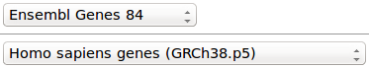
The Start page will enquire which dataset and organism you wish to search. Set CHOOSE DATABASE to the latest Ensembl Gene build (Ensembl Genes 84, as I type). Select Homo sapiens genes from the CHOSE DATASET menu..
Click on thelink to specify the genes of interest. On this page, enter the following data:
REGION: Click on the ‘+’ to view the options, but select nothing to search the entire genome. Click on the ‘-‘ to tidy the REGION options away.
GENE: Click on the ‘+’. Check Transcript count >= and set the value to 15 to limit to genes with many transcripts only. A trifle arbitrary, but never mind. Click on the ‘-‘ to tidy the GENE options away.
MULTI SPECIES COMPARISONS:
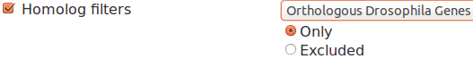
Click on the ‘+’. Check Homologue filters and set the value to Orthologous Drosophila Genes to limit matches to only genes with fly orthologues. Click on the ‘-‘ to tidy the MULTI SPECIES COMPARISONS options away.
PROTEIN DOMAINS AND FAMILIES:
In this section, turn on Limit to genes with these family or domain IDs. Choose Interpro IDs as the means of selection. Enter the two Interpro ID(s) of the PAX6 gene that you noted earlier in a comma or space separated list. This translates to all proteins with either a paired box or a homeobox domain, or both.
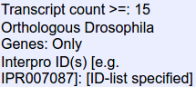
On the left of your page, BioMart will have summarised the search you have requested in its section. Given the search criteria match your expectations, click on the Count button. You should see that your filtering has selected around 13 genes from the 66,000 or so to which Ensembl admits existence.
Now click on thebutton to specify what properties you would like to retrieve for the genes you have selected. Enter the following:
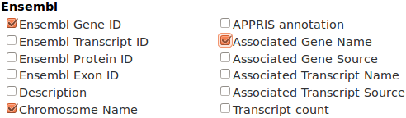
GENE: Check Ensembl Gene ID (checked by default)
Turn off Ensembl Transcipt ID
(they are far too copious!)
Check Chromosome Name
Check Associated Gene Name
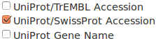
EXTERNAL: Check UniProt/SwissProt Accession
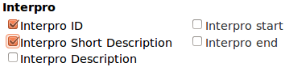
PROTEIN DOMAINS AND FAMILIES:
Check Interpro ID
Check Interpro Short Description
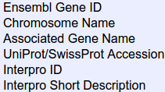
On the left of your page, BioMart summarises the search you have requested in its section. Given the selected attributes match your expectations, click on thebutton. By default, only 10 filtered entries are displayed. Note that some appear to be the same!! They are not however. Some hits differ in features that you have not chosen to display and so give rise to apparent duplications. This can be eliminated by checking Unique results only, try it.
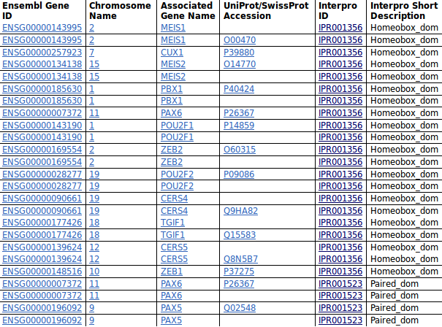
In order to see all your hits, elect to lengthen your results list to 200 rows. Your list is now complete but will include more entries than the gene count Ensembl declared to match your search criteria. Look closely and you will see that only the predicted number of genes occur in the Ensembl Gene Name column, but some occur more than once.
Duplication occurs when an Ensembl Gene matches differing combinations of properties that have been selected for display. For example, the PAX6 protein (Gene ID: ENSG00000007372) will match both the chosen Interpro families resulting in 2 list entries. The same gene also corresponds to proteins uniquely from Uniprot/TrEMBL, resulting in list entries with blank UniProt/SwissProt Accession entries. So there will be at least 3 ENSG00000007372 entries in the list.
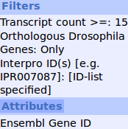
You have identified and displayed information concerning a number of genes, each of which has at least 15 transcripts, includes either a paired box domain or a homeobox domain (or both) and has orthologues in the Drosophila genome. It is probably best to suppress the burning question “Why?”.
Finally, for this search, move once more to theand turn off everything except the Ensembl Gene ID.
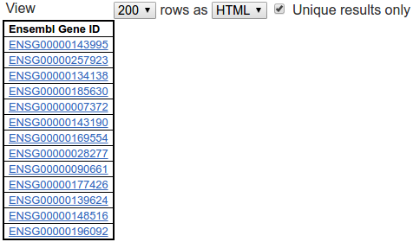

Click on thebutton once more. Set the View of 200 rows as CSV. Set Unique results only, although there will be no duplications this time, of course.
In the Export all results to section, set the format to CSV, choose Unique results only and then click.
Do whatever it takes to end up with a file on your Desktop called:
Ensembl_Genes_List.txt
containing your gene list.
Now try a search of the variations section of the database. The object this time is to list all the splice acceptor variations associated with any of the genes listed in the file you have just made from specified chromosomes. A very simple search to set up as you need only specify the file of Ensembl Gene Ids, the type of variation that is of interest and the chromosomes of interest.
Start afresh by clicking on thebutton in the top left hand corner of your page.
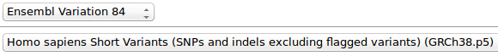
Set CHOOSE DATABASE to the latest Ensembl variation release (Ensembl Variation 84 at the time of typing)
Set CHOOSE DATASET to Homo sapiens Short Variation (SNPs and indels excluding flagging variants).
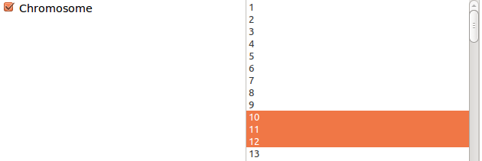
Click on thelink.
Open the REGION section.
Check Chromosome and select just chromosomes 10, 11 and 12.
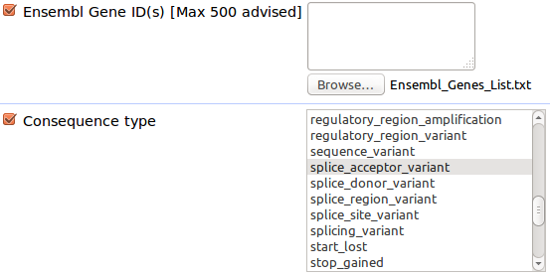
Open GENE ASSOCIATED VARIATION FILTERS.
Check Ensembl Gene ID(s)
Browse for the file Ensembl_Genes_List.txt
Check Variant consequence
Select splice_acceptor_variant
Click Count. You should have around 5 hits.
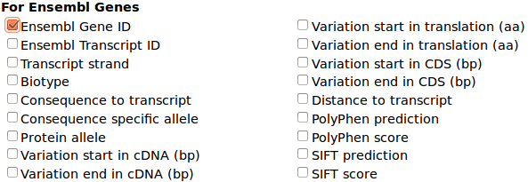
Click on thelink.
Open GENE ASSOCIATED INFORMATION.
Select Ensembl Gene ID
Given your 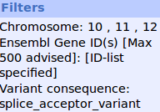and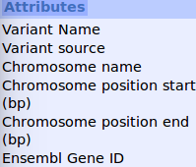are as you expect, click thebutton.
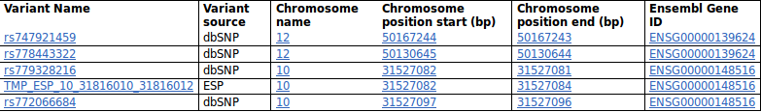
Set the View to 200 rows, HTML, Unique results only.
Your list represents all the variants available from Ensembl that affect the splice acceptor sites of the genes that you discovered in your previous BioMart search that occur on Chromosome 10, 11 or 12.
Only 3 of the genes listed in the file you created matched the location filters. One in each of the chosen chromosomes. Including PAX6 (in chromosome 11). No suitable variations found for PAX6 here though. A pity, but never mind.
Lastly, to demonstrate the extraction of sequences from Ensembl. You have already made a file containing the genomic sequence of the gene PAX6 for further analysis. This was easily achieved using the Ensembl browser interface. However, had you wanted the sequences of all the genes associated with a homeobox domain (not far short of 300) using the browser method would be quite intolerable. With Biomart, such an enterprise is trivial, as we will now demonstrate.
Once again, start afresh. Click on thebutton at the top of the page.
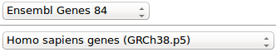
Set CHOOSE DATABASE to the latest Ensembl Gene build (Ensembl Genes 84, as I type). Select Homo sapiens genes from the CHOSE DATASET menu.
Click on thelink to specify the genes of interest.
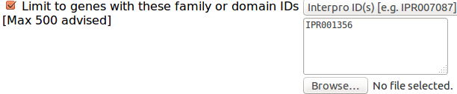
Open PROTEIN DOMAINS AND FAMILIES.
Check Limit to genes with these family or domain Ids.
Choose Interpro IDs as the means of selection.
Enter the Interpro ID for homeobox domains (IPR001356).
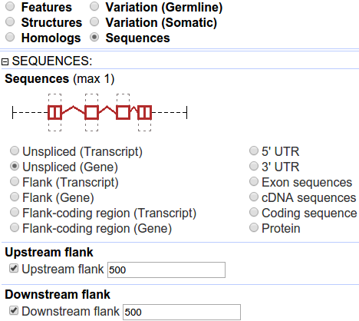
Click Count. You should have around 250 hits.

Move to the Attributes section and select Sequences.
Open the SEQUENCES section.
ask for Unspliced(Gene),
with 500 base pairs of Upstream flank,
and 500 bases of Downstream flank.

That is, all the relevant sequence with an extra bit of on each end.
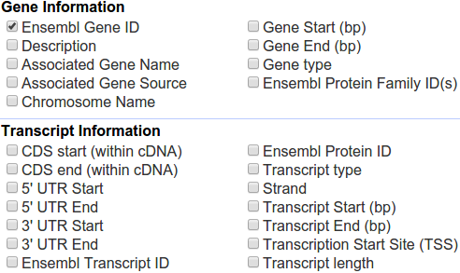

Now move to the Header Information section. Uncheck Ensembl Transcript ID.

To include the identifiers of all the transcripts that Ensembl predicts for all these genes is far to unwieldy.
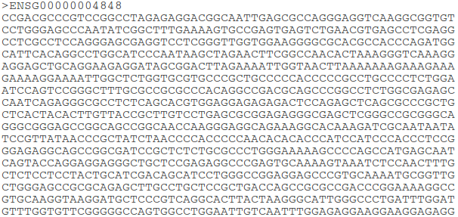

Click on the Results button

The first 10 0f the requested sequences will appear in Fasta format with just the Ensembl Gene ID in the identification line.

In the Export all results to section, keep the default option of creating a File in FASTA format. Choose Unique results only and then click.
Do whatever it takes to end up with your homeobox sequences in a file on your Desktop called:
human_genetic_hox.fasta
Sequence Analysis
The overall target remains to discover all we can about Aniridia and its genetic causes. Here we will see how information can be derived from analysis of sequence data directly. Many of the analysis tools and methods we will use and discuss will be those that were used to generate the “ready made” answers you have already investigated. The conclusions of this section should not therefore contradict those you have already reached.
To start the analysis section, you should have data files including:
Two PCR primers associated with the PAX6 gene in a way we have not yet fully determined, in a file called:
pax6_primers.fasta
The sequence of the Paired box domain of the most prolific human PAX6 isoform in a file called:
pax_domain.fasta
The genomic sequence of the whole of the PAX6 gene, plus an extra 500 bases in each direction, in a file called
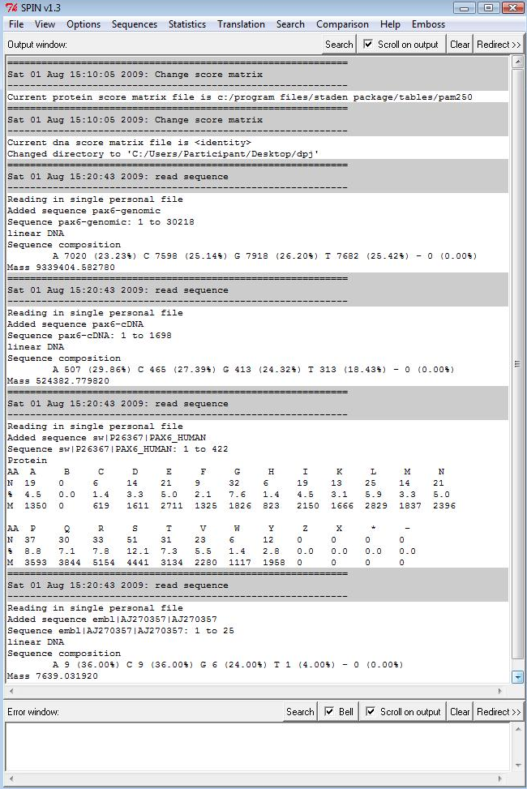
pax6_genomic.fasta
The canonical human PAX6 isoform in a file called:
pax6_human.fasta
The file pax6_genomic.fasta contains the sequence of PAX6 from a person(s) who, it can be assumed, does not suffer from Aniridia. Given a sequence from a person who does suffer from Aniridia, an obvious first step of investigation might be to compare the sequence from the affected source with the wild type. It would be reasonable to speculate that differences might explain the disease. Here we have to cheat a bit. I have provided an mRNA sequence we will suppose you sequenced from an Aniridia patient. It is stored in a file called:
pax6_cdna.fasta
which you will find in a directory called Working Directory on your Desktop.
Internet resources will be employed for many analyses. Software that runs under windows on your workstation will be used very occasionally. All windows software has been installed, without Administrator privileges, using an Installer that will be made available to you.
The EMBOSS package, using a program called spin to provide a Graphical User Interface (GUI) will be used for most of the workstation analyses. This is not ideal, particularly as support for spin is defunct, but the options are few.
Start Spin in the usual windows way (it is part of the The Staden Package, which is in the Start menu under Sequence Analysis Tools Installer). Proceed by setting spin to manage its files somewhere sensible. Strangely, its default inclination is to create user output files in its installation directory? This is silly, so select Change directory from the File pull down menu and select a more sensible default directory. I suggest you might make a directory in your desktop named as you please for this purpose.
Begin by loading all the sequence files you have gathered thus far. From the File drop down menu select Load Sequence and then Simple. This will present a new dialogue box for you to specify a sequence to be loaded. Leave the choice of Database as the default Personal File, as the all the sequences needed initially are stored in local files. To the right a text box awaits the file path for a sequence file. Use the Browse button to find and enter the directory you set up as your default. Select all the sequence files listed above and click Open and then OK in the Load Sequence window. From this point onwards the package will refer to these sequences by their fasta titles (e.g. pax6-cDNA and pax6-genomic).
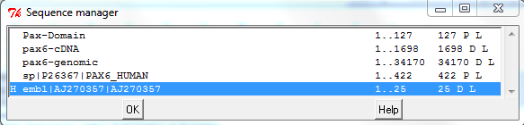

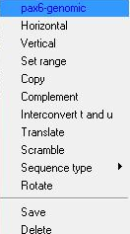
Take some time to become acquainted with the spin Sequence manager. This provides access to all loaded sequences. Its main purpose is to enable sequences to be selected for analysis. From the File drop down menu, select Sequence Manager. A window will appear listing the sequences showing their start and end, length and type (D for DNA or P for Protein). The last sequence to be loaded will be labelled H (for Horizontal). The sequence set to Horizontal is the one that spin will analyse by default. Ensure that pax6-genomic is set to Horizontal by right clicking its name and selecting Horizontal. Right clicking an entry brings forth a menu offering several more possibilities than we will use in these exercises. For example, it is possible to Set range, that is specify regions of entries to be analysed separately. Also it is possible to Translate or Compliment DNA sequences to create new entities for analysis.

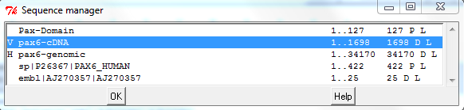
In similar fashion, make pax6-cDNA the V (for Vertical) sequence.
Leave the Sequence manager by clicking OK. You are now be ready to proceed.
Pairwise Sequence Comparison
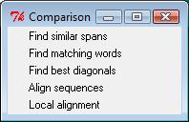
You will be using options from spin's Comparison menu for the next few steps. To set up that menu for easy access, click on spin's Comparison button and then on the dotted line of the menu that will appear. Position the menu window that “tears off” conveniently.
Graphical pairwise sequence comparison - DotPlots
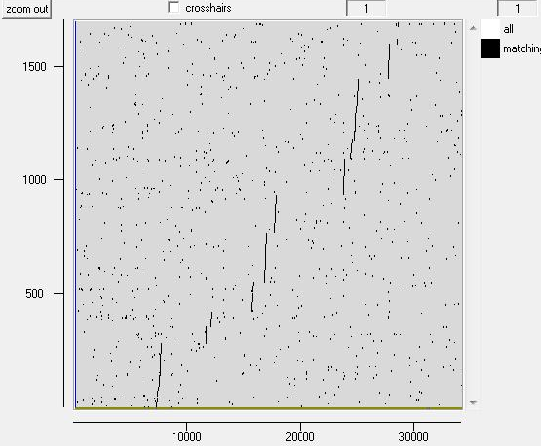
An intuitive graphical representation of the comparison between two sequences is a dotplot. One sequence is represented on each of two Cartesian axes and significant matching regions are indicated as a plot. Further detail will be provided by presentation. These plots are used to indicate which sections of sequence might align with each other convincingly and thus warrant further investigation.
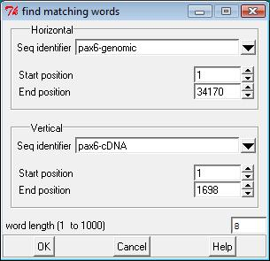
From your Comparison menu, select Find matching words, which offers a simple and fast way to draw a dot plot. Check that you have the sequences you expect in the Horizontal and Vertical positions. Accept the default word length of 8 and click OK. A dotplot will burst forth with the genomic sequence along the bottom axis, and the cDNA sequence on the vertical axis, as illustrated. As far as the resolution of the picture allows one to judge, there appears to be 11 matching regions.

What do you suppose these regions represent?
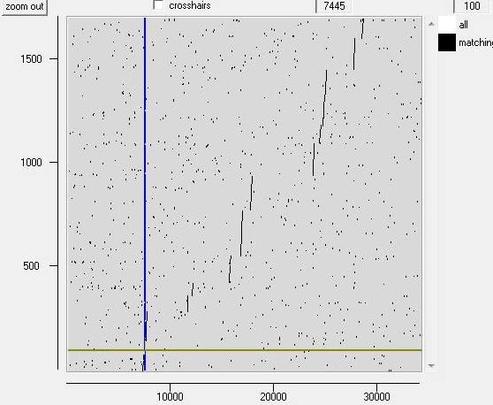
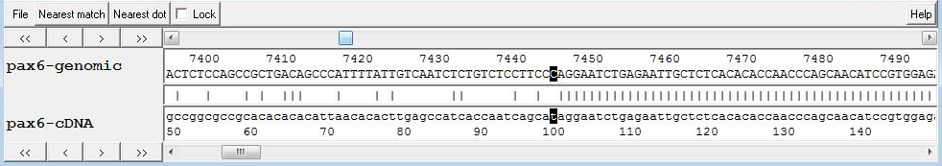
To get a clearer view of the features of any of the graphics you produce with spin, you can always make the picture window bigger, use the X and Y controls at the bottom to reshape the view, hold the Ctrl key down and select a region with your right mouse button to zoom in to a feature. Try any or all of these possibilities. You can also view the sequence of any feature by double clicking your left hand mouse button near that feature. Try this and a Sequence Comparison Display will appear. You can control the sequence region in view by dragging the cross hairs that will appear around. To fix the display exactly on a given feature, get as near as you can manually and then click on the Nearest match button.
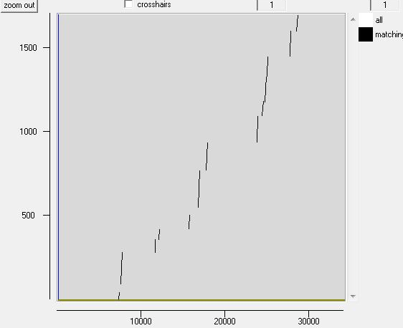
Using a word length as small as 8 shows the meaningfully matching regions quite well in this case, but there is quite a bit of unnecessary “noise”. The features we wish to be shown are long, so it is possible to use a bigger word size without losing matches of importance.
Re-run Find matching words, exactly as before but this time, select a word length of 50. Your new dotplot will be drawn on top of you first and so will thus be difficult to see. A plot can be repositioned by moving around its configuration button (the corresponding square in the top right hand corner) with the middle mouse button. You could move the new dotplot so it is above or below the first or into a separate window (the best choice) by dragging its configuration button into an unoccupied place on your desktop. Your second plot is essentially as the first, without the noisy background. Now it looks more like twelve matching regions. We compare genomic sequence with cDNA, so it is reasonable to assume the matching regions of this plot represent the exons found in a transcript of PAX6.
Is the number of matching regions consistent with the number of exons you might expect?
If not, can you explain the discrepancy?
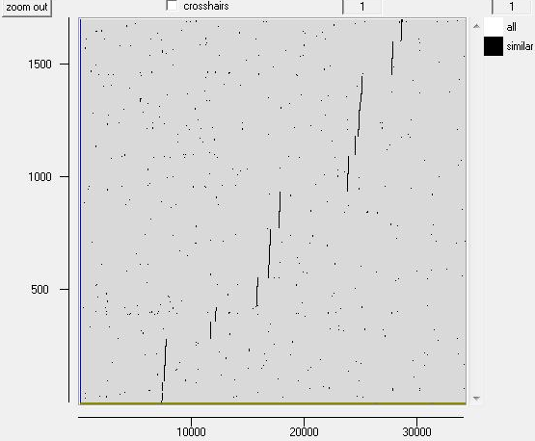
The second plot is clearer. Noise has been eliminated without loss of “real” features. The choice is not always so clear. It can be necessary to experiment using different parameters.
The algorithm you have used thus far is fast but crude. Adequate for these sequences between which all real matches are long and almost exact. However, in most circumstances a more meticulous slower approach might be required in which “similar” as well as exactly matching words are recognised. From your Comparison menu, select Find similar spans, accepting the default window length of 11 and minimum score of 10, click OK. Your plot should be as illustrated.
Again, from your Comparison menu, select Find similar spans. This time, set the window length to 50. spin automatically resets its minimum score field to a new default of 28. Click OK. Separate out your plots so that they can be seen clearly. No surprises? A less noisy background is the most obvious effect. Also you should be able to see that the “real” features appear to have grown a little.
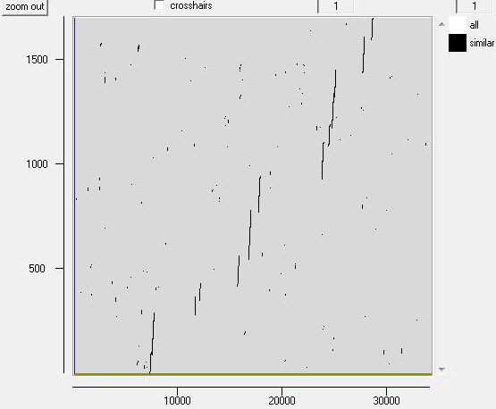
Why do you suppose that might be?
The dotplot can be useful as a rapid overview of the similarity between two sequences. Alone, it provides insufficient detail. For this, we need to generate textual alignments.
spin produces helpful graphics when textually aligning sequences. These graphics are most informative when superimposed over a corresponding dotplot. Here, the most useful dotplot is the simplest. The one you generated using the “Find matching words” algorithm with a word length of 50. If you have not already done so, throw all the others away. If necessary, recreate the required dotplot.
Pairwise textual sequence alignment
Now make some alignments that will show the detail of the dotplot comparisons. The algorithms used are more rigorous than those used for searching databases, often producing more revealing alignments. Thus it can be a good idea to use these tools on similar sequences identified by database similarity searches
Global sequence alignment
A global alignment is one that aligns two sequences over their entire lengths. In spin's Comparison menu, the option Align sequences. Click on spin's Align sequences option. Click OK accepting the defaults:
score for match (4) value added to the alignment score for each correctly matched base
score for mis-match (-2) value added to the alignment score for each incorrectly matched base
penalty for starting gap (8) value subtracted from the alignment score for each gap
penalty for each residue in gap (1) value subtracted from the alignment score for each element of a gap beyond the first
spin represents the computed alignment graphically, over the dotplot. It should suggest that it has successfully aligned the group of exons around 23,500 to 25,000 in the genomic sequence and 940 to 1,450 in the mRNA, but then failed with the rest.
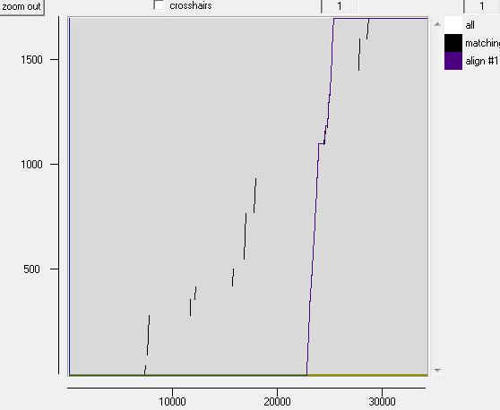

Examine how your alignment graphic matches the dotplot by right clicking its configuration button and using the Hide/Reveal option.

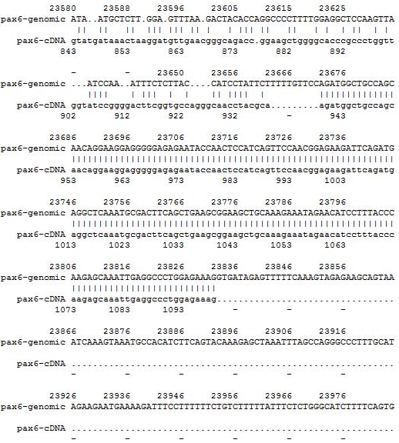

Now inspect the textual alignment in spin's Output window. As the graphic suggests, the mRNA has been prefixed with over 22,000 minus signs to make it of equal length to the genomic sequence. There follows an entirely unconvincing (given the evidence of the dotplots) alignment of the first few exons of the mRNA with the region around 23,000 in the genomic sequence.
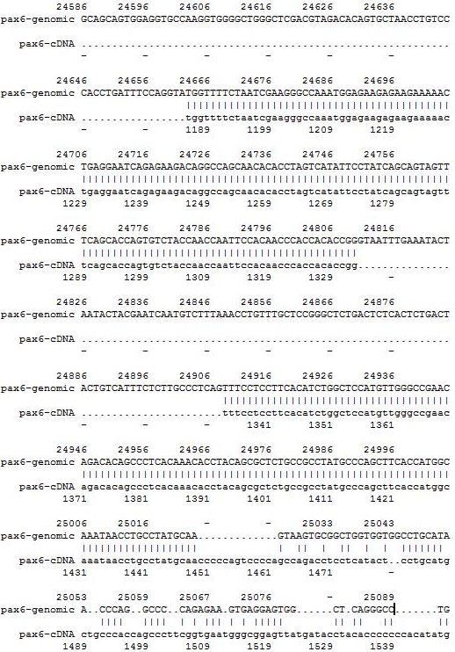
The 4 exons around 23,500-25,000 in the genomic sequence and 940-1,500 in the mRNA are aligned convincingly. The final mRNA exons are aligned, with an excess of poetry, with the bases after 25,000 of the genomic sequence.

The mRNA is then desperately padded to reach the end of the alignment. The bizarre padding at each end of the mRNA is required to fulfil the requirement of a global alignment to be “end to end”. The entirety of both sequences must be included in the alignment.

How many convincingly aligned regions did you see?
Roughly how many did you expect?
Clearly, this alignment is not correct. Can you explain why?

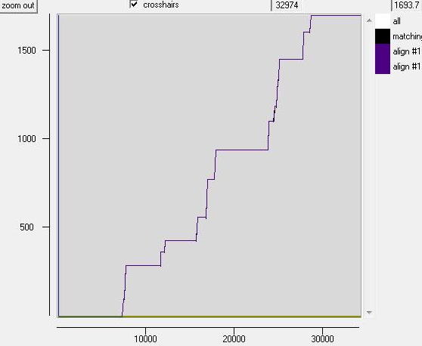
Try the alignment again, this time with much “cheaper” gaps. First Hide the plot associated with your first global alignment attempt. This should leave the dotplot in clear view. Now click on spin's Align sequences option once again. This time, set the penalty for each residue in gap to 0. This amounts to asking that all gaps be penalised exactly 8 points no matter how long they be. Click OK.
Now the alignment graphic shows the alignment dutifully passing though all the matching regions identified by the dotplot. Take a look at the textual output associated with this second alignment.
How many matching regions are there this time?
Is the count now roughly as you would expect?

These global alignments show how misleading it can be to run programs without carefully considering their assumptions and parameter values. The second time around, you achieved the “correct” alignment, but only by making the cost of gaps so cheap that huge introns could be mistaken for normal insertion/deletion events. This only worked because the mRNA/genomic sequences came from the same organism and the corresponding exons were effectively identical. If the comparison was between homologous sequences from different organisms, it would usually be necessary to use gap penalties that reflected the way real insertion/deletion events occurred in the exons. Declaring almost free gaps to cope with introns would rarely succeed.
The best solution is to accept that the alignment between a cDNA/mRNA and genomic sequence is a special case. A general alignment program will not make the right assumptions for such alignments and is thus the wrong tool for the job. There is a program in the EMBOSS package, called est2genome, which is specifically designed for the alignment of cDNA/mRNA and genomic sequences. est2genome (and similar programs) may assume much more about the sequences to be aligned than can a general purpose alignment program. Gaps representing introns can be placed far more accurately if they are known to represent introns. Programs such as est2genome seek the highly conserved bases that occur at intron/exon boundaries, C/T rich intronic regions, polyA regions and Stop/Start codons to assist its detection of exons and gene structures.
est2genome is a fine program, but there are two other options offered at the NCBI in America that do the same job, I think, somewhat more nicely. Of these, I choose the program called splign for this exercise on the grounds it is the more sophisticated service. To investigate, go to the home of splign at:
http://www.ncbi.nlm.nih.gov/sutils/splign
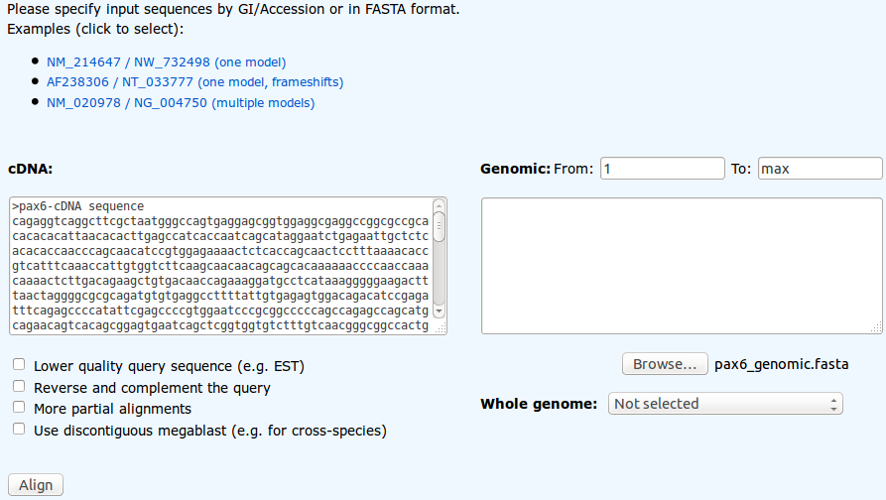
Click on the Online button. In the Genomic section, Browse to upload pax6_genomic.fasta. In the cDNA section, paste the sequence pax6_cdna.fasta. Where cDNA and Genomic sequences share exons that are nearly identical, splign uses the comparison algorithm megablast (default choice). Where exons are less similar (e.g. when the cDNA and Genomic sequences are from different organisms) the more sensitive option discontinuous megablast, might be a better choice. Note the option to compare your cDNA with a Whole genome (including Human). Today, the default options are fine. Click the Align button.
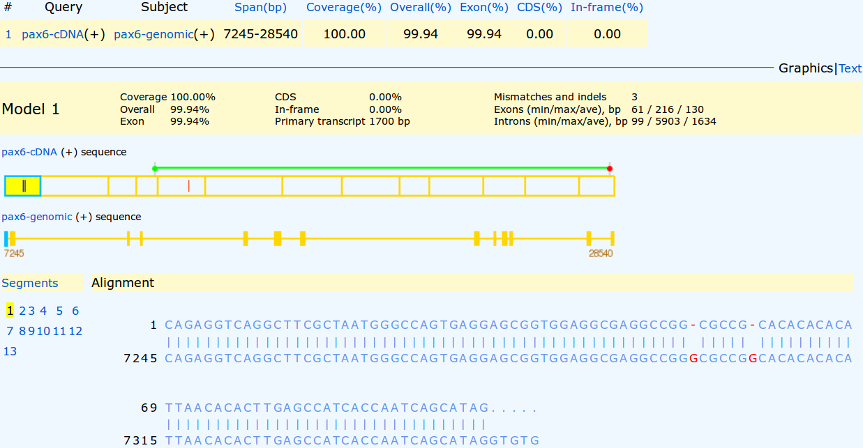
Your results will appear showing the cDNA split into 13 sections (the predicted exons) corresponding to 13 regions of the genomic sequence indicated by yellow rectangles. The first exon alignment is displayed showing two cDNA deletions. Though these are in a non-coding region, they could easily still be very significant. However, for the purposes of this exercise, let us assume they are not. The Start (green) and Stop (red) codons of the cDNA are illustrated by the bar above the cDNA display.
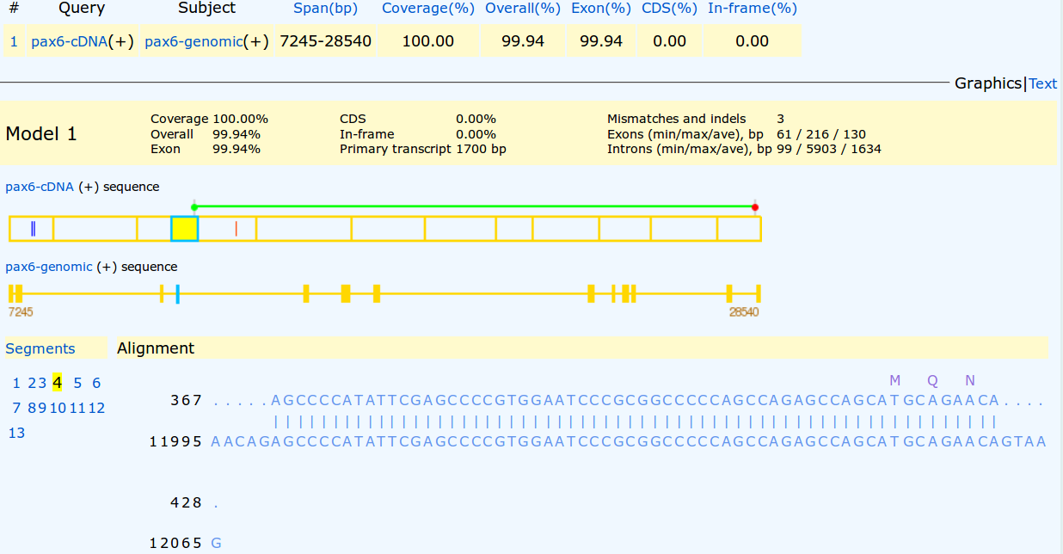
Click on the exon including the green Start codon (the fourth). The first coding exon is now displayed. The statistics at the top of the display include the claim that there are three discrepancies (Mismatches and indels) between the cDNA and Genomic sequences. Two of these are the deletions we have already seen in the first exon of the cDNA. The third is indicated by the red bar in the fifth exon of the cDNA display.
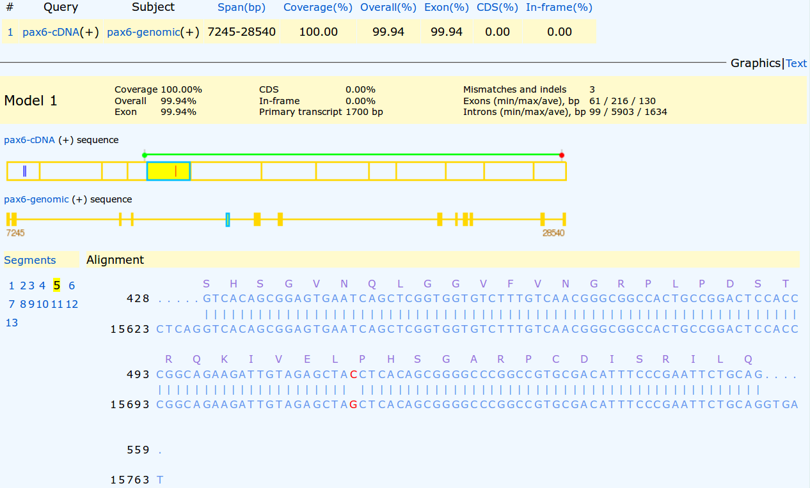

Click on the fifth exon section of the cDNA display.
The third difference, a substitution, should be clear to see. Given it changes the coded protein, this substitution is likely to be the most significant.

What is the amino acid corresponding to this position in the mRNA of the aniridia patient?

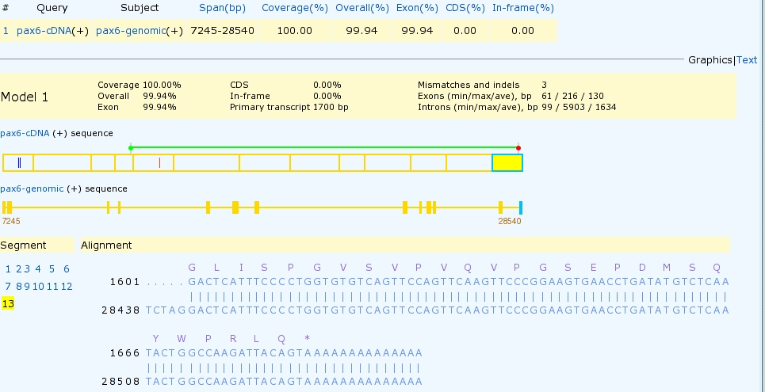

Click on the last exon section in the cDNA display. You should now see the final exon of the cDNA with the Stop codon and polyA region.

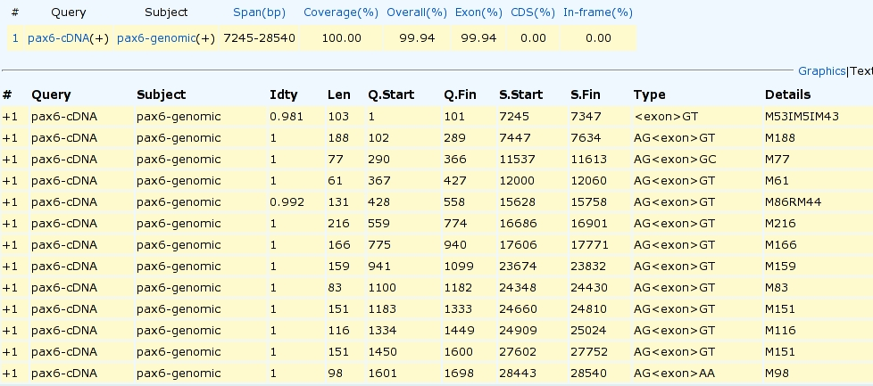

Finally, click on the Text link to view the textual summary of the splign results.


How do you interpret the Details column for exons 1 and 5?

Where is the substitution in the aniridia patient mRNA?

Where is the substitution in the Genomic Sequence?

Compare the predicted splign intron/exon boundaries with the conservation suggested by the logo?

What deviation(s) from the model suggested by the logo can you see?

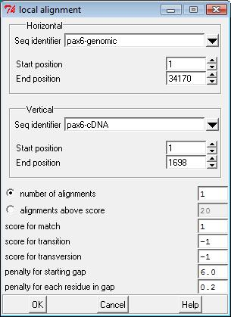
Local sequence alignment
Global sequence alignment algorithms align sequences over their entire lengths. Local alignment methods searches for regions of similarity and need not include the entire length of the sequences. It is important to select the type of alignment that makes best sense for your sequences. Here, we expect an ordered sequence of matching regions (the exons) to occur in both sequences but spaced very differently. With an effort (or preferably appropriate software), we can get reasonably sensible alignments using a global or a local approach. However, if our sequences represented multi-domain proteins that shared some domains but not others, or the same domains but in differing orders, or proteins where there have been regions of duplication, a single sensible global alignment would not exist. A local approach would be essential.
Move back to spin, tidy away all previous graphics plots except one clear dotplot between pax6-genomic and pax6-cDNA. From spin's Comparison menu, select Local alignment. Note that:
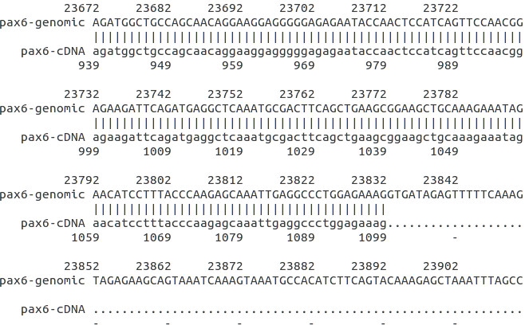
- in common with most local alignment programs, the default number of alignments to be reported is 1
- transversions and transitions may be penalized differently
- gaps are slightly cheaper than for gobal alignments
Accept all the defaults and click OK. The graphic suggests that the single “best” region that spin has elected to locally align, is the region around 25,000 in the genomic sequence where there are 4 exons that are close together. It was this region around which the global alignment algorithm chose to build its first attempt.
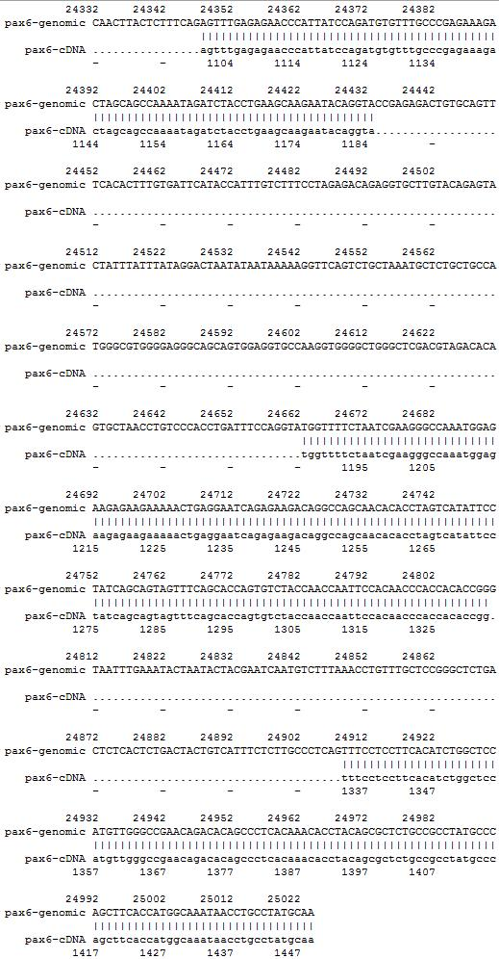
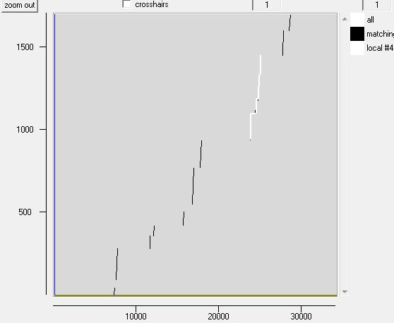

Check that the textual and graphic outputs agree.
How might the gap around 24,600 in the genomic sequence been positioned more intelligently?

The choice of this region is primarily due to the choice of gap penalties. If bigger gap penalties were selected (increase penalty for each residue in gap to 1, say) spin would cease to regard the 4 exons around 25,000 as one entity. Their individual alignment scores would look less attractive. Eventually, the region around 16,700 (the longest single exon) would easily outscore the rest. If you have time, try it.
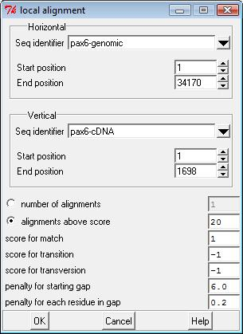
From spin's Comparison menu, select again Local alignment. Clearly, there is more than 1 meaningful local alignment. To see more, spin offers two options.
You could guess the number of alignments value. However, this is not trivial. You know the number of exons (and so the number of logical alignments expected) with some certainty by now, but this does not necessarily correspond to the expected number of local alignments. spin will combine close exons into single alignments if gap penalties are low enough. spin assumes that your choice of number of alignments is exactly correct. Too low and you will miss real alignments. Too high and spin will show alignments of ever increasing fantasy.
It is normally better, therefore, to specify the alignments you wish spin to display by providing a quality cut off rather than a volume cut off. To do this, turn on the alignments above score option. Use the default value of 20.

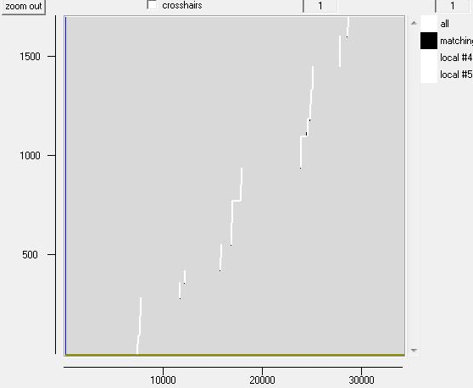
It is not obvious how one might choose a sensible value. In such circumstances, the “lazy” option of just accepting the default is fine. Maybe someone sensible chose it? If not, one can always iterate to a value that works. I.e. if you would like more alignments, lower the value and try again. Too many? raise it. Repeat until the program agrees with what you wished to be correct in the first place. Is not science wonderful? With hope in your heart, click OK.
Looking at the graphic, I would say we got lucky this time. There is a local alignment that covers every exon identified by the dotplot and no extra results requiring explanation.
Scan your results to find the exons. You should see that all have been correctly aligned.
Why do you suppose your aligned exons are not presented in the correct positional order?

Further features of Spin
ORF Identification and Translation
Searching for sequence similarities in databases.
The most popular way to investigate a sequence has always been to compare it with one of the sequence databases now accessible from sites all over the world. When sequences databases were more sparsely populated than now, the objective was to search hopefully, not always with success, for any convincingly similar sequence(s). When such a match was discovered, it could be supposed that known properties of the “similar” database sequence might provide insight to the properties of the query sequence. Now, the databases are full of sequences representative of most interesting conditions. Similarity searches are conducted in the expectation of finding many close “hits” for almost any sequence. Fewer database searches are conducted in complete ignorance of what the query sequence might be.
Here, take the PAX6 genomic DNA sequence retrieved from Ensembl and conduct two searches analogous to those run in the Ensembl pipeline. Results should confirm that which has already been discovered using other sources.
blast is not the only sequence database searching program available, but it is the most popular by a very long way. blast searches are offered in many forms by many servers all over the world, but the most comprehensive and reliable service has to be that offered by the NCBI.
Go to the NCBI homepage at:
http://ncbi.nlm.nih.gov

Select the BLAST option (from the Popular Resources list). In the Basic BLAST section, select nucleotide blast. Use the Enter Query Sequence Browse (or Choose File) button to upload the file:
pax6_genomic.fasta.
For results like those used by Ensembl to predict PAX6 transcripts, you must compare your genomic sequence to a reliable set of human mRNA/cDNA (or similar) sequences.
In the Choose Search Set section, set the Database to Reference RNA sequences (refeseq_rna).
You are now able to specify an Organism, choose Human.
blast is now set to compare the PAX6 genomic region with all Human mRNA sequences in RefSeq.
Note that the default Program Selection is Highly similar sequences (megablast), which seems appropriate here as all the mRNA that correctly match should surely do so almost perfectly.
Click on the Algorithm Parameters button. The defaults are fine here, but before starting your search, try changing the Program Selection and observing the different Algorithm Parameters.

The default settings of all shared parameters are identical for the two slower more sensitive Program Selections.
There are differences for megablast, where speed is of the essence and sensitivity can be sacrificed.
Smaller Word sizes slow searches but increase sensitivity. For megablast the default Word size is 28 otherwise it is 11.
Gapped alignment is time consuming and, by default, considered more crudely by megablast than the other two algorithms.
Filtering and Masking matches with organism specific repeats and/or low complexity regions takes time, and so only avoiding Low complexity regions is on by default for all Program Selections.

When discontinuous megablast is selected, an extra options section appears. Discussing how this flavour of blast works is a little beyond the scope of these note, but briefly. Unlike the other Program Selections, discontinuous megablast does not just look for exactly matching “words” of given size as a first step towards identifying matching regions between sequences. It looks for a pattern of matching bases within a word. For example, the default choice assumes your query is coding and looks for 11 matching bases within a word of 18. Approximately, every third base is allowed not to match. Biologically, this can be justified as allowing for third codon position wobble. For more detail, use the appropriatebutton. Notice there arebuttons by every parameter selection. Try one or two. In the process, discover:
When would Mask lower case letters be a useful thing to do?

Automatically adjust parameters for short input sequences is independent of Program selection, and so remains unaltered.
Which parameters would blast need to automatically adjust to cater for short input sequences (such as primers being tested for uniqueness), and why?

Finally, ensure all the defaults are back in place and the megablast is the Program Selection, ask blast to Show results in a new window and then click on the button. Impressively swiftly, you will have results. At the top of which will be a graphical overview.
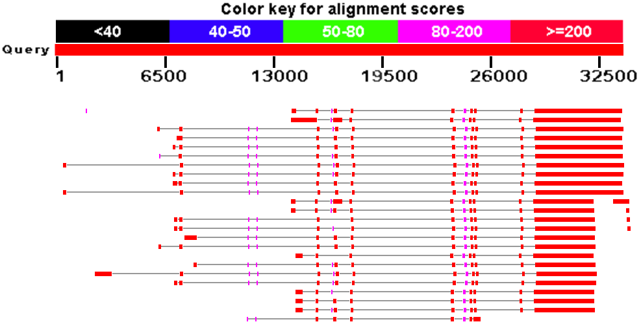
This graphic implies that there are 24 full length matches between your genomic sequence and mRNAs in RefSeq. The RefSeq entries had to be “gapped” in order to compensate for the introns that are represented in the genomic sequence but removed from the mRNA sequences. The red blocks therefore represent very closely matching ( brownie points) exons, the lines joining the red blocks represent introns that have been spliced out. All 24 hits match reasonably uniformly except for the first few exons, implying significant variation in the 5´ UTR.
Why do you suppose that a few of the exons do not achieve the maximum score?

Explain why one exon in the reasonably consistent region, does not appear in all of the transcript matches?

GeneCards reported that there were 24 PAX6 transcripts recorded in RefSeq, 11 high quality NM_ entries plus a further 13 XM_ PREDICTED transcripts. Ensembl claimed to have used 10 or the 11 high quality NM_ RefSeq sequences to aid its transcript predictions, but ignored the 13 XM_ PREDICTED, less certain RefSeq sequences. blast just sees sequences and cannot be influenced by the quality of the support for their existence, so blast reports that all 24 RefSeq PAX6 mRNAs match the PAX6 genomic region convincingly.
Perfect consistency between three sources of information! Wonderful, but this is not always the case. When RefSeq acquires extra sequences, Ensembl will not notice until its next “genebuild” event. When Ensembl finally gets into line with the changes in RefSeq. GeneCards will not respond until its next update. RefSeq has been relatively static of late, with regards to this particular gene. It is rather a nice change to be looking at a neat and consistent picture at this point. Sadly, it will not last.

In summary, if you hover over the graphical hits, their origin will be displayed above the graphic. The facts are:
- The top 10 and the bottom 1 full length hits are of the best quality (i.e. NM_ entries with good supporting evidence). 11 in all.
- From the 11th full length hit, there are 13 entries all labelled “PREDICTED”. We have already concluded that Ensembl is clever enough not to rely on PREDICTED RefSeq entries alone to justify an Ensembl transcript prediction. GeneCards does count them as sufficient to indicate RefSeq transcript predictions however.
- There are 4 small hits to the extreme right of the graphics at the same level as the top 4 PREDICTED hits. These are the ends of mRNAs for the ELP4 gene and are exactly where you should expect them to be given previous discussion. Reject these contemptuously, they do not pertain to our investigation of PAX6.
- The tiny smudge match to the left of the top hit is “uncharacterized” and fails to fit in with my story, so I ignore it!
So, this blast search suggests the existence of 24 PAX6 transcripts supported by RefSeq data, as is reported by GenCards. Also, the results are consistent with the information discovered in Ensembl.
Move down a trifle and you will find a simple list of the 29 matches represented in the graphic.

Why were you not surprised to discover 24 PAX6 transcripts in Refseq matching this sequence?

Which of the Refseq PAX6 transcripts corresponds to isoform 5a?
Moving further down the results you will come to the alignments between pax6-genomic and the matching database entries. All similarity searches use local alignment strategies, so you should not be surprised to see a number of alignments for each “hit” in the list. Here we have a genomic query sequence aligned exclusively with mRNA sequences from RefSeq. The expectation is therefore to find an alignments corresponding to exons. The alignments are ordered by quality, though you are provided with a Sort by: menu to alter the order to taste.
Look at the first alignment for the best matching PAX6 transcript. It is the alignment of the very last exon of a RefSeq transcript with the end of the gene you exported from Ensembl.
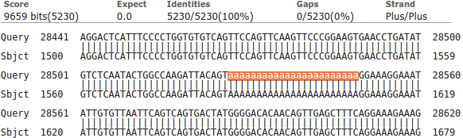
Notice the lower case string of 'a's. The case indicates that they were ignored (filtered) as a Low complexity region whilst megablast was looking for identically matching words that might suggest matching regions. By themselves, the 'a's are not sufficient evidence that a biological match exists. Only because the surrounding sequence is compellingly similar, can it be assumed that such a match does exist. The 'a's are replaced (lower case to indicate they were filtered) when the final alignment is computed. If you look a little further down the same alignment, you will see several other runs of 'a's and 't's for which the same explanation applies.

Now use a version of blast (called blastx) to compare your genomic sequence with a protein database. blastx will translate a DNA query sequence in all six reading frames and compare each translation with a protein sequence database. Thus, in a similar fashion to that employed by the Ensembl pipeline, protein coding regions of the genomic DNA can be identified. For clarity, we will use only the well annotated human proteins of the SwissProt section of Uniprot. First go to the home of blast at:
http://blast.ncbi.nlm.nih.gov/Blast.cgi
In the Basic BLAST section, select blastx. Use the Enter Query Sequence Browse (or Choose File) button to upload file pax6_genomic.fasta.
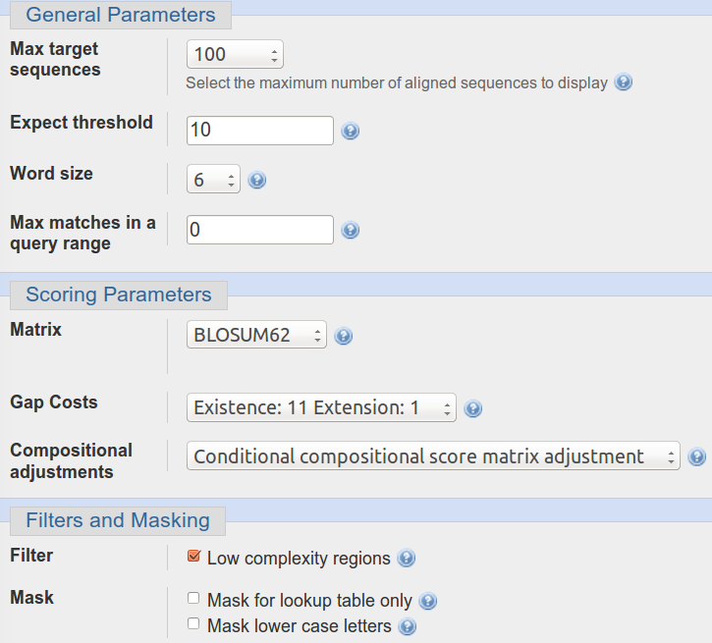
In the Choose Search Set section, set the Database to UniProtKB/Swiss-prot prot(swissprot). Specify the Organism as Human.
Take a look at the Algorithm parameters.
The Word size choice is 2, 3 or 6 . The default is 6. We seek very close matches here, so the largest Word size would seem appropriate.
The default scoring matrix is BLOSUM62, but choices from both the BLOSUM and PAM families are offered.
Low complexity regions will be filtered by default.

Change nothing other than to ask blast to Show results in a new window. and click the button.
After minimal thought, blastx will thrust its conclusions before you. Hover over the graphical hits for identification.
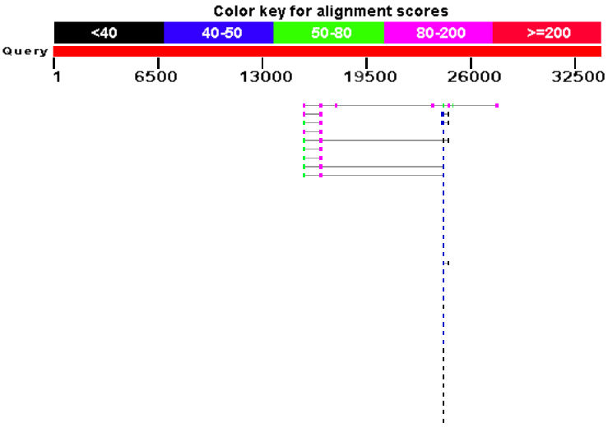
What are the 9 stronger matches around base position 16,000?
Why would you expect exactly 9 matches around this point?
What do you make of the plethora of matches around 24,000?
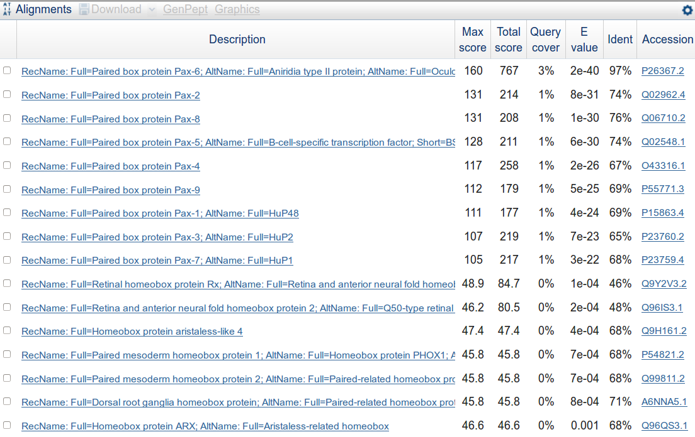
Move down to the textual list of the matches. Hopefully as you fully expected you will find the expected number of Paired box matches at the top of the list followed by many many Homeobox matches.
Why do you suppose the Paired box matches precede the Homeobox matches?
How do you suppose the Max matches in a query range parameter might be of value if this order was reversed?

Take a look at the alignments. You will see many places where regions have been filtered as non-informative. I suggest the one illustrated was filtered because it would match anywhere that was sufficiently Serine rich.
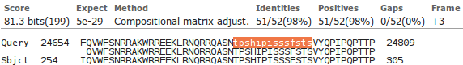
How does this “non-informative” region match expectations suggested by Prosite and the Feature table of Uniprot for PAX6_HUMAN?
Primer Design
To determine the presence or absence of the mutation we have detected, a test based on restriction maps could be employed. This approach is investigated in one of the supplementary exercises at the end of this book. In that extra exercise, it is shown there is more than one restriction enzyme whose cut site is dependant upon the mutation. With a little more work (with the same programs), we could easily ascertain exact restriction fragment sizes expected for selected enzyme(s) with the mutation and without it. As long as the differences were sufficiently unsubtle, a Restriction Fragment Length Polymorphism (RFLP) test could be designed.
For a variety of reasons, including the ready availability and ever decreasing cost of sequencing, this is typically not the preferred way to proceed. It is normally preferable to use PCR to isolate the region around the mutation and sequence all individuals under examination. To do this, the first step would be to design suitable PCR primers. One program, in many different forms, is almost exclusively used for this purpose. The program is primer3. It is free and can be downloaded and run under linux and windows (at least). It is available as part of the EMBOSS package (eprimer3) and from a number of websites, including at the Massachusetts Institute of Technology (MIT):
http://frodo.wi.mit.edu/
This site is popular with many users offering complete control over the various options offered by primer3.
Another excellent primer3 web interface developed in the Netherlands is available at:
http://www.bioinformatics.nl/cgi-bin/primer3plus/primer3plus.cgi
The site incorporates access to a blast search to check the uniqueness of the selected primers (important if unwanted PCR products are to be avoided).
Mostly because of its completely seamless inclusion of a blast search to compare potential primers with appropriate sequence collections, I suggest we here use primer3 as implemented at the NCBI, even though it offers less than complete control over the execution of primer3 itself. Go to:
http://www.ncbi.nlm.nih.gov
Click on the BLAST option. Select Primer-BLAST from the Specialized BLAST section.

Upload your genomic PAX6 sequence using the Browse (or Choose File) button for the PCR Template.

You have established that the mutation of greatest interest is the G/C substitution at position 15714 of the genomic sequence copied from Ensembl. It is logical therefore to specify that this feature be included in the PCR product not too near either end. Accordingly, request the Forward primer to be chosen From the region starting at base pair 15000 and continuing To base pair 15700. Set the range for the Reverse primer to be From 15800 and To 16500.
The default PCR product size is specified in the Primer Parameters section as between 70 and 1000 base pairs. This seems fine.
I would not presume to advise you on the melting temperatures that were most suitable. For this exercise, the defaults work splendidly.
By default, primer-BLAST will report the best 10 primer pairs it can find (# of primers to return). This is plenty for the exercise.
Do you think 10 primer pair suggestions is sufficient? If not, what number would you choose?

In addition to running primer3 to suggest primers, Primer-BLAST checks against the possibility of unwanted PCR products by comparing potential primers against an appropriate sequence database with blast.

In the Primer Pair Specificity Checking Parameters section, set the Database selection to RefSeq representative genomes. Leave the Organism set as Homo sapiens.
You thus request each potential pair of PCR primers to be compared to the entire human genome. Thus unintended products of similar size to the intended product, can be identified.
The ideal conclusion is “just one product will be produced, on chromosome 11, in the region of the PAX6 gene”.
Use the appropriate button to discover the purpose of the Max target size parameter.
This is a new parameter replacing a very different parameter, the purpose of which was somewhat less obvious. The reason for the Max target size parameter is surely pretty transparent, so maybe there is now less requirement to wake up itsbutton? For the present, the maximum size of any proposed PCR product, in this instance, is 1,000 base pairs (the form default). So the greatest size of an unwanted product that might be a problem (the Max target size) must be small enough to potentially be mistaken for a real product of 1,000 base pairs. 4,000 base pairs seems a bit cautious to me? However, unless you feel strongly about the matter, accept the default value of 4000.
What value would you choose here if you were looking for uncluttered results?

Before setting primer-BLAST going, click on the Advanced parameters button. Not really so Advanced? More Avoidable by those in a hurry. At the top are the Primer Pair Specificity Checking Parameters that control the way that blast is run. Note thebuttons offering explanation.
Note the very high default Blast expect (E) value, suggesting you will be interested in matches with your primers that might occur up too 30000 times by chance! This does make sense as the primers will be very short and so many good, even exact, “chance” matches might be expected against a large database.
Comment upon the small default value for the Blast word size?



Note that you could get primer-BLAST to suggest an Internal hybridisation oligo, but decline the invitation this time.

Accept all the Advanced parameters as they are. Ask primer-BLAST to Show results in a new window.
Click on the Get Primers button.

After a few moments of deep thought, primer-BLAST will notice that the template sequence you are using is highly similar (identical in fact) to part of an entry in the database being searched. Hardly surprising if one was to think about it.
You are invited to select all listed regions (just one this time) where matches with primers are likely to be the intended product. In this case, that is the whole list of one, so click on the All button.
Every pair of primers that primer3 selects must match this region of Chromosome 11 as it is precisely the region investigated by primer3 in the first place. This process avoids blast reporting intended products as unintended products. Finally, all is ready, so ask to Show results in a new window and then click on the Submit button.
Once you have revelled in the opportunity to twiddle the fingers and scratch the ear(s) whilst primers3 and blast go merrily about their appointed tasks, you will receive your results. These should look disarmingly like mine if all has gone well, in Summary and in Detail.
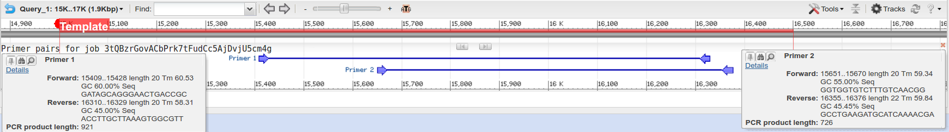
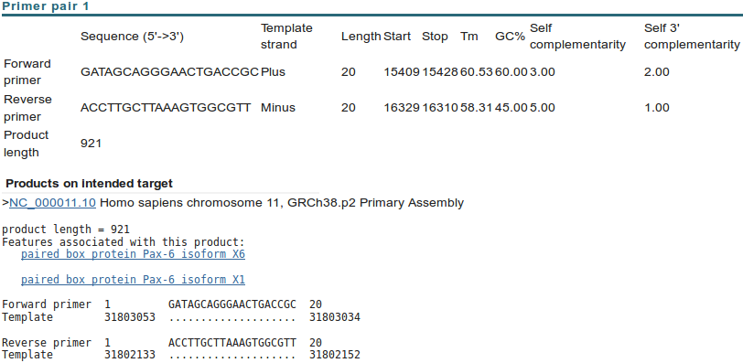
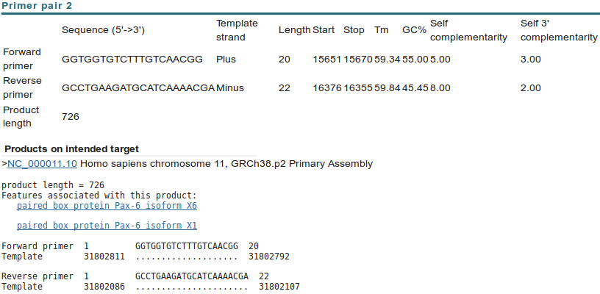

Just two solutions met the default criteria for success used by primer3. Up to 10 were permitted. Hovering over the graphical results will bring forth textual summaries. Try it. Note the rather ugly job identification! Clearly, the poetry generated for your results is extremely unlikely to be the same as illustrated.
Neither of your two suggested primer pairs should be associated with any unintended products, even with the very generous suggestion that products 4000 bases long should be considered a potential problem.
As well as suggesting primers for PCR (or other purposes) and (optionally) suggesting hybridisation oligos, primer-BLAST can be used to evaluate user-selected primers. Earlier, you saved a pair of primer sequences associated with PAX6 when searching the nucleotide databases at the NCBI. It would be interesting to discover the product these might produce. To do this you need an unsullied Primer-BLAST page. Go again to:
http://www.ncbi.nlm.nih.gov
Click on the BLAST option. Select Primer-BLAST from the Specialized BLAST section. Upload your genomic PAX6 genomic sequence using the Browse (or Choose File) button for the PCR Template.

Open up the file you made containing the primers from GenBank (pax6_primers.fasta) in a text editor.
Copy and Paste the two primer sequences into the Use my own forward primer and Use my own reverse primer boxes as appropriate.

In the Primer Pair Specificity Checking Parameters section, set the Database selection to RefSeq representative genomes.
Leave the Organism as Homo sapiens.
Raise the Max target size parameter from 4000 to 20000. You should check for enormous unintended products with this run of Primer-BLAST. The reasons for this will soon become apparent.
Ask primer-BLAST to Show results in a new window. Click on the Get Primers button.
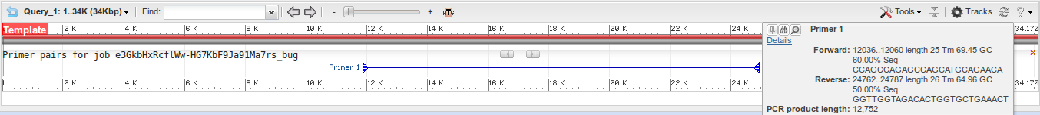
After a short thrill filled pause, you will receive a result that should again looks more that a trifle like mine.
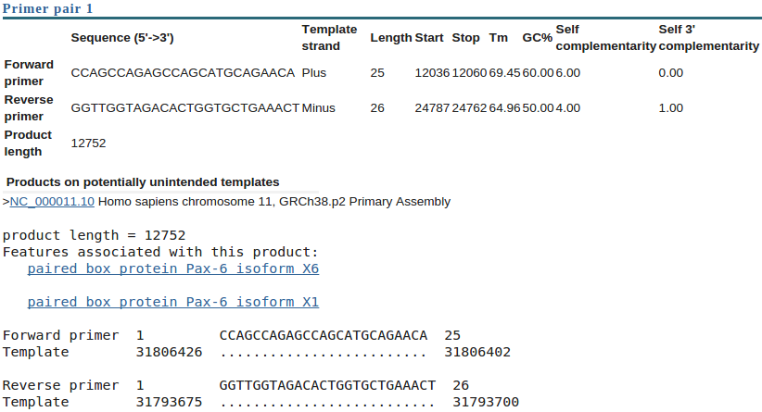
Seemingly a fine match. Even the single potentially unintended product reported is actually the intended product. For some reason, Primer-BLAST does not distinguish between intended products and unintended ones when investigating user specified primers?
Success! However, applying a small measure of sober reflection, one has to wonder at a PCR product of 12,752 base pairs? I suspect that to be just a tad on the boastful side of probable? Clearly, primer-BLAST is convinced, but maybe a look at the references that came with these primer sequences would be advised before accepting this result at face value.
Unfortunately, the only paper referenced does not explain what might be going on particularly clearly. However, there is a hint that the primers you saved were designed for use with mRNA/cDNA data. Therefore it might be interesting to run primer-BLAST one last time with pax6_cdna.fasta as the PCR Template.

Simply move back to your last primer-BLAST launch page. This time, load pax6_cdna.fasta as the PCR Template.
In the Primer Pair Specificity Checking Parameters section, set the Database selection set to Refseq mRNA and leave the organism set to Homo sapiens.
Set the Max target size back to its default value of 4000, you should expect much smaller mRNA products this time, so no need for extending this maximum beyond 4000.
These selections suppose that the design of PCR product was for selection from a library of all human cDNAs.
Ask primer-BLAST to Show results in a new window. Click on the Get Primers button.

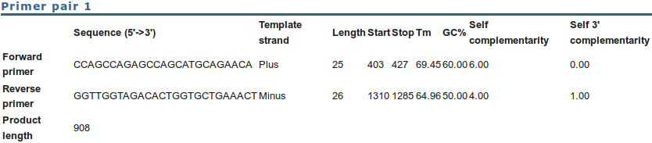
The result is a much more reasonable Product length of just 908 base pairs,reinforcing the theory that these primers were indeed designed for use with a cDNA library.
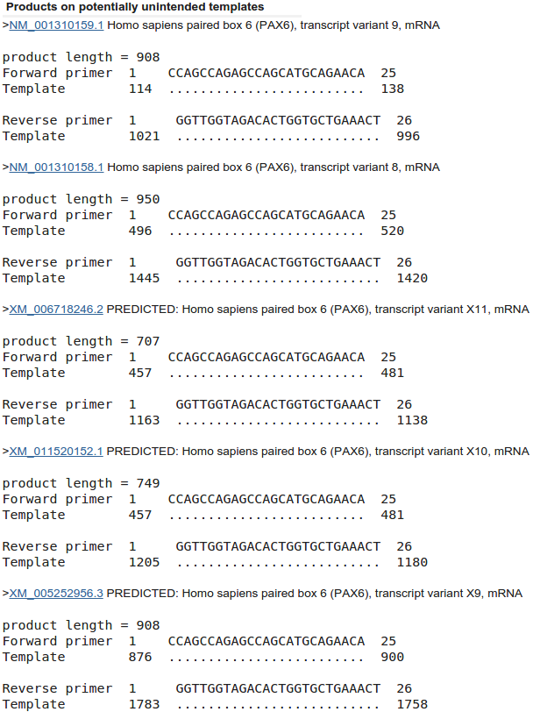
Before moving on, afford a quick glance at the report offered concerning possible unintended products. Here primer-BLAST warns against human mRNAs that might be cloned along with the intended target.
The first thing to note is that the intended target is not generated from a RefSeq mRNA. It comes from an mRNA taken from an aniridia patient directly. Therefore, there is no unintended product that we can ignore because it is really the intended product discovered by a different route, even though no filtering of the RefSeq database was undertaken.
All the unintended products could/would potentially be generated by the primers under investigation and have the potential to cause confusion. If you look down the list, you should conclude that the 16 unintended products come from 16 of the 24 RefSeq PAX6 transcripts first noted by GeneCards and then confirmed later by blast.
9 of the 11 NM_ good quality transcripts are detected. 7 of the 13 poorer quality XM_ “PREDICTED” transcripts are also present. So 16 of the 24 PAX6 transcript sequences in RefSeq were detected.
Why do you suppose blast did not pick up all the transcripts?

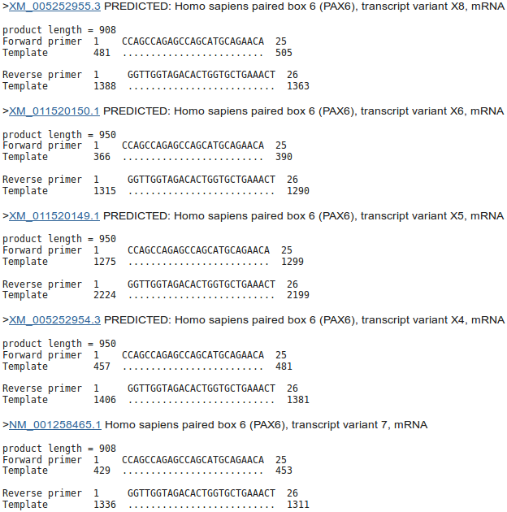
Note that the intended product is 908 base pairs long. Note that all the unintended products except two, near the top of the list are either 908 long or 950 long. A difference of 42.
How would you tell quickly which isoform was represented by each mRNA listed here?

Some fairly redundant questions to finish this section. I think I have already answered them all. But maybe you might wish to differ?
Is the number of “potentially unintended products” as you would you expect, given the evidence from GeneCards, Ensembl and blast?

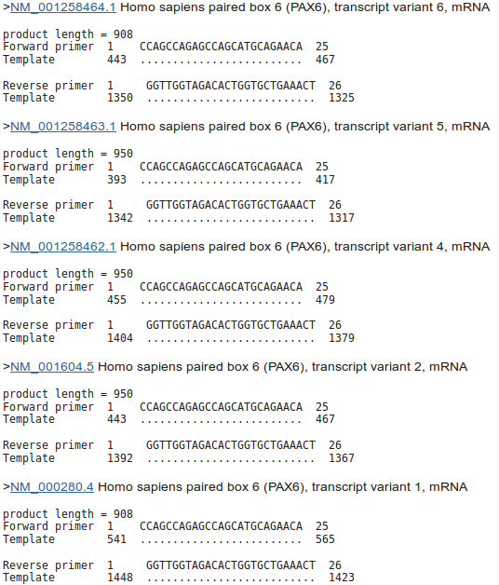

For all the “potentially unintended products”, the selected primers match exactly. Can you explain this?

The “potentially unintended products” are of different sizes. Can you explain the difference between the possible product lengths?

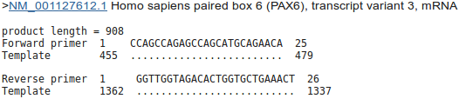
Are the numbers of “potentially unintended products” of each possible length consistent with your blast results?

Gene Identification Software – Specifically Genscan
Computational Protein Analysis
In this section, the plan is to look exclusively at the protein of PAX6. The object is to use various software items to confirm what has already discovered from the various web resources. Often the software you will use will be exactly that which was used to determine the pre-computed results you browsed previously.
Predicting Protein Secondary Structure.
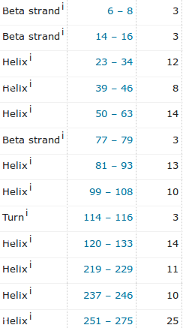
A first step is to look at to look at ways to predict the protein secondary structure of the PAX6 protein. Evidence from various sources suggests that the PAX6 protein has 9 helices arranged in triplets, plus a few beta strands.
To save time, I show here the relevant section from the Uniprot Feature Table. The helical triplets are involved in binding. 2 triplets are to be found in the paired box region, the other in the homeobox a little further along. Here we will try one of the most sophisticated methods available, to predict, essentially from from the primary sequence, what we already know. If you really wish, I also offer a supplementary exercise based around one of the earlier prediction methods, still used, but although faster, significantly less accurate than more modern methods.
Early Secondary Structure Prediction Methods - GOR
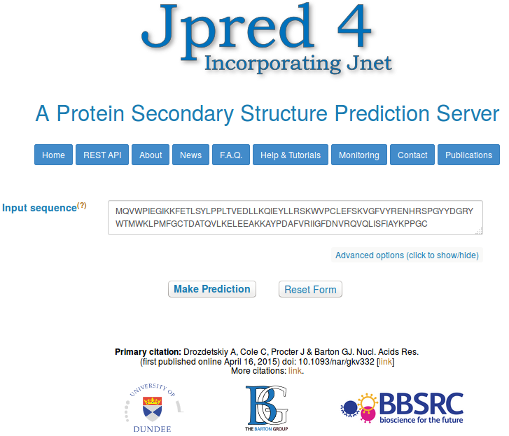
The service considered by many to offer the most effective method of predicting secondary structure is called Jpred. This is developed by the Barton group now located at Dundee University. Over 80% accuracy is claimed for Jpred predictions. Due to the inherent imprecision in defining the end positions of secondary structure elements, 80% is pretty much as good as is practically possible.
Go to the Barton Group web site at:
http://www.compbio.dundee.ac.uk
and follow the link to the server. Copy and paste the PAX6 protein (from the file pax6_human.fasta) into the appropriate text box. Click on Make Prediction.
With alacrity, JPred will report several hits with proteins of known 3D structure (using blast against a database of proteins of known 3D structure). Links are offered to a number of entries in the PDB structure database. At least 2 of the PDB entries listed should be familiar.
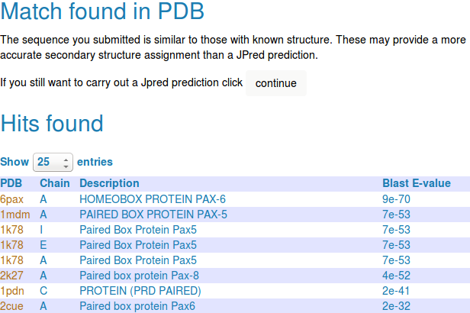
Jpred offers the suggestion that it really does not make sense to continue. After all, if the 3D structure is effectively known, why predict (guess?) the 2D structure? The answer to this challenge being a petulant “Because we want to!”
Click purposefully on the Continue button. JPred, with a small sigh of exasperation, will submit your job and tells you how busy it is. Jpred typically takes a while as it has much to consider.
Jpred will use PSI-Blast to align your sequence with all sequences deemed to be homologous, from a particularly appropriate database. Jpred then makes its structure predictions based on an aligned ”family” of proteins, rather than just one individual sequence. Intuituively at least, this has to be a fine idea. A Multiple Sequence Alignment (MSA) of related proteins will typically represent far more evidence for prediction than any single protein.
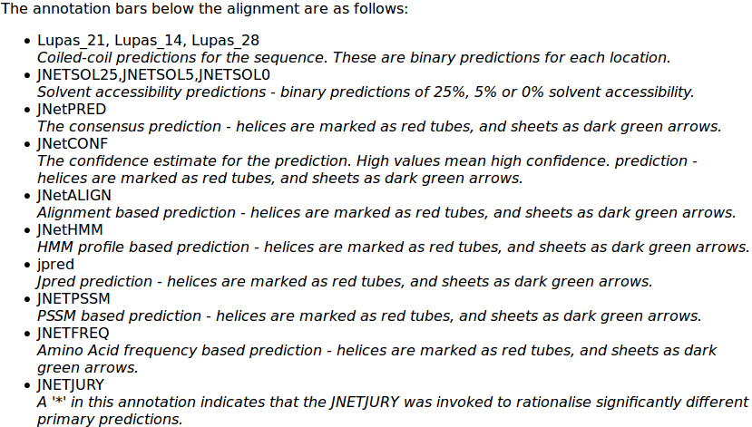
JPred presents the results of running two secondary structure predictions, using the program JNET, based on two different representations of the alignment (HMM and PSSM, similar ideas that will be discussed at some point). Predicted helices are represented as red blocks, predicted beta sheets as green arrows. A consensus prediction is presented (jnetpred) as is an indication of prediction confidence (JNETCONF). Algorithms are also run to predict coiled coils (Lupas, with window sizes 21, 14, 28). The first view of the results offered is a graphical overview aligned with your original single sequence.
The full key to all the abbreviations used (and more information about JNet) can be displayed by clicking on the details on acronyms used link.
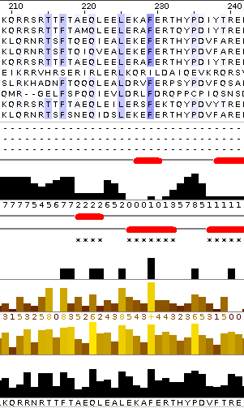
For a fuller view, elect to View results in Jalview. You will arrive at a page inviting you to select from various viewing options. The options are explained clearly, but to save you time reading and pain deciding, I suggest you go for Option 1 for the clearest view. This option does not confuse the picture by gapping your query sequence (and thus making it more difficult to associate structure predictions with regions of the PAX6 protein) and does not force you to look at the entire, huge, MSA generated by PSI-Blast.
Jalview presents something very similar to the original view of the Jpred results. This time though, the most significant part of the PSI-Blast MSA from which the predictions were computed is displayed, if rather blandly.
To highlight the conserved regions of the alignment, some colour is required. Jalview, offers a number of colouring strategies. I refer you to the Help for the full story. Here I will choose what I think is a revealing option with minimal explanation.
From the Jalview Colour pull down menu, select BLOSUM62 Score, to suggest that the inclination to colour any amino acid of the MSA be determined from its BLOSUM 62 score with the corresponding Consensus sequence residue and the quality of that consensus sequence residue. A few of the most highly conserved MSA positions around the homeobox region will now be coloured a watery blue, but otherwise, the display will remain unimpressed.
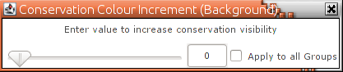
In order to remove unwanted subtlety, from the Jalview Colour pull down menu, select By Conservation, thus electing for the colour intensity to be reflected by the degree of conservation for each MSA column. A jolly little slider bar will leap forward. Slide the bar to and fro to get a feel for what it is doing. Terminate your oscillations with the minimum value selected, thus demanding that any slight odour of conservation should elicit a maximal colour burst! Clearly appropriate. You can ignore the reference to Groups as you have not specified any, so the entire MSA is regarded as a single Group at this point.
Now, all the regions regarded as even vaguely conserved glow enthusiastically blue. All regions, in this instance, being everywhere a conservation score of “0” or more is recorded. That is, everywhere except where the conservation is represented by a “-” by the conservation histogram.
Slide along the entire width of the MSA and you should clearly see that, roughly, the Paired Box domain, Homeobox domain and the compositionally biased C-terminus are exclusively highlighted.
Here I have included the Jalview version of the MSA and structure predictions around the PAX region
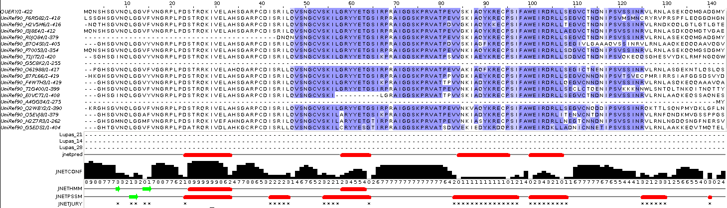
and those around the Homeobox, including some of the C-terminus compositionally biased region.
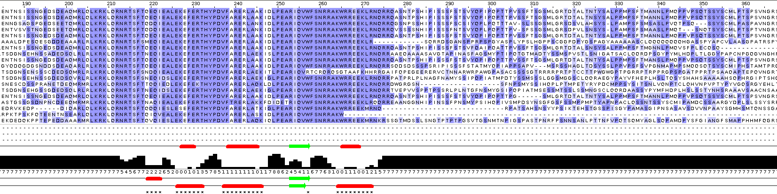
Note that, even though JNET has produced a reasonable secondary structure prediction for the start of the PAX region, Jalview does not consider this region to be sufficiently conserved to colour? Why this might be so will become apparent when you consider the quality of this prediction overall (in a couple of Questions time).
What protein database has Jpred chosen to search for protein sequences for the alignment upon which its predictions will be based?

Why do you suppose this database was used in preference to, say UniprotKB?

Also, I have lined up the entire prediction with the Uniprot Feature Table graphic.
It would appear the helices predicted least confidently by Jpred are the same ones with which GOR IV (investigated in a supplementary exercise) had problems.
How would you rate the Jpred prediction overall?

Domain & Motif prediction.
As has been discovered from several information sources, the PAX6 human protein has two DNA binding domains. A paired box at the N terminal and a homeobox a little further along. Both of the domains include Helix-Turn-Helix (HTH) motifs. In this exercise, you will investigate how you might discover these domains and motifs using the various freely available domain databases (discussed previously) and other feature prediction programs. Clearly, this is superfluous for this particularly, well documented protein, but a valuable option in other circumstances.
One approach would be to consider each relevant domain database in turn. Each major domain database has its own Home web site and customised software to take Query protein sequences, compare those sequences with domain representations (typically based on Hidden Markov Models) and to report convincing matches. This would work, but would be tedious as there are many viable databases to consider. It would be dangerous to rely on too few of the databases available as none is perfect. You need a consensus prediction to be sure you miss nothing.
Also, you would need to know which databases are particularly appropriate for each domain you considered might be present. All databases cannot be optimised for all types of domain (for example, the SMART database specialises in domains that occur in signalling proteins).
So, let us not search individual domain databases in the main part of these exercises. Instead, I offer a supplementary exercise investigating a representative selection of the available searches. I selected the Prosite, Pfam and PRINTS domain databases, If you do this exercises, consider particularly the PRINTS section. It illustrates how and why PRINTS just fails to see one of the two domains (as you already discovered when looking at UniProt).
In this supplementary exercise, I also invite you to look at a simple EMBOSS program that tries (without complete success!) to discover HTH motifs.
Domain & Motif prediction with Prosite, Pfam, HTH & PRINTS
Here, use just Interpro to do the whole job. Interpro will search for all domains using the appropriate domain databases, thus removing the tedium of interrogating a miscellany of domain searching resources individually.
Searching 
Interpro defines protein families according to the way that proteins match elements of a wide range of protein family databases, including all those we have discussed thus far. Interpro provides a search tool that will search all or any of the major protein family databases and assign Interpro family associations to the query protein(s) accordingly. To have a look at some of the possibilities offered by Interpro, Go to:
http://www.ebi.ac.uk/interpro/
If you were to enter the PAX6 human protein into the obvious place on the InterPro home page, you would produce almost exactly the results you saw many pages back, when you were looking at GeneCards. Do this if you have the time and inclination.
By implication, InterPro offers a fuller experience via the InterProScan search tool. Other than the opportunity not to search ALL the domain databases, and having the results arranged slightly differently, I am unsure what the extra effort brings? Never mind, there are many things of which I am unsure, so, from the InterPro Home page ...


Select the InterProScan link. Here you will be offered the opportunity to download the InterProScan program.
I am not sure this is too useful an offer for most? But it is there.
For now, chose the online Sequence search.
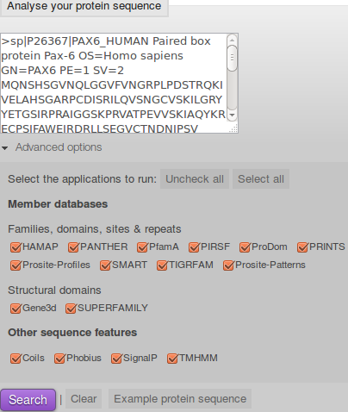
You will arrive at a page that looks very similar to that from which you started, as far as the offer to run a domain search is concerned? Except! We now have Advanced options. Click on the Advanced options.
The Advanced options only allow you to choose which databases you wish to search and which feature prediction programs you wish to run. The default is to use all the databases and to run all the predictor programs. I struggle to imagine an occasion I would want to save the EBI servers a few cycles by considering which options to deselect, but it so nice to know I could if I wished to.
In passing, the offer to run the feature predictor programs in the Other sequence features section is relatively new. Of course, all these programs could be run individually from their home websites (follow the links behind the program names), in the same way as the domain databases can be searched individually. Interpro just aims to make thing easy for the user. The programs currently offered are:
- Coils is a program for predicting coiled coils. Jpred employs a program called Lupas for this purpose. Possibly the same program, given the author of Coils is someone called Lupas, A.
- Phobius & TMHMM are programs to predict Transmembrane regions (essentially hydrophobic, uncharged regions). There is no reason to expect any Transmembrane regions in this protein.
- SignalP predicts the presence and location of signal peptide cleavage sites in amino acid sequences from different organisms. I am pretty certain that there is no reason to expect signal peptides in this protein.
Do you think it a good idea for Interpro to offer feature prediction programs as well as domain database searches?

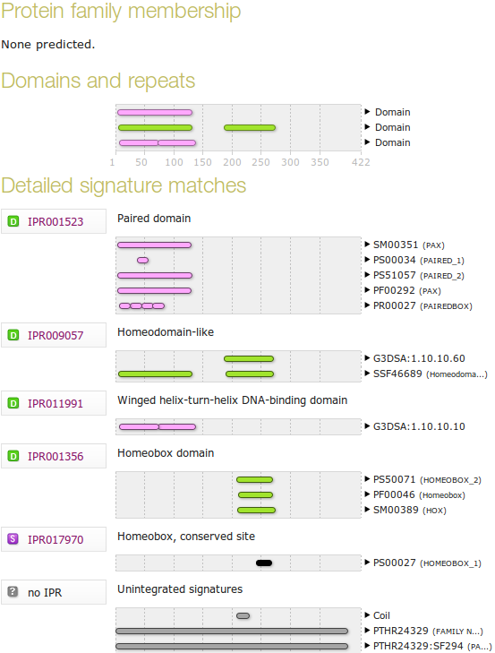
Paste the human PAX6 sequence into the patiently waiting box. Accept the “do everything” default. Click on the Search button.
After several moments of deep thought, filtering and validating, you will be presented with a table of results looking very much like the one your saw when investigating GeneCards.
There is, however, one significant difference. In the Unintegrated signatures section, you will see that a coiled coil has been detected by the program Coils. This was not included in the GeneCards information (taken directly from UniProt), probably as Interpro has only recently included analysis using Coils. GeneCards (and UniProt) will very probably catch up next time UniProt is updated. It is also worth noting the Jpred does not predict a coiled coil anywhere in the protein?
Do you think the Coil prediction might be correct?
Notice that Interpro assigns both the PAX domain and the Homeobox domain of human PAX6 to the Interpro family Homeodomain-like. Both of these associations are based on the hit behind the link SSF46689.
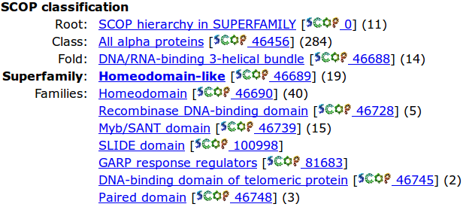
Follow this link and you will see it leads to the Homeodomain-like superfamily of thedatabase that specialises in very general (“at the SCOP superfamily level) protein classifications. One Superfamily entry will typically correspond to a number of more specific domain definitions in other domain databases. Here you can see that the Superfamily domain Homeodomain-like includes both the Homeodomain & Paired domain Families.
Return to your Interpro results page. The Gene3D database is similar to superfamily but based on the CATH database. It suggests the two HTH motifs of the paired box are both Winged helix-turn-helix. The HTH in the Homeobox domain is not detected?
Why might you suppose Interpro predicts only 2 of the 3 helix-turn-helix domains that might be expected?

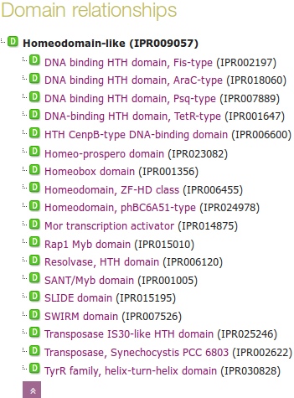
Follow the link to the Interpro family Homeodomain-like (IPR009057). Click on the button in the Domain relationships section to show the full list of Homeodomain-like Interpro domains.
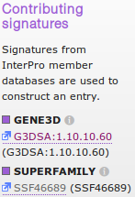
Note also the Contributing signatures in the top right hand corner of the page. Here is listed the domain databases that are searched to determine the presence of an Interpro Homeodomain-like domain.
Essentially, if Gene3D finds a match with its Demineralisation domain and/or Superfamily finds a match with its Homeodomain-like domain, then Interpro acknowledges a match with its Homeodomain-like domain (IPR009057).
None of the other domain databases Interpro searches are used to determine membership of (IPR009057).
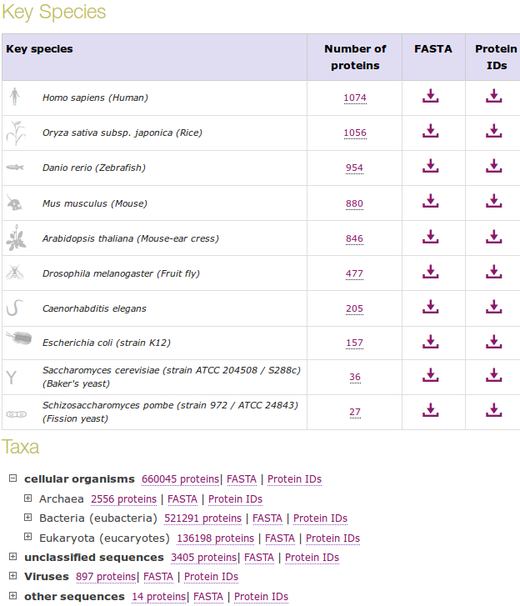
To obtain an impression of how widely spread throughout nature is this domain. Click on the Species button on the left hand side of the page.
As you can see, this is a very popular domain. You can make this list enormous by injudicious employment of the expansion buttons. Why not? It amused me for a few moments anyway.
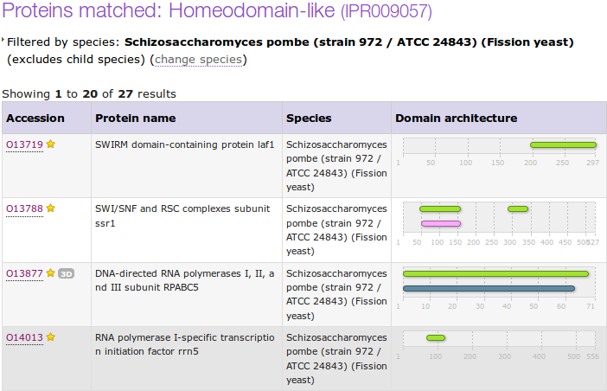
By clicking on the appropriate button, you can get to either the protein sequences in Fasta format or list their accessions codes. Try a few, but be careful! It really does get you ALL the sequences, and that is often quite a lot, which can take time.
Multiple Sequence Alignment
Here we will look at some software tools to align some protein sequences. Before we can do that, we need some sequences to align. I propose we try all the human homeobox domains from the well annotated section of UniprotKB. Getting the sequences is a trifle clumsy, so concentrate now! There used to be a much easier way, but that was made redundant by foolish people intent on making the future ever more tricky!!
So, begin by going to the home of Uniprot:
http://www.uniprot.org/
Choose theoption of the button.
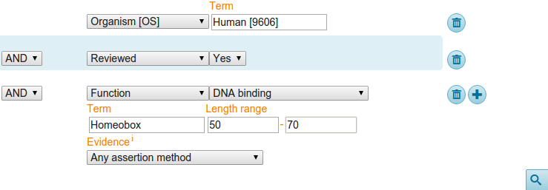
First specify that you are only interested in Human proteins. To do this, set the first field to Organism [OS] and Term to Human [9606].
Set the second field selector to Reviewed and the corresponding Term to Yes (that is, choose to find only SwissProt entries).
Click on the button to request a further field selection option. Set the new field to Function. Set the type of Function to DNA binding. Set the Term selection to Homeobox.
From previous investigations, you should be aware that a Homeobox domain is generally 60 amino acids in length. To avoid partial and/or really weird Homeobox proteins, set the Length range settings to recognise only homeoboxs between 50 and 70 amino acids long.
Leave the Evidence box as Any assertion method, one does not wish to be too fussy! Address the button with authority to get the search going.
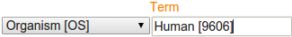
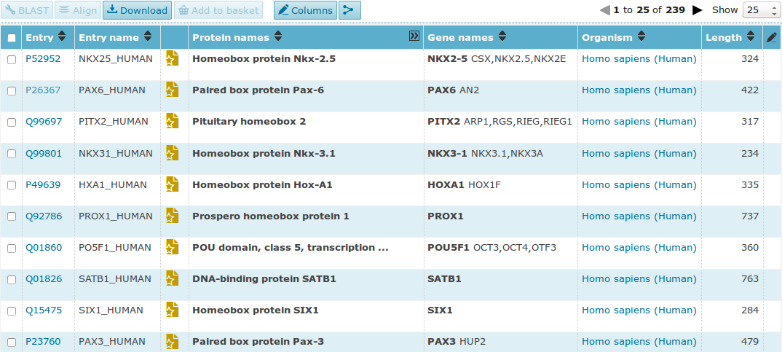
A fine miscellany of sequences will assemble upon you screen. Most seem to declare themselves in possession of a Homeobox or two (including PAX6_HUMAN), so I suggest a declaration of success.

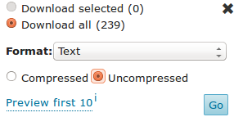
Now save the entire list into a file using thebutton. Set the download to uncompressed. Make sure you have all sequences selected and that Text (i.e. EMBL or SwissProt) format selected. Press the Go button and do whatever it takes to ensure your results end up in a file residing on your Desktop called:
human_homeobox_proteins.emb
ID NKX25_HUMAN Reviewed; 324 AA.
AC P52952; A8K3K0; B4DNB6; E9PBU6;
DT 01-OCT-1996, integrated into UniProtKB/Swiss-Prot.
DT 01-OCT-1996, sequence version 1.
DT 13-APR-2016, entry version 170.
DE RecName: Full=Homeobox protein Nkx-2.5;
DE AltName: Full=Cardiac-specific homeobox;
DE AltName: Full=Homeobox protein CSX;
DE AltName: Full=Homeobox protein NK-2 homolog E;
GN Name=NKX2-5; Synonyms=CSX, NKX2.5, NKX2E;
OS Homo sapiens (Human).
OC Eukaryota; Metazoa; Chordata; Craniata; Vertebrata; Euteleostomi;
OC Mammalia; Eutheria; Euarchontoglires; Primates; Haplorrhini;
OC Catarrhini; Hominidae; Homo.
OX NCBI_TaxID=9606;
RN [1]
RP NUCLEOTIDE SEQUENCE [MRNA] (ISOFORM 1).
RC TISSUE=Heart;
RX PubMed=8900537;
RA Turbay D., Wechsler S.B., Blanchard K.M., Izumo S.;
RT "Molecular cloning, chromosomal mapping, and characterization of the
RT human cardiac-specific homeobox gene hCsx.";
RL Mol. Med. 2:86-96(1996).

Take a swift look at the file you have just created. Your neat list of Human Homeobox sequences will have transformed into a flood of many SwissProt format UniProtKB entries. Ugly, but what is required.

FT CHAIN 1 430 Pre-B-cell leukemia transcription factor
FT 2.
FT /FTId=PRO_0000049237.
FT DNA_BIND 244 306 Homeobox; TALE-type.
FT {ECO:0000255|PROSITE-ProRule:PRU00108}.
FT COMPBIAS 137 145 Poly-Ala.
FT MOD_RES 136 136 Phosphoserine.
FT {ECO:0000269|PubMed:24275569}.
FT MOD_RES 151 151 Phosphoserine.
FT {ECO:0000269|PubMed:18220336,
FT ECO:0000269|PubMed:18669648,
FT ECO:0000269|PubMed:20068231}.
FT MOD_RES 330 330 Phosphoserine.
FT {ECO:0000269|PubMed:18669648,
FT ECO:0000269|PubMed:21406692}.
FT CONFLICT 393 393 M -> I (in Ref. 1; CAA42503).
FT {ECO:0000305}.
SQ SEQUENCE 430 AA; 45881 MW; EF2FFA158C4DAF68 CRC64;
MDERLLGPPP PGGGRGGLGL VSGEPGGPGE PPGGGDPGGG SGGVPGGRGK QDIGDILQQI
MTITDQSLDE AQAKKHALNC HRMKPALFSV LCEIKEKTGL SIRSSQEEEP VDPQLMRLDN
MLLAEGVAGP EKGGGSAAAA AAAAASGGGV SPDNSIEHSD YRSKLAQIRH IYHSELEKYE
QACNEFTTHV MNLLREQSRT RPVAPKEMER MVSIIHRKFS AIQMQLKQST CEAVMILRSR
FLDARRKRRN FSKQATEVLN EYFYSHLSNP YPSEEAKEEL AKKCGITVSQ VSNWFGNKRI
RYKKNIGKFQ EEANIYAVKT AVSVTQGGHS RTSSPTPPSS AGSGGSFNLS GSGDMFLGMP
GLNGDSYSAS QVESLRHSMG PGGYGDNLGG GQMYSPREMR ANGSWQEAVT PSSVTSPTEG
PGSVHSDTSN
//

Search (Control F) for the term DNA_BIND.
It should occur many times (at least once per sequence) in the Feature Tables and most often refer to a Homeobox region.
In the DNA_BIND Feature Table entries, the position of the Homeoboxes are recorded and will be used by the next program to isolate the sequence of the Homeoboxes.

Now to extract from the whole protein sequences you have saved in a file, the sequences of just the Homeobox domains. One way of doing this (possibly not the best), is to use an EMBOSS package program called extractfeat. This can be found in many places, including the Bioinformatics server at Wageningen in the Netherlands. Go to:
http://emboss.bioinformatics.nl/


Find the program extractfeat (in the EDIT section), and set it going.
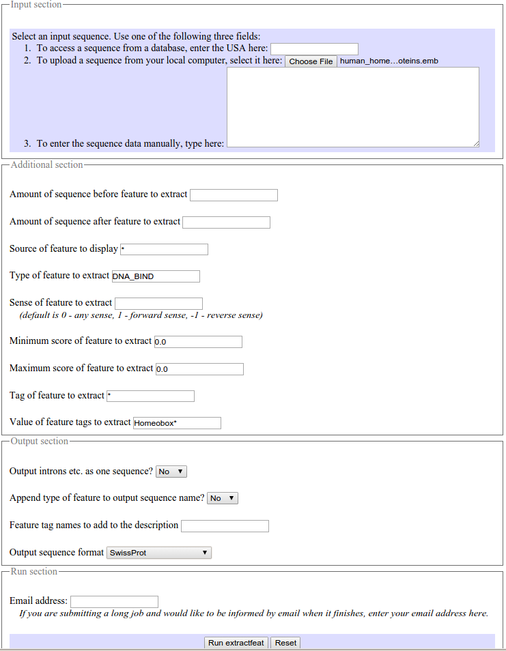

Use the Choose File button to upload the SwissProt format sequences from UniProtKB that you saved in the file human_homeobox_proteins.emb.

Set Type of feature to extract field to DNA_BIND (Make sure you remove the “*”).

Set Value of feature tags to extract to Homeobox* (Make sure you append the “*” to ensure hits with, for example “homeoboxes”).

Set the Output sequence format to SwissProt (Fasta would do, but SwissProt retains more annotation).

Click on thebutton to start extractfeat going. Many sequences of 60 amino acids (or so) in length will leap into view.
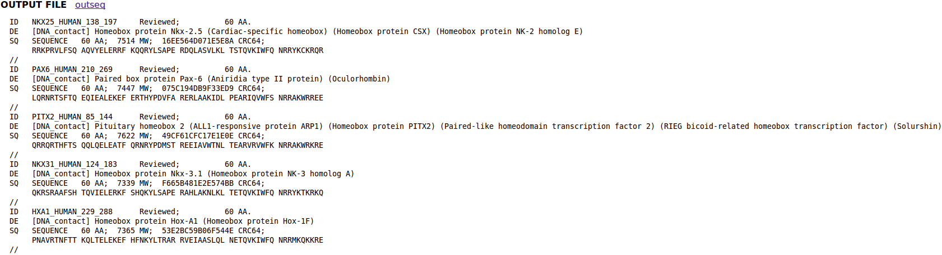
Right click thebutton and select Save Link as... . Do whatever it takes to save all your Homeobox domains into a file residing on your Desktop called:
homeobox_human.emb
Finally, we have some sequences with which to investigate the multiple sequence alignment programs.
Take a look at the file you have created. You should have many human homeobox domains in SwissProt format, looking rather as they did in your browser window. Happily ClustalX, the first multiple alignment program to be investigated, accepts multiple sequence SwissProt format files as input.
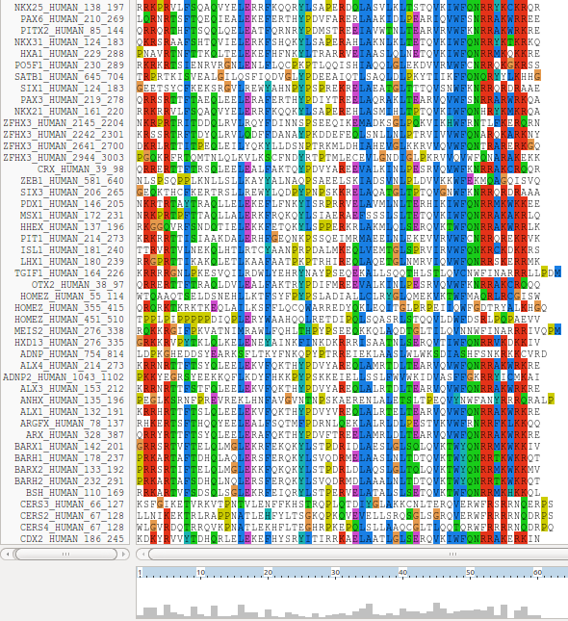
ClustalX is a part of the mostly widely known family of Multiple Sequence Alignments (MSA) programs, originating in the 1980s. Until relatively recently, it was the only real option. ClustalX still has merit, although it lacks some of the sophistication of more recent programs. ClustalX runs on effectively all workstations and has a nice Graphical User Interface (GUI). A good place for us to start. It is installed on your workstations.

Start up the program ClustalX. The ClustalX Graphical User Interface (GUI) will regally mount your screen.

Select Load Sequences from the File pull down menu and load your file of homeobox domains.

The sequences will arrange themselves colourfully. Many of the homeoboxes are similar enough to look convincing even before alignment. Note the “Manhattan skyline” under the sequences indicating the varying degrees of conservation.

You might like to increase the Font size from the minute default setting designed for Hawks and Eagles, to something more comfortable. 24 works tolerably well for me.


From the Alignment pull down menu, go to the Alignment parameters menu and select Pairwise Alignment Parameters. Just for a moment, change the setting from Slow-Accurate to Fast-Approximate. Bring the corresponding parameters into view by clicking on Fast/Approx Pairwise Parameters tab.
Hopefully, we will have discussed the way ClustalX (and similar multiple alignment tools) work. Intuitively, it should not make a lot of difference how the initial pairwise comparison stage is conducted. However, it very often does.
Specifically for this set of proteins, as well as generally, ClustalX will give a noticeably better alignment if the initial pairwise alignment stage is done carefully. Accordingly, reverse your whimsical setting change by moving back from Fast-Approximate to Slow-Accurate.

Click on the Slow/Accurate Pairwise Parameters tab for a final look at the default parameters to be used. The Slow-Accurate option is essentially a version of Global Alignment algorithm we will have discussed previously. Hopefully, all the parameter options will therefore be familiar to you.

I will assume both sets of parameters at least seem familiar? If not please ask. The default Slow/Accurate Pairwise Parameters you now have in view are fine. Click the OK button to dismiss the Pairwise Parameters window.


Before proceeding, save the homeobox sequences in FASTA format, which will better suit the other MSA programs we will try. Do this by selecting Save sequences as... from the File pull down menu. Deselect CLUSTAL format, select FASTA format. Click OK. A file called homeobox_human.fasta will be created. Take a look to check it is as you would expect.


Strangely, saving your sequences in FASTA format convinces clustalx that it should now output its alignments in FASTA format. To prevent this, select Output Format Options from the Alignments pull down menu. Deselect FASTA format and select CLUSTAL format. Click OK.
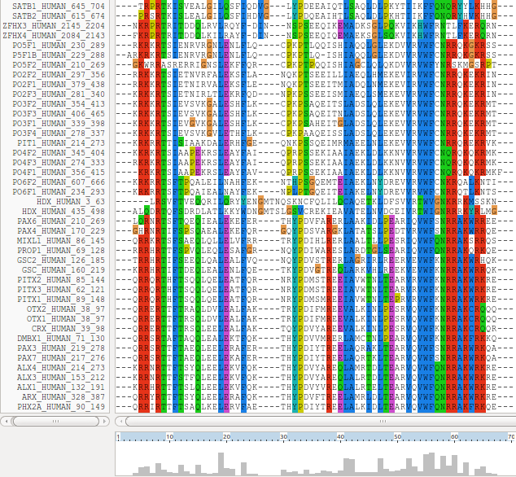

From the Alignment pull down menu, select Do Complete Alignment. Accept the default names for output files and click on the OK button. ClustalX will start to think deeply and eventually come up with it view of how the homeobox domains should be aligned.
Not a bad first try. From an entirely non scientific, cosmetic viewpoint, the ragged ends offend a trifle, as does the gap just before position 30!

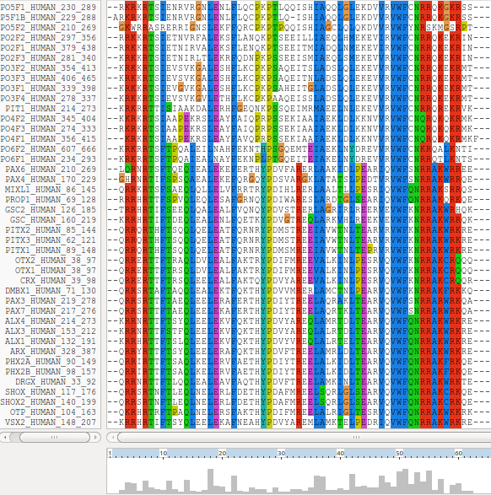
In reality, these features might be very interesting, but here I go for pretty!
So, just to investigate what is possible, select all the homeobox sequences that are causing the gap around position 30 by clicking on their names (quite a lot of them I fear). Hold the Ctrl key down to allow multiple selection.
Once you have them all, go to the Edit pull down menu and select Cut Sequences. Then select Remove Gap-Only columns from the Edit pull down menu. Nasty gap gone … along with all scientific credibility, but … never mind.
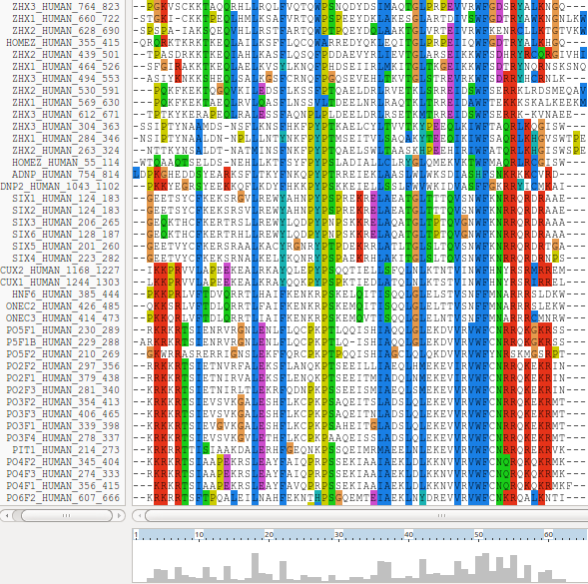
You could recompute the alignment from scratch with the reduced sequence set, but you should end up with the same answer, of course. Just for the sake of it, select Select All Sequences from the Edit pull down menu. Then select Remove All gaps from the Edit pull down menu and confirm your intentions. You are now back where you started, but without the sequences that mess up the alignment intolerably!
Save your filtered set of sequences in a file. From the File pull down menu select Save Sequences as... . Choose FASTA format only.
The default file name is OK, even though it will overwrite the original sequences. I am convinced the sequences eliminated would not be aligned convincingly with any of the tools we have at hand. Let us lose them! Press the OK button.
From the Alignment pull down menu, select Output Format Options and select CLUSTAL format only. Again, from the Alignment pull down menu, select Do Complete Alignment. Accept the default names for the output files. This will overwrite your previous efforts, but no matter. More deep thought. Well, I got back to where I was, no gaps around position 30 but still with ragged ends!
It is difficult to prove you have exactly the same alignment as previously as the order of the MSA will be different. This order being determined by the pairwise comparison stage of the clustalx MSA computation.
You will recall from earlier that the Prosite pattern for a homeobox is the ever memorable:
[LIVMFYG]-[ASLVR]-x(2)-[LIVMSTACN]-x-[LIVM]-{Y}-x(2)-{L}-[LIV]-[RKNQESTAIY]-[LIVFSTNKH]-W-[FYVC]-x-[NDQTAH]-x(5)-[RKNAIMW]
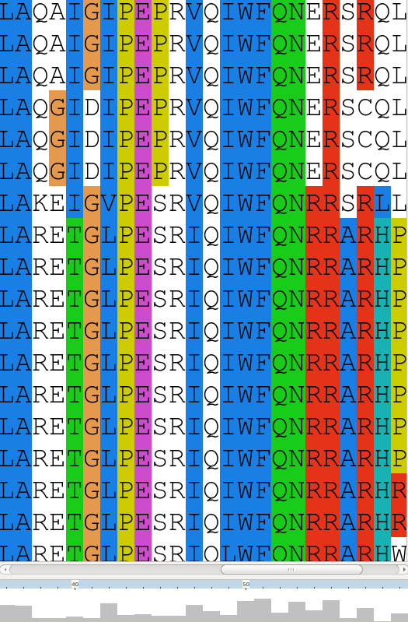

This corresponds to positions 36 to 59 in my alignment. See that the “Manhatten Skyline” is encouraging in the parts of this region that matter.
Note that the profile Tryptophan, in position 50, is very consistent, but not quite 100% as suggested by the Prosite pattern. The W was even conserved in the sequences that were cosmetically removed.
Position 52 is not conserved (“-x-”) according to the Prosite pattern. In the alignment segment offered here, it looks like a pretty consistent Q. However, the “Manhattan skyline” at this position is very low, suggesting that the sequences in view might not be typical of the whole alignment set. Which, upon checking …. they are not!
Looking through this alignment, I get the feeling I could design a better, stricter pattern for the region between 36 and 59. Possibly true, but remember the pattern in Prosite aims to represent the conservation of Homeobox domains in ALL organisms. Here we have only sequences from Human.
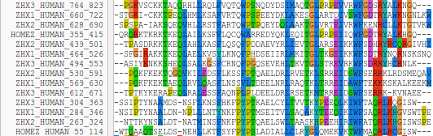
Of course, things are not quite so convincing throughout. If you look at the top and bottom few sequences, you will see that ClustalX had its moments of uncertainty.
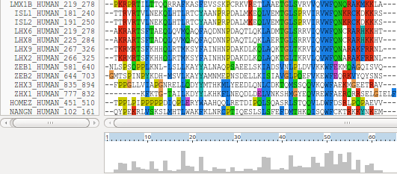

Note, however, the consistent W in position 50 despite the surrounding crumble.
Now to show existence of some msa program options available on the web. There are many. They are available from a number of server sites. An obvious place to start has to be the EBI page dedicated to MSA. Go to:
http://www.ebi.ac.uk/Tools/msa/
Offered here is an impressively full selection of popular, current generation msa tools. Each is accompanied by advice to guide the choice of tool to best fit the circumstances. Each tool is provided with a link to its Launch interface. All the Launch interfaces are very consistent. Once you have run one of the msa options, you should have no trouble running any of the others.
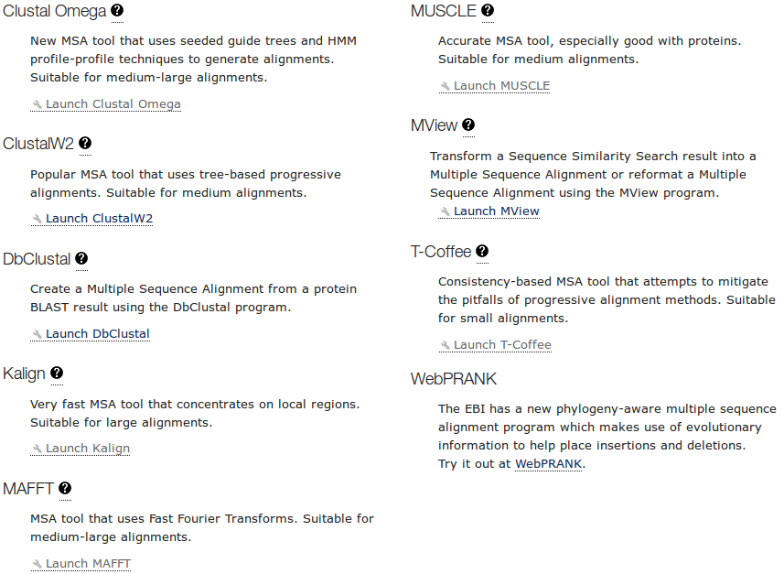
Here I intend to align again the human homeboxes with just one of the tools on offer. Then take a quick look at how the machine generated multiple alignment can be manually edited using jalview, a program that is installed on your workstation and that you have already used as an alignment viewer when investigating Pfam.
Then I will invite you to try a few of the other options for yourself and see that they do not all produce the same alignment! Differences reflect not only the parameters selected, which we will have discussed, but also the particular objectives of the program selected. For example, a multiple protein sequence alignment optimal for investigating conservation of protein structure might well not be identical to one best representing protein evolution.
Used to align the Homeobox sequences used in this exercise, I do not expect you will see much difference between the outputs of any of these options. They will all work sufficiently on such a simple data set.
The program whose use I choose to describe carefully, leading on to a short jalview exercise is MUSCLE. I choose thus as MUSCLE is now the first choice of most of the people with whom I work. Almost as popular are Clustal Omega, MAFFT and, for phylogeny, PRANK.

So the plan now is to use MUSCLE to align again the homeobox sequences previously aligned with clustalX. MUSCLE works in a way similar to clustalX but it takes rather more care in the generation of the Guide Tree used to control the order of pairwise construction of the final multiple alignment. Particularly for more difficult alignments, MUSCLE should do a better job than clustalX. The alignment you will generate here will certainly be different. I leave you to judge for yourselves whether it is better.

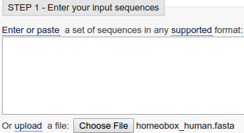
Start by requesting to.
Use thebutton to upload the file containing the FASTA format homeobox sequences, homeobox_human.fasta. This file should no longer included the sequences with a mess around position 30.


Take a look at the Set your Parameters section of the page.


There are a number of OUTPUT FORMATS offered. For a quick glance at your results, both ClustalW or HTML are fine. Here I suggest it would be nice to generate an output that can be downloaded and viewed in Jalview. The default ClustalW or Pearson/FASTA serve for this purpose. As ClustalW looks more like an alignment in the web page, I choose ClustalW.


The EBI site speaks the truth when it claims that “The default settings will fulfill the needs of most users and, for that reason, are not visible.”. But this is obscenely patronizing advice! so click thebutton anyway.
I confess myself confused at the lack of any meaningful options to consider? I was expecting at least the gap open and gap extension penalty options (available elsewhere, including Wageningen), plus a way to change the scoring matrix. I have inquired why things are as they are. No practical issue here, as I intended to suggest the defaults whatever they were.

Look at the range of settings for the OUTPUT TREE parameter. none is indeed the thinking persons choice, but …

How do the options for the OUTPUT TREE relate to the output files of ClustalX and the difference between the way that ClustalX and muscle work?

Comment on how one might choose between the range of options offered for the aligned parameter?

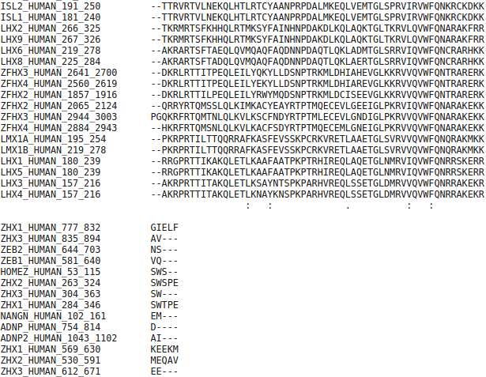
After considering these enigmas, or before if you prefer, Click on thebutton and sit back to admire muscle in action.

The alignment that is computed is, superficially at least, similar to that offered by ClustalX.

The alignment is irritatingly split into two sections. A nice extra parameter might have been “How wide would you like your alignment to be”? A problem with the format rather than the program, to be fair.

At the very bottom of the page, muscle whines:

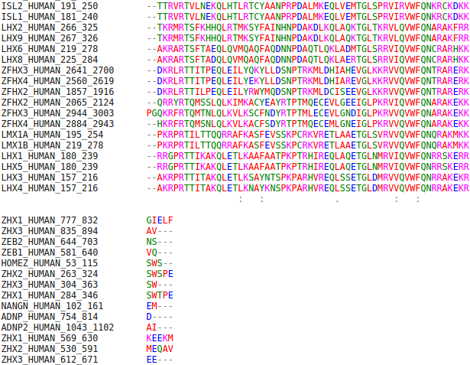
So click the Show Colors button at the top of the page and try to live with the pain of such gross Trans-Atlantic inept spelling in a European site!!! Good Grief! They get everywhere!!

Well, an improvement I suppose? Colours are very useful (even slow ones) in the interpretation of alignments. Various colour schemes are used to clarify the message of alignments. Colouring can indicate shared amino acid properties not immediately evident when the letter representations differ.

But any decoration available here is far short of what can be achieved with Jalview, so click on the Download Alignment File button to save you alignment in a file on your Desktop called:
homeobox_human_muscle.aln
Start up Jalview from the Windows Start menu. Close down all the example outputs it sees fit to show you on start up. From the File pull down menu choose from File from the Input Alignment option. Locate and load the file homeobox_human_muscle.aln.
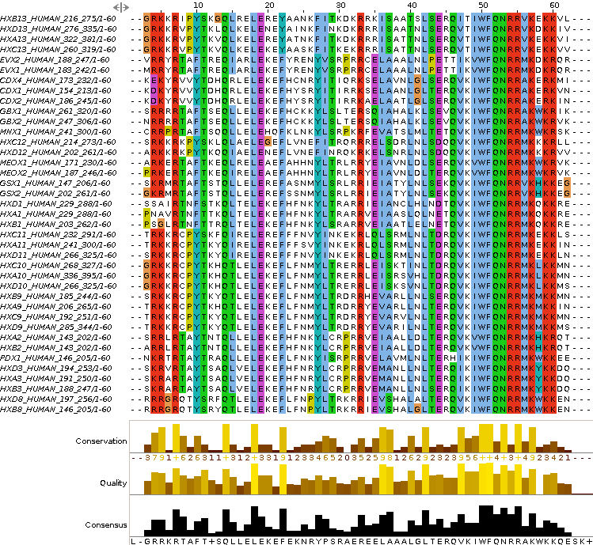

The default view is a trifle bland. Try a few of the options from the Colour pull down menu.

You could try the same colour scheme used by ClustalX, for example.

Now the MUSCLE and massaged ClustalX alignments look even more similar! In the nicely aligned regions at least.

There are many Jalview features that merit investigation. Have a look around if you have time. In particular, Jalview will compute simple phylogenetic trees for you employing a number of methods (Calculate Tree from the Calculate pull down menu). Try it, but be aware this is only sensible if you were very sure of your alignment (and have a few less sequences maybe?).
Jalview is made by the same group as produce JPred. You could send your alignment for Secondary Structure Prediction via the Web Service pull down menu, if you wished.
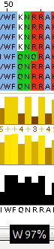
A very important purpose of Jalview is to allow users to edit alignments as well as just to view them. For example, hold down the Shift key, click and hold on any amino acid at the edge of a gap, slide left and right and see that you can introduce and/or alter the position of gaps. It is very important to be able to edit alignments generated by even the best of programs. As I hope has been made clear, the alignment algorithms are crude. If you know something about the sequences you are aligning it is very reasonable to suppose you can improve upon the computer's alignments. Jalview tries to make this possibility easy. Look through some of the other Edit pull down menu options, it does not matter how much you mangle your alignment, you can always make another one.

Finally, take a look at the Jalview “Manhattan Skyline” for the highly conserved W at position 50. This seems a much more reasonable representation of the “truth” than clustalX managed? I am not sure what I believe at this point.
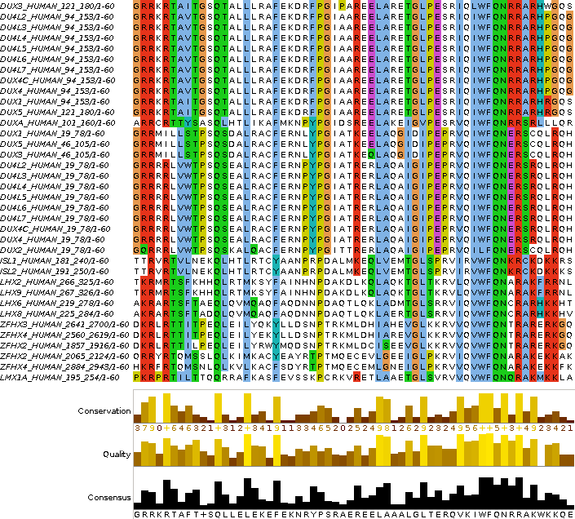
You can also Select and Cut sequences in a way similar to that you employed with clustalx. I could not resist it! I removed all the ugly sequences that caused the gaps at the start and finish of the alignment (just select their names and then select Cut or Delete from the Edit menu). I achieved the gap-free beautiful alignment illustrated.
Of course, Jalview does not compute alignments, so once I had removed all the unfortunate proteins, I had to use an Edit option to tidy up my meddling. I used Remove Empty Columns to get rid of the gap columns at the start of the alignment. The gaps at the end just melted away once the sequences that supported their presence were removed.
Science is easy! Once you remove the need for honesty that is.

Try some of the other msa tools offered by the EBI. Note the differences in the alignments computed. These differences are important and are not just the result of different parameters applied to exactly the same algorithms. Alignments are generated for different purposes in a variety of subtly different ways. A full consideration of msa is beyond the scope of these exercises.
PSI-BLAST
This program is used to find a comprehensive set of relatives of a protein. First, BLAST is used to find closely related proteins. From an alignment of these proteins a general "profile" (a Position Specific Scoring Matrix - PSSM) is computed. A PSSM is very similar in concept and purpose to an HMM profile in that it summarises significant features present in the sequences it represents.
A query against the protein database is then run using the PSSM, and a larger more widely associated group of proteins is found. This larger group is used to construct another PSSM, and the process is repeated until no more significantly matching new sequences can be detected, or the user tires of the whole process.
You have used PSI-BLAST integrated into Jpred already and similar ideas were used to create the PFAM alignments. Here we will use PSI-BLAST explicitly at the NCBI on the Paired DOMAIN of the PAX6 protein that you saved in a file earlier. It should be possible to detect a large family of PAX domains and to eventually multiply align them generating something like the Full alignment from the PFAM database viewed earlier.
To investigate PSI-BLAST go first to the NCBI Home page at:
http://www.ncbi.nlm.nih.gov/
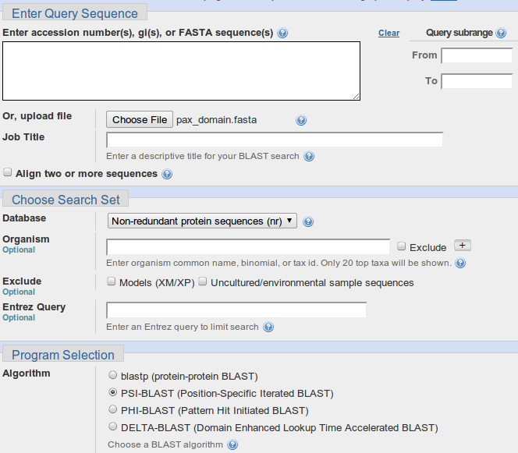

Click on the BLAST option. Select protein BLAST from the Basic BLAST section. Upload the PAX6 paired box domain sequence (stored in the file pax_domain.fasta) using the appropriate Browse button.

Select PSI-BLAST from the Program Selection section. Leave all the others options at their default settings, particularly the option to search all the proteins available.

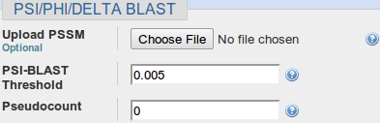
Before you set PSI-BLAST going, click on the Algorithm parameters link and take a look at the PSI/PHI/DELTA BLAST section. Here is offered the option to use a PSSM from a previous run PSI-BLAST, potentially on a different database (but with the same query sequence). Accept the default that database entries scoring better than an Expect Threshold of 0.005 be offered for inclusion into the PSSM of each successive PSI-BLAST iteration. Remember the buttons.
What do you suppose the choice of Pseudocount might influence?
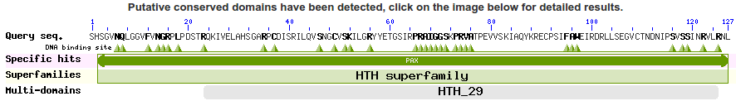
Elect to Show results in a new window and then click on the button. After several moments of deep thought, PSI-BLAST will come back with its first set of results, at the top of which is a report that (unsurprisingly) matches have been detected between the query sequence and several domain databases. For more detail, click on the Conserved Domains graphic.

SMART, Pfam and the NCBI Conserved Domains database hits are reported. None should be a surprise.
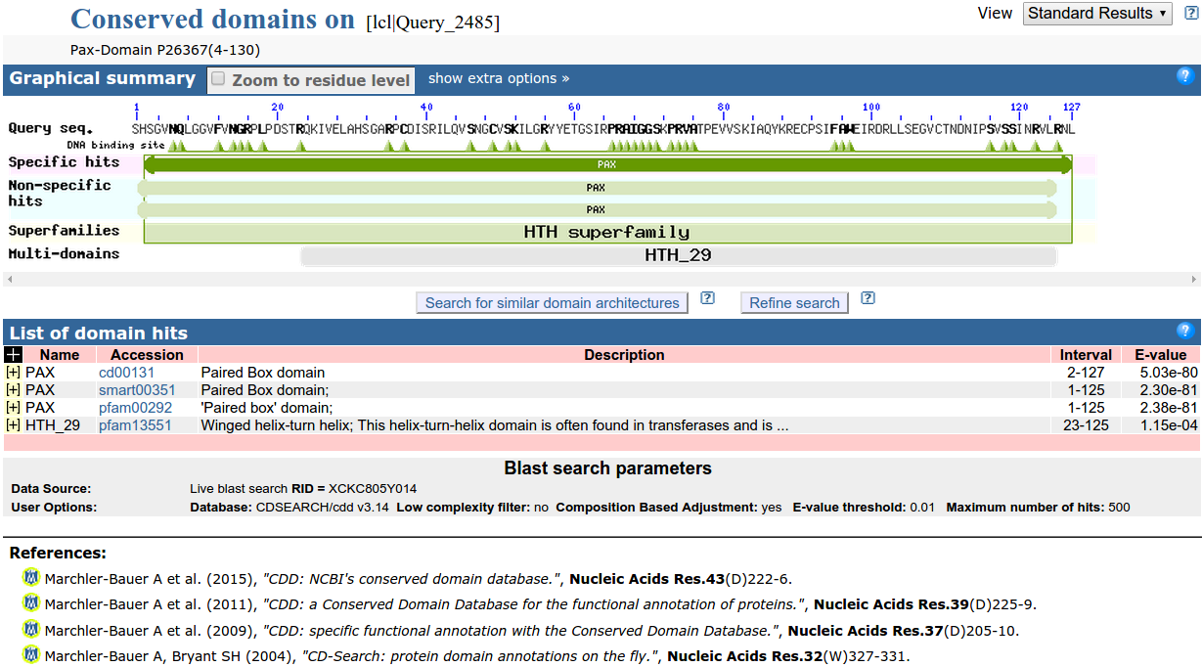
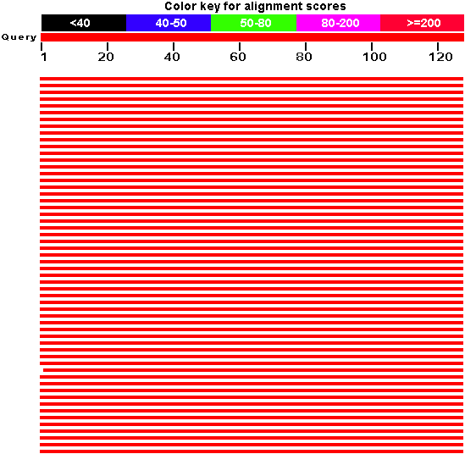

Moving back to the main PSI-BLAST results, you will see that there are many high quality hits covering the whole length of the query sequence.

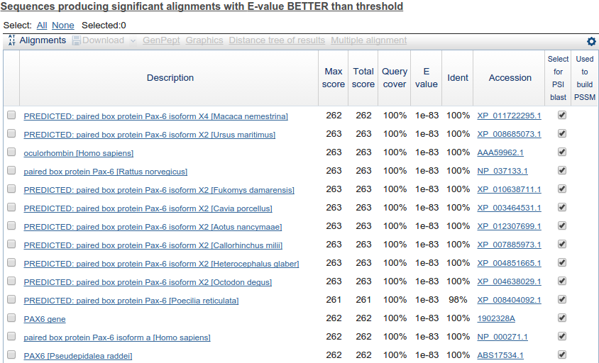

The best 500 of these are listed.

All the listed hits are selected for inclusion into the PSSM for the next iteration. Unless you feel strongly about any particular entry, leave them all selected.
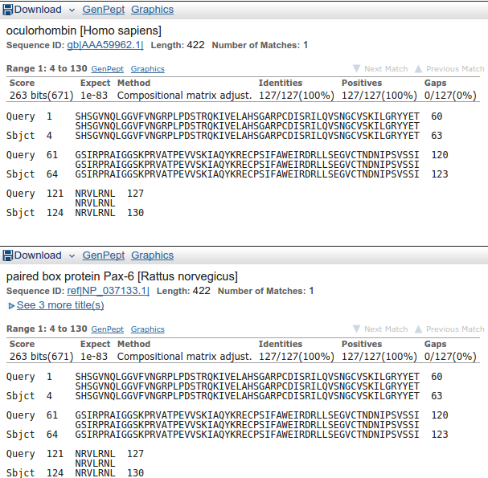
Move down to the Alignments section of the results and you will see that many of the top hits match the query exactly.

Note that many of the top hits come from the GenPept database (roughly equivalent to the TrEMBL section of UniProtKB).

How might the inclusion of relatively poor quality sequences and the presence of so much duplication have been minimised?

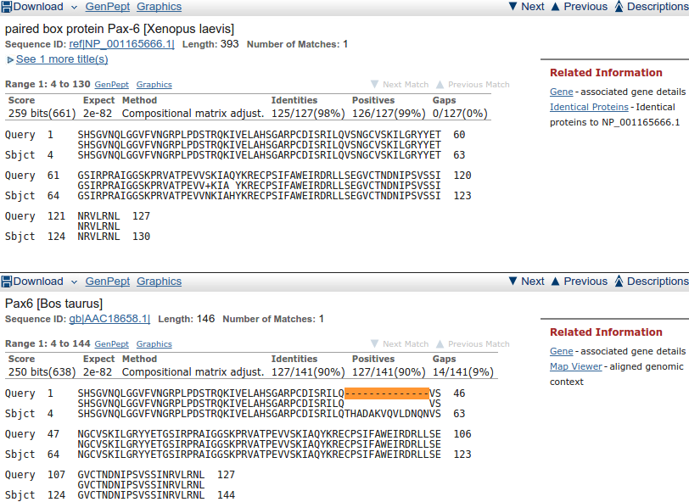

Move down far enough and you will see less perfect matches, some of which involve proteins with the extra 14 amino acids of isoform 5a of PAX6_HUMAN.

Having browsed your results sufficiently, click on the button to Run PSI-Blast iteration 2. It is at the bottom of the hit list.

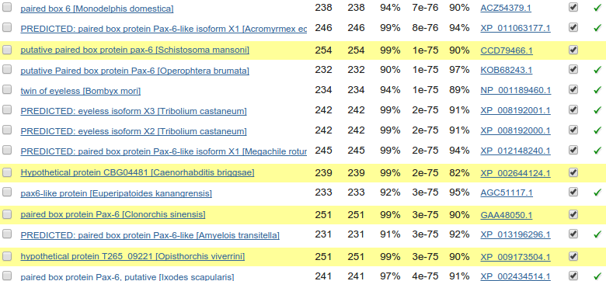
After a few moments, PSI-BLAST will return with the results of searching through the database again using the PSSM derived from the hits of the first iteration(ed). This time the top of the list will be predominantly filled with hits that have already been incorporated into the PSI-BLAST PSSM. However, look far enough down the list and you will find some new ones, highlighted yellow.
Once more, click on the button to Run PSI-Blast iteration 3. That is probably enough! It took 4 iterations before there were no more new sequences suggested for inclusion into the PSMM when I ran this last, so if you really want to take things to their logical conclusion, it should not detain you long.

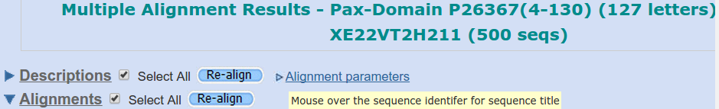
Next, move to the top of the Descriptions list and Select All. Click on the Multiple Alignment button. You have elected to use the NCBI multiple alignment program Cobalt to align all the PAX domain sequences of your final PSI-BLAST iteration that match with an Expect score better than 0.001. In an impressively short time, your alignment will appear.
Move past the long list of proteins that have been aligned (the easiest way is to hide the Descriptions view).

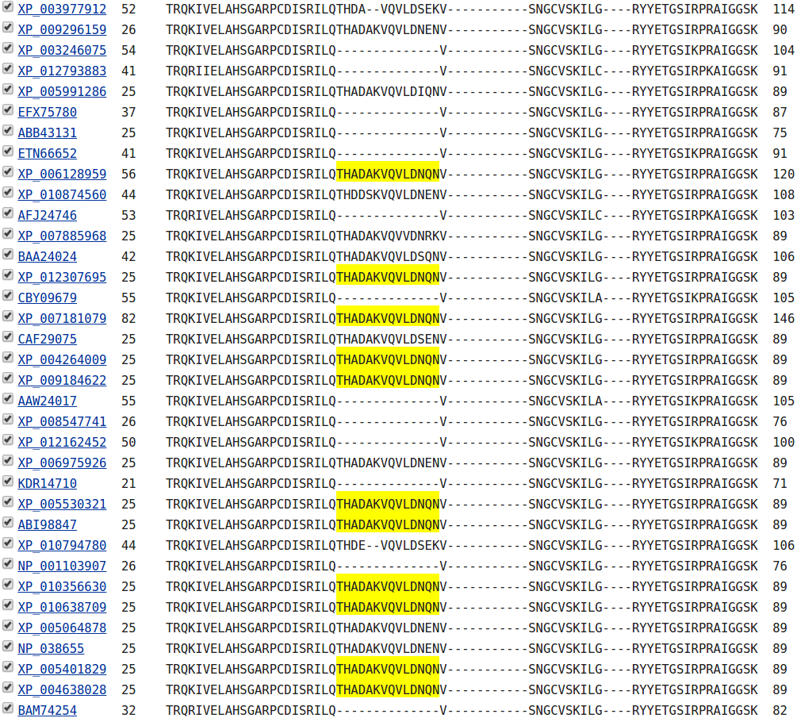
At the top of the actual alignment, set View Format to Plain Text (…. and then hide the Descriptions again??), this being the easiest format to understand in a hurry. The alignment will have very ragged ends, but the important region of 120 or so amino acids representing the PAX domain is really quite impressive. In particular, the isoform 5a insertion is very convincing.
Protein Tertiary Structure

Protein Data Bank (PDB)
The Protein Data Bank (PDB) archive is the major repository of information about the 3D structures of biological molecules, including proteins and nucleic acids. Structures in the archive range from tiny proteins and bits of DNA to complex molecular machines like the ribosome.
In 1998, the Research Collaboratory for Structural Bioinformatics (RCSB) became responsible for the management of the PDB.

In 2003, the wwwPDB formed to maintain a single PDB archive of macromolecular structural data that is freely and publicly available to the global community. It consists of organizations that act as deposition, data processing and distribution centres for PDB data.

PDBe is the European resource for the collection, organisation and dissemination of data on biological macromolecular structures. In collaboration with the other Worldwide Protein Data Bank (wwPDB) and EMDataBank partners, they work to collate, maintain and provide access to the global repositories of macromolecular structure data (the Protein Data Bank (PDB) and Electron Microscopy Data Bank (EMDB)).
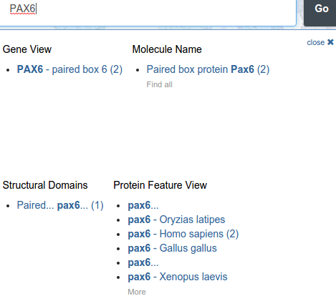
In the course of the exercises undertaken to this point, you will have already had a look at the 3D structures for the 2 major domains of the human PAX6 protein. You might have taken a more direct route to these structures by asking for them directly from the RCSB PDB site as follows.

Go to:
http://www.rcsb.org
Enter PAX6 in the Search box and click on the Go button.
Click on the link under the Molecule Name title..

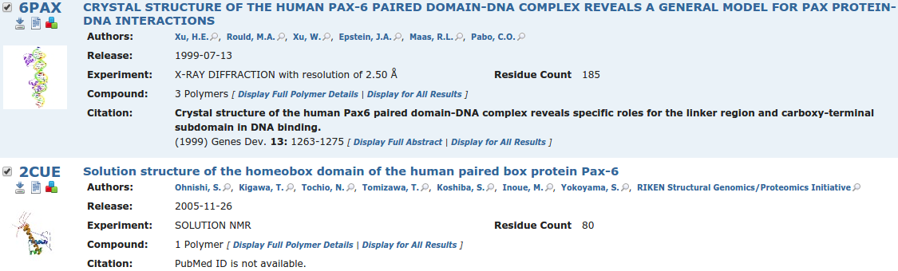
The two PDB structure hits will, hopefully, be familiar. Links are provided with each hit to view the structure with Jmol (a java based structure viewer), view the textual PDB entry and download the PDB entry to a file .
Take a look at the Jmol view of the 6PAX PDB entry. This you have seen this previously, but now I suggest a very quick visualisation of the main mutation that causes aniridia occurs in the PAX protein. The idea is to locate and highlight the Alanine that mutates to a Proline in an aniridia sufferer. As you have discovered, this is the residue 33 in the canonical protein, as recorded by UniProtKB. It is residue 30 in the protein as visualised here, the difference being explained by post translational modification which, in this instance, removes the first three amino acids.
Instructions for using Jmol can be found in many places. For a Quick Guide, you might try:
http://blc.arizona.edu/courses/mcb184/graphics/JmolQuickReferenceSheet.pdf
One place for the full manual is:
http://jmol.sourceforge.net/docs/JmolUserGuide/
Please note Jmol is not the only structure visualisation option available to you, nor is it the most sophisticated. It is just the one used by PDB. Here we look at just the minimum of Jmol skills to see what is required. First notice you can zoom in and out with the wheel of your mouse. You can also rotate the image in all directions using your left hand mouse button. Use these two tricks as needed.
To proceed any further, you really need a console window into which you can type commands. To get a console, choose Console. From the right hand mouse button pull down menu.

In the lower section of the console, select the 30th amino acid with the command:
select 30
Then to make the selected residue more evident, type in the two commands:
spacefill
color cyan
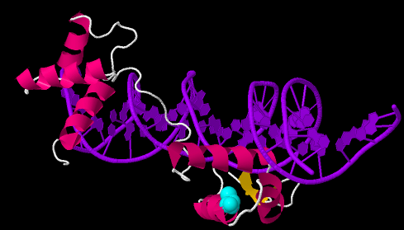
and then manipulate the structure until the selected amino acid can be best observed.

LJM/DPJ/PDFJ 2015.08.23

This page is “Work in progress”
As SCOP and CATH still crop up, I wish to include them, probably as an extra exercise.
Also maybe some other structure discussion I am not really qualified to write?
This is just some remnants left over from previous versions.

Structural Classification of Proteins (SCOP)
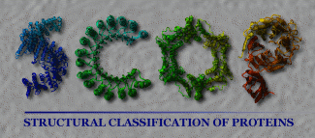
The Structural Classification Of Proteins (SCOP) database is a largely manual hierarchical classification of protein structural domains based on similarities of their amino acid sequences and three-dimensional structures.
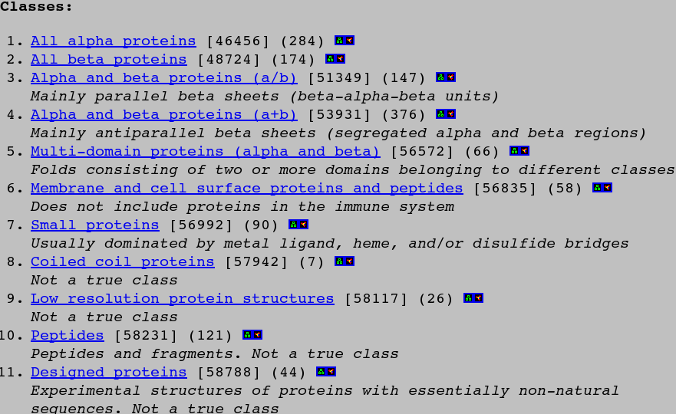
For a quick look at SCOP, go to:
http://scop.mrc-lmb.cam.ac.uk/scop/
You could go directly to all SCOP has to offer concerning PAX proteins by using a Keyword search of SCOP entries. For a better view of the way SCOP is structured, click on the top of the hierarchy link.
The top level SCOP classifications is listed. It should be possible to view sample structures for each class, but your browser is unlikely to be suitably configured, so instead, click on the All alpha proteins link.
Next, the DNA/RNA binding 3-helical bundle category looks the most tempting, so click it. From here options abound! Homeodomain-like has appeal, but “Winged helix” DNA-dinding domain suggests so much more adventure. Either/both works. You decide which way to descend down SCOP's hierarchy. Note the opportunities to branch off to other relevant databases.
Appendix I: Sequence symbols
Nucleotide symbols, their complements, and the standard one-letter amino acid symbols are shown below in separate lists. The letter codes for amino acid codes and nucleotide ambiguity were proposed by IUB (Nomenclature Committee, 1985, Eur. J. Biochem. 150; 1-5)

Nucleotides
The meaning of each symbol and its complement are shown below.
IUB/GCG Meaning Complement
A A T
C C G
G G C
T/U T A
M A or C K
R A or G Y
W A or T W
S C or G S
Y C or T R
K G or T M
V A or C or G B
H A or C or T D
D A or G or T H
B C or G or T V
X/N G or A or T or C X
. not G or A or T or C .
Amino Acids
Here the standard one and three letter amino acid codes, synonymous codons and IUB codes are shown. Codons following semicolons (;) are not sufficiently specific to define a single amino acid even though they represent the best possible back-translation into the IUB codes!
Amino Acid NOTATION
Symbol 3-letter Meaning Codons IUB Depiction

A Ala Alanine GCT,GCC,GCA,GCG !GCX
B Asp,Asn Aspartic,Asparagine GAT,GAC,AAT,AAC !RAY
C Cys Cysteine TGT,TGC !TGY
D Asp Aspartic GAT,GAC !GAY
E Glu Glutamic GAA,GAG !GAR
F Phe Phenylalanine TTT,TTC !TTY
G Gly Glycine GGT,GGC,GGA,GGG !GGX
H His Histidine CAT,CAC !CAY
I Ile Isoleucine ATT,ATC,ATA !ATH
K Lys Lysine AAA,AAG !AAR
L Leu Leucine TTG,TTA,CTT,CTC,CTA,CTG !TTR,CTX,YTR;YTX
M Met Methionine ATG !ATG
N Asn Asparagine AAT,AAC !AAY
P Pro Proline CCT,CCC,CCA,CCG !CCX
Q Gln Glutamine CAA,CAG !CAR
R Arg Arginine CGT,CGC,CGA,CGG,AGA,AGG !CGX,AGR,MGR;MGX
S Ser Serine TCT,TCC,TCA,TCG,AGT,AGC !TCX,AGY;WSX
T Thr Threonine ACT,ACC,ACA,ACG !ACX
V Val Valine GTT,GTC,GTA,GTG !GTX
W Trp Tryptophan TGG !TGG
X Xxx Unknown !XXX
Y Tyr Tyrosine TAT,TAC !TAY
Z Glu,Gln Glutamic,Glutamine GAA,GAG,CAA,CAG !SAR
* End Terminator TAA,TAG,TGA !TAR,TRA;TRR
Appendix II: Sequence comparison scoring matrices
Default EMBOSS DNA Scoring Matrix.
A T G C S W R Y K M B V H D N U
A 5 -4 -4 -4 -4 1 1 -4 -4 1 -4 -1 -1 -1 -2 -4
T -4 5 -4 -4 -4 1 -4 1 1 -4 -1 -4 -1 -1 -2 5
G -4 -4 5 -4 1 -4 1 -4 1 -4 -1 -1 -4 -1 -2 -4
C -4 -4 -4 5 1 -4 -4 1 -4 1 -1 -1 -1 -4 -2 -4
S -4 -4 1 1 -1 -4 -2 -2 -2 -2 -1 -1 -3 -3 -1 -4
W 1 1 -4 -4 -4 -1 -2 -2 -2 -2 -3 -3 -1 -1 -1 1
R 1 -4 1 -4 -2 -2 -1 -4 -2 -2 -3 -1 -3 -1 -1 -4
Y -4 1 -4 1 -2 -2 -4 -1 -2 -2 -1 -3 -1 -3 -1 1
K -4 1 1 -4 -2 -2 -2 -2 -1 -4 -1 -3 -3 -1 -1 1
M 1 -4 -4 1 -2 -2 -2 -2 -4 -1 -3 -1 -1 -3 -1 -4
B -4 -1 -1 -1 -1 -3 -3 -1 -1 -3 -1 -2 -2 -2 -1 -1
V -1 -4 -1 -1 -1 -3 -1 -3 -3 -1 -2 -1 -2 -2 -1 -4
H -1 -1 -4 -1 -3 -1 -3 -1 -3 -1 -2 -2 -1 -2 -1 -1
D -1 -1 -1 -4 -3 -1 -1 -3 -1 -3 -2 -2 -2 -1 -1 -1
N -2 -2 -2 -2 -1 -1 -1 -1 -1 -1 -1 -1 -1 -1 -1 -2
U -4 5 -4 -4 -4 1 -4 1 1 -4 -1 -4 -1 -1 -2 5
Appendix III: list files
A list file is a text file of sequence file names or database references. It is an excellent and flexible way for you to produce a specific mini-database, e.g. to do fasta searches against or look for patterns in. Each entry is on a separate line. These can be sequences either in your Unix account, in a sequence database or even in another list file. You can even put in comments if you preface them with an exclamation mark (!). The @ symbol in front of your list file tells EMBOSS programs that the file is a file of filenames and not a sequence. For example:
seqret @listfile
embl:hsfau ! an entry in the embl database
rabbit.seq ! a file in your directory
swissprot:pax6* ! all SwissProt entries whose identifier starts with “pax6”
@hedgehog.list ! another list file called “hedgehog.list”

Appendix IV: Amino Acid Properties
Amino acid properties important in the determination of protein tertiary structure.
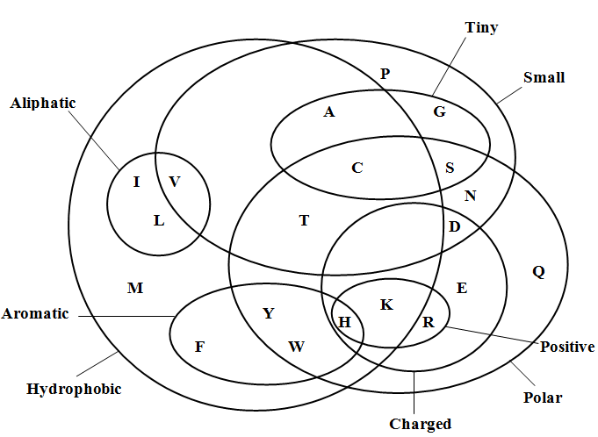

A quick look at OMIM
OMIM is the Online version of Victor McKusick’s Mendelian Inheritance in Man. It is a database of human disease phenotypes, with a substantial genetic component. There are many ways to get to the OMIM entries relating to aniridia and PAX6, including directly from the PAX6 GeneCard.
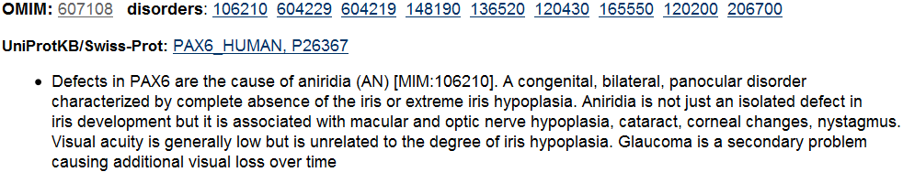
Jump to the Disorders section. The first OMIM link (607108) is to the gene PAX6 entry. There are other OMIM links for PAX6 disorders, including one for Aniridia (106210).
Click on the Aniridia link. Here the Gene map locus is confirmed. Click on the Location link for the OMIM map of Chromosome 11 around PAX6. You will see a fuller representation in Ensembl later.
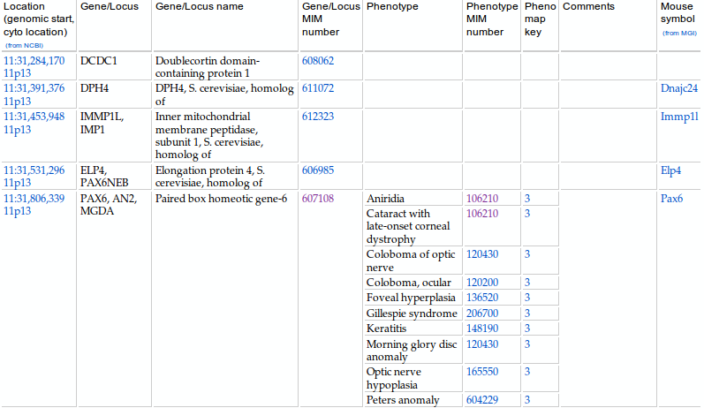
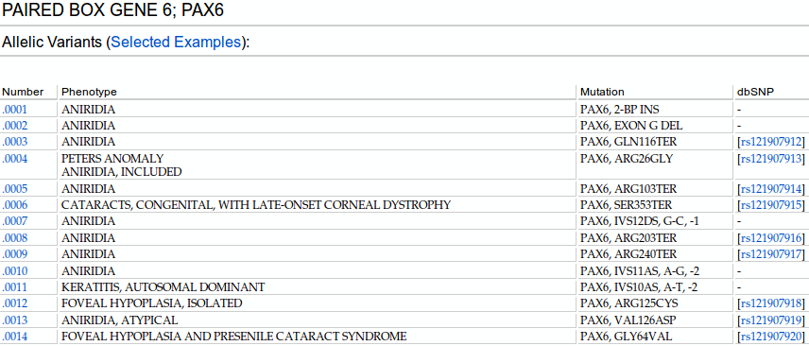
Move back to the aniridia OMIM entry and follow the link to the OMIM entry for PAX6 (607108) which you will find in the TEXT section. From the Table of Contents menu, select Allelic Variants. Click on Table View.
Several variants of this protein causing aniridia are listed, many are associated with a dbSNP entry, none of which is the one we will be investigating. As is admitted, the list is just selected examples
What do you notice about all the variants that are associated with a dbSNP entry?

Does this surprise you?
Other databases from the European Bioinformatics Institute (EBI)

In a new browser window, go to the EBI homepage:
http://www.ebi.ac.uk
For this exercise, you started to investigate aniridia at the Genecards site in Israel. There are many alternative starting points, including the EBI, where many of the databases you have been browsing are maintained, or at least mirrored. The EBI is not restricted to any particular organism and so would be a better choice for inquiries that are not specific to Homo Sapiens. The resources available for searching are displayed just underneath the search box.
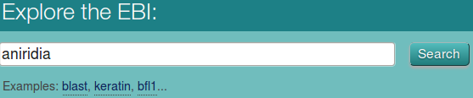
You have already discovered much about anirida, certainly enough to consider using the PAX6 protein accession code P26367 as a search term. However, if you were really starting from the beginning, you would more probably be inclined to type the keyword aniridia into the Explore the EBI box and click the Search button.
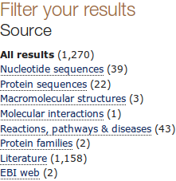
The EBI Search finds matches to aniridia with the many entries in the many databases of the EBI. Take a quick look at the hit list that is generated. From here, this exercise might divert in a numerous directions. For now, the focus is still the PAX6 human protein. So, Filter your results to show just the Protein sequences.

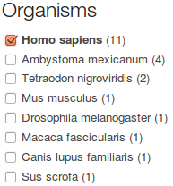

Further refine your list by specifying just the Organism Homo sapiens.

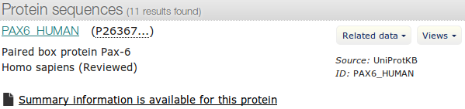

At the top of your list, you shoud not be surprised to see PAX6_HUMAN.

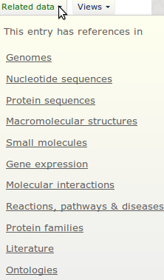
It is possible to link to the corresponding entries in other EBI databases. From the Related data pull down menu, select the Ontologies option.

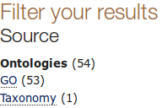
Filter your results to include just entries from the Gene Ontology (GO) database.
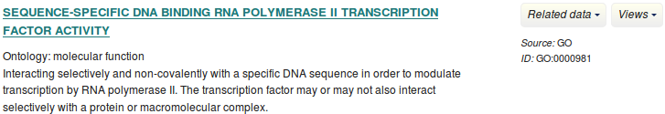
Many of the entries found should cause you little surprise.

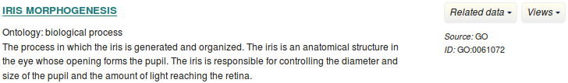
Of course, you could find links to the same GO entries within the UniprotKB database entry.

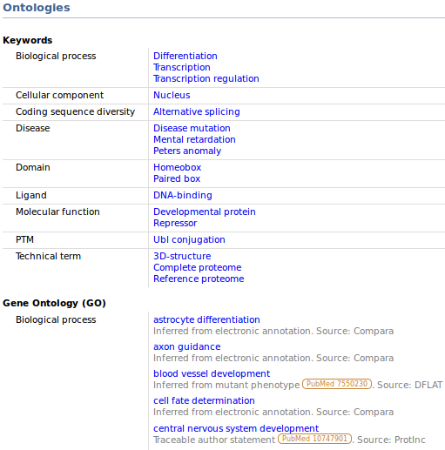

Move to the bottom of your list of GO entries. Follow the link back to PAX6_HUMAN.

Move to the Ontologies Section. You will see confirmation of the major domains of PAX6 and its molecular function suggested by Keywords and Gene Ontology. Stricter use of keywords must reduce the failures of annotation searches as were experienced previously.

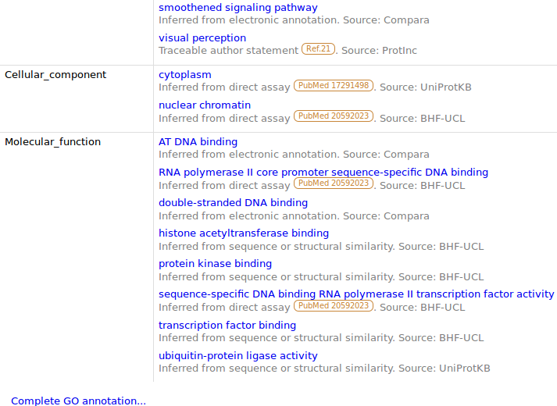

Following the Keywords are a large number of relevant GO terms classified as Biological process, Cellular component or Molecular function.
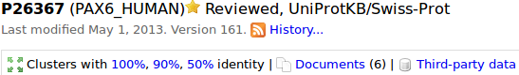
Move to the top of the page. Here there are links to Clusters of proteins with sequences 100%, 90% and 50% identical that of PAX6. These clusters, constructed from UniprotKB, are organised into the databases UniRef100, UniRef90 and UniRef50. Comparing proteins with cluster databases produces more succinct results that would be generated by a search against Uniprot itself. Follow the links to each cluster report. Note that you can Customize the display. Fun, but maybe it is easier just to follow the link to the entire entry in order to obtain more information.
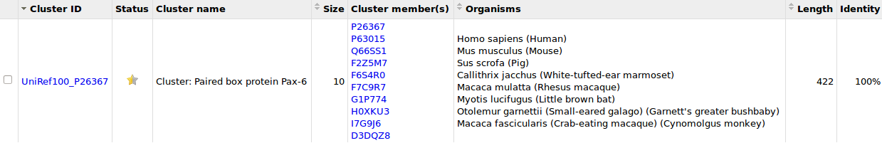

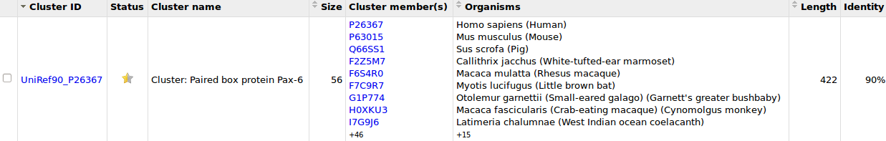

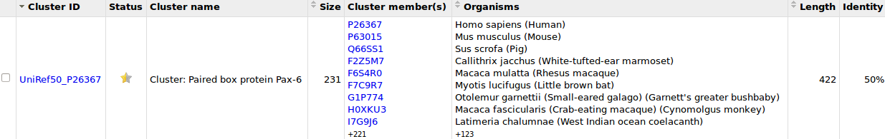
Move again to the UniRef100 cluster report.
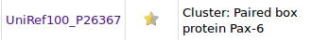
Follow the link to the UniRef100 entry.
What was the seed sequence upon which this cluster was built?
What do you imagine a seed sequence might be (click for Help)?
What is the Representative sequence protein for this cluster?
What do you imagine a Representative sequence might be (click for Help)?

How many sequences are from UniProtKB/Swiss-Prot and how many from UniprotKB/TrEMBL (Look at the Dataset pull down Menu)?
Given your last answer, how would you interpret the colours of the stars in the Status column?

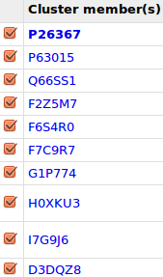
Select all the sequences of the UniRef100 entry.
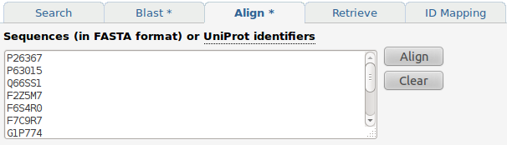
Click the Align tab at the very top of the page.
Click the Align button.

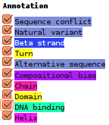
Try some Annotation options. Even all of them!!
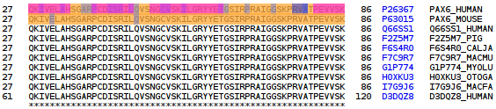

Which sequences react to the Annotation request, and why?
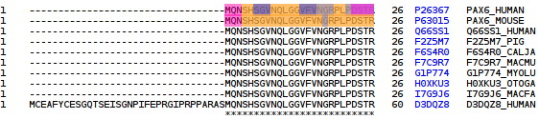
It is clear from the alignment that all the UniRef100 entry sequence are not, in this case at least, identical!

Can you rationalize why one of the sequences is allowed to be different to all the others?

After viewing this UniRef100 entry, how “non-redundant” would you say was UniprotKB?
Why do you suppose it might be useful to have identical sequences in UniprotKB?
Further Features of Ensembl
This is really some final steps I removed from the main Ensembl investigation in order to speed things along a trifle. Not sufficiently vital to leave in place, but still “interesting”? So I make them a supplementary exercise. I hope to add some more material covering the extended variation features of Ensembl later.
These instructions assume you are looking at the PAX6-201 transcript of the human PAX6 gene. If that is not where you are, the URL is:
http://www.ensembl.org/Homo_sapiens/Transcript/Summary?db=core;g=ENSG00000007372;r=11:31806340-31839509;t=ENST00000419022
Just click on the link and you should be taken to the appropriate page. Then … proceed as follows:

Click on the Protein Summary link (from Transcript-based displays → Protein Information). The graphic shows the SMART domains you recently noted. Click on the SMART features. Note that feature start/end points and Interpro links are also available here.
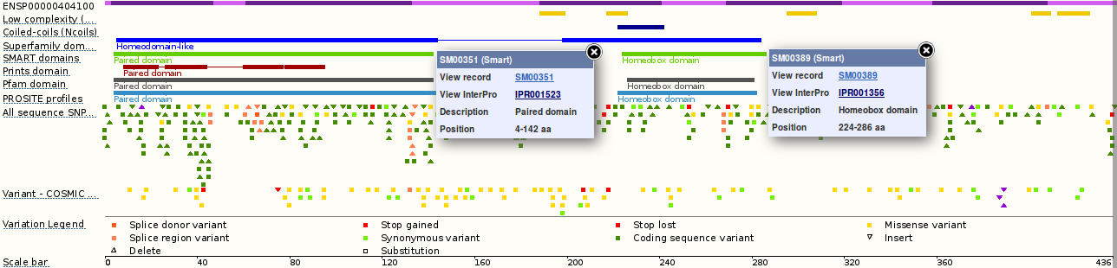
Click on the Gene: PAX6 tab. Click on the Variation Table link (from Gene-based displays → Gene Variation).
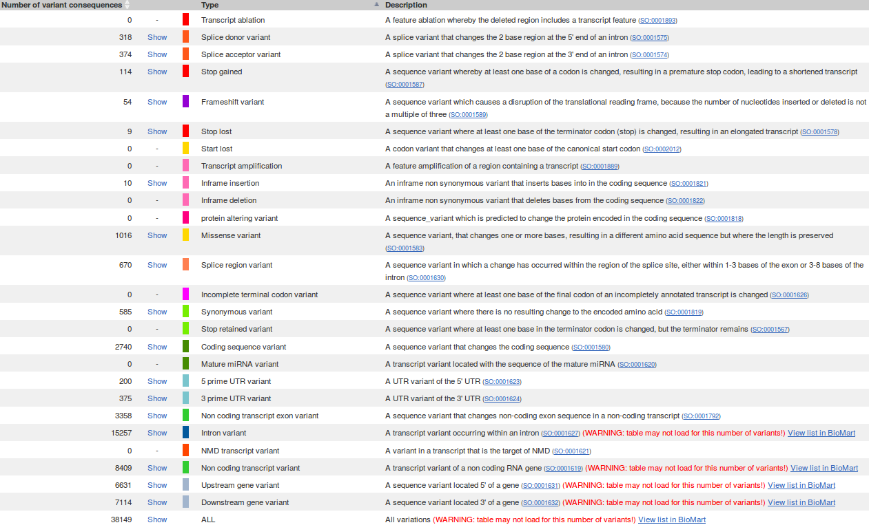
You are rewarded by a table offering to show various subsets (or ALL) of the Variations coincident with the PAX6 region of the human genome. In the next section of the exercise, you will also generate a list of SNPs for PAX6, but this option allows for much greater refinement. Click on some of the Show options offered. I would imagine the Splice donor variants and Splice acceptor variants that occur in the critical start and end base pairs of introns would be of particular interest in “Real Life”.
You will see from the lists you produce, many of these mutations are from the HGMD and reveal little, unless you pay. There are more useful entries elsewhere however. Have a look around. For my illustration, starting with the list of all Splice acceptor variants, I removed some of the table columns that did not contained obviously interesting information using the option at the top of the table.
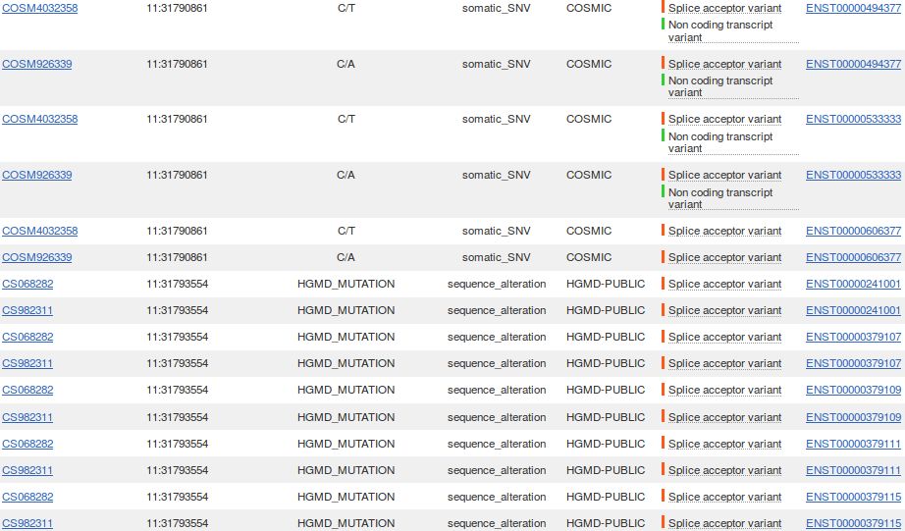
Try the Variation Image link. This offers the same information, dressed up as an enormous graphic! Indubitably pulchritudinous, but the poetry is a tad over blown for a simple lad such as I.

Further Features of Spin
This Supplementary Exercise assumes you to be exactly as you would be if you had just finished the main pairwise alignment exercise with spin, ending with a look at Local Alignment. I moved it here to try and make things a little shorter. It really only shows a few extra features of spin whilst, obsessively, trying to get spin to translate the unaffected sequence to show explicitly that the amino acid that is mutated into a Proline is an Alanine. I only partially and clumsily succeeded with the latter and you knew the answer anyway! So it only just deserves to be a Supplementary Exercise. Anyway, for what it might be worth, here it is.
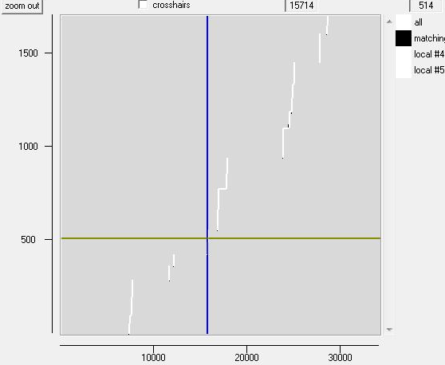
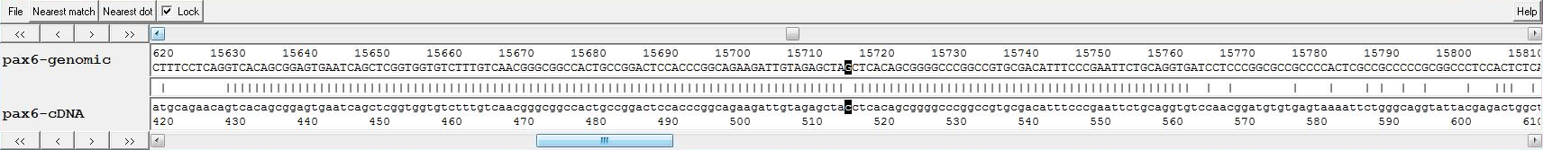
The fact that your alignments are not in positional order does make it a little difficult to find things. In particular, the mutation in the coding exon. splign suggests this is in the 5th exon. One way to view it therefore would be to double click on the 5th exon of the graphical display. This will bring the Sequence Comparison Display into view. Click on the Nearest match button to view the alignment for the 5th exon. Click on the Lock button so that the cDNA and genomic sequences stay in alignment. Make the Sequence Comparison Display as wide as you can. Move the display along until you have the mutation in view. Wonderful, but we have not persuaded any of the software to declare what the translation of the wild type sequence would be at the mutation site.
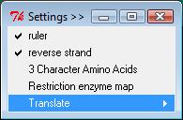
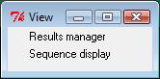
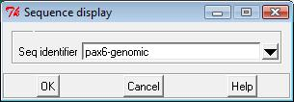
From spin's View menu, select Sequence display. Check that the genomic sequence is selected. Click OK. You should now be viewing the genomic sequence. To add amino acid translations, from the Settings menu, select Translate and choose to Translate + frames. You know the coding reading frame must be on the top strand, but there is no way to easily tell which of the three frames it might be, so translate them all. Position the sequence within your display so that the mutation is in view. Shape the Sequence display so that you can easily see all three translations and as much sequence as is practicable.
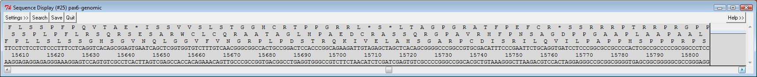
Maybe using your splign results to help you decide, which reading frame is coding in the 5th exon?
What is the amino acid corresponding to the mutated base in the PAX6 genomic sequence?
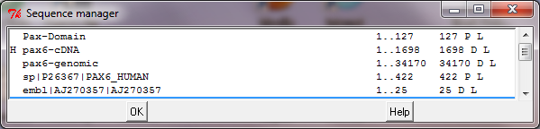
At this point, the unworthy cynic might note that we have known all this from the time we looked at the feature table of the Uniprot entry. True, but how much more rewarding to have worked it all out for ourselves!
Time to tidy up. Remove as many of your textual outputs from spin's Output window as your patience allows. You have saved all that might be useful later. Dispose of spin's graphics windows and Sequence displays, all were very beautiful in their time but have now served their purpose fully. In the next section, you will be analysing the mRNA (pax6-cDNA), so set it as spin's Horizontal sequence in the Sequence manager. From this point on, you will be using a lot of EMBOSS programs from spin. All EMBOSS programs are selected from spin's Emboss menu, even if I do not explicitly state this each and every time.
ORF Identification and Translation
Now identify and translate the coding portion of the cDNA sequence into protein. The EMBOSS program plotorf provides a preliminary graphic of the distribution of ORFs in six frames.
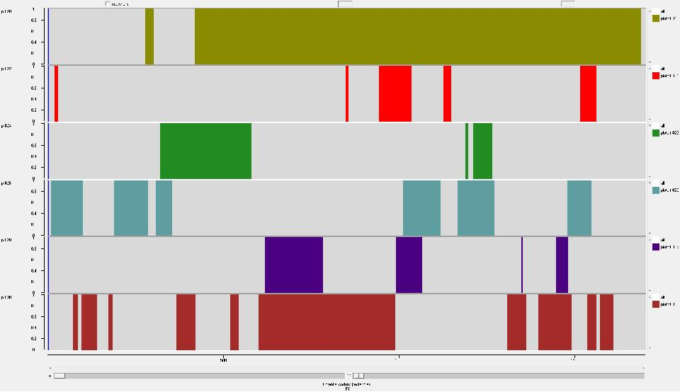
From spin's Emboss menu, select plotorf from the Nucleic/Gene Finding menu. Use the default start/stop codons (Advanced section). Click OK.
You will see a graphical output that shows the potential open reading frames (ORF) in all six-frames. You will notice that the longest ORF occurs in the top section of the graphic (i.e. forward sense, frame 1) starting at around 400 bases and ending around 1700. Try using the cross-hair to obtain a more accurate estimate of the start of the longest ORF. Double click in the graphic, spin will produce a sequence display in which you can request a translation of the appropriate reading frame. From this display, it is easy to determine the extent of the ORF and the coding region.
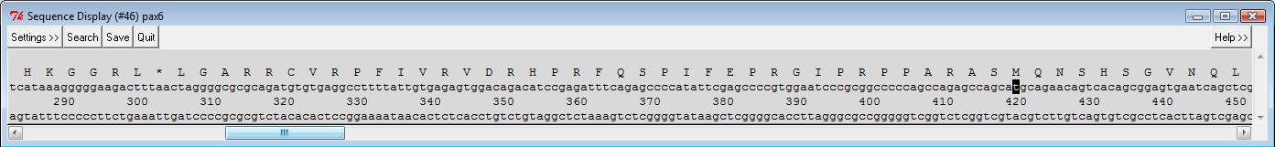
You have passed over several opportunities to record the exact start and stop positions of the coding region of your cDNA. Maybe this is the moment to make a note. You need to know that in the spin Sequence Display the numbered base is below the least significant digit. Thus both the 340th base and the 380th base are As. Also, the last Stop (*) codon (TAA) before the coding region of this mRNA spans bases 301 to 303.
At what base position does the coding sequence of the mRNA commence?
Move the Sequence Display along to the region in which plotorf suggests the coding sequence ends.
What is the base position of the last base of the coding sequence?
Other ways to determine the whereabouts of coding regions include use of the EMBOSS program getorf. Select getorf from the Nucleic/Gene finding menu. In the Additional section, ensure that the Code to use is set to Standard. Use your plotorf results to select a sensible Minimum nucleotide size of ORF to report. Select Translation of regions between START and STOP codons for the Type of output. In the Output section, change the Filename to getorf_results.txt and hit OK.
>pax6-cDNA_1 [318 - 578]
MCEAFYCESGQTSEISEPHIRAPWNPAAPSQSQHAEQSQRSESARWCLCQRAATAGLHPA
EDCRATSQRGPAVRHFPNSAGVQRMCE
>pax6-cDNA_2 [418 - 1683]
MQNSHSGVNQLGGVFVNGRPLPDSTRQKIVELPHSGARPCDISRILQVSNGCVSKILGRY
YETGSIRPRAIGGSKPRVATPEVVSKIAQYKRECPSIFAWEIRDRLLSEGVCTNDNIPSV
SSINRVLRNLASEKQQMGADGMYDKLRMLNGQTGSWGTRPGWYPGTSVPGQPTQDGCQQQ
EGGGENTNSISSNGEDSDEAQMRLQLKRKLQRNRTSFTQEQIEALEKEFERTHYPDVFAR
ERLAAKIDLPEARIQVWFSNRRAKWRREEKLRNQRRQASNTPSHIPISSSFSTSVYQPIP
QPTTPVSSFTSGSMLGRTDTALTNTYSALPPMPSFTMANNLPMQPPVPSQTSSYSCMLPT
SPSVNGRSYDTYTPPHMQTHMNSQPMGTSGTTSTGLISPGVSVPVQVPGSEPDMSQYWPR
LQ
>pax6-cDNA_3 [781 - 617] (REVERSE SENSE)
MTRLVCYRWYRPPRTVICLGFPKQRWTGTPAYTGLFCLQLLESLLSVYYHRLPWV
>pax6-cDNA_4 [986 - 600] (REVERSE SENSE)
MELVFSPPPSCCWQPSCVGCPGTEVPGYQPGRVPQLPVCPFNILSLSYMPSAPICCFSLA
RLRRTLFIDDTLGMLSLVQTPSDSNLSRISQAKMDGHSRLYWAILLTTSGVATLGLLPPI
ALGLMEPVS
Look at your getorf results file with an editor. The number of “answers” getorf suggests will depend upon the minimum ORF size you chose. plotorf suggests that the correct (most likely at least) ORF will be in the region 400 to 1700. Find the relevant prediction in your Sequence Display output. You will (again) see that the translation is from 418 to 1683.
In spin's Sequence Manager, ensure pax6_cDNA is the Horizintal sequence.
To save the translation of this region, pick the EMBOSS program transeq from the Nucleic/Translation menu. Move to the Additional section, and set the Regions to translate to 418-1683. Ensure Translation Frames is set to 1, and Code to use to Standard. In the Output section set the Filename field to pax6.pep. Hit OK.
Using an appropriate editor, alter the comment line in your pax6.pep file to read “pax6 conceptual translation from mutant cDNA” and save you handiwork for perpetuity. Your file should appear similar to that illustrated.
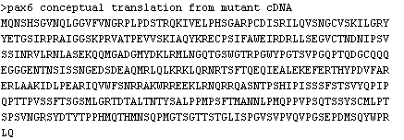

Now, you are able to compare the protein sequence from your cDNA with the PAX6 database entry. This requires a sequence alignment to make apparent any discrepancies between sequences.
Align your translated pax6.pep sequence with the database entry. Choose the spin alignment option you consider most logical (global or local, both will work, but one makes more sense than the other). Load in the protein sequence you saved in the file pax6.pep and the PAX6 human protein from the Uniprot sequence database (you will recall that you saved this in a disk file called pax6_human.fasta in your working directory). The default settings should do, just set the program going and view the results.
What is the single amino acid difference between the two sequences?
What is the position of the difference?
Restriction Maps
Particularly when looking at the NCBI program splign, you recorded the position and type of all the differences between your aniridia patient's mRNA and the genomic sequence from Ensembl. The most interesting mismatch is between base position 514 of the mRNA (C) and 15714 of the genomic sequence (G). You could check these positions by looking at your second global alignment (saved in global_results02.txt) and/or your second local alignment (saved in local_results02.txt), or you could just believe!
Restriction mapping is trivial using computers. Use the EMBOSS program remap to make a restriction map of each sequence in the area where the difference is seen in the alignment. Any differences in the two restriction maps could be used to further investigating the discrepancy between the two sequences.
First map the relevant region of the genomic sequence. Choose remap from the Nucleic/Restriction menu and load the genomic DNA sequence. Set the Start position and End position fields to 15707 and 15766. In the Required section, leave the Comma separated enzyme list as all but set the Minimum recognition site length to 6. In the Output section, you know the translation and sense, so turn off Display translation and Display cut sites and translation of reverse sense. Set the Output filename to remap_genomic.txt. Leave all else and click on OK. Your output should begin as illustrated.
NspBII
| DraII
| Bsp120I
| |NlaIV
| ||NlaIV
| ||| SduI Hpy178III
| ||| ApaI |AarI
| ||| BaeGI |BspMI
| ||| HgiJII || ApoI
NheI | ||| |CfrI || EcoRI
| Cac8I | ||| |XmaIII || | SfeI
| | BmtI | ||| || McrI || | | PstI
\ \ \ \ \\\ \\ \ \\ \ \ \
AGAGCTAGCTCACAGCGGGGCCCGGCCGTGCGACATTTCCCGAATTCTGCAGGTGATCCT
15710 15720 15730 15740 15750 15760
---|----:----|----:----|----:----|----:----|----:----|----:-

BsiYI
|NspBII
|| DraII
|| Bsp120I
|| |NlaIV
|| ||NlaIV
|| ||| ApaI Hpy178III
|| ||| SduI |AarI
|| ||| BaeGI |BspMI
|| ||| HgiJII || ApoI
|| ||| |CfrI || EcoRI
|| ||| |XmaIII || | SfeI
|| ||| || McrI || | | PstI
\\ \\\ \\ \ \\ \ \ \
agagctacctcacagcggggcccggccgtgcgacatttcccgaattctgcaggtgtccaa
510 520 530 540 550 560
---|----:----|----:----|----:----|----:----|----:----|----:-

Run remap again in the fashion outlined above for the corresponding part of the PAX6 mutated cDNA. The region to map is from 507 to 566. This time, set the Output filename to remap_cdna.txt.

The one base pair difference has altered the way a number of restriction enzymes cut. Differences include the deletion of the 3 restriction sites of the genomic map and the creation of the 1 site in the cDNA map. Complete information about these restriction enzymes, can be found at the REBASE (a publicly available database of restriction enzyme data) web site.
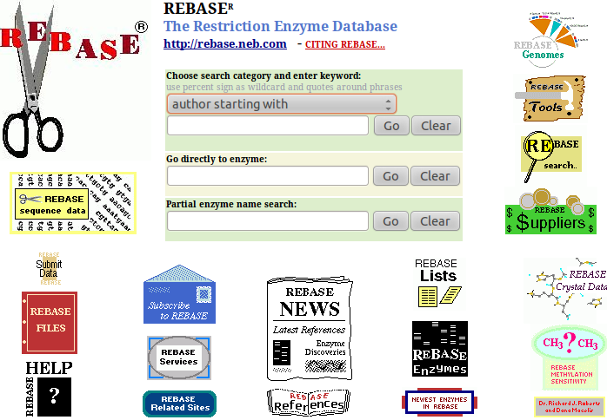

Before moving on, take a quick look around the home of REBASE. Make a new navigator window and go to:
http://rebase.neb.com/
You could download the REBASE in a large number of different formats (including that required by the EMBOSS package). To examine the possibilities, click on the REBASE FILES link.

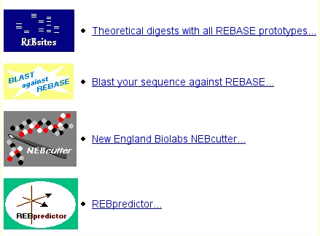

For a really pretty and interactive map, starting from the REBASE home page once more, click on the REBASE Tools link.

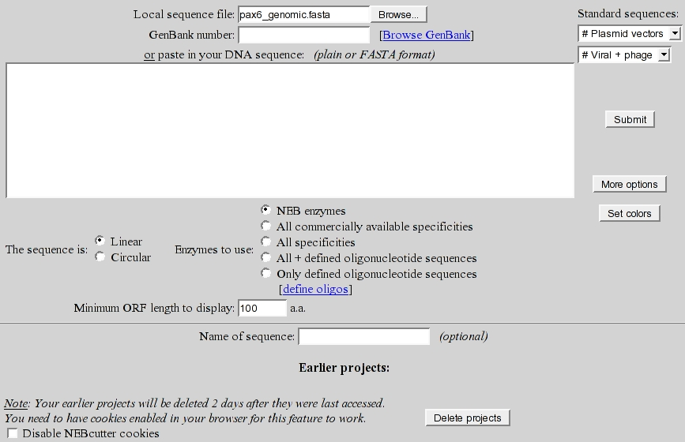

Select New England Biolabs NEBcutter. Load sequence file pax6_genomic.fasta and ask for More options.

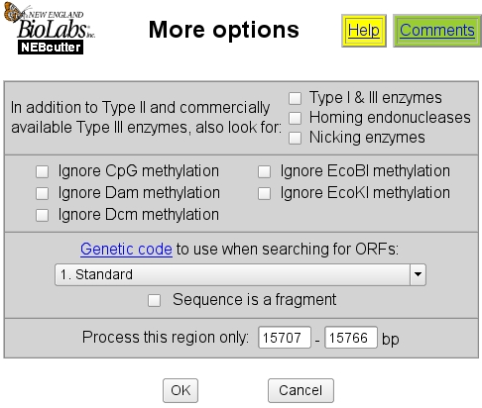

Set the Genetic code to Standard.

Elect to Process this region only from 15707 – 15766. Click OK in the More options window.

Click on Submit in the main NEBCutter window.

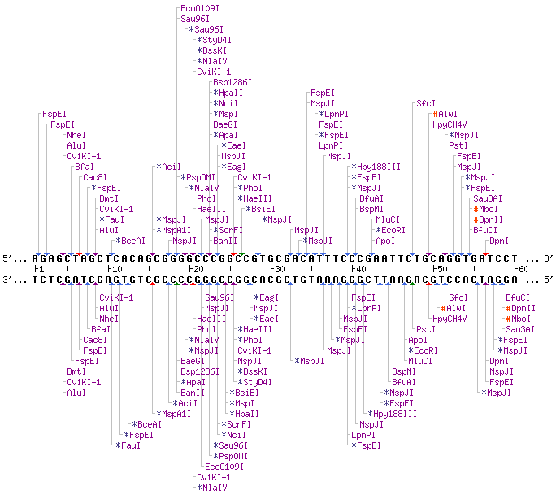

You will be rewarded by a beautiful map of the same genomic PAX6 region investigated with remap. You can link to the individual REBASE entries and customize the map in many ways. This must be a better way to ponder the map of a specific sequence.

In order to make the map you generated look a little more like the one produced by remap, you would need at least to restrict the number of enzymes mapped. If you recall, you told remap to consider only enzymes with a recognition site of 6 base pairs or more.

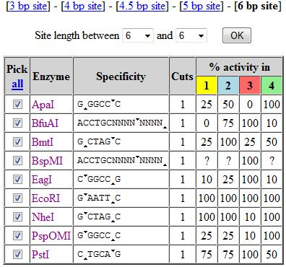
Click on Custom digest (amongst Main options). You will see you map in tabular form. Click on Enzymes with a particular site length, choose 6 bp site and click OK. Your table of enzymes will shrink dramatically to meet your specification.

Pick all the listed enzymes and then click on the green Digest button at the bottom of the page to create a graphical map roughly equivalent of the one you made with remap.

Note that to find out about an enzyme you can hover your mouse over its name, or click on the name for fuller information. There is much more to investigate at this site. I leave you to discover for yourselves.
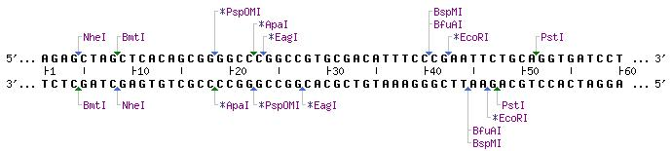
There are quite a few less enzymes mentioned in the map you have just made compared to that generated by remap. Can you speculate what the main reason for this might be?
Some enzymes in this map appear in the same place as remap predicted, but have different names.
Can you explain why?
Gene Identification Software – Specifically Genscan
These programs are used to find promoters, splice sites, coding versus non-coding regions and polyadenylation signals in novel DNA sequences. These features can be combined to form complete gene model predictions.
When looking for splice sites in genomic DNA, some programs use the best currently accepted consensus (e.g. AG dinucleotide at intron/exon boundary) to scan the unknown sequence. Other programs are trained with a set of splice sites in known sequences (neural network approach). These applications often over predict. Prediction accuracy ranges between 50% and 95%. Recent programs for gene identification use Hidden Markov Models. There are many GeneID programs. One of the best single programs for de novo gene prediction is Genscan.
Genscan can recognise more than one potential gene in a sequence. It can also recognise partial genes. Genscan has been primarily designed for vertebrates. It may be less accurate for other organisms.
Go to the Genscan server at:
http://genes.mit.edu/GENSCAN.html
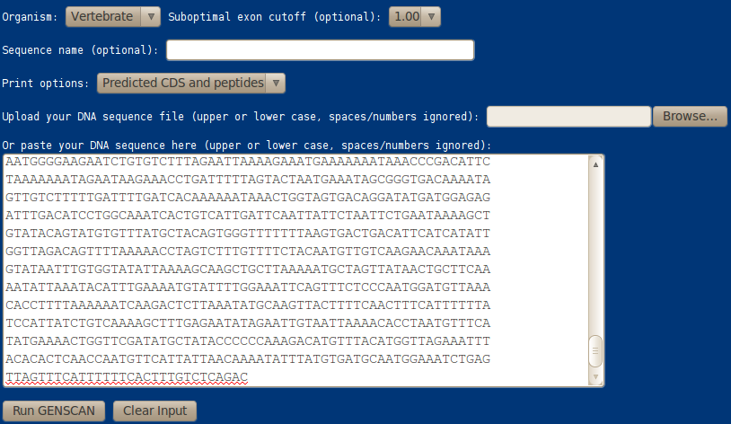
Use the default Organism and Suboptimal exon cutoff. Set Print options to Predicted CDS and peptides. Copy an paste, just the PAX6 genomic sequence from pax6_genomic.fasta into the approriate text box. Genscan does not understand FASTA format. Were you to use the Upload your DNA sequence file option, or to copy and paste the whole of this file, 18 of the 22 characters of the first line “>pax6-genomic sequence” would be regarded as part of the sequence, rendering the Genscan output impossible to interpret. Click on Run GENSCAN.
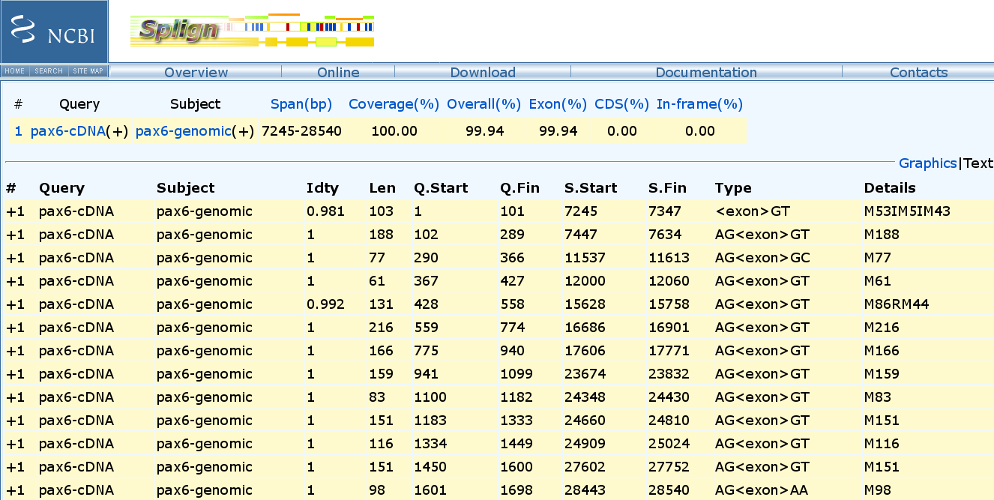
In the results that are generated, predicted genes and sub-features such as exons are numbered (Gn.Ex) and listed in a table displaying their Type, strand (S), start (Begin) and end (End) positions, and length (Len). A probability (P) is assigned to each predicted exon. High probability exons (P > 0.99) are nearly always correct, those with 0.50 < P < 0.99 are correct most of the time, the rest are not reliable.
Gn.Ex Type S .Begin ...End .Len Fr Ph I/Ac Do/T CodRg P.... Tscr..
----- ---- - ------ ------ ---- -- -- ---- ---- ----- ----- ------
1.01 Init + 5509 5600 92 0 2 65 24 139 0.462 3.17
1.02 Intr + 7682 8297 616 2 1 37 65 397 0.257 24.65
1.03 Intr + 12000 12060 61 2 1 96 98 38 0.917 3.91
1.04 Intr + 12789 13073 285 1 0 92 107 50 0.900 4.61
1.05 Intr + 15326 15442 117 0 0 71 52 55 0.567 0.64
1.06 Intr + 15628 15758 131 2 2 141 58 149 0.999 17.61
1.07 Intr + 16550 16591 42 1 0 62 85 51 0.608 0.64
1.08 Intr + 16686 16901 216 2 0 104 94 112 0.995 12.10
1.09 Intr + 17606 17771 166 1 1 76 93 72 0.974 6.03
1.10 Intr + 17856 17927 72 1 0 88 42 58 0.553 0.58
1.11 Intr + 23674 23832 159 2 0 108 54 194 0.919 17.96
1.12 Intr + 24348 24430 83 1 2 29 86 85 0.945 1.76
1.13 Intr + 24660 24810 151 2 1 72 58 76 0.958 2.74
1.14 Intr + 24909 25024 116 1 2 113 108 94 0.977 14.07
1.15 Intr + 27602 27752 151 1 1 115 99 80 0.992 11.54

Illustrated here are the results I got alongside the very authoritative predictions from splign that you computed from the same data earlier. Overall, the prediction is more than reasonable, given the approximate nature of the training set. Observations include:
- 9 of the 10 genes suggested by splign between bases 12000 and 28540 were predicted exactly by Genscan.
- Genscan missed the final exon (28443-2850) and so failed to predict a complete gene.
- Of the 4 exons Genscan predicts in this region but splign denies, one is the 42 base pair exon that is only present in isoform 5a. This is genuine, but splign would not see it as the cDNA used was not an isoform 5a sequence.
- The other 3 “extra” exons in this region were all predicted with suspiciously low probability scores (17856-17927 P=0.553, 16550-16591 P=0.608, 15326-15442 P=0.567).
- Genscan has not made a particularly impressive job of predicting the non-coding exons at the 5' end of the gene.
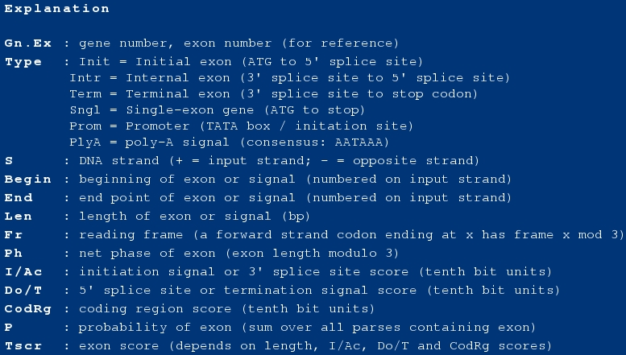

A full explanation of the output table used to be included at the bottom of the results page. It has now been removed, but as I think it was useful, I include it here. Note that Intr is not short for Intron, as most sensible people might guess, it is short for Internal exon!! I suspect a warped sense of humour here?

GENSCAN pep 1 MWPGGPGRLAASSLSRLPGAAATRPVSSEFRQVSPFLPPSFLPSRRSPPP 50
GENSCAN pep 51 LLRRESWAGEVSTQEPKLSTSSESPRRRATAGERERRRARGGRPAQPQRQ 100
GENSCAN pep 101 RQRQRGLSSREEGRLQARQQPRLLAPASPNAPDPREKTKRLCGAQGPGTA 150
GENSCAN pep 151 AESNRCRLLCPARGPANAQRAGAPRTRRGSAEGTCSPRLRPPAGPRALCR 200
GENSCAN pep 201 TGLRRRRVSRHSSAEGGTAPATSPSGVSRQGSRTLESPIFEPRGIPRPPA 250
GENSCAN pep 251 RASMQNNPVGSHPPSCSWWVLVRGRASLELRPGSLEAQRNQARFEVTVEA 300
GENSCAN pep 301 HGVGAQLNSKCGKARVFQQPALAEPHRLKEGPQHLIHLFWKRRSPPGASG 350
GENSCAN pep 351 AVQWAGARLLGLGCPMSGMAGGPVVLYLIDSRELTAEVGTGHSGVNQLGG 400
:...|||||||||
PAX6_HUMAN 1 MQNSHSGVNQLGG 13
GENSCAN pep 401 VFVNGRPLPDSTRQKIVELAHSGARPCDISRILQTHADAKVQVLDNQNVS 450
|||||||||||||||||||||||||||||||||| ||
PAX6_HUMAN 14 VFVNGRPLPDSTRQKIVELAHSGARPCDISRILQ--------------VS 49
GENSCAN pep 451 NGCVSKILGRYYETGSIRPRAIGGSKPRVATPEVVSKIAQYKRECPSIFA 500
||||||||||||||||||||||||||||||||||||||||||||||||||
PAX6_HUMAN 50 NGCVSKILGRYYETGSIRPRAIGGSKPRVATPEVVSKIAQYKRECPSIFA 99
GENSCAN pep 501 WEIRDRLLSEGVCTNDNIPSVSSINRVLRNLASEKQQMGADGMYDKLRML 550
||||||||||||||||||||||||||||||||||||||||||||||||||
PAX6_HUMAN 100 WEIRDRLLSEGVCTNDNIPSVSSINRVLRNLASEKQQMGADGMYDKLRML 149
GENSCAN pep 551 NGQTGSWGTRPGWYPGTSVPGQPTQGLPCLGNVMGETAFEGLGHIDHIVY 600
|||||||||||||||||||||||||.
PAX6_HUMAN 150 NGQTGSWGTRPGWYPGTSVPGQPTQD------------------------ 175
GENSCAN pep 601 GCQQQEGGGENTNSISSNGEDSDEAQMRLQLKRKLQRNRTSFTQEQIEAL 650
||||||||||||||||||||||||||||||||||||||||||||||||||
PAX6_HUMAN 176 GCQQQEGGGENTNSISSNGEDSDEAQMRLQLKRKLQRNRTSFTQEQIEAL 225
GENSCAN pep 651 EKEFERTHYPDVFARERLAAKIDLPEARIQVWFSNRRAKWRREEKLRNQR 700
||||||||||||||||||||||||||||||||||||||||||||||||||
PAX6_HUMAN 226 EKEFERTHYPDVFARERLAAKIDLPEARIQVWFSNRRAKWRREEKLRNQR 275
GENSCAN pep 701 RQASNTPSHIPISSSFSTSVYQPIPQPTTPVSSFTSGSMLGRTDTALTNT 750
||||||||||||||||||||||||||||||||||||||||||||||||||
PAX6_HUMAN 276 RQASNTPSHIPISSSFSTSVYQPIPQPTTPVSSFTSGSMLGRTDTALTNT 325
GENSCAN pep 751 YSALPPMPSFTMANNLPMQPPVPSQTSSYSCMLPTSPSVNGRSYDTYTPP 800
||||||||||||||||||||||||||||||||||||||||||||||||||
PAX6_HUMAN 326 YSALPPMPSFTMANNLPMQPPVPSQTSSYSCMLPTSPSVNGRSYDTYTPP 375
GENSCAN pep 801 HMQTHMNSQPMGTSGTTSTX 820
|||||||||||||||||||
PAX6_HUMAN 376 HMQTHMNSQPMGTSGTTSTGLISPGVSVPVQVPGSEPDMSQYWPRLQ 422
Another way to gain an impression of how well Genscan has performed, is to align the predicted protein with the protein from UniProtKB that you have stored in pax6_human.fasta. To save time, I have done that for you with the EMBOSS program needle (sensitive global alignment option). needle was run with default parameters from the EBI web pages. I have edited the output in this illustration, but only to reduce its size.

Genscan has regarded all the exons it predicts as coding, hence the messy beginning. The effects of the missing internal exons are very clear to see, including the familiar 14 amino acids of isoform 5a, missing in the UniprotKB entry, but correctly predicted by Genscan.

The consequences of the missing terminating exon is also clear to see.
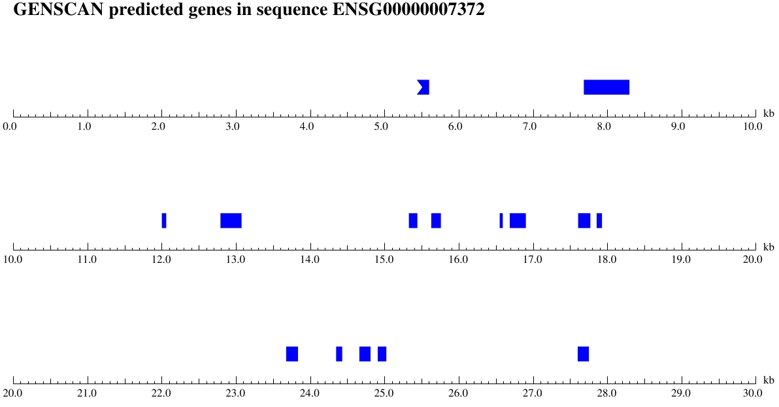
At this point I would love to suggest you take a look at the PDF and/or postscript images using the links at the top of your results page. Unfortunately, for some time now they have not worked. In compensation, I offer the picture you would get if the links still worked. The pictures are very beautiful, but it should be remembered that making predictions look pretty does not improve their accuracy.

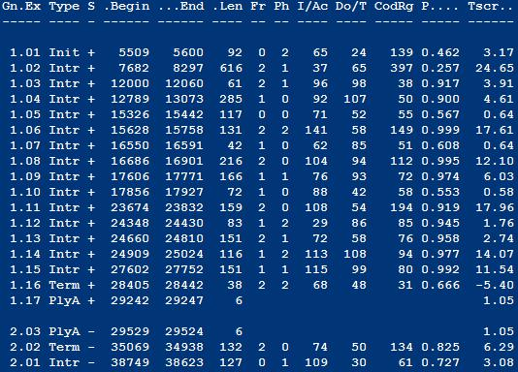

I tried giving Genscan a longer portion of the genomic sequence (an extra 6000 base pairs downstream) and found I got a prediction with a Terminal exon (close, but not quite right) and a polyA. The extra sequence must offer better context.

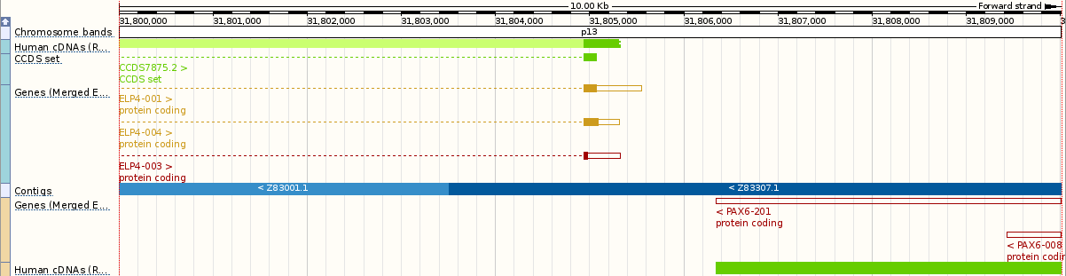
I also got a partial gene on the opposite strand. A quick look with Ensembl at the region towards the end of the PAX6 suggests this could be the last part of ELP4?

The longer genomic sequence is available if you wish to experiment further (or get it yourself with Ensembl).

Genscan predictions are dependent upon the choice of the set of training sequences used. This website (and all the other Genscan sites I have used) offer a very limited range of training set choices. In the circumstances, the prediction is surprisingly accurate. For serious use, it would be necessary to install Genscan locally and to use customized sets of training data.
Early Secondary Structure Prediction Methods - GOR
A number of simple methods for investigating protein secondary structure were developed from as far back as the late 1960s, early 1970s. Significantly better methods emerged as the 1970s progressed, claiming accuracy of around 60% or more. The method we will look at here is one of those improved methods. We will look at the method due to Garnier, Osguthorpe and Robson (GOR), originally published in 1978, but developed/improved well beyond that time. The latest version being Version V (published 2002, a new server announced 2005). GOR V incorporates more modern approaches and has been merged into other prediction strategies. Wikipedia offers an informative article on protein secondary structure that is well worth a look if this is an area of particular interest for you.
The older methods, such as GOR, are not as accurate as the more modern approaches investigated in the main exercise, however, they do have the advantage of being very quick and easy to run. They provide a reasonable prediction (usually) with little fuss and so still have a role to play, I would suggest.
. 10 . 20 . 30 . 40 . 50
MQNSHSGVNQLGGVFVNGRPLPDSTRQKIVELAHSGARPCDISRILQVSN
helix HH H
sheet EE EEEEEEEE EEEEE EEEEEE
turns T TTTT TTT TTT
coil CCCCCCC CCCCC CC C
. 60 . 70 . 80 . 90 . 100
GCVSKILGRYYETGSIRPRAIGGSKPRVATPEVVSKIAQYKRECPSIFAW
helix HHHHHHHHH HHH
sheet EEEEEEEE EEEE EEE
turns TT TTTTT TTT T TTTT TT
coil C CCC C C
. 110 . 120 . 130 . 140 . 150
EIRDRLLSEGVCTNDNIPSVSSINRVLRNLASEKQQMGADGMYDKLRMLN
helix HHH HHHHHHHHHHHHHHHH
sheet EEEEEEEEE EEE
turns TT TTTTTTTTT T
coil C CCC CC C
. 160 . 170 . 180 . 190 . 200
GQTGSWGTRPGWYPGTSVPGQPTQDGCQQQEGGGENTNSISSNGEDSDEA
helix HHH
sheet EEE
turns TT TT TTT TTT TT TTTTT TT
coil CC CCC C CC CC C CCCCCCCCCCCCCC
. 210 . 220 . 230 . 240 . 250
QMRLQLKRKLQRNRTSFTQEQIEALEKEFERTHYPDVFARERLAAKIDLP
helix HHHHHHH HHHHHHHHHHHH HHHHHHHHHHHHHH
sheet E
turns TT TTTT T T
coil CCCCC CCC
. 260 . 270 . 280 . 290 . 300
EARIQVWFSNRRAKWRREEKLRNQRRQASNTPSHIPISSSFSTSVYQPIP
helix HHHH HHHH H
sheet EEE EEEEE
turns TT TTTT TTTTT T TTTTTT
coil CCC CCC CCC CC CCCC
. 310 . 320 . 330 . 340 . 350
QPTTPVSSFTSGSMLGRTDTALTNTYSALPPMPSFTMANNLPMQPPVPSQ
helix
sheet EEEEE EE EEEE EEEEE EEE
turns T TTTT TT TT TT
coil C CC CCCCCCC C CCCCC CC CC
. 360 . 370 . 380 . 390 . 400
TSSYSCMLPTSPSVNGRSYDTYTPPHMQTHMNSQPMGTSGTTSTGLISPG
helix
sheet EEEE EEE EEEE
turns TTTT TT T TTTTTTT TT T T T
coil CC CC CC CC CCC CCCCCCC CC
. 410 . 420
VSVPVQVPGSEPDMSQYWPRLQ
helix
sheet EEEEEEE
turns T TTTTT TTT
coil C CCC CC
First a quick glance at the implementation of the GOR method in the EMBOSS package. This is the method as it was first published. We run it here only to contrast with the better options of the main exercise and more recent version of the same program!
There are a number of ways to access and run the programs of the EMBOSS package. Here we will use a web interface called Emboss Explorer, as implemented at the Wageningen Bioinformatics Webportal, a major Bioinformatics Service Centre of the Netherlands.
Go first to the Wageningen EMBOSS service (http://emboss.bioinformatics.nl/).
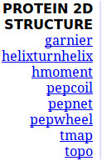
Select garnier from the PROTEIN 2D STRUTURE section of the program list.
Use the Browse facility To upload a sequence from your local computer. The required sequence is the one in pax6_human.fasta. Default parameter settings are fine. Click on the Run garnier button.
This version of GOR suggests the most likely of four types of secondary structure: Alpha Helices (H); Beta Sheets (E); Coils (C) and Turns (T), at each position of the protein sequence.
Some features are composed of only one or two residues. Especially in the case of larger structures such as helices or sheets, such predictions are dubious. Later versions of the algorithm avoid the more foolish predictions.
How credible would you say was the prediction at amino acid 33?
How would you rate the prediction overall?
Although the latest version of GOR is GOR V, GOR IV is more available, reliable and recognisably similar to the original GOR. So try GOR IV at:
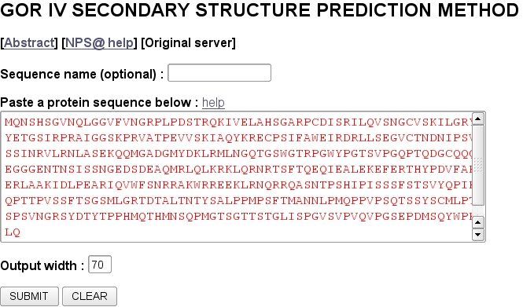
http://npsa-pbil.ibcp.fr
Pôle Bioinformatique Lyonnais (PBIL) (Lyons University) offering a wide range of interesting services including a number of ways to predict protein secondary structure. Move down to the Secondary structure prediction and click on the link to GOR IV. Copy and paste the PAX6 protein from the file pax6_human.fasta into the appropriate text box (just the amino acid codes, this server does not like fasta format). Click on the SUBMIT button.

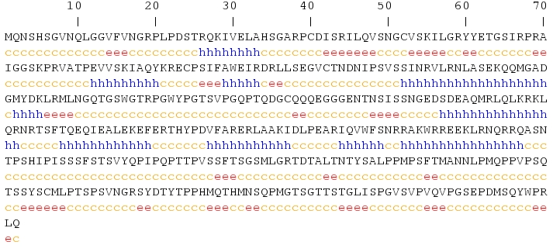
GOR IV, unlike the EMBOSS garnier program (GOR I), does not try to differentiate between Coil and Turn. It chooses for each position the most likely from Helix, Extended (i.e. beta sheet) or unstructured (i.e. Coil).
Also unlike the initial GOR implementation of the garnier program, GOR IV only predicts helices of at least four residues and beta sheets of at least two residues.
How does the prediction at position 33 compare with that of garnier?
Further down your output is a graphic showing how the structure predictions are positioned along the protein sequence. This can usefully be compared to part of the graphic you considered earlier, showing where these features lie in the view of Uniprot.
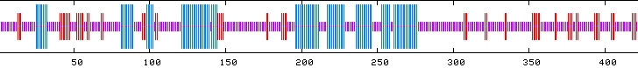
How would you rate the prediction overall?
Domain & Motif prediction with Prosite, Pfam, HTH & PRINTS
In this supplementary exercise, we will search for protein sequence motifs and protein domains using individual database searches and specific simple specialised software. Just in case you still have doubts, I have linked the references above to the wikipedia pages that clearly define both motifs and domains in this context. You may have gathered, I am a big fan of Wikipedia.
Searching 
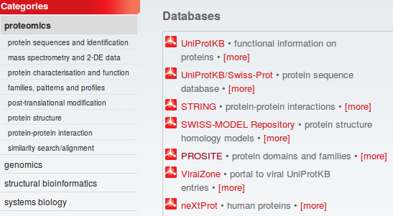
A major database for both motifs and domains is PROSITE. Many sequence motifs in this database are described using a simple pattern description language. They include some very common, simple motifs, many only a few residues long, that indicate possible sites for post-translational modifications (e.g. glycosylation or phosphorylation).
Go to the ExPASy site at:
http://www.expasy.org
Select proteomics from the list of Categories. Select PROSITE from the Databases section. Click on the ScanProsite link at the top of your page.
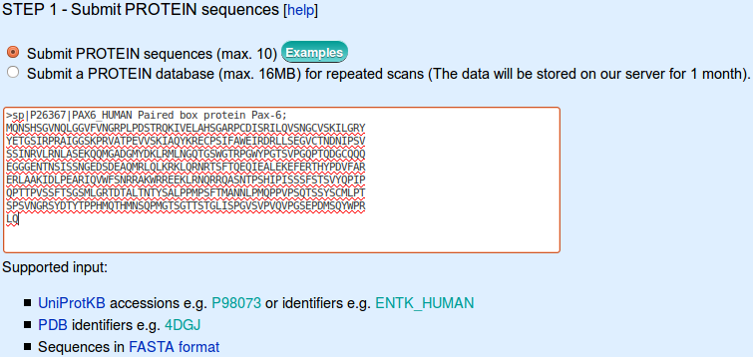

Enter pax6_human in the STEP 1 - Submit PROTEIN sequences section.

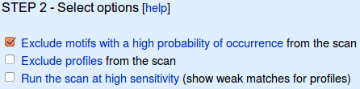
In the STEP 2 - Select options section, ensure that the Exclude motifs with a high probability of occurrence box is ticked.
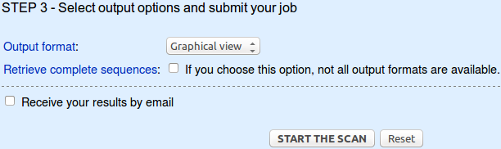
The defaults offered in the STEP 3 - Select output options and submit your job section are fine so just click on the START THE SCAN button. In but a few moments, your results will burst forth.

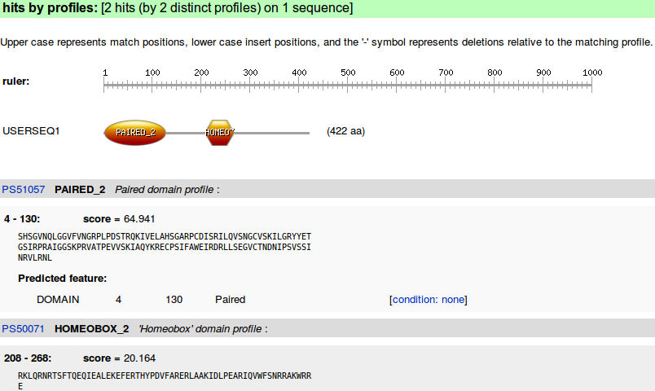

Two hits with PROSITE profiles suggesting the familiar domains in their familiar places.

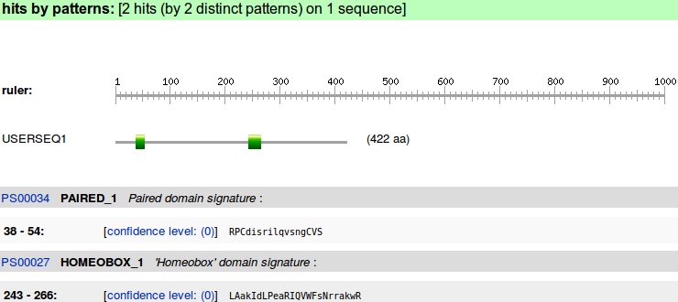
Two hits with PROSITE patterns confirming the same domains by matching their highly conserved subregions. Confirmation of what has already been discovered more than once, but this time, discovered by running a database search program manually. Exactly this program was used to generate the annotation read earlier.
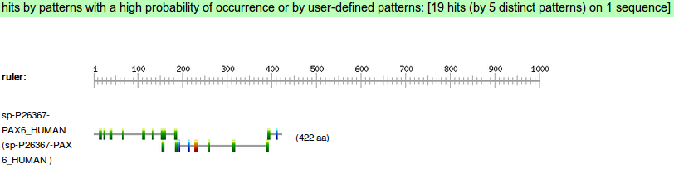
Move back to the search submission page. In Step 2, deselect Exclude patterns with a high probability of occurrence. START THE SCAN again.
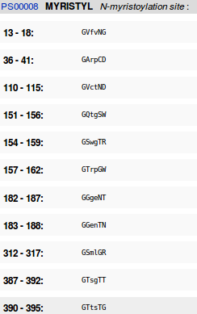

This time you will see many more hits with patterns.

Follow the link to the documentation for an N-myristoylation site (PS00008).

What is the signature pattern for N-myristoylation site?
How would you interpret this pattern?
How many N-myristoylation sites did ScanProsite suggest there might be in PAX6_HUMAN?
How many real N-myristoylation sites would you guess there might be in PAX6_HUMAN?
Searching Pfam
Go to the home of Pfam at:
http://pfam.sanger.ac.uk/
Select the VIEW A SEQUENCE option. Enter pax6_human (or the corresponding accession code) into the proffered space and press the Go button. You will be taken to the sequence and offered links to view (again) typical 3D structures for the domains of this protein. Also, you are offered the opportunity to generate easily a phylogenetic tree based upon PAX6 from the TreeFam database, which is fun if nothing else. We will not be seriously covering phylogeny in the course of these exercises, but why not try it anyway by clicking on the TreeFam link.
Fine, but you are just looking at what has already been decided. Here we set out to discover, by analysis. How could you use Pfam for a sequence that has yet to be annotated.
Go back to the home of Pfam at:
http://pfam.sanger.ac.uk/
This time select the SEQUENCE SEARCH option. Copy and paste the sequence of PAX6_HUMAN into the appropriate box. Click on the Go button.
You should discover nothing you did not expect. This same conclusions, but via investigation of the sequence rather than database lookup.
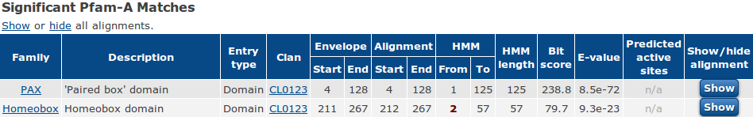
Have a look around generally, but in the course of your investigations, Click on one of the CL0123 links. You will see that both the PAX and Homeobox Pfam families belong to a collection of families (a Clan) all of which contain helix-turn-helix motifs and are mostly involved in DNA binding. Unsurprisingly, the clan in question is the Helix-turn-helix clan.

Would you have found anything of interest had you chosen “to search for Pfam-B matches” (you will need to run the search again in order to answer this one)?

Searching for Helix-Turn-Helix motifs
When looking at the Prosite PAX and homeobox documentation earlier, you will have recorded three positions where there should be Helix-Turn-Helix motifs that bind the DNA major groove. The EMBOSS package includes a program, helixturnhelix, that searches for these motifs. helixturnhelix uses a scoring matrix derived from alignments of known HTH motifs. The original matrix of 1987 looked for motifs spanning 20 amino acids, the later (1990) improved matrix was based on an alignment of 91 HTH motifs and was 22 amino acids wide.
There are a number of ways to access and run the programs of the EMBOSS package. Here we will use a web interface called Emboss Explorer, as implemented at the Wageningen Bioinformatics Webportal, a major Bioinformatics Service Centre of the Netherlands.
Go first to the Wageningen EMBOSS service (http://emboss.bioinformatics.nl/). Select helixturnhelix from the PROTEIN 2D STRUTURE section of the list of programs.
Use the Browse facility To upload a sequence from your local computer. The required sequence is the one you saved in the file pax6_human.fasta, of course. The default parameter settings are fine for a first try. Click on the Run helixturnhelix button.

#=======================================
#
# Sequence: PAX6_HUMAN from: 1 to: 422
# HitCount: 1
#
# Hits above +2.50 SD (972.73)
#
#=======================================

Maximum_score_at at "*"

(1) Score 1109.000 length 22 at residues 238->259
*
Sequence: FARERLAAKIDLPEARIQVWFS
| |
238 259
Maximum_score_at: 238
Standard_deviations: 2.96

helixturnhelix will suggest just one part of the sequence that might be a Helix-Turn-Helix.

To which, if any, of the expected HTH motifs does this prediction correspond?

#=======================================
#
# Sequence: PAX6_HUMAN from: 1 to: 422
# HitCount: 2
#
# Hits above +2.50 SD (972.73)
#
#=======================================

Maximum_score_at at "*"

(1) Score 1086.000 length 20 at residues 39->58
*
Sequence: PCDISRILQVSNGCVSKILG
| |
39 58
Maximum_score_at: 39
Standard_deviations: 2.89

(2) Score 1028.000 length 20 at residues 240->259
*
Sequence: RERLAAKIDLPEARIQVWFS
| |
240 259
Maximum_score_at: 240
Standard_deviations: 2.69
As the expectation was that three HTH motifs might be found, try again. This time, in the Additional Section of heleixturnhelix's menu window, choose to Use the old (1987) weight data.

This time you will find 2 HTH motifs, essentially the one you found previously, plus another. Note that the length of the predictions have shrunk from 22 amino acids to 20.

To which, if any, of the expected HTH motifs does the new prediction correspond?

It seems a bit odd to get the better result from the older scoring matrix, so try once more, using the default scoring matrix. This time, in the Additional section, set the Minimum SD to 2.0 before you click OK.
#=======================================
#
# Sequence: PAX6_HUMAN from: 1 to: 422
# HitCount: 2
#
# Hits above +2.00 SD (825.93)
#
#=======================================

Maximum_score_at at "*"

(1) Score 1109.000 length 22 at residues 238->259
*
Sequence: FARERLAAKIDLPEARIQVWFS
| |
238 259
Maximum_score_at: 238
Standard_deviations: 2.96

(2) Score 827.000 length 22 at residues 37->58
*
Sequence: ARPCDISRILQVSNGCVSKILG
| |
37 58
Maximum_score_at: 37
Standard_deviations: 2.00

By asking to see hits just 2 standard deviations away from the average (random) score, you see a second reasonable prediction. Lowering your standards further will be to no avail with either scoring matrix. Either the third suggested HTH is not present in PAX6_HUMAN, or helixturnhelix is simply not sufficiently clever to find it.

Can you suggest anything particular about the third putative HTH motif that might explain its reluctance to be discovered?


Searching
The PRINTS database defines functional protein families. Domains are identified by a number of short, ordered, well-conserved regions. A full match to one of these “fingerprints” will match all the relevant short regions in the correct order. A partial match is recorded if some are missing or if they occur in an incorrect order. PRINTS can be searched using the fingerPRINTscan program.
Go to the fingerPRINTscan home page:
http://umber.sbs.man.ac.uk/fingerPRINTScan/
Select the FPScan link and paste in the PAX6_HUMAN sequence in raw format. Leave all defaults and hit the Send Query button.

The top hit is with the PAIREDBOX fingerprint. No surprise here. Move down to the list of the best 10 hits.

In the list of Ten top scoring fingerprints, there is a second fingerprint that matches all elements in the correct order. This is the HTHREPRESSR. Click on the HTHREPRESSR link and from the documentation you can confirm that an HTHREPRESSOR is an HTH motif of the sort detected by the EMBOSS program helixturnhelix. Move back to your fingerPRINTscan results.

From the Position information included in the Detailed by motif table, you can see that the HTH motif that fingerPRINTscan finds is the same one that the EMBOSS program helixturnhelix found with default settings.


Take a look at the GRAPHScan for the PAIREDBOX prediction and see that is is good! Four out of four very positive motif matches are shown.

Each motif by itself might not be significant. Together, in a fingerprint, they constitute a confident prediction for a Paired Box domain.



Click on the Graphic link for the HTHREPRESSOR hit. The best (highest) of the four motif 1 hits plus the single motif 2 hit is the finger print that justifies the HTHREPRESSOR prediction.



Move back to the Ten top scoring fingerprints table. Notice that, whilst there is a prediction for a homeobox, it is an incomplete prediction. Only two of the required motifs were detected and so no prediction of a homeobox would have been made automatically by fingerPRINTscan. This explains why there is no PRINTS prediction for a homeobox in the Uniprot Feature Table for PAX6_HUMAN.
However, if you click on the Graphics link for the “ 2 out of 3” motif hit for homeobox, you will see that fingerPRINTscan only missed the homeobox by a whisker!

From the Top ten scoring fingerprints table, you can see that fingerPRINTscan considers the first motif to be missing (“.II”). But I can see a fairly healthy motif 1 in the graphic. I think I would be inclined to give the homeobox the benefit of the doubt, would you not? Programs can be so very picky!!! Its a hit
Model Answers to Questions in the Instructions Text.
Notes:
For the most part, these “Model Answers” just provide the reactions/solutions I hoped you would work out for yourselves. However, sometime I have tried to offer a bit moer back ground and material for thought? Occasionally, I have rambled off into some rather self indulgent investigations that even I would not want to try and justify as pertenent to the objective of these exercises. I like to keep these meanders, as they help and entertain me, but I wish to warn you to only take regard of them if you are feeling particularly strong and have time to burn. Certainly not a good idea to indulge here during a time constrained course event!
Where things have got extreme, I am going to make two versions of the answer. One starting:
Summary:
Which has the answer with only a reasonably digestible volume of deep thought. Read this one.
The other will start:
Full Answer:
Beware of entering here! I do not hold back. Nothing complicated, but it will be long and full of pedantry.
This makes the Model answers section very big. BUT, it is not intended for printing or for reading serially, so I submit, being long and wordy does not matter. Feel free to disagree.
From your investigations using GeneCards:
What do you conclude to be the gene most relevant to aniridia?
The gene most relevant to the keyword aniridia is PAX6. I imagine, in “real life”, one might take an interest (with good reason, as you will see) in some of the other significantly scoring genes. However, this is but an exercise, in which the complexities of reality can be shovelled to one side whenever it suits. So PAX6 it is then!
Properties suggested by GeneCards for the gene of interest were:
Cytogenetic location.

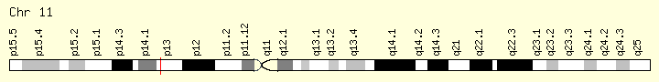
The Cytogenetic location of PAX6 is shown as 11p13
Three sources are quoted for this information, Ensembl, Entrez Gene and HGNC. Happily, and expectedly for such a basic prediction, they all agree.
Number of UniProt isoforms.
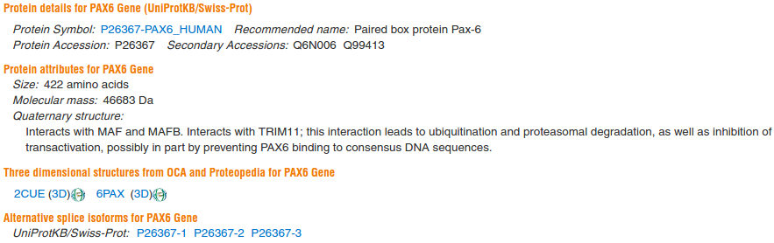

3 isoforms are suggested by the UniProtKB protein sequence database.

How many transcripts are predicted by matches to mRNAs in REFSEQ?
Summary:
There are 24 matches of the PAX6 gene with mRNAs in REFSEQ implying 24 alternative transcripts.
Full Answer:
In the Protein Section, only 11 REFSEQ proteins are reported? But every protein coding RefSeq transcript/mRNA has an associated (not necessarily unique) RefSeq protein? So 11 RefSeq proteins implies only 11 alternative RefSeq transcripts, which contradicts the assertion of 24 above?
Until fairly recently, the two reports did agree because GeneCards only reported the RefSeq mRNAs whose accession codes commenced with NM_ (of which there are exactly 11). These are slightly better evidenced than the remaining 13 whose accession codes commenced with XM_. The NM_ transcripts correspond 1 to 1 with the (reported) RefSeq proteins whose accession codes commence NP_. The XM_ transcripts correspond 1 to 1 with (unreported) RefSeq proteins whose accession codes commence XP_.
Now GeneCards have decided to report the less well evidenced mRNAs (whose accession codes begin XM_) but still not to report their corresponding RefSeq proteins (which do exist and whose accession codes begin XP_). Hence the seemingly illogical discrepancy between the two reports.
It maybe GeneCards has a good reason to only report NP_ proteins? Or, it could be a mistake. I go for the mistake theory. I have asked and received the response below, which supports the mistake theory I suggest.
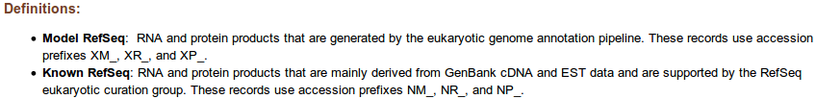
NP_ proteins and XP_ proteins comes from different sections of RefSeq. This is explained in the manual as illustrated. For now, consider just the 11 NP_ proteins reported.
As noted above, 11 RefSeq proteins does not imply 11 distinct protein sequences. RefSeq translates the coding regions of all 11 RefSeq mRNA sequences and records the results, even if most are identical. In this case, there really should be at most 3 distinct protein sequence possibilities, given that UniprotKB predicts just 3 isoforms.
To illustrate the veracity of this claim, I have retrieved all 11 RefSeq PAX6 protein from the databases at the NCBI and multiply aligned them with a program called COBALT (again at the NCBI). I did this using strategies very similar to those you will investigate in the next few pages of these exercises.
The resultant alignment (see below) used to only include 7 of the top 8 proteins. When this was true, I was able to claim that you should be able to see that just 2 distinct proteins are evident (a 14 amino acid Insertion/Deletion near the start of the protein being the only difference). Why there were only 2, rather than the promised 3 distinct sequences will become clear shortly.
Now, as is so tediously often the case, 4 more proteins have emerged, according to RefSeq. 3 of these dare to upset the poetry of my interpretations! I retire in petulance. Uniprot actually claims there are 2 proteins of known sequence and 1 of unknown sequence. The current alignment suggests there are 4 isoforms, all of known sequence? Well, it is acceptable to disagree, these conclusions are all only predictions after all.
So, I hear you ask, why pursue this sort of issue to such depth? It is not really important unless you are are really researching PAX6 and/or aniridia. TRUE! but the more general objective is to expose the fact that sometimes the discrepancies/anomalies you will come across are not due to alternative biological interpretations but to the way the various information resources are administered.
Plus, of course, I am an incorrigible pedant and cannot leave alone the minutiae, however minute they may be.
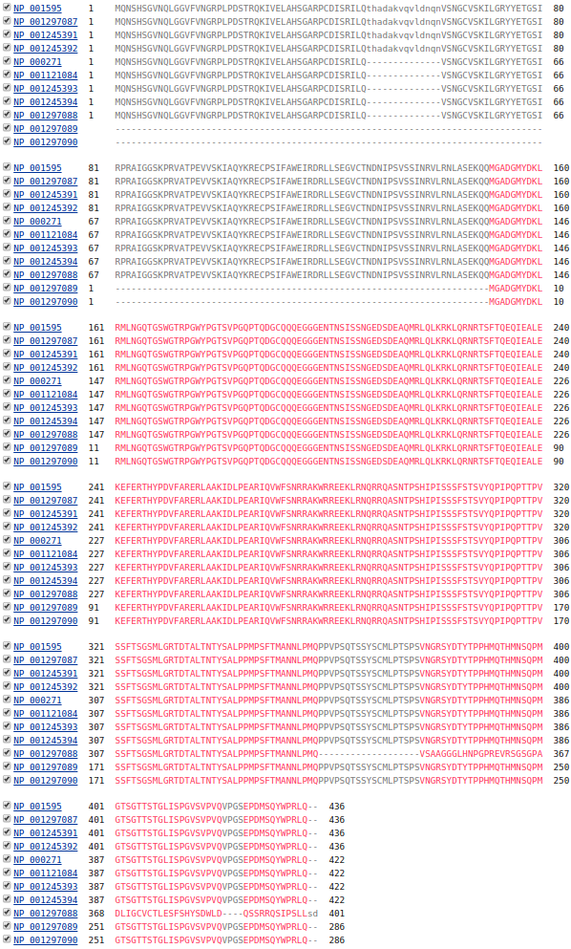
2015.05.23: I have now received a reply from the GeneCard folk concerning the discrepancy between the number of proteins and the number of transcripts. Clearly not a vital issue, except that this sort of thing should make the user wary when using these sorts of resources. As is universally true of all things human construction, they fall sadly short of perfect. I think … they give me a slightly cloudy admission of “a bug” that will be fixed soon. Make you own mind up, but only if you feel so inclined, mostly for my benefit, I record their reply here:
“ … GeneCards presents RefSeq based transcripts and proteins. In addition to transcripts and proteins, RefSeq has also predicted transcripts and predicted proteins (‘NM’ is for transcripts, while ‘XM’ is for predicted transcripts. Similarly 'NP’ is for proteins while 'XP’ is for predicted proteins). The number of not predicted proteins matches the not predicted transcripts, same goes for the predicted items. In GeneCards current version we display the predicted transcripts, and do not display the predicted proteins, which causes the discrepancy you mention. This issue will be fixed in a future version.”
2015.07.08: Now a new version of GeneCards. No change as yet.
2015.08.31: Yet another new version of GeneCards. Still no change. Time for another moan?
2016.03.03: Further update to Genecards. No change. I give up.
How many transcripts are predicted by the Alternative Splicing Database (ASD)?
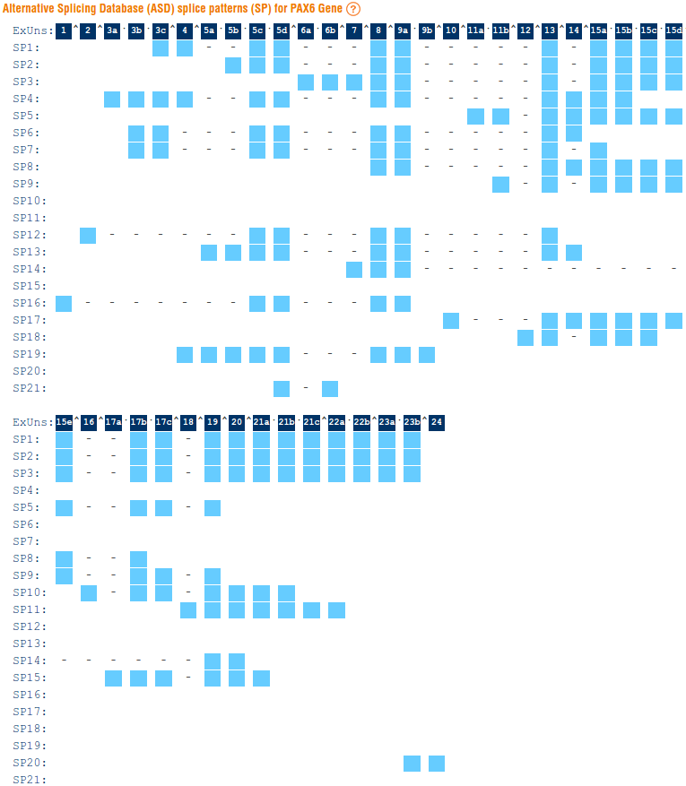
Well, it rather looks as if the ASD has come to the end, although its final release is still available from the EBI.
GeneCards claim they will be revising their policy to refer to ASD sometime in the future. They say:
“We currently do not have any links to ASD, as their data has been frozen and their site taken down. We plan to upgrade this subsection.”
They also offer a brief explanation of how to interpret their graphic.
Genecards computes its graphic using information from both ASD and from a Korean resource (still active) called Ecgene (Genome Annotation for Alternative Splicing). So maybe this item will not entirely disappear?
As far as this discussion is concerned, ASD represents a resource that should be inclined to be quite generous about accepting the credibility of possible splice variants. In contrast, before they started to admit less well evidence transcripts at least, one might expect RefSeq to be more fussy and therefore to predict less possibilities? Yes … quite right … if one includes the RefSeq PREDICTED mRNAs, this is no longer true.
Ignoring the dismal background, The raw observation remains that according to ASD there are 21 splice patterns for the PAX6 gene.
How many transcripts are predicted by Ensembl?
The Ensembl genome database predicts 31 transcripts for PAX6. The winner! True, but Ensembl, uniquely amongst the databases we have considered here, does not restrict itself to transcripts that are protein coding. Now that is simply cheating!
How would you rationalize the discrepancies?
The conflicting numbers of transcripts reported from assorted sources by GeneCards are all only predictions based on different evidence and with variant certainty criteria. The "real" number of transcripts is not known with certainty. Some single sources will predict different numbers of transcripts dependant upon credibility levels and evidence sources that can be set by the user. Ensembl is such a source, as you will see later.
It is also important to realise that the motivations of the various prediction source varies. The Alternative Splicing Database (ASD), for example set out to report transcripts that could occur given any reasonable splice variation, RefSeq transcripts (in principle at least) require a much more demanding level of evidence. Ensembl includes transcripts that are not protein coding, as you will soon see.
How many times does the term PAX6 occur in this entry's annotation?
The term PAX6 does not occur at all in the Genbank entry for BX640762.1. Clearly, this will affect the way text searches involving the key PAX6 work, as will be seen later.

The annotation of the entries of the early databases (EMBL, GenBank, DDBJ) was left to the submitter and so, rather haphazard. It would seem reasonable that this entry should mention the formal name of the gene it represents. We will touch on what is being done to improve this situation later..
Why might the number of Additional mRNA matches not match the number of PAX6 transcripts?
13 Additional mRNA sequences are recorded.
Genbank contains only entries that have been directly sequenced. If an mRNA was sequenced more than once it could be represented in Genbank more than once. If an mRNA exists that has never been sequenced directly, it will not be included in GenBank. So, there is no expectation that the mRNAs of a particular gene in GenBank should match any prediction of the number of transcripts there might be.
RefSeq attempts to represent the biological truth by including just one sequence for every predicted transcript. This often requires the inclusion of sequences that were not directly sequenced, but rather compiled from several directly generated sequences. RefSeq also attempts to remove redundancy where possible. So RefSeq should contain the same number of mRNA sequences as it supposes there to be transcripts.

What sort of variations are recorded in the Humsavar database?
Summary:
Humsavar entries record the presence of mutations in the protein. The position of the mutations are specified as amino acid positions relative to the canonical protein of the gene under investigation. Most of the Humsavar entries for PAX6 appear to be Disease variants.
Full Answer:
Humsavar is a simple text file providing an index of “Human polymorphisms and disease mutations”. It currently (2015.08.31) offers around 71,000 entries divided into three classifications.
Disease variants: 26874 {Variants have been found in patients and disease-association is reported in literature. However, this classification is not a definitive assessment of variant pathogenicity.}
Polymorphisms: 38105 {No disease-association has been reported.}
Unclassified variants: 6816 {Variants have been found in patients but disease-association remains unclear.}
Total: 71795
This is in contrast to the dbSNP variations which refer to variations in the genomic whose position is specified as a number of base pairs from the start of the chromosome and are, generally, NOT disease related as it is not the prime purpose of dbSNP to record such variations (see later discussion).
Note that all SNPs available from dbSNP are also available from Ensembl. Why might that be?
Something of a trick question I fear. Ensembl regularly copies in all of the dnSNP database entries. Therefore, of course, all dbSNP entries will also be in Ensembl. I included this question as it does indicate an encouraging example of sharing data/information.

Why might it be considered odd that rs35883677 be included in dbSNP?
Summary:
Because this variation is not a SNP (Single Nucleotide Polymorphism). It is an InDel (Insertion/Deletion). It suggests that in the position indicated there is sometimes no base (“-”) and sometimes there is an A. Sensibly, dbSNP is not mindlessly exclusive to SNPs. Other interesting variants are also recorded.
Full Answer:
In passing, rs35883677 is an InDel. But it is not labelled as such in the Type column? Not sure I understand why not. I have inquired.
2015.07.08: Searching specifically for indels seems to be something that might be very useful, but is rather inconsistent and illogical I think. If you filter in this region for “indel” at GeneCards, it tries to convince you there are only 2 indels in this region. Nonsense! If one searches for “-/” one gets 76 hits which I suggest are indels, but still not enough my intuition tells me. No clear answer from GeneCards help desk, they say “talk to NCBI” so I do. NCBI suggest a way to search their copy of the database which gives 216 hits for roughly the same region. Reasonable, but the search term is “ind del”? The space in the middle I would never have guessed. To be fair, it is possible to select the search term from a web site link, in which case you do not need to know about the whimsical space, which is essential if you use the Advanced Search in a similar fashion to the way you will experience in the exercise soon. They also offer an alternative way to search for indels:
“ … Another route with a more graphical bent is to start in the Gene database record:
http://www.ncbi.nlm.nih.gov/gene/5080
Then go to the Variation section (Table of Contents), then to See Variation Viewer (GRCh38). There are a lot of tracks you can remove in the Configure menu, and Filters on the left; one each for deletion and insertion. When I check Source = dbSNP and the deletion and insertion boxes, I end up with 107 variants.”
which seems quite logical to me, but generates yet another different number of hits? The possible explanation offered is:
“… I think the dbSNP page might include merged or removed records …”
which sounds quite likely, if a trifle depressingly unpredictable.
Ensembl call indels Insertions or Deletions (as far as I can tell), but I can see no way to search for them using Biomart. I continue to investigate.
2015.07.09: I suspect the problem with search for indels in GeneCards is that they have mislabelled the Molecular consequence dbSNP field as the Variation Type field. This will not work surely? A variation of type Insertion could easily have a molecular consequence that does not involve the word Insertion (or Deletion, or indel, or “in del”). I have asked for elucidation.
2015.08.31: Nothing so far, asked again. Pretty certain my theory is correct.
2016.03.04: Still nothing. OK chaps, I give up. So we just live with these inconsistencies I suppose.
The Ensembl Accession Number for the aniridia gene.
The Ensembl accession code for PAX6 is: ENSG00000007372
Not a vital piece of information at for now, but you will meet this Accession Number several times in the next few pages, so I thought I would get the formal introductions over early.
Note the outrage of leading zeroes before the quite modest number that really identifies the gene. It will be a good idea to remember that there are 7 of them at this stage. It makes my eyes hurt and the rest of me weary to count them every time I type them in.
This Accession Number was designed in the days when the deep thinkers were estimating many many more genes than there actually turned out to be. They did not manage to think deeply enough to predict that splice variation would provide such variety as it does. With one gene capable of producing many variant protein forms, significantly fewer genes are required.
The trouble is that once one has designed a field capable of representing a very very big number, it is not trivial/practical to redesign it when one realizes that said field is a good four zeroes over provided. So we live with lots of leading zeroes with nothing much to do. Quite amusing really. In a perverse sort of way.
The number of human PAX genes.
According to GeneCards PAX6 is one of 9 human paralogues. This information Genecards copies from Ensembl. As before, you could follow the 5 superscript links to see the Ensembl view of each paralogue.

What Orthologues exist in Mouse and Drosophila?
Summary:
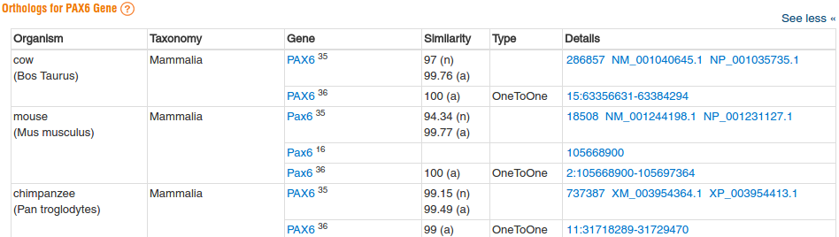
Ask to See all the orthologues listed, the default list is rather withered!

In Mouse, as in a number of other organisms, the othologous gene has the same name as in Human (PAX6).

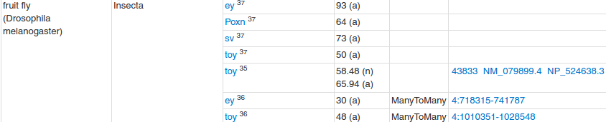
In Drosophila there are several orthologues. ey (eyeless) and toy (twin of eyeless) being the most important. The naming of the Drosophila genes is a little more whimsical than elsewhere.
Full Answer:
Drosophila is an important model organism for the study of Aniridia. You will see later another Drosophila gene mentioned as an important orthologue of PAX6 in human. The orthologue not mentioned here is prd (paired) and it is indeed a genuine orthogue. I am not entirely clear why it does not appear here (despite several explanations from experts). Here is the nearest I got (from the Flybase team) to an answer, sort of:
“As you know, there is often a one-to-many relationship with these things. prd is considered (according to OrthoDB, which FlyBase uses) to be orthologous to Pax1, Pax2, Pax3, Pax4, Pax5, Pax6, Pax7, Pax8, and Pax9. More info here: http://flybase.org/reports/FBgn0003145.html in the Orthologs -> Human orthologs section.
More info on how we calculate these relationships can be found here.
I have no idea what Ensembl are doing. They are often slightly out of sync with some aspects of our data.
ey and toy are related, and are also both orthologous to Pax1, 2, 3, 4, 5, 6, 7, 8, and 9.
So, on the basis of sequence relationship, ey, toy, and prd are PaxX orthologues.”
This seems to say that the FlyBase chaps think the Ensembl fellows have missed something?
One could continue to speculate on the mention here of the Poxn gene, or the sv gene, but I do not feel sufficiently bold.
What functions are suggested for PAX6?
In the Summary section:
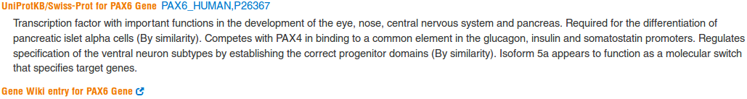
Genecards, referring to UniProtKB, says it all in the first two words. Centrally, PAX6 is a transcription factor.
More general information is available from the. Here it claims, with confidence, there to be just four Drosophila orthologues for PAX6.
“Of the four Drosophila Pax6 orthologues, it is thought that the eyeless (ey) and twin of eyeless (toy) gene products share functional homology with the vertebrate canonical Pax6 isoform, while the eyegone (eyg) and twin of eyegone (toe) gene products share functional homology with the vertebrate Pax6(5a) isoform. Eyeless and eyegone were named for their respective mutant phenotypes.”
No mention here of prd, sv or Poxn, plus we meet toe and eyg for the first time? It is time to remind ourselves that the discovery of details about the example gene PAX6 is NOT THE POINT here! It is, however, valuable to see just how far from a clear, stable and singular picture is available from the various resources visited. I suspect this will not surprise many of you. After all, we are mostly sifting amongst predictions, as opposed to concrete facts. What we find is laced with opinion and differing interpretation. Life is not straight forward. I am never quite sure whether that is a good thing or a bad thing, but it certainly can be frustrating at times.
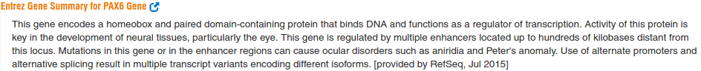
The information from Entrez offers a better description of the expected domains.
It notes that mutations in the gene can result in Aniridia and similar disorders. Entrez also mentions multiple isoforms, as suggested elsewhere.
GeneCards has, relatively recently, offered its own version! It seems a bit sparse, but maybe there will be more later.
Uniquely, this descriptions mentions pathways and annotation based on Gene Ontology (GO, discussed later) associations. The GeneCards Summary only refers to one of the eight paralogues? Maybe PAX4 is more important than the others?
I found I had to read all the descriptions several times before I could see that they were all roughly agreeing. Different views of the same topic? There are many ways of looking at anything after all.
In the Function section:
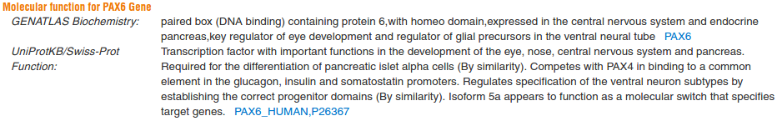
GeneCards refers to GENATLAS and UniProtKB for information about function.
The contribution from UniProtKB is identical to that quoted in the Summary section. GENATLAS, another human gene database, finds a different way to say similar things.
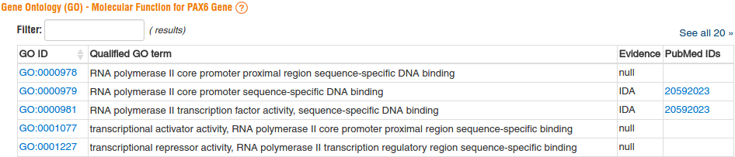
GeneCards also lists all the Gene Ontology terms associated with the molecular function of PAX6. If you look at all 22, they seem mostly consistent with that which we have discovered thus far.
Why there are two Prosite predictions for both the Homeobox and the Paired Box domains?
All Prosite accession codes begin PS. For most domains, Prosite includes a Hidden Markov Model (HMM) entry representing the entire domain and a simple Pattern entry representing a smaller highly conserved signature within the domain. In most instances, a single protein domain will match both a Prosite HMM and a Prosite Pattern entry giving the initial impression that there might be two domains, a large one with a smaller one contained within it.
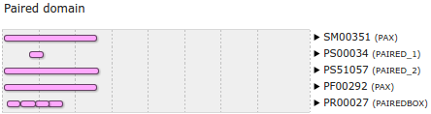
In this example, PS51057 is the HMM representing the conservation apparent over the entirety of most Paired Box domains. PS00034 is the Pattern representing the extremely high conservation evident over a very small (17 amino acids) region of most Paired Box domains.
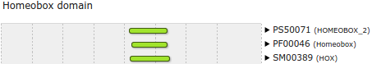
PS50071 is the HMM representing the conservation apparent over the entirety of most Homebox domains. PS00027 is the Pattern representing the extremely high conservation evident over a significantly smaller region of most Homebox domains. The Pattern in this case is not considered strong enough to be taken too seriously. It is demoted to a “conserved site” and appears in a separate graphic.
Why Prints appears to predict four very small Paired box domains instead of the single larger domain indicated by all the other predictions?
All Prints accession codes begin PR. Prints entries do not normally represent domains as a single conserved feature. Instead they define a number of features (each of which may not be significant considered in isolation) that must all occur in a given order and within a specified distance of each other. Matches with each element of a Prints entry are represented separately, so a single domain detected by a match with a Prints entry can erroneously appear to be a match with a series of very small domains.
In this example, the Prints entry for a Paired Box domain is PR00027. For Prints to recognize a Paired Box domain, 4 relatively small conserved signatures must be found in a specific order. Each of the 4 matches is represented separately although Prints is only claiming to have discovered a single Paired Box domain.

From your investigations using OMIM:
What do you notice about all the variants that are associated with a dbSNP entry?
They are all substitutions rather than insertions or deletions (indels). At first glance, this would seem logical as, if accurately named, the dbSNP database really should contain only Single Nucleotide Polymorphisms (SNPs, i.e. substitutions). However, there are lots of indels recorded in the dbSNP database, so maybe the observation here is just chance or reflects only that the majority of dbSNP database entries are substitutions? Maybe this was not such a good question to ask after all.
Does this surprise you?
I am no longer sure. Maybe it surprises me more than it used to? Maybe many things surprise me more than they used to?
From your investigations using Entrez:
What were the features that you found?
Summary:
The first feature was the CoDing Sequence (CDS) for a PAX6 isoform.
The other three features were the coding sequences for three ELP4 isoforms.
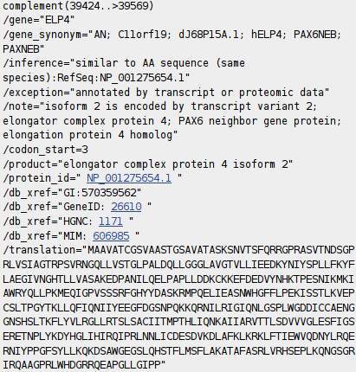
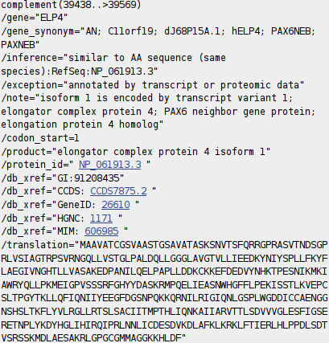
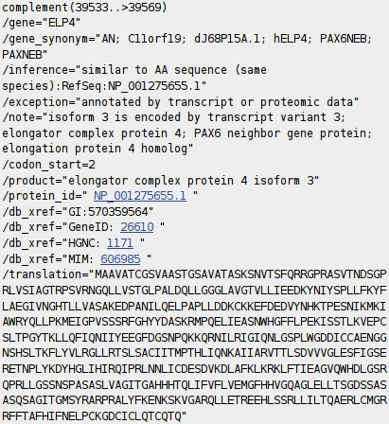

Full Answer:
Note that only the final coding exon of ELP4 is within this RefSeq sequence, which is defined as the genomic region for PAX6. This is clear from the length of the translations offered. The exon referenced is only long enough to code for just over 40 amino acids which is far short of any of the three isoform sequences offered here.
Note also that this final coding exon of ELP4 (stretching from 39438 to 39569 of this RefSeq entry) does not overlap the coding region of the PAX6 gene itself (stretching from 16551 to 33028 of this RefSeq entry).
In fact, the two entire genes do not overlap according to the evidence here. The entire PAX6 gene extends from 5001 to 38170. The portion of the ELP4 gene that is included in this entry extends from 40170 (the end) to 38437 (in the opposite direction). This give a gap between the two genes stretching from 38171 to 38436.
As you will see later, Ensembl will confirm the lack of overlap between these two genes graphically as well as their relative positions.
Note that ELP4 was associated with aniridia by GeneCards. However, I believe only because of its proximity to PAX6.
Why might you have expected more features than there were?
Summary:
GeneCards (referring to UniProt) suggested that PAX6 has three isoforms. This would lead me to expect three features here related to PAX6?
Full Answer:
As you will discover later, one of the PAX6 isoforms could not be represented in the fashion displayed here, but I would still expect there to be two PAX6 isoform features. The explanation from the NCBI is that this sort of RefSeq entry is intended to be used as a template against which sequences from an individual can be mapped to seek variations. Only a token CDS feature is included to indicate the position of the gene. For such an entry, recording every isoform is not essential.
This sounded convincing to me, Until I began to wonder why there were three CDS features for ELP4 which is not even the gene primarily represented by this entry? Maybe I will ask more questions if and when I ever have the strength. In the meantime, mostly for my information, I record their exact explanation here.
“ ... note that RefSeqGene defines genomic sequences to be used as reference standards for well-characterized genes. These sequences serve as a stable foundation for reporting mutations, for numbering exons and introns, and for defining the coordinates of other variations. We normally select one RefSeq transcript to serve as a reference standard. The goal is not to record all introns and exons of all isoforms, but just to choose one representative to help define the locus. Therefore, most of our RSG records have only a single RefSeq as reference standard. If an LSDB manager or other stakeholder requests that other RefSeqs be added as alternate standards, this can easily be done (with the complication that, if a public LRG exists, the RefSeqGene record is fixed). We receive requests from stakeholders to include RefSeqs that represent all known exons, or RefSeqs that have become community standards. Often, after creating an RSG using our own internal criteria, we receive stakeholder requests to change or add transcripts. Many of these requests come from the LRG project regarding transcripts to be included on the LRG records.
Generally, RefSeq accessions can be added or removed without reversioning, unless a transcript is upgraded or a new one defined that extends beyond the bounds of the RSG, or matches a new build of the genome, in which case the RSG will be extended and reversioned as needed.
Regarding the chromosomal locus, our standard range is 5 kb upstream from the 5' end and 2 kb downstream from the 3' end of the mRNAs with the greatest extent. For this calculation, we do indeed use all available RefSeq (NM_) accessions. If the database manager or stakeholder has information on promoters or other upstream or downstream regulatory regions, we can certainly extend the RefSeqGene locus to accommodate these.
Regarding mismatches, the goal is to exactly match the current build of the genome, unless there is overwhelming transcript and EST evidence that a mismatch should be retained.
Regarding the confusing subject of exon numbering, exon numbers are currently provided only on RSG genomic records based on a subset of available transcript RefSeqs for the gene. These are often those selected by locus-specific databases as reference sequence reporting standards. You can find an explanation of how exons are numbered here:
http://www.ncbi.nlm.nih.gov/refseq/rsg/faq/#exon
You will find links to more information on RefSeqGenes on the home page for the RefSeqGene project:
http://www.ncbi.nlm.nih.gov/refseq/rsg/
Regarding the PAX6 RSG sequence, only difference I see between NG_008679.1 and the current build of the genome (GRCh38) is an extra 'G' beyond the 3'-UTR of the PAX6 transcripts (at NC_000011.10:g.31,819,125). ... “
Yes, well I think I followed most of that? and that my interpretation is broadly correct? In summary, there are no fixed rules.
How does the alignment you generated match up with the annotation of the original RefSeq entry you discovered?
Summary:

The most intuitive way of encapsulating graphically the way these two sequencing clones overlap was donated by Cecilia Pinto (Oeiras, 2013.12.09-12). Much better than my rambling attempts, that I keep for sentimental reasons in the “Full Answer”. Thank you Cecilia.

Full Answer:
Do not spend to much time working this one out, the picture above should be more than sufficient. I just needed to see it all balanced ... then I can sleep soundly?
If you do want to read on, I strongly suggest you look at the picture contributed by Cecilia (now promoted to the “Summary Answer”) first. So simple! I have to admit I cannot follow my own wonderful table at all now ... at least, not without bleeding! Although, it did feel good at the time?

So …

The Query sequence is Z95332 (Length 20,874)
The Subject sequence is Z83307 (Length 22,253)

NG_008679  Range Start | NG_008679  Range End | NG_008679  Range | Z95332  Range Start | Z95332  Range Start | Z95332  Range | Z83307  Range Start | Z83307  Range End | Z83307  Range
- | - | - | 1 | 2022 | 2022 | - | - | -
1 | 18748 | 18748 | 2023 | 20770 | 18748 | - | - | -
18749 | 18852 | 104 | 20771 | 20874 (end) | 104 | 1 | 104 | 104
18853 | 40170 (end) | 21319 | - | - | - | 105 | 21422 | 21318
- | - | - | - | - | - | 21423 | 22253 (end) | 831
 |  | 40171 |  |  | 20874 |  |  | 22253

Legend: Not used in construction of RefSeq entry NG_008679
Non-overlapping GenBank entry used in construction of RefSeq entry NG_008679
Overlapping GenBank entry used in construction of RefSeq entry NG_008679
Total entry lengths
The RefSeq entry was thus constructed by overlapping the two Genbank entries and then manually trimming away the edges to form a biologically meaning region. If I was a bit brighter, I think I might have come to that conclusion without the fuss above? Oh well, one has to use what one has.
I refer you again to the far more intuitive way of encapsulating the same message graphically, donated by Cecilia Pinto that is now the “Summary Answer” above. Much better! Thank you Cecilia.

From your investigations using UniProtKB:
Where have you seen these genes mentioned previously?
PAX6 and ELP4 were the genes mentioned in the annotation of the RefSeq entry NG_008679. Part of both of these genes are contained in the clone you are looking at here, Z83307.
How is that this is the first occasion that the gene RCN1 has been apparent?
To avoid mention up to this point, the RNC1 gene must be entirely in the portion of the sequencing clone Z95332 that does not include any part of the sequencing clone Z83307. That is, between bases 1 and 20770 of Z95332 (see illustrations from a few answers back).
When we look at the location views in Ensembl, you will see clearly how the three genes PAX6, ELP4 and RNC1 share the same region of Chromosome 11 and how they overlap the 2 sequencing clones. You will also be able to easily identify the genes and investigate them in precisely the manner we are investigating PAX6, should the urge fall upon you.
How is it that we have found any protein sequences at all by looking at the barren annotation of the two clones Z83307 and Z95332?
The only way that the UniProtKB search facility can find proteins from the sequencing clone accession numbers you supplied, is to follow information it finds in the annotation of those clones. But … there was no such information! At least, not when you looked at these clones (Z83307 and Z95332) at the NCBI.
This search references the same clones stored in EMBL-Bank. The annotations of GenBank and EMBL-Bank are not identical. The main content, established by the International Nucleotide Sequence Database Collaboration (INSDC), will be the same in all but format. However, the NCBI (GenBank) and the EBI (EMBL-Bank), will occasionally, whimsically add content to ensure that life remains distant from any user aspiration for consistency.
ID Z83307; SV 1; linear; genomic DNA; STD; HUM; 22253 BP.
XX
...
DR ENA-CON; GL000101.
DR Ensembl-Gn; ENSG00000007372; homo_sapiens. { Ensembl Genes
DR Ensembl-Gn; ENSG00000109911; homo_sapiens. {
DR Ensembl-Scaffolds; Z83307.1:1-22253; homo_sapiens.
DR Ensembl-Tr; ENST00000241001; homo_sapiens. {
DR Ensembl-Tr; ENST00000350638; homo_sapiens. {
DR Ensembl-Tr; ENST00000379107; homo_sapiens. {
DR Ensembl-Tr; ENST00000379109; homo_sapiens. {
DR Ensembl-Tr; ENST00000379111; homo_sapiens. {
DR Ensembl-Tr; ENST00000379115; homo_sapiens. {
DR Ensembl-Tr; ENST00000379123; homo_sapiens. {
DR Ensembl-Tr; ENST00000379129; homo_sapiens. { Ensembl Transcripts
DR Ensembl-Tr; ENST00000379132; homo_sapiens. {
DR Ensembl-Tr; ENST00000379163; homo_sapiens. {
DR Ensembl-Tr; ENST00000395934; homo_sapiens. {
DR Ensembl-Tr; ENST00000419022; homo_sapiens. {
DR Ensembl-Tr; ENST00000455099; homo_sapiens. {
DR Ensembl-Tr; ENST00000474374; homo_sapiens. {
DR Ensembl-Tr; ENST00000606377; homo_sapiens. {
...
DR GOA; B1B1I8. {
DR GOA; B1B1I9. {
DR GOA; B1B1J0. { Gene Ontology Links
DR GOA; E9PKM0. {
DR GOA; E9PPJ9. {
DR GOA; G5E9D4. {
DR HGNC; HGNC:1171; ELP4. { Human Genome Organisation (HUGO)
DR HGNC; HGNC:8620; PAX6. { Gene Nomenclature
DR InterPro; IPR001523; Paired_dom. {
DR InterPro; IPR008728; Elongator_complex_protein_4. { Interpro Links
DR InterPro; IPR009057; Homeodomain-like. {
DR InterPro; IPR011991; WHTH_DNA-bd_dom. {
DR UniProtKB/TrEMBL; B1B1I8; B1B1I8_HUMAN. {
DR UniProtKB/TrEMBL; B1B1I9; B1B1I9_HUMAN. {
DR UniProtKB/TrEMBL; B1B1J0; B1B1J0_HUMAN. { UniProtKB/TrEMBL Links
DR UniProtKB/TrEMBL; E9PKM0; E9PKM0_HUMAN. {
DR UniProtKB/TrEMBL; E9PPJ9; E9PPJ9_HUMAN. {
DR UniProtKB/TrEMBL; G5E9D4; G5E9D4_HUMAN. {
...
In this instance, the EMBL-Bank versions of the clones, Z83307 and Z95332, include links to genes and transcripts determined by Ensembl plus links to other databases including UniprotKB and Interpro. It is these extra Database Cross-Reference (DR) lines that are being used to identify the UniProtKB entries.
Note that the annotation does not relate the genes and transcripts to which it refers to any particular regions of the genomic DNA? For this we must wait until we investigate Ensembl.
In readiness of that heady experience, I note that the Ensembl codes for the three genes are:
ENSG00000007372 - which is PAX6, of course, and noted in both clones.
ENSG00000109911 - which is ELP4, the second gene mentioned in the clone Z83307
ENSG00000049449 - which is RCN1, the second gene mentioned, but only in the clone Z95332
Note that there is, of course, no mention of ENSG00000049449 in the illustrated annotation of Z83307.
Make a note of the first UniProtKB Accession number for the PAX6 protein.
The first (Primary) PAX6 protein accession code is P26367
Not a challenging question, just a hint that this code will occur regularly as the pages drift by.
Why do you suppose there is more than one Accession number for this protein?
The PAX6 protein has three accession codes in total. P26367, Q6N006 and Q99413.
Before publication, a protein sequence must be allocated a UniProtKB accession number. Every UniProtKB entry has an accession number. As UniProtKB evolves, sufficiently similar entries can be merged to save space. For example, it might be considered sensible to merge two very similar variants of a single protein (isoforms) and to record their differences as a Variation Sequence (VAR_SEQ) Feature Table (FT) entry. Each merge event creates a redundant accession code. However, accession codes must not be lost. It must always be possible to find a sequence using the accession code allocated when originally published. To make this possible, accession codes made “redundant” by entry merges are retained as Secondary accession codes. The accession code thought to be most important is kept as the Primary accession code.
In this case, P26367 is the Primary accession code. Q6N006 and Q99413 are Secondary accession codes. Searching UniProtKB for any of these three accession codes will work.
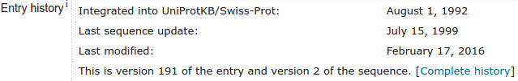
There is even a Complete history button for those wishing for more detail.
Make a note of the UniProtKB Identifier (or entry name).
The UniProtKB Entry name of the PAX6 protein is PAX6_HUMAN. Unlike sequences in the DNA databases, a sequence in UniProtKB can have two names, an Entry name and an Accession Code. This works as there is no naming conflict with any other protein sequence database. Both the Entry name and the Accession Code(s) uniquely identify the database entry. Strictly only one or the other is required. The Entry Names are intended to be more memorable for human users.
Again, not a question to challenge, just a hint that this Identifier will occur regularly it that which follows.
What are the start and end positions of the Paired domain?
These next three “questions” are really not attempting to query, but to get you to just be aware of the values I have included in the text. Hopefully, you will see why later. No real need to write them down again, but … just in the name of pedantry:
UniProtKB claims the Paired domain of the PAX6 Human protein extends from residues 4 → 130.
What are the start and end positions of the Homeobox domain?
UniProtKB claims the Homeobox domain of the PAX6 Human protein extends from residues 210 → 269.
Note the range of the Proline, Serine, Threonine rich region at the end of the protein.
UniProtKB claims the Proline, Serine, Threonine compositionally biased region of the PAX6 Human protein extends from residues 279 → 422. This region will be detected by software you use later and it properties given due regard.

Why do you suppose this is the case?
The Single Nucleotide Polymorphism database (dbSNP) database has entries for a variety of classes of polymorphisms, from a variety of organisms. As ever, Wikipedia provides a pleasingly simple description.
There seems to be no hard and fast rules about which variations are to be included, however, reading from various sources, the main focus is on variations for which the Minor Allele Frequency (MAF) is >= than 1%. Wikipedia suggests the purpose of the database to be:
“physical mapping, population genetics, investigations into evolutionary relationships, as well as being able to quickly and easily quantify the amount of variation at a given site of interest. In addition, dbSNP guides applied research in pharmacogenomics and the association of genetic variation with phenotypic traits.”
I read this to mean primarily population studies and similar, where variations that do not cause major problems but are present at significant levels are the major interest.
Specifically concerning disease causing variations, from the NCBI pages I find:
“Originally, the great majority of data in dbSNP was collected and defined as variations simply using sets of co-aligned genomic or DNA sequences. Because this process typically had little to no focus on disease condition, only about 250 records in dbSNP were successfully associated with phenotype-causing variations or a clinical outcome in OMIM.
Starting in the Spring of 2008, however, dbSNP began accepting submissions of Clinical/LSDB variations as well as annotations to existing variations (including phenotype) ... Currently there are a total of 1266 records in dbSNP that were submitted as Clinical/LSDB variations ... and 1134 records submitted as Clinical/LSDB variations that also have OMIM links … “
I read this to mean there might well be a far greater focus on disease causing variations in the future, but for now, they will be sparse. This is, I submit, what we see evidenced here.
In passing, I regard the patchy evidence provided here for that which I believed in the first place as unsatisfactory. If anyone can suggest anything better, I would be ever so grateful.
Describe the arrangement of Helices within PAX6.
From the evidence of the textual table and the graphic, there are nine helices in all that occur in groups of three.
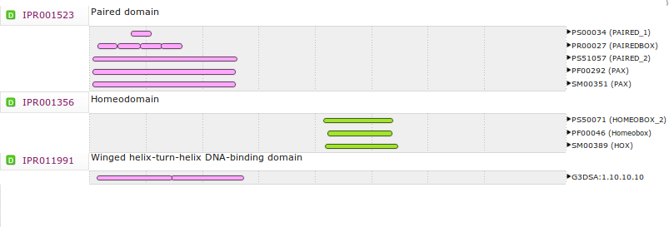
Aligning the graphical representation of the positions of these helices with the Interpro domain prediction graphics similar to that found via GenCards earlier, it is clear that the first two of the helical triplets lie in the PAX domain and the third is in the Homeobox domain.
Note the start position of the middle helix of each set of three.
I have included this information in the text. Again, this is not really a “question” but an invitation to notice something you might confirm by analysis later on. No real need to write anything, but there again - why not:
According to UniProtKB, the second helix of the first triplet starts at residue 39
According to UniProtKB, the second helix of the second triplet starts at residue 99
According to UniProtKB, the second helix of the third triplet starts at residue 237
Note the end position of the third helix of each set of three.
According to UniProtKB, the first helical triplet ends at residue 63
According to UniProtKB, the second helical triplet ends at residue 133
According to UniProtKB, the third helical triplet ends at residue 275
There is a point to recording these numbers … honest! The second two helices of each triplet form a special sub-domain that we will read of (and search for with the relevant analytical software) later. Here we see the first indication of where these features may be.
Note the position of the Beta strands relative to the helix groups.
There are 3 Beta strands, according to UniProtKB. All are within the Paired Box domain. Two before the first helical triplet (residues 6 to 8 and 14 to 16), and one in before the second helical triplet (residues 77 to 79). Later you will run programs to predict the secondary structure of this protein. It will be interesting to compare your predictions with those of UniProtKB.
Beta strands precede the 2 helical triplets in the Paired Box domain but not that in the Homeobox domain. As will be seen just a little later, each of the three helical triplets should include a Helix-turn-helix motif. A Helix-turn-helix preceded by Beta sheet structure(s) can be a Winged helix-turn-helix.
I think the absence of Beta Sheet(s) in the Homeobox may well be the reason that GeneCards (quoting Interpro) reported only two Winged Helix-turn-helix motifs, rather than three. That is, there is an HTH in the Homeobox, but not a Winged HTH.
Describe the arrangement of Helices within the two major domains of PAX6.
I detect some repetition creeping into these questions! Forgive me, they have evolved rather than have been planned as a coherent whole.
You have noted already the nine helices that occur in three groups of three. The highlighted alignment offers another way to confirm that two helical triplets coincide with the Paired domain and one helical triplet with the Homeobox domain. Well, you have to allow for a little bit of overflow here and there, but nothing is perfect is it.

Note the extra sequence in P26367-2 and where it starts.
In the rather starkversion of PAX6_HUMAN, the Sequence Variation (VAR_SEQ) that define the difference between the canonical form of the PAX6 protein and isoform 5a is recorded as:
FT VAR_SEQ 47 47 Q -> QTHADAKVQVLDNQN
which translates literally to:
“the single amino acid, Q, in the 47th residue position of the canonical protein is replaced by the 15 amino acids, QTHADAKVQVLDNQN, in the same position to form isoform 5a”
A more biologically orientated way of putting this might be to say that isoform 5a is define by an insertion of an extra 14 amino acids, THADAKVQVLDNQN, after the 47th amino acid of the canonical protein. As you will see clearly later, the difference between the two isoforms is determined by the inclusion or exclusion of a single small exon of 42 base pairs during the construction of the mRNA.
This insertion is in a rather critical position, as you will discover later.
How would you rationalise the reference to the mRNA entry BX640762 here?
As you have already established, BX640762 is genuinely a PAX6 sequence and deserves its place in this list. However, you have also already established that this sequence would not be found by an annotation search for the most obvious search term “PAX6”. So, I conclude this list was constructed either by using an annotation search with different keyword(s) or by using a sequence search producing a list of sequences that are very similar to the PAX6_HUMAN sequence, independently of what might be found in their annotations.
A quick look at Prosite:
What is the Consensus pattern for a Paired domain?
R-P-C-x(11)-C-V-S
Where in a Paired domain should the Consensus pattern occur?
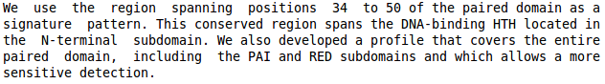
The documentation declares the Consensus pattern to be derived from the amino acids between 34 and 50 of the Paired domain.
UniprotKB claims the Paired domain to start at amino acid 4.
This leads me to conclude the Consensus pattern to be between residues 38 and 54 of the entire protein. Which is exactly correct.
10 20 30 40 50
MQNSHSGVNQ LGGVFVNGRP LPDSTRQKIV ELAHSGARPC DISRILQVSN
60 70 80 90 100
GCVSKILGRY YETGSIRPRA IGGSKPRVAT PEVVSKIAQY KRECPSIFAW
Knowing the rough location of this pattern will be useful later on.
How would you interpret this pattern?
The pattern is matched where there is:
An Argenine(R) - followed by a Proline(P) - followed by a Cystine(C)
followed by exactly 11 amino acids of any type x(11)
followed by a Cystine(C) - followed by a Valine(V) - followed by a Serine(S)
The syntax for these patterns is slightly richer than implied by this example. Specifically:
- It is possible to use square brackets to indicate possible variation in a position. For example:
[VIL] would match if a position that was any of a Valine(V), Isoleucine(I) or Leucine(L).
- Curly brackets can be used to indicate “anything except”. For example:
{P} would match if a position was anything except a Proline(P).
- Round brackets can be used to indicate ranges. For example:
[FY](2,4) matches if at least 2, but no more than 4 positions were either Phenylalanine(F) or Tyrosine(Y).
- L(0,2) or L(,2) would match if there was between 0 and 2 Leucine(L)s.
- A(2,) would match if there were 2 or more Alanine(A)s
The minus signs between the elements of a pattern are optional. Well, they are for all the software I can recall using with these patterns anyway. Some believe the minus signs improve readability.

How effective does the Technical section imply this pattern to be?
The Technical section claims that there are 58 sequences in Swiss-Prot that include a Paired Box domain and so should match this pattern. This claim assumes that all the sequences of Swiss-Prot are 100% accurately annotated. A little optimistic, but one must have faith in something.
The Technical section notes that every one of these 58 Paired boxes includes the pattern.
The Technical section further notes, with some small redundancy, that none of the “known” Paired Boxes go undetected either because they do not contain the pattern or because they are partial sequences.
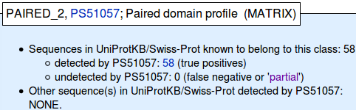
The Technical section finally opines that there are 7 Swiss-Prot sequences that definitely do not include a Paired Box that do match the Paired Box pattern.
Not bad for such a simple strategy I would suggest, but not as good as the PROSITE MATRIX (i.e. Hidden Markov Model, HMM) that is evaluated just below the pattern. This also finds all the genuine Paired Boxes, but does not pick up any false positives.
Also, the performance of this pattern is not as immaculate as is suggested here, as will be touched on in another answer still to come.
How well does the secondary structure suggested by Prosite match that recorded by Uniprot?
Well, the homeobox is predicted by UniProt to be from residues 210-269.
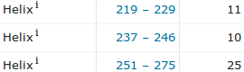
60 amino acids exactly as suggested by the PROSITE documentation.
Three homeobox helices are predicted by UniProt to be at:
Relative to the start of the protein Relative to the start of the homeobox
219 - 229 009 - 019
237 - 246 027 - 036
251 - 275 041 - 065
No turn is predicted by UniProt. This is not too surprising as turns are not easy to predict. PROSITE suggests there should be a turn between just two helices, forming a helix-turn-helix region though which the domain binds DNA. PROSITE makes no mention of a third helix in front of the helix-turn-helix motif.
Diagrammatically:
UniProt: xxxxxxxxHHHHHHHHHHHxxxxxxxHHHHHHHHHHxxxxHHHHHHHHHHHHHHHHHHHHHHHHH
| | | | | | |
1 10 20 30 40 50 60
PROSITE: xxxxxxxxxxxxxxxxxxxxxxxxxxxxxxHHHHHHHHtttHHHHHHHHHxxxxxxxxxx
| | | | | | |
1 10 20 30 40 50 60
PROSITE is short a helix and UniProt is short a turn, but what is left is broadly in the right place? If a trifle over long here and there? What an imperfect world we occupy.
How many helix-turn-helix motifs would you expect in the homeobox domain?
Just one, according to the PROSITE documentation (and all the other evidence discovered thus far) at least.

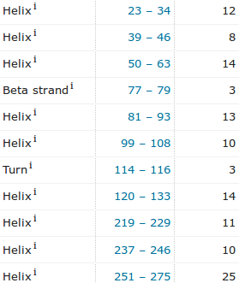
Where (in amino acid positions) would you expect all the PAX6 HTH motifs to be?
HTH motifs are functional elements of one sort of DNA-binding domain.
In all, there are three HTHs in the PAX6 protein for human. The second and third helix of each of the three helical triplets of the protein form an HTH motif of one sort or another. Computing just from the UniProtKB secondary structure predictions alone therefore, the three HTHs will be around:
039 → 063
099 → 133
237 → 275

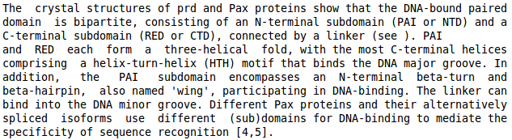
The first two HTH motifs are in the Paired domain. The PROSITE documentation for Paired domain alone is not sufficiently specific to predict the position of these HTHs with residue number precision.
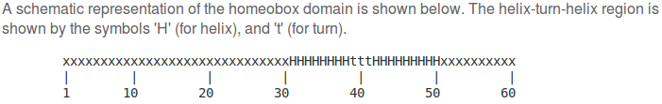
The third HTH is in the homeobox domain. The PROSITE documentation for a homeobox domain suggests this HTH starts at position 31 of the homeobox and continues to position 50. UniProtKB suggests the homeobox starts at residue 210. So, an alternative suggestion of the position of the third HTH would be:
240 → 259
Close enough? All this so you can check the predictions of the HTH positions you might compute later (now a Supplementary Exercise), with only partial success, as it is not an easy prediction. Also, there are a number of different types of HTH. The software is optimised for just one of the possibilities.
A quick look at Pfam:
Extra Pfam Notes:
Not associated with any specific question, and not vital to the main exercise. That is, history, mostly for me.
Originally the Pfam database had two sections: Pfam-A (manual annotated seed alignments, high quality) and Pfam-B (automatically generated alignments of much less quality). This observation is mostly interesting as it reflects the organisation of many of the databases considered in these exercises. That is, a quality, manually maintained section plus a machine generated, less reliable, section to try and include “everything”.
The Pfam people no longer generate their Pfam-B section as it has proved to be of little value. They say (2015.08.10):
“ … we are not longer producing Pfam-Bs, largely because most of the clusters not covered by Pfam are rarely meaningful potential new domains. Our recommendation now, is to take the piece of sequence of interest and run it using the HMMER webserver.
http://www.ebi.ac.uk/Tools/hmmer/search/phmmer
This will then produce a set of results that essentially provide you with the same information as a Pfam entry.”
As in the above quote, they Pfam team seem to use Pfam and Pfam-A to mean the same thing (i.e. the entire Pfam database) these days. Just in case of meeting any old references, Pfam-A entries (that is all of them these days) have accession codes starting PF, the old Pfam-B accession codes start with PB.
Confirmed (2016.03.10):
“ … You can assume Pfam == PfamA (there are still some reference to 'PfamA' internally but that's
historical, due to the reason to distinguish A/B).”
Allowing for the distorted numbering of the alignment, how would you interpret the extra 14 or so amino acids that some sequences appear to have around position 100-190?
These must be the extra 14 amino acids that define the second PAX6 isoform. The sequences that include the extra amino acids must represent isoform 5a proteins.

All the residues represented by lower case letters are insertions, relative to the Seed HMM profile for a Pfam Paired domain.

The worry is that all the insertions should surely be in the same place? The alignment illustrated appears to offer 5 or so alternative insertion positions?

How might you interpret the way that HMMER3 suggests that some sequences have a similar insertions in a slightly different places to others?
Summary:
At first glance, this looks like a scrappy alignment!
The expectation of a neat single insertion point for the extra 14 amino acids of isoform 5a in the region illustrated is denied!
Actually, it is not nearly as bad as it would seem. I investigate in the Full Answer: section, and conclude that the reason this alignment looks so poor is due mostly to the inclusion of just a few “difficult” sequences. If one was to remove these (quite possibly not scientifically supportable, but … what do I care!) one can make an alignment that is much easier upon the intuition.
As I wish to encourage you not to go through the Full Answer: until you have more time, I make the central point here that messing around trying to understand all there is to know about this particular alignment and PAX is absolutely NOT the point. What I would like you to realise is that Pfam alignments (and others) are offered to you in an alignment editor (jalview in this case). This means you can do so much more than just look at it in wonder. You can manipulate any alignment in ways similar to those I used below, see the information from different angles and come to more enlightened conclusions. Not so very earth shattering, in this case, but another time? Who knows.

Full Answer:
Practically, the indifferent quality of this alignment really does not matter that much. It is the HMM profile computed from the Seed alignment that is used to represent a Pfam Paired domain and this it does very effectively. The alignment here is just for show. It still seems a shame that it is not more immediately convincing.
The objective here is to discover just why the alignment for the full PAX family so poorly represents what should be a single point of insertion for the 14 amino acids that differentiate the two PAX isoforms of known sequence. The messy alignment above is particularly distressing as the equivalent generated previously by HMMER2 (the father of HMMER3) was really quite convincing. The Pfam team explain that HMMER3 runs much faster (200 times faster apparently) than HMMER2 did. But surely this is irrelevant is the quality of the alignment suffers significantly?

The first step must be to try and make the situation a little clearer. I aim to bring all the isoform 5a protein sequence together in the alignment, so they can be all viewed at the same time. Jalview makes this trivial. In order to produce the next view of the alignment I did the following:
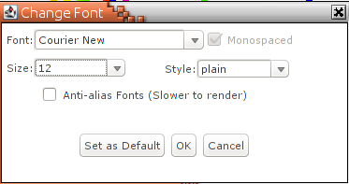
- Ordered the sequences by length. I reason the isoform 5a sequences should generally be longer than the canonical isoform sequences. Calculate → Sort → By Length. Then move to the bottom of the alignment where the longer sequences will be.
- Changed the Font to Courier New and the Font Size to 12. Format → Fill in the form as illustrated. Personal preferences I admit, but I think these choices do make things a little clearer.

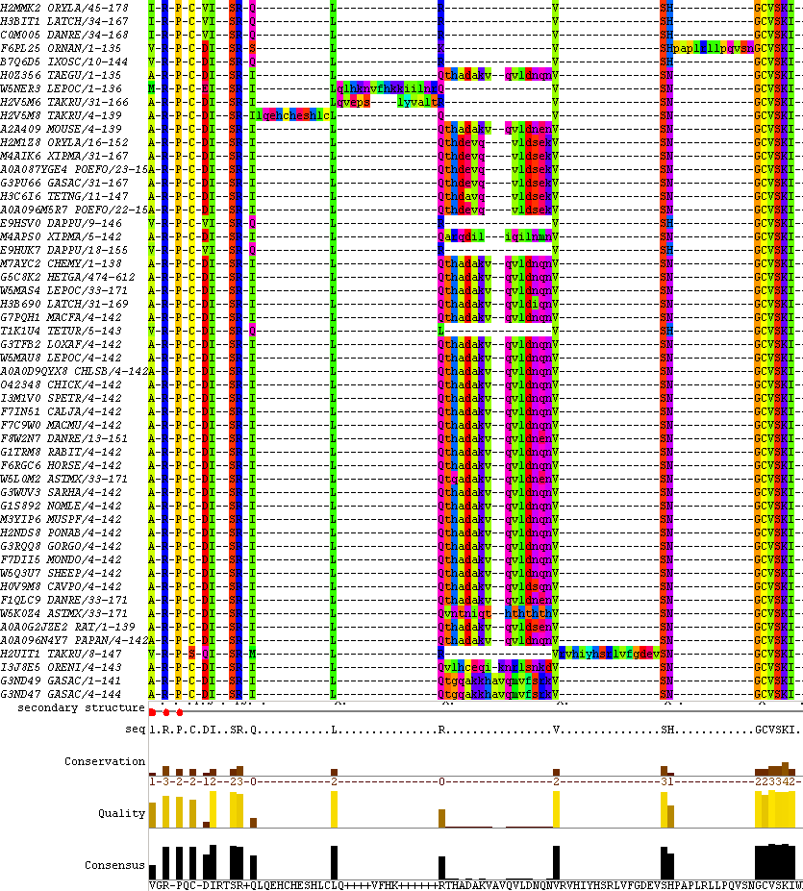

Now all the isoform 5a sequences can be seen together, the overall effect is much more encouraging. HMMER3 has aligned the sequences sensibly. It seems to be the inclusion of just a few sequences that, for whatever reason, are not behaving themselves very well, that has made the overall effect so ugly.
OK, so why not put scientific justification to one side and aim purely for a “nice effect”? This I did by simply removing all the sequences that did not fit from the alignment. Click on the identifiers of all the sequences that are problematic, holding the Ctrl key down all the time. Then remove those selected. Edit → Delete. To gain most of the effect I craved, I had to remove only a few, well under 10, sequences.
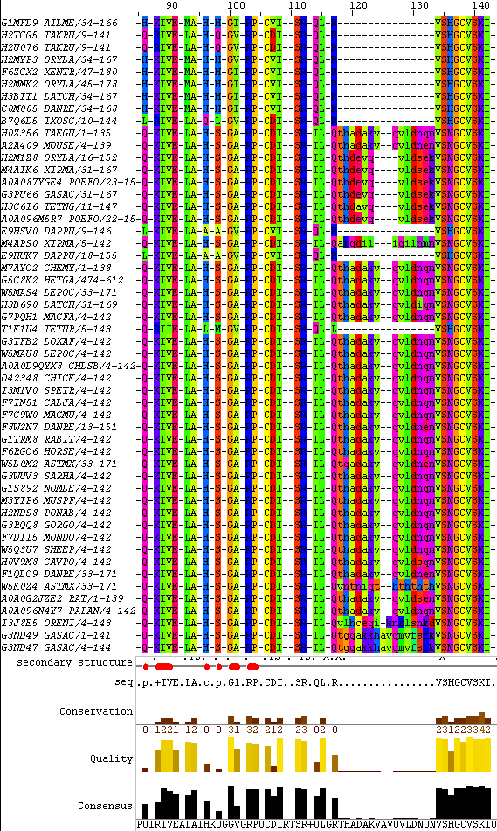
Finally, remove from the alignment all columns that are now purely padding characters (“-”) due to the deletions. Edit → Remove Empty Columns. The resultant alignment is far nearer the expectations encouraged by that which has been learned about this family thus far.
I stop at this point, but take a swift glance at the positions of the highly conserved residues of the PROSITE pattern for Paired domain.
The RPC starts around residue 103 (depending how many sequences were deleted). Placing your mouse over the Consensus bar for these residues shows 85% conservation. Well short of the 100% claimed by PROSITE.
Further, there exists evidence in my alignment that some PAX sequences have a single amino acid insertion between the P and the C!
Further still, investigating the CVS residues a little further along (138-140 in my illustration), the suggestion is around 90% conservation. Impressive, but still not 100%.
I am sure these (and other) anomalies could be massaged into a closer approximation to “perfect” with a little effort. In particular, if you look at the top of the alignment (where the suspiciously short sequences reside). Here I see many many candidates for exclusion from the alignment on the grounds of “convenience”.
Also note, the isoform 5a insertion occurs in the middle of the PROSITE pattern for a Paired domain. As will be discussed again later, this has to make the pattern RPCx(11)CVS very much less than useful at detecting isoform 5a Paired box sequences!
So, I set out to investigate why the HMMER3 initial alignment was so much uglier than the HMMER2 equivalent. I conclude that either one or both of the following is true:
- HMMER3 is a mite more generous than HMMER2 with regards to the PAX sequences it accepts.
- More distantly related PAX sequences have been included in the databases searched by Pfam since the far off days of HMMER2.
Finally, it is encouraging to reflect that HMMER3 goes 200 times faster then HMMER2, that has to be truly impressive. Never mind the alignment of all the PAXs we have been contemplating here, HMMER3 is exceptionally effective at its main task of matching domain representations to protein sequences.
Note down the position in the alignment where all but one seed sequence has a gap.
Note the consensus character at this point and its most logical interpretation.
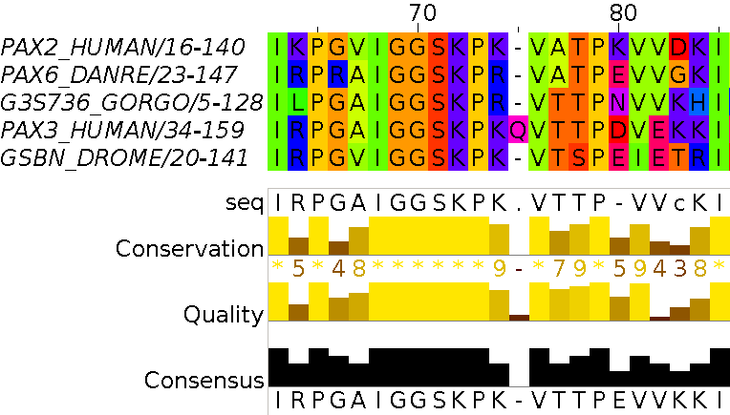
In residue position 75 of the seed alignment, 4 of the 5 protein sequences are gapped. Only one sequence, PAX3_HUMAN, has an amino acid recorded, a Q (Glutamine).

The Consensus character at this point is “-”. Jalview has it own way to calculate the Consensus. Read the documentation for the official explanation. Informally: for positions where there is no dominant amino acid code, + means “more than one possibility”, - means “predominantly a gap”.
How is the heavily gapped position of the seed alignment represented in its HMM Logo?
How would you interpret the Logo in this region?
The heavily gapped position of the seed alignment is position 75. In this position, 4 of the 5 aligned sequences have been gapped, the remaining sequence has a Q.
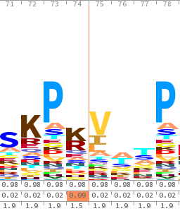
This position does not appear in the Logo (although there is a position 75 … which relates to position 76 of the alignment … which seems a bit silly to me!). This implies that the HMM represents the data at position 75 thus:
“Generally not present, but a relatively high chance of an insertion which is most likely to be a Q”
The alternative, equivalent, representation would be:
“Generally a Q, but a relatively high probability of a deletion”
Had the second alternative been selected, the Logo would have shown a healthy Q at position 75.
A thin brownish line is placed in the Logo to indicate where position 75 was omitted. The Logo is not a precise enough representation to clearly show all the details of the chance of an insertion and whether that the insertion is likely to be a Q …. but this will be recorded in the HMM itself.
A quick look at Prints:
How many links to PRINTS would you expect?
Two surely. It should be clear by now that we are investigating a protein with two major domains, a Paired Box and a Homeobox. It is reasonable to expect that all the domain database searches would find both these domains. PRINTS shows only the presence of the Paired Box domain.
What if anything, do you think is missing?
So, what is missing is evidence of the Homeobox domain. PRINTS has detected the Paired Box but has entirely missed the Homeobox domain. All the domain searches work slightly differently and none always pick up everything that they should. This is why the best strategy is not to rely on just one domain search but to always run them all. That one search occasionally misses something is to be expected, for all the searches to fail together should really not happen (well, rarely at least!).
That it is PRINTS that fails in this instance should not be taken to mean that PRINTS is an inferior domain database. As you will see later on in the exercises, PRINTS only fails to detect the Homeobox by a whisker. The presence of a Homeobox domain is detected, but at a strength below that required for PRINTS to record a hit.
A quick look at the cluster databases:
What was the seed sequence upon which this cluster was built?
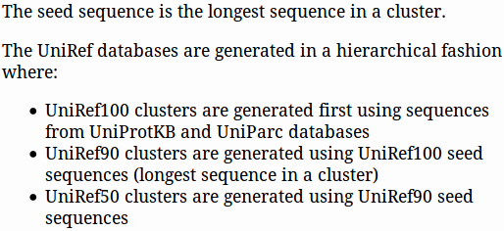
D3DQZ8
What do you imagine a seed sequence might be?

What is the Representative sequence protein for this cluster?
P26367
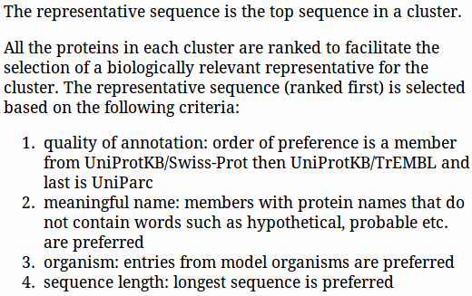
What do you imagine a Representative sequence might be?

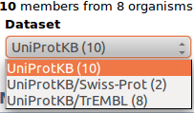
How many sequences are from UniProtKB/Swiss-Prot and how many from UniprotKB/TrEMBL (Look at the Dataset pull down Menu)?
UniProtKB(10)
UniProtKB/Swiss-Prot(2)
UniProtKB/TrEMBL(8)

Given your last answer, how would you interpret the colours of the stars in the Status column?
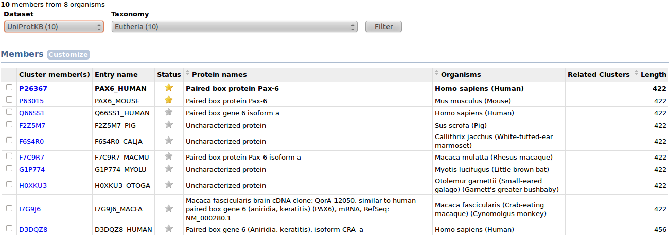

Swiss-Prot

TrEMBL

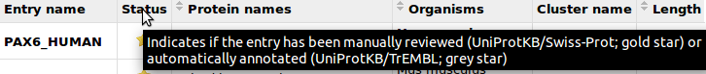
Hover over the column heading Status to confirm this conclusion.
Which sequences react to the Annotation request, and why?
The SwissProt sequence react, the TrEMBL ones do not. Only the SwissProt entries have quality annotation.
Can you rationalize why one of the sequences is allowed to be different to all the others?
xxxxx
After viewing this UniRef100 entry, how “non-redundant” would you say was UniprotKB?
xxxxx
Why do you suppose it might be useful to have identical sequences in UniprotKB?
xxxxx
From your investigations using Ensembl:
Is it a gene dense region?
Just in case you had forgotten, the region in question is P13.
Is it gene dense? A bit less that average I would say. Not a vital question, in the particular, but it is interesting how gene density seems vary quite substantially. P12, for example, is a bit of a desert! In contrast, several parts of Q13 are very well endowed, particularly with protein coding genes.
What about Variation density?
Summary:
It is the Variations column to which I draw your attention here. Uniform density over most of the chromosome is suggested I think? Well, that is barring a couple of small peaks each side of a barren centromere. This was a much more interesting question before Ensembl included the entire dbSNP database form the NCBI. Variations were relatively sparse before this event and the density varied with greater whimsicality.
Full Answer:
2015.06.01: This display was broken! The cause was that a massive increase in the size of the dbSNP database exceeding the capacity of the display!. The boys (and girls) of Ensembl suggested they may have to move to a logarithmic scale in order to cope.
2015.07.18: All fixed. Not sure if the logarithmic scale was implemented, but the picture now looks quite convincing, if bland. The picture in the book is now (fairly) current. There are now so many variations it is difficult to read much into this picture at all? Superficially, the distribution of variations looks even more uniform throughout the chromosome than it did previously. This impression may well be exaggerated by the use of a logarithmic scale? The “peaks” around the centromere are certainly more subdued.
Can you also see the two other genes you might have expected to be in this region?
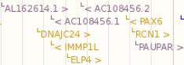
PAX6, ELP4 and RCN1 can be clearly seen in positions predicted by the annotations you found earlier.
The “>” characters for ELP4 and RCN1 both indicate that these genes are on the strand opposite to that where PAX6 resides. This you will also have expected.
What are the (familiar?) contig numbers containing all of PAX6?
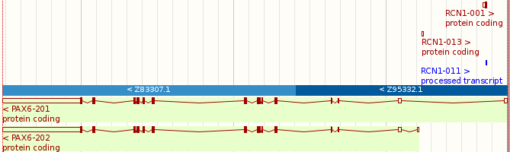
The portions of the genomic clones Z83307 and Z95332 needed to represent the longest transcript of PAX6 are clear to see, represented as alternating dark and light blue bars.
Note the “<” characters in each bar indicating that both clones were reversed and complimented (relative to their representation in GenBank/EMBL-Bank) in order to be assembled with all the other contig contributions to the entire sequence of Chromosome 11. In the EMBL-Bank version of both these clones, PAX6 was suggested to be on the forward strand. In Ensembl. PAX6 is shown below the blue contigs bar, implying that it is on the reverse strand of Chromosome 11 as a whole.
Note the beginnings of some RCN1 transcripts on the forward strand. Ensembl suggests, mostly between UTRs and never involving coincident exons, an overlap between the 5' UTR of some transcripts of PAX6 and the 3' UTR of some transcripts of RNC1.
There is no sign of ELP4 in this view. The part of this gene included in Z83307 does not overlap with the PAX6 region and is so does not appear here.
Explain the visible differences between the coding exons of transcripts PAX6-008 and PAX6-009?
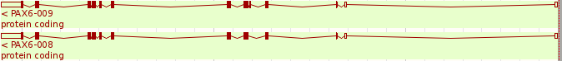
Of course, one cannot be certain that all differences between these transcripts can be observed from a picture.
For complete accuracy, one would need to view the textual representations, however, there is one clear difference observable here. There is an extra coding exon in PAX6-009, the 5th, to be particular (remember you must read the transcript from right to left as PAX6 is on the reverse strand of the Chromosome).
The inclusion/omission of the 5th exon, a very small coding exon, must result in alternative protein products (isoforms) for each of the two transcripts. Maybe this small exon is the source of the extra 14 amino acids that define isoform 5a of PAX6? This should be clearly confirmed/denied when we get to look at the transcripts in more detail. It must be a good bet though? There are only two isoforms with sequence after all.
Or … maybe the answer to the next question will be enough to convince you?
What PAX6 exon of note has Genscan omitted to predict?
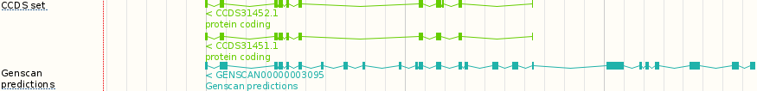
There are two CCDS set hits, one for each isoform. The extra coding exon that defines isoform 5a can be seen clearly in the upper CCDS hit (3rd coding exon in from the right, as we are looking at an analysis of the reverse strand of the gene here, that means the 3rd coding exon from the start of the gene). This extra coding exon is missed by Genscan, probably because of its size. Genscan does predict all the other coding exons (plus extras) and makes a reasonable shot at the non-coding exons also. You could see Genscan in action again in an optional exercise.
Is a merged Ensembl/Havana transcript also a Vega Havana protein coding transcript?
Well, of course! Here it is being a gold merged Ensembl/Havana transcript from the default display:
and here it is again being a blue (I think) Vega Havana protein coding transcript from the extra track you added to your display just showing Vega predictions exclusively.
Which Ensembl protein coding transcripts were only predicted by the Ensembl pipeline?
There are just 2. You could verify this (but please do not!) by comparing carefully the Vega Havana track that you introduced into the display with the Genes (Comprehensive … track from the default display. Or you could read the answer to the next question and take a short cut.
All the Vega Havana track predictions, that are protein coding, should appear also in the Genes (Comprehensive … track. Only the protein coding transcript predictions made exclusively by the Ensembl pipeline will only be in the Genes (Comprehensive … track.
Can you see how to identify the Ensembl protein coding predictions only predicted by the Ensembl pipeline by the way they are numbered?
The numbering for transcripts predicted by the Vega-Havana team commences at 001.
The numbering for transcripts predicted by the Ensembl pipeline commences at 201.
When a transcript is agreed upon by both predictive methods, the Vega-Havana numbering takes precedence.
In this example, there are just two transcripts that are predicted by the Ensembl pipeline but not by the Vega-Havana team. They are the transcripts PAX6-201 & PAX6-202.
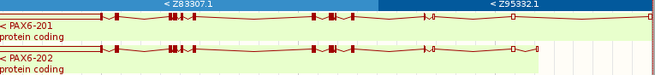
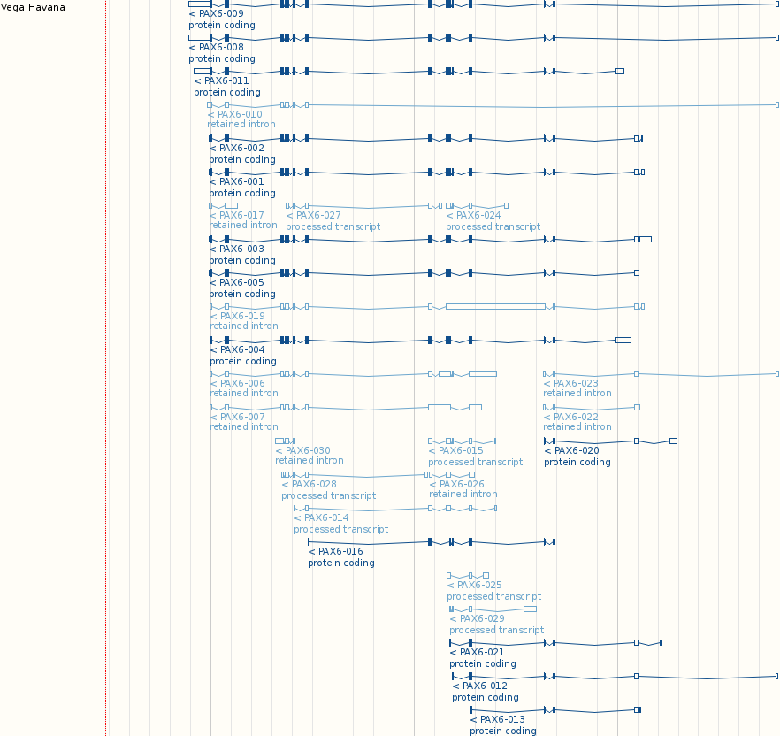
You can confirm this (if you really must!) by looking for differences between the Vega-Havana only track and the Genes (Comprehensive … track. PAX6-201 & PAX6-202 are the only protein coding prediction only in the Vega-Havana track.
How might the Gene Ontology improve sequence database text searching?

As you will have noticed, there are problems with search for sequences using textual search terms against the original annotation content, historically provided by the sequence submitter and not curated. Such annotation could be rather whimsical. Sequences that should match sensibly chosen search keys often do not. Genuine matches are thus inappropriately missed.

Rigorous use of GO terms and accession codes, such as those in the tables you have been viewing, must radically improve search efficacy.

Of course, there remains the problem of which GO terms apply to which sequences. RefSeq and UniProtKB do not always agree, for example. However, GO annotation has to be a significant step in the right direction.
Why is the Transcript Ids column necessary?
The tables you have been viewing relate to the PAX6 gene. However, individual GO terms correspond to a particular protein. Many genes will relate to more that one protein isoform (as is the case for PAX6). Individual GO terms must be associated with specific transcript(s) (effectively specific protein products). The Transcript ID column exists to make the link between a GO term and the particular transcript(s) to which it applies.
Extra Gene Ontolgy Notes:
Until recently (approximately September 2015) Ensembl offered, from transcript view pages, links to illustrations of the hierarchical network of GO terms associated with particular isoforms (transcripts) of a gene. The illustrations were thought to be of little value for efficiently informing a user of the function of a protein, so they were removed. I think I agree with this move, however I did find the pictures conveyed a quick and intuitive understanding of the way the GO database was structured as a network of terms.
When the illustrations were available I asked a question that tried to bring this out. I retain the question here as I think it might still serve a purpose,. An alternative source of enlightenment can be found at the GO site here.
The original questions (and answers) followed instruction to look at the illustrations and were:
Give an example of the most specific terms represented?
Give an example of the most general terms?
I would love to put the whole graph here, but … they are a bit big, so I will restrain myself to two sections.
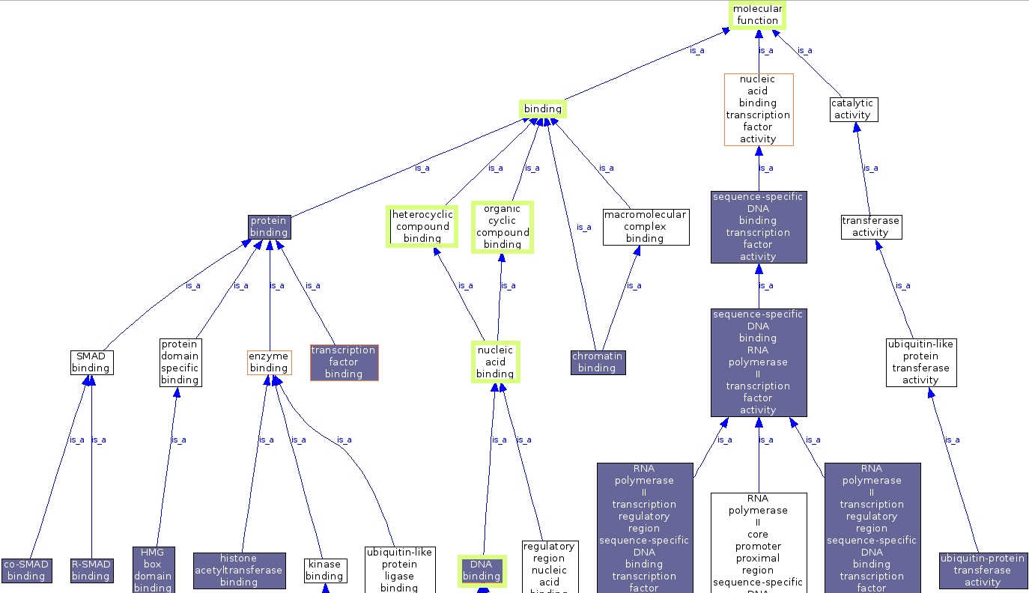
The Gene Ontology (GO) terms are of three categories defining separately the molecular function, cellular component and biological process of a protein. So, there are three graphs.

Considering a small portion of the molecular function graph, going from most specific to least specific.

The protein in question is considered to be:
DNA binding which implies it is_a nucleic acid binding protein so it is_a
heterocyclic compound binding & organic cyclic compound binding protein and thus is_a
binding protein which is_a molecular function
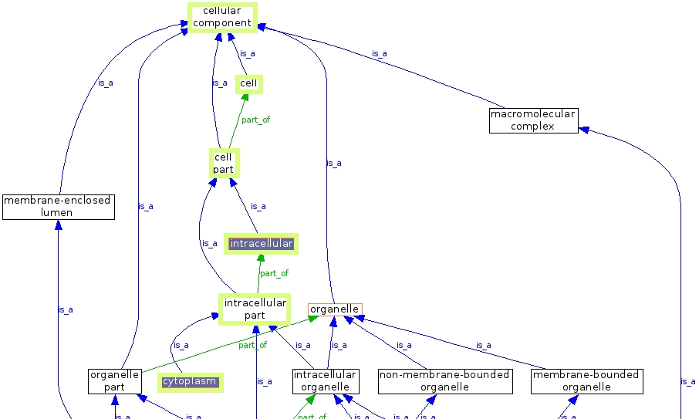

Similarly for the cellular component graph.

The protein in question is considered to be a:
component of the cytoplasm which implies it is_a
component of an intracellular part which implies it is_an
intracellular component which implies it is_a component of a cell part which implies it is_a
cell component which implies it is_a cellular component
In a very similar fashion you could follow a path or two through the biological process maze. This one is too scary for me folks, you are on your own!
Note the number of RefSeq mRNAs and RefSeq proteins associated with Ensembl transcripts predictions.
Which of the 24 RefSeq mRNAs reported by GeneCards can be seen here?
Why would you suppose these mRNAs were selected and the others ignored?
Summary:
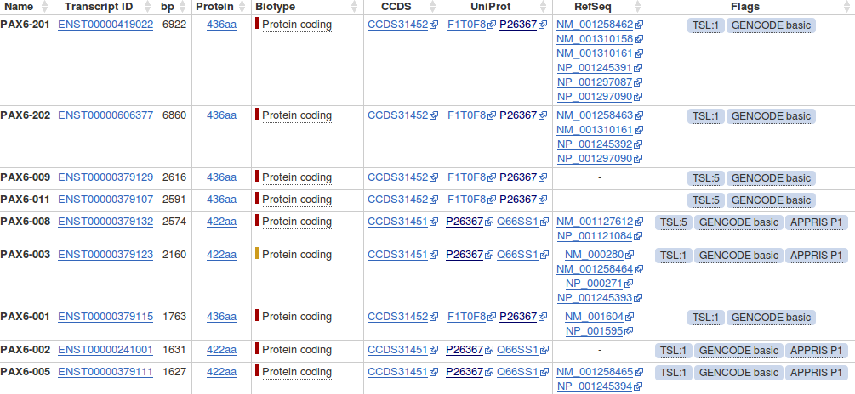
Most of the top protein coding transcripts are associated with RefSeq mRNAs.
The RefSeq mRNAs shown here to match the Ensembl transcript predictions are 10 of the 11 whose accessions codes commence NM_. These appear with their corresponding protein sequences whose accession codes start NP_.
GeneCards records the presence in of further 13 RefSeq mRNAs with accession codes beginning XM_ and associated proteins with accession codes starting XP_. These 13 mRNAs do not appear here.
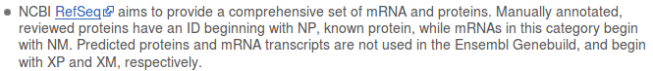
The NM_/NP_ sequences are supported by better evidence than the XM_/XP_ sequences. Ensembl regards only the NM_/NP_ RefSeq entries of sufficient quality to predict transcripts.
Full Answer:
It is curious that the RefSeq mRNAs do not map 1 ←→ 1 with Ensembl transcript predictions? I conclude this is just the two predictive strategies disagreeing to a small extent? Ensembl appears to be happy to predict just 6 transcripts to match the 11 RefSeq suggests?
I suggest the fact that several of the Ensembl transcript predictions correspond to more than one RefSeq mRNA is due to that fact that Ensembl will have used just one RefSeq mRNA to support the existence of the transcript as a whole and the rest to support individual exons. This supposition seems to be reflected in the Supporting Evidence views you will see in a few pages time.
Using the evidence of the protein alignments, which PAX6 isoforms do the fruitfly orthologues most resemble?
The protein used to represent PAX6 human is consistently ENSP00000404100. This can most easily be confirmed by clicking on thelink for each of the 2 Fruitfly orthologues in turn to view the relevant orthologous protein alignments. This is the protein sequence of isoform 5a, probably chosen as it is the longer option (436 amino acids as opposed to 422) and so (from the crude informatics viewpoint) represents more information.
As discovered from GeneCards, there are two Fruitfly orthologues with the gene names ey and toy. Ensembl agrees, which should not be surprising as GeneCards consults Ensembl for orthologue information. Looking at the first few lines of the protein alignments for these genes, it is clear that that 14 amino acid insert that defines isoform 5a (THADAKVQVLDNQN) is not present in either. It is therefore reasonable to conclude that the representative fly proteins are both closest to the canonical protein sequence of PAX6 human (isoform 1).
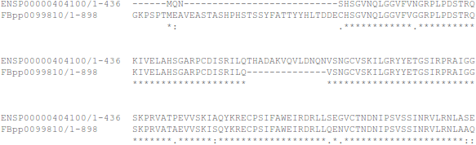
Protein alignment for ey

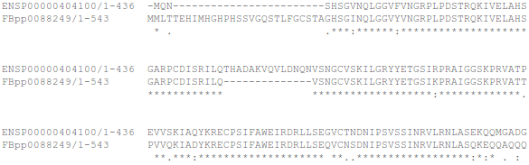
Protein alignment for toy

Well, maybe also it is not that simple? I would not be surprised If there were isoforms for ey and/or toy that were roughly equivalent to human isoform 5a. The alignment displayed could well reflect the relatively arbitrary choice of Ensembl as to which isoform it decides to use for the alignments, rather than any deep and meaningful biological truth. Already you can see that Ensembl prefers the (presumably) less important human isoform, merely because it is longer (more letters to match). Again, useful though these displays are, caution is required before reading too much “biology” into them.
Ensembl does not pick up the prd fruitfly homologue to PAX6 mentioned elsewhere (or the others noted previously)? Again, I wonder why. Mind you, Ensembl does only claim “Selected orthologues”? Still prd is a pretty important one to pass over!
Do the Paralogue reports of GeneCards and Ensembl agree? If not, can you explain the discrepancies?
Well, yes they do agree, so there are no discrepancies to explain. Both sources now agree that there are 9 PAX genes in the human genome. As for orthologues, hardly surprising as GeneCards consults Ensembl for paralogue information.
I left the question here as recently there was disagreement due to misinterpretation of the Ancestral taxonomy field. I wanted to make the point that such small discrepancies are not uncommon and one should therefore be wary. A small price to pay for such immediate access to such volumes of information I suggest.
Which isoform of PAX6 has been chosen for the alignments, and why would you suppose it was selected?
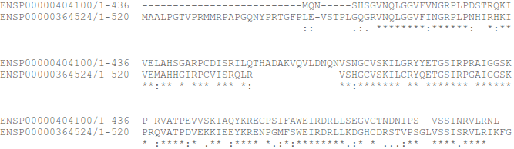
For these alignments, as for the ortholgues, Ensembl consistently uses the same protein (ENSP00000404100). This is isoform 5a which is again used, because it is longer. Never mind the biology, for the computer's purposes, longest is best. It is more likely to match things as there is more of it. Sophisticated what!
The example is the alignment with PAX7.
Which isoform is most common amongst the paralogues?
What a cruel and pointless question! As for the orthologues, there used to be a link that would summon forth all the alignments at once. Sadly, this seems to have been retired? So the only way to answer this question with confidence is to investigate each alignment in turn. Do not do that … just read and believe.
Scanning quickly down the eight pairwise protein alignments, you would be able to see that all involve isoform 5a of PAX6 with paralogue sequences that lack the 14 amino acids insert. This proves nothing beyond the fact that Ensembl chooses to use what is probably the canonical form for the eight paralogues. There could easily also be an isoform 5a equivalent for every paralogue.
An unanswerable question, I suggest? Well, a question for which a complete answer would require further investigation at least. I leave it in, as it does provoke some thought … possibly?
In passing, before the “Show me all the alignments together” link was removed, I had hoped I could view all the orthologues/paralogues compared with each other in one go (i.e. a multiple alignment). No such luck, although, upon reflection, I can see why. That alignment would be very messy outside the PAX regions. Neither the orthologues nor the paralogues claim to be similar over their entire length after all.

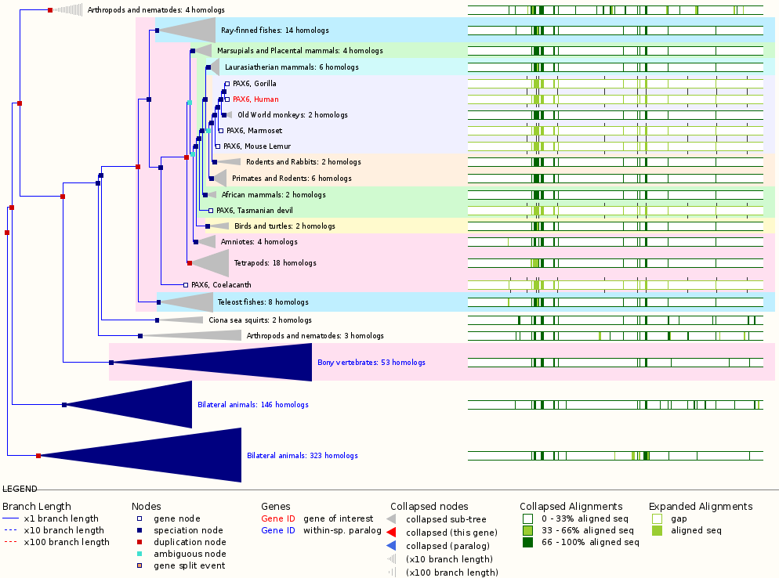
The Gene Tree, as promised. Click here to return to the Instructions.
Some matching sequences offer no support for the 6th exon from the right. Why do you suppose this is?
The 6th exon from the beginning of the transcript (the right of the display) is that whose inclusion defines isoform 5a. All mRNA/cDNA/protein sequences representing the canonical PAX6 human protein will not include this exon. This will be made absolutely apparent when you look at the textual representation of the exons very shortly.
However, canonical sequences can be useful as supporting evidence for all individual exons, excluding the 6th, so several are included in the Exon supporting evidence tracks.
Why is there no protein or CCDS evidence for exons 1, 2 and 3?
CCDS stands for Consensus CoDing Sequence. All CCDS sequences are just the coding regions of genes. They do not include introns or 3'/5' UTRs. Accordingly, there should not be (and is not) any CCDS (or protein) evidence for exons 1, 2 or 3 as these exons include no protein coding regions.
Until recently (mid-2014), the RefSeq mRNA match in the Transcript evidence section did not match all exons. Was this logical?
A rather desparate question to make a quite interesting observation?
This is a problem that has gone away now with the discovery of a RefSeq mRNA that exactly supports this transcript. Previously, the best that could be found was the RefSeq mRNA NM_001127612, which lacked the 6th exon (I,e, a canonical version of this transcript).
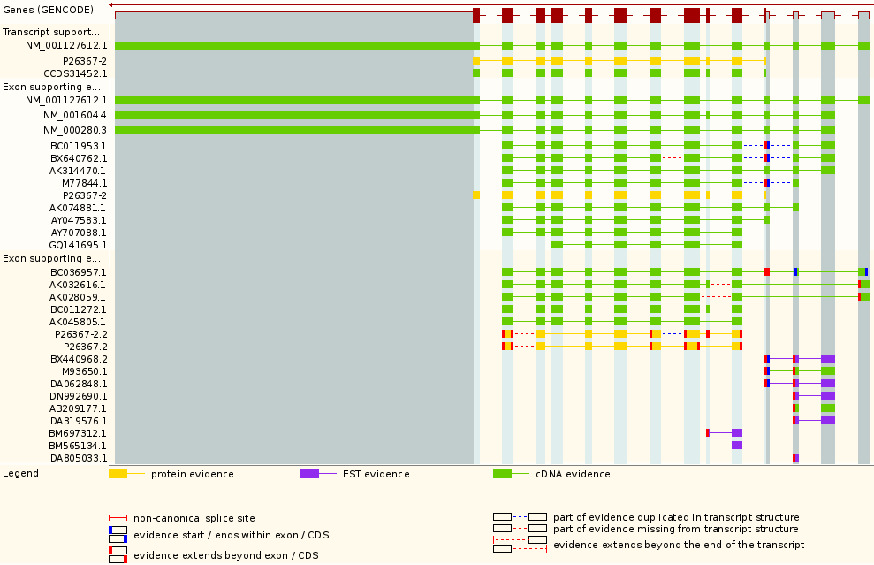
I include here the, now obsolete answer to this question. Perhaps a little pedantic, but I want to retain the particular point that RefSeq mRNAs are, justifiably, not perfect and the general point that we are looking at good, but still flawed, predictions here. One should always retain a modicum of scepticism when using these resources.
Not really. If this transcript is real, there must be an mRNA that matches its every exon, including the 6th, isoform 5a, exon. It would seem there is no such mRNA sequence in RefSeq however. Ideally, there would be.
The problem is that RefSeq mRNAs are not usually the sequence of a single mRNA. They are a composite of a number of sequences assumed to represent the same biological entity. Things can go wrong, as they probably have here. The RefSeq construct suggests a canonical mRNA, Ensembl suggests an isform 5a mRNA. Well, one of them is probably right.
Ensembl first uses CCDS matches to establish the presence of the gene and all its possible isoforms. The RefSeq matches are primarily required to establish various forms of the UTRs for each prediction of a coding region. Here Ensembl has chosen to believe the combination of the UTRs suggested by NM_001127612 and the coding region suggested by CCDS31452. Ensembl must be assuming that the RefSeq mRNA is not 100% correct. This is clearly possible, but I do not regard the reasoning of Ensembl as particularly transparent, particularly as there is another CCDS match that would entirely support the RefSeq evidence?
How many exons are there in this transcript?
14, I think the relevance of this question has reduced over the aeons. I certainly cannot recall clearly why I asked?
What are the first two bases and what are the last two bases of nearly every intron?
As you are probably well aware, introns are highly conserved at each end. They typically begin with GT and end with AG. This rule is obeyed by all but one of the introns of this transcript (intron 3-4 starts GC rather than GT).
As the cartoon suggests, the conservation does not apply just to the first and last two bases, but that is where the conservation is most strict. So strict that when exceptions from this rule were sought in the databases, it was thought most of the deviations were due to annotation error!
The cartoon also suggests that introns have C/T rich regions towards their ends (the Polypyrimidine tract). This too is clearly evident in most of the introns of this transcript, even though only small parts of the introns are displayed.

How long is the sixth exon and why would this concur with your expectations?
It is 42 base pairs long, so it codes for 14 amino acids. Specifically, it codes for the 14 extra amino acids that define isoform 5a.
Explain the Start Phase and End Phase columns?
An exon/intron boundary can occur anywhere in a codon. The Start and End Phases record how an intron has been inserted into a coding region with respect to the coding reading frame.
If an exon ends at the end of a codon, then its End Phase is 0.
Clearly, the next exon must begin at the start of a codon. Its Start Phase is also 0.
If an exon ends after the first base of a codon, then its End Phase is 1.
Clearly, the next exon must begin after the first base of a codon. Its End Phase is also 1.
If an exon ends after the second base of a codon, then its End Phase is 2.
Clearly, the next exon must begin after the second base of a codon. Its End Phase is also 2.
I attempt a picture, though I am sure that is clear? I just like pictures, and lots of colours.
S A I L Q ← intron → T H A D A K V Q V L ← intron → V S N ...
...TCCCGAATTCTGCAG← intron →ACCCATGCAGATGCAAAAGTCCAAGTGCTG← intron →GTGTCCAAC...
End Phase 0← intron →Start Phase 0 End Phase 0← intron →Start Phase 0
S A I L ← intron →Q T H A D A K V Q V L← intron → V S N ...
...TCCCGAATTCTGC← intron →AGACCCATGCAGATGCAAAAGTCCAAGTGCT← intron →GGTGTCCAAC...
End Phase 1← intron →Start Phase 1 End Phase 2← intron →Start Phase 2

Where is the start and end of the Prosite Paired Box pattern (R-P-C-x(11)-C-V-S)?
Where, in relation to the pattern, are the extra isoform 5a amino acids?
Why might the positions of these two features be significant?
MQNSHSGVNQLGGVFVNGRPLPDSTRQKIVELAHSGARPCDISRILQTHADAKVQVLDNQ
NVSNGCVSKILGRYYETGSIRPRAIGGSKPRVATPEVVSKIAQYKRECPSIFAWEIRDRL
LSEGVCTNDNIPSVSSINRVLRNLASEKQQMGADGMYDKLRMLNGQTGSWGTRPGWYPGT
SVPGQPTQDGCQQQEGGGENTNSISSNGEDSDEAQMRLQLKRKLQRNRTSFTQEQIEALE
KEFERTHYPDVFARERLAAKIDLPEARIQVWFSNRRAKWRREEKLRNQRRQASNTPSHIP
ISSSFSTSVYQPIPQPTTPVSSFTSGSMLGRTDTALTNTYSALPPMPSFTMANNLPMQPP
VPSQTSSYSCMLPTSPSVNGRSYDTYTPPHMQTHMNSQPMGTSGTTSTGLISPGVSVPVQ
VPGSEPDMSQYWPRLQ
The pattern RPCxxxxxxxxxxxCVS is pretty easy to spot, but the 14 amino acid insertion of isoform 5a (THADAKVQVLDNQN, corresponding to the entire 3rd coding exon) has landed right in the middle of the pattern!
This is very significant as far as the efficacy of the PROSITE pattern is concerned. Despite the claim of the PROSITE documentation that the pattern picks up all known Paired domains, it is not going to work on any isoform 5a protein. This claim relies on the fact that all the PAX proteins in SwissProt are represented by their canonical sequence. The very common isofrom 5a is consistently recorded as a FEATURE, not search by the pattern matching software.
In order to detect just the PAX isoform 5a, the pattern would have to be:
R-P-C-x(25)-C-V-S
To detect both isoforms, using just one pattern:
R-P-C-x(11,25)-C-V-S
would work, but would be insufficiently specific and would generate far too many false positives. These sort of patterns are useful, but only with caution. They are valuable because of their simplicity, but very fragile.
Where do each of the SMART domains start and end?
Do the regions match your earlier recording? If not, why not?
SMART predicts a Paired_dom from amino acid positions 4 → 142.
Previously you noted that UniProtKB claims a Paired domain extending from residues 4 → 130.

SMART predicts a Homeodomain from amino acid positions 224 → 286.
Previously you noted that UniProtKB predicts a Homeobox extending from residues 210 → 269.

So no agreement in nomenclature or position. It would be nice if we could all agree what to call things, but I suppose that is not likely to happen in this world of personalised whimsy. There is more justification for the variation in predicted position of the various domains.
SMART and UniProtKB will be using marginally different methods and models to predict domains. It is exceedingly good news that there is pretty comprehensive agreement as to which domains present and roughly where they are. However, it would be unreasonable to expect differing prediction strategies to come up with precisely the same answers, correct to the amino acid position. After all, I wonder if any two human experts would exactly agree where a particular feature began and ended, even given all possible evidence?
What are the Interpro database accession codes for the two major PAX6 domains?
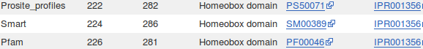
There are three independent predictions (from Prosite_profiles, Smart & Pfam) of a Homeobox domain. Each and all suggest that this protein belongs to the Homeobox domain Interpro family which has the Accession number IPR001356.
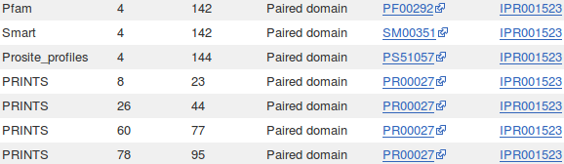
There are four independent predictions (from Prosite_profiles, Smart Pfam & Prints) of a Paired domain. Each and all suggest that this protein belongs to the Paired domain Interpro family which has the Accession number IPR001523.
No matches with Prosite_patterns are here to support the presence of either the Paired domain or the Homeobox domain.
The Prosite_pattern for a Homeobox domain does match and is accepted as sufficient evidence by Interpro to indicate a Homeobox, conserved site, which has its own Interpro entry. Accession number IPR017970. It is not, however, of sufficient significance to contribute to the evidence for the Homeobox domain itself.
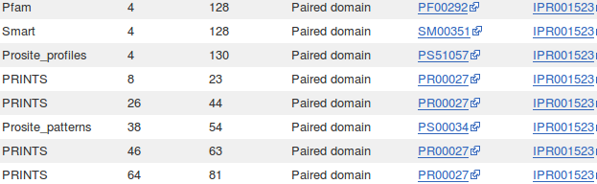
These results are entirely consistent with the Interpro results you have seen previously except that there is no match here with the Prosite_pattern for a Paired domain. This is because the transcipt under incestifation here represnts an isofrom 5a protein. This means the Paired domain Prosite_pattern will not match because of the extra 14 amino acids (see answer to previous question).
Had you investigated the transcript for a canonical protein (for example, ENST00000379123, the gold transcript you looked at earlier) the pattern would have matched and been counted as further evidence for a Paired domain.

Why does Prints appear to predict four Paired_domains?
Prints does not find the Homeobox_domain at all. You already will be aware that this search fails from looking at the UniProtKB predictions.
Prints appears to find FOUR Paired_domains. Of course, this is only because of the way Prints works. Prints finds FOUR signatures that together indicate ONE Paired_domain. I think we might have been here before? Possibly too many times?
Which domain, Paired domain or Homeobox domain is more common in humans?
How many human PAX genes are there?
As you will have expected, there are but 9 Paired_doms in the Human genome. There are many more Homeobox_doms.
Are all the PAX genes on Chromosome 11?
Of course not? What a stupid question!
Well, I suppose they could all be on Chromosome 11? By chance … or maybe design … who knows, the lack of predictable pattern in all this business never ceases to astound me.
But, philosophy aside, the answer is NO.
How does Interpro match with the PAX6 Paralogues reported by Ensembl/GeneCards earlier?
The evidence from both GeneCards and Ensembl is that there are 9 PAX paralogues in Human. Yep, we all agree and … these questions are becoming a trifle repetitive one feels!
Can you explain the strangely frayed ends displayed in some of the representations of the 2cue 3D structure?
2cue is a 3D structure determined by Nuclear Magnetic Resonance (NMR).This is a process that does not involve immobilizing the target as a crystal (as is the case with structures determined by X-ray crystallography). Parts of the protein will still be moving around whilst its structure is being determined.
I think of NMR as analogous to taking a long exposure photograph of a group of children. Each child will appear in many different places! The frayed ends represent various positions in which the ends of the homeobox were detected during the NMR process.
In some views, including the one you were offered to move around, all the possible positions are averaged out before the structure is stored. I prefer the fuzzy view ... much more fun.
I broadly believe that which I have just typed, however, I must stress that my understanding of NMR is tragically incomplete. If anyone would like to offer a better explanation, I am very willing to hear it.
From your investigations of Global Alignment:
What do you suppose these regions represent?
Exons
Is the number of matching regions consistent with the number of exons you might expect?
Well, I think the only point left to this question is to say that the resolution of the graphics is insufficient to make a proper judgement concerning how many exons there might be. From looking at Ensembl, I would expect about 13 or 14? From looking at this picture … I am simply not sure? I seem to have counted 12 when I first wrote this section.
I leave the question, but the need to know the exact number of exons, at this stage has become vanishingly small over the eons of evolution endured by these exercises. Let us say … 12! Which I think is right.
If not, can you explain the discrepancy?
What discrepancy? I pause for thought, but why would I have an expectation of exon count here anyway? Depends which transcript and which isoform.
So … I decline to try to explain anything further. Stupid question!
Why do you suppose that might be?
The larger the window size, the less likely it is that small features, or noise, will be detected. The signal from a small feature (noise or otherwise) will be too weak to influence the general impression of a relatively large window. Therefore. Ther longer the window size you choose, the stronger/longer the feature has to be before it will be noticed.
The presence of an extended strong feature will be detected as long as some part of it remains in a scoring window. The longer the window, the further the window must be from the feature before its influence is insignificant. Therefore, the longer the window, the longer strong features will appear to be.
How many convincingly aligned regions did you see?
4
Roughly how many did you expect?
12 or so … one per exon anyway.
Clearly, this alignment is not correct. Can you explain why?
This alignment algorithm only wishes to maximise an alignment score. It sees ALL the high scoring exon regions, however, as the gaps between many of the exons (introns that is) are so long that the penalties for representing them correctly are greater than the gain achieved by the inclusion the extra exons in the alignment. Arithmetically, it is better to align all the exons either side of the 4 exons that were aligned sensibly, in the biologically improbably fashion shown. Arithmetically the best alignment, biologically ridiculous!
This behaviour is exaggerated because this program regards the enormous gaps in has suggested at the start and end of the alignments as “free”. Some global alignment programs offer the option of penalising the ends gaps in the same way as for internal gaps. Normally, not penalising end gaps is sensible as it allows for the sequences to have slightly different lengths. In this case, penalising end gaps should have resulted in a better alignment.
Had you used stretcher (the faster, less vigorous algorithm offered by the EMBOSS package) you would have got a much improved answer in this case (but not generally). This is because stretcher works in a way far closer to the way an informed human might think. stretcher does not mindlessly insist of the highest alignment score. Instead, it looks for all the high scoring regions (i.e. all the exons) and then computes the best way to link them together. The result is a far more convincing alignment, but not the arithmetically best scoring answer.
How many matching regions are there this time?
Where you to trawl though your textual output carefully (or simply take my immaculate word for it), you would find 13 perfectly (or nearly so) aligned regions, implying 13 exons.
To be pedantic, the nicely aligned regions do not match the exons exactly (as will become apparent later), so it is not possible to claim definite evidence for any particular number of exons. However, 13 has to be a pretty confident estimate.
Is the count now roughly as you would expect?
Yes, roughly as suggested by Ensembl.
From your investigations comparing mRNA/cDNA with genomic DNA:
What is the amino acid corresponding to this position in the mRNA of the aniridia patient?
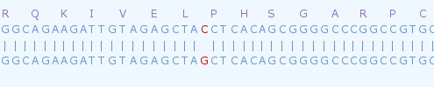
This is easy to answer. The top sequence is the mRNA from the aniridia patient. spline is kind enough to explicitly inform us that the mutated codon, CCT, will be expressed a Proline.
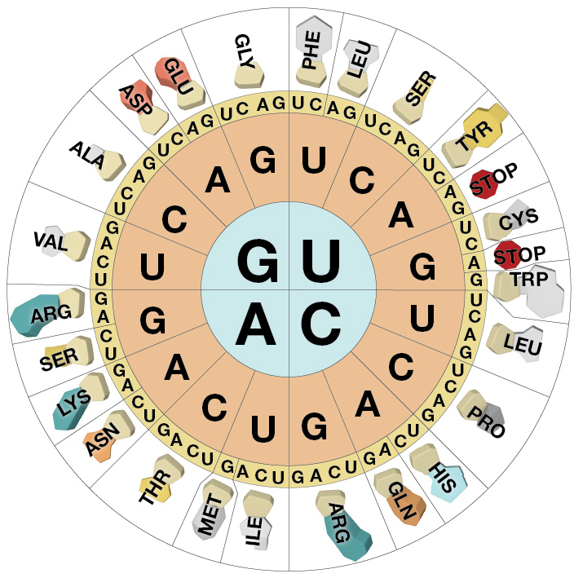
So, why not translate the wild type genomic sequence also spline?! Easy enough to look up. But I resent having to do so!

From this rather beautiful representation of the Genetic Code, I conclude:

Patient CCT → Proline (P)
Wild Type GCT → Alanine (A)

Or, looking back at the relevant Uniprot Feature Table, I come to an identical conclusion. This is the Natural Variant at position 33, as you could easily confirm with a bit of counting along the alignment.
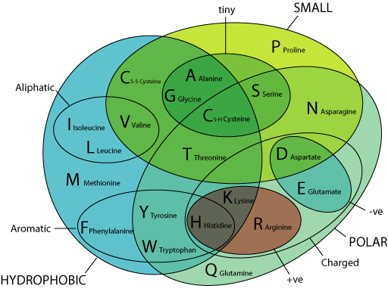

Either way, it could be a quite serious mutation. Alanine and Proline having quite distinct properties.

Also, according to the font of all easily packaged knowledge, Wikipedia:
“Proline and glycine are sometimes known as "helix breakers" because they disrupt the regularity of the α helical backbone conformation; however, both have unusual conformational abilities and are commonly found in turns.”
The helices of this protein are of particular importance to its vital DNA Binding role.
How do you interpret the Details column for exons 1 and 5?
Summary:
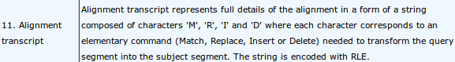
The Details column shows the alignments of each exon in a compressed format described in the spline documentation as illustrated.
The majority of the exon alignments are trivial.
For example:
For Exon 2, spline informs us M188, meaning “There are 188 bases aligned and they all Match perfectly”.
For Exon 3, spline informs us M77, meaning “There are 77 bases aligned and they all Match perfectly”.
The only 2 interesting entries are those were there are some disagreements. That is, the entries for Exons 1 and 5, which, following the documentation, I translate thus:
Exon 1 – M53IM5IM43
An alignment of 103 bases, the first 53 of which Match perfectly (M53), there then follows an Insertion (I), a further 5 Matched bases(M5), a second Insertion (I) all finished off with 43 Matched bases (M43).
Exon 5 – M86RM4R
An alignment of 131 bases, the first 86 of which Match perfectly (M86), there them follows a Replacement (R) and a further 44 Matched bases(M44).
Full Answer:
From the individual Exon 1 display, it can be inferred that the declaration of an Insertion or a Deletion is made to describe the type of variation required to transform the cDNA (Query) sequence into the genomic (Subject). Hence the two indels (Insertions or Deletions) are considered to be Insertions.
Not that it is a vital issue, but I would have thought the other way around was more logical? That is, to consider the genomic sequence as the reference against which a particular mRNA might vary. In other words, what we see here would surely be more relevantly recorded as “This mRNA/cDNA has two Deletions relative to the genomic sequence which, presumably, attempts to represent the norm in the general population”? Just the reflection of an irretrievable pedant, but I am right, nevertheless!!!
In the documentation it enigmatically states “The string is encoded with RLE.”. Just in case, RLE stands for Run-length encoding which is succinctly defined by Wikipedia. In a nutshell, it is a very simple form of data compression that recognizes that:
XXXXXXXXXXXXXXXXXXXXXXXXXXXXXXXXXXXXXXXXXXXXXXXXXXXXXXXXXXXX
can be compressed to:
60X
which has to be very effective for any data that has runs of identical characters of significant length. This is certainly the case here where one would expect long stretches of Ms in most alignments. Of course, life would get tricky if the data included numeric characters, but that is not an issue here.
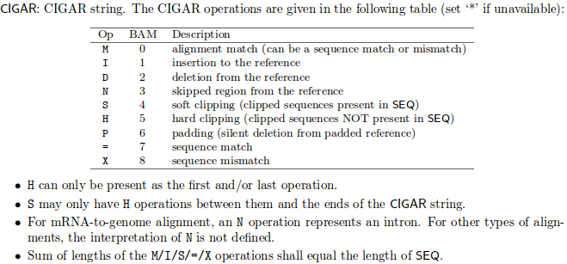
I think it worth mentioning, that this way of representing an alignment is a simplification of CIGAR format. This format is used for SAM (Sequence Alignment Map) and BAM (Binary Alignment Map, exactly the same as SAM, except compressed) files. You will be engulfed in SAM/BAM files if you ever do any Next Generation Sequencing (NGS).

So, straight form the SAM/BAM Format Specification I copy the table of CIGAR enlightenment.

Note, in particular, the extended range of Operators and the different meaning associated with the operator 'M'. The operators '=' and 'X' are such that any 'M' is either an '=' or and 'X' but never both. Which leaves one pondering whem one might use 'M' in preference to either an '=' or an 'X'?
Where is the substitution in the aniridia patient mRNA?
Where is the substitution in the Genomic Sequence?
spline makes one work quite hard to answer this one! Unless I am missing something.
From the alignment of Exon 5, the exon including the Replacement, with a bit of squinting, it can be confirmed that the Replacement is at:
Base pair position 514 of the aniridia patient’s mRNA
Base pair position 15714 of the genomic sequence
It might also have been relevant to ask which amino acid position corresponded to the Replacement. To discover this one would need to look at the alignment of Exon 3, where the coding begins.
More squinting, and I conclude the A of the ATG representing the initial Methionine of the protein coding region is at position 418. That is, the 3' UTR ends at position 417. So the Replacement is at:
Base position 514 – 417 = 97 of the protein coding region of the mRNA.
As 97 / 3 is 32 remainder 1, the Replacement is at codon position 1 of the 33rd amino acid of the protein.
Which you knew already, of course! Cannot help thinking that spline might have helped a bit more here?
Compare the predicted splign intron/exon boundaries with the conservation suggested by the logo?
What deviation(s) from the model suggested by the logo can you see?
You may have gathered, I rather like this logo, although I rather think it is leading me to make the same point a trifle to often?
The logo is in almost 100% agreement with the predictions of spline.
As you will have noted previously, when looking at the Ensembl predictions of exons locations of a similar transcript of the PAX6 human gene, there is a single exception.
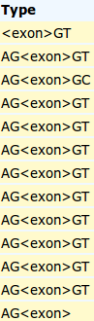
The easiest way to show this in the spline output is to look at the spline text output again.
The Type column records the type of all the <exon> alignments it predicts. It also records 2 flanking intron base pairs.
It is clear that the only time the spline prediction deviates from the model suggested by the logo is at the end of the 3rd exon. Here there is GC rather then GT. Well, nothing is perfect!
From your investigations of Local Alignment:
How might the gap around 24,600 in the genomic sequence been positioned more intelligently?
spin has positioned a gap in this region merely to maximize the overall alignment score. There is more than one way of achieving this simple goal. However, if it were to be recognized that the gap to be positioned was to represent an intron, then one of the arithmetically equivalent options becomes far more attractive than the others. This “best” option is not the one chosen by spin, which is forgiveable as spin had nor reason to expect an intron and was not written to understand the properties of introns anyway.
The alignment chosen for this region by spin was:
24392 24402 24412 24422 24432 24442
pax6-genomic CTAGCAGCCAAAATAGATCTACCTGAAGCAAGAATACAGGTACCGAGAGACTGTGCAGTT
||||||||||||||||||||||||||||||||||||||||||
pax6-cDNA ctagcagccaaaatagatctacctgaagcaagaatacaggta..................
1144 1154 1164 1174 1184 -
...
24632 24642 24652 24662 24672 24682
pax6-genomic GTGCTAACCTGTCCCACCTGATTTCCAGGTATGGTTTTCTAATCGAAGGGCCAAATGGAG
|||||||||||||||||||||||||||||
pax6-cDNA ...............................tggttttctaatcgaagggccaaatggag
- - - - 1195 1205
Shifting the gap 3 places to the left neither changes the size of the gap nor the perfection of the alignment either side of the gap and so does not affect the alignment score. However, it does mean the gap begins with an GT and ends with a AG which is what one might expect if it were known that the gap represented an intron. So, if spin was a little better informed, the improved alignment would have been:
24392 24402 24412 24422 24432 24442
pax6-genomic CTAGCAGCCAAAATAGATCTACCTGAAGCAAGAATACAGGTACCGAGAGACTGTGCAGTT
|||||||||||||||||||||||||||||||||||||||
pax6-cDNA ctagcagccaaaatagatctacctgaagcaagaatacag.....................
1144 1154 1164 1174 1184 -
...
24632 24642 24652 24662 24672 24682
pax6-genomic GTGCTAACCTGTCCCACCTGATTTCCAGGTATGGTTTTCTAATCGAAGGGCCAAATGGAG
||||||||||||||||||||||||||||||||
pax6-cDNA ............................gtatggttttctaatcgaagggccaaatggag
- - - - 1195 1205
This is the alignment that the customized program splign chose as splign understands something of the expected properties of introns. spin was confused because it is a general alignment program concerned only with the simple arithmetic of maximising alignment scores.
Why do you suppose your aligned exons are not presented in the correct positional order?
To spin, the logical order in which to present the alignments is that governed by quality rather than position. So, the highest scoring alignment, rather than the first exon alignment, will be at the top of the list. I think this is generally logical. Once again, the program splign, knowing it was looking for an ordered set of exons, was more obliging.

From your investigations of ORF detection:
At what base position does the coding sequence of the mRNA commence?
From the illustration in the notes above, it can be determined (with a bit of pain filled arithmetic) that the A base of the ATG Methionine codon that starts the coding region of this mRNA is at position 418.
Note that the nearest Stop Codon before the Methionine is well before the start of the ORF indicated by plotorf. This shows that the definition of an ORF being used by plotorf is Start → Stop, rather than Stop → Stop. As you can see from the output below (generated by another Emboss program called showorf).
---------|---------|---------|---------|---------|
301 TAActaggggcgcgcagatgtgtgaggccttttattgtgagagtggacag 350
F1 1 * L G A R R C V R P F I V R V D R 16

---------|---------|---------|---------|---------|
351 acatccgagatttcagagccccatattcgagccccgtggaatcccgcggc 400
F1 17 H P R F Q S P I F E P R G I P R P 33

---------|---------|---------|---------|---------|
401 ccccagccagagccagcATGcagaacagtcacagcggagtgaatcagctc 450
F1 34 P A R A S M Q N S H S G V N Q L 49
What is the base position of the last base of the coding sequence?
Slide along the sequence display and you should be able to conform the coding region of this mRNA ends at position 1683. To complete the dreadful pedantic excess, I support his with more showorf output.
---------|---------|---------|---------|--------
1651 cctgatatgtctcaatactggccaagattacagTAAaaaaaaaaaaaa 1698
F1 450 P D M S Q Y W P R L Q * K K K K 4
Leaving only the mystery of what showorf might be trying to convey by the “4” at the end of the display? I find my concern drifting somewhat.

What is the single amino acid difference between the two sequences?
It has been established that there is but one base pair difference in the coding region of this cDNA and the wild type genomic sequence. There can therefore be, at most, one amino acid that is different between the two protein sequences. Surely a case for a global rather than a local alignment strategy? Not that the choice should be of any real consequence with sequences that are this similar.
1 11 21 31 41 51
sp|P26367|PAX6_H MQNSHSGVNQLGGVFVNGRPLPDSTRQKIVELAHSGARPCDISRILQVSNGCVSKILGRY
********************************:***************************
pax6 MQNSHSGVNQLGGVFVNGRPLPDSTRQKIVELPHSGARPCDISRILQVSNGCVSKILGRY
1 11 21 31 41 51
From the alignment I generated with the global option of spin, there is a A → P (Alanine → Proline) substitution evident. Alanine and Proline are amino acids with quite different properties, so it is reasonable to suppose that the this substitution will be significant.
What is the position of the difference?
The substitution is at residue 33, as you will have seen reported by various sources previously.
From your investigations of Restriction Mapping

There are quite a few less enzymes mentioned in the map you have just made compared to that generated by remap. Can you speculate what the main reason for this might be?
Probably differences in the definition of a 6 cutter.
E.g. BfuAI has a recognition site of ACCTGCNNNN_NNNN-, is this a 6 base pair recognition site or 14?

Enzymes in remap maps but not reported by nebcutter include:
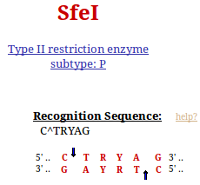
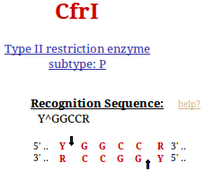
6 cutters according to remap? Surely R & Y only count 0.5? I agree with nebcutter, these are 5 cutters.

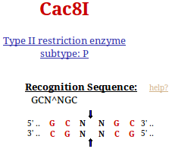

Oh come on remap!! you cannot count Ns!! This is a 5 cutter also.

Some enzymes in this map appear in the same place as remap predicted, but have different names. Can you explain why?
Restriction mapping programs, by default, only map one member of each isoschizomer family. There is no consistency between programs in the choice of the representative enzyme.
For example:
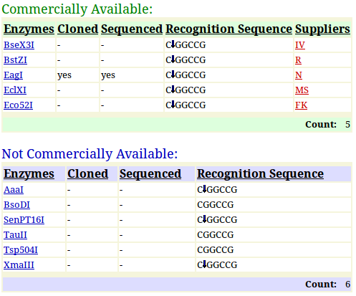

remap chooses to show just XmaIII

nebcutter chooses EagI, probably because it is commercially available.

They both have the same recognition site and so would both cut at the indicated position.
From your investigations of Searching for sequence similarities in databases
When would Mask lower case letters be a useful thing to do?
Generally, whenever one might suspect the automatic masking algorithms of blast might miss a non informative region in a specific query sequence, obviously.
A specific example might be when a query sequence contained a significant informative region that was known to be common amongst the sequences being searched. If this region was left unmasked, blast would pick up so many similar matches to this one region that other interesting similarities might be obscured. By manually masking such a region by changing it to lower case, its matches would not be seen by blast and matches with other regions of the query sequence should be more apparent.
Which parameters would blast need to automatically adjust to cater for short input sequences (such as primers being tested for uniqueness), and why?
The word size: Clearly, if you are trying to find matches for a primer (for example) of around 20 base pairs, it would be pretty silly to use a word size of 28 (default for megablast). A word the same size as the primer would find only exact matches. A word of about 7 would allow a couple of mismatches and would probably be most generally appropriate.
The expect score: As good chance matches between between a short query sequence and a large database will be abundant, it would not be sensible to choose a demanding (i.e. small) expect score to represent the limit of significance. In particular, a primer sized query sequence of around 20 base pairs might easily exactly match more than 10 times (generally the default maximum expect score for a significant match) just by chance. After all, there are only 4 bases, a string of 20 is not that long and the databases can be huge! Typically blast chooses very high expect score cut off for short query sequences, effectively removing the expect score filter altogether.
Earlier versions of blast did not automatically adjust these parameters. When a short query sequences were selected, suitable adjustment was left to the user. Without sensible parameter adjustment, results could be greatly confusing. For example, a 21 base pair primer could easily match perfectly more than 10 times against a large DNA sequence database. blast is set to ignore matches that are expected to occur more than 10 times by chance. Thus even exact matches with such a small sequences would be ignored! Now automatic parameter adjustment is undertaken by blast, the user does not really have to think too hard. However, it does seem to be a good idea to know what blast is doing and why.
Why do you suppose that a few of the exons do not achieve the maximum score?
Summary:
Each local region of significant alignment between a database entry and a query sequence is scored independently. The scoring method that governs the alignment score colour in this graphic, reflects both the quality of the match and its length. Unless a particular region is of sufficient length, it cannot achieve the 200 bit threshold even if the alignment is perfect. Note that is is the shorter regions that fail to reach thestatus. All of the illustrated local alignments associated with PAX6 transcripts are essentially perfect.
Full Answer:
In common with most database searching programs, blast compares query sequences with database entries using a local strategy. The overall evaluation of a particular query sequence is taken to be the highest local score.
Individual local matches are coloured according to individual quality. In this query, all true matches should be perfect, or very nearly so. Scores might therefore be expected to be maximal (). However, they are not? Some only manage a score in the range .
The score referenced for this purpose is the bit score. For a full, no holds barred definition of this score, try here. I prefer this somewhat gentler version:
“The bit score gives an indication of how good the alignment is; the higher the score, the better the alignment. In general terms, this score is calculated from a formula that takes into account the alignment of similar or identical residues, as well as any gaps introduced to align the sequences. A key element in this calculation is the “substitution matrix ”, which assigns a score for aligning any possible pair of residues. The BLOSUM62 matrix is the default for most BLAST programs, the exceptions being blastn and MegaBLAST (programs that perform nucleotide–nucleotide comparisons and hence do not use protein-specific matrices). Bit scores are normalized, which means that the bit scores from different alignments can be compared, even if different scoring matrices have been used.”
Still too scary? The important things to note are that:
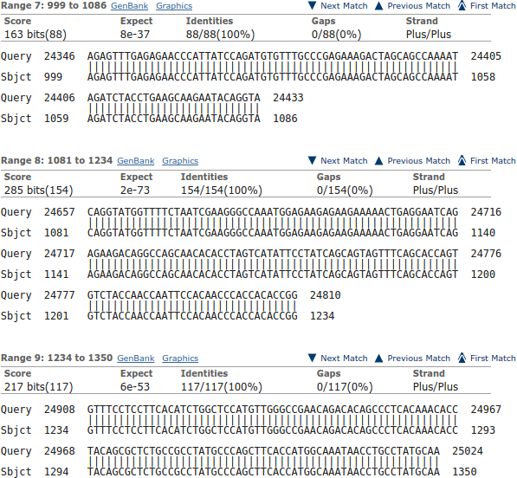
- These scores are based on a simple DNA scoring matrix (1 for a match, -2 for a mismatch by default for megablast), plus penalties for gaps. So scores will be limited by the length of the alignment, ignoring gaps.
- The scores reflect penalties for indels (insertions or deletions).
- The scores are normalised so that they do not depend on the chosen scoring matrix. This allows bits scores from searches using different scoring matrices to be compared.
This being so, bit scores will reflect the length of an alignment as well as its quality. If an alignment is very short, it might be perfect but still not achieve a very high value. bit scores are designed to reflect significance, not just local quality. A short perfect match clearly can be less significant than a longer less perfect match. That is what you see illustrated here.
You can see evidence of what is occurring in the alignments further down your results. Here is illustrated one of the exons that occur in all transcripts at position 24,346. The match is perfect, but the length of the exon is consistently just to short to get to the heady level.
Note how imperfectly blast finds exon/intron boundaries. If the start of an intron happens to match the start of the next exon, blast will included the bases in two alignments. It is not looking for exons and introns as was spline, it just mindlessly seeks matches.
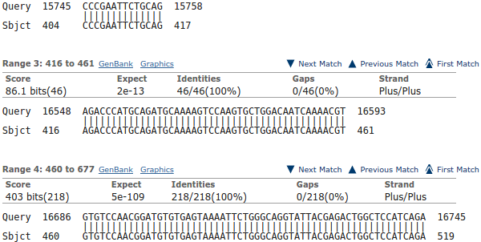
For a further example, look at the exon that is found only in the isoform 5a transcripts. It is tiny (42 base pairs) and scores well below even thought it is a perfect match.
Note that the alignment is 46 base pairs long due to blast adding on two bases either side that are actually the highly conserved intron start and end base pairs. As you can see, these extra base pairs occur in the preceding and succeeding alignment also.
Explain why one exon in the reasonably consistent region, does not appear in all of the transcript matches?
Oh dear oh dear! Not this again.
Well I refer to the isoform 5a exon, of course. The tiny inconsistent one about 9 exons in from the right (when it exists). This will, clearly, only occur in isoform 5a transcripts. One day I will tidy these questions up a trifle!
Why were you not surprised to discover 24 PAX6 transcripts in Refseq matching this sequence?
Repetitive? True. This question is more “interesting” when the resources you have visited do not agree. That is, most of the time. Whilst the situation is in balance, the answer is:
Because GeneCards says there should be 11 quality and a further 13 less supported PAX6 mRNA sequences in RefSeq. A total of 24 PAX6 implied transcripts in total. In passing, you could have discovered the number of PAX6 mRNA sequences in RefSeq but asking RefSeq directly. Probably a more sensible and certainly a more reliable approach.

Which of the Refseq PAX6 transcripts corresponds to isoform 5a?
Summary:
As I am sure you are tired of noting by now, all the transcripts with the extra tiny exon around position 1,600 in the genomic sequence are isoform 5a transcripts.
Full Answer:
The isoform 5a transcripts can be spotted most easily from the graphic. They are the ones with the extra small exon slightly to the left of middle (around base position 1,600). For example, the first, second and third blast matches displayed. If you hover over these matches with your mouse, you will see that they are transcript variants 1, 2, 3, 6, 7, 8, 11, 12, 14, 18, 19, 20, 21 and 23 (in the vertical order of the graphic).
Stated with the unequalled poetry of RefSeq Accession Code and lyrical Title Line, that becomes:
TITLE ACCESSION CODE
Homo sapiens paired box 6 (PAX6), transcript variant 11, mRNA NM_001310161.1
Homo sapiens paired box 6 (PAX6), transcript variant 10, mRNA NM_001310160.1
Homo sapiens paired box 6 (PAX6), transcript variant 8, mRNA NM_001310158.1
Homo sapiens paired box 6 (PAX6), transcript variant 5, mRNA NM_001258463.1
Homo sapiens paired box 6 (PAX6), transcript variant 4, mRNA NM_001258462.1
Homo sapiens paired box 6 (PAX6), transcript variant 2, mRNA NM_001604.5
PREDICTED: Homo sapiens paired box 6 (PAX6), transcript variant X13, mRNA XM_005252958.3
PREDICTED: Homo sapiens paired box 6 (PAX6), transcript variant X12, mRNA XM_011520153.1
PREDICTED: Homo sapiens paired box 6 (PAX6), transcript variant X10, mRNA XM_011520152.1
PREDICTED: Homo sapiens paired box 6 (PAX6), transcript variant X6, mRNA XM_011520150.1
PREDICTED: Homo sapiens paired box 6 (PAX6), transcript variant X5, mRNA XM_011520149.1
PREDICTED: Homo sapiens paired box 6 (PAX6), transcript variant X4, mRNA XM_005252954.3
PREDICTED: Homo sapiens paired box 6 (PAX6), transcript variant X3, mRNA XM_011520148.1
PREDICTED: Homo sapiens paired box 6 (PAX6), transcript variant X1, mRNA XM_011520146.1
Yes well, that was fun? When I first wrote this question, there was only 5 or 6 RefSeq mRNAs! The message of the question was to ensure you could see how to spot the isoform 5a transcripts (again!), not to list them! But, never mind, doing so was in fine tune with the ennui of the moment.
Additional Meanderings:
That really should not detain anyone but me? They belong after the consideration of masking the run of As for the megablast you ran. I just enjoyed this detour, so I keep it somewhere low profile. The whole journey leads nowhere of any note, so, should you decide to read, expect little!
The 500 base pairs of 3' flanking sequence added on to the Ensembl sequence for “good measure”, is not part of the alignment (as would be expected). This can be seen easily if you look at the end of the alignment illustrated above, which is the alignment of the last exon of a transcript.
The entire length of this transcript is 6,732 base pairs.
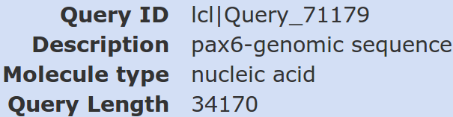
The entire length of the genomic query sequence is 34,170 base pairs.

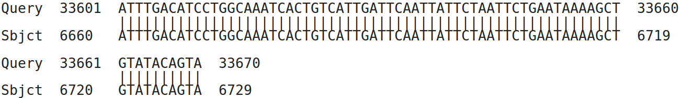
The alignment ends at position position 6,729 of the mRNA (3 from the end) and position 33,670 of the genomic sequence (exactly 500 base pairs from the end).
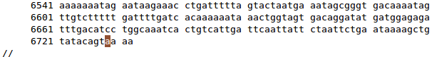
The 3 missing base pairs of the mRNA are all As, due to polyadenylation. Position 6,729 being recorded as a polyA site by RefSeq. A very short polyA tail surely? But there is no telling what stage of the mRNA is recorded on RefSeq. Wikipedia says:
“The tail is shortened over time, and, when it is short enough, the mRNA is enzymatically degraded.”
Of course, the neatness of this observation does reflect less some profund biological truth than it does that this mRNA just happens to be one that extends furthest to the right in the genome, and there is no chance match between the polyA tail and the extra 500 bases of genomic sequence you added on when extracting it from Ensembl.
The journey was fun even though the destination was dubious. Much the way of a considerable portion of life in general one might reflect?
What are the 9 stronger matches around base position 16,000?
Matches between the regions of genomic DNA encoding Paired Box domains.
Why would you expect exactly 9 matches around this point?
Because that is how many Paired box domains are suggested to be in the human genome by counting the number of quality mRNA sequences in RefSeq claiming to include a Paired box coding region. There is PAX6 plus its 8 paralogues, imaginatively all named:
PAX1, PAX2, PAX3, PAX4, PAX5, PAX6, PAX7, PAX8 & PAX9

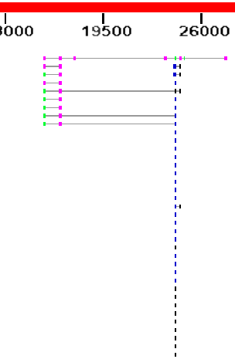
What do you make of the plethora of matches around 24,000?
These are matches between human mRNA sequences with the regions of genomic DNA encoding Homeo Box domains. As you discovered from Interpro, there are many of these.
The thin line joining features implies that those features relate to the same database entry.
Notice that 4 of the 9 proteins matching a Paired box genomic region also match a Homeo box region. the remaining 5 do not. This implies that 4 of the 9 proteins corresponding to the hits detected here have a Paired box domain near the start of the protein and a Homeo box domain further along. This is exactly as was suggested by the PROSITE annotation you examined.
Why do you suppose the Paired box matches precede the Homeobox matches?
Because they score more highly and so, in the opinion of blast, are more worthy. Primarily, they score more highly because they are longer. The list is ranked by E Value. Good matches with long sequence are less likely to occur by chance than equally good matches with shorter sequences.
Possibly a more interesting question might have been: “Why are not all the hits which include both domains at the top of the list?”. Surely they should be, as they match over a longer proportion of the query sequence and so must, in general at least, be of the greatest significance.
They do not always come at the top of the list because blast scores each matching region individually and uses the ranking scores associated with the single region with the highest E Value to evaluate the similarity of the entire database entry with the query. This has to be a dubious practice surely? But, it appears to work, so why complain.
To justify this last assertion, Look at your top hit.
E Val = 2e-40, Max score = 160, Total score 767 associated with the whole of P26367.2
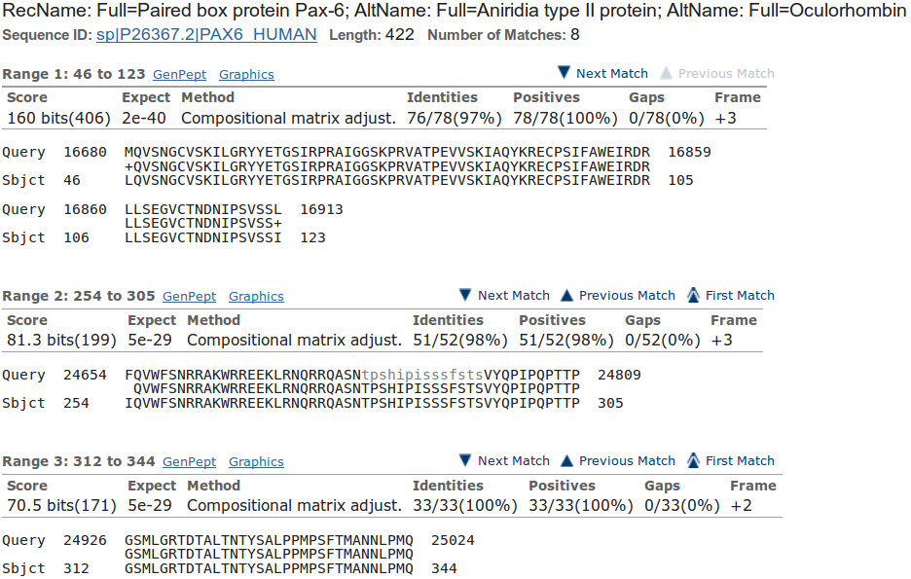
Now look at the first few individual regional alignments for this hit.
As you can see, the E Value and Max score values used to evaluate the whole protein were computed from just the best (ranked by E Value) local alignment! Crude, but never mind.
The Total score for the entire protein is the sum (rounded up to the nearest integer) of all the bit scores for all 8 local alignments computed for this protein (I suggest you just trust me on this assertion).
How do you suppose the Max matches in a query range parameter might be of value if this order was reversed?
If Paired boxes had been more prolific, then the number of Paired box matches might have filled the blast hit list before the highest scoring Homeo box hit was registered.
If Homeo boxes were longer, and so justified a better E value, then the number of Homeo box matches might have filled the blast hit list before the highest scoring Paired box hit was registered.
Either of these situations would be very unfortunate, but easily avoided by setting the Max matches in a query range parameter to something sensible (50 say). This would ensure that only the top 50 items in the blast hit list would be dominated by the strongest hit.
For further discussion of the parameter, see above.
How does this “non-informative” region match expectations suggested by Prosite and the Feature table of Uniprot for PAX6_HUMAN?
blast identifies two non-informative regions. I only discussed the prettiest one above. The region discussed is comprised largely of Serines, Prolines, Threonines & Isoleucines the 15 residues between 294-308.
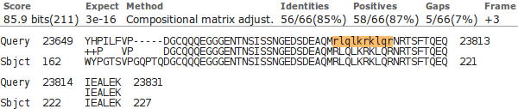
The second (to be found much further down your blast Alignments output) is comprised entirely of Arginines, Luecines and Lysines and Glutamines, the 10 residues between 203 - 212.

Uniprotkb also suggests there are two compositionally biased regions.
Well, hardly an exact match, but there is approximate agreement? One would certainly suppose that blast is only willing to mask fairly severe cases of compositional bias. It is also probable that blast has a rather more mechanistic (i.e. non-biological) interpretation of what computational bias is?
PROSITE also predicts the more obvious region of computational bias, rather more generally:
“An octapeptide and/or a homeodomain can occur C-terminal to the paired domain, as well as a Pro-Ser-Thr-rich C-terminus”

From your investigations of Primer Design
Do you think 10 primer pair suggestions is sufficient? If not, what number would you choose?
Until very recently, the default here was 5. That seemed rather low to me. I included this question to solicit opinion rather than to impart knowledge. A default of 10 seems more in line with my instincts, but people who use this program seriously mostly tell me that they can select suitable primers from the first 2 or 3 suggestions of the program. So, 5 would seem a good choice and 10 would be moving towards cautiously overdoing things.
On the whole, informed opinion suggests that 10 suggestions will be more than enough in most circumstances.
What value would you choose here if you were looking for uncluttered results?
Summary:
Clearly, the smaller the number chosen, the shorter will be the list of spurious products. However, pick something too small and you risk including unintended product(s) that could cause confusion. The size selected must be sufficient that larger unwanted PCR product(s) could easily be spotted by other means (simply by size?).
Full Answer:
Well, mostly for me, and just in case you were curious, when I first wrote the question, the parameter was very different and not so easy to understand. Pure self indulgence, I know, but here is the history. The parameter explained itself, via thebutton, thus:
I interpreted this to mean that only blast predicted products of up to X+4,000 base pairs, where X base pairs is the length of the intended target, will be given any regard. It is thus assumed that a difference of 4,000 base pairs between an intended PCR product (predicted by primer3) and a spurious product (detected by blast) can easily be detected simply by size difference.
Of course this parameter also will reject unwanted blast predicted products that are less than X–4,000 base pairs will be given any regard. Given the largest possible primer3 suggestion will be 1,000 base pairs (the form setting for the exercise specifies products of between 100 and 1,000 base pairs), this is hardly an issue here.
Comment upon the small default value for the Blast word size?
By default, blast will be looking for aligned exactly matching blocks of 7 nucleotides when identifying where a primer might match a database entry. The entire primer match with the template sequence does not have to be exact for the primer to be acceptable. The entire primer is typically only around 20 bases long. And word size much more that 7 would clearly miss too much to be effective.

Why do you suppose blast did not pick up all the transcripts?
Summary:
Well, the simple answer is that the transcripts that were not detected as unwanted products cannot include either the forward primer, or the reverse primer, or both. This is, almost, the only possible explanation.
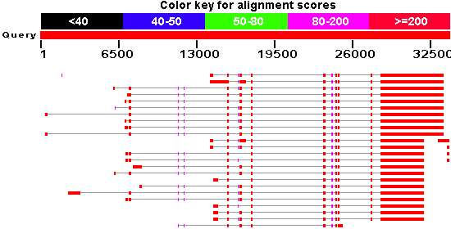
Full Answer:
Of course, for this run, you did specify that you were not interested in products longer than 4,000 base pairs, so it could be that one or more products were possible but longer than that? I suspect this would only be feasible if there were retained introns involved, but previous blast results do not suggest this to be the case. I would say the only possible candidate for an over-length product might be the second hit down in the graphical representation generated previously by blast. The first and third exons from the left look a bit bloated, but not really sufficiently to cause a problem.
It might also be that unwanted PCR products are eliminated/introduced due to variations in the predicted transcripts. However, this can be ruled out as previous experiments, blast assures us that all 24 potential transcripts match the genomic sequence exactly.
Enough! Only because I want to, I will compute the alignments to prove the missing primer matches. Read no further unless you are truly in the mood. Much of the reason for recording the rest of this answer is that, apart from enjoying the pursuit of irrelevant detail, I also wanted to remember how I made the alignments and certainly feel I could have made both these, and my point much more simply? Suggestions welcome.
OK, I started by computing an alignment that was a mapping of all 24 transcripts onto the PAX6 genomic regions as represented in the file pax6_genomic.fasta. I used a program called gmap, which like spline (used in the exercise) is designed to align cDNA/mRNA sequences with corresponding genomic sequences. The version of gmap I used runs under linux from the command line. It has the advantage over spline that is will align more than one cDNA/mRNA sequence against the genome in one run. Unfortunately, it does not generate an output format that can be easily displayed in the way I required here. I did try to persuade a couple of general multiple alignment programs (clustalw & muscle) to make me a usable alignment, but ran into the same difficulties we experienced in the exercise. I failed to find gap penalties that would get the programs to gap the larger introns. Even if I had succeeded to get the gaps in the right place, I would not have believed them to be placed with sufficient accuracy for the same reasons this was not possible when we tried the same trick with general alignment software for just one cDNA sequence against the genome in the exercise.
So, I made a rough alignment with clustalw and edited it to exactly what was suggested by gmap using jalview. This took HOURS. There has to be a better way!! You have already used all the software mentioned except gmap and clustalw. You will use clustalw and see how jalview can be use to edit, as well as just view, alignments a little later.
All that effort to show that the region around the forward primer looks like this:
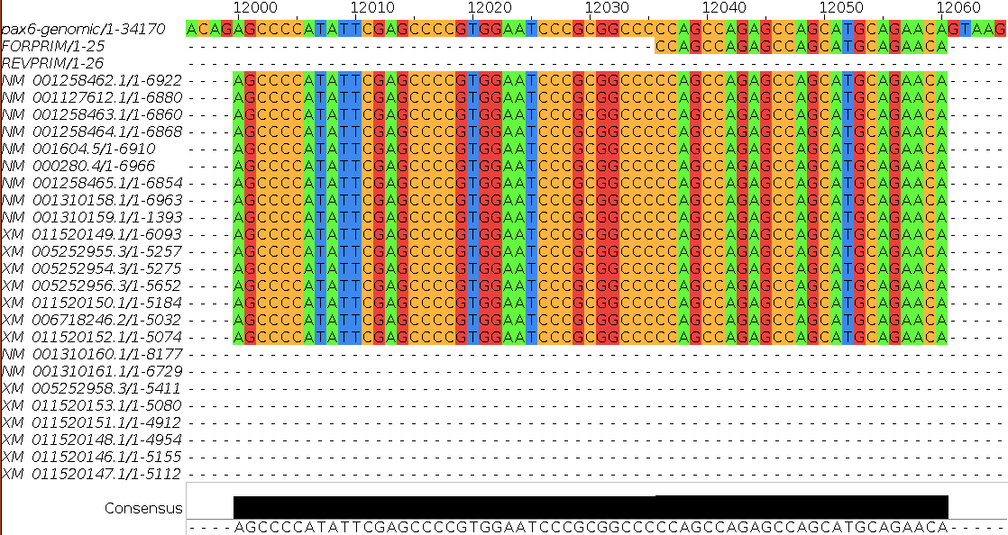
Showing clearly that the 8 transcripts:
NM_001310160.1
NM_001310161.1
XM_005252958.3
XM_011520153.1
XM_011520151.1
XM_011520148.1
XM_011520146.1
XM_011520147.1
Have the exon that includes the forward primer spliced out and so will not produce any PCR product. Feel free to check this by comparing the textual results of your blast of the genomic sequence against the RefSeq mRNAs and the results of PRIMER-BLAST. I did, it was lots and lots of fun and I ended up content that all was logically consistent.
The alignment around the reverse primer looks like this:
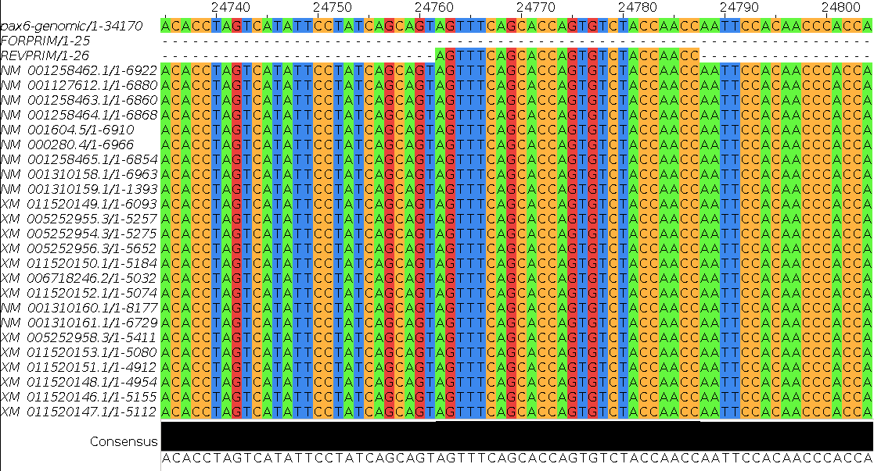
All 24 putative transcripts match the reverse primer perfectly. So blast should indeed find 16 of the 24 transcripts sequences in RefSeq, and it does.
Jalview offers an overview of the entire alignment. The top row shows the genomic sequence. The second row shows the position of the forward primer. The third row shows the position of the reverse primer.
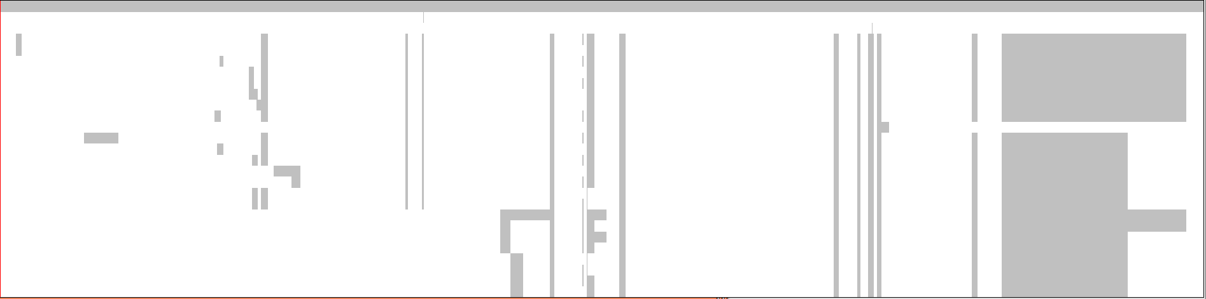
Except for the order of the transcripts, this view is very similar to the overview graphic generated by blast. The transcripts missing the forward primer, which isoform each transcripts represents and the fact that all transcripts match the reverse primer should be very clear.
Finished Dave? Well no, not quite. I wondered why I had included the genomic sequence in my alignment. Finding no answer to that question, I tried to make an alignment of just the primer sequences and the mRNAs. I thought this would be easy. I was wrong. The general programs are still going to get the gaps wrong whatever penalties are used. Some transcripts have exons entirely missing in all other transcripts leaving no clues as to which way round they should be aligned. The scaffold provided by the genomic sequence was essential. So, I made an mRNA only alignment by editing the alignment discussed above with jalview. This was easy (although you would not think so given the time it took me to work out how to do it!). I loaded the alignment into jalview, deleted the genomic sequence and then removed all empty columns (that is, all columns with no bases in them due the the removal of the genomic sequence). Clever eh? Just because it is there, here are the pictures.
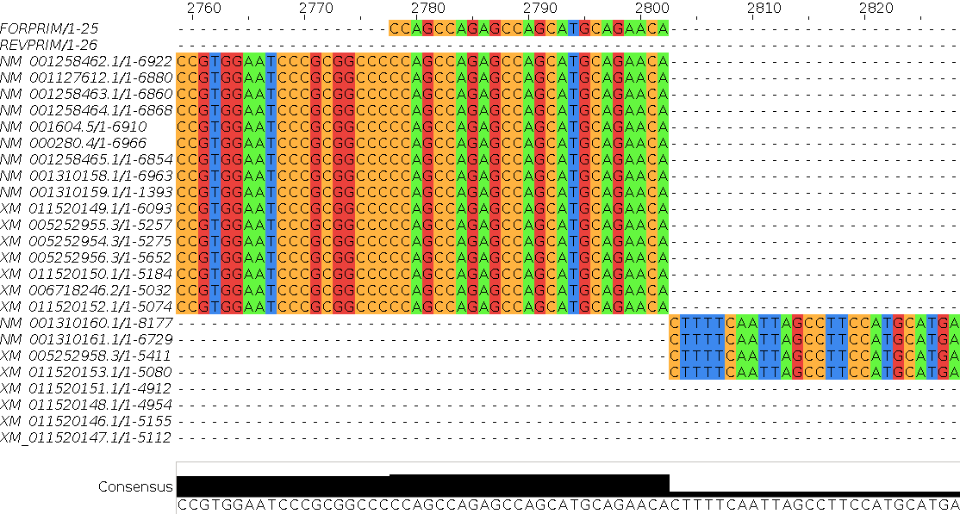
Forward primer region (the primer is right at the end of an exon):
Reverse primer region:
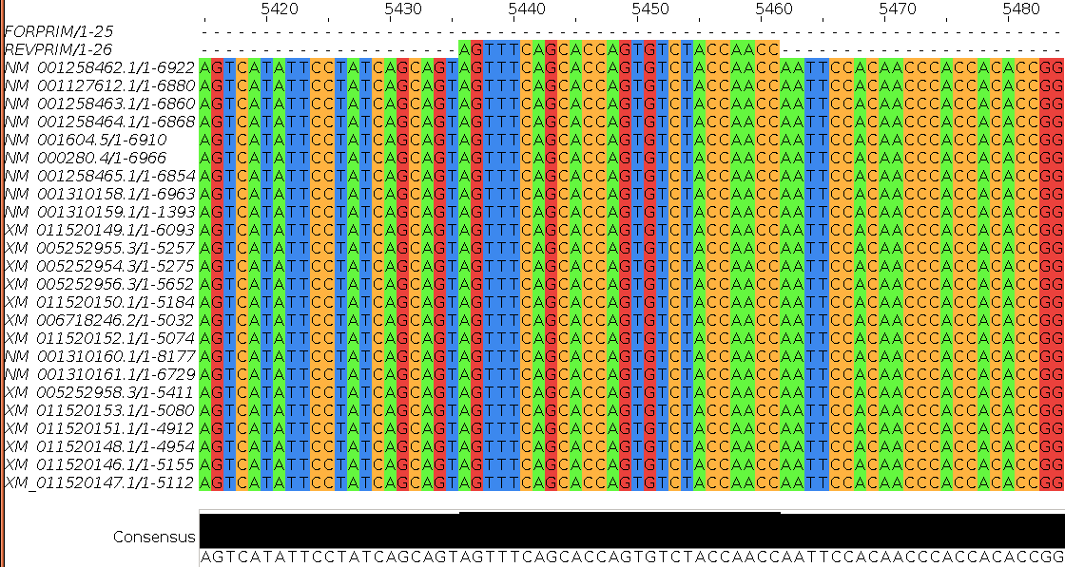
Overview:
Without the evidence of the genomic sequence, the two leftmost exons could logically swap position. There is no transcript that includes both these exons and no overlap between either and any other exon in any transcript (most clearly verified from the previous Overview plot). Thus, there is no exon evidence of the order in which the two should appear.
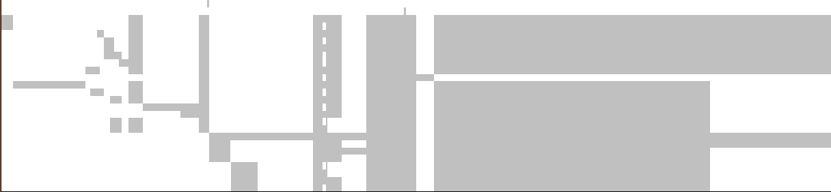
Now I am done! This has to be the most over the top answer yet, but at least it kept me out of trouble for a while.
How would you tell quickly which isoform was represented by each mRNA listed here?
Summary:
All the mRNAs reported were of length 908, 950, 707 or 749.
A reasonable guess might be based on the length of the products? All those that are 908 bases might be assume to produce the 422 amino acid canonical isoform. All those that are 950 (i.e. 42 base pairs longer) might be assumed to 436 produce amino acid isoform 5a proteins (i.e. 14 amino acids longer).
Analogous reasoning might be applied to the mRNAs that are either 707 or 749 base pairs in length.
Just a guess of course, but one I would be happy to have faith in. To be certain, one would need to read the annotations of each listed RefSeq entry!
Full Answer:
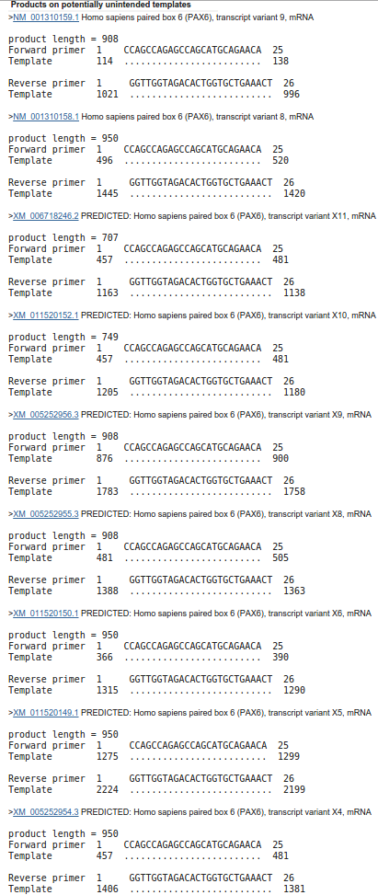
From the illustrations of the last “Full Answer” (in particular, the jalview overviews), it is clear that all the mRNAs that produce a product include the region that determines which isoform is represented. That is, all are one isoform or the other.
The last two of the mRNAs that produce a PCR product, have a bit chewed out just after the isoform defining region (an exon spliced out, if you prefer). It is logical to suppose these would be the mRNAs from which the two shorter products were generated.
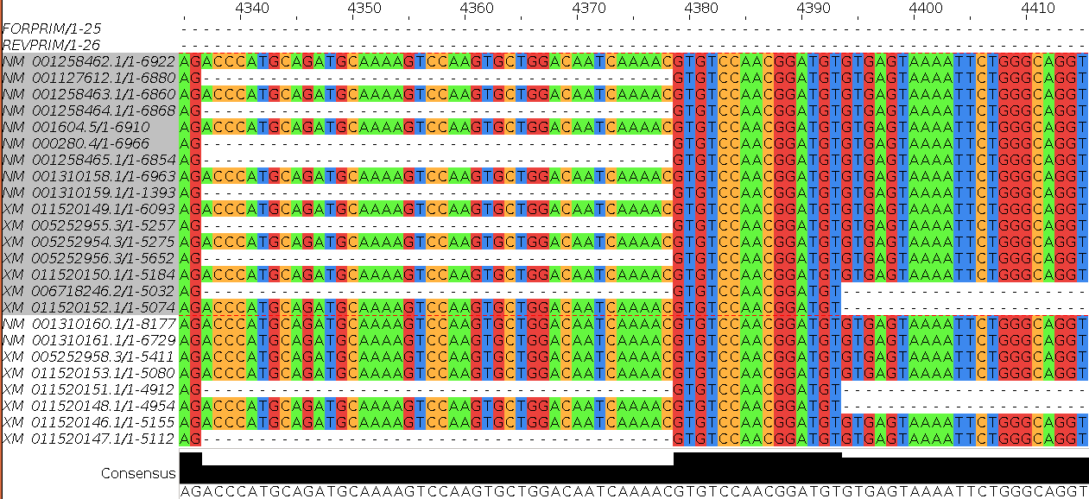
Indeed, looking at the relevant part of the mRNA only alignment shows them to be XM_006718246 (product length 707, excluding the isoform 5a exon that suggest it codes for a canonical protein) and XM_011520152 (product length 749, including the extra 42 base pairs suggesting it codes for an isoform 5a protein ).
All other transcripts that generate PCR products generate products of length either 908 or 950. Given the difference (42 base pairs) is exactly the size of the isoform 5a exon, it is reasonable to assume the transcripts generating PCR products of length 908 represent canonical proteins, whereas the transcripts generating PCR products of length 950 represent isoform 5a proteins.
Prettier? True, and I submit including sufficient evidence to be more that just a guess now.
Is the number of “potentially unintended products” as you would you expect, given the evidence from GeneCards, Ensembl and blast?
Yes, I think so, given you accept my investigation (see above) as to why there were only 16 “potentially unintended products” when you might have expected 24, given your blast results. GeneCards now encourages an initial expectation of 24 “potentially unintended products”. Ensembl only uses the higher quality RefSeq mRNAs. Currently, Ensembl uses 10 of the 11 good quality RefSeq mRNAs to make its transcripts predictions. Close enough?
For all the “potentially unintended products”, the selected primers match exactly. Can you explain this?
Well, of course they do??? All the transcripts found are generated from the same region of genomic DNA and therefore will be identical in all shared regions, including the primer regions. I suppose, in other instances, it would be possible to have transcripts with variation in the regions matching the primers insufficient to stop the primers working? But not in this case.
One might conclude there are no genuinely “unintended” products? All are real PAX6 transcripts of varying certainty. A genuine unintended product would come from an entirely different part of the genome and would not necessarily match exactly with respect to the primers. They would just need to be “good enough to work”.
The “potentially unintended products” are of different sizes. Can you explain the difference between the possible product lengths?
Are the numbers of “potentially unintended products” of each possible length consistent with your blast results?
Yes yes yes! I think both these questions made a bit more sense a few generations of these notes ago. We have already answered them sufficiently I suggest. I refer you to the answers above.
From your investigations of Protein Secondary Structure Prediction with GOR I
How credible would you say was the prediction at amino acid 33?
. 10 . 20 . 30 . 40 . 50
MQNSHSGVNQLGGVFVNGRPLPDSTRQKIVELAHSGARPCDISRILQVSN
helix HH H
sheet EE EEEEEEEE EEEEE EEEEEE
turns T TTTT TTT TTT
coil CCCCCCC CCCCC CC C
. 60 . 70 . 80 . 90 . 100
GCVSKILGRYYETGSIRPRAIGGSKPRVATPEVVSKIAQYKRECPSIFAW
helix HHHHHHHHH HHH
sheet EEEEEEEE EEEE EEE
turns TT TTTTT TTT T TTTT TT
coil C CCC C C
. 110 . 120 . 130 . 140 . 150
EIRDRLLSEGVCTNDNIPSVSSINRVLRNLASEKQQMGADGMYDKLRMLN
helix HHH HHHHHHHHHHHHHHHH
sheet EEEEEEEEE EEE
turns TT TTTTTTTTT T
coil C CCC CC C
. 160 . 170 . 180 . 190 . 200
GQTGSWGTRPGWYPGTSVPGQPTQDGCQQQEGGGENTNSISSNGEDSDEA
helix HHH
sheet EEE
turns TT TT TTT TTT TT TTTTT TT
coil CC CCC C CC CC C CCCCCCCCCCCCCC
. 210 . 220 . 230 . 240 . 250
QMRLQLKRKLQRNRTSFTQEQIEALEKEFERTHYPDVFARERLAAKIDLP
helix HHHHHHH HHHHHHHHHHHH HHHHHHHHHHHHHH
sheet E
turns TT TTTT T T
coil CCCCC CCC
. 260 . 270 . 280 . 290 . 300
EARIQVWFSNRRAKWRREEKLRNQRRQASNTPSHIPISSSFSTSVYQPIP
helix HHHH HHHH H
sheet EEE EEEEE
turns TT TTTT TTTTT T TTTTTT
coil CCC CCC CCC CC CCCC
. 310 . 320 . 330 . 340 . 350
QPTTPVSSFTSGSMLGRTDTALTNTYSALPPMPSFTMANNLPMQPPVPSQ
helix
sheet EEEEE EE EEEE EEEEE EEE
turns T TTTT TT TT TT
coil C CC CCCCCCC C CCCCC CC CC
. 360 . 370 . 380 . 390 . 400
TSSYSCMLPTSPSVNGRSYDTYTPPHMQTHMNSQPMGTSGTTSTGLISPG
helix
sheet EEEE EEE EEEE
turns TTTT TT T TTTTTTT TT T T T
coil CC CC CC CC CCC CCCCCCC CC
. 410 . 420
VSVPVQVPGSEPDMSQYWPRLQ
helix
sheet EEEEEEE
turns T TTTTT TTT
coil C CCC CC
The original GOR predicts a Helix of length 1 at position 33! This is just daft! A single amino acid cannot form a helix all by itself, it must have a few friends to make a believable Helix … or Beta Sheet, come to that.
Later versions of GOR made such silly predictions impossible, preferring to take the second best possibility for all insane predictions. In this case, positions 26, 27 & 33 would all probably be predicted as Beta Sheet (E – for Extended). Wrong (according to UniprotKB) but more logical.
Position 33 is, as you have discovered, the amino acid that, when mutated from an Alanine to a Proline, is the major cause of Aniridia. As you will confirm later, it is at the end of a Helix critical to to the DNA binding properties of the protein. Alanines are fine in Helices. Prolines are not.
How would you rate the prediction overall?
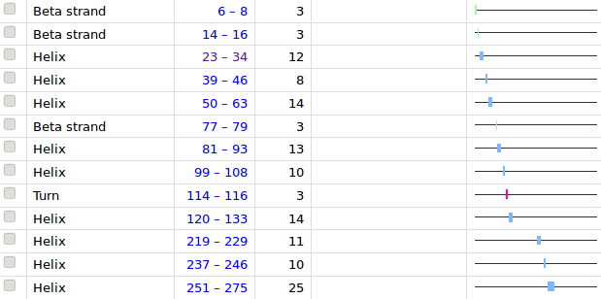
Referring to the structure according to UniProtKB, I colour the Helices Red and the Beta Sheets Blue. Position 33 I colour Grey. I do not believe the turn predictions, there are far too many! However, as the one predicted does, almost, match the UniProtKB assertion, I will highlight it with Green.
The Coils are boring, so I do not colour them at all!
Well, what do you think? It might reach the 60% or so accuracy claimed by the version of GOR, but what does that really mean? There are only four possibilities so 25% “accuracy” can be expected by chance. Add a small insight into the relative abundance of each possibility and you could improve on that before doing anything clever.
My, intuitive only, impression is that the program has found some useful insight into the problem, but I cannot say I am overly impressed. Of course, this is just one example. It is unreasonable to make harsh general judgement based on such light evidence. This is, after all, the crudest implementation of a simple method and I have seen it do much better with more compliant proteins.

From your investigations of Protein Secondary Structure Prediction with GOR IV
How does the prediction at position 33 compare with that of garnier?
Well, at least there is no attempt to suggest a one amino acid helix in this case! GOR IV, with justice, does not regard this as possible. Such silly predictions suggested by the arithmetic are rejected and replaced by more sensible alternatives computed by considering the likelihoods computed for other possibilities.
In a nutshell, GOR IV predicts position 33 to be at the end of a helix whose existence is supported reasonably well by UniProtKB. This is good! GOR I predicts position 33 to be a helix of length 1 amino acid in a region weakly suggested to have some sort of structure. This is weak, to say the least.
How would you rate the prediction overall?
I have coloured up the GOR IV results in the same way as I did for the GOR I results discussed above. Colouring the turn was unnecessary as GOR IV does not even try to predict turns.
10 20 30 40 50 60 70
| | | | | | |
MQNSHSGVNQLGGVFVNGRPLPDSTRQKIVELAHSGARPCDISRILQVSNGCVSKILGRYYETGSIRPRA
ccccccccccccceeeccccccccchhhhhhhhcccccccceeeeeeecccceeeeecceecccccccee
IGGSKPRVATPEVVSKIAQYKRECPSIFAWEIRDRLLSEGVCTNDNIPSVSSINRVLRNLASEKQQMGAD
ccccccccccchhhhhhhhhccccceeehhhhhceeccccccccccccccchhhhhhhhhhhhhhhhhhh
GMYDKLRMLNGQTGSWGTRPGWYPGTSVPGQPTQDGCQQQEGGGENTNSISSNGEDSDEAQMRLQLKRKL
chhhheeeecccccccccccccccccccccccccccceecccccccceeeeccccchhhhhhhhhhhhhh
QRNRTSFTQEQIEALEKEFERTHYPDVFARERLAAKIDLPEARIQVWFSNRRAKWRREEKLRNQRRQASN
hhccccchhhhhhhhhhhhccccccchhhhhhhhhhhcccccchhhhhhcchhhhhhhhhhhhhhhhccc
TPSHIPISSSFSTSVYQPIPQPTTPVSSFTSGSMLGRTDTALTNTYSALPPMPSFTMANNLPMQPPVPSQ
ccccccccccccccccccccccccccceeeccccccccccceeccccccccccceecccccccccccccc
TSSYSCMLPTSPSVNGRSYDTYTPPHMQTHMNSQPMGTSGTTSTGLISPGVSVPVQVPGSEPDMSQYWPR
cceeeeeeccccccccceeccccccceeecceecccccccccceeeeccccccceeecccccccccccee
LQ
ec
This prediction is clearly loads better than the original GOR managed. In particular:
- The region after the last helix (position 280 or so onwards) is, give or take a few spurious attempts at Beta Sheets, predicted accurately as unstructured (i.e. Coil).
- The predictions for the Beta sheets are slightly worse that GOR I managed. Both programs got the second of the three and missed the first entirely, but GOR I did pick two of the three positions for the third Beta sheet, GOR IV missed it altogether!
- Neither program got the helices quite right, but GOR IV was much closer to the right answer (according to UniProtKB). The two helices GOR IV missed altogether were predicted as largely structured (i.e. Beta Sheet instead of Helix). Generally, GOR is pretty reliable at picking structure, but not always the right structure. Knowing this, you could claim that predicting the helices as Beta Sheets beats predicting them as Coil.
I conclude, this is a usefully accurate prediction (as long as you do not take it TOO seriously) and certainly a big improvement on GOR I.
From your investigations of Protein Secondary Structure Prediction with Jpred
Some Notes on colouring the MSA generated by Jpred: (Click here to return to the Instructions.)
Mostly to remind me why and how I decided to colour the MSA as I did. My objective was purely to make obvious where the family of proteins were meaningfully similar. If you are happy that this objective was achieved, it is probably best to read no further.
I discovered most of what follows by Selecting the Help (easiest way is to press F1 key, otherwise there is a pull down option at the top of the display, choose Documentation option) and searching for “conservation”. From the list of hits, I first selected “Alignment Conservation Annotation”. There it says:
“Conservation is measured as a numerical index reflecting the conservation of physico-chemical properties in the alignment: Identities score highest, and the next most conserved group contain substitutions to amino acids lying in the same physico-chemical class.
Conservation is visualised on the alignment or a sequence group as a histogram giving the score for each column. Conserved columns are indicated by '*' (score of 11 with default amino acid property grouping), and columns with mutations where all properties are conserved are marked with a '+' (score of 10, indicating all properties are conserved).
Mousing over a conservation histogram reveals a tooltip which contains a series of symbols corresponding to the physico-chemical properties that are conserved amongst the amino acids observed at each position. In these tooltips, the presence of ! implies that the lack of a particular physico-chemical property is conserved (e.g. !proline).”
I think to understand the detail of the scoring, one would have to read the paper quoted in the Help. I think I will leave that until another day! For now, I just make a few notes.
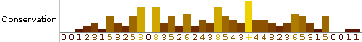
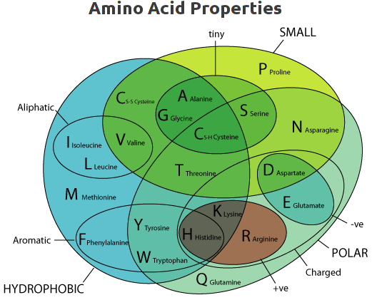
- The numbers under the histogram columns appear to represent simply the number of phsico-chemical properties considered to be conserved. At least, this is consistently true for this example, shown by hovering the mouse over the histogram columns.
- Jalview admits to exactly 10 phsico-chemical properties that must be one of “Not conserved”, “positively conserved” or “negatively conserved”.
ILVCAGMFYWHKREQDNSTPBZX-
XXXXXXXXXXX·······X···XX Hydrophobic
········XXXXXXXXXX·XXXXX Polar
··XXXX·········XXXXX··XX Small
···················X··XX Proline
····XX···········X····XX Tiny
XXX···················XX Aliphatic
·······XXXX···········XX Aromatic
··········XXX·········XX Positive
·············X·X······XX Negative
··········XXXX·X······XX Charged

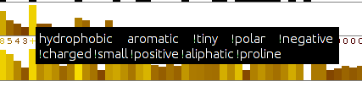
- The column achieving a “+” has all 10 conserved phsico-chemical properties either positively or negatively conserved. It is a highly, but not completely conserved “F”. This would appear to agree with the Help? There is no example of a 100% conserved column in this example. If there was, I would expect it would be represented by a “*” representing a score of 11.
- Conservation of any given property does not have to be 100% and gaps are tolerated. Reasonable as to be too exacting would eliminating. I expect the details are explained in the original paper. I justify this statement, unnecessarily, by claiming there are both gaps and a Proline in the column represented by a “+”.
- I am still uncertain about the difference between a “0” column and a “–” column? I decide to believe they are both columns were there is no measurable conservation, but “0” columns are in regions where they are surrounded by significant conservation? One day, I will read the paper.
- By observation, it can be seen that “conservation” is measured relative to the consensus sequence rather than the query sequence. This seems a reasonable choice to me.
Well that was fun? Now I write some instructions to turn the nasty bland alignment into one that glows blue.
Click here to return to the Instructions.
What protein database has Jpred chosen to search for protein sequences for the alignment upon which its predictions will be based?
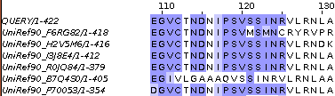
The database Jpred instructed PSI-blast to use to seek proteins homologous to the PAX6 query can be determined by looking at the sequence identifiers displayed down the left hand side of the alignment in Jalview. The identifiers are constructed from the name of the database and the entry identifier separated by an underline character. So the database is the UniRef90 cluster database built from the UniProtKB database.
The UniRef cluster databases comprise entries that are not individual protein sequences, but cluster of similar sequences. In the case of the UniRef90 database, each entry includes all sequences 90% identical to a given seed sequence. A representative sequence is elected as the only one of the cluster to be considered by such as PSI-blast, but clearly, a hit with any representative sequence implies significant similarity with all the sequences of its cluster.
I offer a supplementary exercise to investigate these cluster databases for those to whom they might be of particular interest.
Why do you suppose this database was used in preference to, say UniprotKB?
The reason Jpred runs PSI-blast is to identify sequences representing as wide a family of proteins as possible, to which a Query sequence belongs. For the purpose of structure prediction, there is little value in this collection including many sequences that are essentially identical. A wide variety of sequences, as long as they still are likely to be homologous, is of far greater value than a huge number of sequences. Using a UniRef database allows that only the Representative sequence of each cluster of very similar sequences will be recognised and aligned by PSI-blast. This allows the PSI-blast MSA to include an extensive range of variation without being bloated by sequences too similar to be individually interesting.
How would you rate the Jpred prediction overall?
Well, frankly, not as wonderful as I was expecting. Better than GOR IV (investigated in a supplementary exercise), but still leaves room for improvement? jnetpred (essentially the answer) is reasonable. It misses a couple of helices including one that GOR IV also overlooks. However, it has considerably less false positive prediction tendencies than GOR IV. The JNETHMM predictions are particularly poor, saved by the much more accurate deliberations of JNETPSSM.
JNETHMM is a prediction computed from the Hidden Markov Model (HMM) representation of the final PSI-blast MSA.
JNETPSSM is a prediction computed from the Position Specific Scoring Matrix (PSSM) representation of the final PSI-blast MSA. PSI-blast uses PSSMs of the MSA of each iteration of its search as a Query for the next iteration.
The jnetpred prediction is effectively the consensus of the predictions of JNETHMM and JNETPSSM.
Here I have aligned the GOR IV and Jpred predictions with the secondary structure as recorded by UniProtKB.
So, can the prediction be improved? Jpred is better than this result suggests!
On reflection, maybe just throwing in the entire sequence of PAX6_HUMAN and hoping for the best was a little crude? Our protein has two major domains whose secondary structure one might expect to be conserved. PSI-blast will gather together a mountain of sequences that have one, or the other, or both of the domains and try to align them as if they were homologous over their entire length (a global alignment). BUT, they are not all globally homologous! This means that the alignment of both the domains regions will be polluted by sequence that represent proteins that do not include that domain. This must substantially reduce the quality of the prediction?
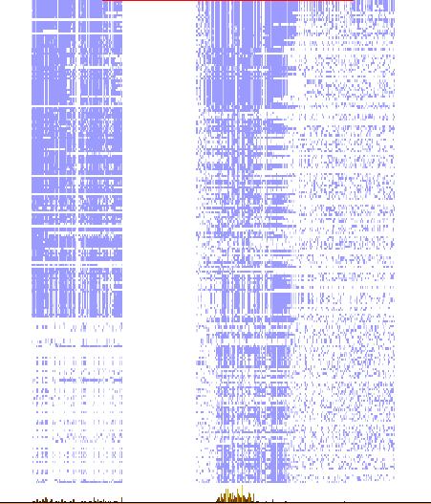
This phenomena can be illustrated by choosing to view the Jalview Overview Window (available from the View pull down menu).
The wider column of blueness at the start of the alignment represents the paired box domains. The picture suggests about one third of the aligned sequences do not have a paired box domain, but those sequences will have unrelated sequence in that region that will reduce the degree to which the alignment represents the properties of a paired box and so also the likelihood of a sensible structure prediction.
The problem for the more common homebox domain looks less severe, however, the alignment clearly includes many sequences that do not look to have a homeobox domain.
So, what to do? I suggest the two domains might be investigated separately? Why not run Jpred twice, once with just the PAX6_HUMAN paired box region and then again with just the homebox region.
I have done this for you and will now show you the results, however, should you wish to try it yourself, you already have the isolated sequence of both domains saved in local files. The sequence of the paired box region should be in a file called pax_domain.fasta. The homeobox sequence should be in a file called homeobox_domain.fasta. Run Jpred again with each sequence and you should get results very similar to mine.
First the new paired box prediction (top) compared to the original (bottom).
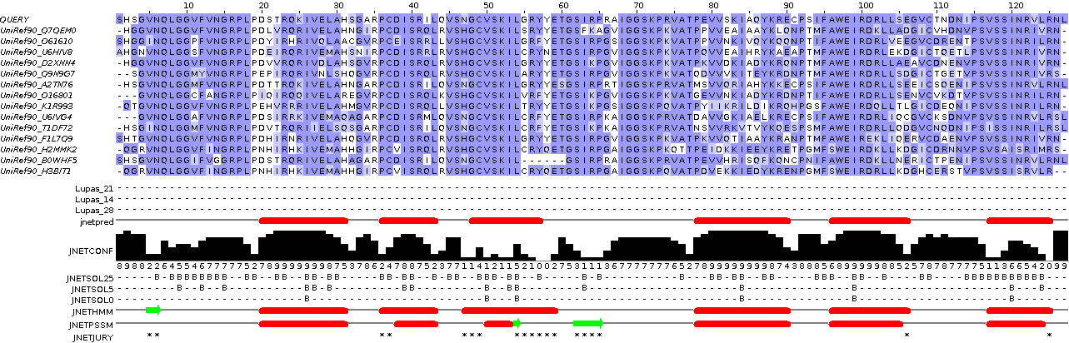
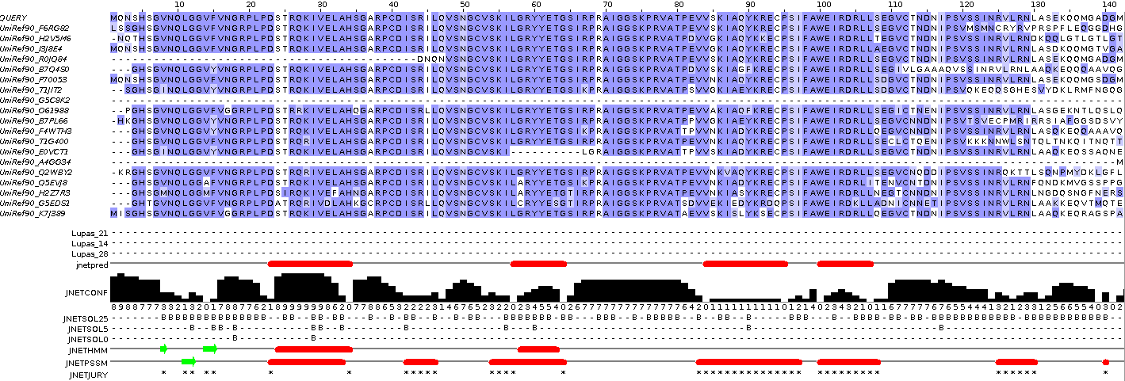
Massively improved I would suggest. All helices present and accurately placed. The JPREDHMM prediction, in particular, is very much improved. The Beta Sheet predictions seem weak? It finds only one (accurately) of the three that UniProtKB suggests to be present. I wonder why, but the helices for the paired box domain specific prediction are excellent.
And so to the homeobox specific results. Once more, the new homeobox prediction (top) compared to the original (bottom).
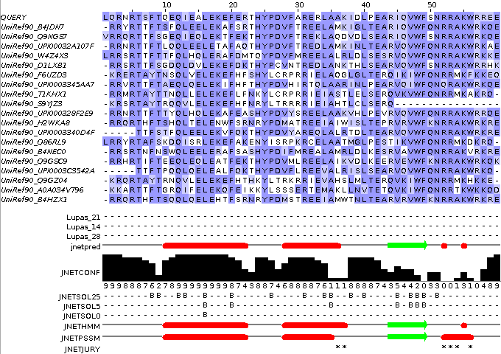
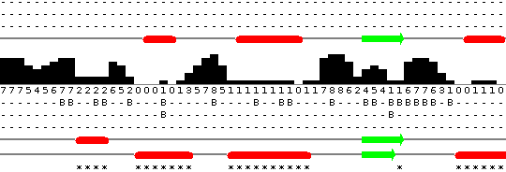
As the homeoboxs are significantly more numerous than the paired boxs, less interference from sequences not including a homeobox might have been expected. I imagined the improvement in prediction would be minimal. However, it is very much better! All three helices are predicted in the correct positions, although Jpred appears to be a little reluctant about the third helix? There is a rather strong beta sheet prediction that is unsupported by UniProtKB. There is no reason to suppose that UniProtKB is 100% correct, of course, but nothing I can find suggests that a beta sheet should appear in the middle of a homeobox. An enigma for another day.
So I conclude that this sort of protein analysis requires a little bit more than just throwing an entire sequence at a dumb program and assuming something marvellous will occur. In this case, considering the regions of the protein that are expected to be homologus separately is a very logical thing to do (and entirely obvious, retrospectively at least). Geoff Barton, whose group is responsible for Jpred agrees. He says:
“ … Always split proteins into domains when searching. … ”
So for both domains the prediction of the helices is far more accurate when each domain is considered separately. However, it is not just the red bars indicating the position of the helical predictions that should be noted. Look also at the confidence histogram. It indicates clearly that with more specific data to work on, better predictions can be made with much improved confidence (i.e. likelihood of being correct!).
Searching PROSITE
What is the signature pattern for N-myristoylation site?
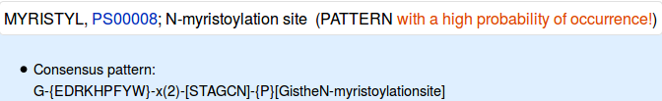
From the database entry, it can be seen that the pattern is 6 positions wide. 2 of those positions can be any amino acid. Only one position is fully specified. Not too demanding on the whole. I would expect this to match most proteins of any size and not always because there was an N-myristoylation site.
How would you interpret this pattern?
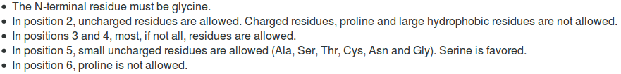
The pattern is explained in the database thus.
The description is not entirely an honest reflection of the information to which the scanning software will respond. The software is given to understand that ANY amino acid can occur in positions 3 and 4. The software has no way to know that “Serine is favoured” in position 5! Maybe you think that my pointing out these transparent truths makes me an intolerable pedant? Well … so is the computer!
How many N-myristoylation sites did ScanProsite suggest there might be in PAX6_HUMAN?
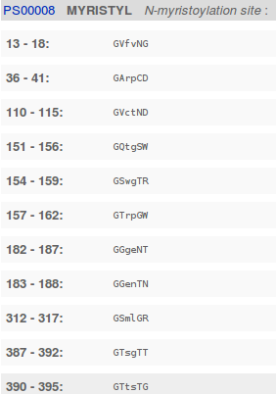

11, is the short answer. A site every 40 amino acids or so.

How many real N-myristoylation sites would you guess there might be in PAX6_HUMAN?
It is not really possible to answer this question from the evidence of this exercise. Intuitively, I would expect a large number of false positives from as weakly specified motif as this one. It has been suggested of this PROSITE pattern, by researchers looking at more sophisticated detection methods, that:
“PS00008 of PROSITE constructed from a small dataset … produces a great number of not only false positive but false negative predictions.”
Good enough for me not to believe the majority of these predictions to be reliable. Not good enough for me to hazard a meaningful guess as to how many real sites I would expect in this particular protein.
Searching Pfam
Would you have found anything of interest had you chosen “to search for Pfam-B matches”?
I did not find it straight forward to persuade the search to include Pfam-B entries.
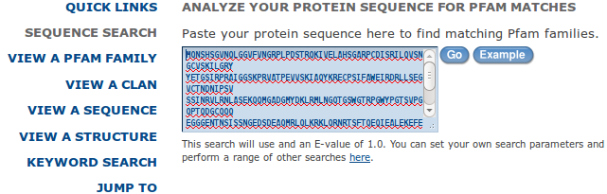
In the end, I set up the search as required just to search Pfam-A. Then, click on the truly tiny here link at the end of the sentence suggesting “You can set up your own search parameters ...”.

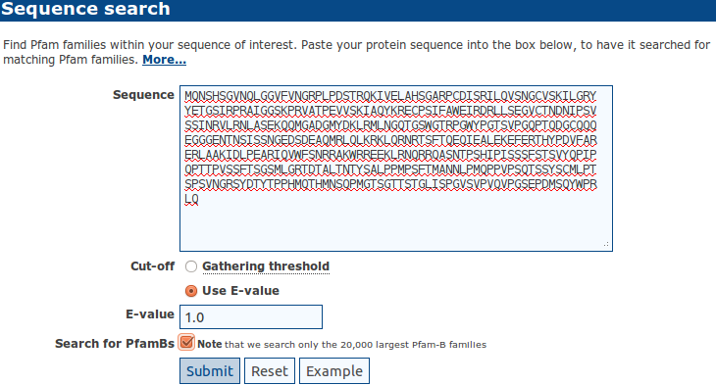
A new search form! I pause to feel badly treated in that I have to re-enter my sequence! I click the Search for PfamBs box, reflecting as I do so, how nice that button would have looked on the previous search form?

With a triumphant flourish, I click on the Submit button.

NOTHING!! Well one use to find a PfamB hit that made all the fiddling around make a very small amount of sense, but now??? NOTHING!!! They claim the hit one got previously was not a worthy hit … but … but … it was a hit!!! AND, I had a very nice story about how it fitted in with all that we have discovered previously. One, in common with dear Victoria, is NOT amused!

2015.08.08: So you thought that was bad Dave Mawr!!! … Now the little button has gone altogether and cannot search PfamB at all???? Query sent to Help.

2015.08.10: In reply to the question “ … Searching PfamB - Is this no longer possible? … “
“ … Correct - we are not longer producing Pfam-Bs, largely because most of the clusters not covered by Pfam are rarely meaningful potential new domains. Our recommendation now, is to take the piece of sequence of interest and run it using the HMMER webserver.
http://www.ebi.ac.uk/Tools/hmmer/search/phmmer
This will then produce a set of results that essentially provide you with the same information as a Pfam entry. … “
This makes sense only if you change really to rarely in line 2? I assume this is what was meant (indeed it is, confirmed later). I also assume PfamB still to exists, in spirit at least, … as a source to discover new PfamA entries? But, users must effectively run HMMER themselves if they wish to search beyond what is offered by PfamA … now consistently referred to as Pfam? Hmm, maybe I try to clear this up a bit sometime?
Searching for Helix-Turn-Helix motifs
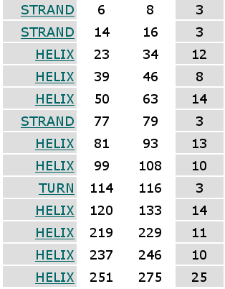
To which, if any, of the expected HTH motifs does this prediction correspond?
Using all the defaults, there is just one prediction:
Sequence: FARERLAAKIDLPEARIQVWFS
| |
238 259

Looking again at the reported secondary structure in UniProtKB, I would expect there to be 3 HTH motifs roughly at:

39 → 63
99 → 116
237 → 275

So here we are looking at the second expected HTH. That is, the one associated with the helical triplet of the HomeoBox domain.

To which, if any, of the expected HTH motifs does the new prediction correspond?
The new prediction is

Sequence: PCDISRILQVSNGCVSKILG
| |
39 58

Near enough to the HTH expected for the first helical triplet of the PairedBox domain for me.

Can you suggest anything particular about the third putative HTH motif that might explain its reluctance to be discovered?
Nope …. which is why one should answer the questions straight away! I must have had a theory at one time?
It is possible to find this third HTH by using the old scoring matrix and an SD limit of 0.8
However, by loosening things up this far, one gets seven answers instead of three. Fours out of the seven are wrong (well, one supposes so at least).

From your investigations of Domain & Motif identification using Interpro
Do you think it a good idea for Interpro to offer feature prediction programs as well as domain database searches?
Well … why not? The purpose of InterProScan is to associate regions of query proteins with Interpro domains. This was originally achieved, exclusively, by simply comparing a query sequence with all entries of relevant individual domain databases. These entries being representations of alignments of examples of specific domains constructed by homology searching (i.e. blast and similar).
I would suggest including a few predictor programs would provide extra evidence gathered from more general, more theoretical definitions of domains. I would imagine the inclusion of these program has improved and widened the picture provided by InterProScan.
Searching domain databases, typically composed of HMM profiles, such as Pfam, Prosite and PRINTS is quite different to running the predictor programs. As I cannot improve on the justification of this claim offered to me by Geoff Barton (Head of the group responsible for Jalview, Jpred, Jnet and much more), I will just reproduce his explanation here:
“ … The main difference is that with an HMM profile you have a "specific" example of a domain or motif whereas with something like COILS, you have something trained across all examples.
For example, for secondary structure prediction, you could (a) do predictions of alpha-helix and beta-strand just by aligning a sequence to a protein of known structure, or an HMM from a family of aligned proteins of known structure. This is a specific case of secondary structure in the context of one protein family. Or (b) you can train a predictor from ALL protein families and then apply this. The advantage of (a) is it is very specific to the individual protein family and so should be more accurate for that family. The disadvantage is that it does not generalise to proteins that are not very like the specific example. The advantage of (b) is that it will work with any protein but will likely be less accurate than (a) for proteins that fit into the (a) category. … “

Do you think the Coil prediction might be correct?
I do not recall anything in what we have discovered thus far that would directly suggest there should be a coiled coil here, in the middle of the HTH. However, wikipedia does suggest coiled coils are associated with transcription factors (which pax6_human is).
" ... Many coiled coil-type proteins are involved in important biological functions such as the regulation of gene expression, e.g. transcription factors. ... "
I think I would not be overly convinced by this prediction, but I would not make that judgement with any great confidence. The all knowing wikipedia says:
“ … Coiled coils usually contain a repeated pattern, hxxhcxc, of hydrophobic (h) and charged (c) amino-acid residues, referred to as a heptad repeat. … “
Geoff Barton comments:
“ … Sometimes the pattern that is particular to coiled-coils also turns up in other helices that pack against each other. You would need to look at some examples of coiled-coil structures to see if the example you are using fits structurally. … “
Which seems very reasonable. The heptad repeat pattern could easily occur just by chance. COILS surely cannot predict the structure of the helices well enough to make an assured judgement? COILS offers a suggestion the user must follow up with other resources.
There is also the evidence that Jpred, possibly using the COILS program disguised as LUPAS, did not detect any coiled coils. This could be for a number of reasons. Possibly LUPAS is not the same program as COILS, or it is a different version, or Jpred runs COILS, but with different parameters.
Not many clear and confident answers in Bioinformatics are there!
Why might you suppose Interpro predicts only 2 of the 3 helix-turn-helix domains that might be expected?
2 Winged helix-turn-helix (wHTH) DNA-binding domains are predicted coincident with the helical triplets of the Paired domain. This should broadly match your expectations.
No helix-turn-helix (HTH) domain is detected coincident with the Homeobox domain, where one might also have been expected?
I am not entirely certain why this might be, so I speculate.
Pfam attempts to classify a variety of types of HTH, and offers a range of HTH domain models (HTH_17, HTH_38, HTH_39 and HTH_40 to name but a few) and a number of wHTH domain models (including HTH_33 and HTH_24).
Interpro also has a considerable number of HTH entries (IPR017895, IPR032877, IPR007394, IPR013197 and more) and wHTH entries (IPR005104, IPR023120 to name but 2).
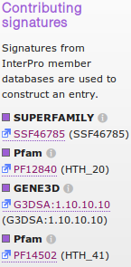
Interpro does use Pfam models to detect its various flavours of HTH/wHTH domain, but it does so selectively. For example, to detect the wHTH domains discovered here, only two Pfam families were used HTH_20 and HTH_41, see illustration). These appear not to have matched in this instant as only a G3DSA entry is quoted.
All the above suggests that no one model exists to pick up all HTH domains? Possibly also, the fact that HTH domains come in such a variety of forms makes them difficult to detect reliably?
If you did the relevant supplementary exercise, you would find that the EMBOSS program used easily detected the Homeobox domain HTH but essentially failed to detect the wHTHs recorded here. This must be because the, very simple, model used by the program only reliably applies to a specific range of HTH domains/motifs that includes the one in the Homeobox domain of the human PAX6 protein?
I am very open to better explanations. I am not completely convinced by the discussion above.
From your investigations of Multiple Sequence Alignment
Clustalx
How might you have saved the need to recompute the alignment by selecting an Edit option other than Remove All Gaps?
Pretty sure using Remove Gap-Only columns rather than Remove All Gaps would have got to the second alignment in one step. I struggle to see how this could fail, but cannot convince myself it would be absolutely certain to work. Maybe some of the sequences that were removed would subtly alter the alignment calculations? Doubtful, given how crude the whole thing is. Anyway, it would have been good enough for me in “Real Life” for this data. I did not suggest this approach as we had to make a Fasta format file with the entire sequence set to be aligned by the alternative software as a by product of working with clustalx. This would not be easily possible if the Remove Gap-Only columns short cut was taken.
Muscle
How do the options for the OUTPUT TREE relate to the output files of ClustalX and the difference between the way that ClustalX and muscle work?

Comment on how one might choose between the range of options offered for the aligned parameter?

Interpro:

Relationships: PARENT/CHILD; CONTAINS/FOUND IN
The PARENT/CHILD relationship is used to indicate family/subfamily relationships defined by the member database methods in the entries. To be a CHILD, >75% of the protein set of the CHILD must be represented in the PARENT. If an InterPro PARENT has more than one InterPro CHILD a protein sequence should not be found in the match table of more than one of these children. If one InterPro entry is described as the child of another InterPro entry, this implies that the child entry is more specific than the parent, and that in all cases a protein sequence match to the child entry implies a match to the parent. Signatures for the parent and child entries must overlap by >50% of their sequence and there must be no adjacent signatures to the CHILD that are also covered by one or more of the PARENT signatures. A list of the PARENT/CHILD relationships by InterPro entry accession is available from the ftp site: ParentChildTreeFile.txt.
The CONTAINS/FOUND IN relationship is used to indicate features of the entry that are not defined by Parent/Child relationships, these include: Regions, Domains, Repeats and Sites. For a CONTAINS/FOUND IN relationship to be established, 40% or above of the proteins in the InterPro entry must contain the feature. Some features can be found in more than one type of protein or family of proteins, but is not children in the family sense. Features may be structural or functional and can be found in proteins with different domain organisations. The CONTAINS/FOUND IN relationship, is therefore useful in linking InterPro entries which are associated by composition but are not related hierarchically.

Taxonomy coverage:

Taxonomy Coverage
The Taxonomy Coverage aims to provide 'at a glance' view of the taxonomic range of the sequences associated with each InterPro entry and the number of sequences associated with each lineage. The taxonomic lineages are 'clickable' and provide a pop-up, which displays the tax-ID, the taxonomy and taxonomic subgroup(s)/species having matches to proteins, the protein match counts and a FASTA link. Clicking on the taxonomy or taxonomic subgroup(s)/species links to the protein overview matches for the selected taxonomy. Clicking on the FASTA box will download the complete set of FASTA sequences for the selected taxonomy of the entry.
The lineages were carefully selected to provide a view of the major groups of organisms. The circular display has the taxonomy-tree root as its centre. Selected model organisms populate the outer most circle. Nodes of the taxonomy-tree are placed on the inner circles. Radial lines lead to the description for each node. No significance is attached to the position of the node on a particular inner-circle, other than convenience, though some attempt has been made to group nodes. The nodes themselves are either true taxonomy nodes and have a NCBI taxonomy number or are artificial nodes created for this display; of which there are three: Unclassified, Other Eukaryotes (Non-Metazoa) and the Plastid Group.
Artificial Taxon: Unclassified contains the following NCBI taxon groups:
- Taxonomy:12884 Viroids
- Taxonomy:12908 unclassified sequences
- Taxonomy:28384 other sequences
The Eukaryota (TAXONOMY:2759) comprises 29 taxons, these have been grouped into two artificial taxons and one existing taxon:
Fungi/Metazoa (TAXONOMY:33154); Node Metazoa
Artificial Taxon; Plastid Group, this contains the following NCBI taxon groups:
- Taxonomy: 2763 Rhodophyta
- Taxonomy: 2830 Haptophyceae
- Taxonomy: 3027 Cryptophyta
- Taxonomy: 33090 Viridiplantae
- Taxonomy: 33630 Alveolata
- Taxonomy: 33634 stramenopiles
- Taxonomy: 33682 Euglenozoa
- Taxonomy: 38254 Glaucocystophyceae
- Taxonomy: 339960 Katablepharidophyta
Each taxonomic group within this artificial taxon contains organisms that have a plastid.
Artificial Taxon; Other Eukaryotes (Non-Metazoa), this comprises the following NCBI taxon groups:
- Taxonomy: 5719 Parabasalidea
- Taxonomy: 5752 Heterolobosea
- Taxonomy: 66288 Oxymonadida
- Taxonomy: 136087 Malawimonadidae
- Taxonomy: 154966 Nucleariidae
- Taxonomy: 193537 Centroheliozoa
- Taxonomy: 207245 Diplomonadida group
- Taxonomy: 543769 Rhizaria
- Taxonomy: 554296 Apusozoa
- Taxonomy: 554915 Amoebozoa
- Taxonomy: 556282 Jakobida
Each taxonomic group within this artificial taxon are the remaining taxonomic groups of the NCBI taxon:2759, which are not in the Plastid Group and are not Fungi/Metazoa (TAXONOMY:33154).

Overlapping Interpro entries

Overlapping InterPro Entries
This section displays entries that share more than 70% of their proteins. Such overlaps define PARENT/CHILD and CONTAINS/FOUND IN relationships between InterPro entries.
IPR009007 | Numbers of overlapping proteins | Average numbers of overlapping amino acids

In the above example, InterPro entry IPR011969 contains proteins which are also found in IPR009007 as a result of the protein signatures of the two entries overlapping.
The two entries have been compared firstly by counting the number of proteins which are common to both, the results of which are displayed in the Venn diagram on the left, and secondly by calculating the average overlap of the protein signatures, in amino acids, with the results displayed in the bar diagram on the right.
Venn diagram display of the overlap of proteins common to both entries:
- The purple intersection contains the number of overlapping proteins common to both IPR009007 and IPR011969, which is 31 in this case.
- The pink section on the left is the number of proteins found in IPR009007 but not IPR011969, which is 35378.
Bar diagram display of the average amino acid overlap between the protein signatures:
The average number of amino acids overlapping in the sequences of the 31 proteins common to both entries is then calculated, with the results displayed in the bar diagram on the right. The bar diagram display is only shown for 'Domain - Domain' relationships.
- The purple segment in the middle shows the average number of amino acids overlapping between IPR009007 and IPR011969 for the 31 proteins, in this case 104.
- The pink segment shows the average number of amino acids found in IPR009007, but not IPR011969, for the 31 proteins, which is 0.
- The blue segment shows the average number of amino acids found in IPR011969, but not IPR009007, for the 31 proteins, which is 15.
The results of these comparisons are used to calculate the percentage overlap score, with all scores greater than 70% displayed on the InterPro pages. In this example, since all proteins found in IPR011969 are also found in IPR009007, and all the amino acids from IPR009007 overlap with those from IPR011969, the percentage overlap score is 100%.
Muscle:
- The blue section on the right is the number of proteins found in IPR011969 but not IPR009007, which is 0; i.e. all proteins associated with IPR011969 occur in IPR009007.

How do the options for the OUTPUT TREE relate to the output files of ClustalX and the difference between the way that ClustalX and muscle work?
none
From first iteration
From second iteration

Comment on how one might choose between the range of options offered for the aligned parameter?
Clearly?
aligned

PSI-Blast

What do you suppose the choice of Pseudocount might influence?

I clicked with confidences upon the link to the help. It opined as illustrated.
I suppose the next step is to read PMID 19088134? There is most certainly no elucidation amongst the strangle of words offered here?
The article Abstract says:
“Position specific score matrices (PSSMs) are derived from multiple sequence alignments to aid in the recognition of distant protein sequence relationships. The PSI-BLAST protein database search program derives the column scores of its PSSMs with the aid of pseudocounts, added to the observed amino acid counts in a multiple alignment column. In the absence of theory, the number of pseudocounts used has been a completely empirical parameter. This article argues that the minimum description length principle can motivate the choice of this parameter. Specifically, for realistic alignments, the principle supports the practice of using a number of pseudocounts essentially independent of alignment size. However, it also implies that more highly conserved columns should use fewer pseudocounts, increasing the inter-column contrast of the implied PSSMs. A new method for calculating pseudocounts that significantly improves PSI-BLAST's; retrieval accuracy is now employed by default.”
The article itself, continues in like vein ….. how about we close our eyes and accept the defaults? I would just wonder why the whole thing does not commence with, at least an attempt, to answer the question in the forefront of my inquiry, which is .. “WHAT, in the current context, IS a pseudocount?”. I do not believe it is as tricky as they appear to wish us to believe. I will try again later, when my view of the world is less storm infested.
******
****************************NOTES**************************************
HelixTurnHelix

helixturnhelix uses the method of Dodd and Egan and finds helix-turn-helix nucleic acid binding motifs in proteins.
The helix-turn-helix motif was originally identified as the DNA-binding domain of phage repressors. One alpha-helix lies in the wide groove of DNA; the other lies at an angle across DNA.
The old (1987) data has a motif length of 20 residues, whilst the default data (Ehth.dat) has a motif length of 22 residues.
With care these can be replaced to suit your data sets. If the files are placed in the following directories they will be used in preference to the files in the EMBOSS distribution data directory:
- . (your current directory)
- .embossdata
- ~/ (your home directory)
- ~/.embossdata
Here is the default file:
# Amino acid counts for 91 Helix-turn-helix (presumed) protein motifs
# from Dodd IB and Egan JB (1990) Nucl. Acids. Res. 18:5019-5026.
#
Sample: 91 aligned sequences
#
# R 1 2 3 4 5 6 7 8 9 10 11 12 13 14 15 16 17 18 19 20 21 22 Total Exp
# - -- -- -- -- -- -- -- -- -- -- -- -- -- -- -- -- -- -- -- -- -- -- ----- ---
A 2 1 3 14 10 12 75 6 15 9 1 1 4 3 8 15 4 4 4 11 0 10 212 995
C 0 0 1 1 0 0 0 0 0 3 3 1 1 0 0 0 0 0 0 1 0 3 14 106
D 0 1 0 1 14 0 0 14 1 0 5 0 1 2 0 0 0 0 1 1 0 2 43 556
E 4 5 0 11 26 0 0 16 9 3 3 0 3 12 13 0 0 2 0 1 13 6 127 669
F 4 0 4 0 0 4 0 1 0 10 0 0 0 0 1 0 0 1 1 1 22 0 49 358
G 9 7 1 4 0 0 8 0 0 0 50 0 6 0 7 1 0 3 1 1 0 4 102 761
H 4 3 1 1 2 0 0 3 2 0 5 0 3 3 0 2 0 2 4 5 0 2 42 225
I 10 0 13 3 2 15 0 4 9 4 0 17 0 2 0 1 31 1 4 8 16 1 141 583
K 4 4 6 11 12 1 1 14 11 0 5 2 2 7 2 1 0 5 8 4 5 15 120 516
L 16 1 17 0 1 35 0 3 12 31 0 22 0 2 1 1 22 1 1 12 20 0 198 954
M 7 0 2 1 1 1 0 0 5 7 1 10 0 0 2 0 2 0 0 2 0 1 42 275
N 0 8 0 1 0 0 0 2 1 1 14 0 8 1 4 2 0 4 9 0 0 11 66 383
P 1 6 0 1 0 0 0 0 0 0 0 0 3 13 7 0 0 0 0 0 0 3 34 403
Q 2 1 21 9 11 0 0 9 8 0 0 2 1 17 7 12 0 3 12 5 3 9 132 437
R 9 10 14 9 5 0 1 16 10 0 1 0 1 17 8 7 0 17 28 3 0 16 172 609
S 2 17 0 8 4 1 6 1 2 2 3 0 37 1 25 5 0 29 3 0 1 5 152 552
T 6 24 3 12 1 5 0 2 2 4 0 5 20 4 3 39 0 4 1 0 4 3 142 512
V 7 3 1 1 2 16 0 0 2 12 0 29 0 5 3 3 32 0 7 8 7 0 138 724
W 2 0 0 0 0 0 0 0 0 1 0 1 0 0 0 0 0 0 2 21 0 0 27 105
Y 2 0 4 3 0 1 0 0 2 4 0 1 1 2 0 2 0 15 5 7 0 0 49 267

The λ repressor of bacteriophage lambda employs a helix-turn-helix (top; green) to bind DNA (bottom; blue and red).
In proteins, the helix-turn-helix (HTH) is a major structural motif capable of binding DNA. It is composed of two α helices joined by a short strand of amino acids and is found in many proteins that regulate gene expression. It should not to be confused with the helix-loop-helix domain.
Its discovery was based on similarities between the genes for Cro, CAP, and λ repressor, which share a common 20-25 amino acid sequence that facilitates DNA recognition. In particular, recognition and binding to DNA is done by the two α helices, one occupying the N-terminal end of the motif, the other at the C-terminus. In most cases, such as in the Cro repressor, the second helix contributes most to DNA recognition, and hence it is often called the "recognition helix". It binds to the major groove of DNA through a series of hydrogen bonds and various Van der Waals interactions with exposed bases. The other α helix stabilizes the interaction between protein and DNA, but does not play a particularly strong role in its recognition.

DPJ – 2015.09.14

If you are working from the PDF version of these notes, some “model answers” can be accessed via the link that is behind the ? or . that terminates each question. This is “work in progress”, I am far from completion at the time of typing.
There is also a mouse genecards. Maybe more to follow?
A computer's idea of “relevance” may not match yours. Here, the Score used to rank hits takes account of the frequency of the search term(s) weighted by where terms occur (e.g. in a “Title” would imply more importance than in a “Comment” field, perhaps?) and the specificity of the term (e.g. “the” is not specific, “aniridia” is). Only if you are really fascinated by this sort of thing try: https://www.elastic.co/guide/en/elasticsearch/guide/current/scoring-theory.html
OK ... so I am not good at mysteries!
You will need to expand the display See All the Additional mRNA sequences before you can access the link you need. Sequences submitted to EMBL (Europe), Genbank (America) or DDBJ (DNA DataBase of Japan) are exchanged daily, so these sequences are not specific to GenBank.
Interpreting the accession code is not straight forward. The prefix letter(s) indicates the type of sequence and the database of first submission. The number before the full stop is there to make the code unique. The number after the full stop is a version number.
Search the web page for PAX6 and ignore all hits in the web page annotation down the right of the page. Only hits in the data entry itself count.
PAired boX (hence the name PAX) at the start (N terminal) of the protein. We investigate further later on.
The annotation is very sparse which makes these entries very hard to find directly. The EML-Bank versions include some links to the Ensembl codes you identified when looking at GeneCards. These would have been helpful but are not part of the official International Nucleotide Sequence Database Collaboration (INSDC) annotation that should be consistent between GenBank, European Nucleotide Archive (ENA), which includes EML-Bank, and DNA Data Bank of Japan (DDBJ).
As opposed to comparing each of the two clones against an entire sequence database.
Just because its neater. In my, significantly less then humble, opinion anyway.
UniprotKB still sometimes uses 2 names for each entry, an Identifier (or Entry Name) and an Accession code.
Apparently, the reasons are “Historic”? An illogicality is admitted, but it is not trivial to fix issues such as this. It is unlikely in the near future therefore, that both PAX6 domains will be recorded equally as Domains that possess the function of DNA Binding, which I would suggest to be the ideal.
Not strictly necessary, to be honest. However, the | symbol occasionally causes problems, so I suggest removing it.
That is, all but those at positions 22-26 and 37-39, which are deletions.
"No experimental evidence..." in this section means that the splice variant is only identified as a result of a match with a single cDNA or EST which is regarded as insufficient to assign an amino acid translation. All UniProt/SwissProt splice variants supported by matches with 2 or more cDNA/ESTs are checked to ensure they are not actually just errors due to frameshifts, intron retention etc.
The Select button allows choice of isoforms. Redundant here as we wish to compute an alignment of the only two isoforms of known sequence.
If, like me, you have conceptual problems with major and minor groves. Try this animated picture. Helped me at least. As did the image above.
This is not strictly true, as you will discover later.
A fuller description is provided from the Logo page. Click on the sequence logo help document link.
For a more complete description of Pfam go to: http://pfam.sanger.ac.uk/help.
HMMs are essentially mathematical representations of the alignments. Not very pretty for humans to look at, but currently considered the best way to present an alignment to a computer program so that alignments can be compared with each other and/or other protein sequences.
A very nice Java tool for viewing alignments that we will use again.
Exactly what you have to do next should be intuitive (mostly a matter of replying affirmatively to a series of foolish questions), but can vary according to operating system and browser. Whatever is required to display the alignment – do it.
On some systems, there can be problems getting Java Web Start to behave properly. Ask if you have any difficulty.
Full alignment columns that are not represented in the seed alignment (and so do not contribute to the calculation of the HMM), are shown in lower case. As has been noted previously, including the 14 extra positions referenced here.
The simplest (most sensible?) route to his point would have been to use the search facility offered from the Ensembl home page. From here you could have specified Human as your organism of choice and PAX6 as a search term to indicate your area of interest. This would get you a list of matching genes with PAX6 at its head. From here, select the target gene to arrive at a textual summary. Then just jump to the gene Location view that now enlivens your life. Faster and more direct? True … but where is the poetry? Try it, if you have the time and inclination.
That is, the centre of the display, the red box actually moves with the display.
See the Gene Legend at the bottom of the display, and illustrated here.
CCDS (Consensus CoDing Sequence) is a collaborative effort to identify a core set of human and mouse protein coding regions that are consistently annotated and of high quality. The long term goal is to support convergence towards a standard set of gene annotations.
Particularly as it is run in the Ensembl pipeline. Here its purpose is only to identify where genes are likely to be. Sequence comparison between just these regions and coding sequences (CCDS sequences, proteins, cDNAs etc.) are then used to predict transcript detail. Ensembl only requires Genscan to work approximately to reduce the volume of sequence comparisons rather than to generate “stand alone” gene predictions.
An Expressed Sequence Tags (EST) is a short (200-500 nucleotide) sequence representing a single reads of a cDNA. As it is generated from a single sequencing read, it will not usually be of very high quality.
My display is telling me that I have have well over 400 tracks turned off!
It does not really matter which protein coding transcript you choose. All the PAX6 transcripts correspond to the same gene. However, to consistently reproduce exactly the results I got, you need to choose the one gold transcript currently on offer.
Or you might have taken the more pedestrian route of clicking on the Gene: PAX6 tab waiting patiently at the top of the page? This would give you a view of the gene disassociated from any particular transcript.
Because Ensembl searches for GO terms in both Uniprot and Refseq.
CoDing Sequence, typically a match with a protein sequence and/or a CCDS entry.
UnTranslated Regions, typically matches with mRNA sequences.
Matches with protein and/or coding DNA sequences.
Those starting NP_ are Refseq proteins. Those starting NM_ are Refseq mRNA sequences. RefSeq links will take you to the NCBI.
This need not necessarily be the case. In fact, until recently (mid-2014) this transcript was supported by a RefSeq mRNA that had the 6th exon missing! Essentially, Ensembl does not take the RefSeq mRNAs as defining a transcript by themselves. This is reasonable as these mRNA sequences do not necessarily represent a single carefully sequenced mRNA. RefSeq mRNAs are typically constructed from many imperfect sequences assumed to be of the same cDNA/mRNA and cannot therefore be assumed to be always 100% accurate. Oh that life was just a little more straight forward?
Exactly which variants are displayed can be customised using the Configure this page facility, try it if you have time. The types of variation can be determined from the Key, a version of which is illustrated above (with the cDNA view).
SMART (a Simple Modular Architecture Research Tool) allows the identification and annotation of genetically mobile domains and the analysis of domain architectures. More than 500 domain families found in signalling, extracellular and chromatin-associated proteins are detectable. These domains are extensively annotated with respect to phyletic distributions, functional class, tertiary structures and functionally important residues. Each domain found in a non-redundant protein database as well as search parameters and taxonomic information are stored in a relational database system. User interfaces to this database allow searches for proteins containing specific combinations of domains in defined taxa.
InterPro is a database of protein families maintained at the EBI.
Third from the bottom of the first page, last time I counted.
PDB is the main database of 3D protein structures. SCOP and CATH are also 3D structure databases, we will very superficially visit both later.
If you really wanted to, the best approach is to search for P26367 in the search box at the top of the page and then look for the Homeobox domain entry in the Detailed signature matches list.
OK … just in case you have forgotten! IPR001523 and IPR001356.
As it contains both a Paired Box and a Homeobox. The list duplication could be “solved” by not asking for the Interpro IDs or Interpro Short Descriptions to be displayed. But … enough!
Where the UniProt/SwissProt Accession column is blank, the existence of one or more independent UniProt/trEMBL entries exist. You could have included these by asking for the UniProt/TrEMBL Acession codes to be displayed, but then the list would be very much longer.
Comma Separated Values
Documentation pages for EMBOSS can be accessed at the EMBOSS home page at: http://emboss.sourceforge.net
A part of the Staden Package.
That is FREE options!
It would be very sensible to move pax6_cdna.fasta and all the files you have created thus far (pax6_genomic.fasta, pax6_primers.fasta, pax_domain.fasta and pax6_human.fasta in particular) into this directory.
If you did things correctly, you should be in the right place without having to move anywhere.
You can select multiple files in a number of ways including holding the Ctrl key down whilst clicking on each of the files you require.
spin will describe all the sequences it has loaded. Note that only the first of the primer sequences was loaded, sadly spin does not recognise that pax6_primers.fasta is a multiple sequence file. This will not matter to us as the exercises stand at present.
This refers, somewhat bizarrely, to the placement of the sequence on Cartesian axes.
This only really makes complete sense when you are computing dotplots, which you are just about to do. spin is limited in that it allows a maximum of 2 sequences to be selected. When only one sequence is required, the Horizontal selection is used.
If you need to, use the pull down menus provided to select from any of the sequences in your Sequence manager.
Thus asking the program to indicate the presence of exactly matching regions of 8 base pairs between the chosen sequences.
There is a zoom out button at the top of the display to undo any zooming in you try.
I.e. dots that do not represent anything interesting.
Not that the speed difference will be apparent with sequences of the size we are comparing here.
Thus matched windows of length 11 in which 10 of the aligned bases are identical are regarded as significant. By default, spin awards 1 point to matching bases and 0 points to mismatched bases. The equivalent program in the EMBOSS package, dotmatcher, awards matching bases +5 and penalises mismatched bases -4. The full EMBOSS default DNA comparison scoring matrix can be found in an appendix.
Depending how you left you displays, you might need to separate out your dotplots in order to see them clearly.
The EMBOSS package offers the program needle, which is a rigorous implementation of the Needleman-Wunsch algorithm for global alignment. EMBOSS also offers a less rigorous (i.e. faster and sloppier) program called stretcher.
A complete description of these parameters will be included in a presentation. Soon, if it has not already occurred.
Click in the crosshair box and use the crosshair to get a good idea of where features are in your plots. I think the cross-hair is very irritating to leave active, so I suggest you click it off again once its purpose is fulfilled.
and so would align correctly given almost any gap penalties, or other parameter settings that might have been chosen.
Comparing mRNA from one organism with genomic sequence from another is one way of investigating gene structure in newly sequenced genomic sequence.
One very simple solution to this problem offered by the GCG (now defunct) package version of needle (a program called gap) was to offer a gap penalty ceiling. The program would compute a gap penalty in the normal way until a given “cut off” was reached. gap would then assume it was trying to stretch over an intron rather than allow for an insertion/deletion, so it would allow the gap to increase at will without further raising the penalty. This worked much better than my intuition suggested it should!
The other is called spidey. The spidey home page is: http://www.ncbi.nlm.nih.gov/IEB/Research/Ostell/Spidey/ It is pretty straight forward to use, just follow your nose. est2genome, splign and spidey should all give the same answer for this simple alignment and very similar answers for all such problems.
Why this is so will be considered later when we look at the database searching program blast.
An indel is either an insertion or a deletion, depending upon which of the aligned sequences you are considering.
How this substitution affects the protein is not clear. Translating both the Genomic sequence and the cDNA might have helped? The Standard Genetic Code is in an Appendix, or look back to the Uniprot feature table for PAX6_HUMAN. It is the Natural Variant at position 33.
The original label for this very nice graphic is: This figure shows two ‘‘sequence logos’’ which represent sequence conservation at the 5’ (donor) and 3’ (acceptor) ends of human introns. The region between the black vertical bars is removed during mRNA splicing. The logos graphically demonstrate that most of the pattern for locating the intron ends resides on the intron. This allows more codon choices in the protein-coding exons. The logos also show a common pattern ‘‘CAG|GT’’, which suggests that the mechanisms that recognize the two ends of the intron had a common ancestor. See R. M. Stephens and T. D. Schneider, "Features of spliceosome evolution and function inferred from an analysis of the information at human splice sites", J. Mol. Biol., 228, 1124-1136, (1992).
I.e. report the best matching region and ignore any others, however deserving they might be? This has always seemed an odd default to me.
If you wish to be meticulously honest. You should Hide the graphic of your first Local alignment (right click its configuration box, choose Hide). Not that it will change anything as you will have found exactly the same alignment the second time round – along with the others.
megablast is a less sensitive but even faster version of blast only suitable when, as now, almost identical matches are sought.
By default, megablast uses Linear Gap Costs. That is, it just multiplies the size of the gap with the Mismatch penalty. The other two algorithms employ the more common Affine strategy, using Existence and Extension penalties. For more about Gap Penalties, go here.
This filter avoids finding “hits” supported only by matches in regions not specific to the query. For example, a polyA tail cannot help to identify a specific mRNA as it is present is all mRNAs. The use of this filter will be evident when we look at the blast output.
If you have any non-default settings, they should be highlighted in yellow.
Or you could just read the textual list that follows the graphic if you wish to insist on the simplistic.
To use a global approach would be to imply that you were only interested in database entries that matched your query sequence from end to end. Generally, this is not true. You would usually be interested in a database sequence that was similar over any significant region.
Why not try them? End up with the alignments for the top hit in E value order.
The mRNA in the file pax6_cdna.fasta ends at this polyA region. I wonder about the long 3' UTR suggested by some of the RefSeq entries?
Here I will assume we have talked about these parameter and you are reasonably well informed of the issues.
The MIT now link to a newer version of primer3 (version 4.0.0, soon primer4 maybe?). Its URL is: http://bioinfo.ut.ee/primer3/. I have yet to investigate this version fully.
My policy has been to not discuss parameters that pertain to the experimental conditions. In future versions of these notes, I will include discussion of some of these parameters. In the mean time, thebuttons are very helpful. I would also suggest the MIT site (or the Wageningen site) for very readable explanations linked from every parameter. The full primer3 manual can be found here.
Which rather makes mock of all the deep thought employed deciding upon the most sensible maximum number of predictions to be reported.
This was not true until very recently. Primer-BLAST reported many more primer pair suggestions and quite a few unintended products for each. The previous parameter restriction the length of unintended products was somewhat more generous.
I have asked the guys at NCBI to explain. No full answer as yet, further prodding required. Prodded last 2016.04.02.
Apparently, such a PCR product is possible! However, above 5,000 base pairs would be slow, require very close attention and be prone to errors.
If the wait becomes unbearable, consider opening a new window/tab and moving on to the next section, returning to Jpred later.
Should that not work, try Full HTML.
I have made some notes on my choice, but they should not really detain you at his point. If you insist, they are here.
Structural Classification Of Proteins, we will visit here later.
CATH is similar to SCOP in that it is another Structural classification database. We will look at it further, if and when I can ever make sense of it. It does also appear to have some parts that are not working properly? I investigate, I seek better persons than I to explain.
Of course, you could run Clustal from websites all over the world if you wished. Specifically, it is available both at the EBI and the Bioinformatics server at Wageningen. Try it if you have time. You get the same results but will, sadly, lose the pretty interface. http://www.ebi.ac.uk/Tools/clustalw2/index.html http://www.bioinformatics.nl/tools/clustalw.html
The Fast-Approximate algorithm is essential that which the database searching program fasta employs. Assuming we have discussed how fasta works, it should require no further explanation here.
From the “Manhattan Skyline”, you can see the conservation is less than 100%. Less conserved than the F that immediately follows in fact? Look at your alignment, the “Manhattan Skyline” does not seem to reflect reality? The W is very well conserved, although the scoring matrices would regard any deviation from W as serious? I need to find out more about how the Skyline is computed.
Available from a variety of websites in addition to the EBI, including the Bioinformatics server at Wageningen: http://www.bioinformatics.nl/tools/muscle.html
As discussed, superficially at least, previously. I hope.
The java alignment editor and viewer you used to look at the Pfam alignments earlier.
But feel free to try the others. HTML is the default at Wageningen. The Phylip formats are the best if you are going to analyse your output further with the phylogeny programs of the PHYLIP package.
All Programs -> Sequence Analysis Tools Installer -> Jalview -> Jalview
We do run specialist training in the generation and interpretation of multiple sequence alignments in Cambridge however. All are welcome.
But hopefully a mite more credible!
Much more so than the Full alignment offered by PFAM, I would contend. Although, it has to be admitted, the Pfam alignment included more sequences and I suspect they would have gone for a less closely homologous set of sequences. Even so … I think the alignment illustrated here is MUCH more beautiful!!
You need either rasmol and/or Chime to be suitably configured. Both are good, but obsolete, structure viewers.
Well ... they were not very big beta sheets!
Note the way you can move along the Chromosome map. I went Forward 3 entries to get my picture.
The full (known) list (and much more) is available in a database specific to human PAX6 allelic variants. This can be found at: http://lsdb.hgu.mrc.ac.uk/
And, of course, the NCBI in the USA.
I include two examples I thought particularly pertinent. The first is a molecular function, the second is a biological process. Both were on the first page of GO entries.
Yes I know we could work it out using the table in the appendix ... but that would be like “reading the manual”!! Exclusively for wimps!
Well, OK there is .. but let us be lazy.
The crosshair and the sequence display are both Staden features that have been made to work for many of the EMBOSS programs.
Using getorf, as we do here, is ponderous compared with just reading along the Sequence Display of spin. However, unlike any native aspect of spin, getorf can be run without any graphics. It can be run many times from a simple script without user intervention. If you had to detect coding regions in many sequences, rather than just one, getorf (plus a simple script) would be the sane option.
You want to eliminate all the very small ORFs but not the one you consider might be the genuinely coding region (i.e. the biggest one). In “real life” one might select a rather large value to select only the longest ORF. For the exercise, maybe a smaller value to see the longest few regions would be appropriate? How about 150?
spin has an irritating tendency to assume you wish to analyse the output of the last option you executed.
This program may not be strictly necessary if you have already obtained the correct protein by using getorf.
You will need to use the Load Sequence/Simple option of the spin File pull down menu as it is not yet in the Sequence manager.
It should be in the Sequence manager as sw|P226367|PAX6_HUMAN, or you could load it directly from the Uniprot database at the EBI using the SRS capabilities built into EMBOSS/spin.
If there is a single restriction enzyme that cuts differently due to the mutation, it might be possible to design a Restriction Fragment Length Polymorphism (RFLP) test to detect the mutation in individuals. Not a likely choice these days. PCR would generally be regarded as a much better option. Treat RFLP as an excuse for doing some restriction maps if you wish.
BUG!! I fear there is a bug here. These 2 options are turned ON even thought they appear to be turned OFF. To really turn them OFF, you need to turn them ON and then turn them OFF again!! Sorry, I will try to get this fixed.
The “>”, “-”, “6” and the space would be thrown away. Many, but not all, of the other 18 characters are valid DNA ambiguity codes (see Appendix I). GENSCAN seems willing to attach meaning to all the letters, even the ones not part of the IUB alphabet?
I have asked whether these pictures will ever again be available, I await a reply. So long ago, my expectations have all but expired.
Read all about it at: http://bioinformatics.oxfordjournals.org/cgi/content/full/21/11/278.
J. Garnier. J.F. Gibrat and B.Robson in Methods in Enzymology, vol 266, p 540-553 (1996). GOR IV uses a data base of 267 proteins to validate its predictions which it claims to have a mean accuracy of 64.4% for a three state prediction (H, E or C).
Expasy is a major site for protein based research in Switzerland. As the all knowing Wikipedia puts it: “ExPASy is a bioinformatics resource portal operated by the Swiss Institute of Bioinformatics (SIB) and in particular the SIB Web Team. It is an extensible and integrative portal accessing many scientific resources, databases and software tools in different areas of life sciences. Scientists can access a wide range of resources in many different domains, such as proteomics, genomics, phylogeny/evolution, systems biology, population genetics, and transcriptomics.”
This method is described in: Dodd I.B., Egan J.B. (1987) "Systematic method for the detection of potential lambda cro-like DNA-binding regions in proteins." J. Mol. Biol. 194: 557-564. Revised in Dodd I.B., Egan J.B. (1990) "Improved detection of helix-turn-helix DNA-binding motifs in protein sequences." Nucleic Acids Res. 18: 5019-5026. You can download the more recent paper from: http://nar.oxfordjournals.org/cgi/reprint/18/17/5019.pdf
Alternatively you can use the mirror at the EBI http://www.ebi.ac.uk/printsscan/
As it would not in the corresponding EMBL or DDBJ entries as the annotation content in all three databases is identical (well nearly, there can be differences as you will discover later). Only the annotation format is supposed to differ between these databases.
The features here only represent the CDS regions of the genes. I wonder why not the entire transcript length?
“the snp135Common table will only contain SNPs with a minor allele frequency >= 1%”
You can follow the link I have built into this PDF, or you can view the PAX6_HUMAN entry in a number of formats using the links at the top of the entry page,. Either way, you will see the PAX6_HUMAN entry displayed in EMBL format. All the lines beginning FT describe the Feature Table for this entry. The line being considered here is amongst them somewhere … Honest!
Interpro allows you to do this easily, as hopefully we have discussed and as you will see for yourself later on.
You need to allow that the gene names occupy much more space than the genes at this scale. The next picture gives a more useful impression.
I suspect the reason only 10 of the 11 eligible sequences are mentioned in this table is that the RefSeq column lists do not set out to be comprehensive. When you view the Supporting Evidence, in a page or two, more RefSeq mRNA sequences are mentioned.
The Wikipedia article shows how this complication might be overcome.
There may or may not be some justification for calling the format CIGAR, but if there is, I have no idea what it might be.
In order to make this illustration, I needed set Sort by: (top of the alignments) to Query start position.
6 base pairs (Sbjct: 1081-1086, CAGGTA) occur in both the first two matches illustrated. Just 1 base pair is shared between the 2nd and 3rd match (Sbjct: 1234, G).
That I did not ask, because I only just thought of it.
The form explicitly declares a minimum of 70, but the ranges from which the forward & reverse primers must come (15000-15700 & 15800-16500) make the smallest possible primer3 prediction 100 base pairs long.
This could be why, as noted in the instructions, the start of the PAX region was considered insignificantly conserved by Jalview.
As does the Jpred Help.

