I solved the questions before the update, so the answers were written according to 0.01.
Use the normal and psoriasis transcriptome data reported in Jabbari et al. (2014) to calculate significance of expression change for all the genes between the two groups. Perform the following steps:
(a) Use GEO2R interface to compare the two groups for a Benjamini-Hochberg corrected p-value cutoff of 0.01. Download the results, and save in a text file.
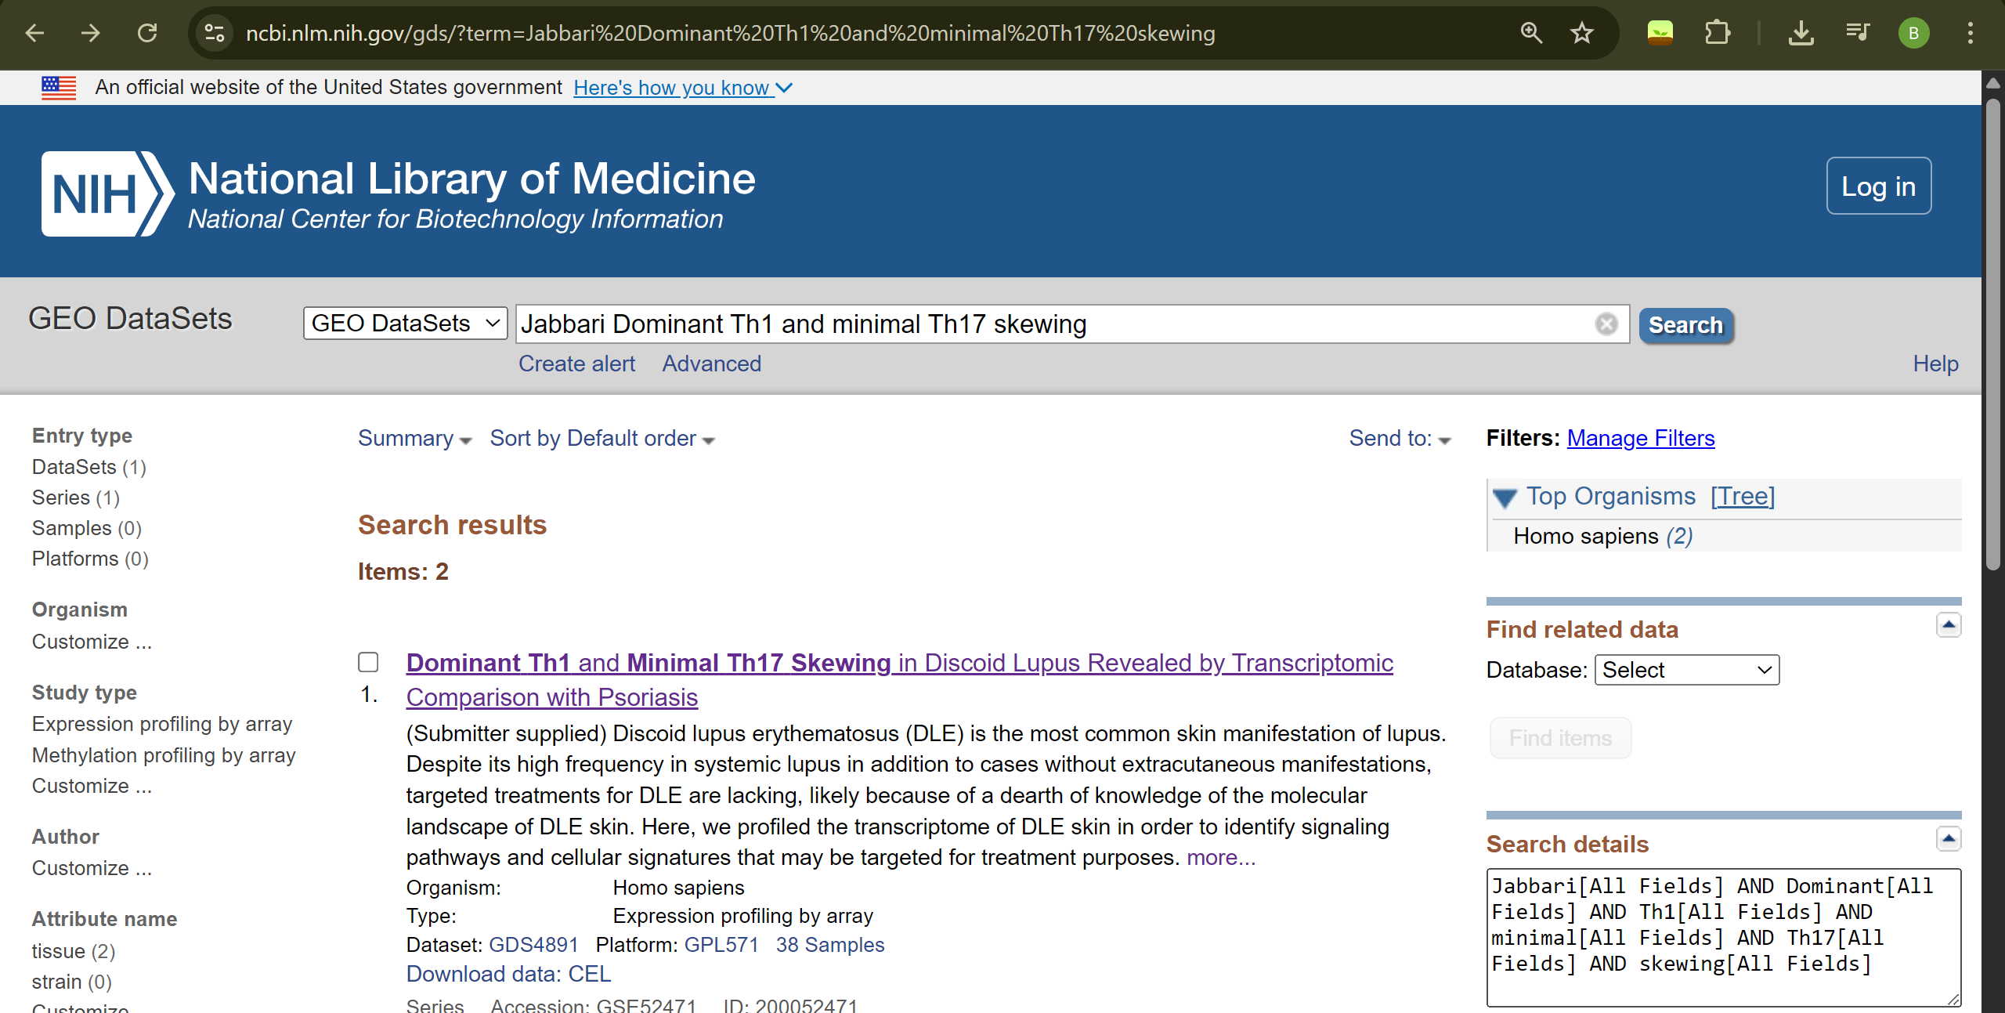
After clicking on the link in the figure, we proceed with the GEO2R analysis. 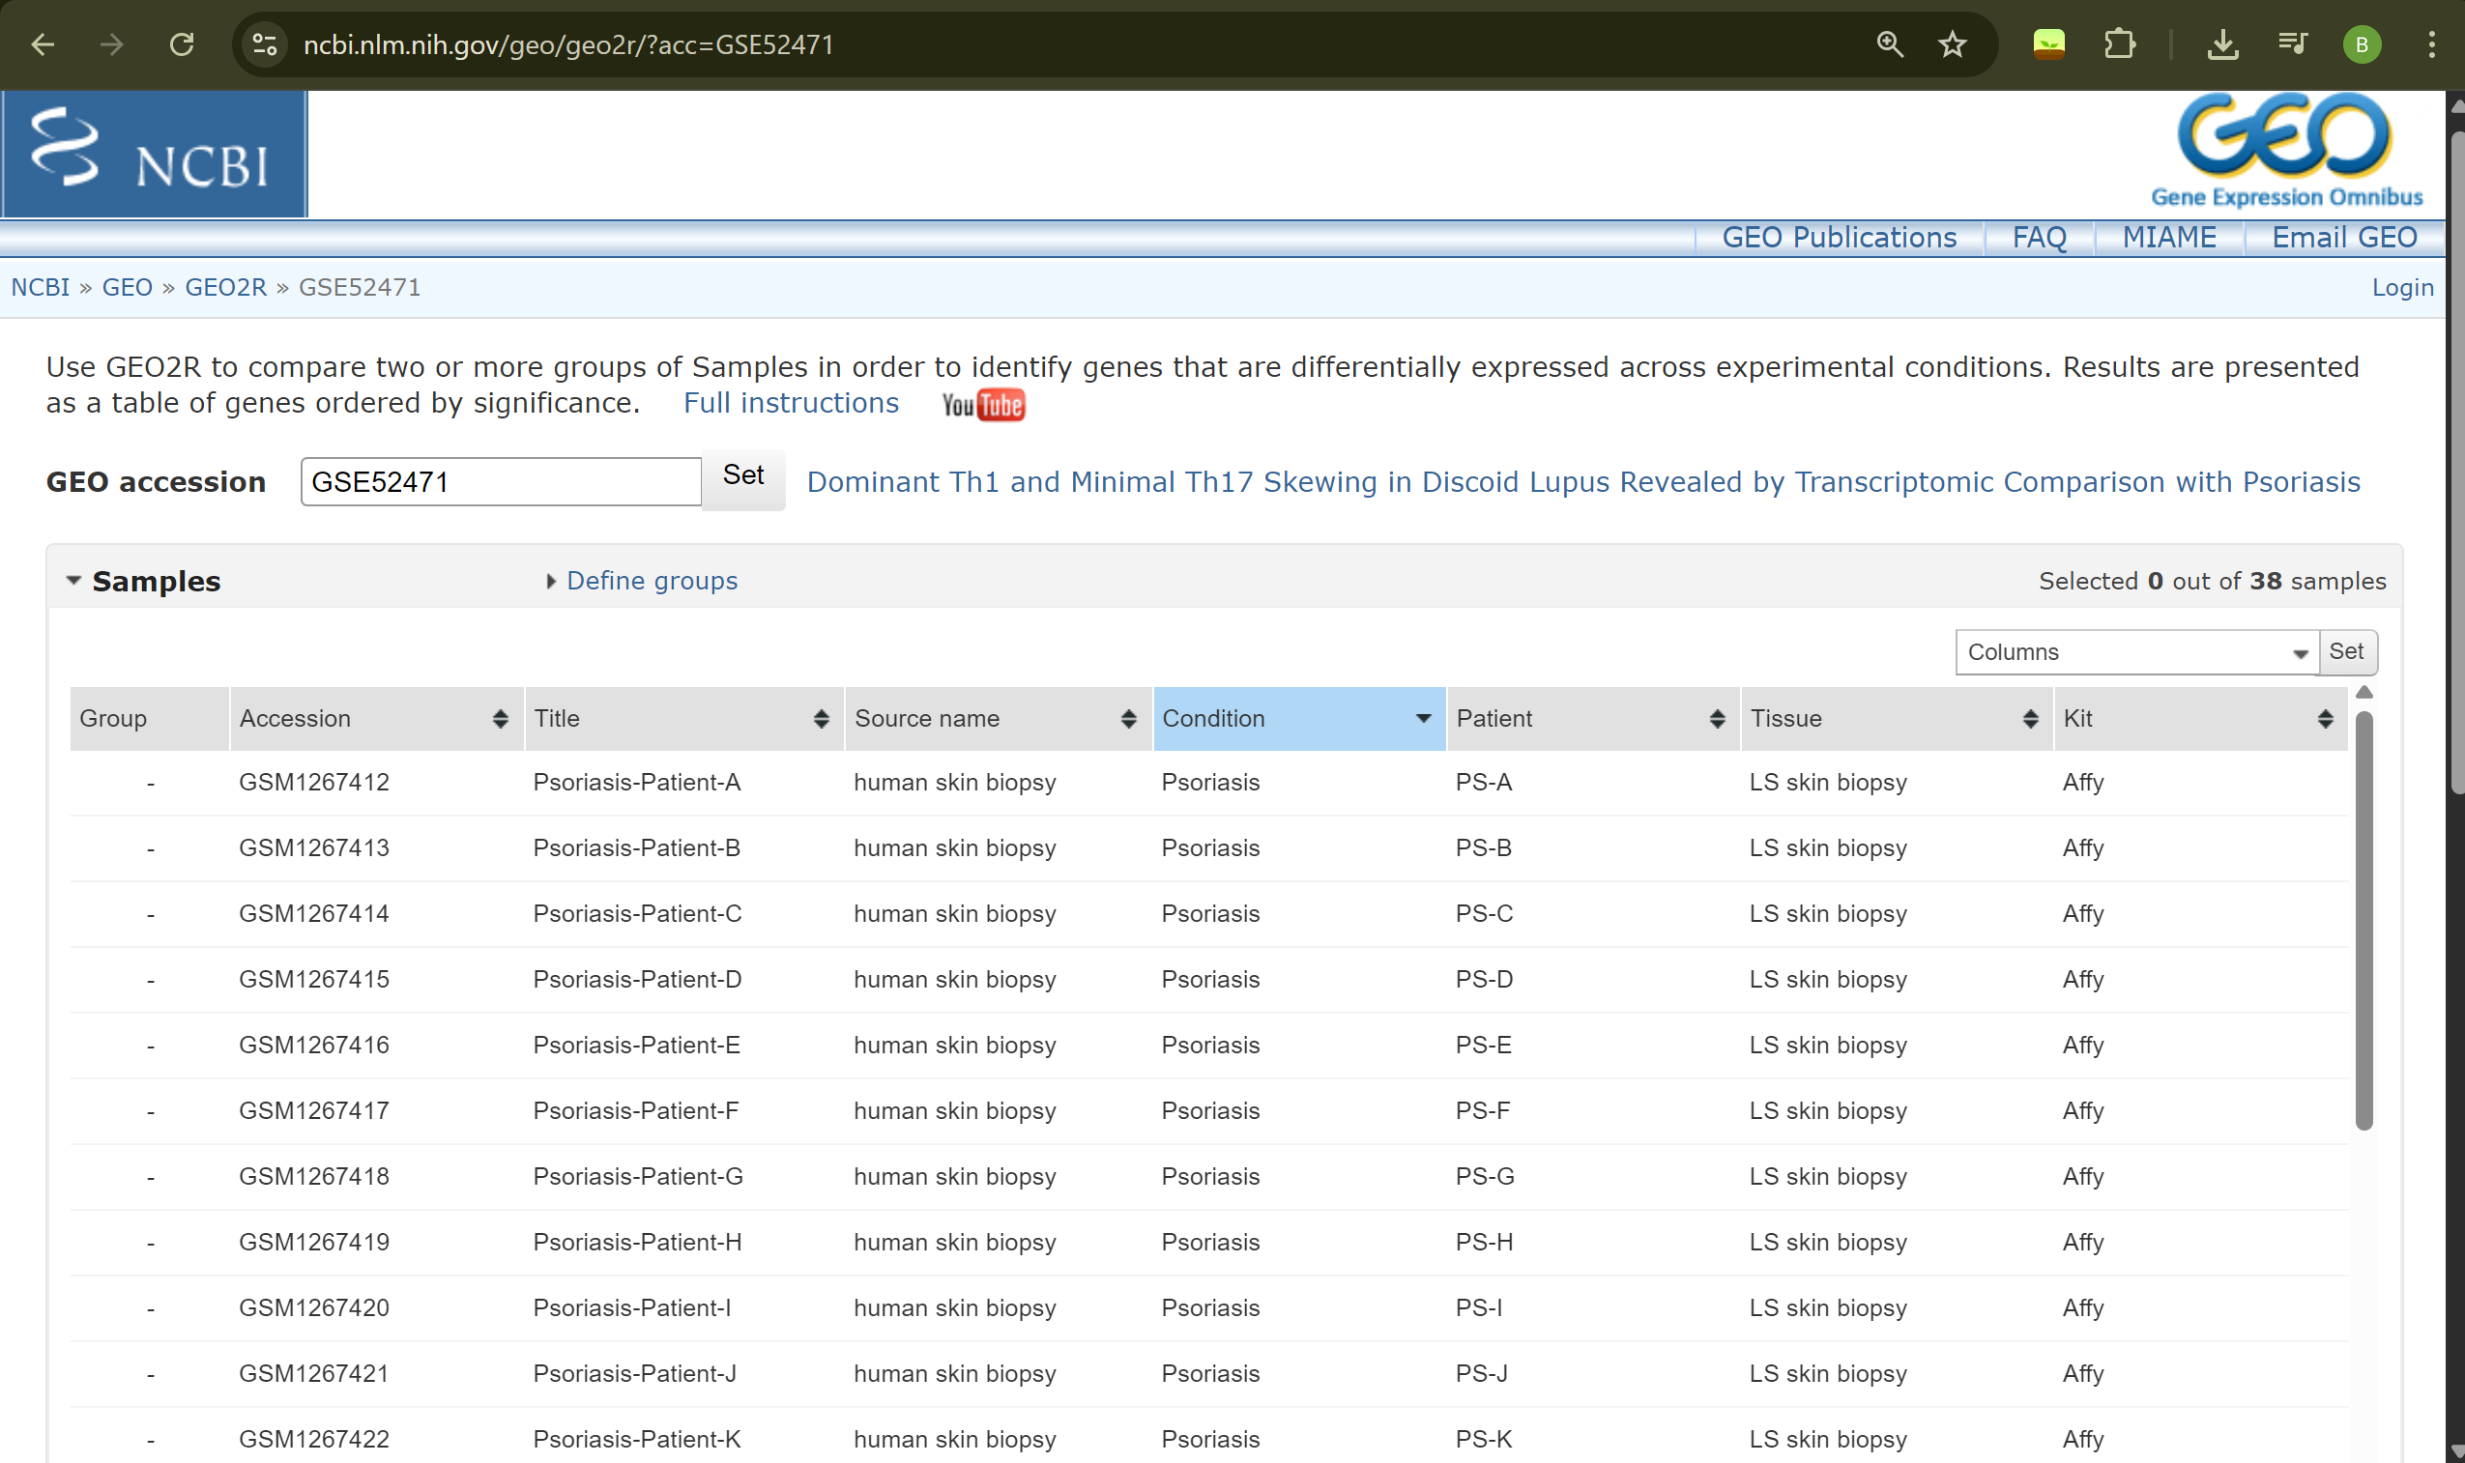
I sorted the data according to conditions; there are three different conditions: psoriasis, normal, and discoid lupus. Since we are asked for psoriasis and normal, I will divide them into two groups: Pso and Normal.
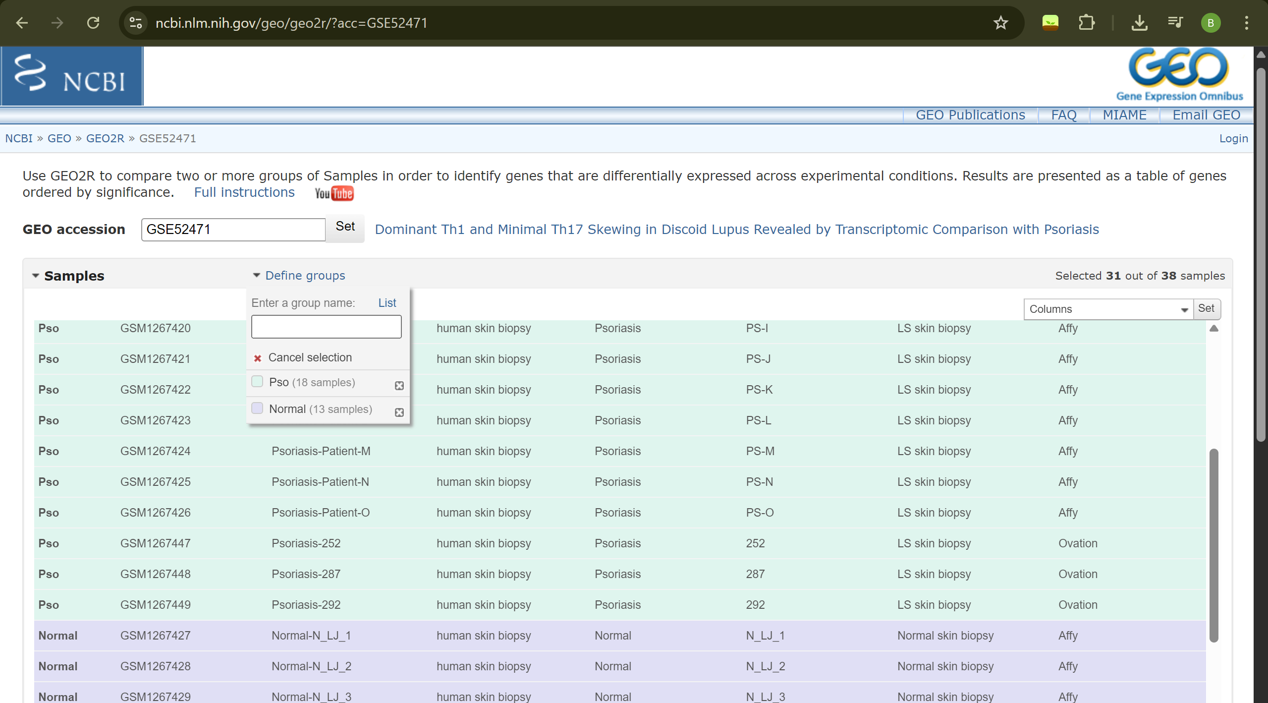
Since Benjamin & Hochberg was already selected in the Options section, it was analyzed without modification. Only the value, which was currently 0.05, was changed to 0.01.
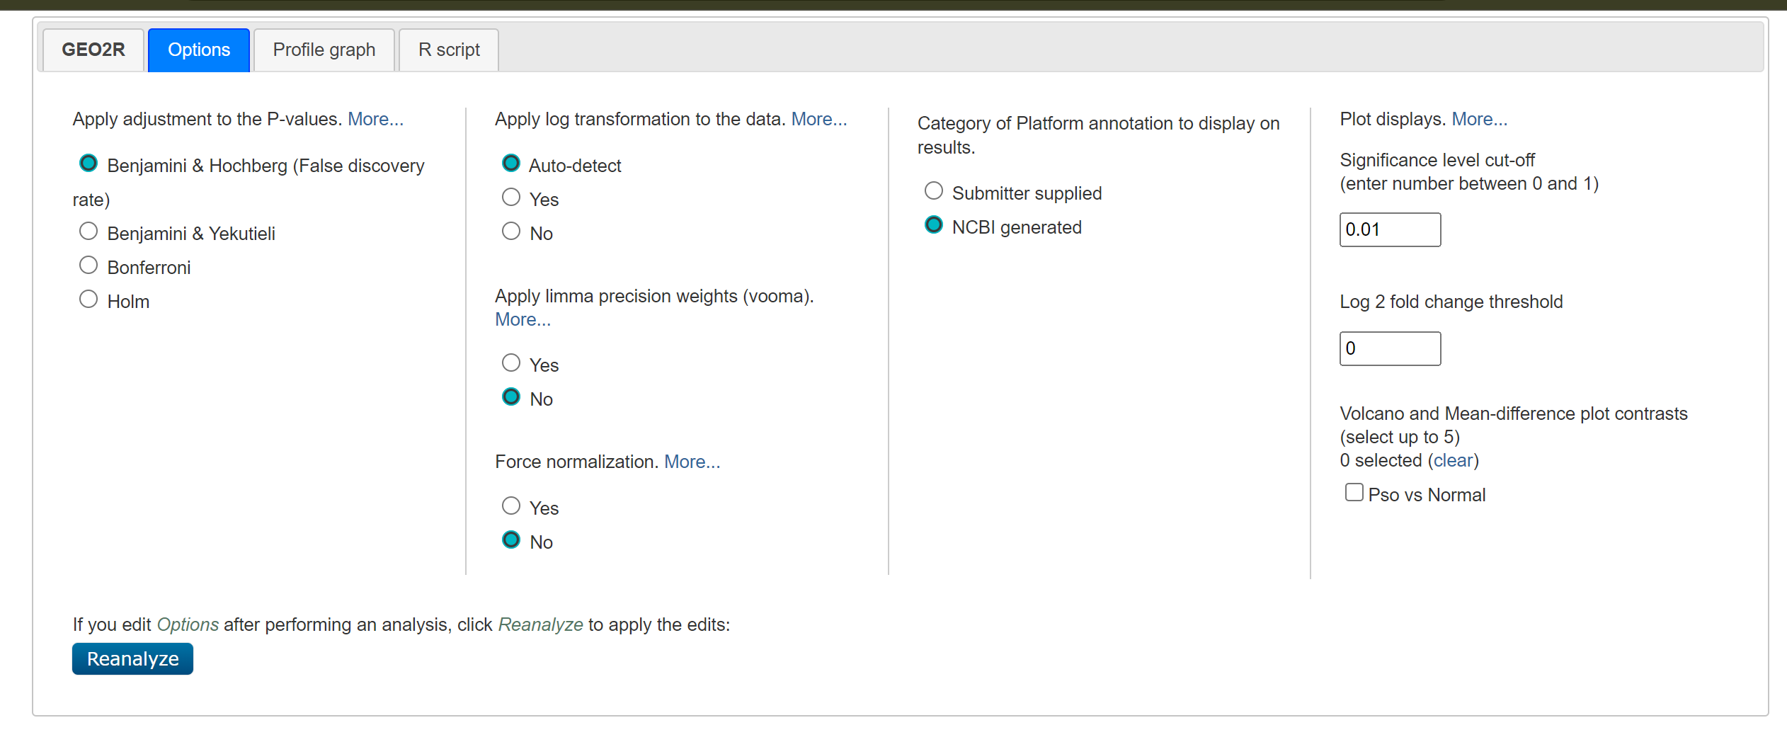
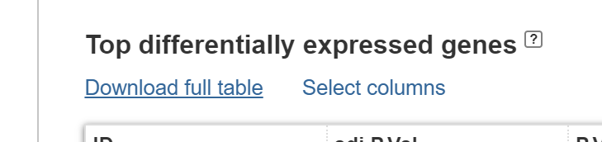 Download full table seçeneği ile indirilip text dosyası halinde saklanmıştır. TSV formatında indirilmiştir ama TXT şekilde açılabilir bir formattır.
I learned the GEO accession code from here.
(b) Get the same dataset via GEOquery package in R based on what you learned in the class. (Hint: Search the GEO to find the dataset). Select 31 samples mentioned above.
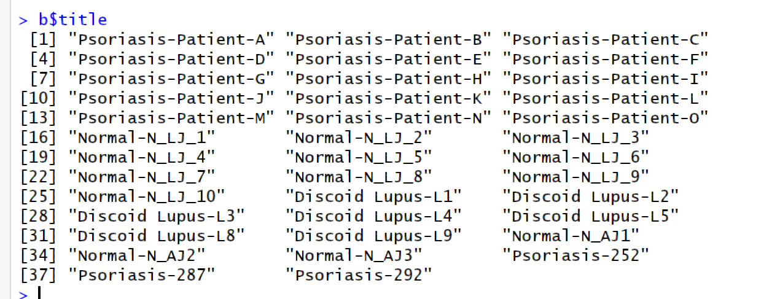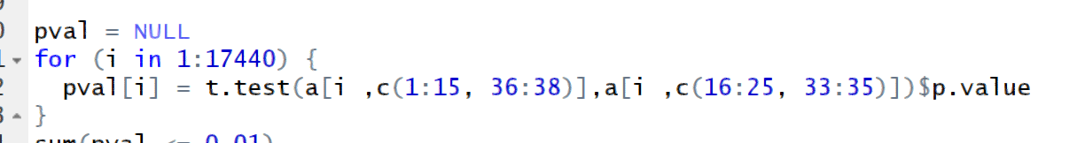
I learned the order of the b$title users I wanted to select, and then for each gene (17,440), the t-test was applied individually using a for loop, and the p-values were recorded.
(c) Apply t-test to the data to compare normal and psoriasis samples. What is the number of significantly differentially expressed genes for a cut-off of 0.05? What is it for a cut-off of 0.01? What is it for a cut-of of 0.05 if Bonferroni correction is applied?
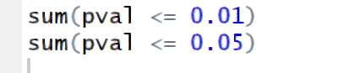
Using the sum function, we determined how many meet the desired conditions by producing True for those that meet them and false for those that do not (1,0), then adding these together and returning the result. The number of p values less than or equal to 0.01 is 6838. The number of p values less than or equal to 0.05 is 9119.
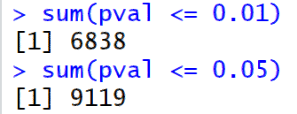
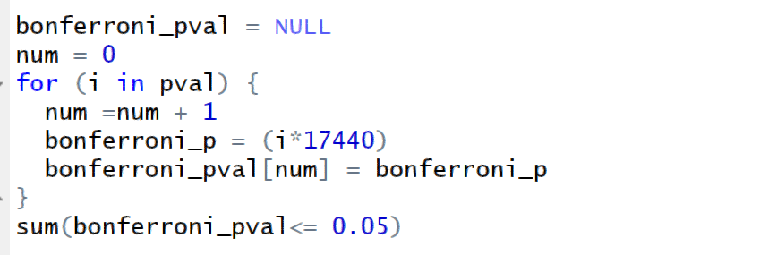
Each gene's p-value was multiplied by the total n value, and the new p-values were recorded. (Some will be greater than one, which is statistically impossible, but since we are not concerned with that, I did not address it.)
The sum function was used again to count the number of p values less than or equal to 0.05, and 1678 differentially expressed genes were found
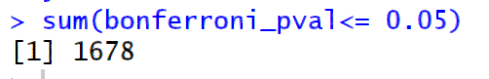
(d) Apply Benjamini-Hochberg (false discovery rate) correction using p.adjust function for the same comparison for a p-value cut-off of 0.01. (Hint: the usage is p.adjust (p, method = “BH”), where the input p is the vector of not-corrected p-values).
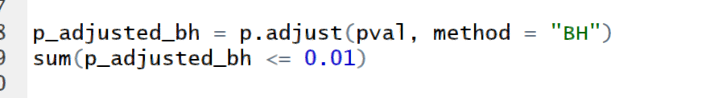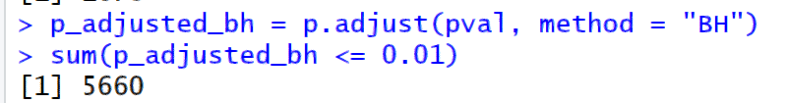
The Benjamini-Hochberg method was applied using the p.adjust function as requested in the question, with method = “BH,” and 5660 differentially expressed genes were found using the sum function.
(e) Compare your results with the results you obtained in (a) from the GEO2R interface with the ones you obtained in (d) with R’s p.adjust function. Did you get the same results? (Hint: you can compare the two gene lists using R’s intersect() function to find the number of common genes)
When we open the GSE52471.top.table.tsv file and look at it, we see that it gives us the p-values for all genes, not just the significant genes according to our analysis. Therefore, we need to add the cutoff ourselves and analyze it again using R. Regarding this question, since I didn't save the gene names and only used the sum function to find the number, I decided to save the number and names using length(which()) and names(pval) = rownames(a) instead, and I made the change.
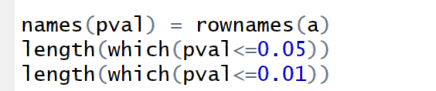 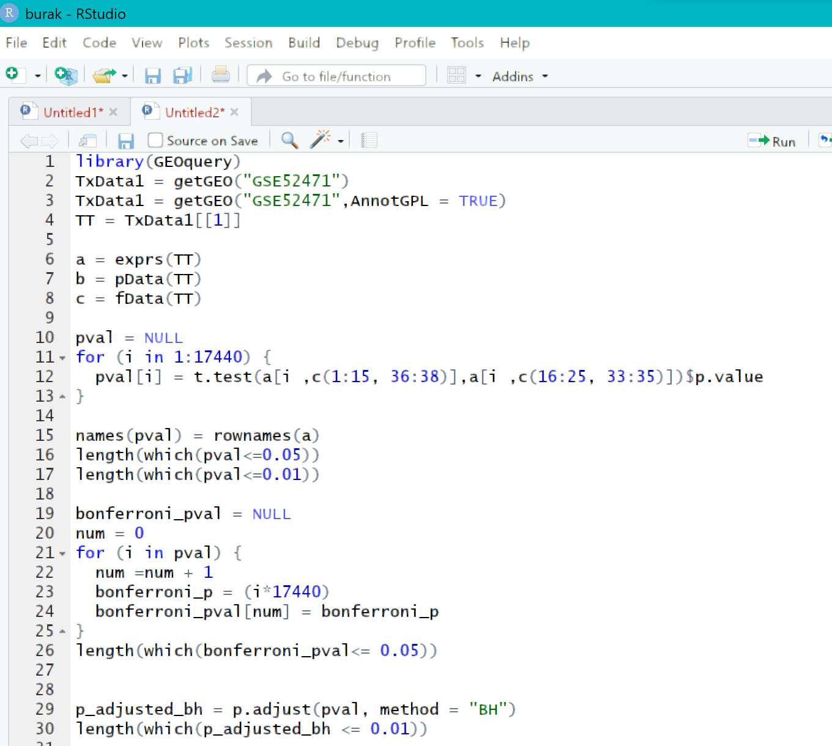
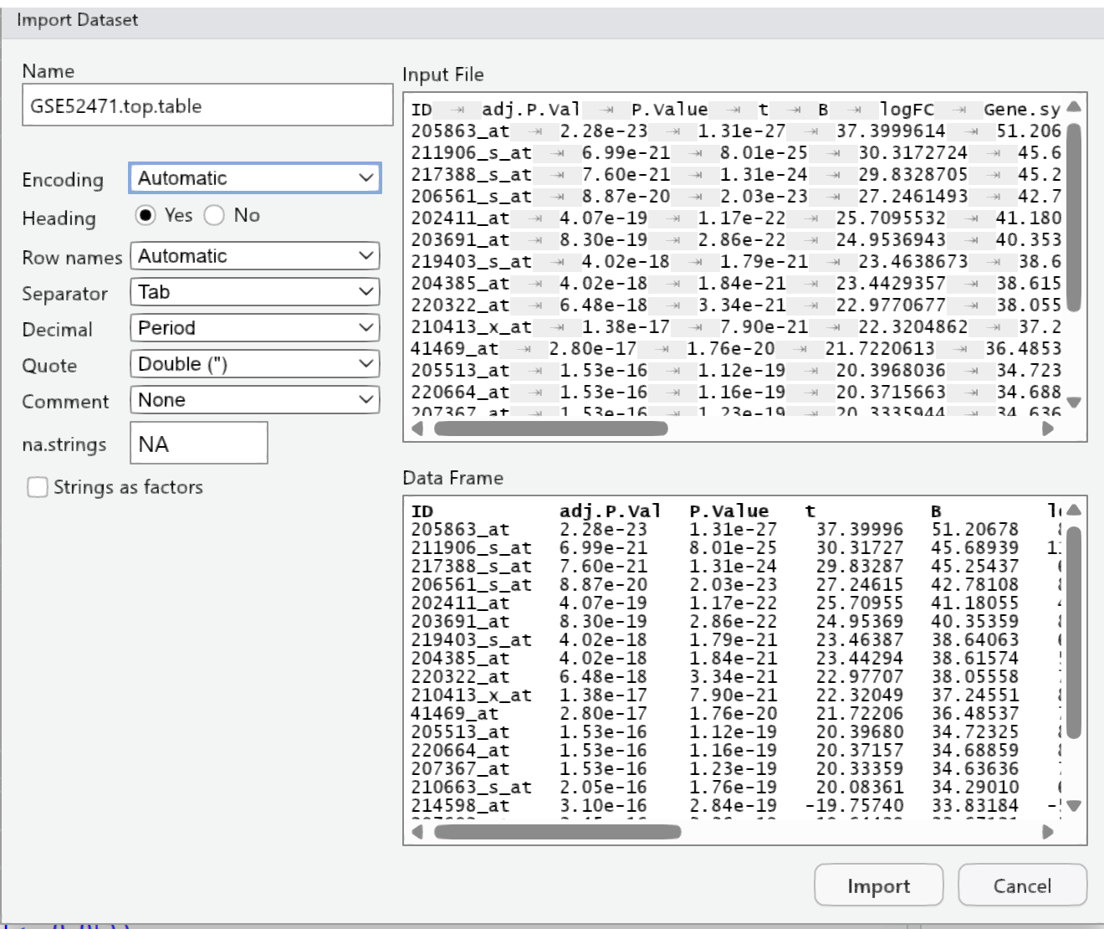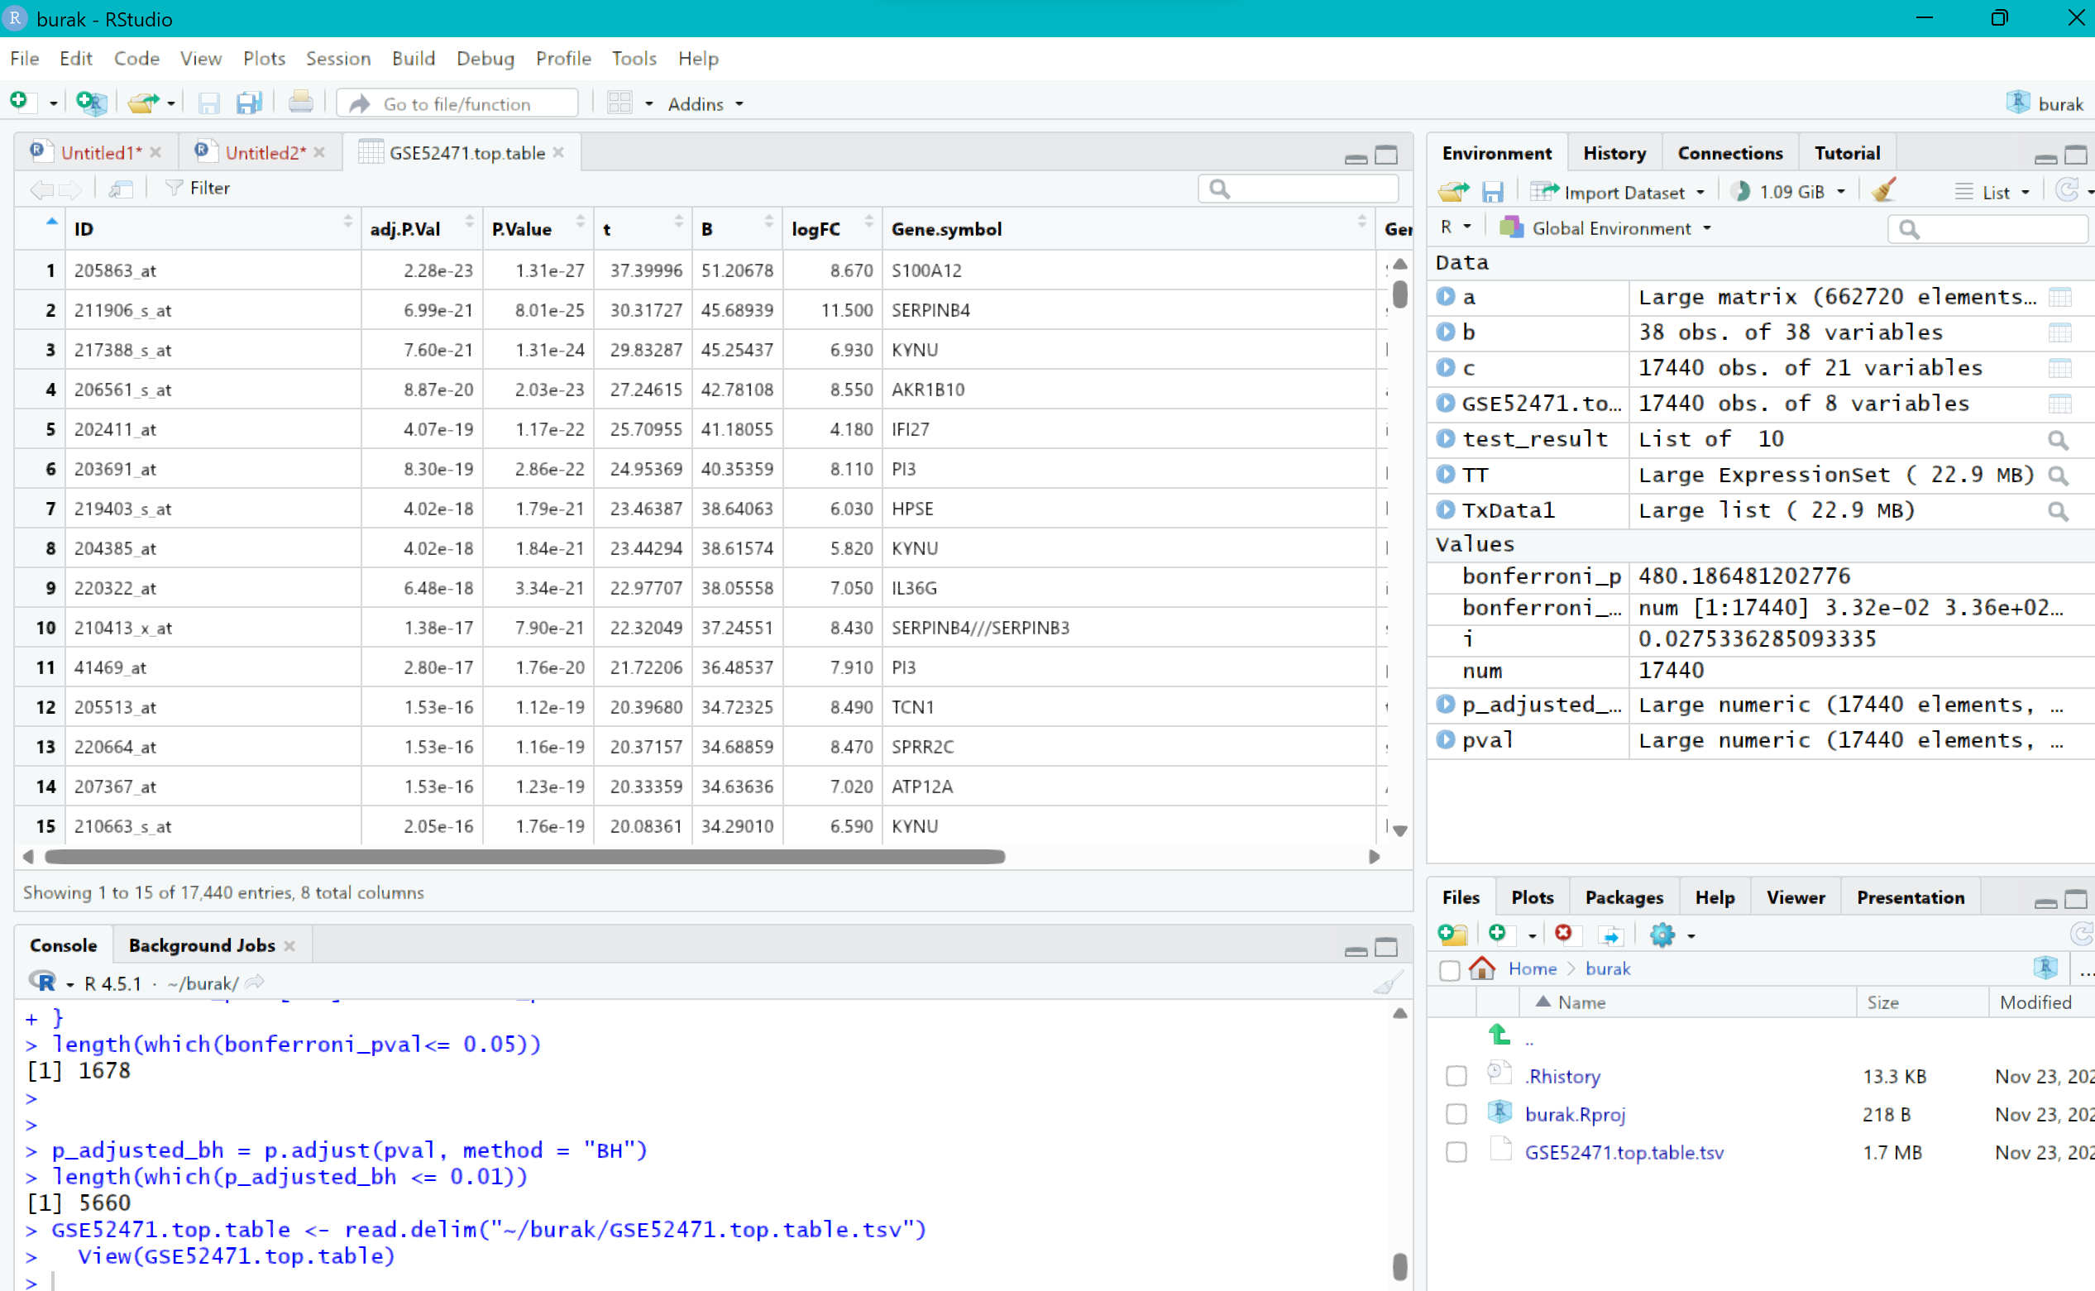
I imported the file I downloaded using Import dataset into R. Since the file I obtained with GEO2R provided the p-values for all genes rather than just those at the cutoff we specified, I redefined the cutoff in R, filtered the data, and then used the intersect() function to find the number of genes that were the same.
The table shows that 7,107 differentially expressed genes were found when the p-value cutoff was 0.01 or less.
I found the number of common differentially expressed genes to be 5,646.

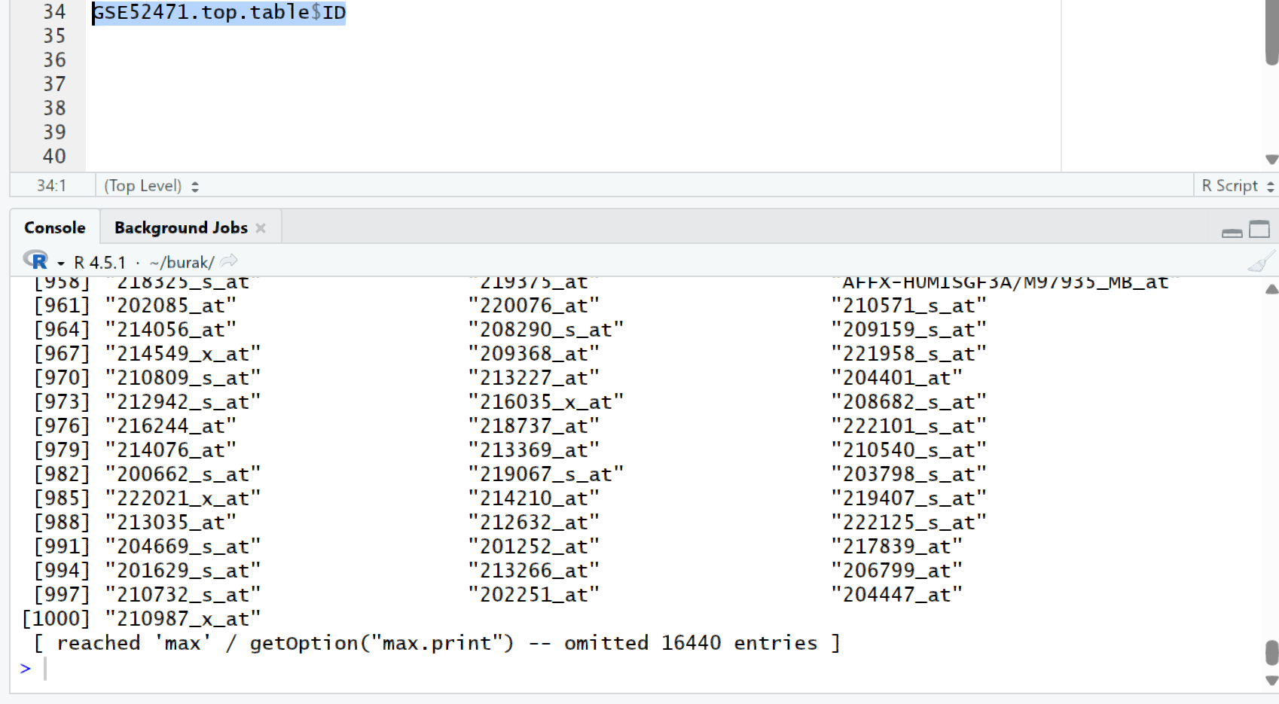
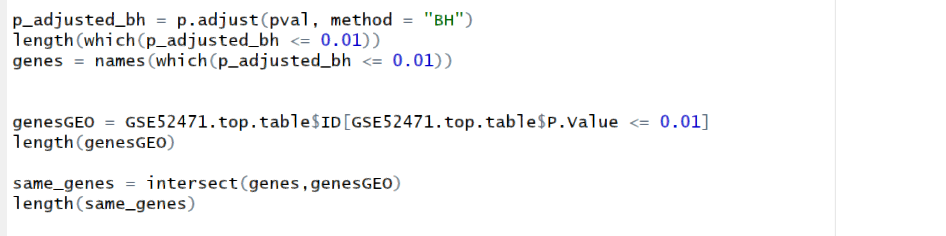
The code and outputs for the steps I mentioned on the previous page are provided on the left.
The p-values of the genes in the table were used for comparison. Since it was not specified in the question, I used the first one. Since the adjusted p-value is actually more reliable, I used it in the next image and provided the results.
When the cutoff is set to 0.01 with the adjusted p-value, 6051 dfexprs genes are found.
The common dfexprs gene count for both is 5506. We found a value close to the non-logarithmic form, which actually indicates that the non-logarithmic form is close to a normal distribution.
----
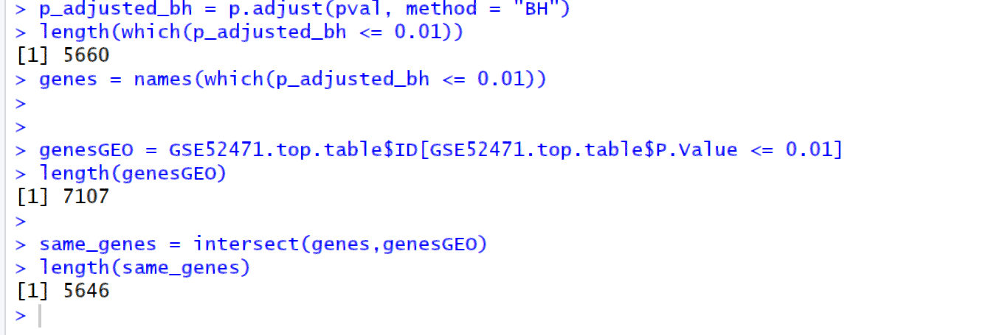
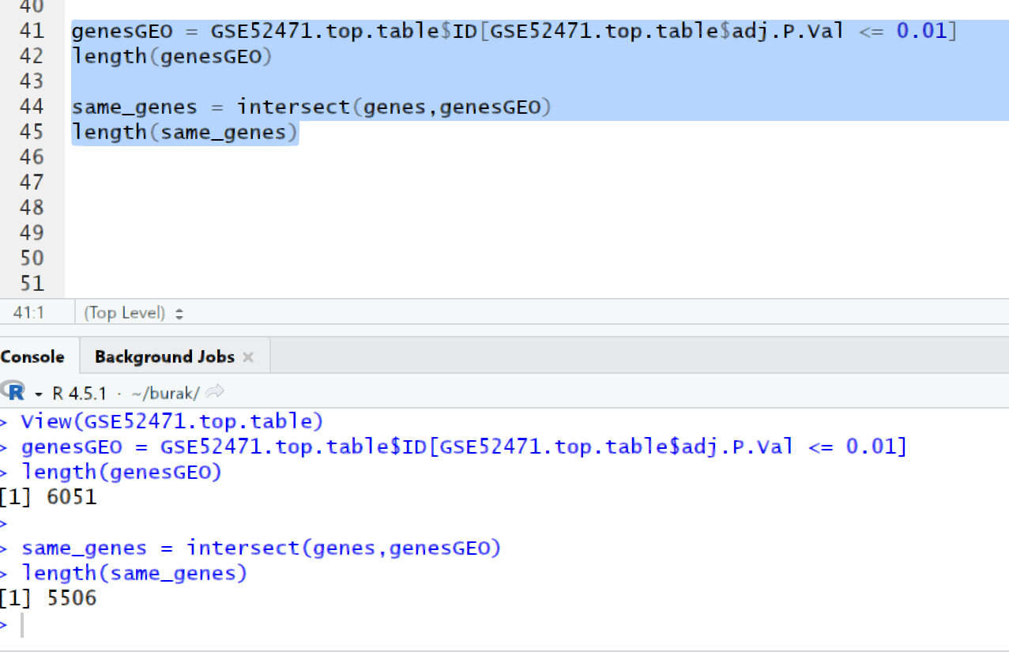
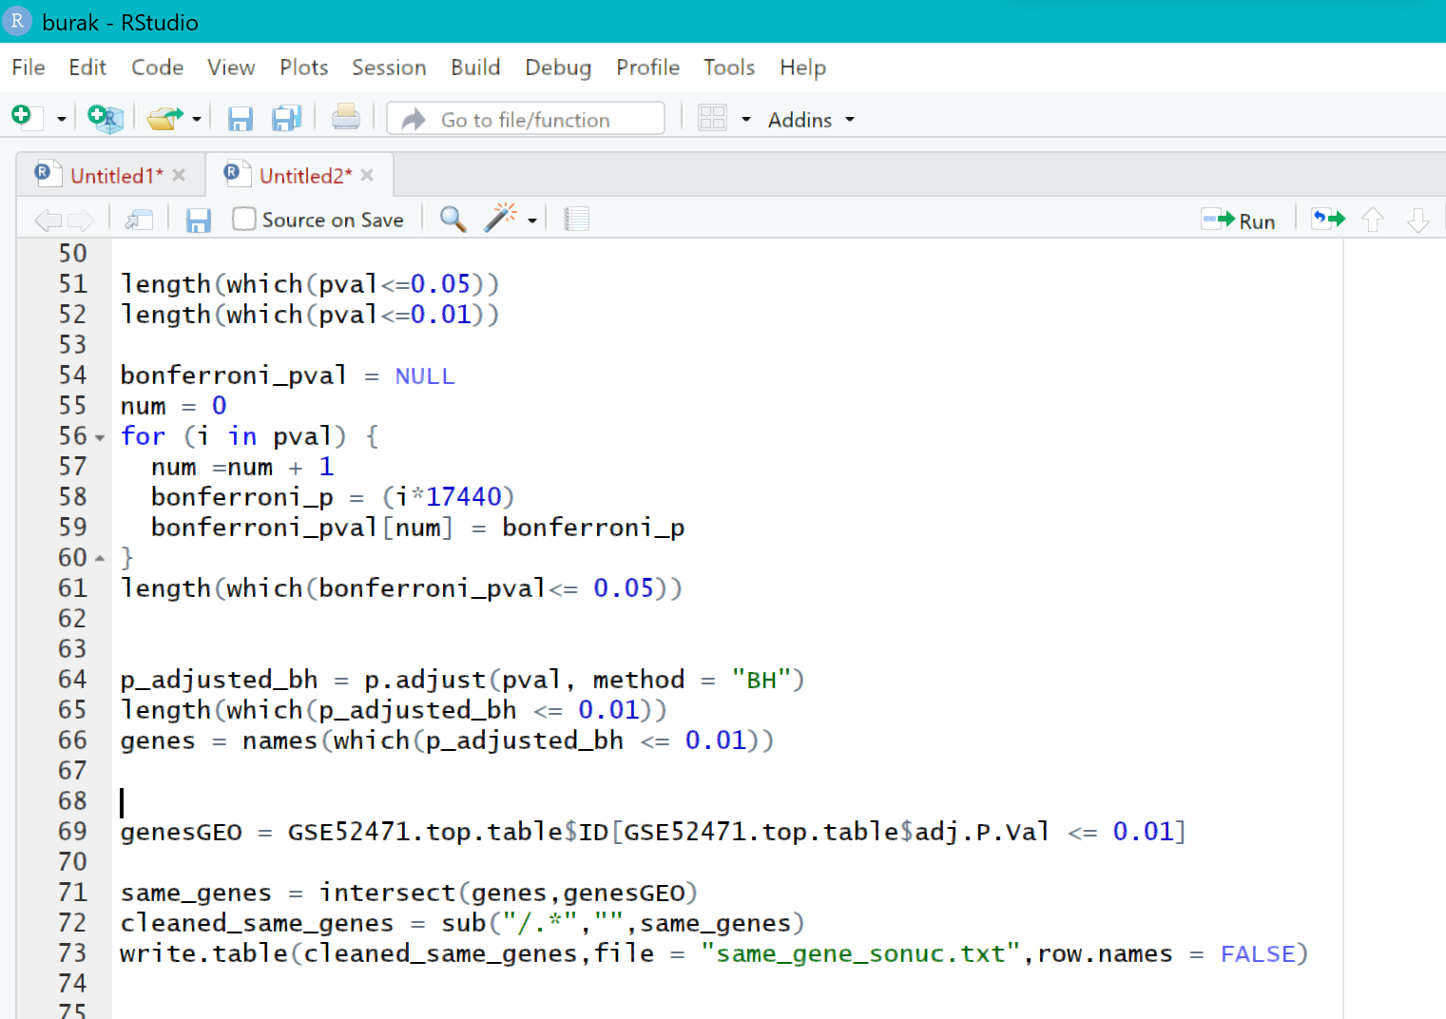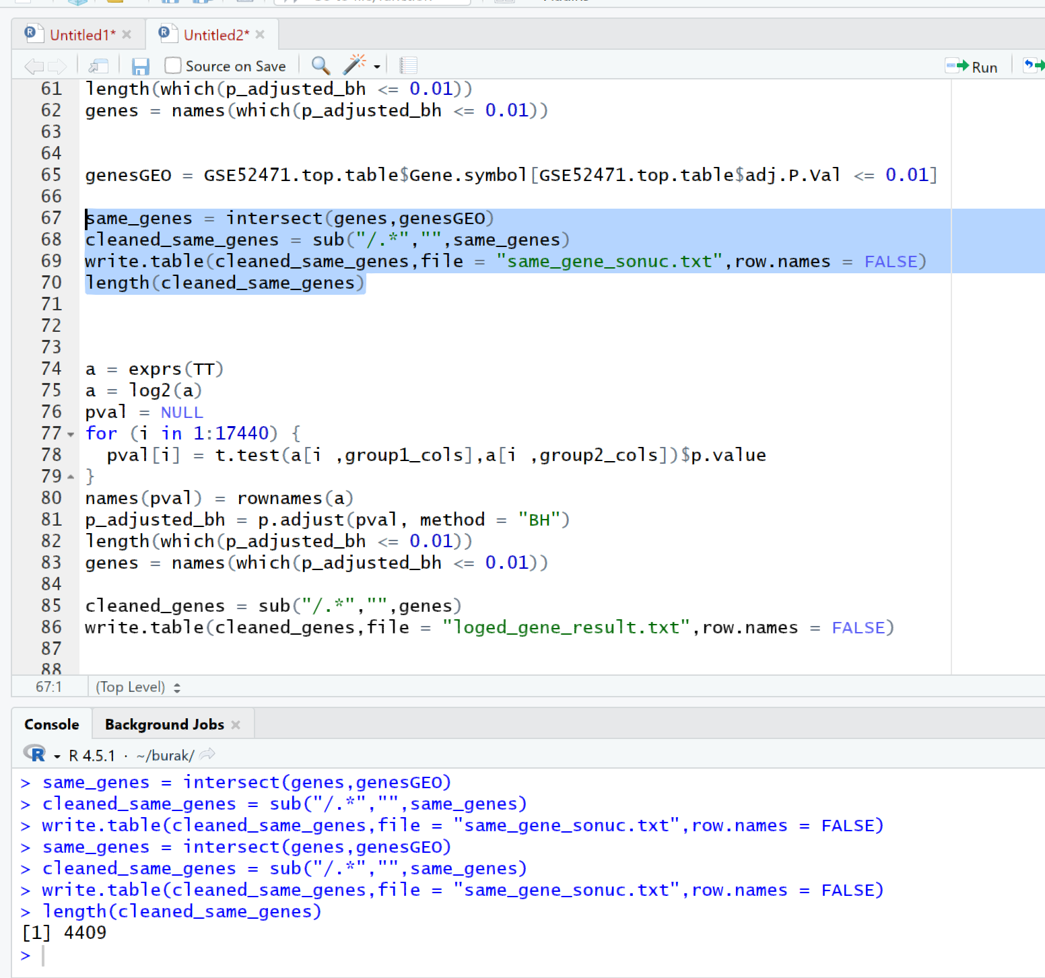
(f) Repeat (d) by first bringing the expression data closer to normal distribution by applying logarithm transformation. What is the number of differentially expressed genes this time with the same Benjamini-Hochberg correction?
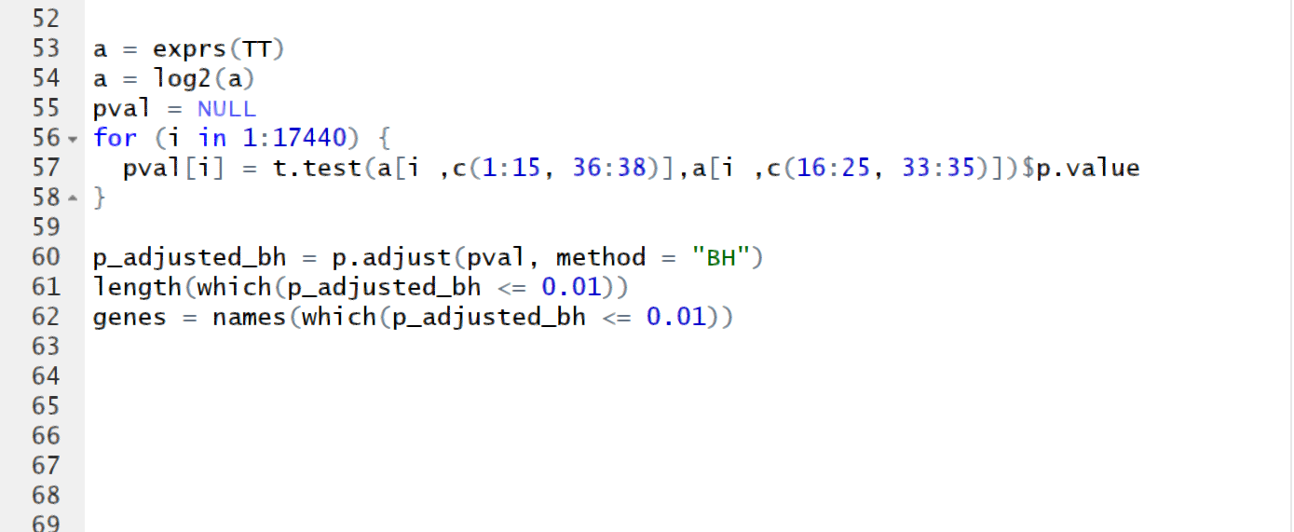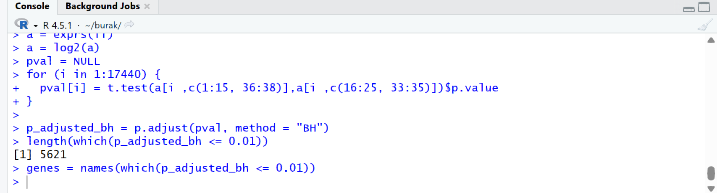
Expression levels were converted to log2 and reanalyzed, this time found 5621 dfexprs genes.
I am sharing the code below, which I later learned about online and then corrected. There are no errors in the previous images; this is just a more professional and better-written version. It has been corrected in the R code file.
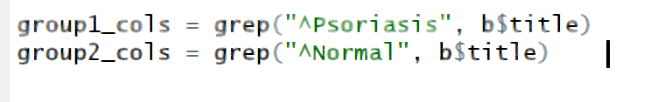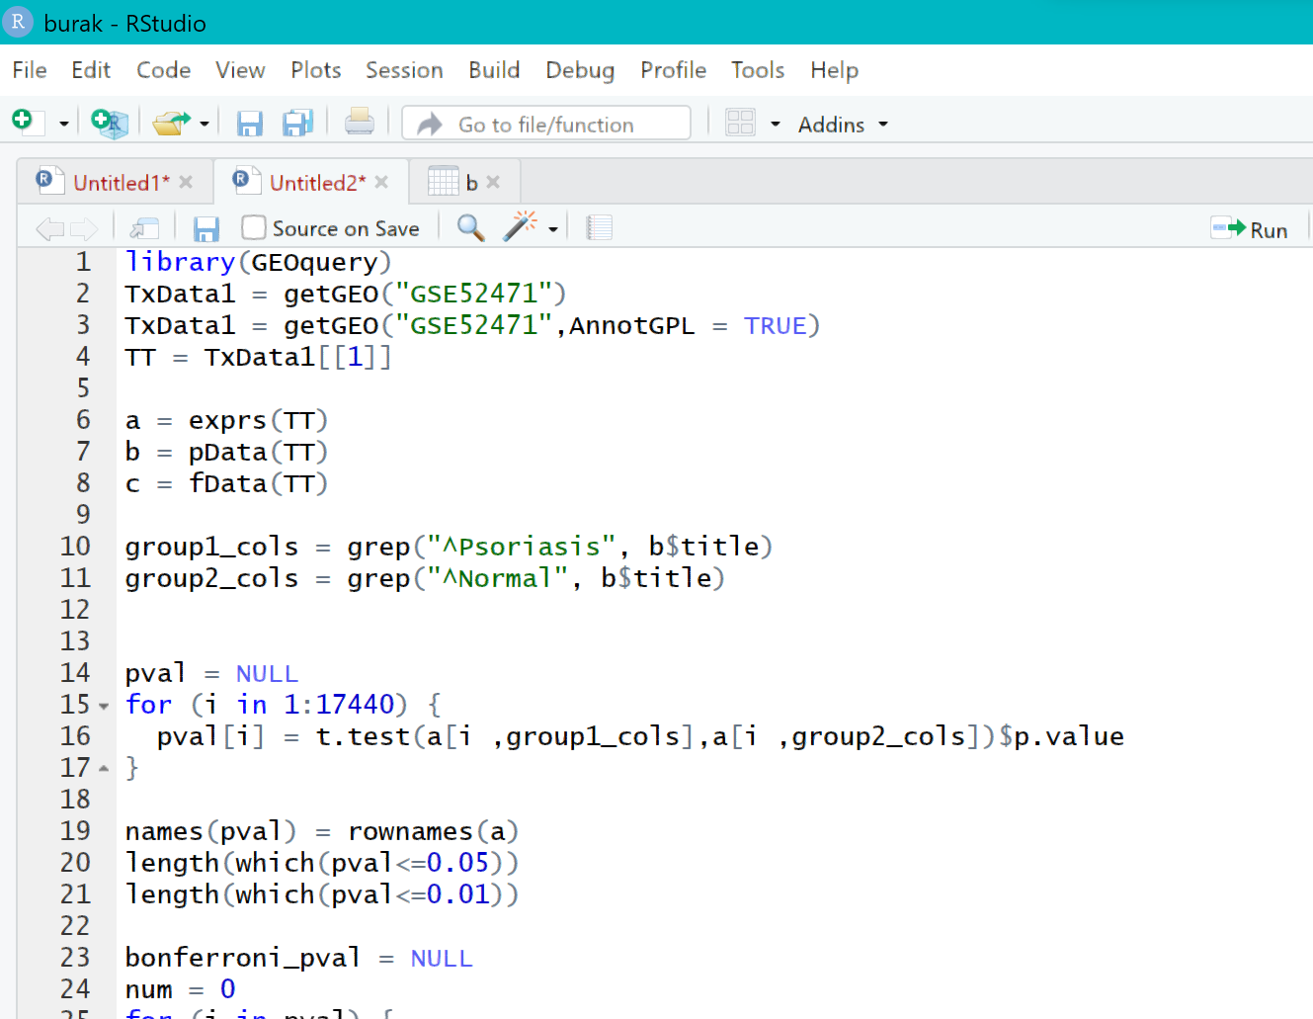
(g) Use g:Profiler tool (https://biit.cs.ut.ee/gprofiler) to perform Gene Ontology and pathway enrichment analysis of the differentially expressed genes for Benjamini-Hochberg-corrected lists obtained in (d) and (f). Use default options/cut-offs in the online tool.
When I tried it many many times I got a parse error from the website. I realized that the reason was that the website gave an error because some lines contained multiple similar genes, or because they were on the same line with this symbol. I found a function online to fix this, used it to correct the genes, and submitted them to the site. It still gave the same error; no matter what I tried, I couldn't fix it, and I didn't understand why. I think there's an issue with the website because I tried it a few times the previous day, and it worked, but this time I couldn't get it to work at all. For this reason, I used a different website. 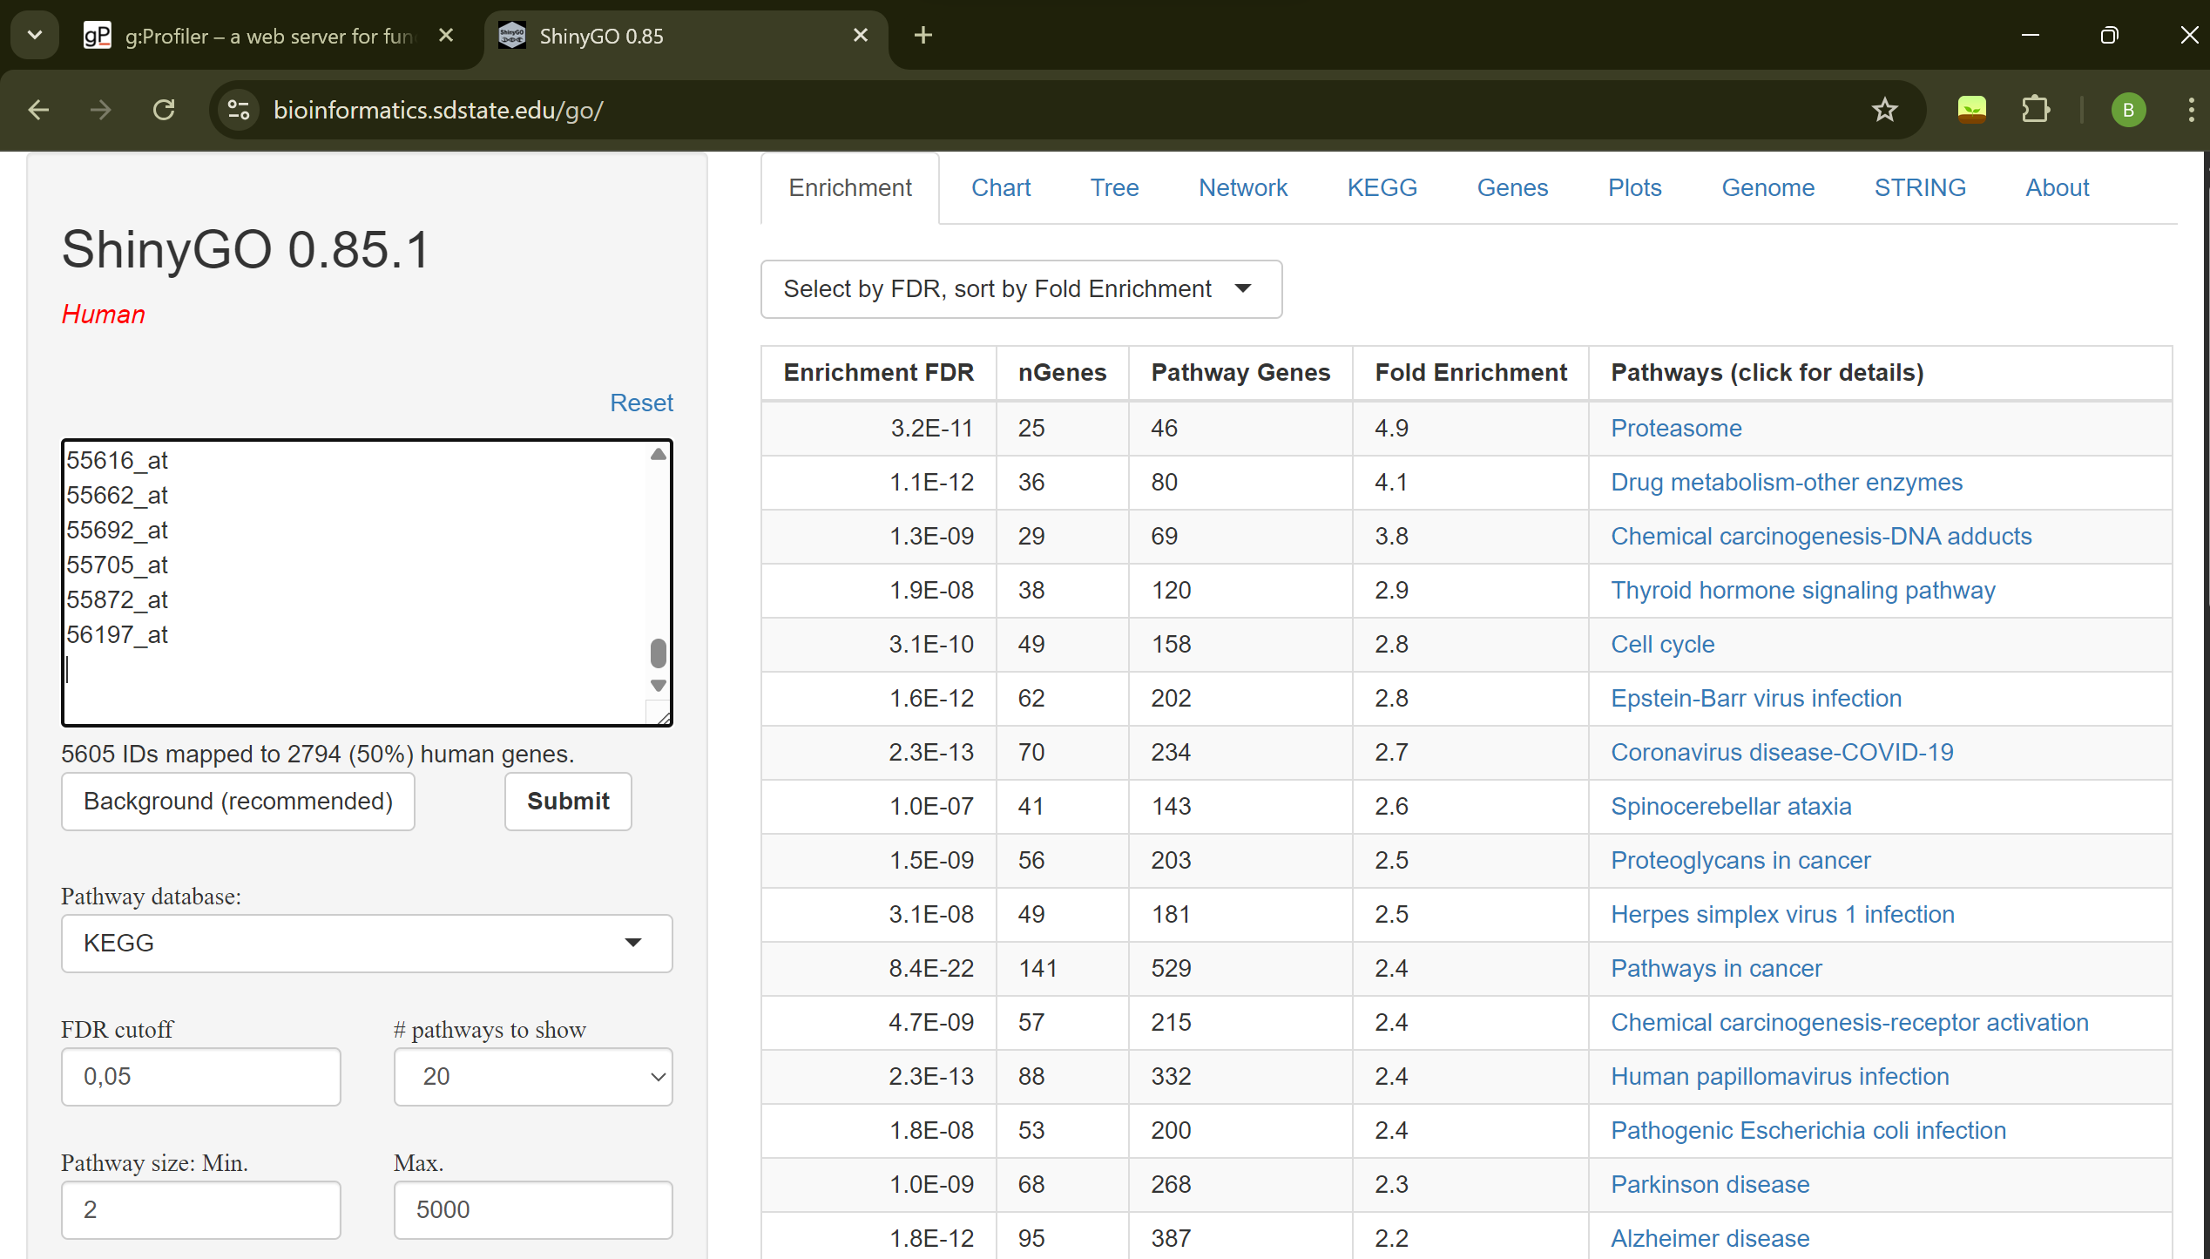 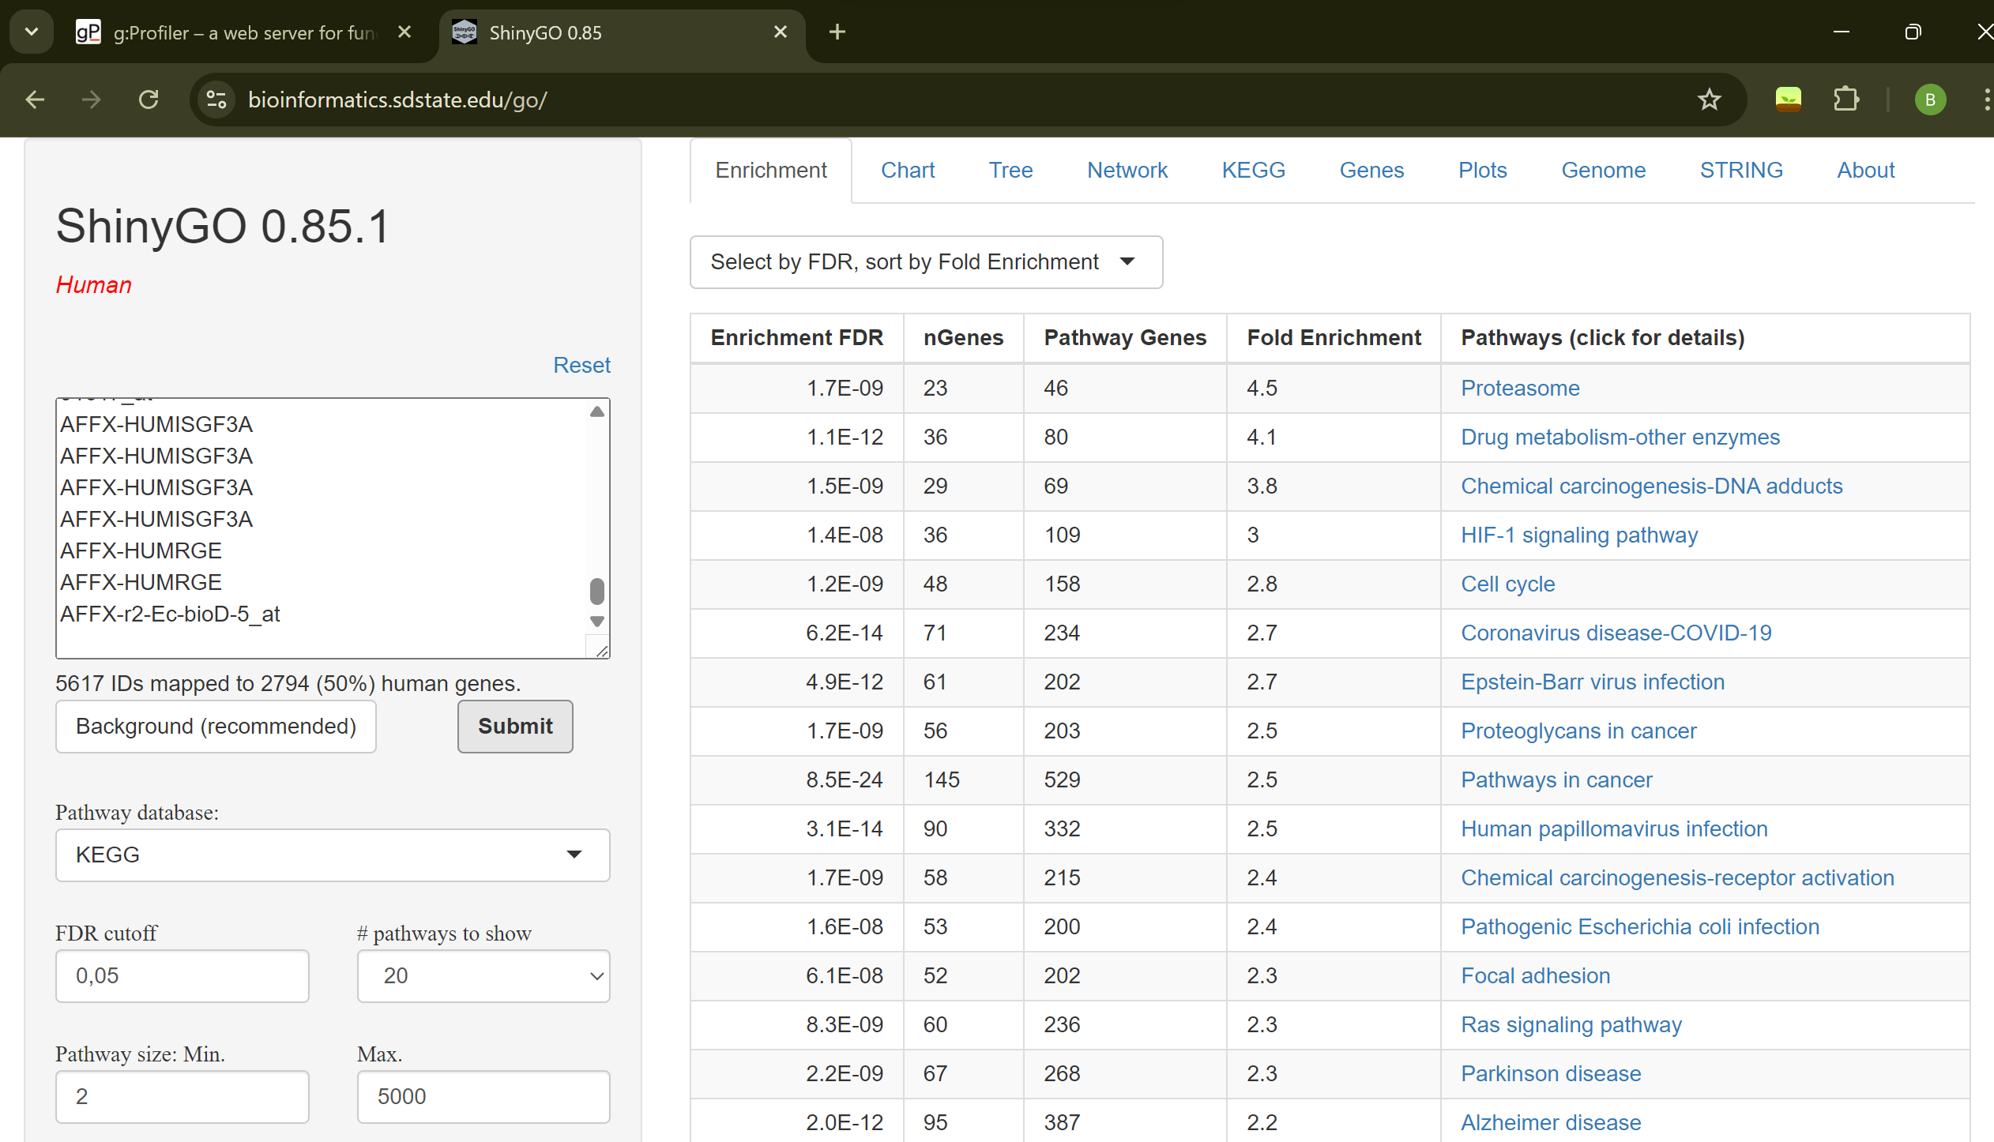
When I manually erased about 10% of the bottom part, it fixed the issue. The image below shows the result of option F. 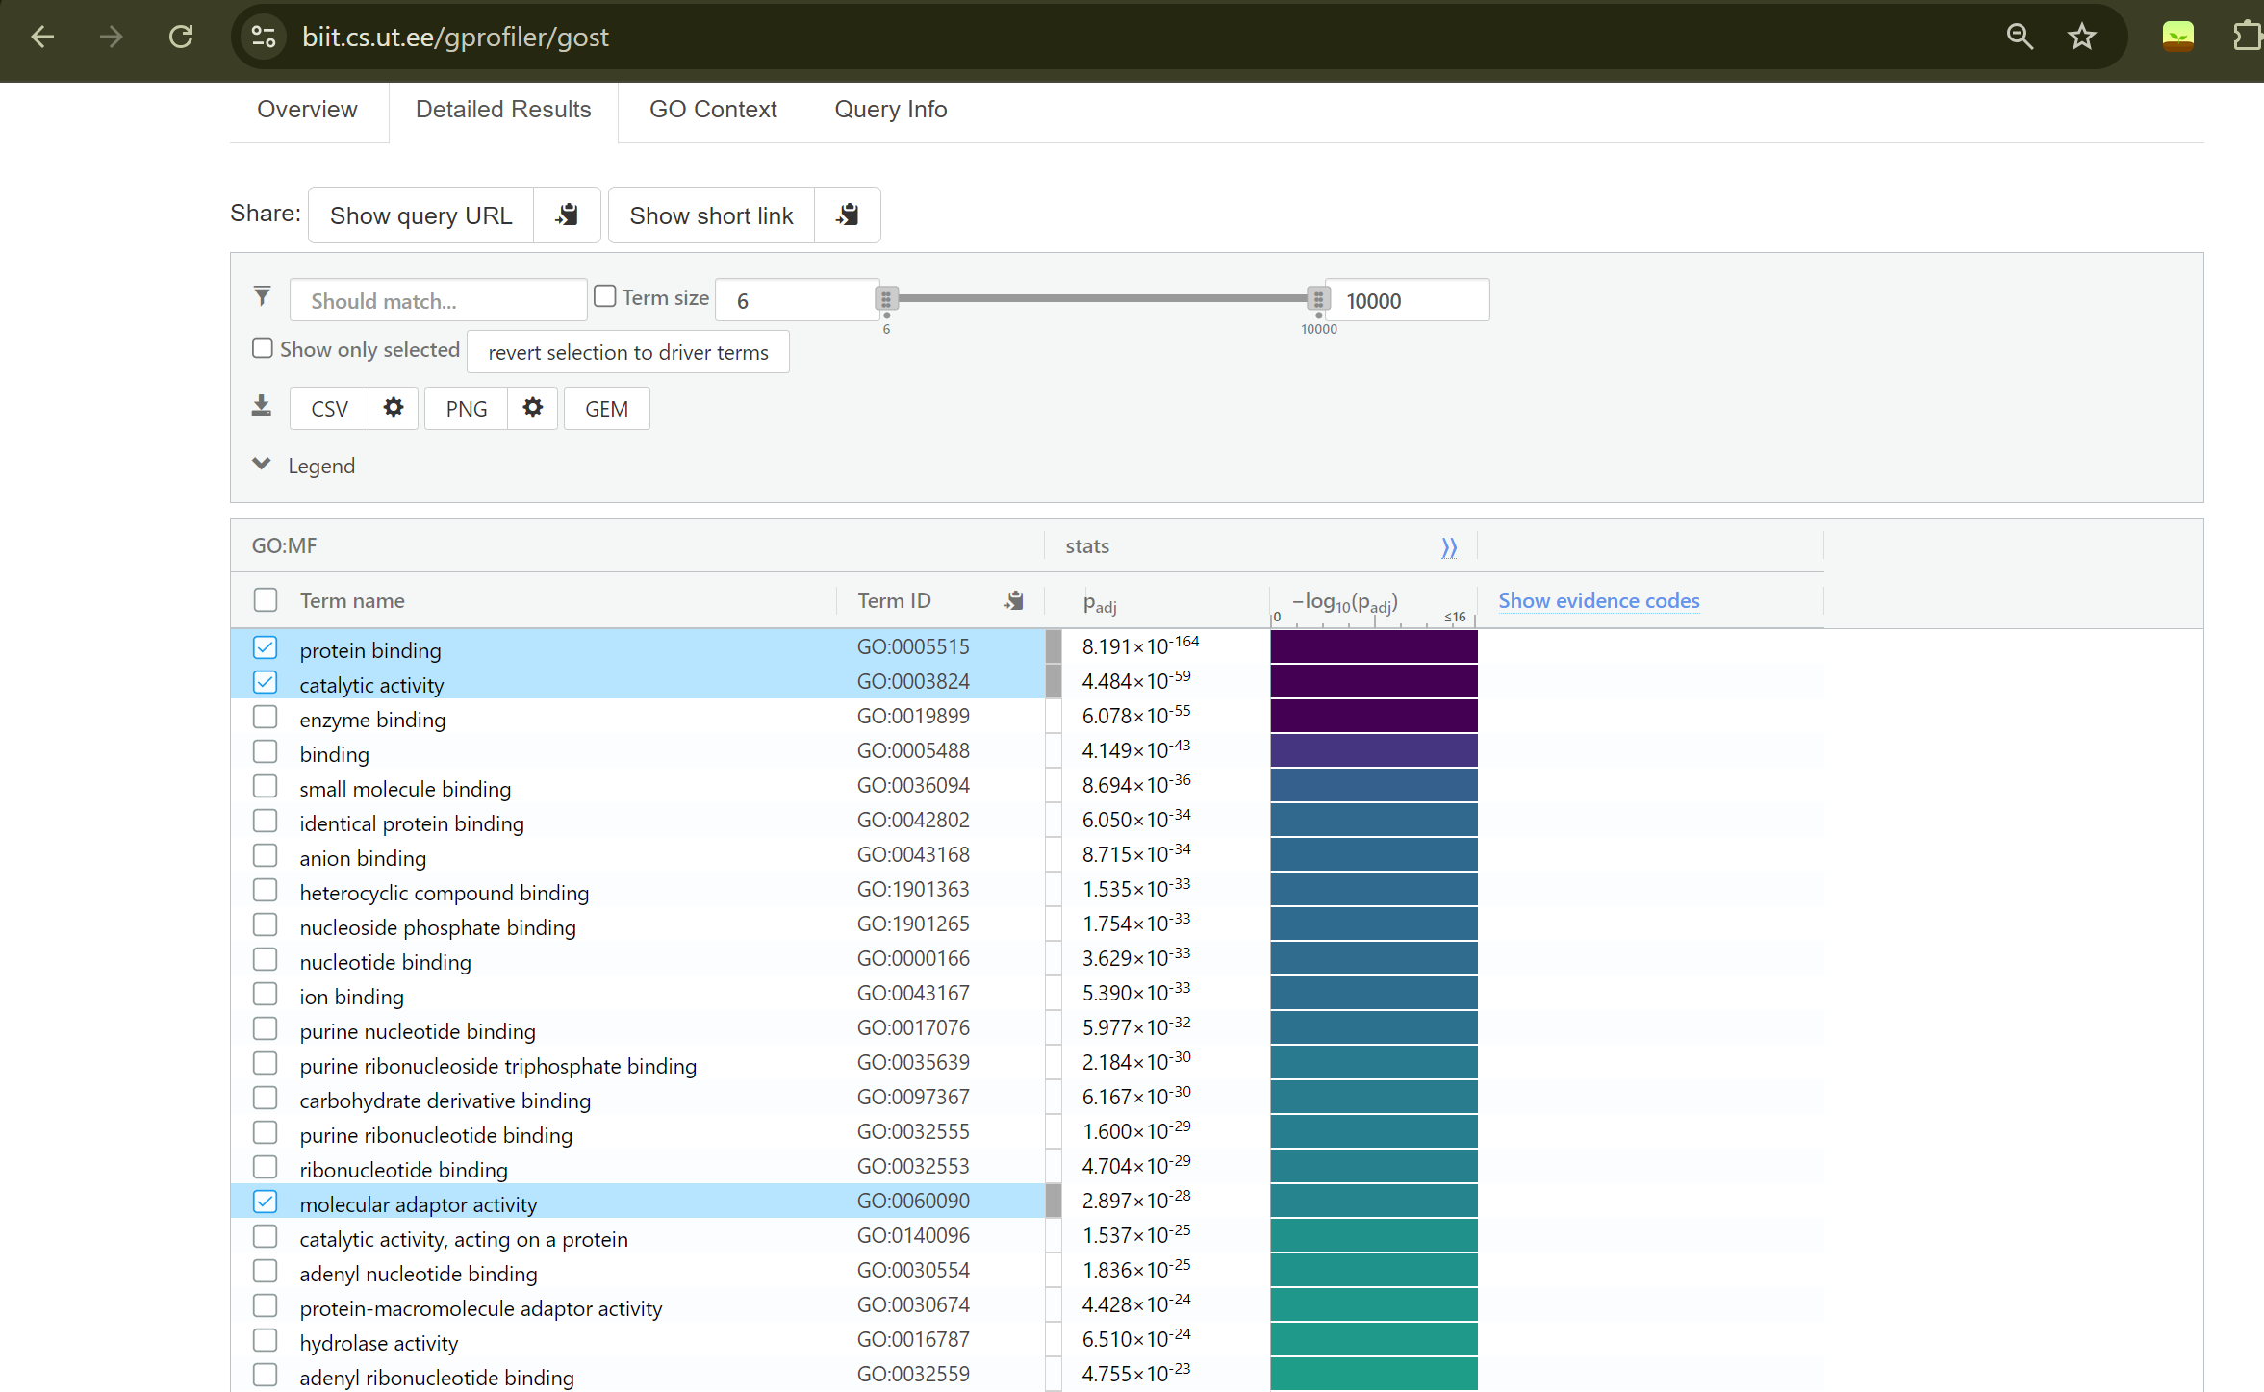
When I manually erased about 10% of the bottom part, it fixed the issue. The image below shows the result of option E. (I used E options result for more better results.) 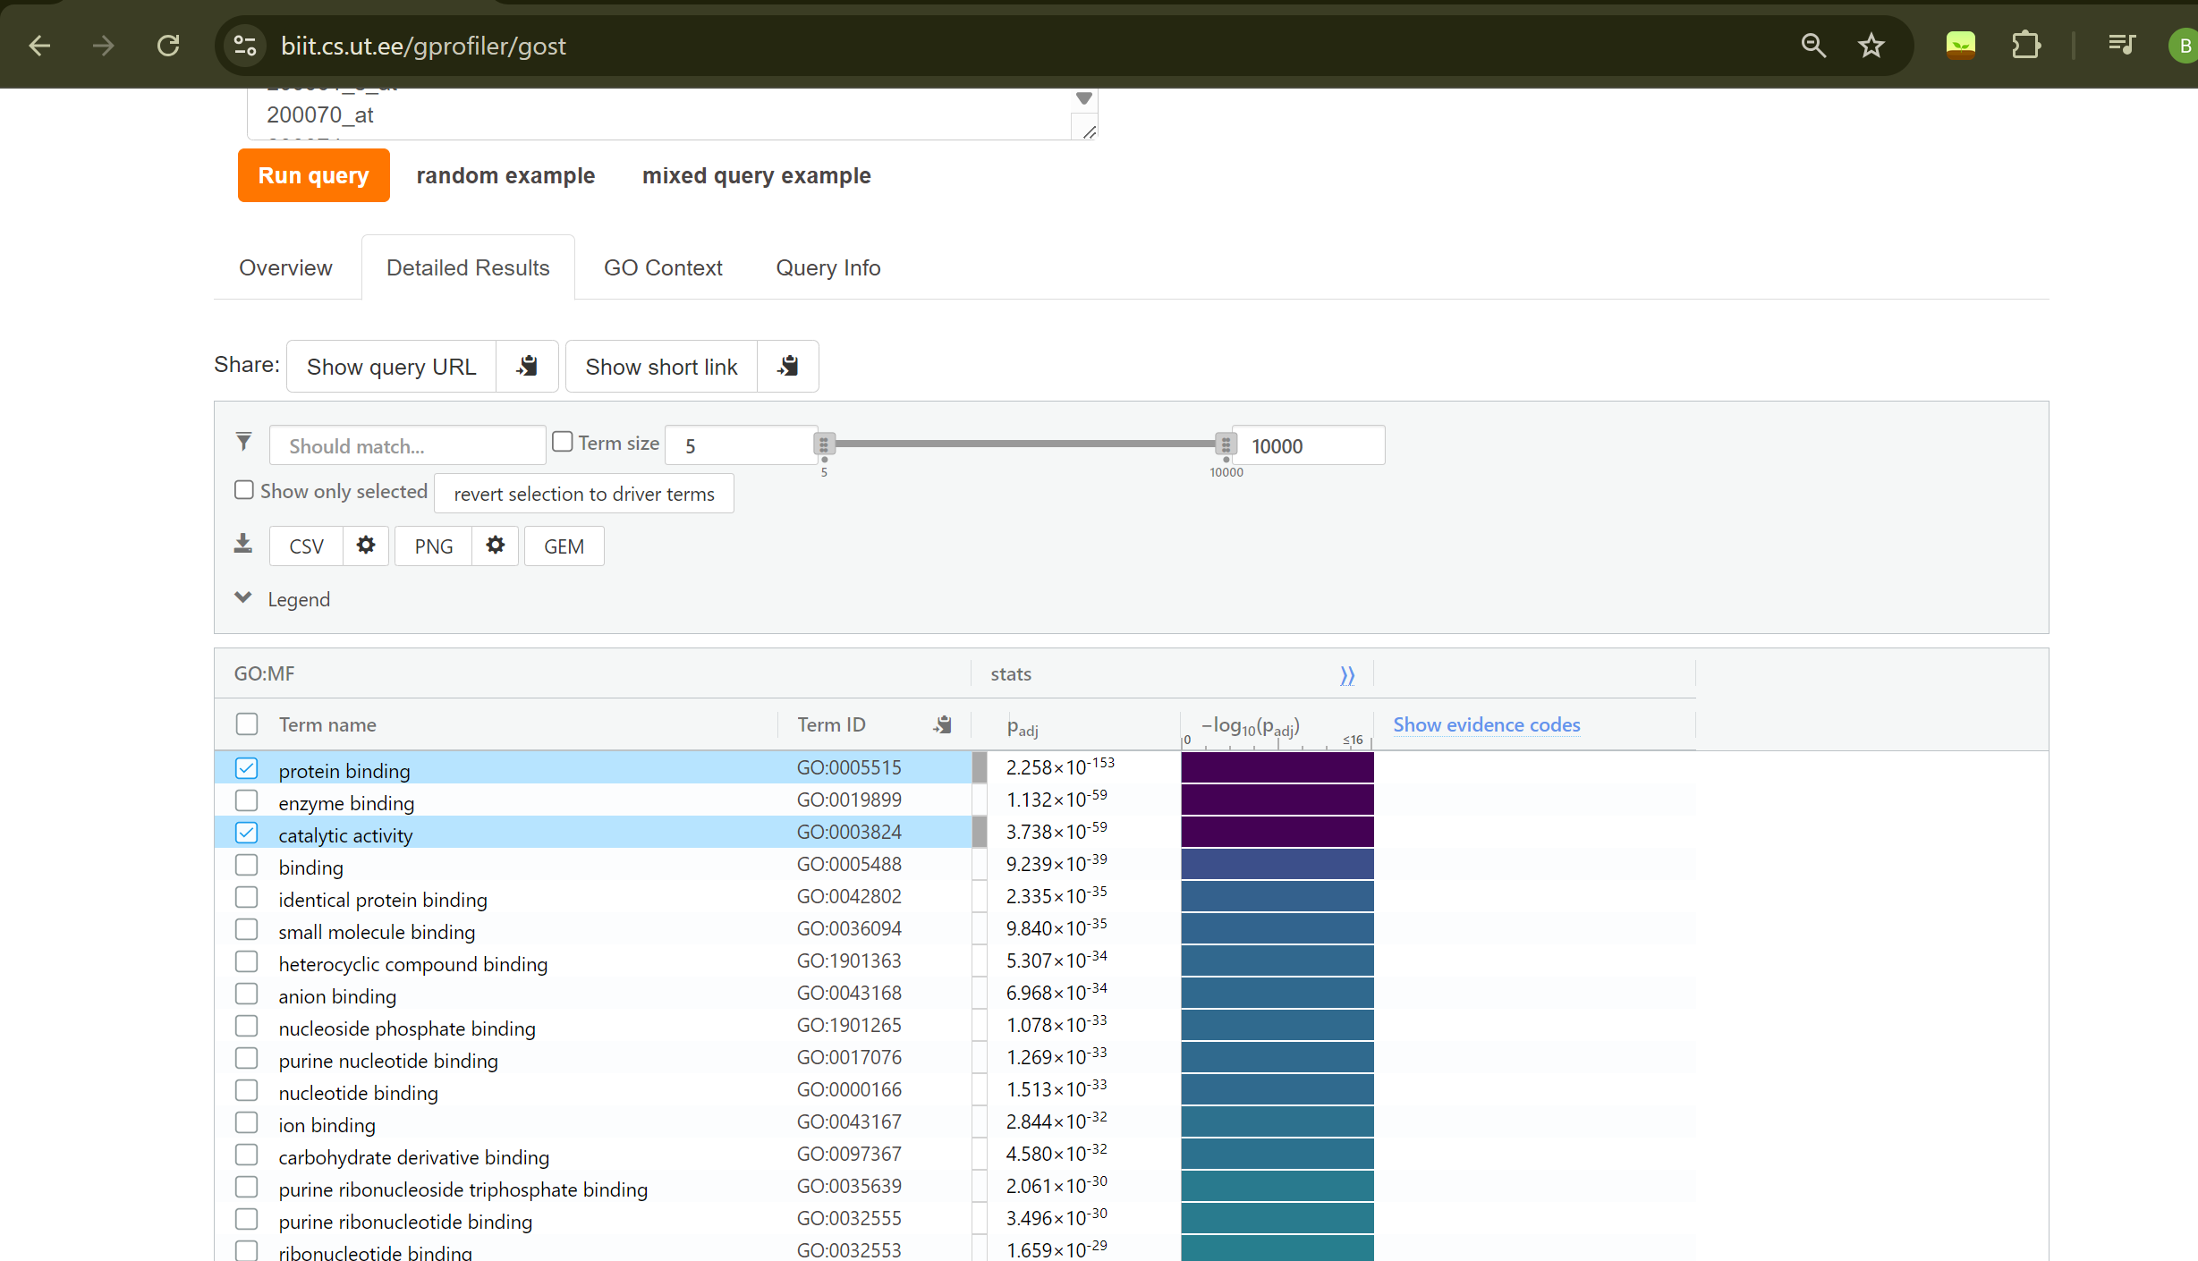

(h) Discuss the enrichment analysis results: Considering the difference in the compared conditions (i.e. psiorasis versus normal), do you think the identified enriched terms are logical? Select two “biological process” or “KEGG pathway” terms that are common in the results of genes from (d) and (f). Select one term that only appears in the enrichment result of (d). Select one term that only appears in the enrichment result of (f). Search these four terms to see if they are related to psiorasis. Feel free to ask this to chatgpt. Discuss in detail.
I selected protein binding and enzyme binding as a common biological process. Yes, considering the comparison between psoriasis and normal skin conditions, the identified enrichment terms are reasonable. Psoriasis is a complex disease involving the upregulation of inflammatory pathways and the downregulation of normal skin barrier functions. Similarly, enzyme binding biological pathways are also expected to function improperly in this disease. Just one of them has hidrolase activity and other one doesn’t have different pathway. Hydrolase activity in psoriasis, mainly from proteases, lipases, and phosphatases, contributes to the disease by amplifying immune responses and promoting keratinocyte hyperproliferation. It does not start the disease by itself but helps maintain and intensify the chronic inflammatory cycle.
i From the expression data, select 5 genes with lowest uncorrected p-values. Caculate Pearson correlation and Spearman correlation between each pair for the normal samples, and separately for the psoriasis samples. Are there any pairs that show significant correlation in one condition, and the significance is lost in the other condition? Below I gave lost correlation its means other have correlation

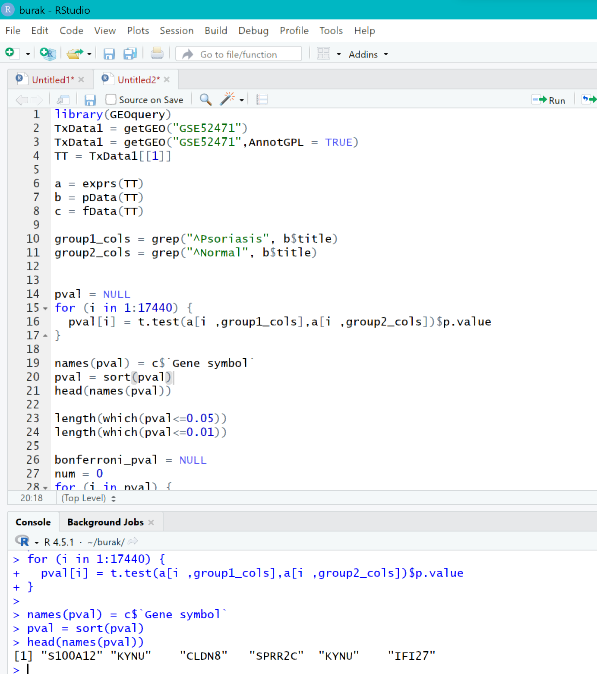
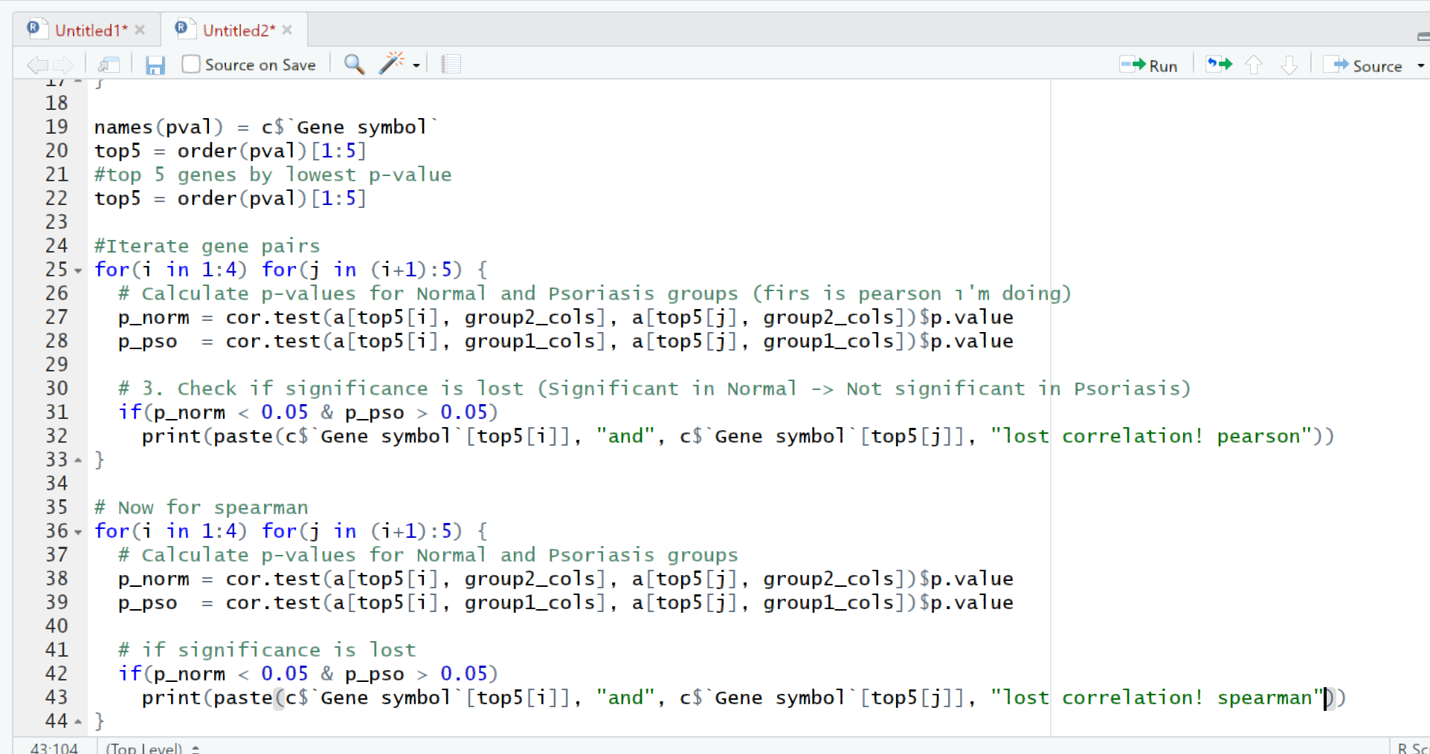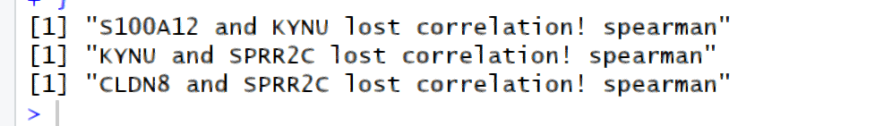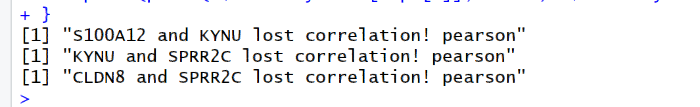

(j) (must be hand-written!) What is the goal of this Homework? Also, explain what you learned in five bullet points.
The goal of this assignment was to learn the complete workflow of transcriptomic data analysis; specifically managing datasets in R, performing statistical tests, and interpreting biological data to understand disease mechanisms.
Data Management: how to manipulate raw datasets using the R
Statistical Analysis: how to apply tests
Normalization: Learned the importance of log-transformation to normalize data distribution
Biological Interpretation: Learned how to perform enrichment analysis
Correlation Analysis: Learned how to calculate Pearson and Spearman correlations to observe how gene-gene interactions change between conditions.

extras