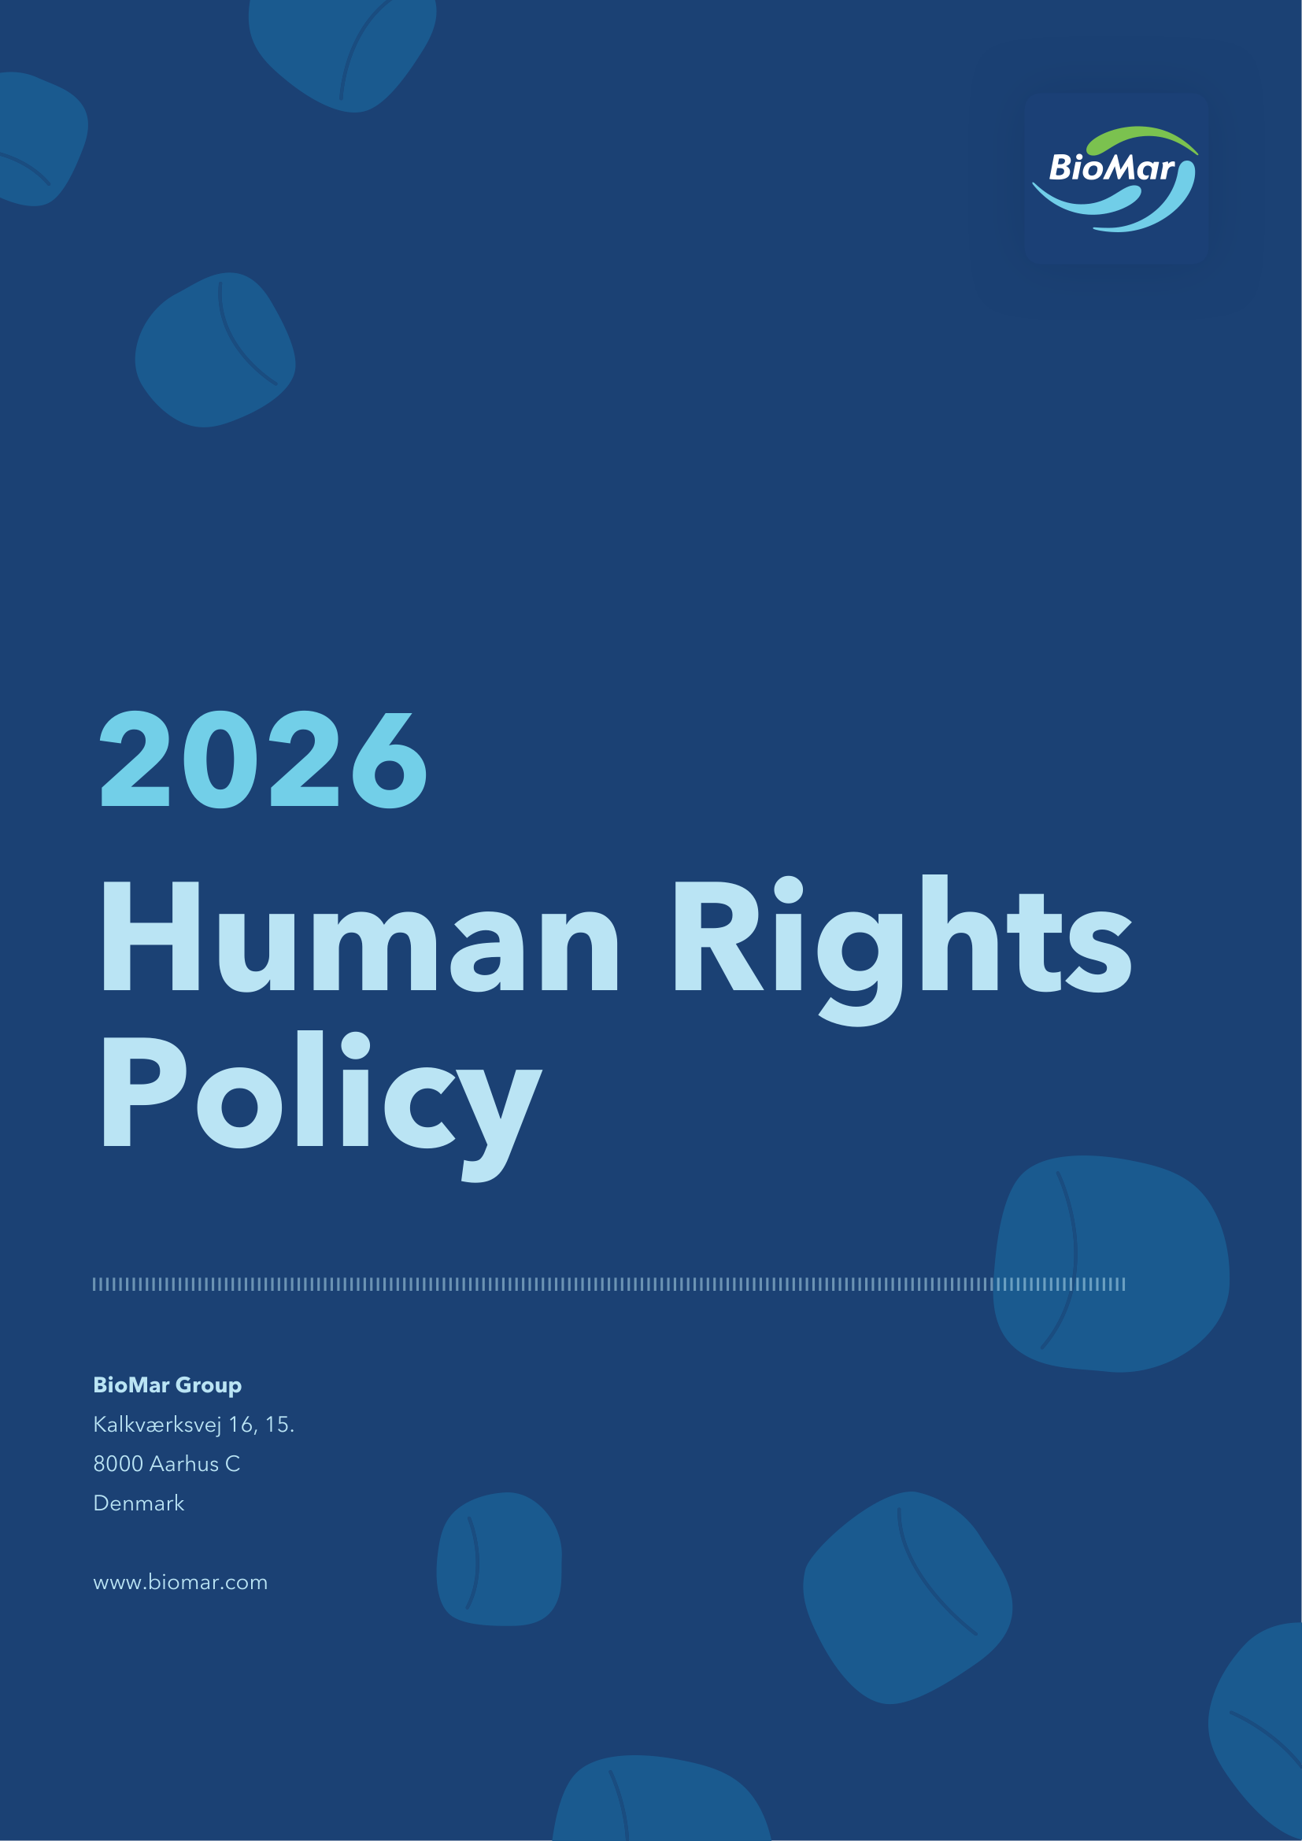

Introduction
BioMar operates across diverse continents, navigating varying economies, political landscapes and cultures. Amid this diversity, our commitment to and respect for human rights remains unwavering. We understand the profound impact human rights have on our employees and all stakeholders, and we continuously evolve our practices to uphold three core principles:
1. Adhere to global human rights standards
2. Ensure a robust due diligence
3. Provide access to grievance and remedy
Principle 1: Adhere to global human rights standards
At BioMar, we are committed to aligning with international human rights standards, including the Universal Declaration of Human Rights (UDHR), the International Bill of Human Rights, the United Nations Guiding Principles, and the OECD Guidelines for Multinational Enterprises. Our commitment encompasses all relevant human rights, with particular focus on:
1. Occupational health and safety
2. Labour conditions for our employees and in the value chain
3. Community rights, including indigenous communities
4. Protection of whistleblowers and access to effective remedy
We recognise that human rights and labour rights are interconnected and mutually reinforcing. Therefore, we are also committed to upholding the core labour standards inherent to the ILO Declaration on Fundamental Principles and Rights at Work, such as:
- Freedom of association and the effective recognition of the right to collective bargaining
- Elimination of all forms of forced or compulsory labour
- Effective abolition of child labour
- Elimination of discrimination in respect of employment and occupation
- Safe and healthy working environment.
These commitments are reflected in our Human Rights Policy and further supported by the associated policies detailed at the end of this document.
At BioMar, our commitment to human rights extends beyond our employees to all stakeholders connected to our operations, including their employees. We expect our suppliers, business partners and customers to uphold international standards and conventions on human and labour rights.
Principle 2: Ensure a robust due diligence
BioMar is committed to ongoing human rights due diligence to assess compliance with international obligations and expectations regarding human and labour rights. These assessments enable us to identify strengths, address challenges, evaluate the effectiveness of mitigation measures and determine appropriate corrective actions.
Our due diligence process encompasses all aspects of our operations and supply chain, including direct activities, suppliers and affected communities, with particular attention to high-risk regions and industry sectors. We leverage multiple data sources such as industry reports, engagement surveys and employment data in order to gain a comprehensive understanding of our impact. Key departments, including Sourcing, Sustainability and Human Resources, collaborate to ensure a thorough and effective assessment. The insights gained from our due diligence reviews play a crucial role in the continuous enhancement of our practices.
Our commitment to strong business ethics and responsible conduct, including respect for human rights, is integral to how we do business. We require the same high standards from our suppliers and business partners to ensure that human rights are respected throughout our value chain. To strengthen our shared commitment, we conduct regular evaluations of our suppliers, assessing their adherence to human rights principles. This process includes annual risk assessments and ongoing engagement to monitor compliance and drive continuous improvement.
By maintaining a structured and proactive approach, we seek to foster responsible business conduct that respects human and labour rights.
Principle 3: Provide access to grievance and remedy
BioMar is committed to fostering a transparent and accountable business environment where all stakeholders, employees, suppliers, business partners and any affected communities can raise concerns freely and safely, without fear of retaliation. Our grievance mechanisms are designed to ensure accessibility, confidentiality and timely resolution of issues related to human and labour rights.
We recognise that individuals who may be negatively affected by our operations, whether internal or external stakeholders, have the right to access effective grievance mechanisms. We acknowledge our responsibility to address and remedy adverse impacts we may have caused or contributed to. We also affirm that we will not obstruct access to other forms of remedy, whether judicial or non-judicial.
BioMar provides various grievance redressal mechanisms for employees and stakeholders that are internal as well as publicly accessible. These channels include Community Dialogue to minimise any inconvenience caused to local communities due to our operations. The channels also include direct access to HR for employees seeking support or resolution and anonymous engagement surveys that we conduct periodically to receive feedback directly from our employees.
As a last-resort mechanism, when anonymity is essential or other reporting channels might not be appropriate, BioMar employees and third parties can report suspected violations of laws, our Code of Conduct, policies or standards through the whistleblower channel: the BioMar Speak-Up Line. This platform is managed by the Ethics Committee via a secure and confidential process and will provide feedback to the reporter within a reasonable timeframe and no later than 60 days from acknowledgement, or within the extended timeframe permitted by law for complex cases.
The BioMar Speak-Up Line is open to external individuals, including workers in our supply chain and affected communities, ensuring that grievances related to our business operations are heard and addressed. We also encourage our stakeholders to inform their employees about the BioMar Speak-Up Line, which is available in multiple languages to promote widespread awareness and accessibility.
We expect our stakeholders and business partners not only to establish grievance mechanisms, but also to commit to providing access to remedy where adverse human rights impacts are identified. Suppliers must ensure that their grievance mechanisms are accessible to all workers, available in appropriate languages and clearly communicated to employees and local communities. We also require them to extend these expectations to their own suppliers, fostering a comprehensive approach to grievance resolution across the value chain.
Furthermore, BioMar is committed to collaborating with judicial and non-judicial mechanisms to address grievances and remedy adverse impacts effectively. We will also work closely with our suppliers to uphold these commitments, including supporting them in identifying and remedying these adverse human rights impacts, ensuring accountability and continuous improvement throughout our business ecosystem.
Governance and related policies
Governance and oversight of our human rights commitments are embedded across BioMar’s operations.
This policy is approved by Executive Management and is owned at the executive level by the Vice President of People, Purpose and Communication. Its day-to-day implementation is cross-functional and involves collaboration across various departments and roles throughout the organisation, including Sustainability, Sourcing and Human Resources to ensure consistent application and oversight. These teams work together to ensure that human rights are respected throughout our business activities, providing the necessary guidance and oversight to uphold our commitments.
The Human Rights Policy applies to all BioMar companies, including our joint-ventures and is integrated into our broader governance framework. Our Managing Directors are responsible for the implementation in the subsidiaries.
We regularly review the policy and its implementation to ensure alignment with evolving international standards, stakeholder expectations and lessons learned from our due diligence and grievance processes.
The following policies support the implementation of the Human Rights Policy:
- Code of Conduct
- Supplier Code of Conduct
- Responsible Sourcing Policy
- Diversity Policy
- Modern Slavery Policy (Only UK and AUS)
- Environmental Policy
- Health and Safety Policy
- Responsible Employment Policy
- Salary Policy
- Quality and Food Safety Policy

Version history | Owner and approver
Version 2.1: 18-06-2026  Approval date: 18-06-2026 | Owner: VP People, Purpose & Communication  Approver: Executive Management

