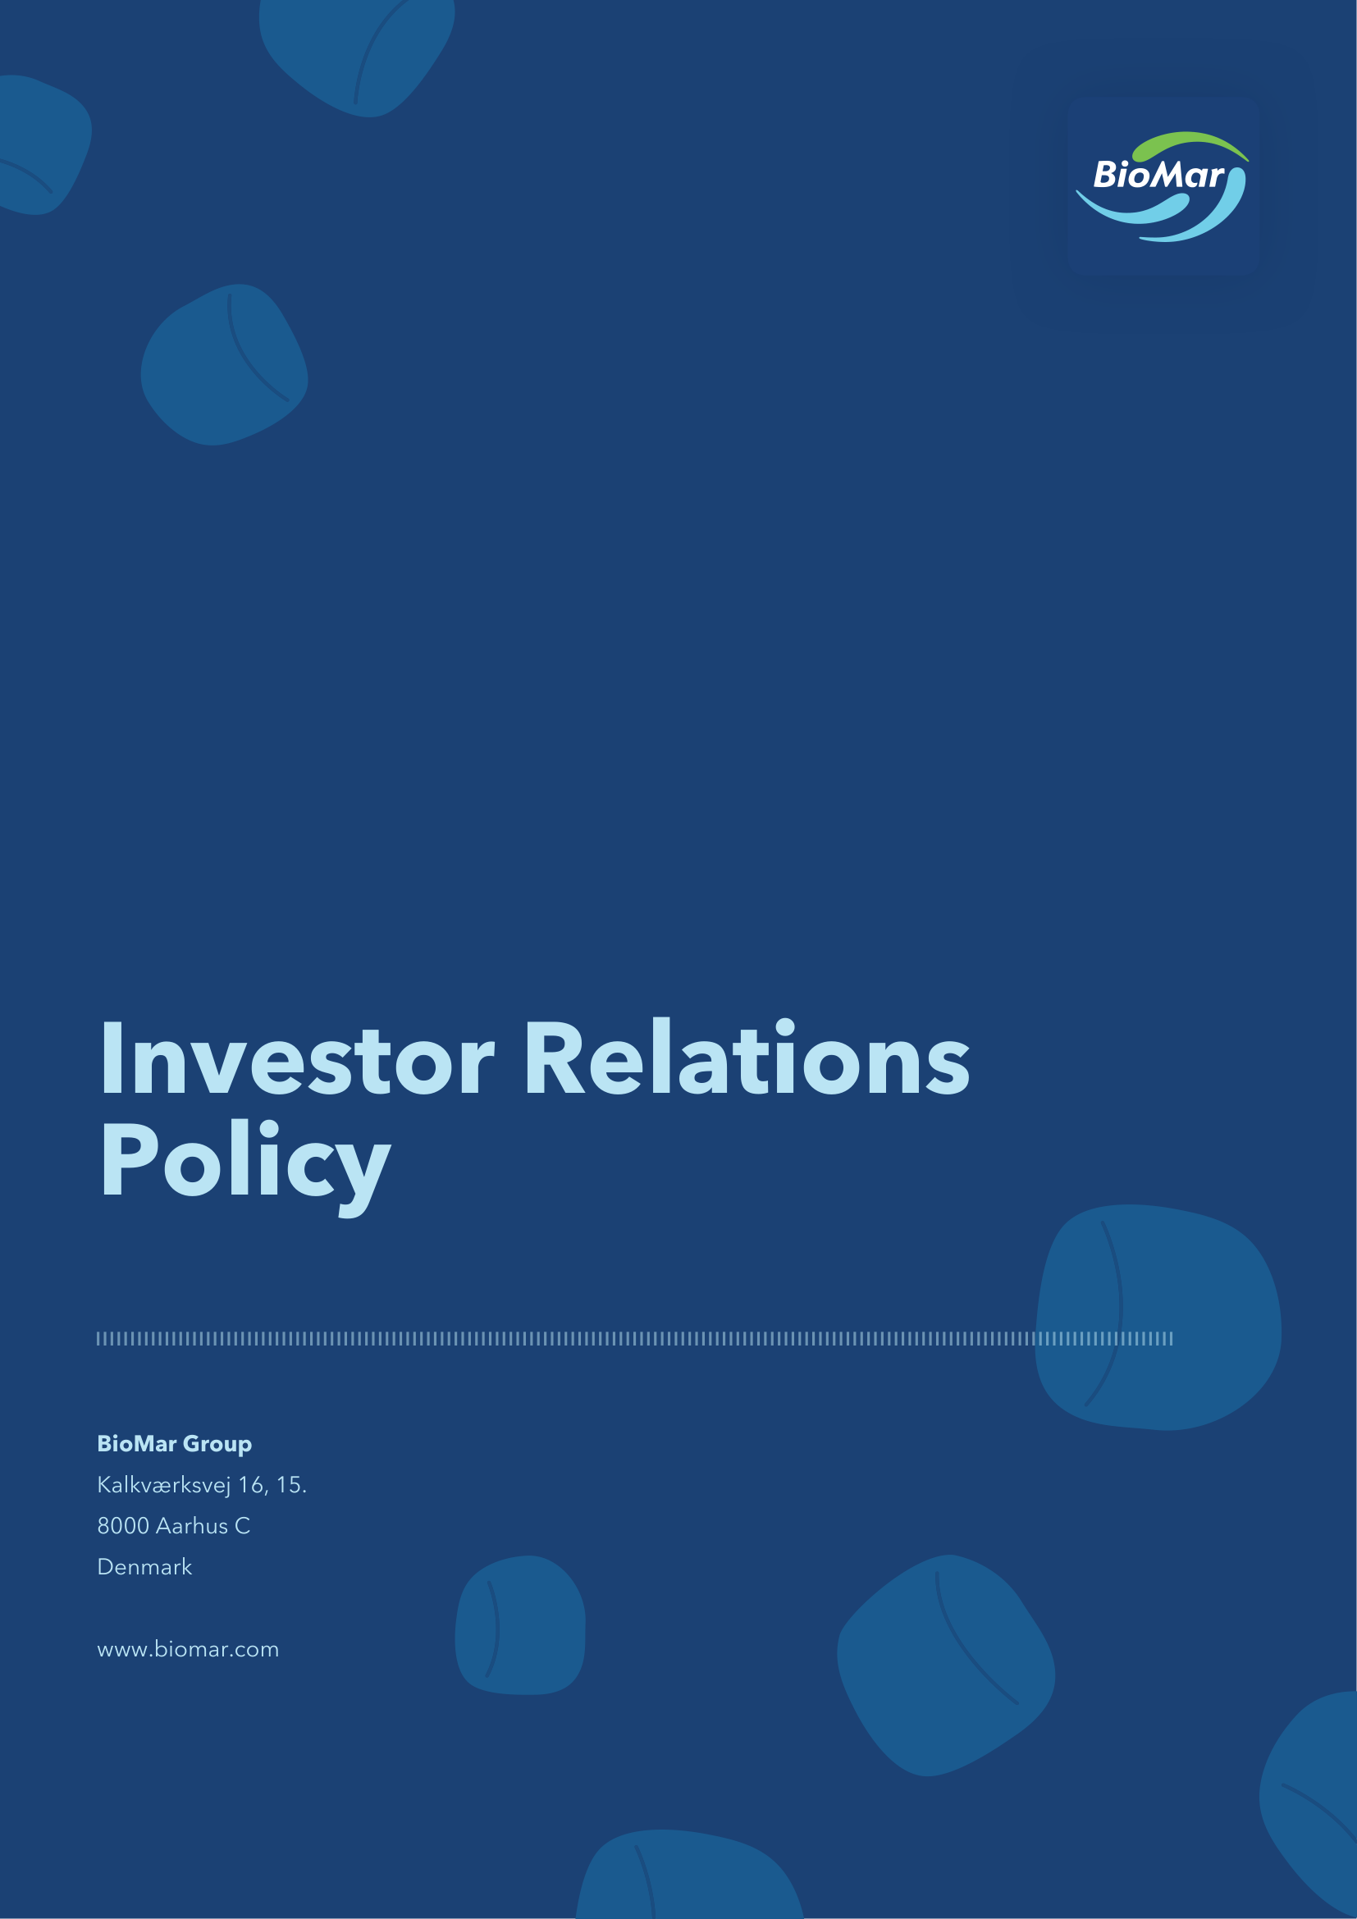

1. Introduction
1.1 This Investor Relations policy (“IR Policy”) of BioMar Group A/S, CVR no. 38 57 06 17 (the “Company”) has been prepared in accordance Nasdaq Nordic Main Market Rulebook for Issuers of Shares, Guidelines from the Danish Financial Supervisory Authority and Regulation (EU) No. 596/2014 on market abuse, as amended (EU Market Abuse Regulation (“MAR”))
1.2 The IR Policy defines how the Company communicates with investors, analysts, and other stakeholders, as well as outlines the investor relations (“IR”) goals and principles for communication and governance. The policy aims to ensure compliance with applicable rules and regulations, while positioning BioMar as a credible, visible, accessible, and professional company in the stock market.
2. Equal, timely and adequate disclosure
2.1 BioMar’s overall goals for its IR activities are to ensure:
2.2 Transparent, consistent, equal and timely disclosure of information to facilitate regular trading and fair pricing of the Company’s share.
2.3 Access to information about the Company’s strategy, risks, opportunities, financial performance and outlook, enabling investors to make an informed investment decision.
2.4 Ensure good corporate governance practices and compliance with applicable rules and regulations for companies listed on Nasdaq Copenhagen.
3. Multi-channel IR communication
3.1 BioMar has adopted a multi-channel IR engagement strategy extending beyond regulatory requirements by using a variety for communication formats and platforms:
3.1.1 The IR website provides a central hub for all IR material published by the Company.
3.1.2 An IR distribution system is used to ensure broad distribution of company news and regulatory disclosures to Nasdaq Copenhagen and the Danish Financial Supervisory Authority.
3.1.3 Online quarterly earnings calls are conducted to provide broad investor access to management presentations of financial results.
3.1.4 Digital live streaming of general meetings is provided to ease shareholder participation.
3.1.5 Social media channels are used to enhance visibility of published investor news.
4. Active investor engagement
4.1 BioMar maintains an open, honest, and consistent dialogue with investors and analysts, subject to compliance with EU’s Market Abuse Regulation (“MAR”).
4.2 Investor and analyst meetings are conducted to provide background information and better understanding of the Company’s strategy, operations, and financials. Activities include, but are not limited to:
• Investor and analyst one-on-one meetings, group meetings, and conference calls
• Investor presentations
• Investor roadshows
• Capital Market Days and similar events
• Quarterly online earnings calls targeting institutional investors
• Online presentations targeting retail investors
4.3 All relevant presentations will be made available on the Company’s website.
4.4 A silent period of four weeks is observed before the publication of annual and interim financial results. The Company will refrain from participating in the above-mentioned activities in the silent period.
5. Strong IR governance and compliance
5.1 The following persons are authorized to communicate with investors, analysts and other financial stakeholders on behalf of the Company:
• The Chair of the Board of Directors,
• The Executive Management,
• The VP, People, Purpose & Communication,
• The Investor Relations, and
• Other persons authorized to do so on a particular matter.
5.2 Investor activities and disclosure obligations in BioMar are governed as follows:
• The Board of Directors and Executive Management have overall responsibility for adequate disclosure.
• A Disclosure Committee consisting of the CEO, the CFO, the Chief Legal Officer, VP Strategy, Business Development & M&A and VP People, Purpose & Communication shall assist with ensuring compliant disclosure.
• The Investor Relations, reporting to the CFO, is responsible for managing investor relations activities in BioMar.
6. Strong IR governance and compliance
6.1 BioMar publishes company announcements in accordance with applicable law and regulation, and the rules for companies listed on Nasdaq Copenhagen.
6.2 All company announcements, financial reports, investor presentations, and other investor material are available on the company’s IR website.
6.3 Additionally, BioMar makes use of press releases, investor news, the company website, and social media channels to keep investors updated on non-regulatory news flow.
6.4 The Company provides guidance to the investment community in the form of forward-looking statements regarding expected future revenues and earnings. However, the Company will not comment on the likelihood that it will meet, exceed, or fall short of its guidance in terms of revenues or earnings.
6.5 Further, the Company will not comment on the likelihood that it will meet, exceed, or fall short of equity analysts’ estimates, either on an individual or consensus basis.
6.6 In addition, the Company will not comment on share price movement of the Company and will refrain from commenting on market rumors or speculative inquiries.
7. Adoption and publication
7.1 The IR Policy has been adopted by the Board of Directors on 19 May 2026.
7.2 The IR Policy is reviewed annually.

