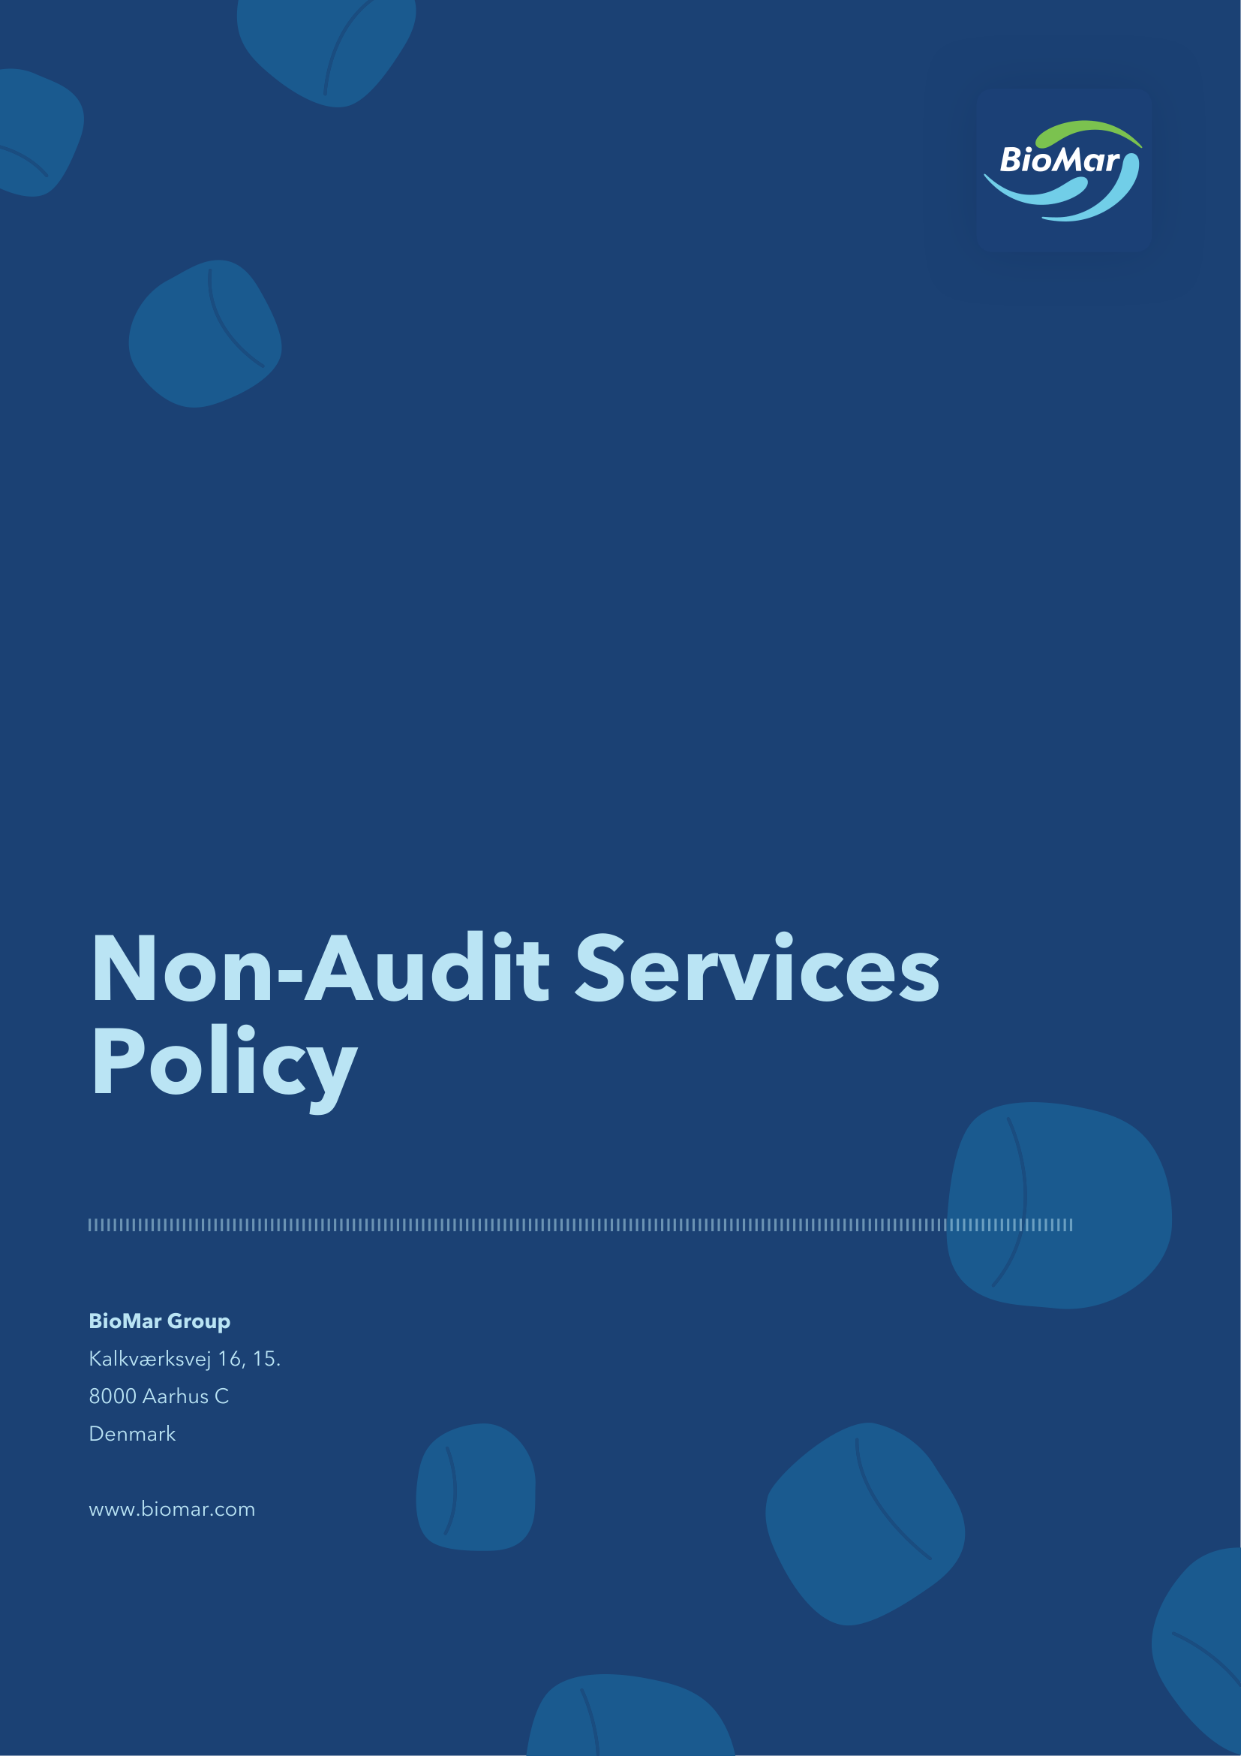

BioMar engages its Group Auditor across multiple jurisdictions for both audit and non-audit purposes. To safeguard auditor independence and ensure compliance with applicable regulation, we are committed to a structured and transparent approach to the engagement of Non-Audit Services (NAS). Our approach is built on three core elements:
- Ensure responsible governance and pre-approval of non-audit services
- Uphold auditor independence through clear service classification
- Maintain proactive monitoring and transparent fee reporting
Ensure responsible governance and pre-approval of non-audit services
BioMar requires that all NAS engagements with the Group Auditor or its network firms are assessed and pre-approved before work begins.
Local entities are required to submit a NAS Request Form for each engagement, defining the scope, expected fee, service category, and rationale for engaging the Group Auditor.
Local management is responsible for compliance with this policy and applicable local statutory requirements, while Group Finance maintains central oversight of approvals, fee levels, and compliance reporting.
Uphold auditor independence through clear service classification
The Group Auditor must always remain independent in fact and in appearance. This means the Group Auditor shall not perform management functions, audit work which has been performed by themselves, or provide services that create self-interest or advocacy threats.
All NAS engagements are assessed and classified as:
- Permitted
- Permitted with restrictions
- Prohibited
Permitted services primarily include statutory audit, audit-related services, and ESG assurance where allowed by regulation.
Permitted-with-restrictions services — such as tax compliance, transfer pricing documentation, financial due diligence, and selected advisory — may only be engaged with required safeguards and approvals.
Prohibited services include, but are not limited to, bookkeeping and payroll, internal control design or implementation for financial reporting, material valuation services, outsourced internal audit, restricted legal representation, and recruitment of directors or key management. Prohibited services shall not be procured from the Group Auditor under any circumstances.
Maintain proactive monitoring and transparent fee reporting
NAS fees are monitored against the 70% cap of average audit fees paid over the last three consecutive years, starting from year one of being listed as a public interest entity.
All BioMar entities report auditor fees quarterly using the Group template. Reported fees must be reconciled to amounts booked in the financial system.
Group Finance consolidates the reported fees centrally and maintains an overall view of NAS fee levels and compliance across all BioMar entities.
Governance
Governance and oversight of our NAS commitments are embedded across BioMar's operations. This policy is owned by Group Finance, with day-to-day implementation supported by local finance teams across all BioMar entities.

