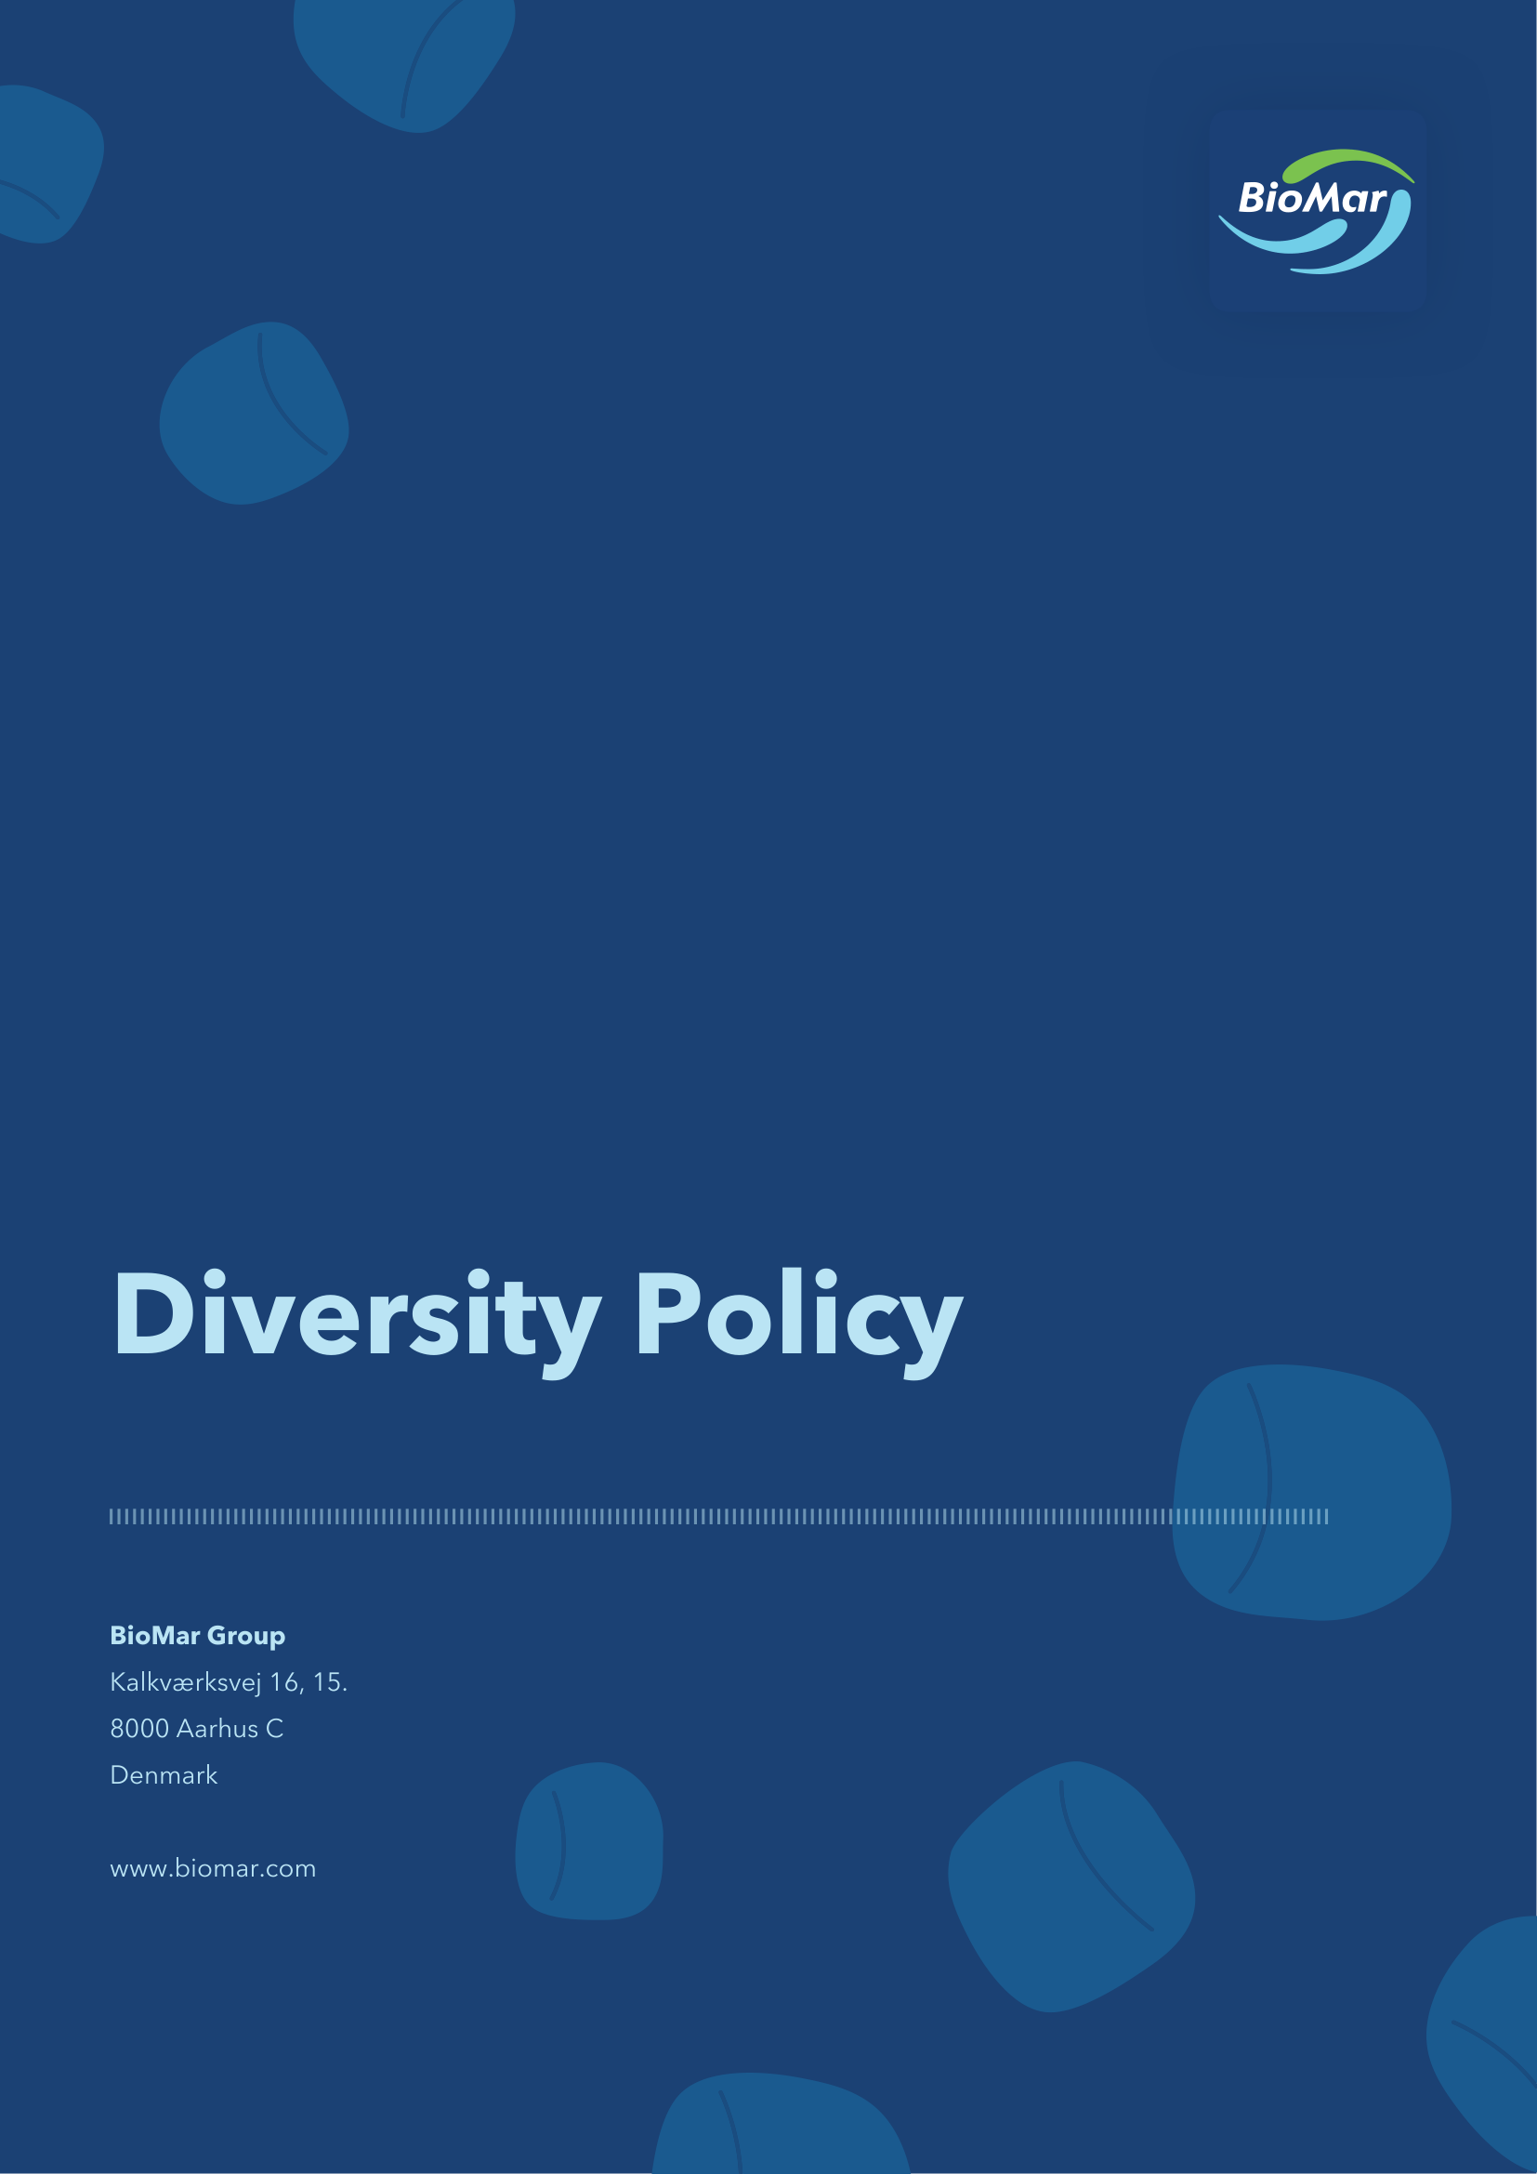

Introduction
In BioMar, we have a fundamental belief that results are created by people. BioMar considers diversity a strength which makes a positive contribution to growth and value creation for the company. We believe diversity, equality, and inclusion are fundamental drivers for unlocking the full human potential of society.
As a socially responsible company, we are committed to facilitating that underrepresented talent thrives, experience development opportunities, and is being selected into relevant roles. We are committed to ensuring diversity is being promoted across all management levels and all employee groups, encouraging our business partners to actively pursue diversity, equality and inclusion in their organisations.
Diversity is broadly defined as the presence of a wide range of different characteristics, backgrounds and perspectives such as professional background, seniority, education, age, gender, nationality, ethnicity, religion, sexual orientation, and physical/mental ability.
Our commitment
BioMar is committed to promoting value creation in the group through encouraging collaboration between people with different backgrounds. Diversity in the employee composition is a supporting factor for breadth and variation of expertise, enhancing innovation, engagement and qualified decision making.
The purpose of BioMar’s targets and efforts on diversity is to ensure a corporate culture supporting diversity. We strive to minimize barriers of conscious and unconscious bias which could potentially restrict diversity or counteract equal employment or career opportunities. This also includes efforts to support balanced gender representation at management levels in accordance with applicable legislation.
It is our principles that:
- We strive for diversity, equality, and inclusion at all levels in the organisation
- We are committed to building a culture recognizing the inherent value of all human beings
- We strive to be flexible in supporting employee differences
- We train our managers to understand and act on the importance of diversity
Inclusion of underrepresented talent
BioMar aims to be a purpose-driven workplace where employees can make a real impact and feel a sense of belonging. We seek to provide equal career opportunities for everyone by promoting diversity through collaboration. We place particular emphasis on supporting the underrepresented gender to strengthen diversity and equality (see below on BioMar’s statutory obligations and initiatives on gender balance in management).
Any talent process, such as hiring, developing, and promoting, must be designed and executed to ensure the best possible fit towards the criteria of the job and the future development of the company. This includes ensuring diversity in teams and workforce composition.
We commit to measure and take action to ensure that all employees experience equal opportunities in respect to development opportunities and career advancement, regardless of background, personal life circumstances and other diversity factors.
At the same time, we commit to safeguarding policies and practices for remuneration, which are gender neutral and to the widest extent possible support the principle of equal pay for work of equal value.
Finally, we commit to building focus on work-life balance into the employee life cycle, ensuring that BioMar supports the foundation for a diverse workforce, where every employee experience to be included.
Diversity in management
BioMar strives to obtain a high degree of diversity at the company's management levels, ensuring multiple perspectives in decision making. Broad representation of educational and business backgrounds, culture, age, and gender as well as both national and international experience at the management levels is a company priority.
To support equal access to management roles, the company works to remove barriers that may limit diversity. This applies to day-to-day work and to every stage of selection and promotion. Unless there is a legitimate reason, we do not tailor job descriptions, job advertisements, applicant screening, or interviews to a specific gender, culture, age, or similar characteristic.
When underrepresentation at management level is identified, compared to the general company population or the society composition, focus is directed towards getting the right representation of the underrepresented talent into management positions by taking dedicated initiatives and actions to support diversity (see below for further on initiatives relating to gender diversity).
Gender diversity in management
BioMar is subject to the Danish Gender Balance Act (the “Act”), which prescribes that BioMar shall have a target of equal gender representation (as defined in the Act) on the Board of Directors, both with respect to members elected by the general meeting and employee representatives, assessed separately for each group.
The Board of Directors aims to achieve equal gender representation on the Board of Directors in accordance with the Act at the same time balancing the professional competences required.
Where required under the Act, the nomination and selection of candidates for the board of directors shall be carried out on the basis of: (i) clearly defined, neutral and objective selection criteria, (ii) a comparative assessment of candidates’ qualifications, and (iii) where applicable, the statutory preference for candidates of the underrepresented gender where candidates are equally qualified, unless objectively justified otherwise in accordance with applicable legislation. Applicable disclosure and reporting requirements relating to gender representation and selection processes shall also be complied with.
In respect of the company’s other management levels, as defined under applicable legislation, BioMar continuously assesses gender representation. Where equal gender representation has not been achieved, BioMar will, in accordance with the Act: (i) establish measurable targets for the underrepresented gender, and (ii) implement initiatives aimed at increasing representation of the underrepresented gender. Such initiatives may include:
- striving to ensure representation of both genders among the final candidates when recruiting for management positions
- building and monitoring a leadership talent pipeline, where increased diversity at entry management levels supports future diversity in senior management
- ensuring that employees experience equal opportunities in respect of career advancement, regardless of gender
- promoting remuneration practices that are gender neutral and support the principle of equal pay for work of equal value
BioMar monitors and reports on gender representation, targets, initiatives and progress in accordance with applicable requirements.
Governance, review and related policies
This policy is approved by the Board of Directors. It is reviewed regularly to reflect changes in laws, best practices, stakeholder expectations and learnings from case handling.
The following policies support the implementation of the BioMar Diversity Policy:
• Code of Conduct.
• Human Rights Policy.
• Responsible Sourcing Policy.
• Supplier Code of Conduct.
• Responsible Employment Policy.
• Compensation Policy.
• Other relevant compliance policies and procedures applicable from time to time.

