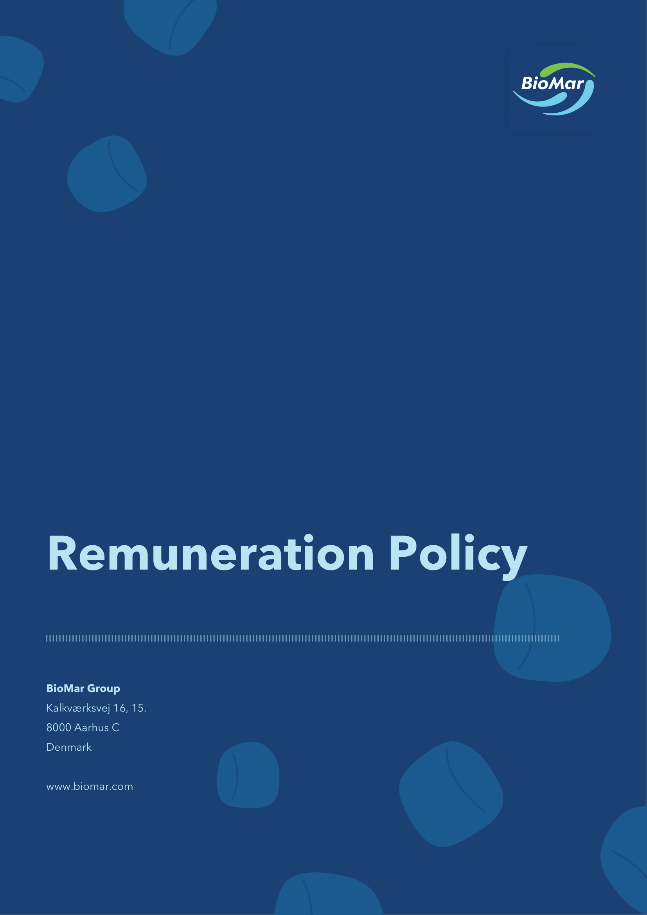

1 Introduction
1.1 This remuneration policy (the “Remuneration Policy”) of BioMar Group A/S, CVR no. 38 57 06 17 (the “Company”) has been prepared in accordance with sections 139 and 139a of the Danish Companies Act and the recommendations published by the Danish Committee on Corporate Governance as implemented by Nasdaq Copenhagen A/S.
1.2 The Remuneration Policy sets out the framework for remuneration to the Board of Directors and the Executive Management of the Company. The “Executive Management” consists of the members of the executive management of the Company registered as such with the Danish Business Authority. “Group” refers to BioMar Group A/S as well as its subsidiaries.
2 Objectives
2.1 The overall objectives of this Remuneration Policy are (i) to attract, motivate and retain qualified members of the Board of Directors and Executive Management, (ii) to ensure alignment of interests between the Board of Directors, Executive Management, the Company itself and its shareholders, and (iii) to ensure and maintain the motivation for achieving the Group’s strategic short and long-term targets as well as to promote long-term sustainable value creation for the benefit of the shareholders.
2.2 The Board of Directors considers that the composition of remuneration supports these objectives. The actual remuneration paid to the Board of Directors and Executive Management in a financial year is decided by the Board of Directors based on recommendations from the Remuneration and Nomination Committee. The Board of Directors shall ensure that the remuneration is in compliance with this Remuneration Policy and that the remuneration does not exceed what is considered usual taking into account the nature and extent of the work and the Company’s financial position.
3 Remuneration of the members of the Board of Directors
The remuneration offered to the members of the Board of Directors shall be designed to be able to attract and retain competent members to the Board of Directors taking into consideration the market practice of comparable listed companies as well as due regard to the required competencies, experience, knowledge, effort and scope of work of the members of the Board of Directors.
3.1 Fixed fee
Each ordinary member of the Board of Directors receives a fixed annual base fee (the “Base Fee”), while the Chair and Vice Chair receive fixed multiples of the Base Fee according to the requirements and responsibilities of the role of the individual board member. Participation in a board committee entitles a board member to an additional fixed annual fee calculated based on a multiple of the Base Fee. Table 1 outlines the fixed multiples of the Base Fee applicable to the remuneration of the Board of Directors.
Table 1: Remuneration structure of the Board of Directors – fixed fee multiples | Table 1: Remuneration structure of the Board of Directors – fixed fee multiples | Table 1: Remuneration structure of the Board of Directors – fixed fee multiples | Table 1: Remuneration structure of the Board of Directors – fixed fee multiples
 | Board of Directors | Audit Committee | Remuneration and Nomination Committee
Chair | 3x Base Fee | Up to 0.75x Base Fee | Up to 0.50x Base Fee
Vice Chair | 1.5x Base Fee | — | —
Member | 1x Base Fee | Up to 0.50x Base Fee | Up to 0.25x Base Fee
3.2 Incentive pay
The Board of Directors shall not receive any incentive pay from the Company.
3.3 Ad-hoc tasks
Should a board member, including the Chair or Vice Chair, assume specific ad-hoc tasks beyond the normal work and responsibilities as member of the Board of Directors, the Board of Directors may decide on an additional fixed fee for such tasks. Any ad hoc task shall be approved by the Board of Directors. The size of the aggregate ad hoc fees payable to a member of the Board of Directors in a financial year may not exceed 100% of the total remuneration paid or payable to such member of the Board of Directors for the financial year, including any additional fixed fees to the Chair, the Vice Chair and board committee members. Any ad hoc fees paid to the members of the Board of Directors will be disclosed in the Company’s remuneration report.
3.4 Benefits and reimbursement of expenses
Expenses such as travel and accommodation relating to board meetings, meetings of board committees and in connection with the performance of specific tasks assigned by the Board of Directors as well as relevant training may be reimbursed by the Company.
The Company may offer to cover social security contributions to the extent imposed by foreign national authorities in relation to fixed fees and reimbursable expenses.
3.5 Term
Members of the Board of Directors are elected by the general meeting for a term of one year. Re-election may take place. Members of the Board of Directors are not entitled to separate payments in relation to their resignation from the Board of Directors.
4 Remuneration of Executive Management
The remuneration to Executive Management is decided by the Board of Directors based on recommendations from the Remuneration and Nomination Committee. When preparing these recommendations, the Remuneration and Nomination Committee takes into account that the remuneration shall not exceed what is considered usual taking into account the nature and extent of the work, and what is considered reasonable with regard to the Company’s financial position. The Company seeks to pay competitive remuneration to the members of the Executive Management, taking into account the qualifications and performance of the individual members.
4.1 Fixed pay
Members of the Executive Management receive a fixed annual cash base salary. The fixed annual cash base salary is consistent with the market level.
4.2 Pension and benefits
4.2.1 Pension
Members of the Executive Management may be covered by the Company’s general pension plan under which both the Company and the member of Executive Management will contribute to the pension payments. The value of the Company’s pension contribution may not exceed 12% of the fixed annual cash base salary.
4.2.2 Benefits
Members of the Executive Management may receive customary monetary and cash-based benefits such as company car, expatriation insurance and health insurance in addition to usual benefits such as phone, computer and internet, insurances, news-paper subscriptions, etc., as well as other benefits.
4.3 Incentive pay
4.3.1 Members of Executive Management may be eligible to receive incentive compensation consisting of a cash incentive opportunity and/or share-based incentives, subject to the decision of the Board of Directors. Share-based programs may comprise of restricted share units (“RSUs”) or performance share units (“PSUs”) or a mix of any such share-based incentives as determined by the Board of Directors.
4.3.2 The Board of Directors may lay down specific terms governing the lapse of incentive arrangements or repayment of incentive pay (clawback) as well as accelerated vesting or exercise, and adjustment of the incentive arrangements, exercise price, performance targets, etc.
4.3.3 When determining the size and composition of the incentive arrangements and the split between the total awarded incentives and the fixed payment, the Board of Directors shall carefully consider the overall principles of the Remuneration Policy, including the aim of supporting the achievement of the Group’s strategic long- and short-term goals.
4.3.4 Short-term incentives
4.3.4.1 The short-term incentive consists of a cash-based bonus designed to incentivise and encourage the members of Executive Management to perform in alignment with the Group's short-term objectives.
4.3.4.2 The annual cash bonus is dependent on the achievement of specific targets and metrics as approved by the Board of Directors each year. Performance shall be measured for each financial year and will depend on the achievement of certain criteria such as financial KPIs, that may include EBIT, EBITDA, return on invested capital, total shareholder return, sales volumes and net working capital, and non-financial KPIs, that may include ESG/sustainability related objectives as well as individual performance targets. The specific criteria as well as the weight of each criteria may vary from year to year as determined by the Board of Directors.
4.3.4.3 The actual payout under the annual cash bonus for a financial year will be decided by the Board of Directors upon recommendation from the Remuneration and Nomination Committee based on assessment of achievement of the pre-established KPIs.
4.3.4.4 The annual short-term cash bonus will generally be paid out following the Board of Directors’ approval of the annual report for the performance period for the annual short-term cash bonus and can constitute an amount corresponding to a maximum of 100% of the fixed annual cash base salary at the end of the relevant performance period.
4.3.4.5 In case of extraordinary circumstances and/or unforeseen events significantly impacting for example the Company’s financial performance, strategy, or environment or society, the Board of Directors can decide to amend or deviate from the pre-defined performance targets and metrics if required to support the purpose of this Remuneration Policy.
4.3.5 Long-term incentives
4.3.5.1 The long-term incentives are designed to incentivise long-term performance, commitment and retention of the members of Executive Management, as well as to promote alignment of their interests with those of the shareholders.
4.3.5.2 Members of the Executive Management may be offered to participate in either a cash-based long-term incentive programme or a share based long-term incentive programme. The value at grant of long-term incentives for a financial year may be up to 150% of the fixed annual cash base salary for the recipient.
4.3.5.3 In case of extraordinary circumstances and/or unforeseen events significantly impacting for example the Company’s financial performance, strategy, or environment or society, the Board of Directors can decide to deviate from principles applicable to any long-term incentive set out in this section.
4.3.5.4 Cash-based long-term incentive
(a) The long-term cash-based incentive is a revolving three-year cash bonus programme covering three financial years. The long-term cash-based incentive is calculated based on achievements of certain criteria, with main weight on core financial KPIs such as ROIC, EBITDA/EBIT, Sales Volumes, total shareholder return and net working capital. In addition, non-financial KPIs could be considered to a limited degree, such as ESG/sustainability related objectives as well as individual performance targets.
(b) The long-term cash-based incentive is granted each year for a three-year period and at the same time the selected KPIs as well as the weight of each criteria are reviewed, determined and, if deemed appropriate, adjusted by the Board of Directors.
(c) The size of the long-term cash-based incentive payout for a financial year will be decided by the Board of Directors upon recommendation from the Remuneration and Nomination Committee based on assessment of achievement of the pre-established KPIs covering the full three-year performance period.
(d) The long-term cash-based incentive payout will generally be made following the Board of Directors’ approval of the annual report for the last financial year of the three year performance period.
4.3.5.5 Share based long-term incentives
(a) Members of Executive Management may be eligible to receive long-term incentives in the form of RSUs or PSUs. The programmes are designed to further align management compensation with the long-term interests of the shareholders and the performance of the Company by linking a higher proportion of annual pay to the share price development of the Company as well as certain performance targets with respect to PSUs. Further, the programmes support the Company’s long term business model and strategy.
(b) The programmes are revolving and shall have a vesting or maturity period of three years from the relevant date of grant until the time they vest or mature. The vesting or maturity period shall be determined by the Board of Directors prior to grant.
(c) Grant of RSUs does not depend on the achievement of specific goals whereas grant of PSUs shall be subject to achievement of specific goals, that may include with main weight on core financial KPIs such as ROIC, EBITDA/EBIT, Sales Volumes, total shareholder return and net working capital. In addition, non-financial KPIs could be considered to a limited degree, such as ESG/sustainability related objectives as well as individual performance targets as financial targets such as EBIT, EBITDA, return on invested capital, total shareholder return, sales volumes and net working capital, and/or other non-financial targets or objectives such as ESG/sustainability related objectives as determined by the Board of Directors from time to time. Ownership of shares is transferred free of charge or by payment of par value of the shares delivered to each member of Executive Management three years after the time of grant (the “Vesting Period”), contingent on achievement of the pre-established KPIs, if any, and the member of Executive Management not having resigned during the Vesting Period. During the Vesting Period, no transfer of shares to the individual member of Executive Management will take place. After expiry of the Vesting Period and transfer of ownership of shares to the individual member of Executive Management, the member shall have all rights and obligations as shareholder of the Company, including the entitlement to receive dividends.
(d) The Company intends to use treasury shares to meet its obligations in relation to long-term share-based incentives. The Board of Directors may decide to satisfy a grant in cash if deemed appropriate.
(e) In line with market practice, share-based incentives shall be subject to good leaver and bad leaver provisions.
4.3.6 Adjustment and repayment of incentive-based remuneration
4.3.6.1 In case of extraordinary events, the Board of Directors may lay down specific terms for incentive-based remuneration governing the lapsing, repayment, capping of ultimate gains or other adjustments of the incentive-based remuneration, including accelerated vesting or exercise and adjustment to the exercise price or the performance targets. Such extraordinary event may include, but is not limited to, significant divestiture of activities, change in capital structure, demerger, merger or other business combination involving the Company or material parts of the Group, a member of Executive Management resigning/being dismissed or other material events that would otherwise positively or negatively influence the value or effect of the incentive-based remuneration.
4.3.7 Extraordinary incentives
4.3.7.1 The Board of Directors may, in individual cases, grant one-off bonuses or other extraordinary incentives, e.g. retention bonus, severance payment, sign-on bonus, transaction bonus or other similar arrangements, provided that such extraordinary incentive is deemed necessary in order to meet the overall objectives of the Remuneration Policy.
4.3.7.2 The value at grant of such extraordinary incentives for a financial year may not exceed an amount corresponding to 100% of the fixed annual cash base salary. Such grant may be cash and/or share-based remuneration. The Board of Directors may decide whether grant and/or vesting shall be subject to fulfilment of certain pre-defined targets as well as other terms which may deviate from the terms applicable to ordinary incentives. Any extraordinary remuneration will be described in the Company’s remuneration report.
4.3.8 Clawback
4.3.8.1 The Company has the option of withholding or reclaiming, in full or in part, granted incentive remuneration in certain situations, including where incentive remuneration was awarded or paid out on the basis of information which is subsequently proved to be clearly or materially misstated or if a member of Executive Management is deemed to have caused a material loss to the Company due to willful misconduct or gross negligence or acting in bad faith in respect of other matters which implied payment of a too large incentive-based remuneration.
5 Service agreements
5.1 Members of the Executive Management are employed on individual contracts, which are generally entered into on an indefinite term with a mutual right of termination. The notice period may be up to 6 months for the member of the Executive Management and up to 18 months for the Company.
5.2 Remuneration paid to a member of the Executive Management during a notice period, including any severance payment, may not exceed two years’ remuneration, including all remuneration components.
6 D&O insurance and indemnification
6.1 The Company has taken out customary directors and officers liability insurance (D&O insurance) covering the Board of Directors and the Executive Management.
6.2 The Board of Directors and the Executive Management will also be covered to the extent that the shareholders in general meeting have adopted an indemnification scheme under which the Company undertakes to indemnify each member of the Board of Directors and the Executive Management for any loss (including costs, expenses and potential tax liabilities related thereto) incurred by such member of the Board of Directors and/or the Executive Management as a result of such person’s performance of his or her duties as a member of the Board of Directors or the Executive Management.
7 Deviations
7.1 In extraordinary circumstances, the Board of Directors may decide to deviate from the specific requirements of the Remuneration Policy on an individual basis in order to attain the overall objectives of the Remuneration Policy and safeguard the long-term interests of the Company and its shareholders. Such deviations may include one-off bonuses, changes to the relative proportion of the remuneration components, including any ad hoc fees, changes to the vesting and exercise period of incentive programmes, changes to the maximum value of short-term incentives, changes to the long-term incentive programmes, including maximum value, amendment of KPIs, duration and leaver provisions of the programmes, maximum on severance pay, other type of benefits in addition to the customary benefit allowance as well as changes to the term and termination provisions of contracts entered into with members of Executive Management.
7.2 Deviations are subject to prior approval by the Board of Directors and shall be explained in the Company’s remuneration report.
8 Remuneration to the Company’s other employees
8.1 In connection with the preparation of this Remuneration Policy, the Board of Directors has taken into account the terms of employment and remuneration of employees of the Company other than the Board of Directors and Executive Management in order to ensure a proper balance between the remuneration of the Executive Management and the Company’s other employees.
8.2 The Board of Directors believes there is an appropriate balance between remuneration to the Company’s employees and remuneration to the Board of Directors and the Executive Management taking into account market practice for remuneration in appropriate peer companies of comparable size and considering the responsibilities and duties of the members of the Board of Directors and the Executive Management compared to other employees of the Company.
8.3 The Company’s overall objective is to be able to attract, motivate and retain qualified employees who can contribute to promoting the Company’s long-term sustainable value creation. Accordingly, the Company aims to ensure that pay levels and employment terms reflect the individual employee’s function and responsibilities, personal and professional qualifications, efforts and commitment as well as performance.
9 Approval process and conflicts of interest
9.1 The Board of Directors has established a Remuneration and Nomination Committee. The Remuneration and Nomination Committee prepares a proposal for a remuneration policy that is submitted to the Board of Directors for approval. The Board of Directors submits the approved remuneration policy to the general meeting for approval.
9.2 The Board of Directors annually reviews the Remuneration Policy based on recommendation from the Remuneration and Nomination Committee. If deemed necessary, the Board of Directors submits a proposal for a revised remuneration policy to the general meeting for approval.
9.3 The Remuneration Policy will be in force for a period of four years from approval, however, the Board of Directors may submit a proposal for a revised remuneration policy to the general meeting for approval at an earlier point, if deemed necessary.
9.4 To avoid conflicts of interests, any remuneration paid to members of the Board of Directors shall be approved by the general meeting. Remuneration paid to members of Executive Management shall be approved by the Board of Directors and must comply with the principles of the Remuneration Policy. Further, any material amendments to the Remuneration Policy are subject to approval of the general meeting.
10 Remuneration report
10.1 The Board of Directors shall annually prepare a remuneration report which provides an overview of remuneration paid or due to members of the Board of Directors and the Executive Management on both an aggregate and an individual level. The remuneration report shall be submitted to the general meeting for an advisory vote.
11 Adoption and publication
11.1 The Remuneration Policy has been adopted on 13 May 2026 at the Company’s extraordinary general meeting and is available on the Company’s website.

