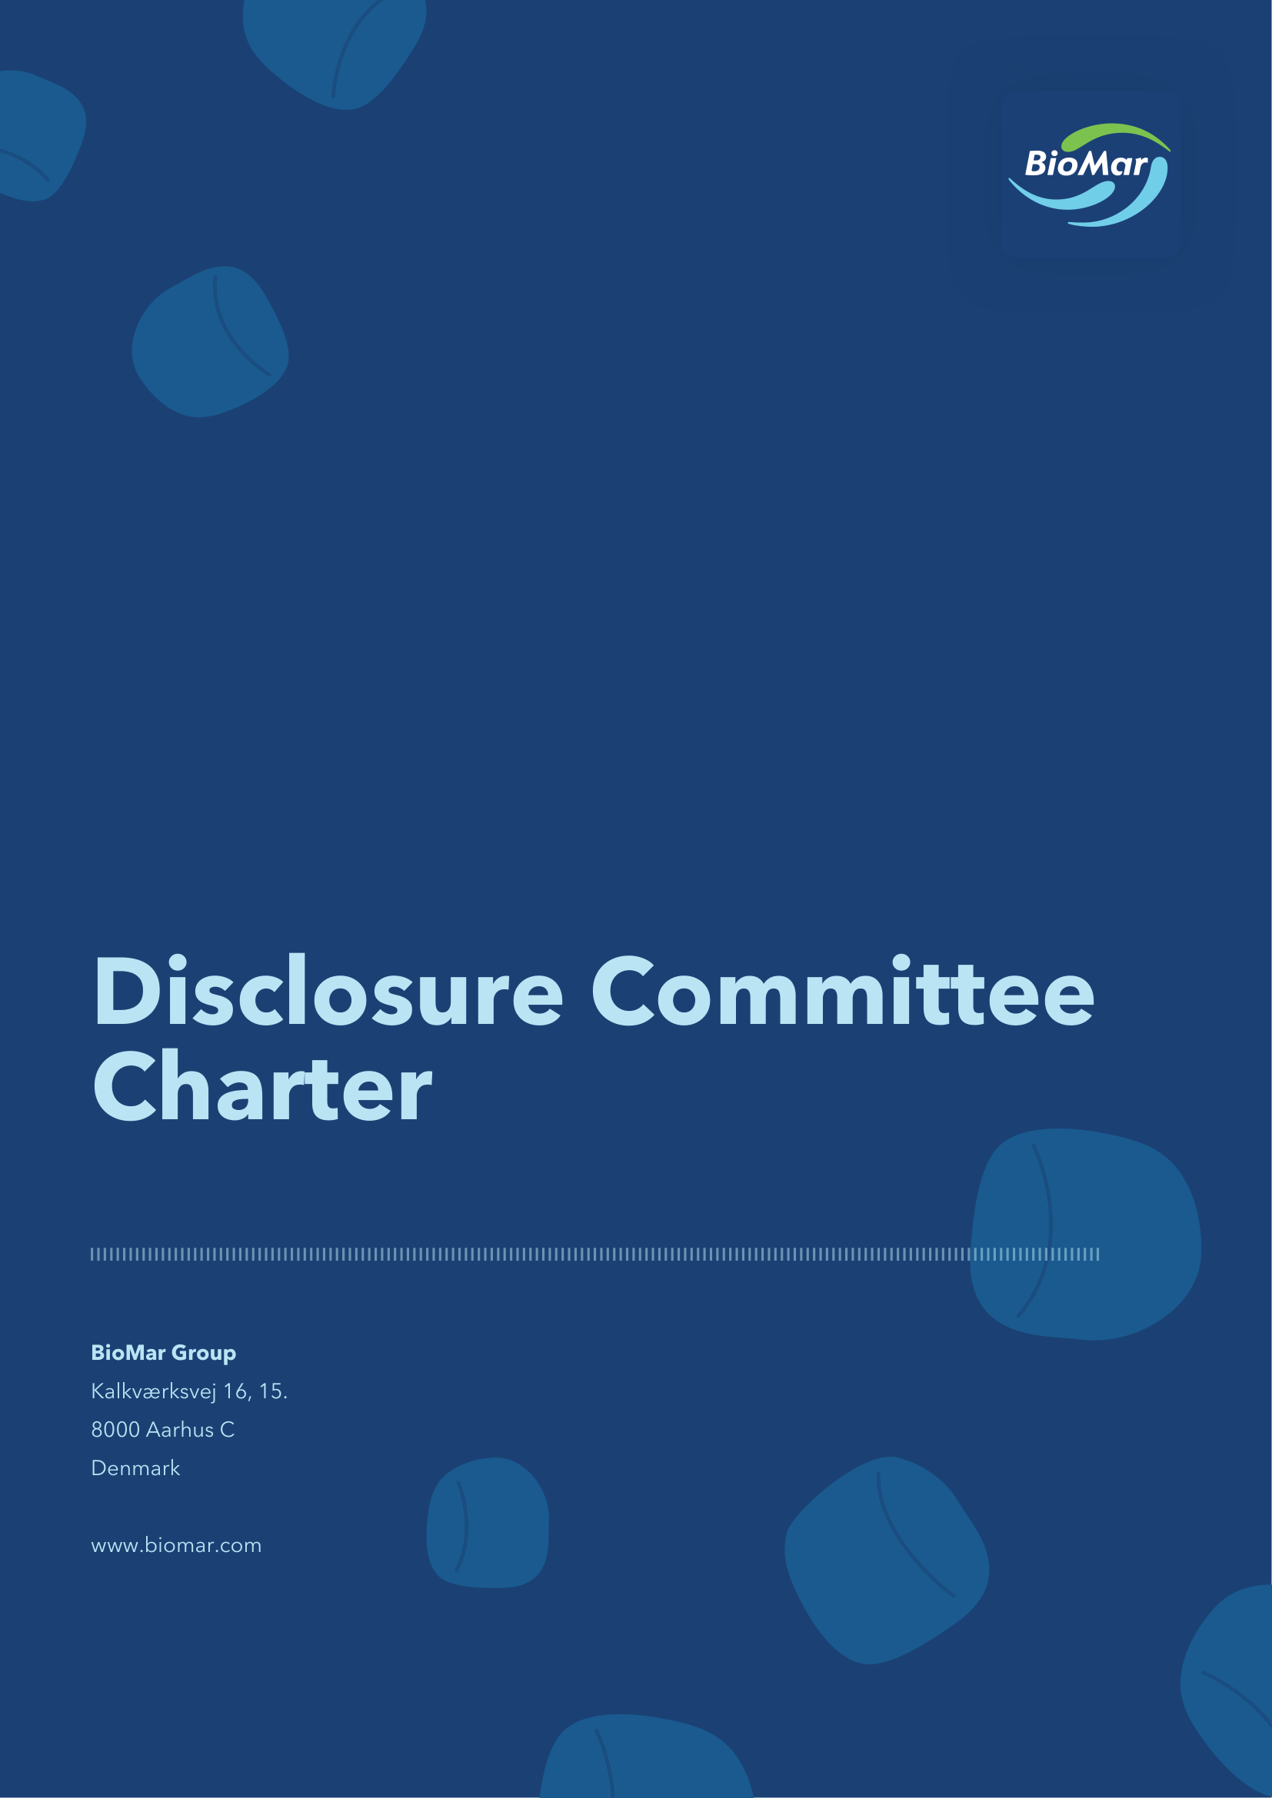

Establishment and purpose
The Executive Management of BioMar Group A/S, CVR no. 38 57 06 17 (the “Company” and together with its subsidiaries the “Group”) has established a disclosure committee (the “Disclosure Committee”).
The objective of the Disclosure Committee is to assist the Executive Management and the Board of Directors in ensuring compliance with the Company’s disclosure obligations and other obligations in relation to Inside Information, including specifically to (i) identify Inside Information, (ii) provide recommendations on immediate disclosure or delay of disclosure of Inside Information, and (iii) assist in relation to drafting and publication of company announcements so as to ensure the Company’s compliance with its disclosure obligations.
Unless otherwise defined herein, the defined terms in this Disclosure Committee Charter shall have the same meaning as in the Company’s Internal Rules for compliance with its disclosure obligations and the Internal Rules on handling of Inside Information and trading in the Company’s Shares and other Financial Instruments.
Inside Information is defined in Appendix B of the Company’s Internal Rules. The Executive Management may together with the Disclosure Committee set out certain guidelines on disclosure thresholds for certain events/issues to assist the Disclosure Committee in identifying whether a matter constitutes Inside Information.
In addition to the general obligation to disclose Inside Information, the Company is subject to certain specific disclosure obligations that require the Company to inform the market as further set out in Schedule 8.1 of the Company’s Internal Rules for compliance with its disclosure obligations.
Members
The Disclosure Committee shall consist of at least three members. The Disclosure Committee currently consists of the CEO, the CFO, the Chief Legal Officer, VP Strategy, Business Development & M&A and VP People, Purpose & Communication.
The Chief Legal Officer shall act as Chair of the Disclosure Committee.
Assignments
The Disclosure Committee has the following assignments:
Identify Inside Information
- Assist the Executive Management with establishing internal procedures to ensure that events or circumstances which may constitute Inside Information are reported to a member of the Disclosure Committee or the Executive Management and ensure that procedures are in place for timely updates on material developments of such matters.
- Ensure establishment of confidentiality lists for events or circumstances which are likely to become Inside Information and that an Ad-Hoc Insider List is set up when it is determined that the matter constitutes Inside Information. For the avoidance of doubt, an Ad-Hoc Insider List must always be set up even in the event that only persons on the Permanent Insider List are in possession of the specific piece of Inside Information. If only persons included on the Permanent Insider List has access to the Inside Information, the Ad-Hoc Insider List can be left blank except for the description of the specific piece of Inside Information to which the Ad-Hoc Insider List relates.
- Monitor and review developments of material events and circumstances to assess whether the matter constitutes Inside Information.
Provide recommendations on immediate disclosure or delay of disclosure of Inside Information
- Consider whether an announcement of Inside Information is required to be published immediately or whether it would be permissible to delay the disclosure of Inside Information. If it is considered to recommend delaying disclosure, the Disclosure Committee shall follow the procedure set out in section 3.3 below.
Process for delay of disclosure of Inside Information
- Applicable from 5 June 2026, consider whether the Inside Information is deemed part of a protracted process, in which case disclosure may not be triggered until the final event or circumstance has occurred. In such case the rules on delay of disclosure do not apply, however rules on insider lists, insider trading and leakage statements continue to apply.
- Consider and present a recommendation to the Executive Management and, if relevant, the Chair of the Board of Directors on whether conditions for delay of disclosure are satisfied, including (i) identify the legitimate interests of the Company that are likely to be prejudiced by immediate disclosure, (ii) establish that the delay of disclosure is not likely to mislead the public, and (iii) confirm that the Company has taken adequate measures to ensure the confidentiality of the information.
- Consider and record the date and time when the information is considered Inside Information.
- Consider when the Inside Information is likely to be disclosed.
- Prepare and continuously update the Log set out in Schedule 2, and ensure ongoing monitoring of the conditions for delay, including instructions of relevant employees to provide relevant updates to the Disclosure Committee.
- Ensure that a draft leakage announcement is prepared, if relevant.
- Assist on disclosure of the leakage announcement or full announcement in the event of a leakage of Inside Information of which disclosure has been delayed or a sufficiently accurate market rumour regarding such Inside Information.
Keep majority shareholder informed of Inside Information, including when such Inside Information is delayed
- For as long as the Company has a controlling shareholder with a separate listing, it is likely that any Inside Information within the Company will also constitute Inside Information within the controlling shareholder. To the extent possible and legally permissible, the Company shall seek to coordinate with the controlling shareholder in terms of release of company announcements containing Inside Information, or, as a minimum, inform the controlling shareholder of the Company’s release of Inside Information prior to such release.
Process for company announcements and notification of delay
- When disclosure is required immediately, ensure that a company announcement is produced as soon as possible and that the draft company announcement is reviewed by the Disclosure Committee, the Executive Management and other relevant individuals, including the controlling shareholder, as well as, if time allows, the Chair of the Board of Directors and/or the Board of Directors.
- The Chief Legal Officer shall assist with the process of submitting company announcements through the publication system made available by Nasdaq Copenhagen and to the Danish Financial Supervisory Authority (when required), including controlling, immediately following the release, that the relevant material is available through Nasdaq Copenhagen and/or the Danish Financial Supervisory Authority, and on the Company’s website.
- Notify the Danish Financial Supervisory Authority through the Officially Appointed Mechanism (“OAM”) if the disclosure of Inside Information has been delayed using the template notification form and procedure set out in Schedule 3.
- Prepare an explanation on the fulfilment of the conditions for delay of disclosure in accordance with the Log.
- Submit the explanation to the Danish Financial Supervisory Authority, if requested, following approval of the explanation by the Executive Management and, if relevant, the Chair of the Board of Directors.
Process in relation to financial results and outlook
- During the process of the preparation of the financial results, including quarterly reports, assess whether the Company’s financial results constitute Inside Information and in the affirmative consider whether the Company is able to delay the disclosure of Inside Information or if an announcement is required earlier than scheduled in the Company’s financial calendar.
- Ensure, that in the event that the Company’s financial results or financial position unexpectedly and significantly deviates from a reasonable assessment made on the basis of information previously disclosed by the Company, that the Company as soon as possible discloses information thereon in a company announcement if the deviation is considered Inside Information.
The Disclosure Committee may delegate specific administrative tasks to designated employees of the Company.
The Disclosure Committee may engage external advisors to assist the Disclosure Committee. The costs of such external advisors shall be paid by the Company.
The Disclosure Committee may contact and consult Nasdaq Copenhagen’s surveillance function in case of doubt, including in situations of potentials leaks of inside information.
Meetings
The Disclosure Committee meets regularly and on an ad-hoc basis to fulfil its duties.
Meetings shall be held when deemed necessary by the Chair of the Disclosure Committee or any other member of the Disclosure Committee. Meetings may be held in writing or by electronic means of communication (e.g. telephone or video conference), unless such format is incompatible with the matters subject to discussion.
The Disclosure Committee forms a quorum when at least three of its members are represented.
The Chair of the Disclosure Committee shall convene the meetings and determine the agenda which shall to the extent possible be sent to the members in advance of each meeting.
Members of the Board of Directors and the Executive Management as well as relevant employees and external parties (e.g. advisors) and representatives of the controlling shareholder may participate in the meetings of the Disclosure Committee except in relation to matters which concerns the relevant member or the relevant member otherwise has a conflict of interest. Members of the Executive Management shall attend the meeting of the Disclosure Committee if requested.
Reporting
The Disclosure Committee will regularly inform the Executive Management on relevant matters. The Executive Management shall procure that relevant matters are reported to the Board of Directors.
Confidentiality
Members of the Disclosure Committee have a duty to keep confidential any information obtained in the capacity as a member of the Disclosure Committee and may under no circumstances, without permission of the Executive Management, disclose information that come to their knowledge in the course of performing the duties as member of the Disclosure Committee to persons outside of the Disclosure Committee.
Review of Charter
The Disclosure Committee shall review this Disclosure Committee Charter once every year. Amendments shall be approved by the Executive Management.
This Disclosure Committee Charter has been approved by the Executive Management on 19 May 2026.
Schedule 1 – Definition of Inside Information
Inside Information is information which is:
- Non-public;
- Precise;
- Relates directly or indirectly to BioMar Group A/S or BioMar Group A/S’ Financial Instruments; and
- If made public, would be likely to have a significant effect on the pricing of BioMar Group A/S’ Financial Instruments.
For further guidance, please refer to the definition of Inside Information in Appendix B in the Internal Rules for the Company’s compliance with its disclosure obligations.
Schedule 2 – Log for monitoring events or circumstances which may constitute Inside Information
It is the assessment that immediate disclosure is likely to prejudice the legitimate interests of BioMar Group A/S (the “Company”), as [explanation of legitimate interest],
delay of disclosure is not likely to mislead the public, as it is the assessment, that the Inside Information is not materially different from previous company announcements made by us (including forecasts) or is otherwise in contrast with market expectations based on signals previously set, and
the Company is able to ensure the confidentiality of the Inside Information.
Log for monitoring fulfilment of items 1-3 | Log for monitoring fulfilment of items 1-3
[Date] | [Description of event or circumstance which (potentially) constitutes Inside Information
[Date] | [Update on material developments]
Other information | Other information
Inside Information first existing within the Company on | [Date], [Time], [CET/CEST]
Decision to delay was made on | [Date], [Time], [CET/CEST]
Disclosure is likely on | [Date], [Time], [CET/CEST]
Persons responsible | [Name and title]
Internal information barriers | [Insider lists/NDAs/Chinese walls/internal rules and procedures on handling confidential information]
Leakage plan | [Brief description of leakage plan other arrangements in the event of leakage, incl. any draft company announcements prepared]
If and when the Inside Information is disclosed to the market, the Danish Financial Supervisory Authority must be informed that the disclosure has been delayed. A copy of this explanation shall be provided to the Danish Financial Supervisory Authority upon request together with a copy of the initial notification.
Schedule 3 – Notification of delayed disclosure of Inside Information
When notifying the Danish Financial Supervisory Authority that disclosure of Inside Information has been delayed, the Company shall make the notification, including submitting the following template, through the Danish Financial Supervisory Authority’s Officially Appointed Mechanism (“OAM”) when disclosing the Inside Information in question to the market through a company announcement.
- The identity of the issuer
Full legal name and CVR no.
BioMar Group A/S, CVR no. 38 57 06 17
- The identity of the person making the notification
Title, name, surname, email address and phone number
- Description of the Inside Information that was subject to delayed disclosure
Title and reference number of the disclosure statement and description of which part of the statement that constituted inside information of which disclosure was delayed
- Date and time of the decision to delay disclosure of Inside Information:
- The identity of all natural persons responsible for the decision of delaying the disclosure of the Inside Information
Title and name

