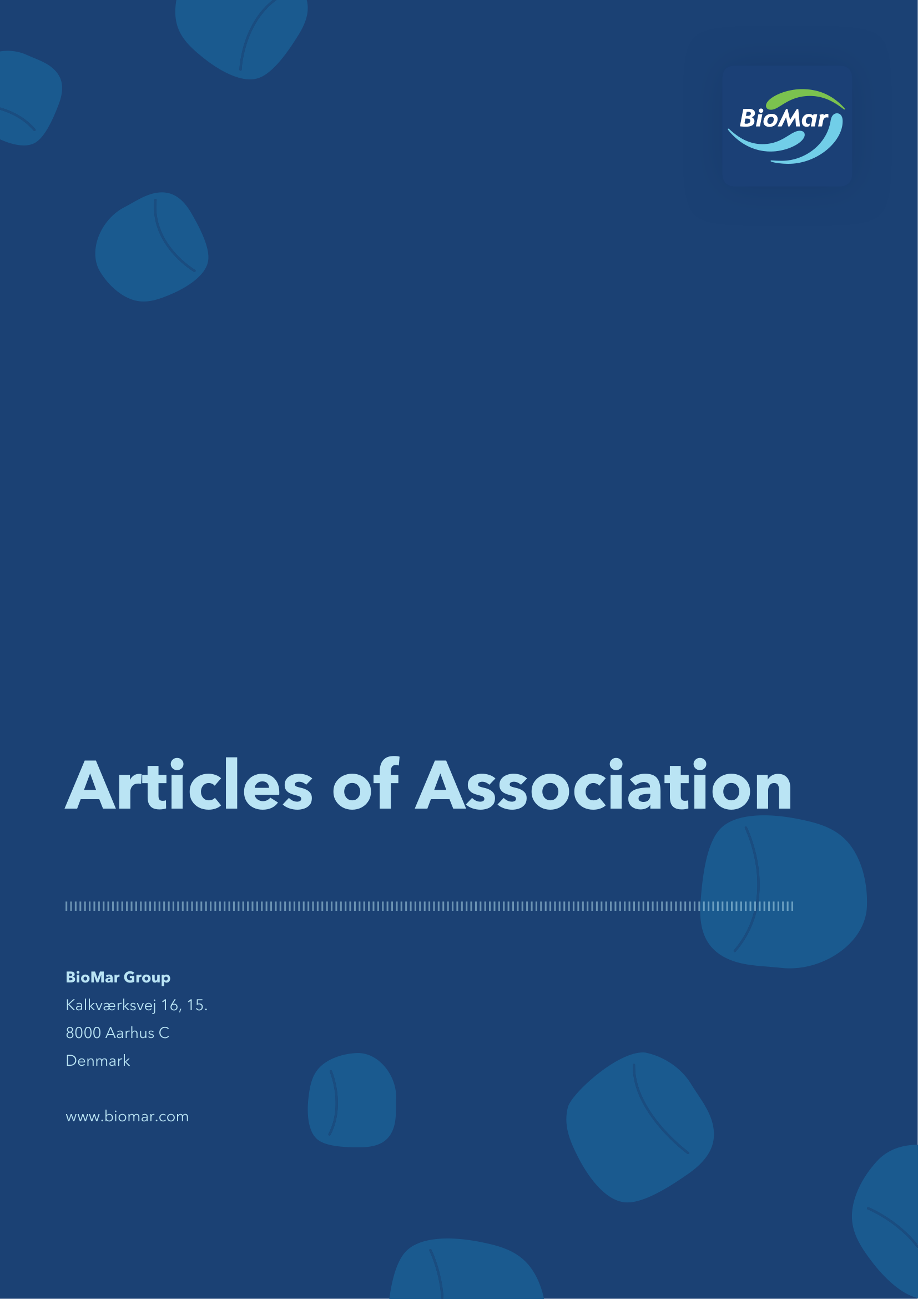

1 Name and objects
1.1 The Company’s name is BioMar Group A/S.
1.2 The object of the Company is to engage in development, research, production and trade activities within feed and aquaculture as well as any other related activities as determined by the Board of Directors. The Company may carry out commercial activities through investments or holdings in other companies or through participation in associated companies.
2 Share capital and shares
2.1 The Company’s nominal share capital is DKK 251,157,500 divided into shares of DKK 2.50 each or multiples thereof.
2.2 The share capital has been fully paid up.
2.3 The shares shall be issued in the name of the holder and shall be recorded in the name of the holder in the Company’s register of shareholders.
2.4 The register of shareholders is kept by VP Securities A/S, company reg. (CVR) no. 21 59 93 36.
2.5 The shares are negotiable instruments. No restrictions shall apply to the transferability of the shares.
2.6 No shares shall carry special rights.
2.7 No shareholder shall be under an obligation to have his/her shares redeemed in full or in part by the Company or by any third party.
2.8 The shares are registered with and issued in dematerialised form through VP Securities A/S, company reg. (CVR) no. 21 59 93 36. Dividend is paid out through VP Securities A/S. Rights concerning the shares shall be notified to VP Securities A/S in accordance with applicable rules.
3 Authorisations to increase share capital
3.1 In the period until 1 March 2031, the Board of Directors is authorised to increase the Company’s share capital in one or more issues of new shares without pre-emption rights for the Company’s existing shareholders by up to a nominal amount of DKK 25,000,000. The capital increase shall take place at or above market price and may be effected by cash payment, conversion of debt or by contribution of assets other than cash.
3.2 In the period until 1 March 2031, the Board of Directors is authorised to increase the Company’s share capital in one or more issues of new shares with pre-emption rights for the Company’s existing shareholders by up to a nominal amount of DKK 50,000,000. The capital increase may be effected by cash payment at a subscription price to be determined by the Board of Directors, which may be below market price.
3.3 The authorisations set out in Articles 3.1 and 3.2 above are subject to an aggregate issue of new shares corresponding to nominally DKK 50,000,000.
3.4 In the period until 1 March 2031, the Board of Directors is authorised to increase the Company’s share capital in one or more issues of new shares without pre-emption rights for the Company’s existing shareholders by up to a nominal amount of DKK 5,000,000 in connection with the issue of new shares to members of the Board of Directors, Executive Management and/or employees of the Company and/or of the Company’s subsidiaries. The capital increase shall take place by cash payment at a subscription price to be determined by the Board of Directors, which may be below market price.
3.5 New shares issued pursuant to Articles 3.1, 3.2 and 3.4 shall be paid in full, shall be issued in the name of the holder, shall be recorded in the name of the holder in the Company’s register of shareholders, shall be negotiable instruments and shall in every respect carry the same rights as the existing shares. The Board of Directors is authorised to lay down the terms and conditions for capital increases pursuant to the above authorisations and to make any such amendments to the Company’s Articles of Association as may be required as a result of the Board of Directors’ exercise of said authorisations.
4 Board of Directors
4.1 The Board of Directors consists of not less than four and not more than seven members elected by the general meeting for a term of one year. Re-election of board members may take place.
4.2 The Board of Directors shall elect a Chair and Vice Chair among its members. If the Chair of the Board of Directors resigns during a term of election, the Vice Chair shall take up the position as Chair and a new Vice Chair shall be elected among the Board of Directors until the Board of Directors elects a new Chair among the members of the Board of Directors.
4.3 Resolutions of the Board of Directors are passed by simple majority. In the event of an equality of votes, the Chair shall have a casting vote, or – in the Chair’s absence – the Vice Chair shall have the casting vote.
4.4 The Board of Directors forms a quorum when more than half of its members are represented, including the Chair or the Vice Chair.
4.5 The Board of Directors is authorised to pass one or more resolutions to distribute interim dividends.
5 Executive Management
5.1 The Board of Directors appoints an Executive Management consisting of one or more members to be in charge of the day-to-day management of the Company.
6 Rules of signature
6.1 The Company shall be bound (i) by the joint signatures of two members of the Executive Management, (ii) by the joint signatures of one member of the Executive Management and the Chair of the Board of Directors, (iii) by the joint signatures of the Chair and two members of the Board of Directors, or (iv) by the joint signatures of all members of the Board of Directors.
7 Corporate language
7.1 The Company’s corporate language is English.
7.2 Company announcements and annual reports shall be prepared in English and, if decided by the Board of Directors, in Danish.
7.3 General meetings shall be held in English or Danish as decided by the Board of Directors, unless otherwise decided by the general meeting. Documents prepared in connection with or following a general meeting shall be in English or Danish as decided by the Board of Directors or, if required by applicable law, in Danish.
8 Electronic communication
8.1 All communication from the Company to the individual shareholders, including notices convening general meetings, may take place electronically by posting on the Company’s website or by email. General notices shall be published on the Company’s website and in such other manner as may be prescribed by applicable law. The Company may as an alternative, choose to send notices, etc. by ordinary post.
8.2 Each shareholder is responsible for ensuring that the Company has the correct email address at all times. The Company is not obliged to verify such contact information or to send notices in any other way.
8.3 The Company’s website contains information about system requirements and electronic communication procedures.
9 General meeting, venue and notice
9.1 The general meetings of the Company shall be held in the Central Denmark Region (Region Midtjylland) or in the Region of Eastern Denmark (Region Østdanmark).
9.2 The Board of Directors may decide to hold general meetings fully or partially by electronic means without physical attendance. Further information on the procedure for electronic participation will be provided on the Company’s website and in the notice convening the general meeting.
9.3 The annual general meeting of the Company shall be held each year in due time for the audited and approved annual report to be submitted to and received by the Danish Business Authority within the statutory time limit. The Company shall no later than eight weeks before the contemplated date of the annual general meeting publish the date of the general meeting and the deadline for submitting requests for specific proposals to be included on the agenda.
9.4 Extraordinary general meetings shall be held when determined by the Board of Directors or requested by the Company’s auditor. Furthermore, an extraordinary general meeting shall be held when requested by shareholders possessing no less than five per cent of the share capital. Such request shall be submitted in writing to the Board of Directors and be accompanied by a specific proposal for the business to be transacted. The Board of Directors convenes an extraordinary general meeting no later than two weeks after such request has been made.
9.5 General meetings shall be convened by the Board of Directors with at least three weeks’ and not more than five weeks’ notice. The notice shall be published on the Company’s website. Furthermore, a notice of the general meeting shall be sent to all shareholders recorded in the Company’s register of shareholders who have so requested.
9.6 For a period of at least three weeks prior to the general meeting, including the date of the general meeting, the following information shall be available on the Company’s website:
a. The notice convening the general meeting
b. The aggregate number of shares and voting rights as at the date of the notice
c. The documents to be presented at the general meeting
d. The agenda and the complete proposals as well as, for annual general meetings, the audited annual report
e. The forms to be used for voting by proxy or by postal vote
9.7 The general meeting shall be presided over by a chairperson appointed by the Board of Directors.
10 Agenda for the annual general meeting
10.1 The agenda for the annual general meeting shall include the following:
a. The Board of Directors’ report on the Company’s activities in the past financial year
b. Presentation and adoption of the audited annual report
c. Distribution of profit or covering of loss according to the adopted annual report
d. Resolution to grant discharge of liability to the Board of Directors and the Executive Management
e. Presentation of the Company’s remuneration report for an advisory vote
f. Approval of remuneration to the Board of Directors for the current financial year
g. Election of members to the Board of Directors
h. Election of auditor
i. Authorisation to acquire treasury shares, if relevant
j. Any proposals from the Board of Directors or shareholders
k. Any other business
10.2 Any shareholder shall be entitled to have a specific matter considered at the annual general meeting. Any request must be submitted in writing to the Board of Directors not later than six weeks prior to the annual general meeting.
11 Shareholders’ attendance and voting rights at the general meeting
11.1 The right of a shareholder to attend and vote at a general meeting is determined by the shares held by the shareholder at the record date. The record date is one week prior to the general meeting. The shares held by the individual shareholder are determined on the record date on the basis of the registration of number of shares held in the Company's register of shareholders as well as notifications concerning ownership which the Company has received on the record date for the purpose of registration in the Company’s register of shareholders which have not yet been registered.
11.2 A shareholder who is entitled to attend the general meeting pursuant to Article 11.1 and who wants to attend the general meeting shall notify the Company of its attendance not later than three days prior to the date of the general meeting.
11.3 A shareholder may attend in person or by proxy, and the shareholder or the proxy may attend together with an adviser.
11.4 The right to vote may be exercised by a written and dated instrument of proxy in accordance with applicable law.
11.5 A shareholder who is entitled to participate in the general meeting pursuant to Article 11.1 may vote by postal vote in accordance with the provisions of the Danish Companies Act. Such postal votes shall be received by the Company not later than the business day before the general meeting. Postal votes cannot be withdrawn.
11.6 Each share of the nominal value of DKK 2.50 shall carry one vote.
12 Resolutions at general meetings
12.1 Resolutions by the general meeting shall be passed by a simple majority of votes cast unless otherwise prescribed by law or by these Articles of Association.
13 Indemnification scheme
13.1 The general meeting of the Company has adopted a resolution approving a scheme for indemnification of current, former and future members of the Board of Directors and the Executive Management in respect of losses, including any costs associated therewith, incurred by such persons arising out of the discharge of their duties as a director or executive of the Company. The indemnification scheme is implemented and managed by the Board of Directors in accordance with the resolution of the general meeting.
14 Annual report and audit
14.1 The Company’s annual accounts shall be audited by a state-authorised public accountant elected by the general meeting for a one-year term. Re-election may take place to the extent permitted under applicable law.
15 Financial year
15.1 The Company’s financial year is the calendar year.
As adopted at the extraordinary general meeting on 13 May 2026 and latest amended by decision of the board of directors on 19 May 2026.

