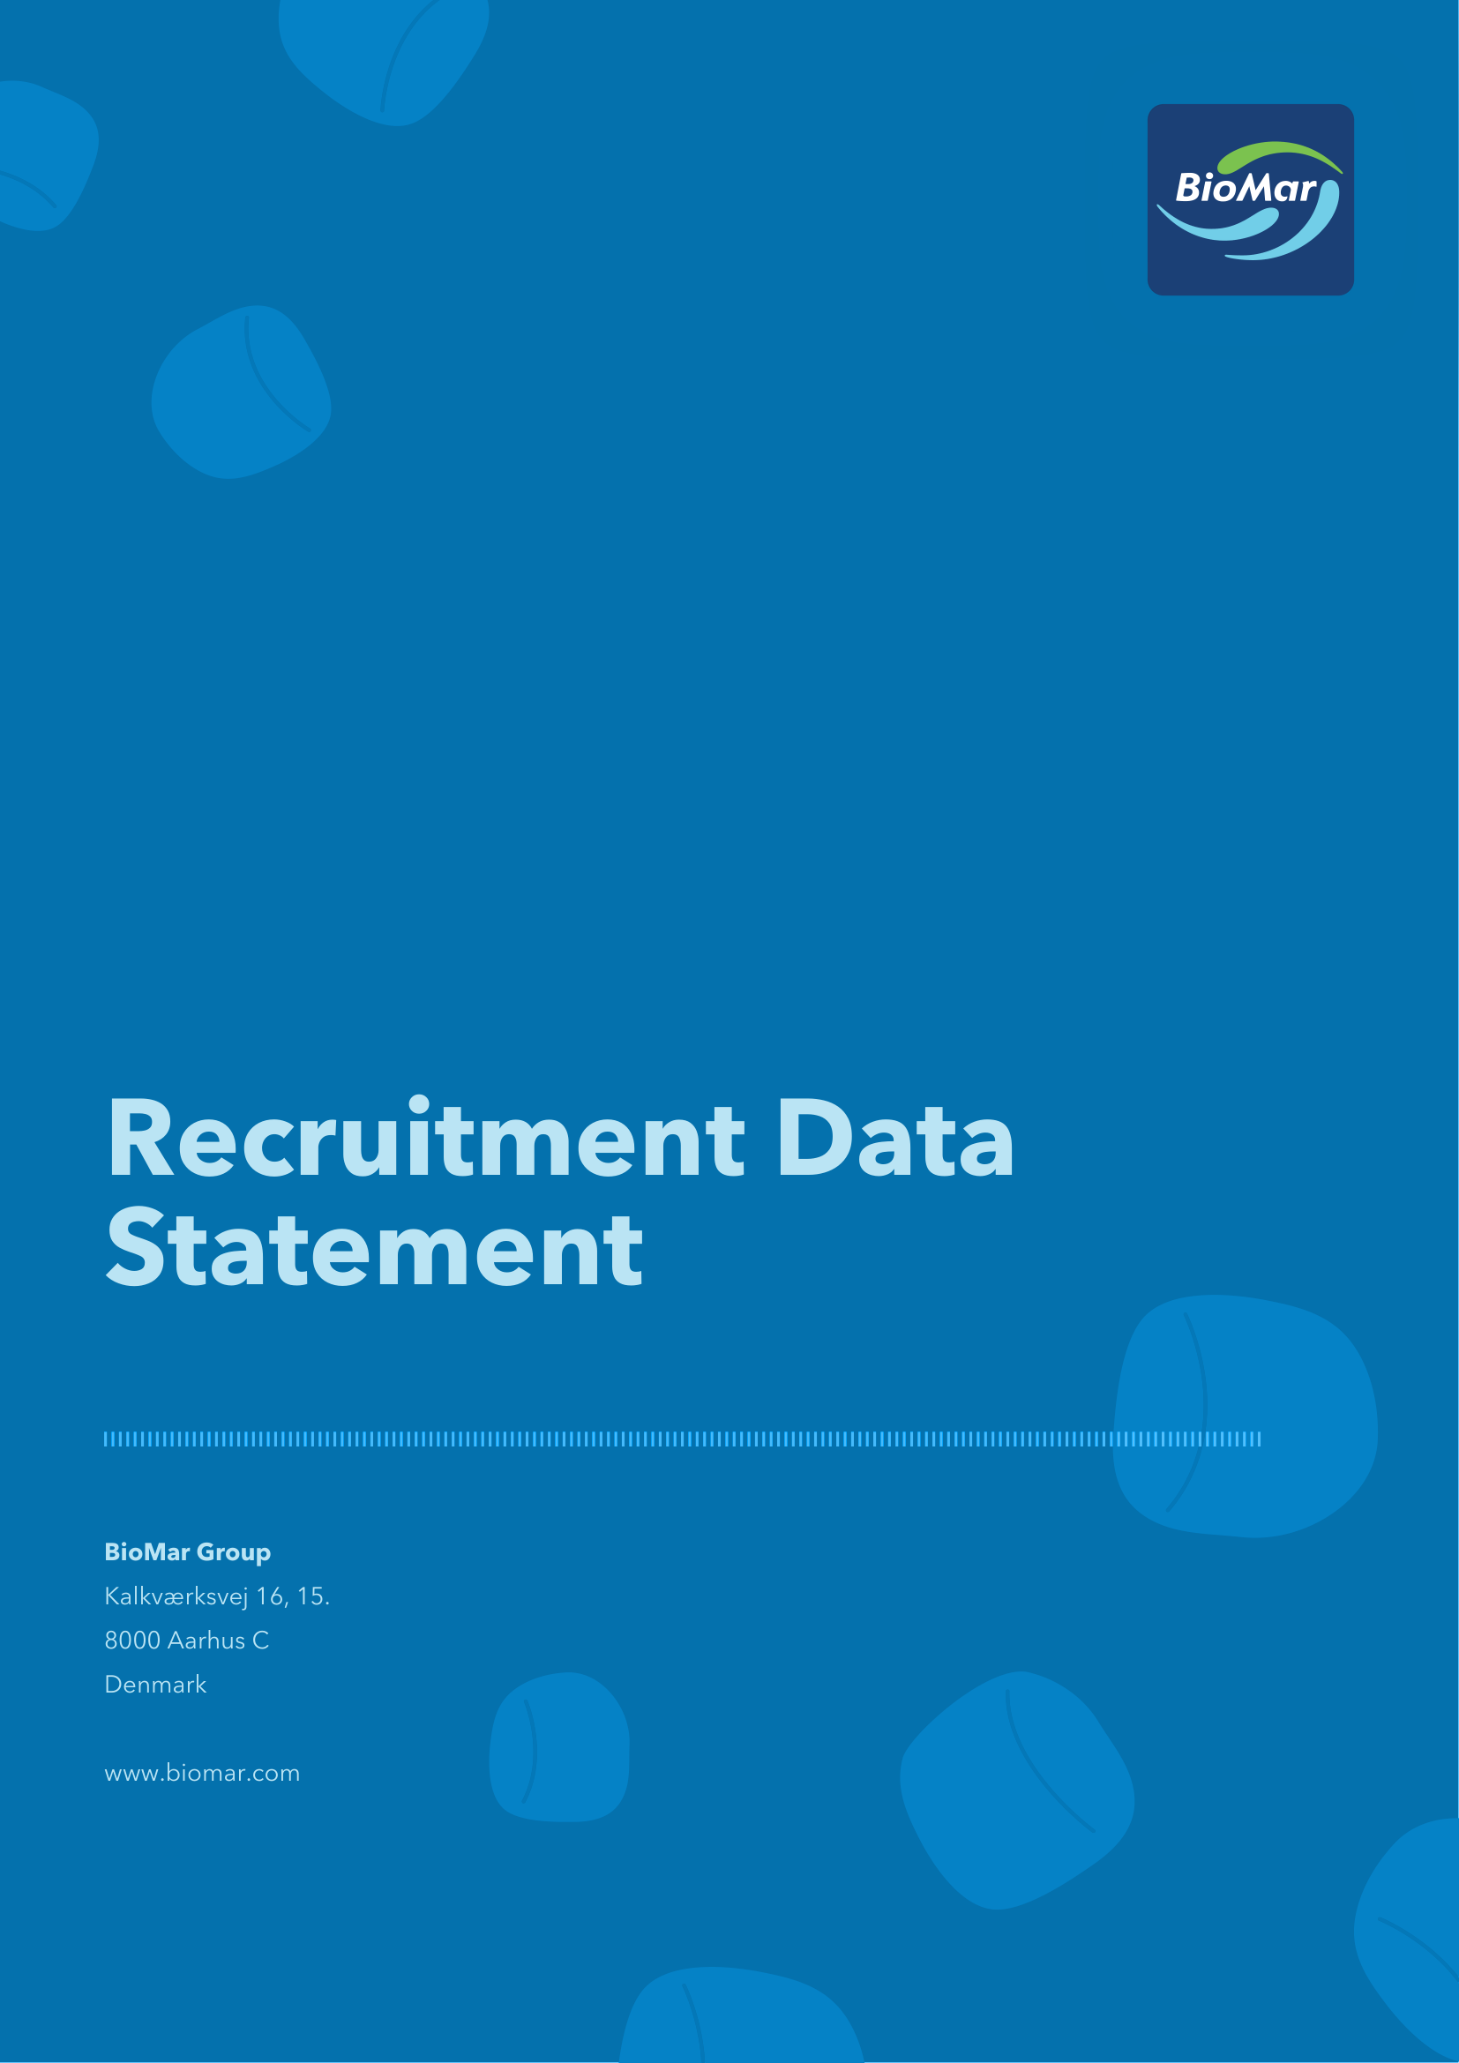

Handling of your personal data
The scope and purpose of your consent
I willingly give my consent to BioMar Group including any group-affiliated companies, to process and store my uploaded application including any uploaded addenda e.g. my CV, educational certificates, portrait photo, etc. for a period of 9 months in order to consider me for any vacant position at BioMar Group within the scope of my qualifications and professional background.
Withdrawal
You may withdraw your consent at any time by contacting Recruitment at recruitment@biomar.com. Upon withdrawal of your consent your profile including your personal data will be deleted from the job database and you will no longer be considered for future vacancies at BioMar Group.
Information on your rights
We always ensure that handling of your personal data is carried out in accordance with the applicable data protection legislation, including good data processing practice. Personal data in this job database will be treated confidentially and only for the purposes described herein.
Who has access to your personal data?
Your personal data may be shared internally for the purposes of the recruitment exercise. This includes members of the HR Department, interviewers, external consultants involved in the recruitment process, managers in the business area with a vacancy and IT staff if access to the data is necessary for the performance of their roles. Your personal data will be made available to the above-mentioned categories of employees within BioMar Group.
How long do we keep your personal data?
Your personal data including your CV will as a default be deleted 9 months after you have uploaded your data in our HR system.
You have the right to withdraw your consent at any time by contacting recruitment@biomar.com.
If your application for employment is successful, personal data gathered during the recruitment process will be transferred to your personnel file and will be retained during your employment.
What are your rights under the data protection legislation?
According to data protection legislations, BioMar Group is compliant to the following rights in connection with our processing of your personal data;
- Right of access: You have the right to obtain access to your personal data handled by BioMar Group.
- Right to rectification: You have the right to obtain rectification of inaccurate personal data concerning you.
- Right to erasure (right to be forgotten): Under certain circumstances you have the right to ask for deleting of your personal data prior to BioMar Group standard procedure for deletion of your personal data.
- Right to restriction of processing: Under certain circumstances, you have the right to restrict BioMar Group processing of your personal data.
- Right to data portability: You are entitled at any time to receive an (electronic) copy of your personal data being processed by BioMar Group.
- Right to object: Under certain circumstances, you have the right to object against BioMar Group processing of your personal data.
- Right to complain to the Data Protection Authority: You have the right to complain to the Data Protection Authority if you believe that BioMar Group processing does not meet the current rules and regulations. Kindly refer to the website of the Danish Data Protection Authority at www.datatilsynet.dk.
If you wish to exercise any of the above-mentioned rights, please contact BioMar Group at recruitment@biomar.com.
Contact information
BioMar Group A/S
CVR 38570617
Kalkværksvej 16, 15., 8000 Aarhus C, Denmark
Data Protection Responsible: dpo@biomar.com

Version history | Owner and approver
Version 1: July 2026 | Owner: —  Approver: Executive Committee

