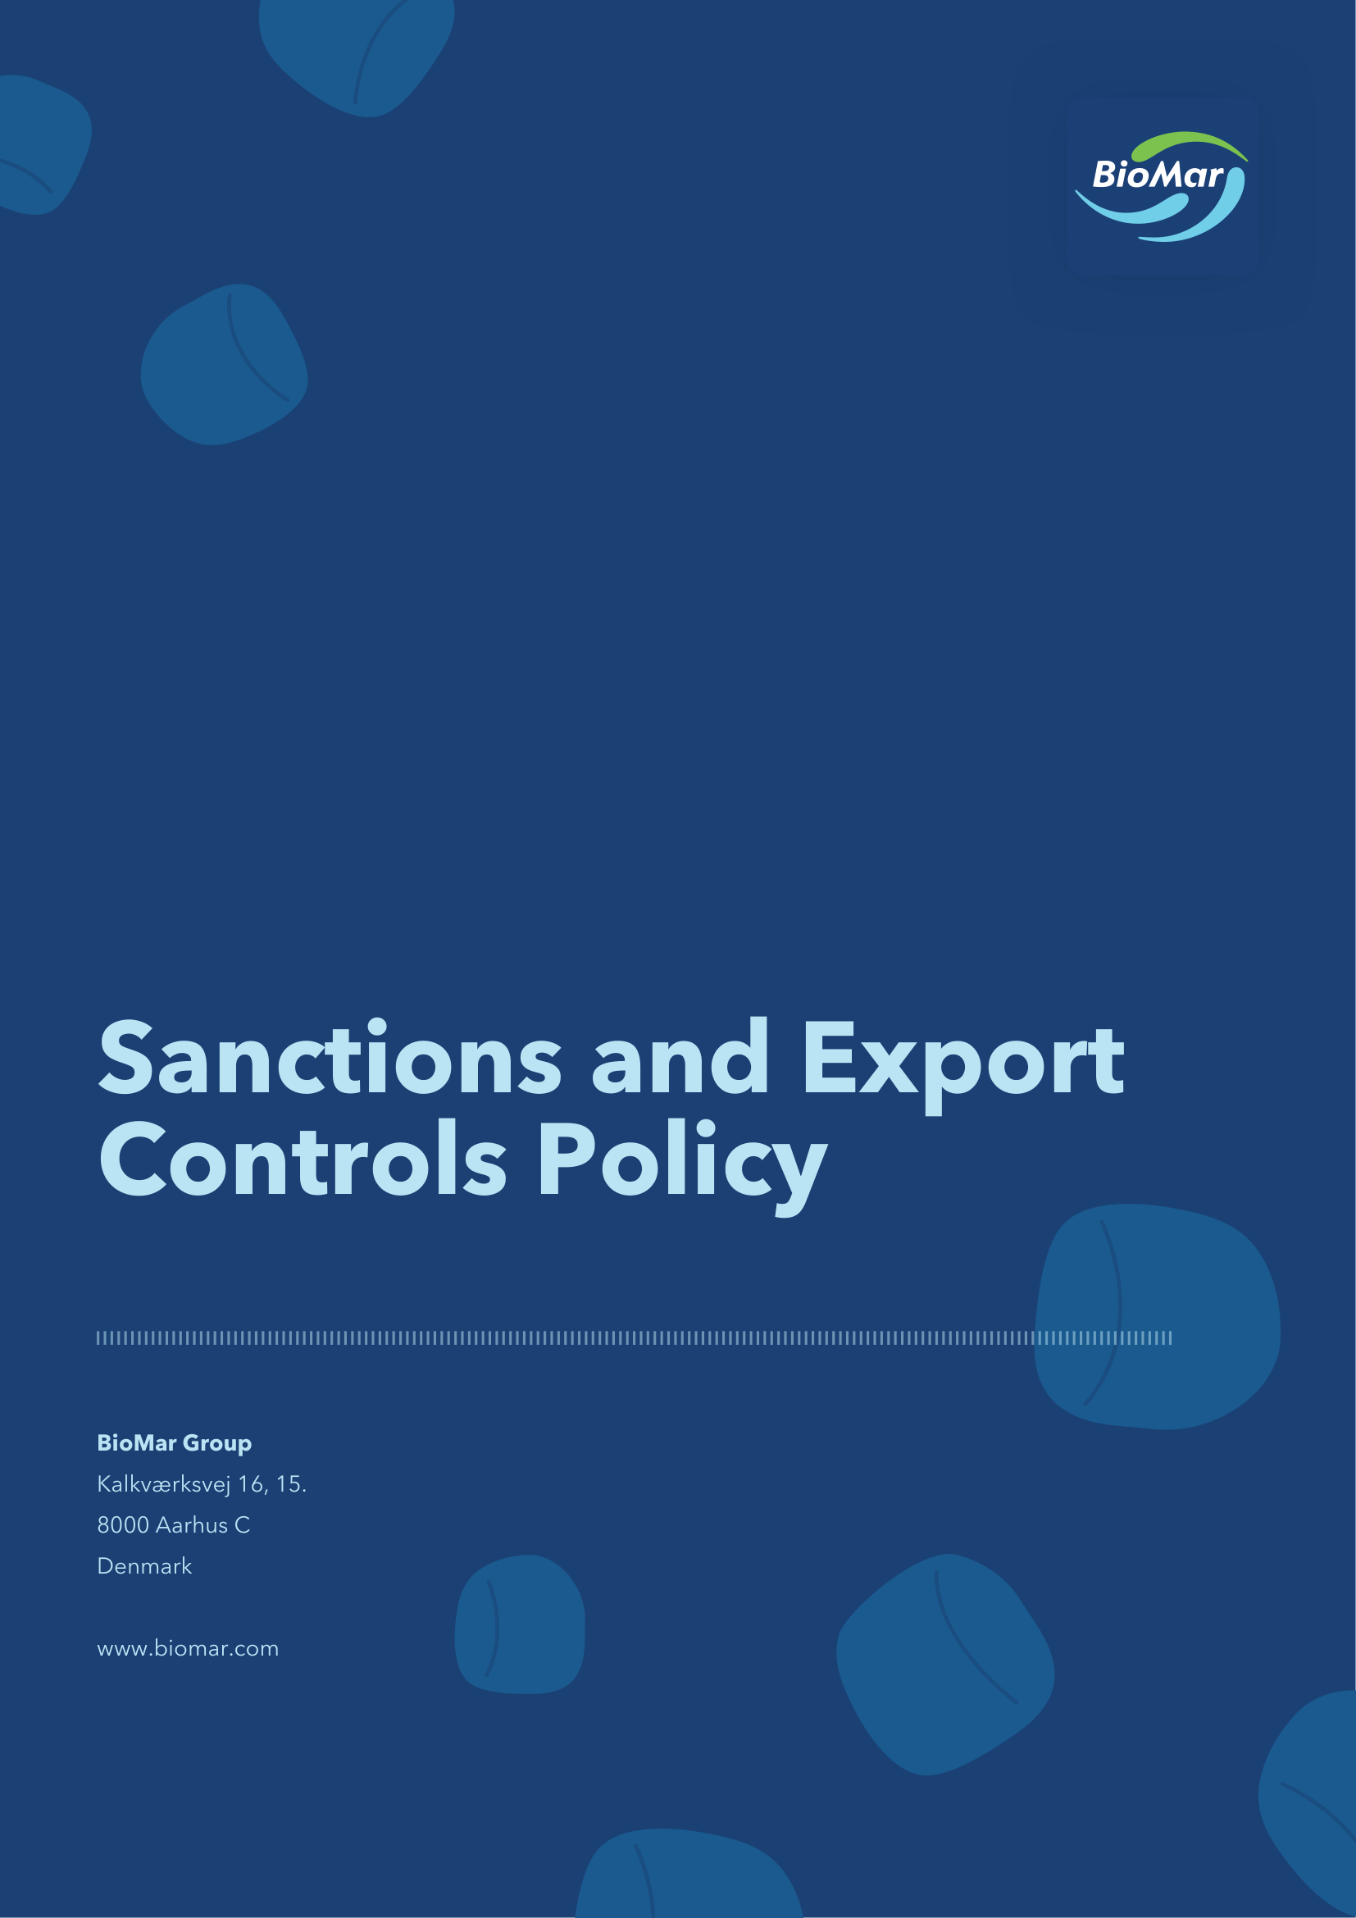

Introduction
Conducting global business responsibly and with integrity is fundamental to BioMar’s values and operations. Compliance with sanctions and export control laws enables BioMar to safeguard that its global trade activities are conducted securely and responsibly, that partners and stakeholders are effectively protected, and that BioMar’s business can operate safely and sustainably around the world. Through strict adherence to sanctions and export control requirements, BioMar not only demonstrates its commitment to lawful and responsible commercial conduct, but also safeguards its reputation and maintains the trust of partners, customers, and stakeholders across the world.
The objective of this Sanctions and Export Controls policy (the “Policy”) is to ensure that all business activities of BioMar Group A/S, CVR no. 38 57 06 17, and its subsidiaries and controlled or jointly controlled companies (collectively “BioMar” or “Group“) comply with international economic or financial sanctions and applicable export control legislation, which prohibit or regulate business conduct towards specific countries, regions, entities, and individuals.
Non-compliance with sanctions and export control rules (defined below) carries significant consequences and may expose BioMar, its employees, officers, management, directors, shareholders, and others associated with BioMar to substantial fines, losses, reputational risk, and, in the case of individuals, prison sentences, and may have significant adverse effects on business relationships.
If an employee, officer, manager, or director of BioMar or any associated person has any concerns regarding this Policy or perceives any conflict or inconsistency between this Policy and governing laws or any other company rules or procedures, the concern should be raised with, and direction sought from, the Compliance Committee.
Who must comply with this Policy?
This Policy applies to all employees, officers, management, and directors of BioMar and to business partners of BioMar, and to such other persons as designated by BioMar from time to time (“Representatives”).
This Policy also applies to anyone performing services for, or on behalf of BioMar, e.g. agents and distributors.
What are Sanctions and Export Control Rules?
Sanctions
Trade sanctions are laws, regulations, and administrative measures enacted by states, such as the United States, and the United Kingdom, Australia, Chile, and Ecuador, international organizations, such as the United Nations, and supranational bodies, such as the European Union, to advance foreign policy, national security, peace, and stability (“Sanctions”).
Sanctions seek to bring about a change in the policy or conduct of those targeted; mainly by prohibiting companies and individuals from doing business with or in relation to certain individuals, legal entities, countries, regions, and governments that are subject to Sanctions.
Sanctions may include:
- export bans, import bans, and prohibitions on the provision of certain specified services;
- prohibitions on certain commercial activities (such as joint ventures and other investments);
- prohibitions against transfer of anything of value to and from a sanctioned individual, entity, country, territory, or government (asset freeze);
- targeted financial sanctions, which may include prohibitions on dealings with specific governments, countries or territories, and designated entities and individuals;
- visa and travel bans; and
- other financial restrictions.
Information about the countries and regions subject to trade sanctions imposed by the EU and the United States may be found here:
- https://www.sanctionsmap.eu/#/main
- https://ofac.treasury.gov/sanctions-programs-and-country-information
Export Control Rules
Export Control Rules means laws and regulations governing the classification, licensing, export, re-export, transfer, and release of certain goods, software, technology, and services, including dual-use and military items, and associated end-use, end-user, and destination restrictions (collectively “Export Control Rules”).
The primary objective of Export Control Rules is to restrict the production or spreading of weapons and items that can be used for military purposes to certain countries and recipients and to place financial or political pressure on politically involved individuals in certain countries.
The extent of the Sanctions and Export Control Rules in place varies from jurisdiction to jurisdiction, and some regimes are more comprehensive than others. The employees, managers, officers, and directors of BioMar must always be cautious when engaging in transactions with countries and regions subject to Sanctions and Export Control Rules and appropriate legal assessment must be carried out beforehand.
Conduct of business
BioMar is committed to complying with all Sanctions and Export Control Rules applicable to its business. Each employee, manager, officer, and director of BioMar is bound to comply with Sanctions, Export Control Rules, and this Policy and may not engage in any business that could violate applicable Sanctions or Export Control Rules.
BioMar will not, and it shall be prohibited to, engage, directly or indirectly, in any activities or business with individuals or legal entities in the countries and regions listed in Attachment A (“High-Risk Sanctioned Countries”), without prior written approval of the Compliance Committee.
In any dealings with High-Risk Sanctioned Countries, it is of the utmost importance to carry out prior due diligence and screenings of business partners, products, transactions, and other activities. Approval by the Compliance Committee may only be granted if the due diligence has confirmed that no Sanctions or Export Control Rules will be violated by the contemplated business.
In dealings with countries that are not defined as High-Risk Sanctioned Countries, all employees, managers, officers, and directors of BioMar must comply with the applicable approval procedures under the Compliance Programme (defined below) before engaging in any activities or conducting any business with individuals or legal entities in such countries.
BioMar has adopted a zero-engagement approach in relation to Russia.
BioMar shall not engage, directly or indirectly, in any trade or commercial activities with individuals or legal entities in Russia, Belarus, or the non-government controlled areas of Ukraine (including Crimea and the regions of Donetsk and Luhansk).
This prohibition includes, without limitation, the sale of all BioMar products and the sourcing of raw materials, components, and other goods or services.
The prohibition applies irrespective of whether such activities could otherwise be conducted in compliance with this Policy, applicable Sanctions and/or Export Control Rules.
Non-compliance
Failure by a Representative to comply with his or her obligations under this Policy, may be considered misconduct and/or breach, and may lead to the institution of disciplinary and/or contractual sanctions and remedies, including termination of employment or business relationship.
Policy Implementation and Training
BioMar will take effective measures to ensure compliance with and awareness of its Sanctions and Export Control Rules related obligations. BioMar will maintain a risk-based compliance programme (of which this Policy is a part), managed by the Compliance Committee, and reviewed and approved on a regular basis by the Executive Committee, aimed at ensuring that BioMar complies with Sanctions and Export Control Rules (the “Compliance Programme”).
The Compliance Programme shall include details of mandatory due diligence and screening procedures, including mapping of countries requiring enhanced due diligence (not considered a High-Risk Sanctioned Country). The Executive Committee is responsible for overseeing the effective implementation of this Policy and the Compliance Programme throughout the entire Group.
All relevant managers and employees of BioMar must on a regular basis participate in training on Sanctions and Export Control Rules and application of this Policy and the Compliance Programme
Policy Review
The Compliance Committee is responsible for assessing whether this Policy is in conformity with applicable legislation, including Sanctions and Export Control Rules, while regularly monitoring its effectiveness and promoting any changes necessary for its improvement.
The Board of Directors of BioMar shall annually review, and if relevant update, this Policy.
The Compliance Committee may, in consultation with the Executive Management, revise and update Attachment A (High-Risk Sanctioned Countries) with immediate effect, if deemed necessary due to changes in Sanctions or Export Control Rules, or other geopolitical developments. Such revisions do not require prior approval from the Board of Directors
Audit
Each Representative shall to the extent possible provide access to all relevant documents, records, systems, processes, and policies in order to enable BioMar (or its third-party professional representatives) to audit and verify compliance with this Policy.
ATTACHMENT A: HIGH-RISK SANCTIONED COUNTRIES
Revised in April 2026
Russia*
Belarus*
Donetsk, Luhansk, and Crimea*
Iran
North Korea
Cuba
Venezuela
Syria

Version history | Owner and approver
Version 1: 28-09-2026  Approval date: 28-09-2026 | Owner: Compliance Committe  Approver: BioMar Board of Directors

