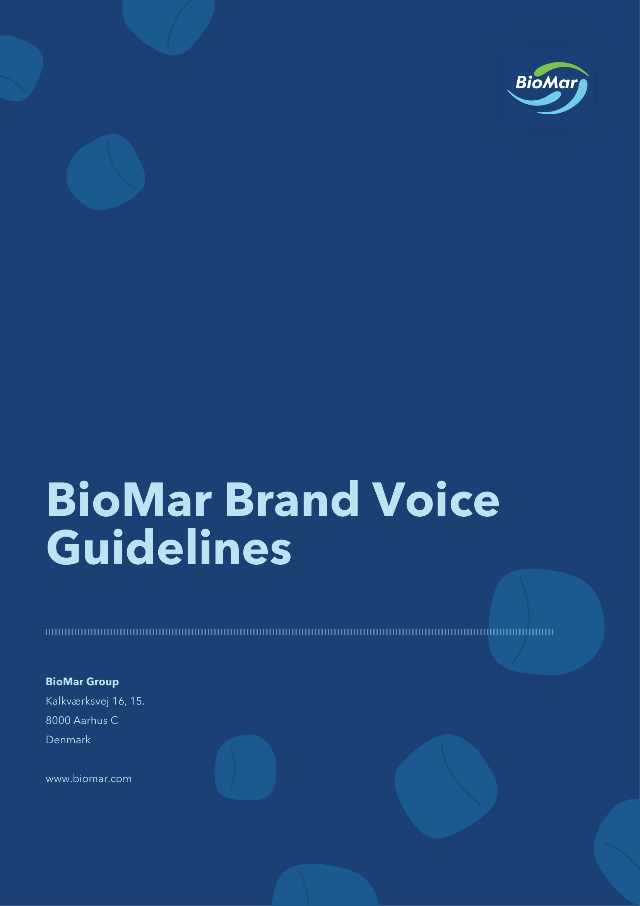

Living the BioMar brand means communicating with clarity, consistency and a strong sense of purpose. Our tone reflects who we are, what we stand for and how we work across all markets. It strengthens trust in BioMar Group and supports a unified global identity.
These guidelines apply to all written communication, including corporate materials, scientific articles, press releases, social media and customer-facing content.
Our Identity in Words
Most companies in aquaculture can claim expertise. What distinguishes BioMar is that we work alongside the people who use our feed, and we say only what the science supports.
That produces a specific voice. We explain rather than assert. We give the reader the evidence and let it do the persuading. We are willing to describe what we do not yet know, because a partner who overstates today is not trusted tomorrow.
We write as a knowledgeable colleague, not as a supplier addressing a buyer. Confident, calm and specific. Never distant.
If a farm manager, a scientist and a journalist all read the same paragraph, each should find it accurate, and none should find it patronising.
Core Principles
Clear and informed
We prioritise clarity. Complex topics are explained using straightforward, structured language, supported by data where relevant.
Professional and approachable
The tone is balanced, not overly formal, not casual. Our messages remain open, factual and respectful.
Accurate and responsible
We write with the same rigour we apply to our work. Claims are evidence-based, avoiding hype, exaggeration or ambiguous promises.
Consistent across markets
BioMar communicates as one global company. The depth of detail may vary by audience, but the tone stays constant.
When principles conflict
Accuracy and accessibility sometimes pull in opposite directions. Accuracy wins. If a claim cannot be simplified without losing precision, keep the precise version and add a sentence of explanation rather than trading it for a smoother one. A reader who has to work slightly harder is better served than a reader who is misled.
Language Style
Straightforward and structured
Clean sentence structures and purposeful terminology. Technical terms are used only when they add value.
Short, readable paragraphs
Paragraphs remain concise and focused. Dense, overly long paragraphs are avoided to ensure clarity and flow.
Neutral and objective
Unnecessary adjectives and dramatic language are avoided. Facts lead the message.
British English
All content in English must follow British spelling, vocabulary and grammar.
Casing
Casing is part of tone. How a word is set on the page changes how it sounds, and inconsistent casing undermines the unified identity these guidelines exist to protect.
Titles and headlines
Use title case for article titles, press release headlines, report titles and presentation slide titles.
In title case:
- Capitalise the first and last word, regardless of what they are.
- Capitalise all nouns, pronouns, verbs, adjectives and adverbs.
Keep articles (a, an, the), coordinating conjunctions (and, but, or, nor) and prepositions of four letters or fewer (in, on, for, with, from) in lower case, unless they are the first or last word.
Yes: New Aquafeed Production Site Opens in Denmark
No: New aquafeed production site opens in Denmark
No: New Aquafeed Production Site Opens In Denmark
Subheadings and body copy
Use sentence case for subheadings, captions, table headers, and chart labels. Title case in a heading signals importance, title case everywhere signals nothing.
Full capitals
We do not set words or phrases in full capitals.
Full capitals read as raised volume. They introduce urgency and pressure into a voice that is meant to be calm, factual and respectful, and they are the visual equivalent of the exaggerated language this document asks writers to avoid.
No: BioMar is proud to announce a MAJOR expansion.
No: DOWNLOAD THE REPORT
Yes: BioMar is expanding its French facility.
Yes: Download the report
Full capitals are also less legible in long strings, and are read poorly by screen readers, which often announce them letter by letter.
Permitted exceptions:
- Established acronyms and initialisms: ASC, SBTi, FCR, EPA, DHA, R&D.
- Product and brand names that are formally set in capitals as part of their identity, such as LARVIVA. Follow the visual identity guidelines, do not extend capitalisation to product names that are not set this way. For more details refer to the Product Guidelines.
- Legal, regulatory or safety text where capitalisation is required by law or by a governing body.
Not permitted:
- Capitals for emphasis. Use bold sparingly instead, or rewrite the sentence so the emphasis is carried by the words.
- Capitals in calls to action, buttons, navigation labels, social posts or email subject lines.
Letterspaced or small capitals used purely as a design treatment are a visual identity decision, not a copy decision.
BioMar
The name is always written BioMar, with a capital B and a capital M, and no space between them. This applies in every context, including running text, headlines, email signatures, and social media copy. It applies regardless of the surrounding casing convention: BioMar keeps its internal capital M even in sentence-case subheadings and in body copy.
Yes: BioMar
No: Biomar, BIOMAR, biomar, Bio Mar, BioMAR
Job titles and departments
Capitalise a job title when it precedes a name or forms part of a formal title. Use lower case when describing a team or role generally.
Yes: Chief Executive Officer Carlos Diaz said…
Yes: the Global Marketing team
Yes: our marketing teams across the region
When Speaking About BioMar
Use of "we"
Used in BioMar-authored content such as website articles, corporate explanations or storytelling pieces.
Use of third person
In joint press releases, partnership announcements or communications where neutrality is required.
Use of "BioMar" and "the company"
Naming BioMar directly is allowed and often preferred, especially to avoid repeating "we". Use "the company" only when third-person language is required, such as in official reports, regulatory contexts or external collaborative releases.
Writing in Practice
Principles are easier to apply against examples. Each pair below shows a common failure and its correction.
A press release opening
Before: BioMar is thrilled to unveil a revolutionary new chapter in aquafeed innovation, redefining what's possible for the industry.
After: BioMar has expanded its Aquaculture Technology Centre in Hirtshals, adding four recirculation systems for trial work with sea bass and sea bream.
A LinkedIn post
Before: HUGE news from the BioMar team!! We're SO excited to share what we've been working on. 🚀🚀
After: Our team in Costa Rica has been trialling a new shrimp feed formulation with three partner farms. Early results on survival rates are encouraging, and we will share the full findings in Q4.
Describing research
Before: Our groundbreaking research proves that targeted nutrition eliminates gill health issues in Atlantic salmon.
After: In a 12-week trial, salmon fed the test diet showed reduced gill score severity compared with the control group.
What to Avoid
- Exaggerated or dramatic language: revolutionary, game-changing, breakthrough, unveil, thrilled
- Overpromising or implying guarantees
- Sustainability claims without supporting data
- Marketing clichés and abstract corporate jargon
- US spelling or tone
- Slang or overly casual expressions
- Emotional language in place of evidence
- Debate-style engagement on social media (see Social Media Guidelines)
- Full capitals for emphasis (see Casing)
Preferred Vocabulary
Direct, factual wording that reflects our industry and expertise. These terms support consistency across markets.
Use | Instead of
aquafeed (feed is permitted to avoid repetition) | feed
production facility / production site | feed mill, factory
alternative ingredients / alternative raw materials | —
blue foods | —
design / formulate feed | make feed
feed solutions | —
novel ingredients / novel raw materials | —
raw materials | —
reliance on… | dependence on…
resilient (industry or species level) | —
strong (leave where possible for LARVIVA materials) | —
targeted nutrition | precision nutrition
A note on "responsible" and "low-impact"
We prefer responsible to sustainable, and low-impact to sustainability, where the sentence allows it.
This is not a stylistic preference. Environmental claims are increasingly regulated, and terms such as sustainable and green carry legal exposure when used without substantiation. Responsible and low-impact describe an approach, sustainable asserts an outcome.
This distinction only works if the substitution is not a disguise. Replacing the word does not license a vaguer claim. "Our responsible sourcing programme" still requires the same evidence as "our sustainable sourcing programme" would. If there is no figure, no methodology and no verification behind the sentence, neither word makes it publishable.
How We Speak About Key Themes
Innovation
Explain the purpose, relevance and outcomes of developments without dramatisation.
Environmental performance
Use metrics, methodologies and recognised terminology. Avoid vague or undefined claims.
Partnerships and people
Warm yet professional. Highlight collaboration, shared progress and expertise.
Channel Application
Corporate website
Structured, explanatory and accessible. Articles follow a clean narrative. Article and press release titles use title case.
External press releases
Concise, factual and direct. The key message appears in the opening paragraph, with natural-sounding quotes.
LinkedIn and social media
Professional tone, short paragraphs and accurate information. Emojis may be used sparingly. See the Social Media Guidelines for detail.
Sustainability and R&D communication
Precise and evidence-driven. Research is translated into accessible, factual language that respects scientific integrity.
This voice is maintained consistently across all languages BioMar communicates in, ensuring the same clarity, professionalism and identity worldwide.
Non-Translatable Elements
The following brand elements remain in English across all markets.
Taglines
- Better Feed. Better Fish. Better Food.
- Start Strong. Stay Strong.
- Powered by Partnership. Driven by Innovation.
- You Care. We Care.
- Optimise your Performance.
- Other taglines
Strategy names
- Above & Beyond
- Other approved strategy names
Concept and product names
- Blue Impact
- P.3 Concept
- SmartCare
- Control Gill
- BioFarm
- Other product names and concepts
Company name
The full name BioMar Group must remain in English at all times. When avoiding repetition, the phrase "the Group" may be used. This phrase can be translated when appropriate within non-English content, for example, el grupo.
Global Spanish
Spanish is the second global language used by BioMar. For global communications, both internal and external, we use BioMar Global Spanish: a unified version designed to work across all Spanish-speaking markets we serve.
Global Spanish is used when communications must be shared globally, published across regions, or printed in formats where local adaptation is not possible.
Principles of BioMar Global Spanish
One Spanish, targeted to all markets
It avoids regionalisms, slang and country-specific expressions unless truly necessary. It should read naturally in all Spanish-speaking BioMar markets.
Market relevance and widely accepted terminology
When a term relates uniquely to one market's species or production reality, we follow that market's terminology. When a term is widely recognised across several markets, we prioritise the broader, more commonly accepted option. See the Global Spanish Dictionary for detail.
Examples:
- We use camarón for shrimp, because Ecuador is the only Spanish-speaking BioMar market farming this species.
- We use alimento or alimento acuícola for feed or aquafeed, as these terms are widely understood across all Spanish-speaking markets.
Corporate and technical clarity
Global Spanish remains neutral, precise and professional, following the same tone rules as English BioMar content.
Form of address, tone and sentence structure
Global Spanish uses the informal second-person singular (tú) when addressing individuals, and ustedes when addressing groups. Sentence structure and vocabulary remain neutral, avoiding regional idioms or country-specific phrasing.
Casing in Spanish. Spanish does not use title case. Titles and headlines in Spanish use sentence case, capitalising only the first word and any proper nouns. The prohibition on full capitals applies equally.
Nueva planta de producción de alimento acuícola en Chile
Use and scope
Global Spanish is the standard used by Global Marketing for all cross-regional and corporate communications. It ensures consistency when content must work across all Spanish-speaking markets and when localisation is not possible.
Local marketing teams are free to use their own local or regional terminology whenever possible.
The BioMar Voice
Every BioMar message should reflect the same character:
A knowledgeable, trustworthy and close partner in global aquaculture.

Version history | Owner and approver
Version 1: July 2026 | Owner: Global Marketing  Approver: Executive Committee

