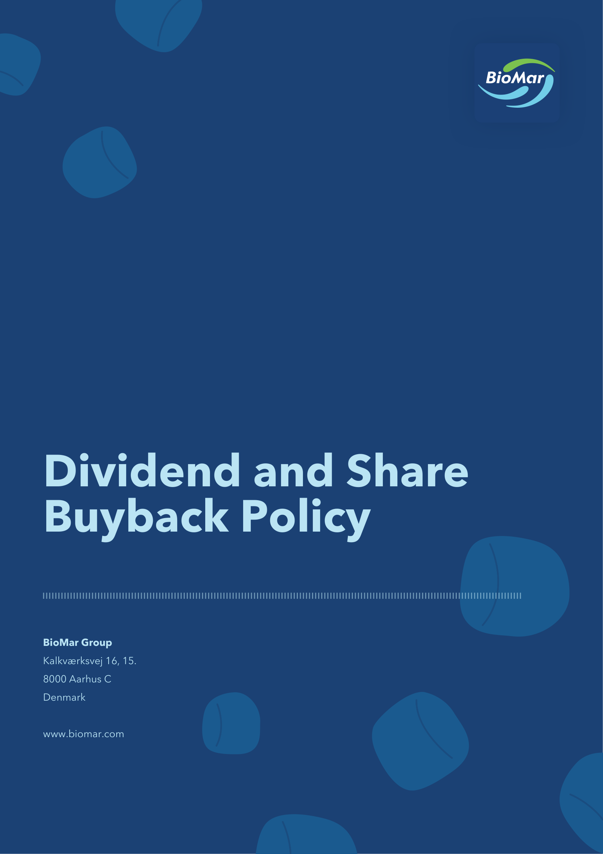

1 Introduction
1.1 The Board of Directors of BioMar Group A/S, CVR no. 38 57 06 17 (the “Company”) has adopted this dividend and share buyback policy (the “Policy”) with the objective to provide a policy for distribution of dividends to and share buyback from the shareholders of the Company. Further, the Policy describes the legal and regulatory requirements and other restrictions to which dividend distributions and share buybacks are subject.
2 Dividend policy and share buyback
2.1 The Board of Directors has adopted a dividend policy pursuant to which the Company intends to pay dividends of at least 50% of the annual net profit available for distribution.
2.2 If relevant, the Board of Directors will carefully consider and propose any payment of dividends or initiation of share buybacks based on a number of factors, including future revenue, profits, financial conditions, general economic and business conditions and future prospects, and such other factors as the Board of Directors may deem relevant as well as other legal and regulatory requirements.
2.3 As an alternative, or in addition, to making dividend payments, the Company’s Board of Directors may initiate share buybacks. A decision to initiate share buybacks will be made in accordance with the factors applicable to dividend payments as set out above.
2.4 There can be no assurances that in any given year dividends will be proposed or declared or a share buyback initiated.
3 Restrictions in financing documentation
3.1 Payments of dividends and interim dividends as well as share buybacks may be subject to covenants related to the Company’s financing restricting the Company’s ability to either declare and pay dividends and/or carry out share buybacks.
4 Legal and regulatory requirements
4.1 All issued and registered shares of the Company have the same rights in respect of eligibility to receive dividends or participate in share buybacks initiated by the Board of Directors.
4.2 Dividends
4.2.1 All distributions of ordinary dividends with respect to a given financial year are pro-posed by the Board of Directors and approved at the annual general meeting in the following year in connection with the approval of the annual report.
4.2.2 The general meeting may resolve to distribute interim dividends or authorise the Board of Directors to decide on the distribution of interim dividends. The Board of Directors has been authorised by the general meeting to distribute interim dividends.
4.2.3 Any resolution to distribute interim dividends adopted within six months after the date of the balance sheet from the Company’s most recently adopted annual report shall, at the Board of Directors’ discretion, be accompanied by either (a) the balance sheet from such annual report, or (b) an interim balance sheet reviewed by the Company’s auditor.
4.2.4 Any resolution to distribute interim dividends adopted more than six months after the date of the balance sheet from the Company’s most recently adopted annual report, shall be accompanied by an interim balance sheet reviewed by the Company’s auditor.
4.2.5 The balance sheet included in the annual report or the interim balance sheet, as applicable, must show that sufficient funds are available for distribution as interim dividends.
4.2.6 Any ordinary or interim dividends may not exceed the amount proposed or recommended by the Board of Directors.
4.2.7 Amounts distributed as ordinary or interim dividends must consist of distributable reserves and must not exceed what is considered sound and adequate when taking into account the financial condition of the Company or be to the detriment of the Company’s creditors and otherwise must satisfy such other factors as the Board of Directors deem relevant.
4.3 Share buybacks
4.3.1 Share buybacks may only be carried out by the Board of Directors using funds that could have been distributed as ordinary dividends.
4.3.2 All share buybacks shall be carried out in accordance with an authorisation granted by the general meeting. The authorisation shall be granted for a specific period of time which may not exceed five years, and which shall specify the maximum permitted value of treasury shares as well as the minimum and maximum amount that the Company may pay as consideration for such shares.
5 Miscellaneous
5.1 Distribution of dividends or initiation of share buybacks may have tax implications for the Company’s shareholders under applicable laws.
5.2 Dividends, if any, will be paid in accordance with the rules of VP Securities A/S, company reg. (CVR) no. 21 59 93 36.
5.3 Dividends not claimed by shareholders will be forfeited in favour of the Company in accordance with the applicable statute of limitations.
Approved by the Board of Directors on 19 May 2026.

