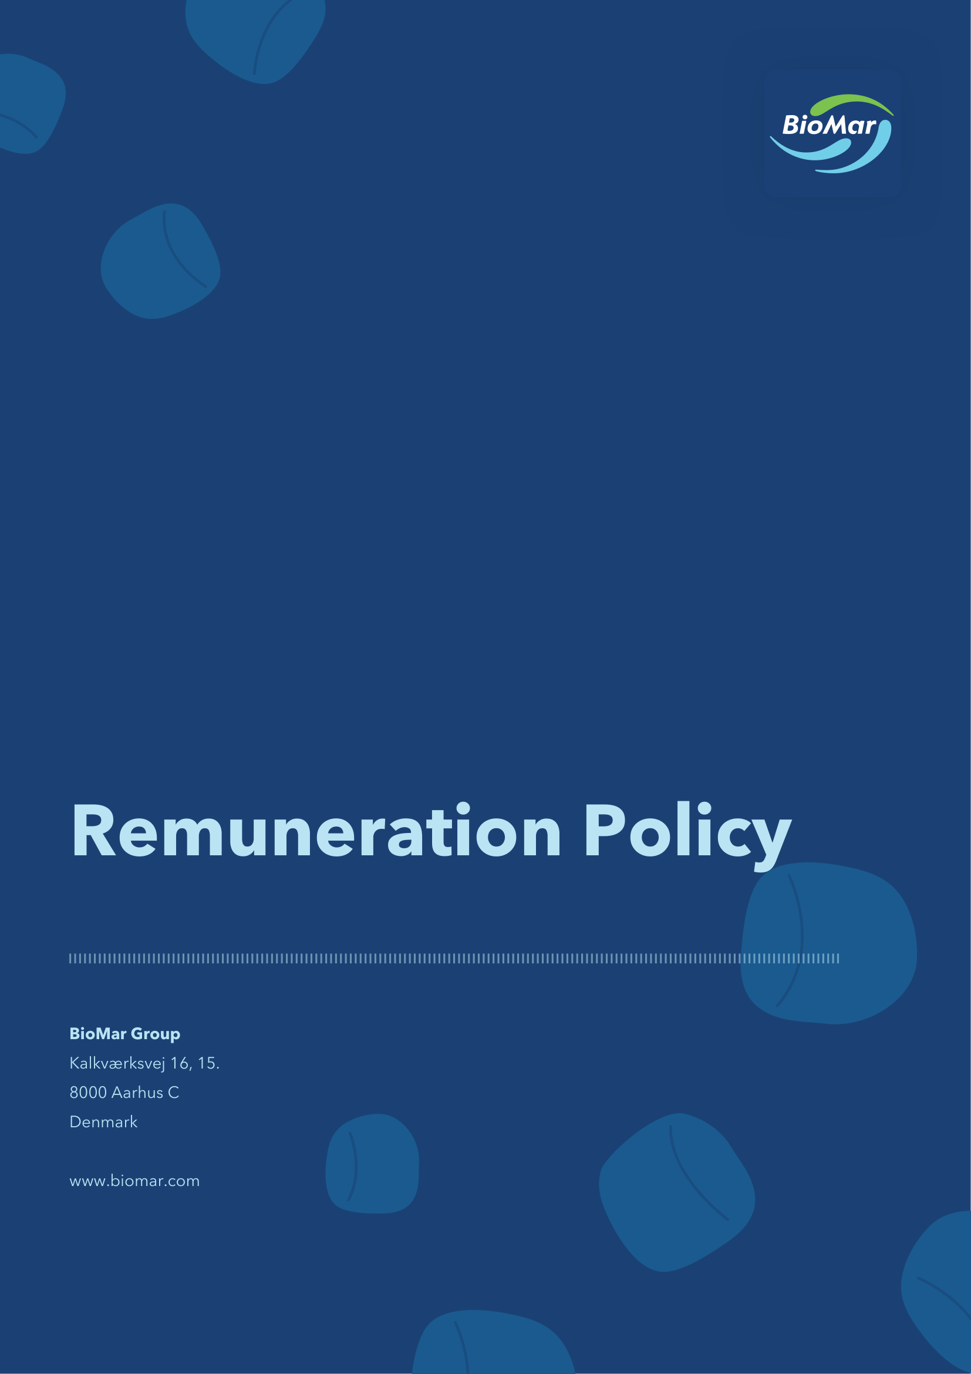

Introduction
This remuneration policy (the “Remuneration Policy”) of BioMar Group A/S, CVR no. 38 57 06 17 (the “Company”) has been prepared in accordance with section 139 and 139a of the Danish Companies Act and the recommendations published by the Danish Committee on Corporate Governance as implemented by Nasdaq Copenhagen A/S.
The Remuneration Policy sets out the framework for remuneration to the Board of Directors and the Executive Management of the Company. The “Executive Management” consists of the members of the executive management of the Company registered as such with the Danish Business Authority. “Group” refers to BioMar Group A/S as well as its subsidiaries.
Objectives
The overall objectives of this Remuneration Policy are (i) to attract, motivate and retain qualified members of the Board of Directors and Executive Management, (ii) to ensure alignment of interests between the Board of Directors, Executive Management, the Company itself and its shareholders, and (iii) to ensure and maintain the motivation for achieving the Group’s strategic short and long-term targets as well as to promote long-term sustainable value creation for the benefit of the shareholders.
The Board of Directors considers that the composition of remuneration supports these objectives. The actual remuneration paid to the Board of Directors and Executive Management in a financial year is decided by the Board of Directors based on recommendations from the Remuneration and Nomination Committee. The Board of Directors shall ensure that the remuneration is in compliance with this Remuneration Policy and that the remuneration does not exceed what is considered usual taking into account the nature and extent of the work and the Company’s financial position.
Remuneration of the members of the Board of Directors
The remuneration offered to the members of the Board of Directors shall be designed to be able to attract and retain competent members to the Board of Directors taking into consideration the market practice of comparable listed companies as well as due regard to the required competencies, experience, knowledge, effort and scope of work of the members of the Board of Directors.
Each ordinary member of the Board of Directors receives a fixed annual base fee (the “Base Fee”), while the Chair and Vice Chair receive fixed multiples of the Base Fee according to the requirements and responsibilities of the role of the individual board member. Participation in a board committee entitles a board member to an additional fixed annual fee calculated based on a multiple of the Base Fee. Table 1 outlines the fixed multiples of the Base Fee applicable to the remuneration of the Board of Directors.
Table 1: Remuneration structure of the Board of Directors – fxi ed fee multiples
 | Board of Directors | Audit Committee | Remuneration and Nomination Committee
Chair | 3x Base Fee | Up to 0.75x Base Fee | Up to 0.50x Base Fee
Vice Chair | 1.5x Base Fee | — | —
Member | 1x Base Fee | Up to 0.50x Base Fee | Up to 0.25x Base Fee
Incentive pay
The Board of Directors shall not receive any incentive pay from the Company.
Ad-hoc tasks
Should a board member, including the Chair or Vice Chair, assume specific ad-hoc tasks beyond the normal work and responsibilities as member of the Board of Directors, the Board of Directors may decide on an additional fixed fee for such tasks. Any ad hoc task shall be approved by the Board of Directors. The size of the aggregate ad hoc fees payable to a member of the Board of Directors in a financial year may not exceed 100% of the total remuneration paid or payable to such member of the Board of Directors for the financial year, including any additional fixed fees to the Chair, the Vice Chair and board committee members. Any ad hoc fees paid to the members of the Board of Directors will be disclosed in the Company’s remuneration report.
Benefits and reimbursement of expenses
Expenses such as travel and accommodation relating to board meetings, meetings of board committees and in connection with the performance of specific tasks assigned by the Board of Directors as well as relevant training may be reimbursed by the Company.
The Company may offer to cover social security contributions to the extent imposed by foreign national authorities in relation to fixed fees and reimbursable expenses.
Term
Members of the Board of Directors are elected by the general meeting for a term of one year. Re-election may take place. Members of the Board of Directors are not entitled to separate payments in relation to their resignation from the Board of Directors.
Remuneration of Executive Management
The remuneration to Executive Management is decided by the Board of Directors based on recommendations from the Remuneration and Nomination Committee. When preparing these recommendations, the Remuneration and Nomination Committee takes into account that the remuneration shall not exceed what is considered usual taking into account the nature and extent of the work, and what is considered reasonable with regard to the Company’s financial position. The Company seeks to pay competitive remuneration to the members of the Executive Management, taking into account the qualifications and performance of the individual members.
Fixed pay
Members of the Executive Management receive a fixed annual cash base salary. The fixed annual cash base salary is consistent with the market level.
Pension and benefits
4.2.1 Pension
Members of the Executive Management may be covered by the Company’s general pension plan under which both the Company and the member of Executive Management will contribute to the pension payments. The value of the Company’s pension contribution may not exceed 12% of the fixed annual cash base salary.
4.2.2 Benefits
Members of the Executive Management may receive customary monetary and cash-based benefits such as company car, expatriation insurance and health insurance in addition to usual benefits such as phone, computer and internet, insurances, news-paper subscriptions, etc., as well as other benefits.
4.3 Incentive pay
4.3.1 Members of Executive Management may be eligible to receive incentive compensation consisting of a cash incentive opportunity and/or share-based incentives, subject to the decision of the Board of Directors. Share-based programs may comprise of restricted share units (“RSUs”) or performance share units (“PSUs”) or a mix of any such share-based incentives as determined by the Board of Directors.
4.3.2 The Board of Directors may lay down specific terms governing the lapse of incentive arrangements or repayment of incentive pay (clawback) as well as accelerated vesting or exercise, and adjustment of the incentive arrangements, exercise price, performance targets, etc.
4.3.3 When determining the size and composition of the incentive arrangements and the split between the total awarded incentives and the fixed payment, the Board of Directors shall carefully consider the overall principles of the Remuneration Policy, including the aim of supporting the achievement of the Group’s strategic long- and short-term goals.
4.3.4 Short-term incentives
4.3.4.1 The short-term incentive consists of a cash-based bonus designed to incentivise and encourage the members of Executive Management to perform in alignment with the Group’s short-term objectives.
4.3.4.2 The annual cash bonus is dependent on the achievement of specific targets and metrics as approved by the Board of Directors each year. Performance shall be measured for each financial year and will depend on the achievement of certain criteria such as financial KPIs, that may include EBIT, EBITDA, return on invested capital, total shareholder return, sales volumes and net working capital, and non- financial KPIs, that may include ESG/sustainability related objectives as well as individual performance targets. The specific criteria as well as the weight of each criteria may vary from year to year as determined by the Board of Directors.
4.3.4.3 The actual payout under the annual cash bonus for a financial year will be decided by the Board of Directors upon recommendation from the Remuneration and Nomination Committee based on assessment of achievement of the pre-established KPIs.
4.3.4.4 The annual short-term cash bonus will generally be paid out following the Board of Directors’ approval of the annual report for the performance period for the annual short-term cash bonus and can constitute an amount corresponding to a maximum of 100% of the fixed annual cash base salary at the end of the relevant performance period.
4.3.4.5 In case of extraordinary circumstances and/or unforeseen events significantly impacting for example the Company’s financial performance, strategy, or environment or society, the Board of Directors can decide to amend or deviate from the pre-defined performance targets and metrics if required to support the purpose of this Remuneration Policy.
4.3.5 Long-term incentives
4.3.5.1 The long-term incentives are designed to incentivise long-term performance, commitment and retention of the members of Executive Management, as well as to promote alignment of their interests with those of the shareholders.
4.3.5.2 Members of the Executive Management may be offered to participate in either a cash-based long-term incentive programme or a share based long-term incentive programme. The value at grant of long-term incentives for a financial year may be up to 150% of the fixed annual cash base salary for the recipient.
4.3.5.3 In case of extraordinary circumstances and/or unforeseen events significantly impacting for example the Company’s financial performance, strategy, or environment or society, the Board of Directors can decide to deviate from principles applicable to any long-term incentive set out in this section.
4.3.5.4 Cash-based long-term incentive
(a) The long-term cash-based incentive is a revolving three-year cash bonus programme covering three financial years. The long-term cash-based incentive is calculated based on achievements of certain criteria, with main weight on core financial KPIs such as ROIC, EBITDA/EBIT, Sales Volumes, total shareholder return and net working capital. In addition, non-financial KPIs could be considered to a limited degree, such as ESG/sustainability related objectives as well as individual performance targets.
(b) The long-term cash-based incentive is granted each year for a three-year period and at the same time the selected KPIs as well as the weight of each criteria are reviewed, determined and, if deemed appropriate, adjusted by the Board of Directors.
(c) The size of the long-term cash-based incentive payout for a financial year will be decided by the Board of Directors upon recommendation from the Remuneration and Nomination Committee based on assessment of achievement of the pre-established KPIs covering the full three-year performance period.
(d) The long-term cash-based incentive payout will generally be made following the Board of Directors’ approval of the annual report for the last financial year of the three year performance period.
4.3.5.5 Share based long-term incentives
(a) Members of Executive Management may be eligible to receive long-term incentives in the form of RSUs or PSUs. The programmes are designed to further align management compensation with the long- term interests of the shareholders and the performance of the Company by linking a higher proportion of annual pay to the share price development of the Company as well as certain performance targets with respect to PSUs. Further, the programmes support the Company’s long term business model and strategy.
(b) The programmes are revolving and shall have a vesting or maturity period of three years from the relevant date of grant until the time they vest or mature. The vesting or maturity period shall be determined by the Board of Directors prior to grant.
(c) Grant of RSUs does not depend on the achievement of specific goals whereas grant of PSUs shall be subject to achievement of specific goals, that may include with main weight on core financial KPIs such as ROIC, EBITDA/EBIT, Sales Volumes, total shareholder return and net working capital. In addition, non-financial KPIs could be considered to a limited degree, such as ESG/sustainability related objectives as well as individual performance targets as financial targets such as EBIT, EBITDA, return on invested capital, total shareholder return, sales volumes and net working capital, and/or other non-financial targets or objectives such as ESG/sustainability related objectives as determined by the Board of Directors from time to time. Ownership of shares is transferred free of charge or by payment of par value of the shares delivered to each member of Executive Management three years after the time of grant (the “Vesting Period”), contingent on achievement of the pre-established KPIs, if any, and the member of Executive Management not having resigned during the Vesting Period. During the Vesting Period, no transfer of shares to the individual member of Executive Management will take place. After expiry of the Vesting Period and transfer of ownership of shares to the individual member of Executive Management, the member shall have all rights and obligations as shareholder of the Company, including the entitlement to receive dividends.
(d) The Company intends to use treasury shares to meet its obligations in relation to long-term share- based incentives. The Board of Directors may decide to satisfy a grant in cash if deemed appropriate.
(e) In line with market practice, share-based incentives shall be subject to good leaver and bad leaver provisions.
4.3.6 Adjustment and repayment of incentive-based remuneration
4.3.6.1 In case of extraordinary events, the Board of Directors may lay down specific terms for incentive- based remuneration governing the lapsing, repayment, capping of ultimate gains or other adjustments of the incentive-based remuneration, including accelerated vesting or exercise and adjustment to the exercise price or the performance targets. Such extraordinary event may include, but is not limited to, significant divestiture of activities, change in capital structure, demerger, merger or other business combination involving the Company or material parts of the Group, a member of Executive Management resigning/being dismissed or other material events that would otherwise positively or negatively influence

Version history | Owner and approver
Version 1: May 2026 | Owner: VP People, Purpose & Communication  Approver: General Meeting

