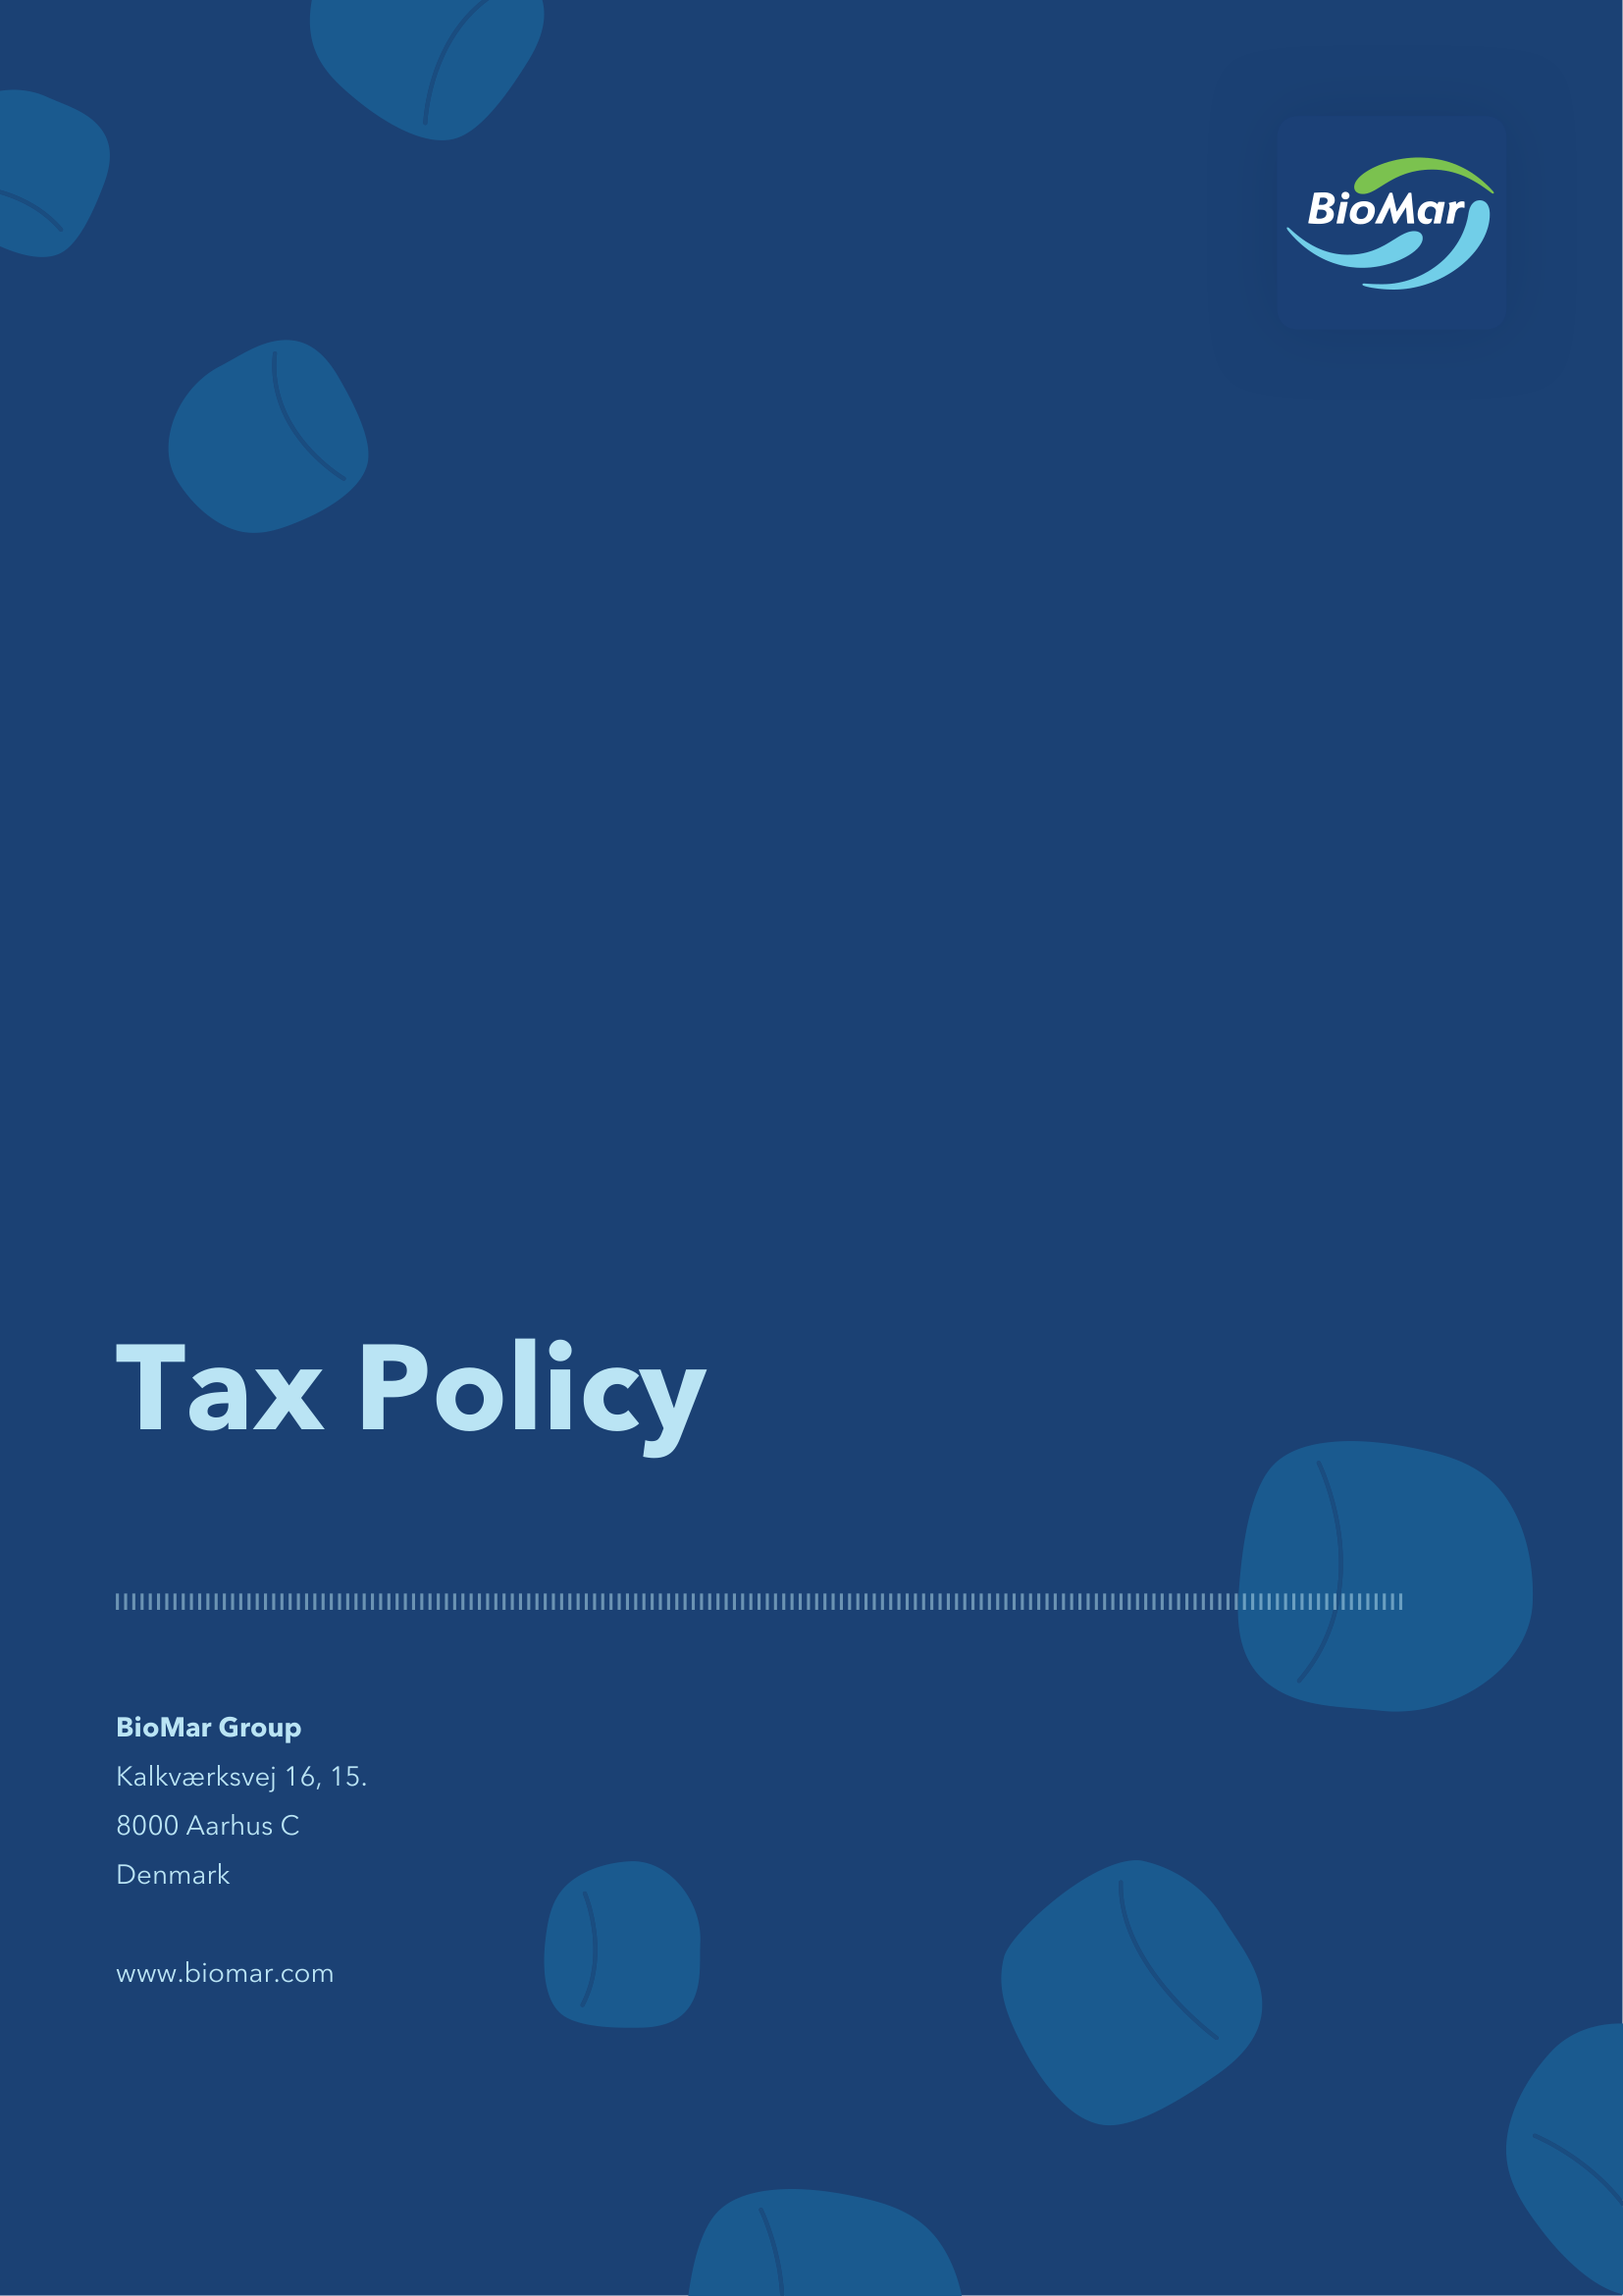

BioMar operates across multiple jurisdictions, navigating complex and varying tax environments. We acknowledge that tax payments are of great importance to the communities in which we operate, and we are committed to being a responsible taxpayer in full compliance with applicable laws and regulations. Our approach to tax is built on three core principles:
Ensure responsible tax compliance and planning
Uphold integrity in transfer pricing and related party transactions
Maintain proactive risk management and transparent reporting
Principle 1: Ensure responsible tax compliance and planning
BioMar is committed to complying with all applicable tax laws, rules, and regulations across all jurisdictions where we operate. This covers all types of direct and indirect taxes, including income tax, withholding tax, VAT, excise duties, customs duties, and payroll tax. All transactions must be transparent vis-à-vis the relevant tax authorities, and all tax affairs must be explainable and justifiable.
Our tax planning is based on commercial considerations and financial realities. We apply only substantive tax structures for commercially sustainable investment purposes — not for artificial tax avoidance or tax evasion. BioMar does not engage in activities in low-tax countries, tax havens on the EU blacklist, or in high-risk tax structures.
BioMar maintains an open, cooperative, and transparent relationship with tax authorities across all jurisdictions. We respond to enquiries in a timely manner and, where appropriate, seek pre-approval or enter into agreements with local tax authorities, including on transfer pricing matters.
Principle 2: Uphold integrity in transfer pricing and related party transactions
All transactions between related parties — including parent company, subsidiaries, associates, joint ventures, and key management personnel — must be conducted at arm's length in accordance with OECD Transfer Pricing Guidelines and applicable local tax legislation, supported by benchmarking studies using independent third-party comparable data where available.
Related party relationships are identified and documented annually, and all material transactions must be supported by written agreements. New intercompany transaction types require Group Finance pre-approval before implementation, with transfer pricing compliance following an annual cycle to ensure timely completion of all documentation requirements.
Principle 3: Maintain proactive risk management and transparent reporting
Tax disputes and uncertain tax positions are systematically identified, assessed, and monitored on an ongoing basis to enable timely resolution and appropriate financial reporting of potential liabilities. Provisions are recognised when they are certain or probable and can be reliably measured; otherwise, matters are disclosed as contingent liabilities.
Governance
Governance and oversight of our tax commitments are embedded across BioMar's operations. This policy is owned by Group Finance, with day-to-day implementation supported by local finance teams across all BioMar entities.

Version history | Owner and approver
Version 1: May 2026 | Owner: Group Finance  Approver: Board of Directors

