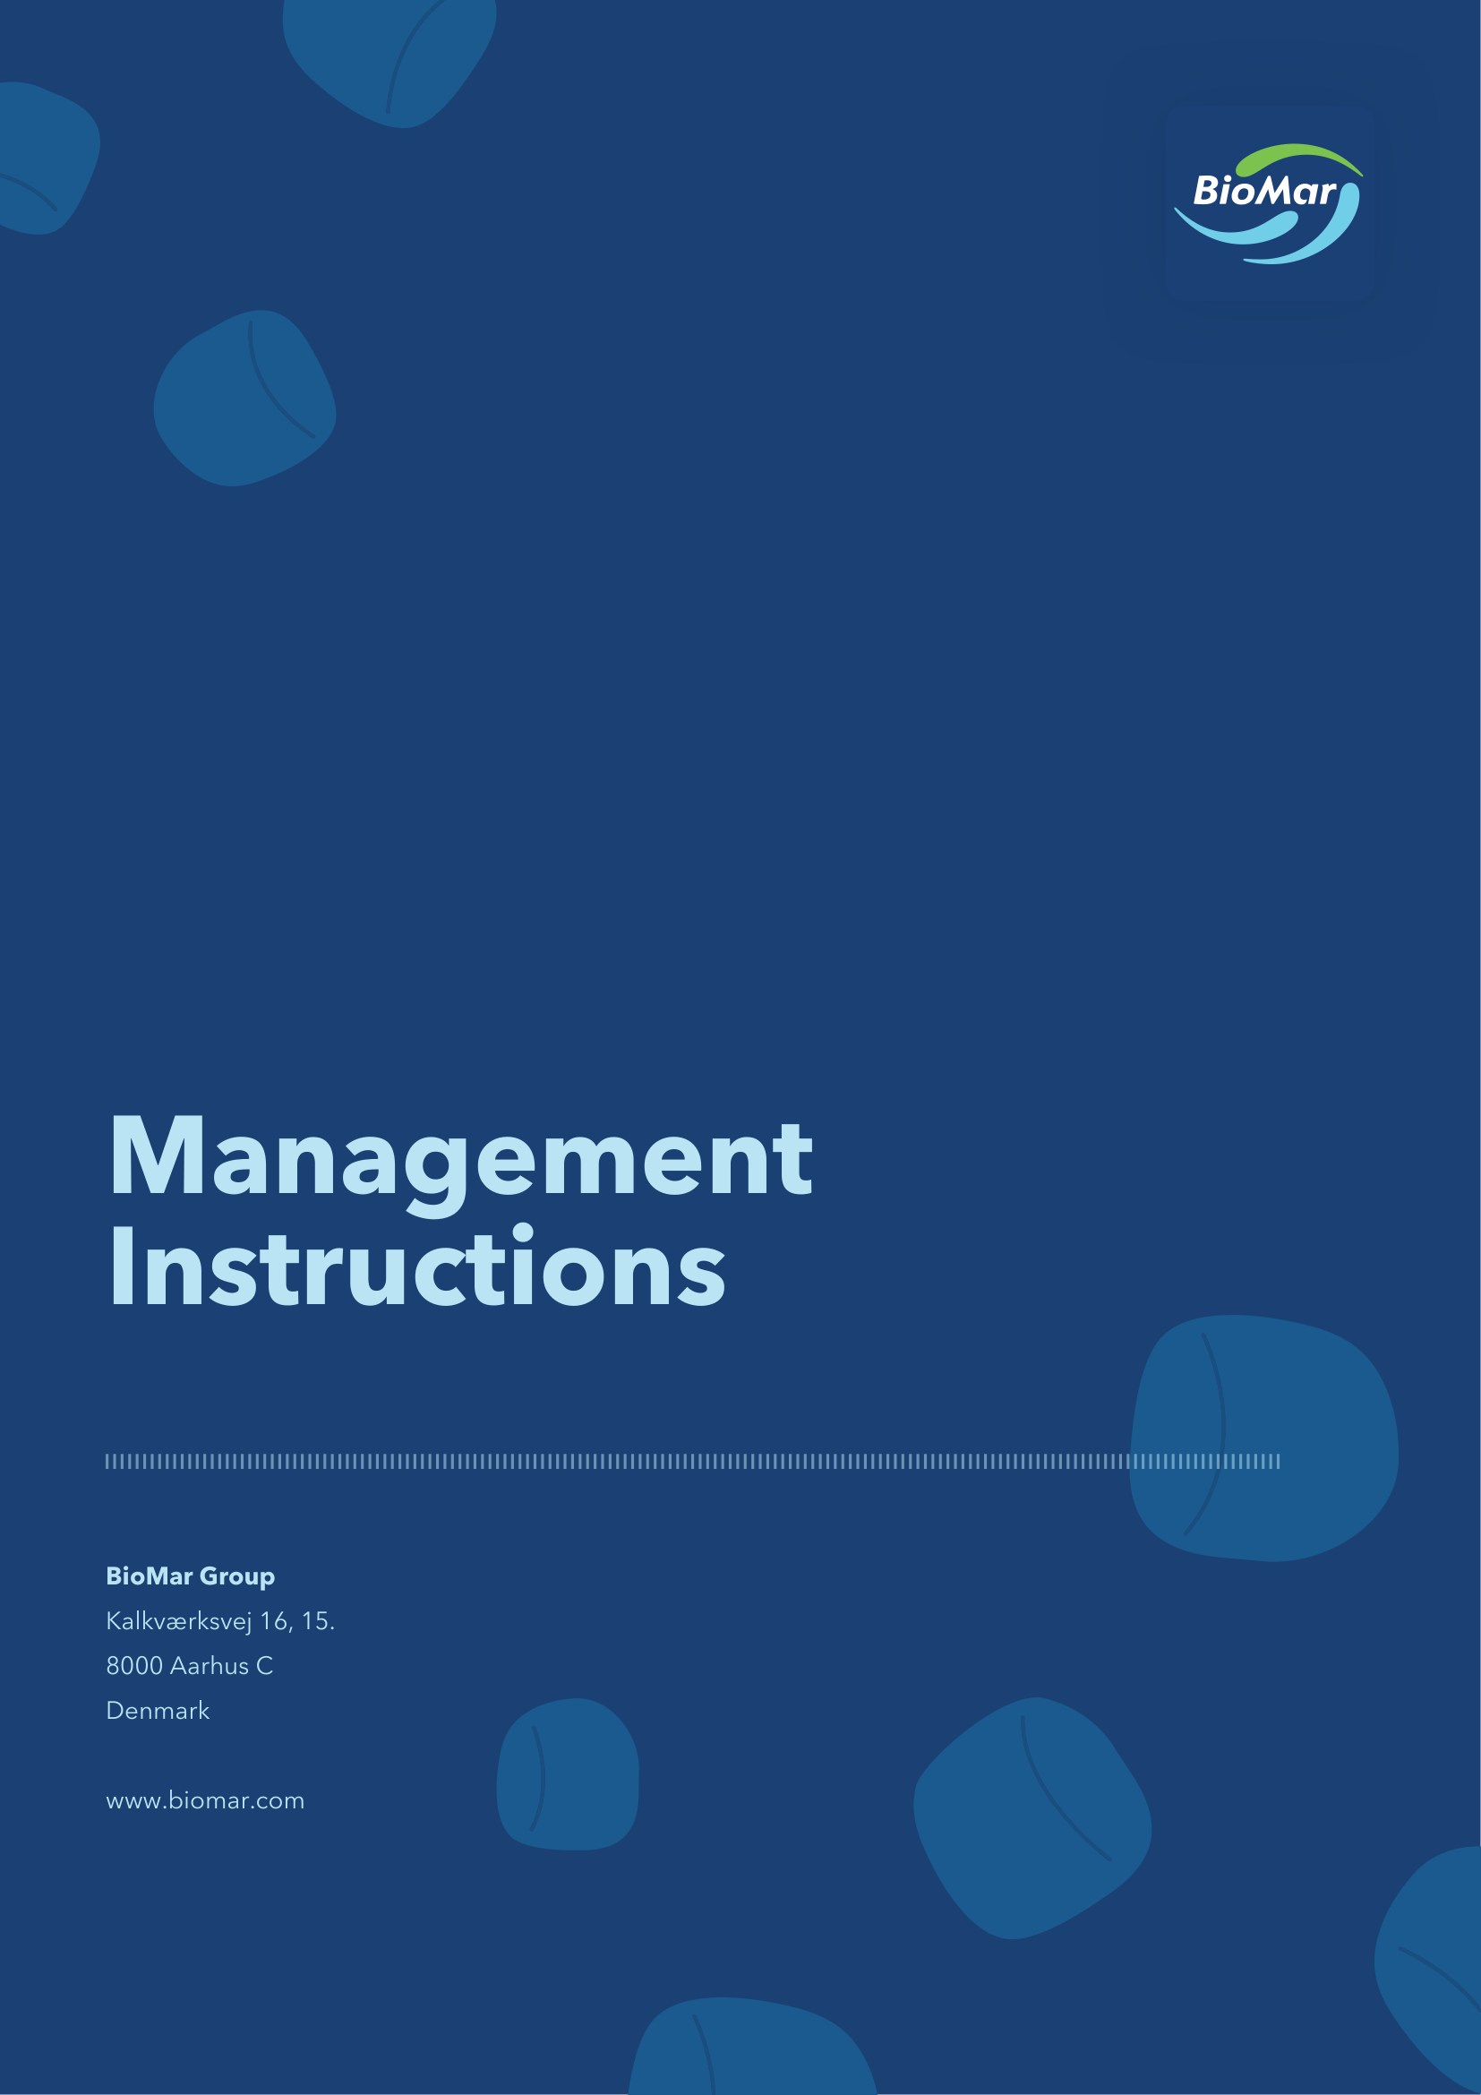

The Company
1.1 BioMar Group A/S, CVR no. 38 57 06 17 (the “Company”) directly or indirectly controls the companies within the BioMar Group (the “Group”) and its shares are admitted for trading and official listing on Nasdaq Copenhagen A/S (“Nasdaq Copenhagen”).
Purpose
2.1 These Executive Management instructions (the “Management Instructions”) have been adopted by the Board of Directors of the Company and establish the guidelines on the daily responsibilities and obligations of the Executive Management.
The Executive Management
3.1 The Board of Directors has appointed the Executive Management which currently consists of the CEO and CFO. The CEO and CFO are registered as members of the Executive Management with the Danish Business Authority.
3.2 The Chair of the Board of Directors is the primary point of contact for the Executive Management in terms of communication with the Board of Directors.
3.3 In case of long-term absence, an Executive Management member cannot delegate his/her authority to an employee without the prior approval of the Chair of the Board of Directors.
The day-to-day management
4.1 The Executive Management handles the day-to-day management of the Company and is consequently responsible for:
1. implementing and executing the Company’s strategy as determined by the Board of Directors;
2. the performance of the Company and to continuously initiate improvements within relevant business areas;
3. carrying out regular control with respect to the satisfactory performance of the employees, in accordance with the instructions provided; and
4. reporting to the Board of Directors on matters of material significance to the business and financial situation of the Company and the Group.
4.2 The day-to-day management does not include transactions which are unusual or of material significance to the Company and the Group.
4.3 Matters deemed unusual or of material significance considering the affairs and size of the Company will typically include, but is not limited to:
1. Adoption of new strategy or changes to existing strategy, including expansion into new business areas;
2. Material organisational or structural changes to the Group;
3. Material contracts, agreements or partnerships outside ordinary course of business;
4. Significant investments outside ordinary course of business and outside current budget and CAPEX;
5. Financing and granting of loans and guarantees;
6. Initiation or settlement of material litigation or disputes that may have significant impact on the Group, including financially or reputationally; and
7. Any matter that by nature would be deemed significant and require a board decision.
In case of doubt, the matters in question are to be discussed with the Chair of the Board of Directors who shall then decide whether the matter in question is to be submitted to the Audit Committee or the Remuneration and Nomination Committee, as applicable, or the Board of Directors for approval.
4.4 The Executive Management shall obtain the prior approval by the Board of Directors of a contemplated transaction outside the scope of the day-to-day management unless awaiting such approval will lead to considerable disadvantages for the Company. In such case, the Executive Management shall consult with the Chair of the Board of Directors and inform the Board of Directors of the performed transaction at its earliest convenience.
4.5 The Executive Management shall at all times be responsible for the Company’s general compliance with applicable laws and regulations, the Company’s Articles of Association, the Rules of Procedure of the Board of Directors and these Management Instructions. The Executive Management shall further ensure that the companies within the Group comply with applicable laws and regulations.
4.6 The Board of Directors may from time to time authorise the Executive Management or individual members of the Executive Management to carry out activities or decisions or to sign on behalf of the Company in respect of specific matters.
4.7 The Executive Management shall draft and - when required - revise business plans, instructions, procedures etc. defining the organisational structure of the Company and the division of responsibilities as well as effective procedures to identify, monitor, report and handle risks. The Executive Management must further ensure that sufficient resources, both in terms of skills and staff numbers, are present in the organisation and that appropriate use is made hereof.
4.8 Business plans, instructions and policies etc. must be presented to the Board of Directors for adoption prior to implementation.
4.9 The Executive Management must in due time prepare the announcements to the market and relevant authorities which the Company is obliged to issue under applicable law and stock exchange rules.
4.10 The Executive Management shall annually assess and present to the Board of Directors the Company’s compliance with the Danish Recommendations on Corporate Governance.
Business reporting
5.1 At ordinary meetings of the Board of Directors, the Executive Management shall account for the business of the Group since the last meeting by presentation of:
(a) Commercial performance update
(b) Financial performance update (including any material deviations from the budgets)
(c) Material dispositions
(d) Strategic projects
(e) Any specific risks as well as an update regarding the overall risk position of the Company and the Group
(f) Any other events or circumstances that the Board of Directors should be informed of (e.g. material compliance matters).
5.2 At each meeting, the Executive Management shall present the board protocol and the audit protocol for signing provided new entries have been made.
5.3 The Executive Management shall regularly meet with the Chair of the Board of Directors, as requested from time to time.
Financial reporting
6.1 The Executive Management shall ensure that the Company’s bookkeeping complies with accounting principles and applicable law and that the administration of assets is duly and adequately performed. In addition, the Executive Management shall continuously ensure the availability of sufficient financial resources, including the availability of sufficient liquid funds to honour present and future obligations, as they fall due. The Executive Management shall deliver a statement hereof to the Board of Directors upon request.
6.2 The Executive Management shall ensure that the auditor gives a statement on material circumstances in the minutes concerning the annual report. In addition to legal requirements, it must be stated whether the administrative financial practice, including business procedures and internal control measures, is organised and works appropriately in all material aspects, including, but not limited to, system, data and operational stability and security.
6.3 Before the end of February each year, the Executive Management shall, together with the auditor(s) present a draft annual report and auditor’s report for approval at an ordinary meeting of the Board of Directors. Furthermore, the Executive Management shall present a draft statement on the annual accounts for approval. The material shall be sent to the Board of Directors together with the draft audit protocol.
6.4 Following the adoption of the annual report by the Board of Directors, the Executive Management shall promptly ensure disclosure of the annual report. Following adoption of the annual report at the annual general meeting, the Executive Management shall ensure that a copy of the annual report endorsed by the chair of the annual general meeting is promptly submitted to the Danish Business Authority.
6.5 Before the deadline as determined by the Board of Directors each year, the Executive Management shall present draft interim reports for the first three, six and nine months of a financial year for the Group for approval by the Board of Directors prepared in accordance with applicable rules and ensure that the interim reports are approved and signed by the Board of Directors.
6.6 The Executive Management shall ensure that the signed versions of the interim reports are properly kept by the Company and ensure that a copy of the interim report is submitted to the Danish Business Authority following disclosure of the interim report.
6.7 The Executive Management shall present an annual statement to the Board of Directors on the Company’s financial resources, including a description of the taking of loans during the year, the size of the loans taken and the placing of liquid assets during the year.
6.8 The Executive Management shall ensure that the Company’s auditor elected by the general meeting is familiar with all information required for the auditor to execute his obligations as auditor.
Meetings of the Board of Directors
7.1 Upon agreement with the Chair, the Executive Management shall call for meetings of the Board of Directors with no less than seven calendar days’ notice, except for urgent circumstances.
7.2 The Executive Management shall assist the Chair of the Board of Directors with the preparation of an agenda for each board meeting and any required material relating to the items on the agenda. Such materials must be circulated to each member of the Board of Directors no later than seven calendar days prior of each meeting, unless otherwise specifically agreed.
7.3 Members of the Executive Management shall be entitled to participate in and to express their views at board meetings unless the Board of Directors in each case decides otherwise. At the request of the Board of Directors, the members of the Executive Management are obligated to participate in board meetings.
7.4 Furthermore, any member of the Executive Management and the Company’s auditor elected by the general meeting has the right to request that an extraordinary meeting of the Board of Directors, with a specific agenda, is conducted.
Confidentiality
8.1 In addition to the duty of confidentiality included in the individual service contracts of the Executive Management, a member of the Executive Management shall be subject to a duty of confidentiality similar to the duty of confidentiality applicable to members of the Board of Directors pursuant to the Rules of Procedure of the Board of Directors when such member of the Executive Management participates in or receives information about business transacted at meetings of the Board of Directors.
Conflict of interest
9.1 No member of the Executive Management can participate in the resolution of a matter relating to:
(a) Agreements between the Company (or a Group company or an affiliated company) and himself/herself;
(b) Legal proceedings between the Company (or a Group company or an affiliated company) and himself/herself; or
(c) Agreements between the Company and a third party or legal proceedings against a third party, if the member of the Executive Management has a significant interest in the matter, directly or indirectly, which may conflict with the interests of the Company.
9.2 In the case of a conflict of interest, the matter must be presented to the Board of Directors for resolution on behalf of the Company.
9.3 If a member of the Executive Management is uncertain whether there is a conflict of interests or a risk hereof, he/she must present the question to the Board of Directors.
9.4 If an actual or potential conflict of interest arises for a member of the Executive Management, such member shall promptly notify the Chair thereof. In the event of any reasonable doubt as to whether there is in fact a conflict of interests, the Chair may decide to defer the decision to the Board of Directors.
9.5 Members of the Executive Management shall not conduct or be engaged in speculative transactions concerning shares and/or other securities issued by or relating to the Company.
9.6 The Company is not entitled to grant loans to or provide security for a member of the Executive Management or their related parties.
Reporting obligations
10.1 Each member of the Executive Management shall upon appointment inform the corporate secretary (the “Corporate Secretary”) as appointed by the Board of Directors of the size of such member’s direct and indirect holding(s) of shares in the Company, share-related securities, and other types of securities (if any) related to the Company. Any subsequent transactions in respect of the Company’s shares and share-related securities related to the Company shall be reported in accordance with the Company’s Internal Rules.
10.2 Each member of the Executive Management shall arrange that the member’s holding(s) of shares in the Company, share-related securities, and other types of securities (if any) related to the Company is registered in the relevant securities register in such manner that the legal name of the holder and the name of the relevant member appears (to the extent possible).
Communication
11.1 The Chair and the CEO shall represent the Company externally.
11.2 If comments by the Board of Directors are required or appropriate, the Chair represents the Board of Directors externally to investors, press and other third parties. The Chair may delegate such authority to the CEO, the CFO or the Vice Chair in regard to specific matters.
11.3 In all other matters, the CEO shall represent the Company in its external communication. The CEO may delegate such authority to other members of the Executive Management and, in specific matters, to heads of functions/departments, who by virtue of their positions are or will be involved in external communication.
Rules of Procedure of the Board of Directors
12.1 The Executive Management has received a copy of the Rules of Procedure of the Board of Directors and undertakes to comply with the obligations of the Executive Management as described herein.
12.2 In case of any discrepancies between the Rules of Procedure of the Board of Directors and these Management Instructions, the Rules of Procedure shall prevail.
Amendment of the Management Instructions
13.1 On an annual basis, the Board of Directors shall review and, if relevant, revise these Management Instructions.
13.2 Amendment of the Management Instructions requires the simple majority of votes of the Board of Directors.
Approved by the Board of Directors on 19 May 2026.

