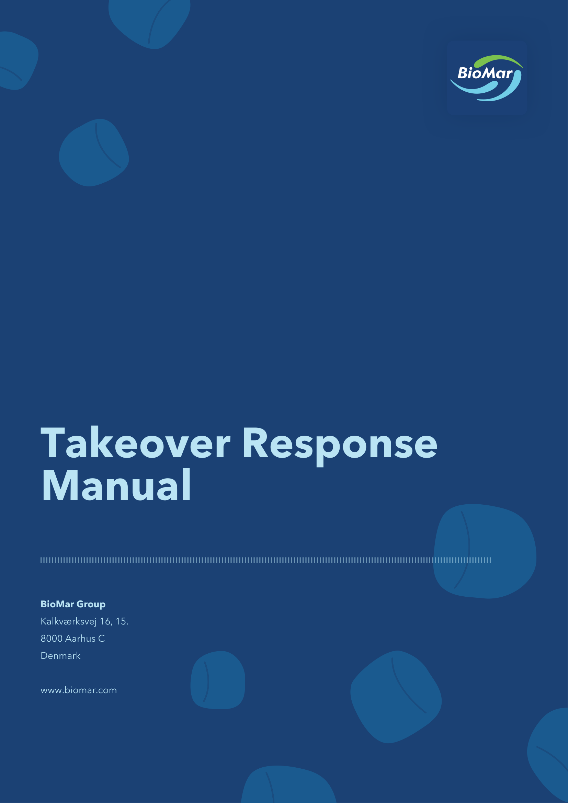

1 Introduction
1.1 Purpose
1.1.1 The purpose of this Takeover Response Manual (the “Manual”) is to define the key procedures to be initiated by BioMar Group A/S, CVR no. 38 57 06 17 (the “Company”) in the event of a Takeover Scenario (as defined below).
1.1.2 The procedures set out in this Manual aim to ensure that the Company, the Board of Directors and the Executive Management are able to respond to and handle a Takeover Scenario in conformity with market practice and legislative requirements in relation to all relevant stakeholders.
1.1.3 The Company has adopted the contingency procedures in this Manual in the event of a Takeover Scenario in order to comply with the Danish Recommendations on Corporate Governance (in Danish “Anbefalinger for god selskabsledelse”) according to which the Board of Directors may not, from the moment it has substantiated reason to believe that a takeover offer will be submitted, without the acceptance of the general meeting, attempt to counter the takeover offer by making decisions which in reality will prevent the shareholders from deciding on the takeover offer.
1.2 Scope
1.2.1 This Manual is prepared for situations where
(a) the Board of Directors, or the Executive Management, or any member of these bodies, is approached by a third party seeking to change the ownership structure of the Company which may potentially result in a Change of Control (as defined below); or
(b) A public takeover offer for the shares in the Company is made without any preceding contact.
(each of the situations described in (a) and (b) above is referred to as a “Takeover Scenario”).
For the purposes of this Manual, “Change of Control” means a direct or indirect transfer of a shareholding in the Company to an acquirer (acting alone or in concert with others) whereby the acquirer obtains control of
(a) at least one third (33.33%) of the voting rights of the Company; or
(b) less than one third (33.33%) of the voting rights of the Company, provided that the acquirer has (a) the right to exercise at least one third (33.33%) of the voting rights by virtue of an agreement with other investors, (b) authority to manage the financial and operational conditions of the Company pursuant to the Company’s Articles of Association or an agreement, or (c) authority to appoint or dismiss a majority of the members of the Board of Directors, and the Board of Directors has controlling influence of the Company.
1.3 Stakeholders
1.3.1 In the context of a Takeover Scenario, the stakeholders are (a) shareholders, (b) employees, (c) customers and business partners, (d) media, (e) financial analysts, (f) Nasdaq Copenhagen A/S (“Nasdaq Copenhagen”) and (g) the Danish Financial Supervisory Authority (in Danish “Finanstilsynet”).
1.4 Introduction to the legal framework
1.4.1 A brief introduction to the legal framework applicable to a Takeover Scenario is set out in Appendix A.
2 Overview of responsibilities in connection with a Takeover Scenario
2.1 Board of Directors
2.1.1 The Board of Directors is overall responsible for the Company’s conduct in a Takeover Scenario.
2.1.2 The Chair of the Board of Directors shall, on behalf of the Board of Directors, investigate and evaluate any approach or takeover offer received. The Chair shall, on behalf of the Board of Directors, be in charge of negotiations with potential offerors.
2.2 Executive Management
2.2.1 The Executive Management is responsible for the continued operation of the Company and for execution of specific tasks assigned to it by the Board of Directors in relation to a Takeover Scenario.
2.2.2 Members of the Executive Management shall not establish or seek to establish contact or engage in communication with any potential offeror in relation to a Takeover Scenario, except with the prior approval of the Board of Directors (or the Chair if such competence has been delegated to them). Any communication to any member of the Executive Management in relation to a Takeover Scenario shall be referred to the Chair.
2.3 General meeting
2.3.1 Generally, the general meeting is not involved in the Company’s response to a Takeover Scenario. However, the general meeting is to be involved in a Takeover Scenario in cases where the structure of such Takeover Scenario requires one or more resolutions to be passed by the general meeting pursuant to applicable company law (e.g. in case of a capital increase).
2.3.2 From the moment the Board of Directors has substantiated reason to believe that a takeover offer may be submitted, it shall not, without the approval of the general meeting, attempt to counter the takeover offer by taking actions which in reality seek to prevent the shareholders from deciding on the takeover offer.
3 Notification of a Takeover Scenario - formation of a Takeover Response Team
3.1 If a Takeover Scenario occurs and the approach is made to the Chair, or if the Chair has substantiated reason to believe that a Takeover Scenario is likely to occur, the Chair shall inform the Vice Chair as soon as practically possible. Similarly, if such approach is made to the Vice Chair, or if the Vice Chair has substantiated reason to believe that a Takeover Scenario is likely to occur, the Vice Chair shall inform the Chair as soon as practically possible.
3.2 If a Takeover Scenario occurs or if any member of the Board of Directors or the Executive Management has substantiated reason to believe that a Takeover Scenario is likely to occur, the Chair must be informed promptly.
3.3 Following the occurrence of a Takeover Scenario, the Chair shall consider whether it is appropriate to form a takeover response team (the “Takeover Response Team”) and decide who shall be included on such a team (e.g. legal advisers, financial advisers, other members of the Board of Directors etc.). The Takeover Response Team shall render advice to the Chair and the Board of Directors. The Takeover Response Team shall meet as often as required in the given circumstances.
3.4 The Chair shall inform the Board of Directors and, if relevant, the CEO at such time and provide such information as the Chair considers appropriate. The Chair shall keep the Board of Directors and, if relevant, the CEO duly updated on material events occurring during and in connection with the Takeover Scenario.
4 Initial considerations
4.1 With assistance from the Takeover Response Team, the Chair and the Vice Chair shall initially consider or act in respect of the following as well as other relevant matters:
(a) Decide whether disclosure of a company announcement is required or otherwise necessary or appropriate.
(b) Prepare an information leakage plan, including draft company announcements and automatic press alerts.
(c) Establish necessary measures to avoid insider trading and dissemination of inside information, including by setting up a special ad-hoc insider register.
(d) Decide whether to prohibit trading in treasury shares.
(e) Assess any potential conflicts of interest.
(f) Suspend or terminate any on-going discussions with the Executive Management on compensation and/or service terms.
(g) Engage financial advisers and other advisers (if deemed relevant).
(h) Identify the facts and analyse the details of the approach, proposal or takeover offer, as applicable (if deemed relevant).
5 Actions directed at shareholders and potential offerors
5.1 The Board of Directors shall decide whether it is appropriate, considering potential conflicts of interest, to approach certain major shareholders of the Company, always subject to strict confidentiality, with a view to obtaining knowledge about such shareholders’ position on the Takeover Scenario in question, including their respective strategic positions.
5.2 Unless otherwise decided by the Board of Directors, the Chair shall be in charge of any continued dialogue with major shareholders established pursuant to Section 5.1 above. Such dialogue with major shareholders shall be carried out with a view to obtaining knowledge about their respective strategic positions and the Chair and the Board of Directors shall take such information into due consideration in connection with any decisions regarding the Takeover Scenario in question.
6 Further considerations
6.1 The Board of Directors, or the Chair if so authorised, shall decide whether to initiate (or continue) discussions with the potential offeror. In the affirmative, the Board of Directors shall continue its considerations and the Board of Directors, or the Chair, if so authorised, shall with assistance from the Takeover Response Team, continue discussions with the potential offeror in order to enable the Board of Directors to ultimately decide on such other matters which are considered relevant and appropriate in the Takeover Scenario in question, including the following:
(a) How to secure, to the widest extent possible, continued focus on the normal management and operations of the Company during the possible takeover process.
(b) Evaluate the offeror’s strategic position.
(c) Whether to allow a potential offeror access to confidential information in order for such offeror to perform due diligence investigations in respect of the Company.
(d) Requirements to be met by a potential offeror in order for the Board of Directors to be able to cooperate (non-disclosure obligations, stand-still obligations, etc.).
(e) Whether to grant exclusivity to an offeror and if so, determine the terms and conditions of such exclusivity.
(f) Whether to actively pursue other competing offers.
(g) Possibilities of negotiating a higher offer price or an improvement of other terms of the takeover offer with the offeror in question.
(h) Whether it is necessary or advisable to obtain a fairness opinion from an independent financial adviser.
(i) Potential reactions from relevant stakeholders, including shareholders, employees, media and financial analysts.
(j) Issues in relation to relevant stakeholders other than the shareholders.
(k) Whether the Company should be willing to accept proposals from potential offerors in respect of deal certainty/protection (e.g. cost coverage, break fee, no-shop, stand-still obligations, etc.).
(l) Evaluate whether existing structures and arrangements of the Company’s business (change of control issues, contracts, negative pledges, etc.) may be regarded as defensive mechanisms and consider relevant reactions as a result hereof, if any.
(m) Whether the Company should accept to assist the offeror in obtaining irrevocable commitments from certain shareholders.
(n) If a takeover offer is presented and announced, preparation and issue of a statement from the Board of Directors setting out a reasoned opinion on the takeover offer, including its views on the consequences of the takeover offer (if effected) on the Company’s interests, and on the offeror’s strategic plans for the Company and such plan’s likely consequences on employment and the locations of the Company’s places of business. In case of competing takeover offers, the Board of Directors may prepare a consolidated statement.
(o) The need for a “wash-clean” announcement (i.e. an announcement disclosing existing inside information within the Company) preferably before launch of the public offer in any case prior to the acceptance of the offer by the shareholders.
7 Communication
7.1 In connection with a Takeover Scenario, the Chair shall decide on the appropriate external and internal communication strategy and act as sole spokesman in relation thereto. Unless specifically approved by the Chair, no other person shall be entitled to make any statement, neither externally nor internally, in relation to the Takeover Scenario and shall refer any third party communication to the Chair.
7.2 If the Company has been informed that a third party intends to make a public offer to the shareholders of the Company, and such public offer has not been disclosed, the Company shall notify Nasdaq Copenhagen when it is reasonable to assume that the intention to make a public offer will be effected.
Approved by the Board of Directors on 19 May 2026.
Appendix A – Introduction to the legal framework
1 Introduction
1.1 The legal framework relevant in the event of a Takeover Scenario includes the Danish Capital Markets Act (in Danish “kapitalmarkedsloven”), the Market Abuse Regulation (in Danish “markedsmisbrugsforordningen”) the Danish Companies Act (in Danish “selskabsloven”), the Danish Executive Order on Takeover Offers (in Danish “bekendtgørelse om overtagelsestilbud”) and the Guidelines on the Danish Executive Order on Takeover Offers.
2 Responsibility of the shareholders and the general meeting in connection with a Takeover Scenario
2.1 The shareholders and the general meeting, respectively, do not have any responsibilities in respect of a Takeover Scenario. The shareholders’ rights in a Takeover Scenario are protected by the general provisions of applicable company law as well as the specific statutory provisions concerning mandatory and voluntary offers for shares in listed companies. However, the shareholders have the exclusive right to decide whether to accept or reject an offer for the shares in the Company or whether to accept a competing offer, if relevant.
3 Responsibility of the Board of Directors and Executive Management in connection with a Takeover Scenario
Division of responsibilities | The Board of Directors is responsible for the overall strategy, organisation and control systems of the Company and for reacting on the Company’s behalf in a Takeover Scenario.  The Executive Management is responsible for the day-to-day management of the Company and for the execution of tasks assigned to it by the Board of Directors in relation to the Takeover Scenario.
General liability standard | Negligence, i.e. failure to demonstrate due and proper care in connection with acts or omissions.
Specific liability regarding trading in securities | The Board of Directors and the Executive Management are responsible for securing equal and timely dissemination of inside information (subject to disclosure requirements) and for limiting the risk of insider trading.
Specific liability in Takeover Scenarios | Except as described in item iv. below and in Section 19 of the Danish Executive Order on Takeover Offers, respectively as described below, there are no specific statutory requirements. There are, however, the following implications in relation to the general liability standard:  The Board of Directors and the Executive Management have a fundamental obligation to take due care of the interests of the Company and its shareholders.  The Board of Directors and the Executive Management have an obligation not to act in a way which is clearly capable of providing certain shareholders or third parties with an undue advantage to the detriment of the other shareholders or the Company.  To conduct “business as usual” is always permissible.  The Board of Directors and the Executive Management may be held liable if measures of a defensive character are not justified by a reasonable business judgement or cannot be characterised as business as usual.  Special attention should also be given to  possible conflicting interests between the Company (as an organisation) and the shareholders; and  possible conflicting interests between different groups of shareholders.
The Danish Executive Order on Takeover Offers Section 19 | From the date on which the offeror or persons acting in concert with the offeror initiate negotiations in regard to an offer and until the negotiations have ended, or a takeover offer is implemented, the Board of Directors and the offeror and persons acting in concert with the offeror may not enter into any agreements or change existing agreements on bonuses and similar benefits for the Executive Management.
The Danish Recommendations on Corporate Governance | The Committee on Corporate Governance recommends that the Company has a procedure in place in the event of takeover offers, containing a “road map” covering matters for the Board of Directors to consider in the event of a takeover offer, or if the Board of Directors obtains reasonable grounds to suspect that a takeover offer may be submitted. In addition, it is recommended that it appears from the procedure that the Board of Directors abstains from countering any takeover offers by taking actions that seek to prevent the shareholders from deciding on the takeover offer, without the approval of the general meeting.
4 Public offers in Denmark
4.1 Key procedures in case of mandatory and voluntary offers can generally be outlined as follows:
Offer document | The offeror must draw up an offer document containing adequate information in order for the shareholders of the Company to be able to form a well-founded opinion on the offer.  The offer must as a general rule, provide equal treatment to shareholders of the same share class. The offer document shall at least address a number of identified issues, such as (but not limited to):  The identity of the offeror(s),  The offeror(s)’ current holding of shares in the Company or control over voting rights,  The price offered (cash or shares),  Financing,  Future plans for the Company, including possible restructurings and employment perspectives, and  Details of related party arrangements regarding use of the voting rights of the Company.  The acceptance period in the offer must be at least four weeks and may not exceed ten weeks. The offer period may, however, be extended beyond ten weeks, provided that the terms of the offer are changed or if competing offers are submitted.  An offeror’s decision to submit an offer shall be published immediately. The offer document shall then be approved and published by the offeror as soon as possible, but within four weeks at the latest.
Duties of the Company | The offeror’s announcement of the decision to submit an offer will usually, upon the request of the offeror, be distributed by the Company as a company announcement.  The offer advertisement, the Board of Directors’ statement, see below, and other relevant documentation (if so requested by the offeror) must be sent to all registered shareholders by the Company at the expense of the offeror. The offeror has a statutory right to request distribution of other relevant documentation three times. Following such three distributions, the Company may reject to distribute any further material.
The Danish Financial Supervisory Authority and Nasdaq Copenhagen | The Danish Financial Supervisory Authority acts as the competent authority with respect to compliance with the rules and regulations on takeover offers.  Nasdaq Copenhagen shall be notified, if the Company has been informed that a third party intends to make a public offer to the shareholders of the Company, and such public offer has not been disclosed yet, provided that the Company has reasonable grounds to assume that the intention to make a public offer will be effected. The offeror in question has a similar duty to notify Nasdaq Copenhagen prior to announcing the intention to submit an offer.
Statement by the Board of Directors | The Board of Directors of the Company is required to issue and publish a statement setting out its opinion of the takeover offer and the reasons on which it is based, including its views on the effects of implementation of the takeover offer on all the Company’s interests and specifically employment, and on the offeror’s strategic plans for the Company and the likely repercussions on employment and the locations of the Company’s places of business as set out in the offer documents. The Board of Directors is allowed to emphasise all relevant pro’s and con’s such as ethical matters and matters relating to employment, etc.  It is not a requirement that the Board of Directors provides a recommendation to the shareholders in respect of accepting or rejecting the offer. The Board of Directors should consider appointing an independent financial advisor to issue a fairness opinion, which could then be reflected in the Board of Directors’ opinion.  The Board of Directors’ statement must be issued and published before the expiry of the first half of the acceptance period. Accordingly, the statement may be required to be published as early as two weeks after the launch of the offer. If a competing offer is launched, the Board of Directors may issue a combined statement addressing both takeover offers. If more than one takeover offer is issued, the statement must be issued and published before expiry of the first half of the acceptance period applicable to the most recent published takeover offer. At the same time as publication of the statement, the Board of Directors shall communicate its opinion to the representatives of its employees through the co-operation committee or the trade union representatives, if no co-operation committee has been established. If the Board of Directors receives a separate statement from the representatives of its employees on the effects of the takeover offer on employment, that statement shall be made public immediately.  Immediately after publication, the Company shall publish the Board of Directors’ statement on its website and send the statement to all registered shareholders at the expense of the offeror.
Appendix B – List of relevant contact persons and relevant advisers in a Takeover Scenario
BioMar Group A/S | BioMar Group A/S
Name | Contact details
Jens Bjerg Sørensen  Chair of the Board of Directors | Email: jbs@schouw.dk
Carlos Armando Diaz Verdugo  CEO | Email: cdiaz@biomar.com
Claus Eskildsen  CFO | Email: ces@biomar.com
Legal advisor | Legal advisor
Name | Contact details
Rikke Schiøtt Petersen  Partner, Gorrissen Federspiel Advokatpartnerselskab | Tel: +45 33 41 42 71  Mob: +45 24 25 28 24  Email: rsp@gorrissenfederspiel.com
Michael Meyer  Partner, Gorrissen Federspiel Advokatpartnerselskab | Tel: +45 86 20 74 11  Mob: +45 40 19 91 57  Email: mm@gorrissenfederspiel.com

