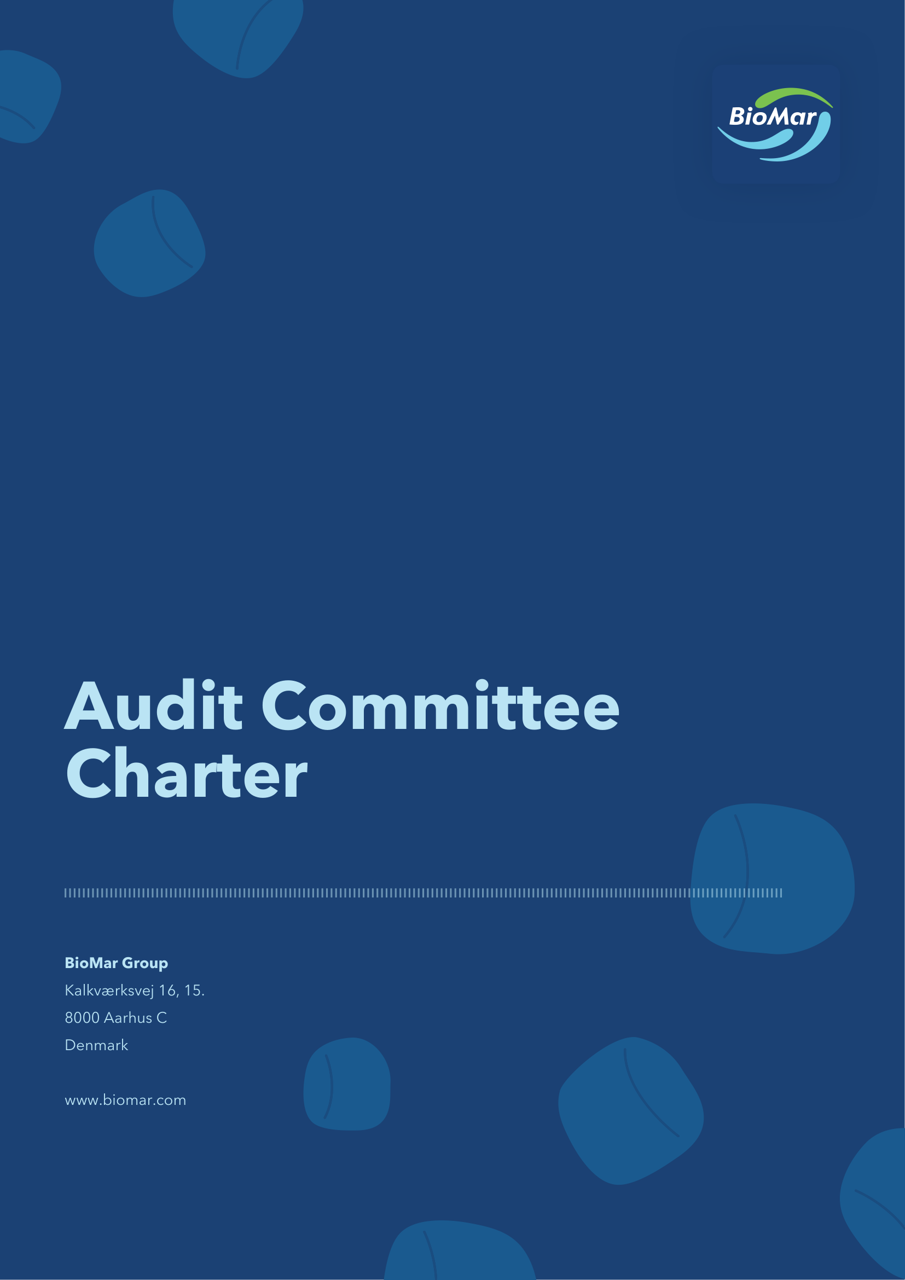

1 Establishment and purpose
1.1 The Board of Directors of BioMar Group A/S, CVR no. 38 57 06 17 (the “Company”), has established an audit committee (the “Audit Committee”) in accordance with applicable laws and regulations, the Danish Recommendations on Corporate Governance and the Rules of Procedure of the Board of Directors.
1.2 The Audit Committee shall review financial and sustainability accounting and audit matters that require, by decision of the Board of Directors or the Audit Committee, a more thorough evaluation, and shall assess the internal controls and risk management systems of the Group.
2 Members
2.1 The Audit Committee shall consist of no less than two members. The members shall be appointed by and among the members of the Board of Directors.
2.2 A member of the Audit Committee shall be designated by the Board of Directors as Chair of the Audit Committee. The Chair of the Board of Directors cannot be the Chair of the Audit Committee.
2.3 Chair of the Audit Committee shall be independent and a majority of the members of the Audit Committee shall be independent unless the Board of Directors deems a composition with less than a majority of independent members to be appropriate under the given circumstances.
2.4 At least one member shall have recent and relevant accounting and/or audit qualifications and as a whole, the members of the Audit Committee shall have competences relevant to the sector in which the Company and the Group is operating as well as competencies within financial and sustainability reporting.
2.5 The members of the Audit Committee shall be appointed for a one-year term. The Board of Directors can at any time and without notice decide to change the composition of the Audit Committee.
2.6 If a member of the Audit Committee resigns or is removed from the Board of Directors during a term, such member shall also be removed from the Audit Committee and the Board of Directors shall appoint a new member at the next board meeting.
3 Assignments
3.1 Supervision of the Company’s financial and sustainability reporting and reporting process.
3.1.1 The overall assignments of the Audit Committee in respect of the supervision of the Company’s financial and sustainability reporting and reporting process are to:
a. Oversee the periodic financial and sustainability reporting process implemented by the Executive Management;
b. Review the external financial and sustainability reporting, including the interim and annual reports prior to submission to the Board of Directors for approval;
c. Inform the Board of Directors of the outcome of the statutory audit in relation to both financial and sustainability reporting, including the financial and sustainability reporting process;
d. Evaluate the Company’s compliance with relevant audit and financial and sustainability accounting related policies, laws and regulations and the “going-concern” principle, including any special assumptions, qualifications and/or uncertainties related thereto;
e. Review the main accounting policies and principles applied including making recommendations to the Board of Directors regarding whether these should be amended;
f. Review significant accounting estimates and judgments and changes made hereto;
g. Evaluate relevant financial, sustainability and business risks and uncertainties for the relevant year in relation to the external financial and sustainability reporting;
h. Review financial outlook in external financial reporting and the process ensuring that any required updates are made in a timely manner;
i. Oversee the preparation process of sustainability reporting, including double materiality assessments and XBRL-tagging process;
j. Evaluate the overall presentation of the financial reporting in order to ensure that it provides a true and fair view of the financial position as well as the development and performance of the Company;
k. Oversee and evaluate the overall integrity of the sustainability reporting in order to ensure that it provides a true and fair view of the Company’s position and development and the presentation hereof in the annual report as well as the internal control systems for sustainability data; and
l. Review and evaluate unusual transactions and all transactions with related parties as required by applicable law. Furthermore, the Audit Committee shall submit related party transactions to the Board of Directors for approval prior to the Company or a subsidiary entering into the transaction, if such transaction is deemed material and out of the ordinary course of business, including, but not limited to, a transaction which is subject to mandatory public disclosure.
3.2 Supervision of the Group’s external auditors for financial and sustainability reporting
3.2.1 The overall assignments of the Audit Committee in respect of the supervision of the Group’s external audit, including the independence of the external audit and provision on non-audit services, are to:
a. Be in charge of the procedure for the recommendation and appointment of the Company’s statutory external auditors for financial and sustainability reporting;
b. Provide the Board of Directors with a recommendation regarding appointment of proposed external auditors from time to time, which shall be approved by the general meeting. If an external audit engagement is not renewed, the Audit Committee shall recommend at least two choices for the audit engagement and express a duly justified preference for one of them. The recommendation shall state, that the recommendation has not been influenced by third parties nor has it been subject to any contractual obligation restricting the general meeting’s choice of the external auditor;
c. Investigate the circumstances of any resignation of external auditors and advice the Board of Directors on steps to be taken in that regard;
d. Monitor compliance with the rules governing the duration of the audit engagement under applicable legislation and oversee statutory external auditor rotation, including that appropriate policies are in place to ensure compliance with applicable rotation period requirements, including for audit firms and individual auditors, and carry out tender processes in accordance with applicable legislation;
e. Provide the Board of Directors with advice regarding the proposed external auditors from time to time, including on the terms of engagement and fee structure;
f. Review the fees to the external auditors and evaluate the quality of work being performed by the external auditors;
g. Review the strategy, plan, scope, materiality thresholds and approach of the external auditors’ annual audit;
h. Review the external auditors’ reports to the Board of Directors, including long-form reports and discuss any reports with the Executive Management and the external auditors;
i. Review and inform the Board of Directors about any material issues, whether related to the financial or the sustainability reporting, which the audits may give rise to including gathering answers/explanations to any significant uncorrected and/or corrected adjustments in the accounts;
j. Consider and resolve any disagreement between the Executive Management and the external auditors regarding financial and sustainability reporting, accounting policies and estimates;
k. Evaluate the overall cooperation with the external auditors;
l. Oversee that appropriate policies with regard to hiring employees from the external auditors are in place;
m. Review and monitor the independence and quality work being performed by the external auditors, especially the appropriateness of the provision of non-audit services to the Group;
n. Discuss any threats and applicable safeguards to the independence of the external auditors with the appointed external auditors and oversee that appropriate procedures exist to ensure compliance of the external auditors’ independence on an annual basis;
o. Oversee that appropriate policies to ensure compliance with applicable requirements for non-audit services are in place;
p. Supervise the scope of, review and approve the external auditor’s provision of non-audit services, including the fees of the external auditor for such services, and oversee that applicable limits for non-audit services are complied with; and
q. Pre-approve all non-audit services to be provided by any external auditors exceeding a cap determined by the Board of Directors in accordance with the Company’s policy for non-audit services.
3.3 Supervision of the Group’s internal control and risk procedures
3.3.1 The overall assignments of the Audit Committee in respect of the supervision of the Group’s internal control and risk areas are to:
a. At least annually review and evaluate the effectiveness of the Company’s internal controls, risk management framework and policies in relation to financial and sustainability reporting;
b. At least annually, discuss the internal control procedures with the CFO and the external auditor in relation to both financial and sustainability reporting as well as present the Board of Directors with potential areas of improvement;
c. Monitor insurance coverage and quality;
d. Annually assess the need for an internal audit function, and in case it is concluded that such is needed, make recommendations on selecting and appointing a head of internal audit and ensuring a budget for an internal audit function;
e. Ensure that if an internal audit function has been established, a description of its functions is set out in a charter and approved by the Board of Directors, and adequate resources and competences are allocated to carry out the work;
f. Monitor the Executive Management’s follow-up on the conclusions and recommendations of the internal audit function, if established;
g. Supervise the Company’s capital structure and dividend distributions to the shareholders from a long-term value creation perspective;
h. Review recommendations to the Board of Directors regarding the Group’s finance (including accounting, controlling, treasury, tax, budgeting and risk functions) and IT organisation as well as the organisational set-up in relation to sustainability;
i. Evaluate the Group’s approach related to IT security and cyber security matters, including in relation to significant IT security and cyber security risks;
j. Review and recommend approval of risk reports, internal risk management plans and guidelines for internal and external risk reporting submitted to the Board of Directors;
k. At least annually review the Company’s guidelines and policies with respect of risk assessment and risk management, including major financial risk exposure. The review shall include the Company’s internal risk reports and systems for prevention of fraud and detection of violations of the Company’s policies;
l. Review and evaluate credit risk limits and recommend approval by the Board of Directors of credit risks above a certain pre-defined limit;
m. Ensure that the Executive Management has adequate resources in place to identify and assess specific risks related to the Group; and
n. Oversee the Group’s whistleblower system and receive information on received whistleblower reports on an ongoing basis.
3.4 Other assignments of the Audit Committee
3.4.1 In addition to the assignments described in section 3.1-3.3, the Audit Committee’s assignments are to:
a. Review the Company’s Data Ethics Policy, Tax Policy, Treasury Policy and Dividend and Share Buyback Policy;
b. Oversee tax structures and tax risk management framework; and
c. Oversee effects of expected changes to legislation.
3.5 The Audit Committee must prepare an annual wheel which provides an overview of the scheduled meetings of the Audit Committee, including an indication of which tasks to be dealt with at each meeting, shall be prepared by the Committee.
4 Meetings
4.1 Meetings shall be held when deemed necessary by the Chair of the Audit Committee, subject to a minimum of four meetings a year. Further, the Audit Committee shall meet upon request of a member of the Audit Committee, the CEO, the CFO or an external auditor.
4.2 As a minimum the meetings shall be held prior to the publication of the Company’s quarterly reports for Q1 and Q3, interim reports for the first six months of each financial year and annual report.
4.3 Unless otherwise agreed, the Chair of the Audit Committee shall convene the meetings with not less than seven calendar days’ notice and determine the agenda. The agenda for each meeting, accompanied by relevant materials shall be sent to the members in advance of each meeting.
4.4 Minutes of the meetings of the Audit Committee shall be prepared for each meeting. When the minutes have been approved, copies of the minutes shall be forwarded to the members of the Board of Directors for review at the following board meeting in the Company and, if relevant, to the Company’s external auditors.
4.5 The work of the Audit Committee is subject to the same confidentiality as the work of the Board of Directors.
4.6 The CFO shall attend the meetings of the Audit Committee, unless otherwise requested by the Audit Committee. Members of the Board of Directors, the CEO, relevant employees of the Company or the Company’s controlling shareholder and external parties (e.g. advisers) may participate in the meetings of the Audit Committee upon invitation. Such participants will not be entitled to vote on resolutions to be passed by the Audit Committee.
4.7 The Executive Management, the head of the Company’s accounting function and the Company’s external auditors shall attend the meetings of the Audit Committee if requested.
4.8 The Company’s external auditors shall attend at least one meeting of the Audit Committee per year at which meeting (or relevant part thereof) the Executive Management shall not be present.
5 Resolutions at the Audit Committee
5.1 The Audit Committee forms a quorum when at least two members are present.
5.2 Resolutions are passed by simple majority. In the event of equal votes, the Chair of the Audit Committee shall have a casting vote.
5.3 Resolutions may be passed over the phone, by electronic means (e.g. telephone or video conference) or in writing. In such case, the proposed resolution shall be forwarded to the members, and the Chair of the Audit Committee shall seek to obtain written consent from all members.
5.4 The Audit Committee must on a regular basis keep the Board of Directors informed of matters which the Audit Committee deems relevant for the Board of Directors.
6 Authorisation
6.1 The Audit Committee shall report and make recommendations to the Board of Directors.
6.2 The Audit Committee’s function is only preparatory. Therefore, the Board of Directors carries full responsibility for all resolutions that have been made based on reports and recommendations prepared by the Audit Committee.
6.3 The Audit Committee is authorised to examine all matters within the scope of its charter and has unlimited access to obtain (i) the necessary information and assistance from employees and officers of the Company, who are obliged to cooperate with the Audit Committee and provide any information and answer all questions from the Audit Committee, and (ii) independent advice and assistance from external advisers when deemed necessary for performing the duties of the Audit Committee. The fees of advisers shall be paid by the Company.
7 Review of Charter
7.1 The Audit Committee shall review this Audit Committee Charter once every year. Amendments shall be approved by the Board of Directors.
7.2 Amendments to this Audit Committee Charter may be adopted at any time by the requisite majority pursuant to the Rules of Procedure of the Board of Directors.
Approved by the Board of Directors on 19 May 2026.

