Radio Tag-Only CJS Models

Kevin See1,✉, Mike Ackerman1, and Nick Porter1

June 09, 2020

1 Biomark, Inc. 705 South 8th St., Boise, Idaho, 83702, USA

✉ Correspondence: [Kevin See <[kevin.see@merck.com](mailto:kevin.see@merck.com)>](mailto:kevin.see@merck.com)

# Introduction

We are interested primarily in estimating survival of fish from release (e.g. at the Lower Lemhi screw trap) between each RT site using radio tag detections only, with a Cormack Jolly-Seber (CJS) model.

# Methods

## Data

The data is radio tag (RT) detections, which were downloaded from various fixed sites over the last three years. We compressed these detections and summarized capture histories, eliminating any detections that indicated upstream movement.

In 2017-18 and 2018-19, we focused on tags that were released from the lower Lemhi rotary screw trap (code LLRTP). In 2019-20, we also included tags released from the upper Lemhi rotary screw trap (code LEMTRP). We did remove any tags released at the lower Lemhi trap that were detected upstream in the Lemhi River. There were 19 tags with a detection history like this.

## Model

We used a Cormack Jolly-Seber model to estimate survival between reaches and detection probability at each detection point. The detection probability at the last site and the survival to that site are confounded in the model, and cannot be estimated separately, and so results from the final reach each year are excluded.

# Results

We can extract summary statistics from the posteriors, and construct plots of detection probabilities, survival probabilities and cumulative survival probabilities.

Table 1: Estimates of survival between detection points.

|  |  |  |  |  |  |  |
| --- | --- | --- | --- | --- | --- | --- |
| season | Reach | mean | se | cv | lwrCI | uprCI |
| 17_18 | LLRTP to LH | 0.819 | 0.052 | 0.064 | 0.719 | 0.921 |
| 17_18 | LH to MB | 0.859 | 0.060 | 0.070 | 0.730 | 0.965 |
| 17_18 | MB to TR | 0.915 | 0.051 | 0.056 | 0.797 | 0.993 |
| 17_18 | TR to RR | 0.840 | 0.056 | 0.067 | 0.720 | 0.943 |
| 17_18 | RR to BG | 0.958 | 0.035 | 0.037 | 0.870 | 0.998 |
| 17_18 | BG to NF | 0.891 | 0.054 | 0.060 | 0.777 | 0.982 |
| 17_18 | NF to DW | 0.807 | 0.069 | 0.085 | 0.662 | 0.923 |
| 17_18 | DW to LR | 0.906 | 0.060 | 0.066 | 0.773 | 0.994 |
| 17_18 | LR to SR | 0.724 | 0.105 | 0.145 | 0.517 | 0.937 |
| 17_18 | SR to CC | 0.803 | 0.132 | 0.165 | 0.507 | 0.989 |
| 18_19 | LLRTP to LH | 0.837 | 0.044 | 0.053 | 0.752 | 0.927 |
| 18_19 | LH to CA | 0.827 | 0.048 | 0.057 | 0.726 | 0.911 |
| 18_19 | CA to TR | 0.934 | 0.032 | 0.034 | 0.863 | 0.984 |
| 18_19 | TR to RR | 0.936 | 0.030 | 0.032 | 0.870 | 0.986 |
| 18_19 | RR to NF | 0.917 | 0.036 | 0.039 | 0.840 | 0.980 |
| 18_19 | NF to DW | 0.797 | 0.049 | 0.062 | 0.692 | 0.887 |
| 18_19 | DW to LR | 0.784 | 0.064 | 0.081 | 0.654 | 0.912 |
| 18_19 | LR to SR | 0.650 | 0.074 | 0.113 | 0.507 | 0.789 |
| 18_19 | SR to CC | 0.676 | 0.091 | 0.134 | 0.501 | 0.859 |
| 18_19 | CC to YP | 0.493 | 0.121 | 0.245 | 0.298 | 0.771 |
| 18_19 | YP to VC | 0.297 | 0.111 | 0.375 | 0.110 | 0.541 |
| 18_19 | VC to SB | 0.839 | 0.137 | 0.163 | 0.500 | 0.996 |
| 19_20 | LEMTRP to BC | 0.933 | 0.054 | 0.058 | 0.796 | 0.998 |
| 19_20 | BC to TC | 0.700 | 0.081 | 0.115 | 0.553 | 0.871 |
| 19_20 | TC to EC | 0.862 | 0.075 | 0.087 | 0.701 | 0.990 |
| 19_20 | EC to SS | 0.929 | 0.057 | 0.061 | 0.787 | 0.997 |
| 19_20 | SS to EU | 0.883 | 0.088 | 0.100 | 0.678 | 0.996 |
| 19_20 | EU to LF | 0.626 | 0.143 | 0.229 | 0.393 | 0.938 |
| 19_20 | LF to LLRTP | 0.684 | 0.141 | 0.206 | 0.417 | 0.938 |
| 19_20 | LLRTP to DD | 0.961 | 0.034 | 0.035 | 0.877 | 0.999 |
| 19_20 | DD to LH | 0.849 | 0.057 | 0.067 | 0.733 | 0.961 |
| 19_20 | LH to MB | 0.884 | 0.059 | 0.067 | 0.758 | 0.982 |
| 19_20 | MB to TR | 0.788 | 0.062 | 0.079 | 0.659 | 0.898 |
| 19_20 | TR to NF | 0.870 | 0.054 | 0.062 | 0.748 | 0.958 |
| 19_20 | NF to DW | 0.905 | 0.051 | 0.056 | 0.792 | 0.986 |
| 19_20 | DW to LR | 0.855 | 0.074 | 0.087 | 0.697 | 0.981 |
| 19_20 | LR to SR | 0.683 | 0.105 | 0.153 | 0.489 | 0.900 |
| 19_20 | SR to CC | 0.718 | 0.137 | 0.190 | 0.464 | 0.971 |

Table 2: Estimates of detection probability.

|  |  |  |  |  |  |  |
| --- | --- | --- | --- | --- | --- | --- |
| season | site | mean | se | cv | lwrCI | uprCI |
| 17_18 | LH | 0.658 | 0.061 | 0.093 | 0.529 | 0.768 |
| 17_18 | MB | 0.631 | 0.063 | 0.100 | 0.501 | 0.750 |
| 17_18 | TR | 0.745 | 0.060 | 0.080 | 0.621 | 0.853 |
| 17_18 | RR | 0.712 | 0.065 | 0.091 | 0.578 | 0.828 |
| 17_18 | BG | 0.869 | 0.049 | 0.056 | 0.759 | 0.948 |
| 17_18 | NF | 0.779 | 0.067 | 0.086 | 0.635 | 0.896 |
| 17_18 | DW | 0.787 | 0.071 | 0.090 | 0.629 | 0.908 |
| 17_18 | LR | 0.843 | 0.068 | 0.081 | 0.686 | 0.949 |
| 17_18 | SR | 0.787 | 0.102 | 0.129 | 0.566 | 0.948 |
| 17_18 | CC | 0.546 | 0.130 | 0.239 | 0.304 | 0.806 |
| 18_19 | LH | 0.654 | 0.050 | 0.076 | 0.555 | 0.748 |
| 18_19 | CA | 0.669 | 0.050 | 0.074 | 0.563 | 0.763 |
| 18_19 | TR | 0.871 | 0.037 | 0.043 | 0.791 | 0.935 |
| 18_19 | RR | 0.858 | 0.038 | 0.045 | 0.779 | 0.926 |
| 18_19 | NF | 0.871 | 0.039 | 0.045 | 0.789 | 0.936 |
| 18_19 | DW | 0.906 | 0.040 | 0.044 | 0.817 | 0.969 |
| 18_19 | LR | 0.814 | 0.062 | 0.076 | 0.678 | 0.919 |
| 18_19 | SR | 0.852 | 0.066 | 0.078 | 0.692 | 0.956 |
| 18_19 | CC | 0.864 | 0.086 | 0.099 | 0.649 | 0.982 |
| 18_19 | YP | 0.838 | 0.136 | 0.162 | 0.499 | 0.994 |
| 18_19 | VC | 0.831 | 0.145 | 0.174 | 0.464 | 0.995 |
| 18_19 | SB | 0.853 | 0.125 | 0.147 | 0.534 | 0.996 |
| 19_20 | BC | 0.200 | 0.042 | 0.212 | 0.125 | 0.292 |
| 19_20 | TC | 0.411 | 0.067 | 0.162 | 0.289 | 0.540 |
| 19_20 | EC | 0.507 | 0.063 | 0.125 | 0.384 | 0.629 |
| 19_20 | SS | 0.442 | 0.061 | 0.138 | 0.324 | 0.566 |
| 19_20 | EU | 0.277 | 0.058 | 0.210 | 0.175 | 0.402 |
| 19_20 | LF | 0.218 | 0.071 | 0.328 | 0.100 | 0.378 |
| 19_20 | LLRTP | 0.621 | 0.088 | 0.142 | 0.440 | 0.781 |
| 19_20 | DD | 0.290 | 0.050 | 0.174 | 0.198 | 0.398 |
| 19_20 | LH | 0.591 | 0.062 | 0.105 | 0.467 | 0.708 |
| 19_20 | MB | 0.780 | 0.058 | 0.074 | 0.660 | 0.881 |
| 19_20 | TR | 0.800 | 0.060 | 0.075 | 0.674 | 0.901 |
| 19_20 | NF | 0.878 | 0.050 | 0.057 | 0.767 | 0.959 |
| 19_20 | DW | 0.855 | 0.058 | 0.068 | 0.726 | 0.945 |
| 19_20 | LR | 0.794 | 0.077 | 0.097 | 0.628 | 0.925 |
| 19_20 | SR | 0.749 | 0.101 | 0.135 | 0.532 | 0.922 |
| 19_20 | CC | 0.809 | 0.134 | 0.165 | 0.515 | 0.992 |

Table 3: Estimates of cumulative transition up to detection points.

|  |  |  |  |  |  |  |
| --- | --- | --- | --- | --- | --- | --- |
| season | site | mean | se | cv | lwrCI | uprCI |
| 17_18 | LLRTP | 1.000 | 0.000 | 0.000 | 1.000 | 1.000 |
| 17_18 | LH | 0.819 | 0.052 | 0.064 | 0.719 | 0.921 |
| 17_18 | MB | 0.703 | 0.053 | 0.076 | 0.592 | 0.805 |
| 17_18 | TR | 0.642 | 0.054 | 0.083 | 0.539 | 0.747 |
| 17_18 | RR | 0.539 | 0.054 | 0.099 | 0.438 | 0.645 |
| 17_18 | BG | 0.517 | 0.053 | 0.102 | 0.415 | 0.621 |
| 17_18 | NF | 0.460 | 0.054 | 0.117 | 0.357 | 0.562 |
| 17_18 | DW | 0.371 | 0.052 | 0.139 | 0.272 | 0.477 |
| 17_18 | LR | 0.336 | 0.049 | 0.145 | 0.243 | 0.431 |
| 17_18 | SR | 0.243 | 0.049 | 0.202 | 0.153 | 0.347 |
| 17_18 | CC | 0.195 | 0.050 | 0.255 | 0.107 | 0.300 |
| 18_19 | LLRTP | 1.000 | 0.000 | 0.000 | 1.000 | 1.000 |
| 18_19 | LH | 0.837 | 0.044 | 0.053 | 0.752 | 0.927 |
| 18_19 | CA | 0.691 | 0.043 | 0.062 | 0.608 | 0.775 |
| 18_19 | TR | 0.646 | 0.042 | 0.064 | 0.565 | 0.726 |
| 18_19 | RR | 0.604 | 0.042 | 0.070 | 0.521 | 0.685 |
| 18_19 | NF | 0.554 | 0.043 | 0.077 | 0.471 | 0.641 |
| 18_19 | DW | 0.441 | 0.042 | 0.095 | 0.360 | 0.525 |
| 18_19 | LR | 0.346 | 0.042 | 0.121 | 0.269 | 0.432 |
| 18_19 | SR | 0.224 | 0.034 | 0.151 | 0.165 | 0.294 |
| 18_19 | CC | 0.151 | 0.029 | 0.191 | 0.102 | 0.215 |
| 18_19 | YP | 0.074 | 0.022 | 0.301 | 0.040 | 0.129 |
| 18_19 | VC | 0.022 | 0.009 | 0.436 | 0.007 | 0.044 |
| 18_19 | SB | 0.018 | 0.008 | 0.459 | 0.006 | 0.037 |
| 19_20 | LEMTRP | 1.000 | 0.000 | 0.000 | 1.000 | 1.000 |
| 19_20 | BC | 0.933 | 0.054 | 0.058 | 0.796 | 0.998 |
| 19_20 | TC | 0.652 | 0.068 | 0.105 | 0.528 | 0.797 |
| 19_20 | EC | 0.560 | 0.058 | 0.104 | 0.448 | 0.678 |
| 19_20 | SS | 0.519 | 0.057 | 0.110 | 0.405 | 0.632 |
| 19_20 | EU | 0.458 | 0.065 | 0.142 | 0.336 | 0.584 |
| 19_20 | LF | 0.284 | 0.067 | 0.236 | 0.178 | 0.437 |
| 19_20 | LLRTP | 0.188 | 0.034 | 0.180 | 0.130 | 0.260 |
| 19_20 | DD | 0.181 | 0.033 | 0.182 | 0.124 | 0.248 |
| 19_20 | LH | 0.153 | 0.029 | 0.186 | 0.104 | 0.214 |
| 19_20 | MB | 0.135 | 0.026 | 0.190 | 0.090 | 0.189 |
| 19_20 | TR | 0.106 | 0.021 | 0.201 | 0.070 | 0.152 |
| 19_20 | NF | 0.093 | 0.019 | 0.207 | 0.060 | 0.135 |
| 19_20 | DW | 0.084 | 0.018 | 0.212 | 0.054 | 0.124 |
| 19_20 | LR | 0.072 | 0.016 | 0.225 | 0.044 | 0.107 |
| 19_20 | SR | 0.049 | 0.013 | 0.263 | 0.027 | 0.078 |
| 19_20 | CC | 0.035 | 0.011 | 0.311 | 0.017 | 0.059 |

We also present these results in Figures 1, 2, 3 and 4.

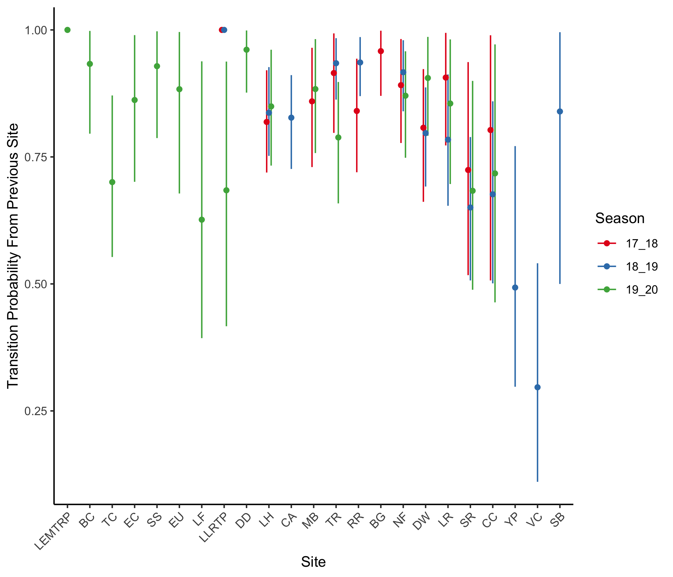

Figure 1: Estimates, with 95% confidence intervals, of transition probabilities between detection points

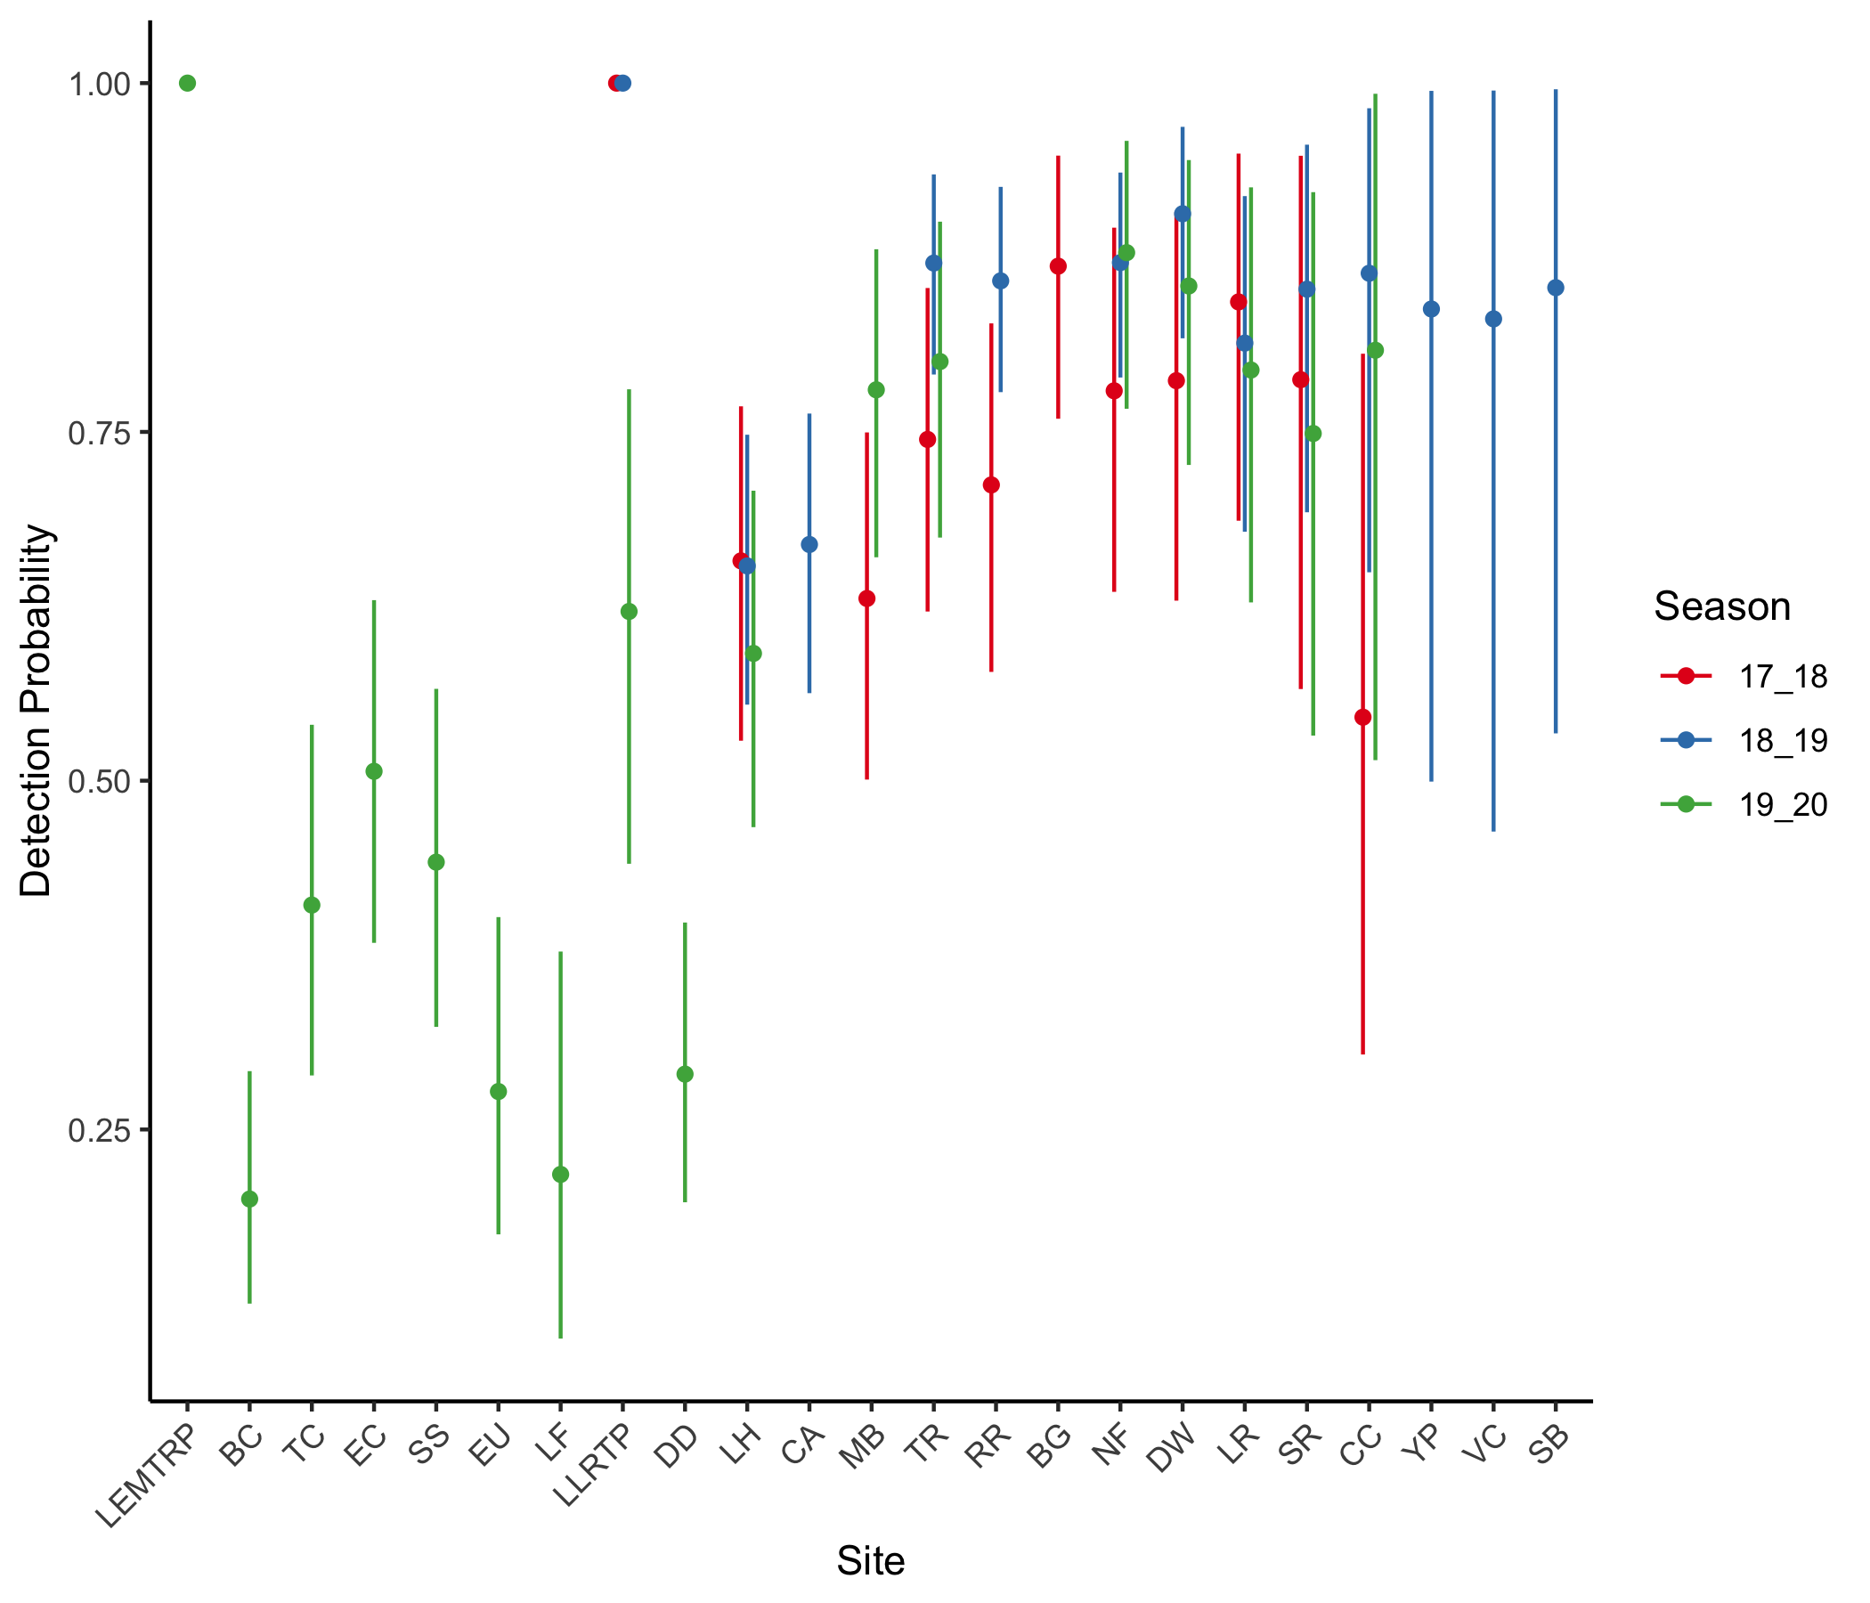

Figure 2: Estimates, with 95% confidence intervals, of detection probabilities.

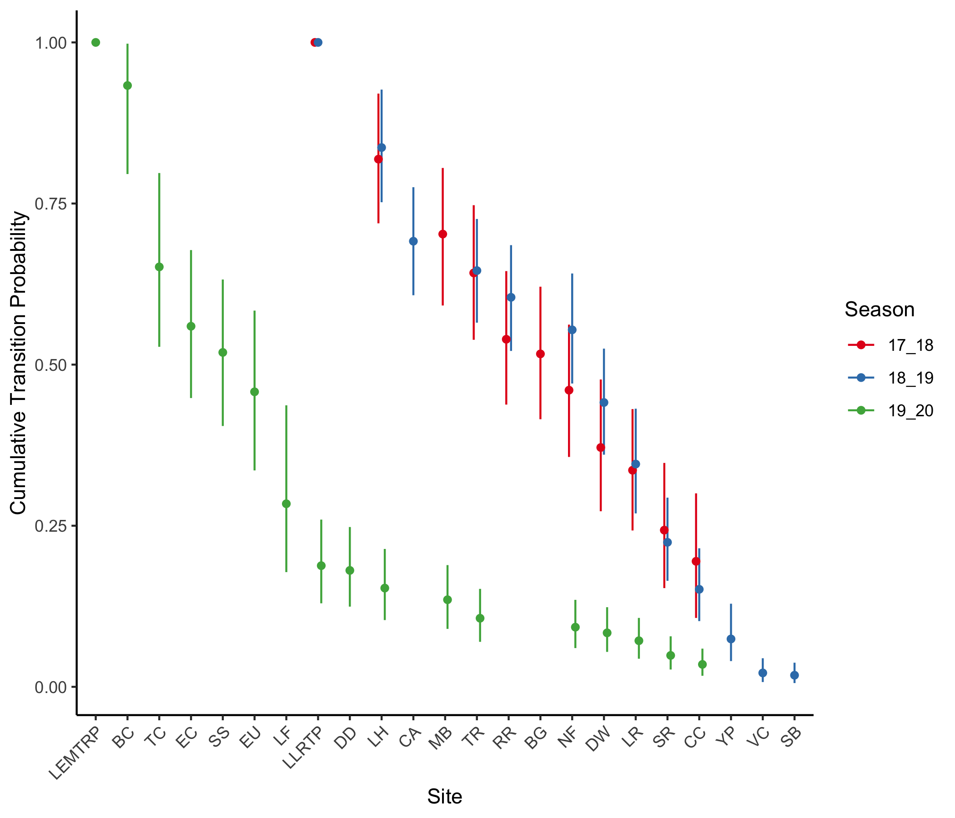

Figure 3: Estimates, with 95% confidence intervals, of cumulative transition probability across reaches.

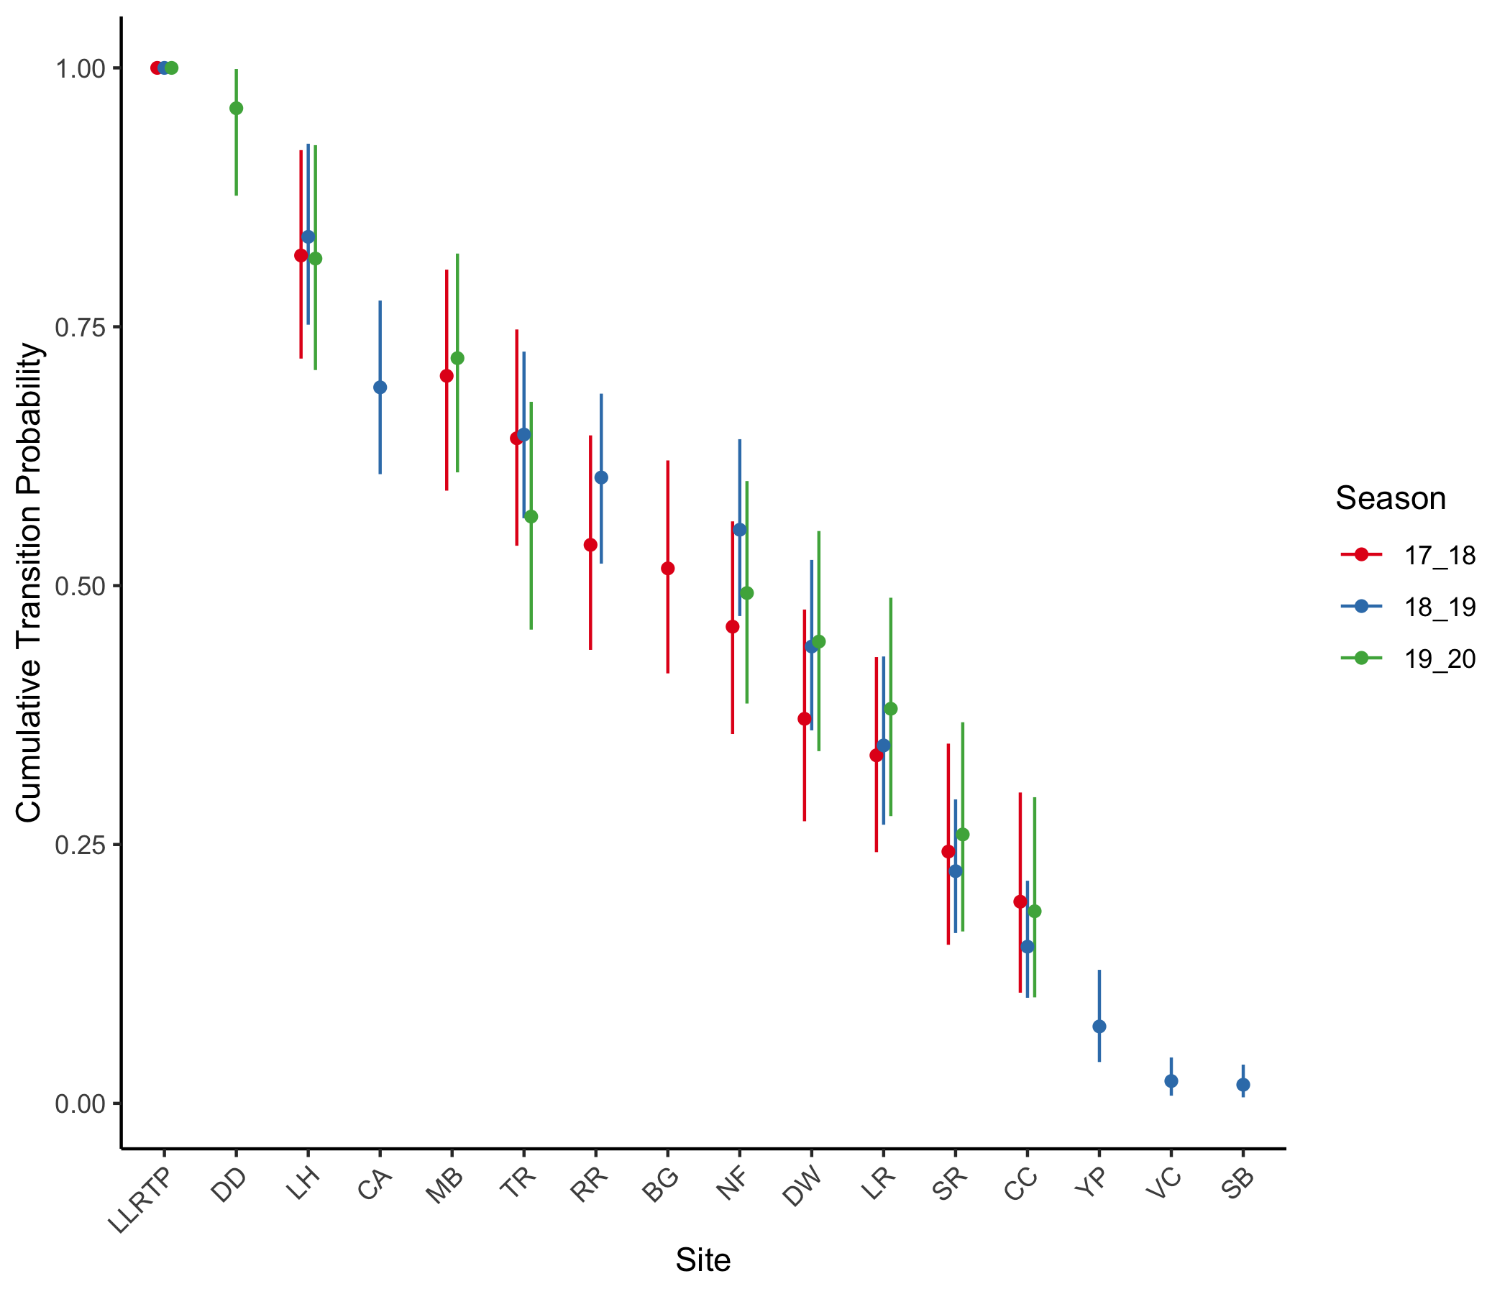

Figure 4: Estimates, with 95% confidence intervals, of cumulative transition probability across reaches, resetting the transitions in 2019-20 to start at Lower Lemhi screw trap.

# Discussion

Some of the caveats to keep in mind with CJS models include:

* Estimates of $ϕ$ are really estimates of *apparent* survival, or transition probability (i.e. the chance that a fish survives **AND** moves past the next detection point). $1−ϕ_{i}$ represents the chances that an animal either died in reach $i−1$, or left the population (became unavailable for detection). The latter is analogous to a fish that hunkers down in a reach to ride out the winter. It may be surviving very well within that reach, or it may have died there, there is no way to tell from only the radio tag observations.