Deep Feature Selection (Deep-FS), which is capable of removing irrelevant features from large datasets in order to reduce the number of inputs which are modelled during the learning process.

The proposed Deep-FS algorithm utilizes a Deep Boltzmann Machine, and uses knowledge which is acquired during training to remove features at the beginning of the learning process. Reducing inputs is

important because it prevents the network from learning the associations between the irrelevant features which negatively impact on the acquired knowledge of the network about the overall distribution

of the data.

The Deep-FS method embeds feature selection in a Restricted Boltzmann Machine which is used for training a Deep Boltzmann Machine. The generative property of the Restricted Boltzmann Machine is used to

reconstruct eliminated features and calculate reconstructed errors, in order to evaluate the impact of eliminating features.

**Identifying Transcriptomic Correlates of Histology using Deep Learning**

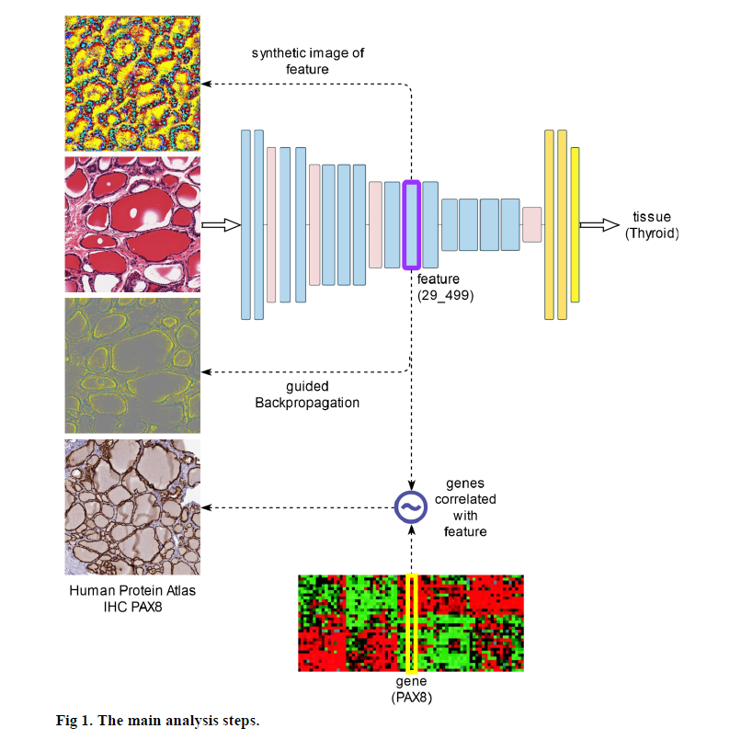

**Visualization and analysis of gene expression in tissue sections by spatial transcriptomics**

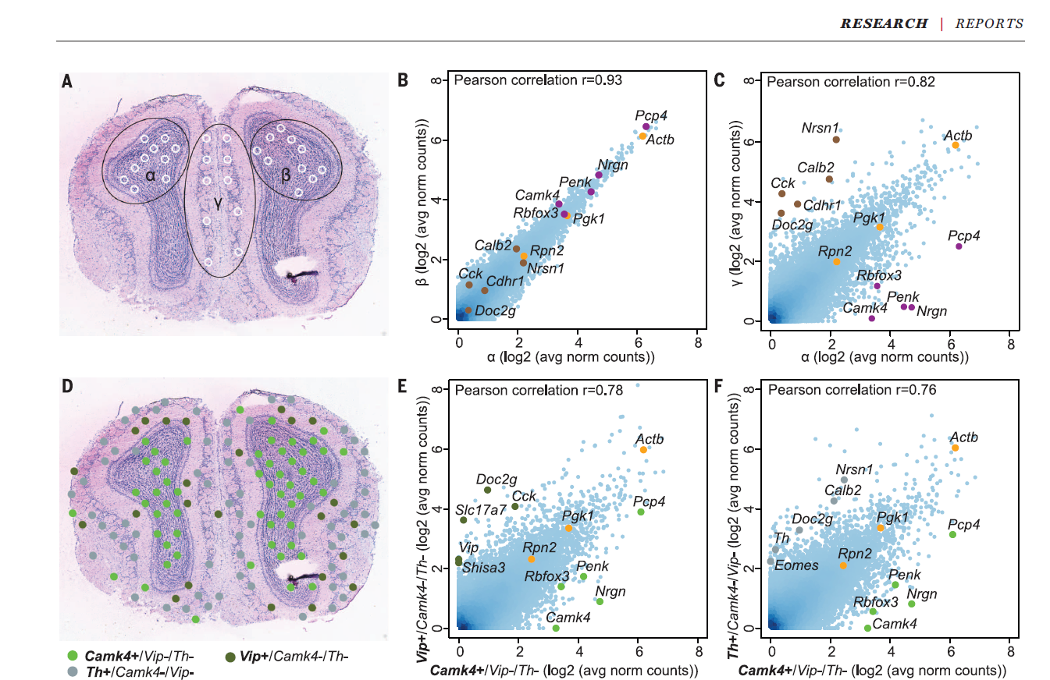

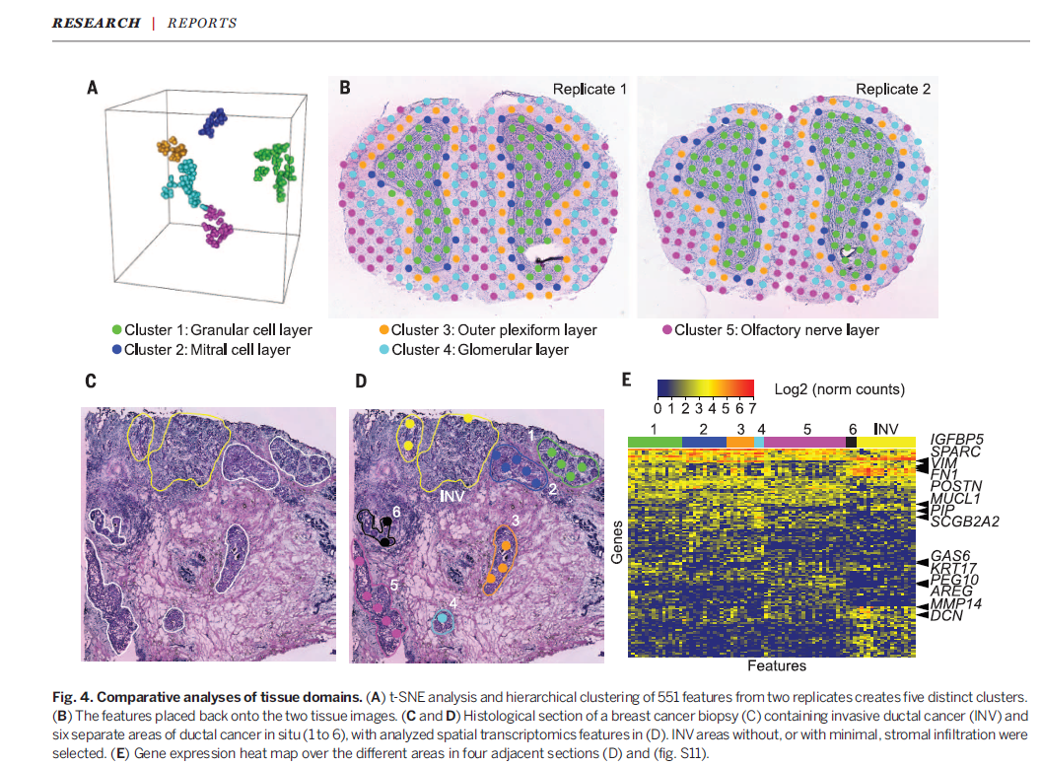

**Gene expression profiling of periodontitis-affected gingival**

**tissue by spatial transcriptomics**

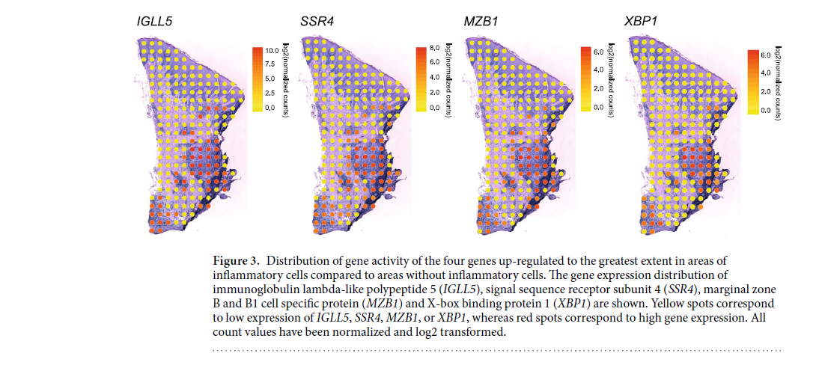

**Joint analysis of histopathology image features and gene expression in breast cancer**

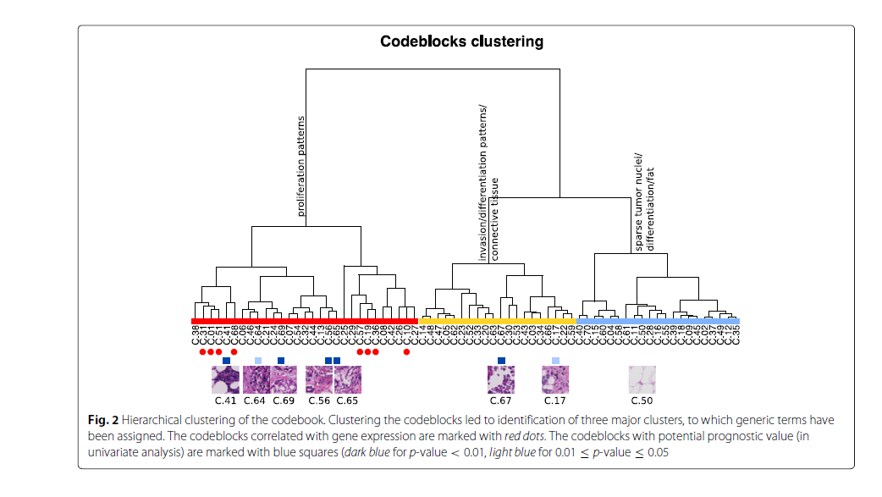

**Super-resolved spatial transcriptomics by deep data fusion**

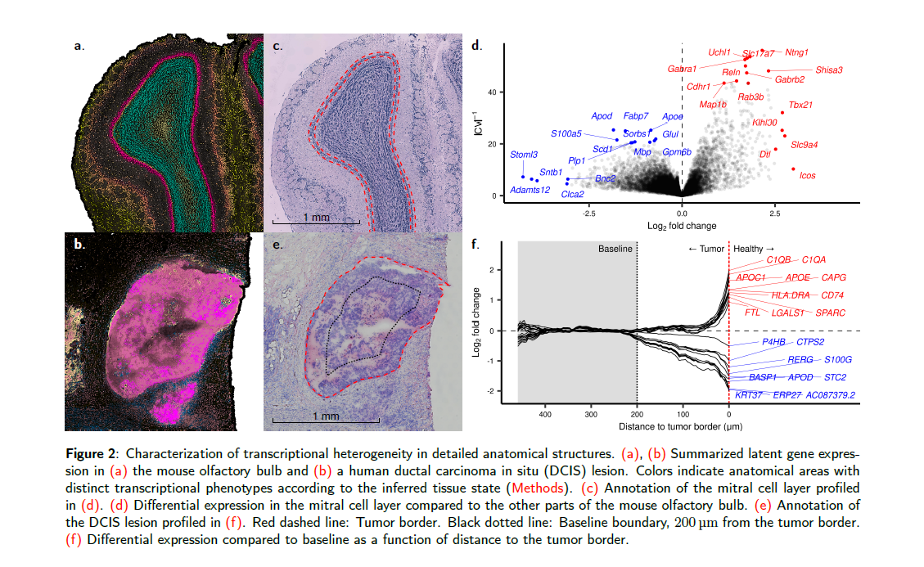

**Seamless integration of image and molecular analysis for spatial transcriptomics workflows**

