**BIOMATRIC ATTANDANCE SYSTEM**

**Table of Contents**

1. **Introduction .............................................................................................................. 1**
2. **Overview ................................................................................................................... 1**
   1. Conventions...................................................................................................... 1
   2. Why BioMatric?........................................................................................ 1
3. **Getting Started ......................................................................................................... 2**
   1. Set-up Considerations ...................................................................................... 3
   2. Visual studio ............................................................................. 4
   3. Application Interface ....................................................................................... 5
4. **Using the System ................................................................................................... 5**
   1. Left Side bar .............................................................................. 5
   2. Right Side bar…………………………………………………………………………6
   3. Modes(Light and dark)………………………………………………………….7
   4. Add program module……………………………………………………………………7
   5. Update and remove program………………………………………………… 8

Introduction

# Introduction

The project definition name describe many ways, Student attendance management system, Attendance portal, online attendance System etc.

The main aim of Student attendance system project is to maintain attendance records of student for any organization school or college. In this asp.net project post we will discuss attendance system project for school students. We developed this attendance system as website application using C# language in Visual Studio ASP.Net and use sql server for database server.

1. **Conventions**

There is convention on manual attendance system which have some disadvantages like students usually mark other student attendance or call for other student attendance.

Also there is manual record for student attendance for yearly or semester record. Student or his belongings had to come to the organization for student leave.

1. **Why Biometric?**

To avoid cheating purposes and setting up all the records for the semester and also it is easy to mark attendance by thumb so that teacher can save the time which he/she spends in marking the attendance manually.

# Getting Started

**2.1 Set-up Considerations.**

**2.1.1 Visual studio**

* Beginning of the application.
* Your application is begin.

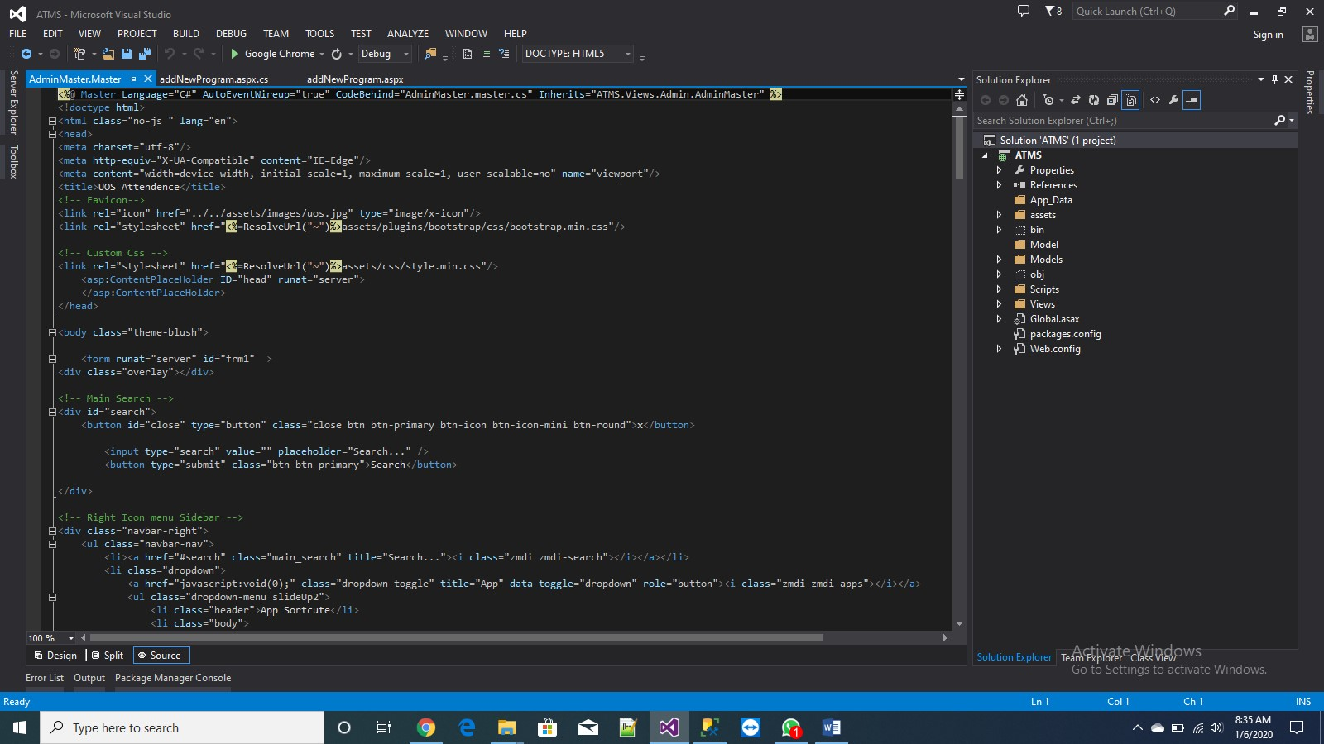

**2.1.2 Application Interface:**

Basic setting up a home page that is master page where all pages are linked. This master page has advantage that all the page will be linked within a padded fixed place and all the code of home that is master is same for all pages. Application has two side bars that is left and right side bars.

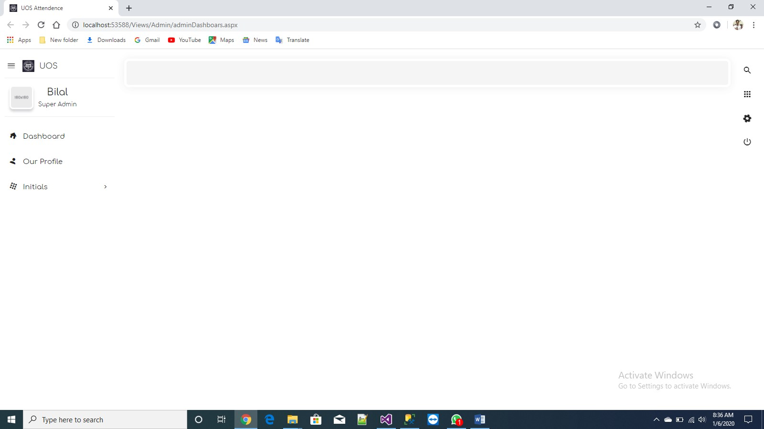

## 2.1.3 Left Side Bar

Left side bar contain all the modules, user info that who is logged in admin , teacher or student with their pictures and name respectively that come from database dynamically. Also it contain pages or modules currently having add program module where admin can add programs offered by university in the start of every semester.

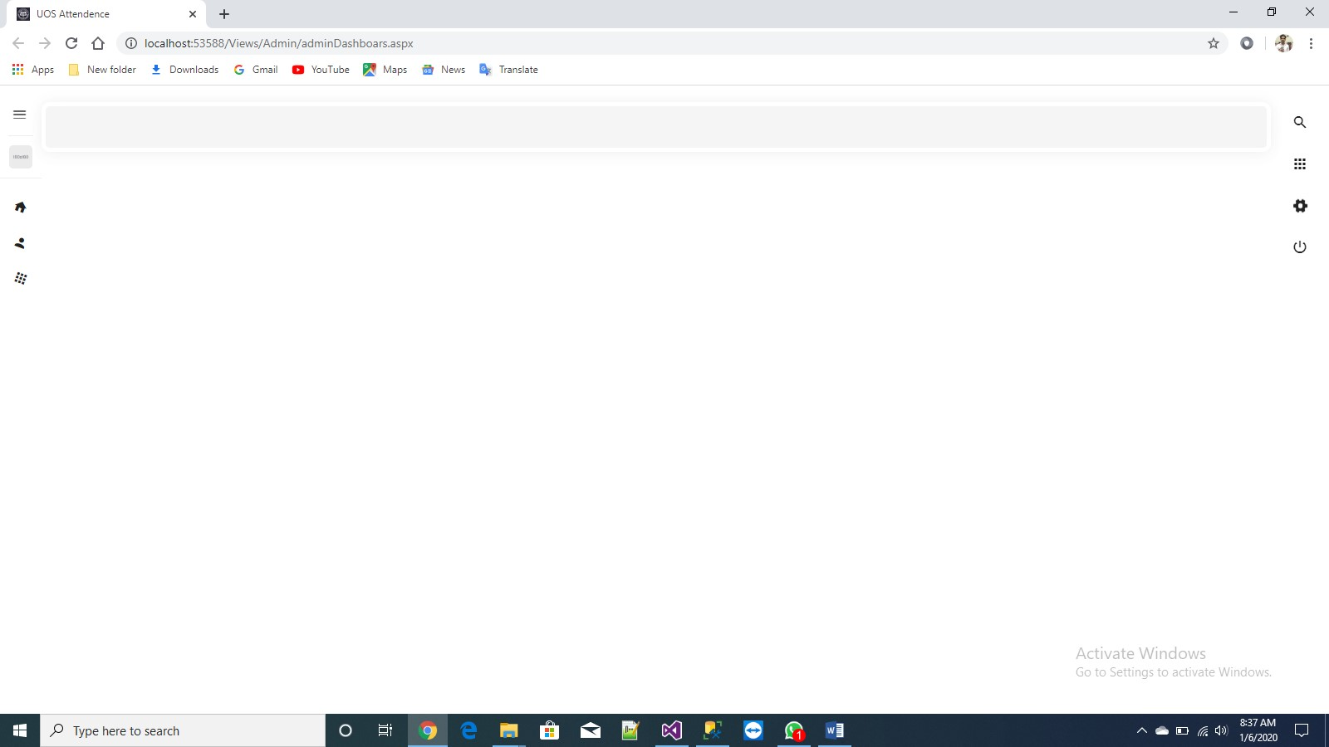

## 2.1.4 Right Side Bar (Light Mode)

Right side bar contain all the settings. Application has two modes the image shown below is the light mode of the application. Means just by a click user can switch to light or dark modes of the application

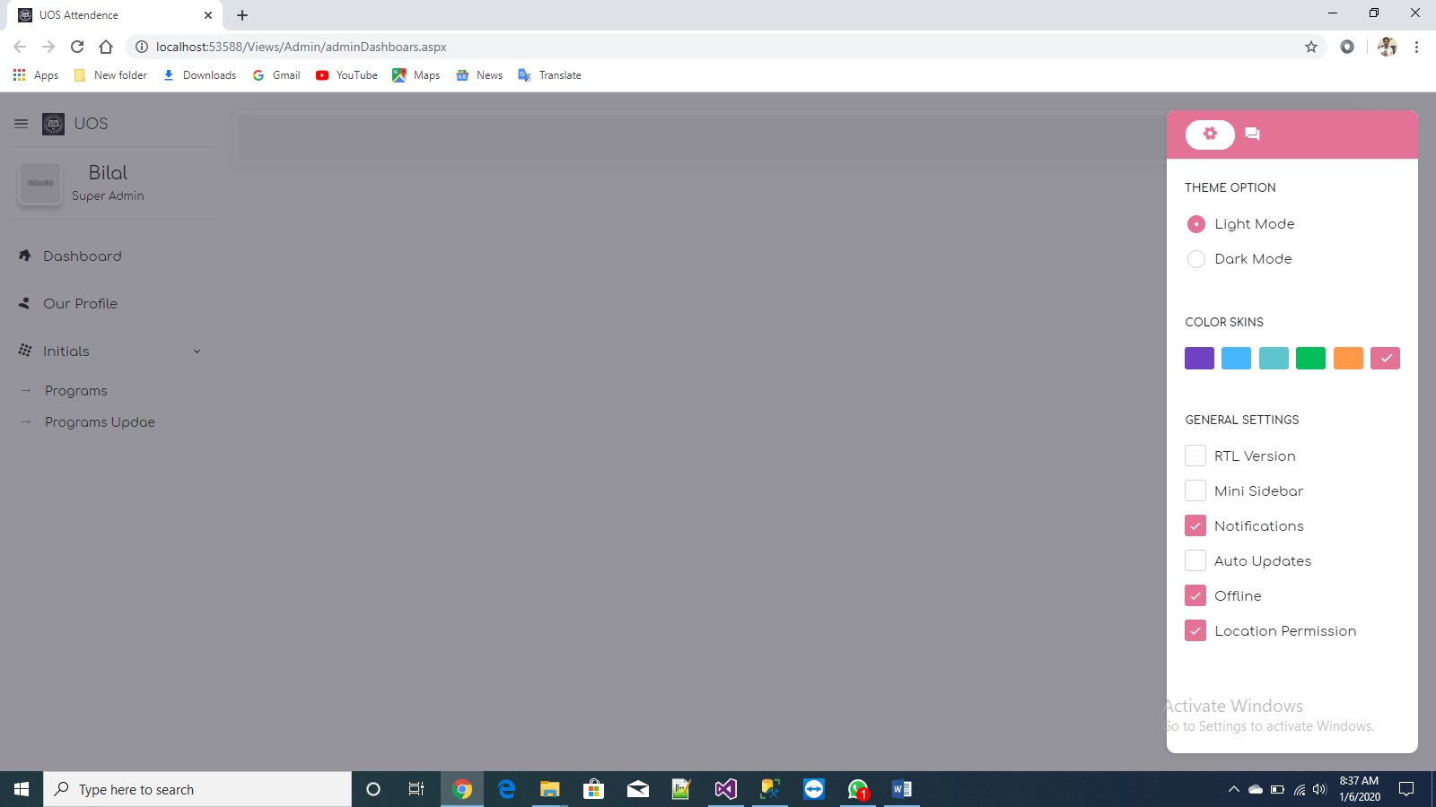

## 2.1.5 Right Side Bar (Dark Mode)

Right side bar contain all the settings. Application has two modes the image shown below is the light mode of the application. Means just by a click user can switch to light or dark modes of the application

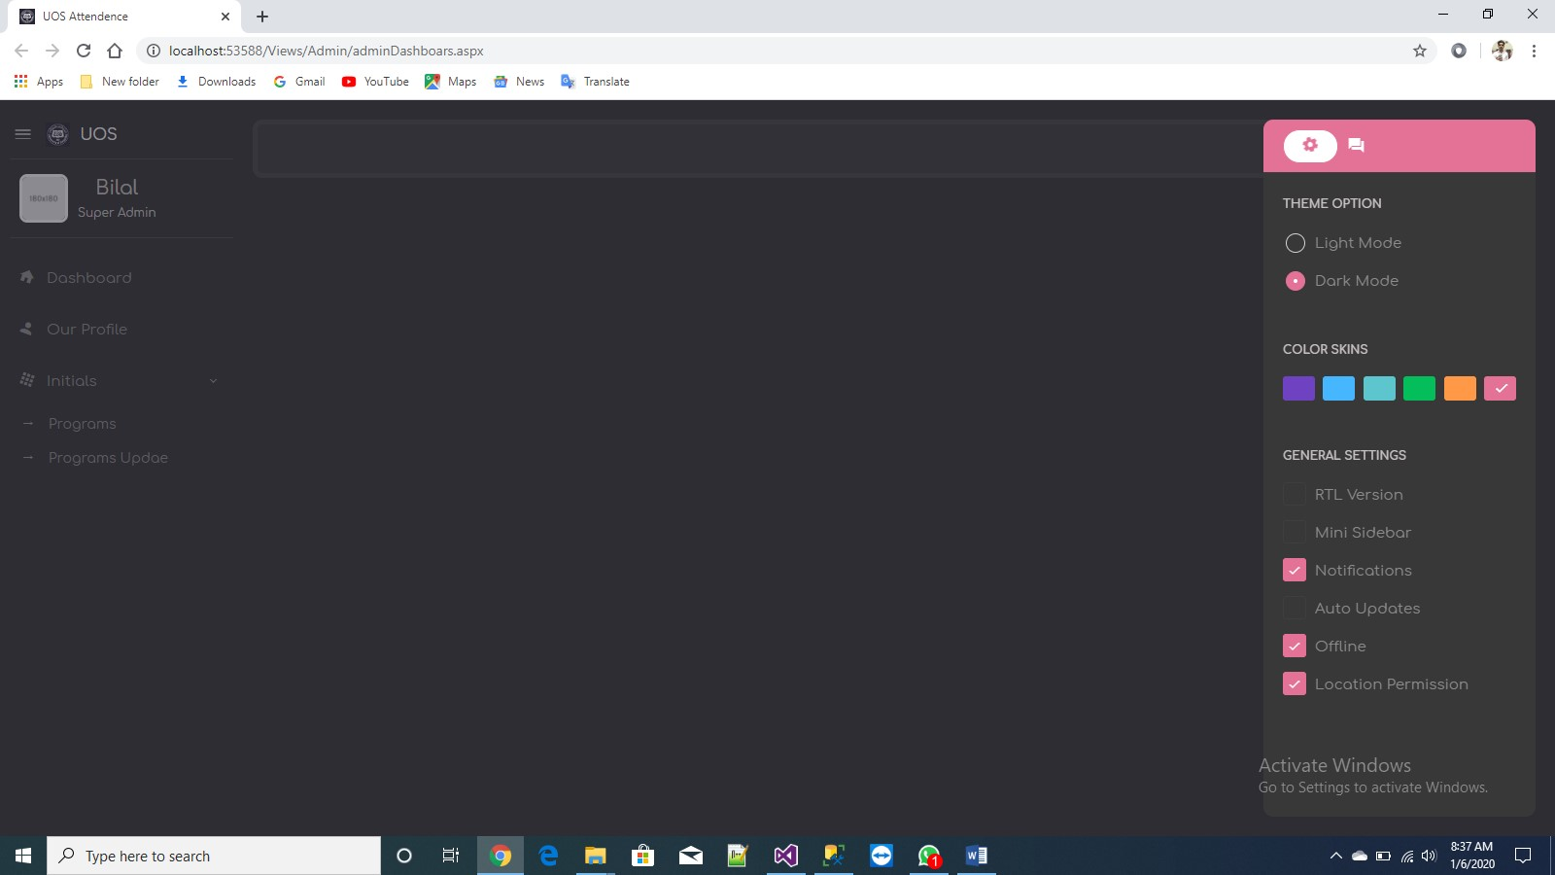

**2.1.6 Add New program Module:**

Here in this module admin can add up a programs that are offered by university. This data goes into database and later on when dependencies will be set than admin can manage roles by these modules.

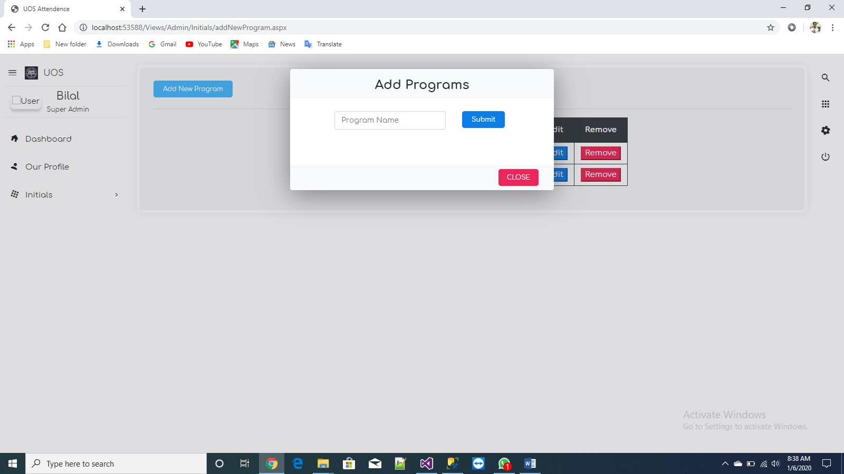

**2.1.7 Update and remove program:**

Programs that are added are shown on same page in the grid view having edit and remove buttons means when admin will click edit , application will take admin to the add program model where he/she can update program and when click to updated and set to the same place from where it is fired. Also admin can click remove where on just one click and when post back occurs program will be deleted from the user interface also from the database because it is two way binding and working in real time.

