 [Translated from Spanish to English - www.onlinedoctranslator.com](https://www.onlinedoctranslator.com/en/?utm_source=onlinedoctranslator&utm_medium=docx&utm_campaign=attribution)

**MANUFACTURE OF MICROFLUIDIC MIXER DOSER FOR POTENCIOSTAT (MMP)**

***Version 1.0***

**Prepared by: Ailin Prado Falla**

# AIM

# Document the manufacture of a microfluidic system for three sample inputs for measurement in a potentiostat with an attached sensor.

# REQUIREMENTS

To follow this tutorial it is necessary to have knowledge of the use of syringe pumps, Altium Design and AutoDesk AutoCAD.

# EQUIPMENT REQUIREMENTS

Syringe pump, potentiostat.

# STEP BY STEP

## MICROFLUIDIC SYSTEM DESIGN

The design in Figure 1 will be made in Autocad 2D for laser cutting on a 2.5mm thick transparent acrylic sheet.

.

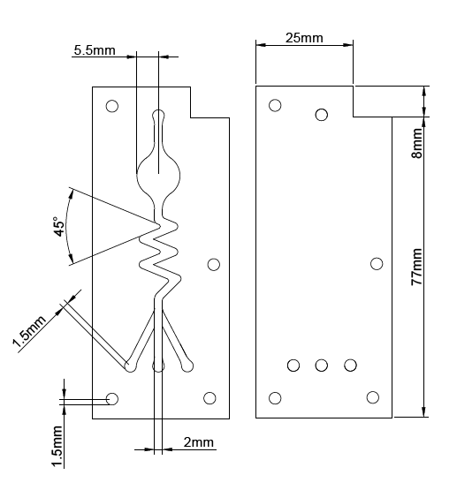

Figure 1: AutoCAD design of microfluidic system parts.

After cutting, the pieces must be washed until the remains burned by the laser are removed.

## ELECTRODE DESIGN ON PCB

## The design begins in the AutoCAD 2D tool to define the shape, angles and measurements of the electrodes shown in figure 2.

## 

Figure 2. Layout of the MMP sensor PCB in Autodesk AutoCAD.

## With the drawing done, it is saved as .dwg, passed to Altium Design and the following steps are followed:

## Open a new project.

## Create PCB.

## Import .dwg file.

## Select the imported drawing.

## Define the shape of the board following the path: Design -> Board shape -> Define board shape from selected objects.

## Create Top Layer regions of the electrodes without the channels or pins following the path: Tools -> Convert -> Create region from selected primitives

## Using the Interactively Route Connections tool create the channels from the electrodes to the pins.

## With the Place Line tool, create the edge of the board in Top layer and Top solder.

## Create a circle with the radius of the electrodes (5.5mm) in the Top solder layer

## 

## Figure 3. Top solder layer design in Altium Design.

## Place pins with the Place Via option.

## Place screw holes in the Place Via option and modify the diameter to 3mm in Diameter and Hole size.

## Follow the instructions from the Department of Electrical and Electronic Engineering for PCB printing.

## Figure 4. A) Design in Altium Design 2D view. B) Design in Altium Design 3D view.

## 

## Figure 5. Printed PCB.

## ASSEMBLY

## With the cut pieces, make sure that the grinding wheel for the pins is on the right side and the cover is on top. Methylene chloride (methacrylate) will be spread evenly on the bottom layer (the one with the channel design) and the lid will be placed on top, taking care that they are perfectly aligned. Afterwards, a weight is placed for 10 minutes to ensure bonding as seen in figure 6.

## 

## Figure 6. Gluing acrylics.

## The PCB will be glued using cyanoacrylate (instant glue). A screw will be placed as a guide on the PCB to insert the acrylic once the glue is applied. This will be spread evenly over the bottom layer of acrylic using a thick brush as follows:

## Pour the glue over the entire surface.

## Spread with the brush

## Place the acrylic taking care of its orientation on the PCB

## Make sure both pieces are aligned.

## Place a weight for 10 minutes.

## Insertando imagen...

## Figure 7. Acrylic assembly with PCB.

## Once both pieces have been glued, we proceed with placing the 2.5mm diameter metal channels with Universal glue. This is applied to the cylinder. Then the tube is inserted into the inlet and outlet holes and waited for 3 hours.

## Finally, the 3mm diameter screws are placed, obtaining the final prototype shown in figure 8.

## Figure 8. Final assembled prototype.

## LEAK ELIMINATION

## To test and eliminate leaks you will need 1 to 3 5ml or 10ml syringes, 4 8 gauge probes, water and instant glue. Steps:

## Cut the exit of the probes 5cm.

## Insert the hole made into the metal channels.

## Fill a syringe with water and insert it into the nozzle of the inlet probe.

## Direct the output of the other probes into a container to avoid waste.

## Send the water with the syringe to the canal.

## 

## Figure 9. Leak test.

## If there are leaks, remove probes and use glue to seal them on the sides.

## Let the glue dry and start again.