# DESIGN AND FABRICATION OF ELECTRODES FOR ELECTROCHEMICAL MEASUREMENT

***Version 1.0***

**Produced by: Olga Patricia Fuentes Daza.**

# OBJECTIVE

To provide a procedure for designing and fabricating electrodes for electrochemical measurement.

# REQUIREMENTS

To follow this tutorial, it is necessary to have training in the use of Eagle software.

# SOFTWARE REQUIREMENTS

# Installed Eagle software and knowledge of its main tools.

# STEP BY STEP

## PBC DESIGN USING EAGLE SOFTWARE

To make the PCB, it is necessary to design the electrode with the help of Eagle tools. It is recommended to create a library with the purpose of having a prototype that serves as a guide for future work.

Abrir Eagle.

In the Control Panel, create a new library by following these steps:

File -> New -> Library

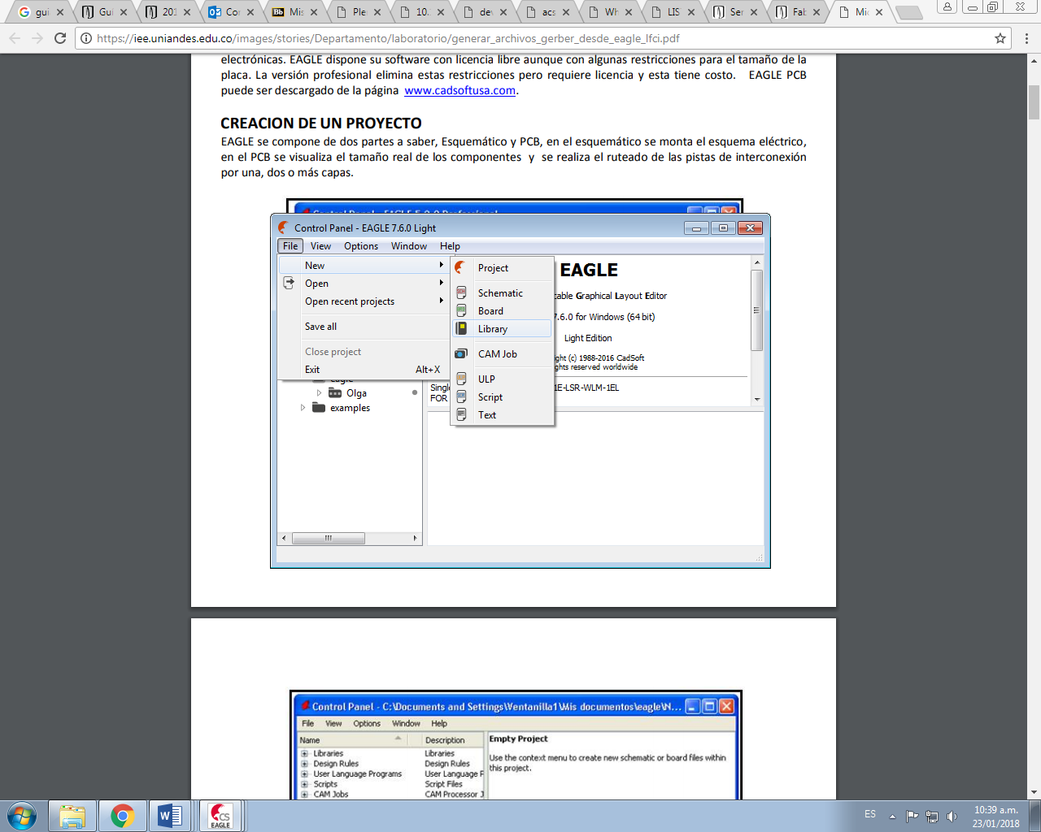

Figure 1: Creating a new library.

1. In the Package module, begin designing the PCB according to the requirements. It is important to consider the configuration of the Grid command according to the metric system that will be used, usually millimeters, and define the values of Size = 1 and Alt = 0.5.



Figure 3: Configuration of the Grid command.

1. Start by drawing a circle using the toolbar located on the left side of the screen, indicating the layer to work on, which in this case is TOP (Interfaz de usuario gráfica, Aplicación, Word

   Descripción generada automáticamente) so that the design is printed on the copper layer of the PCB.
2. the coordinates of the center of the circle at the top, in this case, they should be (0 0). Then enter the final coordinates, which will be (1 0).

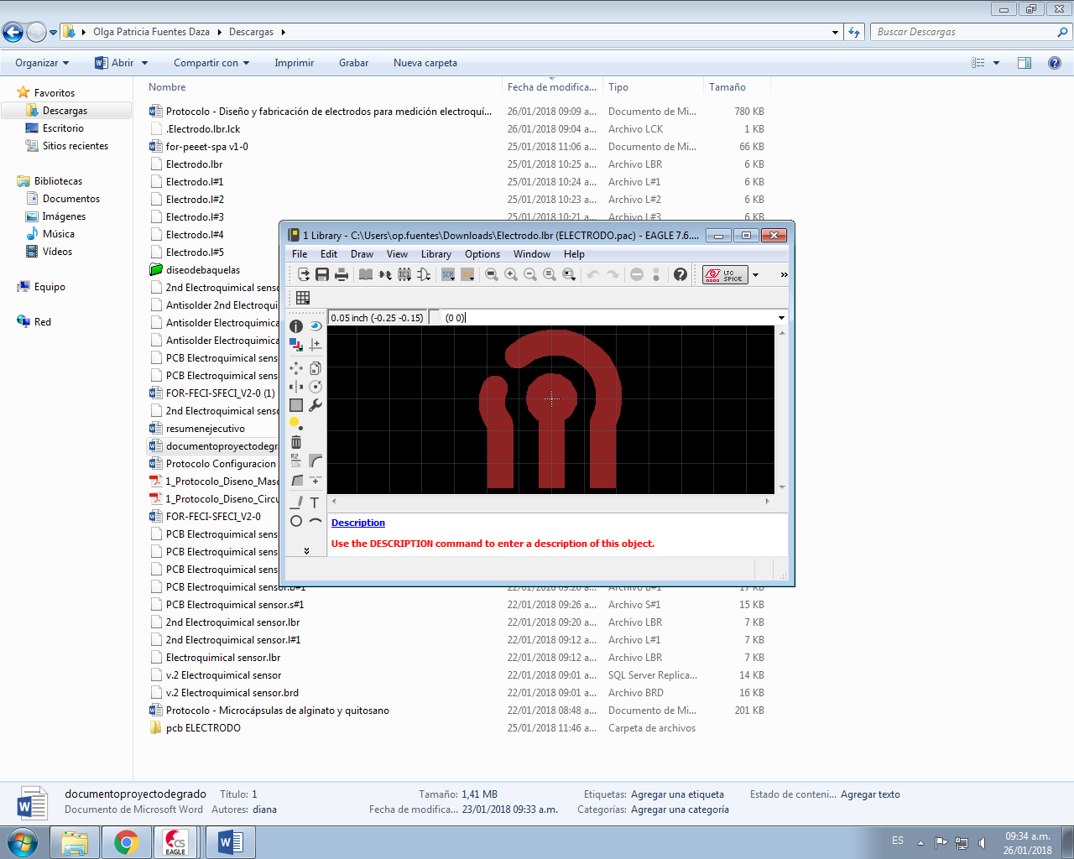

Figure 3: Coordinates of the center of the circle.

1. To fill the circle, select the Info command, then right-click on the circle -> Properties and modify the Width value to be equal to 1 and the Radius value to be equal to 0.5.

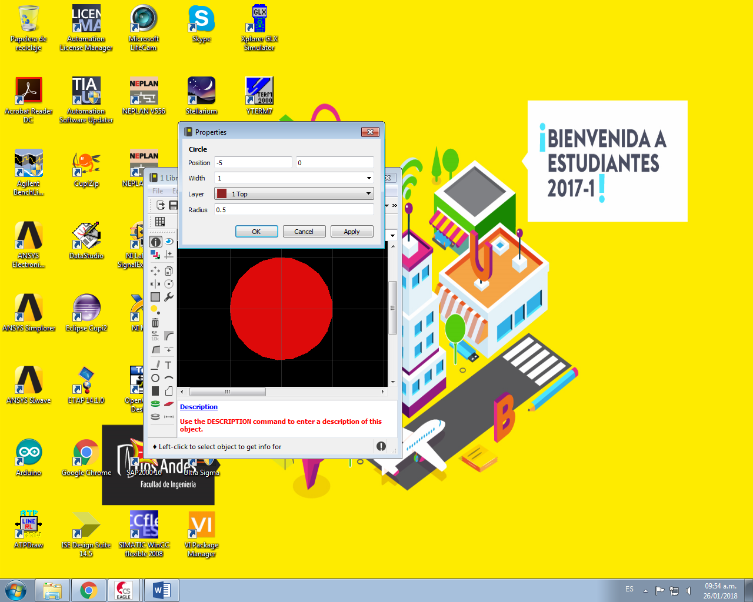

Figura 4: Configuración de las propiedades del círculo.

1. Create a vertical line that goes from the center of the circle down to the desired height, in this case assigning final coordinates of (0 -2.5). Use the Wire command, verify the selection of the TOP layer, and modify the properties of the line with Width equal to 1 and Style "continuous".
2. Repeat the previous procedure to create two more lines located on both sides with an approximate distance of 1 mm, and the resulting figure is as follows: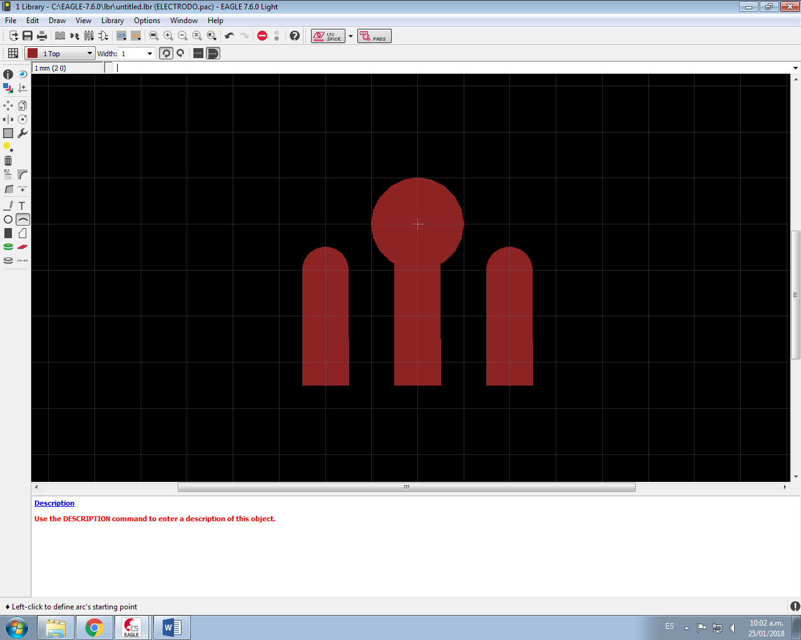

Figura 5: Electrode Design

1. To modify the end part of the three drawn lines, select the Smd command in the tools panel, verify the TOP layer selection, and determine the size of the rectangle which in this case will be 1*1.
2. To draw the arc, select the Arc command in the tools panel and trace it from the start of the right vertical line to approximately 1.3 mm to the left of the circle. Adjust the properties accordingly, in this case modifying the values of from, to, and curve.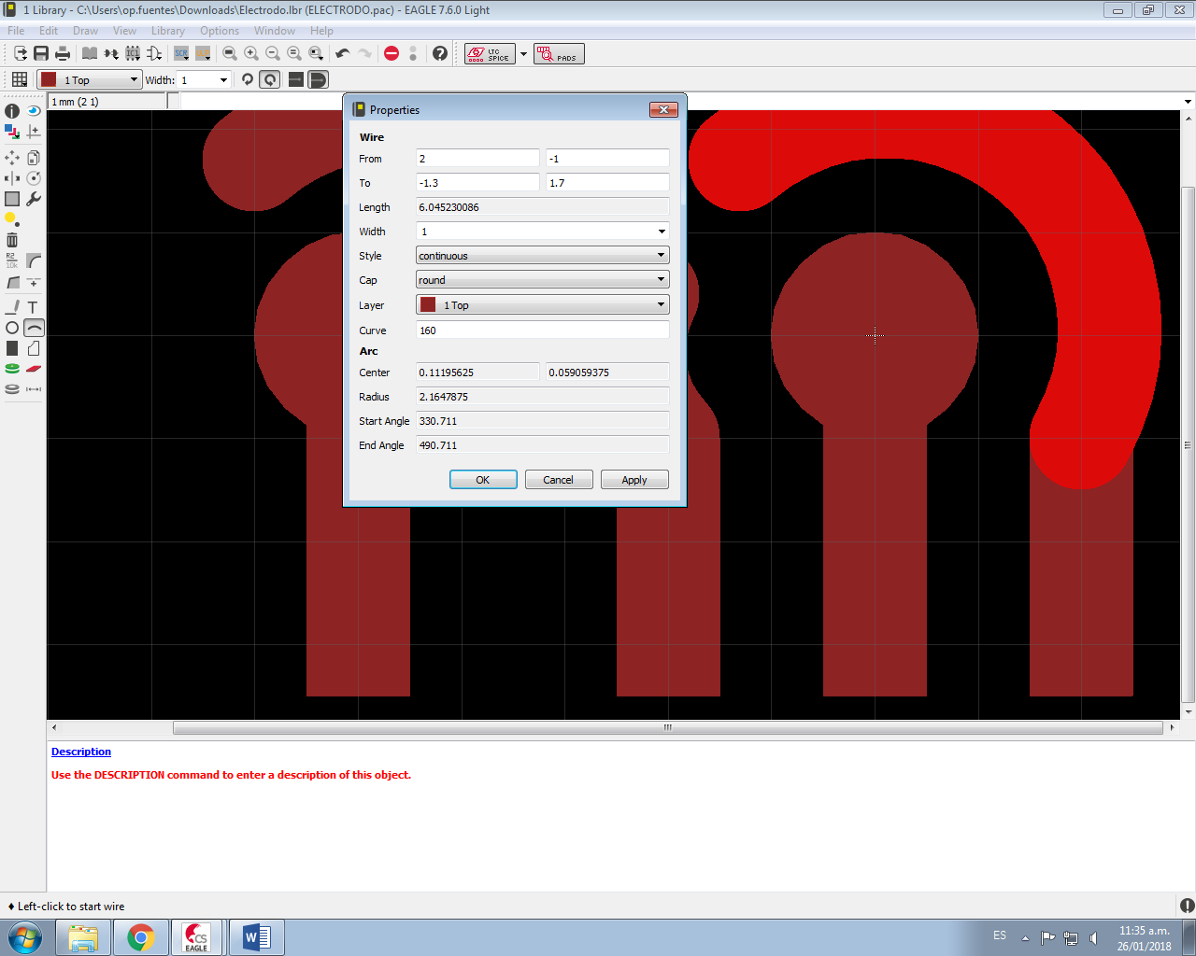

Figure 6: Arc configuration.

1. Finally, the same procedure is repeated for the design of the arc on the left side of the circle. The arc is slightly smaller than the previous one and the final schematic is as follows:

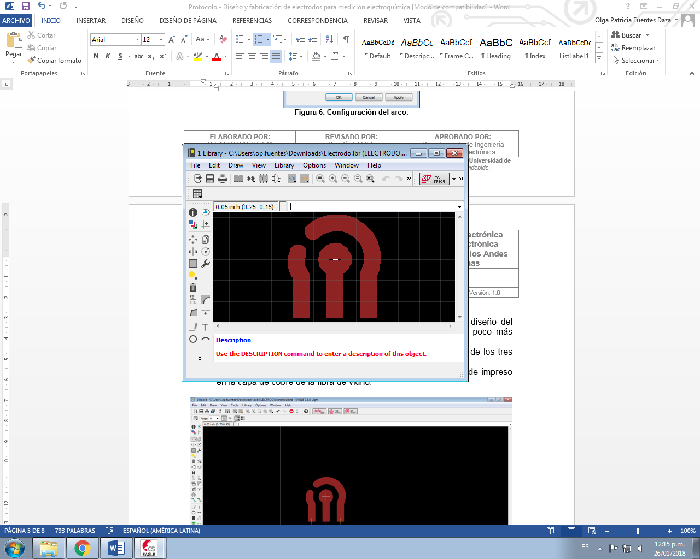

Figure 7: Final design of the electrode

1. In the "table of contents" icon on the toolbar, the window for designing the symbol of the library is opened using the Symbol module. The name is assigned and the previous steps are applied to draw the electrode in the new window.
2. With the electrode designed in Symbol, the connection pins with their respective names are added. Using the Pin command in the tool panel, the three pins that are connected to the end of each electrode terminal are added, the one in the middle is named Working, the left one Reference, and the right one Counter.

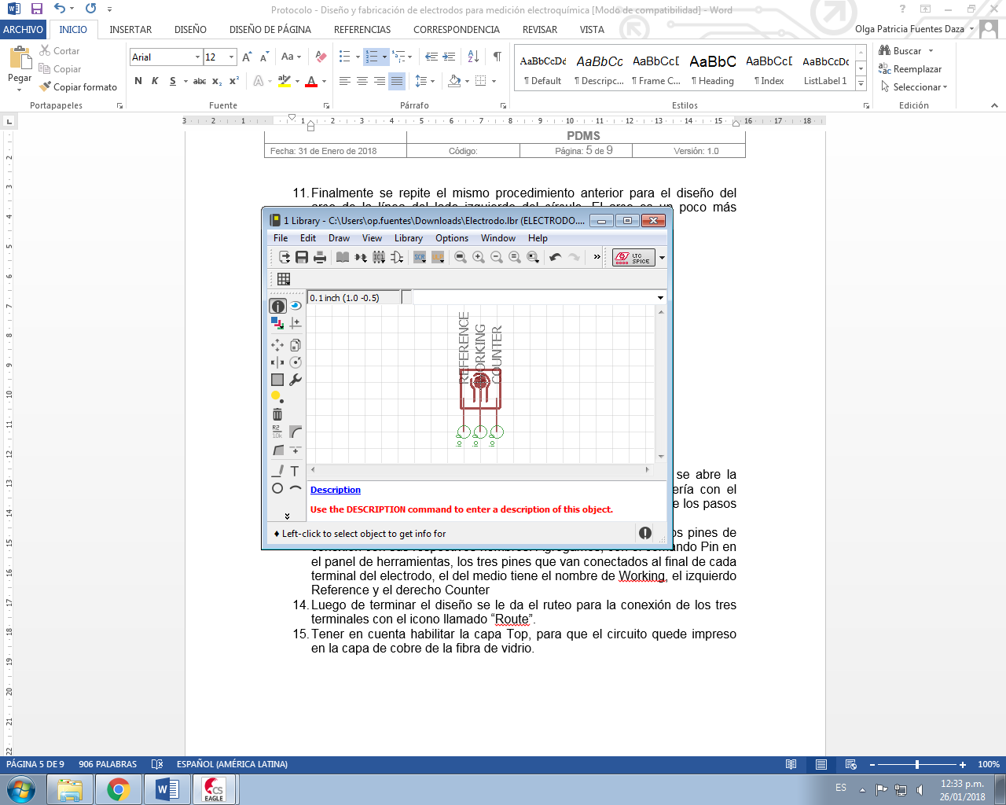

Figure 8: Design of the electrode symbol.

1. Click on the "Content table" icon in the toolbar to create a Device and assign it a name. In the right panel, click on "New" and call the created Package, then in the toolbar locate the "Add" command and add the designed Symbol to the board.
2. To make the electrical connections of the Device's pins, click on "Connect" in the right panel and connect the pins according to the established name.

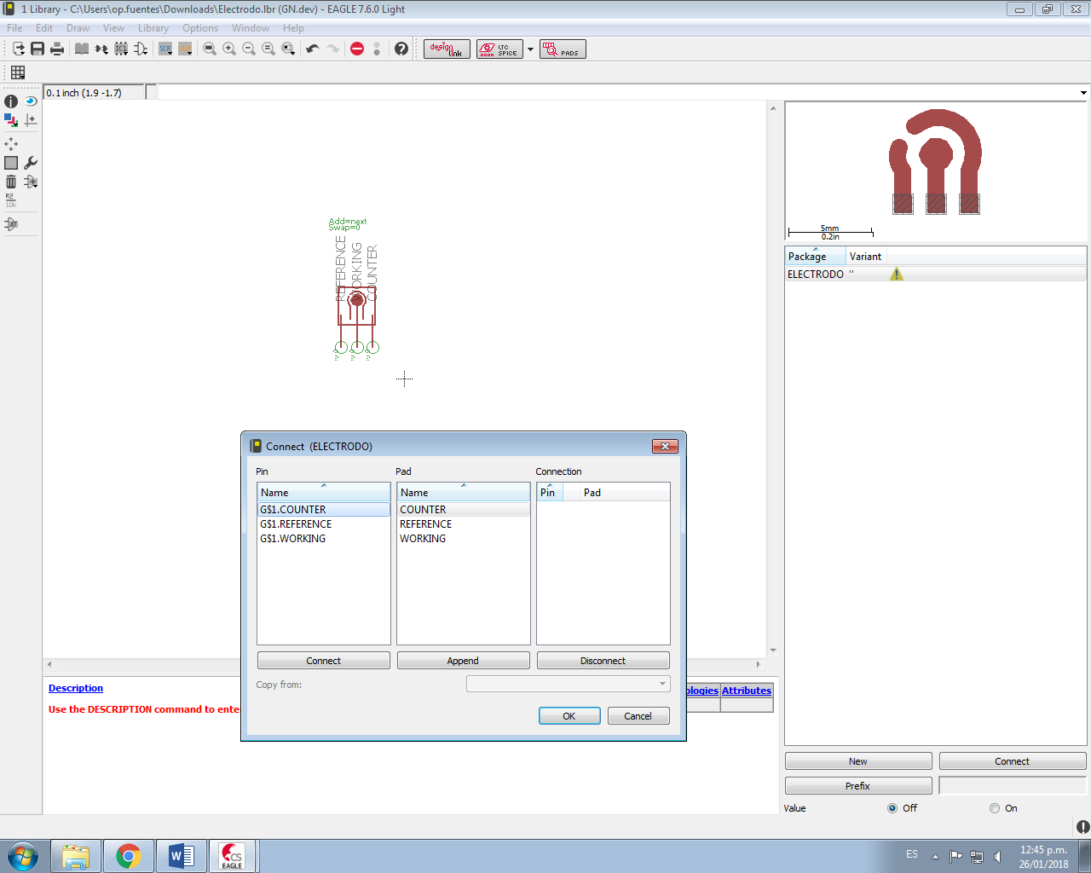

Figure 9: Connection of the electrode pins.

1. Save all changes as the library has been created.

## CREATING A NEW PROJECT IN EAGLE

1. In the Control Panel, create a new project by following these steps:

File -> New -> Project

1. Create a schematic, taking care not to modify the Grid command.
2. Add the created library in the Add button of the toolbar panel.
3. Repeat the previous step to add the connection pins, search for the Pinhead library, and select 3 pins "1x03."
4. The Net command from the toolbar panel is used to connect the electrode to the terminal pins. Route until the desired connections are made.
5. The yellow color of the connection lines indicates that the device is electrically connected to the pins.

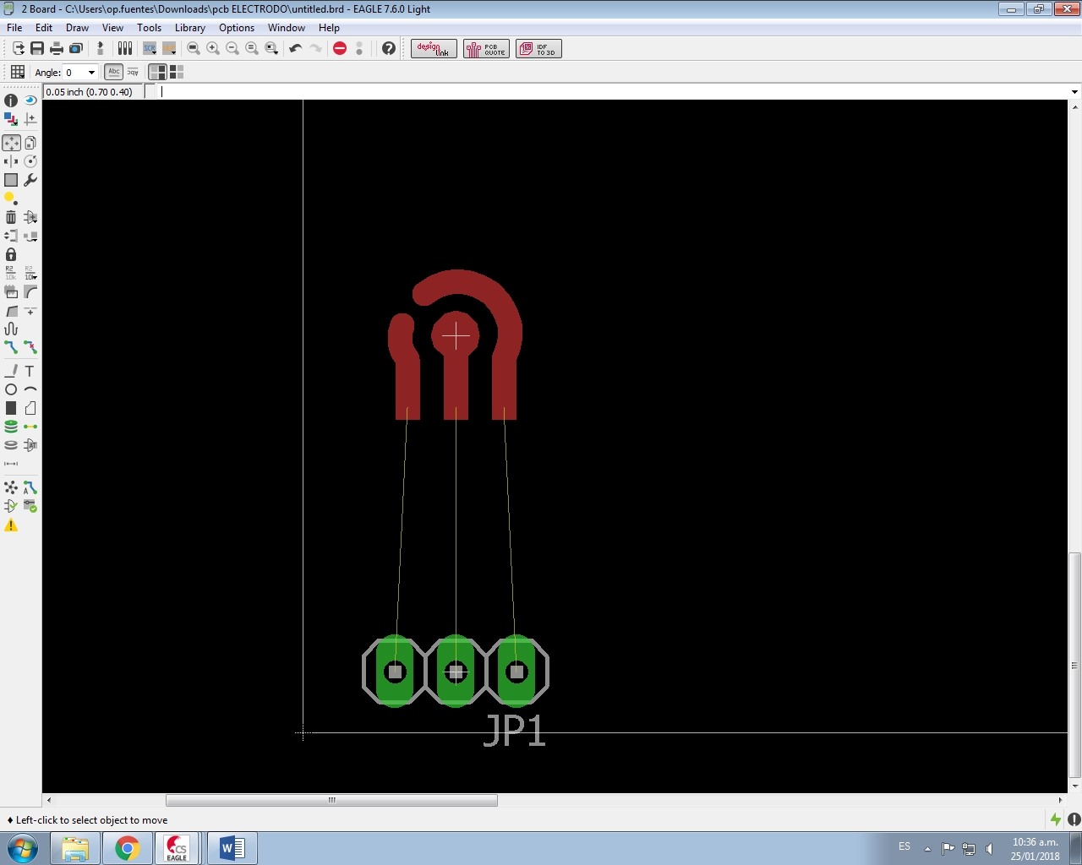

Figure 10: Electrode connection route..

1. Go to the Board and use the Grid command to modify the Size and Alt values according to the metric system to be used. In this case, it is millimeters, and Size=1 and Alt=0.5 are defined.
2. Make the square around the electrode smaller to reduce the printing area. Modify each line with the desired measurement. Right-click on the line -> Properties.

If you want to move the device, Right-click -> Move.

1. After finishing the adjustments, select the "Route" command from the toolbar panel, verifying that the TOP layer is enabled and assigning Width=1.
2. Draw the red connection lines over the yellow ones already drawn between the device and the pins.

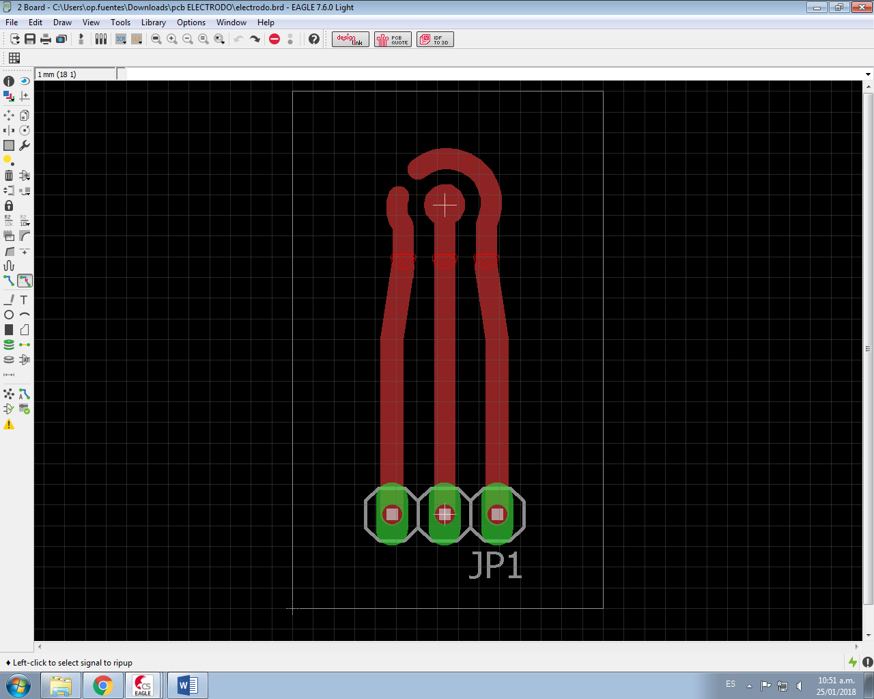

Figura 11: Diseño final del electrodo.

1. Save the project and continue with the following steps for PCB printing.

## PREPARATION OF ELECTRODES FOR ELECTROCHEMICAL MEASUREMENT

1. Go to the website https://iee.uniandes.edu.co/es/.
2. Access the "Laboratories" panel -> "Internal Services" -> "Printed Circuit Board Fabrication."
3. Read the instructions corresponding to the service request and complete the download request form.

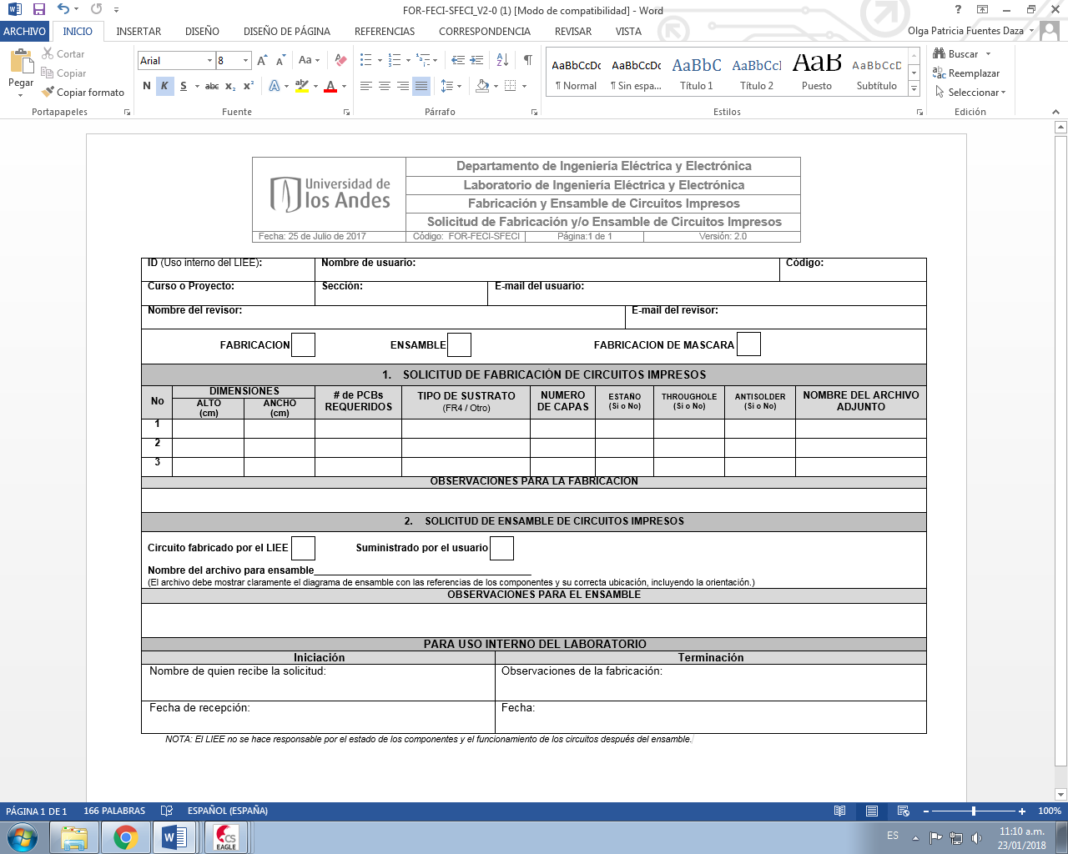

Figure 12: Form for requesting fabrication and/or assembly of printed circuits

1. It is recommended to check the fabrication box when only the designed circuit needs to be printed. However, if accessories such as connection pins are needed to be delivered with the board, provide the necessary materials to the person in charge of the fabrication and give them the corresponding instructions.
2. Take into account the generation of GERBER files from EAGLE. See the instructions on the aforementioned website.
3. Check the specifications of the drills used in the laboratory.
4. If gold evaporation on the copper surface of the electrode board is needed, it is important to inform the laboratory personnel and provide them with the necessary supplies for the process.

# CHANGE CONTROL

|  |  |  |  |
| --- | --- | --- | --- |
| **CHANGE DESCRIPTION** | **DATE** | **VERSION** | **APPROVED BY** |
|  |  |  |  |