**ENZYME ACTIVITY MEASUREMENT**

***Versión 1.0***

**Produced by: Mabel J. Noguera C., María G. Mejía M., Santiago Flórez C.**

# OBJECTIVE

To determine the enzymatic activity in a solution, for this case, the enzyme Lacase will be used.

# REQUIREMENTS

To follow this tutorial, it is necessary to have knowledge in the preparation of solutions such as buffers at a specific pH. It should have been developed an immobilization protocol over the solid of interest and have a plaque of it with maximum dimensions of 1.2 x 4.4 x 0.1 cm, in case of working with solids.

# DEVICE REQUIREMENTS

Spectrophotometer: Genesys 10s UV-VIS Spectrophotometer, Thermo Scientific, present in a cleanroom.

# STEP BY STEP

## PREPARING SOLUTIONS

In order to perform the enzymatic measurement, two solutions need to be prepared beforehand: Buffer Ph ≤ 4.5 and ABTS solution [1:10] in mili Q H2o. To generate the ABTS solution, you will need 110 mg of ABTS (C18H24N6O6S4) CAS: 30931-67-0. Ensure that you have this material before following the next procedure. For your safety, use gloves and do not ingest any of the resulting elements or solutions.

## Take a glass beaker of at least 20 mL.

## Deposit 10mL of milli-Q water in it. Make sure all the water is at the bottom of the container and not adhered to the walls of the same.

## In a glass container (e.g. watch glass), weigh 110 mg of ABTS.

## Deposit the ABTS in the beaker with water.

## Mix with a glass stirrer until obtaining a homogeneous and translucent solution of light green color.

## Package the solution in a 15 mL falcon tube externally covered with aluminum foil, as exposure to light damages the solution. Properly label the falcon with a tag. (ABTS [1:10] solution).

## Store in the refrigerator until use.

**4.2 ENZYME ACTIVITY MEASUREMENT**

For this part, you must have the samples to be analyzed ready, as well as the blank for these, as well as the two solutions mentioned above. Each measurement will be performed in a single cuvette for this. This must have a fixed volume of 1500 µL which is broken down as follows:

**Case 1: Measurement in solution**

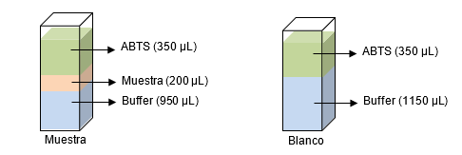

**Case 2: Measurement in solid surface**

The ABTS must be added at the time of measurement.

1. Turn on the spectrophotometer, which automatically enters the SmartStart menu after starting up.
2. In the previous menu, go to the LaccaseABTS analysis, which is stored in the clean room equipment (use arrows indicated in Fig 1.A). Then click on Enter.
3. Next, the analysis parameter window will open (see Fig 1.B), which must be:

*Analysis Name: LaccaseABTS*

*Measurement Mode: Absorbance*

*Wavelength (L.O): 436.0 nm (this value depends on the compound being analyzed)*

*Reference L.O Correction: Off*

*Delay Time (min:sec): 0:00*

*Interval Time (min:sec): 0:01*

*Total Time (hr:min:sec): 0:01:00*

*Show Result (Speed * Factor): On*

*Units: U/L*

*Linearity Value: 0.005*

Note: To select and run the analysis, click on "Run Analysis" (see Fig 1.B). In case of working with solid, be sure to put the plaque in perpendicular position respect to the spectrophotometer ray. Otherwise, the measurements’ quality could be compromised.

1. This will take you to the analysis measurement, which begins with the measurement of the blank. To place the cuvette inside the equipment, make sure that the arrow present in it is facing you (see Fig 1.D), after the order to measure the blank (see Fig 1.C).

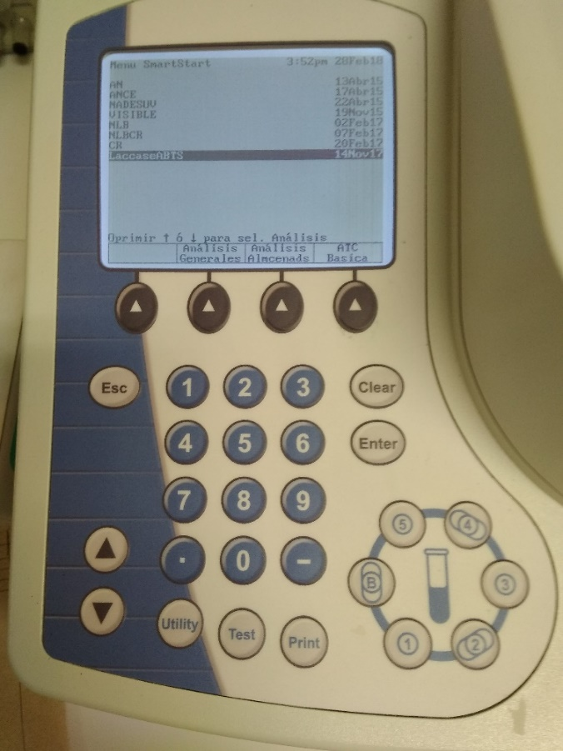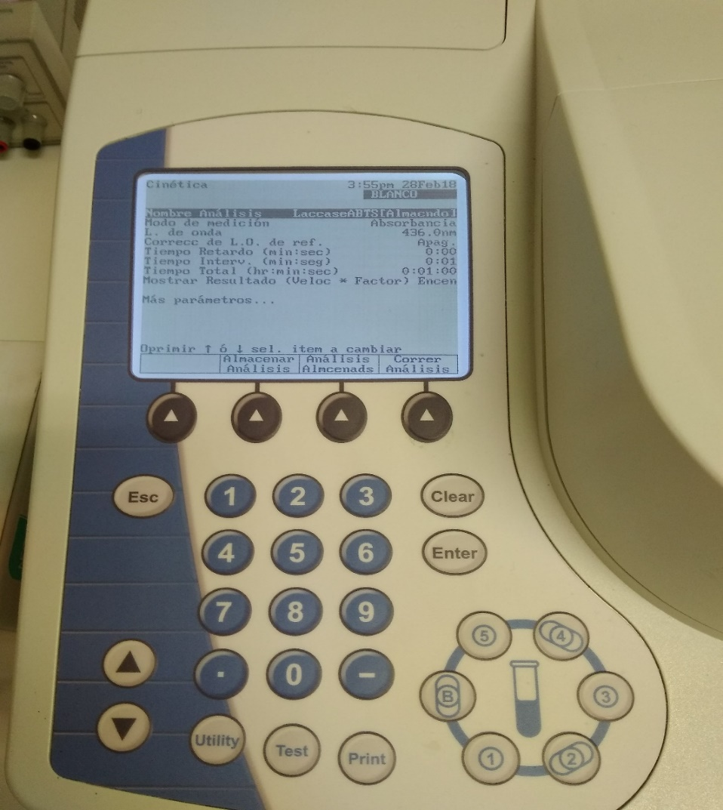

3

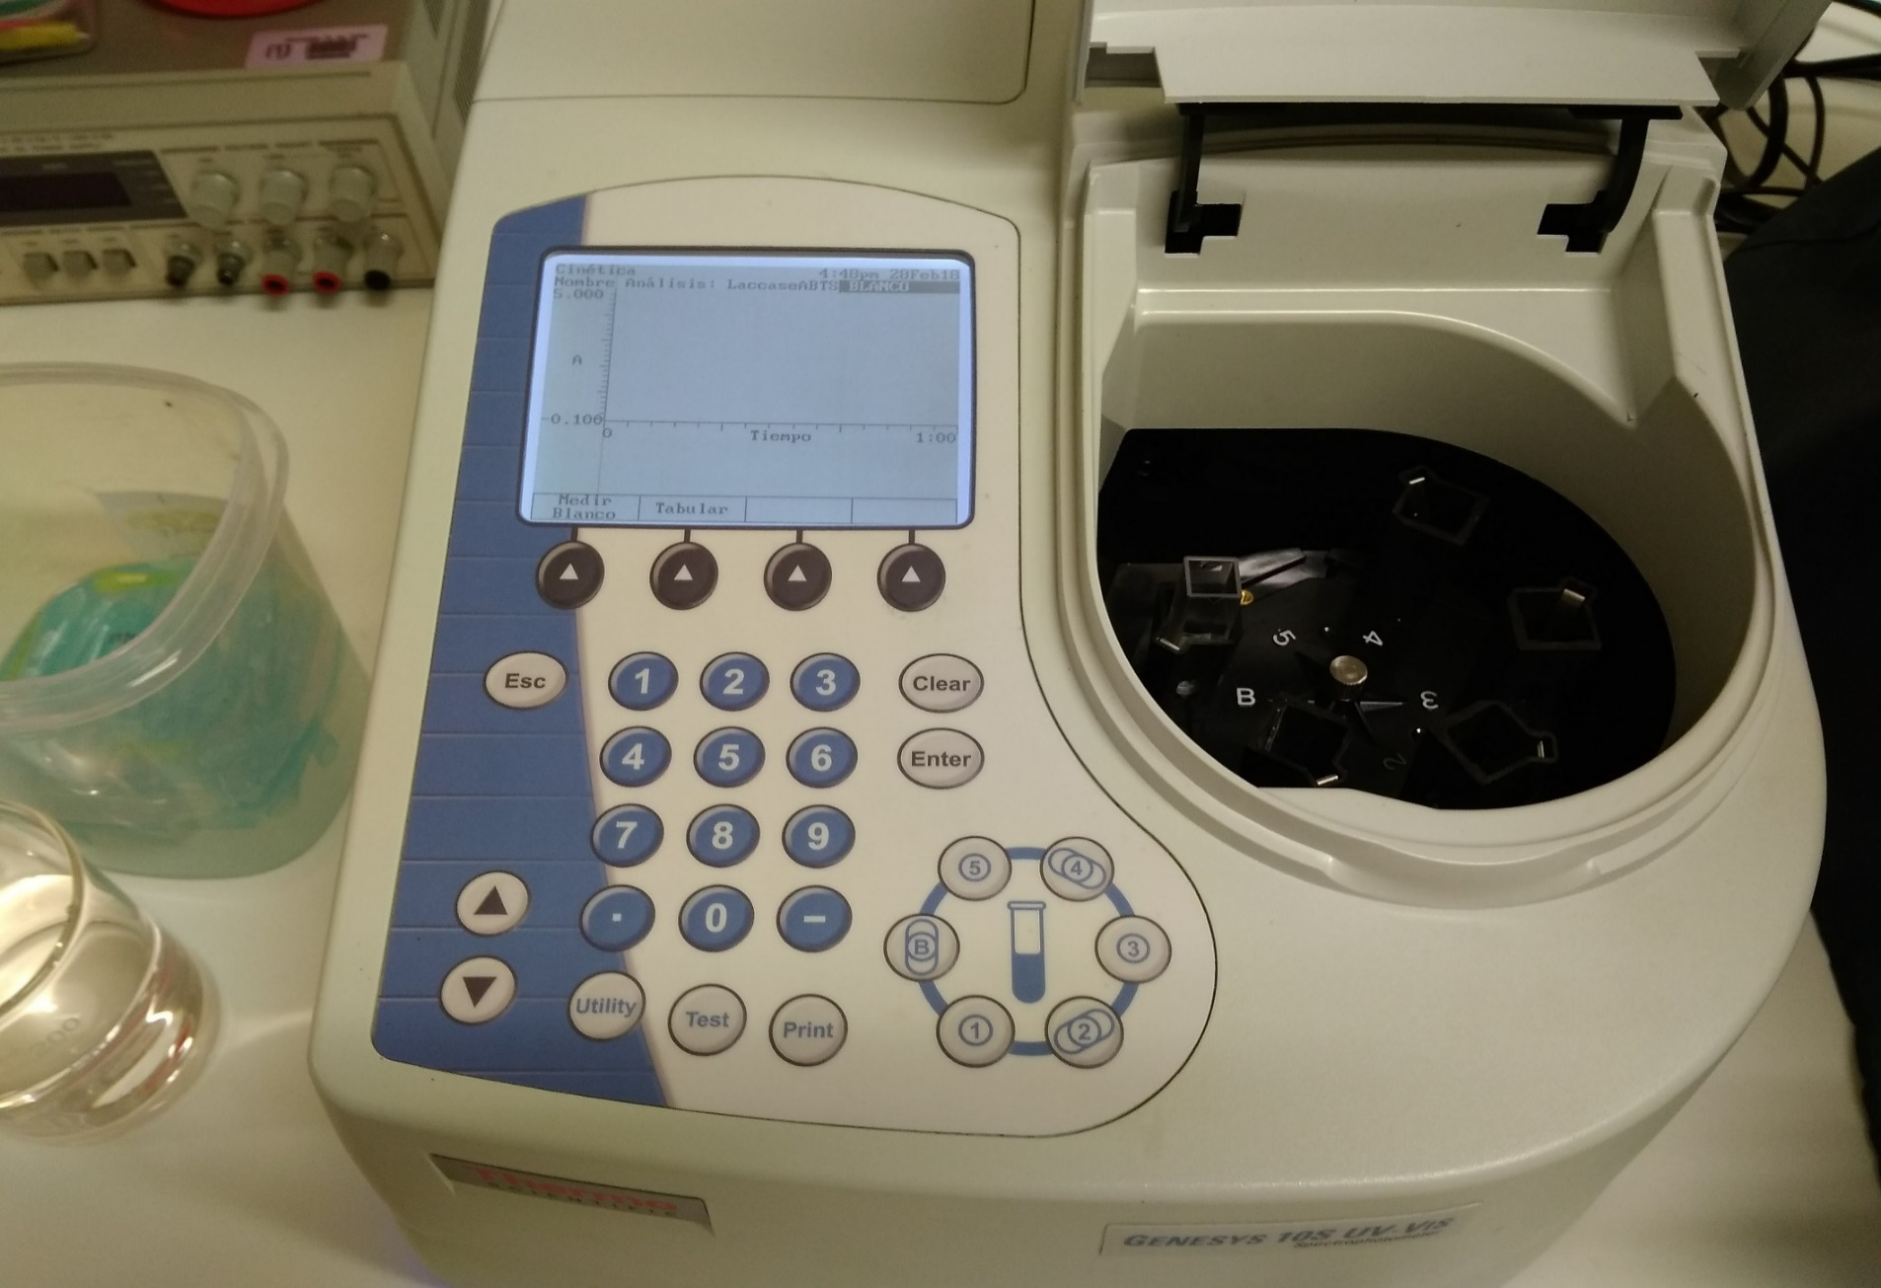

4

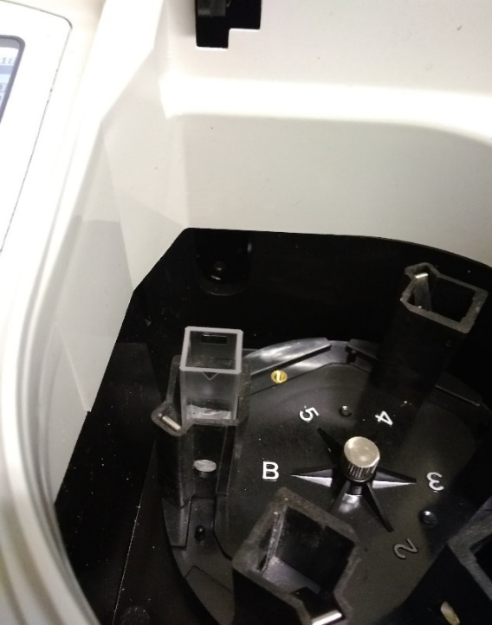

4

A)

B)

C)

D)

2

2

Figure 1: Spectrophotometer. A) "SmartStart Menu", Step 2. B) Analysis Parameters, Step 3. C) Blank Measurement, Step 4. D) Measurement Cuvette, Step

1. You can now continue with the measurement of the desired samples. First, select the cell that corresponds to your sample by selecting the corresponding number. Next, insert the sample cuvette into the system, add the ABTS solution, quickly close the door and press "Measure sample" (see Fig. 2.A).
2. The measurement of absorbance will be evidenced in the selected sample for each time interval. ABS/min is the data that will later allow you to know the enzymatic activity in the sample, so be sure to record this data.
3. If you want to continue measuring with the same blank used for more samples, select the cell number to evaluate and then click on "Measure Sample".
4. Once the analysis of each sample has been completed, remove each cuvette and discard its contents in a waste beaker. Then, gently wash the cuvette with Milli-Q water to avoid staining or scratching. Finally, leave the cuvettes submerged in water while you finish your test.

7

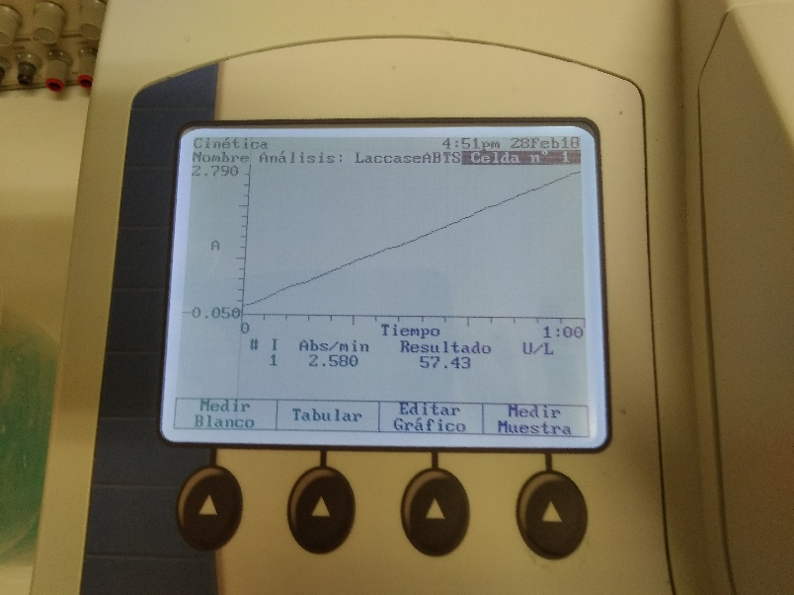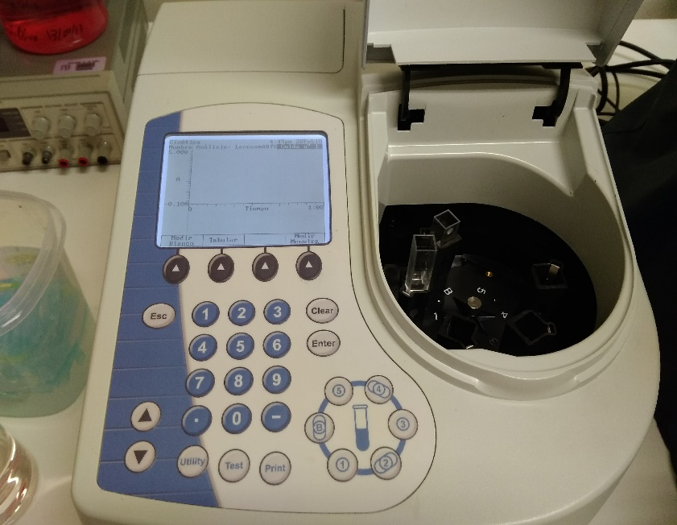

5

5

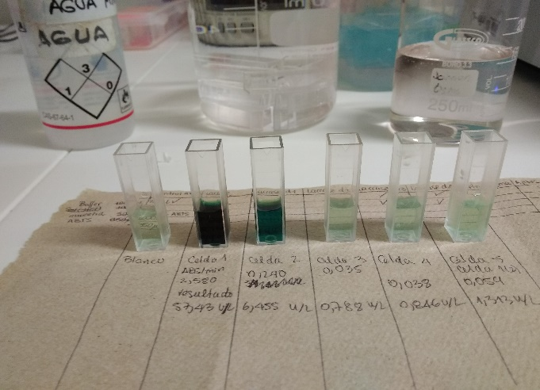

B****

1****

2****

3****

4****

5****

6

A)

B)

C)

Figure 2: Enzymatic activity measurement and results obtained in the spectrophotometer. A) How to perform the measurement. B) How the results are shown. C) Example of samples evaluated in the system.

## DETERMINING ACTIVITY

To determine the enzymatic activity of the sample, the Lambert-Beer equation is used:

**Case 1: Measurement in solution**

In case of working with solutions, the volume of the dilution factor always would be 1500 µL, while the volume of the sample would be calculated with the same unit.

**Case 2: Measurement on solid surface**

In case of working with solid surfaces, the dilution factor would have a conversion where surface area would be included, giving the following equation:

Where c corresponds to the substrate concentration in molar units, ∆t is the time interval, ∆ABS/∆t is the change in absorbance over a 1-minute time interval, d is the path length that the light beam must pass through to the sample in cm, typically 1 cm, and ε is the extinction coefficient of the substance in [M-1 cm-1]. For the case of ABTS, the coefficient is equal to 29300 M-1 cm-1 for a wavelength of 436 nm. In addition, U represents the enzyme unit, which is equal to the oxidation of 1 µmol ABTS/min. On the other hand, for the dilution factor, the total volume of the cuvette will always be 1500 µL, and the volume of the sample should be put in these same units.

**Case 1: Measurement in solution**

**Case 2: Measurement in solid surface**

To calculate the enzymatic activity of each analyzed sample, use the required equation described above, according to the desired measure.

# CHANGE CONTROL

|  |  |  |  |
| --- | --- | --- | --- |
| **CHANGE DESCRIPTION** | **DATE** | **VERSION** | **APPROVED BY** |
|  |  |  |  |