**PREPARATION OF ALGINATE AND CHITOSAN MICROCAPSULES**

***Version 1.0***

**Produced by: Ana Lucía Campaña P.**

# OBJECTIVE

To prepare empty alginic acid and chitosan microcapsules with a diameter of 5µm using sodium alginate, copper sulfate, and chitosan.

# REQUIREMENTS

To follow this tutorial, it is necessary to have training in: weighing on a precision balance, using a magnetic stirrer, and microscopy techniques.

# SOFTWARE REQUIREMENTS

None.

# STEP BY STEP

## 4.1. PREPARATION OF SOLUTIONS

To prepare the alginate and chitosan microcapsules, it is necessary to prepare two base solutions. To generate them, you will need 23.9 mg of copper sulfate (CuSO4) CAS: 7758-99-8 and 5.3 mg of low viscosity chitosan CAS: 9012-76-4. Make sure you have these materials before following the procedure. For your safety, use gloves and do not ingest any of the resulting elements or solutions.

1. Obtain 2 glass beakers of at least 50 mL.
2. Deposit 10 mL of milli-Q water in one of them. Ensure that all the water is at the bottom of the container and not adhered to the walls of the beaker.
3. In a ceramic container, weigh 23.9 mg of copper sulfate.
4. Deposit the copper sulfate into the beaker with water.
5. Stir until a homogeneous and translucent solution is obtained. Properly label the beaker with a tag. (Solution at 15 mM of CuSO4)
6. Deposit 10 mL of milli-Q water in the other beaker. Ensure that all the water is at the bottom of the container and not adhered to the walls of the beaker.
7. In a ceramic container, weigh 5.3 mg of chitosan.
8. Deposit the chitosan in the beaker with water. Properly label the beaker with a tag.
9. Stir until a homogeneous and translucent solution is obtained.

## 4.2. PREPARATION OF THE ALGINATE AND CHITOSAN MICROCAPSULES

For this part, you will need 0.020g of sodium alginate CAS 9005-38-3. Make sure you have the material before following the next procedure.

1. Get 1 glass beaker of at least 50 mL.
2. Deposit 20mL of milli-Q water in it. Ensure that all the water is at the bottom of the container and not adhered to the walls. Note that the container in which you make this solution will be the container in which you obtain and store the alginate microcapsules to avoid losses when transferring them from container to container.
3. In a ceramic container, weigh 20 mg of sodium alginate.
4. Deposit the sodium alginate in the beaker with water.
5. Vigorously shake the sodium alginate solution at approximately 3/9 speed for 3 minutes with the magnetic stirrer.

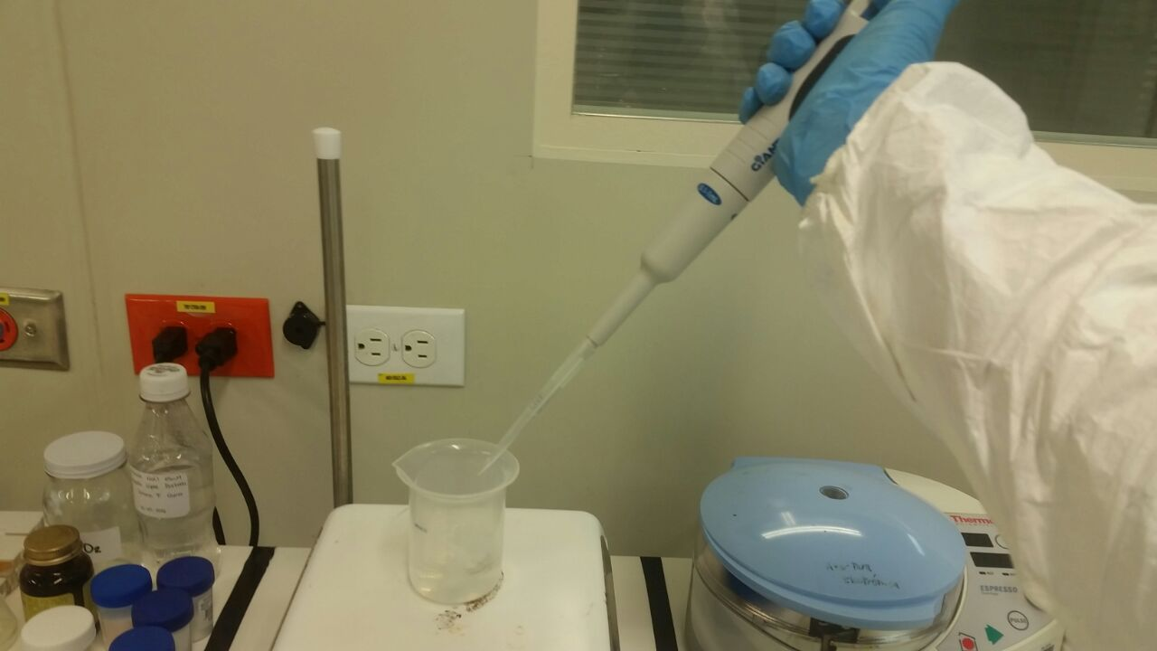

Figure 1: Adding copper sulfate solution to the stirring sodium alginate solution.

1. Using a micropipette, take 600µL of the copper sulfate solution.
2. Quickly add the copper sulfate to the stirring sodium alginate solution as shown in Figure 1.
3. Lower the stirring speed to approximately 1/9.
4. Stir for approximately 30 minutes. (Figure 2).

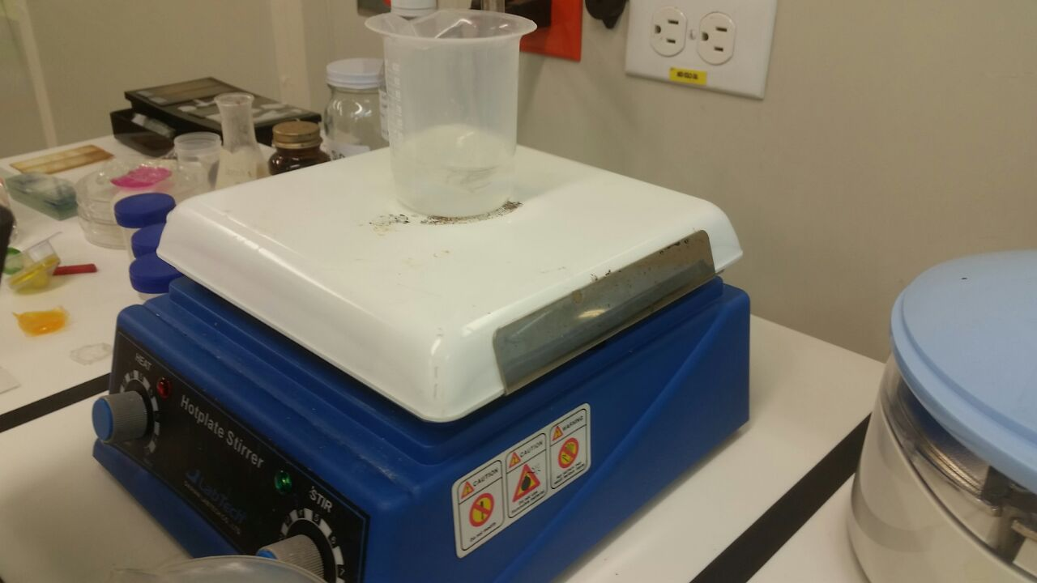

Figure 2: Sodium alginate and copper sulfate solution stirred for 30 minutes.

1. Using a micropipette, take 2 mL of the chitosan solution.
2. Add the 2 mL of chitosan solution not too quickly to the stirring solution of sodium alginate with copper sulfate.
3. Stir for approximately 30 minutes at 1/9 stirring speed.
4. Let the solution stand for at least one day. You will notice a thin white layer appearing at the bottom of the container.
5. The bottom layer contains the alginate and chitosan microcapsules. These can be stored in the solution*.*

## 4.3. OBSERVATION OF THE MICROCAPSULES

1. Centrifuge the solution with the microcapsules to concentrate them.
2. Take a small sample of the solution from the bottom of the beaker.
3. Place the sample on a microscope slide.
4. Cover the sample of the alginate and chitosan capsules with a coverslip.
5. Place the slide on the inverted microscope.
6. Observe the microcapsules under the inverted microscope. Adjust the light and the microscope objective to obtain the best visualization of the microcapsules*.*

# CHANGE CONTROL

|  |  |  |  |
| --- | --- | --- | --- |
| **CHANGE DESCRIPTION** | **DATE** | **VERSION** | **APPROVED BY** |
|  |  |  |  |