# FUNCTIONALIZATION OF ELECTRODE SURFACES FOR ELECTROCHEMICAL MEASUREMENT

***Version 1.0***

**Produced by: Olga Patricia Fuentes Daza.**

# OBJECTIVE

To present the procedure for functionalizing the surface of electrochemical measurement electrodes.

# REQUIREMENTS

To follow this tutorial, it is necessary to have training in: entry to the Clean Room laboratory, weighing on a precision balance, use of micropipettes.

# SOFTWARE REQUIREMENTS

None.

# STEP BY STEP

## PREPARATION OF SOLUTIONS

With the gold evaporation electrode above the copper layer, it is necessary to attach a molecule that is compatible with Cadmium (Cd) to measure this metal. In this case, the Cysteamine (C2H7NS) molecule is selected.

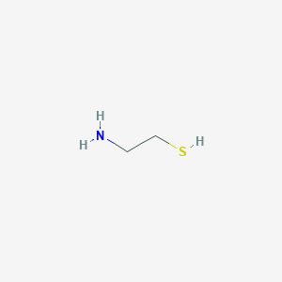

Figure 1: Structure of the Cysteamine molecule.

The process is carried out in the physical and chemical processes room of the Clean Room:

1. Carefully clean the surface of the electrode with 70-90% alcohol.
2. Measure the diameter of the study area of the electrode, which is the distance between the Reference and Counter arcs at the top.
$$d=0.5 cm=5 mm$$

3. Determine the Surface Area using the following formula:
$$A_{s}=π{\left(\frac{d}{2}\right)}^{2}$$

$$A_{s}=π{\left(\frac{5 mm}{2}\right)}^{2}$$

$$A_{s}=19,63 {mm}^{2}$$

4. It is recommended to visit the link https://pubchem.ncbi.nlm.nih.gov/, search for the name of the molecule you want to work with. In the case of Cysteamine, the following data is available:

* Topological Polar Surface Area: $A_{sCyst}=27 A^{2}$
* Density= $0,97 g/{{cm}^{3}}$
* Molecular Weight= $77, 15 g/{mol}$
* Soluble in etanol

Determine how many Cysteamine molecules fit on the electrode by dividing the surface area of the electrode by the surface area of Cysteamine:

$$\frac{A_{s}}{A_{sCyst}}= \frac{19,63 {mm}^{2}}{27 A^{2}{\left(\frac{1 mm}{1* {10}^{7 }A}\right)}^{2}}=7,272,205.217 Cysteamine molecules$$

1. Multiply the number of Cysteamine molecules needed by 3, as the chemical reaction is not 1:1, so a minimum excess of molecules must be ensured.
$$Excess=7,272,205.217 *3=21,816,615.65$$

$$Excess≈2,2* {10}^{7} Cysteamine molecules$$

2. To know how much reagent is needed, it is necessary to convert the number of molecules obtained to moles of the reagent:

$$Moles=2,2* {10}^{7}molecules\left(\frac{1 mol}{6,022* {10}^{23} molecules}\right)$$

$$Moles=3,65* {10}^{-17} Mol of Cysteamine$$

Convert Moles to grams of Cysteamine.

$$3,65* {10}^{-17}Mol of Cyst.\left(\frac{77,15 g}{1 mol}\right)=2,82*{10}^{-15}g Cysteamine$$

$$2,82*{10}^{-15}g Cysteamine= 2,82*{10}^{-12}mg = 2,82*{10}^{-9}μg$$

1. Use a precipitated glass to add Cysteamine.
2. On a precision balance, measure the weight of the glass together with the Cysteamine. The minimum that could be measured was 5.9 mg.

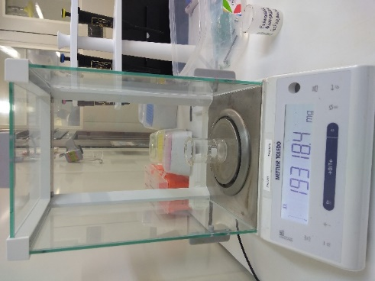

Figure 2: Weighing on a precision balance.

1. Using a micropipette, 3 ml of ethanol is added to the Cysteamine solution and dissolved using the glass stirrer.

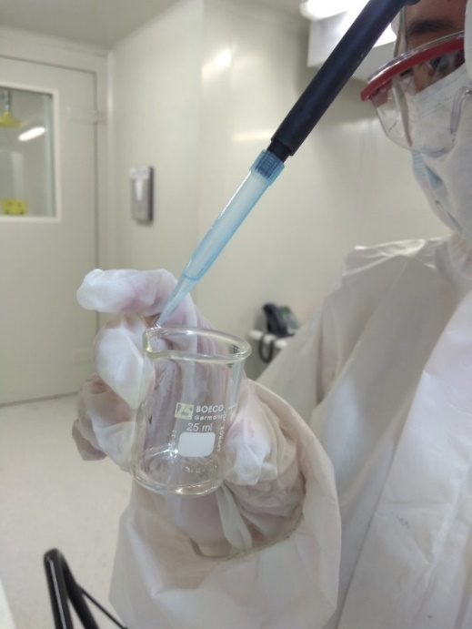

Figure 3: Dissolving Cysteamine.

## FUNCTIONALIZATION OF THE ELECTRODE

1. Using a micropipette, perform a drop size test to determine the amount of drop needed to cover the desired area of the electrode. This will determine that the required drop size is 20 μl.
2. To calculate the concentration of the solution, divide the weight of the Cysteamine used by the amount of ethanol.
$$Concentration= \frac{5,9 mg Cysteamine\left(\frac{1g}{1000mg}\right)}{3ml Ethanol \left(\frac{1l}{1000ml}\right)}$$

$$Concentration=1,96g/l$$

3. Determine the weight of one mole of Cysteamine, which can be obtained from the container in which it is stored, in order to calculate the molarity.
$$Molarity=1,96g/{l*\left(\frac{mol}{77,15 g}\right)}$$

$$Molarity=0,0254{mol}/l=25,49 mM$$

4. With the molarity determined, calculate the number of moles present in the required 20 μl drop to cover the entire desired surface area of the electrode.
$$Number of moles=20 μl*\left(\frac{1l}{1*{10}^{-6} μl}\right)*\left(\frac{25,49mM}{1l}\right)*\left(\frac{1mol}{1000mM}\right)$$

$$Number of Moles=5,098*{10}^{-7} mol of Cysteamine$$

5. Place the electrodes in a hermetic container to prevent rapid evaporation of the applied solution.
6. Organize the electrodes in such a way that they are on a flat surface so that when the drop of Cysteamine is applied, it does not exceed the desired area.
7. Use the micropipette to apply 20 μl of the solution to each of the electrodes.
8. Once the solution has been applied to the electrodes, seal the container and let it sit for 12 hours.

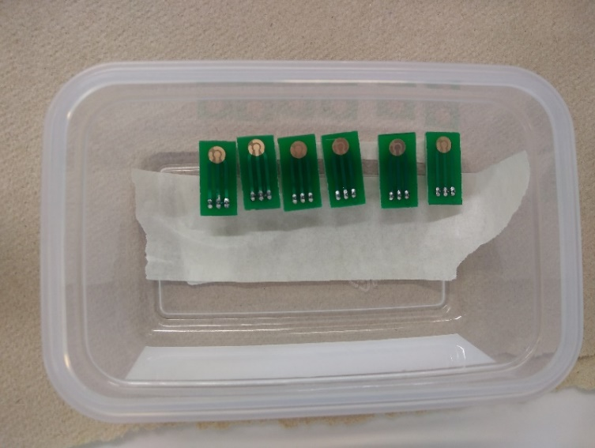

Figure 4: Electrodes.



Figure 5: Application of Cysteamine solution to electrodes.

## CLEANING OF THE ELECTRODES

1. After the reaction time of the solution on the electrodes has elapsed, perform an initial cleaning with ethanol in the flow cabinet. Be careful when applying the ethanol so that the pressure is not too strong and does not break the Cysteamine molecule's bonds.

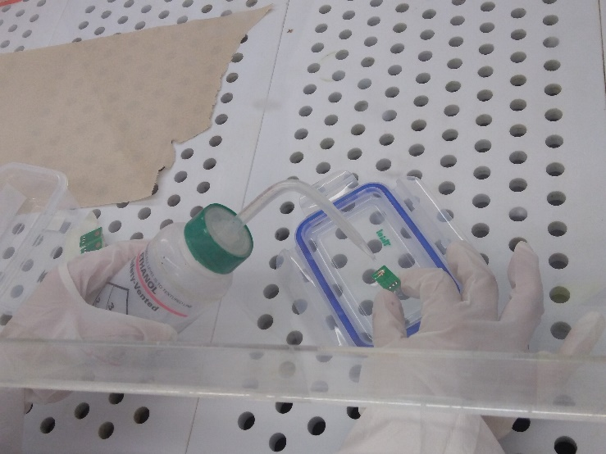

Figure 6: Cleaning the electrode with ethanol.

1. Repeat the procedure with purified water to ensure that the electrode surface is clean.



Figure 7: Cleaning the electrode with purified water.

1. Using the air gun, completely dry the surface of the electrodes.

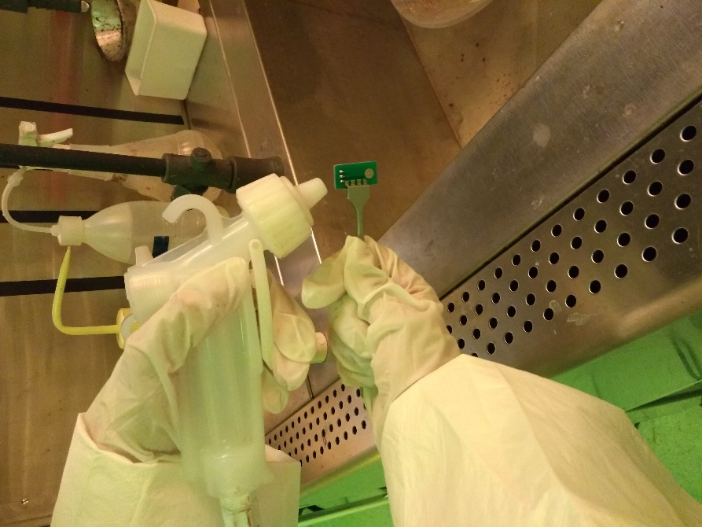

Figure 8: Drying with air gun.

# CHANGE CONTROL

|  |  |  |  |
| --- | --- | --- | --- |
| **CHANGE DESCRIPTION** | **DATE** | **VERSION** | **APPROVED BY** |
|  |  |  |  |