**LITHOGRAPHY PROTOCOL**

***Version 1.0***

**Produced by: María Camila Guachetá Buendía**

# OBJECTIVE

The objective of this protocol is to propose a fast and effective way of doing lithography in the cleanroom laboratory.

# SCOPE

To develop techniques that can be carried out in a cleanroom for the printing of large-scale electronic designs, in order to achieve greater versatility in the technology industry.

# STEP BY STEP

## PREPARATION OF THE MESH

### Context

The materials to be used are:

* Contac.
* Screen printing mesh.
* Wooden frame for screen printing.
* Sewing machine.
* Squeegee.

The mesh consists of a wooden frame with strong joints in the corners and a stretched fabric. The size of the frame depends on the dimensions and quantity of prints to be made, so it should be larger than the total print design.

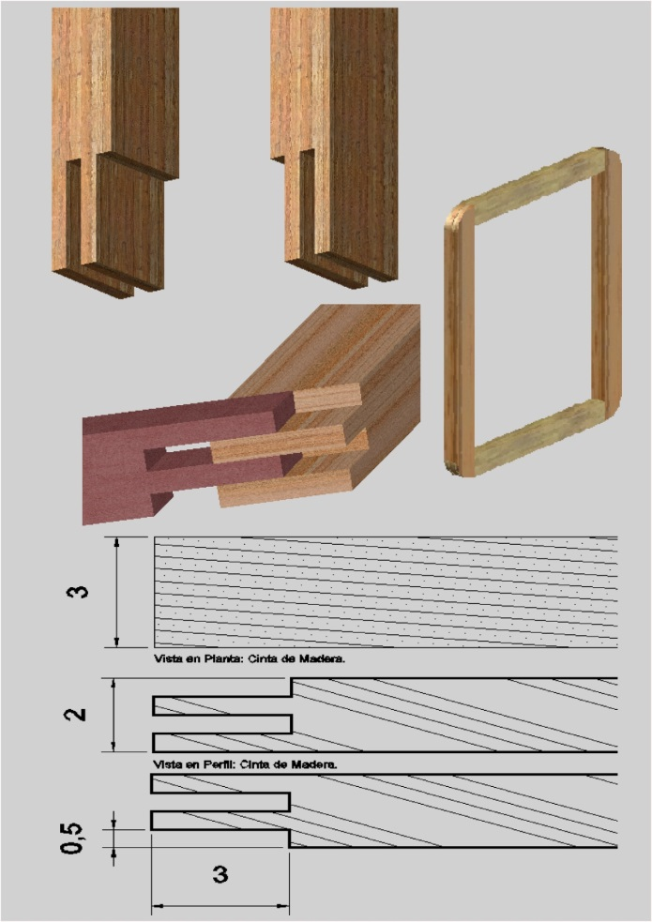

Figure 1: Frame for lithography.

The most commonly used fabrics are nylon and polyester, and the type used for printing is called: LINEN.

The function of the squeegee is to drag the ink across the mesh, thus causing the ink to pass through the fabric and be printed on the desired material. A good print also depends on the correct handling of the squeegee, after dragging the ink, the mesh should be clean, opaque, and without ink drops in the print design area.

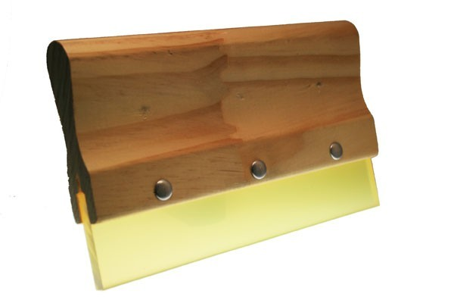

Figure 2: Squeegee.

## MESH TENSIONING METHOD

There are several types of tensioning, however, here we recommend the L and diagonal tensioning. This tensioning is done as follows:

1. First, staple 3 corners, first in one corner, then in the diagonal corner and then in the corner in between these two.

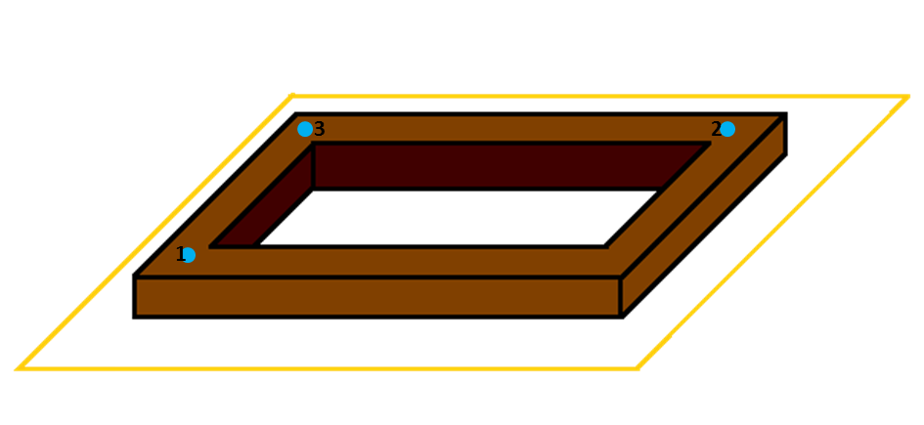

Figure 3: First staple three corners.

1. Then staple the fabric on two sides of the frame forming an L.

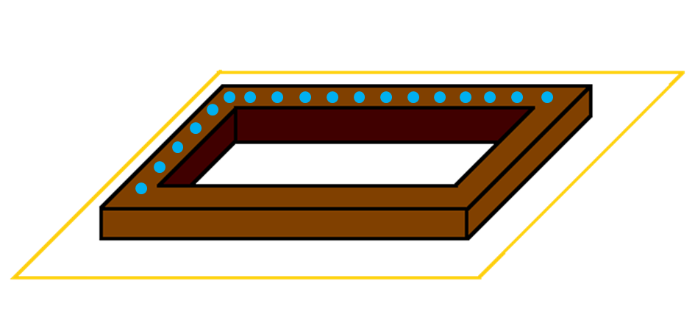

Figure 4: Fabric stapled in L shape.

1. Then lightly stretch diagonally towards the missing corner and staple it.

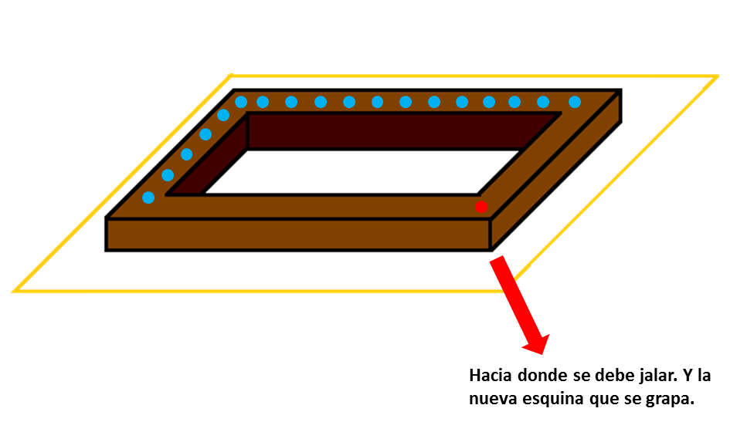

Figure 5: New corner stapled.

1. Tension each of the remaining two sides by stapling in parts.

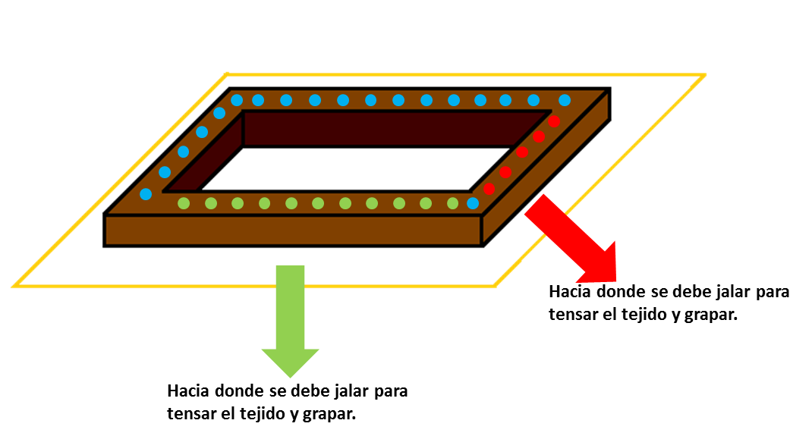

Figure 6: Pull and staple the parts of the fabric that need to be tensioned.

1. The tensioning should be comparable to that of a drumhead. If it is loosely tensioned, this will be noticeable because the fabric will wrinkle.

## MESH SEALING

The materials to be used are:

* Clear peroxide lacquer for wood
* 8 strips of tailcloth or 3 to 4 cm wide and as long as the inner and outer measure of each side of the frame.
* A small one-inch wide brush.

Sealing the mesh is done to prevent ink leakage due to the internal angle formed by the mesh and the frame. The procedure to be followed is as follows :

The lacquer must be thinned with a little thinner so that it runs easily with the brush. Starting from the internal part of the frame, the lacquer is applied with the brush along the side of the frame and over the mesh for about 2cm, a strip of cloth of the corresponding size is taken and placed at an angle with the mesh and the frame. Lacquer is applied again on top until it is well covered. The process is repeated with each missing side.

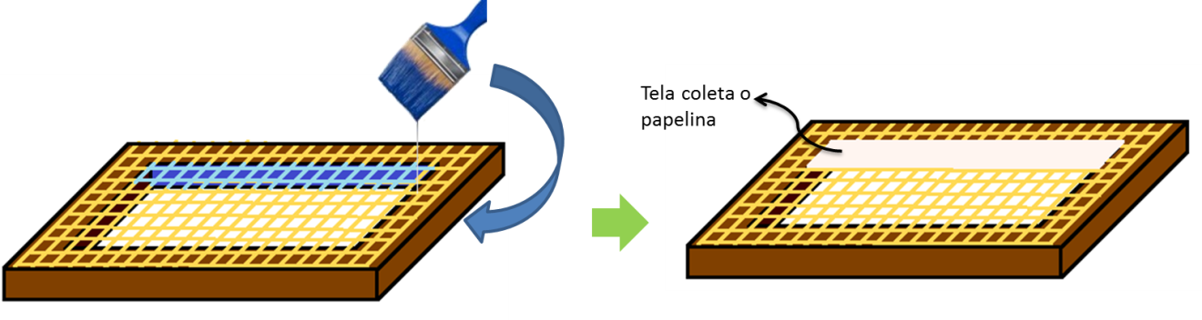

Figure 7: Sealing the mesh on the internal part of the frame.

The frame is turned over and lacquer is applied on one side only over the stapled fabric. Then, the corresponding strip is placed and lacquer is applied again until it is well covered. Finally, the same process must be carried out on each of the other sides.

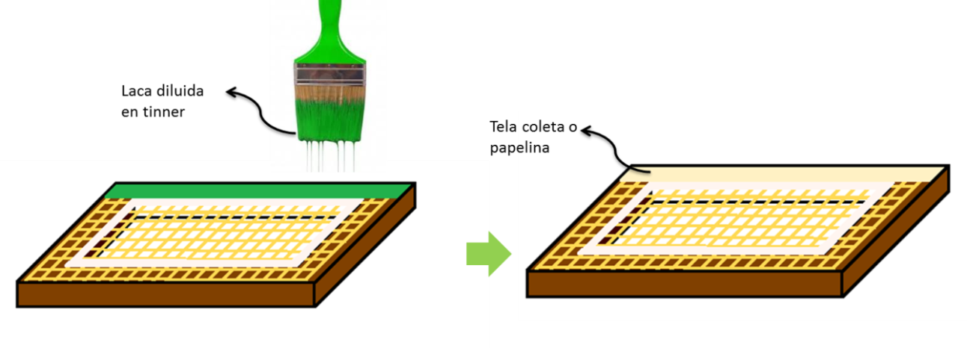

Figure 8: Sealing the mesh on the external part of the frame.

After completing this process, the mesh frame should be covered with contac to allow it to enter the clean room system.

## SCREEN PRINTING WITH LIGHT-SENSITIVE EMULSION

The materials to be used are:

* Positive print design.
* Light-sensitive emulsion.
* Light source.
* Thinner.
* Rags.

The mesh must be degreased, so damp rags with thinner should be used to clean the mesh on both sides. Leave it for about 5 minutes so that the thinner on the mesh has become volatile before proceeding to the next step.

Then, the mesh should be placed horizontally on the table and a little emulsion should be applied on one of the shorter sides of the mesh, lift the mesh a little on the opposite side where the emulsion was applied and use the squeegee to spread the emulsion exerting moderate pressure on the mesh, covering it completely with the emulsion. Any excess emulsion is removed from the squeegee. Then, the internal side of the mesh is observed and the squeegee is passed again with moderate pressure and excess emulsion is cleaned. This last step should be repeated about 10 times on both sides of the mesh until a uniform layer of emulsion is observed.

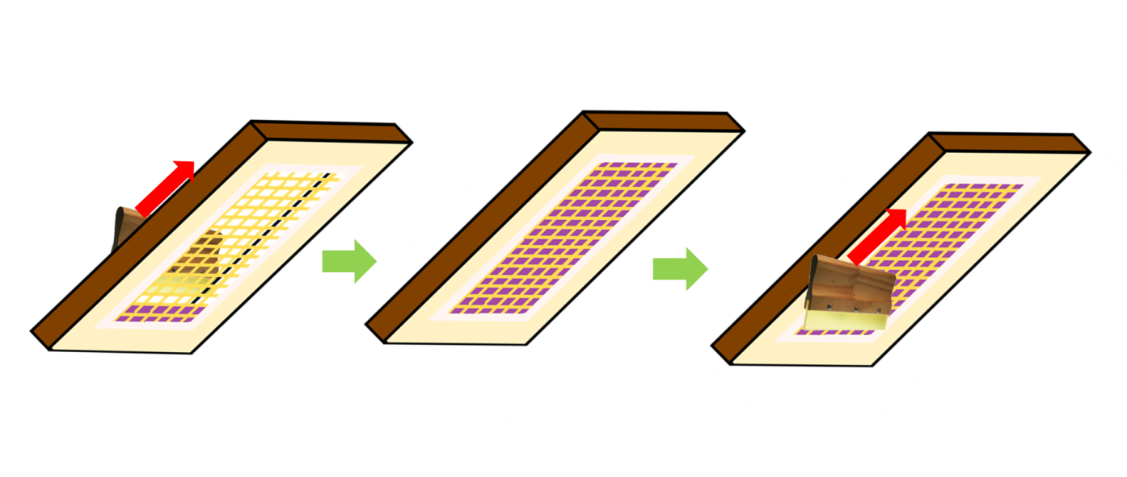

Figure 9: One repetition of spreading emulsion over the mesh

Once the previous step is finished, proceed with drying the mesh. The mixed emulsion is sensitive to light when dry and intense light hardens it. For drying the mesh, it can be left to dry naturally or it can be done with a dryer, but care must be taken not to over dry it as it can damage the emulsion. To check that the emulsion is dry, touch the mesh, and it should not feel sticky and when viewed against a light, it should appear uniform in color.

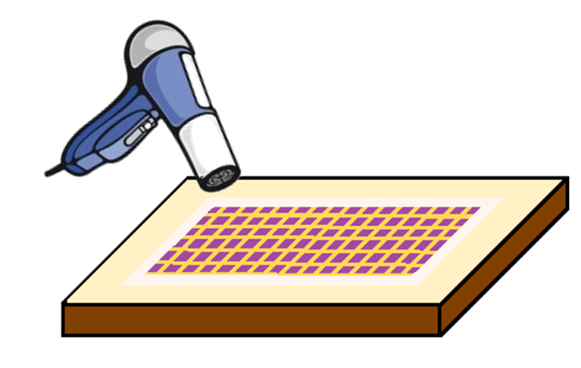

Figure 10: Drying the mesh with a dryer.

## EXPOSING THE MESH TO LIGHT

The materials to be used are:

* A pivot thicker than the frame.
* The frame with the mesh already screen-printed.
* The design to be printed in black and white in positive. A vector or pixelated design program can be used to create the desired design. (The positive design must be printed on a transparent surface of acetate, making sure that the black is completely black).
* A glass sheet larger than the frame and heavy.

First, place the book or foam on the table, then place the frame with the mesh already stretched on top of it, followed by placing the acetate with the positive design you wish to print on top of that. Then place the glass sheet on top and a halogen lamp (with these lamps, the exposure process is shorter) of 500W or more at a distance equal to the diagonal of the positive. For better contact, pressure is applied to the end of the glass.

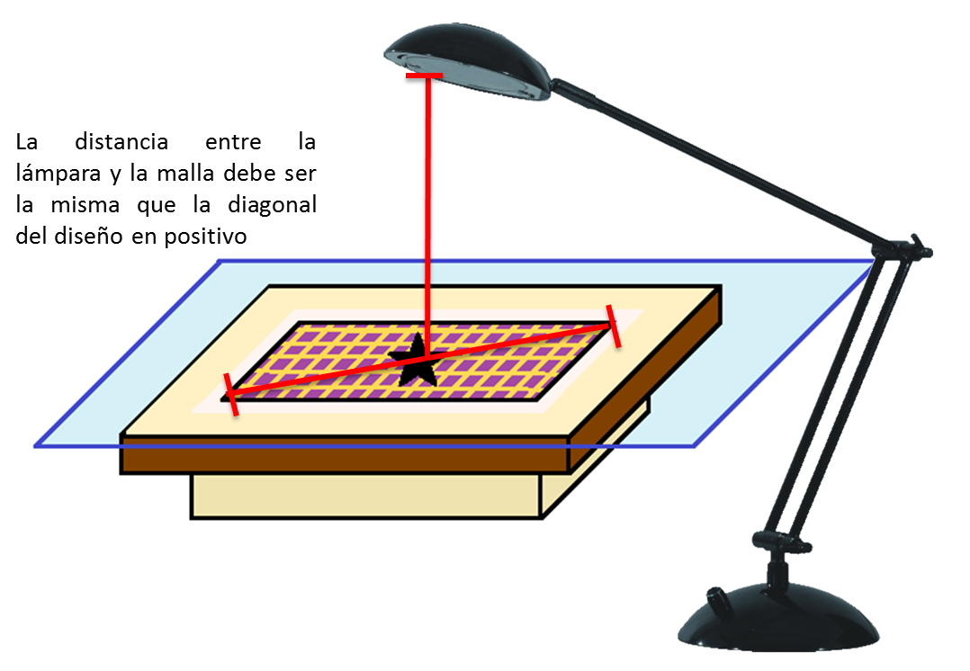

Figure 11: Exposure of the mesh to light.

*Note: Several exposures must be made beforehand to measure the exact time for a perfect exposure*.

## REVELATION OF THE MESH WITH WATER

Immediately after exposure, wash the mesh with pressurized water on both sides, removing all the remaining sensitizing agent, and gently rubbing the mesh with your fingers for a few minutes. Continue washing with pressurized water until all the emulsion is removed from the parts that correspond to the positive, precisely where the light did not reach the mesh.

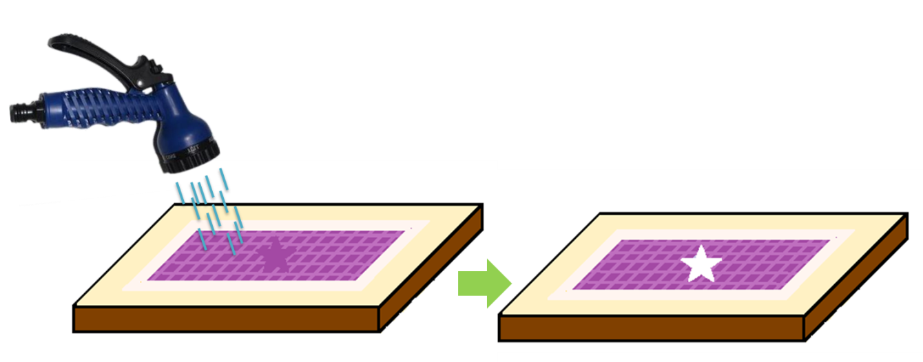

Figure 12: Mesh revelation with water.

## DESIGN PRINTING

The materials to be used are:

* Conductive paint.
* Brush.
* Sheet of paper.
* Mesh with revelation.

For the design printing, a conductive paint must be used. There are conductive paints based on water and oil. Water-based paints are usually made with graphite, which provides good conductivity. However, if you want to make the paint even more conductive, you can scrape copper or other metals and mix them with the paint, but keep in mind that this "shavings" obtained from scraping the metals must be smaller than the holes in the mesh. A recommended option is commercial silver paint.

1. First, attach a paper to the mesh in the following way:

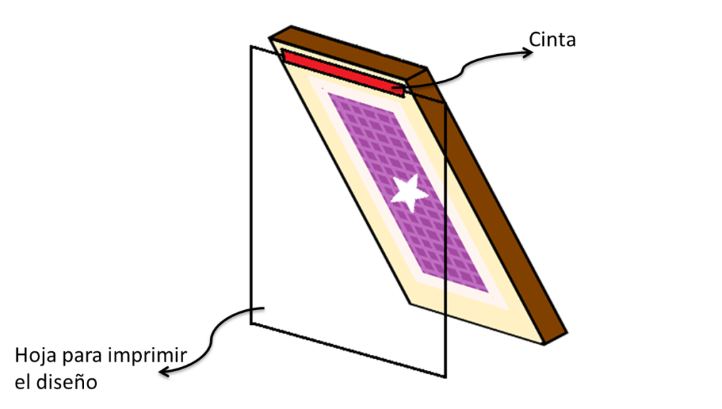

Figure 13: Mesh with sheet for design printing.

1. Apply the paint on the lower part of the design, otherwise, the pores of the design can be covered.
2. Load the paint with the brush by applying constant pressure from bottom to top

.

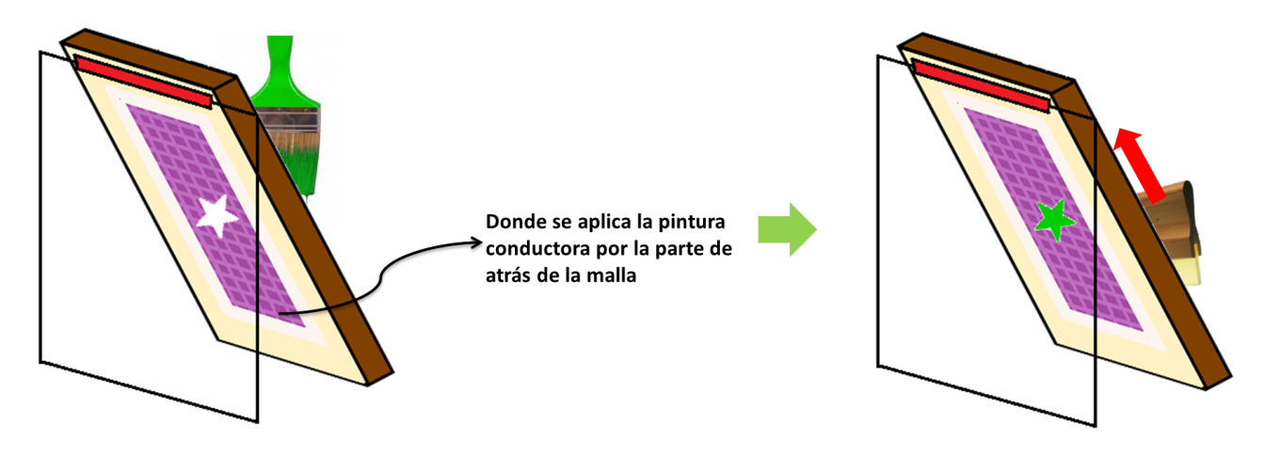

Figure 14: How to apply and spread the conductive paint.

1. After loading the paint on the design, lower the frame and apply pressure to prevent it from moving. Then, brush in the same direction in which the ink was loaded to print.

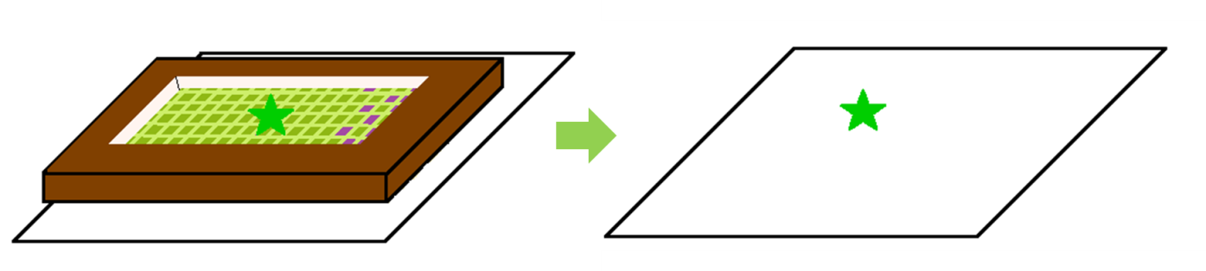

Figure 15: Design printing on paper.

## CLEANING OF THE MESH

The materials to be used are:

* Thinner or water (as appropriate).
* Cleanroom paper (for cleaning).
* Gloves.
* Plastic container.

For cleaning the mesh, first, it must be taken into account what the base of the paint used was. If a water-based paint was used, the mesh will be cleaned with water, but if an oil-based paint was used, the mesh will be cleaned with thinner. After making this clear, the mesh is placed inside the container, and with gloves on, the cleaning paper is dampened and passed over the mesh until it is clean (you can use your fingers to rub and remove the paint from the mesh).

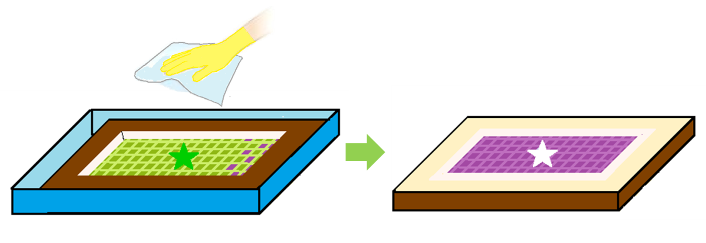

Figura 16: Mesh cleaning.

# CHANGE CONTROL

|  |  |  |  |
| --- | --- | --- | --- |
| **CHANGE CONTROL** | **DATE** | **VERSION** | **APPROVED BY** |
|  |  |  |  |