**DISCRETE DEVICES PROTOCOL ON FLEXIBLE MATERIALS**

***Version 1.0***

**Produced by: María Camila Guachetá Buendía**

# OBJECTIVE

The objective of this protocol is to propose an economical and fast way of creating mixed microchannels inside thermoformable materials.

# SCOPE

To develop innovative techniques that allow for greater versatility in the technology industry. As mixed devices (microfluidics mixed with discrete electronics) are being used, a new way of sensing microfluids in a three-dimensional manner is being proposed.

# STEP BY STEP

## MATERIALS PREPARATION

The materials to be used are:

* Contac
* Scissors
* Hot glue gun
* Copper wire
* Hotplate
* Aluminum foil
* Tape
* Copper sheet
* Adobe Illustrator
* Dropper
* Sulfuric acid
* Gloves.

## SILICONE CURING

Cut two rectangles from the contact paper: one of (4 x 8)cm and another larger one of (6 x 10)cm.



Figure 1: First step with contact paper.

Fold the two rectangles as indicated by the dotted lines in the following image:

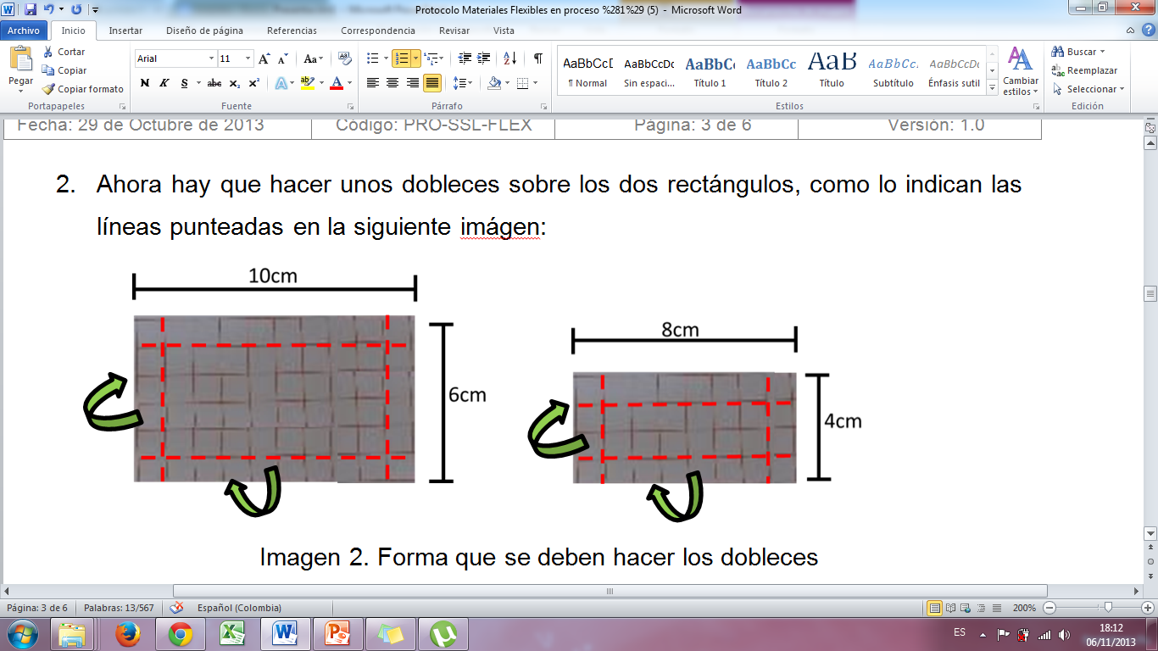

Figure 2: How to fold the paper.

Then, remove the contact paper, that is, only use the paper with the margin.



Figure 3: Paper to be used.

Next, make boxes with the margin paper. These boxes should be made as follows:

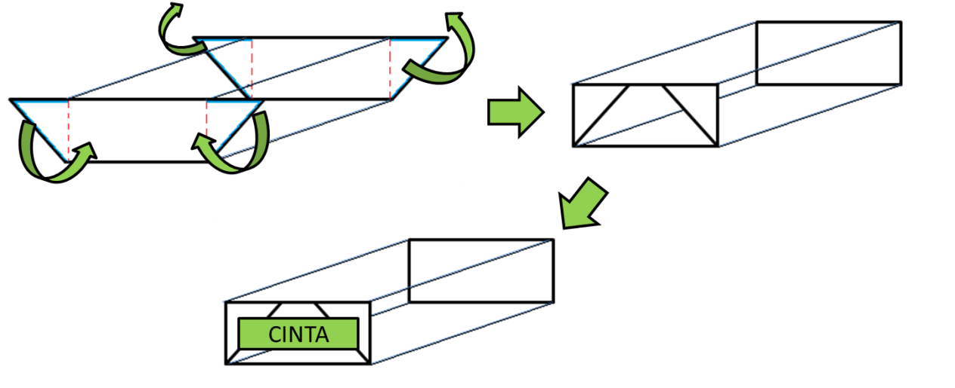

Figure 4: Steps to make the box.

Cut pieces of silicone to fill the smaller box, like this:

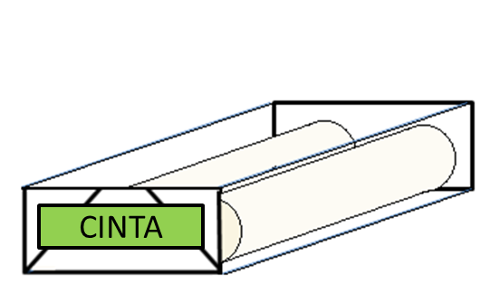

Figure 5: How much silicone is needed.

Heat the hotplate to 140ºC.

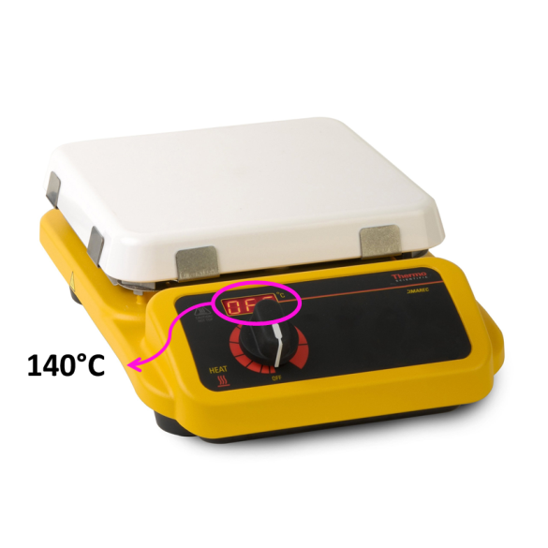

Figure 6: Hotplate temperatura.

Once the hotplate is heated, place the small box with the silicone inside and covered with aluminum foil for 6 minutes.

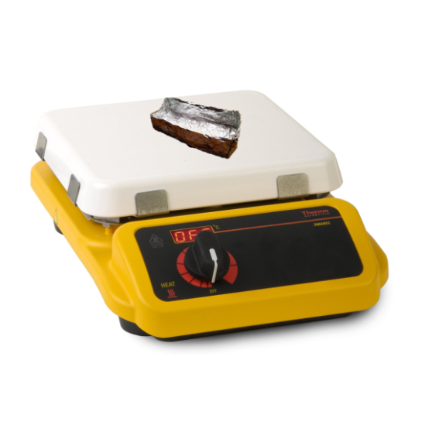

Figure 7: How to cover the box with the melted silicone with aluminum foil.

After 6 minutes, remove the box from the hotplate, remove the aluminum foil, and incorporate the cable, coils, or capacitances previously made into the melted silicone, so that these elements are submerged in the silicone and leveled.

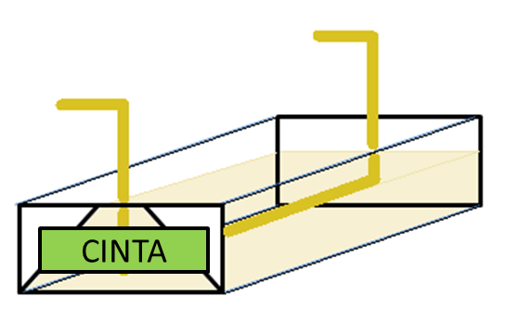

Figure 8: Cable submerged in the melted silicone.

Turn the box over and place it back on the hotplate, covered with aluminum foil, and wait for 2 minutes. (Refer to Figure 8 to cover the box with aluminum foil in the same way.)

After 2 minutes, remove the box and let it cool for 5 to 10 minutes.

To obtain a thinner sample, remove the sample from the smaller box and place it in the larger box. Cover the box with aluminum foil and place it back on the hotplate for about 5 minutes.

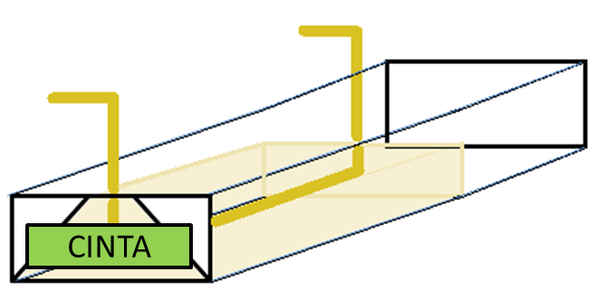

Figure 9: Illustration of how the silicone that was molded in the small box will look in the large box.

After 5 minutes, turn off the hotplate so that the sample cools slowly, and then remove the box.

Wait for the sample to be able to be removed from the box without much force, and with this, the unwanted cables can be removed or the desired microchannels can be created.



Figure 10: Process to finish the microchannel.

## INDUCTORS

To create inductors, two copper wires are needed, one to become the core and the other to become the winding.

The wire that will become the core needs to be tempered. Adjust the wire that will become the winding as well, as shown in the following system.

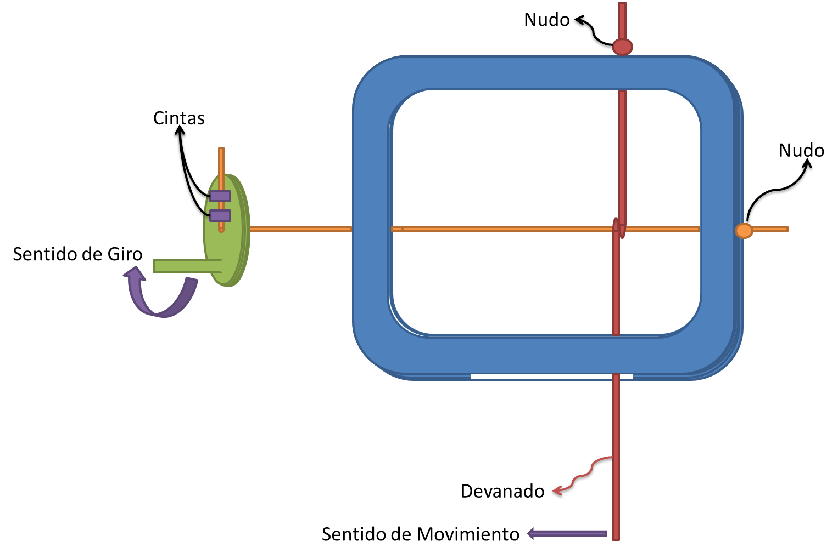

Figure 11: System for creating inductors.

These knots are used to tighten the copper wires. After assembling the system shown in image 11, it should be placed under the microscope and the image on the microscope adjusted. This is to have a clear image of the inductance and the turns of the winding needed.

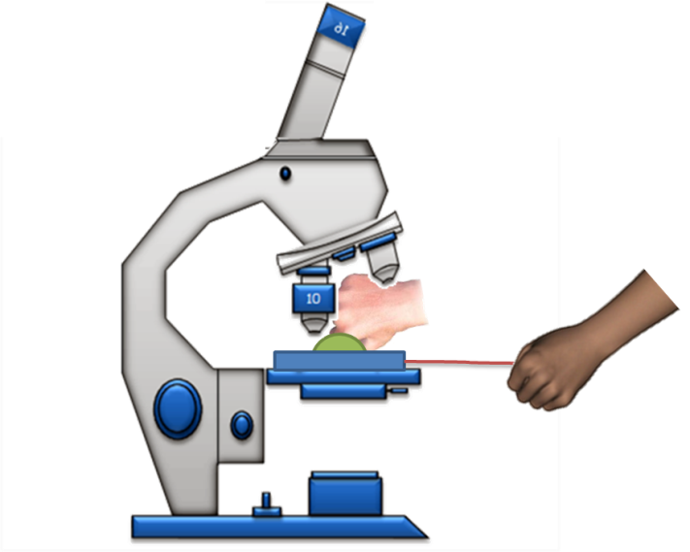

Figure 12: System for creating inductors under the microscope.

After this, it is possible to start turning the crank and tempering the winding wire while slowly moving to create the inductor.

When the desired inductor is finished, the microscope system is removed, the knots and tapes are loosened, and the inductor is removed.

## SUBSTRATE CREATION

There are two procedures for creating the substrate.

### Procedure 1: Gerber

In this procedure, the substrate is first fabricated and then the PCB design is created on it. To fabricate the substrate, the copper sheet should be cleaned with a degreaser, dried, and cut so that it can be placed in the base of the silicone curing boxes.

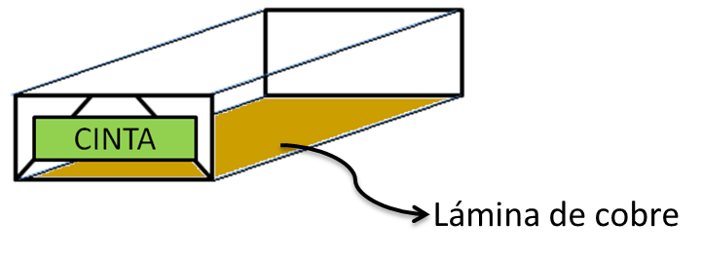

Figure 13: Copper sheet in the box.

Subsequently, the procedure for curing the silicone is followed, but no other component is added (at 140ºC for 6min on the hotplate).

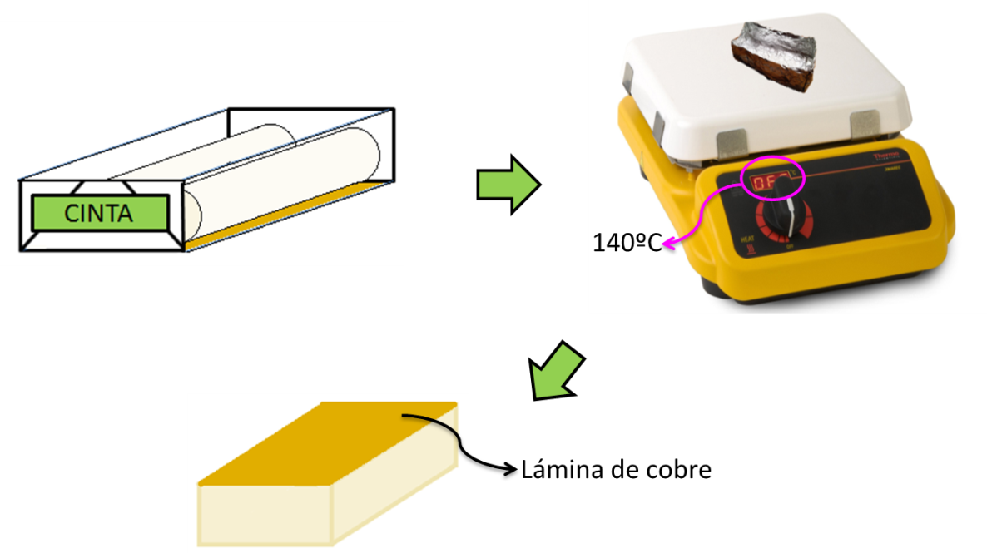

Figure 14: Process for creating the substrate.

The PCB design is also created in a specialized program for this purpose (Eagle, Kicad), and the Gerber files that are necessary for PCB fabrication on the substrate are generated.

Then, the substrate is taken to the printed circuit board (PCB) manufacturing room (Basement 1), and the Gerber files are sent to make the entire PCB fabrication process. All that remains is to wait for the entire PCB to be completed and for an email indicating that it can be picked up at the electronics laboratory. Once the substrate is obtained, standard PCB manufacturing procedures will be carried out.

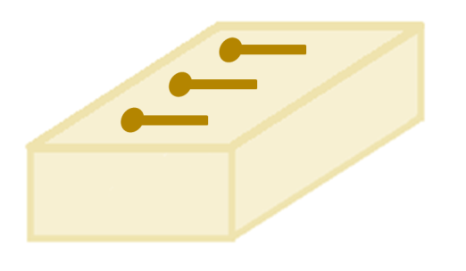

Figure 15: Final result of substrate with PCB design.

### Procedure 2: Cut Vinyl.

In this procedure, the PCB design is created first and then the substrate is created. The PCB design can be created in vector design programs such as AutoCAD, Adobe Illustrator, or specialized PCB design programs that allow exporting the contour of the figures. Once the design is ready with a precise line, it will be printed on cut vinyl.

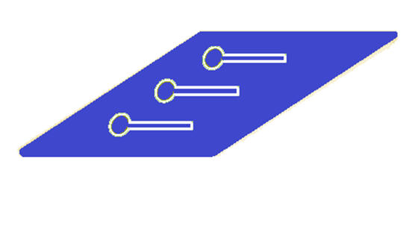

Figure 16: Design on cut vinyl.

This will resemble a sticker that will be placed on the copper sheet that must have been cleaned with degreaser and dried without rusting beforehand. Once the substrate is obtained, standard PCB manufacturing procedures will be carried out.

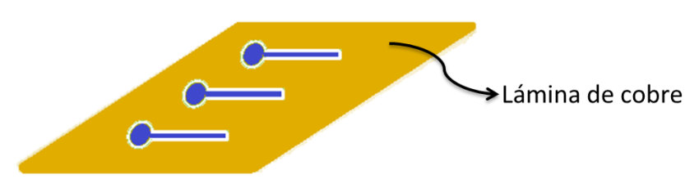

Figure 17: Design of cut vinyl stuck on the copper sheet.

Subsequently, when the previous step is completed, the PCB design is collected, the layer of cut vinyl, which protected that part of the copper sheet from the attack carried out in the PCB manufacturing room, is removed, and the PCB design on the copper sheet is cleaned with sulfuric acid.

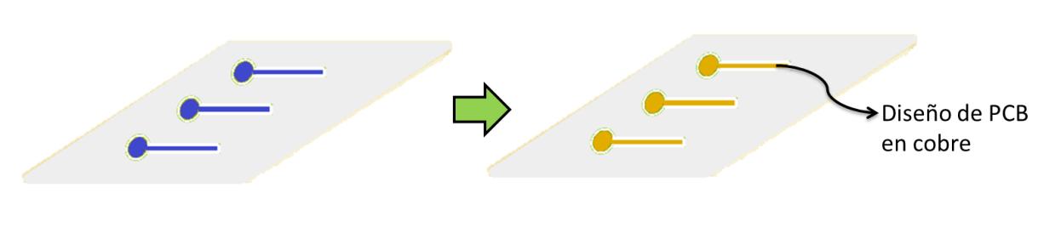

Figure 18. Result after attack in the PCB manufacturing room.

This is carried out as follows: Protective gloves are put on to handle acids. Then, using a dropper, sulfuric acid is applied onto the copper sheet that already has the PCB design. With this, the system is ready to be put for the silicone curing, and in this way, the substrate already has the PCB printed on it (This is done in the same way as Procedure 1: Gerber explained how to create the substrate). In this way, the copper is cleaned, but before printing the design.

## RESISTANCE

Resistors are manufactured using a fluid. For the manufacture of these resistors, first, the PCB is made on the substrate as explained in section 3.4 by either of the two procedures explained there. To obtain such a design:

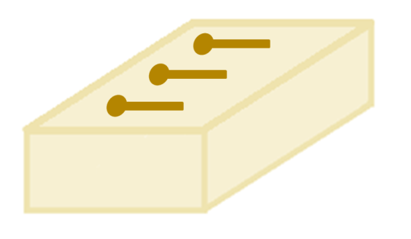

Figure 19: Result of the substrate with PCB design.

Then, a thinner layer of silicone must be made. Later, a wire is placed on top of the thinner layer of silicone so that it remains halfway inside and halfway outside that layer. (Without removing it from the Hotplate).

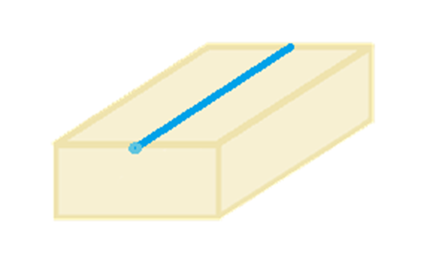

Figure 20: Curing silicone with wire halfway submerged in the silicone.

Now, the side with the PCB design is placed on the base of the box used in the silicone curing, and it is put in the Hotplate for 30 seconds at 140ºC.

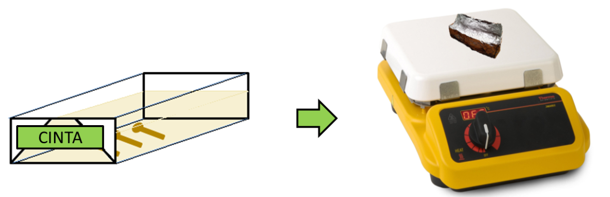

Figure 21: Procedure for melting the top layer of the substrate with PCB design.

Then, remove it from the Hotplate, and take out the substrate that has the PCB design and place it in the same direction on the thinner layer of silicone that has the blue wire quickly. This is to unite these two layers and be as follows:

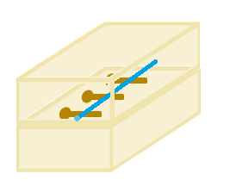

Figure 22: Final result of the resistors.

And wait for it to dry well, and then remove the blue wire with pliers and insert the pinheads so that they make contact with the PCB pads and thus be able to measure the resistance between different distances of the PCB.

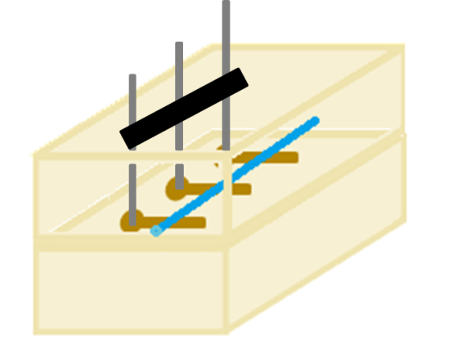

Figure 23: Resistors in Flexible Materials with Pinheads.

## CAPACITORS

In capacitors, the procedure is basically the same as that used for resistors, with the only difference being that two substrates with PCB designs are needed. These are heated as shown in section 3.4 with resistors (Image %%). They must be joined by the side that is more melted, i.e., the side that was at the bottom of the box placed in the Hotplate. When joining these two substrates, a wire must be placed in the middle, obtaining the result that can be seen in image 25. Finally, all that is left is to place the pinheads and remove the wire with pliers.

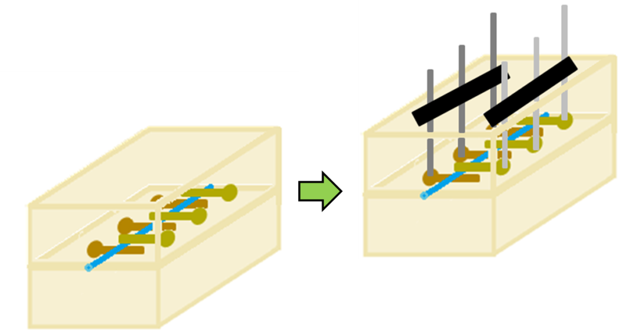

Figure 24: Capacitors in Flexible Materials with Pinheads.

# CHANGE CONTROL

|  |  |  |  |
| --- | --- | --- | --- |
| **CHANGE DESCRIPTION** | **DATE** | **VERSION** | **APPROVED BY** |
|  |  |  |  |