**PROTOCOL FOR THE USE OF PLASMA CLEANER WITH GLASS AND PDMS**

***Version 1.0***

***Produced by: Zahira Itzel González Cleves***

# OBJECTIVE

To show the Uniandes community the procedure to follow in the use of the plasma cleaner.

# SCOPE

To inform the Uniandes community of the procedure to follow for sealing glass and PDMS microsystems.

# CONDITIONS OF USE OF THE PLASMA CLEANER

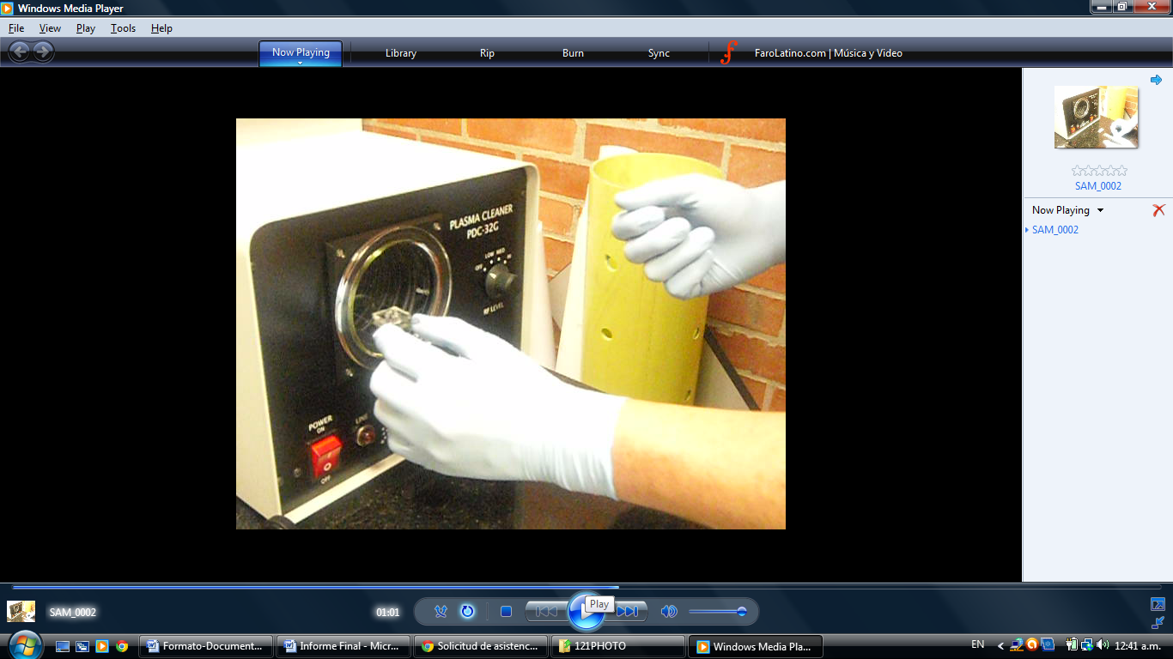

Figure 1: Photo of the Plasma Cleaner.

**Important:**

Remember to always use powder-free gloves throughout the process and ensure that there is no dirt inside the Plasma Cleaner chamber.

## PREPARATION OF SAMPLES

1. Cover the PDMS pieces with transparent tape to remove impurities and then remove the tape.



Figure 2: Cleaning of PDMS.

1. Clean the glass pieces with alcohol (ethanol) and dry them with compressed air.

## USE OF THE PLASMA CLEANER

1. Cleaning: always have a clean piece of aluminum foil covering the chamber entrance and lid. Also, have one on a clean surface while the plasma is not in use.
2. Turn on the plasma a few minutes before use.
3. Take into account the configuration of your microsystem. Figure 3 shows a microsystem consisting of a glass slide on which a PDMS layer is located.

Diapositiva2.TIF

Figure 3: Example of microsystem configuration.

1. In some cases, microchannels are fabricated in the glass, and in others, they are etched into the PDMS. In either case, the microchannels are located between the top side of the glass and the bottom side of the PDMS (Figure 4).

Diapositiva1.TIF

Figure 4: Description of the parts of the microsystem.

1. Inside the plasma cleaner, position the two pieces (glass and PDMS) so that the surfaces to be joined are facing upwards. That is, the top side of the glass and the bottom side of the PDMS should be facing upwards (Figure 5).

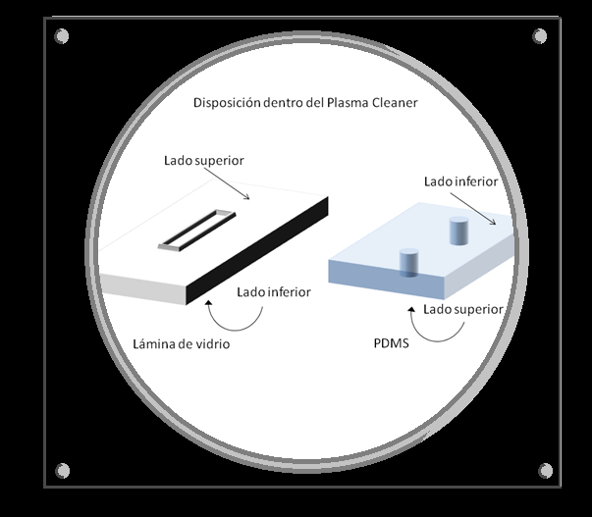

Figure 5: Placement of the pieces inside the plasma cleaner.

1. Turn on the vacuum pump.
2. Put the plasma lid on and at the same time slowly open the vacuum valve going to the plasma until it is alone. Make sure the air inlet on the lid is closed.
3. Wait one minute.
4. Turn on the plasma at medium power for the necessary time (1:30 for PDMS), ensuring that the plasma has ignited (purple/pink glow).
5. Turn off the plasma and close the vacuum valve before turning off the pump.
6. Turn off the vacuum pump.
7. Open the lid knob slowly by turning the main valve so that air enters slowly. Hold the lid so it doesn't fall. The air must be filtered by a 0.2 filter.
8. Remove the samples.
9. Join the glass piece with the PDMS piece, making sure to align the inputs and outputs.

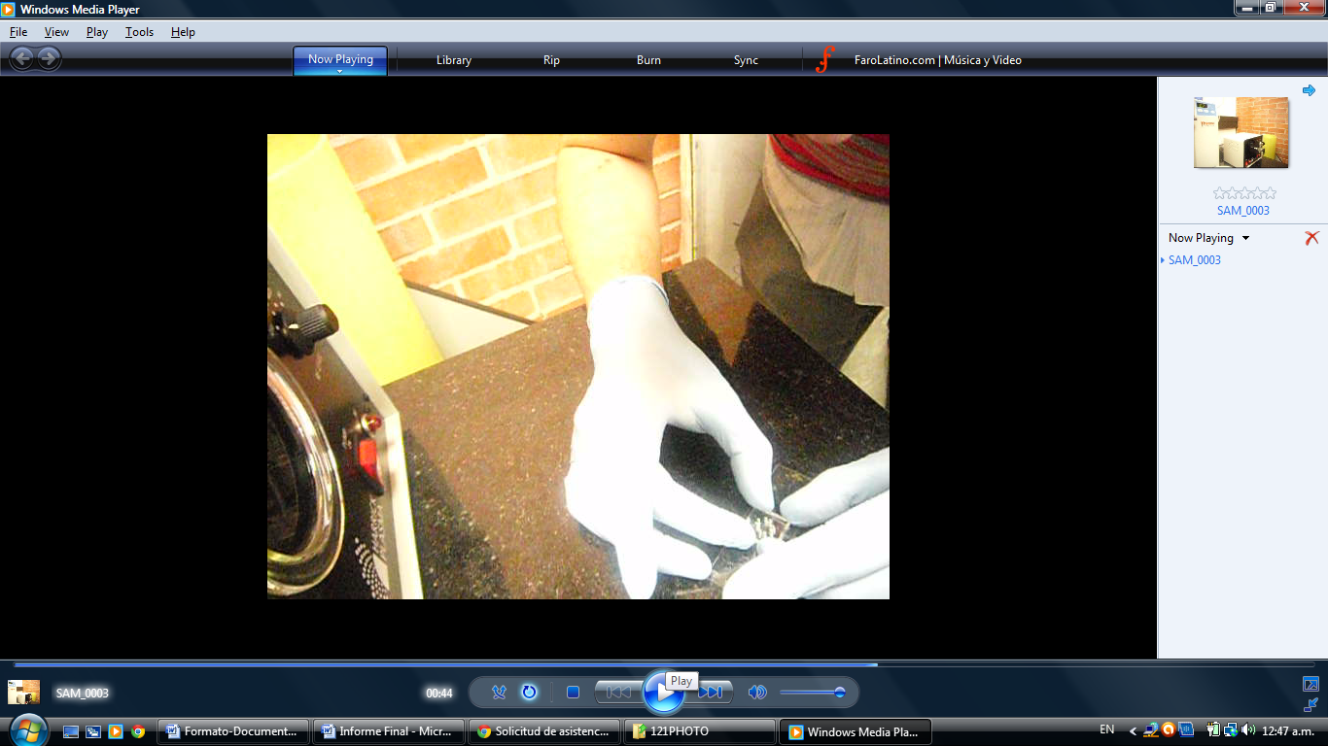

Figure 6: Joining the pieces.

1. Heat the microsystem on a Hot Plate for 15 minutes at 100˚C.

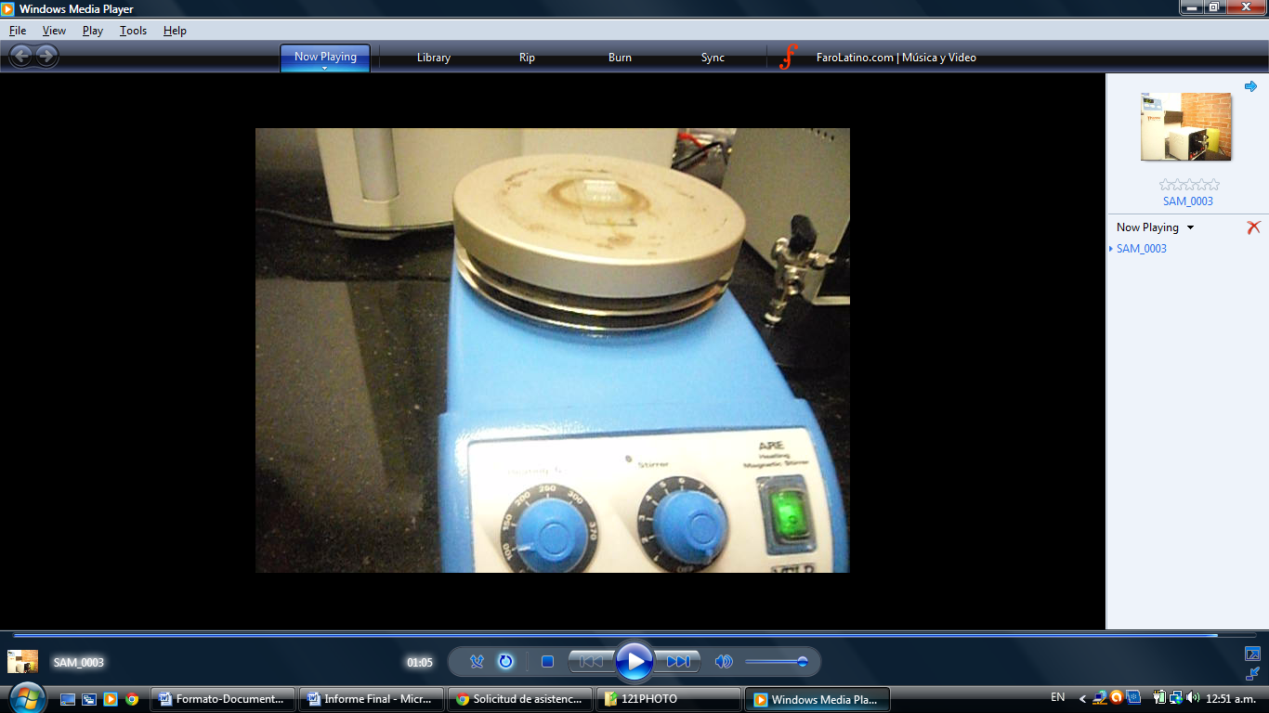

Figure 7: Heating the microsystem.

1. Cover the plasma with aluminum foil again and put the lid on, also clean.

# CHANGE CONTROL

|  |  |  |  |
| --- | --- | --- | --- |
| **CHANGE DESCRIPTION** | **DATE** | **VERSION** | **APPROVED BY** |
|  |  |  |  |