# MANUFACTURING OF MICROREACTOR FOR MAGNETIC NANOPARTICLE SYNTHESIS

***Version 1.0***

**Produced by: Simón Gómez Rosselli.**

# OBJECTIVE

The aim is to assemble a reactor that can produce magnetite at a nano-scale.

# REQUIREMENTS

To assemble the reactor following this guide, it is necessary to have knowledge in the preparation of solutions at a given concentration.

# EQUIPMENT REQUIREMENTS

Laser cutter, present in Ml 304. Cole-Parmer dual-syringe pump, present in ##. 10 ml syringes.

# STEP BY STEP

## LASER CUTTING

The first step in the production of the reactor is laser cutting, which involves cutting the pieces. This particular reactor consists of three pieces: two covers and the reaction volume. This part of the process is not explained in this guide since the equipment requires training by a student who has already been trained to use it during their career.

***Pieces obtained by laser cutting***

Bottom cover

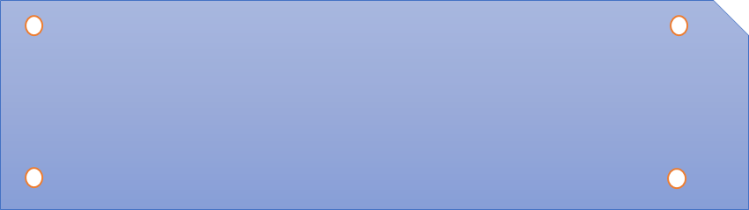

Intermediate piece

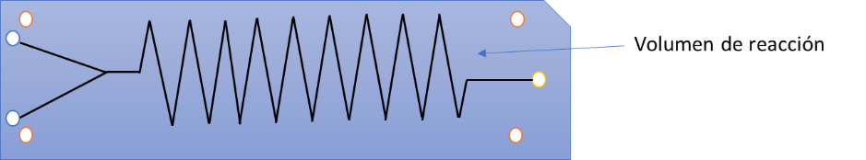

Top cover

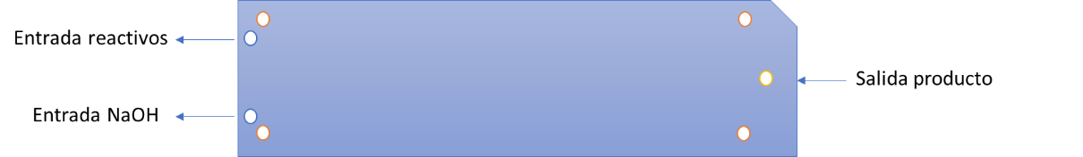

Figure 1: Reactor pieces

*Where the colors of the spaces in the diagrams represent:*

Screw space

Chemical inlet (reactants and pH control)

Product outlet

## ASSEMBLY

For the assembly process, the following materials are required:

* Top reactor cover
* Intermediate reactor piece
* Bottom reactor cover
* Methylene chloride (acrylic adhesive)
* Screws with their respective nut, diameter of screw space X4
* Plastic tubes of the diameter of the reactor inlet and outlet X3
* Metal container with an area larger than the reactor pieces, 5 cm in length.
* Metal tweezers
* Weight (metal bar weighing over 1Kg)
* Liquid silicone
* Metal rivet X3

The steps are as follows:

1. Remove excess acrylic pieces from the cut spaces (such as screw spaces and reaction volume. For the reaction volume, it is better to puncture the corners or tips of the volume with a needle)
2. Place the screws in the screw spaces of the bottom cover.
3. Place the bottom cover with the screws on the table, with the heads of the screws facing up.
4. Take the metal container and pour enough methylene chloride onto it so that the entire base contains adhesive. The following steps need to be done quickly as methylene chloride evaporates.
5. Take the tweezers and grab the intermediate piece of the reactor, then place it on the adhesive. Leave it there for a minute.
6. Place the intermediate piece on the bottom piece so that the screws also fit into the screw spaces of the intermediate piece.
7. Place the weight on the pieces evenly. Leave the weight for two minutes.
8. Take the reactor cover with the tweezers and repeat the same procedure, ensuring that the inlet and outlet spaces of the reactor match the other pieces.
9. Save the leftover adhesive in the adhesive jar.
10. Tighten the screws with the nuts.
11. Apply liquid silicone to the underside of one of the plastic tubes, being careful not to block the hole, and place it in the reactor outlet hole. Press it with your hand for a minute.
12. Repeat the previous step for the inlets.
13. Place a metal rivet in the outlet of each tube.

***Note****: If there is any doubt about the language regarding the spaces of the reactor, refer to figure 1.*

To finalize the assembly of the reactor, it is necessary to check for leaks. Therefore, it is necessary to follow the following steps.

1. Grab a syringe.
2. Add a volume of water greater than 5 ml.
3. Connect the syringe to one of the rivets.
4. Slowly empty the syringe in order to observe if the water leaks out.

***Note:*** If water leaks out, it is necessary to perform a bonding procedure with methylene chloride, just like the one that was already performed, but in order to bond all sides of the reactor***.***

The assembled reactor should look something like this.



Figure 2: Finished product.

Where the colored spaces have the same meaning as in figure 1 and the tubes represent the plastic tubes with their respective rivets.

## PREPARATION OF REAGENTS

## SET-UP OF THE SYRINGE PUMP

The syringe pump is a fundamental equipment for the use of the nano particle reactor since it ensures a constant flow for prolonged periods, which cannot be achieved using a syringe with the hands. This experiment requires a double syringe pump since it needs an input of reagents and a pH control input.

* + - 1. To begin the syringe pump set-up, it is first necessary to fill the 10 ml syringes with the reagents and NaOH and connect them to the respective reactor rivets.
      2. Once this has been done, the process of mounting the pump will begin as shown below.
      3. First, it is necessary to mount the syringes on the pump, so it is necessary to loosen the upper right screw of the pump by turning it to the left.



Figure 3: Upper part of the syringe pump.

* + - 1. To begin the syringe pump set-up, it is first necessary to fill the 10 ml syringes with the reagents and NaOH and connect them to the respective reactor rivets.
      2. Once this has been done, the process of mounting the pump will begin as shown below.
      3. First, it is necessary to mount the syringes on the pump, so it is necessary to loosen the upper right screw of the pump by turning it to the left.



Figure 4: Top view of the syringe pump..

The main menu of the pump is shown in figure 5.



Figure 5: Syringe pump main menu.

* + - 1. As seen in the previous figure, there are 4 important steps in the set-up that need to be considered. The first step, in orange, consists of determining the type of operation that is desired. When this button is pressed, the following is displayed.



Figura 6: Tipo de operación bomba de jeringa.

* + - 1. In figure 7, it can be observed that this pump can perform four types of operations, where infuse refers to injecting fluid and withdraw refers to extracting fluid. In this particular case, we only want to inject fluid into the reactor, so infuse only was selected and entr was entered.
      2. For the second step, in yellow, it is necessary to choose the type of syringe, so for this case, a 10 ml plastic syringe was selected.



Figure 7: Syringe size.

* + - 1. The third step, in green, consists of setting the flow of fluid that you want to inject per minute, so the desired flow in ml is selected and entr is entered.



Figure 8: Flow rate selection.

* + - 1. El cuarto paso, de color azul, no es necesario para esta experimentación, pero en caso de que no se desee vaciar todo el líquido de la jeringa se puede fijar un volumen deseado que se desea inyectar.
      2. Por último, una vez se haya cuadrado todo lo demás, se pulsa el botón de “RUN”, de color morado en la guía (figura 5). Debe aparecer en la pantalla un resumen de lo seleccionado. Donde se desee parar el proceso por cualquier razón pulsar el botón de stop, como se muestra en la figura 9.



Figure 9: Process summary.

# CHANGE CONTROL

|  |  |  |  |
| --- | --- | --- | --- |
| **CHANGE DESCRIPTION** | **DATE** | **VERSION** | **APPROVED BY** |
|  |  |  |  |